Measurement-based assessment of the regional contribution and drivers of reduction in annual and daily fine particulate matter impact metrics in Paris, France (2009-2018)

Christopher S. Malley^{a*}, Elsa N. Lefèvre^{b}

ªStockholm Environment Institute, Department of Environment and Geography, University of York, UK
^{b}Climate and Clean Air Coalition Secretariat, UN Environment, Paris, France

Corresponding author:
Tel: +44 7578 725402
Email: chris.malley@york.ac.uk (C.S. Malley)

Highlights

- Changes in fine particulate matter measured in Paris assessed between 2009 and 2018
- Changes in annual and 24h PM_{2.5} metrics linked to changes in hourly PM_{2.5}
- Reduction in annual and 24h PM_{2.5} driven by local emission reductions
- Large regional contribution to PM_{2.5} at urban background and traffic sites calculated

Abstract

Health effects from long- and short-term exposure to fine particulate matter (PM_{2.5}) have resulted in an annual average PM_{2.5} standard across Europe and World Health Organisation guidelines for annual (10 µg m⁻³) and 24h PM_{2.5} concentrations (25 µg m⁻³). Developing strategies to reduce both annual and 24h average PM_{2.5} requires that the conditions that produce the magnitude of these metrics are understood. This paper presents a standard and replicable set of statistics that link the magnitude of annual and daily PM_{2.5} metrics to variation in i) hourly PM_{2.5} concentrations, ii) geographic regions traversed by air mass back trajectories, and iii) the ‘urban increment’ and ‘regional contribution’ to urban PM_{2.5} concentrations. These statistics are calculated between 2009 and 2018 at monitoring sites across Paris and the Île-de-France region, France, where there is a national objective to achieve the WHO annual PM_{2.5} guideline, and where short-term PM_{2.5} episodes still occur. The aim is to investigate changes in the conditions producing annual average, and 24h PM_{2.5} concentrations exceeding 25 µg m⁻³, and how these long- and short-term metrics could be reduced further. The statistics indicate that reductions between 2009 and 2018 in both annual PM_{2.5} concentrations (PM_{2.5AA}, -0.79 µg m⁻³ y⁻¹ averaged across 3 urban background sites (33% average 2009-2018 reduction)) and the number of days with 24h PM_{2.5} concentrations above 25 µg m⁻³ (D24h25, -6 days y⁻¹ (62% average 2009-2018 reduction)), were driven by reductions in local emissions in Paris and the Île-de-France region. For example, reduction in PM_{2.5AA} and D24h25 were greater at urban traffic sites, and between 2009 and 2018 the highest hourly PM_{2.5} concentrations occurred less frequently during rush hour periods, while the lowest hourly PM_{2.5} concentrations occurred more frequently during the day. In addition, when relatively moderate and high hourly PM_{2.5} concentrations were measured, air mass back trajectories spent more time (during the 4 preceding days) over European geographic regions, compared to the ocean indicating an increased relative contribution from regional transport to these hourly PM_{2.5} concentrations. Consequently, there is now a greater difference in the contribution of different hourly PM_{2.5} concentrations to annual and 24h PM_{2.5} compared with 2009, with relatively high hourly PM_{2.5} concentrations having a larger contribution to D24h25, and moderate hourly PM_{2.5} concentrations having a larger contribution to PM_{2.5AA}. Strategies to reduce PM_{2.5} concentrations in Paris should consider how mitigation measures will affect different ranges of hourly PM_{2.5} concentrations to understand the (potentially differing) effect on long- and short-term PM_{2.5} impact metrics. Comparison of hourly PM_{2.5} concentrations at urban sites and upwind rural sites showed regional contributions to PM_{2.5AA} of approximately 50% and 70% at urban traffic and urban background sites, respectively. The largest regional contributions were also estimated for the highest hourly PM_{2.5} concentrations, compared to moderate hourly PM_{2.5} concentrations. Regional emission reductions could therefore make a substantial contribution to achieving the WHO air quality guidelines in Paris.

Keywords: fine particulate matter; air pollution; air quality monitoring; chemical climatology; Paris; trends

1. Introduction

Exposure to particulate matter with aerodynamic diameter less than 2.5 µm (PM_{2.5}) is associated with negative human health effects from both short- and long-term exposure, with risk estimates generally higher for long-term exposure (REVIHAAP, 2013). In response, many countries and regions have established air quality standards and target values for the protection of human health. In the European Union (EU), the PM_{2.5} limit value has been set at 25 µg m⁻³ as an annual average concentration. In addition, there are also further objectives that are designed to target the exposure to PM_{2.5} of the general population, and defined as an ‘exposure concentration obligation’ (20 µg m⁻³), and a ‘national exposure reduction target) (to achieve at least (18 µg m⁻³) for annual average PM_{2.5} concentrations based on an ‘average exposure indicator’ value calculated across each EU Member State (European Council Directive 2008/50/EC, 2008). The World Health Organisation has a lower guideline value for annual average PM_{2.5} concentrations of 10 µg m⁻³, and a short-term exposure guideline value of 25 µg m⁻³ as a 24h average concentrations (WHO, 2006).

To assess compliance with air quality standards across cities, countries and regions, air quality monitoring networks are commonly used (Guerreiro et al., 2014). The calculation of a regulatory/impact metric, e.g. annual or 24h average PM_{2.5} concentrations, across these monitoring sites provides a common method for assessment of the severity of PM_{2.5} concentrations within and between different regions (EEA, 2016). However, the annual or daily average PM_{2.5} concentration(s) (as well as other air pollution impact metrics) is derived from the pattern of shorter-term, e.g. hourly, variation in PM_{2.5} concentrations across the year. Variation in hourly PM_{2.5} concentrations are determined by multiple drivers, such as i) variation in the proximity and strength of local and regional emission sources of primary PM_{2.5} and secondary PM_{2.5} precursors (Air Quality Expert Group, 2012; Viana et al., 2008; Vieno et al., 2014), ii) atmospheric chemistry (e.g. formation of secondary organic and inorganic PM_{2.5}) (Putaud et al., 2010) and iii) variation in meteorological conditions affecting dispersion of emissions from their source, and long-range transport of emissions from source to receptor (Fuzzi et al., 2015; Monks et al., 2009). The combination of these drivers at different locations can drive substantial short-term variation in PM_{2.5} concentrations that then determine the magnitude of an annual or daily PM_{2.5} impact metric. Different mitigation strategies, implemented locally or regionally, may be more effective at reducing different ranges of hourly PM_{2.5} concentrations, or that occur during different times of the year or day. Therefore, to assess the likely effectiveness of different mitigation actions to simultaneously reduce annual and daily PM_{2.5} in a location, it is important to understand the similarities and differences in the variation of hourly PM_{2.5} concentrations that determines the annual average and daily PM_{2.5} concentrations.

There is a clearly defined, and consistently applied, method for the interpretation of monitoring site data to quantify the magnitude of an impact metric, outlined in EU legislation (de Leeuw and Ruyssenaars, 2011; European Council Directive 2008/50/EC, 2008). However, there is not an analogous methodology for the analysis of monitoring data to assess how variation in hourly PM_{2.5} concentrations determines the magnitude of a regulatory or impact metric such as annual or daily average PM_{2.5} concentrations. The aim of this work is to present a standard set of statistics that can be relatively easily calculated from a time series of hourly PM_{2.5} concentrations across a monitoring network that investigates the nature of this variation. Specifically, the goal is to link the magnitude of both annual and daily average PM_{2.5} concentrations in a location, through variations in hourly PM_{2.5} concentrations to identify the drivers of this variation. This methodology has been previously described as a ‘chemical climatology’ framework that defines a standard set of statistics to link the magnitude of a specific impact metric (e.g. annual or daily PM_{2.5} concentrations), through the variation in atmospheric composition that gives rise to it, to its causal drivers (see Section 2.2 for further explanation) (Malley et al., 2016b, 2016a, 2014).

The PM_{2.5} monitoring network covering Paris and the Île-de-France region (the region of France that includes Paris), France, was chosen as a case study to demonstrate the additional information gained through the consistent calculation of a standard set of ‘chemical climatology’ statistics that link the magnitude of annual and daily PM_{2.5} impact metrics to variation in hourly PM_{2.5} concentrations across a compliance monitoring network. Paris has 2.2 million inhabitants, and the metropolitan area containing Paris and the surrounding area has 12.5 million (INSEE, https://www.insee.fr/fr/information/2008354). AIRPARIF, the organisation in charge of monitoring air quality in the Paris agglomeration, has a network comprising 70 monitoring sites located at traffic, urban background and rural background locations, including 13 sites monitoring PM_{2.5} (Airparif, 2018a). France has a target to meet the more stringent WHO annual PM_{2.5} guideline, and which monitoring sites in Paris do not yet meet (Airparif, 2018b). Pascal et al. (2016) estimated that meeting this target could avoid over 5000 premature deaths annually in Paris (and 17,000 premature deaths across France). The French Agence Nationale de Securité Sanitaire de l’Alimentation, de l’Environnement et du Travail (ANSES) recently recommended to adopt lower limit values for annual PM_{2.5} as well as a daily standard, while simplifying the different layers of standards coexisting in France (ANSES, 2017). In addition, Paris continues to have instances of short-term episodes of degraded air quality (Airparif, 2018a). This makes it a useful case study to apply these statistics to investigate how long- and short-term PM_{2.5} impact metrics could be simultaneously reduced.

Measurements from the network of PM_{2.5} monitoring sites in Paris and the Île-de-France region are used to calculate the set of standard statistics. These statistics quantify the magnitude of two ‘impact’ metrics, i.e. annual average PM_{2.5} concentrations (PM_{2.5AA}) and the number of days when 24h PM_{2.5} concentrations exceed 25 µg m⁻³ (D24h25). These impact metrics are linked to variation in hourly PM_{2.5} concentrations by calculating the percentage contribution of hourly PM_{2.5} concentrations in 10 µg m⁻³ ranges to the magnitude of each impact metric. To understand the variation in hourly PM_{2.5} concentrations that determines the magnitude of these impact metrics, the proportion of hourly PM_{2.5} concentrations in each range that occurred in each season, at each hour of the day, and during the arrival of air masses from different geographic regions was calculated. Finally, to assess local vs regional contributions to hourly PM_{2.5} concentrations, the increase in hourly PM_{2.5} concentrations at urban background and traffic sites above upwind rural background concentrations (i.e. the ‘urban increment’) was determined when hourly PM_{2.5} concentrations of different magnitudes were measured at each site. The aim in calculating these statistics at the Paris and Île-de-France region monitoring sites specifically was to identify i) the relative importance of different ranges of hourly PM_{2.5} concentrations in determining annual average PM_{2.5} and daily PM_{2.5} concentrations above 25 µg m⁻³ (i.e. the contribution of infrequent peak concentrations vs frequent moderate concentrations), and how these have changed between 2009 and 2018, ii) what this indicates about changes in the relative contribution of local vs regional emission sources to annual and daily PM_{2.5} concentrations at these sites and iii) how effective further reductions in relatively low, moderate and high hourly PM_{2.5} concentrations would be in achieving additional reductions in annual and daily PM_{2.5} concentrations e.g., to achieve the WHO guidelines.

Previous studies have assessed spatial and temporal variation in PM_{2.5} concentrations across Paris and the Île-de-France region using a variety of techniques, including ground-based monitoring over the long-term and during short-term ‘campaigns’ (Airparif, 2018a, 2018b, Beekmann et al., 2015, 2010; Bressi et al., 2014; Colette et al., 2008; Drewnick et al., 2014; Favez et al., 2009, 2007; Ghersi et al., 2012; Gros et al., 2007; Petetin et al., 2014; Sciare et al., 2010), atmospheric chemistry transport modelling (Bessagnet et al., 2005; Diamantopoulou et al., 2016; Kim et al., 2015; Thunis et al., 2017; Vautard et al., 2007), back trajectory analysis (Dimitriou and Kassomenos, 2014; Petetin et al., 2014), and remote sensing observations (Beekmann et al., 2015; Chazette and Royer, 2017). These previous studies have provided insight into the factors producing PM_{2.5} variation in Paris, including the substantial contribution from emission sources outside of Paris (Beekmann et al., 2015; Ghersi et al., 2012; Petetin et al., 2014), as well as the contribution of different chemical components (Beekmann et al., 2015), emission sources (Bressi et al., 2014), and the conditions that contribute to the peak, high PM_{2.5} concentration episodes (Chazette and Royer, 2017).

This paper builds on these previous studies by providing a framework and set of statistics that focus analysis on how these factors (e.g. local vs regional emission sources, peak vs moderate hourly PM_{2.5} concentrations) determine specific PM_{2.5} impact or regulatory metrics, i.e. annual average PM_{2.5} and daily PM_{2.5} concentrations above 25 µg m⁻³. For example, this work informs on the relative effectiveness of reducing PM_{2.5AA} and D24h25 in Paris from implementing mitigation strategies on local vs regional scales, or from strategies which may differently affect hourly PM_{2.5} concentrations occurring at different times of the year, times of the day, or which focus on peak or moderate PM_{2.5} concentrations. Finally, the application of this standard set of statistics in other cities where fewer studies have been conducted could increase understanding of what strategies would be more efficient in simultaneously reducing annual and 24h average PM_{2.5} concentrations in these locations. Their standardised application across different cities would facilitate comparison and provide insight into whether mitigation strategies implemented in one city will likely be as effective at reducing annual and 24h PM_{2.5} concentrations at other locations.

2. Methods

2.1 Measurement and air mass back trajectory data

Hourly time series of PM_{2.5} concentrations were obtained for all years between 2009 and 2018 from the Airparif publicly accessible data repository (https://www.airparif.asso.fr/en/telechargement/telechargement-polluant). In total, 13 sites across Paris and the Île-de-France region had measured hourly PM_{2.5} concentrations across 2009-2018 (Table 1, Figure 1). The classification of each site follows the EU Airbase classification scheme that combines the type of environment within which a site is located (urban, suburban, rural) with the type of station (traffic, industrial, background) (European Commission, 2013).

In addition to the hourly PM_{2.5} concentrations, air mass back trajectories were calculated to estimate the location of an air mass at each hour during the 96 hours before an air mass arrived in Paris. These trajectories were analysed alongside the hourly PM_{2.5} time series for each monitoring site to identify the geographic regions that were traversed in the 96 hours prior to an air mass arriving in Paris and a particular hourly PM_{2.5} concentration being measured. The HYSPLIT model was used to calculate these 96-hour back trajectories for each hour across the year between 2009 and 2018 using the Openair package within the R statistical software (Carslaw and Ropkins, 2012; Draxler and Rolph, 2013; R Core Team, 2016). The NCEP-NCAR reanalysis data was the meteorological data that was used as input to the air mass back trajectory calculations (Kistler et al., 2001). The output from applying the HYSPLIT model to calculate back trajectories was the latitude, longitude, and height of the air mass that arrived in Paris (lat: 48.867, lon: 2.333, arrival height: 10 m) during a particular hour of the year, for each of the 96 hours before it arrived in Paris for each hour during all years between 2009 and 2018.

2.2 ‘Chemical climatology’ statistics

A standard set of statistics were calculated at each site within Paris and the Île-de-France region to provide a consistent framework to assess variation in PM_{2.5} concentrations across the monitoring network. The statistics calculated are summarised in Table 2, and are based on a ‘chemical climatology’ framework outlined previously (Malley et al., 2014), and builds on its application at two sites in the UK (Malley et al., 2016b). The specific aim of this framework is to define a standard set of statistics that can be used to link a specific ‘impact’ of atmospheric composition, through the ‘state’ of variation in atmospheric composition that produces the magnitude of the impact metric, to its causal ‘drivers’. Therefore, the application of this framework necessitates that an ‘impact’ metric(s) is defined, for which the ‘state’ and ‘drivers’ statistics are then specifically calculated. Here, the impact metrics were the annual average PM_{2.5} concentration (PM_{2.5AA}), and the number of days when the daily (24h) mean PM_{2.5} concentration exceeded 25 µg m⁻³ (D24h25). These statistics were calculated at a site for each year with greater than 75% hourly observations across the whole year.

Additional statistics were then defined to investigate the conditions producing both of these ‘impact’ metrics by linking the magnitude of both metrics to variation in hourly PM_{2.5} concentrations. Therefore, the frequency of hourly PM_{2.5} concentrations in 10 µg m⁻³ ranges (i.e. between 0-10, 10-20, 20-30, 30-40, 40-50 and > 50 µg m⁻³) were calculated, along with the percentage contribution to PM_{2.5AA} and D24h25 from hourly PM_{2.5} concentrations in each 10 µg m⁻³ range. The frequency with which hourly PM_{2.5} concentrations in each range occurred during different seasons (Spring: MAM, Summer: JJA, Autumn: SON, Winter: DJF), and during each hour of the day was calculated. The air mass back trajectories were combined with the hourly PM_{2.5} data by first assigning the position of the air mass at each of the 96 hours before it arrived at the site as being over France, ocean or sea, or one of the broad UN European regions. Hence in a non-leap year, there were 8760 hours when air masses arrived at the site, and for each of these hours, the position of the air mass during the 96 hours before it arrived was categorised. Hours when PM_{2.5} concentrations were in each 10 µg m⁻³ range were then grouped, and the average proportion of time spent over each European region calculated (Table 2).

For these additional statistics to be valid, it was required that there were 75% of hourly observations in each month of the year and hour of the day as well as the annual 75% data capture criteria outlined above. In practise data capture was generally substantially higher across the monitoring sites that were measuring PM_{2.5} in Paris during a particular year between 2009 and 2018. For example, there were 94 years across the 13 sites included between 2009 and 2018 during which PM_{2.5} was measured, and of these 91 years (97%), and 63 years (67%) had annual data capture exceeding 90% and 95%, respectively. Trend estimates in each statistic described above, and summarised in Table 2, were calculated where these data capture criteria were met in 8 or more years between 2009 and 2018. The magnitude and direction of the trend was calculated using the non-parametric Theil-Sen statistic, i.e. the median of trends between all pairs of data points (Theil, 1950a, 1950b, 1950c). The statistical significance of the trend was estimated using the non-parametric Mann-Kendall statistic (Mann, 1945). These statistics have been applied previously to assess trends in air pollutant concentrations (Lefohn et al., 2018).

Finally, within the study area there were three ‘rural background’ sites that should be less influenced by local emission sources compared with ‘urban background’ and ‘urban traffic’ sites. Previous studies have used the difference between upwind rural background sites and urban sites to define the ‘urban increment’, and the ‘regional contribution’, i.e. the contribution to PM_{2.5} concentrations in a city from sources within, and outside that city, respectively (Lenschow, 2001). A larger difference indicates that the hourly PM_{2.5} concentration at the urban site is determined more by local processes, while a smaller difference between urban and rural background hourly PM_{2.5} concentrations indicates that regional emissions and transport makes a larger contribution to determining the measured PM_{2.5} concentration during that hour at the urban site.

The urban increment and regional contribution were calculated at each hour of the day for the urban sites in Paris. Continuous rural monitoring of PM_{2.5} in areas surrounding Paris only started in 2013, and therefore quantification of the i) regional contribution, the percentage of hourly PM_{2.5} at urban sites accounted for by measured PM_{2.5} at an upwind rural site, and ii) the urban increment, the percentage of hourly PM_{2.5} at an urban site in excess of the hourly PM_{2.5} measured at an upwind rural site was calculated for 2014-2018. Various methods have been used to determine the most representative ‘upwind’ site at a particular hour, including wind direction measurements from a central location in the city (Airparif, 2012), and back trajectories (Beekmann et al., 2015; Petetin et al., 2014).

In this study, the availability of wind direction measurements from the Montsouris meteorological station in central Paris, and the calculation of back trajectories, allowed the variability in urban increment and regional contribution estimates to be compared for different methods. There were two rural background sites located broadly south of Paris, and one rural background site located north of Paris (Figure 1). Therefore, for the wind direction method, when the wind direction at Montsouris was between 0 and 90 degrees, and 270 and 360 degrees, the RUR-N site to the north of Paris was selected as being the most upwind rural sites, and when the wind direction at Montsouris was between 90 and 270 degrees, the RUR-S and RUR-SE sites were selected as the most upwind sites, and the average hourly PM_{2.5} concentration was calculated between the two sites.

For the back trajectory method, the number of hours spent in the northern and southern sections (as defined above) during the final four hours before arriving in Paris was calculated. When the air mass spent the majority of time in the northern section, RUR-N was selected as the upwind site, and when the majority of time was spent in the southern section, the average of RUR-S and RUR-SE was used. For both methods, for each site at each hour, the difference between upwind PM_{2.5} and the concentration measured at the urban site was calculated, as was the percentage of urban PM_{2.5} accounted for by the upwind PM_{2.5} measurement. When upwind PM_{2.5} exceeded the urban PM_{2.5} measurement, this percentage was set to 100%. For the wind direction method, the rural PM_{2.5} concentration exceeded the urban PM_{2.5} concentration during 13.5% of hours across all sites between 2014 and 2018. The majority of these instances occurred during hours when hourly PM_{2.5} concentrations measured at the urban sites were low (<10 µg m⁻³ (57% of instances), and 10-20 µg m⁻³ (25% of instances)). During hours where hourly PM_{2.5} concentrations at the upwind rural site exceeded the urban concentration, the median difference across all sites was on average 2 µg m⁻³ (average 5-95th percentile difference across all sites: 0.5-9.9 µg m⁻³). Hours were grouped into the 10 µg m⁻³ hourly PM_{2.5} concentration ranges and the average percentage of urban PM_{2.5} concentration accounted for by the upwind measurement (i.e. the regional contribution) was calculated for hourly PM_{2.5} concentrations in each range. From these statistics the overall regional contribution to PM_{2.5AA} and the average regional contribution on days when the 24h average concentration exceeded 25 µg m⁻³ was calculated.

Sensitivity analyses were performed where the northern and southern sections were defined as smaller segments centred on the rural monitoring sites (i.e. a 45° and 90° segment that encompassed the rural monitoring site). Hence the regional contribution was calculated only when air mass back trajectories spent the majority of time within a 45° and 90° segment encompassing the rural monitoring site during the final four hours before arrival in Paris. These calculations assessed the difference in urban increment and regional contribution when they were estimated during the conditions when the rural monitoring sites were most representative of the hourly PM_{2.5} concentrations being transported to the urban monitoring sites. It is assumed when calculating the regional contribution and urban increment at hourly time steps that the rural PM_{2.5} concentration measured at hour h is representative of the regional contribution to PM_{2.5} concentrations measured at the urban site at hour h, and does not account for any time lag in the transport of an air mass from rural to urban sites. To assess the effect of this assumption, a further sensitivity analysis calculated the regional contribution and urban increment for annual average PM_{2.5} using 24h average PM_{2.5} concentrations and wind direction data. This averages out any hourly differences in measured rural hourly PM_{2.5} concentration and the regional contribution to measured hourly PM_{2.5} concentrations at the urban site due to short-term time lags in the transport of air masses between urban and rural sites.

3 Results

The variation in the magnitude of the long- (annual average PM_{2.5} concentrations (PM_{2.5AA})) and short-term (number of days when 24h average PM_{2.5} concentrations exceeded 25 µg m⁻³ (D24h25)) impact metrics at the monitoring sites in Paris and the Île-de-France region between 2009 and 2018 are first described (Section 3.1). This is followed by analysis of the contribution of different ranges of hourly PM_{2.5} variation to each metric (Section 3.2.1), the timing of these different hourly PM_{2.5} concentrations across the year, and across the day (Section 3.2.2), and during the arrival of air mass back trajectories that traversed different European regions (Section 3.3). Finally, Section 3.4 describes the regional contribution to relatively low, moderate and high hourly PM_{2.5} concentrations.

3.1 Impact metrics: Annual average PM_{2.5} concentrations (PM_{2.5AA}) and daily average PM_{2.5} above 25 µg m⁻³ (D24h25)

In 2018, PM_{2.5AA} at the 13 monitoring sites measuring PM_{2.5} across Paris and the Île-de-France region was largest at urban traffic sites, as expected, and ranged from 13 to 18 µg m⁻³ (Figure 2a), compared to 12-15 µg m⁻³ at 4 urban background sites. At two of three rural background sites, PM_{2.5AA} was lower than 10 µg m⁻³, the WHO air quality guideline and French air quality objective. D24h25 was also highest, and most variable, across traffic sites (25-65 days in 2018), compared to urban background (19-40 days) (Figure 2b).

Only four of the monitoring sites, three urban background and one urban traffic site had sufficient data capture to calculate PM_{2.5AA} for all 10 years. These sites, and those where the time series started later (e.g. in 2011), indicate a reduction in PM_{2.5} between 2009 and 2018. Annual PM_{2.5} concentrations decreased on average by 0.79 µg m⁻³ y⁻¹ (33% average 2009-2018 reduction) at the three urban background sites (site ids: BOB, GEN and VITRY) between 2009 and 2018, with statistically significant (p < 0.05) decreasing trends calculated at all sites (Table S1). The reduction was even larger (-2 µg m⁻³ y⁻¹, 41% reduction between 2009 and 2018) at the traffic site, AUT, where PM_{2.5AA} was approximately 30 µg m⁻³ in 2009, peaked in 2011, before decreasing to almost half this value in 2018. Other traffic sites with shorter time series show a similar reduction (e.g. the A1 and RN6 sites had sufficient data capture from 2011, and PM_{2.5AA} decreased 2.40 µg m⁻³ y⁻¹ (47% reduction between 2011 and 2018) and 1.38 µg m⁻³ y⁻¹ (37%), respectively (Table S1)).

There was also a statistically significant reduction in D24h25 (Figure 2b, Table S1). In the earliest years D24h25 exceeded 200 days at some traffic sites, compared to less than 60 days at all urban traffic sites in 2018. At urban background sites the number of exceedances was approximately 80 days in 2009, to less than 40 in 2018, with an average reduction of 6 days y⁻¹ across the BOB, GEN and VITRY urban background sites. Consequently, the contribution from D24h25 days to PM_{2.5AA} has reduced since 2009, when up to 80% of PM_{2.5AA} was derived during days when the 24h mean PM_{2.5} concentration exceeded 25 µg m⁻³ at traffic sites, and over 40% at urban background sites, but decreased to between 15 and 30% of PM_{2.5AA} in 2018 at both urban traffic and urban background sites (Figure S1). The larger decrease in PM_{2.5AA} and D24h25 at urban traffic sites suggests that local emission reductions, in particular from road transport, may have resulted in the reduction in both long and short-term impact metrics at the sites in Paris between 2009 and 2018.

3.2 Variation in hourly PM_{2.5} concentrations

3.2.1 Contribution of hourly PM_{2.5} concentrations to long- and short-term impact metrics

Urban traffic sites had the largest reduction in PM_{2.5AA} and D24h25 between 2009 and 2018, and highest short- and long-term PM_{2.5} concentrations in 2018. Results are therefore first presented for urban traffic sites here and then compared to urban background locations.

The urban traffic site located at Porte Auteuil on the Paris ring road (site id: AUT) has the longest time series of the urban traffic sites, with sufficient data capture to calculate a complete set of ‘chemical climatology’ statistics between 2010 and 2017. The location of the AUT site on the heavily-trafficked Paris ring road means that it may not be representative of other urban traffic locations in Paris and Île-de-France region. The distribution of hourly PM_{2.5} concentrations across the year, and the percentage of time that hourly PM_{2.5} concentrations in each 10 µg m⁻³ range occurred at this site between 2010 and 2017 are shown in Figures 3a and 3b, respectively. At AUT, the reduction in PM_{2.5AA} and D24h25 was associated with a reduction in the frequency of hourly PM_{2.5} concentrations above 20 µg m⁻³ (Figure 3b, Table S2). In 2017 during almost 75% of hours, hourly PM_{2.5} concentrations were below 20 µg m⁻³, compared to only 20% of the hours in 2010. In 2010, there was a similar contribution from different hourly PM_{2.5} concentrations to both PM_{2.5AA} (Figure 3c) and D24h25 (Figure 3d) compared to 2017. However, in 2017 there was a larger contribution from relatively low and moderate hourly PM_{2.5} concentrations (0-30 µgm⁻³) to PM_{2.5AA}, compared to a similar contribution to D24h25 as in previous years from across the hourly PM_{2.5} ranges.

Relatively moderate hourly PM_{2.5} concentrations make the largest contribution to PM_{2.5AA} at the AUT site (10-20, 20-30 and 30-40 µg m⁻³, which contribute approximately 40%, 25% and 12% to PM_{2.5AA} respectively) (Figure 3c). Therefore, actions which have the effect of reducing these moderate hourly PM_{2.5} concentrations could further reduce PM_{2.5AA}. In addition, the highest hourly PM_{2.5} concentrations above 40 µg m⁻³ occurred less than 5% of the time but contributed approximately 15% to PM_{2.5AA}. Therefore, actions that reduce the highest hourly PM_{2.5} concentrations could also make a disproportionate contribution to reducing PM_{2.5AA}. Hourly PM_{2.5} concentrations greater than 40 µg m⁻³ also contributed on average over 30% to 24h PM_{2.5} concentrations exceeding 25 µg m⁻³, with the remaining contribution from hourly PM_{2.5} concentrations between 20 and 40 µg m⁻³ (Figure 3d). The patterns shown for AUT were broadly similar at other urban traffic sites (Figures S2-S4, Table S2). For example, at the three other urban traffic sites included (A1, BP-EST and RN6), hourly PM_{2.5} concentrations above 40 µg m⁻³ contributed 14%-18% of PM_{2.5AA} in 2017, and 33-40% to 24h PM_{2.5} concentrations exceeding 25 µg m⁻³. There was also a greater frequency of relatively high hourly PM_{2.5} concentrations in earlier years (2010-2011) where data was available, compared to the most recent years included in the analysis.

Consistent with the smaller reduction in PM_{2.5AA} and D24h25 at urban background sites (from lower starting values in 2009), the changes in the contribution of hourly PM_{2.5} to these metrics were also less pronounced compared with urban traffic sites. Figures 4 shows the corresponding plots to Figure 3 for the Bobigny urban background site (site id: BOB) in the metropolitan area of Paris which had sufficient data capture to calculate these statistics for every year between 2009 and 2018. At BOB there was a decrease in the frequency of all hourly concentrations above 10 µg m⁻³ between 2009 and 2018 (Table S2). In 2017 (the latest year with sufficient data capture at both BOB and AUT), a larger proportion of PM_{2.5AA} at BOB was determined by concentrations below 10 µg m⁻³ compared to AUT, with a smaller proportion determined by hourly PM_{2.5} concentrations between 10 and 30 µg m⁻³. However, the moderate hourly PM_{2.5} concentrations between 10 and 40 µg m⁻³ still made the largest contribution to PM_{2.5AA} at BOB. Hourly PM_{2.5} concentrations between 20 and 40 µg m⁻³ made the largest contribution to 24h PM_{2.5} concentrations exceeding 25 µg m⁻³ at BOB. Finally, the highest hourly PM_{2.5} concentrations (>40 µg m⁻³) at BOB contributed approximately the same proportion to PM_{2.5AA} (~15%), and to D24h25 (~30%) as at urban traffic sites in 2017. The patterns at the BOB site were similar to those at other urban background sites. The highest hourly PM_{2.5} concentrations contributed 12-18% to PM_{2.5AA}, and 31-37% to D24h25 at the three other urban background sites (VITRY, PA04C and GEN) included in the analysis in 2017 (Figures S5-S7).

3.2.2 Variation in hourly PM_{2.5} concentrations across the year and day

In the last few years, the highest hourly PM_{2.5} concentrations above 40 µg m⁻³ generally occurred in winter or spring at both sites, while lower hourly PM_{2.5} concentrations occur more evenly across all seasons at both urban background and urban traffic sites (Figures 5 and 6). There was not a consistent trend in the contribution of seasons to different hourly PM_{2.5} concentration bins (Table S3). Variation in the percentage contribution to PM_{2.5AA} and D24h25 from different seasons may be driven by interannual variability in the frequency of meteorological conditions that lead to chemical formation of secondary PM_{2.5}, regional transport of PM_{2.5} into Paris and Île-de-France (e.g. arrival of air masses from central and eastern Europe), and the accumulation of local PM_{2.5} and precursor emissions. Airparif (2018a) identified 2009, 2011, 2012 and 2013 as being years where these meteorological conditions occurred most frequently over the time series studied in this work.

At AUT in 2010, the lowest hourly PM_{2.5} concentrations occurred predominantly at night, but in in more recent years, a larger proportion of low hourly PM_{2.5} concentrations occurred during the day (e.g. 86% of hourly PM_{2.5} concentrations between 0 and 10 µg m⁻³ occurred between 19:00 and 07:00 in 2010, compared to 54% in 2017, Figure 7, Table S4). In addition, the frequency of moderate hourly PM_{2.5} concentrations between 20 and 40 µg m⁻³ during rush hour periods increased between 2010 and 2017, and decreased during the middle of the day (Figure 7, Table S4).

For the highest hourly PM_{2.5} concentrations (>50 µg m⁻³), there was a significant decrease in the percentage occurring during rush hour periods, and a more even distribution of these hourly PM_{2.5} concentrations above 50 µg m⁻³ occurring across the day (Table S4, Figure 7). Hence during rush hour periods, there was an increase in the frequency of moderate PM_{2.5} concentrations. These patterns are consistent with a reduction in local emissions to the extent that i) during the day conditions are more frequently conducive to producing very low hourly PM_{2.5} concentrations, ii) conditions that would previously have produced relatively high hourly PM_{2.5} concentrations, e.g. during rush hour periods of heavy traffic, now result in relatively moderate hourly PM_{2.5} concentrations, and iii) high hourly PM_{2.5} concentrations are now being driven less by local traffic emissions. These patterns were also observed at other urban traffic sites which had shorter time series, e.g. at the A1 traffic site between 2011 and 2018 (Figures S7-S9, Table S4).

At the urban background sites, changes in the frequency of hourly PM_{2.5} concentrations occurring during different hours of the day were less pronounced than at traffic sites (Table S4), likely reflecting their greater distance from large local emission sources with distinct diurnal profiles (Figure 8 for BOB, Figures S10-S12 for the other urban background sites). Across all years there was a less distinct daily pattern in when the highest PM_{2.5} concentrations occurred at BOB and other urban background sites, which could reflect a lower local contribution to the highest hourly PM_{2.5} concentrations at urban background locations throughout the study period (Figure 8 and Figures S10-S12 c.f. Figure 7 and Figures S7-S9).

3.3 Air mass back trajectory analysis

The air mass back trajectories arriving at each hour indicate the geographic regions traversed during the 96 hours prior to an hourly PM_{2.5} concentration being measured at a site. For all sites, higher PM_{2.5} concentrations were associated with a larger percentage of these 96 hours being spent traversing over land, and specifically over central and eastern Europe (Figure 9, Figures S14-S15). Between 2009 and 2018, there was an increase in the proportion of time spent over land during the 96 hours before relatively moderate and high hourly PM_{2.5} concentrations were measured at the Paris monitoring sites, especially at traffic sites. At AUT, when concentrations between 20-30, 30-40, 40-50 and >50 µg m⁻³ were measured, the percentage of time trajectories spent over land (all non-marine geographic regions) increased from approximately 40 to 60%, 50 to 70%, 60 to 75% and 70 to 90% between 2010 and 2017, respectively (Figure 9a, Table S5). This pattern was also observed at the A1 traffic site (Table S5, Figure S14). At the BOB urban background site, the increase in proportion of time spent over land between 2009 and 2018 was mainly associated with hourly PM_{2.5} concentrations between 10 and 30 µg m⁻³, and was similar across 2009-2018 for higher hourly PM_{2.5} concentrations (Figure 9b, Table S5). This pattern is reflected at other urban background sites, which show for hourly PM_{2.5} concentrations between 0-10, 10-20, 20-30, 30-40, 40-50 and >50 µg m⁻³ approximately 30-35%, 50-55%, 60-70%, 65-75%, 75-80%, and 80->90% of time spent over land, respectively, in the most recent years (Figure 9b and Figure S15).

Hence in the earlier years, the percentage of time trajectories spent over land when relatively moderate and high hourly PM_{2.5} concentrations were measured at AUT and other urban traffic sites was lower compared to urban background sites. However, by 2017/2018, trajectories spent a more similar percentage of time over land when hourly PM_{2.5} concentrations between 20 and >50 µg m⁻³ were measured at both urban traffic and urban background sites (e.g. Figure 9a c.f. Figure 9b for comparison of AUT and BOB). This suggests that in earlier years conditions were such that relatively high hourly PM_{2.5} concentrations could occur when relatively less time was spent traversing major emission source regions prior to arrival at some traffic locations in Paris, compared to the most recent years. This could reflect larger local emission sources in 2009 compared with 2018, that made larger contributions to relatively moderate and high hourly PM_{2.5} concentrations, including during hours when back trajectories had spent a large portion of time traversing over the ocean before arriving to Paris. In 2017 and 2018, the back trajectory analysis indicates that the highest hourly PM_{2.5} concentrations were determined to a lesser extent by local emission sources, and were more strongly associated with regional emissions sources and longer range transport.

For urban background sites, such as BOB, the increase between 2009 and 2018 in time spent over land when relatively moderate hourly PM_{2.5} concentrations were measured, and the similar proportion of time when relatively high (>30 µg m⁻³) hourly PM_{2.5} concentrations were measured, may be due to the greater distance from major local emission sources. This could result in the highest hourly PM_{2.5} concentrations being determined less by local emissions over the entire period between 2009 and 2018. Hence reductions in local emission sources may have increased the regional contribution to relatively moderate hourly PM_{2.5} concentrations at urban background sites, as well as to relatively high and moderate hourly PM_{2.5} concentrations at urban traffic sites, while the highest hourly PM_{2.5} concentrations at urban background sites have been consistently less influenced by local emissions at urban background sites, and more by regional emissions.

3.4 Urban PM_{2.5} increment at Paris monitoring sites

The regional contribution, calculated at sites for 2014-2018, provides an indication of the extent to which hourly PM_{2.5} concentrations measured at urban sites in Paris and the Île-de-France region are determined by non-local processes, because this portion of the hourly PM_{2.5} concentration is also measured at a site outside the city, upwind of local emission sources. In contrast, the urban increment indicates the extent to which local processes determine hourly PM_{2.5} concentrations at the urban site, because this portion of urban PM_{2.5} is in excess of that measured at the upwind rural site.

At urban traffic and urban background sites in Paris and the Île-de-France region, larger regional contributions, and smaller urban increments, were generally estimated for relatively low (0-10 µg m⁻³) and high (>50 µg m⁻³) hourly PM_{2.5} concentrations, compared to moderate hourly PM_{2.5} concentrations (Figure 10). The regional contribution was greater at urban background sites than at urban traffic sites for all hourly PM_{2.5} concentration ranges. At BOB, the regional contribution was over 60% for the majority of hourly PM_{2.5} concentrations, and over 90% for hourly PM_{2.5} concentrations greater than 50 µg m⁻³ in 2018 (Figure 10). This is reflected in a 5-10% larger regional contribution on days when the 24h mean exceeds 25 µg m⁻³ compared to PM_{2.5AA} (Table 3). This pattern was similar for other urban background sites, with a generally larger urban increment at PA04C and GEN, and a smaller urban increment at VITRY compared to BOB (Figure S16).

In some years, there were also relatively high urban increments for the highest hourly PM_{2.5} concentrations, e.g. an urban increment of over 50% at BOB, and other urban background an urban traffic sites, in 2016 for hourly PM_{2.5} concentrations >50 µg m⁻³ (Figures 9, S16 and S17). In 2016, an air pollution episode driven by meteorological conditions (low wind speed, temperature inversion) that favoured accumulation of local pollutant emissions, occurred during Winter (Airparif, 2017a). At BOB, 49% of hourly PM_{2.5} concentrations above 50 µg m⁻³ occurred during this episode between 30/11/2016 and 07/12/2016. Hence there is a larger urban increment estimated for hourly PM_{2.5} concentrations above 50 µg m⁻³ at sites in 2016 compared with other years between 2014 and 2018, when comparable meteorological conditions did not occur (Airparif, 2018a). Therefore, in general, this analysis indicates that a substantial proportion of high hourly PM_{2.5} concentrations derive from regional emissions and long-range transport. It also suggests that for the moderate hourly PM_{2.5} concentrations that make the largest contribution to PM_{2.5AA}, a major fraction of PM_{2.5} during these hours at urban background sites also derives from regional sources. Furthermore, an overall regional contribution to PM_{2.5AA} and D24h25 between 65 and 81% indicates that regional emissions and transport makes the largest contribution to both the long-term (PM_{2.5AA}) and short-term (D24h25) metrics at urban background sites, and therefore reducing emissions regionally in addition to local reductions would contribute to achieving national air quality targets, and reducing the highest hourly PM_{2.5} concentrations.

In addition, at urban traffic locations such as AUT, the regional component was 35-60% for hourly PM_{2.5} concentrations between 10 and 50 µg m⁻³, and up to 85% for hourly PM_{2.5} concentrations greater than 50 µg m⁻³. Hence a substantial proportion of high hourly PM_{2.5} concentrations at traffic sites were also determined by regional emissions. At AUT, for PM_{2.5AA} and D24h25, the average regional contribution was 45-52% and 52-65%, respectively, across 2014-2018 (Table 3). These patterns were consistent at other traffic sites, with a larger urban increment at A1, similar at BP-EST, and smaller at RN6 (Figure S17). Hence reducing local emissions further could make a larger contribution to reducing PM_{2.5AA} and D24h25 at urban traffic sites in Paris compared to urban background sites, but regional emission reductions could also make a substantial contribution, and in particular also reduce the highest hourly PM_{2.5} concentrations.

Finally, the regional component at both traffic and urban background sites was substantially higher when the RUR-N site was upwind of Paris and is used as the estimate of the regional background PM_{2.5} concentration imported into Paris, compared to the when the sites south of Paris are upwind (Table 3). This indicates that emission sources north of Paris contribute to a larger regional component at AUT and BOB during hours when air masses arrive from this direction.

4 Discussion

The calculation of a standard set of ‘chemical climatology’ statistics across a monitoring network provides a common methodology for the assessment of how variation in hourly PM_{2.5} concentrations contributes to annual average PM_{2.5} and the number of days when 24h PM_{2.5} concentrations exceed 25 µg m⁻³, the impact metrics associated with air quality standards for protection of human health from long- and short-term exposure, respectively. These statistics are a set of indicators which i) highlight changes that have occurred in hourly PM_{2.5} variation, and the resulting effect on annual and 24h PM_{2.5} concentrations, and ii) indicate what changes to drivers of PM_{2.5} variability might be responsible for changes in PM_{2.5} variability. This case study for Paris and the Île-de-France region practically demonstrates how this set of statistics provides useful additional information from a compliance monitoring network on the drivers that contribute to determining impact/regulatory PM_{2.5} metrics in a city.

4.1 Drivers of change in annual and daily PM_{2.5} concentrations in Paris between 2009 and 2018

The statistics calculated at the monitoring sites in Paris and the Île-de-France region provide multiple indicators that show that the reduction in the magnitude of both annual PM_{2.5} concentrations and the number of days when 24h PM_{2.5} concentrations exceed 25 µg m⁻³ between 2009 and 2018 result from a reduction in the contribution of local emissions, particularly from road transport. Specifically, i) there was a larger reduction in both impact metrics at urban traffic sites compared with urban background sites, ii) these reductions coincided with a lower contribution of relatively high hourly PM_{2.5} concentrations to both impact metrics, iii) at traffic sites there were more lower hourly PM_{2.5} concentrations, and fewer higher concentrations occurring during daytime, and more moderate hourly PM_{2.5} concentrations occurring during rush hours, and iv) the proportion of time air masses had spent (during the 4 preceding days) over European geographic regions, compared to the ocean, increased when moderate and high hourly PM_{2.5} concentrations were measured. While these statistics indicate that local emission reductions have reduced PM_{2.5AA} and D24h25 across the Paris and Île-de-France monitoring sites, hourly PM_{2.5} concentrations are determined by multiple drivers including variation in emission source strength, non-linear atmospheric chemical formation of secondary inorganic and organic aerosol, and meteorological conditions affecting dispersion and transport of emissions to receptor sites (Fuzzi et al., 2015; Monks et al., 2009; Putaud et al., 2010). Therefore, in addition to local emission reductions, other factor such as meteorological conditions may have also contributed to the patterns shown in this work, such as long-term increases in boundary layer height observed across Europe (Palarz et al., 2017), and above average temperatures during the most recent years, especially during winter months (Airparif, 2018a).

Estimated changes in emissions in Île-de-France are consistent with these observations. Based on the emission inventory submitted to the European Monitoring and Evaluation Programme (EMEP) Centre for Emission Inventories and Projections (CEIP), in the 0.5º degree grids covering Île-de-France (i.e. between 1.45° and 3.56° longitude and 48.12° and 49.24° latitude), total primary PM_{2.5}, and NO_{x} emissions have decreased by 21% and 25% respectively between 2009 and 2015 (latest year available) (www.ceip.at (EEA, 2017)). The residential sector and road transport were the two major sources for primary PM_{2.5} and NO_{x}, respectively. In comparison, there was a 20% and 13% reduction in primary PM_{2.5} emissions between 2009 and 2015 in France and EU-28, respectively, a 24% and 19% reduction for NO_{x} emissions, and a 2% and 1% increase for NH₃ emissions (EEA, 2017). The decrease in emissions outlined above for Paris and the Île-de-France region has coincided with mitigation measures that have been implemented over the past 20 years to reduce local emissions. Most importantly, the improvement of the vehicle fleet linked to the introduction of EURO 3 standards in 2001, EURO 4 from 2006 and EURO 6 in 2009 compensated the increase of the number of diesel vehicles in the region, and resulted in a 40% reduction in primary PM_{2.5} emissions from road transport in Paris between 2002 and 2012 (Airparif, 2013).

While the composition of measured PM_{2.5} concentrations is not investigated in this study, Beekmann et al. (2015) showed that secondary inorganic aerosol (SIA, sum of nitrate, sulphate and ammonium) contributed approximately one third to annual average PM_{2.5} concentrations in Paris, and approximately 50% of the regional contribution and ~20% of the local contribution (the remaining fraction being predominantly elemental carbon and organic matter). Other shorter-term studies in Paris also showed that secondary inorganic aerosol made a large contribution to regional component of PM_{2.5} concentrations in Paris during particular times of the year (Petetin et al., 2016; Sciare et al., 2010). Hence the reduction in local contribution to annual and 24h PM_{2.5} metrics in this work may result from larger emission reductions in Paris and the surrounding area than in France as a whole and the rest of Europe over the past decade. It may also be due to the smaller reduction in emission of one SIA precursor (NH₃), which makes a larger contribution to the regional component of PM_{2.5} compared to the urban increment.

4.2 Implications for reducing annual and daily PM_{2.5} concentrations in Paris

This study shows that the reduction in PM_{2.5AA} between 2009 and 2018 at urban background and traffic sites across Paris was not sufficient to achieve the national goal of attaining the 10 µg m⁻³ annual PM_{2.5} WHO guideline. To achieve this requires additional PM_{2.5AA} reductions of 10-31% at urban background sites, and 29-43% at urban traffic locations compared to 2018 values. In addition, there were also a substantial number of days where 24h concentrations exceeded the WHO guideline of 25 µg m⁻³. A consequence of the changes in PM_{2.5} concentrations at Paris monitoring sites between 2009 and 2018 is that there is now a greater difference in the contribution of hourly PM_{2.5} concentrations to the annual and daily impact metrics compared to in 2009. In 2018, there was a substantially larger contribution from relatively high hourly PM_{2.5} concentrations to 24h PM_{2.5} concentrations exceeding 25 µg m⁻³ than to annual average PM_{2.5}, whereas in 2009 the contribution was relatively similar. Hence, reducing peak hourly PM_{2.5} concentrations would be more effective for reducing 24h PM_{2.5} concentrations exceeding 25 µg m⁻³ than the annual average, and reducing moderate PM_{2.5} concentrations would be more effective for annual PM_{2.5}.

In addition, this study indicates that regional emission reductions, in addition to further local emission reductions in Paris, could make a substantial contribution to reducing annual PM_{2.5} concentrations below the 10 µg m⁻³ target and reducing the number of 24h PM_{2.5} concentrations exceeding 25 µg m⁻³. The regional contributions calculated in this study are similar to those calculated in Paris during previous measurement campaigns, e.g. at urban background sites in Paris, ~70% of annual PM_{2.5} was estimated to be imported into Paris (Airparif, 2012; Beekmann et al., 2015; Petetin et al., 2014), while ~40% of annual PM_{2.5} at an urban traffic site was estimated to be imported (Airparif, 2012; Ghersi et al., 2012). Moderate hourly PM_{2.5} concentrations make the largest contribution to PM_{2.5AA}. Therefore, the substantial regional contribution estimated for these hourly PM_{2.5} concentrations suggests a large potential for regional emission reductions to reduce the frequency of these hourly PM_{2.5} concentrations, and hence PM_{2.5AA}. This analysis is consistent with Airparif (2017b) that modelled the reduction in PM_{2.5} concentrations between 2014 and 2020 from the implementation only of local emission reductions as part of the Île-de-France air quality management plan. They showed that these local actions were not sufficient to reduce annual PM_{2.5} concentrations below 10 µg m⁻³ at urban or traffic sites in Paris and the Île-de-France region. In addition, the generally larger regional contribution estimated in this work for the highest hourly PM_{2.5} concentrations, also shown in Beekmann et al. (2015), highlights that reducing the regional contribution could be effective in reducing the highest hourly PM_{2.5} concentrations at both urban background and traffic locations in Paris, and in reducing the frequency of days where 24h PM_{2.5} concentrations exceed 25 µg m⁻³.

The differences in the contribution of hourly PM_{2.5} concentrations to annual and 24h PM_{2.5} metrics, and the variation in regional contribution to different ranges of hourly PM_{2.5} concentrations highlights the importance of considering the effects of implementing a particular emission reduction measure on different hourly PM_{2.5} concentrations. Changes in the frequency of relatively high, moderate and low hourly PM_{2.5} concentrations will have different effects on annual and 24h PM_{2.5} concentrations. For example, the results here indicate a reduction in the contribution from local road transport emissions in Paris between 2009 and 2018. These reductions increased the frequency of moderate hourly PM_{2.5} concentrations and when they occur, i.e. more frequently during rush hour. In contrast, the frequency of concentrations above 50 µg m⁻³ reduced, and now occur more evenly across the day. As described above, this has consequences for changes in the magnitude of the annual and daily average PM_{2.5}, and how these metrics are determined by different hourly PM_{2.5} concentrations. The development of strategies to reduce PM_{2.5AA}, both in the future in Paris, and in general, should consider how a particular mitigation action, implemented on a particular spatial scale will affect different ranges of hourly PM_{2.5} concentrations, to assess the overall effect of an intervention on specific air quality metrics and targets.

To illustrate this, it is useful to consider the different mitigation measures that have been put in place aiming to reduce local emissions in Paris over the study period. In addition to the progressive introduction of more stringent Euro emission standards described above, the speed limit on the Parisian périphérique was reduced from 80km/h to 70km h⁻¹ in 2014, and in 2015, following multiple air-pollution episodes, Paris reintroduced an alternate day ban on vehicles on days with critical air pollution levels, coupled with lowered speed limits. This system was replaced in 2017 by the implementation of a “low emission zone” covering Paris and the introduction of an emission-based car classification system that restricts the most polluting vehicles during air pollution episodes (Airparif, 2018c). This is associated with a longer-term strategy of progressively eliminating the most polluting vehicles from the city centre. Currently, petrol-powered cars registered before 1997, two-wheelers registered before 2000 and diesel cars registered before 2001 are banned from circulating in Paris on weekdays (8:00-20:00). Buses and heavy-duty vehicles registered before 2006 are also banned. Subsequent bans for other categories are planned, up to a total ban on diesel cars by 2024 and all petrol cars in 2030 (Airparif, 2018c). In addition, the public transport network has been extended, and the number of journeys taken by public transport has increased by 20% in Paris between 2009 and 2016, including journeys by metro, bus and tram. This was complemented by the development of the Parisian bike lanes network (200km of lanes in 2000 to ~740km in 2015), the creation of a bike sharing service ‘Velib’ (whose use steadily increased from 13 million annual uses in 2007 to 39 million in 2016), and the launch of Autolib’, an electric car sharing service in 2011, which recorded 5.76 million journeys in 2016 (L’Observatoire des deplacements a Paris, 2017).

The measures put in place to restrict vehicles in Paris during air pollution episodes aim to reduce the highest hourly PM_{2.5} concentrations. Based on this analysis, these could reduce the frequency of 24h PM_{2.5} concentrations above 25 µg m⁻³, but would be less effective in reducing annual PM_{2.5} concentrations (in contrast to other pollutants such as NO₂, where annual averages concentrations are determined more strongly by proximity to local sources (Malley et al., 2018)). In addition, the highest hourly PM_{2.5} concentrations at the monitoring sites in Paris were estimated to have a larger regional contribution relative to moderate hourly PM_{2.5} concentrations. The regional contribution to the highest hourly PM_{2.5} concentrations would not be reduced by these measures in place in Paris designed to reduce local emissions. To reduce annual PM_{2.5} concentrations, the longer-term strategy of banning diesel and petrol engines from the centre of Paris by 2030 could be more effective, as it could reduce the frequency of the moderate PM_{2.5} concentrations that make the largest contribution to PM_{2.5AA} and which are occurring more frequently during rush hour periods.

Finally, this study provides information and a methodology for other cities on how changes in PM_{2.5AA} can be evaluated, or on considerations for reducing PM_{2.5AA} concentrations further. The target of the French government to achieve the WHO air quality guideline for annual PM_{2.5} has been replicated in some others cities such as London (Mayor of London, 2018) , but not in other European countries. This study highlights the need to consider the contribution of relatively low, moderate and high hourly PM_{2.5} concentrations to PM_{2.5AA} and D24h25 at locations across the city. This is due to differences in local vs regional contributions to hourly PM_{2.5} concentrations in different ranges, and therefore that there may be differences in the effectiveness of emission reduction strategies implemented within a city, and regionally, in reducing low, moderate and high hourly PM_{2.5} concentrations, with consequences for the effectiveness of these strategies for reducing the magnitude of the impact metrics. This study shows that the composition of a monitoring network, and including different types of locations within a city, and also monitoring PM_{2.5} concentrations in rural locations outside the city is beneficial for effectively applying the framework described here and evaluating the local vs regional contribution to PM_{2.5} concentrations within a city.

4.3 Limitations

This study provides a methodology for the application of a standard set of statistics across a network of monitoring sites, in this case within one city, to identify the conditions producing annual PM_{2.5} concentrations and 24h PM_{2.5} concentrations above WHO guidelines. A limitation of this study is that it is confined to the location of the monitoring sites within a city. Paris has a relatively dense monitoring network compared to other European cities (EEA, 2016), and to measurement networks in other regions (Hsu et al., 2013). However, PM_{2.5} can be spatially heterogeneous due to changes in local emission source strengths and changes in the built environment affecting dispersion of emissions. Hence there may be areas of Paris where variation in PM_{2.5} concentrations is distinct from the locations that the monitoring sites are representative of. For example, the AUT urban traffic site is located on the Paris ring road and may not be representative of traffic locations in other areas of Paris and Île-de-France.

Analysis of the regional contribution and urban increment assumes that rural background monitoring sites are representative of PM_{2.5} concentrations with minimal influence from Paris and the Ile-de-France region itself. During particular meteorological conditions (e.g. stagnant, anticyclonic conditions), a portion of PM_{2.5} concentrations at all rural sites may be influenced by local emissions, including from agriculture (Pey et al., 2010). However, Airparif (2012) determined that completely stagnant air masses over Paris and Ile-de-France are very uncommon, fewer than 5 days per year. Petetin et al. (2014) applied the same methodology and estimated a 3% and 11% uncertainty in regional contribution and urban increment for annual PM_{2.5} in Paris for 2009-2010. The methodologies applied here identified the upwind rural site during each hour based on whether back trajectory analysis or wind direction measurements from a central Paris site indicated that air masses were travelling north or south from Paris. Comparison of the back trajectory and wind directions methodologies for selecting the upwind site indicate that these two methods give very similar results (Table 3). However, air mass movements were categorised simply based on whether they were moving north or south to select the upwind site as there were only three rural background sites available, that were directly north, directly south, and south east of Paris. Consequently, there may have been hours when the upwind direction was not completely represented by the location of the rural monitoring sites and their orientation with respect to Paris and the urban monitoring sites. In addition, the hourly PM_{2.5} concentration measured at the upwind rural site at hour h was used as the estimate of regional contribution to the hourly PM_{2.5} concentration measured at the urban site at hour h, assuming no influence of any time lag resulting in a difference between the regional contribution to PM_{2.5} measured at the urban site, and upwind rural PM_{2.5} concentrations. The regional contribution and urban increment estimated using 24h average PM_{2.5} concentration and wind direction data, which averages out any time lag at hourly timescales, were very similar to the values estimated using hourly data (Table 3). This indicates a minimal effect on regional contribution and urban increment estimated using hourly PM_{2.5} concentrations from any time lag between PM_{2.5} concentrations measured at urban and rural sites.

Sensitivity analyses calculated the regional contribution and urban increment for hourly PM_{2.5} concentrations only during hours when the upwind direction (determined by back trajectory locations during the 4 hours prior to arrival in central Paris) was within 45° segments around Paris centred on the three rural monitoring sites. The regional contribution for these analyses were very similar to those derived for the full hourly PM_{2.5} time series (Figure S18 c.f. Figure 10). Additional rural PM_{2.5} monitoring at a site west of Paris would allow the regional component when air masses came from this direction to be compared with the results shown here, where rural PM_{2.5} concentrations when air masses come from the west are represented by the north or southern rural PM_{2.5} sites.

5 Conclusions

This analysis shows how the calculation of a standard set of relatively simple statistics can provide additional information from a compliance air quality monitoring network of sites across a city on the conditions producing long- and short-term impact/regulatory metrics (annual average and 24h PM_{2.5} concentrations above 25 µg m⁻³). The statistics calculated across the Paris and Île-de-France monitoring network link the magnitude of annual and 24h PM_{2.5} impact metrics to the contribution of hourly PM_{2.5} concentrations that give rise to them. Having established the contribution of hourly PM_{2.5} concentrations to these impact metrics, additional statistics then analyse how hourly PM_{2.5} concentrations in different 10 µg m⁻³ ranges vary across the year, and across the day, and over which geographic regions air masses traverse in the 4 days before hourly PM_{2.5} concentrations in each range were measured. Finally, the regional contribution to hourly PM_{2.5} concentrations in different ranges was estimated comparing hourly PM_{2.5} concentrations at urban sites with those at upwind rural sites.

The application of these statistics here indicates that reductions in both annual PM_{2.5} and the number of days with 24h PM_{2.5} concentrations above 25 µg m⁻³ between 2009 and 2018 result primarily from local emission reductions. This is reflected in a lower frequency of the highest hourly PM_{2.5} concentrations occurring during rush hour at urban traffic sites, and an increase in the proportion of time spent over European regions prior to hours with moderate or high PM_{2.5} concentrations at urban traffic sites. A consequence of these changes between 2009 and 2018 is that there is now a greater difference in the contribution of different hourly PM_{2.5} concentrations to the annual and 24h impact metrics compared to in 2009, with a lower contribution from relatively high hourly PM_{2.5} concentrations to annual PM_{2.5}, and a larger contribution from more moderate hourly PM_{2.5} concentrations compared to 24h PM_{2.5} concentrations above 25 µg m⁻³. Hence strategies to reduce PM_{2.5} concentrations in Paris should consider how mitigation actions will affect different ranges of hourly PM_{2.5} concentrations to understand the (potentially differing) effect on long- and short-term PM_{2.5} impact metrics.

Analysis of the regional contribution to urban PM_{2.5} concentrations highlights the potential of regional emission reductions to contribute to sites in Paris meeting the WHO air quality guidelines for PM_{2.5}. At urban traffic sites, the regional contribution to annual PM_{2.5} was approximately 50%, and approximately 70% at urban background sites. In addition, the highest hourly PM_{2.5} concentrations tended to have larger regional contributions compared to moderate hourly PM_{2.5} concentrations, emphasising the large role of regional emissions and transport in producing short-term high PM_{2.5} concentration episodes in Paris. The future application of these statistics to other locations would allow a better understanding of the conditions producing long- and short-term impact metrics in those cities, as well as comparison between cities, and facilitate assessment of whether specific mitigation strategies applied in one location would be effective in achieving air quality goals in another.

Acknowledgements

The authors gratefully acknowledge Airparif (https://www.airparif.asso.fr/) for the collection, processing, archiving and public accessibility of hourly PM_{2.5} measurements from the monitoring sites used in this work.

References

Air Quality Expert Group, 2012. Fine Particulate Matter (PM2.5) in the United Kingdom, http://uk-air.defra.gov.uk/assets/documents/reports/cat11/1212141150_AQEG_Fine_Particulate_Matter_in_the_UK.pdf.
Airparif, 2018a. Bilan de la qualite de l’air Annee 2017: Surveillance et information en Ile-de-France. Airparif Report. March 2018. Available at: https://www.airparif.asso.fr/_pdf/publications/bilan-2017.pdf.
Airparif, 2018b. Surveillance et information sur la qualite de l’air. Airparif Report, June 2018. Available at: https://www.airparif.asso.fr/_pdf/publications/Rbilan75_2017.pdf.
Airparif, 2018c. Zones a basses emissions dans l’agglomeration parisienne. Airparif report. March 2018. Available at: https://www.airparif.asso.fr/_pdf/publications/Rapport_ZBE_2016-2019_070518.pdf.
Airparif, 2017a. Bilan de la qualite de l’air Annee 2016: Surveillance et information en Ile-de-France. Airparif Report. June 2017. Available at: https://www.airparif.asso.fr/_pdf/publications/bilan-2016.pdf.
Airparif, 2017b. Evaluation prospective de la qualite de l’air a l’horizon 2020 en Ile-de-France. Airparif report. Available at: https://www.airparif.asso.fr/_pdf/publications/rapport-ppa_180917.pdf.
Airparif, 2013. Evolution de la Qualite de l’air a Paris entre 2002 et 2012. Airparif Report. July 2013. Available at: https://www.airparif.asso.fr/_pdf/publications/rapport-pdp-130703.pdf.
Airparif, 2012. Source apportionment of airborne particles in the Ile-de-France region. Airparif Report. Available at: https://www.airparif.asso.fr/_pdf/publications/rapport-particules-anglais-120829.pdf.
ANSES, 2017. Les normes de qualite de l’air ambiant: Avis de l’Anses Rapport d’expertise. Available at: https://www.anses.fr/fr/system/files/AIR2016SA0092Ra.pdf.
Beekmann, M., Baltensperger, U., Borbon, A., Sciare, J., Gros, V., Baklanov, A., Lawrence, M., Pandis, S., Kostenidou, V., Psichoudaki, M., Gomes, L., Tulet, P., Wiedensohler, A., Held, A., Poulain, L., Kamilli, K., Birmli, W., Schwarzenboeck, A., Sellegri, K., Colomb, A., Pichon, J.M., Fernay, E., Jaffrezo, J.L., Laj, P., Afif, C., Ait-Helal, V., Aumont, B., Chevailler, S., Chelin, P., Coll, I., Doussin, J.F., Durand-Jolibois, R., Mac Leod, H., Michoud, V., Miet, K., Grand, N., Perrier, S., Petetin, H., Raventos, T., Schmechtig, C., Siour, G., Viatte, C., Zhang, Q., Chazette, P., Bressi, M., Lopez, M., Royer, P., Sarda-Esteve, R., Drewnick, F., Schneider, J., Brands, M., Bormann, S., Dzepina, K., Freutel, F., Gallavardin, S., Klimach, T., Marbach, T., Shaiganfar, R., Von Der Weiden, S.L., Wagner, T., Zorn, S., De Carlo, P., Prevot, A., Crippa, M., Mohr, C., Laborde, M., Gysel, M., Chirico, R., Heringa, M., Butet, A., Bourdon, A., Mathieu, E., Perrin, T., Wenger, J., Healy, R., Connor, I.O., Mc Gillicuddy, E., Alto, P., Jalkanen, J.P., Kulmala, M., Lameloise, P., Ghersi, V., Sanchez, O., Kauffman, A., Marfaing, H., Honoré, C., Chiappini, L., Favez, O., Melleux, F., Aymoz, G., Bessagnet, B., Rouil, L., Rossignol, S., Haeffelin, M., Pietras, C., Dupont, J.C., Kukui, S., Dieudonné, E., Ravetta, F., Raut, J.C., Ancellet, G., Goutail, F., Besombes, J.L., Marchand, N., Le Moullec, Y., Cuesta, J., Te, Y., Laccoge, N., Lolli, S., Sauvage, L., Loannec, S., Ptak, D., Schmidt, A., Conil, S., Boquet, M., 2010. The Megapoli Paris campaign for Urban aerosol characterisation - A comprehensive data set for air quality model evaluation, in: HARMO 2010 - Proceedings of the 13th International Conference on Harmonisation within Atmospheric Dispersion Modelling for Regulatory Purposes. pp. 519–523.
Beekmann, M., Prévôt, A.S.H., Drewnick, F., Sciare, J., Pandis, S.N., Denier Van Der Gon, H.A.C., Crippa, M., Freutel, F., Poulain, L., Ghersi, V., Rodriguez, E., Beirle, S., Zotter, P., Von Der Weiden-Reinmüller, S.L., Bressi, M., Fountoukis, C., Petetin, H., Szidat, S., Schneider, J., Rosso, A., El Haddad, I., Megaritis, A., Zhang, Q.J., Michoud, V., Slowik, J.G., Moukhtar, S., Kolmonen, P., Stohl, A., Eckhardt, S., Borbon, A., Gros, V., Marchand, N., Jaffrezo, J.L., Schwarzenboeck, A., Colomb, A., Wiedensohler, A., Borrmann, S., Lawrence, M., Baklanov, A., Baltensperger, U., 2015. In situ, satellite measurement and model evidence on the dominant regional contribution to fine particulate matter levels in the Paris megacity. Atmos. Chem. Phys. 15, 9577–9591. doi:10.5194/acp-15-9577-2015
Bessagnet, B., Hodzic, A., Blanchard, O., Lattuati, M., Le Bihan, O., Marfaing, H., Rouïl, L., 2005. Origin of particulate matter pollution episodes in wintertime over the Paris Basin. Atmos. Environ. 39, 6159–6174. doi:10.1016/j.atmosenv.2005.06.053
Bressi, M., Sciare, J., Ghersi, V., Mihalopoulos, N., Petit, J.E., Nicolas, J.B., Moukhtar, S., Rosso, A., Féron, A., Bonnaire, N., Poulakis, E., Theodosi, C., 2014. Sources and geographical origins of fine aerosols in Paris (France). Atmos. Chem. Phys. 14, 8813–8839. doi:10.5194/acp-14-8813-2014
Carslaw, D.C., Ropkins, K., 2012. openair - An R package for air quality data analysis. Environ. Model. Softw. 27–28, 52–61. doi:doi:10.1016/j.envsoft.2011.09.008
Chazette, P., Royer, P., 2017. Springtime major pollution events by aerosol over Paris Area: From a case study to a multiannual analysis. J. Geophys. Res. 122, 8101–8119. doi:10.1002/2017JD026713
Colette, A., Menut, L., Haeffelin, M., Morille, Y., 2008. Impact of the transport of aerosols from the free troposphere towards the boundary layer on the air quality in the Paris area. Atmos. Environ. 42, 390–402. doi:10.1016/j.atmosenv.2007.09.044
de Leeuw, F., Ruyssenaars, P., 2011. Evaluation of current limit and target values as set in the EU Air Quality Directive. ETC/ACM Technical Paper 2011/3. Available at: http://acm.eionet.europa.eu/docs/ETCACM_TP_2011_3_evaluation_AQ_LT_TV.pdf.
Diamantopoulou, M., Skyllakou, K., Pandis, S.N., 2016. Estimation of the local and long-range contributions to particulate matter levels using continuous measurements in a single urban background site. Atmos. Environ. 134, 1–9. doi:10.1016/j.atmosenv.2016.03.015
Dimitriou, K., Kassomenos, P., 2014. A study on the reconstitution of daily PM10 and PM2.5 levels in Paris with a multivariate linear regression model. Atmos. Environ. 98, 648–654. doi:10.1016/j.atmosenv.2014.09.047
Draxler, R.R., Rolph, G.D., 2013. HYSPLIT (HYbrid Single-Particle Lagrangian Integrated Trajectory) Model Access via NOAA ARL READY Website http://www.arl.noaa.gov/HYSPLIT.php. NOAA Air Resources Laboratory, College Park, MD.
Drewnick, F., Crippa, M., Prévôt, A.S.H., Meleux, F., Baltensperger, U., Beekmann, M., Borrmann, S., 2014. Application of mobile aerosol and trace gas measurements for the investigation of megacity air pollution emissions: The Paris metropolitan area. Atmos. Meas. Tech. 7, 279–299. doi:10.5194/amt-7-279-2014
EEA, 2017. European Union emission inventory report 1990–2015 under the UNECE Convention on Long-range Transboundary Air Pollution (LRTAP). European Environment Agency Report No. 9/2017. Available at: https://www.eea.europa.eu/publications/annual-eu-emissions-invent.
EEA, 2016. Air Quality in Europe - 2016 report. European Environment Agency Report No. 28/2016. Available at: http://www.eea.europa.eu/publications/air-quality-in-europe-2016.
European Commission, 2013. Guidance on the Commission Implementing Decision laying down rules for Directives 2004/107/EC and 2008/50/EC of the European Parliament and of the Council as regards the reciprocal exchange of information and reporting on ambient air. European Commission .
European Council Directive 2008/50/EC, 2008. On ambient air quality and cleaner air for Europe. 21st May 2008, L 152/1.
Favez, O., Cachier, H., Sciare, J., Le Moullec, Y., 2007. Characterization and contribution to PM2.5of semi-volatile aerosols in Paris (France). Atmos. Environ. 41, 7969–7976. doi:10.1016/j.atmosenv.2007.09.031
Favez, O., Cachier, H., Sciare, J., Sarda-Estève, R., Martinon, L., 2009. Evidence for a significant contribution of wood burning aerosols to PM2.5 during the winter season in Paris, France. Atmos. Environ. 43, 3640–3644. doi:10.1016/j.atmosenv.2009.04.035
Fuzzi, S., Baltensperger, U., Carslaw, K., Decesari, S., Denier Van Der Gon, H., Facchini, M.C., Fowler, D., Koren, I., Langford, B., Lohmann, U., Nemitz, E., Pandis, S., Riipinen, I., Rudich, Y., Schaap, M., Slowik, J.G., Spracklen, D. V., Vignati, E., Wild, M., Williams, M., Gilardoni, S., 2015. Particulate matter, air quality and climate: Lessons learned and future needs. Atmos. Chem. Phys. doi:10.5194/acp-15-8217-2015
Ghersi, V.., Rosso, A.., Moukhtar, S.., Léger, K.., Sciare, J.., Bressi, M.., Nicolas, J.., Feron, A.., Bonnaire, N.., 2012. Sources of fine aerosols (PM2.5) in the region of Paris [Origine des particules fines (PM2.5) en Ile-de-France]. Pollut. Atmos. 189–199.
Gros, V., Sciare, J., Yu, T., 2007. Air-quality measurements in megacities: Focus on gaseous organic and particulate pollutants and comparison between two contrasted cities, Paris and Beijing. Comptes Rendus - Geosci. 339, 764–774. doi:10.1016/j.crte.2007.08.007
Guerreiro, C.B.B., Foltescu, V., de Leeuw, F., 2014. Air quality status and trends in Europe. Atmos. Environ. 98, 376–384.
Hsu, A., Reuben, A., Shindell, D., de Sherbinin, A., Levy, M., 2013. Toward the next generation of air quality monitoring indicators. Atmos. Environ. 80, 561–570.
Kim, Y., Sartelet, K., Raut, J.C., Chazette, P., 2015. Influence of an urban canopy model and PBL schemes on vertical mixing for air quality modeling over Greater Paris. Atmos. Environ. 107, 289–306. doi:10.1016/j.atmosenv.2015.02.011
Kistler, R., Kalnay, E., Collins, W., Saha, S., White, G., Woollen, J., Chelliah, M., Ebisuzaki, W., Kanamitsu, M., Kousky, V., van den Dool, H., Jenne, R., Fiorino, M., 2001. The NCEP-NCAR 50-year reanalysis: Monthly means CD-ROM and documentation. B. Am. Meteorol. Soc. 82, 247–267.
L’Observatoire des deplacements a Paris, 2017. Le bilan des deplacements en 2016 a Paris. L’Observatoire des déplacements à Paris Report. Available at: http://temis.documentation.developpement-durable.gouv.fr/docs/Temis/0033/Temis-0033289/8724_2016.pdf.
Lefohn, A.S., Malley, C.S., Smith, L., Wells, B., Hazucha, M., Simon, H., Naik, V., Mills, G., Schultz, M.G., Paoletti, E., De Marco, A., Xu, X., Zhang, L., Wang, T., Neufeld, H.S., Musselman, R.C., Tarasick, D., Brauer, M., Feng, Z., Tang, H., Kobayashi, K., Sicard, P., Solberg, S., Gerosa, G., 2018. Tropospheric ozone assessment report: Global ozone metrics for climate change, human health, and crop/ecosystem research. Elem Sci Anth. doi:10.1525/elementa.279
Lenschow, P., 2001. Some ideas about the sources of PM10. Atmos. Environ. 35, 23–33. doi:10.1016/S1352-2310(01)00122-4
Malley, C.S., Braban, C.F., Heal, M.R., 2014. New Directions: Chemical climatology and assessment of atmospheric composition impacts. Atmos. Environ. 87. doi:10.1016/j.atmosenv.2014.01.027
Malley, C.S., Heal, M.R., Braban, C.F., 2016a. Insights from a chronology of the development of atmospheric composition monitoring networks since the 1800s. Atmosphere (Basel). 7. doi:10.3390/atmos7120160
Malley, C.S., Heal, M.R., Braban, C.F., Kentisbeer, J., Leeson, S.R., Lingard, J.J.N., Ritchie, S., Maggs, R., Beccaceci, S., Quincey, P., Brown, R.J.C., Twigg, M.M., 2016b. The contributions to long-term health-relevant particulate matter at the UK EMEP supersites between 2010 and 2013: Quantifying the mitigation challenge. Environ. Int. 95, 98–111.
Malley, C.S., Von Schneidemesser, E., Moller, S., Braban, C.F., Kevin Hicks, W., Heal, M.R., 2018. Analysis of the distributions of hourly NO<inf>2</inf>concentrations contributing to annual average NO<inf>2</inf>concentrations across the European monitoring network between 2000 and 2014. Atmos. Chem. Phys. 18. doi:10.5194/acp-18-3563-2018
Mann, H.B., 1945. Nonparametric tests against trend. Econometrica 13, 245–259.
Mayor of London, 2018. London Environment Strategy. May 2018. Greater London Authority Report. Available at: https://www.london.gov.uk/sites/default/files/london_environment_strategy_0.pdf.
Monks, P.S., Granier, C., Fuzzi, S., Stohl, A., Williams, M.L., Akimoto, H., Amann, M., Baklanov, A., Baltensperger, U., Bey, I., Blake, N., Blake, R.S., Carslaw, K., Cooper, O.R., Dentener, F., Fowler, D., Fragkou, E., Frost, G.J., Generoso, S., Ginoux, P., Grewe, V., Guenther, A., Hansson, H.C., Henne, S., Hjorth, J., Hofzumahaus, A., Huntrieser, H., Isaksen, I.S.A., Jenkin, M.E., Kaiser, J., Kanakidou, M., Klimont, Z., Kulmala, M., Laj, P., Lawrence, M.G., Lee, J.D., Liousse, C., Maione, M., McFiggans, G., Metzger, A., Mieville, A., Moussiopoulos, N., Orlando, J.J., O’Dowd, C.D., Palmer, P.I., Parrish, D.D., Petzold, A., Platt, U., Poeschl, U., Prevot, A.S.H., Reeves, C.E., Reimann, S., Rudich, Y., Sellegri, K., Steinbrecher, R., Simpson, D., ten Brink, H., Theloke, J., van der Werf, G.R., Vautard, R., Vestreng, V., Vlachokostas, C., von Glasow, R., 2009. Atmospheric composition change - global and regional air quality. Atmos. Environ. 43, 5268–5350.
Palarz, A., Celinski-Myslaw, D., Ustrnul, Z., 2017. Temporal and spatial variability of surface-based inversions over Europe based on ERA-Interim reanalysis. Int. J. Clim. 1097-0088. doi:10.1002/joc.5167
Pascal, M., de Crouy Chanel, P., Corso, M., Medina, S., Wagner, V., Goria, S., 2016. Impacts de l’exposition chronique aux particules fines sur la mortalité en France continentale et analyse des gains en santé de plusieurs scénarios de réduction de la pollution atmosphérique. Santé publique Fr.
Petetin, H., Beekmann, M., Sciare, J., Bressi, M., Rosso, A., Sanchez, O., Ghersi, V., 2014. A novel model evaluation approach focusing on local and advected contributions to urban PM2.5levels - Application to Paris, France. Geosci. Model Dev. 7, 1483–1505. doi:10.5194/gmd-7-1483-2014
Petetin, H., Sciare, J., Bressi, M., Gros, V. rie, Rosso, A., Sanchez, O., Sarda-Est ve, R., Petit, J.E., Beekmann, M., 2016. Assessing the ammonium nitrate formation regime in the Paris megacity and its representation in the CHIMERE model. Atmos. Chem. Phys. doi:10.5194/acp-16-10419-2016
Pey, J., Pérez, N., Querol, X., Alastuey, A., Cusack, M., Reche, C., 2010. Intense winter atmospheric pollution episodes affecting the Western Mediterranean. Sci. Total Environ. doi:10.1016/j.scitotenv.2010.01.052
Putaud, J.P., Van Dingenen, R., Alastuey, A., Bauer, H., Birmili, W., Cyrys, J., Flentje, H., Fuzzi, S., Gehrig, R., Hansson, H.C., Harrison, R.M., Herrmann, H., Hitzenberger, R., Hueglin, C., Jones, A.M., Kasper-Giebl, A., Kiss, G., Kousa, A., Kuhlbusch, T.A.J., Loeschau, G., Maenhaut, W., Molnar, A., Moreno, T., Pekkanen, J., Perrino, C., Pitz, M., Puxbaum, H., Querol, X., Rodriguez, S., Salma, I., Schwarz, J., Smolik, J., Schneider, J., Spindler, G., ten Brink, H., Tursic, J., Viana, M., Wiedensohler, A., Raes, F., 2010. A European aerosol phenomenology-3: Physical and chemical characteristics of particulate matter from 60 rural, urban, and kerbside sites across Europe. Atmos. Environ. 44, 1308–1320. doi:doi: 10.1016/j.atmosenv.2009.12.011
R Core Team, 2016. R: a Language and Environment for Statistical Computing. R Foundation for Statistical Computing. Vienna, Austria. https://www.R-project.org/.
REVIHAAP, 2013. Review of evidence on health aspects of air pollution – REVIHAAP Project technical report. World Health Organization (WHO) Regional Office for Europe. Bonn. Available: http://www.euro.who.int/__data/assets/pdf_file/0004/193108/REVIHAAP-Final-technical-rep.
Sciare, J., D’Argouges, O., Zhang, Q.J., Sarda-Estève, R., Gaimoz, C., Gros, V., Beekmann, M., Sanchez, O., 2010. Comparison between simulated and observed chemical composition of fine aerosols in Paris (France) during springtime: Contribution of regional versus continental emissions. Atmos. Chem. Phys. 10, 11987–12004. doi:10.5194/acp-10-11987-2010
Theil, H., 1950a. A rank-invariant method of linear and polynomial regression analysis II. Proc. Kon. Ned. Akad. V. Wetensch. A 53, 521–525.
Theil, H., 1950b. A rank-invariant method of linear and polynomial regression analysis I. Proc. Kon. Ned. Akad. V. Wetensch. A 53, 386–392.
Theil, H., 1950c. A rank-invariant method of linear and polynomial regression analysis III. Proc. Kon. Ned. Akad. V. Wetensch. A 53, 1397–1412.
Thunis, P., Degraeuwe, B., Pisoni, E., Meleux, F., Clappier, A., 2017. Analyzing the efficiency of short-term air quality plans in European cities, using the CHIMERE air quality model. Air Qual. Atmos. Heal. 10, 235–248. doi:10.1007/s11869-016-0427-y
Vautard, R., Builtjes, P.H.J., Thunis, P., Cuvelier, C., Bedogni, M., Bessagnet, B., Honoré, C., Moussiopoulos, N., Pirovano, G., Schaap, M., Stern, R., Tarrason, L., Wind, P., 2007. Evaluation and intercomparison of Ozone and PM10 simulations by several chemistry transport models over four European cities within the CityDelta project. Atmos. Environ. 41, 173–188. doi:10.1016/j.atmosenv.2006.07.039
Viana, M., Kuhlbusch, T.A.J., Querol, X., Alastuey, A., Harrison, R.M., Hopke, P.K., Winiwarter, W., Vallius, A., Szidat, S., Prevot, A.S.H., Hueglin, C., Bloemen, H., Wahlin, P., Vecchi, R., Miranda, A.I., Kasper-Giebl, A., Maenhaut, W., Hitzenberger, R., 2008. Source apportionment of particulate matter in Europe: A review of methods and results. J. Aerosol Sci. 39, 827–849.
Vieno, M., Heal, M.R., Hallsworth, S., Famulari, D., Doherty, R.M., Dore, A.J., Tang, Y.S., Braban, C.F., Leaver, D., Sutton, M.A., Reis, S., 2014. The role of long-range transport and domestic emissions in determining atmospheric secondary inorganic particle concentrations across the UK. Atmos. Chem. Phys. 14, 8435–8447. doi:doi: 10.5194/acp-14-8435-2014
WHO, 2006. Air quality guidelines: Global update 2005. Particulate matter, ozone, nitrogen dioxide and sulfur dioxide. World health organization regional office for europe. Available: Http://apps.Who.Int/iris/bitstream/10665/69477/1/who_sde_phe_oeh_06.02_eng.Pdf [ac.

Tables

Table 1. Description of the monitoring sites across the Airparif region used in this analysis

Site ID | Site Name | Classification | Longitude | Latitude
RUR-SE | Zone rurale Sud-Est - Foret de Fontainebleau | rural background | 2.6436 | 48.3543
GON | Gonesse | suburban background | 2.435489 | 48.99798
A1 | Autoroute 1 - St Denis | urban traffic | 2.353368 | 48.92444
RUR-N | Zone Rurale Nord - Saint-Martin-Du-Tertre | rural background | 2.35 | 49.1078
BP-EST | Boulevard Peripherique Est | urban traffic | 2.41278 | 48.83916
VITRY | Vitry-Sur-Seine | urban background | 2.376136 | 48.77554
AUT | Boulevard Peripherique Auteuil | urban traffic | 2.257698 | 48.84828
RAMBO | Rambouillet | suburban background | 1.832367 | 48.63428
RUR-S | Zone Rurale Sud - Bois Herpin | rural background | 2.2349 | 48.3698
PA04C | Paris Centre | urban background | 2.351669 | 48.85925
RN6 | Rute Nationale 6 - Melun | urban traffic | 2.653507 | 48.52811
BOB | Bobigny | urban background | 2.456172 | 48.90364
GEN | Gennevilliers | urban background | 2.293602 | 48.92982

Table 2. Summary of ‘chemical climatology’ statistics calculated at each site.

Chemical climate component | Statistic
Impact | Annual average PM_{2.5} concentration (PM_{2.5AA})  (Metric relevant for health impacts from long-term exposure used for EU air quality limit values and WHO guideline value (10 µg m⁻³) which is the French national objective)
Number of days when 24h mean PM_{2.5} concentration exceeds 25 µg m⁻³ (D24h25)
(WHO guideline value for short-term exposure.)
State | Percentage contribution from hourly PM_{2.5} concentration in 10 µg m⁻³ ranges to PM_{2.5AA}
 | Percentage contribution from hourly PM_{2.5} concentration in 10 µg m⁻³ ranges to D24h25
 | Percentage of hourly PM_{2.5} concentrations in each 10 µg m⁻³ range occurring during each month of the year
 | Percentage of hourly PM_{2.5} concentrations in each 10 µg m⁻³ range occurring during each hour of the day
Drivers | Percentage of time spent over geographic regions of Europe during the 96 hours prior to hourly PM_{2.5} concentrations in each 10 µgm-3 range being measured at a site
 | Average ‘regional contribution’ and ‘urban increment’ of hourly PM_{2.5} concentrations in each 10 µg m⁻³ range

Table 3: Estimate of the average urban increment (expressed as a percentage of total PM_{2.5} % total PM_{2.5}, and an absolute concentration in µg m⁻³) to annual average PM_{2.5} (PM_{2.5AA}), and the average urban increment during days when the daily 24h average concentrations exceeded 25 µg m⁻³ (D24h25). The method indicates whether air mass back trajectories or wind direction measurements were used to identify the rural monitoring site that was most representative of upwind PM_{2.5} concentrations, and those values that were derived considering only hourly PM_{2.5} concentrations when one particular rural site was selected as the upwind site (see Section 2.2 for details). The daily average PM_{2.5} method calculates the statistics using 24h average PM_{2.5} concentrations and wind direction data.
Method | PM_{2.5AA} AUT |  |  |  |  | D24h25 AUT |  |  |  |  | PM_{2.5AA} BOB |  |  |  |  | D24h25 BOB
 | 2014 | 2015 | 2016 | 2017 | 2018 | 2014 | 2015 | 2016 | 2017 | 2018 | 2014 | 2015 | 2016 | 2017 | 2018 | 2014 | 2015 | 2016 | 2017 | 2018
Back trajectory | 55%  14.5 | 48%  12.6 | 50%  11.5 | 50%  10.4 | 48%  10.1 | 48%  16.0 | 40%  14.2 | 36%  12.0 | 36%  11.4 | 35%  10.5 | 35%  7.0 | 28%  5.9 | 30%  7.0 | 31%  5.9 | 27%  3.5 | 25%  8.2 | 21%  7.0 | 26%  10.4 | 26%  7.7 | 19%  3.9
Back trajectory RUR-N only | 44%  12.0 | 39%  9.4 | 42%  9.0 | 41%  8.2 | 40%  8.2 | 39%  13.8 | 29%  10.2 | 26%  7.6 | 25%  8.1 | 26%  7.8 | 17%  2.2 | 13%  0.7 | 17%  1.5 | 18%  1.7 | 16%  0.5 | 14%  3.1 | 9%  0.2 | 8%  0.02 | 12%  1.3 | 7%  -1.4
Back trajectory RUR-S only | 66%  17.9 | 57%  15.9% | 59%  14.2 | 57%  12.2 | 58%  13.2 | 61%  19.1 | 54%  18.9 | 47%  16.4 | 47%  14.4 | 50%  15.0 | 52%  12.3 | 41%  10.8 | 44%  11.8 | 42%  9.1 | 40%  6.7 | 42%  15.0 | 37%  15.9 | 41%  18.3 | 39%  12.9 | 34%  10.4
Back trajectory RUR-SE only | 58%  16.1 | 55%  14.2 | 53%  13.0 | 55%  12.3 | 55%  12.0 | 53%  18.5 | 49%  16.7 | 44%  15.3 | 45%  15.0 | 45%  14.0 | 39%  8.9 | 35%  7.2 | 35%  8.9 | 39%  8.1 | 35%  5.7 | 31%  11.6 | 28%  9.1 | 33%  14.2 | 33%  11.1 | 27%  7.5
Wind direction | 55%  14.4 | 48%  12.5 | 50%  11.5 | 49%  10.4 | 48%  10.1 | 48%  15.9 | 40%  14.0 | 37%  12.0 | 36%  11.5 | 34%  10.4 | 34%  6.8 | 28%  5.8 | 30%  7.0 | 31%  5.9 | 27%  3.5 | 26%  8.1 | 21%  6.8 | 25%  10.2 | 26%  7.6 | 18%  3.7
RUR-N only | 46%  12.2 | 39%  9.9 | 43%  9.4 | 42%  8.5 | 42%  8.5 | 40%  13.9 | 31%  10.8 | 28%  8.3 | 28%  9.0 | 28%  8.3 | 19%  2.9 | 15%  1.7 | 18%  1.8 | 19%  2.6 | 18%  1.2 | 15%  4.2 | 10%  1.7 | 8%  0.2 | 17%  3.7 | 12%  0.8
RUR-S only | 67%  18.3 | 57%  15.9 | 59%  14.2 | 57%  12.4 | 56%  12.7 | 62%  19.5 | 52%  18.2 | 49%  16.8 | 48%  14.6 | 46%  13.9 | 53%  12.7 | 40%  10.6 | 45%  11.8 | 43%  9.1 | 39%  6.4 | 43%  15.2 | 37%  15.3 | 43%  19.2 | 40%  13.3 | 31%  9.2
RUR-SE only | 58%  16.1 | 55%  14.2 | 53%  13.0 | 55%  12.3 | 55%  12.0 | 53%  18.5 | 49%  16.7 | 44%  15.3 | 45%  15.0 | 45%  14.0 | 39%  8.9 | 45%  7.2 | 45%  8.9 | 39%  8.1 | 35%  5.7 | 31%  11.6 | 28%  9.1 | 33%  14.2 | 33%  11.1 | 27%  7.5
Daily average PM_{2.5} | 57%  13.8 | 50%  11.7 | 51%  10.8 | 51%  9.3 | 50%  9.1 |  |  |  |  |  | 36%  6.4 | 27%  5.3 | 28%  6.4 | 29%  4.9 | 24%  2.7

Figures
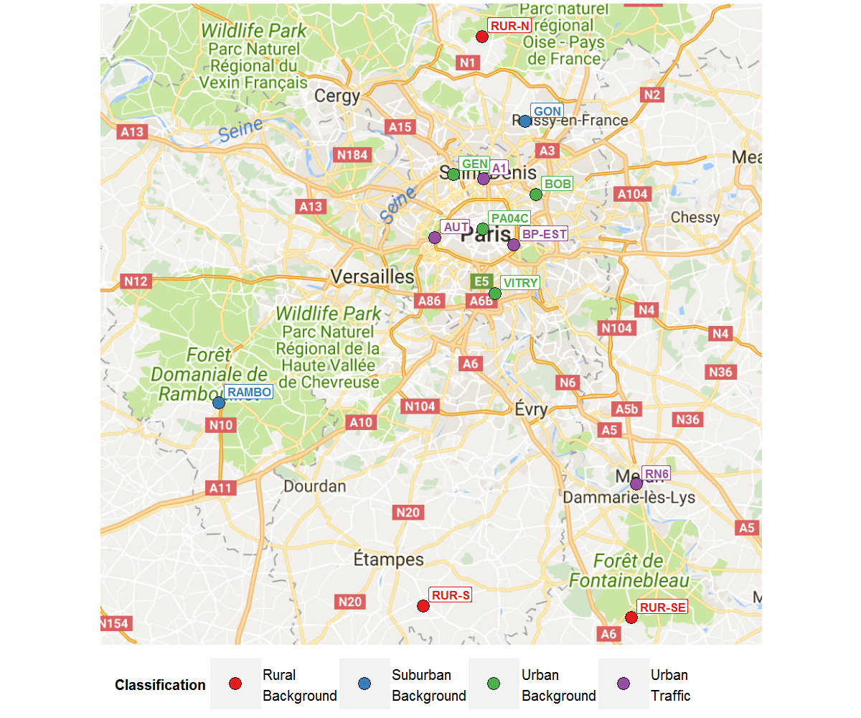

Figure 1. Map of monitoring sites across Paris and surrounding area used in this analysis

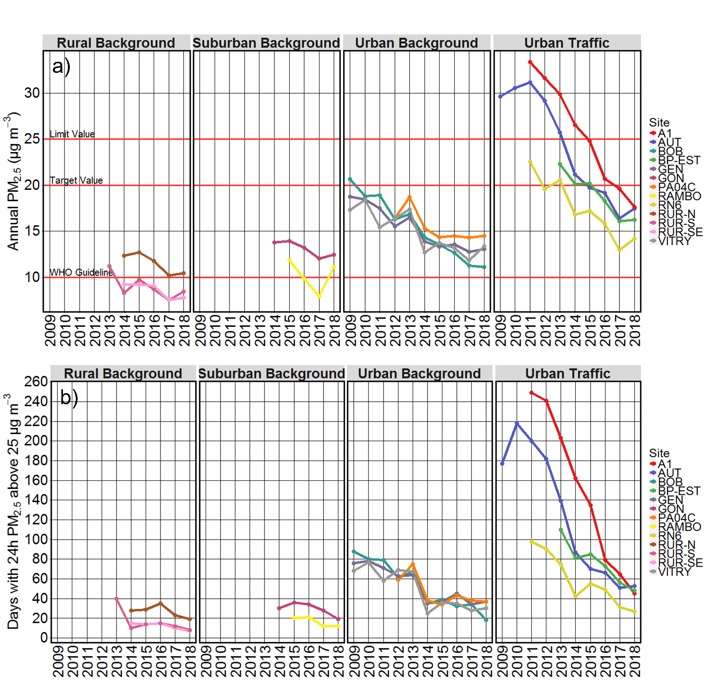Figure 2. a) Annual average PM2.5 concentrations, and b) Number of days when 24h average PM_{2.5} concentrations exceed 25 µg m⁻³ at monitoring sites in Paris between 2009 and 2018.

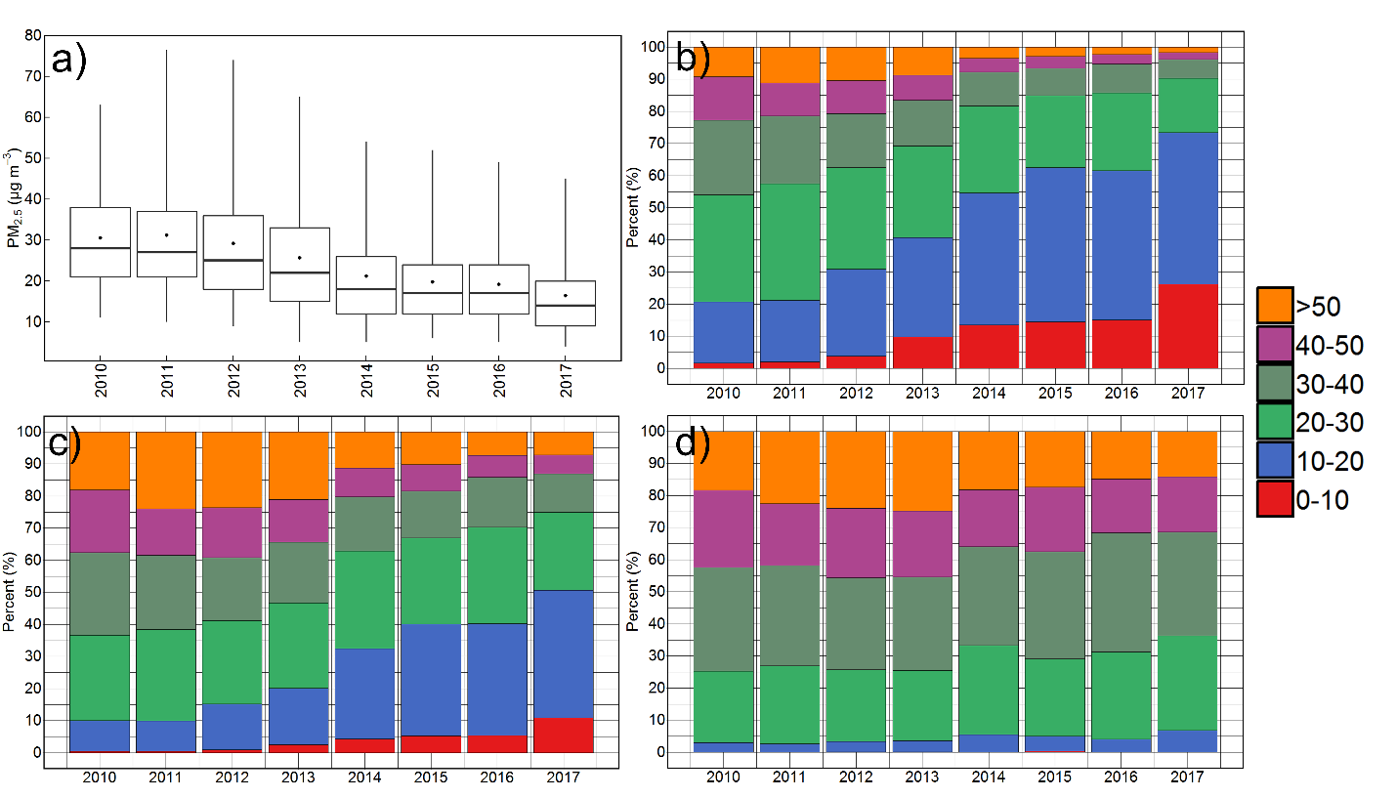
Figure 3. a) The median (line), mean (dot), 25th and 75th percentiles (bottom and top of box), and 5th and 95th percentile concentrations, b) The percentage of hours across the year that hourly PM_{2.5} concentrations were in each 10 µg m⁻³ range, c) The percentage contribution that hourly PM_{2.5} concentrations make to annual average PM_{2.5} concentrations, and d) the percentage contribution that hourly PM_{2.5} concentrations make to 24h average PM_{2.5} concentrations above 25 µg m⁻³at the AUT urban traffic site between 2010 and 2017.

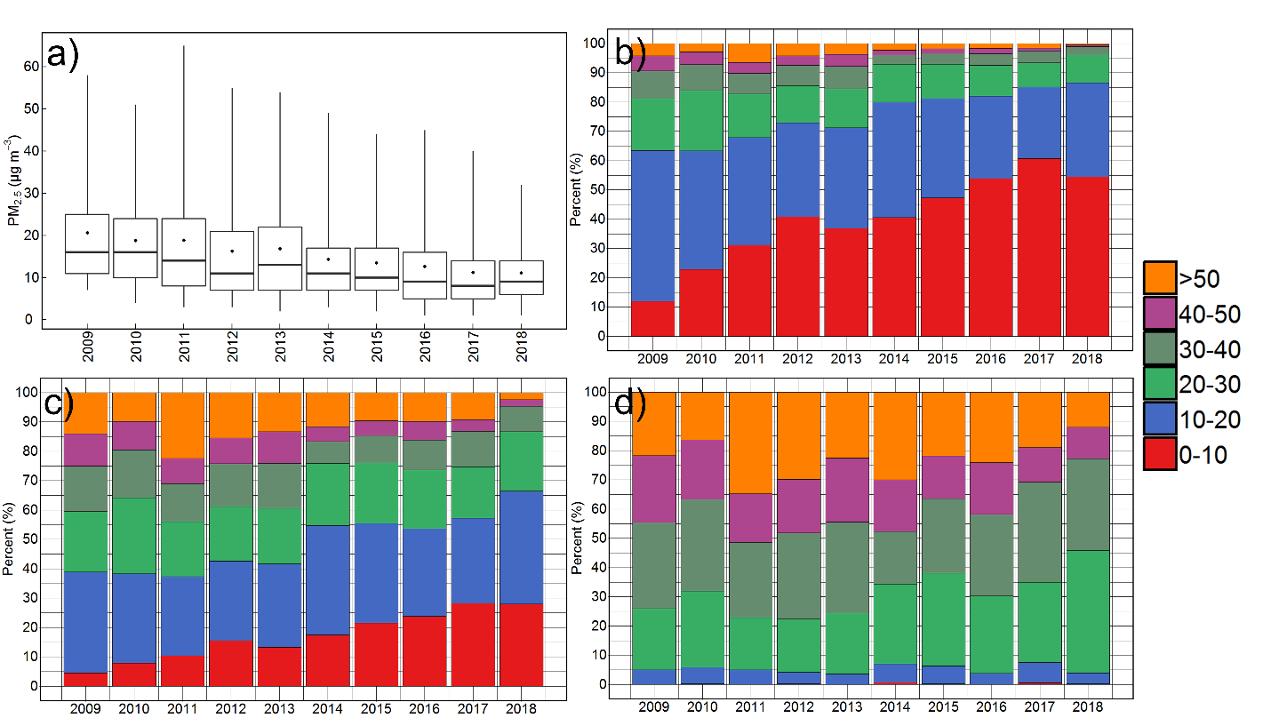

Figure 4. a) The median (line), mean (dot), 25th and 75th percentiles (bottom and top of box), and 5th and 95th percentile concentrations, b) The percentage of hours across the year that hourly PM_{2.5} concentrations were in each 10 µg m⁻³ range, c) The percentage contribution that hourly PM_{2.5} concentrations make to annual average PM_{2.5} concentrations, and d) the percentage contribution that hourly PM_{2.5} concentrations make to 24h average PM_{2.5} concentrations above 25 µg m⁻³at the BOB urban background site between 2009 and 2018.

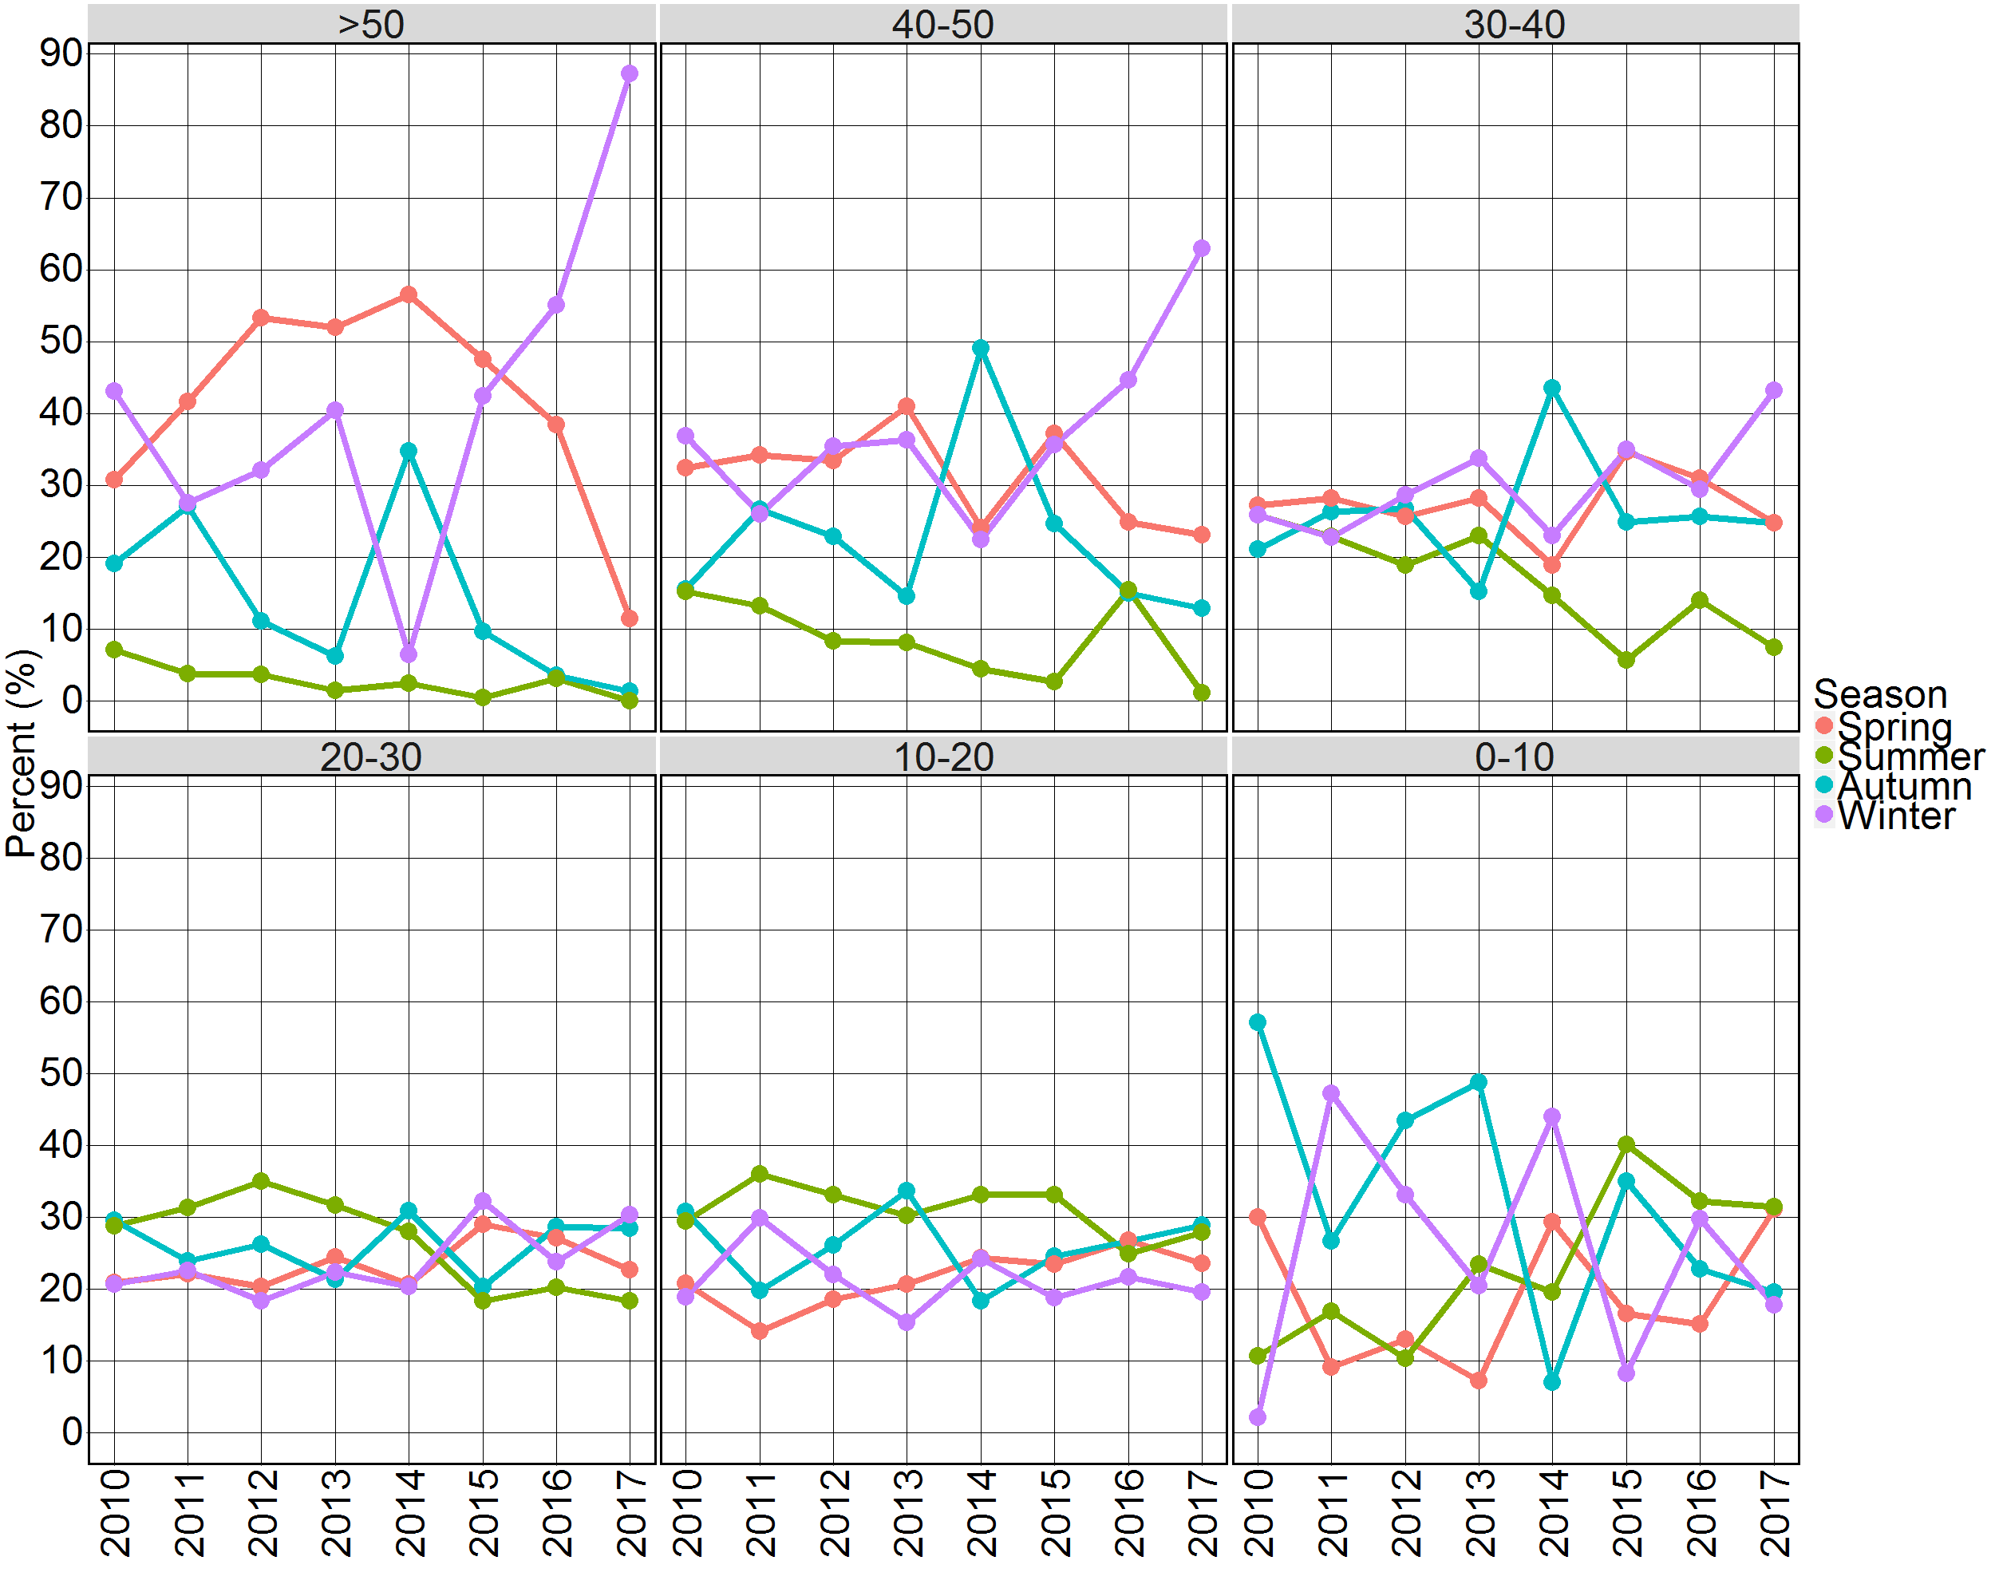

Figure 5. The percentage of hourly PM2.5 concentrations in each range that occurred in spring, summer, autumn and winter at AUT between 2010 and 2017.

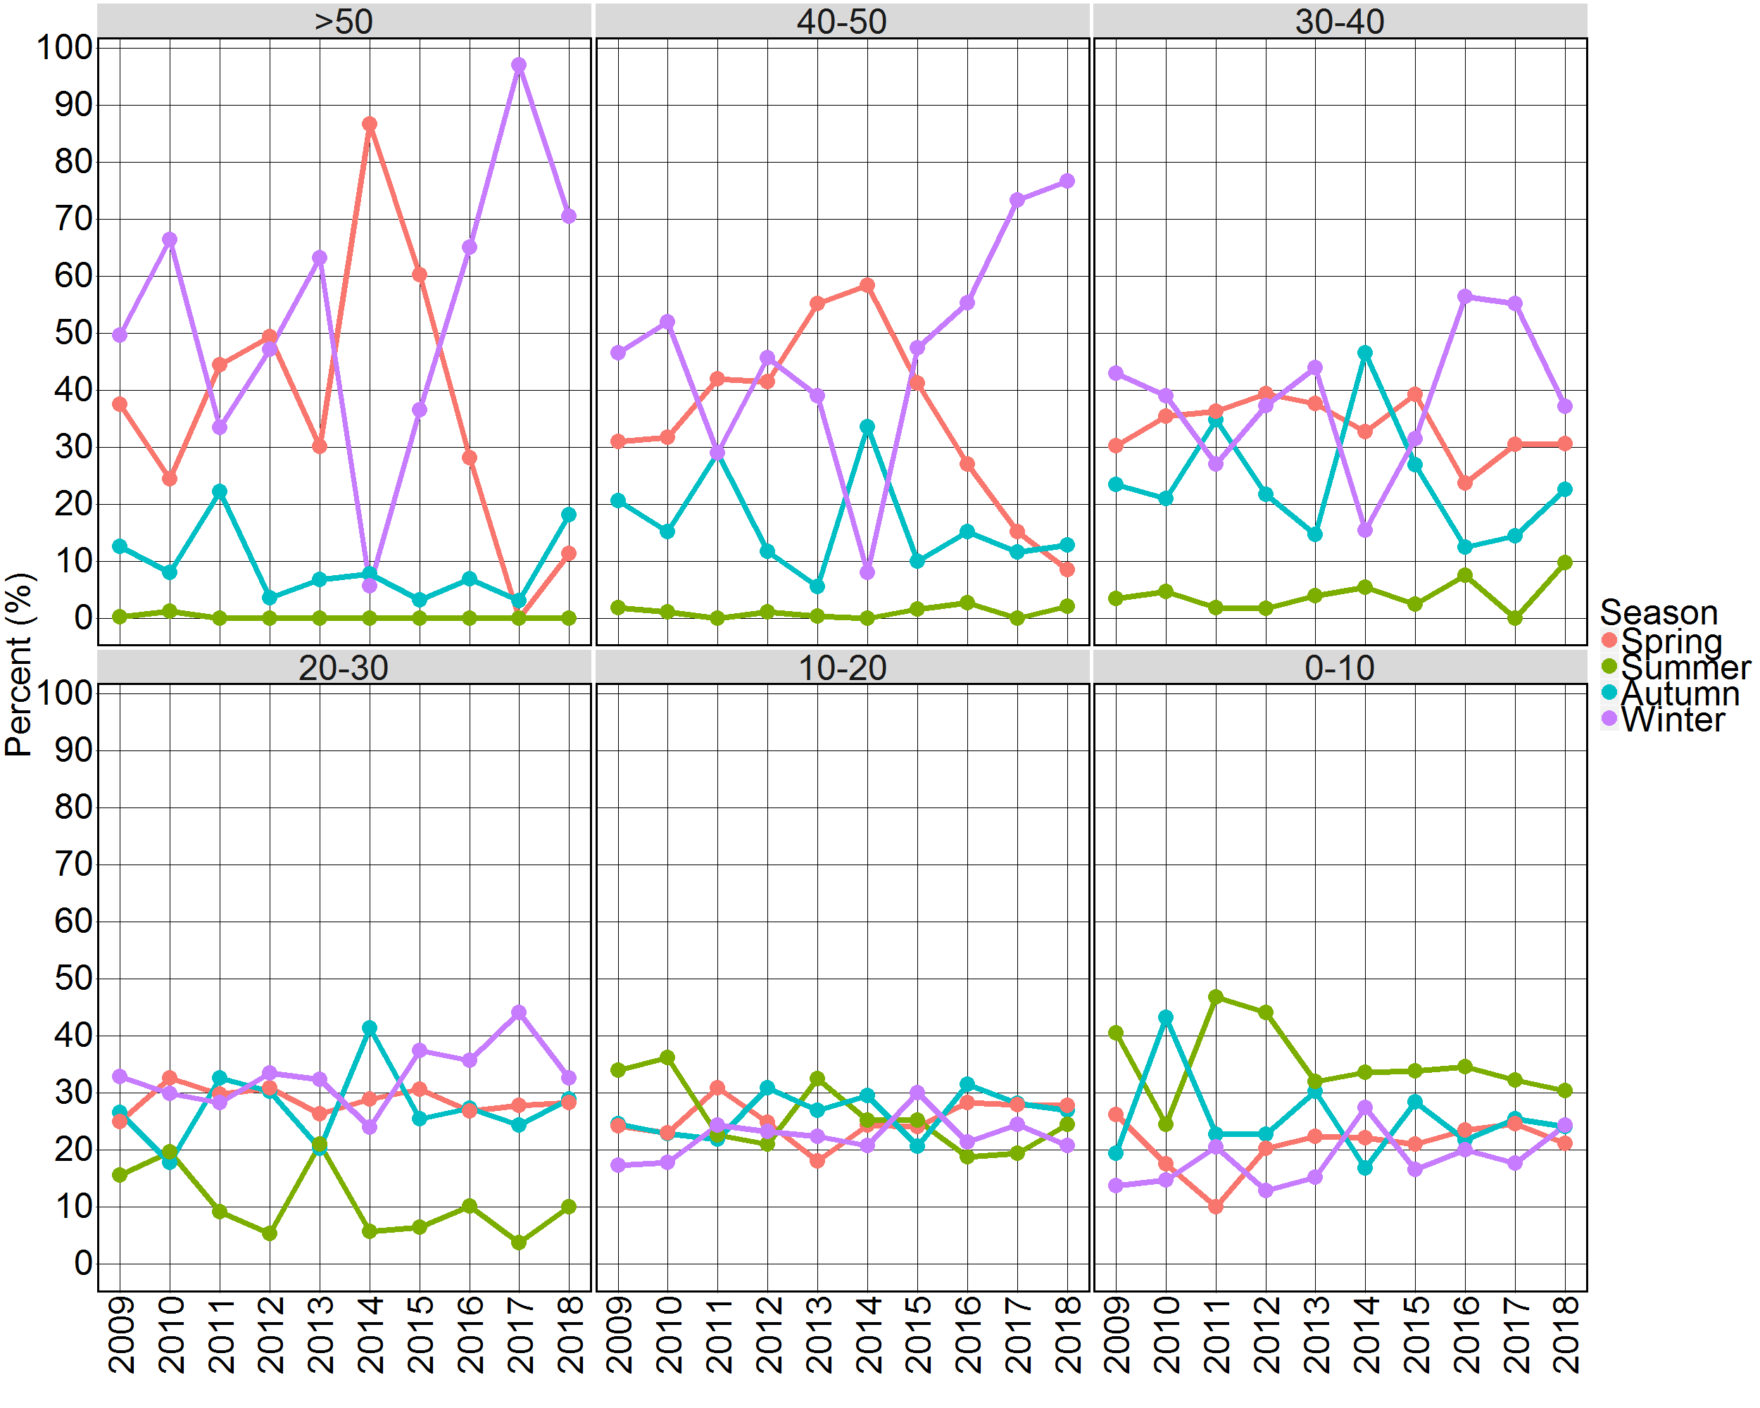
Figure 6. The percentage of hourly PM2.5 concentrations in each range that occurred in spring, summer, autumn and winter at BOB between 2010 and 2018.

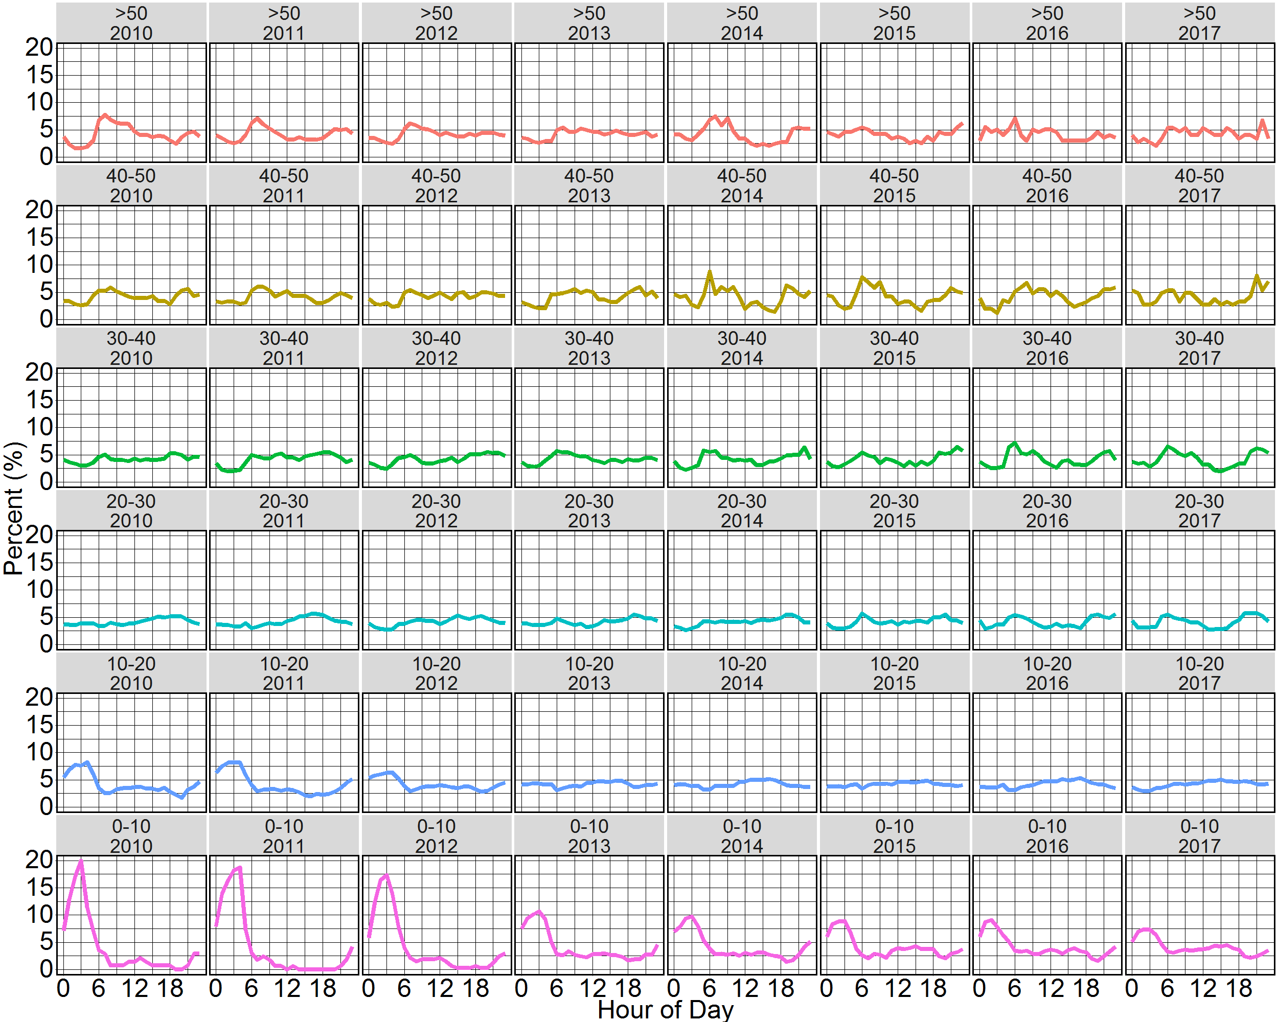
Figure 7. The percentage of hourly PM2.5 concentrations in each range that occurred during each hour of the day at AUT between 2010 and 2017.

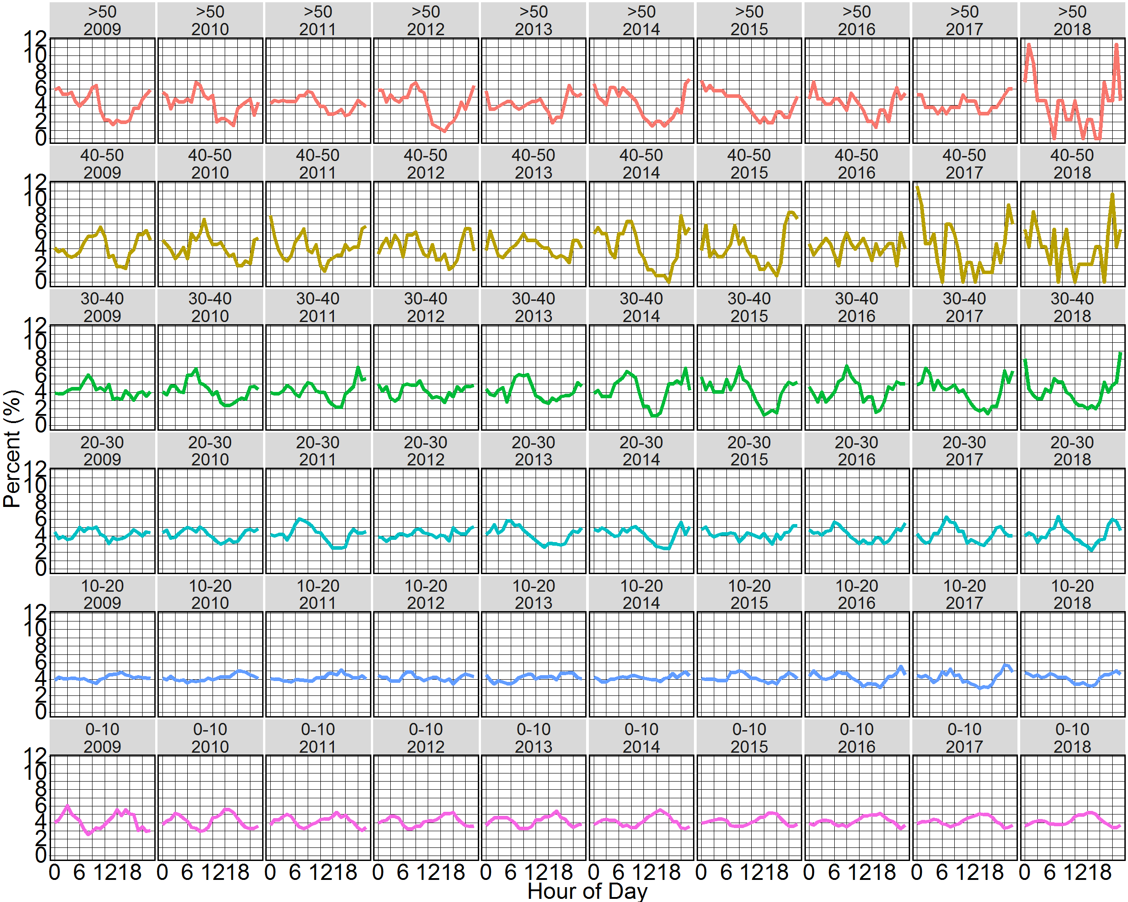
Figure 8. The percentage of hourly PM2.5 concentrations in each range that occurred during each hour of the day at BOB between 2010 and 2018.

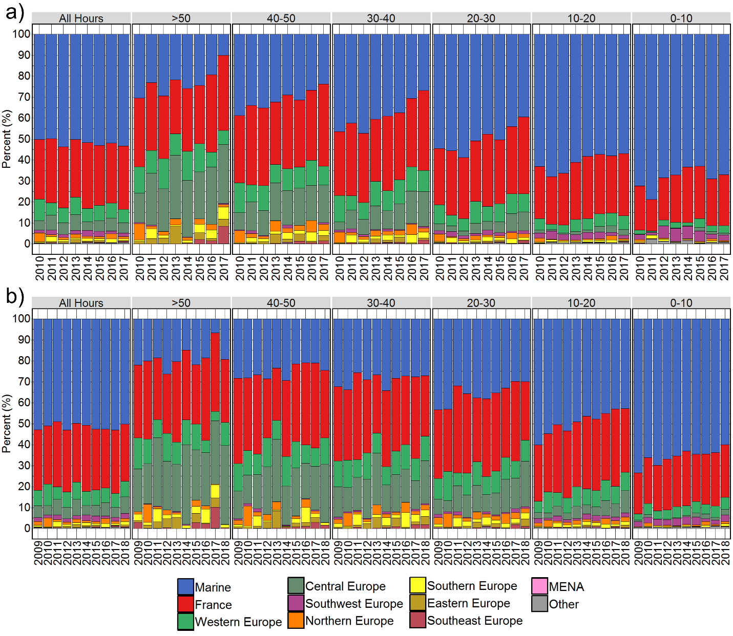

Figure 9. The percentage of time that air mass back trajectories spent over geographic regions in the 96 hours prior to arrival at the a) AUT urban traffic site and b) BOB urban background site, when hourly PM_{2.5} concentrations were in each range.

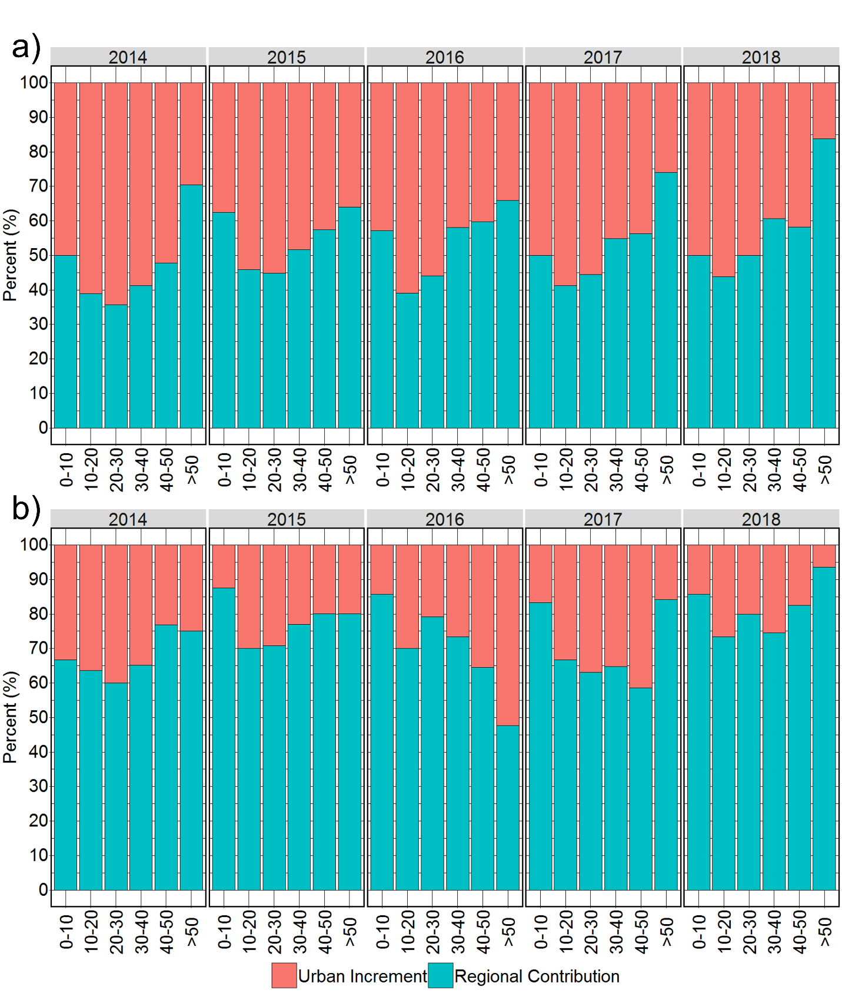

Figure 10. The percentage of hourly PM_{2.5} at urban sites accounted for by measured PM_{2.5} at an upwind rural sites, i.e. the ‘regional contribution’ shown by the blue bar, and the percentage of hourly PM_{2.5} at an urban site in excess of the hourly PM_{2.5} measured at an upwind rural site, i.e. the ‘urban increment’ shown by the pink bar for different ranges of hourly PM_{2.5} concentrations at the a) AUT urban traffic and b) BOB urban background sites.

