Microenvironmental modelling of personal fine particulate matter exposure in Accra, Ghana

Christopher S. Malley¹, Mike R. Ashmore¹, Johan C.I. Kuylenstierna¹, James A. McGrath², Miriam A. Byrne², Chrysanthi Dimitroulopoulou³, Daniel Benefoh⁴

¹ Stockholm Environment Institute, Department of Environment and Geography, University of York, UK
² School of Physics & Centre for Climate and Air Pollution Studies, Ryan Institute, National University of Ireland Galway, Galway, Ireland
³ Environmental Hazards and Emergencies Dept, Centre for Radiation, Chemical and Environmental Hazards, Public Health England, Chilton, Oxon, United Kingdom
⁴ Ghana Environmental Protection Agency, Accra, Ghana

Highlights

- Micro-environmental modelling of personal PM_{2.5} exposure in Accra, Ghana
- Personal PM_{2.5} exposure estimated for male and female, adult and child population groups
- Women cooking using charcoal stoves have highest exposure compared to child and male groups
- Air exchange rates, kitchen volume and emission rate key variables personal PM_{2.5} exposure sensitive to
- Modelling framework can evaluate strategies to reduce exposure of vulnerable groups

Abstract

The health burden from exposure to fine particulate matter (PM_{2.5}) is disproportionately concentrated in low- and middle-income countries. To evaluate strategies to reduce PM_{2.5} exposure, the contribution of different sources, both indoor and outdoor, to overall personal PM_{2.5} exposure needs to be identified. Despite this, exposure to PM_{2.5} from indoor and outdoor origin are most often considered separately. This work presents the first application of a microenvironmental modelling approach in a sub-Saharan African city (Accra, Ghana) to estimate personal PM_{2.5} exposures to population groups disaggregated by gender and age and identify the key factors determining these exposures. Time-activity profiles for each population group were combined with PM_{2.5} concentrations estimated for three home microenvironments using a dynamic microenvironmental model, INDAIR, and for work, school and transport microenvironments using a steady-state model to estimate personal PM_{2.5} exposures. In Accra, cooking using charcoal, compared to liquified petroleum gas (LPG), was estimated to result in substantially higher home PM_{2.5} concentrations, and higher personal PM_{2.5} exposure for the female adult and child population groups, compared with the male population groups. In households cooking using charcoal, more than 60% of total personal PM_{2.5} exposure was estimated to be due to residential cooking for the child and female population groups, which reduces to less than 10% when LPG was used for cooking, with the remaining contribution from PM_{2.5} of outdoor origin. The key parameters to which personal PM_{2.5} exposure estimates are sensitive are the air exchange rate between indoor and outdoors, the kitchen volume, and charcoal emission rates. This study therefore informs on the additional data collection and measurements that could substantially enhance the parameterisation of micro-environmental models for application in low- and middle-income countries where a limited number of studies have been conducted, and improve their utility in assessing strategies to reduce personal air pollution exposure of different population groups.

Keywords: microenvironmental modelling; particulate matter; personal exposure; accra; indoor air pollution; outdoor air pollution

1. Introduction

An air pollutant of primary concern for human health is fine particulate matter (quantified as particles with aerodynamic diameter less than 2.5 µm (PM_{2.5})) (REVIHAAP, 2013). An estimated 4.9 million premature deaths were attributable to long-term PM_{2.5} exposure globally in 2017 (Stanaway et al., 2018), in addition to being associated with morbidity such as preterm birth (Malley et al., 2017), and asthma exacerbation (Anenberg et al., 2018). In low- and middle-income countries, 98% of cities do not meet WHO Air Quality Guideline for annual PM_{2.5} concentrations (10 µg m⁻³), compared to 56% of cities in high-income countries (WHO, 2016). Despite this, the majority of PM_{2.5} monitoring is in high-income countries, and the mis-match between the severity of pollution problem and the degree of monitoring is particularly marked in Africa (Hsu et al., 2013; WHO, 2016).
Sources of PM_{2.5} include those in households, such as cooking, smoking, lighting and other occupant activities, and outdoors, such as traffic, industry, agriculture, waste. Commonly, PM_{2.5} exposure from outdoor and household sources is considered separately, e.g. in health impact assessment and evaluation of source contributions (Forouzanfar et al., 2016, 2015; Lelieveld et al., 2015; Lim et al., 2012; Smith et al., 2014; WHO, 2014, 2006). However, the personal exposure of an individual to PM_{2.5} depends on both the i) temporal and spatial variation in outdoor and indoor PM_{2.5} concentrations in different microenvironments (e.g. home, school or workplace), and ii) timing and duration that people spend in these different locations. Previous studies have demonstrated that there can be large differences in personal PM_{2.5} exposures within a city between different genders, ages or socioeconomic groups (Arku et al., 2015; Smith et al., 2016; Van Vliet et al., 2013), and that the ambient PM_{2.5} concentration measured at a fixed monitoring site is not representative of a particular population’s personal PM_{2.5} exposure (Chen et al., 2018; Dimitroulopoulou et al., 2017). Therefore, to understand the magnitude of PM_{2.5} exposure across different population groups, to characterise the contribution of different sources to the personal PM_{2.5} exposure of a population(s), and the likely benefit from particular interventions aimed at reducing air pollution, it is necessary to integrate outdoor and indoor PM_{2.5} exposures.

Estimates of total personal PM_{2.5} exposure can be obtained through direct measurement (e.g. Arku et al., 2015; Chen et al., 2018), or through modelling (e.g. Smith et al., 2016). Personal exposure models provide a framework where the factors determining personal PM_{2.5} exposure can be parameterised for different populations (Gerharz et al., 2009). These factors can be varied to estimate not only the level of personal PM_{2.5} exposure, but also to identify the sensitivity of personal PM_{2.5} exposures for different population groups (e.g. disaggregated by age, gender and/or socioeconomic status) to each variable (Shimada and Matsuoka, 2011). Personal PM_{2.5} exposure models also allow the effect of different policy and mitigation scenarios on personal PM_{2.5} exposure to be estimated for different sub-populations (Dimitroulopoulou et al., 2017)..

The modelling frameworks that have been applied to assess personal air pollution exposure (PM_{2.5} as well as other pollutants) vary depending on the specific application, as reviewed by Milner et al. (2011). Models used to estimate air pollution concentrations in particular locations (e.g. the home, work, transport) range from simple indoor/outdoor ratios (Borrego et al., 2009), to microenvironmental models that simulate concentrations in a microenvironment based on key building characteristics (Dimitroulopoulou et al., 2017, 2006; McGrath et al., 2014), or to a higher level of refinement to computation fluid dynamic models that simulate air flows around and inside buildings (Giorgios, 2009). These models can then be combined with data on where, when and for how long different populations spend time to estimate personal PM_{2.5} exposure.

While the aforementioned modelling frameworks to assess personal PM_{2.5} exposure (as well as other air pollutants) have been applied in North America (Fabian et al., 2012; Özkaynak et al., 2008), Europe (Borrego et al., 2009; McGrath et al., 2017; Dimitroulopoulou et al., 2001; 2006; 2017) and east Asia (Shimada and Matsuoka, 2011), there has been no application of this approach in a large African city. In these locations there are large sources of PM_{2.5}-relevant emissions from both indoor and outdoor sources for large sections of the population that still use solid biomass for cooking, and personal PM_{2.5} exposure, and the strategies to reduce it, will differ for different population groups (e.g. different genders, ages, professions, and socioeconomic status) (Arku et al., 2015). A single-room box model has been previously developed that is designed for application in low and middle-income countries to estimate kitchen PM_{2.5} concentrations in households using different cooking fuels and stove technologies (Johnson et al., 2011; Johnson and Chiang, 2015; Langbein et al., 2017), and a small number of studies have made direct measurements of personal PM_{2.5} exposure in Accra (Arku et al., 2015; Delapena et al., 2018), as well as studies in rural areas of Ghana (Van Vliet et al., 2013) and Tanzania (Titcombe and Simcik, 2011), with the Arku et al. (2015) developing an empirical model of factors likely to influence exposure.

To address the knowledge gap identified above, the aim of this work was to apply a modelling framework to estimate personal PM_{2.5} exposure from both indoor and outdoor sources for different population groups disaggregated by gender and age in a large African city (Accra, Ghana with a population of 4 million people). The effects on personal PM_{2.5} exposure of variation in key parameters such as outdoor PM_{2.5} concentrations, cooking fuel and stove location, and household size and layout were also assessed. This provides the basis for an analysis of how personal exposure differs between different socio-economic groups within the city, and what strategies can reduce personal PM_{2.5} exposure of particular population groups within an African city. Assessment of the sensitivity of the personal PM_{2.5} exposures to different variables (building characteristics, emission rates, air exchange rates etc.) also informs where future work should focus to improve assessment of PM_{2.5} exposure in data-limited regions.

2. Methods

2.1 Modelling approach

Our modelling of personal PM_{2.5} exposure within different population groups in Accra takes account of i) exposure to outdoor PM_{2.5} concentrations, ii) exposure to outdoor PM_{2.5} that penetrates indoors, iii) exposure to PM_{2.5} indoors that results from indoor emissions (i.e. residential cooking using LPG and charcoal), and iv) differences in time-activity profiles for different broad population demographics. These results are used to determine i) variation in personal PM_{2.5} exposure across broad population categories in Accra and ii) the key factors that determine the magnitude of personal PM_{2.5} exposure for each population group.
Personal PM_{2.5} exposure estimates were calculated for six generic population groups (i. male child, ii. female child, iii. male office worker, iv. female home worker, v. female outdoor worker, and vi. female outdoor worker and cook) by combining diurnal PM_{2.5} concentration estimates in the different locations indoor and outdoor microenvironments) with six time-activity profiles (at 15-minute resolution). Indoor microenvironments were separated between workplace/school (which were not disaggregated into different rooms), transport and the home, which was split into kitchen, living room and bedroom.

The diurnal variation in PM_{2.5} concentrations in each microenvironment were estimated individually. For outdoors, two distinct diurnal outdoor PM_{2.5} profiles were used based on ambient PM_{2.5} measurement from previous studies to contrast between ‘high’ and ‘low’ outdoor PM_{2.5} in residential locations (Dionisio et al., 2010; Zhou et al., 2011) (Section 2.2). In schools, offices and transport, PM_{2.5} concentrations were estimated based on an ‘infiltration fraction’ of outdoor PM_{2.5} concentrations calculated from air exchange rates and deposition rates based on a steady-state model described in Sun et al. (2019) (Section 2.3). In homes, the microenvironmental model INDAIR was run deterministically, as opposed to probabilistically (see below), to estimate the diurnal variation in PM_{2.5} concentrations in each room in the homes. This model is dynamic, and based on solving simultaneous differential equations to calculate PM_{2.5} concentrations in different home microenvironments as a function of emission rate (from indoor sources), deposition and penetration loss, room volume, and air exchange rates (indoor-outdoor, and inter-room) (Dimitroulopoulou et al., 2017, 2006, 2001).

The only indoor emissions modelled were from cooking. Diurnal PM_{2.5} concentrations in homes cooking with either charcoal, LPG, or with no cooking were modelled (Section 2.4). Other cooking fuels such as wood or kerosene were not modelled as less than 1% of households cook with either wood or kerosene in Accra (Ghana Statistical Service, 2014). Other potential sources of indoor emissions affecting personal PM_{2.5} including smoking and the use of kerosene for lighting. Smoking was not included as an additional source of household PM_{2.5} emissions, due to its low prevalence in Ghana, with 89% of urban households reporting no smoking within the home in the 2014 Demographics and Household Survey (Ghana Statistical Service et al., 2015). Kerosene lighting was not included because only 1.5% of households in Accra use kerosene for lighting (Ghana Statistical Service, 2014).

Time-activity profiles and the estimated diurnal variation in PM_{2.5} concentrations in each micro-environment were used to calculate 24h average PM_{2.5} exposure for each population group, and sensitivity analyses were then used to identify the key factors determining these personal PM_{2.5} exposures (Section 2.5).

Sensitivity analyses identified the variables which most strongly influenced personal PM_{2.5} exposures. Modelling of the indoor PM_{2.5} concentrations using INDAIR was repeated by successively replacing each parameter with the low and high sensitivity value individually. Similarly, additional model runs were performed where the air exchange rates for schools, offices and transport were replaced with low and high sensitivity values. The percentage change in 24h PM_{2.5} concentrations was calculated when the high and low sensitivity estimates of each variable was used compared to the central estimate. The aim of running this analysis deterministically, as opposed to running the INDAIR model probabilistically, was to isolate and quantify the effect of each input variable on PM_{2.5} concentrations in the home, and personal PM_{2.5} exposure for each population group.

2.2 Outdoor PM_{2.5} concentrations

PM_{2.5} concentrations measured previously in four different neighbourhoods in Accra were used to estimate outdoor PM_{2.5} concentrations in this study. Dionisio et al. (2010) continuously measured PM_{2.5} concentrations in Accra over 2 years between 2006 and 2007 at four residential sites in Jamestown (JT), Nima (NM), Asylum Down (AD) and East Legon (EL). Annual mean PM_{2.5} concentrations varied from 34 to 60 µg m⁻³, excluding the Harmattan period, where PM_{2.5} concentrations are dominated by desert dust. Zhou et al. (2011) measured diurnal variation in PM_{2.5} concentrations in each of these four neighbourhoods. These diurnal profiles were combined with the annual PM_{2.5} concentrations measured in each neighbourhood to create two diurnal ambient PM_{2.5} concentration profiles, a ‘low’ outdoor PM_{2.5} diurnal profile, as the average of the NM, AD and EL profiles (that had similar PM_{2.5} concentrations), and a ‘high’ outdoor PM_{2.5} diurnal profile from JT (shown in Figure 1).

2.3 PM_{2.5} concentrations in workplaces, schools and transport

For offices, schools, and transport, the indoor PM_{2.5} concentrations were assumed to be directly related to the PM_{2.5} concentration outdoors, and that the outdoor PM_{2.5} concentration in the ‘low’ and ‘high’ outdoor PM_{2.5} concentration model runs are representative of outdoor air where people work or are educated, as well as where they live in Accra. The fraction of outdoor PM_{2.5} infiltrating indoors was calculated by applying a steady-state model described in Sun et al. (2019), in which the infiltration fraction (F_{inf}) is estimated from an penetration factor (P), air exchange rate (AER) and deposition rate (k), shown in Equation.

$$F_{inf}= \left(\frac{P*AER}{AER+k}\right)$$

(Eq. 1)
The penetration factor was set to 1 for offices, schools and transport, and the deposition rate was the same as selected for PM_{2.5} deposition in home microenvironments (described in Section 2.5 and Table 3). Air exchange rates have not been directly measured in Accra for schools, offices or cars. However, they have been measured in similar contexts. For schools, an assessment of ventilation in non-mechanically ventilated South African schools was undertaken by measuring CO₂ levels (Richardson et al., 2014). CO₂ levels in the majority of schools corresponded to AER between 5 and 6 h⁻¹, and therefore 5.5 h⁻¹ was selected as the central AER, with the high and low sensitivity values based on the highest and lowest air flow rates measured in the South African classrooms.

Ventilation in office buildings in Accra and other Ghanaian cities has been modelled previously using AERs varying from 0.5 h⁻¹ to 10 h⁻¹ (Koranteng, 2011, 2010; Koranteng and Mahdavi, 2011; Simons et al., 2016, 2012). These values were not directly measured for buildings in Accra, but based on an assessment of the buildings in Accra and Kumasi being evaluated. In this study, a central value of 1.5 h⁻¹ was selected, which is consistent with measurements studied conducted in mechanically ventilated offices in climate similar to Accra, e.g. Malaysia, as described in Daghigh et al. (2009), and a comprehensive global review of air exchange rates (Hodas et al., 2016). Low and high sensitivity values were selected as low and high values used in previous modelling studies of office buildings in Ghana (Koranteng, 2011, 2010; Koranteng and Mahdavi, 2011; Simons et al., 2016, 2012) (Table 3).

The AER in transport (passenger cars) is most strongly dependent on i) ventilation setting (recirculation of air inside the vehicle or outside air being drawn in), ii) vehicle speed, and iii) vehicle age (Fruin et al., 2011; Hudda et al., 2012; Hudda and Fruin, 2013; Nayeb Yazdi et al., 2019; Tong et al., 2019). In Ghana, the dominant modes of transport are on foot, by car and by minibus (tro-tro) (Ministry of Roads and Highways et al., 2013), and over 50% of vehicles in Ghana are over 15 years old (Obeng-Odoom, 2010). The central value of 10 h⁻¹ for transport AER was based on previously measured average AER in vehicles over 15 years old (Fruin et al., 2011). Low and high sensitivity values were selected to reflect AERs in newer vehicles, and vehicles drawing in outside air, independent of age (Fruin et al., 2011; Hudda and Fruin, 2013).

2.4 Modelling home PM_{2.5} concentrations

In INDAIR, the change in PM_{2.5} concentration is calculated by solving the following differential equation for each home micro-environment:

$$\frac{{dC}_{i_{k}}}{dt}= {{(λ}_{ri,o})}_{k}\left(f_{k} x C_{o}- C_{i_{k}}\right)- ν_{g}\left(\frac{A_{k}}{V_{k}}\right)C_{i_{k}}+ λ_{r delta-l}\left(C_{i_{l}}- C_{i_{k}}\right) + λ_{r delta-m}\left(C_{i_{m}}- C_{i_{k}}\right) +\frac{Q_{k}}{V_{k}}$$

C_{ik} = indoor concentrations in compartment k (µg m⁻³) (Eq. 2)
C_{o} = outdoor concentration (µg m⁻³)
ν_{g} = deposition velocity of pollutant (m h⁻¹)
(λ_{ri,o})_{k} = air exchange rate between outdoor and indoor concentrations (air exchanges per hour)
λ_{r delta-l}; λ_{r delta-m} = air exchange rate between compartments (air exchanges per hour)
f_{k} = building fabric filtration factors
A_{k} = surface area of compartments (m²)
V_{k} = volume of the compartments (m³)
Q_{k} = indoor emission rates (µg h⁻¹)

Table 1 summarises the value used for each of the input parameters to Equation 1, along with the values used for low and high sensitivity analyses. Two household configurations were modelled in this study: The ‘Ghana Living Standards Survey Round 6’ estimates that 28.9% of households in the Greater Accra Metropolitan Area live in detached houses, semi-detached houses or flats and apartments. These are broadly represented by the first, three-room home configuration modelled in this study with a kitchen, bedroom and living area. Additionally, 63.9% of households are compound houses (a collection of 1-2 room homes with shared bathroom/cooking facilities), which are represented by the second, two-room configuration with a bedroom and living area (Ghana Statistical Service, 2014; UN Habitat, 2011). Room volumes were taken as the mean, minimum and maximum values from a sample of 80 households across different areas of Accra, whose floorplans were recorded, floor area calculated, and room volumes estimated assuming a 2.75 m ceiling height, in line with the Ghana Building Code (Ghana Standards Authority, 2018) (Table S1 includes summary statistics for the homes included in the survey conducted for this work). The area to volume ratio was that used for UK homes (Dimitroulopoulou et al., 2006), in the absence of local information on furnishing configurations, which would influence surface area to volume ratios.

Indoor-outdoor air exchange rates were not available for Ghana, and values for developing countries reviewed in Hodas et al. (2016) were mainly derived for rural homes. Urban indoor-outdoor air exchange rates for developing country homes were therefore estimated based on PM₁₀ decay rates in homes in Dhaka, Bangladesh during a measurement campaign (Dasgupta et al., 2006; World Bank, 2006). Dhaka and Accra have the same Koppen-Geiger climate classification (Peel et al., 2007), and in both cities the vast majority of households (92% in Accra, 88%) are permanent homes made from cement, concrete blocks or bricks (Bangladesh Bureau of Statistics, 2011; Ghana Statistical Service, 2014). In total, air exchange rates were derived for eight experiments all in homes with brick walls, and concrete floors and roofs, consistent with the main building materials in Accra (Dasgupta et al., 2006; World Bank, 2006). The mean air exchange rate was 12.5 air changes h⁻¹. While this value is substantially higher than is typically measured in Europe and North America (Hodas et al., 2016), it is consistent with the air exchange rates measured in low- and middle-income countries reviewed in Hodas et al. (2016) and Williams and Unice (2013) which ranged from 2 to 64 air changes h⁻¹ based on studies in India, Guatemala, Kenya and Peru. The high value used to undertake a sensitivity test was based on a doubling of this air exchange rate and low sensitivity test used a value based on typical air exchange rates for homes in high-income countries (i.e. in the UK, (Dimitroulopoulou et al., 2006)). The air exchange rates between indoor microenvironments were based on previously derived values for homes in the UK, in the absence of specific data in low- and middle-income countries. Deposition velocities were based on previously reported values for PM_{2.5}, described in Dimitroulopoulou et al. (2006), assuming the same particle size distribution.

The two main fuels used for cooking in Accra are charcoal and LPG account for 38.9% and 52.7% of households in the Greater Accra Metropolitan Area (GAMA) respectively (Ghana Statistical Service, 2014). It was estimated that a household cooking using charcoal consumes 1.175 kg charcoal h⁻¹ based on charcoal per capita consumption rates (160.86 kg/person/year (UNDP, 2016)), average household size (4 people per household in 2012 (Ghana Statistical Service, 2014)) and average cooking time (90 min day⁻¹ (Ghana Statistical Service, 2012a)). A household cooking using LPG was estimated to use 0.170 kg LPG h⁻¹ based on total LPG use for cooking (133.1 kilotonnes in 2012 (Economic Consulting Associates, 2017)) and the number of households cooking using LPG in Ghana (1.427 million (Ghana Statistical Service, 2014)).

Emission rates, shown in Table 1, for PM_{2.5} for cooking using charcoal and LPG were derived by combining the fuel consumption rates with fuel-specific PM_{2.5} emission factors. For LPG, the recommended emission factors from the WHO Indoor Air Quality Guidelines were used (central estimate: 0.35 g kg⁻¹ LPG used, minimum: 0.01 g kg⁻¹, maximum: 0.52 g kg⁻¹) (Edwards et al., 2014). For charcoal, emission factors from two studies conducted in northern Ghana were used (Coffey et al., 2017; Obeng et al., 2017). The central estimate emission rate was based on an emission factor (0.8 g PM kg⁻¹ charcoal consumed (Coffey et al., 2017)) measured for cooking typical meals on ‘coalpot’ stoves (a locally made charcoal stove). The ‘low’ sensitivity value was based on an emission factor (0.47 g kg⁻¹ (Obeng et al., 2017)) measured for coalpot stoves during a standard ‘water boiling test’, and the ‘high’ sensitivity value was based on an emission factor (1.6 g kg⁻¹ (Coffey et al., 2017)) for a Philips charcoal stove tested under the same conditions as the central estimate.

When modelling the cooking patterns in the different homes, the major cooking situations in Accra were reflected. The Ghana 2010 Population and Housing Census recorded 56% of houses and apartments in Accra cooking in a separate kitchen within their home. The remainder mostly cooked on a verandah or in an open space outside the home. Cooking with charcoal, cooking with LPG and no cooking in the kitchen were modelled for the three-room configuration representative of a house or apartment in Accra. For compound homes, only 20% cooked in a separate room in their home, while the majority (63%) cooked on a verandah or outside (Ghana Statistical Service, 2012b). A no-cooking scenario in the two-room configuration representative of a compound home was therefore also modelled.

2.5 Time-activity profiles

The basis for the time-activity profiles for each population group were the results from the Ghana Time Use Survey (GTUS) (Ghana Statistical Service, 2012a), which was combined with assumptions to define a set of time-activity profiles for sub-populations. This allowed exploration of the effect of contrasting time-activity patterns on personal PM_{2.5} exposure. It is recognised that there is, in practice, a much greater variability in time-activity patterns within each group. In general, the GTUS data on participation rates and average time spent on the activity by those participating was used to develop representative time-activity profiles, focussing on those activities in which a high proportion of the population group participate. Simulations were also focused on working days, recognising that exposure patterns for children will be very different on non-schooldays (GTUS data are reported by day of week, but the differences are not large for activities other than learning).

Time-activity profiles were developed for six groups. This includes male and female child (10-17 years) groups (denoted Male Child and Female Child, respectively), and four different working adult (24-65) patterns, segregated by gender. The differences between boys’ and girls’ activities are relatively small, but are used to explore the effect of gender differences in exposure to home cooking. For working-age adults, the working patterns were chosen to provide contrasts in personal exposure from indoor and outdoor sources. These are (1) an office worker commuting to the central business district (Male Office Worker); (2) an individual who works entirely within the home (Female Home Worker); (3) a street seller who works outside but does not first prepare food for sale (Female Outdoor Worker) and (4) a street seller who prepares food for sale before leaving home (Female Outdoor Worker and Cook). The time-activity profiles defined only consider a working family with children, aiming to explore the interaction between activity patterns and pollution sources within the family. Participation rates and time spent by those participating data for families with young children from GTUS were therefore used.

Based on the GTUS data described above, the time spent on each activity was determined for the six representative population groups, and the appropriate microenvironment for the task. This is summarised for each population group in Table 4, and the underlying data and assumptions used are described in supplementary text. Values in GTUS are given to the nearest minute, but in providing generic time-activity profiles, these were rounded to 15-minute intervals. In Figure 2 and Table S1, the assignment of locations for each time-activity profile includes the 3-room home microenvironment (i.e. kitchen, living room and bedroom). For the 2-room home modelling, the kitchen and living room, and time spent in them, were combined to one room.

The GTUS does not provide data on when, during the day, different groups undertake different activities, and therefore a set of six representative time-activity profiles were defined. The time-activity profiles are set up to be representative of the individual members of a single family, and therefore the timing of different activities has been designed to provide some consistency between family members (summarised in Figures 2 and 3).

3. Results

The results from the INDAIR modelling of PM_{2.5} concentrations in home microenvironments in Accra are presented in Section 3.1. This is followed by the results of how diurnal variations in PM_{2.5} concentration in all microenvironments (i.e. home, work, school, transport), combine with time-activity profiles to allow estimation of personal PM_{2.5} concentrations for each broad population group (Section 3.2). Sensitivity analyses are presented for home PM_{2.5} concentrations and personal PM_{2.5} concentrations within each of their respective sections.

3.1 PM_{2.5} concentrations in home microenvironments

When modelled in INDAIR with no cooking, the 24h PM_{2.5} concentration in each indoor microenvironment was approximately 90% of the 24h outdoor PM_{2.5} concentration (Table 2). This is higher than would be expected in European homes, for example, and is due to the relatively high indoor-outdoor air exchange rate used for Accra homes compared to European homes (Dimitroulopoulou et al., 2006). When cooking was simulated, a substantial increase in PM_{2.5} concentrations was observed in the kitchen, relative to the no cooking case, that was also greater when compared with the corresponding increases in the living room and bedroom. For example, with 90 minutes of cooking with charcoal, 24h PM_{2.5} concentrations in the kitchen were 145% higher than the no-cooking scenario for ‘high’ outdoor PM_{2.5}, compared to 65% and 20% higher for living room and bedroom 24h PM_{2.5} concentrations (Table 2), respectively. Cooking with LPG similarly resulted in larger increases in 24h PM_{2.5} concentrations, compared to no cooking, in the kitchen than in the living room and bedroom, although the absolute increases in 24h PM_{2.5} concentrations were substantially less than for cooking with charcoal (Table 2).

The diurnal variation in PM_{2.5} concentrations mirrored the outdoor PM_{2.5} profile for the no-cooking model runs (Figures 4, 5 and 6). During the cooking period, 15-minute average kitchen PM_{2.5} concentrations exceeded 1400 µg m⁻³ for charcoal-fuelled cooking, and 140 µg m⁻³ for cooking using LPG. Maximum PM_{2.5} concentrations were substantially lower for the living room and bedroom, at approximately 600 and 240 µg m⁻³ for the charcoal cooking scenario. When cooking stopped, indoor PM_{2.5} concentrations returned to background levels within one hour.

3.2 Personal PM_{2.5} exposures

Table 2 summarises the 24h personal PM_{2.5} exposures for the various population groups with different time-activity profiles. For the no-cooking scenarios, 24h PM_{2.5} exposures were determined by i) whether the ‘high’ or ‘low’ outdoor PM_{2.5} concentration was used, and ii) the proportion of time spent outdoors and in different indoor microenvironments. In the no-cooking scenarios, personal PM_{2.5} exposure was similar across the broad population groups, varying at most by 10% (Table 2). Across all population groups, 24h personal PM_{2.5} exposure was approximately half in the ‘low’ outdoor PM_{2.5} scenario compared to the ‘high’ outdoor PM_{2.5} scenario.

In scenarios with cooking in the home, personal PM_{2.5} exposure varied substantially between the population categories. The largest increase in personal PM_{2.5} exposure relative to the no-cooking scenario occurred when charcoal was used for cooking. The smallest increase in 24h PM_{2.5} occurred for the Male Office Worker profile, as this population group was assumed not to spend time in the kitchen during the cooking period. The largest 24h PM_{2.5} exposure was for the three female adult profiles (Female Home Worker, Female Outdoor Worker and Female Outdoor Worker and Cook), and for the Female Child group, for which 24h PM_{2.5} exposure was more than double than the no-cooking scenario. The scenario where LPG was used for cooking resulted in 24h PM_{2.5} exposures that were only 12-15% above the 24h PM_{2.5} exposures in the no-cooking scenario for the female adult and child population groups in the high PM_{2.5} regime, and lower for Male Child and Male Office Worker groups. Cooking for a longer time period was estimated to mainly affect the personal PM_{2.5} exposure of the Female Outdoor Worker and Cook group, due to the longer time spent in the kitchen where cooking took place. In the scenario with 3.5 hours of cooking, 24h PM_{2.5} exposures were almost 80% higher for the Female Outdoor Worker and Cook group -, compared to the 1.5 hour cooking period scenario, but increased less (48%) for the other female categories, and even less for the Male Child, Female Child and Male Office Worker groups.

While cooking was the largest contributor to 24h PM_{2.5} exposure for the child and female adult population categories in these scenarios, the difference between ‘high’ and ‘low’ outdoor PM_{2.5} concentrations continued to influence overall 24h personal PM_{2.5} exposure. For all female groups, 24h personal PM_{2.5} exposures were approximately 17% lower for the ‘low’ outdoor PM_{2.5} concentrations for scenarios with charcoal cooking for 90 minutes (Table 2). The reduction was even greater for the male child (28%) and male adult (35%) groups, and for all population groups in the LPG cooking scenarios, where indoor cooking emissions make a substantially smaller contribution to 24h personal PM_{2.5} exposure.

The different cooking scenarios resulted in a different percentage contribution from indoor and outdoor PM_{2.5} sources to overall personal PM_{2.5} exposure for each population group (Figures 7-9). For example, for the 3-room-home scenario in the high PM_{2.5} environment, with 90 minutes cooking using charcoal fuel, approximately 60% of the personal 24h PM_{2.5} exposure was derived from indoor cooking sources for the female groups, compared to less than 10% when the cooking fuel used was LPG (Figure 7). For the ‘low’ outdoor PM_{2.5} concentration profile, approximately 72% and 15% of 24h personal PM_{2.5} exposure was derived from indoor charcoal and LPG cooking sources, respectively, due to the lower exposure from outdoor sources both outside the home and from outdoor air penetrating into home microenvironments (Figure 7). Cooking for 3.5 hours resulted in 70-80% of personal PM_{2.5} exposure being derived from indoor cooking sources for the Female Outdoor Worker and Cook group (Figure 8). The non-cooking contribution to PM_{2.5} exposure for each population group had a contribution from PM_{2.5} exposure outdoors, and exposure to PM_{2.5} of outdoor origin indoors (in the home). These contributions varied depending on time-activity profile, with the female adult categories (where more time was spent in the home) having a large contribution to non-cooking PM_{2.5} from exposure to outdoor PM_{2.5} that infiltrated into the home.

3.3 Sensitivity Analyses

Table 3 shows the sensitivities of 24h PM_{2.5} concentrations in each home microenvironment, and 24h personal PM_{2.5} exposures for each population group, to the low and high values of key input variables for the 3-room home with charcoal cooking for 90 minutes per day. The indoor-outdoor air exchange rate was among the key variables to which 24h PM_{2.5} concentrations in each microenvironment and personal PM_{2.5} exposures for each population group were most sensitive. When the low indoor-outdoor air exchange rate was used, with the value typical for European homes, there was a greater than 100% increase in kitchen and living room 24h PM_{2.5} concentrations, and personal PM_{2.5} exposure for all population groups compared to when the central estimate of indoor-outdoor air exchange was used. However, there was a substantially smaller change in 24h PM_{2.5} concentrations in each microenvironment when the high sensitivity value was used for the indoor-outdoor air exchange rate.

The high and low estimates of kitchen volume and charcoal emission rate also resulted in substantial changes in 24h PM_{2.5} concentrations and personal exposures (Table 3). The bedroom 24h PM_{2.5} concentrations were in general less sensitive to high and low values applied to kitchen volume or charcoal emission rate, as there was assumed to be no direct air exchange between the kitchen and the bedroom. Of all the population groups, the Male Office Worker group was least sensitive to these variables (indoor-outdoor AER, charcoal emission rate and kitchen volume), as their personal 24h PM_{2.5} exposure was determined less by indoor charcoal cooking emissions. In this case, the AER of the office microenvironment was also a key variable. For children, the AER of the school had a smaller, but not insignificant effect on 24h PM_{2.5} exposure. For the LPG and no-cooking scenarios, 24h PM_{2.5} personal exposure was more sensitive to these non-cooking parameters (Tables S2-S6).

4. Discussion

4.1 Comparison of modelled personal PM_{2.5} exposure to available measurements

The number of studies measuring personal PM_{2.5} exposure, and home PM_{2.5} concentrations in Accra specifically, and low- and middle-income countries in general, are substantially smaller than have been conducted in high-income countries. Comparison with the few available studies in Accra, in Africa, and in Asia provide insight into the effectiveness of this micro-environmental modelling framework application in characterising personal PM_{2.5} exposures in Accra. Available measurement studies of home PM_{2.5} concentrations and personal PM_{2.5} exposures in low- and middle-income countries vary in terms of study design, documentation of the conditions under which measurements were made, the PM_{2.5} metrics reported (e.g. daily average PM_{2.5} concentrations vs shorter time-scale concentrations), and sample sizes (Table 4).

In Accra, Zhou et al. (2011) measured substantially lower 24h cooking-area PM_{2.5} concentrations compared to modelled kitchen PM_{2.5} concentrations in this study, most probably because the majority of cooking areas in Zhou et al. (2011) were outdoors. This indicates that the PM_{2.5} concentrations in each home microenvironment, and personal PM_{2.5} exposures derived in the no-cooking scenarios in this work, with no indoor emission sources in the home, may be valid estimates of personal PM_{2.5} exposure for homes where cooking takes place outdoors. The kitchen PM_{2.5} concentrations measured in Accra households in Pennise et al. (2009) using wood for cooking were slightly higher than the 24h kitchen PM_{2.5} concentration modelled in this study. This may be due to generally higher emission rates when burning wood compared to charcoal (Edwards et al., 2014), and the longer time period during which the fire burned (approximately 4 hours) compared to that assumed in this study (1.5 and 3.5 hours).

Studies conducted in other areas of Ghana (Van Vliet et al., 2013), sub-Saharan Africa (Titcombe and Simcik, 2011; Tumwesige et al., 2017), and in Asia (Balakrishnan et al., 2013; Dasgupta et al., 2006) show substantial variation in indoor PM_{2.5} concentrations when using a particular fuel for cooking, that may reflect different outdoor PM_{2.5} concentrations, as well as stove and fuel differences (Table 4). However, the 24h home PM_{2.5} concentrations for cooking using solid biomass (charcoal) and LPG estimated for Accra in this study are within the range of results obtained from these measurement studies including both the magnitude of household PM_{2.5} concentrations and the substantial reduction in home PM_{2.5} concentrations when using LPG for cooking compared to solid biomass (Table 2 cf. Table 4).

Earlier studies have used a one-room box model to estimate kitchen PM_{2.5} concentrations in countries where solid biomass use is prevalent, and these studies account for air exchange between the kitchen and outdoors, cook stove emission rate, and kitchen volume, but not PM_{2.5} deposition, air exchange between different microenvironments within the home, or the infiltration of outdoor air indoors (Johnson et al., 2011; Johnson and Chiang, 2015). Langbein et al. (2017) estimated kitchen PM_{2.5} concentrations during cooking periods for a range of different fuels and cooking stoves using a one-room model. The average PM_{2.5} concentration during cooking estimated for seven stoves using charcoal as fuel ranged between 1376-3474 µg m⁻³, which is similar to the ~1500 µg m⁻³ kitchen PM_{2.5} concentrations estimated using INDAIR for Accra homes during cooking periods. This indicates that the INDAIR model produces comparable results to other modelling methodologies used to quantify kitchen PM_{2.5} concentrations resulting from indoor cooking emissions. It also indicates that the inclusion of additional processes in the INDAIR modelling methods, compared to the simple box model, to represent infiltration of outdoor air indoors, pollutant deposition and air exchange between home microenvironments, does not substantially affect the kitchen PM_{2.5} concentration estimated during cooking when emissions in the kitchen dominate household PM_{2.5} concentrations.

Two studies have measured personal PM_{2.5} exposure in Accra. Arku et al. (2015) measured the mean personal PM_{2.5} exposure of 56 students from 8 schools to be 56 µg m⁻³, and observed that average exposure for girls (67 µg m⁻³) was larger than for boys (44 µg m⁻³). The larger exposure for girls is consistent with the current study, but the PM_{2.5} exposure levels are lower than those modelled when cooking using charcoal. This is likely because 62.5% of students in Arku et al. (2015) lived in households where cooking was done outdoors. The no-cooking scenarios in the current study (specifically with ‘high’ ambient PM_{2.5} concentrations) assume no cooking in the home, and are more comparable to the personal PM_{2.5} exposure measurements for the students reported in Arku et al. (2015). In Delapena et al. (2018), average personal PM_{2.5} exposure across 11 primary cooks in Accra using charcoal was 30 µg m⁻³, compared to 24 µg m⁻³ for cooks using LPG only. The personal PM_{2.5} exposure of primary cooks using charcoal in Delapena et al. (2018) is substantially less than modelled in the current study, and there is only a 19% reduction in exposure for cooks using LPG, compared to 55-600% reduction modelled in the current study. The reason for this difference is unclear, but may be due to the cooking location (it is not stated whether cooking takes place indoors or outside), and the relatively small sample size of the participants in Delapena et al. (2018) or differences in household characteristics, cooking patterns and time-activity patterns among the participants included in the measurement study compared to those used as input for the modelling in this work. In another study in rural Tanzania that assessed personal PM_{2.5} exposure of cooks using charcoal (average exposure 588 µg m⁻³) and LPG (14 µg m⁻³), results were more comparable with those obtained from the modelling in this work (Titcombe and Simcik, 2011). Comparison of the results from the current work with available personal exposure measurement studies highlights the need for systematic reporting of conditions (household characteristics, cooking patterns timing, and duration, and time-activity patterns) to facilitate a consistent comparison of results between measurement and modelling studies.

4.2 Insights into micro-environmental modelling for personal PM_{2.5} exposure assessment in Accra and other Low and Middle-Income Cities

To understand how population exposure to PM_{2.5} from the major indoor and outdoor sources in low and middle-income countries can be reduced, it is necessary to be able to effectively assess the determinants of personal PM_{2.5} exposure for different population groups, in the same way that this has been assessed in high-income countries. However, there is a substantially smaller volume of data assessing population exposure to PM_{2.5} in low- and middle-income countries. The microenvironmental modelling described here and applied for the first time in a sub-Saharan African city, provides a framework and practical example for how these aspects of personal PM_{2.5} exposure analysis can be investigated in cities in low- and middle-income countries, and highlights where additional studies could be focussed to most effectively improve assessment of personal PM_{2.5} exposure for different population groups. Specifically, more specific information on indoor-outdoor air exchange rates, charcoal emissions rates and building dimensions would substantially improve the parameterisation of microenvironmental personal exposure models.

Despite the uncertainty in these parameters, the application in Accra highlights differences in personal PM_{2.5} exposure for different population groups, disaggregated by gender and age. Women in households cooking with charcoal had the highest overall exposure to PM_{2.5}, higher than for the male and female children groups, or for the male office worker group who were assumed not to be involved in cooking at home. The greater amount of time spent outside, and less time spent in the kitchen, meant that the Female Child population group were estimated to have higher overall personal PM_{2.5} exposures than the Male Child group.

The microenvironmental modelling framework also provides quantification of the likely effect on personal PM_{2.5} exposure of different actions and strategies aimed at reducing PM_{2.5} exposure, and the different effect that interventions may have on different population groups. In Accra, for adult females and the child groups, the use of LPG for cooking instead of charcoal substantially reduced 24h PM_{2.5} exposure, and the contribution of indoor emissions to personal PM_{2.5} exposure. However, the difference in 24h PM_{2.5} exposure for the male office worker group between the charcoal and LPG cooking scenarios was substantially lower due to a smaller influence of cooking emissions on the male office worker group, and PM_{2.5} exposure determined to a greater degree by outdoor PM_{2.5}. Therefore, actions that target the major sources of outdoor PM_{2.5} concentrations (which may also include residential cooking emissions) could be more effective in reducing PM_{2.5} exposure for this group. Reducing emissions from the major sources of outdoor PM_{2.5} concentrations could also reduce the infiltration of outdoor PM_{2.5} indoors, thus benefitting all population groups represented by the time activity profiles in this work.

Finally, in many countries, protecting the general public from air pollution concentrations that are damaging to human health is achieved through evaluation of PM_{2.5} concentrations at fixed monitoring sites in comparison with air quality standards. This work shows that the PM_{2.5} concentration experienced by different population groups may differ from a PM_{2.5} concentration at a monitoring site, as has been previously shown in high-income countries (Özkaynak et al., 2008). In this work the greatest difference in personal PM_{2.5} exposure from the measured outdoor PM_{2.5} concentrations were for those scenarios where cooking used charcoal, for the adult female, and child time-activity profiles. However, there was also an (smaller) increase in personal PM_{2.5} exposure compared to outdoor measurements when cooking used LPG, and decreases in personal PM_{2.5} exposure for some population groups for the no cooking scenario, due to the lower PM_{2.5} concentrations in the home microenvironment compared to outdoor in the absence of indoor emission sources. This highlights the limitation in using outdoor fixed site measurements as a proxy for personal PM_{2.5} exposure, which varies (both up and down) depending on the household cooking situation and time-activity patterns of different population groups.

4.3 Uncertainties and future application of microenvironmental modelling framework in low- and middle-income countries

Numerous assumptions were made so that the available data could be used to estimate personal PM_{2.5} exposure using the micro-environmental modelling approach in Accra. The sensitivity analysis clearly identifies those parameters which are most crucial to determining the level of PM_{2.5} exposure for different population groups, and therefore where data collection efforts could focus to improve the parameterisation of the modelling methods used in this work. This work highlights the need for additional experiments in other low and middle-income countries (with various home, cooking and meteorological conditions) that would allow for improvement in the parameterisation of air exchange rates, and other key parameters (e.g. PM_{2.5} emission rates for different stoves and fuels) in microenvironmental models to improve estimation of personal PM_{2.5} exposure in low and middle-income countries.

The time-activity profiles for the six population groups do not represent the totality of time-activity patterns of the population of Accra, and within each of the population group there may be substantial variation in how people spend their time. Additional information on how people spend their time in Accra, in particular on the timing of key activities such as cooking, work/school and commuting would provide the basis for i) improving the time-activity profiles derived in this work and ii) extending the variety of time-activity profiles for which personal PM_{2.5} exposure could be estimated.

5 Conclusions

This study presents the first application of a micro-environmental modelling framework to assessment of personal PM_{2.5} exposure in a sub-Saharan African city (Accra, Ghana) of different population groups disaggregated by gender and age. The modelling framework estimates diurnal PM_{2.5} variations in home microenvironments (kitchen, living room and bedroom) using the INDAIR model which accounts for dispersion of PM_{2.5} emissions from indoor sources (e.g. cooking), infiltration of outdoor PM_{2.5} indoors, pollutant deposition, and air exchange between home microenvironments. Diurnal PM_{2.5} variations in other microenvironments (school, work, transport) are estimated based on indoor/outdoor ratios and are combined with time-activity profiles derived for broad population categories to estimate personal PM_{2.5} exposure for child and adult (disaggregated by male and female) population groups. This modelling integrates data from a variety of sources, including the Ghana Time-Use Survey to derive time-activity profiles, data on household dimensions in Accra, available ambient PM_{2.5} measurements as well as data from available studies on air exchange rates and PM_{2.5} emission rates from charcoal and LPG use for cooking.

The results highlight that the highest personal PM_{2.5} exposures were for female adult population groups, in households where charcoal was used for cooking. This was followed by female children in those households, and then by male children (whose exposure was lower due to a smaller amount of time spent helping with cooking), and finally, male office workers (who were assumed to not take part in cooking). For the female adult and child population groups, more than 70% of personal PM_{2.5} exposure in households that cook using charcoal was due to indoor cooking emissions, while the male child and male office worker group had a larger contribution from PM_{2.5} from outdoor sources (both exposure outside the home and from exposure to outdoor PM_{2.5} in the home). For the female adult and child population groups, cooking using LPG instead of charcoal reduced personal PM_{2.5} exposure by more than 70%, and less than 25% of personal PM_{2.5} exposure was determined by indoor cooking emissions. The reduction in personal PM_{2.5} exposure was lower for the male child (but still substantial) and male office worker profiles when switching to cooking using LPG, highlighting the ability of the micro-environmental modelling method to assess differences in the effect of interventions designed to reduce exposure on different population groups with different time-activity profiles.

The study also identified the variables to which personal PM_{2.5} exposure estimates were most sensitive. For those time-activity profiles with the highest personal PM_{2.5} exposure, the air exchange rate between the kitchen and outdoors was the variable to which personal PM_{2.5} exposure was most sensitive, alongside the kitchen volume and PM_{2.5} emission rate (for cooking with charcoal). The information on many of these variables is limited in low- and middle-income countries. Therefore additional measurement, collection and collation of data related to these key variables would allow for improved parameterisation of micro-environmental models, and hence assessment of personal PM_{2.5} exposure in Accra, and facilitate the extension of this approach to other low- and middle-income countries to contribute to the development and evaluation of specific policy interventions designed to reduce PM_{2.5} exposure to the most vulnerable population groups.

Acknowledgements:

This study was supported by the Stockholm Environment Institute (SEI) Low Emissions Development Pathways (LED-P) Initiative. The authors acknowledge Richmond Agyemang, Peggy Bebuo, Aduse Pokuaah and Oduro Agartha for collecting data on building dimensions in Accra.

References

Anenberg, S.C., Henze, D.K., Tinney, V., Kinney, P.L., Raich, W., Fann, N., Malley, C.S., Roman, H., Lamsal, L., Duncan, B., Martin, R. V, van Donkelaar, A., Brauer, M., Doherty, R., Jonson, J.E., Davila, Y., Sudo, K., Kuylenstierna, J.C.I., 2018. Estimates of the Global Burden of Ambient PM2.5, Ozone, and NO2 on Asthma Incidence and Emergency Room Visits. Environ. Health Perspect. https://doi.org/10.1289/EHP3766
Arku, R.E., Dionisio, K.L., Hughes, A.F., Vallarino, J., Spengler, J.D., Castro, M.C., Agyei-Mensah, S., Ezzati, M., 2015. Personal particulate matter exposures and locations of students in four neighborhoods in Accra, Ghana. J. Expo. Sci. Environ. Epidemiol. https://doi.org/10.1038/jes.2014.56
Balakrishnan, K., Ghosh, S., Ganguli, B., Sambandam, S., Bruce, N., Barnes, D.F., Smith, K.R., 2013. State and national household concentrations of PM2.5 from solid cookfuel use: Results from measurements and modeling in India for estimation of the global burden of disease. Environ. Heal. 12. https://doi.org/10.1186/1476-069x-12-77
Bangladesh Bureau of Statistics, 2011. Bangladesh Population & Housing Census 2011: Zila Report: Dhaka. Bangladesh Burea of Statistics, Statistics and Informatics Divison Report. Available at: http://203.112.218.65:8008/WebTestApplication/userfiles/Image/PopCenZilz2011/Zila_Dhaka.pdf.
Borrego, C., Sá, E., Monteiro, A., Ferreira, J., Miranda, A.I., 2009. Forecasting human exposure to atmospheric pollutants in Portugal - A modelling approach. Atmos. Environ. https://doi.org/10.1016/j.atmosenv.2009.07.049
Chen, X.C., Ward, T.J., Cao, J.J., Lee, S.C., Chow, J.C., Lau, G.N.C., Yim, S.H.L., Ho, K.F., 2018. Determinants of personal exposure to fine particulate matter (PM2.5) in adult subjects in Hong Kong. Sci. Total Environ. https://doi.org/10.1016/j.scitotenv.2018.02.049
Coffey, E.R., Muvandimwe, D., Hagar, Y., Wiedinmyer, C., Kanyomse, E., Piedrahita, R., Dickinson, K.L., Oduro, A., Hannigan, M.P., 2017. New Emission Factors and Efficiencies from in-Field Measurements of Traditional and Improved Cookstoves and Their Potential Implications. Environ. Sci. Technol. https://doi.org/10.1021/acs.est.7b02436
Daghigh, R., Adam, N.M., Sahari, B.B., 2009. Ventilation parameters and thermal comfort of naturally and mechanically ventilated offices. Indoor Built Environ. https://doi.org/10.1177/1420326X09103013
Dasgupta, S., Huq, M., Khaliquzzaman, M., Pandey, K., Wheeler, D., 2006. Indoor air quality for poor families: New evidence from Bangladesh. Indoor Air. https://doi.org/10.1111/j.1600-0668.2006.00436.x
Delapena, S., Piedrahita, R., Pillarisetti, A., Garland, C., Rossanese, M.E., Johnson, M., Pennise, D., 2018. Using personal exposure measurements of particulate matter to estimate health impacts associated with cooking in peri-urban Accra, Ghana. Energy Sustain. Dev. https://doi.org/10.1016/j.esd.2018.05.013
Dimitroulopoulou, C., Ashmore, M.R., Byrne, M.A., Kinnersley, R.P., 2001. Modelling of indoor exposure to nitrogen dioxide in the UK. Atmos. Environ. https://doi.org/10.1016/S1352-2310(00)00176-X
Dimitroulopoulou, C., Ashmore, M.R., Hill, M.T.R., Byrne, M.A., Kinnersley, R., 2006. INDAIR: A probabilistic model of indoor air pollution in UK homes. Atmos. Environ. 40, 6362–6379. https://doi.org/10.1016/j.atmosenv.2006.05.047
Dimitroulopoulou, C., Ashmore, M.R., Terry, A.C., 2017. Use of population exposure frequency distributions to simulate effects of policy interventions on NO2exposure. Atmos. Environ. https://doi.org/10.1016/j.atmosenv.2016.11.028
Dionisio, K.L., Arku, R.E., Hughes, A.F., Jose Vallarin, O., Carmichael, H., Spengler, J.D., Agyei-Mensah, S., Ezzati, M., 2010. Air Pollution in Accra Neighborhoods: Spatial, Socioeconomic, and Temporal Patterns. Environ. Sci. Technol. https://doi.org/10.1021/es903276s
Economic Consulting Associates, 2017. Econometric analysis of potential LPG household cooking market in Ghana. Economic Consulting Associates and Global LPG Partnerships Report. February 2017. Available at: https://static1.squarespace.com/static/5633c4c2e4b05a5c7831fbb5/t/5a9ebde59140b754006c.
Edwards, R., Karnani, S., Fisher, E.M., Johnson, M., Naeher, L., Smith, K.R., Morawska, L., 2014. WHO Indoor Air Quality Guidelines: Household fuel Combustion. Review 2: Emissions of Health-Damaging Pollutants from Household Stoves.
Fabian, P., Adamkiewicz, G., Levy, J.I., 2012. Simulating indoor concentrations of NO2and PM2.5in multifamily housing for use in health-based intervention modeling. Indoor Air. https://doi.org/10.1111/j.1600-0668.2011.00742.x
Forouzanfar, M.H., Afshin, A., Alexander, L.T., Anderson, H.R., Bhutta, Z.A., Biryukov, S., Brauer, M., Burnett, R., Cercy, K., Charlson, F.J., Cohen, A.J., Dandona, L., Estep, K., Ferrari, A.J., Frostad, J.J., Fullman, N., Gething, P.W., Godwin, W.W., Griswold, M., Kinfu, Y., Kyu, H.H., Larson, H.J., Liang, X., Lim, S.S., Liu, P.Y., Lopez, A.D., Lozano, R., Marczak, L., Mensah, G.A., Mokdad, A.H., Moradi-Lakeh, M., Naghavi, M., Neal, B., Reitsma, M.B., Roth, G.A., Salomon, J.A., Sur, P.J., Vos, T., Wagner, J.A., Wang, H., Zhao, Y., Zhou, M., Aasvang, G.M., Abajobir, A.A., Abate, K.H., Abbafati, C., Abbas, K.M., Abd-Allah, F., Abdulle, A.M., Abera, S.F., Abraham, B., Abu-Raddad, L.J., Abyu, G.Y., Adebiyi, A.O., Adedeji, I.A., Ademi, Z., Adou, A.K., Adsuar, J.C., Agardh, E.E., Agarwal, A., Agrawal, A., Kiadaliri, A.A., Ajala, O.N., Akinyemiju, T.F., Al-Aly, Z., Alam, K., Alam, N.K.M., Aldhahri, S.F., Aldridge, R.W., Alemu, Z.A., Ali, R., Alkerwi, A., Alla, F., Allebeck, P., Alsharif, U., Altirkawi, K.A., Martin, E.A., Alvis-Guzman, N., Amare, A.T., Amberbir, A., Amegah, A.K., Amini, H., Ammar, W., Amrock, S.M., Andersen, H.H., Anderson, B.O., Antonio, C.A.T., Anwari, P., Ärnlöv, J., Artaman, A., Asayesh, H., Asghar, R.J., Assadi, R., Atique, S., Avokpaho, E.F.G.A., Awasthi, A., Quintanilla, B.P.A., Azzopardi, P., Bacha, U., Badawi, A., Bahit, M.C., Balakrishnan, K., Barac, A., Barber, R.M., Barker-Collo, S.L., Bärnighausen, T., Barquera, S., Barregard, L., Barrero, L.H., Basu, S., Batis, C., Bazargan-Hejazi, S., Beardsley, J., Bedi, N., Beghi, E., Bell, M.L., Bello, A.K., Bennett, D.A., Bensenor, I.M., Berhane, A., Bernabé, E., Betsu, B.D., Beyene, A.S., Bhala, N., Bhansali, A., Bhatt, S., Biadgilign, S., Bikbov, B., Bisanzio, D., Bjertness, E., Blore, J.D., Borschmann, R., Boufous, S., Bourne, R.R.A., Brainin, M., Brazinova, A., Breitborde, N.J.K., Brenner, H., Broday, D.M., Brugha, T.S., Brunekreef, B., Butt, Z.A., Cahill, L.E., Calabria, B., Campos-Nonato, I.R., Cárdenas, R., Carpenter, D.O., Casey, D.C., Castañeda-Orjuela, C.A., Rivas, J.C., Castro, R.E., Catalá-López, F., Chang, J.-C., Chiang, P.P.-C., Chibalabala, M., Chimed-Ochir, O., Chisumpa, V.H., Chitheer, A.A., Choi, J.-Y.J., Christensen, H., Christopher, D.J., Ciobanu, L.G., Coates, M.M., Colquhoun, S.M., Cooper, L.T., Cooperrider, K., Cornaby, L., Cortinovis, M., Crump, J.A., Cuevas-Nasu, L., Damasceno, A., Dandona, R., Darby, S.C., Dargan, P.I., das Neves, J., Davis, A.C., Davletov, K., de Castro, E.F., De la Cruz-Góngora, V., De Leo, D., Degenhardt, L., Del Gobbo, L.C., del Pozo-Cruz, B., Dellavalle, R.P., Deribew, A., Jarlais, D.C. Des, Dharmaratne, S.D., Dhillon, P.K., Diaz-Torné, C., Dicker, D., Ding, E.L., Dorsey, E.R., Doyle, K.E., Driscoll, T.R., Duan, L., Dubey, M., Duncan, B.B., Elyazar, I., Endries, A.Y., Ermakov, S.P., Erskine, H.E., Eshrati, B., Esteghamati, A., Fahimi, S., Faraon, E.J.A., Farid, T.A., Farinha, C.S. e S., Faro, A., Farvid, M.S., Farzadfar, F., Feigin, V.L., Fereshtehnejad, S.-M., Fernandes, J.G., Fischer, F., Fitchett, J.R.A., Fleming, T., Foigt, N., Foreman, K., Fowkes, F.G.R., Franklin, R.C., Fürst, T., Futran, N.D., Gakidou, E., Garcia-Basteiro, A.L., Gebrehiwot, T.T., Gebremedhin, A.T., Geleijnse, J.M., Gessner, B.D., Giref, A.Z., Giroud, M., Gishu, M.D., Goenka, S., Gomez-Cabrera, M.C., Gomez-Dantes, H., Gona, P., Goodridge, A., Gopalani, S.V., Gotay, C.C., Goto, A., Gouda, H.N., Gugnani, H.C., Guillemin, F., Guo, Y., Gupta, Rahul, Gupta, Rajeev, Gutiérrez, R.A., Haagsma, J.A., Hafezi-Nejad, N., Haile, D., Hailu, G.B., Halasa, Y.A., Hamadeh, R.R., Hamidi, S., Handal, A.J., Hankey, G.J., Hao, Y., Harb, H.L., Harikrishnan, S., Haro, J.M., Hassanvand, M.S., Hassen, T.A., Havmoeller, R., Heredia-Pi, I.B., Hernández-Llanes, N.F., Heydarpour, P., Hoek, H.W., Hoffman, H.J., Horino, M., Horita, N., Hosgood, H.D., Hoy, D.G., Hsairi, M., Htet, A.S., Hu, G., Huang, J.J., Husseini, A., Hutchings, S.J., Huybrechts, I., Iburg, K.M., Idrisov, B.T., Ileanu, B.V., Inoue, M., Jacobs, T.A., Jacobsen, K.H., Jahanmehr, N., Jakovljevic, M.B., Jansen, H.A.F.M., Jassal, S.K., Javanbakht, M., Jayatilleke, A.U., Jee, S.H., Jeemon, P., Jha, V., Jiang, Y., Jibat, T., Jin, Y., Johnson, C.O., Jonas, J.B., Kabir, Z., Kalkonde, Y., Kamal, R., Kan, H., Karch, A., Karema, C.K., Karimkhani, C., Kasaeian, A., Kaul, A., Kawakami, N., Kazi, D.S., Keiyoro, P.N., Kemp, A.H., Kengne, A.P., Keren, A., Kesavachandran, C.N., Khader, Y.S., Khan, A.R., Khan, E.A., Khan, G., Khang, Y.-H., Khatibzadeh, S., Khera, S., Khoja, T.A.M., Khubchandani, J., Kieling, C., Kim, C., Kim, D., Kimokoti, R.W., Kissoon, N., Kivipelto, M., Knibbs, L.D., Kokubo, Y., Kopec, J.A., Koul, P.A., Koyanagi, A., Kravchenko, M., Kromhout, H., Krueger, H., Ku, T., Defo, B.K., Kuchenbecker, R.S., Bicer, B.K., Kuipers, E.J., Kumar, G.A., Kwan, G.F., Lal, D.K., Lalloo, R., Lallukka, T., Lan, Q., Larsson, A., Latif, A.A., Lawrynowicz, A.E.B., Leasher, J.L., Leigh, J., Leung, J., Levi, M., Li, X., Li, Y., Liang, J., Liu, S., Lloyd, B.K., Logroscino, G., Lotufo, P.A., Lunevicius, R., MacIntyre, M., Mahdavi, M., Majdan, M., Majeed, A., Malekzadeh, R., Malta, D.C., Manamo, W.A.A., Mapoma, C.C., Marcenes, W., Martin, R. V, Martinez-Raga, J., Masiye, F., Matsushita, K., Matzopoulos, R., Mayosi, B.M., McGrath, J.J., McKee, M., Meaney, P.A., Medina, C., Mehari, A., Mejia-Rodriguez, F., Mekonnen, A.B., Melaku, Y.A., Memish, Z.A., Mendoza, W., Mensink, G.B.M., Meretoja, A., Meretoja, T.J., Mesfin, Y.M., Mhimbira, F.A., Miller, T.R., Mills, E.J., Mirarefin, M., Misganaw, A., Mock, C.N., Mohammadi, A., Mohammed, S., Mola, G.L.D., Monasta, L., Hernandez, J.C.M., Montico, M., Morawska, L., Mori, R., Mozaffarian, D., Mueller, U.O., Mullany, E., Mumford, J.E., Murthy, G.V.S., Nachega, J.B., Naheed, A., Nangia, V., Nassiri, N., Newton, J.N., Ng, M., Nguyen, Q. Le, Nisar, M.I., Pete, P.M.N., Norheim, O.F., Norman, R.E., Norrving, B., Nyakarahuka, L., Obermeyer, C.M., Ogbo, F.A., Oh, I.-H., Oladimeji, O., Olivares, P.R., Olsen, H., Olusanya, B.O., Olusanya, J.O., Opio, J.N., Oren, E., Orozco, R., Ortiz, A., Ota, E., PA, M., Pana, A., Park, E.-K., Parry, C.D., Parsaeian, M., Patel, T., Caicedo, A.J.P., Patil, S.T., Patten, S.B., Patton, G.C., Pearce, N., Pereira, D.M., Perico, N., Pesudovs, K., Petzold, M., Phillips, M.R., Piel, F.B., Pillay, J.D., Plass, D., Polinder, S., Pond, C.D., Pope, C.A., Pope, D., Popova, S., Poulton, R.G., Pourmalek, F., Prasad, N.M., Qorbani, M., Rabiee, R.H.S., Radfar, A., Rafay, A., Rahimi-Movaghar, V., Rahman, M., Rahman, M.H.U., Rahman, S.U., Rai, R.K., Rajsic, S., Raju, M., Ram, U., Rana, S.M., Ranganathan, K., Rao, P., García, C.A.R., Refaat, A.H., Rehm, C.D., Rehm, J., Reinig, N., Remuzzi, G., Resnikoff, S., Ribeiro, A.L., Rivera, J.A., Roba, H.S., Rodriguez, A., Rodriguez-Ramirez, S., Rojas-Rueda, D., Roman, Y., Ronfani, L., Roshandel, G., Rothenbacher, D., Roy, A., Saleh, M.M., Sanabria, J.R., Sanchez-Niño, M.D., Sánchez-Pimienta, T.G., Sandar, L., Santomauro, D.F., Santos, I.S., Sarmiento-Suarez, R., Sartorius, B., Satpathy, M., Savic, M., Sawhney, M., Schmidhuber, J., Schmidt, M.I., Schneider, I.J.C., Schöttker, B., Schutte, A.E., Schwebel, D.C., Scott, J.G., Seedat, S., Sepanlou, S.G., Servan-Mori, E.E., Shaheen, A., Shahraz, S., Shaikh, M.A., Levy, T.S., Sharma, R., She, J., Sheikhbahaei, S., Shen, J., Sheth, K.N., Shi, P., Shibuya, K., Shigematsu, M., Shin, M.-J., Shiri, R., Shishani, K., Shiue, I., Shrime, M.G., Sigfusdottir, I.D., Silva, D.A.S., Silveira, D.G.A., Silverberg, J.I., Simard, E.P., Sindi, S., Singh, A., Singh, J.A., Singh, P.K., Slepak, E.L., Soljak, M., Soneji, S., Sorensen, R.J.D., Sposato, L.A., Sreeramareddy, C.T., Stathopoulou, V., Steckling, N., Steel, N., Stein, D.J., Stein, M.B., Stöckl, H., Stranges, S., Stroumpoulis, K., Sunguya, B.F., Swaminathan, S., Sykes, B.L., Szoeke, C.E.I., Tabarés-Seisdedos, R., Takahashi, K., Talongwa, R.T., Tandon, N., Tanne, D., Tavakkoli, M., Taye, B.W., Taylor, H.R., Tedla, B.A., Tefera, W.M., Tegegne, T.K., Tekle, D.Y., Terkawi, A.S., Thakur, J.S., Thomas, B.A., Thomas, M.L., Thomson, A.J., Thorne-Lyman, A.L., Thrift, A.G., Thurston, G.D., Tillmann, T., Tobe-Gai, R., Tobollik, M., Topor-Madry, R., Topouzis, F., Towbin, J.A., Tran, B.X., Dimbuene, Z.T., Tsilimparis, N., Tura, A.K., Tuzcu, E.M., Tyrovolas, S., Ukwaja, K.N., Undurraga, E.A., Uneke, C.J., Uthman, O.A., van Donkelaar, A., van Os, J., Varakin, Y.Y., Vasankari, T., Veerman, J.L., Venketasubramanian, N., Violante, F.S., Vollset, S.E., Wagner, G.R., Waller, S.G., Wang, J.L., Wang, L., Wang, Y., Weichenthal, S., Weiderpass, E., Weintraub, R.G., Werdecker, A., Westerman, R., Whiteford, H.A., Wijeratne, T., Wiysonge, C.S., Wolfe, C.D.A., Won, S., Woolf, A.D., Wubshet, M., Xavier, D., Xu, G., Yadav, A.K., Yakob, B., Yalew, A.Z., Yano, Y., Yaseri, M., Ye, P., Yip, P., Yonemoto, N., Yoon, S.-J., Younis, M.Z., Yu, C., Zaidi, Z., Zaki, M.E.S., Zhu, J., Zipkin, B., Zodpey, S., Zuhlke, L.J., Murray, C.J.L., 2016. Global, regional, and national comparative risk assessment of 79 behavioural, environmental and occupational, and metabolic risks or clusters of risks, 1990&#x2013;2015: a systematic analysis for the Global Burden of Disease Study 2015. Lancet 388, 1659–1724. https://doi.org/10.1016/S0140-6736(16)31679-8
Forouzanfar, M.H., Alexander, L., Anderson, H.R., Bachman, V.F., Biryukov, S., Brauer, M., Burnett, R., Casey, D., Coates, M.M., Cohen, A., Delwiche, K., Estep, K., Frostad, J.J., Astha, K.C., Kyu, H.H., Moradi-Lakeh, M., Ng, M., Slepak, E.L., Thomas, B.A., Wagner, J., Aasvang, G.M., Abbafati, C., Ozgoren, A.A., Abd-Allah, F., Abera, S.F., Aboyans, V., Abraham, B., Abraham, J.P., Abubakar, I., Abu-Rmeileh, N.M.E., Aburto, T.C., Achoki, T., Adelekan, A., Adofo, K., Adou, A.K., Adsuar, J.C., Afshin, A., Agardh, E.E., Al Khabouri, M.J., Al Lami, F.H., Alam, S.S., Alasfoor, D., Albittar, M.I., Alegretti, M.A., Aleman, A. V, Alemu, Z.A., Alfonso-Cristancho, R., Alhabib, S., Ali, R., Ali, M.K., Alla, F., Allebeck, P., Allen, P.J., Alsharif, U., Alvarez, E., Alvis-Guzman, N., Amankwaa, A.A., Amare, A.T., Ameh, E.A., Ameli, O., Amini, H., Ammar, W., Anderson, B.O., Antonio, C.A.T., Anwari, P., Cunningham, S.A., Arnlov, J., Arsenijevic, V.S.A., Artaman, A., Asghar, R.J., Assadi, R., Atkins, L.S., Atkinson, C., Avila, M.A., Awuah, B., Badawi, A., Bahit, M.C., Bakfalouni, T., Balakrishnan, K., Balalla, S., Balu, R.K., Banerjee, A., Barber, R.M., Barker-Collo, S.L., Barquera, S., Barregard, L., Barrero, L.H., Barrientos-Gutierrez, T., Basto-Abreu, A.C., Basu, A., Basu, S., Basulaiman, M.O., Ruvalcaba, C.B., Beardsley, J., Bedi, N., Bekele, T., Bell, M.L., Benjet, C., Bennett, D.A., Benzian, H., others, 2015. Global, regional, and national comparative risk assessment of 79 behavioural, environmental and occupational, and metabolic risks or clusters of risks in 188 countries, 1990-2013: a systematic analysis for the Global Burden of Disease Study 2013. Lancet 386, 2287–2323. https://doi.org/10.1016/s0140-6736(15)00128-2
Fruin, S.A., Hudda, N., Sioutas, C., Delfino, R.J., 2011. Predictive model for vehicle air exchange rates based on a large, representative sample. Environ. Sci. Technol. https://doi.org/10.1021/es103897u
Gerharz, L.E., Krüger, A., Klemm, O., 2009. Applying indoor and outdoor modeling techniques to estimate individual exposure to PM2.5 from personal GPS profiles and diaries: A pilot study. Sci. Total Environ. https://doi.org/10.1016/j.scitotenv.2009.06.006
Ghana Standards Authority, 2018. Ghana Building Code GS 1207:2018. Available at: http://197.221.82.117/bc.
Ghana Statistical Service, 2014. Ghana Living Standards Survey Round 6 (GLSS 6): Main Report. Ghana Statistical Service Report, August 2014. Available at: http://www.statsghana.gov.gh/glss6.html.
Ghana Statistical Service, 2012a. How Ghanaian Women and Men Spend Their Time: Ghana Time-Use Survey 2009 Main Report. Ghana Statistical Service, December 2012. Available at: http://www.statsghana.gov.gh/docfiles/publications/Ghana_time_Use_Report%202012_16-12-13.pdf.
Ghana Statistical Service, 2012b. Ghana 2010 Population and Housing Census: Summary Report of Final Results. Available at: http://www.statsghana.gov.gh/gssmain/storage/img/marqueeupdater/Census2010_Summary_report_of_final_results.pdf.
Ghana Statistical Service, Ghana Health Service, ICF Foundation, 2015. Ghana Demographic and Health Survey 2014. Rockville, Maryland, USA: GSS, GHS, and ICF International. Available at: https://dhsprogram.com/pubs/pdf/fr307/fr307.pdf.
Giorgios, G., 2009. Computational Fluid Dynamics for Indoor Air Quality Assessment. JRC Technical Notes. European Union Joint Research Centre Report EUR 24262 EN - 2009. Available at: https://publications.europa.eu/en/publication-detail/-/publication/de3eb9cc-082d-4850-93bb-.
Hodas, N., Loh, M., Shin, H.M., Li, D., Bennett, D., McKone, T.E., Jolliet, O., Weschler, C.J., Jantunen, M., Lioy, P., Fantke, P., 2016. Indoor inhalation intake fractions of fine particulate matter: review of influencing factors. Indoor Air. https://doi.org/10.1111/ina.12268
Hsu, A., Reuben, A., Shindell, D., de Sherbinin, A., Levy, M., 2013. Toward the next generation of air quality monitoring indicators. Atmos. Environ. 80, 561–570.
Hudda, N., Eckel, S.P., Knibbs, L.D., Sioutas, C., Delfino, R.J., Fruin, S.A., 2012. Linking in-vehicle ultrafine particle exposures to on-road concentrations. Atmos. Environ. https://doi.org/10.1016/j.atmosenv.2012.05.021
Hudda, N., Fruin, S.A., 2013. Models for predicting the ratio of particulate pollutant concentrations inside vehicles to roadways. Environ. Sci. Technol. https://doi.org/10.1021/es401500c
Johnson, M., Lam, N., Brant, S., Gray, C., Pennise, D., 2011. Modeling indoor air pollution from cookstove emissions in developing countries using a Monte Carlo single-box model. Atmos. Environ. 45, 3237–3243. https://doi.org/10.1016/j.atmosenv.2011.03.044
Johnson, M.A., Chiang, R.A., 2015. Quantitative guidance for stove usage and performance to achieve health and environmental targets. Environ. Health Perspect. https://doi.org/10.1289/ehp.1408681
Koranteng, C., 2011. Scholars research library A thermal comfort evaluation in low-rise office buildings in Ghana. Arch. Appl. Sci. Res.
Koranteng, C., 2010. Energy Performance of Office Buildings in Ghana. J. Sci. Technol. https://doi.org/10.4314/just.v30i2.60542
Koranteng, C., Mahdavi, A., 2011. An investigation into the thermal performance of office buildings in Ghana. Energy Build. https://doi.org/10.1016/j.enbuild.2010.10.021
Langbein, J., Peters, J., Vance, C., 2017. Outdoor cooking prevalence in developing countries and its implication for clean cooking policies. Environ. Res. Lett. https://doi.org/10.1088/1748-9326/aa8642
Lelieveld, J., Evans, J.S., Fnais, M., Giannadaki, D., Pozzer, A., 2015. The contribution of outdoor air pollution sources to premature mortality on a global scale. Nature 525, 367-+. https://doi.org/10.1038/nature15371
Lim, S.S., Vos, T., Flaxman, A.D., Danaei, G., Shibuya, K., Adair-Rohani, H., Amann, M., Anderson, H.R., Andrews, K.G., Aryee, M., Atkinson, C., Bacchus, L.J., Bahalim, A.N., Balakrishnan, K., Balmes, J., Barker-Collo, S., Baxter, A., Bell, M.L., Blore, J.D., Blyth, F., Bonner, C., Borges, G., Bourne, R., Boussinesq, M., Brauer, M., Brooks, P., Bruce, N.G., Brunekreef, B., Bryan-Hancock, C., Bucello, C., Buchbinder, R., Bull, F., Burnett, R.T., Byers, T.E., Calabria, B., Carapetis, J., Carnahan, E., Chafe, Z., Charlson, F., Chen, H., Chen, J.S., Cheng, A.T.-A., Child, J.C., Cohen, A., Colson, K.E., Cowie, B.C., Darby, S., Darling, S., Davis, A., Degenhardt, L., Dentener, F., Des Jarlais, D.C., Devries, K., Dherani, M., Ding, E.L., Dorsey, E.R., Driscoll, T., Edmond, K., Ali, S.E., Engell, R.E., Erwin, P.J., Fahimi, S., Falder, G., Farzadfar, F., Ferrari, A., Finucane, M.M., Flaxman, S., Fowkes, F.G.R., Freedman, G., Freeman, M.K., Gakidou, E., Ghosh, S., Giovannucci, E., Gmel, G., Graham, K., Grainger, R., Grant, B., Gunnell, D., Gutierrez, H.R., Hall, W., Hoek, H.W., Hogan, A., Hosgood H. Dean, I.I.I., Hoy, D., Hu, H., Hubbell, B.J., Hutchings, S.J., Ibeanusi, S.E., Jacklyn, G.L., Jasrasaria, R., Jonas, J.B., Kan, H., Kanis, J.A., Kassebaum, N., Kawakami, N., Khang, Y.-H., Khatibzadeh, S., Khoo, J.-P., Kok, C., Laden, F., others, 2012. A comparative risk assessment of burden of disease and injury attributable to 67 risk factors and risk factor clusters in 21 regions, 1990-2010: a systematic analysis for the Global Burden of Disease Study 2010. Lancet 380, 2224–2260.
Malley, C.S., Kuylenstierna, J.C.I., Vallack, H.W., Henze, D.K., Blencowe, H., Ashmore, M.R., 2017. Preterm birth associated with maternal fine particulate matter exposure: A global, regional and national assessment. Environ. Int. https://doi.org/10.1016/j.envint.2017.01.023
McGrath, J.A., Byrne, M.A., Ashmore, M.R., Terry, A.C., Dimitroulopoulou, C., 2014. Development of a probabilistic multi-zone multi-source computational model and demonstration of its applications in predicting PM concentrations indoors. Sci. Total Environ. https://doi.org/10.1016/j.scitotenv.2014.05.081
McGrath, J.A., Sheahan, J.N., Dimitroulopoulou, C., Ashmore, M.R., Terry, A.C., Byrne, M.A., 2017. PM exposure variations due to different time activity profile simulations within a single dwelling. Build. Environ. https://doi.org/10.1016/j.buildenv.2017.02.002
Milner, J., Vardoulakis, S., Chalabi, Z., Wilkinson, P., 2011. Modelling inhalation exposure to combustion-related air pollutants in residential buildings: Application to health impact assessment. Environ. Int. https://doi.org/10.1016/j.envint.2010.08.015
Ministry of Roads and Highways, Ministry of Transport, Ghana Statistical Service, 2013. Second National Household Transport Survey Report 2012. Transport Indicators Database Project Report. Available at: http://www2.statsghana.gov.gh/docfiles/publications/Second%20National%20Household%20Transport%20Survey%20Report%202012.pdf.
Nayeb Yazdi, M., Arhami, M., Delavarrafiee, M., Ketabchy, M., 2019. Developing air exchange rate models by evaluating vehicle in-cabin air pollutant exposures in a highway and tunnel setting: case study of Tehran, Iran. Environ. Sci. Pollut. Res. https://doi.org/10.1007/s11356-018-3611-9
Obeng-Odoom, F., 2010. Drive left, look right: The political economy of urban transport in Ghana. Int. J. Urban Sustain. Dev. https://doi.org/10.1080/19463130903561475
Obeng, G.Y., Mensah, E., Ashiagbor, G., Boahen, O., Sweeney, D.J., 2017. Watching the smoke rise up: Thermal efficiency, pollutant emissions and global warming impact of three biomass cookstoves in Ghana. Energies. https://doi.org/10.3390/en10050641
Özkaynak, H., Palma, T., Touma, J.S., Thurman, J., 2008. Modeling population exposures to outdoor sources of hazardous air pollutants. J. Expo. Sci. Environ. Epidemiol. https://doi.org/10.1038/sj.jes.7500612
Peel, M.C., Finlayson, B.L., McMahon, T.A., 2007. Updated world map of the Koppen-Geiger climate classification. Hydrol. Earth Syst. Sci. 11, 1633–1644.
Pennise, D., Brant, S., Agbeve, S.M., Quaye, W., Mengesha, F., Tadele, W., Wofchuck, T., 2009. Indoor air quality impacts of an improved wood stove in Ghana and an ethanol stove in Ethiopia. Energy Sustain. Dev. https://doi.org/10.1016/j.esd.2009.04.003
REVIHAAP, 2013. Review of evidence on health aspects of air pollution – REVIHAAP Project technical report. World Health Organization (WHO) Regional Office for Europe. Bonn. Available: http://www.euro.who.int/__data/assets/pdf_file/0004/193108/REVIHAAP-Final-technical-rep.
Richardson, E.T., Morrow, C.D., Kalil, D.B., Bekker, L.G., Wood, R., 2014. Shared air: A renewed focus on ventilation for the prevention of tuberculosis transmission. PLoS One. https://doi.org/10.1371/journal.pone.0096334
Shimada, Y., Matsuoka, Y., 2011. Analysis of indoor PM2.5 exposure in Asian countries using time use survey. Sci. Total Environ. 409, 5243–5252. https://doi.org/10.1016/j.scitotenv.2011.08.041
Simons, B., Koranteng, C., Ayarka, J., 2016. Practical Energy Saving Techniques For Multi-Storey Office Buildings In Accra, Ghana. Int. J. Eng. Comput. Sci. https://doi.org/10.18535/ijecs/v4i12.31
Simons, B., Koranteng, C., Woanyah-deladem, S., 2012. Thermal comfort evaluation of high-rise buildings in Accra , Ghana. Adv. Appl. Sci. Res.
Smith, J.D., Mitsakou, C., Kitwiroon, N., Barratt, B.M., Walton, H.A., Taylor, J.G., Anderson, H.R., Kelly, F.J., Beevers, S.D., 2016. London Hybrid Exposure Model: Improving Human Exposure Estimates to NO2 and PM2.5 in an Urban Setting. Environ. Sci. Technol. https://doi.org/10.1021/acs.est.6b01817
Smith, K.R., Bruce, N., Balakrishnan, K., Adair-Rohani, H., Balmes, J., Chafe, Z., Dherani, M., Hosgood, H.D., Mehta, S., Pope, D., Rehfuess, E., Grp, H.C.R.E., 2014. Millions Dead: How Do We Know and What Does It Mean? Methods Used in the Comparative Risk Assessment of Household Air Pollution, in: Fielding, J.E. (Ed.), Annual Review of Public Health, Vol 35, Annual Review of Public Health. Annual Reviews, Palo Alto, pp. 185–206. https://doi.org/10.1146/annurev-publhealth-032013-182356
Stanaway, J.D., Afshin, A., Gakidou, E., Lim, S.S., Abate, D., Abate, K.H., Abbafati, C., Abbasi, N., Abbastabar, H., Abd-Allah, F., Abdela, J., Abdelalim, A., Abdollahpour, I., Abdulkader, R.S., Abebe, M., Abebe, Z., Abera, S.F., Abil, O.Z., Abraha, H.N., Abrham, A.R., Abu-Raddad, L.J., Abu-Rmeileh, N.M., Accrombessi, M.M.K., Acharya, D., Acharya, P., Adamu, A.A., Adane, A.A., Adebayo, O.M., Adedoyin, R.A., Adekanmbi, V., Ademi, Z., Adetokunboh, O.O., Adib, M.G., Admasie, A., Adsuar, J.C., Afanvi, K.A., Afarideh, M., Agarwal, G., Aggarwal, A., Aghayan, S.A., Agrawal, A., Agrawal, S., Ahmadi, A., Ahmadi, M., Ahmadieh, H., Ahmed, M.B., Aichour, A.N., Aichour, I., Aichour, M.T.E., Akbari, M.E., Akinyemiju, T., Akseer, N., Al-Aly, Z., Al-Eyadhy, A., Al-Mekhlafi, H.M., Alahdab, F., Alam, K., Alam, S., Alam, T., Alashi, A., Alavian, S.M., Alene, K.A., Ali, K., Ali, S.M., Alijanzadeh, M., Alizadeh-Navaei, R., Aljunid, S.M., Alkerwi, A., Alla, F., Alsharif, U., Altirkawi, K., Alvis-Guzman, N., Amare, A.T., Ammar, W., Anber, N.H., Anderson, J.A., Andrei, C.L., Androudi, S., Animut, M.D., Anjomshoa, M., Ansha, M.G., Antó, J.M., Antonio, C.A.T., Anwari, P., Appiah, L.T., Appiah, S.C.Y., Arabloo, J., Aremu, O., Ärnlöv, J., Artaman, A., Aryal, K.K., Asayesh, H., Ataro, Z., Ausloos, M., Avokpaho, E.F.G.A., Awasthi, A., Ayala Quintanilla, B.P., Ayer, R., Ayuk, T.B., Azzopardi, P.S., Babazadeh, A., Badali, H., Badawi, A., Balakrishnan, K., Bali, A.G., Ball, K., Ballew, S.H., Banach, M., Banoub, J.A.M., Barac, A., Barker-Collo, S.L., Bärnighausen, T.W., Barrero, L.H., Basu, S., Baune, B.T., Bazargan-Hejazi, S., Bedi, N., Beghi, E., Behzadifar, Masoud, Behzadifar, Meysam, Béjot, Y., Bekele, B.B., Bekru, E.T., Belay, E., Belay, Y.A., Bell, M.L., Bello, A.K., Bennett, D.A., Bensenor, I.M., Bergeron, G., Berhane, A., Bernabe, E., Bernstein, R.S., Beuran, M., Beyranvand, T., Bhala, N., Bhalla, A., Bhattarai, S., Bhutta, Z.A., Biadgo, B., Bijani, A., Bikbov, B., Bilano, V., Bililign, N., Bin Sayeed, M.S., Bisanzio, D., Biswas, T., Bjørge, T., Blacker, B.F., Bleyer, A., Borschmann, R., Bou-Orm, I.R., Boufous, S., Bourne, R., Brady, O.J., Brauer, M., Brazinova, A., Breitborde, N.J.K., Brenner, H., Briko, A.N., Britton, G., Brugha, T., Buchbinder, R., Burnett, R.T., Busse, R., Butt, Z.A., Cahill, L.E., Cahuana-Hurtado, L., Campos-Nonato, I.R., Cárdenas, R., Carreras, G., Carrero, J.J., Carvalho, F., Castañeda-Orjuela, C.A., Castillo Rivas, J., Castro, F., Catalá-López, F., Causey, K., Cercy, K.M., Cerin, E., Chaiah, Y., Chang, H.Y., Chang, J.C., Chang, K.L., Charlson, F.J., Chattopadhyay, A., Chattu, V.K., Chee, M.L., Cheng, C.Y., Chew, A., Chiang, P.P.C., Chimed-Ochir, O., Chin, K.L., Chitheer, A., Choi, J.Y.J., Chowdhury, R., Christensen, H., Christopher, D.J., Chung, S.C., Cicuttini, F.M., Cirillo, M., Cohen, A.J., Collado-Mateo, D., Cooper, C., Cooper, O.R., Coresh, J., Cornaby, L., Cortesi, P.A., Cortinovis, M., Costa, M., Cousin, E., Criqui, M.H., Cromwell, E.A., Cundiff, D.K., Daba, A.K., Dachew, B.A., Dadi, A.F., Damasceno, A.A.M., Dandona, L., Dandona, R., Darby, S.C., Dargan, P.I., Daryani, A., Das Gupta, Rajat, Das Neves, J., Dasa, T.T., Dash, A.P., Davitoiu, D.V., Davletov, K., De la Cruz-Góngora, V., De La Hoz, F.P., De Leo, D., De Neve, J.W., Degenhardt, L., Deiparine, S., Dellavalle, R.P., Demoz, G.T., Denova-Gutiérrez, E., Deribe, K., Dervenis, N., Deshpande, A., Des Jarlais, D.C., Dessie, G.A., Deveber, G.A., Dey, S., Dharmaratne, S.D., Dhimal, M., Dinberu, M.T., Ding, E.L., Diro, H.D., Djalalinia, S., Do, H.P., Dokova, K., Doku, D.T., Doyle, K.E., Driscoll, T.R., Dubey, M., Dubljanin, E., Duken, E.E., Duncan, B.B., Duraes, A.R., Ebert, N., Ebrahimi, H., Ebrahimpour, S., Edvardsson, D., Effiong, A., Eggen, A.E., El Bcheraoui, C., El-Khatib, Z., Elyazar, I.R., Enayati, A., Endries, A.Y., Er, B., Erskine, H.E., Eskandarieh, S., Esteghamati, A., Estep, K., Fakhim, H., Faramarzi, M., Fareed, M., Farid, T.A., Farinha, C.S.E. s., Farioli, A., Faro, A., Farvid, M.S., Farzaei, M.H., Fatima, B., Fay, K.A., Fazaeli, A.A., Feigin, V.L., Feigl, A.B., Fereshtehnejad, S.M., Fernandes, E., Fernandes, J.C., Ferrara, G., Ferrari, A.J., Ferreira, M.L., Filip, I., Finger, J.D., Fischer, F., Foigt, N.A., Foreman, K.J., Fukumoto, T., Fullman, N., Fürst, T., Furtado, J.M., Futran, N.D., Gall, S., Gallus, S., Gamkrelidze, A., Ganji, M., Garcia-Basteiro, A.L., Gardner, W.M., Gebre, A.K., Gebremedhin, A.T., Gebremichael, T.G., Gelano, T.F., Geleijnse, J.M., Geramo, Y.C.D., Gething, P.W., Gezae, K.E., Ghadimi, R., Ghadiri, K., Ghasemi Falavarjani, K., Ghasemi-Kasman, M., Ghimire, M., Ghosh, R., Ghoshal, A.G., Giampaoli, S., Gill, P.S., Gill, T.K., Gillum, R.F., Ginawi, I.A., Giussani, G., Gnedovskaya, E. V., Godwin, W.W., Goli, S., Gómez-Dantés, H., Gona, P.N., Gopalani, S.V., Goulart, A.C., Grada, A., Grams, M.E., Grosso, G., Gugnani, H.C., Guo, Y., Gupta, Rahul, Gupta, Rajeev, Gupta, T., Gutiérrez, R.A., Gutiérrez-Torres, D.S., Haagsma, J.A., Habtewold, T.D., Hachinski, V., Hafezi-Nejad, N., Hagos, T.B., Hailegiyorgis, T.T., Hailu, G.B., Haj-Mirzaian, Arvin, Haj-Mirzaian, Arya, Hamadeh, R.R., Hamidi, S., Handal, A.J., Hankey, G.J., Hao, Y., Harb, H.L., Harikrishnan, S., Haro, J.M., Hassankhani, H., Hassen, H.Y., Havmoeller, R., Hawley, C.N., Hay, S.I., Hedayatizadeh-Omran, A., Heibati, B., Heidari, B., Heidari, M., Hendrie, D., Henok, A., Heredia-Pi, I., Herteliu, C., Heydarpour, F., Heydarpour, S., Hibstu, D.T., Higazi, T.B., Hilawe, E.H., Hoek, H.W., Hoffman, H.J., Hole, M.K., Homaie Rad, E., Hoogar, P., Hosgood, H.D., Hosseini, S.M., Hosseinzadeh, M., Hostiuc, M., Hostiuc, S., Hoy, D.G., Hsairi, M., Hsiao, T., Hu, G., Hu, H., Huang, J.J., Hussen, M.A., Huynh, C.K., Iburg, K.M., Ikeda, N., Ilesanmi, O.S., Iqbal, U., Irvani, S.S.N., Irvine, C.M.S., Islam, S.M.S., Islami, F., Jackson, M.D., Jacobsen, K.H., Jahangiry, L., Jahanmehr, N., Jain, S.K., Jakovljevic, M., James, S.L., Jassal, S.K., Jayatilleke, A.U., Jeemon, P., Jha, R.P., Jha, V., Ji, J.S., Jonas, J.B., Jonnagaddala, J., Jorjoran Shushtari, Z., Joshi, A., Jozwiak, J.J., Jürisson, M., Kabir, Z., Kahsay, A., Kalani, R., Kanchan, T., Kant, S., Kar, C., Karami, M., Karami Matin, B., Karch, A., Karema, C., Karimi, N., Karimi, S.M., Kasaeian, A., Kassa, D.H., Kassa, G.M., Kassa, T.D., Kassebaum, N.J., Katikireddi, S.V., Kaul, A., Kawakami, N., Kazemi, Z., Karyani, A.K., Kefale, A.T., Keiyoro, P.N., Kemp, G.R., Kengne, A.P., Keren, A., Kesavachandran, C.N., Khader, Y.S., Khafaei, B., Khafaie, M.A., Khajavi, A., Khalid, N., Khalil, I.A., Khan, G., Khan, M.S., Khan, M.A., Khang, Y.H., Khater, M.M., Khazaei, M., Khazaie, H., Khoja, A.T., Khosravi, A., Khosravi, M.H., Kiadaliri, A.A., Kiirithio, D.N., Kim, C. Il, Kim, D., Kim, Y.E., Kim, Y.J., Kimokoti, R.W., Kinfu, Y., Kisa, A., Kissimova-Skarbek, K., Kivimäki, M., Knibbs, L.D., Knudsen, A.K.S., Kochhar, S., Kokubo, Y., Kolola, T., Kopec, J.A., Kosen, S., Koul, P.A., Koyanagi, A., Kravchenko, M.A., Krishan, K., Krohn, K.J., Kromhout, H., Kuate Defo, B., Kucuk Bicer, B., Kumar, G.A., Kumar, M., Kuzin, I., Kyu, H.H., Lachat, C., Lad, D.P., Lad, S.D., Lafranconi, A., Lalloo, R., Lallukka, T., Lami, F.H., Lang, J.J., Lansingh, V.C., Larson, S.L., Latifi, A., Lazarus, J. V., Lee, P.H., Leigh, J., Leili, M., Leshargie, C.T., Leung, J., Levi, M., Lewycka, S., Li, S., Li, Y., Liang, J., Liang, X., Liao, Y., Liben, M.L., Lim, L.L., Linn, S., Liu, S., Lodha, R., Logroscino, G., Lopez, A.D., Lorkowski, S., Lotufo, P.A., Lozano, R., Lucas, T.C.D., Lunevicius, R., Ma, S., Macarayan, E.R.K., Machado, Í.E., Madotto, F., Mai, H.T., Majdan, M., Majdzadeh, R., Majeed, A., Malekzadeh, R., Malta, D.C., Mamun, A.A., Manda, A.L., Manguerra, H., Mansournia, M.A., Mantovani, L.G., Maravilla, J.C., Marcenes, W., Marks, A., Martin, R. V., Martins, S.C.O., Martins-Melo, F.R., März, W., Marzan, M.B., Massenburg, B.B., Mathur, M.R., Mathur, P., Matsushita, K., Maulik, P.K., Mazidi, M., McAlinden, C., McGrath, J.J., McKee, M., Mehrotra, R., Mehta, K.M., Mehta, V., Meier, T., Mekonnen, F.A., Melaku, Y.A., Melese, A., Melku, M., Memiah, P.T.N., Memish, Z.A., Mendoza, W., Mengistu, D.T., Mensah, G.A., Mensink, G.B.M., Mereta, S.T., Meretoja, A., Meretoja, T.J., Mestrovic, T., Mezgebe, H.B., Miazgowski, B., Miazgowski, T., Millear, A.I., Miller, T.R., Miller-Petrie, M.K., Mini, G.K., Mirarefin, M., Mirica, A., Mirrakhimov, E.M., Misganaw, A.T., Mitiku, H., Moazen, B., Mohajer, B., Mohammad, K.A., Mohammadi, M., Mohammadifard, N., Mohammadnia-Afrouzi, M., Mohammed, S., Mohebi, F., Mokdad, A.H., Molokhia, M., Momeniha, F., Monasta, L., Moodley, Y., Moradi, G., Moradi-Lakeh, M., Moradinazar, M., Moraga, P., Morawska, L., Morgado-Da-Costa, J., Morrison, S.D., Moschos, M.M., Mouodi, S., Mousavi, S.M., Mozaffarian, D., Mruts, K.B., Muche, A.A., Muchie, K.F., Mueller, U.O., Muhammed, O.S., Mukhopadhyay, S., Muller, K., Musa, K.I., Mustafa, G., Nabhan, A.F., Naghavi, M., Naheed, A., Nahvijou, A., Naik, G., Naik, N., Najafi, F., Nangia, V., Nansseu, J.R., Nascimento, B.R., Neal, B., Neamati, N., Negoi, I., Negoi, R.I., Neupane, S., Newton, C.R.J., Ngunjiri, J.W., Nguyen, A.Q., Nguyen, G., Nguyen, Ha Thu, Nguyen, H.L.T., Nguyen, Huong Thanh, Nguyen, M., Nguyen, N.B., Nichols, E., Nie, J., Ningrum, D.N.A., Nirayo, Y.L., Nishi, N., Nixon, M.R., Nojomi, M., Nomura, S., Norheim, O.F., Noroozi, M., Norrving, B., Noubiap, J.J., Nouri, H.R., Nourollahpour Shiadeh, M., Nowroozi, M.R., Nsoesie, E.O., Nyasulu, P.S., Obermeyer, C.M., Odell, C.M., Ofori-Asenso, R., Ogbo, F.A., Oh, I.H., Oladimeji, O., Olagunju, A.T., Olagunju, T.O., Olivares, P.R., Olsen, H.E., Olusanya, B.O., Olusanya, J.O., Ong, K.L., Ong, S.K., Oren, E., Orpana, H.M., Ortiz, A., Ota, E., Otstavnov, S.S., Øverland, S., Owolabi, M.O., P A, M., Pacella, R., Pakhare, A.P., Pakpour, A.H., Pana, A., Panda-Jonas, S., Park, E.K., Parry, C.D.H., Parsian, H., Patel, S., Pati, S., Patil, S.T., Patle, A., Patton, G.C., Paudel, D., Paulson, K.R., Paz Ballesteros, W.C., Pearce, N., Pereira, A., Pereira, D.M., Perico, N., Pesudovs, K., Petzold, M., Pham, H.Q., Phillips, M.R., Pillay, J.D., Piradov, M.A., Pirsaheb, M., Pischon, T., Pishgar, F., Plana-Ripoll, O., Plass, D., Polinder, S., Polkinghorne, K.R., Postma, M.J., Poulton, R., Pourshams, A., Poustchi, H., Prabhakaran, D., Prakash, S., Prasad, N., Purcell, C.A., Purwar, M.B., Qorbani, M., Radfar, A., Rafay, A., Rafiei, A., Rahim, F., Rahimi, Z., Rahimi-Movaghar, A., Rahimi-Movaghar, V., Rahman, M., Rahman, M.H. ur, Rahman, M.A., Rai, R.K., Rajati, F., Rajsic, S., Raju, S.B., Ram, U., Ranabhat, C.L., Ranjan, P., Rath, G.K., Rawaf, D.L., Rawaf, S., Reddy, K.S., Rehm, C.D., Rehm, J., Reiner, R.C., Reitsma, M.B., Remuzzi, G., Renzaho, A.M.N., Resnikoff, S., Reynales-Shigematsu, L.M., Rezaei, S., Ribeiro, A.L.P., Rivera, J.A., Roba, K.T., Rodríguez-Ramírez, S., Roever, L., Román, Y., Ronfani, L., Roshandel, G., Rostami, A., Roth, G.A., Rothenbacher, D., Roy, A., Rubagotti, E., Rushton, L., Sabanayagam, C., Sachdev, P.S., Saddik, B., Sadeghi, E., Saeedi Moghaddam, S., Safari, H., Safari, Y., Safari-Faramani, R., Safdarian, M., Safi, S., Safiri, S., Sagar, R., Sahebkar, A., Sahraian, M.A., Sajadi, H.S., Salam, N., Salamati, P., Saleem, Z., Salimi, Y., Salimzadeh, H., Salomon, J.A., Salvi, D.D., Salz, I., Samy, A.M., Sanabria, J., Sanchez-Niño, M.D., Sánchez-Pimienta, T.G., Sanders, T., Sang, Y., Santomauro, D.F., Santos, I.S., Santos, J.V., Santric Milicevic, M.M., Sao Jose, B.P., Sardana, M., Sarker, A.R., Sarmiento-Suárez, R., Sarrafzadegan, N., Sartorius, B., Sarvi, S., Sathian, B., Satpathy, M., Sawant, A.R., Sawhney, M., Saylan, M., Sayyah, M., Schaeffner, E., Schmidt, M.I., Schneider, I.J.C., Schöttker, B., Schutte, A.E., Schwebel, D.C., Schwendicke, F., Scott, J.G., Seedat, S., Sekerija, M., Sepanlou, S.G., Serre, M.L., Serván-Mori, E., Seyedmousavi, S., Shabaninejad, H., Shaddick, G., Shafieesabet, A., Shahbazi, M., Shaheen, A.A., Shaikh, M.A., Shamah Levy, T., Shams-Beyranvand, M., Shamsi, M., Sharafi, H., Sharafi, K., Sharif, M., Sharif-Alhoseini, M., Sharifi, H., Sharma, J., Sharma, M., Sharma, R., She, J., Sheikh, A., Shi, P., Shibuya, K., Shiferaw, M.S., Shigematsu, M., Shin, M.J., Shiri, R., Shirkoohi, R., Shiue, I., Shokraneh, F., Shoman, H., Shrime, M.G., Shupler, M.S., Si, S., Siabani, S., Sibai, A.M., Siddiqi, T.J., Sigfusdottir, I.D., Sigurvinsdottir, R., Silva, D.A.S., Silva, J.P., Silveira, D.G.A., Singh, J.A., Singh, N.P., Singh, V., Sinha, D.N., Skiadaresi, E., Skirbekk, V., Smith, D.L., Smith, M., Sobaih, B.H., Sobhani, S., Somayaji, R., Soofi, M., Sorensen, R.J.D., Soriano, J.B., Soyiri, I.N., Spinelli, A., Sposato, L.A., Sreeramareddy, C.T., Srinivasan, V., Starodubov, V.I., Steckling, N., Stein, D.J., Stein, M.B., Stevanovic, G., Stockfelt, L., Stokes, M.A., Sturua, L., Subart, M.L., Sudaryanto, A., Sufiyan, M.B., Sulo, G., Sunguya, B.F., Sur, P.J., Sykes, B.L., Szoeke, C.E.I., Tabarés-Seisdedos, R., Tabuchi, T., Tadakamadla, S.K., Takahashi, K., Tandon, N., Tassew, S.G., Tavakkoli, M., Taveira, N., Tehrani-Banihashemi, A., Tekalign, T.G., Tekelemedhin, S.W., Tekle, M.G., Temesgen, H., Temsah, M.H., Temsah, O., Terkawi, A.S., Tessema, B., Teweldemedhin, M., Thankappan, K.R., Theis, A., Thirunavukkarasu, S., Thomas, H.J., Thomas, M.L., Thomas, N., Thurston, G.D., Tilahun, B., Tillmann, T., To, Q.G., Tobollik, M., Tonelli, M., Topor-Madry, R., Torre, A.E., Tortajada-Girbés, M., Touvier, M., Tovani-Palone, M.R., Towbin, J.A., Tran, B.X., Tran, K.B., Truelsen, T.C., Truong, N.T., Tsadik, A.G., Tudor Car, L., Tuzcu, E.M., Tymeson, H.D., Tyrovolas, S., Ukwaja, K.N., Ullah, I., Updike, R.L., Usman, M.S., Uthman, O.A., Vaduganathan, M., Vaezi, A., Valdez, P.R., Van Donkelaar, A., Varavikova, E., Varughese, S., Vasankari, T.J., Venkateswaran, V., Venketasubramanian, N., Villafaina, S., Violante, F.S., Vladimirov, S.K., Vlassov, V., Vollset, S.E., Vos, T., Vosoughi, K., Vu, G.T., Vujcic, I.S., Wagnew, F.S., Waheed, Y., Waller, S.G., Walson, J.L., Wang, Yafeng, Wang, Yanping, Wang, Y.P., Weiderpass, E., Weintraub, R.G., Weldegebreal, F., Werdecker, A., Werkneh, A.A., West, J.J., Westerman, R., Whiteford, H.A., Widecka, J., Wijeratne, T., Winkler, A.S., Wiyeh, A.B., Wiysonge, C.S., Wolfe, C.D.A., Wong, T.Y., Wu, S., Xavier, D., Xu, G., Yadgir, S., Yadollahpour, A., Yahyazadeh Jabbari, S.H., Yamada, T., Yan, L.L., Yano, Y., Yaseri, M., Yasin, Y.J., Yeshaneh, A., Yimer, E.M., Yip, P., Yisma, E., Yonemoto, N., Yoon, S.J., Yotebieng, M., Younis, M.Z., Yousefifard, M., Yu, C., Zaidi, Z., Zaman, S. Bin, Zamani, M., Zavala-Arciniega, L., Zhang, A.L., Zhang, H., Zhang, K., Zhou, M., Zimsen, S.R.M., Zodpey, S., Murray, C.J.L., 2018. Global, regional, and national comparative risk assessment of 84 behavioural, environmental and occupational, and metabolic risks or clusters of risks for 195 countries and territories, 1990–2017: a systematic analysis for the Global Burden of Disease Stu. Lancet. https://doi.org/10.1016/S0140-6736(18)32225-6
Sun, Z., Liu, C., Zhang, Y., 2019. Evaluation of a steady-state method to estimate indoor PM2.5 concentration of outdoor origin. Build. Environ. https://doi.org/10.1016/j.buildenv.2019.106243
Titcombe, M.E., Simcik, M., 2011. Personal and indoor exposure to PM2.5and polycyclic aromatic hydrocarbons in the southern highlands of Tanzania: A pilot-scale study. Environ. Monit. Assess. https://doi.org/10.1007/s10661-010-1799-3
Tong, Z., Li, Y., Westerdahl, D., Adamkiewicz, G., Spengler, J.D., 2019. Exploring the effects of ventilation practices in mitigating in-vehicle exposure to traffic-related air pollutants in China. Environ. Int. https://doi.org/10.1016/j.envint.2019.03.023
Tumwesige, V., Okello, G., Semple, S., Smith, J., 2017. Impact of partial fuel switch on household air pollutants in sub-Sahara Africa. Environ. Pollut. https://doi.org/10.1016/j.envpol.2017.08.118
UN Habitat, 2011. Ghana Housing Profile. UN Habitat Report. Available at: https://unhabitat.org/ghana-housing-profile/.
UNDP, 2016. NAMA Study for a Sustainable Charcoal Value Chain in Ghana. United Nations Development Programme Report. Available at: https://www.undp.org/content/undp/en/home/librarypage/environment-energy/mdg-carbon/NAMAs/nama-study-for-a-sustainable-charcoal-value-ch.
Van Vliet, E.D.S., Asante, K., Jack, D.W., Kinney, P.L., Whyatt, R.M., Chillrud, S.N., Abokyi, L., Zandoh, C., Owusu-Agyei, S., 2013. Personal exposures to fine particulate matter and black carbon in households cooking with biomass fuels in rural Ghana. Environ. Res. https://doi.org/10.1016/j.envres.2013.08.009
WHO, 2014. Indoor air quality guidelines: household fuel combustion. World Health Organization, Geneva. Available at: http://www.who.int/indoorair/guidelines/hhfc/en/.
WHO, 2006. Air quality guidelines: Global update 2005. Particulate matter, ozone, nitrogen dioxide and sulfur dioxide. World health organization regional office for europe. Available: Http://apps.Who.Int/iris/bitstream/10665/69477/1/who_sde_phe_oeh_06.02_eng.Pdf [ac.
WHO, W.H.O., 2016. Ambient Air Pollution: A global assessment of exposure and burden of disease. World Heal. Organ. https://doi.org/9789241511353
Williams, P.R.D., Unice, K., 2013. Field Study of Air Exchange Rates in Northern Highlands of Peru. Environ. Forensics 14, 215–229. https://doi.org/10.1080/15275922.2013.814182
World Bank, 2006. Improving Indoor Air Quality for Poor Families: Controlled Experiments in Bangladesh (IIAQPF) 2005-2006. Ref. BGD_2005_IIAQPF_v01_M. Dataset downloaded from https://datacatalog.worldbank.org/dataset/bangladesh-improving-indoor-air-quality-poor-families-co.
Zhou, Z., Dionisio, K.L., Arku, R.E., Quaye, A., Hughes, A.F., Vallarino, J., Spengler, J.D., Hill, A., Agyei-Mensah, S., Ezzati, M., 2011. Household and community poverty, biomass use, and air pollution in Accra, Ghana. Proc. Natl. Acad. Sci. U. S. A. 108, 11028–11033. https://doi.org/10.1073/pnas.1019183108

Tables

Table 1. Summary of parameters used to model home PM_{2.5} concentrations and indoor/outdoor (I/O) PM_{2.5} ratios for transport, school and office microenvironments, including low and high values used for sensitivity analysis
Variable | Value | Low sensitivity analysis | High sensitivity analysis
Kitchen volume 3+ rooms  Kitchen volume 2 rooms | 32.3 m³  ⁻ | 10.2 m³  ⁻ | 97.1 m³  ⁻
Kitchen area/volume ratio | 2 | 1.7 | 3
Living room volume 3+ rooms  Living room volume 2 rooms | 82.7 m³  51.9 m³ | 36.8 m³  36.8 m³ | 159.7 m³  69.0 m³
Living room area/volume ratio | 2 | 1.7 | 3
Bedroom volume 3+ rooms  Bedroom volume 2 rooms | 61.4 m³  39.4 m³ | 30.4 m³  29.5 m³ | 112.4 m³  46.5 m³
Bedroom area/volume ratio | 2 | 1.7 | 3
Kitchen-outdoor air exchange | 12.5 h⁻¹ | 1 h⁻¹ | 25 h⁻¹
Living Room-outdoor air exchange | 12.5 h⁻¹ | 1 h⁻¹ | 25 h⁻¹
Bedroom-outdoor air exchange | 12.5 h⁻¹ | 1 h⁻¹ | 25 h⁻¹
Kitchen-living room air exchange | 12.5 h⁻¹ | 1 h⁻¹ | 25 h⁻¹
Kitchen-bedroom air exchange | 0 h⁻¹ | 0 h⁻¹ | 0 h⁻¹
Living room-bedroom air exchange | 6.5 h⁻¹ | 0.5 h⁻¹ | 12.5 h⁻¹
Deposition velocity | 1.8 x 10⁻⁴ m s⁻¹ | 1.2 x 10⁻⁶ m s⁻¹ | 8.6 x 10 ⁻⁴ m s⁻¹
LPG PM_{2.5} emission rate | 0.99 mg min⁻¹ | 0.028 mg min⁻¹ | 1.44 mg min⁻¹
Charcoal PM_{2.5} emission rate | 15.67 mg min⁻¹ | 9.2 mg min⁻¹ | 31.3 mg min⁻¹
Transport Air Exchange Rate | 10 h⁻¹ | 2.8 h⁻¹ | 72 h⁻¹
School Air Exchange Rate | 1.5 h⁻¹ | 0.75 h⁻¹ | 10 h⁻¹
Offices Air Exchange Rate | 5.5 h⁻¹ | 1.2 h⁻¹ | 8.7 h⁻¹

Table 2. Summary of 24h mean PM_{2.5} concentrations (µg m⁻³) in the three home microenvironments, and 24h personal PM_{2.5} exposure for the six population groups (MC = Male Child, FC = Female Child, MOW = Male Office Worker, FHW = Female Home Worker, FOW = Female Outdoor Worker, FOWC = Female Outdoor Worker/Home Cook).

Rooms | Cooking Fuel | Duration of cooking (hour) | Outdoor PM_{2.5} concentration regime | Kitchen | Living room | Bedroom | MC | FC | MOW | FHW | FOW | FOCW
3 | None | 0 | high | 54 | 54 | 54 | 53 | 53 | 48 | 54 | 56 | 56
3 | None | 0 | low | 31 | 31 | 31 | 30 | 30 | 27 | 31 | 32 | 32
3 | Charcoal | 1.5 | high | 140 | 89 | 65 | 83 | 137 | 62 | 138 | 139 | 141
3 | Charcoal | 1.5 | low | 116 | 66 | 42 | 60 | 114 | 40 | 115 | 115 | 116
3 | Charcoal | 3.5 | high | 255 | 136 | 80 | 105 | 159 | 94 | 204 | 202 | 252
3 | Charcoal | 3.5 | low | 231 | 112 | 56 | 82 | 136 | 73 | 180 | 178 | 228
3 | LPG | 1.5 | high | 60 | 57 | 55 | 55 | 58 | 49 | 60 | 61 | 61
3 | LPG | 1.5 | low | 36 | 33 | 31 | 32 | 35 | 27 | 36 | 37 | 37
3 | LPG | 3.5 | high | 67 | 59 | 56 | 56 | 59 | 51 | 64 | 65 | 68
3 | LPG | 3.5 | low | 43 | 36 | 32 | 33 | 37 | 30 | 40 | 41 | 44
2 | None | 0 | high | 57 | 54 | 54 | 53 | 53 | 48 | 55 | 56 | 56
2 | None | 0 | low | 32 | 31 | 31 | 30 | 30 | 27 | 31 | 32 | 32

Table 3. Percentage variation in 24h mean PM_{2.5} concentrations (µg m⁻³) in the three home microenvironments and 24h personal PM_{2.5} exposure for the six population groups (MC = Male Child, FC = Female Child, MOW = Male Office Worker, FHW = Female Home Worker, FOW = Female Outdoor Worker, FOWC = Female Outdoor Worker/Home Cook) for the 3 room, 90 minute charcoal cooking case in the ‘high’ outdoor PM_{2.5} environment when high and low sensitivity values are used for each input variable.

Variable | Sensitivity | Kitchen | Living Room | Bedroom | MC | FC | MOW | FHW | FOW | FOCW
Kitchen Volume | High | -40.9 | -26.2 | -11.2 | -24.0 | -40.9 | -15.0 | -40.4 | -40.1 | -40.3
Kitchen Volume | Low | 132.7 | 85.0 | 36.3 | 77.8 | 132.9 | 48.7 | 131.3 | 130.1 | 130.7
Living Room Volume | High | 0.0 | 0.0 | 0.0 | 0.0 | 0.0 | 0.0 | 0.0 | 0.0 | 0.0
Living Room Volume | Low | 0.0 | 0.0 | 0.0 | 0.0 | 0.0 | 0.0 | 0.0 | 0.0 | 0.0
Bedroom Volume | High | 0.0 | 0.0 | 0.0 | 0.0 | 0.0 | 0.0 | 0.0 | 0.0 | 0.0
Bedroom Volume | Low | 0.0 | 0.0 | 0.0 | 0.0 | 0.0 | 0.0 | 0.0 | 0.0 | 0.0
Area volume ratio | High | -3.9 | -4.9 | -5.2 | -3.3 | -3.3 | -3.7 | -3.8 | -3.3 | -3.3
Area volume ratio | Low | 1.2 | 1.6 | 1.7 | 1.0 | 1.1 | 1.2 | 1.2 | 1.1 | 1.1
Indoor-outdoor air exchange rate | High | -27.5 | -15.4 | -3.4 | -15.4 | -27.7 | -8.8 | -26.9 | -27.1 | -27.4
Indoor-outdoor air exchange rate | Low | 347.6 | 110.7 | -15.5 | 159.8 | 253.2 | 101.4 | 251.7 | 252.6 | 288.9
Deposition velocity | High | -23.0 | -28.7 | -29.5 | -26.1 | -24.1 | -32.6 | -22.5 | -19.9 | -19.9
Deposition velocity | Low | 8.8 | 11.4 | 12.0 | 11.2 | 9.8 | 22.7 | 8.6 | 7.5 | 7.6
Charcoal emission rate | High | 61.1 | 39.2 | 16.7 | 35.8 | 61.2 | 22.4 | 60.5 | 59.9 | 60.2
Charcoal emission rate | Low | -25.3 | -16.2 | -6.9 | -14.8 | -25.3 | -9.3 | -25.0 | -24.8 | -24.9
Transport air exchange rate | High | 0.0 | 0.0 | 0.0 | 0.4 | 0.2 | 0.4 | 0.0 | 0.0 | 0.0
Transport air exchange rate | Low | 0.0 | 0.0 | 0.0 | -0.8 | -0.5 | -0.9 | 0.0 | 0.0 | 0.0
School air exchange rate | High | 0.0 | 0.0 | 0.0 | 1.1 | 0.6 | 0.0 | 0.0 | 0.0 | 0.0
School air exchange rate | Low | 0.0 | 0.0 | 0.0 | -5.6 | -3.4 | 0.0 | 0.0 | 0.0 | 0.0
Work air exchange rate | High | 0.0 | 0.0 | 0.0 | 0.0 | 0.0 | 10.5 | 0.0 | 0.0 | 0.0
Work air exchange rate | Low | 0.0 | 0.0 | 0.0 | 0.0 | 0.0 | -5.1 | 0.0 | 0.0 | 0.0

.

Table 4. Summary of studies in Accra, Ghana, sub-Saharan Africa and Asia where household PM_{2.5} concentrations have been measured
Study | Location | Measurement | Cooking fuel | PM_{2.5} concentration metric | PM_{2.5} concentration
Zhou et al. (2011) | Accra, Ghana | Kitchen PM_{2.5} concentration in 80 households in 4 neighbourhoods in 2006-2007 | Biomass | 48h average | Average of households in high biomass use community: 60 µg m⁻³  Average of households in low biomass use community: 31 µg m⁻³
Pennise et al. (2009) | Accra, Ghana | Kitchen PM_{2.5} measured in households using wood as cooking fuel with traditional and ‘Gyapa’ stoves | Wood | 24h average | Traditional stove average: 650 µg m⁻³  Gyapa stove average: 320 µg m⁻³
Van Vliet et al. (2013) | Brong Ahafo, Ghana | Kitchen PM_{2.5} measured in rural households cooking using solid biomass | Solid biomass (wood and charcoal) | 24h average | ‘Enclosed’ kitchen average: 474.9 µg m⁻³
Tumwesige et al. (2017) | Tanzania, Uganda, Ghana, Ethiopia, Gambia | Review of studies in sub-Saharan Africa measuring PM_{2.5} concentrations in kitchens cooking using solid biomass | Solid biomass (wood and charcoal) | 24h average | Mean kitchen PM_{2.5} concentration across 4 studies identified: 361 – 1840 µg m⁻³
Tumwesige et al. (2017) | Uganda, Cameroon | Kitchen PM_{2.5} measured in rural households cooking using solid biomass, using biogass and before and after in households switching from solid biomass to LPG | Solid biomass (wood and charcoal), LPG and biogas | 24h average | Solid biomass average: 444 µg m⁻³  After switch to cooking with LPG: 173 µg m⁻³  Biogas average: 15 µg m⁻³
Titcombe et al. (2011) | Tanzania | Kitchen PM_{2.5} measured in rural households cooking with charcoal and using LPG for cooking | Charcoal, LPG | 24h average | Charcoal average: 763 µg m⁻³  LPG Average: 22 µg m⁻³
Balakrishnana et al. (2013) | India | Kitchen and living room PM_{2.5} measured in 617 rural homes | Solid biomass, LPG | 24h average | Kitchen, solid biomass average: 590 µg m⁻³  Kitchen, LPG average: 179 µg m⁻³  Living Room, solid biomass average: 157 µg m⁻³  Living Room, LPG average: 95 µg m⁻³
Dasgupta et al. (2006) | Dhaka, Bangladesh | Simultaneous measurement of kitchen and ambient PM_{2.5} concentrations in households across Bangladesh | LPG | 24h average | Kitchen average: 101 µg m⁻³  Ambient average: 89 µg m⁻³

Figures

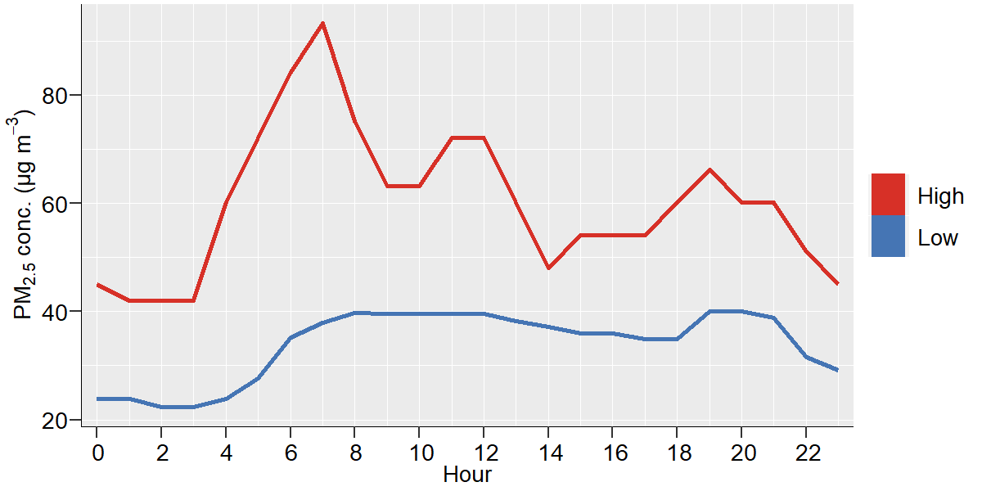
Figure 1. Diurnal outdoor residential PM_{2.5} profiles in regions of Accra with High and Low annual average PM_{2.5} concentrations based on measurements made in Accra between 2006 and 2007 (Dionisio et al., 2010; Zhou et al., 2011)

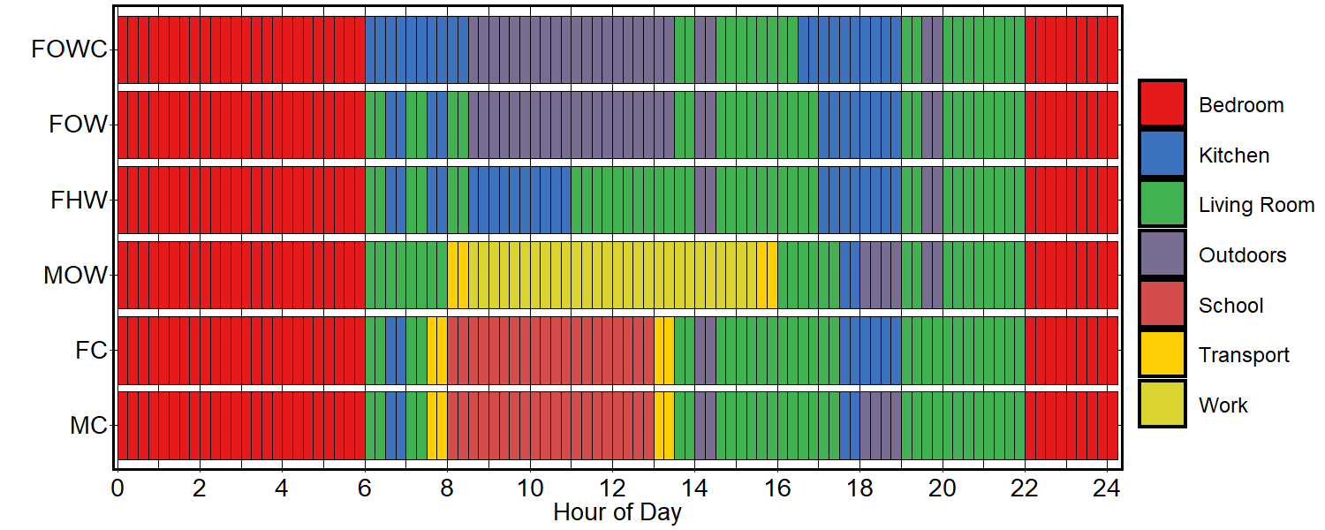

Figure 2. Duration and timing of periods spent in different microenvironments by different categories of people (MC = Male Child, FC = Female Child, MOW = Male Office Worker, FHW = Female Home Worker, FOW = Female Outdoor Worker, FOWC = Female Outdoor Worker/Home Cook).

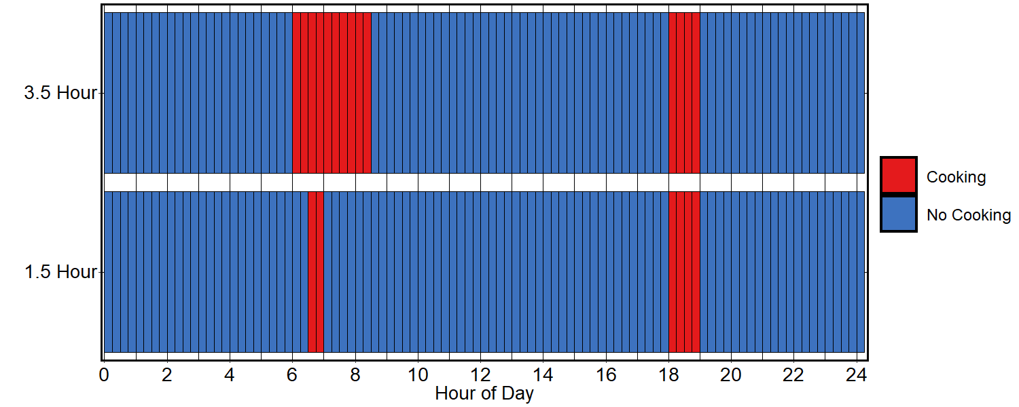Figure 3. Timing and duration of cooking periods in the homes with 90 minutes and 3.5 hours cooking per day

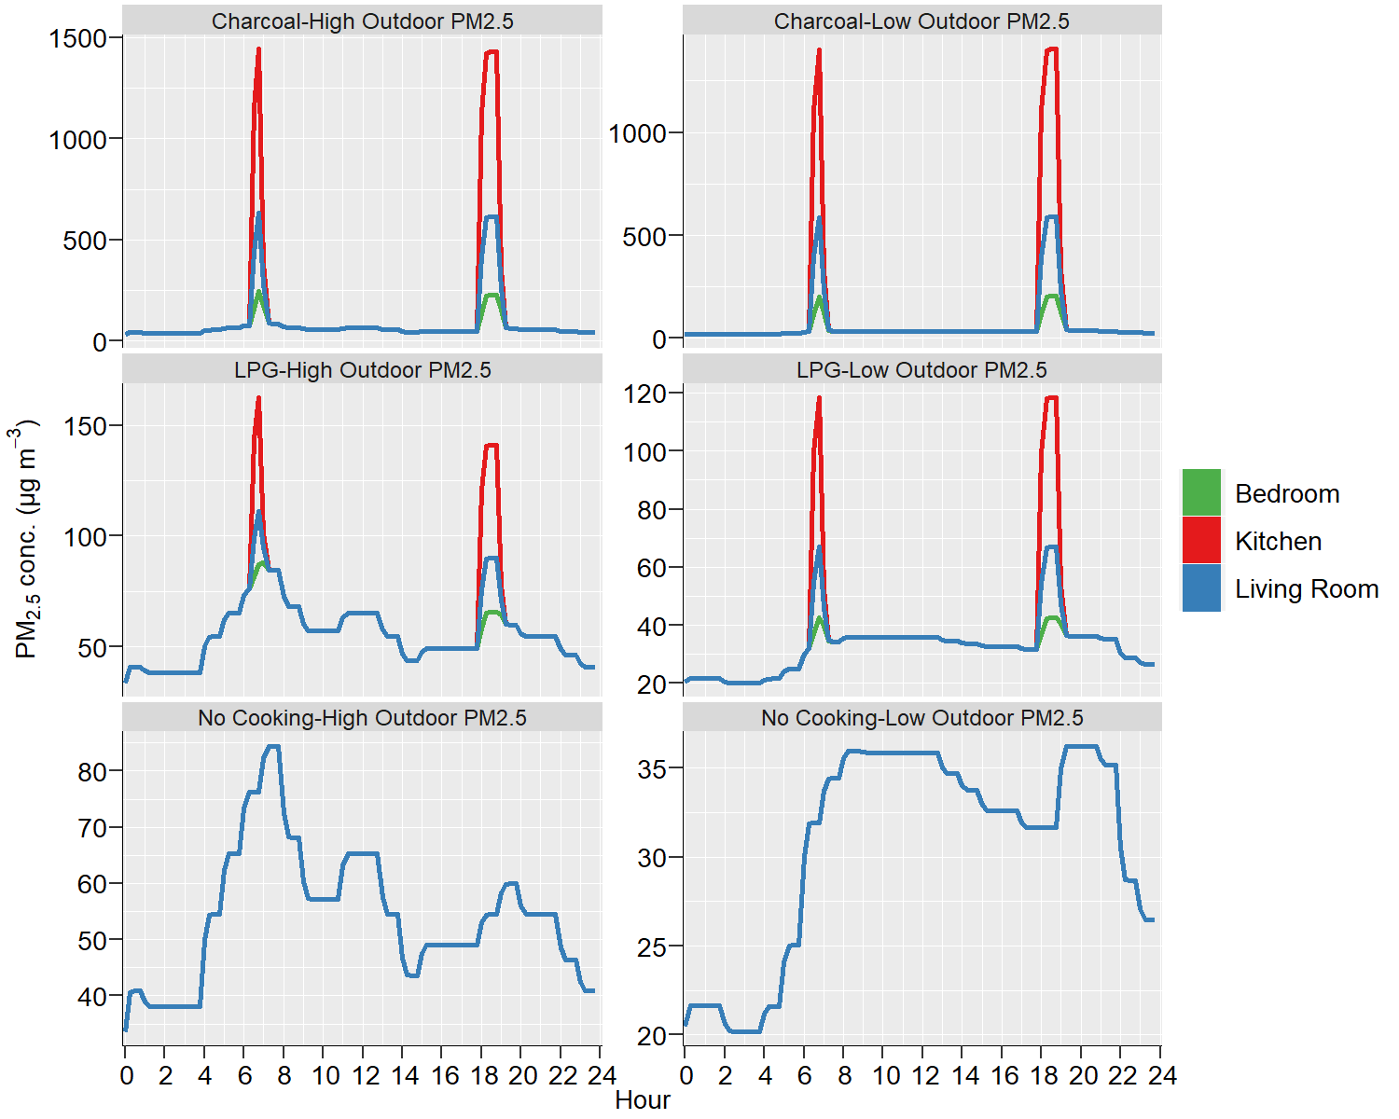
Figure 4. Diurnal variation in modelled PM_{2.5} concentrations in 3 home microenvironments with ‘high’ and ‘low’ outdoor PM_{2.5} concentration profiles with 90 minutes cooking per day using charcoal and LPG, and with no cooking.

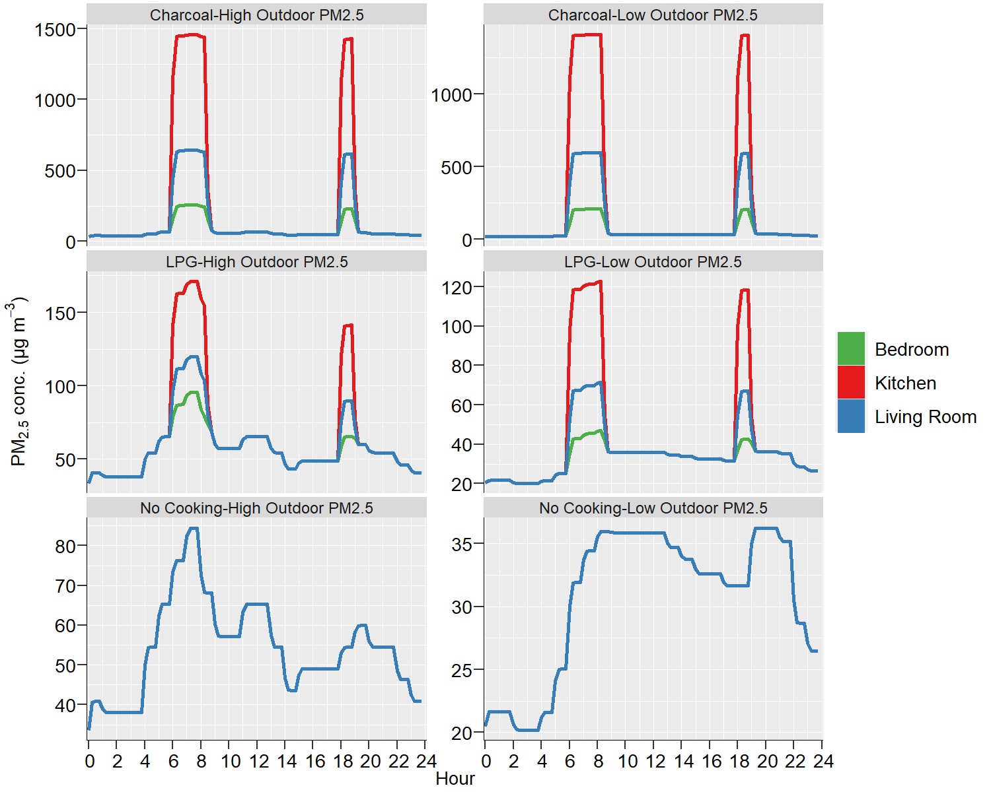

Figure 5. Diurnal variation in modelled PM_{2.5} concentrations in 3 home microenvironments with ‘high’ and ‘low’ outdoor PM_{2.5} concentration profiles with 3.5 hour cooking per day using charcoal and LPG, and with no cooking.

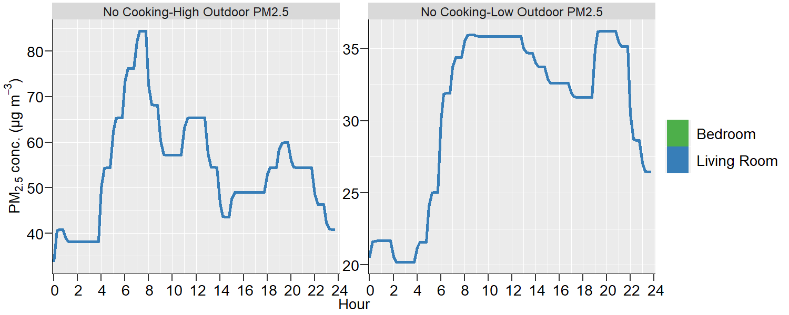
Figure 6. Diurnal variation in modelled PM_{2.5} concentrations in 2 home microenvironments with ‘high’ and ‘low’ outdoor PM_{2.5} concentrations where cooking was assumed not to occur within the household.

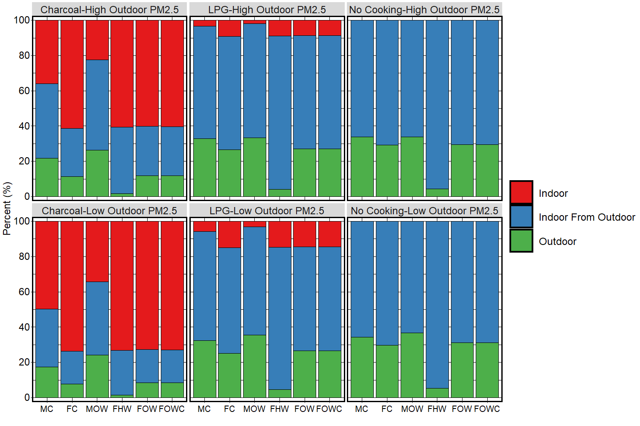
Figure 7. Contribution to 24h personal PM_{2.5} exposure for six different population groups (MC = Male Child, FC = Female Child, MOW = Male Office Worker, FHW = Female Home Worker, FOW = Female Outdoor Worker, FOWC = Female Outdoor Worker/Home Cook) for scenarios with a 3 room home configuration and 1.5 hours cooking per day, but with different outdoor PM_{2.5} concentration profiles, and cooking fuels (charcoal and LPG, and no cooking in the household.

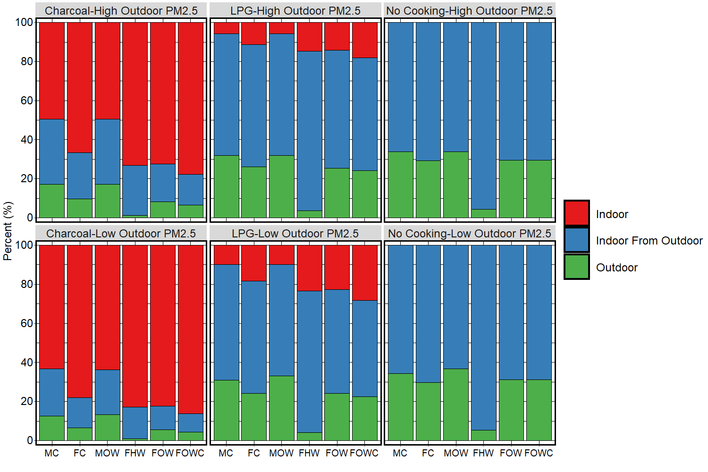
Figure 8. Contribution to 24h personal PM_{2.5} exposure for six different population groups (MC = Male Child, FC = Female Child, MOW = Male Office Worker, FHW = Female Home Worker, FOW = Female Outdoor Worker, FOWC = Female Outdoor Worker/Home Cook) for scenarios with a 3 room home configuration and 3.5 hours minutes cooking per day, but with different outdoor PM_{2.5} concentration profiles, and cooking fuels (charcoal and LPG, and no cooking in the household.

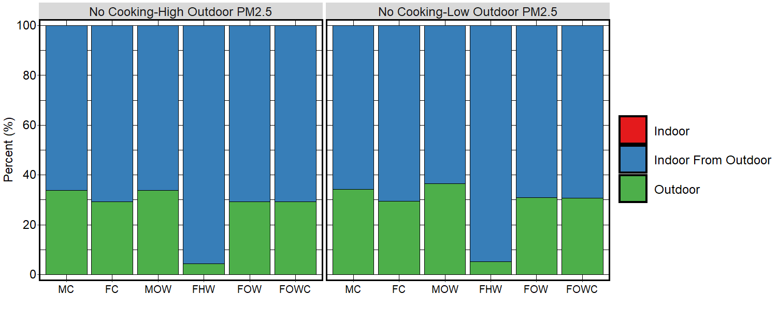
Figure 9. Contribution to 24h personal PM_{2.5} exposure for six different population groups (MC = Male Child, FC = Female Child, MOW = Male Office Worker, FHW = Female Home Worker, FOW = Female Outdoor Worker, FOWC = Female Outdoor Worker/Home Cook) for scenarios with a 2 room home configuration and no cooking occurring in the household, but with different outdoor PM_{2.5} concentration profiles.

