Health opportunity costs: assessing the implications of uncertainty using elicitation methods with experts

Soares MO, Sculpher MJ, Claxton K

Submission to MDM

Running title: Elicitation to inform health opportunity costs

Soares MO*, PhD: Centre for Health Economics, the University of York, UK; marta.soares@york.ac.uk
Sculpher MJ, PhD: Centre for Health Economics, the University of York, UK; mark.sculpher@york.ac.uk
Claxton K, PhD: Centre for Health Economics and Department of Economics, the University of York, UK; karl.claxton@york.ac.uk

* corresponding author

Word count (up to 5000): 5280

FUNDING STATEMENT:
This research is funded by the National Institute for Health Research (NIHR) Policy Research Programme, conducted through the Policy Research Unit in Economic Methods of Evaluation in Health and Social Care Interventions, PR-PRU-104/0001. The views expressed are those of the author(s) and not necessarily those of the NIHR or the Department of Health and Social Care.
Any errors are the responsibility of the authors.

abstract
Well-established methods of economic evaluation are used in many countries to inform decisions about the funding of new medical interventions. To guide such decisions, it is important to consider what health gains would be expected from the same level of investment elsewhere in the health care system. Recent research in the UK has evaluated the evidence available and the methods required to estimate the health effects of changes in health care expenditure within the National Health Service. Due to the absence of sufficiently broad-ranging data, assumptions were required to estimate health effects in terms of a broader measure of health (quality adjusted life-years), which is more relevant for policy. These assumptions constitute important sources of uncertainty.
This work presents an application of the structured elicitation of the judgements of key individuals about these uncertain quantities. This paper describes the design and conduct of the exercise, including: the quantities elicited; the individual (rather than consensus) approach used; how uncertainty in knowledge was elicited (mode and bounds of an 80% credible interval); and methods to generate group estimates. It also reports on a successful application involving 28 clinical experts and 25 individuals with policy responsibilities. Whilst, as expected, most experts found replying to the questions challenging, they were able to express their beliefs quantitatively. Consistently across the uncertainties elicited, experts’ judgements suggest the QALY impacts of changes in expenditure from earlier work using assumptions are likely to have been underestimated and the ‘central’ estimate of health opportunity cost from that work (£12,936 per QALY) to have been over-estimated.

INTRODUCTION
A number of countries use well-established methods of economic evaluation(1) to inform decisions about which new medical interventions warrant funding; examples include NICE in the United Kingdom (UK), CADTH in Canada, INFARMED in Portugal and HITAP in Thailand.(2-4) Economic evaluation identifies evidence on the expected health effects and costs of the intervention in relation to relevant alternatives. However, to inform a decision fully, there needs to be some consideration of how any health gains offered by the new intervention are to be assessed against any additional costs it imposes on health systems. A key piece of information to guide this assessment is an estimate of the health gains that could have been achieved elsewhere with the same levels of investment– the health opportunity costs. That is, to consider the health effects that could be generated by making the additional resources required for the new interventions available for other services and interventions that could be funded instead, or the health effects of those activities that would need to be given up if these resources are committed to the new intervention.
A number of studies in different countries have based an assessment of opportunity costs on the empirical relationship between changes in health care expenditure and health outcomes(5-8). Recent research in the UK used national data on expenditure and outcomes in different disease areas reported at a local level in the UK’s National Health Service (NHS).(9-11) By exploiting the variation in expenditure and mortality outcomes, the relationship between changes in expenditure and mortality was estimated (while accounting for endogeneity). By using the effect of expenditure on the mortality and life-year burden of disease as a surrogate for the effects on a more complete measure of burden (one that also includes the quality of life burden of disease), a cost per quality-adjusted life-year (QALY) that reflects the likely impact of changes in expenditure on both mortality and morbidity was also reported.
These estimates of the marginal productivity of health care expenditure indicate the health that is expected to be forgone as a consequence of additional costs displacing other health care activities. They reflect what is likely to happen in the health care system, given current levels of information, local decision-making and the influence of other aspects of social value which are not captured in measures of health such as QALYs. They represent the relevant expected health opportunity costs when the decision context is restricted to approving or rejecting a new intervention. In this context, it also indicates the maximum that the health care system can afford to pay for the additional benefits offered by a new intervention (e.g., the temporary monopoly price for pharmaceuticals protected by patent) without reducing the total number of QALYs generated.
The assumptions that were required to link the estimates of effects of changes in expenditure on the mortality burden of disease to the likely effect on QALYs constitute important sources of uncertainty. To inform these assumptions appropriately, the judgements of key individuals, such as those with substantive clinical or policy expertise, are important. Elicitation methods offer a systematic process for formalising and quantifying, typically in probabilistic terms, individuals’ judgements about uncertain quantities.(12, 13)
Elicitation is an important activity in many fields, including in support of decision making where there may be significant uncertainties and their quantification can feed directly onto decisions. Furthermore, elicitation is a vital element of a Bayesian approach to statistics, the principles of which are core to decision analyses. Here the use prior information to augment existing data has an established theoretically basis, particularly where empirical evidence is limited. (12)
This research presents an application of structured elicitation to inform estimates of expected health opportunity costs in the UK NHS, a key quantity to inform policy decisions. This constitutes a novel and important context for the use of structured elicitation, aiming to reflect uncertainty in the judgements required for policy appropriately and explicitly. We demonstrate the applicability of the elicitation exercise in practice. Its design draws from wider experience of elicitation in health technology assessment(14) and literature from other areas of science (for example (15) and (16)).
This paper is structured as follows. The next section summarises earlier work by Claxton et al(9)to estimate NHS marginal productivity and which is the motivation for the current work. The following sections focus on the elicitation exercise, presenting its methods (design, conduct and analyses) and the results of its application. The paper finishes with a discussion including key policy implications.

Summary of Claxton et al(9) and overview of the key uncertainties identified
Claxton et al(9) evaluated the relationship between expenditure and mortality using a cross-sectional design, seeking to identify differences in mortality across health care commissioning units (at the time of this research there were 152 Primary Care Trusts, or PCTs) that could be attributed to differences in NHS spend. Empirically, the research first quantified expenditure elasticities; that is, how changes in NHS expenditure in a given year were allocated between Programme Budgeting Categories (PBCs), which reflect broad disease areas characterised by International Classification of Disease (ICDs) codes.
Secondly, the research estimated outcome elasticities; that is, how changes in expenditure by PBC (in a particular year) altered PBC-specific mortality rates (using national data on mortality reported for ICD codes or groups of ICDs, mapped onto PBCs). Analyses adjusted for important covariates (including need) and used instrumental variables to estimate causal effects overcoming the problem of endogeneity.
Results showed that the mortality effects of changes in spend could only be identified for eleven of the 23 PBCs (such as cancer and gastrointestinal disorders). For the remaining disease areas (such as mental health disorders), health care focusses primarily on improving health-related quality of life (HRQoL). Across the 11 PBCs for which mortality effects were detected, empirically-based estimates of how changes in total NHS expenditure affect mortality were generated, returning the following point estimates (using 2008 expenditure and 2008–10 mortality): £105,872 for the cost per death averted; £23,360 for the cost per life year and £28,045 for the cost per life year where life years were adjusted for HRQoL.
However, an estimate of health opportunity costs relevant for policy needs additionally to consider:
- whether changes in expenditure have effects beyond the year of expenditure – this can be termed duration of effects;
- how the effects of changes in expenditure on mortality relate to effects on a broader measure of health that incorporates both duration and HRQoL impacts (QALYs) – this can be termed surrogacy;
- how changes in expenditure affect health in disease areas for which the previous work could not measure a mortality effect – this can be termed extrapolation.
In the original research(9), very limited data were available with which to assess each of these questions, and hence assumptions were made (listed in Table 1). These were used to obtain a ‘central’ estimate of health opportunity costs (expressed as a cost per QALY) across all disease areas of £12,936 per QALY. An analysis of the uncertainty imposed by the empirical estimates (the expenditure elasticities estimated for each of the 23 PBCs, and the outcome elasticities estimated for 11 of these) indicated that the probability of this central estimate being less than £20,000 per QALY was 0.89.(9)
<<Table 1 here>>

Methods
The research aimed at formally eliciting the beliefs of key individuals on the three judgements outlined above (and in Table 1) which are required for a policy-relevant estimate of health opportunity costs. Another uncertain quantity that was elicited concerned the expected life-years gained from averting a death. This is not required to evaluate health opportunity costs in terms of QALYs (although it is important to distinguish morbidity from mortality impacts on the QALY estimate) and hence, for conciseness, methods and results of the elicitation for this quantity are not described in this manuscript, but are available elsewhere(16). Uncertainty in knowledge was explicitly elicited throughout.(12,17,18) The design of the exercise sought to minimise the use of cognitive heuristics that may lead to bias.(19-21)
Two groups of individuals were considered: the first comprised of clinical experts, acting as substantive experts in key disease areas; and the second included policy experts, defined as individuals drawn from organisations that develop or implement policy, or that have a major interest in policy in this area, but that are not expected to have specific substantive expertise in key clinical areas. Policy experts were asked for their judgements on the quantities of interest once they had considered the information that had been elicited from clinical experts. As such, the elicited judgements from policy experts reconcile their own judgements together with the views of the substantive (clinical) experts.
This exercise did not seek to establish consensus as such methods are known to have a number of limitations (e.g. the fact that aggregation is done implicitly, dominant individuals may imbalance group dynamics and consensus methods are known to return overly-precise judgements)(22). Hence, experts were asked to give their opinions individually (and discouraged from interacting), and a group estimate was generated analytically (detailed below).(12)
All aspects of the exercise (design, conduct and analyses) were protocolled in advance.(23)

What quantities were elicited?
The elicitation questionnaire focussed on the effects on population health of changes in NHS expenditure in a particular year (all else unchanged). Experts were prompted to think of changes in expenditure that were significant, but still represented a small proportion of NHS expenditure.
The first uncertain quantity elicited regarded duration of effects. A two-part question was used (Section A, Table 2) that, firstly, asked about the duration of mortality effects beyond the first year. Secondly, it asked about the magnitude of mortality effects in the 2nd, 3rd and 4th years after the change in expenditure. Participants were asked to express the latter as a proportion of the effect in the 1st year as the effect on the 1st year is an estimable quantity (and was the focus of the empirical work in Claxton et al(9)). Using a relative quantity allows for conditional independence to be reasonably assumed and avoids the burdensome task of eliciting dependency. Conditional independence was also assumed in the elicitation of other uncertain quantities, and the accompanying diagram in Table 2 illustrates the conditional relationships specified. Note that the wording intentionally asked for the effects that can be attributed to changes in expenditure in a particular year, and hence was able to identify future (lagged) effects causal to that year’s change in spend.
The second uncertain quantity subject to elicitation related to the surrogacy relationship and aimed to establish the effects of increased expenditure on a year’s QALY burden (Section B, Table 2). QALY burden was defined as comprising of the life-years lost due to premature mortality (due to disease) in the year of interest, adjusted for quality, plus any impacts on the level of HRQoL from disease in individuals alive in that year. This was elicited separately for the year of expenditure (1st year) and subsequent years (2nd, 3rd and 4th years). To allow for conditional independence, it was formulated as relative to effects on mortality burden in the same year.
The third uncertain quantity related to extrapolation (Section C, Table 2). Experts were asked about reductions in QALY burden in disease areas that did not have measurable mortality effects (e.g. mental health). They were asked to express these reductions proportionally in relation to the average QALY burden reduction from an increase in NHS expenditure across all disease areas with measurable mortality effects. Again, this was elicited separately for the year of expenditure (1st year) and subsequent years (2nd, 3rd and 4th years).
Whilst elicited judgements are likely to differ between disease areas, it was considered too burdensome for the experts to present their judgements for each of the 23 PBCs. Hence, seven disease areas (Circulatory, Respiratory, Gastrointestinal, Neurological, Mental health, Endocrinology, Musculoskeletal) were selected. These were chosen because changes in expenditure and changes in mortality in those areas are the most important drivers of the central estimate of health opportunity cost, and most sensitive to the surrogacy and extrapolation assumptions. Estimates were elicited from experts separately for each of these seven main PBCs, and a single estimate for the remaining PBCs combined. These are heterogeneous and broad disease areas, so in responding to questions experts were asked to consider the ICDs within each PBC where an increase in expenditure is more likely to fall.
<<Table 2 here>>

Which experts?
We aimed to recruit purposively 20 clinicians (at least 2 from each clinical area) and 20 individuals affiliated to selected policy-relevant organisations(24). Responses from experts were anonymous, but the organisations they belong to were recorded (policy experts), as were the clinical areas of expertise (clinical and relevant policy experts), to facilitate analysis of between-expert heterogeneity.(14)

How were the different quantities elicited?
It was important for elicitation to reflect experts’ uncertainty, so experts were asked for multiple summaries on each quantity.(12) One was the mode (the value the expert believes to be most likely, their best guess) as it is generally thought that experts can more easily report this than the mean or median.(12, 25) The other summary estimates were the bounds of a credible interval (Crl, the Bayesian equivalent to confidence intervals). Evidence shows that, while eliciting CrI is intuitive, there is a clear tendency for these to be too narrow (a bias called ‘overconfidence’), i.e. people believe their estimates are more accurate than is justified.(26) This limitation is acknowledged, but experts’ time constraints were a major consideration(27). Hence, strategies were adopted to minimise the potential for bias: 80% CrI were elicited as these typically shows less over confidence than 95% CrIs(12), and single limit estimates were also elicited—where the lower bound is elicited first, and then the upper bound separately—as these are also thought to produce wider estimates than asking directly for the range.(28, 29) Hence, the wording used in this work was:
(Mode) My best guess for the value of this quantity is ….
(Lower bound of 80% CrI): I am very certain (90% certain) that the true value for this quantity is higher than...
(Upper bound of 80% CrI): I am very certain (90% certain) that the true value for this quantity is lower than...

Conduct of the exercise
A paper questionnaire was developed (Appendix, item 1) and extensively piloted. To facilitate appropriate training, the exercise was, where possible, conducted in groups (workshops). A training session for experts was developed that described the objectives of the elicitation exercise; clarified concepts such as those of uncertainty, variability and heterogeneity; familiarised experts with the quantities the research sought to elicit; described and explained the impact of bias and heuristics; and trained experts on the methods of elicitation used (item 3 in Supplementary material).(30-32) This was delivered by two of the authors (KC and MOS).
Throughout the exercise individuals were encouraged to revisit and to revise their answers to previous questions(33), but we have not recorded when this occurred. At the end of each section of the exercise, participants were asked whether they were confident the answers they had given reflected their views and uncertainties. Response options were ‘yes’, ‘not sure’ and ‘no’. Individuals were also provided with opportunities for free text feedback.
The judgements from clinical experts were elicited prior to those of policy experts. The judgements from clinical experts were summarised (histograms of the modes and upper and lower credible interval bounds) and presented to policy experts to help them formulate their judgements using the same elicitation tool (item 2 in Supplementary material).

Analyses and pooling across experts
Analyses were conducted in Excel 2010(34). In describing the elicited beliefs, the first step was to fit a distribution to each quantity elicited from each individual expert.(30,35) The quantities of interest here ranged between 0 and +infinity and were fitted with the Log-Normal distribution as pre-specified(23). Given that three summaries were elicited from each expert, more than one type of two-parameter distribution can reasonably reflect their judgements. It was protocolled(23) that, to reflect this additional uncertainty, two alternative (two-parameter) distributions would be fitted: one using the lower bound (LB) of the credible interval and the mode, and another using the upper bound (UB) and the mode. A unique distribution for each quantity elicited by each expert was then derived by linear pooling of the two distributions, i.e. pooling means and variances. Further detail on this stage of analysis is presented in Appendix (item 2).
After describing each expert’s judgement for each quantity using distributions, these were pooled together to derive and a single distribution for the group. Linear pooling was used(12) with equal weights across experts⁴ to preserve the individual judgements in the collective (pooled) judgement.(14, 26 ) Linear pooling means that, if the experts’ distributions for a single quantity are identical, the pooled distribution is also identical to the individuals’ distributions. Also, if there is the support from at least one expert that the quantity of interest takes a particular value, the pooled distribution will also show some support for that value.(12,36)
The primary analysis reflects the pooled results from clinical experts and the secondary analysis reflects the pooled results from policy experts.
Sensitivity analyses
Two sensitivity analyses were protocolled(23). One explored heterogeneity (i.e. between-expert uncertainty) by: i) considering only responses of clinical experts in the clinical specialty relating to the disease area in the question; and ii) by grouping policy experts by the type of organisation they belonged to (see footnote 3). The second protocolled sensitivity analysis disregarded those responses where individuals indicated not to be confident that the response reflected their views and uncertainties. A third and final sensitivity analysis was not protocolled and provided a qualitative assessment of the implications of using a Gamma distribution, instead of the Log-Normal, in the fitting.

Results

Primary analyses using substantive (clinical) experts’ responses
Twenty-eight clinical experts participated in three (group) workshops and four individual interviews. A summary of the pooled distributions across all clinical experts are presented in Table 3.
<<Table 3 here>>
Results to Question A1 (duration of effects) indicate that changes in NHS expenditure in a particular year are expected to affect mortality in subsequent years. The mean duration of effects is highest for circulatory and gastrointestinal (approximately 11 additional years), and lowest for neurological disease (approximately 6 additional years). The pooled distribution shows considerable uncertainty, as demonstrated by its wide 80% CrI. As an illustration, the top panel of Figure 1 shows the individual experts’ distributions for the duration of effects in circulatory disease (in grey), overlaid with the pooled distribution across all experts (in black). Note that uncertainty in the pooled distribution reflects not just each individual’s uncertainty but also between-expert heterogeneity.
<<Figure 1 here>>
Experts’ judgements suggest that, across all disease areas, mortality effects beyond year 1 are expected to be higher than effects in the first year (Section B). In circulatory, for example, it is expected that the effect in the second year is 1.5 times that in the first year. This can be interpreted to reflect the preventative nature of much of the expenditure in this disease area, where health benefits of current expenditure are higher in the future. The magnitude of expected mortality effects decreases over time for all disease areas. For example, in circulatory disease, surrogacy on the third year is expected to be at 1.2 and in the fourth year at 0.9. The pooled distributions are wide and the 80% CrI include the value of 1.
Experts’ judgements indicate that surrogacy relationships are expected to be above 1 in the year of expenditure for all disease areas (between 2.9 and 3.7, see Table 3). This implies that changes in spend are expected to reduce QALY burden proportionately more than mortality burden, although this is associated with considerable uncertainty. The individual experts’ distributions on the surrogacy relationship in year 1 for circulatory disease have been graphically presented in the bottom panel of Figure 1. Only 5 of the 27 distributions (one expert did not complete this question) have mean estimates below or equal to 1 (results not presented here). The pooled distribution across the 27 experts shows a mean of 2.9 and an 80% CrI suggesting the true value lies between 0.3 and 6.6 (Table 3). Over time, expected values for surrogacy do not fall below 1.
Extrapolation relationships follow the same pattern as surrogacy, with expected values consistently above 1 (between 2.6 and 4.7). The 80% CrI seem to reduce width over time.

Secondary analysis using policy experts’ responses
Twenty-five policy experts participated in two workshops (affiliations in footnote). Table 4 presents a summary of pooled distributions.
<<Table 4 here>>
Results were fairly similar to those obtained with the pool of clinical experts, but between-expert variation is lower for this group of experts (exemplified in Figure 2 for duration of effects, top panel, and surrogacy, bottom panel, in circulatory disease). With respect to mortality effects, policy experts generally indicated higher duration (in terms of expected values) than clinical experts, and a similar magnitude over time.
<<Figure 2 here>>
In terms of surrogacy, expected values are also comparable to those of clinical experts. Expected values do not fall below 1 (although CrI include 1) -- for example, for respiratory, surrogacy had an expected value of 2.9. Expected extrapolation relationships also follow similar patterns to those of clinical experts, but decrease slightly faster over time.

Face-validity and qualitative feedback
The information provided by individual experts is reproduced in item 4 of Supplemental material. Only a very small proportion of clinical experts (1/28 in Section A, 3/28 in Section B and 0/24 in Section C) indicated their responses did not reflect their views and uncertainties, with the remaining answering ‘yes’ or ‘unsure’ (respectively, 16 and 11 out of 28 in Section A, 7 and 19 out of 28 in Section B and 14 and 10 out of 24 in Section C). This was qualitatively similar for policy experts. Qualitative feedback was insightful regarding the reasons for these responses. Participants, both clinical and policy, consistently mentioned that the heterogeneity across the ICDs that composed the different disease areas made responding to questions particularly challenging. Some clinical experts also found it difficult to answer questions on disease areas that did not relate to their specialism. Some policy experts also indicated that they relied heavily on the clinical experts’ answers. The qualitative feedback did not suggest that the answers lacked face validity, but instead explains the wide distributions returned by participants.

Sensitivity analysis
Results of sensitivity analyses are shown in full in Appendix (item 2) – here, we present only a qualitative summary of results.
Results do not change meaningfully when removing individuals that indicate their responses did not reflect their views and uncertainties (item 2.1A in Appendix). When also removing individuals that responded ‘not sure’ to this question (i.e. only considering those that responded ‘yes’), again differences were not meaningful except for surrogacy where means were slightly higher across all disease areas (item 2.1B in Appendix). In terms of heterogeneity in the primary analysis (item 2.2 in Appendix), the pooled distribution of clinicians in their clinical area of expertise shows some differences in relation to the pooled results across all clinicians (see for example, the mean duration of mortality effects for circulatory, gastrointestinal and neurological). The magnitude of such effects over time is (in general) higher for circulatory and neurological. Expected surrogacy relationships are similar for the year of expenditure except for neurological, where experts indicate surrogacy to be higher. Expected extrapolation relationships are lower for mental health, in the first year and over subsequent years, but higher for the first year in musculoskeletal disease.
In terms of heterogeneity in secondary analyses (item 2.3 in Appendix), of note is the pooled distribution for group G2 (the biggest group comprising of 15 out of the total 25 experts, including ‘Governmental bodies’ such as the Department of Health and Social Care or Public Health England) which presents generally lower expected values and more precise distributions than the overall group. This implies that the heterogeneity introduced by the remaining groups is contributing to a widening of the CrI.
The post-hoc sensitivity analyses evaluating an alternative distribution to represent experts’ beliefs (item 2.4 in Appendix) shows overall conclusions to be robust, but that the magnitude of effects is sensitive to the choice: the LogNormal distribution (pre-specified in our analyses plan) has a heavier tail than the Gamma (implemented in sensitivity analyses) and hence generally returns higher expected values when fitted to the same mode and credible interval bounds.

Discussion
This research developed an exemplar elicitation exercise aimed at quantitatively gathering the (uncertain) beliefs of individuals on a set of quantities for which there is currently insufficient evidence, but which are central to an estimate of health opportunity costs for the English NHS. Resourcing decisions in the NHS require consideration of health opportunity costs, and hence this work has direct relevance for current policy in the UK. Despite being motivated by earlier research(9), this work will also have longer-term relevance as the judgements elicited can be used to support other empirical studies for the UK, including those using different econometric methodologies, as these can be expected to suffer from the same evidence gaps.
Elicited judgements should not replace high-quality evidence, and it is paramount that primary evidence is collected on each of the uncertain quantities covered here. Our work, however, was designed in such a way that, as new evidence reports on individual quantities, the judgements elicited on the other quantities can be retained for use in policy. This was achieved by defining quantities as conditionally independent. The work presented here is also important internationally, as it can be adapted for evaluations pertaining to other countries or settings, beyond the UK’s NHS.
The group estimates obtained provide a summary of the beliefs of multiple experts on quantities for which there currently is no evidence. There are, therefore, important implications for a meaningful estimate of health opportunity costs for use in policy. Firstly, regarding duration of mortality effects, the original analyses(9) assumed impacts only in the year of expenditure. The results from the current work, however, indicate that mortality effects are expected also to occur in subsequent years. This suggests that the original work underestimated the QALY impacts of changes in expenditure. Secondly, the original work assumed perfect surrogacy in the effects of changes expenditure between mortality burden and total QALY burden. The results from this research indicate, however, that surrogacy is expected to be above 1 (this holds across disease areas for the 1st, 2nd and 3rd years), indicating that the effects of changes in expenditure on total QALY burden are, in proportionate terms, expected to be higher than (rather than equal to) those on mortality burden. Again, this suggests that the original work underestimated the QALY impacts of changes in expenditure. Thirdly, in terms of extrapolation, the original work assumed changes in spend to have equal effects on diseases with, and without, measured mortality effects. This work demonstrates that the extrapolation relationship is generally expected to be above 1. That is, the health effects in disease areas without measured mortality effects are expected to be higher than what was assumed in the original work. Consistently across the three uncertainties, experts’ judgements suggest the QALY impact of changes in expenditure are likely to be underestimated when using the assumptions which underpin the ‘central’ estimate of £12,936 per QALY reported in Claxton et al 2015(9).
The exercise was carefully developed to align with the scope of the policy question, was piloted extensively and was accompanied by an extensive training package to support experts and guide them through the tasks. As a consequence, it ran successfully. Experts were able to express their beliefs quantitatively, with only a few indicating their answers did not reflect their views (i.e. were not face-valid). However, in approximately half of the answers, individuals indicated they were unsure that their answers reflected their views or uncertainties. Feedback left in open text did not, however, indicate these answers were not face-valid, but instead suggested that the breadth of the questions meant that the distributions retrieved were wide. Convening individuals in groups aided delivery of the standardised training package and maximised expert engagement. However, it also made recruitment difficult: 132 clinical and 84 policy experts were contacted to recruit effective samples of 28 and 25, respectively. Issues with recruitment in elicitation have been recognised elsewhere.(27)
As expected, the level of uncertainty in knowledge expressed by the individual experts was large, and group estimates were highly uncertain (as evident by the wide credible intervals). In their feedback (Appendix, item 2), experts consistently indicated that heterogeneity in the broad disease areas contributed to the uncertainty expressed in their responses. However, eliciting for ‘finer’ definitions of disease, for example 3-digit ICD codes of which there are more than 1500, would have been unfeasibly burdensome. Therefore, future research could instead provide further information to experts to help them make judgements over which ICDs may matter the most within each disease area.
The design of an elicitation exercise requires a number of methodological choices to be made, many of which are example-specific. This exercise used methods established in the literature, and justifies the choices made. However, it is important to acknowledge that methods research in this area is limited and that little is known about how different choices affect results. For example, whilst there is some evidence that consensus methods present a number of challenges inherent to group interaction (see Methods section), its accuracy in relation individual elicitation is largely unknown.
This paper demonstrates that structured elicitation can feasibly be used to explicitly quantify the judgements required to delimit important policy problems, judgements which otherwise would still need to be made implicitly and without the support of relevant experts. In this work, we focussed on achieving a relevant estimate of health opportunity costs, a central quantity for policy on health care resource allocation decisions. We have learnt that the methods used here (i.e. the elicitation protocol) are applicable in this novel context. For example, the elicitation of the mode and bounds of an 80% credible interval was widely understood by the experts); also that experts working close to policy valued the summaries of the judgements of clinical experts provided. We also learnt that there are challenges in eliciting policy-relevant, but broad ranging, quantities, but the use of structured expert elicitation is explicit that current knowledge about the required judgements can only be uncertain.

Acknowledgements
We would like to acknowledge the participants in the elicitation exercises, the Department of Health’s Appraisal Alignment Working Group (AAWG), Alex Rollinger for organising the workshops and all colleagues participating in the piloting.

References

1. Drummond Ma, Sculpher MJa, Claxton Ka, Stoddart GLa, Torrance GWa. Methods for the economic evaluation of health care programmes. Fourth edition / Michael F. Drummond, Mark J. Sculpher, Karl Claxton, Greg L. Stoddart, George W. Torrance. ed2015.
2. HITAP. 2017 [Available from: http://www.hitap.net/en/.
3. Infarmed. 2017 [Available from: http://www.infarmed.pt/.
4. National Institute for Health and Care Excellence. 2017 [Available from: https://www.nice.org.uk/.
5. Vallejo-Torres L, Garcia-Lorenzo B, Serrano-Aguilar P. Estimating a cost-effectiveness threshold for the Spanish NHS. Health Econ. 2017.
6. Karnon J, editor Estimating a Reference ICER for Australia. 12th International Health Economics Association (iHEA) World Congress,; 2017; Boston, USA.
7. Stadhouders N, editor Estimating marginal benefits of healthcare spending in the Netherlands. 12th International Health Economics Association (iHEA) World Congress; 2017; Boston, USA.
8. Edoka I, editor Estimating Marginal Returns to Healthcare Spending in South Africa: An Instrumental Variable Approach. 12th International Health Economics Association (iHEA) World Congress; 2017; Boston, USA.
9. Claxton K, Martin S, Soares M, Rice N, Spackman E, Hinde S, et al. Methods for the estimation of the National Institute for Health and Care Excellence cost-effectiveness threshold. Health Technol Assess. 2015;19(14):1-503, v-vi.
10. Martin S, Rice N, Smith PC. Does health care spending improve health outcomes? Evidence from English programme budgeting data. J Health Econ. 2008;27(4):826-42.
11. Martin S, Rice N, Smith PC. Comparing costs and outcomes across programmes of health care. Health Econ. 2012;21(3):316-37.
12. O'Hagan A. Uncertain judgements : eliciting experts' probabilities. Chichester: Wiley; 2006.
13. Cooke R. Experts in uncertainty : opinion and subjective probability in science: Oxford University Press; 1991.
14. Soares MO, Sharples L, Morton A, Claxton K, Bojke L. Experiences of Structured Elicitation for Model-Based Cost-Effectiveness Analyses. Value Health. 2018;21(6):715-23.
15. Authority EFS. Guidance on Expert Knowledge Elicitation in Food and Feed Safety Risk Assessment. 2014;12(6):3734.
16. Elicitation: The Science and Art of Structuring Judgement. Dias LC, Morton A, J Q, editors: Springer; 2018.
17. Hora SC. Aleatory and epistemic uncertainty in probability elicitation with an example from hazardous waste management. Reliab Eng Syst Safe. 1996;54(2-3):217-23.
18. Griffin SC, Claxton KP, Palmer SJ, Sculpher MJ. Dangerous omissions: the consequences of ignoring decision uncertainty. Health Econ. 2011;20(2):212-24.
19. Montibeller G, von Winterfeldt D. Cognitive and Motivational Biases in Decision and Risk Analysis. Risk Anal. 2015;35(7):1230-51.
20. Kynn M. The 'heuristics and biases' bias in expert elicitation. J Roy Stat Soc a Sta. 2008;171:239-64.
21. Tversky A, Kahneman D. Judgment under Uncertainty: Heuristics and Biases. Science. 1974;185(4157):1124-31.
22. Clemen RT, Winkler RL. Combining probability distributions from experts in risk analysis. Risk Anal. 1999;19(2):187-203.
23. (EEPRU)" PRUiEEoHaHCI. Allocative Efficiency 2017 [Available from: http://scharr.dept.shef.ac.uk/eepru_wordpress/allocative-efficiency/.
24. Bolger F. The selection of experts for (probabilistic) expert knowledge elicitation. 2018. p. 393-443.
25. Peterson C, Miller A. Mode Median + Mean as Optimal Strategies. J Exp Psychol. 1964;68(4):363-&.
26. Garthwaite PH, Kadane JB, O'Hagan A. Statistical methods for eliciting probability distributions. J Am Stat Assoc. 2005;100(470):680-700.
27. Kadane JB, Wolfson LJ. Experiences in elicitation. J Roy Stat Soc D-Sta. 1998;47(1):3-19.
28. Teigen KH, Jorgensen M. When 90% confidence intervals are 50% certain: On the credibility of credible intervals. Appl Cognitive Psych. 2005;19(4):455-75.
29. Speirs-Bridge A, Fidler F, McBride M, Flander L, Cumming G, Burgman M. Reducing Overconfidence in the Interval Judgments of Experts. Risk Anal. 2010;30(3):512-23.
30. Gosling J. Methods for eliciting expert opinion to inform health technology assessment 2014 [Available from: https://pdfs.semanticscholar.org/38eb/a762cdaf5d6dae2fee2063bf776d5facec5b.pdf.
31. Arkes HR. Costs and Benefits of Judgment Errors - Implications for Debiasing. Psychol Bull. 1991;110(3):486-98.
32. Sellier AL, Scopelliti I, Morewedge CK. Debiasing Training Improves Decision Making in the Field. Psychol Sci. 2019;30(9):1371-9.
33. Winman A, Hansson P, Juslin P. Subjective probability intervals: How to reduce overconfidence by interval evaluation. J Exp Psychol Learn. 2004;30(6):1167-75.
34. Microsoft. Microsoft Office Excel. 2010.
35. Winkler RL. Assessment of Prior Distributions in Bayesian Analysis. J Am Stat Assoc. 1967;62(319):776-&.
36. Dietrich F, List C. Probabilistic Opinion Pooling 2014 [Available from: http://personal.lse.ac.uk/list/PDF-files/OpinionPoolingReview.pdf.

TABLE LEGENDS:

Table 1: Key uncertainties and assumptions made in the original work by Claxton et al (9)
Table 2: Summary of quantities elicited with diagrammatic representation.
Table 3: Duration of effects, surrogacy and extrapolation -- all clinical experts pooled.
Table 4: Duration of effects, surrogacy and extrapolation -- all policy experts pooled.

FIGURE LEGENDS:

Figure 1: Illustration of individual experts’ fitted distributions (grey) and the pooled distribution (black) –clinical experts
Figure 2: Illustration of individual experts’ fitted distributions and the jointly pooled distribution – policy experts, circulatory

TABLES:

Table 1: Key uncertainties and assumptions made in the original work by Claxton et al (9)
Key uncertainty |  | Description | Assumptions on key uncertainty in (9)
A | Duration of effects | Changes in expenditure may have an effect on mortality beyond the year of expenditure | Effects restricted to the year of expenditure change
B | Surrogacy | How the effects of changes in expenditure on mortality relate to effects on a broader measure of health that incorporates both duration and health-related quality of life impacts (quality adjusted life-years) | Assumed to be proportionate, i.e. the effects of changes in expenditure on mortality that were empirically estimated were used as the best estimate of the effects of expenditure on quality adjusted life-years.
C | Extrapolation | How changes in expenditure affect health in disease areas for which previous work could not measure a mortality effect | Assumed to be proportionate, i.e. the effects of changes in expenditure on health (quality adjusted life-years) for disease areas which previous work could measure a mortality effect were used as best estimate of the effect of expenditure on health for disease areas for which previous work could not measure a mortality effect.

Table 2: Summary of quantities elicited with diagrammatic representation.
Questions | Diagramatic representation
Section A  Question. For how many more years (beyond the year of increased expenditure) would you expect disease-specific mortality rates to be reduced?  Question. From an increase in expenditure in a particular year, how do reductions in mortality rates in subsequent years compare (in proportionate terms) to the reduction observed in the first year? This was elicited separately for the 2nd, 3rd and 4th years. Refers to quantities A2, A3 and A4, respectively, in the diagram. | 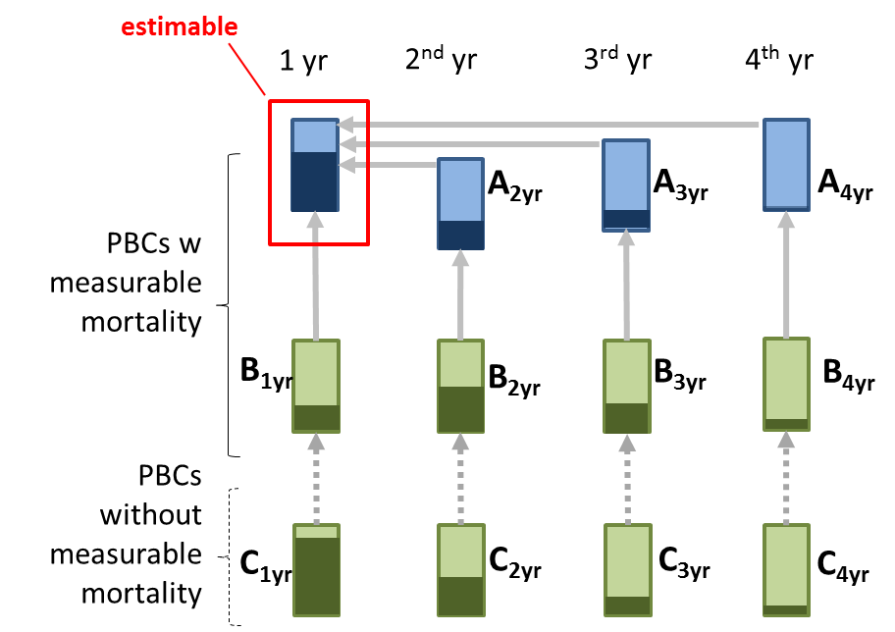  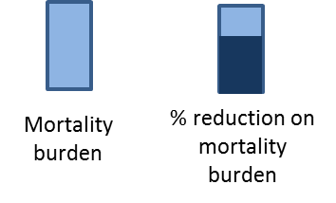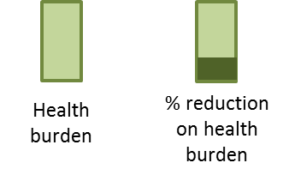
Section B
Question. If expenditure is increased in a particular year, how many times bigger (or smaller) are proportionate reductions on quality-adjusted life year burden when compared to proportionate reductions on mortality burden? We elicited for the year of increased expenditure (1st year) and also for any later effects of expenditure on the 2nd, 3rd and 4th years subsequent to increased expenditure. Refers to quantities B1, B2, B3 and B4, respectively, in the diagram.
Section C
Question. How much bigger (or smaller) are reductions in health burden (quality-adjusted life-years) when expenditure is increased, for example, in ‘mental health disorders’ instead of disease areas with a measured effect of increased expenditure on mortality (average effect across all disease areas in this group). This was elicited for the year of expenditure (1st year) and also for any later effects of expenditure on subsequent years (2nd, 3rd and 4th). Refers to quantities C1, C2, C3 and C4, respectively, in the diagram.

Table 3: Duration of effects, surrogacy and extrapolation -- all clinical experts pooled.
 |  | year 1 | year 2 | year 3 | year 4 | Total additional duration (yrs)*
 |  | Mode [Mean] (lower, upper bounds of the 80% credible interval)
Circulatory | mortality effects (vs. year 1) | estimable from data | 0.2 [1.5]  (0.2,3.4) | 0.1 [1.2]  (0.1,2.6) | 0 [0.9]  (0.1,2.1) | 3.4 [11.2]  (2.4,23.7)
 | surrogacy  (vs. same year) | 0.3 [2.9]  (0.3,6.6) | 0.4 [2.9]  (0.4,6.6) | 0.3 [2.9]  (0.3,6.5) | 0.2 [2.9]  (0.2,6.6) | --
Respiratory | mortality effects (vs. year 1) | estimable from data | 0.1 [1.5]  (0.1,3.4) | 0.1 [0.7]  (0.1,1.6) | 0 [0.6]  (0,1.5) | 1.3 [8.9]  (1.1,20.1)
 | surrogacy  (vs. same year) | 0.3 [3.8]  (0.3,8.7) | 0.2 [3.9]  (0.3,8.8) | 0.1 [3.4]  (0.2,7.5) | 0.1 [3.4]  (0.1,7.4) | --
Gastrointestinal | mortality effects (vs. year 1) | estimable from data | 0.1 [1.7]  (0.1,3.8) | 0 [1.1]  (0,2.4) | 0 [0.9]  (0,1.9) | 0.7 [11.4]  (0.8,26)
 | surrogacy  (vs. same year) | 0.4 [3.6]  (0.4,8.2) | 0.1 [4.5]  (0.2,9.9) | 0.2 [4.3]  (0.2,9.6) | 0.2 [4.2]  (0.2,9.4) | --
Neurological | mortality effects (vs. year 1) | estimable from data | 0 [1.3]  (0,2.8) | 0 [0.9]  (0,1.9) | 0 [1]  (0,1.9) | 0.7 [5.9]  (0.7,13.2)
 | surrogacy  (vs. same year) | 0.4 [4.3]  (0.4,9.7) | 0.7 [3.3]  (0.5,7.3) | 0.7 [2.9]  (0.5,6.4) | 0.3 [3.2]  (0.3,7.4) | --
Endocrinology | mortality effects (vs. year 1) | estimable from data | 0.1 [1.4]  (0.1,3.1) | 0 [1]  (0.1,2.3) | 0 [0.6]  (0,1.4) | 2 [9]  (1.5,19.7)
 | surrogacy  (vs. same year) | 0.1 [4.7]  (0.1,10) | 0.1 [6.2]  (0.2,13.2) | 0.1 [5.2]  (0.1,10.6) | 0 [5.5]  (0.1,11.1) | --
Others with mortality | mortality effects (vs. year 1) | estimable from data | 0.1 [1.8]  (0.1,4) | 0 [1.1]  (0,2.4) | 0 [0.9]  (0,1.8) | 2.1 [9.5]  (1.6,20.8)
 | surrogacy  (vs. same year) | 0.1 [4.7]  (0.2,10.3) | 0.3 [5.4]  (0.3,12.2) | 0.3 [6.4]  (0.3,14.3) | 0.2 [8.8]  (0.3,19.2) | --
Mental Health | Extrapolation (vs. same year) | 0.7 [4] (0.6,8.8) | 0.6 [3.8] (0.5,8.5) | 0.6 [3.6] (0.5,7.9) | 0.6 [3.3] (0.5,7.3)
Musculoskeletal |  | 0.5 [4.7] (0.5,10.7) | 0.5 [4.1] (0.4,9.3) | 0.6 [3.4] (0.5,7.5) | 0.6 [3.1] (0.5,7)
Others without mortality |  | 0.6 [3.4] (0.5,7.5) | 0.4 [3.2] (0.4,7.1) | 0.7 [2.5] (0.5,5.3) | 0.6 [2.6] (0.4,5.8)
* beyond the year of increased expenditure

Table 4: Duration of effects, surrogacy and extrapolation -- all policy experts pooled.
 |  | year 1 | year 2 | year 3 | year 4 | Total additional duration (yrs)*
 |  | Mode [Mean] (lower, upper bounds of the 80% credible interval)
Circulatory | mortality effects (vs. year 1) | estimable | 0.2 [1.4] (0.2,3.1) | 0.3 [1]  (0.2,2) | 0.2 [0.8] (0.1,1.7) | 1.2 [15.1] (1.2,34.3)
 | surrogacy  (vs. same year) | 0.2 [2.8] (0.2,6.3) | 0.3 [2.3] (0.2,5.1) | 0.3 [2.3] (0.3,5.2) | 0.3 [2.4] (0.3,5.4) | --
Respiratory | mortality effects (vs. year 1) | estimable | 0.3 [1.1] (0.2,2.3) | 0.2 [0.6] (0.1,1.4) | 0 [0.6] (0,1.4) | 0.4 [11.3] (0.5,25)
 | surrogacy  (vs. same year) | 0.6 [2.4] (0.4,5.2) | 0.5 [2.7] (0.4,6.1) | 0.3 [2.6] (0.3,5.9) | 0.3 [2.9] (0.3,6.5) | --
Gastrointestinal | mortality effects (vs. year 1) | estimable | 0.1 [2] (0.1,4.6) | 0.1 [1.6] (0.1,3.6) | 0 [1.9] (0.1,4.1) | 1.2 [16.9] (1.3,38.4)
 | surrogacy  (vs. same year) | 0.4 [2.8] (0.3,6.3) | 0.4 [2.9] (0.3,6.5) | 0.4 [3.1] (0.3,6.9) | 0.5 [2.7] (0.4,5.9) | --
Neurological | mortality effects (vs. year 1) | estimable | 0.3 [1.3] (0.2,2.9) | 0.2 [1.2] (0.1,2.6) | 0.1 [1.2] (0.1,2.8) | 1 [17.8] (1.2,40.2)
 | surrogacy  (vs. same year) | 1.2 [2.9] (0.8,5.8) | 1 [2.7] (0.7,5.6) | 0.7 [2.5] (0.5,5.3) | 0.7 [2.3] (0.5,4.9) | --
Endocrinology | mortality effects (vs. year 1) | estimable | 0.1 [1.9] (0.1,4.3) | 0.1 [1.3] (0.1,2.8) | 0.1 [1.1] (0.1,2.4) | 0.6 [12.6] (0.7,28.3)
 | surrogacy  (vs. same year) | 0.8 [2.4] (0.5,5) | 0.7 [2.6] (0.5,5.5) | 0.7 [2.6] (0.5,5.6) | 0.7 [2.8] (0.5,6.2) | --
Others with mortality | mortality effects (vs. year 1) | estimable | 0.1 [1.3] (0.1,3) | 0.3 [0.9] (0.2,1.8) | 0.2 [0.9] (0.1,1.9) | 0.7 [13.5] (0.8,30.4)
 | surrogacy  (vs. same year) | 0.3 [2] (0.3,4.5) | 0.3 [2.4] (0.3,5.3) | 0.5 [2.1] (0.3,4.6) | 0.2 [2.2] (0.2,5.1) | --
Mental Health | Extrapolation (vs. same year) | 1 [3.9] (0.7,8.4) | 1 [3.4] (0.7,7.3) | 0.8 [3] (0.6,6.4) | 0.7 [2.9] (0.5,6.2) | --
Musculoskeletal |  | 0.6 [5] (0.5,11.2) | 1.2 [3.1] (0.8,6.4) | 0.9 [2.7] (0.7,5.7) | 0.7 [2.5] (0.5,5.3) | --
Others without mortality |  | 0.3 [4.2] (0.3,9.6) | 0.3 [3] (0.3,6.9) | 0.6 [2.5] (0.4,5.4) | 0.5 [2.3] (0.4,4.9) | --
* beyond the year of increased expenditure

figures:

Figure 1: Illustration of individual experts’ fitted distributions (grey) and the pooled distribution (black) –clinical experts
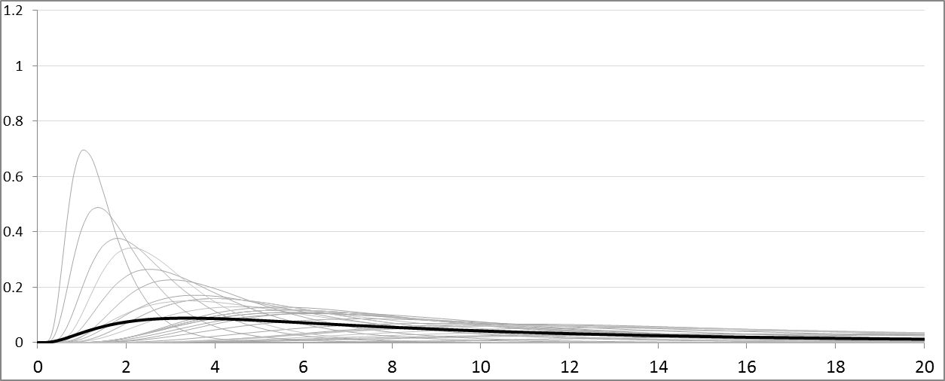
A1 (duration of effects): circulatory
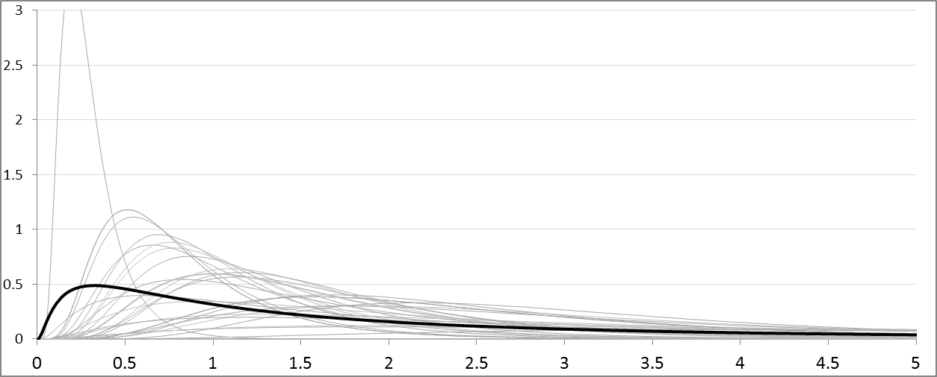
B1 (surrogacy), year 1: circulatory

Figure 2: Illustration of individual experts’ fitted distributions and the jointly pooled distribution – policy experts, circulatory
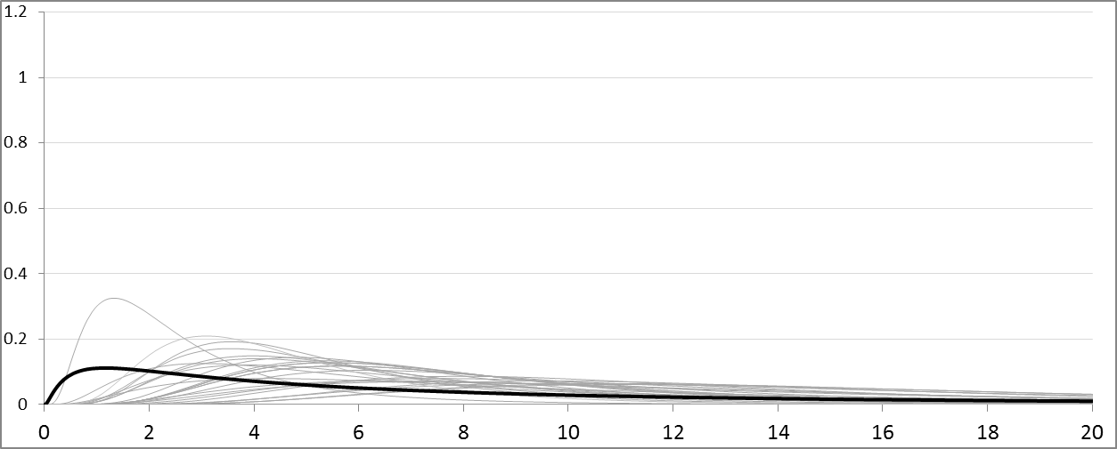
A1 (duration of effects): circulatory
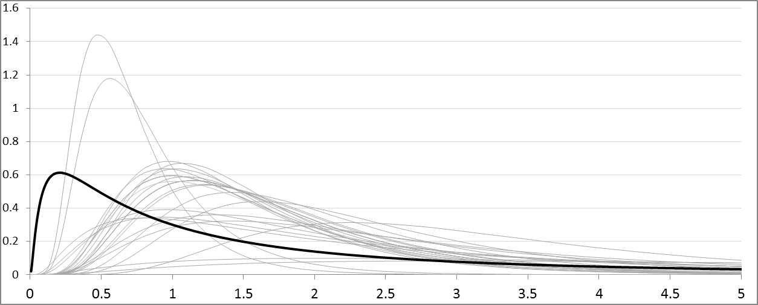
B1 (surrogacy), year 1: circulatory

Decision makers may also compare the proposed investment to other specific disinvestments or alternative investments. However, they still need to consider how these compare to what the health care system would be expected to deliver, i.e., an estimate of marginal productivity is still relevant. If the decision maker had full information about all interventions that are or could be provided for all indications and subgroups of the population and was also tasked with the wholesale redesign of the health care system, well established mathematical programming solutions would be possible and appropriate. The marginal productivity would be the outcome of this optimisation (i.e., the shadow price of the expenditure constraint from solving the dual problem).
Primary care was added to the list for the broad expertise these individuals have of all clinical areas (and for this reason these would be overrepresented in relation to others). Clinical experts were identified through involvement with decision making bodies (e.g. NICE guidelines and appraisal committees), involvement with research or by recommendation from colleagues.
Department of Health, NHS England (NHSE), Public Health England (PHE), National Institute for Health and Care Excellence (NICE), Joint Committee on Vaccination and Immunisation (JCVI), NHS Clinical Commissioners (NHSCC), Association of the British Pharmaceutical Industry (ABPI), Patients’ organisations
This is a variable interval method (where the expert identifies values for the quantity that correspond to specified percentiles of his or her subjective distribution).
The lognormal distribution was chosen for positive quantities because a closed-form solution to the percentiles and the mode was available. When using two summaries from experts, the parameters of the Log-normal distribution could be directly evaluated, in closed form, and not requiring simulation. However, in some cases where a Log-Normal was fitted to a lower bound and mode from experts, there was no solution. In this case, minimum square errors were used to find the distribution parameters that provided the closest solution. This was implemented using the Solver Add-in of Excel, a simulation based procedure.
Linear pooling takes the two (or more) distributions as two groups of the same population. Hence, the means and variances can be pooled directly using the following relations: $$μ_{pooled}={{(μ}_{1}+μ_{2})}/2$$ $${σ^{2}}_{pooled}={(σ_{1}^{2}+μ_{1}^{2}+σ_{2}^{2}+μ_{2}^{2})}/{2-}μ_{pooled}^{2}$$ where $μ_{1}$ and $σ_{1}^{2}$ are the mean and variance, respectively, of the first distribution, and $μ_{2}$ and $σ_{2}^{2}$ the mean and variance of the second distribution. Note that these two groups are equally weighted which, in this case, means the sample size of each is assumed equal and thus does not appear in the equations.
Of the 28 experts recruited, 5 indicated circulatory expertise, 2 respiratory, 3 gastrointestinal, 2 neurological, 3 endocrinology, 3 mental health, 1 musculoskeletal, 3 primary care, 5 indicated other and 3 indicated no clinical expertise. All except two individuals indicated only one area of expertise. Of these two, one indicated circulatory, neurological, musculoskeletal and other (rehabilitation) and another indicated respiratory and primary care.
Affiliation: 15 of the individuals recruited belonged to Governmental Bodies [such as Department of Health (DH), NHS England (NHSE), Public Health England (PHE)], 5 to Non Departmental Public Bodies and Independent Departmental Expert Committees [such as the National Institute for Health and Care Excellence (NICE) or the Joint Committee on Vaccination and Immunisation (JCVI)], 2 to Industry-related bodies [Association of the British Pharmaceutical Industry (ABPI)], 2 to Patient representative organisations and 2 indicated Other. Of these one individual indicated as the sole policy organisation an NHS Clinical Commissioning Group (NHSCC). Another individual used the ‘other’ field to be more specific about being a lay member in an independent expert committee.

