P^{H} characterization of urease using Raman Spectroscopy
Manish Chauhan¹, Animesh Jha², Venkatraman Subramanian³, Pietro Valdastri¹
¹School of Electronics and Electrical Engineering, ²School of Chemical and Process Engineering, ³Faculty of Medicine and health University of Leeds, Leeds LS2 9JT, m.chauhan@leeds.ac.uk

Abstract: Jack bean urease is a complex biochemical enzyme with the unique monomeric structure of polypeptides with an active site containing 2 nickel ions. Its pH-based characterization is spectroscopically investigated in an acidic (Hydrochloric acid) environment for understanding its limit of detection.
OCIS codes: (000.0000) General; (300.0300) Spectroscopy; (170.5660) Raman spectroscopy

1. Introduction
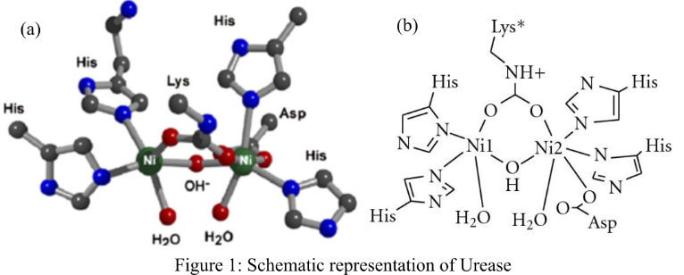
Urease or Canavalia ensiformis is a complex biochemical enzyme which is synthesized by various bacterial species, plants, nano-pathogens and fungi [1]. It occurs widely in leguminous seeds and plays an important role in seed germination and its chemical defense [2]. Being a complex nickel-dependent protein, its structure comprises of a monomeric chain of a single kind of polypeptide to form a chain of 840 amino acid residues (like Lys, Cys etc.) [3]. This subunit chain comprises of an active site with two nickel ions (Ni2+) which is shown in Figure 1. A set of bridging hydroxide and water molecule complete the coordination sphere of these nickel ions. Another water molecule completes the tetrahedral cluster of solvent molecules. Given the complex hexameric structure of urease due to extensive intermolecular interactions, there are 6 monomer chain in fully loaded enzyme molecule. This gives it 6 active sites with 12 nickel ions per molecule. Figure 1 Schematic representation of Urease active site [3, 4] showing bi-nickel center. One Ni ions is connected to residues of two ’His’ and one ’Lys’. The second Ni ion is again connected to two residues ’His’, one ’Asp’ and one ’Lys’ respectively. It is seen that one of the ’Lys’ sites bridge the residue between both the nickel ions. Whether urease is synthesized from plant or bacteria; its basic nickel-dependent structure, three-dimensional structural sequence and catalytic mechanism of hydrolyzing natural urea to ammonia and CO₂ ((NH₂)₂CO + H₂O → CO₂ + 2NH₃) remains same [6]. Despite this, the metabolic activity of plant and bacterial urease are different where plant urease plays a crucial role in nitrogen cycle in nature and bacterial urease (ex: from H.pylori) causes gastric cancer [6]. Both the processes involve dependence on pH of the environment, like hydrolysis of urea with Jack bean urease is ideally studied in a pH range of 5.80~7.49 [7] and bacterial urease neutralizes the acidic pH of stomach (2~4) [6]. The following work presents the characterization of Jack bean urease at pH 2, 3, 4 and 7 for the above hydrolyses reaction through Raman spectroscopic technique because it provides the symmetric and anti-symmetric molecular vibration. The authors presented a similar work [8] but pH-based characterization will provide the vital information on limit of detection of urease in low to high pH environments, in the presence of Ni2+-ions.
2. Experimental Method
The experiment was performed using 4M urea and 0.00018M urease (procured Sigma Aldrich, Gillingham, UK) in 10ml of de-ionized water in order to simulate natural biological conditions. These quantities were calculated through empirical experimentation with different quantities of urea (MW: 60.06g/mol) and urease (MW: 48kDa). With optimum pH of 7.4, vibrational spectrum was captured for water, urea and urease solution at pH=7. In order to understand the hydrolysis reaction over time, the spectrum was measured after 2, 5, 10, 20- and 30-min gap from time of mixing the chemicals. The above steps were repeated for pH between 1~4 in order to simulate hydrolysis with bacterial urease in 10ml water (typical gastric fluid amount in a fasting condition).
3. Results and Discussions
An excitation laser of 514.5nm (laser power of 25 mW at the source) was used for the experiment on the inViaTM Raman microscope. A diminished 5mW laser was focused on the above prepared samples to produce Raman spectra which were baseline corrected using Lorentz function for peak identification. As seen from the figure 2(a) the baseline spectrum of water shows the asymmetric and symmetric –OH stretch of water on the shoulder at ~3250 cm⁻¹ and ~3410 cm⁻¹. The –OH part of water involved in hydrogen bonding can be identified at ~3630 cm⁻¹. Urea is easily identifiable at 546 cm⁻¹, 1014 cm⁻¹, 1127 cm⁻¹, 1466 cm⁻¹, 1625 cm⁻¹ and 1650 cm⁻¹. While Urease shows signature peak at 353 cm⁻¹, 480 cm⁻¹, 839 cm⁻¹, 1078 cm⁻¹, 2893 cm⁻¹, 2976 cm⁻¹.
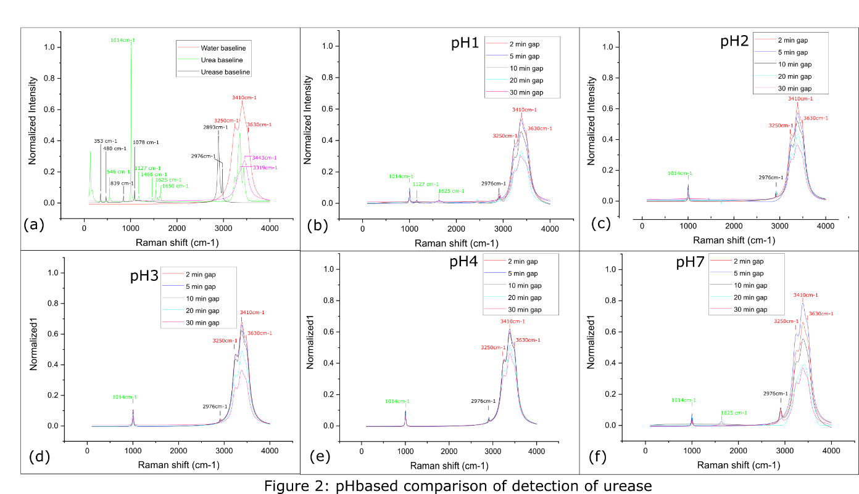
Following observations were made as the pH was increased from 1 to 7, (i) The urea peak at 1014cm⁻¹, urease peak at 2976 cm⁻¹ and the water peaks at 3250 cm⁻¹, 3410 cm⁻¹ and 3630 cm⁻¹ was repeatable for water. The peaks for HCl were not detected as its peaks were in the water spectrum; (ii) The intensity of peaks decreased over time as the hydrolysis of urea continued; (iii) The CO and symmetric NH₂ peaks at 1127 cm⁻¹ and 1652 cm⁻¹ respectively were not detected. This could be due to reduced acidity of the solution. The peaks from Figure 2(b)-(e) were performed with 4M and 0.00018M urea and urease respectively but in order to check the limit of detection, the Raman peaks were also obtained for 2M urea and 0.0001M urease in Fig 2(f). No prominent peaks could be obtained below this concentration.
3. Conclusion
Limit of detection of urea and urease compounds at different pH (1, 2, 3, 4 and 7) is demonstrated using Raman spectroscopic techniques. The minimum quantity of 0.0001M urease at 2M urea in a 10ml acidic solution was required in order to simulate for hydrolysis of urea detectable by Raman Spectroscopy. The vibrational bonds over various pH shows repeatability and reduced intensity over time indicating reduction in intensity of hydrolysis reaction.
4. References

[1] Mobley, H.L., Mendz, G.L. and Hazell, S.L., 2001. Restriction and Modification Systems--Helicobacter pylori: Physiology and Genetics. ASM press. [2] Balasubramanian, A. and Ponnuraj, K., 2010. Crystal structure of the first plant urease from jack bean: 83 years of journey from its first crystal to molecular structure. Journal of molecular biology, 400(3), pp.274-283. [3] TAKISHIMA, K., SUGA, T. and MAMIYA, G., 1988. The structure of jack bean urease: the complete amino acid sequence, limited proteolysis and reactive cysteine residues. European Journal of Biochemistry, 175(1), pp.151-157. [4] Prushan, M.J., Tomezsko, D.M., Lofland, S., Zeller, M. and Hunter, A.D., 2007. A nickel (II) di-μ2-phenolato bridged dinuclear complex: Weak antiferromagnetic interactions in nickel (II) dimers. Inorganica chimica acta, 360(7), pp.2245-2254.
[5] Carlsson, H. and Nordlander, E., 2010. Computational modeling of the mechanism of urease. Bioinorganic chemistry and applications, 2010.
[6] Mobley, H.L., Island, M.D. and Hausinger, R.P., 1995. Molecular biology of microbial ureases. Microbiol. Mol. Biol. Rev., 59(3), pp.451-480. [7] Krajewska, B. and Zaborska, W., 1999. The effect of phosphate buffer in the range of pH 5.80–8.07 on jack bean urease activity. Journal of Molecular Catalysis B: Enzymatic, 6(1-2), pp.75-81. [8] M. Chauhan, C. Maddi, A. Jha, V. Subramanian, and P. Valdastri, "Characterization of Urease enzyme using Raman and FTIR Spectroscopy," in Biophotonics Congress: Optics in the Life Sciences Congress 2019 (BODA,BRAIN,NTM,OMA,OMP), The Optical Society (Optical Society of America, 2019), paper JT4A.46.

