[Name of the proceedings]

Simulation of carbon fibre composites in an industrial microwave

Betime Nuhiji a, Matthew P. Bower a

[1], Timothy Swait a, Vaibhav Phadnis a, Richard J. Day b and Richard J. Scaife a

a Advanced Manufacturing Research Centre with Boeing, The University of Sheffield, Wallis Way, Catcliffe

Rotherham, S60 5TZ, United Kingdom

b Faculty of Arts, Science and Technology, Glyndŵr University Wrexham, Plas Coch, Mold Road, Wrexham, Wales, LL11 2AW

Abstract

The ability of microwave radiation to penetrate and interact directly with materials has led to its extensive use in food and drug industries, and more recently in composites manufacturing. Microwave heating of composites allows rapid heat transfer throughout the material thickness with reduced thermal gradients and processing times as well as energy efficiency. Design of microwave systems to process composite parts with various geometries and sizes demands improved understanding of electromagnetic energy distribution and factors influencing it. Finite-element (FE) models can be efficient design tools in such cases, as physical experimentation can be impractical.

In this study, a fully-coupled FE model of a carbon fibre composite in an industrial microwave environment is developed using COMSOL Multiphysics®. The effects of the heating process parameters including the number of active magnetrons, specimen thickness and the variation in the frequency of radiation on the electromagnetic field distribution are studied. The FE model showed that a substantial difference in the electromagnetic field distribution exists for the frequencies above 1 GHz compared to the lower frequencies in the microwave regime, resulting in non-uniform heating.

[Copyright information to be updated in production process]

*Keywords: electromagnetic energy; electromagnetic modelling; finite element modelling; microwave curing; carbon fibre reinforced composites;*

1. Introduction

As the demand for composite materials increases in the aerospace supply chain, so does the requirement for high rate manufacturing. The current process of autoclave curing is slow and energy intensive, therefore new technologies used to manufacture composite structures that are energy-efficient and can reduce cycle times are being considered [1-7]. Of these, microwave curing of composites can offer substantial reductions in the time and energy required to manufacture carbon fibre reinforced plastics (CFRP). This improvement in processing times and energy consumption derive from a composite materials ability to volumetrically absorb electromagnetic (EM) energy within the GHz region.

Curing composites using microwave energy has developed over the last 30 years in academia on a laboratory scale [8-13], where investigators have attempted to reduce conventional cure cycle times and characterise the thermo-mechanical properties of these materials. More recently, larger microwave ovens have been manufactured to translate the technology to an industrial scale, including commercially available and large-scale bespoke microwave cavities fabricated by individual research groups [14-16]. Research conducted using the scaled-up microwaves focus on the more practical issues with microwave curing: developing robust control systems, analysing induced strains from tool-part interactions and attempting to understand microwave penetration depth [17-19]. The systems used are designed to generate a uniform EM field pattern within the cavity, although this field will alter once a load is exerted into the cavity. Any additional complexity in the composite part or tooling geometry (i.e. size, material inserts) will alter the EM field further. Understanding the interactions between the EM field and the composite, tooling and auxiliary materials is crucial in determining the heat generated inside the cavity, and the thermal history of the composite ultimately determines its quality.

Experimental evaluation of the microwave curing process is the most common approach taken in literature with an array of research groups [8, 13, 20, 21] conducting trials, with a variety of microwaves and composites being tested. Alongside this, a mathematical modelling approach has been explored to simulate the behaviour of a composite when exposed to a microwave field, and predict regions of localised heating [22, 23]. Mathematically modelling the curing process is the first step towards generating a useful simulation tool although very few attempts have been made to simulate the microwave curing process beyond the use of mathematical models.

The use of software packages designed to simulate the influence of an EM field is common in a number of industries, where reports have been published on laboratory scaled microwave cavities for composite materials [4, 24]. By increasing the size of the cavity, the complexity within a simulation also increases due to the number of elements, mesh size and in turn the computational power required. Industrial microwave cavities have been investigated for metal casting [25], food [26], coal [27], pharmaceuticals [28], chemical [29] and minerals [30] processing. Of these, Lin et al. [27] explored how an EM field was affected by altering parameters such as the cavity, frequency and power as well as the influence that this would have on the field distribution when the cavity was empty in comparison to when loaded (coal). This demonstrates how the simulation (conducted using COMSOL Multiphysics®) was validated by the experimental results, although it is worth noting that the microwave cavity was 600 mm x 600 mm in size. As it pertains to composite manufacturing, there is a limited quantity of literature focused on the modelling of large-scale industrial microwave cavities. Ali et al. [31] used COMSOL Multiphysics® to simulate a cavity 527 x 392 x 480 mm in size with a 150 x 15 x 8 mm composite load. Li et al [32] also developed a model that simulated the heating of a 180 mm x 180 mm CFRP panel using a microwave system with an octahedral configuration. The model used the EM field strength, composite geometry and ply orientation to produce a thermal distribution, heat flux and cure evolution.

This preliminary study aims to build on the literature, to produce a detailed EM thermal model of an industrial scale Vötsch HEPHAISTOS VHM microwave cavity (2600 x 3500 x 2550 mm) containing a CFRP load. The research investigates how an EM field can be influenced by altering parameters such as frequency, the number of magnetrons switched on in the cavity as well as the effect that the metallic trolley has on the field distribution.

1. Materials and manufacturing
   1. Industrial microwave

An industrial Vötsch HEPHAISTOS VHM 180/200 microwave system was used in the study. The microwave operates at a fixed frequency (2.45 GHz), where the EM field is generated via 24 magnetrons positioned in a hexagonal configuration consisting of 21.6 kW power (900 W each). Temperature inside the cavity is monitored using fibre optic thermo-sensors (FOT’s). These readings are used to control the cure cycle with a PID algorithm. Two infrared (IR) cameras are used to image the cavity, which generates the heat distribution of a composite within the chamber. The design of the cavity was established to improve field homogeneity [33].

*2.1.1* *Water trials*

Initial trials were conducted inside the microwave cavity to validate the model, where water was selected to reduce the complexity of the simulation, whilst the latter trials involve composite simulation. The load consisted of 2 kg water at 20 °C contained in a cylindrical polypropylene tub and heated to 60 °C at various nominal power levels.

*2.1.1* *Composite curing trials*

A CFRP panel (600 mm x 600 mm) was cured in the microwave with a ceramic tool (1455 mm x 1200 mm). Plies of unidirectional carbon fibre pre-impregnated with epoxy resin (Cycom 5320-1) were laminated in the following stack sequence: [0/45/90/-45/0/0]sym with two additional plies of plain weave carbon fibre on the top and bottom of the stack, creating a 14 ply laminate. This laminate structure was selected as it is representative of an aerospace, quasi-isotropic panel. The panel cured thickness was 2 mm. The panel was shielded with aluminium tape to avoid potential arcing and was cured using the manufactures schedule (121 °C for 180 minutes; 177 °C for 120 minutes) with a 3 °C/minute ramp rate.

* 1. Differential scanning calorimetry (DSC)

A Perkin Elmer DSC 4000 was used to measure the heat of reaction in an as-received sample of CF/epoxy (Cycom 5320-1), as well as any residual cure within CFRP parts cured using microwaves. Composite sections were selected from the centre of the panel, oven dried overnight to remove any moisture, three individual samples were tested for repeatability. To measure the heat capacity as well as the residual cure of raw prepreg and CFRP parts, respectively, samples were heated to 300 °C at 10 °C/minute and cooled to room temperature. The materials enthalpy of reaction was measured to be 181 J/g. Once conducted, the CFRP parts were analysed for their degree of cure (DOC) using Equation 1.

$DoC=\frac{δH\left(r\right)-δH\left(T\right)}{δH\left(T\right)}×100 \%$ Eq. 1

δH(T) is the total enthalpy of reaction (J/g) and δH(r) is the residual enthalpy (J/g).

* 1. Multiphysics simulation

Processing technologies using microwave heating have typically been developed via experimental trials. This leaves potential for small variations in the materials or setup, causing significant unknown changes to the process. It also suggests that each time a component is altered, an experimental development program is needed to optimise the process. The understanding of the microwave system through multiphysics simulation will enable much quicker process development.

COMSOL Multiphysics® software was selected as a simulation platform for its versatility in offering physics based finite element (FE) modelling modules [34]. The most relevant for this study are Radio Frequency (RF) and Heat Transfer (HT) modules. These FE modules enable users to model EM heating at different frequencies, and when used together, provide a fully-coupled heating modelling framework. The HT module can also be used to analyse the effects of Joule and induction heating. The computing power required in high-frequency microwave heating based simulations can be intensive due to the requirement of resolving a single wavelength using at least five meshed elements for accurate prediction. This is even more challenging when the microwave cavity is of an industrial scale such as in this study. A custom-made desktop PC with 2 Intel processors (type - Xeon(R) CPU E5-2697A v4, clock frequency – 2.6 GHz) of 16 cores each, physical RAM of 896 GB on Windows 10 64-bit professional operating system was used for the simulation purpose.

*2.3.1 Model setup - Vötsch industrial microwave chamber*

The geometry of the microwave chamber was parameterised and modelled, details defined in Table 1. The material properties are shown in Table 2, except for the microwave walls and trolley, which consisted of structural steel and utilised from the software’s in-built material library. A CAD model of the microwave displaying its individual parts is shown in Figure 1. The data in Table 2 was either sourced from literature (the composite properties) or taken from the COMSOL simulation database.

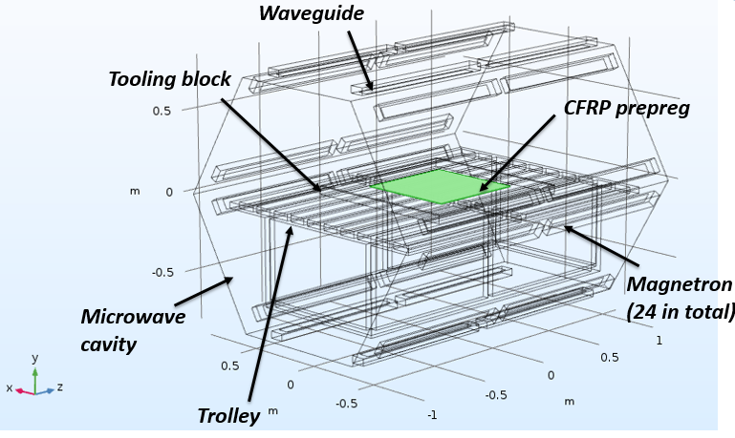

Fig. 1. A CAD model of the Vötsch VHM 180/200 microwave chamber [35]

Table 1 - Geometric and mesh parameters used in the FE model

|  |  |  |
| --- | --- | --- |
| **Parameter** | **Value** | **Description** |
| **T0** | 20°C | Room temperature |
| **f0** | 2.45 GHz | Microwave frequency |
| **λ0** | 0.1224 m | Microwave wavelength |
| **hmax** | 0.059958 m | Maximum mesh element size |
| **W** | 0.9 m | Overall width of microwave chamber |
| **H** | 0.9 m | Overall height of microwave chamber |
| **L** | 2.25 m | Overall length of microwave chamber |

Table 2 - Material properties for microwave simulations. Note that the composite properties were sourced from [4, 33, 36] whereas the water and polypropylene properties are an in-built feature of the COMSOL software

|  |  |  |  |  |
| --- | --- | --- | --- | --- |
| **Parameter** | **Composite** | **Water** | **Polypropylene tub** | |
| **Relative permittivity** | 4.5- j0.5 | 80.2- j0.00 | - |
| **Electrical conductivity (S/m)** | X =541.86, Y =541.86 Z = 0 | 0.05 | - | |
| **Heat capacity (J/Kg-K)** | 850 | 4184 | 1470 | |
| **Thermal conductivity (W/mK)** | X = 1541.2, Y = 1541.2 Z = 652.03 | 0.6 | 0.18 | |
| **Gravimetric density (kg/m3)** | 1126 | 1000 | 1190 | |

*2.3.2 Computational requirements*

A full-scale microwave FE model was developed, where the preliminary analysis recognised that the computational resources required to solve the FE model for the fixed frequency of 2.45 GHz were not sufficient. For example, a full-scale FE model of the chamber utilising 2.45 GHz required a physical RAM in excess of 1 TB as compared to 896 GB available on the system listed in the Section 2.3. The intensive quantity of RAM requirement arose from the mathematical issues involving wave dynamics, demanding a very fine mesh to resolve the wave field distribution in an entity (a rule of thumb dictates having five meshed elements to resolve a wavelength). For the microwave frequency of 2.45 GHz, the meshed element size was a few millimetres, and for the microwave, this resulted in ~5 M meshed elements and ~20 M degrees of freedom, which made the FE solution extremely computationally expensive. An exercise was thus undertaken to determine the maximum microwave frequency that the machine can compute.

*2.3.3 Microwave frequency simulation*

It was discovered that the full-scale FE model solves for any microwave frequency up to 2 GHz (the simulation for 2 GHz was completed successfully in two and half days and the RAM requirement was 870 GB). Thus the present full-scale FE model was simplified to achieve a balance between the availability of numerical resources and the accuracy of prediction. A half model was developed following the symmetry about the mid-plane of the microwave cavity and utilised for FE analysis. The meshed version of this model is shown in Figure 2, where the following assumptions were made:

* CFRP panel is surrounded by a medium with zero dielectric losses (i.e. air).
* CFRP panel is assumed homogeneous and orthotropic material properties are assigned to it.
* Material properties are assumed to be independent of state of cure and temperature.
* Thermo-physical and dielectric properties are constant, and not as a function of temperature or time.
* Initial temperature of the CFRP panel and air is homogeneous and the mass transfer is negligible.
* Chemical reaction between the air and CFRP sample is negligible, if any.
* Walls of the microwave cavity consist of structural steel.
* Heat transfer is not solved for the tool or trolley.
* Boundaries of the CFRP panel are perfectly insulated.
* Waveguide ports is excited by transverse EM standing wave fields in the Z direction.

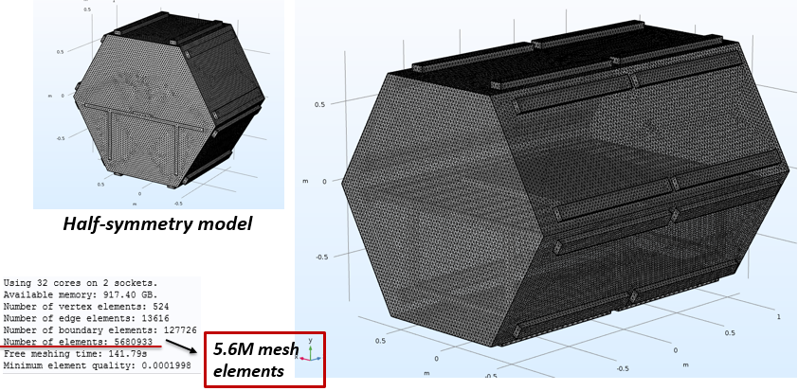

Fig. 2. Half-symmetry model of the Vötsch microwave chamber showing mesh details for a full-scale model

It should also be noted that the COMSOL model does not include chemical kinetics to simulate the cure that occurs as the composites resin system is heated. This leads to a lower overall temperature being registered throughout the cure, as the energy released by the resins exothermic reaction is not captured in the simulation.

*2.3.4 Boundary conditions and half symmetry based model*

The COMSOL software uses Maxwell’s equations [37] to solve EM propagation, while the Fourier’s energy balance equation [26] couples the electric field with the heat transfer. The boundary conditions used in the simulations are shown in Figure 3, where a perfect magnetic conductor boundary condition ensured electric field symmetry in the cavity (Figure 3a). An impedance boundary condition accounted for the plausible EM losses, and was specified for all external surfaces of the microwave cavity except for the symmetry face (Figure 3b). Thermal contacts between various meshed entities (such as composite and tooling block) involved in the simulations are considered by COMSOL automatically on the account of change in their material properties. The thermal insulation boundary condition was specified on all the faces of the CFRP, as radiation and convection within the cavity was not accounted for.

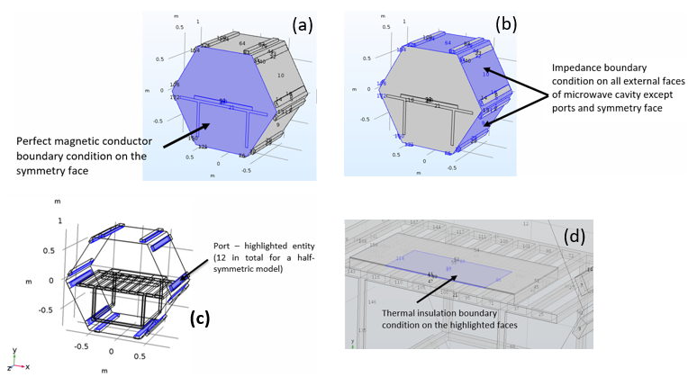

Thermal insulation boundary condition on the highlighted faces

Impedance boundary condition on all external faces of microwave cavity except ports and symmetry face

Port – highlighted entity (12 in total for a half-symmetric model)

Perfect magnetic conductor boundary condition on the symmetry face

Fig. 3. Boundary conditions used throughout the microwave simulations

A default physics based meshing strategy was adopted wherein each component was meshed with a maximum element size small enough to resolve a microwave wavelength adequately. A full-scale microwave model yielded in excess of 5 M mesh elements which demanded physical RAM in excess of 1 TB (Figure 2). To mitigate this, the symmetry was exploited and half the model was meshed with ~2.5 M elements which brought down the RAM requirement to ~700 GB (Figure 4).

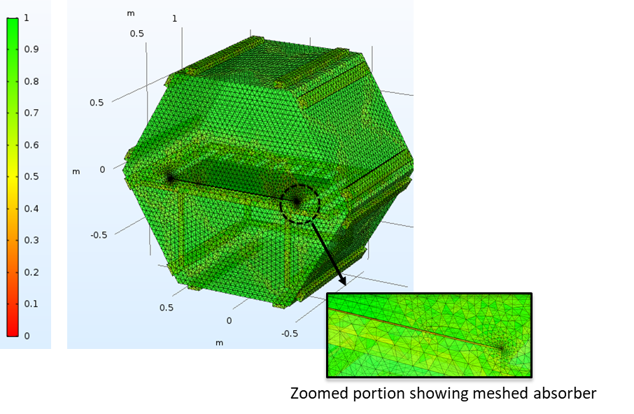

Zoomed portion showing meshed absorber

Fig. 4. Mesh quality for microwave chamber (the legend associates mesh quality with its aspect ratio rating such that the best element quality has a numeric value of 1, while the worst element quality inclined towards zero. The zoomed portion shows declining element quality due to short edges of the geometry)

1. Results and Discussion
   1. Microwave water heating trials

Simulation was conducted via heating water in the microwave to obtain initial validation for the FE model. Studies were then conducted to understand the effect of various parameters on the heat distribution in the chamber using an FE model.

*3.1.1 Effect of varying microwave frequencies on heat distribution*

A parametric study was carried out using an FE simulation to understand the effect of frequencies in the microwave regime. The frequencies chosen reside within the industrial, scientific and medical (ISM) radio bands (from 500 MHz to 2.45 GHz, where the majority of commercial microwaves operate, with an interval of 500 MHz). By varying the frequency, the relationship between EM field homogeneity and frequency was measured. The EM fields become inhomogeneous when standing waves are generated within a cavity, and standing waves occur when incident EM waves are in-phase. The in-phase EM waves interact via constructive and destructive interference, due the peaks of the waves being in sync, leading to an amplification in the intensity of the field. Standing waves result in large variations in the EM field strength causing localised heating of materials within the cavity. Figure 5 displays the distribution of the electric field for two frequencies (500 MHz and 2.45 GHz) that represent the extremes of the range of microwave frequency considered.

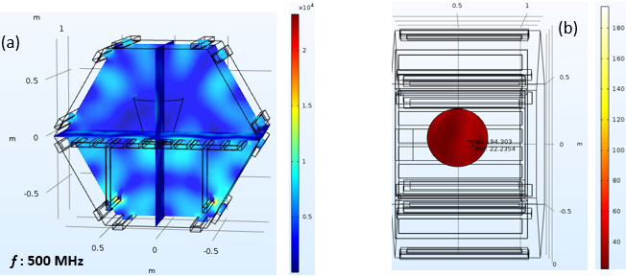

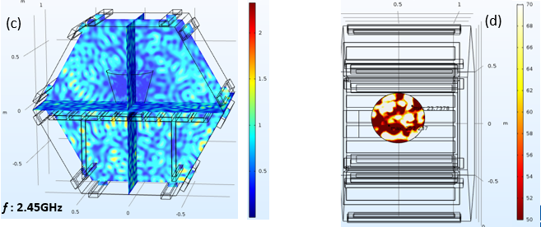

Fig. 5. - (a) and (c) slice plots showing the magnitude of electric field (V/m) inside the microwave cavity for microwave frequencies of 500 MHz and 2.45 GHz, respectively; (b) and (d) heat maps of water pertaining to (a) and (c) after 10 minutes of heating cycle

It is evident from Figure 5a and b that the distribution of electric field shows greater uniformity at 500 MHz as compared to that in 2.45 GHz (Figure 5c and d). In the latter case, EM energy was scattered due to the presence of standing waves. This resulted in non-uniform heating of water seen in Figure 5d. The low frequency (500 MHz) displays greater homogeneity (less variation in the electric field) due to the long wavelength. This results in fewer waves being present within the cavity, reducing the opportunity for EM waves to interfere and therefore the number of standing waves present. It should therefore be noted that despite the conventional frequency for the majority of domestic and industrial microwaves being 2.45 GHz, this is not necessarily the ideal frequency for generating a uniform EM field in a large scale chamber and in turn a uniform heat distribution within a composite. Additionally in this model, only one of the microwave modules (12 magnetrons) has been simulated and all 12 magnetrons were active throughout the simulation (see Section 3.1.3 for the effect of changing which magnetrons are active). By powering all magnetrons at once, the chance of generating standing waves within the cavity is increased as a greater number of EM waves are present. The likelihood that the waves will be in-phase is increased. This could be counteracted by actively switching specific magnetrons on and off at specific times during a cure cycle to ensure the incident EM waves are out-of-phase, which improves the field homogeneity. At present, however, this level of magnetron control is not available with the Vötsch system, as the controller currently allows individual magnetrons to be turned on or off at the beginning of the cure cycle but not during it.

*3.1.2 Effect of the metallic trolley on field distribution*

The effect of the metallic trolley on the field uniformity was evaluated at a fixed frequency (500 MHz), shown in Figure 6. The four images show a planar representation of the electric field moved sequentially from the bottom towards the top of the cavity when a frequency 500 MHz was used. It is clear from Figure 6b that the uniformity of the electric field was compromised due to the presence of the metallic trolley. When metallic objects are exposed to EM fields, they reflect the incident microwave energy, which disrupts the EM field resulting in further inhomogeneity. The metallic trolley also shields objects by reflecting incident microwaves, which may be detrimental to the curing process.

The images in Figure 6 complement the simulations in Figure 5, which also highlights that the homogeneity of the electric field inside the cavity could be disturbed by the metallic trolley on which the composite resides. Field strength around the trolley is increased (denoted by the yellow areas around the trolley), highlighting the importance of modifying or potentially removing the metallic trolley.

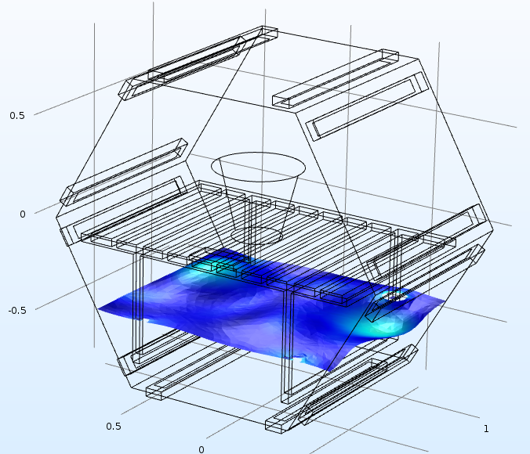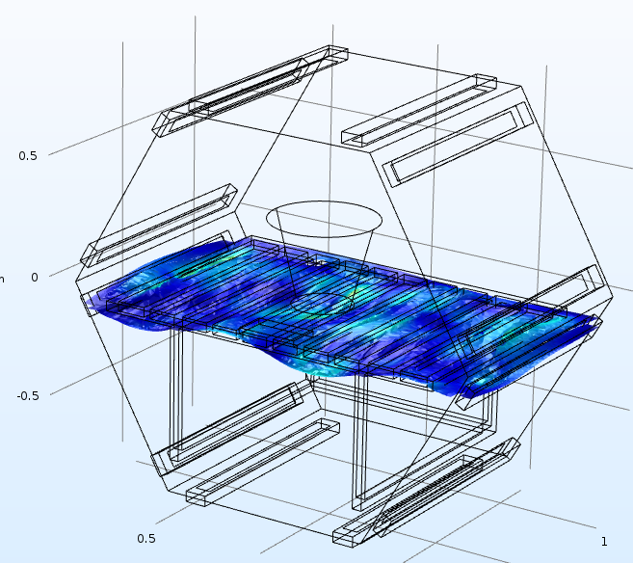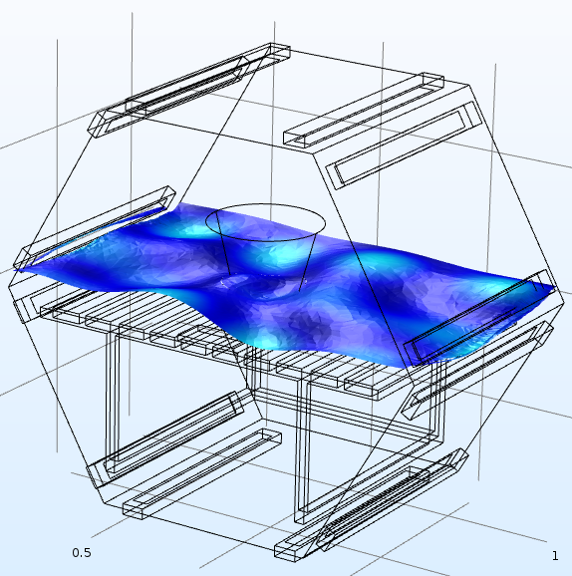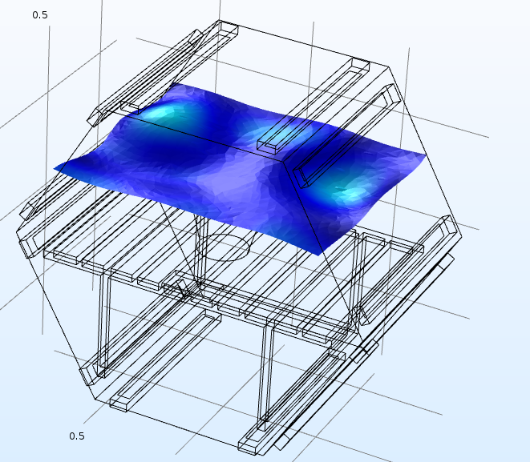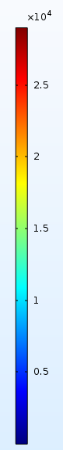

(d)

(c)

(b)

(a)

Fig. 6. Distribution of the electric field (V/m) at 500 MHz showing loss of its uniformity when obstructed by the metallic trolley, microwave frequency: 500 MHz (the planar electric field moves from position a through to position d in the microwave cavity and is obstructed close to position 2 due to presence of the trolley)

*3.1.3 Effect of selective power variation on the heat distribution*

The simulation was repeated for various microwave frequencies ranging from 500 MHz to 2 GHz at intervals of 500 MHz to identify a correlation between the EM frequency and the resulting water temperature (Figure 7). In these simulations, the magnetrons were selectively powered to understand the effect of electric energy entering through the port into the microwave cavity based on their locations. The microwave software allows for individual magnetrons to be switched on/off at the beginning of a cure cycle, which provides the opportunity to concentrate the EM field in a specific region by controlling which magnetron ports emit radiation.

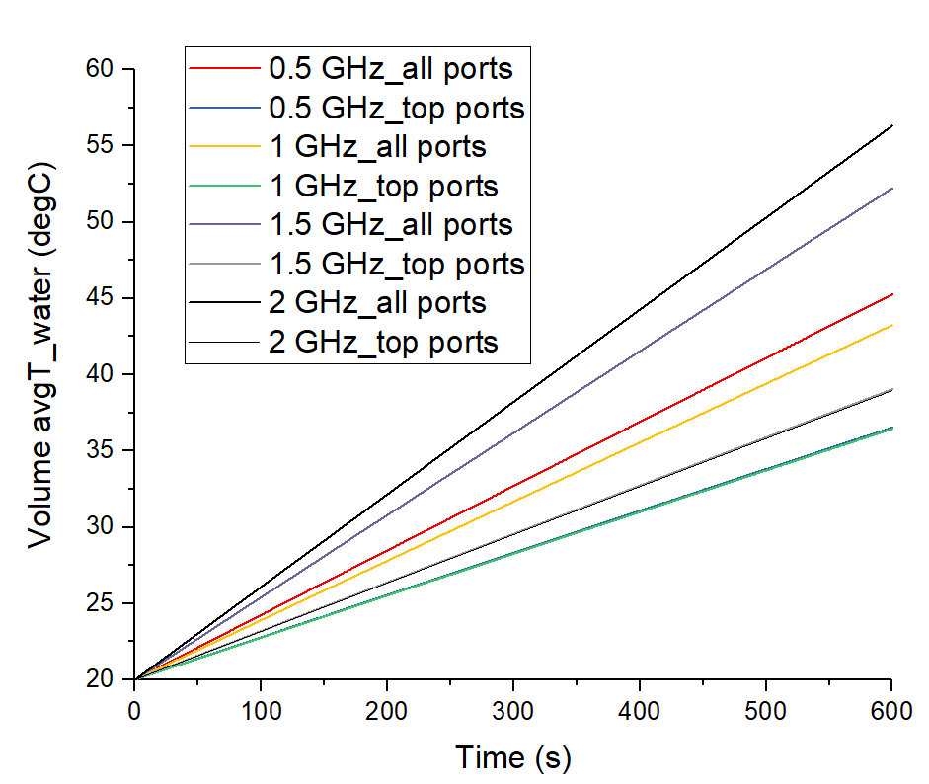

Fig. 7. Transient temperature change in bucket of water at various microwave frequencies and using a selective magnetron powering strategy

Three simulation cases were studied. One case focused at powering the microwave cavity using only half the number (six, due to symmetry) of magnetrons located on the top of the microwave along its height. The second focused on using only the bottom six magnetrons. The third case considered powering the cavity entirely through all of the magnetrons in the microwave. The thermal field was quantified in terms of the maximum temperature of water averaged over its volume. Results of the water temperature variation with time for the frequency of interest and selected microwave powering strategy are shown in Figure 7. The simulation found that the top and bottom magnetron scenarios gave similar results in terms of temperature increase over time. However, the scenario with all magnetrons active did alter the outcome. In this simulation, the heating rate associated with each frequency is shown in Figure 7, where increasing the frequency (maximum of 2 GHz) results in a greater temperature ramp rate. In addition, as expected, using half the magnetrons (top six ports) reduces the thermal ramp due to the reduction in energy entering the chamber. This highlights the trade-off between using a lower frequency or fewer microwave emitters to homogenise the EM field and using a higher frequency or more microwave emitters to increase heating rate at the expense of field uniformity. The exception to this trend is the ‘0.5 GHz all port’ case that has heated fast than the ‘1 GHz all port’. This is thought to have resulted due to wave scattering and reflection that causes a nonlinear response in heating. It should be noted that water temperature may not vary linearly with time due to various losses and variation in material properties as a function of temperature and frequency.

Further simulations were conducted to evaluate the effect of using a selected number of magnetrons on the EM field distribution. Figure 8 shows the effect of using a selective magnetron strategy to heat water within the microwave cavity. The simulation displays the field distribution within the chamber with the top and bottom magnetrons switched on (left and right, respectively) at 2 GHz. The figure highlights the simulations capability to model a ‘selective heating’ scenario where only specific magnetrons are switched on at a time, whilst still capturing the corresponding change in EM field strength associated with using less magnetrons. The simulation using the bottom six magnetrons (Figure 8b) displays a less homogenous field than the scenario using the top six magnetrons (Figure 8a), as the microwaves emitted from the bottom six ports interact with the metallic trolley more readily due to their positioning. The simulations capability to model a selective magnetron scenario represents an opportunity for microwave processing, as an understanding of how specific regions of a composite part can be heated using an array of magnetrons. Selective heating applications can include welding of thermoplastic composites and general bonding using adhesive films.

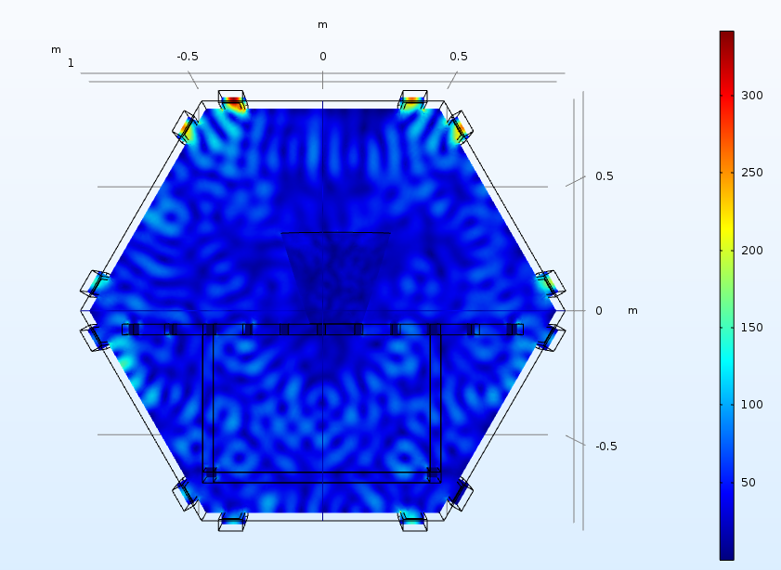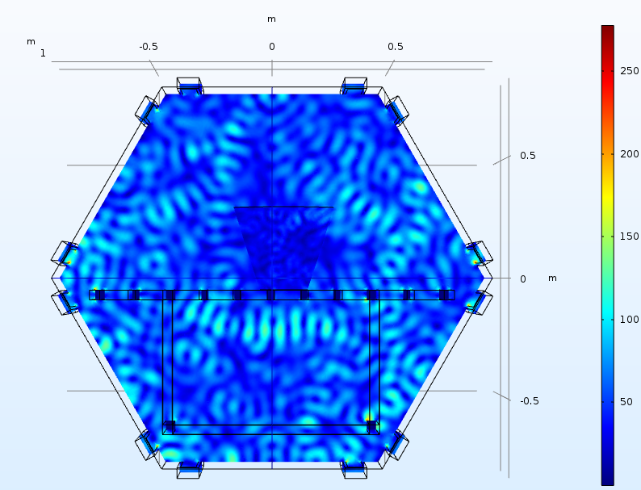

*Fig. 8. Distribution of electric field (in V/m) for the two simulation scenarios (Left – top 6 magnetrons, Right – bottom 6 magnetrons). Frequency: 2 GHz.*

* 1. Microwave water heating trials

An EM heating model of a CFRP laminate was simulated. It is worth noting that the simulation is a half-symmetry model of the Vötsch cavity. A half-symmetry model was used to reduce the computational power required to simulate the full model at 2.45 GHz. The highest frequency that a full scale model could be conducted at was ~2 GHz, just under the 2.45 GHz required. CFRP prepreg was modelled as a rectangular block with orthotropic electrical and thermal material assigned to it, where all 12 magnetrons were utilised to power the microwave. Individual layers of prepreg were not modelled and the adhesion between neighbouring plies and resin kinetics during curing were not accounted for.

3.2.1 Effect of varying sample size

The effect of varying sample size was analysed by altering the thickness of the CFRP panel from 4 mm to 8 mm. It was observed that with an increase in thickness of the CFRP, its overall temperature after a fixed time interval reduced (refer to Figure 9 - the legend on the left shows the temperature at the end of a 6 minute heating cycle, where the maximum and the minimum temperatures for each specimen are provided). This could be attributed to the larger load plus the fact that the microwave power was deposited in the outer part of the composite, as the skin depth is small. (The microwave penetration depth for conductive materials (i.e. carbon fibre) is dependent on the electrical conductivity and the EM frequency, where the materials that possess higher conductivities limit the penetration depth [16]). Heat transfer into the bulk is through thermal conduction which is much slower, which was successfully captured by the FE model.

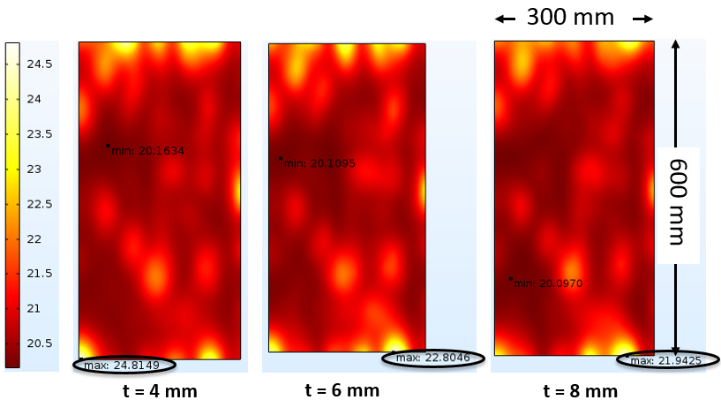

Min: 20 °C

Min: 20 °C

Min: 20 °C

*Fig. 9. Effect of increasing the thickness of a CFRP sample on the maximum temperature achieved after 6 minutes*

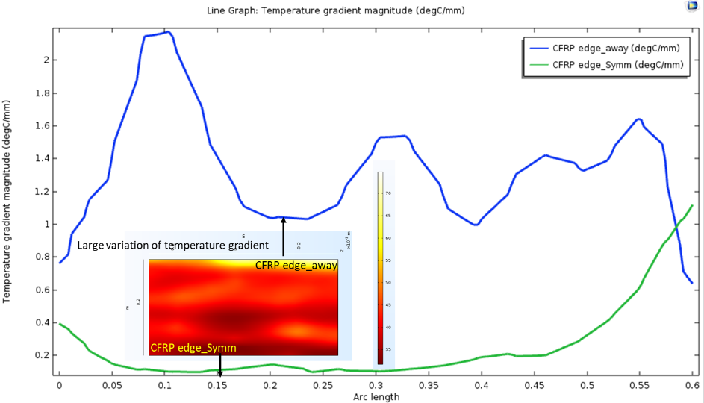 It was also observed that large temperature gradients exist on the longer edge of the CFRP away from the symmetry face (Figure 10). This trend was observed in almost all simulation cases; Figure 10 shows the comparison of the temperature gradient on the longer edges (both at the symmetry face and away from the symmetry face) of the CFRP panel, abscissa denotes the length of these edges. The edge of the composite displays an increased temperature as the EM field accumulates in these locations. This has been validated in the experimental setting with arcing and high temperatures recorded in these locations (Figure 11). It should be noted that the aluminium tape around the CFRP panel was not modelled in the Vötsch simulation. The effect of heat concentration at the sharp edges would be reduced, in practice, as the EM waves would be reflected

*Fig. 10. Temperature gradient on the longer edges of the CFRP sample showing an ‘outside in’ heating pattern (microwave frequency – 2.45 GHz, all magnetrons powered, heating cycle time – 1 hour)*

*3.2.2 Model verification of the simulation*

An experimental verification of the microwave simulation was conducted at 2.45 GHz. The cure process was controlled using three FOTs located along one side of the composite. The FOTs were placed on top of the composite between the laminate and the breather, with FOT-1 and FOT-2 located on the composite and FOT-3 located under the tool. Vacuum was applied throughout the cure cycle to consolidate the laminate using the microwaves internal vacuum system. The CFRP panel was successfully cured using 24 magnetrons. The cure cycle is shown in Figure 11, where the black line indicates the power input into the microwave and the others represent the set point and temperatures measured by the FOTs. The cure cycle displays a slight temperature variation between FOT-1 and FOT-2, with the former registering a higher temperature throughout the cure cycle. This supports the findings of the simulation as the highest temperatures were recorded around the symmetry line, which corresponds to the location of FOT-1 in the experiment (Figure 10).

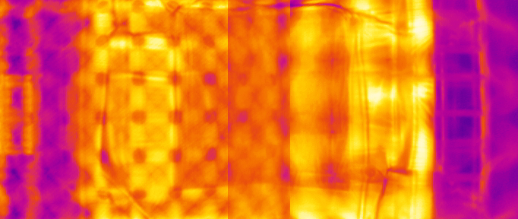

FOT 1

FOT 2

FOT 3

Cold spots

*Fig. 11. Experimental verification: a) Microwave cure cycle showing the Power output via the dashed line and the temperature measured by each FOT, b) IR image of CFRP during the curing process*

Figure 11 highlights the temperature fluctuations (20 °C range) that occur as the control system attempts to hold a set temperature during the dwell periods. The pulse-width nature of the power delivered by the microwaves control system causes these temperature fluctuations that could potentially instigate an exotherm or lead to under-cured resin. FOT-3 is significantly lower in temperature than the composite throughout the cure cycle as the tool is microwave transparent.

The IR image shown in Figure 11 has numerous hot and cold spots across the CFRP panel and the tool. Five cold spots are located along the length of the panel which correspond to destructive interference nodes of the standing waves generated within the microwave cavity. The panel has a known length of 600 mm and five ‘cold nodes’ are present indicating a wavelength of 120 mm, which is the expected wavelength for microwave radiation at 2.45 GHz. The hot and cold spots vary in temperature by 10 °C on average. This directly correlates to the simulation shown in Figure 5 and Figure 6 with numerous hot and cold regions present, particularly near the metallic trolley. The trolley can be seen in the IR image (Figure 11) showing that it is interacting with the EM field by reflecting radiation towards the camera which was validated in the simulation.

The CFRP panel in Figure 11 is difficult to distinguish from the tool surface as both are a similar temperature despite the CFRP absorbing significantly more EM energy than the tool. The CFRP panel is processed in a vacuum bag that contains a thick layer of glass breather which insulates the panel and hinders the IR cameras view of the composite. The simulation images in Figure 9 and Figure 10 show raised temperatures at the edge of the panels where the EM field accumulates. The IR image does not show this same effect, however. The aluminium shielding around the edge of the panel reflects the incident EM radiation, which in turn reduces the temperature at the edge of the panel.

To evaluate the composite cured in the microwave, the panel was characterised using DSC to measure the degree of cure (DOC). The composite was calculated to be 98 % cured using Equation 1. The manufacturers’ specified DOC is 95% where the high DOC in the composite indicates that a microwave is an effective means of processing composites.

1. Conclusion

The study focused on producing a model of the EM field which can facilitate the simulation of the microwave processing of composites. An industrial Vötsch microwave cavity was successfully implemented into computer models and meshed using COMSOL Multiphysics® under symmetry conditions. The boundary conditions and assumptions used to model the cavity were identified and EM simulations of heating water and composite materials were conducted.

The effect of EM frequency on the field homogeneity and temperature distribution was observed, with lower frequencies producing a more homogenous field and a high frequency resulting in improved thermal ramp rates within the composite but lower uniformity of the EM field. This highlights the trade-off required when using microwave energy to process composites. An experimental trial was also conducted on a composite using the microwave system. The temperature throughout the CFRP cure cycle was monitored via FOTs and IR cameras to capture the microwave heating process which showed the heat distribution generated across the composite panel.

From the study, it is clear that the computational power required to generate a model for a large (~8 m3) industrial cavity is substantial (over 896 GB RAM) and, therefore, there is a need to employ a computer cluster. Additionally, an electromagnetic field alters as the dielectric properties of the composite material and heat evolved through chemical reaction vary with temperature and time during cure. These effects need to be taken into account in order to replicate an in-situ cure cycle and will be investigated by the authors in future work.

Acknowledgements

This work was supported by the AMRC industrial members, where the authors sincerely appreciate the continuous support provided. The authors would also like to thank the Cytec Solvay group for supplying carbon fibre prepreg. Richard Day was supported by an EPSRC High Value Manufacturing Catapult fellowship (EP/L017121/1).

References

[1] Nuhiji B, Attard D, Deveth A, Fox B. The influence of processing techniques on the matrix distribution and filtration of clay in a fibre reinforced nanocomposite. Composites Part B: Engineering. 2016;84(1-8).

[2] Severijns C, Freitas STd, Poulis JA. Susceptor-assisted induction curing behaviour of a two component epoxy paste adhesive for aerospace applications. International Journal of Adhesion and Adhesives. 2017;75:155–64.

[3] Wu Q, Ma L, Wu L, Xiong J. A novel strengthening method for carbon fiber composite lattice truss. Composite Structures. 2016;153:585–92.

[4] Green JE, Nuhiji B, Zivtins K, Bower MP, Grainger RV, Day RJ, et al. Internal Model Control of a Domestic Microwave for Carbon Composite Curing. IEEE Transactions on Microwave Theory and Techniques. 2017.

[5] Nuhiji B, Attard D, Deveth A, Bungur J, Fox B. The influence of processing techniques on the matrix distribution and filtration of clay in a fibre reinforced nanocomposite. Composites Part B: Engineering. 2016;84:1-8.

[6] Nuhiji B, Attard D, Thorogood G, Hanley T, Magniez K, Bungur J, et al. The Effect of a Rapid Heating Rate, Mechanical Vibration and Surfactant Chemistry on the Structure-Property Relationships of Epoxy/Clay Nanocomposites. Materials (Basel). 2013;6(8):3624-40.

[7] Nuhiji B, Attard D, Thorogood G, Hanley T, Magniez K, Fox B. The effect of alternate heating rates during cure on the structure–property relationships of epoxy/MMT clay nanocomposites. Composites Science and Technology. 2011;71(15):1761-8.

[8] Lee WI, Springer GS. Microwave Curing of Composites. Journal of Composite Materials. 1984;18(4):387-409.

[9] Boey FYC, Lee WL. Microwave radiation curing of a thermosetting composite. Journal of Materials Science Letters. 1990;9(10):1172-3.

[10] Boey FYC, Lee TH. Electromagnetic radiation curing of an epoxy/fibre glass reinforced composite. International Journal of Radiation Applications and Instrumentation Part C Radiation Physics and Chemistry. 1991;38(4):419-23.

[11] Boey F, Gosling I, Lye SW. High-pressure microwave curing process for an epoxy-matrix/glass-fibre composite. Journal of Materials Processing Technology. 1992;29(1):311-9.

[12] Clark DE, Sutton WH. Microwave processing of materials. Annual Review of Materials Science. 1996;26(1):299-331.

[13] Nightingale C, Day RJ. Flexural and interlaminar shear strength properties of carbon fibre/epoxy composites cured thermally and with microwave radiation. Composites Part A: Applied Science and Manufacturing. 2002;33(7):1021-30.

[14] Feher L, Thumm M, Drechsler K. Gigahertz and Nanotubes – Perspectives for Innovations with Novel Industrial Microwave Processing Technology. Advanced Engineering Materials. 2006;8(1-2):26-32.

[15] Zhou JL, Yingguang; Hao, Ziaozhoug; Li, Nanya. High-Pressure Microwave Curing Technology for Advanced Polymer Matrix Composite Materials. In: Gao J, editor. Advances in Manufacturing Technology: IOS Press; 2017. p. 57-62.

[16] Kwak M, Robinson P, Bismarck A, Wise R. Microwave curing of carbon–epoxy composites: Penetration depth and material characterisation. Composites Part A: applied science and manufacturing. 2015;75:18-27.

[17] Li N, Li Y, Hao X, Gao J. A comparative experiment for the analysis of microwave and thermal process induced strains of carbon fiber/bismaleimide composite materials. Composites Science and Technology. 2015;106(Supplement C):15-9.

[18] Li N, Li Y, Jelonnek J, Link G, Gao J. A new process control method for microwave curing of carbon fibre reinforced composites in aerospace applications. Composites Part B: Engineering. 2017;122:61-70.

[19] Li N, Li Y, Wu X, Hao X. Tool-part interaction in composites microwave curing: Experimental investigation and analysis. Journal of Composite Materials. 2017;51(26):3719-30.

[20] Kwak M, Robinson P, Bismarck A, Wise R. Curing of composite materials using the recently developed hephaistos microwave. 18th international conference on composite materials2011. p. 21-6.

[21] Thostenson ET, Chou TW. Microwave processing: fundamentals and applications. Composites Part A: Applied Science and Manufacturing. 1999;30(9):1055-71.

[22] Lee WI, Springer GS. Interaction of electromagnetic radiation with organic matrix composites. Journal of Composite Materials. 1984;18(4):357-86.

[23] Thostenson ET, Chou TW. Microwave and Conventional Curing of Thick-Section Thermoset Composite Laminates: Experiment and Simulation. Polymer Composites. 2001;22(2):197 - 212.

[24] Nesbitt A, Navabpour P, Degamber B, Nightingale C, Mann T, Fernando G, et al. Development of a microwave calorimeter for simultaneous thermal analysis, infrared spectroscopy and dielectric measurements. Measurement Science and Technology. 2004;15(11):2313.

[25] Awida MH, Shah N, Warren B, Ripley E, Fathy AE. Modeling of an Industrial Microwave Furnace for Metal Casting Applications. MTT-S International Microwave Symposium Digest. Atlanta, USA: IEEE; 2008.

[26] Knoerzer K, Regier M, Schubert H. A computational model for calculating temperature distributions in microwave food applications. Innovative Food Science and Emerging Technologies. 2008;9(3):374 – 84.

[27] Lin B, Li H, Chen Z, Zheng C, Hong Y, Wang Z. Sensitivity analysis on the microwave heating of coal: A coupled electromagnetic and heat transfer model. Applied Thermal Engineering. 2017;126 949–62.

[28] Leonelli C, Veronesi P, Grisoni F. Numerical Simulation of an Industrial Microwave Assisted Filter Dryer: Criticality Assessment and Optimization. Journal of Microwave Power and Electromagnetic Energy. 2007;41(3):5-13.

[29] Polaert I, Estel L, Delmotte M, Luart D, Len C. A New and Original Microwave Continuous Reactor Under High Pressure for Future Chemistry. AIChE Journal. 2017;63(1):192 - 9.

[30] Folorunso O, Dodds C, Dimitrakis G, Kingman S. Continuous energy efficient exfoliation of vermiculite through microwave heating. International Journal of Mineral Processing. 2012;114–117 69–79.

[31] Ali S, Bajpai PK, Singh I, Sharma AK. Curing of natural fibre-reinforced thermoplastic composites using microwave energy. Reinforced plastics and composites. 2014;33(11):993–9.

[32] Li Y, Hang X, Li N, Hao X. A temperature distribution prediction model of carbon fiber reinforced composites during microwave cure. Journal of Materials Processing Technology. 2016;230:280-7.

[33] Feher LE, Thumm MK. Microwave innovation for industrial composite fabrication-the HEPHAISTOS technology. IEEE Transactions on Plasma Science. 2004;32(1):73-9.

[34] COMSOL. COMSOL. 2018.

[35] Nuhiji B; Swait, Timothy, J.; Bower, Matthew P.; Green, James E,; Day, Richard, J.; Scaife, Richard, J.;. Tooling materials compatible with carbon fibre composites in a microwave environment Composite Part B. 2019;163:769 - 78.

[36] Malmberg, C. G., & Maryott, A. A. Dielectric Constant of Water from 00 to 1000 C. Journal of research of the National Bureau of Standards, 1956;56(1), 1.

[37] Mishra RR, Sharma AK. Microwave–material interaction phenomena: Heating mechanisms, challenges and opportunities in material processing. Composites Part A: Applied Science and Manufacturing. 2016;81:78-97.

1. * Matthew P. Bower. Advanced Manufacturing Research Centre, The University of Sheffield.

   *E-mail address:* matt.bower@sheffield.ac.uk