新材料の研究開発のカギとなり、イノベーションの核となるのは、マテリアル・インフォマティクスによる物質探索と特殊環境下で定量的に精密制御された合成系で物質合成を行い、そのまま物性評価を行うシステムの創製である。本研究では、少量多品種かつAIのよるマテリアル・インフォマティクスと組み合わせた自動制御コンビナトリアル物質合成・評価システムの創製を行うことを目的とする。

本研究では、マテリアル・インフォマティクスと精密制御されたコンビナトリアル合成システム及び物性評価システムを一体化あるいはシームレスに接続するシステムを創製するために、ナノ・マイクロシステムと各種合成系を組み合わせてコンピュータによる自動制御化を行う。申請者は、マイクロ波化学合成系を図1に示すようにマイクロ化学チップで実現することに成功した。このマイクロ化学チップでは、マイクロ波導波路とマイクロ流路を共存させるために、ポスト壁導波路という構造を設計してチップに導入した。このポスト壁導波路を導入することで、小型化と水のマイクロ波利用効率が最大となる24.15 GHzのマイクロ波をマイクロ流路に局所的に照射することができる。(Sensors&ActuatorsB 242(2017)384)このチップを創製するために、誘電率がマイクロ波・ミリ波の帯域までほとんど変化せず、300℃でも動作可能な耐熱性を有し、化学薬品耐性を有しているポリテトラフルオロエチレン(Polytetrafluoroethylene, PTFE：テフロンの商品名で知られている)を構造材として用いた。PTFEは、優れた物性を示すが、難加工材料であることが知られている。申請者は、シンクロトロン放射光ビームライン(NewSUBARU BL2&BL11)を有しており、このビームラインを用いるとシンクロトロン光によるPTFEの直接ドライ切削加工が可能であり、マイクロメートル程度の構造も形成でき、隕石中からフッ酸を用いてアミノ酸を抽出するためのマイクロ化学システムの創製にも成功している。(Appl. Phys. Lett. 108 (2016)051610)これらの技術をさらに発展させることで、シンクロトロン光を液相に直接照射することで、液相中の光化学反応を励起して、ナノ粒子やその凝集構造等を形成できることを実証した。(J. Synchrotron Rad. 24(2017)653)
これらの基盤研究をシステム化することで、マテリアル・インフォマティクスとコンビナトリアル物質合成・評価を一体化する。その概念図を図2に示す。マイクロ波やナノ・マイクロ空間での高圧状態の形成やレーザー・シンクロトロン光による非平衡状態を精密に制御しながら実現できるので、マテリアル・インフォマティクスに基づく計算を自動化して実際の合成と評価を行うことが可能となることが期待できる。

Recent development in materials informatics allows us to search for new innovative materials for sustainable development with increasing device performance and decreasing power consumption. This proposed project aims to establish an automated synthesis process with precisely atomic compositional control supported by our specialist characterisation methods. The Japanese PI has over 10-year experience in synchrotron-assisted synthesis, which will be fed for machine learning for the material search. Together with their structural and electromagnetic properties, we will create a catalogue of new materials for electromagnetic shielding and waveguide for mobile communications. These materials will be synthesised by combinatorial method assisted by synchrotron radiation available in Japan and characetrised by non-destructive imaging and associated electromagnetic measurements developed by the UK PI. We have been working on the development of spintronic devices over the last decade and plan to expand our collaboration into mobile communications. Our catalogue will enable us to synthesise custom-designed materials with required properties in a small to large volume scale. This will be highly useful for 5G communications and beyond.
The main aim of this project is to create a system which allows seamless connection between a precisely controlled combinatorial synthesis process and characteristaion tools evaluating physical properties of the synthesised materials. For the former process, the Japanese PI will take a lead using his beamline at SPring-8, while the latter tools will be developed by the UK PI based on his non-destructive imaging and electromagnetic characterisation.
In order to achieve the aim, two objectives are determined. The first one is to create a catalogue of materials, which are ideal for the above synthesis process, based on materials informatics. Machine learning will be used for the search of new materials by feeding the Japanese PI’s previous studies and the UK PI will assist the search as he has another project for the development of Heusler alloys for magnetic tunnel junctions using machine learning [JST-CREST (JPMJCR17J5)].
The second objective is to fabricate a lab-on-a-chip for the analysis of microwave irradiation as an example, the PTFE structure will be fabricated by anisotropic pyrochemical micro-etching initiated by synchrotron-induced scission of molecular bonds. The fabrication will be carried out by controlling the synchrotron beam and pressure under non-equilibrium state in a nanoscale area. By combining the characterization tools from the UK, the chip can be used as a custom-designed electromagnetic shielding and/or waveguide for mobile communications.

We plan to create a catalogue of new materials using materials informatics. The UK PI has been working on the development of a new ferromagnetic materials using machine learning as explained above. He found that several physical parameters are superior for the random forest process and will use them for this project. The experimental data will be supplied by the Japanese PI for the machine learning, which will be carried out using the Japanese PI’s facility.
The selected materials will be syntheised by the Japanese PI to develop a new seamless fabrication and characterisation process. For the development of the combinatorial synthesis process, we will implement a micron-scale chemical chip developed by the Japanese PI. A microchannel is embedded in the post-wall waveguide on a chip, allowing liquid flow to be controlled by the heat generated by the waveguide for microwave at 24.15 GHz [Sensors and Actuators B 242, 384 (2017)]. The chip was based on polytetrafluoroethylene (PTFE), which can only be dry-patterned using synchrotron radiation available at SPring-8 (NewSUBARU BL2&BL11), which is maintained by the Japanese PI. The latter tools have been developed by the UK PI, namely a non-destructive imaging with decelerated electron beam [Nature Communications 7, 12701 (2016)] will be used to assess the interfaces between PTFE chip and the waveguide etc. The exchange in the first year will be used for these technology transfer. The combination of these techniques will enable the fabrication of a new device with a new material to be developed in this project for the use of electromagnetic compatibility for 5G communications and beyond.
Using the developed process, we will fabricate a laboratory-on-chip for electromagnetic shielding and waveguide.

In this research, we create a system that seamlessly connects material informatics, precision controlled combinatorial synthesis system and physical property evaluation system. The integrated system can achieve the automatic control by computer combining nano / micro system and various synthesis systems. The applicant succeeded in realizing a microwave chemical synthesis system with a microchemical chip as shown in Fig. 1. In this microchemical chip integrated with the microwave heating, in order to make the microwave waveguide and the microchannel coexist, a structure called a post wall waveguide was designed and introduced into the chip. By introducing this post-wall waveguide, it is possible to locally irradiate the microwave channel with a microwave of 24.15 GHz that maximizes the miniaturization and the microwave utilization efficiency of water. (Sensors & Actuators B 242 (2017) 384) So as to create this chip, the dielectric constant of structural material for the chip is required for being hardly changes up to the microwave / millimeter wave band. In addition, it has to have heat resistance that can operate even at 300 ° C, and has chemical resistance. Polytetrafluoroethylene (PTFE: known under the trade name of Teflon) exhibits excellent physical properties which satisfy with the requirements described the above, but is known to be a difficult-to-process material. The applicant has a synchrotron radiation beam line (NewSUBARU BL2 & BL11 at University of Hyogo, Japan), and by using this beam line, PTFE can be directly dry-etching by synchrotron light, and a structure of the order of micrometers can be formed. We have also succeeded in creating a microchemical system for extracting amino acids from meteorites using hydrofluoric acid as shown in Fig. 2. (Appl. Phys. Lett. 108 (2016) 051610) By further developing these technologies, the photochemical reaction in the liquid phase is excited by directly irradiating the liquid phase with synchrotron light, metallic and oxide nanoparticles and their aggregated structure can be formed as shown in Fig. 3. (J. Synchrotron Rad. 24 (2017) 653)
By integrating these basic research into a system, material informatics and combinatorial material synthesis and evaluation will be integrated. The conceptual diagram is shown in Fig. 4. Since it is possible to realize high-pressure states in microwaves, nano-micro spaces, and non-equilibrium states by laser synchrotron light, it can be realized with precise control, so calculations based on material informatics are automated for actual synthesis and evaluation. Can be expected to be possible.

Fig. 1. (a) Perspective diagram of designed structure of microchannel embedded in the post-wall waveguide. (b) Photograph of fabricated structure of microchip of which microchannel is embedded in the post-wall waveguide. A micro liquid channel that flows into the post-wall waveguide is introduced in the space of dielectric medium material (PTFE). (c) A theoretical temperature distribution of water under microwave irradiation simulated using COMSOL Multiphysics. The square shape made from blank dot shows the post-wall waveguide.

(c)

Fig. 2. Lab-on-a-chip for the analysis of amino acid; the PTFE structure was fabricated by anisotropic pyrochemical microetching initiated by SR-induced scission of molecular bonds. The SEM image shows the magnified structure of the fine-filter; there are square depressions measuring 50 lm on each side.

Fig. 3 Layout of the X-ray irradiation experiment at BL8S1, Aichi SRC. X-ray spectra are shown in the inset. Photon intensity obtained from (A) synchrotron radiation at BL8S1 of Aichi SRC, (B) Pt mirror (incident angle: 0.2_), (C) 400 mm-thick Be film, (D) 500 mm-thick Al film, (E) metallic solution through air (1 m distance) and (F) 180 mm-thick steel used stainless (SUS) mask.
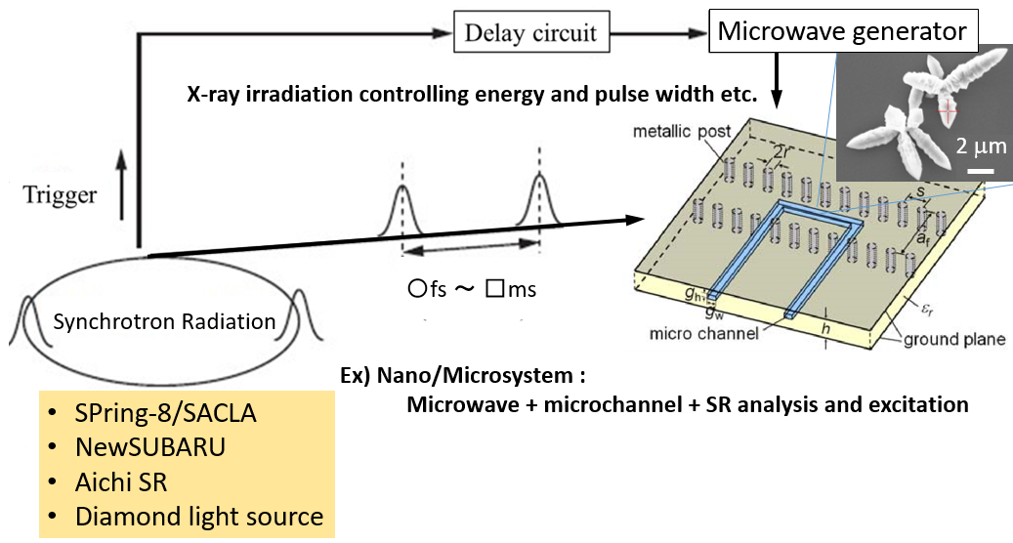
Fig. 4 Schematic illustration of combinatorial chemical synthesis using microwave and X-ray irradiation. Synchrotron analysis can be simultaneously performed.

