Childhood Cancer: estimating regional and global incidence

Author names and affiliations:
WT Johnston^{1, *}, Friederike Erdmann^{2, 3}, Robert Newton^{1, 4}, Eva Steliarova-Foucher⁵, Joachim Schüz², Eve Roman¹
¹ Epidemiology and Cancer Statistics Group, Department of Health Sciences, University of York, York, United Kingdom
² Section of Environment and Radiation, International Agency for Research on Cancer (IARC), Lyon, France
³ Childhood Cancer Research Group, Danish Cancer Society Research Center, Copenhagen, Denmark
⁴ Medical Research Council / Uganda Virus Research Institute (MRC/UVRI) Research Unit on AIDS, Entebbe Uganda
⁵ Section of Cancer Surveillance, International Agency for Research on Cancer (IARC), Lyon, France

*Corresponding author:
WT Johnston
Present address:
Epidemiology and Cancer Statistics Group, Department of Health Sciences, University of York, Heslington, York, United Kingdom YO10 5DD
tom.johnston@york.ac.uk

Word counts:
Abstract: 340
Total manuscript (excludes references, tables and figures): 3664
Highlights:

Abstract
Background
Most of the world’s population is not covered by cancer surveillance systems or vital registration, and worldwide/UN-regional cancer incidence is estimated using a variety of methods. Quantifying the cancer burden in children (<15 years) is more challenging than in adults; childhood cancer is rare and often presents with non-specific symptoms that mimic those of more prevalent infectious and nutritional conditions.
Methods
A Baseline Model (BM) was constructed comprising a set of quality assured sex- and age-specific cancer rates derived from the US Surveillance, Epidemiology and End Results (SEER) program, for diagnostic groups of the International Classification of Childhood Cancers (ICCC-3) 3rd edition, and information on a known risk factor for endemic Burkitt lymphoma and Kaposi’s sarcoma. These rates were applied to global country-level population data for 2015 to estimate the global and regional incidence of childhood cancer. Results were compared to GLOBOCAN 2018, extrapolations from the International Incidence of Childhood Cancer (IICC-3) and estimates from the Global Childhood Cancer (GCC) model (based on IICC-3 data combined with information on health care systems and other parameters).
Results
The BM estimated 360,114 total childhood cancers occurring worldwide in 2015; 54% in Asia and 28% in Africa. BM estimated standardised rates ranged from ~178 cases per million in Europe and North America, through to ~218 cases per million in West and Middle Africa. Totals from GLOBOCAN and extrapolations from the IICC-3 study were lower (44.6% and 34.7% respectively), but estimates from the GCC model was 10.2% higher. In all models, agreement was good in countries with very high human development index (HDI), but more variable in countries with medium and low HDIs; the discrepancies correlating with registration coverage across these settings.
Conclusion
Disagreements between the BM estimates and other sources occur in areas where health systems are insufficiently equipped to provide adequate access to diagnosis, treatment, and supportive care. Incorporating aetiological evidence into the BM enabled the estimation of the additional burden of Burkitt lymphoma and Kaposi sarcoma; similar adjustments could be applied to other cancers, as and when information becomes available.

Key words (max 10):
Childhood cancer; incidence; estimates; global; cancer registry; Burkitt lymphoma; Kaposi sarcoma; global estimates

Acknowledgements:
Funding sources:
Federal Office for Radiation Protection (BfS), Germany, contract 3614S30041
Bloodwise, United Kingdom, grant number 15037

Disclaimer:
Where authors are identified as personnel of the International Agency for Research on Cancer / World Health Organization, the authors alone are responsible for the views expressed in this article and they do not necessarily represent the decisions, policy or views of the International Agency for Research on Cancer / World Health Organization.

Conflicts of interest: None

Authorship contributions:
ER and JS conceived the study; WTJ undertook the analyses; WTJ and ER wrote the manuscript; FE, RN, ES-F and JS critiqued the analyses and manuscript. All authors read and approved the final manuscript.

Abbreviations:
SEER – Surveillance, Epidemiology and End Results program
IICC-3 – International incidence of childhood cancer study, 3rd volume
ICCC-3 – International classification of childhood cancer, 3rd edition
ICD-10 – International classification of diseases, 10th Revision
BL – Burkitt lymphoma
BM – Baseline model
eBL – endemic Burkitt lymphoma
EBV – Epstein-Barr virus
HDI – Human development index 2015
KS – Kaposi sarcoma
KSHV – Kaposi sarcoma-associated herpes virus
GCC – Global childhood cancer microsimulation model

Introduction
With a view to providing the best available information for researchers and policy-makers, WHO’s International Agency for Research on Cancer (IARC) collates cancer data from around the world. Information on cancer burden observed in areas covered by population-based cancer registries is disseminated through the Cancer Incidence in Five Continents series (http://ci5.iarc.fr) and International Incidence of Childhood Cancer (http://iicc.iarc.fr). In the GLOBOCAN project (http://gco.iarc.fr/) IARC uses a variety of increasingly sophisticated methods to estimate incidence in countries, UN regions and the world [1,2] for cancer sites defined by the International Classification of Diseases (ICD-10)[3]. Quantifying global and regional cancer incidence is, however, challenging, since the majority of the world’s population is not adequately covered by vital registration, cancer surveillance systems or both; the evidence suggesting that around two-thirds live in countries with incomplete death/birth notification and three-quarters in countries with no cancer registration [1,4–6].

Globally, childhood cancer is a significant, but comparatively neglected, cause of morbidity and mortality [7,8]. In many regions with inadequate coverage of registration systems, morbidity from non-cancer causes is often very high [9,10] and the comparative rarity of childhood cancer increases the difficulty in accurately quantifying incidence. An additional complication is that the types of cancers that develop in children differ from those diagnosed at older ages with respect to their biology, behaviour, symptoms, modes of presentation, treatment options, and outcomes [5]. Notably, childhood cancers comprise a heterogeneous cancer group within which adult-type carcinomas, which underpin definition of the ICD-10 coding system, are rare [11]. Accordingly, childhood cancers are classified by morphology (histology) and topography (site); the International Classification of Childhood Cancers, currently in its third edition (ICCC-3)[11], groups cancers coded to WHO’s third revision of the International Classification of Diseases for Oncology (ICD-O3)[12] into twelve main diagnostic groups, which reflect the cancer types occurring in children. In practice this means that, aside from providing an estimate of the totality of childhood cancer, GLOBOCAN’s estimates for ICD-10 categories cannot be used to characterise all clinically meaningful subtypes in children.

While some childhood cancers (e.g. Burkitt’s lymphoma and retinoblastoma) have symptoms and signs that are relatively easy to recognize, others (e.g. acute leukaemia and astrocytoma) tend to present with non-specific symptoms, indicative of other more common conditions and therefore require access to more sophisticated technologies to make a precise diagnosis. However, this access is missing or limited in many countries [5], notably those where childhood morbidity and mortality from infectious and parasitic diseases is a major public health issue [13,14]. In such settings the opportunity to miss cases of childhood cancer presenting with symptoms of infection such as fever (e.g. leukaemia), or vomiting and weight loss (e.g. brain tumours), is compounded by the extreme rarity of cancer in this age group and the barriers affecting utilisation of services; including accessibility to health care, cultural factors, disease awareness and financial circumstances [15–17].

Currently, the most comprehensive data compendium is the International Incidence of Childhood Cancer study, volume 3 (IICC-3) [18], which summarises ICCC-3 coded registrations [11] from more than 500 quality assured registries in 81 countries and territories. Among the contributing registries covering local, regional or national populations, more affluent regions of the world are far better represented; the disparity is illustrated in Figures 1 and 2, where the populations covered in IICC-3 and the UN world estimates for 2015 [19] are categorised by WHO Region and human development index (HDI). With large parts of Africa, Asia and Latin America missing, countries outside the very high HDI category are poorly represented. One exception is the UN region of Southern Africa, where two countries (Botswana and South Africa) provided data from cancer registries estimating a regional coverage of 80%, the third highest globally. The lowest estimated coverage is noted for Eastern Africa (1.5%), Middle Africa (1.1%), and Western Africa (0.5%).

Current estimates of the global burden of cancer [1,20,21] suggest broad scale geographic variations in the incidence of childhood cancer. In reality, however, it is unclear what the relative contributions of genuine differences in the risk of childhood cancer and variations in reporting standards and under-diagnosis of childhood cancer cases in different settings make to the registration patterns observed [5,22].
With the aim of correcting for possible underdiagnosis, Ward and colleagues developed a Global Childhood Cancer (GCC) model in which they extrapolated both the available cancer incidence data and health system measures across regions and within groups of countries with similar levels of development [23]. With this model, they estimated the total observed and unobserved worldwide childhood cancer incidence and described regional variations in the underlying risk of childhood cancer and levels of underdiagnosis. However, although this approach acknowledges, and attempts to account for variation in the availability and accessibility of healthcare, it remains susceptible to sparsity of data (Figure 1). For example, estimates for populous Western Africa are heavily reliant on just one registry in Mali.

In this paper we present regional and global childhood cancer incidence estimates derived from a baseline model (BM); which was specifically developed to integrate established aetiological information into estimates of childhood cancer incidence. To develop the BM we used rates from the Surveillance, Epidemiology and End Results (SEER) program [24] and augmented them with data from other sources to take account of the aetiological associations of P. falciparum with endemic (African) Burkitt’s lymphoma (eBL) [25–28] and Kaposi Sarcoma (KS) [29,30]. In addition, we have assessed the strengths and weaknesses of the BM model by comparing it to national extrapolations of the registry data presented in the IICC-3 study for the 81 participating countries [18], the estimates based on the data available worldwide from cancer registries and vital statistics published by GLOBOCAN [31], and finally, to the GCC model [23].

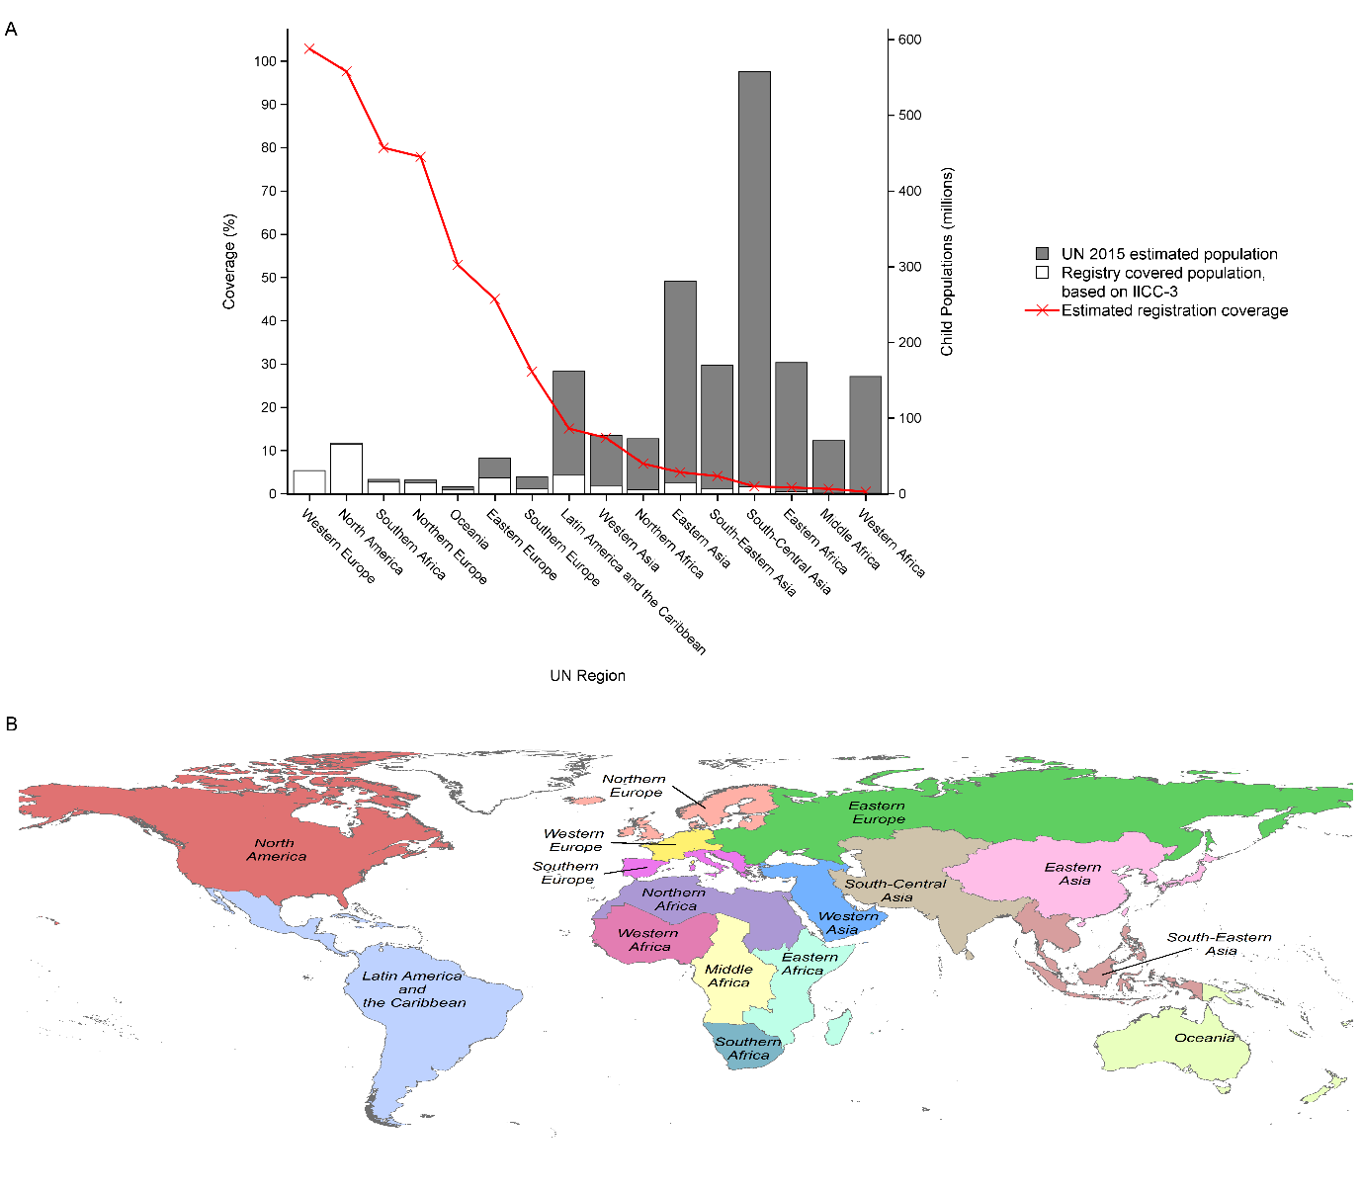
Figure 1 – A) Estimated coverage of regional childhood populations in 2015 by population-based cancer registries contributing to IICC-3. Red line denotes coverage as a percentage and stacked columns depict estimated regional populations of children aged <15 years (millions) in 2015 [19] (filled) and estimated population coverage of registries contributing to IICC-3 (open) [32]. B) United Nations world regions[33].

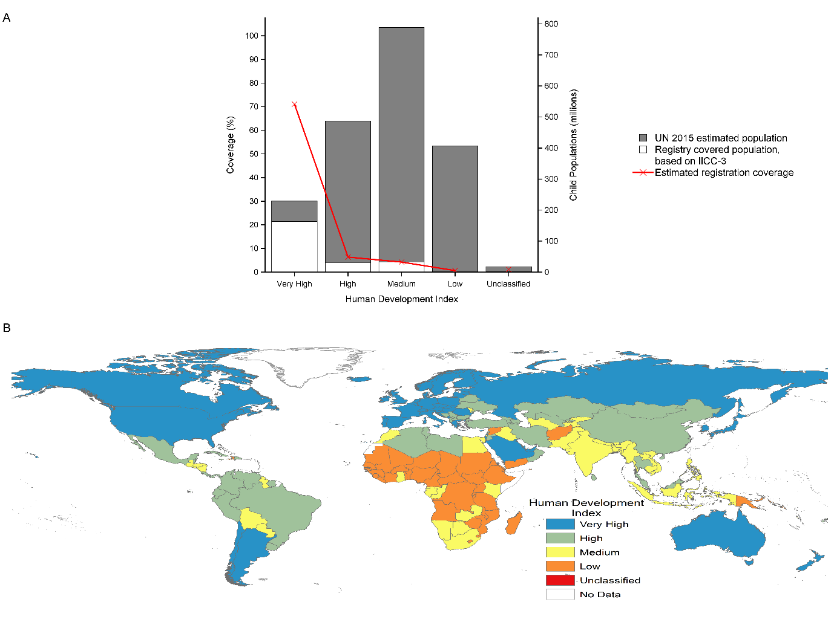
Figure 2 – A) Estimated coverage of childhood populations by human development index (HDI) in 2015 by population-based cancer registries contributing to IICC-3. Red line denotes coverage as a percentage and stacked columns depict estimated populations of children aged <15 years (millions) in 2015 [19] by HDI group (filled) and estimated population coverage of registries contributing to IICC-3 (open) [32]. B) Countries categorised by HDI in 2015[34].

Methods
Population data for 2015 were downloaded from the UN World Population Prospects dataset [19] (https://esa.un.org/unpd/wpp/) and population density estimates from the European Commission’s Global Human Settlement Layer [28] (https://ghsl.jrc.ec.europa.eu/index.php). Cancer incidence data were obtained from four sources: SEER[36] using SEER*Stat software version 8.3.5 [37]; IICC-3 [32] (http://iicc.iarc.fr/results); supplementary information published by Ward and colleagues [23]; and GLOBOCAN 2018 [31] (http://gco.iarc.fr/today).
Malaria arising from infection with Plasmodium falciparum is strongly associated with the distribution of endemic Burkitt lymphoma (eBL) [38] and, to a lesser degree, Kaposi sarcoma (KS) [39–43]. To quantify the relationship between the incidence of these cancers and the proportion of the population at a high risk of P. falciparum infection, cancer incidence data and population density estimates were linked to the estimated spatial distribution of human P. falciparum infection [44,45]. P. falciparum data were downloaded using the Malaria Atlas Project [46] interactive map tool (https://map.ox.ac.uk/explorer/#/), and the resulting regression equations were used to estimate country-specific eBL and KS rates.
The incidence rates in the Baseline Model (BM) were based initially on age-, sex- and ICCC-3 diagnosis-specific rates extracted from SEER data for the year 2014 (see Table S1). Age- and sex-specific rates of BL and KS were augmented with BL and KS rates based on the P. falciparum risk in each country. Thus, all age- and sex-specific incidence rates were assumed to be the same worldwide with the exceptions of those for BL and KS. Full details of the SEER data used and the derivation of the supplemental BL and KS rate are given in the supplement. The numbers of cancers occurring in 2015 were estimated by multiplying the age- sex- and diagnosis-specific rate in the BM by the corresponding age and sex groups in the UN estimated national populations[19].
Estimated numbers of childhood cancers in 2015 arising from the BM were compared to GLOBOCAN and the GCC [23]. To enable comparison of the BM results with IICC-3, age-, sex-, and ICCC-3 diagnosis-specific rates using data from all years from each selected registry (Table S5) were used to estimate the number of childhood cancers nationally in 2015 based on UN population estimates[19].
All incidence rates were determined based on estimated cancers and populations in 2015 apart from the GLOBOCAN estimates which were based on the estimated 2018 populations. Where possible, incidence rates were age-standardised using the WHO (2000-2025) standard population [47]. Ratios of estimated numbers of cancers were used to compare the different methods. The relationships between the Human Development Index and the incidence rates from either the IICC-3 data or the GCC model were estimated using linear regression and Pearson correlation statistics.
BM derivation and comparative analyses were undertaken using the SAS System version 9.4 [48] (The SAS Institute, Cary, NC, USA). Maps were created and spatial data processed using ArcGIS version 10.5.1 [49] (ESRI, Redlands, CA, USA), and common scales and colouring of maps depicting rates, numbers and ratios have been applied throughout. Countries were grouped by United Nations regions (https://population.un.org/wpp/Download/Standard/Population/) and Human Development Index (http://hdr.undp.org/en/data).

Results

Baseline model (BM): estimated childhood cancers in 2015
Application of crude SEER rates to the 2015 global childhood population (Figure S1), yielded a global total of 344,543 cancers (ASR (WHO): 178.0 per million); 56% occurring in Asia and 26% in Africa (Figure S2). Using the augmented BM rates which accounted for the role of exposure to P. falciparum, the expected number increased by 4.5% to 360,114 (186.0 per million); 54% occurring in Asia and 28% in Africa. Driven in part by varying age structures within national child populations (Figure S1), estimated standardised rates ranged from around 178 cases per million (e.g. Europe and North America) through to 218 cases per million (e.g. West and Middle Africa). Estimated numbers and rates are distributed by age, sex, region and HDI in Tables S3 and S4.

Leukaemias were the most common cancer in all regions (28.8% overall, range: 25.6% to 30.4%), followed by CNS tumours (24.0% overall, range: 20.3% to 25.3%) and lymphomas (11.2% overall, range: 8.8% to 17.7%) (Figure 3). Only in those regions most affected by P. falciparum did the distribution of estimated cancers differ: soft tissue sarcomas (which includes KS) were the fourth most common cancer (Figure 3).

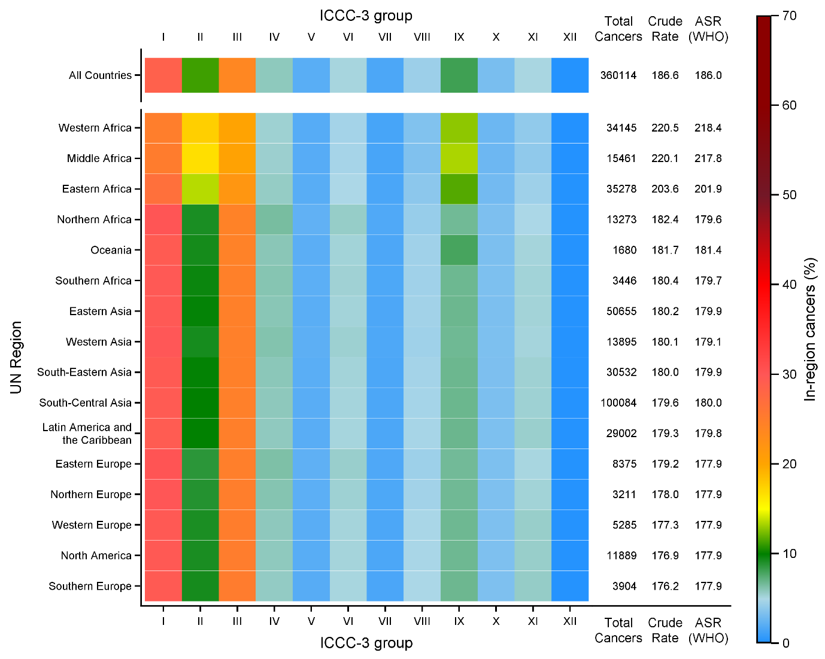
Figure 3 – Estimated incidence in children aged <15 years in 2015, based on the Baseline Model; distribution of estimated cancers by ICCC-3 main diagnostic group showing total cancers and crude and age-standardised (WHO) rates (per million) in UN regions.

GLOBOCAN 2018 and BM estimates compared
The GLOBOCAN estimate for total cancers <15 years is 199,645; 160,469 (44.6%) fewer than the BM. Differences between the regional estimates were largest in Africa and Asia (Table 1). Whilst both methods rank South-Central Asia and Eastern Asia as having the largest numbers of cancers, rankings outside these two regions differ (Figure 4). The GLOBOCAN estimate had proportionally more cancers in countries classified with high/very high HDIs (Table 1, Figure 4).
Only in North America did the GLOBOCAN estimate exceed the BM estimate where there were an additional 61 (0.5%) cases (Table S). This small difference may be due differences in the source data underpinning the two models or may simply reflect year-to-year variability in observed rates; the BM is based on SEER rates from 2014 only.

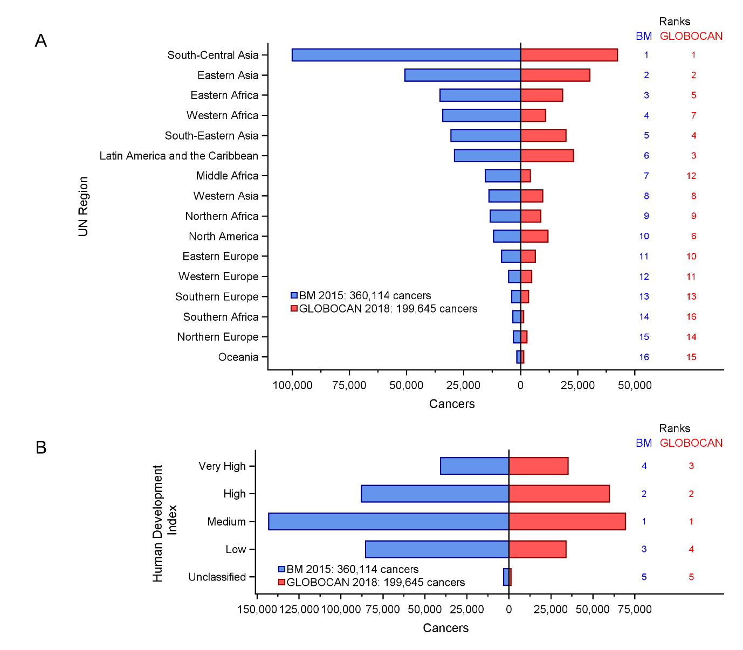
Figure 4 – Estimated numbers of cancers in children aged <15 years by (A) UN Region (B) human development index (HDI) from GLOBOCAN 2018 and the BM for 2015. Regional rankings are indicated on the right.

Table 1: Number of cancer cases among children aged <15 years, as estimated by the Baseline Model (BM) for 2015 and GLOBOCAN 2018 by UN region and the human development index category, ordered by the difference of between the BM and GLOBOCAN estimates.
 |  | Estimated cancers |  |  |  | Difference
 |  | BM (%) |  | GLOBOCAN (%) |  | N | %
World |  | 360,114 | (100.0) | 199,645 | (100.0) | -160,469 | (-44.6)
UN Region | Middle Africa | 15,461 | (4.3) | 4,241 | (2.1) | -11,220 | (-72.6)
 | Western Africa | 34,145 | (9.5) | 10,881 | (5.5) | -23,264 | (-68.1)
 | Southern Africa | 3,446 | (1.0) | 1,324 | (0.7) | -2,122 | (-61.6)
 | South-Central Asia | 100,084 | (27.8) | 42,383 | (21.2) | -57,701 | (-57.7)
 | Eastern Africa | 35,278 | (9.8) | 18,355 | (9.2) | -16,923 | (-48)
 | Eastern Asia | 50,655 | (14.1) | 30,298 | (15.2) | -20,357 | (-40.2)
 | South-Eastern Asia | 30,532 | (8.5) | 19,846 | (9.9) | -10,686 | (-35)
 | Northern Africa | 13,273 | (3.7) | 8,830 | (4.4) | -4,443 | (-33.5)
 | Western Asia | 13,895 | (3.9) | 9,647 | (4.8) | -4,248 | (-30.6)
 | Eastern Europe | 8,375 | (2.3) | 6,381 | (3.2) | -1,994 | (-23.8)
 | Latin America & Caribbean | 29,002 | (8.1) | 23,110 | (11.6) | -5,892 | (-20.3)
 | Oceania | 1,680 | (0.5) | 1,348 | (0.7) | -332 | (-19.7)
 | Northern Europe | 3,211 | (0.9) | 2,766 | (1.4) | -445 | (-13.8)
 | Southern Europe | 3,904 | (1.1) | 3,451 | (1.7) | -453 | (-11.6)
 | Western Europe | 5,285 | (1.5) | 4,834 | (2.4) | -451 | (-8.5)
 | North America | 11,889 | (3.3) | 11,950 | (6.0) | 61 | (0.5)
Human Development Index | Unclassified | 3,156 | (0.9) | 1,256 | (0.6) | -1,900 | (-60.2)
 | Low | 85,370 | (23.7) | 34,019 | (17.0) | -51,351 | (-60.2)
 | Medium | 143,024 | (39.7) | 69,372 | (34.7) | -73,652 | (-51.5)
 | High | 87,822 | (24.4) | 59,775 | (29.9) | -28,047 | (-31.9)
 | Very High | 40,742 | (11.3) | 35,223 | (17.6) | -5,519 | (-13.5)

IICC-3 extrapolations and BM compared
In a single year, the selected registries participating in IICC-3 recorded an average of 31,583 cancers in an estimated childhood population of 231,530,179; the individual registry data contributing to these totals are presented in Table S5. Extrapolating to the participating registries’ national populations (1,279,969,991 children, 2015) yielded a total of 151,435 estimated average annual cancers (Table 2); 80,436 (34.7%) fewer than the BM for the same countries. Age-standardised (WHO) incidence among participating countries was 117.6 cases per million, ranging from 44.1 (South Africa) to 188.1 cases per million (Croatia).
Larger differences in national BM and IICC-3 estimates correlated with larger scaling factors (Table 2); the exception being Southern Africa, where despite the comparatively high estimated childhood population coverage (80%), and correspondingly low scaling factor, the difference in estimated numbers of cancer was 75%. This reflects the fact that the two national registries in this region (South Africa and Botswana) are outliers, reporting the lowest overall crude rates (44.2 and 54.7 cases per million, respectively (Table S5, Figure S9).
Cancer-specific estimates for countries in Middle, Western and Eastern Africa (Figure 5) showed the greatest differences in comparison with the BM (Figure 3); notably lymphomas, soft tissue sarcomas, retinoblastoma and renal tumours were relatively more frequent, and leukaemia and CNS tumours less so in the IICC-3-based estimates. IICC-3 estimates also showed leukaemias as being more common in Latin America and less common in Northern Africa in comparison with BM. The relative frequency of cancers in the other and unspecified diagnostic group (ICCC-3 group XII) was highest in Africa, Asia and Latin America.
Countries with higher HDI had the highest age-standardised rates of neuroblastoma, CNS tumours, leukaemias and germ cell tumours (Figure 6). Conversely, countries with lower HDIs had the highest rates of soft tissue sarcomas (which includes KS), lymphomas (which includes eBL), other and unspecified tumours, and retinoblastoma.
Overall, agreement between IICC-3-based extrapolations and BM estimates was best among countries with high HDIs, the high level of agreement being apparent for most diagnostic groups (Figure 7). As HDI decreased, agreement decreased: BM estimates for leukaemias, CNS tumours, neuroblastoma, and germ cell tumours were larger than the IICC-3 extrapolations. Agreement for numbers of lymphomas and soft tissue sarcomas remained good (Figure 7). Other and unspecified tumours was the only diagnostic group where estimated cancers based on IICC-3 were consistently higher than those of the BM (Figure 7); in 11 countries this was more than ten-fold, most notably Mali (66 times higher) and Uganda (21 times higher).

Table 2 – Estimated numbers of cancers in children aged<15 years in 2015, as derived from the IICC-3 data and the Baseline Model (BM) by UN Region and human development index (HDI); only countries contributing to IICC-3 are included in both estimates, regions ordered by the scaling factor† required to extrapolate IICC-3 registry data to countries with participating registries in each UN region or HDI group.
Region |  | Scaling Factor† | Estimated cancers |  |  |  | Difference
 |  |  | BM (%) |  | IICC-3 (%) |  | N (%)
IICC-3 Countries |  | 5.53 | 231,871 | (100.0) | 151,435 | (100.0) | -80,436 | (-34.7)
UN Region | South-Central Asia | 48.61 | 82,632 | (35.6) | 42,971 | (28.4) | -39,661 | (-48)
 | Eastern Asia | 19.39 | 48,823 | (21.1) | 35,008 | (23.1) | -13,814 | (-28.3)
 | Eastern Africa | 18.21 | 9,466 | (4.1) | 5,749 | (3.8) | -3,717 | (-39.3)
 | Middle Africa | 12.38 | 2,183 | (0.9) | 1,242 | (0.8) | -941 | (-43.1)
 | Western Africa | 11.52 | 1,864 | (0.8) | 1,347 | (0.9) | -517 | (-27.7)
 | Northern Africa | 11.19 | 10,339 | (4.5) | 6,624 | (4.4) | -3,715 | (-35.9)
 | South-Eastern Asia | 9.64 | 12,030 | (5.2) | 7,615 | (5.0) | -4,416 | (-36.7)
 | Latin America & Caribbean | 5.29 | 23,117 | (10.0) | 17,411 | (11.5) | -5,706 | (-24.7)
 | Western Asia | 3.69 | 6,586 | (2.8) | 5,229 | (3.5) | -1,357 | (-20.6)
 | Southern Europe | 2.81 | 3,090 | (1.3) | 2,945 | (1.9) | -145 | (-4.7)
 | Eastern Europe | 2.05 | 7,721 | (3.3) | 5,998 | (4.0) | -1,723 | (-22.3)
 | Oceania | 1.13 | 985 | (0.4) | 833 | (0.6) | -152 | (-15.4)
 | Northern Europe | 1.13 | 2,825 | (1.2) | 2,298 | (1.5) | -527 | (-18.7)
 | Southern Africa | 1.11 | 3,054 | (1.3) | 760 | (0.5) | -2,294 | (-75.1)
 | North America | 1.02 | 11,889 | (5.1) | 10,811 | (7.1) | -1,078 | (-9.1)
 | Western Europe | 0.97 | 5,268 | (2.3) | 4,596 | (3.0) | -673 | (-12.8)
Human Development Index | Medium | 34.65 | 207,782 | (44.8) | 111,218 | (36.7) | -96,563 | (-46.5)
 | Low | 32.44 | 19,238 | (4.1) | 12,310 | (4.1) | -6,928 | (-36)
 | High | 28.19 | 158,079 | (34.1) | 113,909 | (37.6) | -44,170 | (-27.9)
 | Very High | 2.70 | 78,193 | (16.9) | 65,137 | (21.5) | -13,056 | (-16.7)
 | Unclassified | 1.63 | 449 | (0.1) | 296 | (0.1) | -154 | (-34.2)
† Scaling factor = (total 2015 regional or HDI populations in IICC-3 countries based[19])/(sum of average annual populations covered by registries in IICC-3[32])

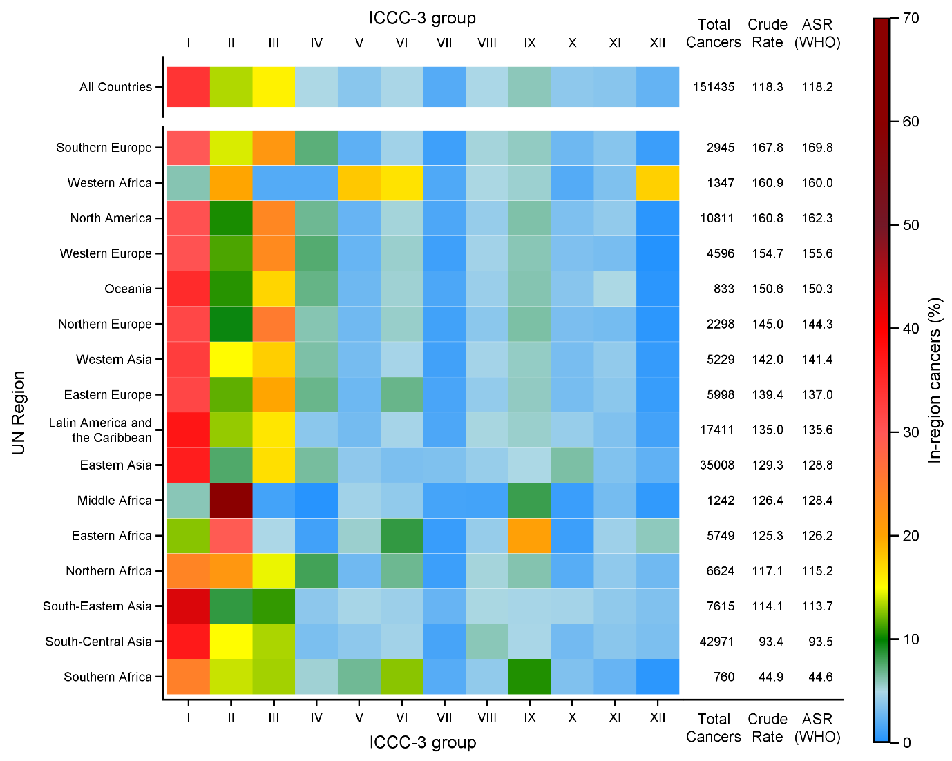
Figure 5 – Estimated incidence in children aged <15 years in 2015, based on IICC-3 reported rates and extrapolated to the countries represented in IICC-3 (Table S5); distribution of estimated cancers by ICCC-3 main diagnostic group showing total cancers and crude and age-standardised (WHO) rates (per million) in UN regions.

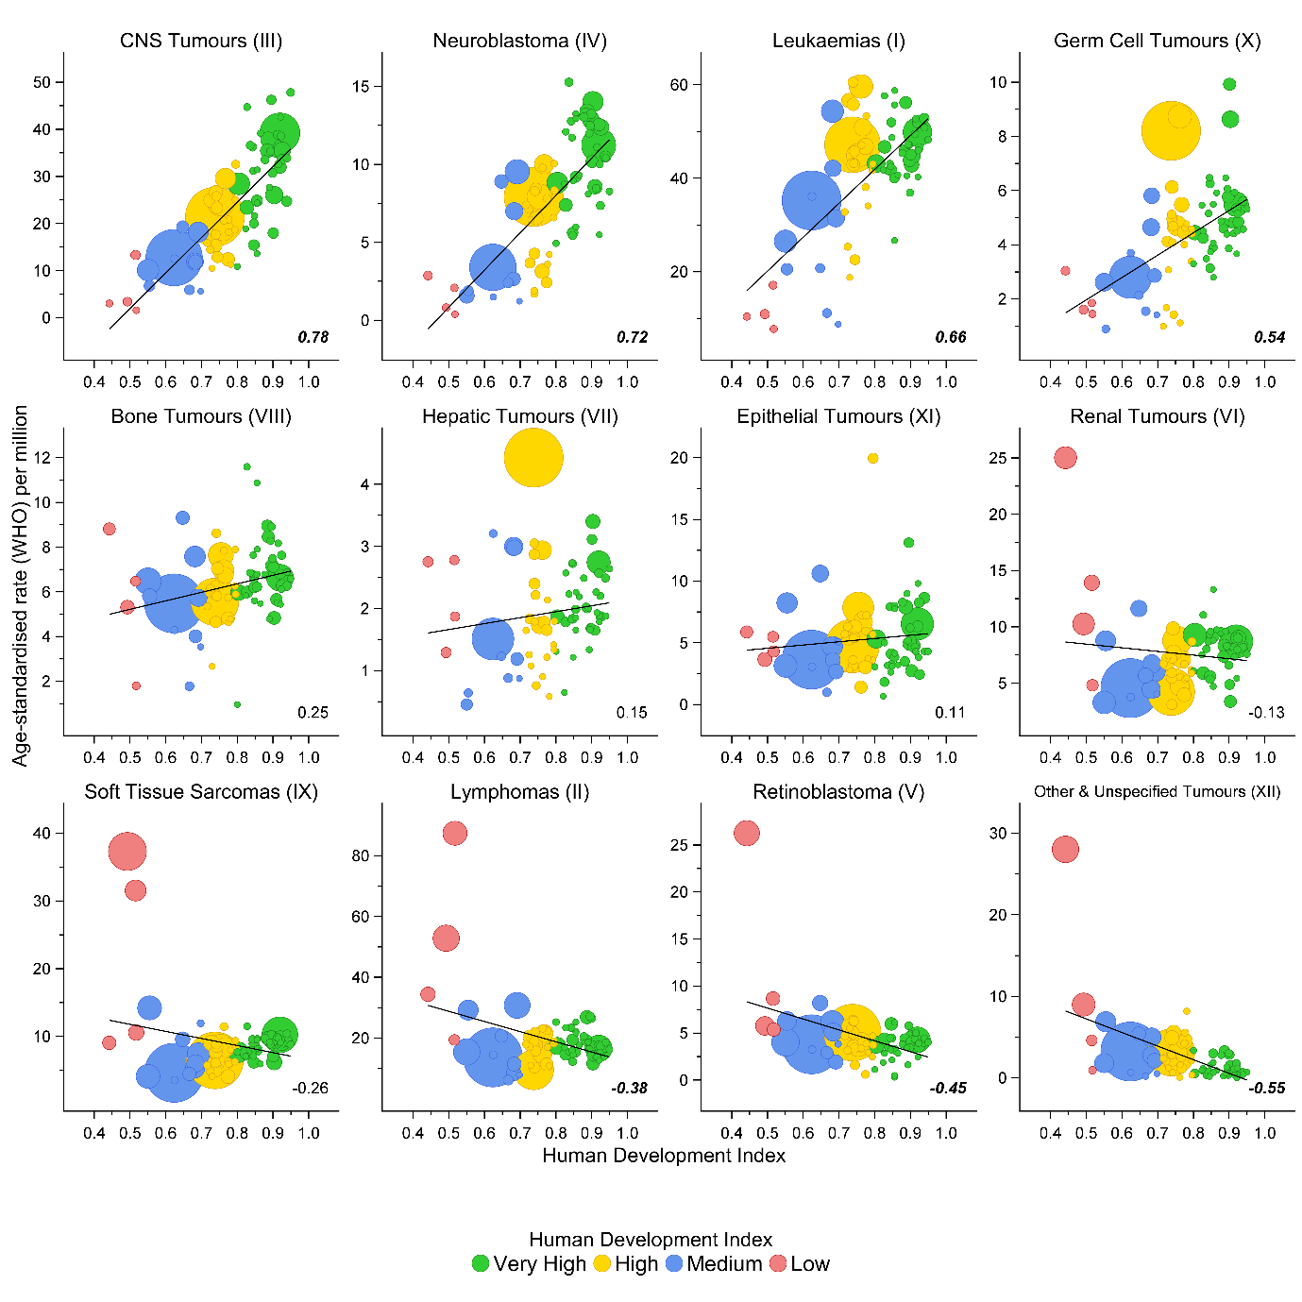
Figure 6 – Age-standardised (WHO) cancer incidence in 2015 based on national extrapolation of data from IICC-3 registries against the 2015 human development index (HDI) by ICCC-3. HDI indicated by colour, with circles proportional to the number of cases. Linear regression line and Pearson correlation values shown, with those in bold having p<0.004 (Bonferroni adjustment).

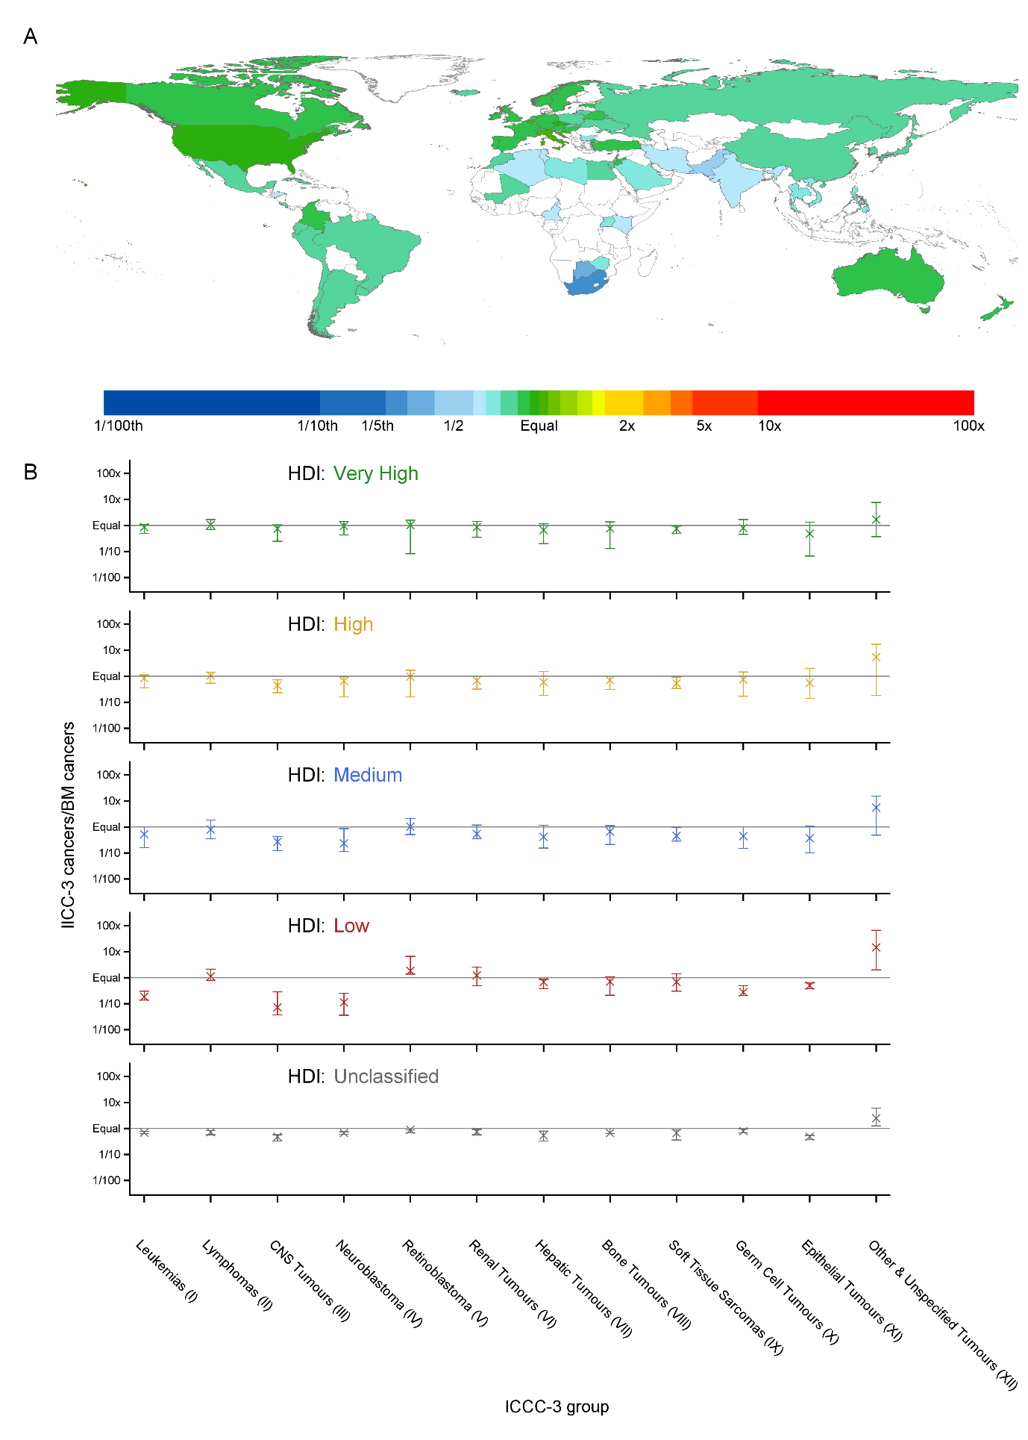
Figure 7 – Country-level ratios of IICC-3-based estimates to BM estimates of childhood cancers in 2015. A) Total cancers, countries coloured by ratio. B) Median and range of ratios for each ICCC-3 main diagnostic group, grouped by human development index (HDI). All ratios have been log10 transformed.

Global Childhood Cancer (GCC) and BM compared
The GCC model estimated a total worldwide childhood cancer incidence of 396,670 cases in 2015 [23]; 36,556 (10.2%) higher than the BM (Table 3). There was widespread agreement at the national level (Figure 8), with BM estimates falling within the GCC 95% uncertainty interval for 121 countries (60.5% of 200 countries in both estimates; Figure S16). Regions where estimates differed most were primarily those requiring larger extrapolations of underpinning IICC-3 rates (Table 3). Most notably Western Africa, where the GCC estimate was nearly twice that of the BM; the IICC-3 scaling factor here was 213.04, more than double that of any other region (Figure 8, Table 3). By contrast, the GCC estimate for Southern Africa was nearly 41% lower than the BM; the IICC-3 scaling factor was only 1.25, similar to countries with very high HDI (Table 3, Figure 8). These two regional differences were reflected in different ranks for these regions (Figure 9).
As expected, regional patterns seen within IICC-3 (Figure 5) were apparent in GCC estimates (Figure 10); leukaemias as the dominating cancer type in many regions. African regions showed fewer leukaemias and more cases of lymphoma, retinoblastoma and other and unspecified tumours. Southern Africa had the lowest estimated childhood cancer incidence, 107.2 cases per million (crude rate; Figure 10).
Agreement between GCC and BM estimates on the level of diagnostic groups varied with HDI (Figure 8). Among countries with high and very high HDI, agreement was generally good. However, in countries with medium and low HDI, the GCC model estimated fewer cases of leukaemia, CNS tumours and neuroblastoma than the BM, but more cancers of other types; particularly retinoblastoma and other and unspecified tumours (Figure 8, Figure S17).

Table 3 – Incidence of cancer in children aged <15 years in 2015 as estimated by the Baseline Model (BM) and the Global Childhood Cancer (GCC) model by UN region and human development index (HDI) ordered by the scaling factor† required to extrapolate IICC-3 registry data to all countries in a UN region or HDI group.
Region |  | Scaling Factor† | Estimated cancers |  |  |  | Difference
 |  |  | BM (%) |  | GCC model (%) |  | N (%)
World |  | 8.34 | 360,114 | (100.0) | 396,670 | (100.0) | 36,556 | (10.2)
UN Region | Western Africa | 213.04 | 34,145 | (9.5) | 66,977 | (16.9) | 32,832 | (96.2)
 | Middle Africa | 88.48 | 15,461 | (4.3) | 20,121 | (5.1) | 4,660 | (30.1)
 | Eastern Africa | 68.77 | 35,278 | (9.8) | 41,599 | (10.5) | 6,321 | (17.9)
 | South-Central Asia | 58.87 | 100,084 | (27.8) | 106,448 | (26.8) | 6,364 | (6.4)
 | South-Eastern Asia | 24.50 | 30,532 | (8.5) | 30,079 | (7.6) | -453 | (-1.5)
 | Eastern Asia | 20.13 | 50,655 | (14.1) | 39,606 | (10.0) | -11,049 | (-21.8)
 | Northern Africa | 14.39 | 13,273 | (3.7) | 15,542 | (3.9) | 2,269 | (17.1)
 | Western Asia | 7.73 | 13,895 | (3.9) | 12,222 | (3.1) | -1,673 | (-12)
 | Latin America & Caribbean | 6.64 | 29,002 | (8.1) | 32,197 | (8.1) | 3,195 | (11)
 | Southern Europe | 3.55 | 3,904 | (1.1) | 3,655 | (0.9) | -249 | (-6.4)
 | Eastern Europe | 2.22 | 8,375 | (2.3) | 7,165 | (1.8) | -1,210 | (-14.5)
 | Oceania | 1.89 | 1,680 | (0.5) | 1,300 | (0.3) | -380 | (-22.6)
 | Northern Europe | 1.28 | 3,211 | (0.9) | 2,504 | (0.6) | -707 | (-22)
 | Southern Africa | 1.25 | 3,446 | (1.0) | 2,047 | (0.5) | -1,399 | (-40.6)
 | North America | 1.02 | 11,889 | (3.3) | 10,882 | (2.7) | -1,007 | (-8.5)
 | Western Europe | 0.97 | 5,285 | (1.5) | 4,326 | (1.1) | -959 | (-18.1)
Human Development Index | Low | 149.84 | 85,370 | (23.7) | 124,708 | (31.4) | 39,338 | (46.1)
 | Medium | 23.72 | 143,024 | (39.7) | 152,545 | (38.5) | 9,521 | (6.7)
 | High | 15.66 | 87,822 | (24.4) | 81,143 | (20.5) | -6,679 | (-7.6)
 | Unclassified | 11.28 | 3,156 | (0.9) | 2,642 | (0.7) | -514 | (-16.3)
 | Very High | 1.41 | 40,742 | (11.3) | 35,632 | (9.0) | -5,110 | (-12.5)
† Scaling factor = (total 2015 regional or HDI population[19])/(sum of average annual populations covered by registries in IICC-3 [32])

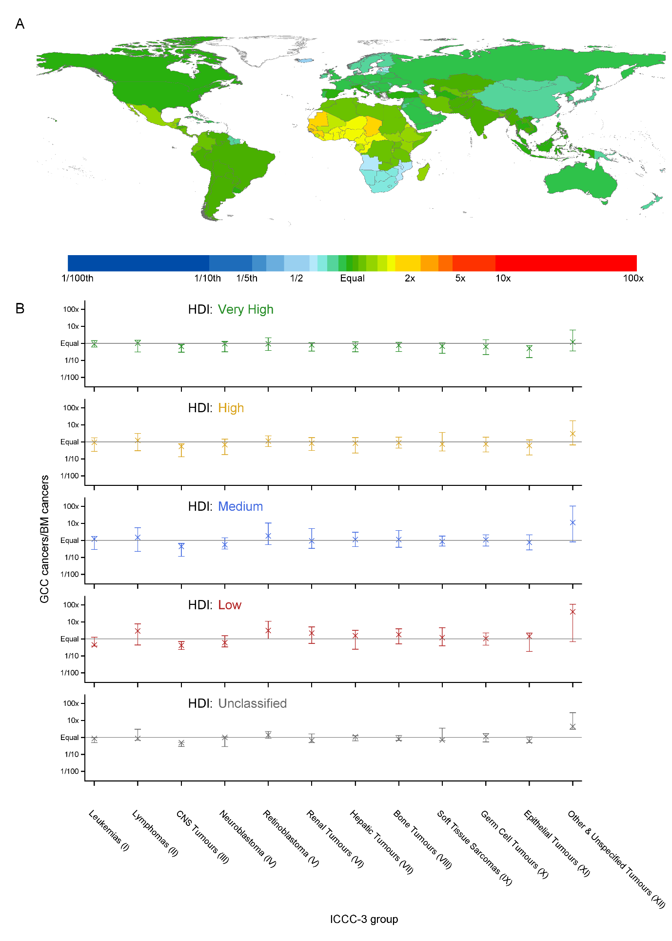
Figure 8 – Country-level ratios of GCC estimates to BM estimates of childhood cancers in 2015. A) Total cancers, countries coloured by ratio. B) Median and range of ratios for each ICCC-3 main diagnostic group, grouped by HDI. All ratios have been log10 transformed.
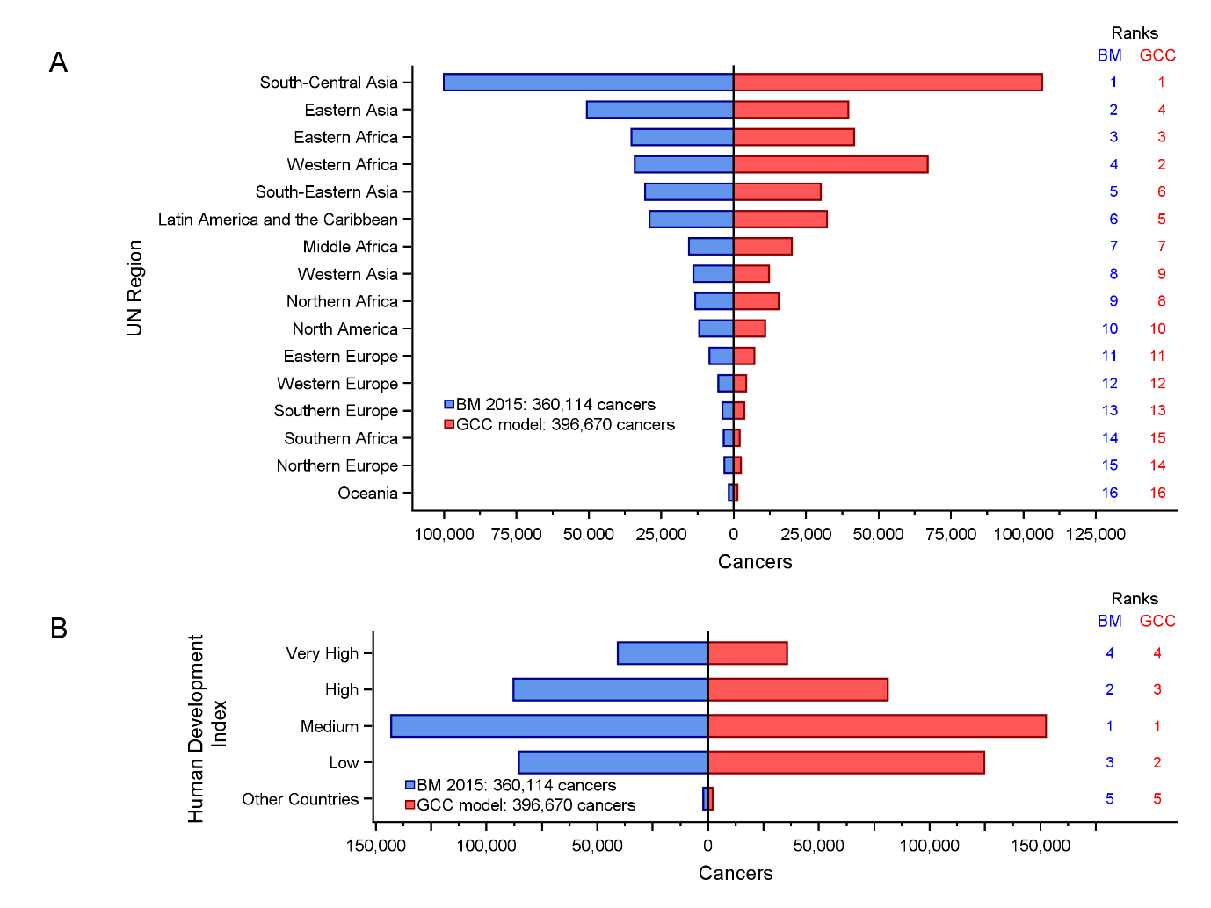
Figure 9 – Estimated numbers of cancers in children aged <15 years in 2015 by (A) UN Region (B) human development index (HDI) from the GCC model and the BM. Regional rankings are indicated on the right.

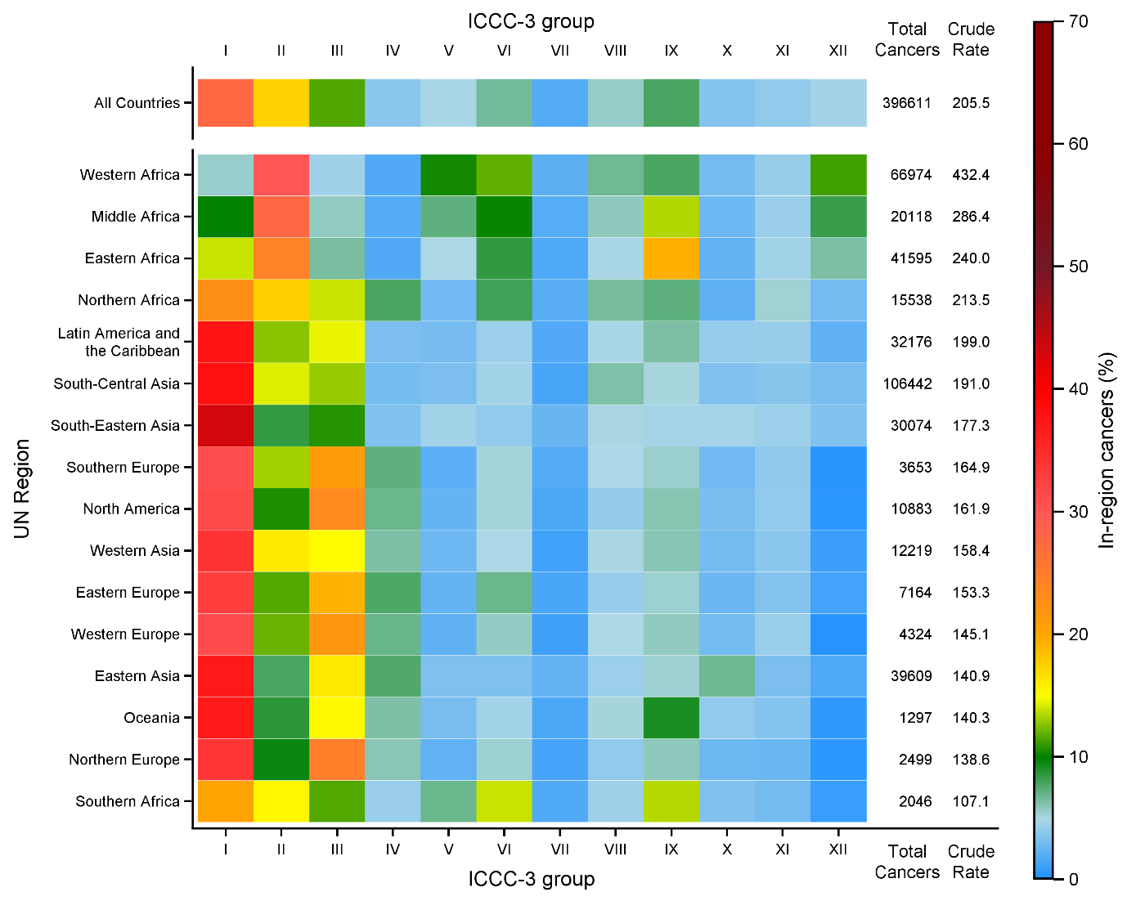
Figure 10 – Estimated incidence in children aged <15 years in 2015, based on the GCC model; distribution of estimated cancers by ICCC-3 main diagnostic group showing total cancers and crude rates (per million) in UN regions. An age-standardised rate could not be determined from the available data.

Discussion
We developed a Baseline Model (BM) of childhood cancer using population-based rates from the US Surveillance, Epidemiology and End Results (SEER) programme, which are broadly similar to those of other countries with good quality registries and high standards of care[18,50]. Aetiological links between some cancers and infectious agents have been established, and two such associations were incorporated into the current version of the BM: augmenting the SEER rates for Burkitt Lymphoma and Kaposi Sarcoma by relating locally observed rates of these cancers to the occurrence of an established risk factor (P. falciparum transmission). Using this model, we estimated that 360,114 cases of cancer would occur among children <15 years in 2015 globally. This estimate represents a significant increase compared to the WHO’s GLOBOCAN project and indicates >40% of childhood cancers may remain undiagnosed worldwide, with most of the undocumented cases occurring in less developed regions.
The main contribution of the BM relates to the incorporation of established aetiological factors into the model. For childhood cancers where such proven determinants are absent, we have assumed that the rates would be broadly similar across the globe. With a projected annual global total of 360,114 in 2015, the BM worldwide estimate is substantially higher than those founded on the global pattern of observed registrations: the 2018 GLOBOCAN estimate being 44.6% lower, and the IICC-3 estimate based on extrapolations for 81 included countries, 34.7% lower (Table 4). While the estimate of 200,000 new childhood cancers in GLOBOCAN is based upon the available data from cancer registries and vital statistics in the countries [1], the 360,000 from the BM also includes additional cases, notably those that might remain undetected in the regions where a large proportion of the population is exposed to endemic P. falciparum infection as well as those that could potentially be diagnosed in a well-functioning health system.
The GLOBOCAN and IICC-3 estimates, to differing degrees, rely on cancers diagnosed and registered from within the health care system. In developing the GCC model, the authors used the IICC-3 rates as a baseline and estimated the levels of underdiagnosis by compensating for reported variations in health care systems [23]. Overall, the resulting GCC estimates, at 396,670, is 50.0% higher than GLOBOCAN and 10.2% higher than the BM (Table 4). The major discrepancies emanated from countries with low HDIs, being particularly pronounced for cancers with complex symptom profiles and no obvious visible presenting signs (e.g. CNS tumours and leukaemias) where diagnosis requires access to highly trained personnel and front-line diagnostics [8].
The GCC African pattern of total cancer rates (Figure S14) is largely due to fact that it was seeded by IICC-3 data; which contains both the highest (Mali), and the lowest (Southern Africa), estimates of total childhood cancer among the IICC-3 registries. Hence, the highest GCC rates were in Western Africa, the region where Mali’s comparatively small Bamako registry rate is the seed used to extrapolate to the entire region; the 16 affected countries includes Nigeria which, with an estimated 79.9 million <15 years in 2015, is the third most populous childhood nation [18,19]. Apart from having a comparatively high overall standardised rate (159.5 per million), which could reflect numerator/denominator incompatibility, the Bamako registry has by far the highest level of other and unspecified cancers (28.2 per million; 56.4 times larger than in SEER) of all IICC-3 datasets, and an unusual cancer distribution; a reflection of the capacity to adequately diagnose cancer in childhood. By contrast, at the other end of the scale, Southern Africa presents the other extreme [18]. With two seed registries, the average annual population of 14,640,692 covered by the South African national paediatric registry, represents 77% of the total childhood population of the Southern Africa region. Hence, cancer rates across the region (5 countries, 19.1 million children) are heavily weighted towards data submitted by South Africa, which has the lowest incidence of all registries accepted to IICC-3 (Figure 8). As both South Africa and Botswana reported data from the whole country (while most other African cancer registries covered urban areas), under-ascertainment from rural areas or under-reporting from certain data sources seems a likely explanation [51].

Table 4 – Summary of inputs and outputs for estimates being compared
Name | Inputs | Extent | Total Cancers
 |  |  | N | Crude Rate  (per million)†
BM | SEER 2014 rates  Modelled P. falciparum incidence  Specific IICC-3 registry data | Worldwide, 2015 | 360,114 | 186.6
GCC | IICC-3 registry data  Health system surveys  WHO indicators | Worldwide,  2015 | 396,670 | 207.7
IICC-3 | Cancer registry data, extrapolated to the represented countries | 81 represented countries, 2015 | 151,435 | 118.3
GLOBOCAN | Cancer registry data and/or national vital statistics | Worldwide, 2018 | 199,645 | 103.4
† Appropriate data to allow age standardisation to the WHO 2000-2025 standard were not available for the GLOBOCAN or GCC model estimates.

A major advantage of the Baseline Model relates to its adaptability and comparatively simple structure; the key components being an initial set of sex-, and age-specific cancer rates and some information on known risk factors for specific cancers. Both elements can be changed: a different set of base rates could be selected or constructed, and further geographically varying risk factors could be added, as and when they emerge. For example, like BL and KS, retinoblastoma has relatively high reported levels in less economically developed regions of the world [18], to the point where rates are in excess of those reported in SEER. In addition, diagnosis is possible based on clinical observations[52], meaning that misdiagnosis is not as likely as for other cancers. As yet, however, clear associations with environmental or lifestyle exposures have yet to be identified and described in the detail required for use in the BM [53–56].
The estimates derived from the BM are reliant on the suitability and accuracy of country-specific population estimates, as well as SEER incidence rates (numerators and denominators). The extent to which variability and uncertainty in these measures will have affected the results is not clear. The model underpinning the World Population Prospects population estimates used in this study is based on a wide range of sources and is expected to be robust to errors in the source data [19]. Nonetheless, systematic under or overestimation of specific subpopulations will affect both observed and expected cancer rates. With respect to SEER, the model used rates averaged across all locations, ethnicities, and socio-demographic groups; hopefully providing robust estimates from a socially and ethnically diverse population, and ameliorating the impact of any systematic errors arising from particular subgroups. However, such an approach could mask potential aetiologic variations. For example, childhood acute lymphoblastic leukaemia incidence rates within SEER tend to vary with ethnicity; rates among those categorized as Hispanic White being twice that of those categorized as non-Hispanic Black, with rates among non-Hispanic Whites and Asians lying between the two [57]. The underpinning reasons for such differences, which could at least be partly due to numerator/denominator incompatibilities, is a topic of current research that may yield results that could be used to refine future BM estimates.
Another key assumption made in constructing the BM is the initial uniformity conferred by the application of age- and sex-specific rates derived by the SEER programme to all countries around the world. As such, the BM’s global geographic patterning is driven by differences in age structure and inclusion of two well-known geographically mediated causal associations: the IICC-3 incidence of BL and KS being correlated with the proportion of the population exposed to P. falciparum. Hence, as presently constructed, the BM takes no account of other potential geographically varying risk factors. Such information can, however, be incorporated once causal mechanisms for other childhood cancer subtypes are more fully elucidated, and data on relevant exposure markers become available.

Conclusions
Using the original baseline model (BM) we estimated that approximately 360,000 cancers occurred in children in 2015 worldwide. These data were derived by imputing identical background incidence of childhood cancer to all world regions and correcting them for an effect of P. falciparum infection according to the known spread of this exposure. Our approach suggests that up to 45% of incident childhood cancers may be undocumented within existing (childhood) cancer surveillance systems. A majority of the children whose cancer diagnoses are missed reside in countries with lower human development index; indicating a need for improved provision, accessibility and utilisation of appropriate diagnostics and care and documentation of diagnosed cases.

References
[1] J. Ferlay, M. Colombet, I. Soerjomataram, et al., Estimating the global cancer incidence and mortality in 2018: GLOBOCAN sources and methods, Int. J. Cancer. 144 (2019) 1941–1953. doi:10.1002/ijc.31937.
[2] R. Saracci, C. Wild, International Agency for Research on Cancer, International Agency for Research on Cancer: the first 50 years, 1965-2015, 2015. http://www.iarc.fr/en/publications/books/iarc50/ (accessed July 3, 2019).
[3] World Health Organization, International Statistical Classification of Diseases and Related Health Problems, ICD-10., Tenth Revision, World Health Organization, Geneva, Switzerland, 1992.
[4] C. AbouZahr, D. de Savigny, L. Mikkelsen, et al., Civil registration and vital statistics: progress in the data revolution for counting and accountability, The Lancet. 386 (2015) 1373–1385. doi:10.1016/S0140-6736(15)60173-8.
[5] I. Magrath, E. Steliarova-Foucher, S. Epelman, et al., Paediatric cancer in low-income and middle-income countries, Lancet Oncol. 14 (2013) e104–e116. doi:10.1016/S1470-2045(13)70008-1.
[6] L. Mikkelsen, D.E. Phillips, C. AbouZahr, et al., A global assessment of civil registration and vital statistics systems: monitoring data quality and progress, The Lancet. 386 (2015) 1395–1406. doi:10.1016/S0140-6736(15)60171-4.
[7] N. Bhakta, L.M. Force, C. Allemani, et al., Childhood cancer burden: a review of global estimates, Lancet Oncol. 20 (2019) e42–e53. doi:10.1016/S1470-2045(18)30761-7.
[8] K. Pritchard-Jones, R. Pieters, G.H. Reaman, et al., Sustaining innovation and improvement in the treatment of childhood cancer: lessons from high-income countries, Lancet Oncol. 14 (2013) e95–e103. doi:10.1016/S1470-2045(13)70010-X.
[9] P. Mahapatra, K. Shibuya, A.D. Lopez, et al., Civil registration systems and vital statistics: successes and missed opportunities, The Lancet. 370 (2007) 1653–1663. doi:10.1016/S0140-6736(07)61308-7.
[10] Levels and Trends in Child Mortality, UNICEF DATA. (2018). https://data.unicef.org/resources/levels-and-trends-in-child-mortality/ (accessed September 11, 2019).
[11] E. Steliarova-Foucher, C. Stiller, B. Lacour, et al., International Classification of Childhood Cancer, third edition, Cancer. 103 (2005) 1457–1467. doi:10.1002/cncr.20910.
[12] A. Fritz, International classification of diseases for oncology : ICD-O, 3rd ed., World Health Organization, Geneva, 2000.
[13] L. Liu, S. Oza, D. Hogan, et al., Global, regional, and national causes of under-5 mortality in 2000-15: an updated systematic analysis with implications for the Sustainable Development Goals, Lancet Lond. Engl. 388 (2016) 3027–3035. doi:10.1016/S0140-6736(16)31593-8.
[14] G.A. Roth, D. Abate, K.H. Abate, et al., Global, regional, and national age-sex-specific mortality for 282 causes of death in 195 countries and territories, 1980–2017: a systematic analysis for the Global Burden of Disease Study 2017, The Lancet. 392 (2018) 1736–1788. doi:10.1016/S0140-6736(18)32203-7.
[15] J. Goudge, L. Gilson, S. Russell, et al., Affordability, availability and acceptability barriers to health care for the chronically ill: Longitudinal case studies from South Africa, BMC Health Serv. Res. 9 (2009) 75. doi:10.1186/1472-6963-9-75.
[16] M.E. Rutherford, K. Mulholland, P.C. Hill, How access to health care relates to under-five mortality in sub-Saharan Africa: systematic review, Trop. Med. Int. Health. 15 (2010) 508–519. doi:10.1111/j.1365-3156.2010.02497.x.
[17] F. Erdmann, M. Feychting, H. Mogensen, et al., Social Inequalities Along the Childhood Cancer Continuum: An Overview of Evidence and a Conceptual Framework to Identify Underlying Mechanisms and Pathways, Front. Public Health. 7 (2019). doi:10.3389/fpubh.2019.00084.
[18] E. Steliarova-Foucher, M. Colombet, L.A.G. Ries, et al., International incidence of childhood cancer, 2001–10: a population-based registry study, Lancet Oncol. 18 (2017) 719–731. doi:10.1016/S1470-2045(17)30186-9.
[19] United Nations DESA / Population Division, World Population Prospects 2017, World Popul. Prospects 2017. (2017). https://population.un.org/wpp/Download/Standard/CSV/ (accessed September 25, 2017).
[20] F. Bray, J. Ferlay, I. Soerjomataram, et al., Global cancer statistics 2018: GLOBOCAN estimates of incidence and mortality worldwide for 36 cancers in 185 countries, CA. Cancer J. Clin. 68 (2018) 394–424. doi:10.3322/caac.21492.
[21] Global Burden of Disease Cancer Collaboration, C. Fitzmaurice, C. Allen, et al., Global, Regional, and National Cancer Incidence, Mortality, Years of Life Lost, Years Lived With Disability, and Disability-Adjusted Life-years for 32 Cancer Groups, 1990 to 2015: A Systematic Analysis for the Global Burden of Disease Study, JAMA Oncol. 3 (2017) 524. doi:10.1001/jamaoncol.2016.5688.
[22] S.C. Howard, M.L. Metzger, J.A. Wilimas, et al., Childhood cancer epidemiology in low-income countries, Cancer. 112 (2008) 461–472. doi:10.1002/cncr.23205.
[23] Z.J. Ward, J.M. Yeh, N. Bhakta, et al., Estimating the total incidence of global childhood cancer: a simulation-based analysis, Lancet Oncol. 20 (2019) 483–493. doi:10.1016/S1470-2045(18)30909-4.
[24] H.S. Park, S. Lloyd, R.H. Decker, et al., Overview of the Surveillance, Epidemiology, and End Results Database: Evolution, Data Variables, and Quality Assurance, Curr. Probl. Cancer. 36 (2012) 183–190. doi:10.1016/j.currproblcancer.2012.03.007.
[25] L.M. Carpenter, R. Newton, D. Casabonne, et al., Antibodies against malaria and Epstein-Barr virus in childhood Burkitt lymphoma: A case-control study in Uganda, Int. J. Cancer. 122 (2008) 1319–1323. doi:10.1002/ijc.23254.
[26] I. Magrath, Denis Burkitt and the African lymphoma, Ecancermedicalscience. 3 (2009). doi:10.3332/ecancer.2009.159.
[27] S.M. Mbulaiteye, R.J. Biggar, K. Bhatia, et al., Sporadic childhood Burkitt lymphoma incidence in the United States during 1992–2005, Pediatr. Blood Cancer. 53 (2009) 366–370. doi:10.1002/pbc.22047.
[28] J. Orem, E.K. Mbidde, B. Lambert, et al., Burkitt’s lymphoma in Africa, a review of the epidemiology and etiology, Afr. Health Sci. 7 (2007) 166–175. doi:10.5555/afhs.2007.7.3.166.
[29] Y. Chang, J. Ziegler, H. Wabinga, et al., Kaposi’s sarcoma-associated herpesvirus and Kaposi’s sarcoma in Africa, Arch. Intern. Med. 156 (1996) 202–204. doi:10.1001/archinte.1996.00440020112014.
[30] M. Dedicoat, R. Newton, Review of the distribution of Kaposi’s sarcoma-associated herpesvirus (KSHV) in Africa in relation to the incidence of Kaposi’s sarcoma, Br. J. Cancer. 88 (2003) 1–3. doi:10.1038/sj.bjc.6600745.
[31] J. Ferlay, M. Ervik, F. Lam, et al., Global Cancer Observatory: Cancer today, Cancer Today. (2018). http://gco.iarc.fr/today (accessed October 18, 2018).
[32] Steliarova-Foucher, E, Colombet, M, Ries, LAG, et al., International Incidence of Childhood Cancer Volume III (electronic version), International Agency for Research on Cancer, Lyon, France, 2017. http://iicc.iarc.fr/results/index.php (accessed September 11, 2017).
[33] UNSD — Methodology, (n.d.). https://unstats.un.org/unsd/methodology/m49/ (accessed June 25, 2019).
[34] United Nations Development Programme, Human Development Report 2016: Human Development for Everyone, UN, 2017. doi:10.18356/b6186701-en.
[35] European Commission, Joint Research Centre (JRC), Columbia University, Center for International Earth Science Information Network - CIESIN, GHS population grid, derived from GPW4, multitemporal (1975, 1990, 2000, 2015), (2015). http://data.europa.eu/89h/jrc-ghsl-ghs_pop_gpw4_globe_r2015a (accessed March 21, 2018).
[36] Surveillance, Epidemiology, and End Results (SEER) Program, SEER*Stat Database: Incidence - SEER 18 Regs Research Data + Hurricane Katrina Impacted Louisiana Cases, Nov 2016 Sub (2000-2014) <Katrina/Rita Population Adjustment> - Linked To County Attributes - Total U.S., 1969-2015 Counties, National Cancer Institute, DCCPS, Surveillance Research Program, released April 2017, based on the November 2016 submission., (2017).
[37] Surveillance Research Program, SEER*Stat Software, National Cancer Institute, 2018. seer.cancer.gov/seerstat.
[38] IARC Working Group on the Evaluation of Carcinogenic Risks to Humans, World Health Organization, International Agency for Research on Cancer, eds., IARC monographs on the evaluation of carcinogenic risks to humans: Malaria and some polyomaviruses (SV40, BK, JC, and Merkel cell viruses), IARC Press, Lyon, France, 2014.
[39] A. Nalwoga, S. Cose, S. Nash, et al., Relationship between anemia, malaria coinfection, and Kaposi sarcoma-associated herpesvirus seropositivity in a population-based study in rural Uganda, J. Infect. Dis. 218 (2018) 1061–1065. doi:10.1093/infdis/jiy274.
[40] A. Nalwoga, S. Cose, K. Wakeham, et al., Association between malaria exposure and Kaposi’s sarcoma-associated herpes virus seropositivity in Uganda, Trop. Med. Int. Health. 20 (2015) 665–672. doi:10.1111/tmi.12464.
[41] R. Newton, N. Labo, K. Wakeham, et al., Determinants of gammaherpesvirus shedding in saliva among Ugandan children and their mothers, J. Infect. Dis. 218 (2018) 892–900. doi:10.1093/infdis/jiy262.
[42] K. Wakeham, E.L. Webb, I. Sebina, et al., Risk factors for seropositivity to Kaposi sarcoma-associated herpesvirus among children in Uganda, J. Acquir. Immune Defic. Syndr. 1999. 63 (2013) 228–233. doi:10.1097/QAI.0b013e31828a7056.
[43] K. Wakeham, E.L. Webb, I. Sebina, et al., Parasite infection is associated with Kaposi’s sarcoma associated herpesvirus (KSHV) in Ugandan women, Infect. Agent. Cancer. 6 (2011) 15. doi:10.1186/1750-9378-6-15.
[44] P.W. Gething, A.P. Patil, D.L. Smith, et al., A new world malaria map: Plasmodium falciparum endemicity in 2010, Malar. J. 10 (2011) 378. doi:10.1186/1475-2875-10-378.
[45] U. Dalrymple, B. Mappin, P.W. Gething, Malaria mapping: understanding the global endemicity of falciparum and vivax malaria, BMC Med. 13 (2015). doi:10.1186/s12916-015-0372-x.
[46] Malaria Atlas Project, Malaria Atlas Project, (2017). https://map.ox.ac.uk/explorer/#/ (accessed March 28, 2018).
[47] O.B. Ahmad, C. Boschi-Pinto, A.D. Lopez, et al., Age Standardization of Rates: A new WHO Standard, (2001) 14.
[48] SAS Institute Inc., SAS software, The SAS Institute, Cary, NC, USA, 2017.
[49] ESRI Inc., ArcGIS Desktop, Environmental Systems Research Institute, Redlands, CA, USA, 2017.
[50] F. Bray, M. Colombet, L. Mery, et al., eds., Cancer Incidence in Five Continents, Vol XI (electronic version), International Agency for Research on Cancer, Lyon, France, 2017. http://ci5.iarc.fr (accessed January 11, 2019).
[51] D.C. Stefan, D.K. Stones, R.D. Wainwright, et al., Childhood cancer incidence in South Africa, 1987-2007, South Afr. Med. J. Suid-Afr. Tydskr. Vir Geneeskd. 105 (2015) 939–947. doi:10.7196/SAMJ.2015.v105i11.9780.
[52] K.M. Waddell, K. Kagame, A. Ndamira, et al., Clinical features and survival among children with retinoblastoma in Uganda, Br. J. Ophthalmol. 99 (2015) 387–390. doi:10.1136/bjophthalmol-2014-305564.
[53] M.L. Hooper, Is sunlight an aetiological agent in the genesis of retinoblastoma?, Br. J. Cancer. 79 (1999) 1273–1276. doi:10.1038/sj.bjc.6690204.
[54] A. Jemal, S.S. Devesa, T.R. Fears, et al., Retinoblastoma incidence and sunlight exposure, Br. J. Cancer. 82 (2000) 1875–1878. doi:10.1054/bjoc.2000.1215.
[55] J. Naru, R. Aggarwal, U. Singh, et al., HPV-16 Detected in One-Fourth Eyes With Retinoblastoma: A Prospective Case-control Study From North India, (2016). doi:info:doi/10.1097/MPH.0000000000000552.
[56] S. Azary, A. Ganguly, G.R. Bunin, et al., Sporadic Retinoblastoma and Parental Smoking and Alcohol Consumption before and after Conception: A Report from the Children’s Oncology Group, PLOS ONE. 11 (2016) e0151728. doi:10.1371/journal.pone.0151728.
[57] J.L. Barrington-Trimis, M. Cockburn, C. Metayer, et al., Trends in Childhood Leukemia Incidence Over Two Decades from 1992–2013, Int. J. Cancer. 140 (2017) 1000–1008. doi:10.1002/ijc.30487.

