The genome of Ectocarpus subulatus – a highly stress-tolerant brown alga
Simon M. Dittami^{1*}, Erwan Corre², Loraine Brillet-Guéguen^{1,2}, Agnieszka P. Lipinska¹, Noé Pontoizeau^{1,2}, Meziane Aite³, Komlan Avia^{1,4}, Christophe Caron^{2†}, Chung Hyun Cho⁵, Jonas Collén¹, Alexandre Cormier¹, Ludovic Delage¹, Sylvie Doubleau⁶, Clémence Frioux³, Angélique Gobet¹, Irene González-Navarrete⁷, Agnès Groisillier¹, Cécile Hervé¹, Didier Jollivet⁸, Hetty KleinJan¹, Catherine Leblanc¹, Xi Liu², Dominique Marie⁸, Gabriel V. Markov¹, André E. Minoche^{7,9}, Misharl Monsoor², Pierre Pericard², Marie-Mathilde Perrineau¹, Akira F. Peters¹⁰, Anne Siegel³, Amandine Siméon¹, Camille Trottier³, Hwan Su Yoon⁵, Heinz Himmelbauer^{7,9,11}, Catherine Boyen¹, Thierry Tonon^{1,12}

¹ Sorbonne Université, CNRS, Integrative Biology of Marine Models (LBI2M), Station Biologique de Roscoff, 29680 Roscoff, France
² CNRS, Sorbonne Université, FR2424, ABiMS platform, Station Biologique de Roscoff, 29680, Roscoff, France
³ Institute for Research in IT and Random Systems - IRISA, Université de Rennes 1, France
⁴ Université de Strasbourg, INRA, SVQV UMR-A 1131, F-68000 Colmar, France
⁵ Department of Biological Sciences, Sungkyunkwan University, Suwon 16419, Republic of Korea
⁶ IRD, UMR DIADE, 911 Avenue Agropolis, BP 64501, 34394 Montpellier, France
⁷ Centre for Genomic Regulation (CRG), The Barcelona Institute of Science and Technology, Dr. Aiguader 88, Barcelona, 08003 Spain
⁸ Sorbonne Université, CNRS, Adaptation and Diversity in the Marine Environment (ADME), Station Biologique de Roscoff (SBR), 29680 Roscoff, France
⁹ Max Planck Institute for Molecular Genetics, 14195 Berlin, Germany
¹⁰ Bezhin Rosko, 40 Rue des Pêcheurs, 29250 Santec, France
¹¹ Department of Biotechnology, University of Natural Resources and Life Sciences (BOKU), Vienna, 1190 Vienna, Austria
¹² Centre for Novel Agricultural Products, Department of Biology, University of York, Heslington, York, YO10 5DD, United Kingdom.
† Deceased

* Correspondence: simon.dittami@sb-roscoff.fr, phone +33 29 82 92 362, fax +33 29 82 92 324.

Abstract
Brown algae are multicellular photosynthetic stramenopiles that colonize marine rocky shores worldwide. Ectocarpus sp. Ec32 has been established as a genomic model for brown algae. Here we present the genome and metabolic network of the closely related species, Ectocarpus subulatus Kützing, which is characterized by high abiotic stress tolerance. Since their separation, both strains show new traces of viral sequences and the activity of large retrotransposons, which may also be related to the expansion of a family of chlorophyll-binding proteins. Further features suspected to contribute to stress tolerance include an expanded family of heat shock proteins, the reduction of genes involved in the production of halogenated defence compounds, and the presence of fewer cell wall polysaccharide-modifying enzymes. Overall, E. subulatus has mainly lost members of gene families down-regulated in low salinities, and conserved those that were up-regulated in the same condition. However, 96% of genes that differed between the two examined Ectocarpus species, as well as all genes under positive selection, were found to encode proteins of unknown function. This underlines the uniqueness of brown algal stress tolerance mechanisms as well as the significance of establishing E. subulatus as a comparative model for future functional studies.

Introduction
Brown algae (Phaeophyceae) are multicellular photosynthetic organisms that are successful colonizers of rocky shores in the world’s oceans. In many places they constitute the dominant vegetation in the intertidal zone, where they have adapted to multiple stressors including strong variations in temperature, salinity, irradiation, and mechanical stress (wave action) over the tidal cycle (Davison and Pearson 1996). In the subtidal environment, brown algae form kelp forests that harbor highly diverse communities (Steneck et al. 2002). They are also harvested as food or for industrial purposes, such as the extraction of alginates (McHugh 2003). The worldwide annual harvest of brown algae has reached 10 million tons in 2014 and is constantly growing (Food and Agriculture Organization of the United Nations 2016). Brown algae share some basic photosynthetic machinery with land plants, but their plastids derived from a secondary or tertiary endosymbiosis event with a red alga, and they belong to an independent lineage of eukaryotes, the stramenopiles (Archibald 2009). This phylogenetic background, together with their distinct habitat, contributes to the fact that brown algae have evolved numerous unique metabolic pathways, life cycle features, and stress tolerance mechanisms.
To enable functional studies of brown algae, strain Ec32 of the small filamentous alga Ectocarpus sp. has been established as a genetic and genomic model (Peters et al. 2004; Heesch et al. 2010; Cock et al. 2010). This strain was formerly described as Ectocarpus siliculosus, but has since been shown to belong to an independent clade by molecular methods (Stache-Crain et al. 1997; Peters et al. 2015). More recently, three additional brown algal genomes, that of the kelp species Saccharina japonica (Ye et al. 2015), that of Cladosiphon okamuranus (Nishitsuji et al. 2016), and that of Nemacystus decipiens (Nishitsuji et al. 2019), have been characterized. Comparisons between these four genomes have allowed researchers to obtain a first overview of the unique genomic features of brown algae, as well as a glimpse of the genetic diversity within this group. However, given the evolutionary distance between these algae, it is difficult to link genomic differences to physiological differences and possible adaptations to their lifestyle. To be able to generate more accurate hypotheses on the role of particular genes and genomic features for adaptive traits, a common strategy is to compare closely related strains and species that differ only in a few genomic features. The genus Ectocarpus is particularly well suited for such comparative studies because it comprises a wide range of morphologically similar but genetically distinct strains and species that have adapted to different marine and brackish water environments (Kützing 1843; Harvey 1848; Stache-Crain et al. 1997; Montecinos et al. 2017). One species within this group, Ectocarpus subulatus Kützing (Peters et al. 2015), comprises isolates highly resistant to elevated temperature (Bolton 1983) and low salinity. A strain of this species was even isolated from freshwater (West and Kraft 1996), constituting one of the handful of known marine-freshwater transitions in brown algae (Dittami et al. 2017).
Here we present the draft genome and metabolic network of a strain of E. subulatus, establishing the genomic basis for its use as a comparative model to study stress tolerance mechanisms, and in particular low salinity tolerance, in brown algae. Similar strategies have been successfully employed in terrestrial plants, where “extremophile” relatives of model- or economically relevant species have been sequenced to explore new stress tolerance mechanisms in the green lineage (Amtmann 2009; Dassanayake et al. 2011; Oh et al. 2012; Dittami and Tonon 2012; Ma et al. 2013; Zeng et al. 2015). The study of the E. subulatus genome, and subsequent comparative analysis with other brown algal genomes, in particular that of Ectocarpus sp. Ec32, provides insights into the dynamics of Ectocarpus genome evolution and divergence, and highlights important adaptive processes, such as a potentially retrotransposon driven expansion of the family of chlorophyll-binding proteins with subsequent diversification. Most importantly, our analyses underline that most of the observed differences between the examined species of Ectocarpus correspond to proteins with yet unknown functions.

Results

Sequencing and assembly of the E. subulatus genome
A total of 34.7Gb of paired-end read data and of 28.8Gb of mate-pair reads (corresponding to 45 million non-redundant mate-pairs) were acquired (Supporting Information Table S1). The final genome assembly size of strain Bft15b was 227Mb (Table 1), and we also obtained 123Mb of bacterial contigs corresponding predominantly to Alphaproteobacteria (50%, with the dominant genera Roseobacter 8% and Hyphomonas 5%), followed by Gammaproteobacteria (18%), and Flavobacteria (13%). The mean sequencing coverage of mapped reads was 67X for the paired-end library, and the genomic coverage was 6.9, 14.4, and 30.4X for the 3kb, 5kb, and 10kb mate-pair libraries, respectively. RNA-seq experiments yielded 8.8Gb of RNA-seq data, of which 96.6% (Bft15b strain in seawater), 87.6% (freshwater strain in seawater), and 85.3% (freshwater strain in freshwater) aligned with the final genome assembly of the Bft15b strain.

Gene prediction and annotation
The number of predicted proteins in E. subulatus was 60% higher than that predicted for Ec32 (Table 1), mainly due to the presence of mono-exonic genes, many of which corresponded to transposases, which were not removed from our predictions, but had been manually removed from the Ec32 genome. Ninety-eight percent of the gene models were supported by at least one associated RNA-seq read, and 92% were supported by at least ten reads, with lowly-expressed (<10 reads) genes being generally shorter (882 vs 1,403 bases), and containing fewer introns (2.6 vs 5.7). In 7.3% of all predicted proteins we detected a signal peptide, and 3.7% additionally contained an ‘ASAFAP’-motif (Supporting Information Table S2) indicating that they are likely targeted to the plastid(Gruber et al. 2015). Overall the BUSCO (Simão et al. 2015) analyses indicate that the E. subulatus genome is 86% complete (complete and fragmented genes) and 91% when not considering proteins also absent from all other currently sequenced brown algae (Table 1).

Repeated elements
Thirty percent of the E. subulatus genome consisted of repeated elements. The most abundant groups of repeated elements were large retrotransposon derivatives (LARDs), followed by long terminal repeats (LTRs, predominantly Copia and Gypsy), and long and short interspersed nuclear elements (LINEs, Figure 1A). The overall distribution of sequence identity levels within superfamilies showed two peaks, one at an identity level of 78-80%, and one at 96-100% (Figure 1C). An examination of transposon conservation at the level of individual families revealed a few families that follow this global bimodal distribution (e.g. TIR B343 or LARD B204), while the majority exhibited a unimodal distribution with peaks either at high (e.g. LINE R15) or at lower identity levels (e.g. LARD B554) (Figure 1C). Terminal repeat retrotransposons in miniature (TRIM) and LARDs, both non-autonomous groups of retrotransposons, were among the most conserved families. A detailed list of transposons is provided in Supporting Information Table S3. In line with previous observations carried out in Ectocarpus sp. Ec32, no methylation was detected in the E. subulatus genomic DNA.

Organellar genomes
Plastid and mitochondrial genomes from E. subulatus have 95.5% and 91.5% sequence identity with their Ectocarpus sp. Ec32 counterparts in the conserved regions respectively. Only minor structural differences were observed between organellar genomes of both Ectocarpus genomes, as detailed in Supporting Information Text S1.

Global comparison of predicted proteomes

Metabolic network-based comparisons
Similar to the network previously obtained for Ectocarpus sp. Ec32 (Prigent et al. 2014), the E. subulatus Bft15b metabolic network comprised 2,074 metabolic reactions and 2,173 metabolites in 464 pathways, which can be browsed at http://gem-aureme.irisa.fr/sububftgem. In total, 2,445 genes associated with at least one metabolic reaction, and 215 pathways were complete (Figure 2). Comparisons between both networks were carried out on a pathway level (Supporting Information Text S1, Section “Metabolic network-based comparisons”), but no pathways were found to be truly specific to either Ec32 and/or Bf15b.

Genes under positive selection
Out of the 2,311 orthogroups with single-copy orthologs that produced high quality alignments, 172 gene pairs (7.4%) exhibited dN/dS ratios > 0.5 (Supporting Information Table S4). Among these, only eleven (6.4%) were found to fit significantly better with the model allowing for positive selection in the Ectocarpus branch. These genes are likely to have been under positive selection, and two of them contained a signal peptide targeting the plastid. All of them are genes specific to the brown algal lineage with unknown function, and only two genes contained protein domains related to a biochemical function (one oxidoreductase-like domain, and one protein prenyltransferase, alpha subunit). However, all of them were expressed at least in E. subulatus Bft15b. There was no trend for these genes to be located in specific regions of the genome (all except two for Ectocarpus sp. Ec32 were on different scaffolds) and none of the genes were located in the pseudoautosomal region of the sex chromosome.

Genes specific to either Ectocarpus genome, and expanded genes and gene families
After manual curation based on tblastn searches to eliminate artefacts arising from differences in the gene predictions, 184 expanded gene clusters and 1,611 predicted proteins were found to be specific to E. subulatus compared to Ectocarpus sp., while 449 clusters were expanded and 689 proteins were found specifically in the latter (Figure 2, Supporting Information Table S5). This is far less than the 2,878 and 1,093 unique clusters found for a recent comparison of N. decipiens and C. okamuranus (Nishitsuji et al. 2019). Gene set enrichment analyses revealed no GO categories to be significantly over-represented among the genes unique to or expanded in E. subulatus Bft15b, but several categories were over-represented among the genes and gene families specific to or expanded in the Ectocarpus sp. Ec32 strain. Many were related either to signalling pathways or to the membrane and transporters (Figure 2), but it is difficult to distinguish between the effects of a potentially incomplete genome assembly and true gene losses in Bft15b. In the manual analyses we therefore focussed on the genes specific to and expanded in E. subulatus.
Among the 1,611 E. subulatus-specific genes, 1,436 genes had no homologs (e-value < 1e-5) in the UniProt database as of May 20th 2016: they could thus, at this point in time, be considered lineage-specific and had no function associated to them. Among the remaining 175 genes, 145 had hits (e-value < 1e-5) in Ectocarpus sp. Ec32, i.e. they likely correspond to multi-copy genes that had diverged prior to the separation of Ectocarpus and S. japonica, and for which the Ectocarpus sp. Ec32 and S. japonica orthologs were lost. Thirteen genes had homology only with uncharacterized proteins or were too dissimilar from characterized proteins to deduce hypothetical functions; another eight probably corresponded to short viral sequences integrated into the algal genome (EsuBft1730_2, EsuBft4066_3, EsuBft4066_2, EsuBft284_15, EsuBft43_11, EsuBft551_12, EsuBft1883_2, EsuBft4066_4), and one (EsuBft543_9) was related to a retrotransposon. Two adjacent genes (EsuBft1157_4, EsuBft1157_5) were also found in diatoms and may be related to the degradation of cellobiose and the transport of the corresponding sugars. Two genes, EsuBft1440_3 and EsuBft1337_8, contained conserved motifs (IPR023307 and SSF56973) typically found in toxin families. Two more (EsuBft1006_6 and EsuBft308_11) exhibited low similarities to animal and fungal transcription factors, and the last (EsuBft36_20 and EsuBft440_20) consisted almost exclusively of short repeated sequences of unknown function (“ALEW” and “GAAASGVAGGAVVVNG”, respectively). In total, 1.7% contained a signal peptide targeting the plastid, i.e. significantly less than the 3.7% in the entire dataset (Fisher exact test, p<0.0001).
The large majority of Ectocarpus sp. Ec32-specific proteins (511) also corresponded to proteins of unknown function without matches in public databases. Ninety-seven proteins were part of the E. siliculosus virus-1 (EsV-1) inserted into the Ec32 genome and the remaining 81 proteins were poorly annotated, usually only via the presence of a domain. Examples are ankyrin repeat-containing domain proteins (12), Zinc finger domain proteins (6), proteins containing wall sensing component (WSC) domains (3), protein kinase-like proteins (3), and Notch domain proteins (2).
Regarding the 184 clusters of expanded genes in E. subulatus, 139 (1,064 proteins) corresponded to proteins with unknown function, 98% of which were found only in Ectocarpus. Furthermore, nine clusters (202 proteins) represented sequences related to transposons predicted in both genomes, and eight clusters (31 proteins) were similar to known viral sequences. Only 28 clusters (135 proteins) could be roughly assigned to biological functions (Table 2). They comprised proteins potentially involved in modification of the cell-wall structure (including sulfation), in transcriptional regulation and translation, in cell-cell communication and signalling, as well as a few stress response proteins, notably a set of HSP20s, and several proteins of the light-harvesting complex (LHC) potentially involved in non-photochemical quenching. Only 0.6% of all genes expanded in Bft15b contained a signal peptide targeting the plastid, i.e. significantly less than the 3.7% in the entire dataset (Fisher exact test, p<0.0001).
Striking examples of likely expansions in Ectocarpus sp. Ec32 or reduction in E. subulatus Bft15b were different families of serine-threonine protein kinase domain proteins present in 16 to 25 copies in Ec32 compared to only 5 or 6 in Bft15b, Kinesin light chain-like proteins (34 vs. 13 copies), two clusters of Notch region containing proteins (11 and 8 vs. 2 and 1 copies), a family of unknown WSC domain containing proteins (8 copies vs. 1), putative regulators of G-protein signalling (11 vs. 4 copies), as well as several expanded clusters of unknown and viral proteins. However, these results need to be taken with caution because the E. subulatus Bft15b genome was less complete than that of Ectocarpus sp. Ec32.

Correlation with gene expression patterns
To assess whether genomic adaptations in E. subulatus Bft15b were located preferentially in genes that are known to be responsive to salinity stress, we compared expanded gene families to previously available expression data obtained for a freshwater strain of E. subulatus grown in freshwater vs seawater (Dittami et al. 2012). This analysis revealed that genes that were down-regulated in response to low salinity were significantly over-represented among the gene families expanded in Ectocarpus sp. Ec32 or reduced in E. subulatus Bft15b, (42% of genes vs 26% for all genes; Fischer exact test p=0.0002), while genes that were upregulated in response to low salinity were significantly under-represented (25% vs 33%; Fischer exact test p=0.006; Figure 3, Supporting Information Table S6). This indicates that E. subulatus Bft15b has mainly lost members of gene families that were generally down-regulated in low salinities, and conserved those that were upregulated in this condition.

Targeted manual annotation of specific pathways
In addition to the global analyses carried out above, genes related to cell wall metabolism, sterol metabolism, polyamine and central carbon metabolism, algal defence metabolites, transporters, and abiotic stress response were manually examined and annotated, because, based on literature studies, these functions could be expected to explain the physiological differences between E. subulatus Bft15b and Ectocarpus sp. Ec32. Overall the differences between both Ectocarpus strains with respect to these genes were minor; a detailed description of these results is available in Supporting Information Text S1 and Supporting Information Table S7, and a brief overview of the main differences is presented below.
Regarding gene families reduced in E. subulatus Bft15b or expanded in Ectocarpus sp. Ec32, the E. subulatus genome encoded only 320 WSC-domain containing proteins, vs. 444 in Ectocarpus sp.. Many of these genes were down-regulated in response to low salinity, (61% of the WSC domain containing genes with available expression data; Fischer exact test, p=0.0004) while only 7% were upregulated (Fischer exact test, p-value=0.0036). In yeast, WSC domain proteins may act as cell surface mechanosensors and activate the intracellular cell wall integrity signalling cascade in response to hypo-osmotic shock (Gualtieri et al. 2004). Whether or not they have similar functions in brown algae, however, remains to be established. Furthermore, we found fewer aryl sulfotransferase, tyrosinases, potential bromoperoxidases, and thyroid peroxidases in the E. subulatus genome compared to Ectocarpus sp., and it entirely lacks haloalkane dehalogenases (Supporting Information Text S1). All of these enzymes are involved in the production of polyphenols and halogenated defence compounds, suggesting that E. subulatus may be investing less energy in defence, although a potential bias induced by differences in the assembly completeness cannot be excluded here.
Regarding gene families expanded in E. subulatus Bft15b or reduced in Ectocarpus sp. Ec32, we detected differences with respect to a few “classical” stress response genes. Notably an HSP20 protein was present in three copies in the genome of E. subulatus and only one copy in Ectocarpus sp.. We also found a small group of LHCX-family chlorophyll-binding proteins (CBPs) as well as a larger group belonging to the LHCF/LHCR family that have probably undergone a recent expansion in E. subulatus (Figure 4). Some of the proteins appeared to be truncated (marked with asterisks), but all of them were associated with RNA-seq reads, suggesting that they may be functional. A number of these proteins were also flanked by LTR-like sequences. CBPs have been reported to be up-regulated in response to abiotic stress in stramenopiles (Zhu and Green 2010; Dong et al. 2016), including Ectocarpus (Dittami et al. 2009), probably as a way to deal with excess light energy when photosynthesis is affected.

Discussion
Here we present the draft genome and metabolic network of E. subulatus strain Bft15b, a brown alga which, compared to Ectocarpus sp. Ec32, is characterized by high abiotic stress tolerance (Bolton 1983; Peters et al. 2015). Based on time-calibrated molecular trees, both species separated roughly 16 Mya (Dittami et al. 2012), i.e. slightly before the split between Arabidopsis thaliana and Thellungiella salsuginea (7-12 Mya) (Wu et al. 2012). This split was probably followed by an adaptation of E. subulatus to highly fluctuating and low salinity habitats (Dittami et al. 2017).

Traces of recent transposon activity and integration of viral sequences
The E. subulatus Bft15b genome is only approximately 6% (flow cytometry) to 23% (genome assembly) larger than that of Ectocarpus sp. Ec32, and no major genomic rearrangements or duplications were detected. However, we observed traces of recent transposon activity, especially from LTR transposons, which is in line with the absence of DNA methylation. Bursts in transposon activity have been identified as one potential driver of local adaptation and speciation in other model systems such as salmon (de Boer et al. 2007) or land plants (Hu et al. 2011; Wu et al. 2012). Furthermore, LTRs are known to mediate the retrotransposition of individual genes, leading to the duplication of the latter (Tan et al. 2016). In E. subulatus Bft15b, only a few expansions of gene families were observed since the separation from Ectocarpus sp. Ec32, and only in the case of the recent expansion of the LHCR family were genes flanked by a pair of LTR-like sequences. These elements lacked both the group antigen (GAG) and reverse transcriptase (POL) proteins, which implies that, if retro-transposition was the mechanism underlying the expansion of this group of proteins, it would have depended on other active transposable elements to provide these activities.
A second factor that has shaped the Ectocarpus genomes were viruses. Viral infections are a common phenomenon in Ectocarpales (Müller et al. 1998), and a well-studied example is the Ectocarpus siliculosus virus-1 (EsV-1) (Delaroque et al. 2001). It was found to be present latently in several strains of Ectocarpus sp. closely related to strain Ec32, and has also been found integrated in the genome of the latter, although it is not expressed (Cock et al. 2010). As previously indicated by comparative genome hybridization experiments (Dittami et al. 2011), the E. subulatus Bft15b genome does not contain a complete EsV-1 like insertion, although a few shorter EsV-1-like proteins were found. Thus, the EsV-1 integration observed in Ectocarpus sp. Ec32 has likely occurred after the split with E. subulatus, and the biological consequences of this insertion remain to be explored.

Few classical stress response genes but no transporters involved in adaptation
One aim of this study was to identify genes that may potentially be responsible for the high abiotic stress and salinity tolerance of E. subulatus. Similar studies on genomic adaptation to changes in salinity or to drought in terrestrial plants have previously highlighted genes generally involved in stress tolerance to be expanded in “extremophile” organisms. Examples are the expansion of catalase, glutathione reductase, and heat shock protein families in desert poplar (Ma et al. 2013), arginine metabolism in jujube (Liu et al. 2014), or genes related to cation transport, abscisic acid signalling, and wax production in T. salsuginea (Wu et al. 2012). In our study, we found that gene families reduced in E. subulatus Bft15b compared to the marine Ectocarpus sp. Ec32 model have previously been shown to be repressed in response to stress, whereas gene families up-regulated in response to stress had a higher probability of being conserved. However, there are only few signs of known stress response gene families among them, notably the two additional HSP20 proteins and an expanded family of CBPs. E. subulatus Bft15b also has a slightly reduced set of genes involved in the production of halogenated defence compounds that may be related to its habitat preference: it is frequently found in brackish and even freshwater environments with low availability of halogens. It also specializes in habitats with high levels of abiotic stress compared to most other brown algae, and may thus invest less energy in defence against biotic stressors.
Another anticipated adaptation to life in varying salinities lies in modifications of the cell wall. Notably, the content of sulfated polysaccharides is expected to play a crucial role as these compounds are present in all marine plants and algae, but absent in their freshwater relatives (Kloareg and Quatrano 1988; Popper et al. 2011). The fact that we found only small differences in the number of encoded sulfatases and sulfotransferases indicates that the absence of sulfated cell-wall polysaccharides previously observed in E. subulatus in low salinities (Torode et al. 2015) is probably a regulatory effect or simply related to the lack of sulfate in low salinity. This is also coherent with the wide distribution of E. subulatus in marine, brackish water, and freshwater environments.
Finally, transporters have previously been described as a key element in plant adaptation to different salinities (Rao et al. 2016). Similar results have also been obtained for Ectocarpus in a study of quantitative trait loci (QTLs) associated with salinity and temperature tolerance (Avia et al. 2017). In our study, however, we found no indication of genomic differences related to transporters between the two species. This observation corresponds to previous physiological experiments indicating that Ectocarpus, unlike many terrestrial plants, responds to strong changes in salinity as an osmoconformer rather than an osmoregulator, i.e. it allows the intracellular salt concentration to adjust to values close to the external medium rather than keeping the intracellular ion composition constant (Dittami et al. 2009).

Species-specific genes of unknown function are likely to play a dominant role in adaptation
In addition to genes that may be directly involved in the adaptation to the environment, we found several gene clusters containing domains potentially involved in cell-cell signalling that were expanded in the Ectocarpus sp. Ec32 genome (Table 2), e.g. a family of ankyrin repeat-containing domain proteins (Mosavi et al. 2004). These observed differences may be, in part, responsible for the existing pre-zygotic reproductive barrier between the two examined species of Ectocarpus (Lipinska et al. 2016).
The vast majority of genomic differences between the two investigated species of Ectocarpus, however, corresponds to proteins of entirely unknown functions. All of the 11 gene pairs under positive selection were unknown genes taxonomically restricted to brown algae. Of the 1,611 E. subulatus Bft15b-specific genes, 88% were unknown. Most of these genes were expressed and are thus likely to correspond to true genes; their absence from the Ectocarpus sp. Ec32 genome was also confirmed at the nucleotide level. A large part of the mechanisms that underlie the adaptation to different ecological niches in Ectocarpus may, therefore, lie in these genes of unknown function. This can be partly explained by the fact that still only few brown algal genomes have been sequenced, and that currently most of our knowledge on the function of their proteins is based on studies in model plants, animals, yeast, or bacteria, which have evolved independently from stramenopiles for over 1 billion years (Yoon et al. 2004). They differ from land plants even in otherwise highly conserved aspects, for instance in their life cycles, cell walls, and primary metabolism (Charrier et al. 2008). Substantial contributions of lineage-specific genes to the evolution of organisms and the development of innovations have also been described for animal models (Tautz and Domazet-Lošo 2011), and studies in basal metazoans furthermore indicate that they are essential for species-specific adaptive processes (Khalturin et al. 2009).
Despite the probable importance of these unknown genes for local adaptation, Ectocarpus may still heavily rely on classical stress response genes for abiotic stress tolerance. Many of the gene families known to be related to stress response in land plants (including transporters and genes involved in cell wall modification), and for which no significant differences in gene contents were observed, have previously been reported to be strongly regulated in response to environmental stress in Ectocarpus (Dittami et al. 2009, 2012; Ritter et al. 2014). This high transcriptomic plasticity is probably one of the features that allow Ectocarpus to thrive in a wide range of environments, and may form the basis for its capacity to further adapt to “extreme environments” such as freshwater (West and Kraft 1996).

Conclusion and future work
We have shown that since the separation of E. subulatus and Ectocarpus sp. Ec32, both genomes have been shaped partially by the activity of viruses and transposons, particularly large retrotransposons. Over this period of time, E. subulatus has adapted to environments with high abiotic variability including brackish water and even freshwater. We have identified a few genes that likely contribute to this adaptation, including HSPs, CBPs, a reduction of genes involved in halogenated defence compounds, or some changes in cell wall polysaccharide-modifying enzymes. However, the majority of genes that differ between the two examined Ectocarpus species or that may be under positive selection encode proteins of unknown function. This underlines the fundamental differences that exist between brown algae and terrestrial plants or other lineages of algae. Studies as the present one, i.e. without strong a priori assumptions about the mechanisms involved in adaptation, are therefore essential to start elucidating the specificities of this lineage as well as the various functions of the unknown genes.

Methods
Biological material. Haploid male parthenosporophytes of E. subulatus strain Bft15b (Culture Collection of Algae and Protozoa CCAP accession 1310/34), isolated in 1978 (exact collection date unknown) by Dieter G. Müller form an intertidal mudflat in vicinity of Duke Marine Station (34.716561,-76.6744956), Beaufort, North Carolina, USA, were grown in 14 cm (100 ml) Petri Dishes in Provasoli-enriched seawater (Starr and Zeikus 1993) under a 14/10 daylight cycle at 14°C. Strains were exanimated by light microscopy (800X magnification, phase contrast) to ensure that they were free of contaminating eukaryotes, but did still contain some alga-associated bacteria. Approximately 1 g fresh weight of algal culture was dried on a paper towel and immediately frozen in liquid nitrogen. For RNA-seq experiments, in addition to Bft15b, a second strain of E. subulatus, the diploid freshwater strain CCAP 1310/196 isolated from Hopkins River Falls, Australia (West and Kraft 1996), was included. One culture was grown as described above for Bft15b, and for a second culture, seawater was diluted 20-fold with distilled water prior to the addition of Provasoli nutrients (Dittami et al. 2012) (culture condition referred to as freshwater).
Flow cytometry experiments to measure nuclear DNA contents were carried out as previously described (Bothwell et al. 2010), except that young sporophyte tissue was used instead of gametes. Samples of the genome-sequenced Ectocarpus sp. strain Ec32 (CCAP accession 1310/4 from San Juan de Marcona, Peru) were run in parallel as a size reference.
DNA and RNA were extracted using a phenol-chloroform-based protocol (Le Bail et al. 2008). For DNA sequencing, four Illumina libraries were prepared and sequenced on a HiSeq2000: one paired-end library (Illumina TruSeq DNA PCR-free LT Sample Prep kit #15036187, sequenced with 2x100 bp read length), and three mate-pair libraries with span sizes of 3kb, 5kb, and 10kb respectively (Nextera Mate Pair Sample Preparation Kit; sequenced with 2x50bp read length). One poly-A enriched RNA-seq library was generated for each of the three aforementioned cultures according to the Illumina TruSeq Stranded mRNA Sample Prep kit #15031047 protocol and sequenced with 2x50 bp read length.
The degree of DNA methylation was examined by HPLC on CsCl-gradient purified DNA (Le Bail et al. 2008) from three independent cultures per strain as previously described (Rival et al. 2013).
Redundancy of mate-pairs (MPs) was reduced to mitigate the negative effect of redundant chimeric MPs during scaffolding. To this means, mate-pair reads were aligned with bwa-0.6.1 to a preliminary E. subulatus Bft15b draft assembly calculated from paired-end data only. Mate-pairs that did not map with both reads were removed, and for the remaining pairs, read-starts were obtained by parsing the cigar string using Samtools and a custom Pearl script. Mate-pairs with redundant mapping coordinates were removed for the final assembly, which was carried out using SOAPDenovo2 (Luo et al. 2012). Scaffolding was then carried out using SSPACE basic 2.0 (Boetzer et al. 2011) (trim length up to 5 bases, minimum 3 links to scaffold contigs, minimum 15 reads to call a base during an extension) followed by a run of GapCloser (part of the SOAPDenovo package, default settings). A dot plot of syntenic regions between E. subulatus Bft15b and Ectocarpus sp. Ec32 was generated using D-Genies 1.2.0 (Cabanettes and Klopp 2018). Given the high degree of synteny observed (Supporting Information Text S1), additional scaffolding was carried out using MeDuSa and the Ectocarpus sp. Ec32 genome as reference (Bosi et al. 2015). This super-scaffolding method assumes that both genome structures are be similar. Annotations were generated first for version 1 of the Bft15b genome and then transferred to the new scaffolds of version 2 using the ALLMAPS (Tang et al. 2015) liftover function. Both the assemblies with (V2) and without (V1) MeDuSa scaffolding have been made available. RNA-seq reads were cleaned using Trimmomatic (default settings), and a second Bft15b genome-guided assembly was performed with Tophat2 and with Cufflinks. Sequencing coverage was calculated based on mapped algal reads only, and for mate-pair libraries the genomic coverage was calculated as number of unique algal mate-pairs * span size / assembly size.
As cultures were not treated with antibiotics prior to DNA extraction, bacterial scaffolds were removed from the final assembly using the taxoblast pipeline (Dittami and Corre 2017). Every scaffold was cut into fragments of 500 bp, and these fragments were aligned (blastn, e-value cutoff 0.01) against the GenBank non-redundant nucleotide (nt) database. Scaffolds for which more than 90% of the alignments were with bacterial sequences were removed from the assembly (varying this threshold between 30 and 95% resulted in only very minor differences in the final assembly). Finally, we ran the Anvi’o v5 pipeline to identify any remaining contaminant bins (both bacterial and eukaryote) based on G/C and kmer contents as well as coverage (Eren et al. 2015). “Contaminant” scaffolds were submitted to the MG-Rast server to obtain an overview of the taxa present in the sample (Meyer et al. 2008). They are available at http://application.sb-roscoff.fr/blast/subulatus/download.html.
Repeated elements were searched for de novo using TEdenovo and annotated using TEannot with default parameters. LTR-like sequences were predicted by the LTR-harvest pipeline (Ellinghaus et al. 2008). These tools are part of the REPET pipeline (Flutre et al. 2011), of which version 2.5 was used for our dataset.
BUSCO 2.0 analyses (Simão et al. 2015) were run on the servers of the IPlant Collaborative (Goff et al. 2011) with the general eukaryote database as a reference and default parameters and the predicted proteins as input.
Plastid and mitochondrial genomes of E. subulatus Bft15b, were manually assembled based on scaffolds 416 and 858 respectively, using the published organellar genomes of Ectocarpus sp. Ec32 (accessions NC_013498.1, NC_030223.1) as a guide (Le Corguillé et al. 2009; Cock et al. 2010; Delage et al. 2011). Genes were manually annotated based on the result of homology searches with Ectocarpus sp. Ec32 using a bacterial genetic code (11) and based on ORF predictions using ORF finder. Ribosomal RNA sequences were identified by RNAmmer (Lagesen et al. 2007) for the plastid and MITOS (Bernt et al. 2013) for the plastid, and tRNAs or other small RNAs were identified using ARAGORN (Laslett and Canback 2004) and tRNAscan-SE (Schattner et al. 2005). In the case of the mitochondrial genome, the correctness of the manual assembly was verified by PCR where manual and automatic assemblies diverged.
Putative protein-coding sequences were identified using Eugene 4.1c (Foissac et al. 2008). Assembled RNA-seq reads were mapped against the assembled genome using GenomeThreader 1.6.5, and all available proteins from the Swiss-Prot database as well as predicted proteins from the Ectocarpus sp. Ec32 genome (Cock et al. 2010) were aligned to the genome using KLAST (Nguyen and Lavenier 2009). Both aligned de novo-assembled transcripts and proteins were provided to Eugene for gene prediction, which was run with the parameter set previously optimized for the Ectocarpus sp. Ec32 genome (Cock et al. 2010). The subcellular localization of the proteins was predicted using SignalP version 4.1(Nielsen 2017) and the ASAFIND software version 1.1.5 (Gruber et al. 2015).
For functional annotation, predicted proteins were submitted to InterProScan and compared to the Swiss-Prot database by BlastP search (e-value cutoff 1e-5), and the results imported to Blast2GO (Götz et al. 2008) The genome and all automatic annotations were imported into Apollo (Lee et al. 2013; Dunn et al. 2017) for manual curation. During manual curation sequences were aligned with characterized reference sequences from suitable databases (e.g. CAZYME, TCDB, SwissProt) using BLAST, and the presence of InterProScan domains necessary for the predicted enzymatic function was manually verified.
The E. subulatus Bft15b genome-scale metabolic model reconstruction was carried out as previously described (Prigent et al. 2014) by merging an annotation-based reconstruction obtained with Pathway Tools (Karp et al. 2016) and an orthology-based reconstruction based on the Arabidopsis thaliana metabolic network AraGEM (de Oliveira Dal’Molin et al. 2010) using Pantograph (Loira et al. 2015). A final step of gap-filling was then carried out using the Meneco tool (Prigent et al. 2017). The entire reconstruction pipeline is available via the AuReMe workspace (Aite et al. 2018). For pathway-based analyses, pathways that contained only a single reaction or that were less than 50% complete were not considered.
Functional comparisons of gene contents were based primarily on orthologous clusters of genes shared with version 2 of the Ectocarpus sp. Ec32 genome (Cormier et al. 2017) as well as the S. japonica (Areschoug) genome (Ye et al. 2015). They were determined by the OrthoFinder software version 0.7.1 (Emms and Kelly 2015). To identify genes specific to either of the Ectocarpus genomes, we examined all proteins that were not part of a multi-species cluster and verified their absence in the other genome by tblastn searches (threshold e-value of 1e-10). Only genes without tblastn hit that encoded proteins of at least 50 amino acids were further examined. A second approach consisted in identifying clusters of genes that were expanded or reduced in either of the two Ectocarpus genomes based on the Orthofinder results. Blast2GO 3.1 (Götz et al. 2008) was then used to identify significantly enriched GO terms among the genes specific to either Ectocarpus genome or the expanded/reduced gene families (Fischer’s exact test with FDR correction FDR<0.05). These different sets of genes were also examined manually for function, genetic context, GC content, and EST coverage (to ensure the absence of contaminants).
The search for genes under positive selection was based on a previous analysis in other brown algae (Lipinska et al. 2019). Therefore, Orthofinder analyses were expanded to include also Macrocystis pyrifera, Scytosiphon lomentaria (Lipinska et al. 2019), and Cladosiphon okamuranus (Nishitsuji et al. 2016). Rates of non-synonymous to synonymous substitution (ω=dN/dS) were searched for in clusters of single-copy orthologs. Protein sequences were aligned with Tcoffee (Di Tommaso et al. 2011) (M-Coffee mode), translated back to nucleotide using Pal2Nal (Suyama et al. 2006), and curated with Gblocks (Talavera and Castresana 2007) (-t c -b4 20) or manually when necessary. Sequences that produced a gapless alignment that exceeded 100bp were retained for pairwise dN/dS analysis between Ectocarpus strains using CodeML (F3x4 model of codon frequencies, runmode = −2) of the PAML4 suite (Yang 2007). Orthogroups for which the pairwise dN/dS ratio between Ectocarpus species exceeded 0.5, which were not saturated (dS < 1), and which contained single-copy orthologs in at least two other species were used to perform positive selection analysis with CodeML (PAML4, F3x4 model of codon frequencies): branch-site models were used to estimate dN/dS values by site and among branches in the species tree generated for each orthogroup. The branch leading to the genus Ectocarpus was selected as a ‘foreground branch’, allowing different values of dN/dS among sites in contrast to the remaining branches that shared the same distribution of ω. Two alternative models were tested for the foreground branch: H1 allowing the dN/dS to exceed 1 for a proportion of sites (positive selection), and H0 constraining dN/dS<1 for all sites (neutral and purifying selection). A likelihood ratio test was then performed for the two models (LRT=2×(lnLH1-lnLH0)) and genes for which H1 fitted the data significantly better (p<0.05) were identified as evolving under positive selection.
Phylogenetic analyses were carried out for gene families of particular interest. For chlorophyll-binding proteins (CBPs), reference sequences were obtained from a previous study (Dittami et al. 2010), and aligned together with E. subulatus Bft15b and S. japonica CBPs using MAFFT (G-INS-i) (Katoh et al. 2002). Alignments were then manually curated, conserved positions selected in Jalview (Waterhouse et al. 2009), and maximum likelihood analyses carried out using PhyML 3.0 (Guindon and Gascuel 2003), the LG substitution model, 1000 bootstrap replicates, and an estimation of the gamma distribution parameter. The resulting phylogenetic tree was visualized using MEGA7 (Kumar et al. 2016).

Acknowledgements
We would like to thank Philippe Potin, Mark Cock, Susanna Coelho, Florian Maumus, and Olivier Panaud for helpful discussions, as well as Gwendoline Andres for help setting up the Jbrowse instance. This work was funded partially by ANR project IDEALG (ANR-10-BTBR-04) “Investissements d’Avenir, Biotechnologies-Bioressources”, the European Union’s Horizon 2020 research and innovation Programme under the Marie Sklodowska-Curie grant agreement number 624575 (ALFF), and the CNRS Momentum call. Sequencing was performed at the Genomics Unit of the Centre for Genomic Regulation (CRG), Barcelona, Spain.

Author contributions
Conceived the study: SMD, AP, AS, HH, CB, TT. Provided materials: AFP, APL. Performed experiments: SMD, SD, IGN, DM, MMP. Analysed data: SMD, APL, EC, LBG, NP, MA, KA, CHC, JC, AC, LD, SD, CF, AGo, AGr, CH, DJ, HK, XL, GVM, AEM, MM, PP, MMP, ASim, CT, HSY, TT. Wrote the manuscript: SMD, KA, APL, JC, LD, CH, Ago, AGr, GVM, ASim, TT. Revised and approved of the final manuscript: all authors.

Additional Information

Competing interests
The authors declare no competing interest.

Data availablility
Sequence data (genomic and transcriptomic reads) were submitted to the European Nucleotide Archive (ENA) under project accession number PRJEB25230 using the EMBLmyGFF3 script (Dainat and Gourlé 2018). A JBrowse (Skinner et al. 2009) instance comprising the most recent annotations is available via the server of the Station Biologique de Roscoff (http://mmo.sb-roscoff.fr/jbrowseEsu). The reconstructed metabolic network of E. subulatus is available at http://gem-aureme.irisa.fr/sububftgem. Additional resources and annotations including a blast server are available at http://application.sb-roscoff.fr/project/subulatus/index.html. The complete set of manual annotations is provided in Supporting Information Table S7.

References
Aite M, Chevallier M, Frioux C, et al. 2018. Traceability, reproducibility and wiki-exploration for “à-la-carte” reconstructions of genome-scale metabolic models. PLOS Computational Biology 14: e1006146.
Amtmann A. 2009. Learning from evolution: Thellungiella generates new knowledge on essential and critical components of abiotic stress tolerance in plants. Molecular plant 2: 3–12.
Archibald JM. 2009. The puzzle of plastid evolution. Current biology 19: R81-8.
Avia K, Coelho SM, Montecinos GJ, et al. 2017. High-density genetic map and identification of QTLs for responses to temperature and salinity stresses in the model brown alga Ectocarpus. Scientific reports 7: 43241.
Le Bail A, Dittami SM, de Franco PO, et al. 2008. Normalisation genes for expression analyses in the brown alga model Ectocarpus siliculosus. BMC Molecular Biology 9: 75.
Bernt M, Donath A, Jühling F, et al. 2013. MITOS: improved de novo metazoan mitochondrial genome annotation. Molecular Phylogenetics and Evolution 69: 313–9.
de Boer JG, Yazawa R, Davidson WS, Koop BF. 2007. Bursts and horizontal evolution of DNA transposons in the speciation of pseudotetraploid salmonids. BMC Genomics 8: 422.
Boetzer M, Henkel C V, Jansen HJ, Butler D, Pirovano W. 2011. Scaffolding pre-assembled contigs using SSPACE. Bioinformatics (Oxford, England) 27: 578–9.
Bolton JJ. 1983. Ecoclinal variation in Ectocarpus siliculosus (Phaeophyceae) with respect to temperature growth optima and survival limits. Marine Biology 73: 131–138.
Bosi E, Donati B, Galardini M, et al. 2015. MeDuSa: a multi-draft based scaffolder. Bioinformatics 31: 2443–2451.
Bothwell JH, Marie D, Peters AF, Cock JM, Coelho SM. 2010. Role of endoreduplication and apomeiosis during parthenogenetic reproduction in the model brown alga Ectocarpus. New phytologist 188: 111–21.
Cabanettes F, Klopp C. 2018. D-GENIES: dot plot large genomes in an interactive, efficient and simple way. PeerJ 6: e4958.
Charrier B, Coelho SM, Le Bail A, et al. 2008. Development and physiology of the brown alga Ectocarpus siliculosus: two centuries of research. New phytologist 177: 319–32.
Cock JM, Sterck L, Rouzé P, et al. 2010. The Ectocarpus genome and the independent evolution of multicellularity in brown algae. Nature 465: 617–21.
Le Corguillé G, Pearson G, Valente M, et al. 2009. Plastid genomes of two brown algae, Ectocarpus siliculosus and Fucus vesiculosus: further insights on the evolution of red-algal derived plastids. BMC Evolutionary Biology 9: 253.
Cormier A, Avia K, Sterck L, et al. 2017. Re-annotation, improved large-scale assembly and establishment of a catalogue of noncoding loci for the genome of the model brown alga Ectocarpus. New Phytologist 214: 219–232.
Dainat J, Gourlé H. 2018. NBISweden/EMBLmyGFF3: EMBLmyGFF3-1.2.2. Zenodo.
Dassanayake M, Oh D-H, Haas JS, et al. 2011. The genome of the extremophile crucifer Thellungiella parvula. Nature Genetics 43: 913–918.
Davison IR, Pearson GA. 1996. Stress tolerance in intertidal seaweeds. Journal of Phycology 32: 197–211.
Delage L, Leblanc C, Nyvall Collén P, et al. 2011. In silico survey of the mitochondrial protein uptake and maturation systems in the brown alga Ectocarpus siliculosus (E Newbigin, Ed.). PLoS ONE 6: e19540.
Delaroque N, Müller DG, Bothe G, Pohl T, Knippers R, Boland W. 2001. The complete DNA sequence of the Ectocarpus siliculosus virus EsV-1 genome. Virology 287: 112–132.
Dittami SM, Corre E. 2017. Detection of bacterial contaminants and hybrid sequences in the genome of the kelp Saccharina japonica using Taxoblast. PeerJ 5: e4073.
Dittami SM, Gravot A, Goulitquer S, et al. 2012. Towards deciphering dynamic changes and evolutionary mechanisms involved in the adaptation to low salinities in Ectocarpus (brown algae). Plant Journal 71: 366–377.
Dittami SM, Heesch S, Olsen JL, Collén J. 2017. Transitions between marine and freshwater environments provide new clues about the origins of multicellular plants and algae. Journal of Phycology 53: 731–745.
Dittami SM, Michel G, Collén J, Boyen C, Tonon T. 2010. Chlorophyll-binding proteins revisited--a multigenic family of light-harvesting and stress proteins from a brown algal perspective. BMC Evolutionary Biology 10: 365.
Dittami SM, Proux C, Rousvoal S, et al. 2011. Microarray estimation of genomic inter-strain variability in the genus Ectocarpus (Phaeophyceae). BMC Molecular Biology 12: 2.
Dittami SM, Scornet D, Petit J-L, et al. 2009. Global expression analysis of the brown alga Ectocarpus siliculosus (Phaeophyceae) reveals large-scale reprogramming of the transcriptome in response to abiotic stress. Genome biology 10: R66.
Dittami SM, Tonon T. 2012. Genomes of extremophile crucifers: new platforms for comparative genomics and beyond. Genome biology 13: 166.
Dong H-P, Dong Y-L, Cui L, et al. 2016. High light stress triggers distinct proteomic responses in the marine diatom Thalassiosira pseudonana. BMC Genomics 17: 994.
Dunn N, Diesh C, Deepak, et al. 2017. GMOD/Apollo: Apollo2.0.8(JB#d3827c). Zenodo.
Ellinghaus D, Kurtz S, Willhoeft U. 2008. LTRharvest, an efficient and flexible software for de novo detection of LTR retrotransposons. BMC Bioinformatics 9: 18.
Emms DM, Kelly S. 2015. OrthoFinder: solving fundamental biases in whole genome comparisons dramatically improves orthogroup inference accuracy. Genome Biology 16: 157.
Eren AM, Esen ÖC, Quince C, et al. 2015. Anvi’o: an advanced analysis and visualization platform for ‘omics data. PeerJ 3: e1319.
Flutre T, Duprat E, Feuillet C, Quesneville H. 2011. Considering transposable element diversification in de novo annotation approaches (Y Xu, Ed.). PLoS ONE 6: e16526.
Foissac S, Gouzy J, Rombauts S, et al. 2008. Genome annotation in plants and fungi: EuGene as a model platform. Current Bioinformatics 3: 11.
Food and Agriculture Organization of the United Nations F. 2016. Global production statistics 1950-2014. http://www.fao.org/fishery/statistics/global-production/en. 16 Sep. 2016.
Goff SA, Vaughn M, McKay S, et al. 2011. The iPlant collaborative: cyberinfrastructure for plant biology. Frontiers in Plant Science 2: 34.
Götz S, García-Gómez JM, Terol J, et al. 2008. High-throughput functional annotation and data mining with the Blast2GO suite. Nucleic Acids Research 36: 3420–35.
Gruber A, Rocap G, Kroth PG, Armbrust EV, Mock T. 2015. Plastid proteome prediction for diatoms and other algae with secondary plastids of the red lineage. Plant Journal 81: 519–28.
Gualtieri T, Ragni E, Mizzi L, Fascio U, Popolo L. 2004. The cell wall sensor Wsc1p is involved in reorganization of actin cytoskeleton in response to hypo-osmotic shock in Saccharomyces cerevisiae. Yeast 21: 1107–1120.
Guindon S, Gascuel O. 2003. A simple, fast, and accurate algorithm to estimate large phylogenies by maximum likelihood. Systematic biology 52: 696–704.
Harvey WH. 1848. Phycologia britannica, or, a history of British sea-weeds: containing coloured figures, generic and specific characters, synonymes, and descriptions of all the species of algae inhabiting the shores of the British Islands. London: Reeve & Benham.
Heesch S, Cho GY, Peters AF, et al. 2010. A sequence-tagged genetic map for the brown alga Ectocarpus siliculosus provides large-scale assembly of the genome sequence. New phytologist 188: 42–51.
Hu TT, Pattyn P, Bakker EG, et al. 2011. The Arabidopsis lyrata genome sequence and the basis of rapid genome size change. Nature genetics 43: 476–81.
Karp PD, Latendresse M, Paley SM, et al. 2016. Pathway Tools version 19.0 update: software for pathway/genome informatics and systems biology. Briefings in Bioinformatics 17: 877–890.
Katoh K, Misawa K, Kuma K, Miyata T. 2002. MAFFT: a novel method for rapid multiple sequence alignment based on fast Fourier transform. Nucleic Acids Research 30: 3059–66.
Khalturin K, Hemmrich G, Fraune S, Augustin R, Bosch TCG. 2009. More than just orphans: are taxonomically-restricted genes important in evolution? Trends in Genetics 25: 404–413.
Kloareg B, Quatrano RS. 1988. Structure of the cell-walls of marine-algae and ecophysiological functions of the matrix polysaccharides. Oceanogr Mar Biol 26: 259–315.
Kumar S, Stecher G, Tamura K. 2016. MEGA7: Molecular Evolutionary Genetics Analysis Version 7.0 for Bigger Datasets. Molecular Biology and Evolution 33: 1870–1874.
Kützing FT. 1843. Phycologia generalis oder Anatomie, Physiologie und Systemkunde der Tange. Leipzig: F.A. Brockhaus.
Lagesen K, Hallin P, Rødland EA, Staerfeldt H-H, Rognes T, Ussery DW. 2007. RNAmmer: consistent and rapid annotation of ribosomal RNA genes. Nucleic Acids Research 35: 3100–8.
Laslett D, Canback B. 2004. ARAGORN, a program to detect tRNA genes and tmRNA genes in nucleotide sequences. Nucleic Acids Research 32: 11–6.
Lee E, Helt GA, Reese JT, et al. 2013. Web Apollo: a web-based genomic annotation editing platform. Genome biology 14: R93.
Lipinska AP, Van Damme EJM, De Clerck O. 2016. Molecular evolution of candidate male reproductive genes in the brown algal model Ectocarpus. BMC evolutionary biology 16: 5.
Lipinska AP, Serrano-Serrano ML, Cormier A, et al. 2019. Rapid turnover of life-cycle-related genes in the brown algae. Genome Biology 20: 35.
Liu M-J, Zhao J, Cai Q-L, et al. 2014. The complex jujube genome provides insights into fruit tree biology. Nature Communications 5: 5315.
Loira N, Zhukova A, Sherman DJ. 2015. Pantograph: A template-based method for genome-scale metabolic model reconstruction. Journal of Bioinformatics and Computational Biology 13: 1550006.
Luo R, Liu B, Xie Y, et al. 2012. SOAPdenovo2: an empirically improved memory-efficient short-read de novo assembler. GigaScience 1: 18.
Ma T, Wang Junyi, Zhou G, et al. 2013. Genomic insights into salt adaptation in a desert poplar. Nature communications 4: 2797.
McHugh DJ. 2003. A guide to the seaweed industry. FAO Fisheries Technical Paper (FAO, Rome, Italy).
Meyer F, Paarmann D, D’Souza M, et al. 2008. The metagenomics RAST server - a public resource for the automatic phylogenetic and functional analysis of metagenomes. BMC bioinformatics 9: 386.
Montecinos AE, Couceiro L, Peters AF, Desrut A, Valero M, Guillemin M-L. 2017. Species delimitation and phylogeographic analyses in the Ectocarpus subgroup siliculosi (Ectocarpales, Phaeophyceae) (M Cock, Ed.). Journal of Phycology 53: 17–31.
Mosavi LK, Cammett TJ, Desrosiers DC, Peng Z. 2004. The ankyrin repeat as molecular architecture for protein recognition. Protein Science 13: 1435–1448.
Müller DG, Kapp M, Knippers R. 1998. Viruses in marine brown algae In: Academic Press, 49–67.
Nguyen VH, Lavenier D. 2009. PLAST: parallel local alignment search tool for database comparison. BMC Bioinformatics 10: 329.
Nielsen H. 2017. Predicting Secretory Proteins with SignalP In: Daisuke Kihara, ed. Protein Function Prediction. Berlin, Heidelberg: Springer, 59–73.
Nishitsuji K, Arimoto A, Higa Y, et al. 2019. Draft genome of the brown alga, Nemacystus decipiens, Onna-1 strain: Fusion of genes involved in the sulfated fucan biosynthesis pathway. Scientific Reports 9: 4607.
Nishitsuji K, Arimoto A, Iwai K, et al. 2016. A draft genome of the brown alga, Cladosiphon okamuranus , S-strain: a platform for future studies of ‘mozuku’ biology. DNA Research: dsw039.
Oh D-H, Dassanayake M, Bohnert HJ, Cheeseman JM. 2012. Life at the extreme: lessons from the genome. Genome biology 13: 241.
de Oliveira Dal’Molin CG, Quek L-E, Palfreyman RW, Brumbley SM, Nielsen LK. 2010. AraGEM, a genome-scale reconstruction of the primary metabolic network in Arabidopsis. Plant physiology 152: 579–89.
Peters AF, Coucerio L, Tsiamis K, Küpper FC, Valero M. 2015. Barcoding of cryptic stages of marine brown algae isolated from incubated substratum reveals high diversity. Cryptogamie, Algologie 36: 3–29.
Peters AF, Marie D, Scornet D, Kloareg B, Cock JM. 2004. Proposal of Ectocarpus siliculosus (Ectocarpales, Phaeophyceae) as a model organism for brown algal genetics and genomics. Journal of Phycology 40: 1079–1088.
Popper ZA, Michel G, Hervé C, et al. 2011. Evolution and diversity of plant cell walls: from algae to flowering plants. Annual review of plant biology 62: 567–90.
Prigent S, Collet G, Dittami SM, et al. 2014. The genome-scale metabolic network of Ectocarpus siliculosus (EctoGEM): a resource to study brown algal physiology and beyond. Plant Journal 80: 367–381.
Prigent S, Frioux C, Dittami SM, et al. 2017. Meneco, a Topology-Based Gap-Filling Tool Applicable to Degraded Genome-Wide Metabolic Networks (C Kaleta, Ed.). PLOS Computational Biology 13: e1005276.
Rao AQ, ud Din S, Akhtar S, et al. 2016. Genomics of salinity tolerance in plants In: Abdurakhmonov IY, ed. Plant Genomics. InTech, 273–299.
Ritter A, Dittami SM, Goulitquer S, et al. 2014. Transcriptomic and metabolomic analysis of copper stress acclimation in Ectocarpus siliculosus highlights signaling and tolerance mechanisms in brown algae. BMC Plant Biology 14: 116.
Rival A, Ilbert P, Labeyrie A, et al. 2013. Variations in genomic DNA methylation during the long-term in vitro proliferation of oil palm embryogenic suspension cultures. Plant Cell Reports 32: 359–368.
Schattner P, Brooks AN, Lowe TM. 2005. The tRNAscan-SE, snoscan and snoGPS web servers for the detection of tRNAs and snoRNAs. Nucleic Acids Research 33: W686-9.
Simão FA, Waterhouse RM, Ioannidis P, Kriventseva E V., Zdobnov EM. 2015. BUSCO: assessing genome assembly and annotation completeness with single-copy orthologs. Bioinformatics 31: 3210–3212.
Skinner ME, Uzilov A V, Stein LD, Mungall CJ, Holmes IH. 2009. JBrowse: a next-generation genome browser. Genome research 19: 1630–8.
Stache-Crain B, Müller DG, Goff LJ. 1997. Molecular systematics of Ectocarpus and Kuckuckia (Ectocarpales, Phaeophyceae) inferred from phylogenetic analysis of nuclear- and plastid-encoded DNA sequences. Journal of Phycology 33: 152–168.
Starr RC, Zeikus JA. 1993. Utex - the culture collection of algae at the University of Texas at Austin: 1993 list of cultures. Journal of Phycology 29: 1–106.
Steneck RS, Graham MH, Bourque BJ, et al. 2002. Kelp forest ecosystems: Biodiversity, stability, resilience and future. Environmental Conservation 29: 436–459.
Suyama M, Torrents D, Bork P. 2006. PAL2NAL: robust conversion of protein sequence alignments into the corresponding codon alignments. Nucleic acids research 34: W609-12.
Talavera G, Castresana J. 2007. Improvement of phylogenies after removing divergent and ambiguously aligned blocks from protein sequence alignments. Systematic biology 56: 564–77.
Tan S, Cardoso-Moreira M, Shi W, et al. 2016. LTR-mediated retroposition as a mechanism of RNA-based duplication in metazoans. Genome research 26: 1663–1675.
Tang H, Zhang X, Miao C, et al. 2015. ALLMAPS: robust scaffold ordering based on multiple maps. Genome Biology 16: 3.
Tautz D, Domazet-Lošo T. 2011. The evolutionary origin of orphan genes. Nature Reviews Genetics 12: 692–702.
Di Tommaso P, Moretti S, Xenarios I, et al. 2011. T-Coffee: a web server for the multiple sequence alignment of protein and RNA sequences using structural information and homology extension. Nucleic acids research 39: W13-7.
Torode TA, Marcus SE, Jam M, et al. 2015. Monoclonal antibodies directed to fucoidan preparations from brown algae. PloS One 10: e0118366.
Waterhouse AM, Procter JB, Martin DMA, Clamp M, Barton GJ. 2009. Jalview Version 2--a multiple sequence alignment editor and analysis workbench. Bioinformatics (Oxford, England) 25: 1189–91.
West J, Kraft G. 1996. Ectocarpus siliculosus (Dillwyn) Lyngb. from Hopkins River Falls, Victoria - the first record of a freshwater brown alga in Australia. Muelleria 9: 29–33.
Wu H-J, Zhang Z, Wang J-Y, et al. 2012. Insights into salt tolerance from the genome of Thellungiella salsuginea. Proceedings of the National Academy of Sciences of the United States of America 109: 12219–24.
Yang Z. 2007. PAML 4: phylogenetic analysis by maximum likelihood. Molecular biology and evolution 24: 1586–91.
Ye N, Zhang X, Miao M, et al. 2015. Saccharina genomes provide novel insight into kelp biology. Nature communications 6: 6986.
Yoon HS, Hackett JD, Ciniglia C, Pinto G, Bhattacharya D. 2004. A molecular timeline for the origin of photosynthetic eukaryotes. Molecular biology and evolution 21: 809–18.
Zeng X, Long H, Wang Z, et al. 2015. The draft genome of Tibetan hulless barley reveals adaptive patterns to the high stressful Tibetan Plateau. Proceedings of the National Academy of Sciences of the United States of America 112: 1095–100.
Zhu S-H, Green BR. 2010. Photoprotection in the diatom Thalassiosira pseudonana: Role of LI818-like proteins in response to high light stress. Biochimica et Biophysica Acta (BBA) - Bioenergetics 1797: 1449–1457.

Figures
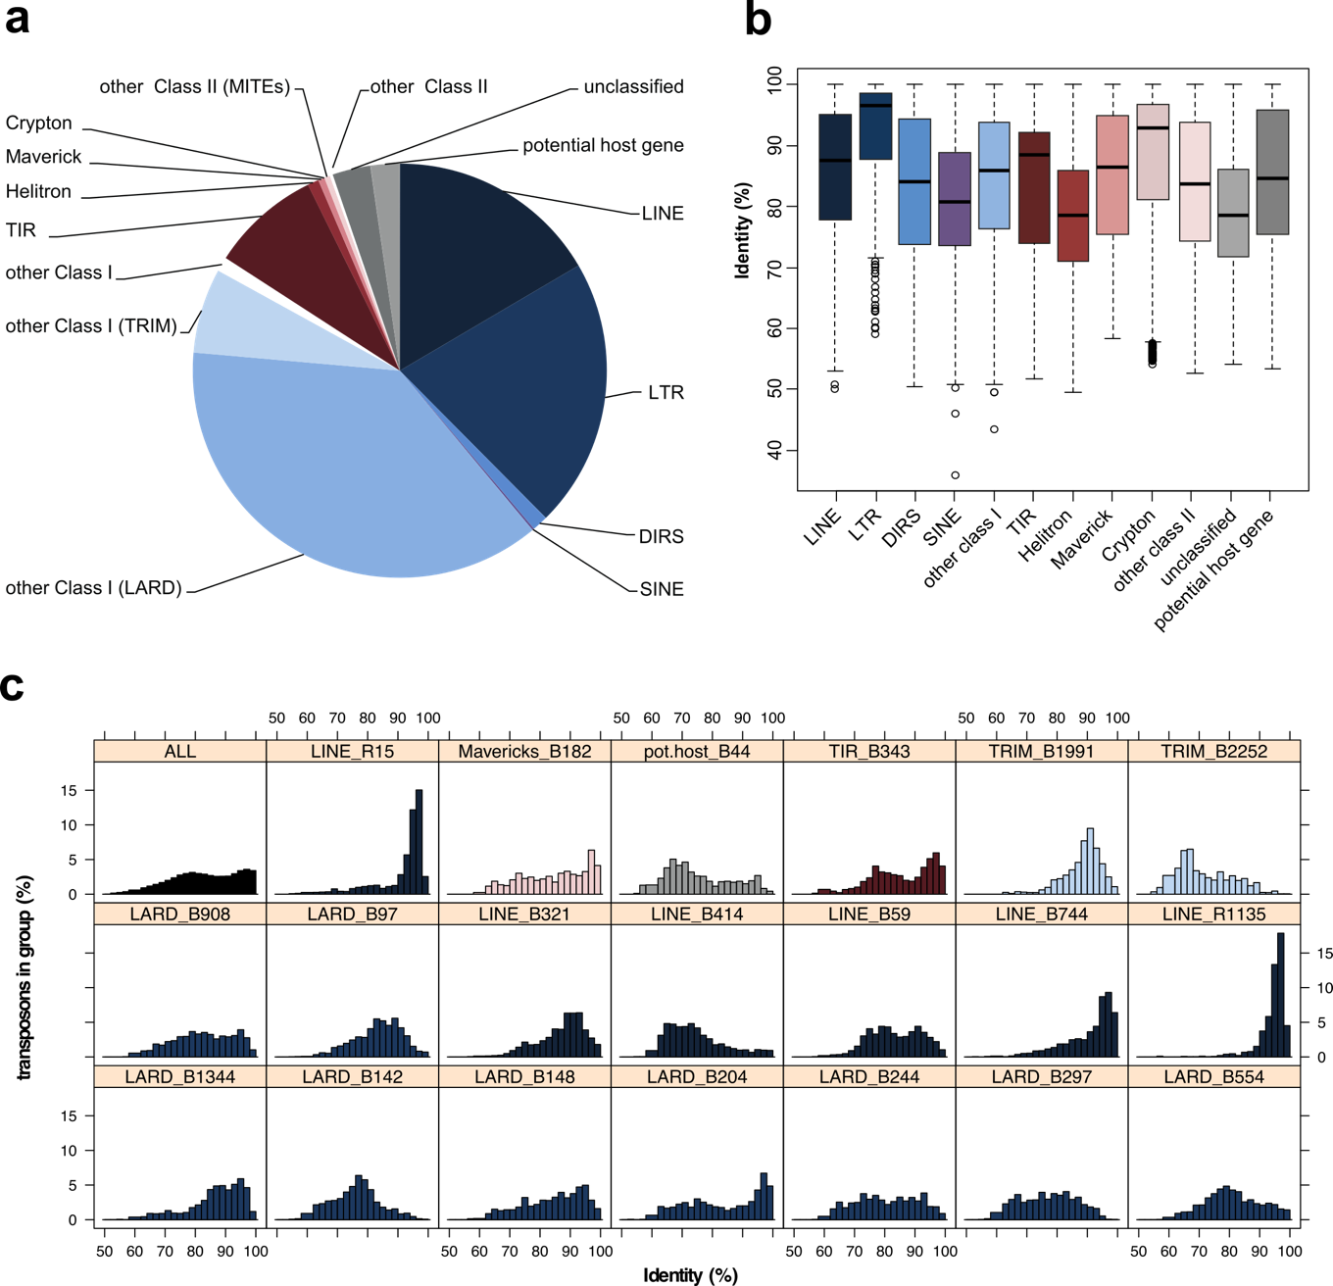
Figure 1: Repeated elements identified within the genome of E. subulatus Bft15b. A) Number of transposons detected in the different superfamilies; B) Boxplot of sequence identity levels for the detected superfamilies; and C) Distribution of sequence identities in all and the 20 most abundant transposon families.
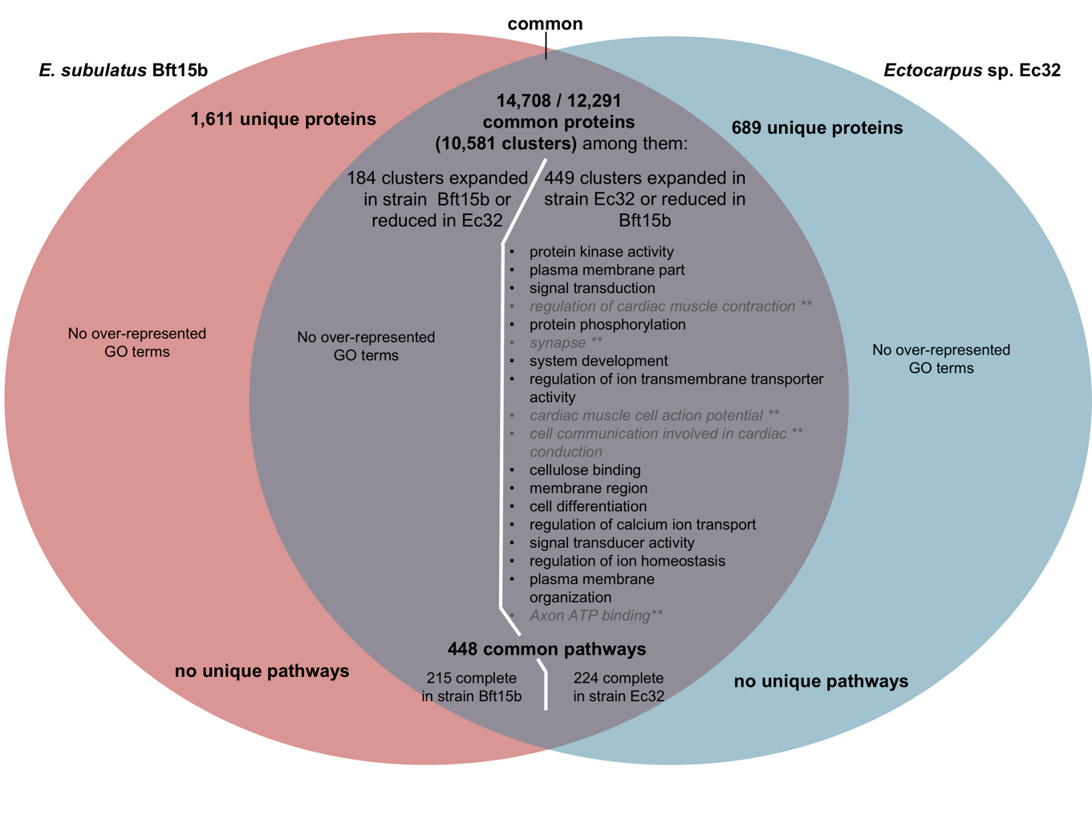
Figure 2: Comparison of gene content and metabolic capacities of E. subulatus Bft15b and Ectocarpus sp. Ec32. The top part of the Venn diagram displays the number of predicted proteins and protein clusters unique and common to both genomes in the OrthoFinder analysis. The middle part shows GO annotations significantly enriched (FDR ≤ 0.05) among these proteins. For the common clusters, the diagram also contains the results of gene set enrichment analyses for annotations found among clusters expanded in E. subulatus Bft15b and those expanded in Ectocarpus sp. Ec32. Functional annotations not directly relevant to the functioning of Ectocarpus or shown to be false positives are shown in grey and italics. The bottom part shows the comparison of both genomes in terms of their metabolic pathways.
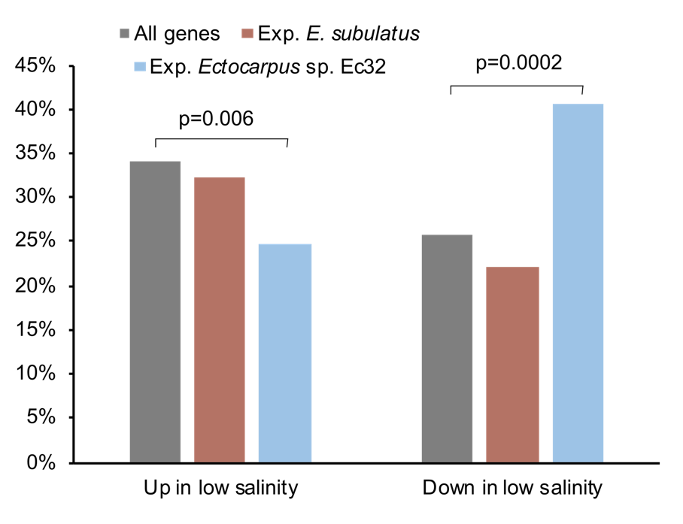
Figure 3: Percentage of significantly (FDR<0.05) up- and down-regulated genes in E. subulatus in response to low salinity (5% seawater). Grey bars are values obtained for all genes with expression data (n=6,492), while brown and blue bars include only genes belonging to gene families expanded in E. subulatus Bft15b (n=99) or Ectocarpus sp. Ec32 (n=202), respectively (“Exp.” stands for expanded). P-values correspond to the result of a Fisher exact test. Gene expression data were obtained from previous microarray experiments(Dittami et al. 2012). Please refer to Supporting information Table S6 for additional data.

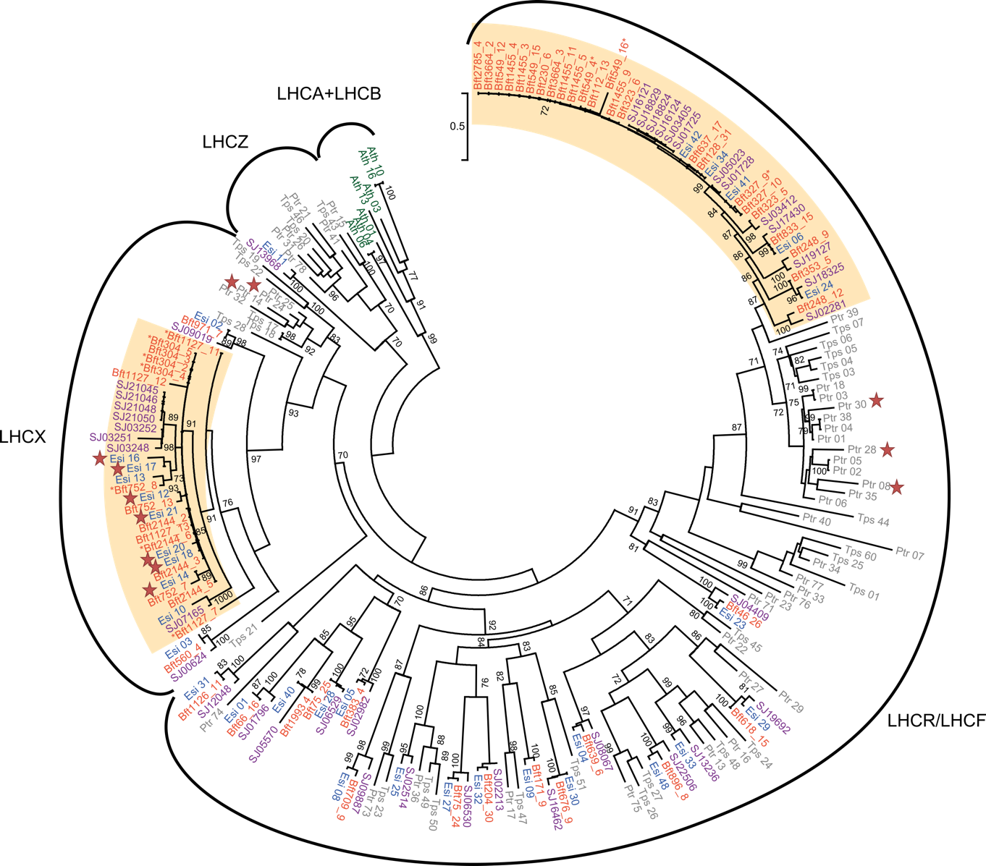
Figure 4: Maximum likelihood tree of chlorophyll binding proteins (CBPs) sequences in E. subulatus Bft15b (orange) Ectocarpus sp. Ec32 (blue), S. japonica (purple), and diatoms (Thalassiosira pseudonana and Phaeodactylum tricornutum, grey). Support values correspond to the percentage of bootstrap support from 1000 replicate runs, only values ≥ 70% are shown. A. thaliana sequences (green) were added as outgroup. Accessions for E. subulatus Bft15b are given without the Esu prefix; for Ectocarpus sp. Ec32, diatoms and A. thaliana, see (Dittami et al. 2010). Stars indicate genes that have been previously shown to be stress-induced (Dittami et al. 2010), asterisks next to the protein names indicate incomplete proteins. Probable expansions in E. subulatus Bft15b are indicated by an ocher background.

Tables
Table 1: Assembly statistics of available brown algal genomes. PE = paired-end, MP = mate-pair, n.d. = not determined
 | E. subulatus Bft15b | Ectocarpus sp. Ec32 (Cock et al. 2010) | S. japonica (Ye et al. 2015) | C. okamuranus (Nishitsuji et al. 2016) | N. decipiens (Nishitsuji et al. 2019)
Sequencing strategy | Illumina (PE+MP) | Sanger+Bac libraries | Illumina PE+PacBio | Illumina (PE+MP) | Illumina (PE+MP)
Genome size estimate (flow cytometry) | 226 | 214(Peters et al. 2004)* | 545 | 140 | n. d.
Genome size (assembled) | 242 Mb | 196 Mb | 537 Mb | 130 Mb | 154 Mb
Genomic Coverage | 119 X | 11 X# | 178 X | 100 X | 420 X
G/C contents | 54% | 53% | 50% | 54% | 56%
Number of scaffolds >2kb | 1,757 | 1,561 | 6,985 | 541 | 685
Scaffold N50 (kb) | 510 kb | 497 kb | 254 kb | 416 kb | 1,863 kb
Number of predicted genes | 25,893 | 17,418 | 18,733 | 13,640 | 15,156
Mean number of exons per gene | 5.4 | 8.0 | 6.5 | 9.3 | 11.2
Repetitive elements | 30% | 30%## | 40% | 4.1% | 8.8%
BUSCO genome completeness (complete+fragmented) | 86% (91%*#) | 94% (99%*#) | 91% (96%*#) | 88% (93%*#) | 92% (97%*#)
BUSCO Fragmented proteins | 13.5% | 7.4% | 14.2% | 11.9% | 5.6%
## 23% according to (Cock et al. 2010), but 30% when re-run with the current version (2.5) of the REPET pipeline.
*# not considering proteins absent from all three brown algal genomes.

Table 2: Clusters of orthologous genes identified by OrthoFinder as expanded in the genome of E. subulatus Bft15b or reduced in Ectocarpus sp. Ec32, after manual identification of false positives, and removal of clusters without functional annotation or related to transposon or viral sequences.
Cluster(s) | # Ec32 | # Bft15b | Putative annotation or functional domain
Cell-wall related proteins
OG0000597 | 1 | 3 | Peptidoglycan-binding domain
OG0000284, -782, -118 | 6 | 12 | Carbohydrate-binding WSC domain
OG0000889 | 1 | 2 | Cysteine desulfuration protein
OG0000431 | 1 | 3 | Galactose-3-O-sulfotransferase (partial)
Transcriptional regulation and translation
OG0000785 | 1 | 2 | AN1-type zinc finger protein
OG0000059 | 4 | 10 | C2H2 zinc finger protein
OG0000884 | 1 | 2 | Zinc finger domain
OG0000766 | 1 | 2 | DNA-binding SAP domain
OG0000853 | 1 | 2 | RNA binding motif protein
OG0000171 | 1 | 6 | Helicase
OG0000819 | 1 | 2 | Fungal transcriptional regulatory protein domain
OG0000723 | 1 | 2 | Translation initiation factor eIF2B
OG0000364 | 2 | 3 | Ribosomal protein S15
OG0000834 | 1 | 2 | Ribosomal protein S13
Cell-cell communication and signaling
OG0000967 | 1 | 2 | Ankyrin repeat-containing domain
OG0000357 | 2 | 3 | Regulator of G protein signaling domain
OG0000335 | 2 | 3 | Serine/threonine kinase domain
OG0000291 | 2 | 3 | Protein kinase
OG0000185 | 3 | 4 | Octicosapeptide/Phox/Bem1p domain
Others
OG0000726 | 1 | 3 | HSP20
OG0000104 | 1 | 9 | Light harvesting complex protein
OG0000277 | 3 | 3 | Major facilitator superfamily transporter
OG0000210 | 2 | 4 | Cyclin-like domain
OG0000721 | 1 | 2 | Myo-inositol 2-dehydrogenase
OG0000703 | 1 | 2 | Short-chain dehydrogenase
OG0000749 | 1 | 2 | Putative Immunophilin
OG0000463 | 1 | 3 | Zinc-dependent metalloprotease with notch domain

