Selective Microwave-assisted Pyrolysis of Cellulose towards Levoglucosenone using Clay Catalysts
Alisa Doroshenko,^{[a]} Ihor Pylypenko,^{[b]} Karl Heaton,^{[c]} Stephen Cowling,^{[d]} James Clark,*^{[a]} and Vitaliy Budarin*^{[a]}
[a] Alisa Doroshenko, Prof. James Clark, Dr. Vitaliy Budarin
Green Chemistry Centre of Excellence
Department of Chemistry
University of York
Heslington, York, UK, YO10 5DD
E-mail: vitaliy.budarin@york.ac.uk, james.clark@york.ac.uk
Homepage: www.vitaliybudarin.com
[b] Dr. Ihor Pylypenko
Department of Chemical Technology of Ceramic and Glass
The National Technical University of Ukraine “Igor Sikorsky Kyiv Polytechnic Institute”
Peremohy Ace, 37, Kyiv, Ukraine, 03056
[c] Karl Heaton
MS Service
Department of Chemistry
University of York
Heslington, York, UK, YO10 5DD
[d] Dr. Stephen Cowling
Liquid Crystals and Materials Chemistry Group
Department of Chemistry
University of York
Heslington, York, UK, YO10 5DD
Supporting information for this article is given via a link at the end of the document.

Abstract: Levoglucosenone (anhydrosugar) is one of the most promising chemical platforms derived from the pyrolysis of biomass. It is a chiral building block for pharmaceuticals as well as an intermediate in the production of solvents and polymers. Therefore, the development of cost-efficient, low-energy production methods are vital for a future sustainable biorefinery. Here we report a novel, green approach to the production of levoglucosenone using a microwave (MW) assisted pyrolysis of cellulose in the presence of readily available clays. We showed that natural and pillared clays in the presence of MW irradiation significantly increase the yield of levoglucosenone from cellulose. Both the water content and the presence of acid centers are critical characteristics which influence the yield and distribution of catalyzed products. A unique experiment was designed using a synergetic effect between different types of catalysts which enhanced the levoglucosenone yield to 12.3wt% with 63% purity.
Bio-oil is a complex organic mixture resulting from thermal processing (pyrolysis) of biomass and bio-waste and represents an alternative renewable source for chemicals and fuels. The majority of individual compounds in bio-oil are multi-functional oxygen-containing chemicals. Some of them are attractive platform molecules ready for industrial use without any pre-functionalization.^{[1]} These platform molecules could form the core of a sustainable and efficient biorefinery.
Currently, one of the biggest challenges for such a biorefinery is separation of the complex bio-oil to individual compounds. The direct distillation of the oxygen-containing compounds is impossible, while the application of chromatography columns is an expensive decision for the large-scale chemical industry.
A possible solution is selective in-situ targeting of the desired compounds during pyrolysis of biomass (which typically contains hemicellulose, cellulose and lignin). At present, most of the problems associated with refining hemicellulose have been addressed,^{[2]} while refining cross-linked lignin requires significant further developments. Hence our focus on cellulose. Pyrolysis of cellulose to a complex mixture of chemicals is already developed but a controllable and sustainable production of the platform molecules levoglucosenone (LGO) and 5-hydroxymethylfurfural (5-HMF) is not. Conventional pyrolysis of cellulose proceeds at high temperatures (T>360°C), inducing secondary reactions and therefore producing a complex mixture of products.
One of the ways to increase selectivity during pyrolysis is catalysis.^{[3]} Natural aluminosilicates such as zeolites are widely reported to preferentially catalyze the conversion of biomass to aromatics.^{[4,5]} However, although cost-efficient and readily-available, clays have not attracted significant attention. Pillared clays (a class of swollen clays modified with a variety of large polynuclear hydroxo-complexes) are of particular interest.^{[6]}
Another way to improve the pyrolysis selectivity is the application of MW-assisted heating, which proceeds at lower temperatures (~165-220°C) than conventional pyrolysis.
In this paper we investigated the synergy between MW-assisted cellulose pyrolysis in the presence of natural bentonite and pillared bentonite. We chose Al-pillared bentonite (Al-PILC) as pillared clay because of its commercial availability, simple synthesis and high acidity, caused by the intercalated Al₁₃ hydroxo-complexes (AlO₄Al₁₂(OH)₂₄(H₂O)₁₂)⁷⁺, acting as a heteropoly acid.
Successful intercalation of the Al₁₃ hydroxo-complexes into native bentonite (Na-form) increases the basal spacing (d₀₀₁) from 15.20Å to 18.11Å (Figure 1a-b). Furthermore, thermally-resolved Small-Angle X-ray Scattering (SAXS) (Figure 1a-b, insertion graphs) shows the difference in water behavior between the pillared and native bentonite. The step-wise changes (w₂, w₁, w₀) of the basal spacing for the bentonite are related to a serial removal of discrete water sheets in the interlamellar space of this catalyst.^{[7]} The absence of such phenomenon for an Al-PILC (Figure 1b, insertion graph) indicates that Al₁₃-complexes are acting as supportive pillars between the clay sheets, preventing their collapse. Additionally, the N₂ adsorption results indicate the formation of a larger number of micro- and meso-pores for Al-PILC in comparison to the non-pillared clay leading to ca. a six-fold increase in BET surface area and smaller water diffusion rate (Figure 1c and S6).
The different environment for water within the samples is shown by thermal gravimetric analysis. The bentonite desorbs twice as much water as Al-PILC (4.2wt%) below 180°C, (the temperature of cellulose pyrolysis in a MW-reactor, Figure 1d). Mass-loss of the Al-PILC is stretched out in time and temperature because of a slower water diffusion compared to the original macro-porous bentonite (Figure 1d).^{[8,9]}
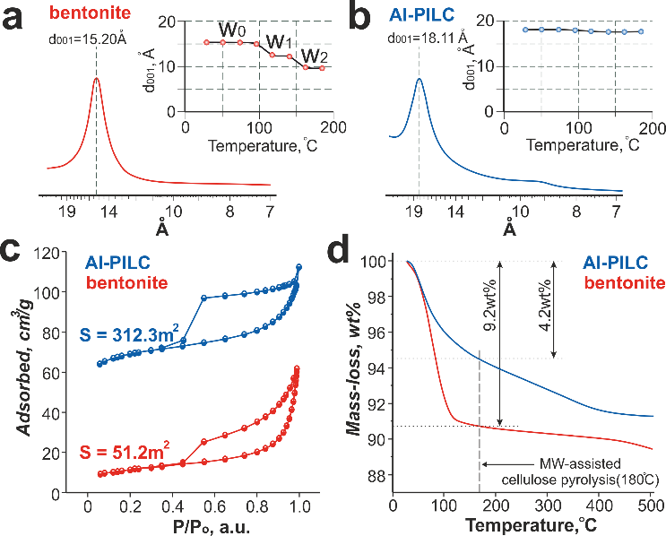
Figure 1. Characterisation of the catalysts: a), b) SAXS analysis and thermally-resolved SAXS data; c) N₂ adsorption data; d) thermal analysis
The acid properties of materials were confirmed to be different through pyridine titration and temperature-programed desorption of ammonia (Figure S8-9). The original bentonite contains mainly Lewis species while Al-PILC has both Lewis and Bronsted acid centers.
The influence of the clay catalysts on the MW-assisted cellulose pyrolysis has been systematically investigated. The catalysts were intensively mixed together with cellulose at different loads and subjected to microwave-assisted pyrolysis (Figure S10).
The results obtained clearly show that the Al₁₃ pillaring procedure significantly changes the catalytic performance of the bentonite (Figure 2a-b). Low bentonite loading (<20wt%) increases bio-oil production (Figure 2a), which is in good agreement with previous studies.^{[10,11]} However, we found that at higher loading, the bio-oil yield is decreased. This effect can be attributed to competition between the cellulose hydrolysis process and the bio-oil’s interaction with clay (charring and adsorption). The moisture produced below 180°C from macropore bentonite promotes cellulose hydrolysis and increases yields of sugars and bio-oil (Figure 2a). In contrast to the bentonite, the Al-PILC (which releases low amounts of water 4.2wt%, Figure 1d), leads to a gradual decrease in the bio-oil yield (Figure 2a).
Interestingly, we found that levoglucosan yields are proportional to bio-oil yields independent of the nature and quantity of the catalyst (Figure 2a-b). This observation confirms levoglucosan as being a primary intermediate for low molecular weight organic volatiles (M˂162 g/mol) through its decomposition in cellulose pyrolysis.^{[12,13]} Moreover, levoglucosan is an intermediate for the production of sugars via interaction with internally produced water.^{[14]}
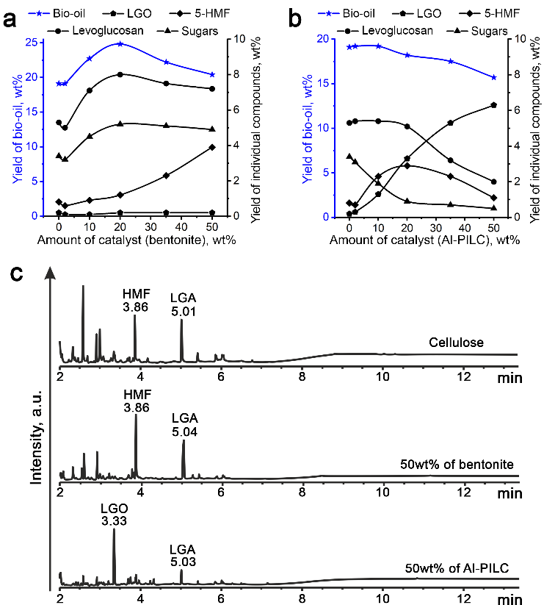
Figure 2. Experimental data: a), b) – composition of the bio-oils resulted from the MW-assisted pyrolysis of cellulose mixed with bentonite and Al-PILC respectively (all yields are calculated with respect to the cellulose weight); c) GC-FID data of the extracted bio-oil for cellulose (top), 50wt% of bentonite (middle) and 50wt% of Al-PILC (bottom)
The production of sugars in the presence of bentonite slows down at >20wt% of the catalyst, while the yield of 5-HMF starts to increase up to 4wt% (Figure 2a). It is reasonable to assume that 5-HMF is a product of sugars conversion.^{[15,16]} In contrast, the use of Al-PILC gives maximum yield of 5-HMF at 20wt% of the catalyst (Figure 2b). This pronounced difference in HMF yields could be due to differences in both the water content and nature of acid centers of these catalysts. Recently Lewis acid species were reported to play a significant role in glucose transformation to 5-HMF,^{[14,17]} and bentonite, incorporating Lewis sites, could be a promising candidate for this reaction. In contrast, Al-PILC contains many more Bronsted centers. Moreover, additional acid centers are produced during thermal decomposition of the Al₁₃-complex towards Al₂O₃ (Figure 3). We did not find any evidence of Al₂O₃ having a catalytic effect, while the Al₁₃-complex produced acid sites could promote reactions typical for Bronsted species such as LGO production – a well-known product of cellulose pyrolysis in the presence of Bronsted acids.^{[8,9]} This explains a nearly negligible LGO yield with bentonite (Figure 2a) and its substantial growth to 6.3wt% (40% purity) at 50wt% of Al-PILC (Figure 2b). Conventional pyrolysis of cellulose mixed with the same Al-PILC loading resulted in higher LGO yield (10.1%), but much lower selectivity of ~26% (Figure S15). Thus, our experiments show that MW irradiation improves pyrolysis selectivity and that the production of 5-HMF and LGO are competitive (Figure 2c) and depend on the amount of locally available water and type of acid centers.^{[18]}
Stoichiometrically the formation of levoglucosan (C₆H₁₀O₅) from cellulose (C₆H₁₀O₅)_{n} does not require H₂O, but surprisingly its production needs a catalytic amount of water, while an excess of H₂O promotes cellulose hydrolysis to sugars (Figure 3). Final yield of the pyrolysis of dry cellulose favors charring reactions.^{[19]} We believe that the ratio between levoglucosan and sugars determines the possible yields of LGO and 5-HMF and is controlled by the amount of available water. The final yield of LGO is controlled by the presence of Bronsted acid sites, such as those present in Al-PILC (Figure 3). The catalytic formation of LGO can occur directly from levoglucosan, or indirectly via 1,4:3,6-dianhydro-α-D-glycopyranose (DGP) intermediate.^{[20]}
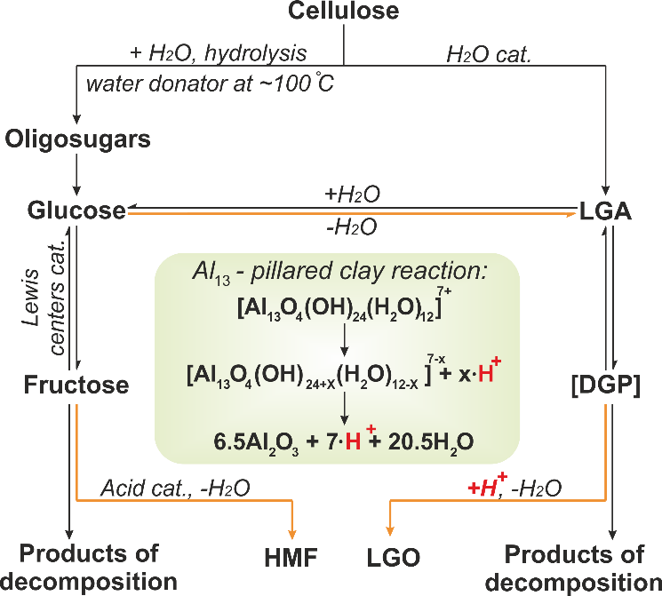
Figure 3. The suggested scheme of MW-assisted pyrolysis of cellulose
Therefore, based on these observations, we designed a “layer” experiment to enhance the yield of LGO (Figure 4a) emphasizing a synergetic effect between both catalysts. The vessel was packed with of bentonite at the bottom to generate water, enhancing the bio-oil yield during MW-assisted pyrolysis (Figure 4a). The bentonite loading (20wt%) was chosen based on the highest yield of bio-oil obtained in the previous experiments (Figure 2a). Cellulose was mixed with Al-PILC and a layer of pure Al-PILC catalyst was placed on the top (Figure 4a). The yield of the bio-oil increased and the composition analysis showed the presence of 12.3wt% of LGO of ~60% purity in the bio-oil mixture (Figure 4b).
To demonstrate a significant biorefinery potential, we successfully performed MW-assisted pyrolysis of paper waste simply mixed with 50wt% of the Al-PILC, giving 4.8wt% of LGO (Figure S16). To reactivate the catalyst, we followed a two-step process: acidic MW-hydrolysis followed by oxidation with hydrogen peroxide. The MW-hydrolysis resulted in the production of glucose, 5-HMF, levulinic and lactic acids (Figure S18). The Al-PILC was successfully regenerated three times losing a total of ~34% of its activity.
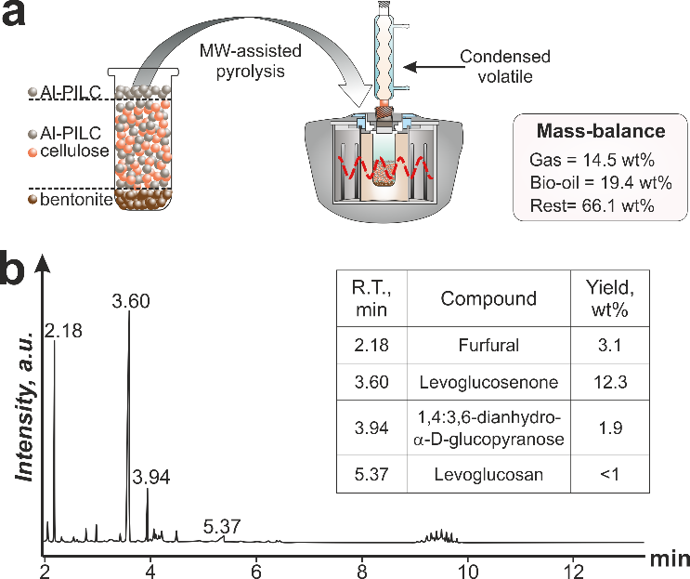
Figure 4. Synergetic effect of bentonite and Al-PILC to enhance the yield of LGO (notably, the retention time of the LGO is longer compared to that one on Figure 2c, because the spectra were collected at different times)
In conclusion, through MW-assisted pyrolysis of cellulose in the presence of bentonite and Al-PILC, we have identified a competitive nature between the production of 5-HMF and LGO. We believe the majority of LGO and 5-HMF comes from levoglucosan and sugars respectively. The ratio between sugars and levoglucosan is controlled mainly by the amount of water produced during the pyrolysis stage. This water favors hydrolysis reactions, increasing the yields of sugars, which are partially converted to 5-HMF on the Lewis acid sites. The Bronsted acid sites of Al-PILC promote the production of 40% pure LGO at 6.3wt% yield at 50wt% of the catalyst loading. We also found a synergetic effect between both catalysts to enhance the yield of LGO to 12.3wt%, which is comparable with our conventional pyrolysis experiment but the selectivity towards LGO is three times higher. The Al-PILC catalysts is considered a good candidate for LGO production and in the MW-assisted pyrolysis of paper waste was regenerated three times.
Experimental Section
All experimental details are available in the Supplementary Materials.
Keywords: Microwave chemistry • Biomass • Pyrolysis • Clays • Platform molecules
[1] M. De bruyn, J. Fan, V. L. Budarin, D. J. Macquarrie, L. D. Gomez, R. Simister, T. J. Farmer, W. D. Raverty, S. J. McQueen-Mason, J. H. Clark, Energy & Environmental Science 2016, 9, 2571–2574.
[2] G. T. Mihiretu, M. Brodin, A. F. Chimphango, K. Øyaas, B. H. Hoff, J. F. Görgens, Bioresource Technology 2017, 241, 669–680.
[3] G. W. Huber, S. Iborra, A. Corma, Chem. Rev. 2006, 106, 4044–4098.
[4] Md. M. Rahman, R. Liu, J. Cai, Fuel Processing Technology 2018, 180, 32–46.
[5] T. R. Carlson, J. Jae, Y.-C. Lin, G. A. Tompsett, G. W. Huber, Journal of Catalysis 2010, 270, 110–124.
[6] F. Bergaya, A. Aouad, T. Mandalia, in Developments in Clay Science, Elsevier, 2006, pp. 393–421.
[7] M. Ammar, W. Oueslati, H. Ben Rhaiem, A. Ben Haj Amara, Desalination and Water Treatment 2014, 52, 4314–4333.
[8] F. Figueras, Catalysis Reviews 1988, 30, 457–499.
[9] J. T. Kloprogge, E. Booy, J. B. H. Jansen, J. W. Geus, Clay miner. 1994, 29, 153–167.
[10] B. A. Mohamed, N. Ellis, C. S. Kim, X. Bi, Applied Catalysis B: Environmental 2019, 253, 226–234.
[11] M. Sulman, Yu. Kosivtsov, E. Sulman, V. Alfyorov, Yu. Lugovoy, V. Molchanov, I. Tyamina, O. Misnikov, A. Afanasjev, N. Kumar, et al., Chemical Engineering Journal 2009, 154, 355–360.
[12] S. Maduskar, V. Maliekkal, M. Neurock, P. J. Dauenhauer, ACS Sustainable Chemistry & Engineering 2018, 6, 7017–7025.
[13] X. Zhang, W. Yang, C. Dong, Journal of Analytical and Applied Pyrolysis 2013, 104, 19–27.
[14] P. H. Blanco, J. B. Lad, A. V. Bridgwater, M. S. Holm, ACS Sustainable Chem. Eng. 2018, 6, 12872–12883.
[15] P. Daorattanachai, S. Namuangruk, N. Viriya-empikul, N. Laosiripojana, K. Faungnawakij, Journal of Industrial and Engineering Chemistry 2012, 18, 1893–1901.
[16] M. Ohara, A. Takagaki, S. Nishimura, K. Ebitani, Applied Catalysis A: General 2010, 383, 149–155.
[17] A. A. Marianou, C. M. Michailof, A. Pineda, E. F. Iliopoulou, K. S. Triantafyllidis, A. A. Lappas, Applied Catalysis A: General 2018, 555, 75–87.
[18] F. Cao, T. J. Schwartz, D. J. McClelland, S. H. Krishna, J. A. Dumesic, G. W. Huber, Energy Environ. Sci. 2015, 8, 1808–1815.
[19] M. J. Antal, H. L. Friedman, F. E. Rogers, Combustion Science and Technology 1980, 21, 141–152.
[20] F. Shafizadeh, R. H. Furneaux, T. T. Stevenson, Carbohydrate Research 1978, 61, 519–528.

Entry for the Table of Contents

COMMUNICATION
Text for Table of Contents  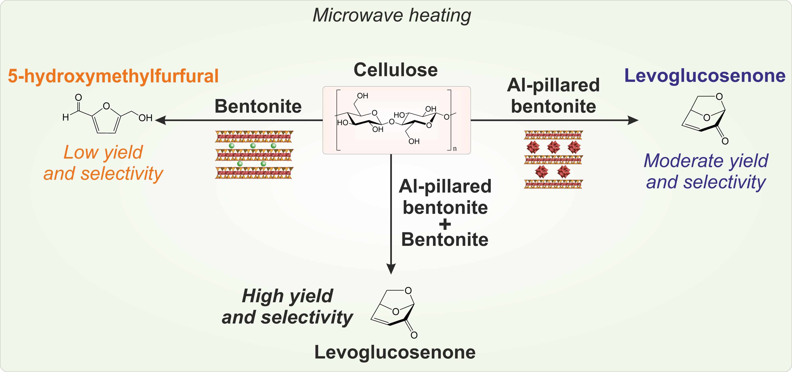 |  | Alisa Doroshenko, Ihor Pylypenko, Karl Heaton, Stephen Cowling, James Clark,* and Vitaliy Budarin*  Page No. – Page No.  Selective microwave-assisted pyrolysis of cellulose towards levoglucosenone using clay catalysts

Clays can be superior catalysts to obtain platform molecules from biomass via microwave pyrolysis.

