Characterization of the Nairobi River catchment impact zone and occurrence of pharmaceuticals: implications for an impact zone inclusive environmental risk assessment

Simone Bagnis¹, Alistair Boxall⁵, Antony Gachanja⁴, Mark Fitzsimons¹, Martin Murigi⁴, Jason Snape² ³, Alan Tappin¹, John Wilkinson⁵, Sean Comber^{1*}
¹School of Geography, Earth and Environmental Sciences, Plymouth University, Plymouth PL4 8AA, UK
² AstraZeneca UK, Global Safety, Health and Environment, Macclesfield, UK
³School of Life Sciences, Gibbet Hill Campus, the University of Warwick, Coventry, CV4 7AL, UK
⁴Department of Chemistry, Jomo Kenyatta University of Agriculture and Technology, Nairobi, Kenya
⁵Department of Environment and Geography, University of York, Heslington, York, YO10 5NG, UK
* Corresponding author: sean.comber@plymouth.ac.uk

Abstract
The largely uncontrolled release of active pharmaceuticals ingredients (APIs) within untreated wastewater discharged to waterbodies, associated with many rapidly urbanising centres is of growing concern owing to potential antimicrobial resistance, endocrine disruption and potential toxicity. A sampling campaign has been undertaken to assess the source, occurrence, magnitude and risk associated with APIs and other chemicals within the Nairobi/Athi river basin, in Kenya, East Africa. The catchment showed an extensive downstream impact zone estimated to extend 75 km, mostly, but not exclusively, derived from the direct discharge of untreated wastewater from the urban centre of Nairobi city. The exact extent of the downstream boundary of the Nairobi city impact zone was unclear owing to the inputs of untreated wastewater sources from the continuous urbanized areas along the river, which counteracted the natural attenuation caused by dilution and degradation. The most frequently detected APIs and chemicals were caffeine, carbamazepine, trimethoprim, nicotine, and sulfamethoxazole. Paracetamol, caffeine, sulfamethoxazole, and trimethoprim alone contributed 86% of the total amount of APIs determined along the Nairobi/Athi catchment. In addition to direct discharge of untreated domestic wastewater attributed to the informal settlements within the conurbation, other sources were linked to the industrial area in Nairobi City where drug formulation is known to occur, the Dandora landfill and veterinary medicines from upstream agriculture. It was shown that there was a possible environmental risk of API ecotoxicological effects beyond the end of the traditional impact zone defined by elevated biochemical oxygen demand concentrations; with metronidazole and sulfamethoxazole exhibiting the highest risk.
Key words: Pharmaceuticals; Nairobi; water quality; wastewater; Kenya; risk assessment

Introduction
The management of water quality is of utmost importance to guarantee the safeguard of environmental and human health and ensure sustainable development. The direct discharge of untreated wastewater (DDUW) is a significant source of water pollution constituting approximately 80% of the wastewater discharged globally (Koncagul et al., 2017). This is an obvious concern not only from major pollutants such as ammonia, biochemical oxygen demand (BOD), metals and persistent organic pollutants but also from the presence of emerging contaminants, such as active pharmaceutical ingredients (APIs) which have implications for environmental as well as human health. Any discharge of a chemical to a receiving water results in its dilution within a mixing zone downstream. For chemicals discharged at toxic levels, then there will be a zone downstream where significant ecological harm would be expected, prior to sufficient dilution occurring to reduce levels to below ecotoxicological thresholds. This “impact zone” is well established for BOD and ammonia, however, for chemicals which may be more toxic and persistent, their ecological impact may extend beyond the impact zone for BOD and ammonia (Bagnis et al., 2019, 2018). Little attention has been devoted to the environmental risk assessment of APIs and other ‘down the drain’ chemicals in areas of poor wastewater treatment in order to assess the extent and significance of impact zones within heavily polluted catchments.
In the past decade there has been a global increase of production and consumption of APIs in low and low-middle income countries (LLMICs) where the DDUW is prevalent (Kookana et al., 2014). In particular, recent investigations have highlighted the widespread occurrence of high concentrations of APIs in pan-African rivers, unequivocally ascribed to the poor African wastewater treatment coverage and efficiency (Agunbiade and Moodley, 2014; K'oreje et al., 2016, 2012; Madikizela et al., 2017; Matongo et al., 2015; Ngumba et al., 2016; Schoeman et al., 2015; Wang et al., 2014; Wood et al., 2015). A relatively well studied example of such contaminated areas in Africa is the Nairobi River catchment, flowing through the capital city of Kenya, Nairobi (K’oreje et al., 2012; Mbui et al., 2016; Ngumba et al., 2016). Nairobi was established in the early 1990’s with a population of 250,000 and was reputed as a city with high environmental standards and was labelled accordingly as “the green city in the sun”. However, due to rapid urbanization and population growth (3,149,000 officially, but potentially double this in reality) its reputation has changed, and owing to inadequate waste management, the water bodies comprising the Nairobi catchment are severely polluted (Mbui et al., 2016; Mobegi et al., 2016). The wastewater generated in the city’s informal settlements and from the centre is mostly directly discharged in the Nairobi River basin without treatment, leading to an extensive impact zone characterized by the occurrence of high concentrations of pollutants such as ammonia, BOD combined with low dissolved oxygen and the potential presence of trace metals and APIs (K’oreje et al., 2016, 2012; Ngumba et al., 2016) together with other emerging and traditional organic contaminants (Kithiia, 2007; Kithiia and Ongwenyi, 1997; Mbui et al., 2016; Mobegi et al., 2016; Njuguna, 1979). The water within the catchment is a critical resource, for irrigation, industry, potable water after treatment and in some cases untreated drinking water.
Unlike the other previous studies of this catchment, this work within the Nairobi/Athi catchment investigated a wider variety of APIs and used a risk assessment to determine the extent of the potential impact zone for APIs and whether it may extend beyond that of pollutants such as BOD and ammonia. Furthermore a source apportionment exercise was carried out using a principle component analysis to combine available chemical data and knowledge gained during a spatially extensive monitoring programme, to identify other potential sources of APIs in addition to domestically derived DDUW.

Materials and methods

Study area and sampling
The sampling area was located in the Nairobi capital province (1,661 m altitude and 696 km² of urban area) which is located in the Nairobi/Athi River catchment (Figure 1). The Athi River is the second largest river basin in Kenya, after the Tana River. The catchment flows from the flanks of the Rift valley, the Aberdare ranges and the Ngong hills. Downstream of Nairobi the river flows through arid areas of Kenya to the Indian Ocean at Malindi. The Nairobi River is a main tributary, which itself has two main tributaries, the Mathare and Ngong Rivers, which drain Nairobi city centre and the surrounding urbanized zones, including informal settlements, industrial areas and agricultural lands (Figure 1) (Kithiia, 2007).

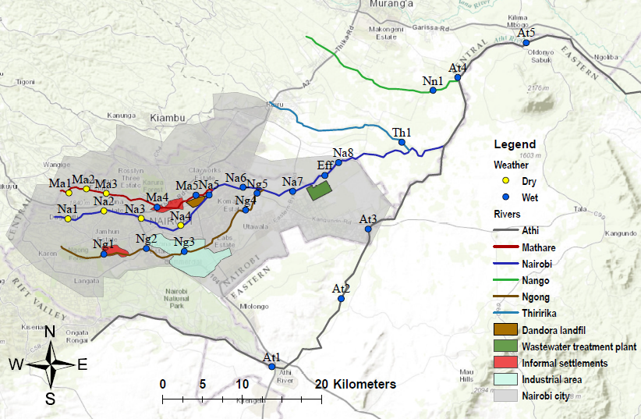
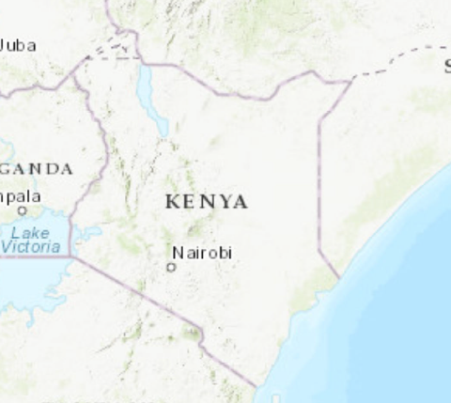

Figure 1 The Nairobi River catchment, the sampling points and the main sites of interest. The water flow is eastwards. “Eff” is the wastewater treatment plant effluent discharge point.
The Mathare and Ngong flow through large informal settlements areas (Mathare and Kibera), the latter also through the city’s industrial area. At the confluence of the Nairobi and Ngong lies the extensive Dandora landfill site (Muhonja et al., 2018). Dandora wastewater treatment stabilization ponds (WWTP) treat wastewater from approximately 27% of the city’s population and discharges to the Nairobi River downstream in the east of the city. Afterwards, the Nairobi River discharges into the Athi River which, after the Fourteen Falls, proceeds to the Indian Ocean. Also, two other minor tributaries of the Athi River were sampled before their confluence, namely Thiririka and Nango Rivers (Figure 1).
Despite the sampling exercise being planned to occur during the dry season, owing to an unusual weather pattern most of the samples (19 out of 26) were collected during the start of the wet season in mid-March (Figure 1). The sampling campaign comprised a total of 26 sampling points: five along the Mathare River, five along the Ngong River, eight along the Nairobi River, one from the effluent of WWTP, five along the Athi River, and one each from the Thiririka and Nango Rivers at the confluence with the Athi River. The last sample was collected 75 kilometres downstream of the city, measured from the first upstream sample collected at the Nairobi River (Figure 1).
DDUW was identified as diffuse point sources, such as leaching of wastewater or overflowing pit latrines from informal settlements (marked in red in Figure 1). There were also expected to be significant discharges of APIs deriving from the industrial area (marked in light blue in Figure 1) (Ngumba et al., 2016). The samples were collected in 500 ml amber glass bottles and stored on ice and then overnight at 4 °C, with sample preparation completed within 24h.

Chemicals
The subset of 55 target APIs were selected from the list of APIs validated in the methodology of Furlong et al., (2014) and analysed at the Department of Environmental Sciences, University of York, York, United Kingdom.

Analytical methodology

HPLC-MS direct injection methodology
The determination of APIs in filtered water was achieved by a “direct aqueous injection - high performance liquid chromatography (HPLC) tandem mass spectrometry (MS/MS) system methodology”, developed and validated by the United States Geological Survey (USGS) agency (Furlong et al., 2014).
Briefly, the method is validated for the determination of the 55 human-use APIs analysed in this work using “a direct-injection” of 100 µL volume of the pre-filtered (0.7 µm mesh glass filter) sample in an HPLC-MS/MS using an electrospray ionization source set in the positive mode. An inline stain-less filter was applied before the column (4.6 mm, 0.2 µm). The APIs were separated using a reversed phase column (Zorbax Eclipse plus-C18 HPLC column, 1.8 µm particle size, 3.0 inner diameter and 100 mm of length) with a gradient of water modified with formic acid/ammonium formate and methanol.
The use of multiple reaction monitoring (MRM) was adopted to enhance the sensitivity and specificity of electrospray HPLC/MS/MS for the qualitative determination of the compounds in the matrix. An internal standard method using stable isotope dilution standards (IDS) of target pharmaceuticals and the pesticide atrazine was used for quantification (Furlong et al., 2014). The goal of the methodology development was to provide a routine method for the determination of APIs at limit of detection (LOD) and quantification (LOQ) below 50 ng L⁻¹ (see Table S2 for the full list of individual API LOQ and LOD). Transformation products for many chemicals may also be of environmental concern, however, the absence of chemical calibration standards and the complexity of the mass spectra analysis prevented them being included in this suite of analysis. Full details of the methodology, analytical quality control and method validation are provided elsewhere (Wilkinson et al., 2019).

Fluorescence spectrometry and total organic carbon analyses
The peaks of fluorescence in the excitation/emission matrix (EEM) which correspond to tryptophan (230/350) and tyrosine (230/290) were used as a proxy of sewage contamination according to the method proposed by Bagnis et al., (2019), fluorescence spectrometry of the dissolved organic matter (DOM) can be used to characterize the extent of the impact zone. The samples were diluted to a TOC level of 5 mg L⁻¹ or less to allow quantification and to minimize the filter effects. The analyses were performed in triplicates using 1 ml of pre-filtered sample in a Hitachi F-4500 fluorescence spectrophotometer. A 3-D scan was performed at a range from 200 to 500 nm for both excitation and emission at a sampling interval of 10 nm and 2400 nm/min of scan speed. A blank of ultra-high purity water (UHP) was subtracted from the samples to eliminate the signal noise from the actual sample. An external calibration curve from tryptophan (Acros Organic) and tyrosine (Sigma) standards was used to quantify the amount of both the tryptophan and tyrosine-like DOM. The concentrations of these two surrogates were summed to to generate an estimate of protein-like DOM (PL-DOM).
The total organic carbon (TOC) analyses were performed using high-temperature catalytic oxidation (TOC-5000A - Shimadzu) according to the method of Badr et al., (2003).

Calculations
The 5-d biochemical oxygen demand (BOD₅) was estimated from the correlation of a data set of TOC and BOD₅ (Comber et al., 2018) and calculated as follow (Kwak et al., 2013):
$$BOD=\frac{(TOC+9.9851)}{0.2876}$$ | 1

Source apportionment of APIs
The Principal Component Analysis (PCA) statistical procedure, validated by Larsen and Baker (2003), was adopted to estimate the source apportionment of the APIs relative to the sampling points along the main stream of the Nairobi/Athi River (Na1 to Na8 and At4 to At5) as representative for the whole catchment, and the effluent from the wastewater treatment plant (Eff) as a source for comparison (Figure 1).
Briefly, with the aim of explaining the variability of the APIs in a minimum number of factors, the data were reduced to Principal Components (PCs) through a factor analysis performed by means of SPSS Statistics 24 (IBM). The analysis was performed with Kaiser normalization and a varimax rotation to simplify the interpretation of the factors.
All the factors originated through the computation are orthogonal to each other reducing the covariance. The first PC corresponds to the component loadings (CL) relative to the linear combination of the original concentration values, and it accounts for the greatest variability. All the other components are in decreasing order of variability. All the components with eigen values less than 1 were excluded by default. Based on the sampling protocol 4 potential sources of APIs were selected for analysis, the influence of untreated wastewater entering the river from informal settlements, industrial discharges from the commercial area, effluent discharged from the wastewater treatment ponds and possible upstream agricultural inputs. The source emission of each API is indicated by the CL which express the relationship between the PC and the chemical (Dai et al., 2016; Larsen and Baker, 2003).
The most loaded factor scores (> 0.5) for each API were originally considered amongst PCs, with some exceptions in a second analysis comparing the PC with the original concentrations. Thus, the pattern of each PC was critically analysed against literature information to determine the source apportionment.

Environmental risk assessment
A simplified environmental risk assessment (ERA) was performed using the measured concentrations at the furthest downstream sampling point along the impact zone. The assessment was performed through the risk quotient (2) which is a unitless ratio of the measured environmental concentrations (MEC) of the APIs detected to the predicted no effect concentrations (PNEC), retrieved from recent published studies available in the literature.
$$RISK=\frac{MEC}{PNEC}$$ | 2
The risk was evaluated based on the guidelines from the European Medicine Agency (EMA, 2006). It should be noted, however, that ecotoxicological data for APIs is lacking and rarely are there full datasets for either chronic, sub-lethal endpoints or for all significant trophic levels. Taking this into account, for this appraisal the lowest PNEC available from reliable literature sources was used to compare with the MEC.

Results and discussion

Impact zone characterization
The rivers physico-chemical parameters at each sampling point are shown in Table 1. The distance of each sampling point was measured relative to the first upstream sampling point for each river. A concise description of the sampling area and the respective elevation is also provided. The catchment mean of the physico-chemical parameters were: pH 8.5, conductivity 570.2 µs cm⁻¹, TDS 245.9 ppm, and temperature 23.7 °C. The temperature varied accordingly to the time of sampling, the lowest in the early morning and increasing along the day until the afternoon (21-29 °C). The altitude difference from the highest point of sample collection (Na1) to the lowest (At5) was of 416 m.
The estimated BOD₅ recorded at the sample points along the Nairobi/Athi catchment allowed a prediction of the extent of the impact zone generated by the DDUW in the Nairobi and Athi River catchments (Table 1). Such estimates were based on the definition of impact zone as the area between the discharge point of untreated wastewater and the downstream point at which the concentration of BOD₅ returns to the expected environmental range of typically less than 8 mg L⁻¹for unpolluted rivers (Bagnis et al., 2019, 2018).
The sampling points on the Nairobi and Mathare Rivers upstream the city centre showed very high BOD₅ 1136 mg L⁻¹ and 1349 mg L⁻¹ respectively, and concentrations of PL-DOM of 0.3 mg L⁻¹ and 2.0 mg L⁻¹ respectively, which suggest a higher contribution from sewage inputs to the Mathare River (Table 1). The range of predicted BOD₅ values recorded at these sampling points were nearly three times above typical values for high strength crude sewage (Tchobanoglous et al., 2003), but are in the observed range for industrial effluents (e.g. dyes and pharmaceutical factories) (Lokhande et al., 2011; Pittwell, 1988). This suggests the presence of industrial sources of pollution upstream the Nairobi city centre, however, additional studies would be necessary to ascertain their presence and nature.
Table 1. A short description of each sampling point with accompanying physico-chemical parameters.
Sampling point | River | Area | Distance (km) |  | Elevation (m) |  | pH |  | Conductivity  (µs cm⁻¹) |  | TDS (ppm) |  | Temperature (ºC) |  | BOD₅ (mg L⁻¹) |  | PL-DOM  (mg L⁻¹)
At1 | Athi | Downstream Nairobi national park | 0 | 1507 |  | 8.1 |  | 195 |  | 129 |  | 25.7 |  | 389.4 |  | 0.9
At2 | Athi | Upstream a tanning plant WWD | 13.1 | 1472 |  | 8.8 |  | 198 |  | 130 |  | 28.3 |  | 267.8 |  | 0.7
At3 | Athi | Downstream a tanning plant WWD | 23.2 | 1472 |  | 9.6 |  | 920 |  | 609 |  | 26.3 |  | 624.2 |  | 8.9
At4 | Athi | Upstream Fourteen Falls | 48.3 | 1428 |  | 8.1 |  | 302 |  | 199 |  | 22 |  | 160.3 |  | 1.2
At5 | Athi | Fourteen Falls | 59.3 | 1392 |  | 8 |  | 342 |  | 224 |  | 23.5 |  | 292.2 |  | 0.9
Eff | WWTP | Effluent WWTP | / | 1480 |  | 8.8 |  | 1099 |  | 723 |  | 26 |  | 520.8 |  | 2.8
Ma1 | Mathare | Upstream city centre | 0 | 1781 |  | 7.4 |  | 530 |  | 359 |  | 21.2 |  | 1349 |  | 2.0
Ma2 | Mathare | Dam | 2.2 | 1770 |  | 8.3 |  | 420 |  | 276 |  | 24.7 |  | 197.4 |  | 0.6
Ma3 | Mathare | Downstream dam | 4.8 | 1734 |  | 7.3 |  | 153 |  | 101 |  | 22.1 |  | 901.8 |  | 0.6
Ma4 | Mathare | Middle of Mathare slum | 11.6 | 1627 |  | 8.4 |  | 486 |  | 320 |  | 21.3 |  | 297.2 |  | 3.7
Ma5 | Mathare | Confluence with Nairobi River | 19.5 | 1563 |  | 7.8 |  | 624 |  | 412 |  | 20.7 |  | 292.7 |  | 3.8
Na1 | Nairobi | Upstream city centre | 0 | 1808 |  | 7.6 |  | 362 |  | 239 |  | 20.1 |  | 1136 |  | 0.3
Na2 | Nairobi | Upstream city centre | 5.0 | 1728 |  | 8 |  | 1050 |  | 728 |  | 21 |  | 490.6 |  | 5.4
Na3 | Nairobi | City centre | 9.9 | 1680 |  | 7.9 |  | 768 |  | 508 |  | 26.2 |  | 454.2 |  | 4.0
Na4 | Nairobi | Between city centre and Mathare River | 15.5 | 1628 |  | 7.3 |  | 928 |  | 616 |  | 28.9 |  | 638.2 |  | 13.2
Na5 | Nairobi | Confluence with Mathare River | 21.0 | 1568 |  | 8.2 |  | 618 |  | 409 |  | 22.3 |  | 292.0 |  | 3.4
Na6 | Nairobi | Confluence with Ngong River | 25.7 | 1500 |  | 8 |  | 597 |  | 394 |  | 23.1 |  | 1421 |  | 2.8
Na7 | Nairobi | Upstream WWTP | 32.4 | 1491 |  | 8.5 |  | 788 |  | 522 |  | 27 |  | 515.2 |  | 0.6
Na8 | Nairobi | Downstream WWTP | 39.38 | 1459 |  | 8.6 |  | 935 |  | 615 |  | 25 |  | 503.5 |  | 2.9
Ng1 | Ngong | Upstream Kibera Slum | 0 | 1714 |  | 7.3 |  | 94 |  | 62.3 |  | 19.5 |  | 191.9 |  | 0.6
Ng2 | Ngong | Middle Kibera Slum | 5.7 | 1702 |  | 7.6 |  | 551 |  | 364 |  | 22 |  | 1115 |  | 4.5
Ng3 | Ngong | Industrial area | 11.2 | 1632 |  | 7.8 |  | 769 |  | 508 |  | 25.3 |  | 822.3 |  | 5.3
Ng4 | Ngong | Quarry area | 21.2 | 1547 |  | 7.8 |  | 817 |  | 539 |  | 25.2 |  | 508.5 |  | 3.6
Ng5 | Ngong | Confluence with Nairobi River | 24.0 | 1500 |  | 8.2 |  | 796 |  | 526 |  | 24 |  | 373.5 |  | 4.1
Nn1 | Nango | Confluence with Athi River | / | 1432 |  | 7.7 |  | 313 |  | 205 |  | 22.7 |  | 249.9 |  | 0.3
Th1 | Thiririka | Confluence with Nairobi River | / | 1430 |  | 7.7 |  | 171 |  | 112 |  | 22.5 |  | 206.2 |  | 0.5

The highest level of PL-DOM (13.2 mg L⁻¹) was observed along the Nairobi River at sampling point Na4 (Table 1), located between the city centre and the confluence to the Mathare River (Figure 1), which highlighted high inputs of sewage contamination from the densely populated city centre. Afterwards, the PL-DOM concentration steadily decreased owing to dilution and degradation until sampling point Na8 located after the effluent discharge point from the WWTP, where a slight increase was observed, consistent with the WWTP effluent discharge. The estimated BOD₅ transect along the Nairobi River showed a trend similar to the PL-DOM, with an exception of the sampling point before the confluence with the Ngong River (Na6), where the highest concentration was recorded (1421 mg L⁻¹).
The Mathare River below the dam, flows through the city’s informal settlements and exhibited an increasing concentration of PL-DOM associated with wastewater. PL-DOM concentrations within the Mathare informal settlement areas were of a comparable magnitude to those measured in the Ngong river passing through similar settlements in Kibera (Table 1). The first upstream sampling point collected along the Ngong River (Ng1) showed a relatively low predicted BOD₅ (192 mg L⁻¹), whilst the highest predicted BOD₅ concentration was recorded just after the informal settlement of Kibera (Ng2) (1115 mg L⁻¹). The predicted BOD₅ concentration steadily decreased until the confluence with the Nairobi River most likely as an effect of dilution (Table 1). The PL-DOM showed an increase to a maximum at Kibera, then kept steady along the length of the river, suggesting continuous input of sewage all along the river which counteracted any dilution or attenuation. Another important contribution to this impact zone is the extensive industrial area located on the north side of the Ngong River (Figure 1).
The Athi River water quality showed an abrupt increase of PL-DOM at sampling point At3, most likely caused by the contribution of an upstream wastewater discharge point from a tannery. Thereafter, the PL-DOM concentrations gradually decreased to 0.9 mg L⁻¹ at the last sampling point (At5) downstream from the confluence with the Nairobi River. Away from the tannery discharge, the predicted BOD₅ concentrations within the Athi River were relatively low compared with the rest of the catchment (Table 1). Also, the two smaller tributaries, joining the main river downstream of the Nairobi conurbation, the Thirika and Nango Rivers, recorded some of the lowest BOD₅ and PL-DOM concentrations within the whole catchment, reflecting their sub-catchments being away from high population densities (Figure 1).
Overall, a relatively rapid increase of PL-DOM and predicted BOD₅ was observed along the transect upstream and within the urban centre followed by a decrease thereafter. Besides the influence of industrial and domestic DDUW, this observation was at least partly caused by the change in hydrological conditions within the river during the sampling campaign. The start of the wet season coincided with sampling the downstream sites and so besides natural attenuation factors, such as (bio) degradation, greater dilution from rainwater runoff would have affected these sites (see Figure 1). The whole sampling area along the Nairobi/Athi catchment was heavily impacted by BOD₅ from numerous industrial and landfill sources as well as diffuse sewage pollution. There is no a clear end of such impact zone as the concentration of BOD₅ at the last downstream sampling point (At5; 75km from the first upstream site) was still greater than 8 mg L⁻¹, considered as the threshold for the “severely polluted” categorization of water affected by wastewater pollution (Koncagul et al., 2017). However, it could be considered an overestimation if there was a significant proportion of recalcitrant DOM in solution, leading to a positive bias in predicted BOD₅, as suggested by the modelling approach of Bagnis et al., (2018). On the basis of this possible assumption, combined with the lack of any BOD data from further downstream, then for the purpose of undertaking a risk assessment, site At5 was assumed to be the end of the impact zone.

Frequency of APIs detection
The samples were collected in 27 locations along the catchment and analysed for the occurrence of 55 APIs belonging to 19 therapeutic categories (Figure 2). A full dataset of measured API concentrations is provided in Table S2 of the Electronic Supplementary Information. Forty-five out of the fifty-five compounds under scrutiny were detected in at least one sampling location, and at least one representative for each of the nineteen therapeutic classes was detected along the entire catchment.

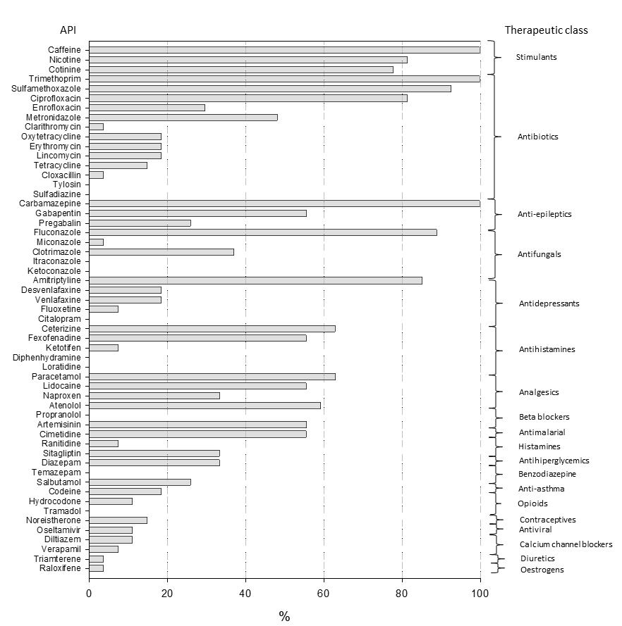
Figure 2 Frequency of detection of the 55 active pharmaceutical ingredients (APIs) at the 27 sampling points (100%) grouped per therapeutic class.

The APIs with the highest frequency of detection (>90%) were caffeine, carbamazepine, and trimethoprim, detected in 100% of the sampling points, followed by sulfamethoxazole (93%), fluconazole (89%), amitriptyline (85%), ciprofloxacin (81.5) and nicotine (81.5%) (Figure 2). Unfortunately this data cannot be compared with consumption data for APIs in Kenya as there are not accurate records, owing to a combination of drug company data being confidential and high levels of over-the-counter medicines being sold by unregistered pharmacies.
Caffeine is a useful marker for DDUW contamination (Dai et al., 2016; Verlicchi et al., 2012), because it is extensively removed during conventional wastewater treatment and so only low levels would be expected in catchments with a developed wastewater system (Sui et al., 2010). Its detection in all of the sampling points suggested extensive human-impacted contamination by untreated sewage throughout the catchment. Also, other human derived stimulants such as nicotine and its main metabolite cotinine were also frequently detected (81.5% and 78% respectively). However, it must also be recognized that the large areas allocated to coffee crops cultivation distributed throughout the Nairobi region, and the presence of tobacco factories in the industrial area of Nairobi, might contribute to the occurrence of these compounds in surface waters (Barjolle et al., 2017).
In a similar fashion, the antiepileptic drug carbamazepine is also used as a marker for sewage contamination, because of its persistence and high solubility, and it was consequently detected at all of the sampling points (100%), further suggesting the influence of domestic wastewater on the catchment (Durán-Álvarez et al., 2015; Gasser et al., 2011; Kruglova et al., 2014). In the same therapeutic class were the less frequently detected gabapentin (56%) and pregabalin (26%).
The antibiotics trimethoprim and sulfamethoxazole were detected with high frequency and high concentrations as has been the case for other African countries (aus der Beek et al., 2016). Three out of the thirteen antibiotics investigated in this work, namely trimethoprim, sulfamethoxazole, and ciprofloxacin were detected in a frequency higher than fifty percent; and seven, namely metronidazole, clarithromycin, lincomycin, erythromycin, oxytetracycline, tetracycline, and enrofloxacin in between 10 and 50 % of samples; but cloxacin was detected in less than 10% of the samples collected and tylosin and sulfadiazine not detected at all (Figure 2).
The antifungal fluconazole was detected at a frequency of 89% of the sampling points, followed by clotrimazole (37%) and miconazole (3.7%) belonging to the same therapeutic class and which are predominantly for human use, but are also effective for horses, cats and dogs. The remaining two antifungals itraconazole and ketoconazole were not detected.
The API amitriptyline was the most frequently detected in the antidepressant therapeutic class (85%), whilst desvenlafaxine and venlafaxine were detected at five sampling points each (19%) and fluoxetine at two locations (7.4%). The antidepressant citalopram was not detected.
Six APIs belonging to the class of antihistamine were investigated. The APIs cetirizine (63%) and fexofenadine (55.6%) were detected at a similar frequency; ketotifen was detected at only two sampling locations (7%); whilst the antihistamines diphenhydramine and loratidine were not detected at all.
Analgesics often predominate in API monitoring studies and paracetamol (also known as acetaminophen) was found in seventeen out of the 27 sampling locations (63%) followed by lidocaine (56%) and naproxen (33%). Paracetamol has been recognized as the most frequently detected API globally (Barra Caracciolo et al., 2015), even though it is quickly catabolized by microorganisms and consistently removed from water and wastewater (Baena-Nogueras et al., 2017; Lin et al., 2010; Yamamoto et al., 2009), and therefore typically absent in samples collected away from any source. Naproxen has a similar environmental behaviour and is quickly eliminated from the aqueous environment (Grenni et al., 2018).
The beta-blocker atenolol was detected at 60% of the sampling points, whilst propranolol was not detected. The antimalarial artemisinin was detected in fifteen sites out of the 27 (56%).
All the other compounds not listed so far fell below the detection frequency of 50%. A total of 11 compounds out of the total 55 were not detected, namely tylosin, sulfadiazine, citalopram, itraconazole, ketoconazole, diphenhydramine, propranolol, miconazole, loratidine, temazepam, and tramadol; 3, namely cloxacillin, triamterene, raloxifene were detected only at one site; 3, namely fluoxetine, ketotifen, verapamil, in only 2 sites; and 3, namely oseltamivir, diltiazem, hydrocodone were detected only at three 3 sampling points. Of these compounds only four are on the WHO essential medicines list and possibly more importantly, only one, fluoxetine, is listed in the Kenyan list of essential medicines (Kenya Essential Medicines List, 2016), which might explain their low frequencies of detection.
Compounds not detected or detected in less than 3 sampling points at concentrations <10 ng L⁻¹ in the impact zone were excluded from further statistical analyses as the risk is considered irrelevant in the EU ERA protocol (EMA, 2018) (S.3).

Catchment APIs distribution
It is not possible to represent 55 APIs across 26 sites in a graphical manner. Consequently, by way of summarising the data generated for all of the sites monitored the 55 API concentrations were summed in order to provide an overall burden on the catchment and to allow comparison with previous data (Table 2). Site Ng2 along the Ngong River exhibited the highest mean and maximum total API concentrations of 31,160 and 55,193 ng L⁻¹ respectively for all of the sites monitored (Figure 3).
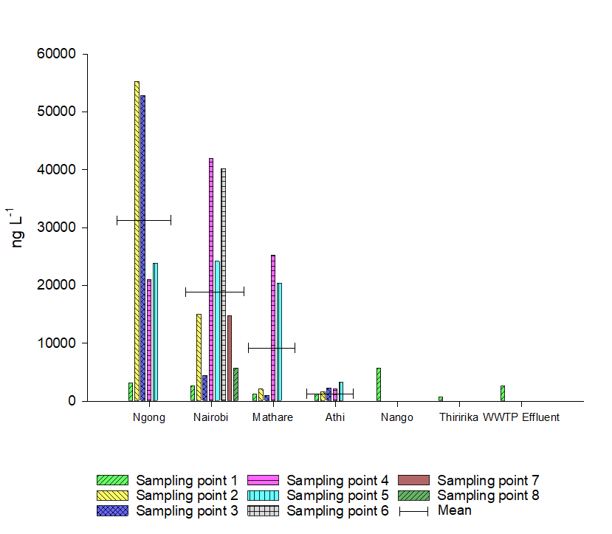
Figure 3 Sum and mean of the 55 APIs at each river sampling point (e.g. Sampling point 1 of Ngong = Ng1; Sampling point 1 of Nairobi = Na1, etc.). The wastewater treatment plant effluent concentration is to the far right for comparative purposes.
The total concentration of APIs increased from 3052 ng L⁻¹ at the sampling point Ng1, upstream the informal settlement of Kibera, to the max total concentration of 55,193 ng L⁻¹ at 5.6 km downstream the slum (Ng2). The subsequent sample (Ng3) was collected in the middle of the industrial area and other informal settlements and showed the second highest total concentration of APIs along this river (52,792 ng L⁻¹). The total concentrations at the last two samples, Ng4 and Ng5, decreased to less than half the maximum concentration, respectively 21,000 and 23,776 ng L⁻¹. Such a decrease is very likely due to a combination of reduced input and dilution caused by recent rainfall runoff at the start of the wet season which arrived early. It is also likely that biodegradation played a role on the decrease of concentrations of the compounds more rapidly catabolised by microorganisms.
The average total APIs concentrations of the Nairobi was of 18,560 ng L⁻¹ and its maximum concentration was of 41,954 ng L⁻¹ recorded at the sampling point Na4 located after the city centre and before the confluence with the Mathare River (Figure 3). The samples collected upstream (Na1, Na2) and in the city centre (Na3) showed a significantly lower concentration with respect to the samples collected downstream (Na4, Na5, Na6). The last two sampling locations recorded total concentrations similar to the upstream ones (Na7, Na8), showing a natural recovery of the river water quality with regard to APIs.
The Mathare River exhibited relatively less API contamination at locations upstream of the city (Ma1, Ma2, Ma3), but was the third highest river for average total amount of APIs (9913 ng L⁻¹) owing to two highly polluted sites (25,156 ng L⁻¹ at Ma4, and 20,343 ng L⁻¹ at Ma5). These last two sampling points are located in proximity of the Mathare informal settlement and the Dandora landfill (Figure 1) which might explain the sudden increase in API levels.
The Thiririka River was sampled before the confluence with the Nairobi as it could potentially be contaminated by APIs from the upstream urban centre of Githurai located adjacent to Nairobi and therefore contributes to the impact zone. However the results showed a relatively low total concentration of pharmaceuticals (653 ng L⁻¹).
The Athi River showed an average total APIs concentration of 2064 ng L⁻¹ and a max total APIs concentration of 3255 ng L⁻¹. The first three sampling locations have no influence from the sources of APIs within the city centre. After the sampling point At3 the water quality is influenced by the confluence with the Nairobi River. However, the max total APIs concentration is detected at the sampling location At5 (3255 ng L⁻¹), which is likely influenced by the waters coming from the Nango River (5674 ng L⁻¹).
The sample collected from the effluent of the Dandora WWTP showed a total API concentration much lower (2586 ng L⁻¹) than the averages observed in the Nairobi city rivers (Ngong, Mathare and Nairobi) which confirms the importance of the wastewater treatment in reducing the environmental occurrence of APIs within urban developments (Comber et al., 2018). Given the extremely high levels of parent APIs measured within the catchment, then there will obviously be concern regarding any potentially toxic transformation products. Although not determined as part of this programme of work, they should be considered in future monitoring, using a combination of occurrence data in studies such as this and transformation product ecotoxicological data, to identify high risk chemicals for further study.

APIs individual contribution and occurrence patterns
The analgesic paracetamol was the compound with the highest contribution to the contamination by APIs (47.4%) (Figure 4), and the API occurring in the largest concentration in the Ngong River (max 31,003 ng L⁻¹), the Nairobi River (max 24,541 ng L⁻¹), and the Mathare River (max 14,180 ng L⁻¹). These high concentrations were in contrast to its relative low frequency of detection (Figure 2) highlighting its well-known rapid biodegradation (Baena-Nogueras et al., 2017; Bagnis et al., 2019; Lin et al., 2010; Yamamoto et al., 2009), which together with dilution, significantly contributed to its decrease of occurrence in the environment and absence at sampling locations away from the source. Paracetamol was detected in other waterbodies of the African continent at concentrations in the same order of magnitude as recorded in this study (Table 2).
Sulfamethoxazole was the second most abundant API detected in the catchment (15.8%) (Figure 4), occurring as the most abundant API in the Athi River (max 1530 ng L⁻¹, At5), and exhibited the second highest individual concentration in the River Ngong (11250 ng L⁻¹, Ng2). This compound is used in large amounts globally and widely detected in water compartments, and according to the ERA performed by Straub (2015) the Nairobi/Athi catchment reported the highest global MEC (21,000 ng L⁻¹) in a previous study (K'oreje et al., 2012) (Table 2). The widespread detection of sulfamethoxazole is owed partly to the highly variable removal rate, caused by the transformation of its metabolites Na-sulfamethoxazole and Glu-sulfamethoxazole back to sulfamethoxazole in WWTP’s, which often results in a net negative removal (Göbel et al., 2004). The increase of concentration at the last sampling point with respect to the previous might be caused by a combination of transformation and the contribution of non-identified point sources. Regardless, once in the environment the main mechanism of removal is biodegradation, whilst photodegradation is significant only on a surface shallow layer (Straub, 2016).
The stimulant caffeine showed the third highest contribution (18.1%) and max concentration in the River Ngong (10891 ng L⁻¹). This compound was detected in South African water bodies in comparable concentrations (Agunbiade and Moodley, 2016; Matongo et al., 2015) (Table 2).
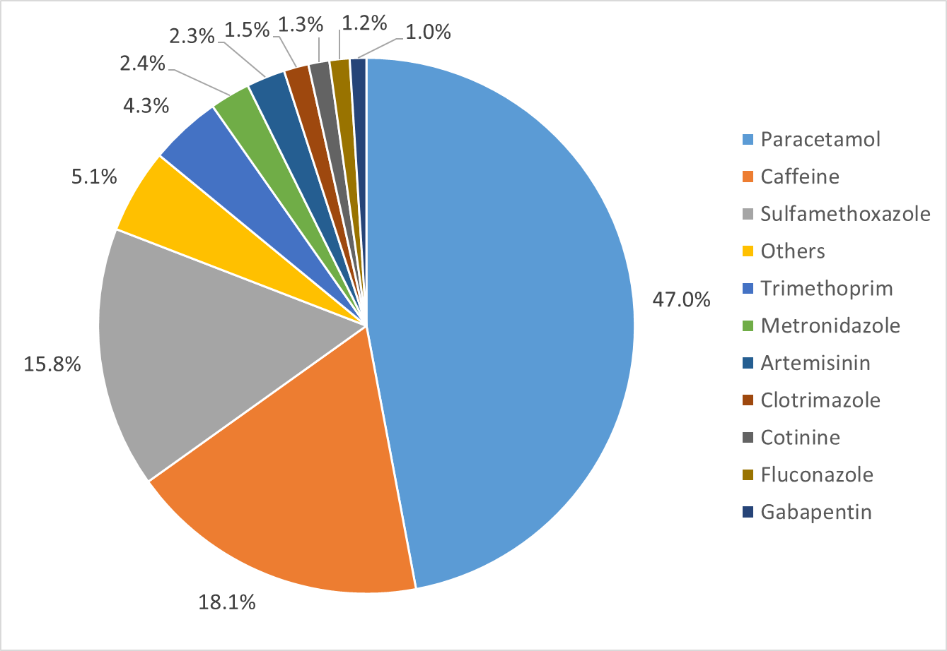
Figure 4 Percentage contribution of each API (sum of each sampling point concentration) to the total concentration of APIs detected along the Nairobi/Athi catchment. The slice “others” contains the compounds occurring for less than 1%, for ease of analyses.
The antibiotic trimethoprim also showed an important environmental input relative to the total APIs (4.3%) and it was detected at all sampling sites. The maximum concentration (3345 ng L⁻¹) was recorded downstream of the Dandora landfill, suggesting a leachate contribution from this potential secondary environmental source of APIs, as previously observed in other studies (Clarke et al., 2015; Masoner et al., 2014). This antibiotic was previously detected by other studies concerning African water bodies showing concentrations consistent with this study (Table 2). Trimethoprim is often prescribed with sulfamethoxazole and correlating the data for this study shows a significant relationship between concentrations of the two antibiotics (r² = 0.51).
These four compounds alone contributed 85.6% of the total amount of APIs detected along the Nairobi/Athi catchment. Two of these are antibiotics, which might therefore be of concern regarding antibiotic resistance within riverine systems as reported in other studies (Subirats et al., 2017).
The other compounds with a contribution higher than 1% are the antibiotic metronidazole (2.4%), the antifungals clotrimazole (1.5%) and fluconazole (1.2%), the stimulant cotinine (1.3%), and the antimalarial artemisinin (2.3%). All the APIs contributing to the less than the 1% were grouped in one category that contributes to the 5.1% of the total (Figure 4).
In Table 2 are reported the concentrations of a list of APIs detected both in this study and in other studies on the African continent (Table 2). For all of them the concentrations of reported APIs are generally similar. Carbamazepine, however, shows concentrations much larger in the study of K'oreje et al., (2016) than this study, both performed in the same catchment. This is probably because of the different sampling periods, in fact the latter study was performed during a dry season, whilst much of this work was performed during a wet season, which results in significant dilution from rainfall runoff. Also ciprofloxacin was detected in much higher concentrations in the study of Agunbiade and Moodley, (2014), though referring to a different water body in South Africa.
Table 2 APIs detected at the highest concentration (ng L⁻¹) in comparison with previous studies on the African continent (n.a: not available).
API (ng L⁻¹) | This study | K’Oreje et al. 2012 | Agunbiade et al. 2014 | Matongo et al. 2015 | Ngumba et al. 2016
Carbamazepine | 172 | 4000 | n.a. | n.a. | n.a.
Caffeine | 10890 | n.a. | 10000 | 33200 | n.a.
Trimethoprim | 3346 | 6000 | n.a. | 290 | 2650
Nicotine | 872 | n.a. | n.a. | n.a. | n.a.
Sulfamethoxazole | 11250 | 21000 | 8000 | 5320 | 13765
Paracetamol | 31003 | 16500 | 16060 | 1740 | n.a.
Amitriptyline | 54 | n.a. | n.a. | n.a. | n.a.
Ciprofloxacin | 168 | n.a. | 4000 | n.a. | 509

APIs source apportionment
The PCA analysis was performed with the purpose to reduce the complexity of the APIs dataset along the Nairobi/Athi River and to allow an easier estimate of the sources of APIs; it resulted in four PCs listed in Table 3. Using a combination of the location of the sampling sites within the catchment, the PCA grouping using the API concentrations and estimates of the protein-like dissolved organic material and the known physico-chemical attributes of the APIs such as their persistence within sewage treatment, it is possible to split the dataset into 4 reasonably clear potential sources namely; untreated wastewater, treated wastewater, point sources such as landfill leachate and agriculture.
Table 3 The four principal components (PC1, PC2, PC3, PC4) with the active pharmaceutical ingredients (APIs) and the protein-like DOM (PL-DOM) as variables along the Nairobi/Athi River sampling points. Also, the table includes the estimate source and relative variance.
 | PC 1 | PC 2 | PC 3 | PC4
Amitriptyline | 0.876 | -0.090 | -0.226 | 0.000
Artemisinin | -0.347 | -0.246 | -0.067 | -0.495
Atenolol | 0.729 | 0.583 | 0.202 | -0.121
Caffeine | 0.538 | 0.774 | 0.199 | -0.079
Carbamazepine | 0.397 | 0.160 | 0.840 | -0.028
Cetirizine | 0.067 | 0.347 | 0.847 | -0.180
Cimetidine | 0.797 | 0.320 | 0.319 | 0.069
Ciprofloxacin | -0.142 | -0.127 | -0.136 | 0.902
Clotrimazole | 0.544 | 0.497 | 0.435 | 0.136
Cotinine | 0.956 | 0.173 | 0.098 | -0.093
Enrofloxacin | -0.090 | -0.249 | -0.215 | 0.909
Fluconazole | 0.066 | 0.111 | 0.915 | -0.228
Gabapentin | 0.500 | -0.340 | 0.574 | -0.367
Metronidazole | -0.098 | 0.974 | 0.065 | -0.074
Naproxen | 0.750 | -0.381 | 0.436 | -0.055
Nicotine | 0.959 | 0.082 | 0.211 | -0.010
Paracetamol | 0.735 | 0.553 | 0.238 | 0.051
Sulfamethoxazole | 0.948 | 0.116 | 0.109 | -0.176
Tetracycline | -0.140 | 0.077 | -0.143 | 0.972
Trimethoprim | 0.003 | 0.980 | 0.136 | -0.02
PL-DOM | 0.876 | -0.157 | 0.377 | -0.126
Estimated source | Untreated  wastewater | Point  sources | Wastewater  treatment plant  effluent | Farming upstream city centre
Variance (%) | 46 | 17 | 16 | 9

The first principal component (PC1) showed the highest variance (46%) and was interpreted as the diffuse discharge of untreated wastewater. This is because the PC was highly weighted by APIs and protein-like DOM (PL-DOM) (Table 3). In fact, PC1 was heavily weighted by caffeine, nicotine, and paracetamol which are typically detected in untreated wastewater but completely or highly removed in wastewater treatment plants (Comber et al., 2018; Rosal et al., 2010; Sui et al., 2010). Similarly owing to its persistence atenolol was also detected in untreated wastewater (Castiglioni et al., 2006; Comber et al., 2018; Rajab et al., 2013; Rosal et al., 2010) but was absent in the WWTP effluent, strengthening the assumption that direct discharge of untreated wastewater was a significant source to the river. Despite the information available in the literature about the degradability of the antidepressant amitriptyline is scarce, there is evidence of high persistence (Baena-Nogueras et al., 2017; Bagnis et al., 2019; Li et al., 2013). But, similar to atenolol, its detection in the river waters and the absence in the effluent of the Dandora wastewater treatment plant and the high PC weight (0.88) suggested a contribution of its occurrence from DDUW. Also clotrimazole, cotinine, naproxen, cimetidine and gabapentin showed high weighting. These compounds are in high concentration in the sampling area between Na4 and Na6 which correspond to the area between the city centre and the suburban area downstream. Since only around 28% of Nairobi is on mains sewerage, it is very likely that this area corresponds to the downstream boundary of the service (Ngumba et al., 2016). Also, leachate runoff from the Dandora landfill might contribute to this load (Na6).
The second principal component (PC2) contributed 17% of the total variance. This profile was highly weighted by the APIs atenolol, caffeine, clotrimazole, metronidazole, paracetamol, and trimethoprim. Because of the little significance of PL-DOM to this PC, it was assumed the source of these APIs was linked to poorly defined point sources along the river. The maximum concentration of trimethoprim was recorded at a downstream sampling point (Na6) with respect to the highest concentration of PL-DOM (Na4). The Na6 sampling area corresponded with the tract of river flowing next to the Dandora Landfill, whose leachate runoff might be deemed as a point source of trimethoprim (Clarke et al., 2015; Masoner et al., 2014). However, also the presence of other sources was considered likely, such as hospitals or veterinary clinics.
The third principal component (PC3) contributed 16% of the total variance. This PC represented the effluent from the WWTP as it is weighted by only the APIs that were detected in the effluent sample namely carbamazepine, cetirizine, fluconazole, and gabapentin, and moderately weighted by PL-DOM as well, typical of WWTP effluents.
The fourth principal component (PC4) contributed 9% of the total variance. This component was weighted only by the antibiotics also known to be used for veterinary purposes such as ciprofloxacin, tetracycline and enrofloxacin, which were detected at the sampling point Na1 in relatively high concentrations. These APIs are thought to represent sources from agriculturally dominated land use upstream of the city. Since these APIs are used for veterinary purposes as well as in human medicines, without further, more intensive sampling it was assumed they were from agricultural sources (Alexandrino et al., 2017; Granados-chinchilla and Rodríguez, 2017; Peng et al., 2016).
There would obviously be overlap between these potential sources within a catchment and with only limited data the outputs are tentative. However, they do suggest some important points (i) that there are multiple sources of APIs to the catchment, (ii) that the untreated wastewater inputs are of high significance (iii) other sources such as landfills need further study and (iv) as in other countries, agriculture is also likely to be a source of APIs.
Surface water ERA beyond the end of the impact zone
The data provided a broad and detailed assessment of the extent of the contamination by the direct discharge of untreated wastewater in the Nairobi/Athi catchment and the occurrence of APIs at a point far from the source (At5). This last sampling point, even though still showing elevated levels of predicted BOD₅ (292 mg L⁻¹) was taken as the end of the impact zone on the basis of allowing a risk assessment to be applied using the protocol for environmental risk assessment for medicinal active compounds (Bagnis et al., 2019; EMA, 2006). For APIs detected above 10 ng L⁻¹ and with a log Kow of less than 4.5 the calculated risk quotient was calculated as set out by the EMA (2006). The risk was labelled in severity as follows: RQ <0.01 is insignificant; < 0.1 low risk; 0.1 ≤ RQ ≥ 1 medium risk; RQ > 1 high risk (Chen and Ying, 2015).
Table 4 Environmental risk assessment (ERA) for APIs at sampling point At5
ERA
API* | MEC  (ng L⁻¹) | PNEC  (ng L⁻¹) | RQ | RISK | REFERENCE
SFX | 1529 | 560 | 2.7 | High | AMR Industry Alliance, 2018; Straub, 2016
MTR | 182 | 130 | 1.4 | High | Bengtsson-Palme and Larsson, 2016
FLC | 112 | 250 | 0.45 | Moderate | AMR Industry Alliance, 2018
TRM | 64.6 | 500 | 0.13 | Moderate | Straub, 2013
CTN | 87.5 | 1000 | 0.09 | Low | Gosset et al. 2017
PAR | 45.8 | 814 | 0.06 | Low | Minguez et al. 2015
AMI | 12.8 | 720 | 0.02 | Low | Minguez et al. 2015
ART | 466 | 19000 | 0.02 | Low | Jessing et al. 2009
CFF | 634 | 8700000 | <0.01 | Insignificant | ECHA (https://echa.europa.eu/registration-dossier/-/registered-dossier/10085/6/1)
CBZ | 55.2 | 100000 | <0.01 | Insignificant | Minguez et al. 2015
GAB | 54.6 | 100000 | <0.01 | Insignificant | Minguez et al. 2015
* AMI, amitriptyline; ART. artemisinin; CFF, caffeine; CRB, carbamazepine; CTN, cotinine; FLC, fluconazole; GAB, gabapentin; MTR, metronidazole; PAR, paracetamol; SFX, sulfamethoxazole; TRM, trimethoprim.

The lowest reported PNEC were selected or calculated from the available literature including tests of cyanobacteria, invertebrates, algae, fish and clinically relevant bacteria (AMR Industry Alliance, 2018; Bengtsson-Palme and Larsson, 2016; Chen and Ying, 2015; Gosset et al., 2017; Jessing et al., 2009; LePage et al., 2017; Minguez et al., 2014; Straub, 2016, 2013; Tell et al., 2018). Fexofenadine, nicotine, lidocaine were detected at concentrations below 10 ng L⁻¹ and, according to the protocol of ERA for medicines of the EMA (2006), are unlikely to represent a risk for the environment. The log K_{ow} for these APIs is also below 4.5, respectively 2.8, 1.2, 2.3 (Drugbank, 2018), and therefore there is no need for an additional ERA involving the assessment of persistence, bio-accumulation and toxicity (EMA, 2006). Sulfamethoxazole and metronidazole were determined to be the highest risk driven largely by their low PNECs. Fluconaxole and trimethoprim were the only other APIs deemed to be of concern with moderate RQs (0.45 and 0.13 respectively).
Therefore, despite the natural attenuation of APIs occurring along the impact zone it was shown there may still be concern regarding their effects at or near its boundary. It should be noted that for some APIs there are a lack of sub-lethal, chronic ecotoxicological data across trophic levels and so further work is required in order to generate PNEC data that may be used with a high degree of confidence. Furthermore, the sample collected at this point in the river (Site At5) was taken after the wet season rains had arrived and therefore potentially diluting the sources of APIs from the identified sources including DDUW. During the dry season with lower flows in the river and therefore less dilution, the risk from sources independent of rainfall (e.g. industrial and municipal sewage (treated or untreated) would be expected to be higher. This highlights the need for more detailed and seasonal surveys, extending further downstream that the last sample collected during this survey, to accurately assess the risk.

Conclusions
Based on the data reported above the following conclusions may be drawn regarding the occurrence and potential impacts of APIs within the Nairobi catchment:
- The Nairobi/Athi catchment showed an extensive downstream impact zone mostly derived from the DDUW from the urban centre of Nairobi city.
- The impact zone extended downstream to a distance of about 75 km far from the city. However, its downstream boundary was unclear owing to the inputs of untreated wastewater sources from the continuous urbanized areas along the river, which counteract the natural attenuation caused by dilution and degradation.
- The most frequently detected APIs and chemicals were caffeine, carbamazepine, trimethoprim, nicotine, and sulfamethoxazole. Paracetamol, caffeine, sulfamethoxazole, and trimethoprim alone contributed 86% of the total amount of APIs detected along the Nairobi/Athi catchment.
- The main API sources were attributed to the informal settlements and the industrial area in Nairobi City, as well as the Dandora landfill. Also, farming or agricultural sites upstream of the city were likely sources of veterinary APIs.
- It is shown that there is a potential environmental risk of API ecotoxicological impacts beyond the end of the impact zone, and a high risk for metronidazole and sulfamethoxazole. Given that these are both antibiotics, then their potential impact on antimicrobial resistance within the catchment also bares further investigation. However, any assessment would benefit from greater coverage of the catchment including sampling further downstream in order to better establish the extent of the mixing zone as well as a more systematic monitoring of wet and dry seasons, accompanied by hydrological data in order to be able to calculate loads to the catchment. Further, more detailed source apportionment as well as access to sales and consumption data would also assist in refining risk models.

References
Agunbiade, F.O., Moodley, B., 2016. Occurrence and distribution pattern of acidic pharmaceuticals in surface water, wastewater, and sediment of the Msunduzi River, Kwazulu-Natal, South Africa. Environ. Toxicol. Chem. 35, 36–46. https://doi.org/10.1002/etc.3144
Agunbiade, F.O., Moodley, B., 2014. Pharmaceuticals as emerging organic contaminants in Umgeni River water system, KwaZulu-Natal, South Africa. Environ. Monit. Assess. 186, 7273–7291. https://doi.org/10.1007/s10661-014-3926-z
Alexandrino, D.A.M., Mucha, A.P., Almeida, C.M., Gao, W., Jia, Z., Carvalho, M.F., 2017. Biodegradation of the veterinary antibiotics enrofloxacin and ceftiofur and associated microbial community dynamics. Sci. Total Environ. 581–582, 359–368. https://doi.org/10.1016/j.scitotenv.2016.12.141
AMR Industry Alliance, 2018. AMR Industry Alliance Antibiotic Discharge Targets AMR Alliance Recommended PNECs for Risk Assessments.
aus der Beek, T., Weber, F.A., Bergmann, A., Hickmann, S., Ebert, I., Hein, A., Küster, A., 2016. Pharmaceuticals in the environment-Global occurrences and perspectives. Environ. Toxicol. Chem. 35, 823–835. https://doi.org/10.1002/etc.3339
Badr, E.S.A., Achterberg, E.P., Tappin, A.D., Hill, S.J., Braungardt, C.B., 2003. Determination of dissolved organic nitrogen in natural waters using high-temperature catalytic oxidation. TrAC - Trends Anal. Chem. 22, 819–827. https://doi.org/10.1016/S0165-9936(03)01202-0
Baena-Nogueras, R.M., González-Mazo, E., Lara-Martín, P.A., 2017. Degradation kinetics of pharmaceuticals and personal care products in surface waters: photolysis vs biodegradation. Sci. Total Environ. 590–591, 643–654. https://doi.org/10.1016/j.scitotenv.2017.03.015
Bagnis, S., Fitszsimons, Ma., Snape, J., Tappin, A., Comber, S., 2019. Impact of the wastewater-mixing zone on attenuation of pharmaceuticals in natural waters: implications for an impact zone inclusive environmental risk assessment. Sci. Total Environ. 658, 42–50. https://doi.org/https://doi.org/10.1016/j.scitotenv.2018.12.191
Bagnis, S., Fitzsimons, M., Snape, J., Tappin, A., Comber, S., 2018. Sorption of active pharmaceutical ingredients in untreated wastewater effluent and effect of dilution in freshwater: Implications for an “impact zone” environmental risk assessment approach. Sci. Total Environ. 624, 333–341. https://doi.org/10.1016/j.scitotenv.2017.12.092
Barra Caracciolo, A., Topp, E., Grenni, P., 2015. Pharmaceuticals in the environment: Biodegradation and effects on natural microbial communities. A review. J. Pharm. Biomed. Anal. 106, 25–36. https://doi.org/10.1016/j.jpba.2014.11.040
Bengtsson-Palme, J., Larsson, D.G.J., 2016. Concentrations of antibiotics predicted to select for resistant bacteria: Proposed limits for environmental regulation. Environ. Int. 86, 140–149. https://doi.org/10.1016/j.envint.2015.10.015
Castiglioni, S., Bagnati, R., Fanelli, R., Pomati, F., Calamari, D., Zuccato, E., 2006. Removal of Pharmaceuticals in Sewage Treatment Plants in Italy. Environ. Sci. Technol. 40, 357–363. https://doi.org/10.1021/es050991m
Chen, Z., Ying, G., 2015. Occurrence , fate and ecological risk of five typical azole fungicides as therapeutic and personal care products in the environment : A review. Environ. Int. 84, 142–153.
Clarke, B.O., Anumol, T., Barlaz, M., Snyder, S.A., 2015. Investigating landfill leachate as a source of trace organic pollutants 127, 269–275.
Comber, S., Gardner, M., Sörme, P., Leverett, D., Ellor, B., 2018. Active pharmaceutical ingredients entering the aquatic environment from wastewater treatment works: A cause for concern? Sci. Total Environ. 613–614, 538–547. https://doi.org/10.1016/j.scitotenv.2017.09.101
Dai, G., Wang, B., Fu, C., Dong, R., Huang, J., Deng, S., Wang, Y., Yu, G., 2016. Pharmaceuticals and personal care products (PPCPs) in urban and suburban rivers of Beijing, China: occurrence, source apportionment and potential ecological risk. Environ. Sci. Process. Impacts 00, 1–11. https://doi.org/10.1039/c6em00018e
Drugbank, 2018. DrugBank - Accessed December 2018 [WWW Document]. URL https://pubchem.ncbi.nlm.nih.gov/
Durán-Álvarez, J.C., Prado, B., González, D., Sánchez, Y., Jiménez-Cisneros, B., 2015. Environmental fate of naproxen, carbamazepine and triclosan in wastewater, surface water and wastewater irrigated soil - Results of laboratory scale experiments. Sci. Total Environ. 538, 350–62. https://doi.org/10.1016/j.scitotenv.2015.08.028
EMA, 2018. Guideline on the environmental risk assessment of medicinal products for human use. DRAFT. Doc. Ref. EMEA/CHMP/SWP/4447/00 44, 1–12. https://doi.org/EMEA/CHMP/SWP/4447/00
EMA, 2006. Guideline on the Environmental Risk Assessment of Medicinal 1–12.
FASS, 2019. FASS [WWW Document]. URL https://www.fass.se/LIF/menydokument?userType=0&menyrubrikId=2532
Furlong, E.T., Kanagy, C.J., Kanagy, L.K., Coffey, L.J., Burkhardt, M.R., 2014. Determination of Human-Use Pharmaceuticals in Filtered Water by Direct Aqueous Injection–High-Performance Liquid Chromatography/Tandem Mass Spectrometry. B. 5, Lab. Anal. 49. https://doi.org/http://dx.doi.org/10.3133/tm5B10
Gasser, G., Rona, M., Voloshenko, A., Shelkov, R., Lev, O., Elhanany, S., Lange, F.T., Scheurer, M., Pankratov, I., 2011. Evaluation of micropollutant tracers . II . Carbamazepine tracer for wastewater contamination from a nearby water recharge system and from non-speci fi c sources. DES 273, 398–404. https://doi.org/10.1016/j.desal.2011.01.058
Göbel, A., Mcardell, C.S., Suter, M.J., Giger, W., 2004. Trace Determination of Macrolide and Sulfonamide Antimicrobials , a Human Sulfonamide Metabolite , and Trimethoprim in Wastewater Using Liquid Chromatography Coupled to Electrospray Tandem Mass Spectrometry 76, 4756–4764.
Gosset, A., Durrieu, C., Orias, F., Bayard, R., Perrodin, Y., 2017. Identification and assessment of ecotoxicological hazards attributable to pollutants in urban wet weather discharges. Environ. Sci. Process. Impacts 19, 1150–1168. https://doi.org/10.1039/c7em00159b
Granados-chinchilla, F., Rodríguez, C., 2017. Tetracyclines in Food and Feedingstuffs : From Regulation to Analytical Methods , Bacterial Resistance , and Environmental and Health Implications 2017.
Grenni, P., Bagnis, S., Comber, S.D.W., 2018. Naproxen - Chemistry, clinical aspects and effects. Nova Science Publishers, Inc., New York.
Jessing, K.A.K., Cedergreen, N.I.N.A., Jensen, J.O.H.N., Hansen, H.A.N.S.C.B., 2009. Degradation and ecotoxicity of the biomedical drug artemisinin in soil. Environ. Toxicol. Chem. 28, 701–710.
K’oreje, K.O., Demeestere, K., De Wispelaere, P., Vergeynst, L., Dewulf, J., Van Langenhove, H., 2012. From multi-residue screening to target analysis of pharmaceuticals in water: Development of a new approach based on magnetic sector mass spectrometry and application in the Nairobi River basin, Kenya. Sci. Total Environ. 437, 153–164. https://doi.org/10.1016/j.scitotenv.2012.07.052
K’oreje, K.O., Vergeynst, L., Ombaka, D., De Wispelaere, P., Okoth, M., Van Langenhove, H., Demeestere, K., 2016. Occurrence patterns of pharmaceutical residues in wastewater, surface water and groundwater of Nairobi and Kisumu city, Kenya. Chemosphere 149, 238–244. https://doi.org/10.1016/j.chemosphere.2016.01.095
Kenya Essential Medicines List, 2016.
Kithiia, S.M., 2007. An assessment of water quality changes within the Athi and Nairobi river basins during the last decade. Int. Assoc. Hydrol. Sci. 314, 205–212.
Kithiia, S.M., Ongwenyi, G.S., 1997. Some problems of water quality degradation in the Nairobi River sub-basins in Kenya. IAHS Publ. 121–127. https://doi.org/10.1109/17.913165
Koncagul, E., Tran, M., Connor, R., Uhlenbrook, S., Cordeiro Ortigara, A.R., 2017. Wastewater - The untapped resource, The United Nations World Water Development Report 2017.
Kruglova, A., Ahlgren, P., Korhonen, N., Rantanen, P., Mikola, A., Vahala, R., 2014. Biodegradation of ibuprofen, diclofenac and carbamazepine in nitrifying activated sludge under 12??C temperature conditions. Sci. Total Environ. 499, 394–401. https://doi.org/10.1016/j.scitotenv.2014.08.069
Kwak, J., Khang, B., Kim, E., Kim, H., 2013. Estimation of Biochemical Oxygen Demand Based on Dissolved Organic Carbon , UV Absorption , and Fluorescence Measurements. J. Chem. 9. https://doi.org/10.1155/2013/243769
Larsen, R.K., Baker, J.E., 2003. Source Apportionment of Polycyclic Aromatic Hydrocarbons in the Urban Atmosphere: A Comparison of Three Methods. Environ. Sci. Technol. 37, 1873–1881.
LePage G.L., Gunnarsson L., Snape J. and Tyler C. 2107. Integrating human and environmental health in antibiotic risk assessment: A critical analysis of protection goals, species sensitivity and antimicrobial resistance. Environment International. 109, 155-169.
Li, H., Sumarah, M.W., Topp, E., 2013. Persistence of the tricyclic antidepressant drugs amitriptyline and nortriptyline in agriculture soils. Environ. Toxicol. Chem. 32, 509–516. https://doi.org/10.1002/etc.2112
Lin, A.Y.C., Lin, C.A., Tung, H.H., Chary, N.S., 2010. Potential for biodegradation and sorption of acetaminophen, caffeine, propranolol and acebutolol in lab-scale aqueous environments. J. Hazard. Mater. 183, 242–250. https://doi.org/10.1016/j.jhazmat.2010.07.017
Lokhande, R.S., Singare, P.U., Pimple, D.S., 2011. Study on Physico-Chemical Parameters of Waste Water Effluents from Taloja Industrial Area of Mumbai , India 1, 1–9. https://doi.org/10.5923/j.ije.20110101.01
Madikizela, L.M., Tavengwa, N.T., Chimuka, L., 2017. Status of pharmaceuticals in African water bodies: Occurrence, removal and analytical methods. J. Environ. Manage. 193, 211–220. https://doi.org/10.1016/j.jenvman.2017.02.022
Masoner, J.R., Kolpin, D.W., Furlong, E.T., Cozzarelli, I.M., Gray, J.L., Schwab, E.A., 2014. Environmental Science Contaminants of emerging concern in fresh leachate from land fi lls in the conterminous United. Environ. Sci. Process. Impacts. https://doi.org/10.1039/c4em00124a
Matongo, S., Birungi, G., Moodley, B., Ndungu, P., 2015. Pharmaceutical residues in water and sediment of Msunduzi River, KwaZulu-Natal, South Africa. Chemosphere 134, 133–140. https://doi.org/10.1016/j.chemosphere.2015.03.093
Mbui, D., Chebet, E., Kamau, G., Kibet, J., 2016. The state of water quality in Nairobi River, Kenya. Asian J. Res. Chem. 9, 579. https://doi.org/10.5958/0974-4150.2016.00078.X
Minguez, L., Pedelucq, J., Farcy, E., Ballandonne, C., Budzinski, H., 2014. Toxicities of 48 pharmaceuticals and their freshwater and marine environmental assessment in northwestern France. Environ. Sci. Pollut. Res. https://doi.org/10.1007/s11356-014-3662-5
Mobegi, E.K., Nyambaka, H.N., Nawiri, M.P., 2016. Physico-chemical Characteristics and Levels of Polycyclic Aromatic Hydrocarbons in Untreated Water from Ngong River , Kenya. J. Pollut. Eff. Control 4. https://doi.org/10.4172/2375-4397.1000163
Muhonja, C.N., Makonde, H., Magoma, G., Imbuga, M., 2018. Biodegradability of polyethylene by bacteria and fungi from Dandora dumpsite Nairobi-Kenya. PLoS One 13, 1–17. https://doi.org/10.1371/journal.pone.0198446
Ngumba, E., Gachanja, A., Tuhkanen, T., 2016. Occurrence of selected antibiotics and antiretroviral drugs in Nairobi River Basin, Kenya. Sci. Total Environ. 539, 206–213. https://doi.org/10.1016/j.scitotenv.2015.08.139
Njuguna, S.G., 1979. Pollution Effects on a Tropical Stream : the Nairobi River 4, 8–13.
Peng, P., Wang, Y., Liu, L., Zou, Y., Liao, X., Liang, J., 2016. The excretion and environmental effects of amoxicillin , ciprofloxacin , and doxycycline residues in layer chicken manure. Poult. Sci. 95, 1033–1041.
Pittwell, I.R., 1988. 5 Day Biochemical Oxygen Demand ( BOD5 ) Second Edition 1988, in: Blue Books Series.
Rajab, M., Heim, C., Greco, G., Helmreich, B., Letzel, T., 2013. Removal of Sulfamethoxazole from Wastewater Treatment Plant Effluents by a Boron-doped Diamond Electrode. Int. J. Environ. Pollut. Solut. https://doi.org/10.7726/ijeps.2013.1008
Rosal, R., Rodríguez, A., Perdigón-Melón, J.A., Petre, A., García-Calvo, E., Gómez, M.J., Agüera, A., Fernández-Alba, A.R., 2010. Occurrence of emerging pollutants in urban wastewater and their removal through biological treatment followed by ozonation. Water Res. 44, 578–588. https://doi.org/10.1016/j.watres.2009.07.004
Schoeman, C., Mashiane, M., Dlamini, M., Okonkwo, O., 2015. Quantification of Selected Antiretroviral Drugs in a Wastewater Treatment Works in South Africa Using GC-TOFMS. J. Chromatogr. Sep. Tech. 6, 272. https://doi.org/10.4172/2157-7064.1000272
Straub, J.O., 2016. Aquatic environmental risk assessment for human use of the old antibiotic sulfamethoxazole in Europe 1999. Environ. Toxicol. Chem. 35, 767–779. https://doi.org/10.1002/etc.2945
Straub, J.O., 2013. An Environmental Risk Assessment for Human-Use Trimethoprim in European Surface Waters. Antibiotics 2, 115–162. https://doi.org/10.3390/antibiotics2010115
Subirats, J., Triadó-Margarit, X., Mandaric, L., Acuna, V., Balcázar, J.L., Sergi, S., Borrego, C.M., 2017. Wastewater pollution differently affects the antibiotic resistance gene pool and biofilm bacterial communities across streambed compartments. Molec Ecol. 26(20) 5567–5581. https://doi.org/10.1111/mec.14288
Sui, Q., Huang, J., Deng, S., Yu, G., Fan, Q., 2010. Occurrence and removal of pharmaceuticals, caffeine and DEET in wastewater treatment plants of Beijing, China. Water Res. 44, 417–426. https://doi.org/10.1016/j.watres.2009.07.010
Tchobanoglous, G., Burton, F., D., S.H., Eddy, M.&, 2003. Wastewater engineering:treatment and reuse. Boston: McGraw-Hill.
Tell, J., Caldwell D.J., Haner A., Helstern J., Hoeger B., Journel R., Mastrocco F., Ryan J., Snape J., Straub J.O., Vestel J., 2017. Science‐based targets for antibiotics in receiving waters from pharmaceutical manufacturing operations. Integrated Environmental Assessment and Management. 15, 312-319.
Verlicchi, P., Al Aukidy, M., Zambello, E., 2012. Occurrence of pharmaceutical compounds in urban wastewater: Removal, mass load and environmental risk after a secondary treatment-A review. Sci. Total Environ. 429, 123–155. https://doi.org/10.1016/j.scitotenv.2012.04.028
Wang, T., Omosa, I.B., Chiramba, T., 2014. Review Article Water and Wastewater Treatment in Africa – Current Practices and Challenges 1029–1035. https://doi.org/10.1002/clen.201300208
Wilkinson J., Boxall A. and Kolpin D. 2019. A Novel Method to Characterise Levels of Pharmaceutical Pollution in Large-Scale Aquatic Monitoring Campaigns. Appl. Sci. 9(7), 1368-1382. https://doi.org/10.3390/app9071368
Wood, T.P., Duvenage, C.S.J., Rohwer, E., 2015. The occurrence of anti-retroviral compounds used for HIV treatment in South African surface water. Environ. Pollut. 199, 235–243. https://doi.org/10.1016/j.envpol.2015.01.030
Yamamoto, H., Nakamura, Y., Moriguchi, S., Nakamura, Y., Honda, Y., Tamura, I., Hirata, Y., Hayashi, A., Sekizawa, J., 2009. Persistence and partitioning of eight selected pharmaceuticals in the aquatic environment: Laboratory photolysis, biodegradation, and sorption experiments. Water Res. 43, 351–362. https://doi.org/10.1016/j.watres.2008.10.039

