Supplementary Materials
Supplementary Analysis 1. ATL analyses based on coordinates from Rice et al., 2018b.
We used spatially identical LH and RH seeds in our main analysis, derived by flipping left-lateralised semantic sites into the RH. This method allowed for consistency across sites, since not all RH regions show a semantic response. However, a RH region important for semantic processing has been identified for the ATL (Rice et al., 2018b), consistent with the putative bilateral nature of this semantic component (Rice et al., 2015a, 2015b, Lambon Ralph et al., 2017), and this RH ATL (MNI: 44, -11, -36) peak is in a slightly different location from the one in our main analysis (MNI coordinates: 41, -15, -31). We therefore replicated our analysis using the task-based right ATL co-ordinates reported by Rice et al. Figure S1 below shows a comparison of the connectivity patterns for these two right ATL sites.

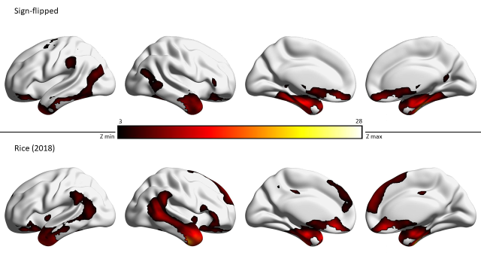
Figure S1. Connectivity for right ATL comparing two seed locations. Top row: data from our main analysis, using a seed derived by sign-flipping the ventral ATL peak in LH to RH. Bottom row: alternative RH site localising the semantic peak in right ATL using task activation data reported by Rice et al. (2018b).

A comparison of the connectivity of our sign-flipped homotope with Rice et al.’s alternative site reveals a high similarity. The maps are highly correlated (r = .7). Both seeds show intrinsic connectivity with bilateral ATL, inferior parietal, bilateral medial temporal and ventromedial prefrontal cortex. The seed functionally localised by Rice et al. (2018b), unlike our sign-flipped homotope, also shows connectivity with dorsomedial prefrontal cortex, in line with the results reported by Jackson et al. (2016).
Next, we examined the effects of seed selection on the difference analysis comparing the connectivity of left and right ATL presented in Figure 5 (Supplementary Figure S2 below). There were more extensive differences in connectivity when left ATL was compared with the functional peak for right ATL (taken from Rice et al., 2018b), compared with the sign-flipped homotope used in the main analysis. However, this may have reflected differences in the spatial localisation of these seeds, since the connectivity of ATL changes from medial to lateral and from anterior to posterior regions. For our RH (flipped) > LH contrast, we observe greater involvement of the contralateral hemisphere (where RH>LH connectivity differences were absent for our sign-flipped homotope), as well as more anterior frontal and medial connectivity differences across hemispheres.
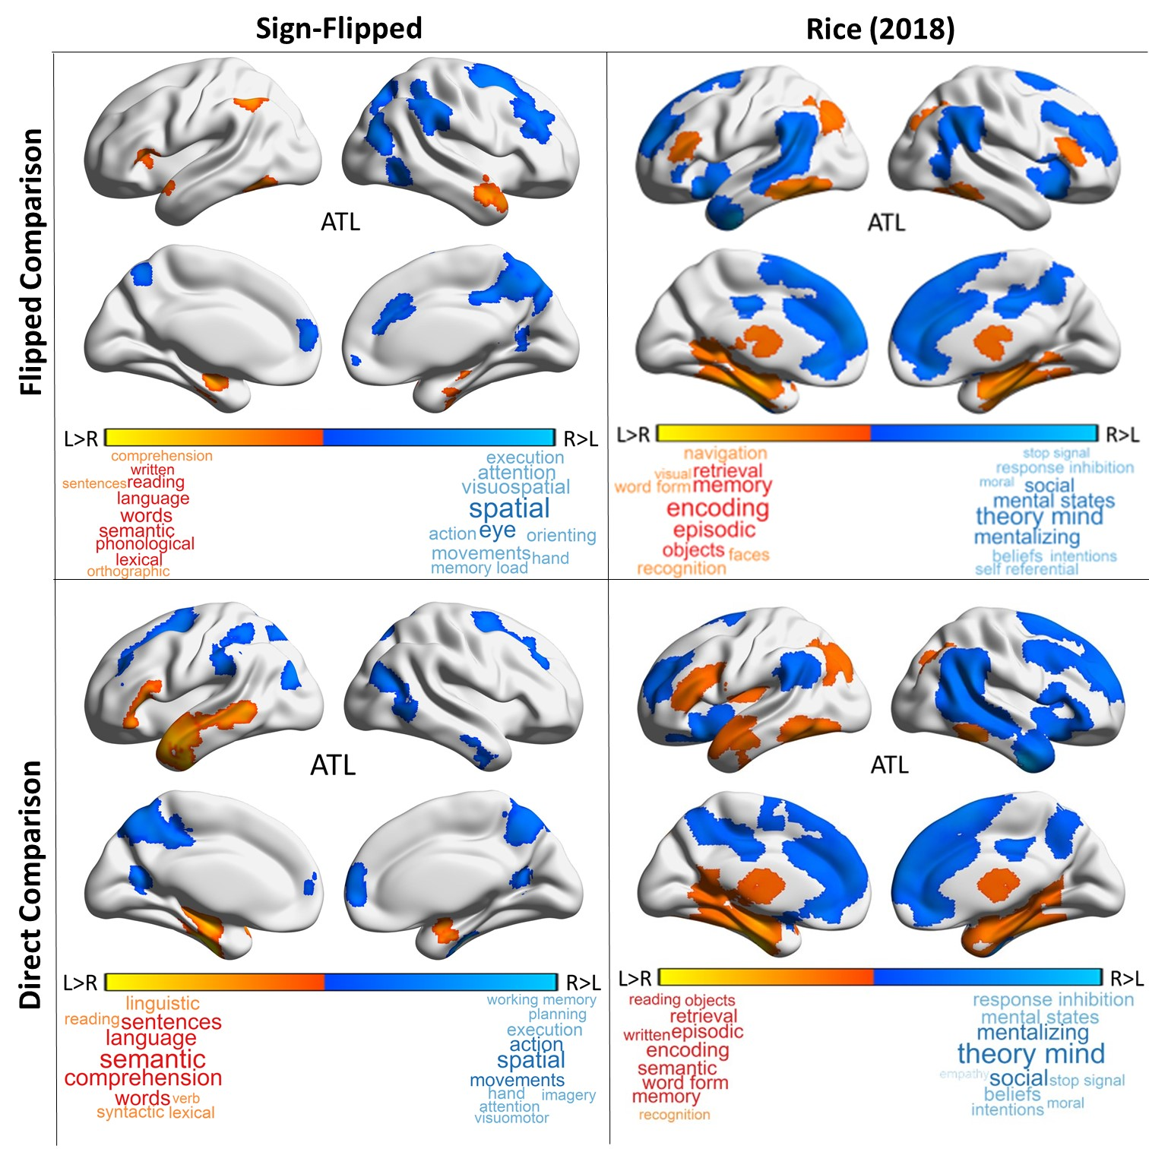
Figure S2. Comparison of intrinsic connectivity difference maps for our sign-flipped homotope and Rice’s (2018) right ATL coordinate.

We examined the effect that our selection of the ATL seed had on the correlations and equivalence testing reported in Table 2 (main analysis). We recomputed the relevant correlations and equivalence tests for the pairs involving the ATL seed (namely, IFG, pMTG and AG to ATL, as well as L-ATL to R-ATL). The results, shown in Table S1 reveal greater similarity between IFG and ATL for Rice’s RH ATL seed, and greater differences between ATL and AG, and ATL and pMTG. A new finding was that connectivity between left pMTG and left ATL was significantly higher than between right pMTG and right ATL using the seed from Rice et al. (2018b) – this finding was not observed with the RH homotope seed. Unsurprisingly, there was stronger similarity between the connectivity patterns of left and right ATL using the sign-flipped homotope (Pearson’s r = 0.85) than for Rice’s alternative ROI (r = 0.61).

 |  | LH |  | RH | LH vs. RH: Fisher r to z |  | Equivalence test for difference in r (TOST)
IFG to ATL | .129 |  | .107 |  |  | z=0.22, p>.1 |  | r(194)=0.02, p=.004
pMTG to ATL | .298 |  | .092 |  |  | z=2.11, p<.05 |  | r(194)=0.21, p=.491
ATL to AG | .141 |  | .055 |  |  | z=0.85, p>.1 |  | r(194)=0.09, p=.042
Table S1. Within-hemisphere correlations for the new ATL group mean connectivity maps derived from Rice et al. (2018b) compared to our three other seeds. All correlations are significant at p < .001. Correlations that are different between LH and RH, and those that are not statistically equivalent across hemispheres, are highlighted in bold.

Finally, we examined the relationship between individual differences in connectivity from the alternative right ATL seed provided by Rice et al. (2018b) and behavioural performance but there were no significant results.

Supplementary Analysis S2: Direct comparison of differential connectivity

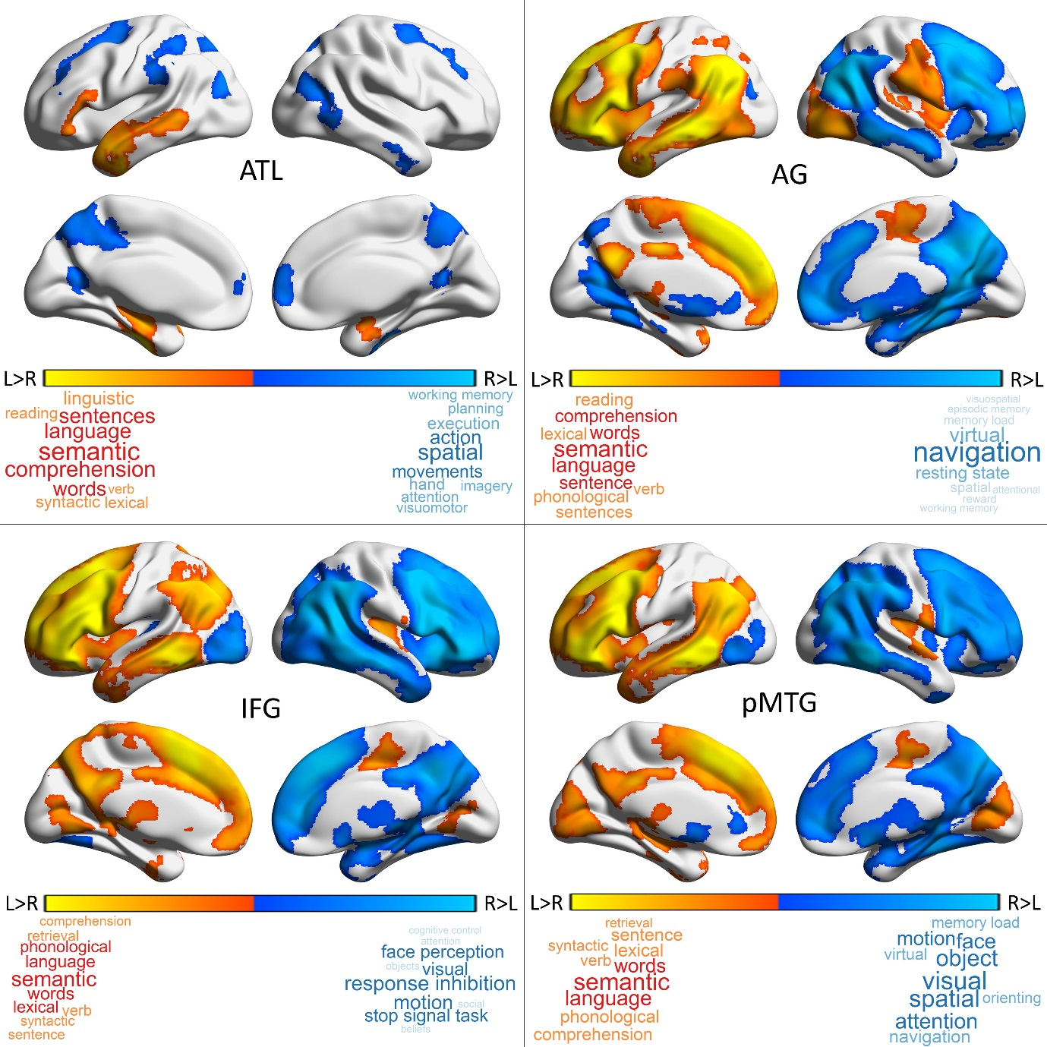
Figure S3. Intrinsic connectivity group maps showing the difference in connectivity between our semantic seeds of interest (left hemisphere) and their homotopes (right hemisphere). Each panel shows a direct comparison of left and right hemisphere seeds for a specific brain region (z = 3.1, p < .05). The results of cognitive decoding using Neurosynth (Yarkoni et al., 2011) are shown in the word clouds.

Supplementary Analysis S3: Conjunctions of homotopes
In this supplementary analysis, we repeated our conjunction analysis (see Methods for details: we used easythresh_conj.sh with p = .05 and a cluster-forming threshold of Z=3.1) but focussing on the common connectivity shared by each LH seed and its RH homotope this time.

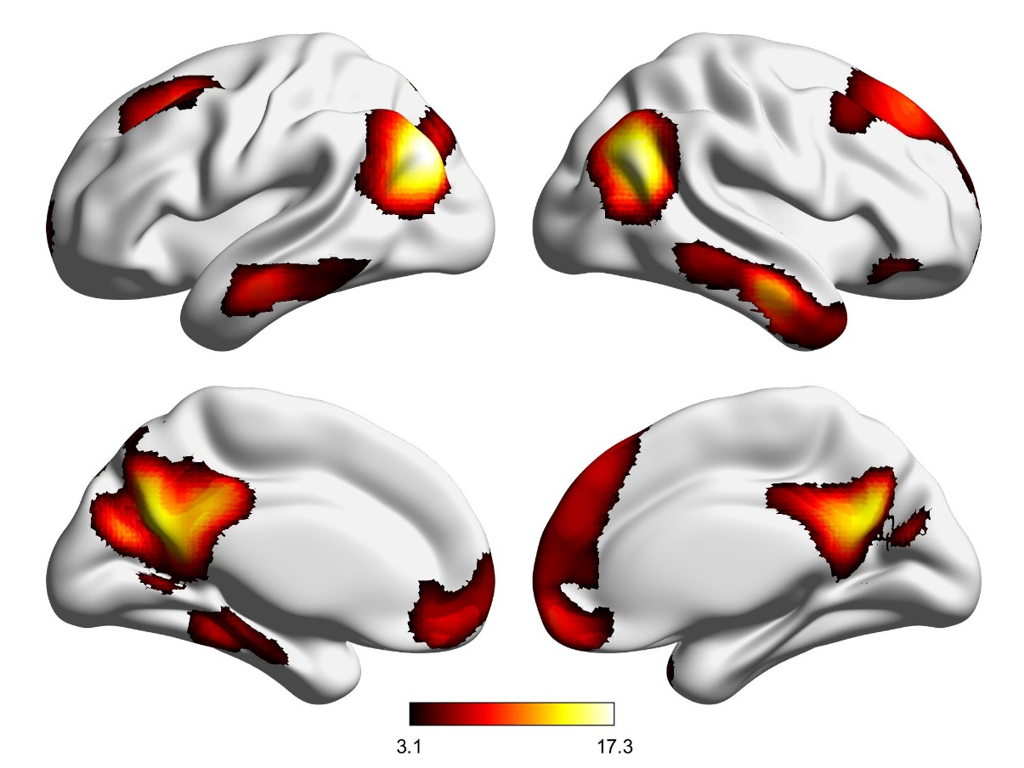
Figure S4. Common connectivity for left and right Angular Gyrus.

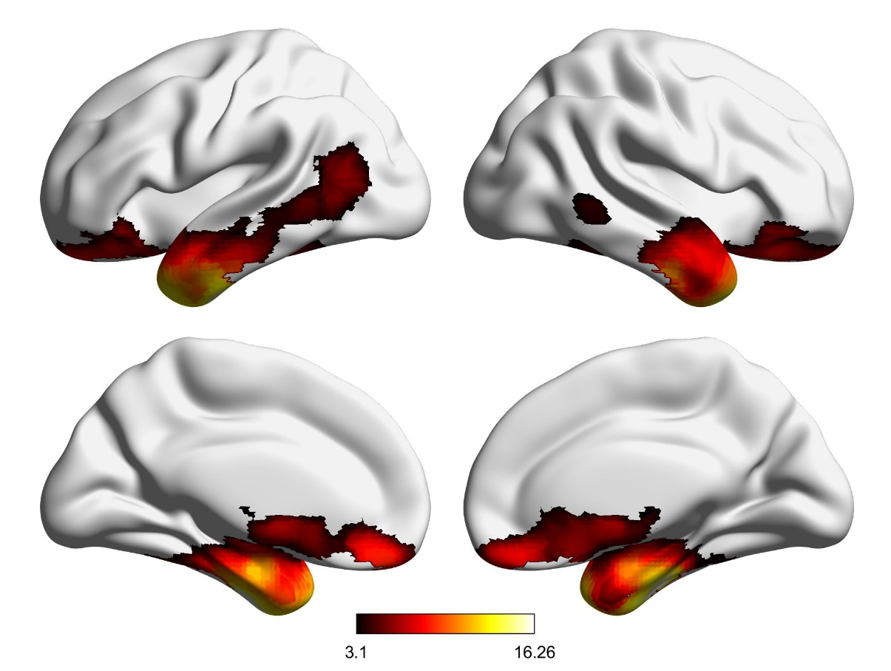
Figure S5. Common connectivity for left and right Anterior Temporal Lobe.
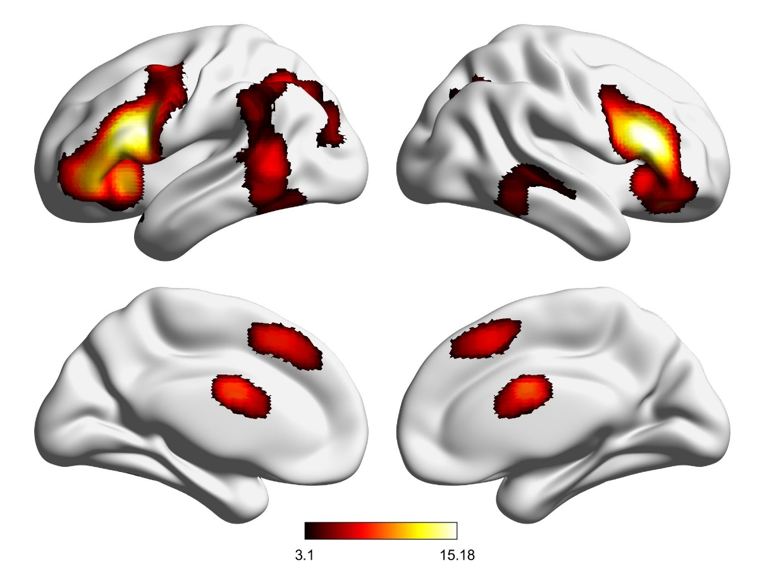
Figure S6. Common connectivity for left and right Inferior Frontal Gyrus

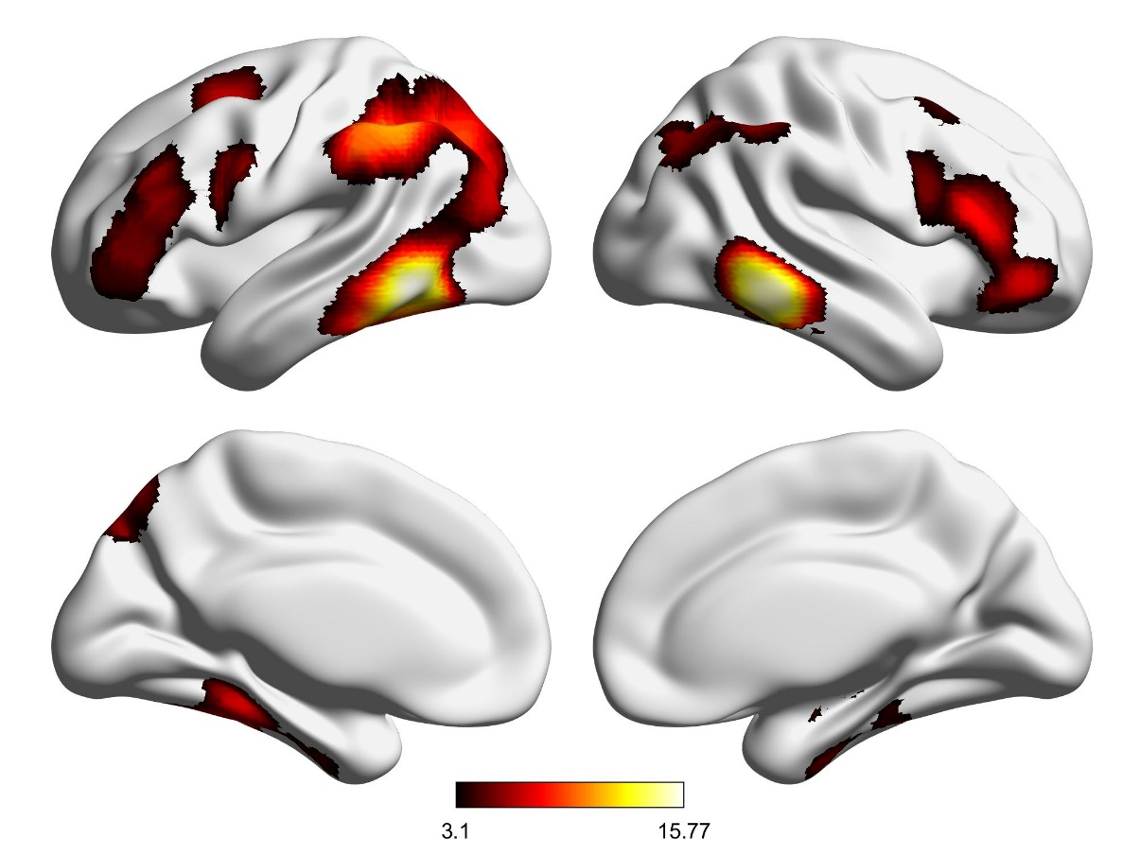
Figure S7. Common connectivity for left and right posterior Middle Temporal Gyrus

The results show that both left AG and its homotope show a pattern of common connectivity with regions in the DMN, including bilateral AG, lateral temporal cortex, anterior and posterior cingulate, and dorsolateral prefrontal cortex (Fig S4). The common connectivity for both ATLs covers lateral and medial aspects of the temporal lobe, more extended in the left than right hemisphere, as well as bilateral medial orbitofrontal cortex (Fig S5). Common connectivity for left and right IFG includes inferior and middle frontal gyri, pre-supplementary motor area/paracingulate cortex, pMTG and parietal regions that are close to AG, more extended in the left than right hemisphere (Fig S6). Lastly, pMTG’s common connectivity included bilateral pMTG, IFG and superior frontal sulcus, and intraparietal sulcus, more extended in left than right hemisphere (Fig S7).
The findings reported here are consistent with the connectivity of the seeds reported in the literature and in the main body of our manuscript: both AG seeds are allied to all core regions of the DMN (Bellana et al., 2016) while both ATLs show common connectivity to DMN and memory regions, as would be expected for the storage of semantic representations (Rice et al., 2015a, 2015b). IFG and pMTG showed similar common connectivity across LH and RH, including to each other and other control regions, adding further evidence that both these seeds form part of a network supporting controlled aspects of semantic cognition (Davey et al., 2016; Hallam et al., 2016).

