The Art of Flat Labor Organizing:
Participatory Art and Migrant Domestic Workers’ Self-Organizing in London

Joyce Jiang (University of York) and Marek Korczynski (University of Nottingham)

Abstract
There has been an upsurge of interest regarding how actors engage with art within organizational processes. However, scholars have tended not to study the role of art within contemporary collective labor organizing. This paper focuses on how participatory art may support flat, participative labour organizing, particularly among marginalized, relatively powerless workers. We present an ethnographic account of how art practices are deeply embedded within the flat organizing processes of Justice For Domestic Workers, a self-organizing group of migrant domestic workers in London. We reflect on this case to theorise the art of flat organizing, an ideal type of a set of participatory art practices that are compatible with and supportive of flat labour organizing.

Introduction
There has been an upsurge in scholarship which focuses on how actors engage with art within organizational processes. Art is here understood as the outcomes and processes of creative expressiveness through a range of media such as drawing, painting, singing, and writing. Scholars have studied the topic in a range of literatures and sub-disciplines, from the rise of the literature on the aesthetics of management and organization (Linstead and Hopfl, 2000; Taylor, 2002), to the development of the literature on arts within social movements (Danaher, 2010; Milbrandt , 2010; McCaughan, 2012), to the literature on the popular culture of organizations (Rhodes and Parker, 2008), via the development of the Art of Management conferences. Within these welcome developments in the visual and cultural turns in organization studies (Boxenbaum et al., 2018), there has not been a similar rise in studies on the (potential) role of art in collective labor organizing. We define collective labor organizing as the process of the creation of independent collective associations of workers. Although the topic of art in labour organizing has not attracted a great deal of new attention, it is an important topic, given the concern over the considerable decline in labour movements across many countries and the search for ways to arrest this decline. Our focus in this paper is upon the role of art within labour organizing.

The limited scholarship on how art can contribute to labour organizing (Tucker, 2010; Hall, 2001) has mainly focused on the inter-war period when folk songs were being used as a tool for labour organizing in the USA (Cohen, 2010; Lynch, 2007). Analysis has suggested that for all the lionizing of folk songs activists, such as Woody Guthrie, folk songs were actually only rarely embedded in the organizing practices in a sustainable way. Roy (2010) makes the key argument that there was a mis-allignment between the social relations implicit with the folk song practices, and the social relations within the labour organizing practices. His argument suggests that for art practices to be a sustainable part of labour organizations, there must be alignment in the social relations of these two elements. Scholarship on developments in labor organizing points to an emerging pattern of flat labour organizing, involving participation and a move away from formal bureaucracy. Such flat labour organizing is often aimed at marginalized, powerless workers. Potentially, participatory art practices (Bishop, 2006) may be aligned with such a flat labour organizing approach.

There is a gap in our knowledge regarding the role of art in contemporary labour organizing. We address this gap by reporting on an ethnographic study of the role of participatory art within the flat organizing practices of migrant domestic workers in London. From this case, we develop an ideal type of what we call The Art of Flat Organizing, a set of participatory art practices that are compatible with, and supportive of, flat labour organizing, particularly among relatively powerless workers. In the conclusion, we consider whether there are likely to be more opportunities for participative art practices to play a role in the development of flat organizing among other groups of marginalized, powerless workers.

The Art of Organizing
In this section, we examine the literature on the role of art in labour organizing, before turning to consider contemporary innovations in what we call flat labour organizing. We then consider the potential for participatory art to contribute towards flat labour organizing, and outline key literature on the workers studied in the paper – migrant domestic workers.

Art in Labour Organizing
The literature exploring the contribution of the arts to labor organizing is a limited one. Tucker (2010) argues that aesthetic ideas and practices were central to French syndicalism in the early twentieth century, and to the brief flowering of the Industrial Workers of the World in the USA in a similar period (Rosemont, 2015). In the field of visual art, the main topic has been a focus on the symbolism within union banners and the role of cartoons in union journals (Gorman, 1986; Cushing and Drescher, 2009; Morrison and Isaac, 2012; see also Franko [2002] on dance and labour organizing). Overwhelmingly, the main medium of artistic expression that has been linked to labour organizing has been music. Korczynski et al. (2013) have shown that historically singing at work was an implicit mode of informal self-organizing among groups of workers, and sometimes within occupations. More recently, Keevers and Sykes have shown how music practices can facilitate the creation of solidarity among participants in an NGO. Hall’s (2001) overview of the role of music within the formal institutions of the British labour movement between the wars showed that music tended to be peripheral to the mainstream organizing process. This is expressed well in the title of Jones’ book – music was primarily seen as ‘A Pleasant Change from Politics’. The only times when music became more central were in the songs of the relatively rare ‘cultures of struggle’ (strikes, protest and picket lines). Street’s (1986) pivotal examination of politics in pop music into the second half of the twentieth century gives only a few passing references to the role of music in labour union activities.

There is a rather richer literature from the United States regarding the role of protest, union and strike songs, particularly in the inter-war period (Roy, 2010; Foner, 1975; Cohen, 2010; Lynch, 2007; Reuss and Reuss, 2000; Roscigno and Danaher, 2004). Lynch’s (2007) close analysis of strike songs during the 1930s depression era pointed to songs having three functions that supported strike mobilisations – they communicated the workers’ voice; the process of singing was itself intrinsically motivating for the participants; and the process of singing together created a sense of solidarity among the participants. However, it is also clear that outside of the short periods of intense mobilization, these singing practices had little relevance for workers. Cohen (2010: 106) notes that Pete Seeger’s and Woody Guthrie’s search for a singing labour movement was, at best, only partially successful. Volk (2001) has called for labour songs to be more frequently used in labour organizing, but there is little to suggest that this call has been taken up. Roy’s (2010) comparative analysis of the embedded use of singing in the civil rights movements against the only sporadic success in how communist party activists tried to use folk music in labor organizing sheds important light on the role of music, and indeed wider art practices, in labor organizing. Roy’s key argument is that when the social relations of art practices and the social relations of organizing are in line with each other, then it is possible for art practices to be an embedded element in organizing. When there are key points of contradiction between the social relations within the art practices and the social relations of organizing, then there is little chance for art practices to become an embedded part of organizing. Albrecht’s earlier sociological analysis of arts points to one potentially important contradiction. Art embodies specific ‘expressive and intrinsic’ values including: the importance of the qualitative nature of experiences, in contrast to the impersonality of bureaucratic processes (Albrecht, 1968: 390). Tucker makes a similar contrast between aesthetics and bureaucracy: ‘the aesthetic emphasis on creativity and respect for the integrity of particular experiences and identities can be counterposed to the instrumental, bureaucratic world’ (2010: 7). Given that labor organizing has traditionally had key elements of bureaucracy within it (Tucker, 2010: 125), Albrecht’s and Tucker’s point suggests a potentially important reason why art practices have been so rarely embedded within labor organizing processes.

Contemporary Labour Organizing
Following Roy’s approach, if we want to consider the potential role for art practices within contemporary labor organizing, we have to understand the nature of contemporary labor organizing. The first point to note is the considerable importance attached to initiatives in labour organzing, in recent decades, particularly in the UK (Simms et al., 2012) and the USA (Milkman, 2006). There is growing concern that the decline in labor organizing has left large numbers of workers vulnerable to intensified forms of exploitation. While structural changes in labor and product markets are key factors informing the decline in labour organizing, scholars have also focused on organizing practices within the labor movement itself that can potentially reverse the decline in the scope and power of labor institutions.

There has been an array of attempts to innovate in the processes of labour organizing. Most notably, there has been an emphasis on the ‘organizing’ model, on community unionism, and on the development of indie unionism. We will briefly cover each before pointing to commonalities across these innovative modes of labour organizing. Regarding the organizing model, Heery (2002: 26) notes, ‘to a substantial degree, effort [at organizing new members] has been informed by the ‘organizing model’ that originated in the USA in the 1980s and which has since influenced the labour movements of Canada, Australia and New Zealand, as well as Britain.’ This label ‘organizing model’ is often used as a point of contrast to the partnership approach to union revitalization. The term ‘organizing’ has covered quite a wide array of practices (Simms et al., 2012) but central to it is the ‘empowerment’ of workers, in the sense of stimulating activism and strengthening trade unionism in the workplace in order that workers can resolve their own problems without recourse to external representation.

While the ‘organizing model’ tends to emphasise the centrality of the workplace for labour organizing, the community unionism approach emphasises the importance of the embeddedness of the workplace in a wider community (McBride and Greenwood 2009, Wills and Simms 2004; Holgate et al., 2012). The community unionism approach adopts the bottom-up empowerment focus of the organizing model and points to the potential for joining with community organisations in organizing processes. Community unionism has specifically focussed on attempting to organize relatively powerless and marginalized workers, such as migrant workers in low-wage, unregulated sectors. Some authors see the potential to develop a wider social movement unionism here (Clawson, 2003).

More recently, scholars have pointed to the potential importance of ‘new actors’ in labour organizing outside of established unions (Fine 2006). In the USA, key new actors are workers’ centres (Hetland, 2015), while in the UK new independent unions, or ‘indie’ unions are emerging as potentially important new actors (Pero, 2019). Pero highlights key characteristics of these new indie unions as a focus on precarious migrant workers, the creation of intense communities of coping and struggle around core employment issues which signify respect, low levels of formal bureaucracy in the search for speed and agility of action, and an emphasis on empowerment of workers.

While there are certainly differences across these attempts to innovate in labour organizing, there are important common elements across the organizing model, community unionism, and the rise of indie unionism. First, there is a broad emphasis on participative decision-making by workers. Historically, a key tension within union democratic process has been the role and relative importance of representative and participative democracy. The new emerging forms of labour organizing tend to lean strongly towards the importance of participative democracy. Second, and related to the emphasis on participative democracy, there are important elements of distributed leadership across these new labour organizing initiatives. In reciprocal community unionism (Wills and Simms, 2004), for instance,featuring broad local alliances, leadership roles are shared among leaders of the participating groups in the alliances. In the organizing model, there is an emphasis on shared leadership among an activist group in pursuing the workplace-based organizing efforts. Third, there is an overall move away from formal bureaucracy within the organizing processes. As Hyman (1979; 1989) has cogently argued, bureaucratic relations has often been an important element in the texture of the social relations of unions. He identifies bureaucracy within unionism as involving (1989: 181-182): a separation of representation from mobilisation, a hierarchy of control and activism, and the detachment of formal mechanisms of policy and decision-making from the experience of members. In various ways, key elements of the above innovative approaches seek to effectively move away from such bureaucratic tendencies in union organizing. Finally, we can also point to commonalities not just in terms of the organizing practices, but also in terms of the constituents at whom such organizing is aimed. All three organizing approaches have been aimed, to varying degreees, at the marginalized, disenfranchised workers who tend to lack the traditional bases of labour movement power (Wright 2000). Migrant workers in low wage, unregulated sectors are a good example of such workers.

We can characterize this emphasis on organizing the relatively powerless and marginalized workers through participative decision-making, distributed leadership, and a move away from formal bureaucratic relations as ‘flat organizing’. Although, historically, labour organizing have tended not to embrace art practices, it may be that there may be more space for art practices within the emergent flat organizing approaches.

A Potential Role for Participatory Art Practices?
Following Roy’s insight that it is more likely for art practices to be embedded in organizing when the social relations of art practices and of organizing are alligned, it is appropriate to consider how participatory art practices may be able to support emerging forms of participatory flat organizing.

According to Bishop (2006), participatory art practices tend to involve: i. an active engagement of people in art practices; ii. an opening out of concepts of authorship, away from the fetishization of the individual elite artist (to this, we add: a challenge to the code of aesthetics that underpins the myth of the individual elite artist); iii. an emphasis upon the creation of a sense of sociality among the participants within the art practices. Participatory art is sometimes labelled interactive, relational, cooperative, activist, dialogical, and community-based art (Finkelpearl, 2014). The explicit creation of participatory art is often traced back to Dadaist events in Paris in the early 1920s, and Brechtian theatre in inter-war Germany. The title of key texts that have informed the development of the project of participatory art give an indication of key impulses within the approach: ‘The poetics of the open work’ (Umberto Eco), ‘The death of the author’ (Roland Barthes); ‘Relational aesthetics’ (Bourriaud et al.); and ‘Social aesthetics’ (Larry Bang Larsen). Since the spread, from the 1960s onwards, of participatory art practices across across many community organisations and spheres of civil society, many authors speak of a participatory arts movement (Bishop, 2006).

The emphasis on active engagement, the move away from hierarchy and the importance of bottom-up participation within participatory art practices suggests that these practices follow a similar logic to flat organizing processes. Furthermore, given that participatory art practices have been a key part of community organisations and social movement organizing processes (Eyerman and Jamison, 1998; Rosenthal and Flacks, 2011; McKee, 2016), we can learn from literature on these areas to point to some more specific roles, practices and processes that may have resonance for a potential role for participatory art in flat labour organizing.

The art tutor often plays a pivotal role in participatory art . The art tutor role involves facilitating the participation of those who tend not to actively engage in art, and facilitating this participation outside of reference to dominant aesthetic standards. In practice, these qualities are often central to the job definition of tutors within community arts based organisations. In the context of tutors facilitating participation in arts in tandem with labor organizing, we can situate art tutors as an example of what Isaac (2009), and Cornfield (2015) call ‘aesthetic activism’, what Sandoval and Latorre (2008) call ‘artivism’, and what McKee (2016: 25) refers to as ‘artist as organiser’. The central idea here is that organizing and art practices are folded into each other, such that the art tutor plays a key role in articulating and developing, through art, the participative voice of members within the organization/movement.

Because participatory art practices challenge dominant aesthetics, it is often important for there to be a ‘safe space’ in which the practices are located. Safe space here refers to a space outside of the gaze of the dominant aesthetics (Hunter, 2008). In the context of participatory arts allied to labour organizing, there is a potential for the artistic safe space to overlap with the ‘free space’ (Polletta, 1999), ‘safe havens’ or ‘autonomous zones’ that have been identified as key micro-mobilization context within the social movement literature (McAdam, 1988) – spaces where participants are free to develop a hidden transcript (Scott, 1990) that challenges the social order. In the terms of Ranciere (2010), these are spaces where participants can trouble ‘the partition of the sensible’, with ‘the sensible’ understood as that which is seeable, hearable, and sayable as legitimately political in a given social order. Notably, Ranciere prioritises the aesthetics in destabilising the sensible. Courpasson et al. (2017) remind us that it is important to consider place in understanding resistance.

Given that flat labour organizing has often been aimed at powerless, marginalized workers, we need to enquire also if participatory art practices may also have resonance for the powerless and marginalized more generally. There may be greater possibilities of generating knowledge (for instance about exploitative social orders) among the powerless specifically through art. First, for the powerless, the hidden transcript operates as one of the main ‘weapons of the weak’ (Scott, 1990). The use of art may facilitate the moving of the hidden into the public, for it may operate as form of ‘veiling’. It can be easier to be transgressive of social orders through the arts than through normal communication (Ranciere, 2010). Second, as Taylor and Ladkin (2009: 58) argue, art enables a ‘non-discursive representation of… “gut-felt knowing’’. Such bodily, gut-felt knowing is often not easy to articulate in written or spoken word. Powerless, marginalized workers may be more likely to have a felt rather than directly articulable sense of injustice because these workers often lack the cultural resources to challenge the dominant social order. This is one of the reasons why arts-based methods in social enquiry are more frequently employed with ‘vulnerable populations’ (Coemans and Hannes, 2017) than with the less vulnerable. Art – by connecting with a felt sense of injustice - can contribute to what McAdam (1988) calls the process of ‘cognitive liberation, in which people, begin to question the legitimacy of rules and rulers (Foster, 2012).

The Specific Context of Migrant Domestic Workers
Migrant domestic workers (MDWs) in London, who are the focus of the case study in this paper, are a good example of powerless and marginalized workers. Domestic workers undertake domestic duties such as childcare, house-care, and cooking. MDWs are domestic workers who follow their employer in a journey of international migration. Studies show that MDWs tend to be socially isolated (Hondagneu-Sotelo and Riegos, 1997). In addition, Anderson (2000) argues that the maternalist dynamic of domestic work - being positioned as ‘part of the family’ - often conceals the implicit hierarchy of power relations at work. Others have also argued that domestic work is often framed as ‘servant’ work with loyalty, obligation and patronage being emphasized (Grant, 1997). Because of these factors, many MDWs suffer high degrees of exploitation, often receiving pay and benefits below the legal minimum. MDWs’ position of powerlessness and isolation in this social order has led a number of scholars to suggest that they are almost ‘unorganizable’ (Ford, 2004).

Research Methods
The research focuses on the organizing process (and art practices within that) of Justice For Domestic Workers (J4DW). J4DW was established by eight MDWs in 2009. In 2010, it had 300 members, By 2017, there were 1,300 members. J4DW renamed itself ‘The Voice of Domestic Workers’ in 2017. However, we call it J4DW in this paper as the data was collected before the organisation was renamed. The majority of members came to the UK with a domestic worker visa. To qualify for a domestic worker visa, MDWs have to work for one employer for at least one year, with the employer agreeing to move to the UK, bringing the domestic worker with them. Most J4DW members work and live in their employers’ houses. J4DW is affiliated to the hotel and restaurant branch of Unite the Union. J4DW worked closely with Kalayaan a charity for MDWs and Unite the Union to lobby and campaign for MDWs. J4DW provides for their members: free English as Second Language, IT and art classes; legal surgeries; employment rights advice; employment tribunal support; emergency support for those escaping employers; and social trips. J4DW cooperates with research institutes, undertakes parliamentary lobbying; and communicates with the media on issues of concern to MDWs.

Given ‘the close relationships between ethnography and aesthetic research, and the connections between art and everyday experience’ (Linstead, 2018: 319), we decided to adopt an ethnographic approach. There were five main strands of data collecting over a three year period. First, we recorded MDWs’ art works in art workshops and their exhibitions and performances in anniversary gatherings, parliamentary debates and campaigns. Second, observations and participant observations were intensively conducted in J4DW’s English classes, monthly self-regulated meetings, social activities, campaigns and parliamentary meetings over 12-months (2010-2011). The researcher worked as a volunteer in both MDWs’ language training and art workshops, and in these settings, the observations were participant observations. Third, we conducted 24 in-depth semi-structured interviews lasting from 25 minutes to one and a half hours with MDWs, union officials, community activists and art tutors. MDW interviewees were diverse in terms of their nationalities, with The Philippines, India and Indonesia being the main countries of origin. The age of interviewees ranged from 24 to 54. Given the lack of formal records at J4DW, it was not possible to say if this group differed in any important way from the whole membership. Fourth, informal talks were carried out in social gatherings, campaigns and art workshops. Finally, posts on art workshops on the facebook page of J4DW open to the public were examined, and some quotes have been used with the consent of the domestic worker author. The researcher continued to visit J4DW and attend their meetings, classes and campaigns occasionally (on average 5-6 times per year) between 2012 and 2017.

In ethnographic research, a reflexive consideration of our own social role in the research process is essential. The fact that the researcher was an Asian female migrant assisted in building relationships with MDWs. However, the researcher’s status as a middle-class researcher and unmarried woman may have created a social distance from MDWs. To address this, the researcher showed a committed presence by both working as a volunteer for MDWs’ language and art training (as noted earlier) and by developing on-going relationships with MDWs, becoming their ‘friend’ and sometimes informal advisor.. The analysis of the ethnographic data was undertaken in an inductive thematic manner: data were coded to categories and themes that emerged from the field work. In addition, we used methodological triangulation – a technique designed to compare these five stands of data to help provide a more comprehensive insights into the role of art in J4DW organizing. The purpose of triangulation was to enhance the comprehensiveness of data, to contextualise the interpretations, and to capture different dimensions of J4DW.

In the presentation of the findings, individual respondents have been anonymized. Where individuals can be visually recognised in the portrait art reproduced here, they have given their consent for this. We have not anonymized the organisation - J4DW as the chair and board members of the organisation agreed upon the non-anonymisation of the organisation. J4DW has widely appeared in social media, newspapers and public forums, and therefore revealing the organization’s identity is not politically sensitive.

Findings
In this section, we begin by giving an overview of the specific organizational context. Then we turn to to outline the mode of organizing within J4DW and the role of art within J4DW. Finally, we outline some key outcomes of these organizing and art processes.

Organizational Context
We briefly outline the specific labour market context, bargaining context, and regulatory context in this case. Before joining J4DW, the MDWs in this case were isolated, and dispersed, often experiencing a sense of powerlessness, and holding a frame of themselves as primarily quasi-family members and/or servants, rather than as workers. This mirrors findings from other research on migrant domestic workers (Grant, 1997; Anderson, 2000). In an earlier paper (Jiang and Korczynski, 2016), we have outlined this pattern in more detail. Here, we give only indicative data. Moreover, these themes are also present in the art created by the MDWs and discussed later in the paper. One MDW said: ‘I always call myself a domestic servant. That’s how I felt before. It’s just like slaves.’ Some MDWs expressed feelings of helplessness. One worker said ‘I was just sitting there. I just think god could help me’; another workers stated, ‘I just cry, cry and cry. There’s nothing I can do’.

In this context, J4DW’s emergent bargaining strategy had two main components. First, they encouraged MDWs to develop a frame of themselves primarily as (exploited) workers. Second, they helped to develop a sense of individual empowerment for the individual MDWs to bargain with their employers, in the context of emerging collective norms. This emergent bargaining strategy also developed within the art practices, as we show below. J4DW did not seek to engage in collective bargaining with multiple dispersed employers in private households. The visa context is the key regulatory context for MDWs. This has been a changing context.

Before April 2012, MDWs could accompany their employer to the UK and receive a domestic worker visa for a maximum of 12 months at a time. They could change employers in the UK and were allowed to renew the visa every year provided they continued to be employed as a domestic worker. In 2012, the government introduced the ‘tied domestic worker visa’ which granted MDWs a non-renewable 6 month visa without the right to change employers. A further change occurred in 2016 - as we explicate in the outcomes section of the paper. Throughout the period of the research, J4DW mobilised consistently to improve the visa situation of MDWs.

Flat Organizing in J4DW
Participative democracy and collective leadership development constituted an important part of the organizational processes in J4DW. The leader of J4DW was a Filipino domestic worker. She believed that all MDWs had the potential to be leaders: ‘I believe that domestic workers are able to organize themselves once they develop their confidence through training. ... there is a need for a group-led leadership. Otherwise the organization won’t be sustainable.’ Participation in decision-making was central to J4DW. The major decisions affecting MDWs were collectively discussed at their monthly self-regulated meetings that all J4DW members were encouraged to attend.

The board of J4DW comprises domestic workers directly elected by members, founders of Kalayaan, an official from Unite the Union and one community priest. All director positions within J4DW were non-paid and voluntary. One director noted:
We are different from professional leaders of other organisations. We give our mobile phone number to our members. They can contact us 24 hours a day, 7 days a week. If you don’t work as a domestic worker, it is difficult to understand our needs. For example, they might escape their employers or be abused by their employers at night… This is not what professional organisers can offer.
There was also a policy to rotate the representation of J4DW at public events – for instance, presenting policy issues at media events and to politicians.

There was a palpable lack of formal bureaucracy in J4DW. This was particularly notable at the monthly group meetings. These meetings were always highly informal in manner. Babies crawled along the carpet, members sat on tables, jokes were shared. Overall, there was a strong emphasis on creating informal trusting relations, which would allow members to explore and understand each other problems and vulnerabilities. Recruitment typically involved an MDW asking another domestic worker, usually a friend of theirs, to join them in coping with working circumstances. J4DW used small interactive groups which provided the time and space for individuals to reflect on and share their concerns, and made it possible for members to listen to each other and identify common problems. Members were always encouraged to share their personal experiences by talking, painting or acting in weekly English classes, monthly art workshops and monthly meetings. The majority of interviewees appreciated the mutual support in J4DW. As one Indian domestic worker noted, ‘I didn’t encounter any problems because we are helping each other. One has the problem; we are helping them. We help one another.’ Fellow MDWs offered food, clothing and short-term accommodation to MDWs who escaped from abusive employers. They collectively donated money to fellow MDWs in times of hardship. Many MDWs stated that they had never received such a level of care, support and compassion from any other group in the UK.

Although one main aim of J4DW’s activities was to develop critical labour awareness among MDWs, the chair of J4DW was also aware that radical ideology could not be imposed on MDWs and felt that individual explorations, within a group setting, was crucial. As she noted:
We understand why some MDWs don’t join our campaigns. They might lose their jobs if their employers know they are involved in campaigns. Some didn’t have any campaign experiences before. We won’t push them. This is a slow process. Once they know their work rights a bit more and know that many other domestic workers are beside them, they might change… We will educate and support them first.

There was an emphasis on promoting active participation among members. J4DW members were reluctant to make the payment of a membership fee a prerequisite for receiving services and attending classes. As the chair explained: ‘Some of them [members] are too poor. We also think that membership is more about active participation. £1 per person per month [membership fee] is symbolic. Even if they don’t pay the fee, we encourage them to attend our classes and organizing activities.’

Role of Art in J4DW
Monthly art workshops have been organised since J4DW was founded. Members showed great passion in attending art workshops. Approximately three quarters of J4DW members have participated in the workshops, often when they first joined the group. There were 20-30 members who participated in art activities every month. As we outline below, in addition to these art workshops, there were a number of other ways in which art was woven into the overall fabric of J4DW.

Participatory art
There was a range of art practices undertaken within J4DW, including singing, drawing, painting, writing, acting, and constructing and presenting satirical sketches. These art practices were participatory in nature. There was a notable absence of the use of established forms of art, such as songs or theatre plays, that had been authored by other, well-known artists. The art in J4DW was art made through the active engagement of the participants/members themselves. The art workshops took place in Unite the Union, The Showroom Gallery or Cubitt Gallery in London. Cubitt is an artist-led cooperative which aims to t challenge professional perceptions of what constitutes contemporary visual culture, while The Showroom focuses on collaborative and process-driven approaches to cultural production with local communities. Both art organizations showed great enthusiasm for the social and critical potential of art practices which produce communal knowledge. The sense of community and solidarity that developed within the process of making the art were often more important than the artistic outcomes of those processes. The participatory art practices were undertaken outside of the dominant code of aesthetics which valorizes individual elite artists.

As an example, we can consider the workshop where workers were asked to draw an image which symbolized difficulties in their work or life. One worker drew a crocodile to represent the inhuman treatments she has received from her employer (figure 1). One drew an image of a bird being locked in a cage, which was an indication of the social isolation she has suffered (figure 2). These images stimulated story telling from other members. One Indian domestic worker shared her experience of being locked in a countryside house without food by her employer. One Moroccan worker shared her story of not being allowed to go back home when her mother was dying. Many of these stories were moving both in the way they were delivered and in the way they were received. Several MDWs started sharing their own stories and then commented on others’ experiences. Tears and hugs punctuated the workshop. During informal conversations with participants after the workshop, some MDWs commented that sharing their experiences through drawing and talking about images reduced their loneliness and isolation, and they started realising that many fellow workers had suffered from work exploitation and abuse. Through the processes of drawing and reflecting on the drawings, a sense of community and solidarity was being developed.

FIGURES 1 AND 2 HERE

Towards the end of the workshop, the art tutor and MDWs together reflected on their common concerns. They summarized three key themes arising: job, love and shelter. Key job-related issues were non-compliance with minimum wages, long working hours and social isolation, in the labor process. The issue of ‘love’ centred on many MDWs feeling heart-broken and guilty about being separated from their families. The issues of ‘shelter’ related to MDWs’ concern that if they escaped from abusive employers, they risked losing shelter and visa status in the UK. These three common concerns - job (employment right), love (right of family reunion) and shelter (legal visa status) - have been widely reflected in the key agendas of J4DW campaigns, parliamentary debates and media representations. In this way, the processes and the outcomes of the art practices also directly contributed to the wider organizing focus of J4DW.

To examine the participatory art within J4DW in more detail, we consider the structuring of the art processes as a safe space, and the role of the tutor activist. Then, we focus on the quality of the art processes themselves in terms of motivation and empowerment through art, and in terms of art as knowing and questioning. We end this section by outlining how art was a key way in which J4DW communicated with external parties.

Art as safe space
The art workshop space was provided by Unite the Union, The Showroom and Cubitt for free and was used exclusively for J4DW activities on Sunday. This ensured intimacy within a small-scale community setting. Many MDWs said that this was the only physical space where they were not watched by their employers and where they were able to make friends who shared similar concerns. The majority of J4DWs worked for 6 or 7 days a week and had little time to go out freely. The session started with warm greetings between members, involving kisses, hugs and laughter. Just as important as the physical space, J4DW also created an art space which was safe in that there was no scrutiny by dominant aesthetic standards relating to the art. The art tutor noted that ‘this type of art has no common aesthetic standard. It’s grounded in its content. It’s as much about process as it is about the artistic products and outcomes.’ So , for instance, the drawings of the crocodile and the caged bird (figures 1 and 2) were not judged in terms of the conformance to dominant aesthetic standards. Rather, they were primarily seen and discussed as important and meaningful expressions of participants’ experiences.

J4DW art workshops were characterized by informality and a sharing culture. Members could interrupt the art tutor at any time if they had any questions or other issues to raise. People who were shy and less active were always encouraged to participate by the tutor. Notably, there was one J4DW member who appeared scared and silent the first time the researcher met her. However, in the art workshops in the following months she was actively sharing stories and participating. Friendships blossomed during the months of doing art together. Many MDWs stated that building friendship counted among the most important experience that happened during the art workshops. Two MDWs changed job, moving to outer London. Although the return journey now expensive they still attended the art workshops. One explained, ‘this is like my family. I feel warm here. This is the only place I feel released and I know who I am’.

Role of tutor
At the onset, the art tutor set the stage for sharing, learning and participation. Statements by the art tutor like, ‘If we share through art, we learn from each other’, laid the foundation for the open group discussions during workshops. All art tutors either had trade union backgrounds or had actively been involved in activities combating social injustice. However, even if these art tutors held clear views on the nature of injustice in the social order, they did not seek to impose these views on MDWs. Rather, they saw the production of art as a social activity that could express MDWs’ lived experiences. As one art tutor commented, ‘some of them don’t speak good English. Drawing or taking photos can be an easy way for them to express themselves.’

The art tutors adopted a participatory learning approach in which art functioned as a tool to enable MDWs to develop mutual trust and express common concerns. Consider the example of the workshop to prepare a drama piece for J4DW’s second anniversary gathering. MDWs were asked to demonstrate their stories in their migrant trajectory through acting and singing. None of MDWs in the class had experience of acting. The tutor started the session by asking the participants to share their life stories in small groups. The tutor also joined them for the group discussion and showed sympathy with their sad stories. There were tears, laughter, hugs and sighing. Several common themes arose from the discussion: separation from their own children, exploitations at work, lonely life in the host society and contribution to their own family. The tutor then put them into different groups according to different themes with each group performing a particular migration trajectory.

Motivation and empowerment through art
Many MDWs reported that the art practices themselves were inspiring and motivating. They felt emotional energy and mutual support when singing and acting together:
I think I have never been truly understood by others… but we understand each other. We care and love each other…even the tutor. When we perform, I can feel everyone else was in that situation before. It touched my heart. (Filipino, 29, 3 years in UK)

Art workshops are more interesting. I feel much more emotional when I sing songs or draw with other friends. It made me angry when I saw images of how we are badly treated. Sometimes I cried. It made me think. Singing together gave me passion and energy… it made me more willing to be involved. (Moroccan, 43, single, 4 years in UK).

The arts workshops aimed to develop individual and group empowerment. For instance, in the exercise of the ‘life river’ drawing, MDWs were asked to reveal not only the difficulties they came across in the migrant journey, but also the joy. The J4DW chair explained that ‘we encourage them to think about the contributions they made to the family and society. They are the heroes to some people.’ One MDW drew an image of a woman feeding a fish in the river (figure 3). She explained that they are feeding their whole family back home. This spurred MDWs to reflect on positive empowering dimensions of their work. Another MDW commented: ‘I sent my money back home. Now my children are in the college. I’m very happy’. The sense of pride in recognizing the value of their work was evident in a Christmas poem written by a J4DW member. Members had been asked to write a poem to express their feelings about Christmas:
But for many years now,
I am always far away from my Family.
I miss that moment that I should be celebrating Christmas with my own Family,
but I know I have to make sacrifices for my children.
I am sad and lonely away from them,
but I am also happy
because I could provide them everything they could ever ask for.
Every Christmas I am their best Santa Claus.

FIGURE 3 HERE

To counter feelings of powerlessness among MDWs, J4DW also organized a self-portrait workshop. MDWs were told that they would be photographed individually by a professional artist, and were encouraged to present themselves positively. They were then taught to put a piece of thin paper on top of their own portrait photos, draw outlines of their major features, and finally colour it. At the end, all drawings were displayed so that MDWs could exchange their views on each other’s work (figure 4). Most self-portraits featured smiling faces. Members reflected positively on these images:
It’s very interesting to look at a close-up photo of your face. I’m thinking is it really me? It looks artistic, but also happy…It touched me when I’m trying to think about what is good about me. There is something I feel happy and proud. I changed the life of some people. (Filipino, 36, 5 years in UK).

For many years now, I am always far away from my family. I am sad and lonely away from them, but I am also happy because I could provide them everything they could ever ask for (Filipino, 54, 6 years in UK)

FIGURE 4 HERE

Other members shared their stories of gaining economic independence and evading their abusive husbands or fathers back home. Some emphasized that they now worked in advanced economies. They were becoming proud of themselves.

J4DW organizers and art tutors believed that positive gendered and ethnic identity could reinforce MDWs’ confidence as proud workers who believe that they are capable of challenging exploitative structures. A good example was Miss J4DW Valentine’s Beauty Pageant. J4DW encouraged members of different ethnicities and ages to participate in the pageant. On the runway, contestants were asked to present traditional costumes of their own cultures. Contestants also needed to answer questions regarding the empowerment of domestic workers. For example, they were asked: ‘how can domestic workers improve their situations?’ The winner of the pageant was expected to represent J4DW at conferences regarding domestic workers’ rights. One organiser of the pageant explained that the purpose of the contest was to develop domestic workers’ self-confidence which can be derived from positive gendered identity or ethnic identity, and they believed that this confidence can be transferred to the political arena. As another organiser noted:
Many of us have the feeling of being abandoned. This contest helps us to discover ourselves, especially the positive self, and recognize our own beauty. Of course, when we say beauty, we don’t just mean beautiful women… Beauty also means courageous women who are able to speak out and defend her community. The winner will represent us to do lobbying.

If art helped facilitate a sense of individual empowerment, it also helped to develop and express a sense of group empowerment. MDWs were asked to draw a picture about changes in their life after joining J4DW. One group drew a picture of themselves standing together, holding hands, smiling and confident. Star labels were attached which read ‘sisterhood community’ and ‘unity’ (figure 5). This image of solidarity stood in strong contrast to their isolated life of powerlessness before.

FIGURE 5 HERE

Knowing and questioning through art
As noted earlier, at the point of joining J4DW, many MDWs held familial and servant framings of their position which over-rode a sense of worker identity. Art workshops often helped MDWs towards a reframing of their position. Answers were not proposed, but questions were posed which allowed participants to re-think the social order. A good example was when MDWs were asked to draw a ‘rights tree’ (figure 6) to highlight their rights and demands in the UK. The tutor suggested the task could help MDWs consider whether there was a gap between their work reality and legal employment rights in the UK. When they were drawing the tree, MDWs started discussing their employment rights:
MDW 1: If we work for 10 hours a day, 6 days a week, we should get about 400 pounds a week, right?
MDW 2: What? That’s impossible. I don’t have days off. I got up at 6:00 am in the morning and slept at 11 pm. I only got 250 pounds a month. I thought my situation was very good. I heard many bad stories from others.
MDW 1: We should get the national minimum wage. Your employer is not good.
MDW2: What is national minimum wage?
MDW1: It’s about 7 pounds per hour.
MDW 2: ah…I have been silly. I can save a lot of money and send it back to home then. I thought they treated me well like a family. We eat on the same table...no, they are not so good as I think.
There was a class discussion of MDWs’ employment conditions and rights. More MDWs were astonished by the legal employment rights and started blaming their employers for their poor conditions. An alternative framing of their situation had begun.

FIGURE 6 HERE

Art practices to facilitate knowing and questioning was also evident at the workshop where everyone was asked to draw an image of the difficulty in their work or life. One worker drew a medicine box. She explained that she was physically and emotionally hurt because she was abused by her employer and had been separated from her family for so long. Other MDWs offered stories and feelings which were evoked by the medicine box and they talked about multiple sources of physical and emotional wounds at work and ways of overcoming them. For example, one MDW said that she could not escape her abusive employer because her employer kept her passport. She could only resort to praying. Another worker shared her experiences of not being paid the minimum wage and being fired for no good reason. She was considering bringing the case to an Employment Tribunal with the help from J4DW. Some MDWs noted that they were more comfortable sharing their emotional wounds through the arts compared to the shame and embarrassment they felt when they spoke about these things. One worker stated, ‘I have never shared my stories with anyone for long, not even my family. I just don’t know to how to open my mouth. It’s too heavy to talk about the abuse and suffering. It’s also embarrassing…I can share by drawing.’

In another workshop, one MDW drew a lady standing on a high ladder with cleaning tools and chemicals in her hands (Figure 7). She explained, she had to work with potentially dangerous chemicals and lacked protective clothing, and experienced injuries from lifting and falling from a ladder. She called herself ‘brave lady’ in an ironic manner, as she had to endure this without access to workplace safety rights. This stimulated a wide discussion among MDWs about health risks in their workplaces. Many shared their experiences of suffering from occupational wrist, shoulder, elbow, back or hip pain. Health and safety issues have been incorporated into the main agendas of lobbying and campaigns in J4DW.

FIGURE 7 HERE

Communicating to external parties
J4DW frequently communicated to sympathizers and allies via the arts. Through arts, they communicated in the public sphere a collective narrative, articulating who MDWs were, what they stood for and what they were against. For instance, J4DW held a competition in which members were asked to design a Christmas card, and party invitation to be sent out to politicians, journalists, academics, activists, and union officials. The winning card is reproduced in figure 8. Featured are baubles and words arranged in the shape of a Christmas tree. The words are ‘, ‘national minimum wage’, ‘long hours of work’, ‘holiday, day of rest’, ‘social life’, ‘respect’, ‘family reunion’, and ‘equality’ Also included are four angels with the words ‘decent work’, ‘workers solidarity’, ‘UNITE the union’, and ‘UMWEP’ (United Migrant Workers Education Project), and a Santa jumping out of a box entitled ‘workers rights’. At the bottom are three concrete areas of demands: ILO convention for domestic workers, domestic workers visa, and diploma visa.

FIGURE 8 HERE

J4DW’s Christmas party, which was open to the public, included songs, dancing and dramas in which MDWs’ experiences of exploitation and abuse from employers were represented. For example, a self-composed song highlighted the heavy daily workload and expressed their demands for better wages. It was sung to the tune of ‘Jingle Bells’.
Dashing through the halls, with a trolley and a tray
Hoovering each room, tidy, clean and spray
Picking up the mess, scrubbing every floor
Every surface, every loo, storerooms by the score, oh!

Jingle bells, laundry smells, sweeping night and day
O what hell it is to work for stinking rates of pay
Jingle bells, laundry smells, sweeping night and day
O what fun it is to dream of decent rates of pay

The song was sung and received in a humorous way. The audience joined MDWs by clapping, dancing and humming along.

The Showroom and Cubitt Gallery provided free venues for J4DW to exhibit art works produced in the workshops and to organize its anniversary party and public events. J4DW art works were well received by audiences that consisted of media representatives, trade union officials, NGO staff, community activists and activists. One community activist commented that the drama, drawing and poem produced by MDWs were emotionally resonant, and it was impossible not to feel sympathy and compassion for this group of workers after viewing their art works.

Outcomes
Art, as a key part of the organizing process for J4DW, has contributed to J4DW more than quadrupling in size between 2010 and 2017. In addition, the data indicate that further to the art workshops, many MDWs came to hold a critical frame regarding their employment situation, and developed a sense of solidarity with their fellow workers and a desire to take part in J4DWs’ collective actions. We cannot say precisely the impact of art here, yet it is notable that the most regular participants of the art workshops were also organizers and active participants in campaigns and demonstrations. Art has played a significant role in the organizing of MDWs in J4DW. An education officer from Unite the Union, noted: ‘They are a source of inspiration. They have more organizing spirit. It is outstanding to see they come every Sunday, to see them work together.’

Through the art workshops, it was apparent that many J4DW members felt more confident in dealing with their own problems and engaging in public events related to MDWs. One MDW posted this Facebook comment after attending the beauty pageant:
Thank you so much J4DW for boosting my confidence. I was too nervous to be the emcee and to speak in front of the public. The outside world has consumed my confidence. A lot of bullies. I met critics who put me to shame instead of building me. I'm too scared to get out from my comfort zone. But once again, J4DW who have inspired me… You have empowered me. I love you and you will always be my home.

With the support from J4DW, two Filipino domestic workers successfully brought unfair dismissal cases to an employment tribunal and won compensation. After that, a working group, led by the two MDWs involved, was established to help members with regard to employment tribunals. Campaigns are on-going to urge the British government to ratify ILO convention on International Domestic Workers. Most J4DW members showed great enthusiasms in joining this campaign and in fighting for their employment rights. The development of political engagement has also been extended to members joining other progressive organizations in the UK such as women organizations and community organizations. A notable collective success for the lobbying and mobilizing of J4DW involved the UK government in 2016 granting migrant domestic workers the right to change employers (within a 6 month visa window). As noted earlier, the previous legislation had prevented MDWs from changing employers. The 2016 substantial improvement came about following consistent lobbying by J4DW and its sister organisation, Kalayaan.

Discussion

Overall Correspondence between Organizing Practices and Art Practices
We argued that a key insight from the literature was that analysis should proceed from understanding the social relations both of organizing processes, and of art practices. The findings showed a flat mode of organizing in J4DW. J4DW was organized in a participative way with an emphasis on a lack of distance between leaders and members. There was a distributed approach to leadership, manifest most notably in the policy of rotating the role of lead representative of the group when J4DW communicated with external parties. Rather than formal bureaucracy, informal trusting and caring relations permeated the organization.

The findings also showed the widespread and embedded nature of participatory art practices in J4DW. There was a monthly art workshop. As well as having a group of core committed participants, this art workshop effectively functioned as a key forum for the socialization of members into the organization, with around three-quarters of members having taken part in the workshop, often in the early part of their membership. J4DW adopted a processual approach to their art workshops which prioritised arts practices as a social process through which members shared stories, understood each other and developed community awareness. In stark contrast to the impersonality of bureaucratic processes which are often embedded in traditional union structures, J4DW’s art workshops embodied the qualitative and emotional nature of experiences which facilitated social bonding and trustful relationship among members. In addition, there were a range of other embedded art practices in J4DW which occurred outside the monthly art workshop. The art practices were participatory in that they involved the active engagement of the participants with an emphasis upon the importance of expression outwith regard to dominant standards of aesthetics, and an emphasis upon the importance of developing community, trust and solidarity in the processes of undertaking the art practices.

Overall, there was holistic correspondence between art practices and mode of organizing. The art practices were in line with, and grew with and from flat organizing. Participation, flat, trusting relations, and the development of both individual empowerment and a sense of collective labor solidarity were terms that could be applied equally to the art practices and to the mode of organizing. This correspondence underpinned the on-going sustainable use of art within J4DW.

The art practices were not just compatible with organizing practices at J4DW, they were also clearly supportive of J4DW organizing practices in a number of important ways. Notably, those who were active in art classes were also highly active in the wider activities of J4DW. The motivation in and through arts that participants experienced was carried over into their enthusiasm to play an active role in J4DW activities. Further, the sense of individual empowerment that MDWs found through participatory art meant that these were the MDWs who had the confidence to step forward to represent J4DW and to lead campaigns. In addition, the knowing and questioning within art practices threw up key areas of action that came to inform the agenda of J4DW. Not only was art frequently used as part of J4DW engagement with external parties, it was also the case that art practices could be incorporated into modes of decision-making (e.g. when the winner of the pageant became a representative of J4DW at conferences on domestic workers’ rights). The art practices also supported the emergent bargaining strategy of J4DW which involved both developing a frame among MDWs of themselves as workers with rights, and encouraging the individual empowerment of these workers with regard to their employers in the context of developing collective norms.

Theorizing This Correspondence – The Art of Flat Organizing
Here we abstract from the case to identify the core art practices at play – participatory art, tutor as art activist, safe space, questioning and knowing through art, and empowerment through art. We theorize these art practices as a whole as an ideal type (Eliaeson, 2000) of ‘the art of flat organizing’, which we define as a set of participatory art practices that are compatible with, and supportive of flat labour organizing.

Participatory art. Our first step in seeking to develop abstract theorizing from the case is to return to the definition of participatory art. We return to how we extended Bishop’s (2006) definition to highlight three elements – i) the active engagement of people in art practices; ii) the opening out of concepts of authorship away from the fetishization of individual elite artists through a separation of the art practices from the dominant code of aesthetics; and iii) an emphasis upon the creation of a sense of sociality among the participants within the art practices. We include each of these elements within our concept of the art of flat organizing, and add that the specific form of sociality to be emphasized within the art practices is that of community and solidarity.

Tutor as art activist. The art tutor is the crucial point of connection between participatory art practices and the wider process of flat labour organizing. The art tutor’s role is the node which must function to keep the correspondence between the art practices and organizing practices. The main literature on art tutors as ‘aesthetic activists’ (Isaac, 2009, and Cornfield, 2015)) emphasizes the importance of the tutor as enabling active art participation among those who do not normally engage in art activities, primarily by positioning the art practices outside of reference to dominant aesthetic standards. In addition, we abstract from the J4DW case to emphasise the art tutor as enabling the development of community and solidarity among participants, and as enabling questioning, knowing, and empowerment through art practices.

Safe space. Here, we use a double meaning in the term ‘safe space’. Within the context of the participatory art movement, safe space refers to a space where art can be created outside of dominant aesthetic standards – a space which allows drawing or singing by those who might otherwise say: ‘I can’t draw’, ‘I can’t sing’. Within the social movement literature, safe space refers to small-scale settings that are removed from the direct control of dominant groups, that facilitate an open questioning of an established social order (Polletta, 1999:1). It is a space where participants, who might otherwise be silent, can begin to articulate questions about exploitation and domination. Putting these two senses of safe space together: within the ideal type of the art of flat organizing, safe space involves a space for the questioning of the social order relating to work through the creation of art outside of the dominant aesthetic standards.

Questioning and knowing through art. As we noted earlier in the paper, the role of art in questioning social orders and expressing knowledge in non-textual ways has been noted in a number of literatures. Within the ideal type, we emphasise first how art– by connecting with a felt sense of injustice - can contribute to what McAdam (1988) calls the process of ‘cognitive liberation’, in which people, begin to question the legitimacy of rules and rulers (Foster, 2012). Second, we emphasise the argument of Taylor and Ladkin (2009: 58) that art enables a “gut-felt knowing’’. Within the J4DW case, the drawing of the crocodile in one of the art workshops represents a good example of gut-felt knowing. The discussion among the participants that flowed in this workshop is a good example of questioning of a social order facilitated through art.

Empowerment through art. Art therapy literature emphasizes the potential for art to develop empowerment among individual participants (Franklin, 1992). Given the importance we attach to developing a sense of community and solidarity with participatory art practices, we see empowerment as working at both the individual and collective level. Within the J4DW case, we can see individual and collective empowerment in the movement from the positive framing of the individual self-portraits to the drawing of the ‘sisterhood’ picture of the workers standing together, holding hands (figure 5). Table 1 lays out the key elements of the ideal type of the art of flat organizing.

TABLE 1 HERE

Finally, we propose that art practices that resemble the art of flat labour organizing are most likely to be found where the flat labour organizing involves marginalized, and relatively powerless workers, such as migrant workers in low wage, informal sectors. These workers often lack the cultural resources to challenge dominant framings supportive of the existing social order, and so these are the participants for whom knowing, questioning and empowerment through art are likely to speak most loudly.

Conclusion
This paper has focused on the how participatory art may support flat, participative labour organizing, particularly among marginalized, relatively powerless workers. We have made two contributions in this paper. Empirically, we have reported on an ethnography of flat organizing in J4DW for migrant domestic workers in London, and we have shown how participatory art practices were compatible with and supportive of the wider flat organizing processes. We have also made a theoretical contribution by drawing out the core abstract elements in the J4DW case to put forward an ideal type of the art of flat organizing – specific participatory art practices that are compatiable with and supportive of flat labour organizing, particularly among marginalized, relatively powerless workers. The ideal type of the art of flat organizing can be a useful device for the analyst to understand patterns of art practices in labour organizing. Although ideal types might rarely exist in the pure form in the social world, they can be used as a heuristic device to aid analysis.

Does our analysis of the case of J4DW suggest that there are likely to be more opportunities for participative art practices to play a part in the development of flat organizing among marginalized, powerless workers? We offer a qualified ‘yes’ as our answer to this question. Our qualification relates to the question of whether there is something specific about the group of workers in this study that makes the flourishing of participative art practices more likely than for most other groups of the unorganized in the contemporary economy at whom flat organizing might be aimed. The key characteristics of the members of J4DW are that they are migrant domestic workers; they are women, they are socially isolated; and, prior to joining J4DW, they tend to hold servant and/or familial framings of their situation. It may be that their migrant and socially isolated status makes them particularly open to involvement in participative art practices – in two senses. First, their position of social isolation intensified by the fact that the MDWs tend to live in their employer’s house means that the shared safe space that the J4DW art practices represented a crucial and often unique space in their lives. It was a space for the simultaneous creation of friendships, and generation of the ‘hidden transcripts’ of the powerless (Scott, 1990), of challenging the ‘sensible’ (Ranciere, 2010). Second, their migrant status and their social isolation meant that the English communication skills of many MDWs tended not to be fully developed. Art offered a mode of expressive communication that did not rest upon English skills. After the qualifications, our affirmative answer to the question: yes our analysis of the J4DW case suggests that there are likely to be real opportunities for participative art practices to play a part in any growth of flat labour organizing among powerless, marginalised workers. Flat organizing and a specific set of participatory art practices (highlighted in the ideal types) follow the same logic, and can grow symbiotically. We hope that readers see the story of the painting, drawing, singing, and acting within migrant domestic workers’ self-organizing in London as an inspiring story. It may also be a prescient one.

References
Albrecht, M. (1968). Art as an Institution. American Sociological Review 33:83 -397.
Anderon, B. (2000). Doing the Dirty Work? The Global Politics of Domestic Labor. London: Zed Books Ltd.
Barthes, R. (2002). The death of the author. In Finkelstein, D. (Ed) The book history reader, 2 (pp.277-280). London: Routledge.
Bourriaud, N., Pleasance, S., Woods, F., & Copeland, M. (2002). Relational aesthetics . Dijon: Les presses du réel.
Boxenbaum, E., Jones, C., Meyer, R. E., & Svejenova, S. (2018). Towards an Articulation of the Material and Visual Turn in Organization Studies. Organization Studies, 39(5–6), 597–616.
Bishop, C. (2006). Participation. Whitechapel: Documents of Contemporary Art.
Clawson, D. (2003). The Next Upsurge: Labor and the New Social Movements. Ithaca: Cornell University Press.
Coemans, S. & Hannes, K. (2017). Researchers under the Spell of the Arts. Education Research Review, 22: 34-49.
Cohen, D. (2010). Work and Sing: A History of Occupational and Labor Union Songs in the United States. Crocket, CA: Carquinez Press.
Cornfield, D. (2015). Beyond the Beat: Musicians Building Community in Nashville. Princeton University Press.
Courpasson, D., Dany, F., & Delbridge, R. (2017). Politics of place: The meaningfulness of resisting places. Human Relations, 70(2), 237–259.
Cushing, L. and T. Drescher (2009). Agitate! Educate! Organize! American Labor Posters. Ithaca, NY: Cornell/ILR Press.
Danaher, W. (2010). Music and Social Movements. Sociological Compass, 4: 811-823.
Eco, U. (2006). The poetics of the open work. In. C. Bishop (Ed.) Participation (pp.20-40) Whitechapel: Documents of Contemporary Art.
Eliaeson, S. (2000). Max Weber’s Methodology: An Ideal Type. Journal of the History of the Behavioural Science, 36(3), 241-263.
Eyerman, R, and A. Jamison (1998). Music and Social Movements: Mobilizing Traditions in the Twentieth Century. Sage Publications.
Fine, J. R. (2006). Work Centres: Organizing Communities at the Edge of the Dream. Ithaca, NY and Washington. DC: ILR/Cornell University Press and Economic Policy Institute.
Finkelpearl, T. (2014). ‘Participatory Art’. In Encyclopedia of Aesthetics (2 ed.). M. Kelley (Ed.), N. pag
Foner, P. S. (1975). America Labor Songs of the Nineteenth Century. Urbana: University of Illinois Press.
Ford, M. (2004). Organizing the Unorganizable: Unions, NGOs and Indonesian Migrant Labour.International Migration, 42: 99-117.
Foster, V. (2012). What If? The Use of Poetry to Promote Social justice. Social Work Education, 31: 742-55.
Franklin, M. (1992). Art therapy and self-esteem. Art Therapy, 9:78-84.
Franko, M. (2002). The work of dance: Labor, movement, and identity in the 1930s. Wesleyan University Press.
Gorman, J. (1986). Banner Bright: An Illustrated History of Trade Union Banners. Buckhurst Hill: Scorpion Publishing Ltd.
Grant, B. (1997). Domestic Workers: Employees or Servants?. Agenda, 35: 61-65.
Hall, D. (2001). A pleasant change from politics: music and the British Labour movement between the wars. Oxford: New Clarion Press.
Heery, E. (2002). Partnership versus organizing: alternative futures for British trade unionism. Industrial Relations Journal, 33(1), 20-35.
Hetland G (2015). The labour of learning: overcoming the obstacles facing union-worker centre collaborations. Work, Employment and Society 29(6): 932-949.
Holgate, J., Pollert, A., Keles, J., & Kumarappan, L. (2012). Union Decline and Voice Among Minority Ethnic Workers: Do Community-based Social Networks Help to Fill in the Gap? Urban Studies, 49: 613-30.
Hondagneu-Sotelo P & Riegos C (1997) Sin organizacion, no hay solucion: Latina domestic workers and non-traditional labour organizing. Latino Studies Journal 8: 54–81.
Hunter, M. A. (2008). Cultivating the art of safe space. Research in Drama Education, 13(1), 5-21.
Hyman R (1979). The politics of workplace trade unionism: Recent tendencies and some problems in theory. Capital & Class 8: 54–67.
Hyman R (1989). The Political Economy of Industrial Relations: Theory and Practice in a Cold Climate. Basingstoke: Macmillan.
Isaac, L. (2009). Movements, Aesthetics, and Markets in Literary Change: Making the American Labor Problem Novel. American Sociological Review, 74: 938-965.
Jiang, Z., & Korczynski, M. (2016). When the ‘unorganizable’organize: The collective mobilization of migrant domestic workers in London.’ Human Relations, 69(3), 813-838
Keevers, L., & Sykes, C. (2016). Food and music matters: Affective relations and practices in social justice organizations. Human Relations, 69(8), 1643–1668.
Korczynski, M., M. Pickering, and E. Robertson (2013 Rhythms of Labour: Music at Work in Britain. Cambridge: Cambridge University Press.
Larsen, L. B. (1999). Social Aesthetics: II examples to begin with, in the light of parallel history. Afterall: A Journal of Art, Context and Enquiry, (1), 76-87.
Linstead, S. A. (2018). Feeling the Reel of the Real: Framing the Play of Critically Affective Organizational Research between Art and the Everyday. Organization Studies, 39(2–3), 319–344.
Linstead, S., & Höpfl, H. J. (Eds.). (2000). The aesthetics of organization. London: Sage.
Lynch, T. P. (2007). Strike Songs of the Depression. Jackson: University of Mississippi Press.
McAdam, D. (1988). Micromobilization contexts and recruitment to activism. International Social Movement Research, 1(1), 125-154.
McBride, J., & Greenwood, I. (Eds) (2009). Community Unionism. Basingstoke: Palgrave Macmillan.
McCaughan, E. J. (2012). Art and Social Movement: Cultural Politics in Mexico and Aztlan. Durham, NC: Duke University Press.
McKee, Y. (2016). Strike Art: Contemporary Art and the Post-Occupy Condition. Verso Books.
Milbrandt, M. K. (2010). Understanding the Role of Art in Social Movements and Transformation. Journal of Art for Life, 1: 7-18.
Milkman, R. (2006). L.A Story: Immigrant Workers and the Future of the U.S. Labor Movement. New York: Russell Sage Foundation.
Morrison, D. R., & Isaac, L. W. (2012). Insurgent images: Genre selection and visual frame amplification in IWW cartoon art. Social Movement Studies, 11(1), 61-78.
Pero, D. (2019 Indie Unions in Britain, Working Paper, University of Nottingham.
Polletta, F. (1999). ‘Free Space’ in Collective Action. Theory and Society, 28: 1-38.
Rancière, J. (2010). Dissensus: On Politics and Aesthetics. London: Continuum.
Reuss, R. A. & Reuss, J. (2000). American Folk Music and Left-wing Politics, 1927-1957. Scarecrow Press.
Rhodes, C., and Parker, M. (2008). Images of organizing in popular culture. Organization, 15 (5), 627-637.
Roscigno, V. & Danaher, W. (2004). The Voice of Southern Labor: Radio, Music, and Textile Strikes: 1929–1934. Minneapolis: University of Minnesota Press.
Rosemont, F. (2015). Joe Hill: The IWW & the Making of a Revolutionary Working Class Counterculture. PM Press.
Rosenthal, R. & Flacks, R. (2011). Playing for Change. New York: Routledge.
Roy, W. G. (2010). Reds, Whites and Blues: Social Movements, Folk Music and Race in the United States. Princeton University Press.
Sandoval, C., & Latorre, G. (2008). Chicana/o artivism: Judy Baca’s digital work with youth of color. Learning race and ethnicity: Youth and digital media, 81-108.
Scott, J. (1990). Domination and the Arts of Resistance. New Haven and London: Yale University Press.
Simms, M., Holgate, J., & Heery, E. (2012). Union voices: Tactics and tensions in UK organizing. Ithaca: Cornell University Press.
Street, J. (1986). Rebel Rock: The Politics of Popular Music, Oxford: Blackwell.
Taylor, S. S. (2002). Overcoming aesthetic muteness: Researching organizational members’ aesthetic experience. Human Relations, 55(7), 821-840.
Taylor, S. S. and D. Ladkin (2009). Understanding arts-based methods in managerial development. Academy of Management Learning and Education, 8: 55-69.
Tucker, K. H. (2010). Workers of the World, Enjoy!: Aesthetic Politics from Revolutionary Syndicalism to the Global Justice Movement. Temple University Press.
Volk, T. M. (2001). Little Red Songbooks: Songs for the Labor Force of America. Journal of Research in Music Education, 49: 33-48.
Wills, J., & Simms, M. (2004). Building Reciprocal Community Unionism in the UK. Capital and Class 82 (spring): 59–84.
Wright, E. O. (2000). Working-class power, capitalist-class interests, and class compromise. American Journal of Sociology, 105(4), 957-1002.

Art of Flat Organizing | >>  >>  >> | Compatible with,  and  Supportive  of | >>  >>  >> | Flat Labour Organizing
Participatory Art Practices  Tutor Activist  Safe Space  Knowing and Questioning through Art  Empowerment through Art |  |  |  | Distributed Leadership  Participative Decision-making  Low Levels of Formal Bureaucracy

Table 1 The Art of Flat Organizing

Figure 1
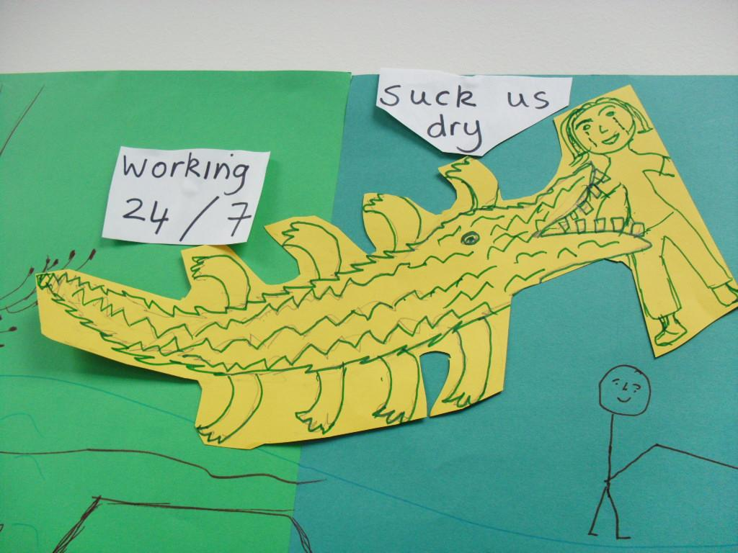

Figure 2
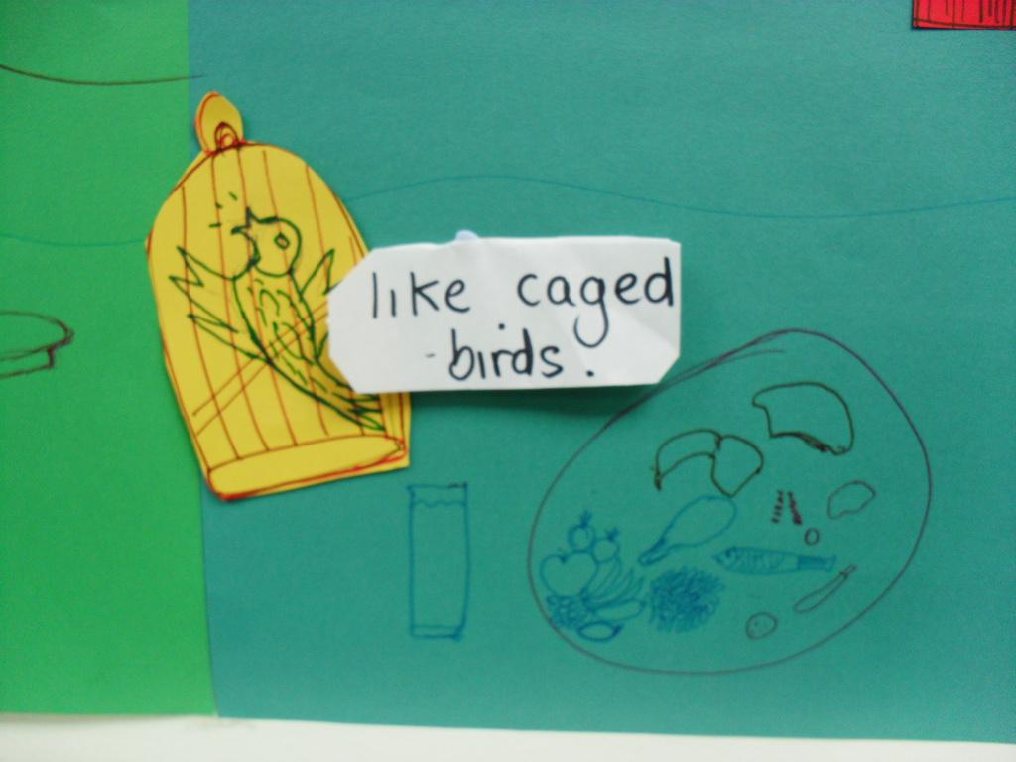

Figure 3
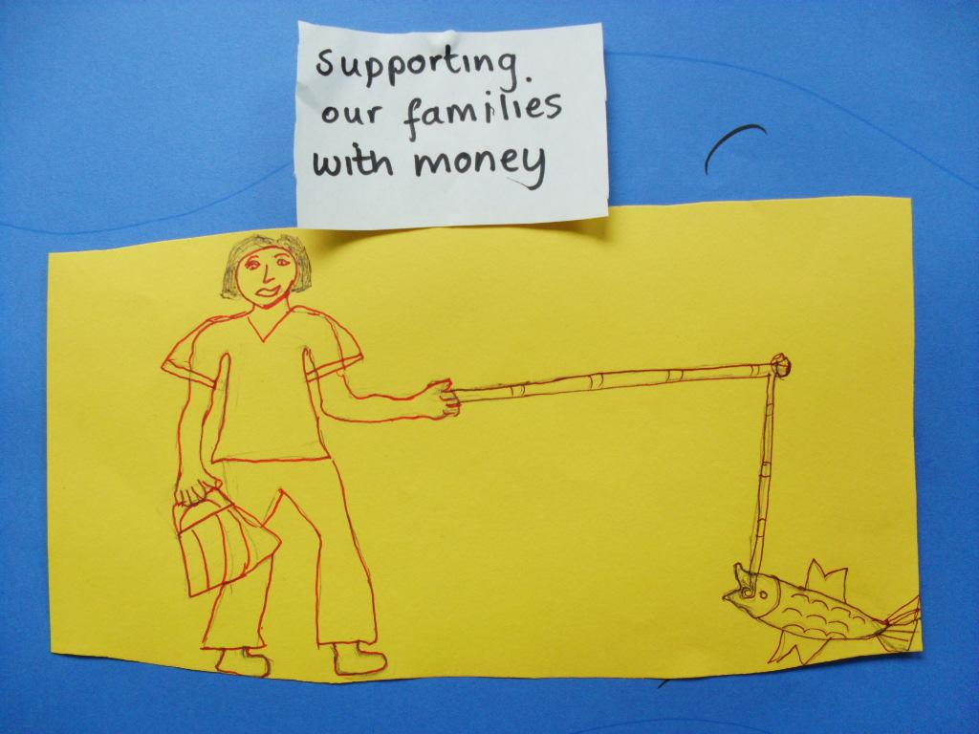

Figure 4
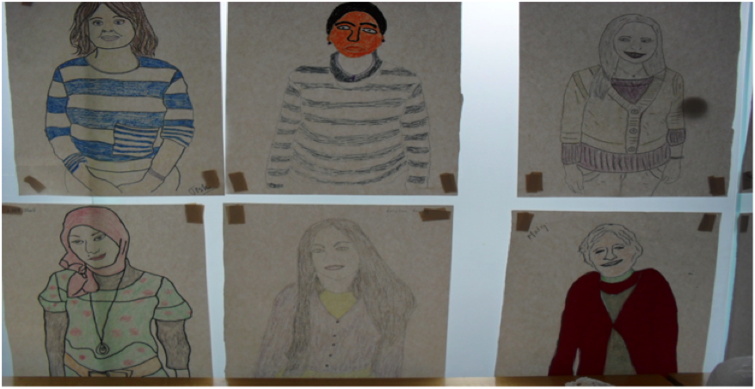

Figure 5
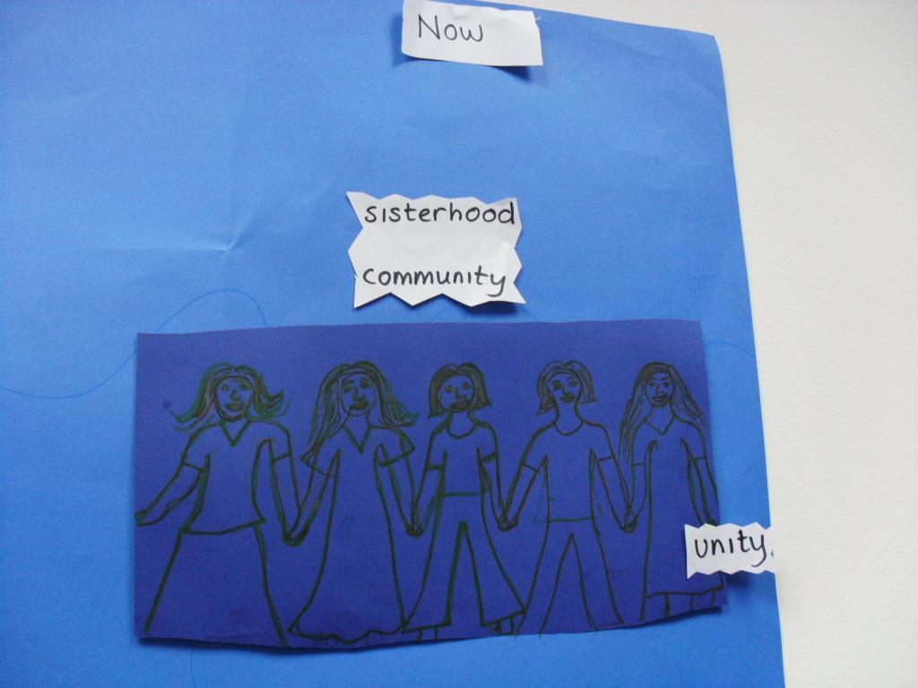

Figure 6
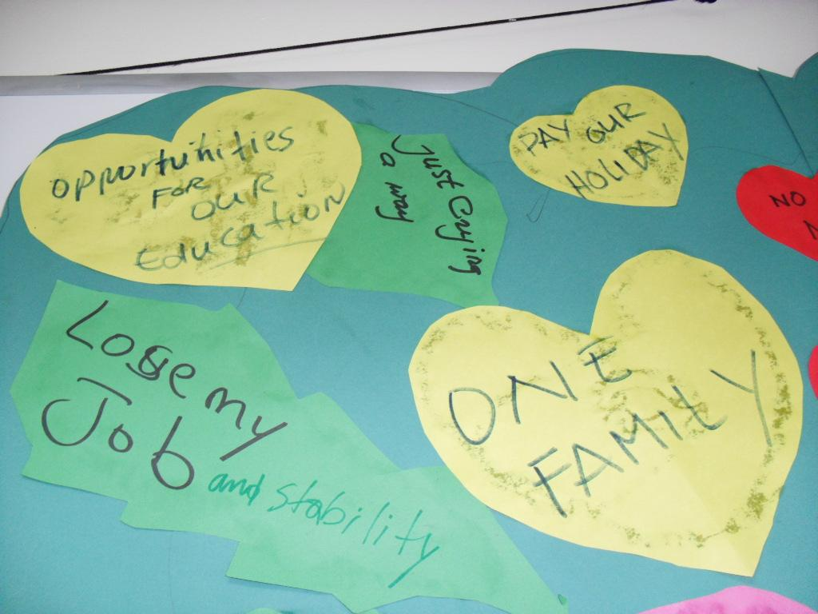

Figure 7
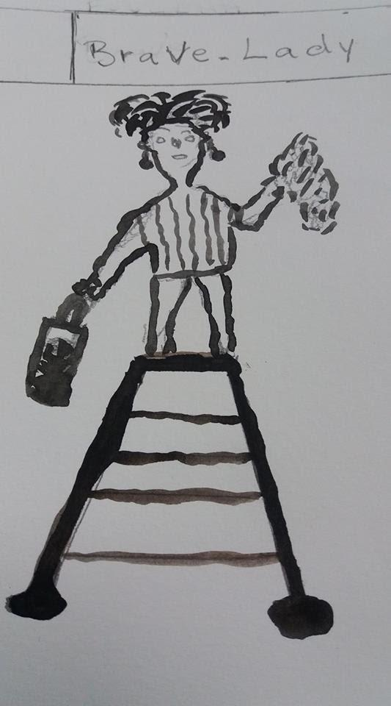

Figure 8
