Water networks can determine the affinity of ligand binding to proteins
John F. Darby¹, Adam P. Hopkins³, Seishi Shimizu¹, Shirley M. Roberts¹, James A. Brannigan¹, Johan P. Turkenburg¹, Gavin H. Thomas², Roderick E. Hubbard^{1,4} and Marcus Fischer^{5,*}
1 York Structural Biology Laboratory, Department of Chemistry, University of York, Heslington, York, YO10 5DD, UK
2 Department of Biology, University of York, Heslington, York, YO10 5DD, UK
3 Demuris Ltd., Newcastle Biomedicine Bio-Incubators, Framlington Place, Newcastle upon Tyne, NE2 4HH, UK
4 Vernalis (R&D) Ltd, Granta Park, Abington, Cambridge, CB21 6GB, UK
5 Department of Chemical Biology & Therapeutics, and Department of Structural Biology, St. Jude Children’s Research Hospital, Memphis, Tennessee 38105, USA
KEYWORDS Protein-ligand interactions, water network, water-mediated molecular interactions, room-temperature crystallography, thermodynamics.
ABSTRACT: Solvent organization is a key but underexploited contributor to the thermodynamics of protein–ligand recognition, with implications for ligand discovery, drug resistance and protein engineering. Here, we explore the contribution of solvent to ligand binding in the Haemophilus influenzae virulence protein SiaP. By introducing a single mutation without direct ligand contacts, we observed a >1000-fold change in sialic acid binding affinity. Crystallographic and calorimetric data of wild-type and mutant SiaP showed that this change results from an enthalpically unfavourable perturbation of the solvent network. This disruption is reflected by changes in the normalized atomic displacement parameters of crystallographic water molecules. In SiaP’s enclosed cavity, relative differences in water-network dynamics serve as a simple predictor of changes in the free energy of binding upon changing protein, ligand or both. This suggests that solvent structure is an evolutionary constraint on protein sequence that contributes to ligand affinity and selectivity.

INTRODUCTION
Protein function evolved in an aqueous environment. Water is fundamental for the folding, structure, dynamics and function of proteins and is the driving force behind the hydrophobic effect, enzyme catalysis¹, electron transfer², functional tuning³, allostery⁴ and ligand binding⁵. Water’s unique ability to donate and accept two hydrogen bonds (H-bonds) at minimal size mediates interactions between proteins and their ligands. Ligands also have to compete with water for binding to the protein cavity. Depending on the context, water molecules will be replaced, retained or displaced to favor or oppose ligand binding⁶. Historically, water was thought to primarily contribute entropically to ligand binding through a classical hydrophobic effect⁷. However, thermodynamic signatures of hydrophobic ligand binding have demonstrated that, in some cases, enthalpic contributions also play an important role⁸⁻⁹. This occurs either through displacement of poorly ordered water molecules or formation of newly ordered water networks during binding. For instance, extending a ligand by a methyl group to displace a trapped water molecule from the lipophilic part of the binding site increases its potency 33-fold in the adenosine A_{2A} G protein–coupled receptor¹⁰. While drug designers seek to pragmatically improve ligands by considering waters, capturing water’s energetic contributions to ligand binding remains challenging due to its high context dependence. This makes it difficult to decide whether displacing or keeping a water is advisable. Consequently, water is often ignored when studying protein–ligand interactions. To address this shortcoming, several investigators have developed computational implementations of the inhomogeneous solvation theory¹¹⁻¹² over the past decade and applied them with some notable successes to distinguishing “happy” from “unhappy” waters in ligand discovery¹³⁻¹⁵.
Although two ligands may bind with similar affinities, their signatures of enthalpy (ΔH) and entropy (ΔS) in the overall Gibbs free energy of binding (ΔG) may be vastly different. This is due to complex contributions from ΔH and ΔS that can be attributed to the disruption or stabilization of water networks¹⁶⁻¹⁸. The effect of these contributions is not always compensatory, it can be obscured by conformational shifts¹⁹ and vary substantially in a series of protein mutations or ligand modifications²⁰. This underscores the importance of the hydrogen-bond network of water²¹. Beyond acknowledging its importance qualitatively, we need to better understand the quantitative impact of perturbing water networks. However, experimental accounts of isolating the contributions of individual waters remain rare. Difficulties lie in the complexity of even deceptively simple biological systems and the lack of
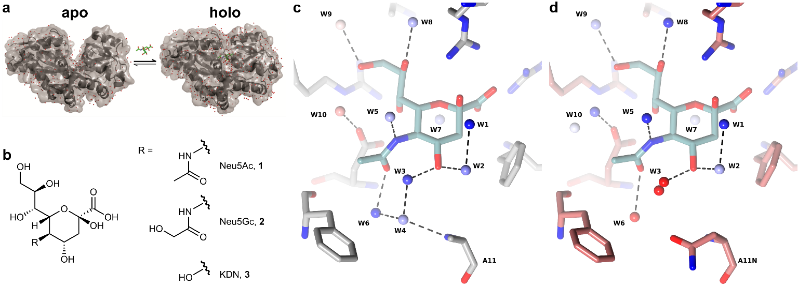
Figure 1. Structure of SiaP and sialic acid ligands. (a) SiaP undergoes a ‘Venus flytrap’ closure upon binding to sialic acid ligands Neu5Ac, Neu5Gc or KDN [chemical structures in (b)]. (c) The binding site of SiaP (grey sticks) binds Neu5Ac (light blue sticks) and traps ten water molecules, numbered W1-W10, near Neu5Ac. Waters are shown as spheres coloured by their B_{norm} factor deviation from the mean (blue -1σ, white +1σ, red +3σ or higher). (d) SiaP mutant A11N (red sticks) bound to Neu5Ac (light blue sticks), with waters numbered and coloured as in (c). The presence of Asn11 displaces W4 (occupancy ≤0.1) and remodels W3 (modelled in two positions with partial occupancy) and W6.

appropriate experimental methods to isolate thermodynamics of individual waters. The few studies in which water–ligand thermodynamics were measured used model systems with relatively rigid and preformed ligand-binding sites, such as carbonic anhydrase^{18, 21} and thermolysin^{8, 22}. Although these studies have been ground-breaking in their descriptions of water networks, they may not fully capture context-dependent network effects in more complex biological systems with therapeutic relevance.
Here, we studied substrate binding protein SiaP, a sialic acid binding virulence factor from Haemophilus influenzae, to gain insight into factors that drive ligand binding. SiaP utilizes a ‘Venus flytrap’ conformational rearrangement (Figure 1), engulfing the sialic acid substrate and more than a dozen water molecules, which are well-defined in crystallographic electron density maps²³⁻²⁶ (Fig. S1). The substrate is then presented to the membrane-embedded translocation machinery of a tripartite ATP-independent periplasmic (TRAP) secondary transporter, SiaQM, for uptake into the cell. Sialic acid is subsequently used as either a nutrient or, more importantly, for immune evasion through cell surface sialylation enabling host colonization and cell wall synthesis²⁷. In this study, we consider the contribution of this water network to the thermodynamics of SiaP binding to several substrate ligands: the common sialic acid, N-acetylneuraminic acid (Neu5Ac, 1), and closely related ligands, N-glycolylneuraminic acid (Neu5Gc, 2) and 2-keto-3-deoxynononic acid (KDN, 3), which are all transported by SiaPQM (Fig. 1). The binding affinity of Neu5Ac to wild-type SiaP (SiaP WT) was determined using isothermal titration calorimetry (ITC) as 30 nM (Table 1). Following the introduction of a single alanine-to-asparagine mutation at SiaP residue 11 (A11N) that does not interact directly with the ligand, we observed a 1400-fold decrease in Neu5Ac affinity. To understand the origin of this dramatic change, we solved high-resolution crystal structures of the SiaP–ligand complexes at both cryogenic temperature and room temperature (RT). Comparison of the structures of SiaP WT and SiaP A11N bound to Neu5Ac demonstrated that the ligand-binding mode and protein conformation were unaffected. However, we observed subtle changes to the solvent network around the ligand. A thermodynamic cycle between ligand-bound and -unbound (apo) SiaP highlights perturbed water networks as the major source of the observed large decrease in affinity. We corroborated this observation with a simple calculation that considers only the differences in water dynamics to estimate the free energy of binding of related complexes.
Enhancing our understanding of the role of water in ligand binding will have important implications for predicting binding affinities from structural information and designing small molecule drugs, probes and proteins. More fundamentally, this work indicates that water networks are an additional evolutionary constraint upon protein sequence to maintain ligand binding and modulate the affinity of those interactions.
METHODS
Wild-type (WT) and mutant (A11N) SiaP protein were purified and crystallized as described²⁸ (details in SI section 1.1). Reagents of the appropriate grade were purchased from Sigma unless otherwise noted. See the supplementary methods for further details on all experimental methods and calculations.
Ligand binding experiments. Thermal shift assays to determine thermal melting temperatures (T_{m}) were run in triplicate on a Stratagene Mx3005P qPCR machine (Qiagen) with SYPRO Orange dye (Sigma) using a ramping speed of 1°/30s from 25°C – 95°C; the fluorescence was monitored at 517nm (excitation) and 585nm (emission). Isothermal titration calorimetry (ITC) measurements

Table 1. Thermodynamics and thermal stability of SiaP proteins with sialic acid ligands.
 | K_{d} (µM)  ΔG, ΔH and -TΔS (kcal mol⁻¹) by ITC |  |  |  | Thermal stability* (ºC) ± SD
 | Neu5Ac | Neu5Gc |  | KDN | T_{m (H2O)} | ΔT_{m} _{(H2O)} + 50 µM Neu5Ac | T_{m (D2O)} | ΔT_{m (D2O)} + 50 µM Neu5Ac
SiaP WT | 0.030 ± 0.012  -10.3, -21.5, 11.2 |  | 0.138 ± 0.013  -9.4, -22.7, 13.3 | 8.3 ± 1.5  -6.9, -14.2, 7.3 | 53.6 ± 0.2 | 5.5 ± 0.1 | 56.7 ± 0.1 | 5.1 ± 0.5
SiaP A11N | 42 ± 2.8  -6.0, -9.1, 3.2 | 31 ± 0.4  -6.2, -7.7, 1.5 |  | 497†  n.d. | 51.9 ± 0.1 | 0.2 ± 0.1 | 55.5 ± 0.2 | 0.2 ± 0.1
* Determined by differential scanning fluorimetry; † K_{d} was determined by fluorescence; n.d. not determined

were carried out using a MicroCal Auto-iTC200 (Malvern Instruments). Standard binding experiments were carried out in Tris-HCl (H₂O) at varying temperatures (15, 20, 25, 30, 37 °C) and repeated in triplicate. Experiments to determine solvent isotope effects were carried out in phosphate buffer in D₂O or H₂O. These measurements were repeated up to six times to minimize standard error and enable comparison of small enthalpy changes.
Theoretical calculations. Calculated thermodynamic values ΔG, ΔH, and ΔS of introducing the mutation A11N to the apo state of the protein (WT vs. A11N) were estimated using literature values for the thermodynamics of hydration of protein groups as detailed in SI section 1.7. Molecular mechanics calculations were performed with CHARMM²⁹ version 40.1 using the CHARMM36 forcefield with standard atom typing and parameters for the protein atoms and c36_carb.rtf to define atom types and charges for Neu5Ac.
Crystallography. Crystallographic data were collected at the European Synchrotron Radiation Facility (ESRF), Grenoble, or at DIAMOND light source, Didcot. To maintain crystal humidity during helical room-temperature data collection, harvested crystals were covered with a MiTeGen MicroRT sleeve that contained mother liquor, sealed using vacuum grease. For refined structures, normalized B-factors were converted into Boltzmann energies as discussed in the text and further detailed in SI section 1.9
RESULTS
Structural analysis of SiaP–ligand complexes highlights binding contribution of water molecules. The binding affinity of Neu5Ac to SiaP WT and SiaP A11N was measured by ITC and further characterized by thermal-shift analysis. Neu5Ac bound SiaP WT with a dissociation constant (K_{d}) of 0.030 µM (Table 1). When binding to SiaP A11N, the K_{d} dropped to 42 µM, a difference of more than three orders of magnitude, consisting of ΔΔH of 12.4 kcal mol^{–1} and –TΔΔS of –8.0 kcal mol^{–1} at 298K. These differences in affinity were reflected in a 5.5°C thermal stabilisation of SiaP WT by 50 µM Neu5Ac, compared to only 0.2°C stabilisation of SiaP A11N (Table 1).
To rationalise this large change in binding affinity, we obtained and compared high-resolution crystal structures of SiaP WT and SiaP A11N in complex with Neu5Ac (data statistics in Table S3). Figure 1 shows a simplified representation of the ligand-binding site of these two structures and highlights ten water molecules trapped within this site (electron density maps shown in Fig. S1). Remarkably, the positions of the protein and ligand atoms in the two structures appeared mostly unchanged, with an overall root mean square deviation (RMSD) of 0.08 Å that was within experimental error, with the exception of the mutant asparagine side chain at residue 11. The mutated side chain was not in direct contact with the ligand, with a nearest distance of ~4.7 Å. Hence, the 1400-fold change in Neu5Ac affinity cannot be explained by apparently negligible differences between the crystal structures. However, the mutated asparagine side chain sterically expelled water molecule W4 from the binding site (see SI for details). Consequently, two water molecules nearest the mutation site (Fig. 1) moved by 0.6 Å (W6) and 0.2/1 Å (for two equally occupied, alternative positions of W3). The other water positions remained largely unperturbed -the difference in the average length of H-bonds made by ten waters between the WT and A11N Neu5Ac-bound structures was less than 0.01 Å (SI section 1.2).
To clarify whether the large change in binding affinity of Neu5Ac was ligand specific, we measured the binding of other sialic acids, Neu5Gc and KDN, to SiaP. Binding of Neu5Gc followed a pattern similar to that of Neu5Ac, with tight binding to SiaP WT (K_{d} 0.138 µM) and weak binding to SiaP A11N (K_{d} 31 µM). The weaker binding ligand KDN had a K_{d} of 8.3 µM for SiaP WT. Its affinity for SiaP A11N decreased to the point where it escaped accurate determination by ITC. Using intrinsic fluorescence, we estimated a K_{d} of around 500 µM (Table 1, cf. SI Methods). Although not as extreme as for Neu5Ac, the 200-fold decrease in affinity upon A11N mutation for Neu5Gc and 50-fold drop for KDN are still considerable.
To track structural changes, we solved the structures of these four additional SiaP–ligand complexes in the same space group at high resolution (1.2-1.7 Å) at cryogenic temperatures (Fig. 2). Again, the protein and ligand conformations were retained following the introduction of the A11N mutation, and subtle changes to the water networks around the point of mutation were apparent. In the case of Neu5Gc, W4 was not expelled from the binding site, as it was for Neu5Ac, but its position shifted so that the H-bonds geometries of W3, W4 and W6 were suboptimal. W6 shifted and was no longer H-bonded to Neu5Gc. For the smaller ligand KDN, an additional water, W11, filled the space of the missing N-linked side chain of Neu5Ac, resulting in an overall shift in the water network. Therefore, the affinity of SiaP WT for KDN was much lower than that for Neu5Ac and Neu5Gc (Table 1).
Thermodynamic cycle identifies water contributions to decreased binding affinity. To isolate the contribution of displaced water to the overall binding thermodynamics, we utilised a thermodynamic cycle (Fig. 3). The measured experimental values for ligand binding are equilibrium constants A (for SiaP WT) and B (for SiaP A11N), and the values for mutation of the protein are transitions X (ligand bound) and Y (unbound). The difference in free energy between SiaP WT and SiaP A11N ligand–bound complexes, noted as X, can therefore be derived via the route X = –A + Y + B, as indicated by the blue dashed arrow in Figure 3.
Transition Y in the unbound protein is commonly ignored and assumed to be negligible. While we saw a less than 2°C decrease in protein stability upon mutation in H₂O (Table 1), we used established, albeit approximate methods to estimate Y (see SI). The literature values for solvation entropy and enthalpy of methane to acetamide, as a surrogate for the alanine-to-asparagine mutation, were used with conventional surface area proportionality calculations (see SI). For water-exposed residues this approximation has been supported by alchemical free energy simulations³⁰. Together, these calculations estimate a –1.2 kcal mol^{–1} change in solvation energy when introducing the mutation³¹⁻³³. This energy difference between the apo states (Y) does not account for the magnitude of the difference between A and B, which was –4.4 kcal mol^{–1}.
We also sought to consider other confounding factors in our interpretation. For X, the conformation of ligand and protein were essentially unchanged (RMSDs < 0.1 Å), except for the introduction of the mutated side chain A11N. While the asparagine side chain is found in a minor rotameric form, we observed that it is not sterically constrained by the surrounding protein (SI section 1.2). We, therefore assumed the internal energy of the ligand and protein to be approximately the same and would be a minor contributor to X.
In order to consider the magnitude of contributions that electrostatic and Van der Waals interactions would have on ligand interaction energies, we performed conventional energy calculations (SI methods 1.6). Using a molecular mechanics model for interaction of Neu5Ac with residue 11 in the absence of water, we calculated the ligand-binding energy difference between WT and A11N to be ~1 kcal mol^{–1}. The sign of this change was dependent on the orientation of the amide of the asparagine side chain.
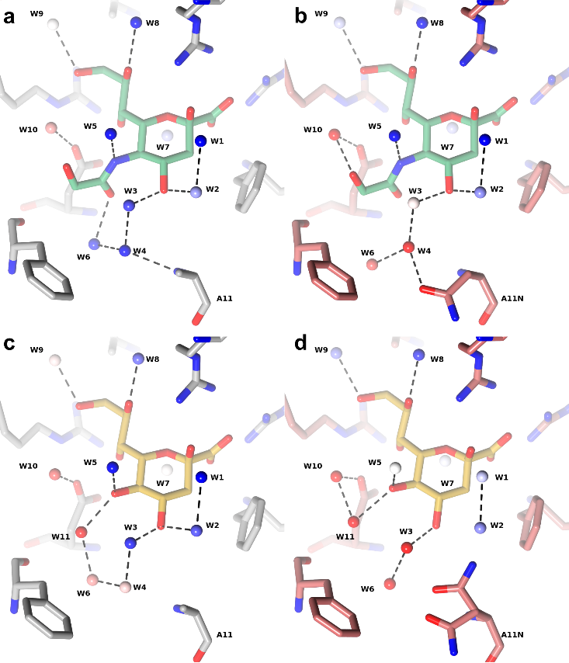
Figure 2. Crystal structures of WT and mutant (A11N) SiaP bound to Neu5Gc or KDN. (a) Binding site of SiaP WT (grey sticks) bound to Neu5Gc (green sticks) highlighting water molecules, numbered W1 – W10, within 4 Å of Neu5Ac. Waters are shown as spheres coloured by the B_{norm} factor deviation from the mean (blue -1σ, white +1σ, red +3σ or higher). (b) Binding site of SiaP A11N (red sticks) bound to Neu5Gc, waters numbered and coloured as in (a). SiaP WT (c) and SiaP A11N (d) bound to KDN (yellow sticks), waters near KDN are numbered W1-W11. Waters are shown as spheres and coloured as in (a).
With the estimated value for Y and measured values for A and B in the thermodynamic cycle we obtained a ΔG value of X of 3.2 kcal mol^{–1}, made up of ΔH 11.7 kcal mol^{–1} and –TΔS –8.6 kcal mol^{–1}. This suggested that the majority of the experimentally observed 4.4 kcal mol^{–1} decrease in Neu5Ac free energy of binding upon protein mutation can be attributed to the disruption of solvent, rather than a significant change in the free energy of the unbound or bound mutant protein.
Next, we compared the values obtained for X using the adjusted thermodynamic cycle with published values for the binding free energies of water molecules, derived from theoretical and experimental studies. For ΔH contributions, the theoretical values proposed by Cooper, of 1.4 to 2.9 kcal mol⁻¹, and by Hilser of 0.5 kcal mol⁻¹ ³⁴⁻³⁵ are lower than values stated by Freire³⁶ (8 kcal mol⁻¹) or those derived experimentally here. A similar difference is seen for the entropy (–TΔS at 298K) with theoretical studies from Cooper estimating 0.8 kcal mol⁻¹ versus up to 2 kcal mol⁻¹ from Dunitz³⁷. Consistent with Dunitz’s estimate, inhomogeneous solvation theory calculations on 23 hydration sites by Huggins³⁸ resulted in an average –TΔS value of 1.82 kcal mol⁻¹, with higher values of 2.67 kcal mol⁻¹ for a water near two charged residues. Protein molecular dynamics calculations by Olano and Rick on two hydrated protein cavities give values more closely comparable to those seen experimentally here³⁹. For one model, they calculated a ΔG of desolvation of 4.8 kcal mol⁻¹, made up of ΔH 10 kcal mol⁻¹ and –TΔS –5 kcal mol⁻¹, reasonably close to our experimental values.
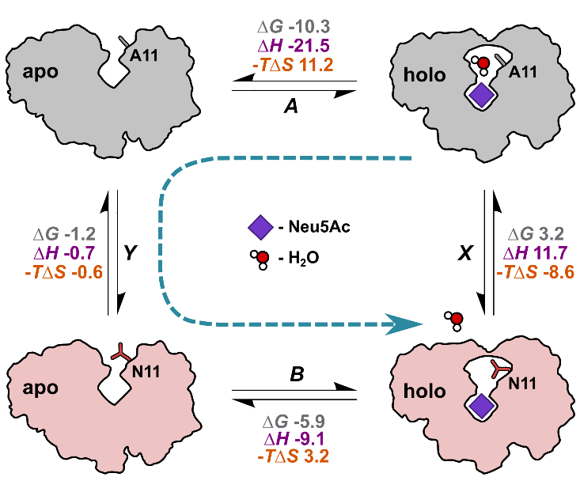
Figure 3. Thermodynamic cycle of SiaP. Schematic representation of a thermodynamic cycle in which transitions A and B represent Neu5Ac (purple) binding to SiaP (WT in grey, A11N mutant in red). A water molecule present in SiaP WT (top right) is expelled from SiaP A11N in complex with Neu5Ac (bottom right). Transitions X and Y represent the introduction of the mutant side chain for the holo and apo protein, respectively. Each transition is determined by an equilibrium constant (A, B, X, Y). Gibbs free energy (ΔG), enthalpy (ΔH) and entropy (–TΔS) are noted in kcal mol^{–1}. Values for A and B are measured by ITC, and Y is approximated by literature values. The blue dashed line represents the determination of X, where X = –A + Y + B.
These comparisons show that our approximation of the thermodynamic contributions of an individual water molecule (here W4) to the free energy of binding are comparable to the highest theoretical values reported in the literature. The magnitude of the change suggests that the thermodynamic consequence of mutating SiaP originates from the collateral disruption of the remaining solvent network. It has been previously observed that in protein–ligand interactions that occur with sequestration of water molecules, the change in heat capacity of binding (ΔCp) is negative³⁵. To determine ΔCp, we performed ITC experiments over a range of temperatures for ligand binding to SiaP WT and A11N (Fig. 4, Table S1-S2). Overall, ΔCp measured for all three ligands (Neu5Ac, Neu5Gc, KDN) binding to SiaP WT were large and negative (SI Table 1), typical for a ligand binding event that sequesters waters (Fig. 1-2). Cooper calculated water sequestration to result in a more negative ΔCp of approximately –18 cal mol⁻¹ K⁻¹ per water molecule³⁵. Others experimentally determined more negative ΔCp values of –48±31 ^{Ref. 40}, –57±21 ^{Ref. 41}, and –60±8 cal mol⁻¹ K⁻¹ per water molecule⁴². We calculated a value of 24 cal mol⁻¹ K⁻¹ for transition X of our thermodynamic cycle (SI section 1.7). This is of the expected sign and magnitude for the release of a single water we observed upon mutation (SI section 1.7). However, the experimental change in ΔCp observed between WT and mutant was within the experimental error with a p-value of 0.41 (Fig. 4b).
To further experimentally determine the contribution of solvent reorganization to ligand binding, we compared ligand binding in H₂O versus D₂O ^{Ref. 43} (see SI sections 1.4-1.5). The stabilising effect of Neu5Ac on ΔT_{m} of WT and mutant protein in D₂O was the same as in H₂O (Table 1), but D₂O stabilised both proteins by 3-4°C, compared to H₂O, due to changes in hydration of nonpolar residues⁴⁴ as reported for other proteins⁴⁵. It is known that D-bond enthalpy is increased by ~10% in comparison to H-bond enthalpy⁴³. The rearrangement of water upon ligand binding can, therefore, be observed from this isotope effect by comparing ITC data measured in H₂O and D₂O buffer solutions (Fig. 4).
These measurements for SiaP WT, gave a change in the enthalpic contribution to binding of –0.5 kcal mol⁻¹ in D₂O. This observation of a more negative ΔH in D₂O was unusual and may indicate changes in the H-bond patterns of the solvated and bound species⁴⁶. These changes are likely due to the conformational change of SiaP, upon Neu5Ac binding, leading to enthalpically driven water capture. In contrast, for SiaP A11N the enthalpic contribution of Neu5Ac binding is changed in D₂O by +0.5 kcal mol⁻¹. This typical signature of water contribution to ligand binding can be attributed to the displacement of water by the A11N side chain in the closed state of SiaP. Hence, the overall difference in ΔH_{D2O} between WT and mutant SiaP was ~1 kcal mol⁻¹. Considering that D-bond enthalpy is increased by ~10% over H-bonding⁴³, the estimate of ΔH_{H2O} would be ~10 kcal mol⁻¹ in water, which is of similar magnitude as the ΔH of 11.7 kcal mol⁻¹ of transition X in our thermodynamic cycle. These data further underscore a strong enthalpic solvent contribution to ligand binding, which decreases upon mutation.
Solvent dynamics link to ligand affinity. Given that the geometry of the water H-bond networks are preserved, it is possible that it is the dynamics of the water molecules that make a contribution. Within static crystal structures, atomic displacement parameters (or B-factors) capture some dynamic aspects; they model the fall-off of electron density from the mean position. As their magnitude depends on resolution, we normalized water B-factors (B_{norm}) to facilitate comparisons across different complexes. B_{norm} values among all datasets reported here ranged from –1.22 to 6.9 in agreement with previously observed limits of –1.2 to 7.2 set by Carugo⁴⁷ (SI and Tables S5-S9), where a completely displaced water with an occupancy of zero would have a B_{norm} value of 7.2. We borrow this term to account for displaced waters in our pairwise comparison. Generally, B_{norm} values for waters W1-W10 are higher in the SiaP-mutant structures, compared to the WT complexes, across all ligands (Figs. 1 and 2). The greatest differences were observed for W3, W4 and W6 and in some cases W2. For example, water networks around Neu5Gc appeared positionally retained in the SiaP A11N complex (Fig. 2a, b), whereas B_{norm} values revealed that these waters were indeed substantially perturbed by the presence of the A11N mutation. Qualitatively it makes sense that water network shifts are detected near the mutation site and this response can be tracked either by movement or elevated B_{norm} values.
We ventured to compare these qualitative observations of the important contributions of water to the overall experimental free energy of binding. As a simplistic, experimentally-driven way to assess the energetic contributions of the water network, we converted crystallographic B-factors to Boltzmann energies via equation (1)
$E=-k_{B}T\ln\left(0.86-0.12 \left(\frac{B_{wat}-B_{mean}}{B_{stdev}}\right)\right)$ (1)
This composite equation leans on several assumptions mentioned above. First, we normalize absolute water B values to B_{norm}; then, using Carugo’s relationship⁴⁷, we convert B_{norm} to occupancies; finally, we use the Boltzmann equation to scale those occupancies into water energies for comparison with experimental ΔG values (see SI section 1.9 for details and definitions).
We then used equation (2) to combine the changes across the water network for each complex (E_{rel}) in comparison to a reference complex (E_{ref}).
${∆G}_{calc}={∆G}_{exp}\left(ref\right)-\sum_{wat=1}^{n}{E_{rel}}-E_{ref}$ (2)
We used this approximation to estimate the relative changes in water network energetics upon modifying protein and/or ligand using the highest-affinity complex with the native substrate Neu5Ac as a reference. Note that in contrast to common practice of ignoring water, we are accounting only for relative B_{norm} values of a set of 10 binding-site water molecules within each crystal structure. So as to support the notion that water contributions can dominate binding affinities, rather than to obtain true binding free energies. Comparing water networks between Neu5Ac–SiaP A11N and the reference, predicted a ΔG_{calc} of –5.16 kcal mol⁻¹ versus the experimental ΔG_{exp} of –5.96 kcal mol⁻¹. Notably, this is the complex with the surprising 1400-fold decrease in affinity that had originally sparked this study. The success of this ΔG_{calc} prediction, with an error of 0.81 kcal mol⁻¹, or 4-fold difference in experimental (42 μM) versus predicted (166 μM) K_{d}, was opposed by the worst prediction in the set with a ΔG_{calc} of –9.62 kcal mol⁻¹ versus a ΔG_{exp} of –6.14 kcal mol⁻¹ (ΔΔG 3.48 kcal mol⁻¹) for the SiaP A11N–Neu5Gc complex (Fig. 5d and SI section 1.9).
To account for the impact of temperature on protein and solvent structure^{48,49}, we further determined crystal structures of Neu5Ac bound to SiaP WT and A11N at room temperature (RT) (Fig. 5). The resulting structures superposed with an RMSD of 0.23 Å to their cryogenic equivalent, with the water network differing by less than 0.18 Å on average (Table S10). Notably, at RT we observe three alternate conformations of residue A11N, which are not visible in the cryogenic electron density maps, and refined to 34, 24 and 42% occupancy (for conformations from left to right in Fig. 5c; see SI section 1.2 for further discussion). Consequently, the positions of W2, W3 and W4 co-varied with their respective side chain conformers.
Using the water network in the RT structure to calculate the ΔG_{calc} of the cryogenic structure resulted in an error of 0.09 kcal mol⁻¹, within experimental error. Unsurprisingly, the presence of multiple alternative protein/water conformations in the SiaP A11N complex at RT complicated our simplistic predictions and led to the second-worst prediction overall, which had an error of 3.16 kcal mol⁻¹. In contrast, the comparison to the analogous cryo structure was off by only 0.81 kcal mol⁻¹. As independent datasets, both were included in calculating the overall root mean square error (RMSE) across all eight crystal structures presented here. The RMSE of this simple ΔG predictor was 2.2 kcal mol⁻¹ (Fig. 5d and SI). At least qualitatively, this allows energetic rank-ordering of the complexes (SI section 1.9), and hints at the dominant contribution of solvent order to changes in binding affinity upon changing protein, ligand or both.
DISCUSSION
Considering common practices in rational ligand discovery, it is perplexing to find a decrease in ligand affinity by three orders of magnitude, while protein and ligand conformations and interactions appear preserved upon mutation. Our detailed structural and thermodynamic approach identified water perturbation as the main contributor to this dramatic effect. While there are many possible confounding effects, including side-chain electrostatics and rotameric states, changes in the free energy of the unbound or bound mutant protein, ligand and protein strain, and others, our analysis suggests these do not dominate the observed change in free energy of binding. Therefore, the majority of the experimentally observed 4.4 kcal mol^{–1} decrease in Neu5Ac free energy of binding upon protein mutation can be attributed to the disruption of solvent. Overall, three principal observations emerged from this study.
First, water has a significant role in the thermodynamics of ligand binding that may not be obvious in apparently unperturbed crystal structures. Here, these hidden features were exposed (i) by considering B_{norm} values of perturbed water networks and (ii) by collecting crystallographic data at room-temperature to reveal higher-energy conformations of a mutated residue that were invisible in the conventional cryogenic dataset.
Second, a corrected thermodynamic cycle revealed that the majority of the observed 1400-fold decrease in binding affinity upon mutation was caused by the perturbation of solvent networks. Although this treatment was very approximate it demonstrated that the magnitude of the changes were beyond what would be expected. This was corroborated by experimental measurements of solvent contributions to ligand binding. Theoretical calculations of water thermodynamics likely “underestimate” the observed contribution of water since experimental studies are confounded by collateral perturbation of the water network, even if conducted as systematically as this study.
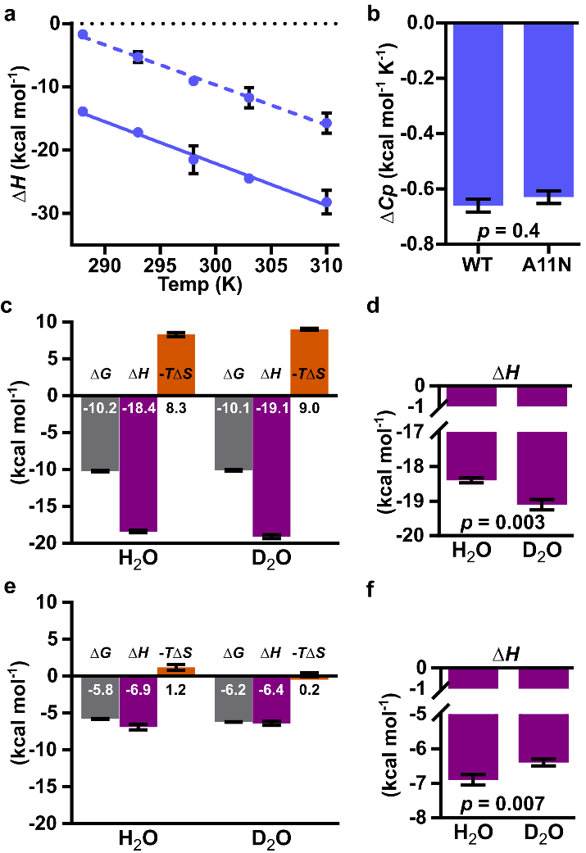
Figure 4. Heat capacities and thermodynamic signature plots for H₂O and D₂O. (a) Enthalpy (ΔH) of sialic acid binding to SiaP as a function of temperature for Neu5Ac binding to SiaP WT (solid lines) and SiaP A11N (dotted lines). (b) The linear slope of ΔH from (a) plotted as ΔCp for SiaP WT and SiaP A11N binding to Neu5Ac. (c) ITC signature plot for Neu5Ac binding to SiaP WT in H₂O and D₂O at 298K. The free energy (ΔG, grey), enthalpy (ΔH, purple), and entropy (–TΔS, orange) of binding are shown. (d) Inset of ΔH from (c) with p-value, as determined by unpaired Student’s t-test. (e and f) ITC signature plot for Neu5Ac binding to SiaP A11N in H₂O and D₂O, coloured as in (c) with inset of ΔH as in (d).
From a ligand standpoint, water plasticity enables promiscuous binding. For instance, in the KDN complex a new water molecule maintains water network integrity in the absence of the ligand’s N-acetyl group. An extreme example of promiscuity is oligopeptide-binding protein OppA⁵, where all protein–peptide interactions are water mediated, thereby allowing sequence-independent peptide binding. In turn, to achieve high ligand selectivity and affinity, water networks need to be optimized alongside protein sequence. This suggests that water poses an additional constraint on protein evolution; after all, protein function evolved in water.
Third, flexibility is linked to protein function⁵⁰. Crystallographic B-factors serve as a proxy for changes in atom mobility. Atomic displacements in the crystal capture static and dynamic disorder from lattice disorder, intramolecular motion and crystal contacts. We normalized B-factors of enclosed cavity waters and used relative values referenced to a structure solved in the same space group, under the assumption that systematic errors cancel out and meaningful differences emerge. Despite ignoring all other terms, Boltzmann energies derived from B_{norm} values of perturbed water networks captured the majority of decreases in the free energy of ligand binding to SiaP, for a range of –4.5 to –10.3 kcal mol⁻¹ across different mutants and ligands. The exquisite sensitivity of water to nearby change makes it a pragmatic reporter for routes of optimization in ligand discovery and protein design.
Considering water perturbation alone to rationalise affinity changes is the direct opposite of the traditional and convenient practice of ignoring water. Such a reductionist approach has obvious limitations. It ignores explicit H-bonds, chemical environment, internal energies of ligand and protein and allosteric effects. Nonetheless, given its predictive power to estimate ΔG with an RMSE of ~2.2 kcal mol⁻¹ for the enclosed cavity of SiaP, this approach implicitly captures major contributions of water networks to the overall energetics of ligand binding. Others have previously included protein B-factors in a scoring function to improve the performance of protein−ligand binding-affinity predictions⁵¹. Notably, Dunitz makes this link between water’s free energy of binding to corresponding B-factors, although using absolute values rather than normalized ones, in his seminal Science paper³⁷. Around the same time, Poornima and Dean mention B-factors take into account the mobility of water molecules as part of their Hydration in Drug Design trilogy⁵². Considering the context-dependence of water’s thermodynamic contributions, different thermodynamic signatures amongst similar ligands and the fact that just changing isotopes from H₂O to D₂O substantially affects protein stability and ligand-binding enthalpy, it is surprising that the conceptually reasonable connection between mobility and affinity is borne-out in our simplistic approximation.
We also expected thermodynamic data collected at room-temperature to be more interpretable by structural data collected at RT rather than those collected at cryogenic temperature. However, our RT structures exposed another complication by revealing otherwise hidden, alternative states of the mutated side chain: water positions and occupancies co-varied with these alternative states. This suggests that predictions in less-controlled systems are likely more challenging. Given its simplicity, it will be interesting to see how this B_{norm} approach applies to other systems – the time to estimate relative free energies of binding is negligible compared to computationally expensive approaches that can lead to comparable RMSEs⁵³⁻⁵⁴.
These caveats should not distract from the implications of this study towards a more dynamic view of exploiting protein–ligand interactions. Our experimental data quantify water as a major contributor to ligand binding. Clearly, the importance of water cannot be underestimated in ligand discovery or protein engineering. If not a predictor in its own right, this comprehensive dataset will serve as a resource for the computational community to advance methods that predict free energies of binding while accounting for water network contributions. Beyond their role in ligand discovery, water networks are key in the natural or intentional evolution of protein function.
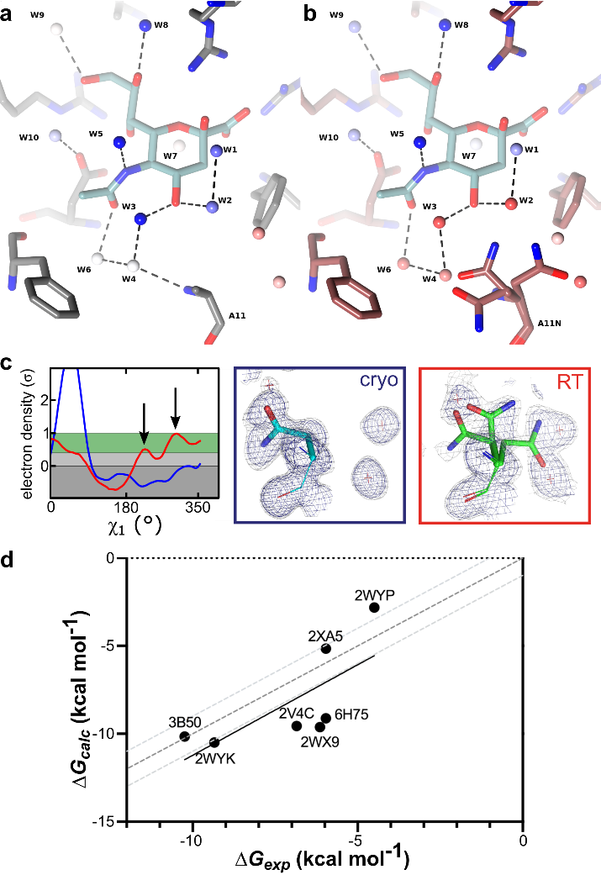
Figure 5. Room temperature structures and ΔG_{calc} predictions using only differences in water networks. (a) SiaP WT binding site with Neu5Ac bound. Colours as in Fig. 1. (b) SiaP A11N binding site colours as previously described. (c) Arrows in the Ringer plot (left panel) indicate two alternative A11N conformations at RT (red line) that are not seen at cryogenic temperatures (blue line), and 2mFo-DFc electron density omit maps (right) contoured at 1σ (blue) and 0.5σ (grey). (d) Plot of ΔG_{exp} vs. ΔG_{calc} for each protein–ligand complex (PDB label); light grey dotted lines indicate ΔG values of ± 1 kcal mol⁻¹ from the dark grey line of identity. The datasets have an RMSE of 2.2 kcal mol⁻¹ with an R² of 0.51 and p-value of 0.07 (linear fit shown as solid black line).
CONCLUSION
In summary, we propose that solvent networks can make substantial contributions to the affinity of a ligand binding to a protein. Perturbation of these water networks, even without disrupting ligand or surrounding protein, can substantially impact ligand affinity through the decrease of enthalpically optimal interactions and the introduction of solvent mobility. In addition to highlighting key factors to consider in structure-based ligand design, our results suggest that protein structure co-evolves with water structure to discriminate for a particular ligand. Any change in the protein or the ligand not only removes specific protein–ligand interactions, but also perturbs the water network. This plasticity provides an additional mechanism to modulate the relative affinity of related ligands and balance selectivity and promiscuity.
ASSOCIATED CONTENT
Supporting Information. Detailed methods, thermodynamic calculations, and detailed ITC, thermal shift and crystallographic data tables. This material is available free of charge via the Internet at http://pubs.acs.org.
Accession codes. Crystal structures are available at the PDB (Supplementary Tables 3-4). The structures have the following primary accession codes, with protein (WT, A11N), ligands (Neu5Ac, Neu5Gc, KDN) and crystallographic data collection temperature (cryo, RT) in parentheses: 2WYK (WT+Neu5Gc@cryo), 2V4C (WT+KDN@cryo), 2XA5 (A11N+Neu5Ac@cryo), 2WX9 (A11N+Neu5Gc@cryo), 2WYP (A11N+KDN@cryo), 6H76 (WT+Neu5Ac@RT), 6H75 (A11N+Neu5Gc@RT).
AUTHOR INFORMATION
Corresponding Author
* Marcus Fischer, marcus.fischer@stjude.org
Funding Sources
This work was in part supported by ALSAC (to MF), Wellcome Trust C2D2 funding (to University of York) and a BBSRC CASE studentship to APH.
ACKNOWLEDGMENTS
We thank the staff at the ESRF (Grenoble, France) and the DIAMOND Light Source (Oxfordshire, UK) for their assistance in crystallographic data collection, especially at room temperature (proposal numbers MX-306, MX-7864); and C.M. Fischer and Dr. A.J. McArthur (St. Jude’s Dept. of Scientific Editing) for critical reading of the manuscript.
REFERENCES
1. Wang, L.; Yu, X.; Hu, P.; Broyde, S.; Zhang, Y., A water-mediated and substrate-assisted catalytic mechanism for Sulfolobus solfataricus DNA polymerase IV. J Am Chem Soc 2007, 129 (15), 4731-7.
2. Lin, J.; Balabin, I. A.; Beratan, D. N., The nature of aqueous tunneling pathways between electron-transfer proteins. Science 2005, 310 (5752), 1311-3.
3. Okada, T.; Fujiyoshi, Y.; Silow, M.; Navarro, J.; Landau, E. M.; Shichida, Y., Functional role of internal water molecules in rhodopsin revealed by X-ray crystallography. Proc Natl Acad Sci U S A 2002, 99 (9), 5982-7.
4. Royer, W. E.; Pardanani, A.; Gibson, Q. H.; Peterson, E. S.; Friedman, J. M., Ordered water molecules as key allosteric mediators in a cooperative dimeric hemoglobin. Proc Natl Acad Sci U S A 1996, 93 (25), 14526-31.
5. Tame, J. R.; Murshudov, G. N.; Dodson, E. J.; Neil, T. K.; Dodson, G. G.; Higgins, C. F.; Wilkinson, A. J., The structural basis of sequence-independent peptide binding by OppA protein. Science 1994, 264 (5165), 1578-81.
6. Spyrakis, F.; Ahmed, M. H.; Bayden, A. S.; Cozzini, P.; Mozzarelli, A.; Kellogg, G. E., The Roles of Water in the Protein Matrix: A Largely Untapped Resource for Drug Discovery. J Med Chem 2017, 60 (16), 6781-6827.
7. Chandler, D., Interfaces and the driving force of hydrophobic assembly. Nature 2005, 437 (7059), 640-7.
8. Biela, A.; Nasief, N. N.; Betz, M.; Heine, A.; Hangauer, D.; Klebe, G., Dissecting the hydrophobic effect on the molecular level: the role of water, enthalpy, and entropy in ligand binding to thermolysin. Angew Chem Int Ed Engl 2013, 52 (6), 1822-8.
9. Snyder, P. W.; Mecinovic, J.; Moustakas, D. T.; Thomas, S. W., 3rd; Harder, M.; Mack, E. T.; Lockett, M. R.; Heroux, A.; Sherman, W.; Whitesides, G. M., Mechanism of the hydrophobic effect in the biomolecular recognition of arylsulfonamides by carbonic anhydrase. Proc Natl Acad Sci U S A 2011, 108 (44), 17889-94.
10. Cooke, R. M.; Brown, A. J.; Marshall, F. H.; Mason, J. S., Structures of G protein-coupled receptors reveal new opportunities for drug discovery. Drug Discov Today 2015, 20 (11), 1355-64.
11. Nguyen, C. N.; Young, T. K.; Gilson, M. K., Grid inhomogeneous solvation theory: hydration structure and thermodynamics of the miniature receptor cucurbit[7]uril. J Chem Phys 2012, 137 (4), 044101.
12. Young, T.; Abel, R.; Kim, B.; Berne, B. J.; Friesner, R. A., Motifs for molecular recognition exploiting hydrophobic enclosure in protein-ligand binding. Proc Natl Acad Sci U S A 2007, 104 (3), 808-13.
13. Mobley, D. L.; Gilson, M. K., Predicting Binding Free Energies: Frontiers and Benchmarks. Annu Rev Biophys 2017, 46, 531-558.
14. Jung, S. W.; Kim, M.; Ramsey, S.; Kurtzman, T.; Cho, A. E., Water Pharmacophore: Designing Ligands using Molecular Dynamics Simulations with Water. Sci Rep 2018, 8 (1), 10400.
15. Balius, T. E.; Fischer, M.; Stein, R. M.; Adler, T. B.; Nguyen, C. N.; Cruz, A.; Gilson, M. K.; Kurtzman, T.; Shoichet, B. K., Testing inhomogeneous solvation theory in structure-based ligand discovery. Proc Natl Acad Sci U S A 2017, 114 (33), E6839-E6846.
16. Lumry, R.; Rajender, S., Enthalpy-entropy compensation phenomena in water solutions of proteins and small molecules: a ubiquitous property of water. Biopolymers 1970, 9 (10), 1125-227.
17. Klebe, G., Applying thermodynamic profiling in lead finding and optimization. Nature Reviews Drug Discovery 2015, 14 (2), 95-110.
18. Breiten, B.; Lockett, M. R.; Sherman, W.; Fujita, S.; Al-Sayah, M.; Lange, H.; Bowers, C. M.; Heroux, A.; Krilov, G.; Whitesides, G. M., Water networks contribute to enthalpy/entropy compensation in protein-ligand binding. J Am Chem Soc 2013, 135 (41), 15579-84.
19. Fenley, A. T.; Muddana, H. S.; Gilson, M. K., Entropy-enthalpy transduction caused by conformational shifts can obscure the forces driving protein-ligand binding. Proc Natl Acad Sci U S A 2012, 109 (49), 20006-11.
20. Chodera, J. D.; Mobley, D. L., Entropy-enthalpy compensation: role and ramifications in biomolecular ligand recognition and design. Annu Rev Biophys 2013, 42, 121-42.
21. Fox, J. M.; Kang, K.; Sastry, M.; Sherman, W.; Sankaran, B.; Zwart, P. H.; Whitesides, G. M., Water-Restructuring Mutations Can Reverse the Thermodynamic Signature of Ligand Binding to Human Carbonic Anhydrase. Angewandte Chemie International Edition 2017, 56 (14), 3833-3837.
22. Cramer, J.; Krimmer, S. G.; Heine, A.; Klebe, G., Paying the Price of Desolvation in Solvent-Exposed Protein Pockets: Impact of Distal Solubilizing Groups on Affinity and Binding Thermodynamics in a Series of Thermolysin Inhibitors. J Med Chem 2017, 60 (13), 5791-5799.
23. Muller, A.; Severi, E.; Mulligan, C.; Watts, A. G.; Kelly, D. J.; Wilson, K. S.; Wilkinson, A. J.; Thomas, G. H., Conservation of structure and mechanism in primary and secondary transporters exemplified by SiaP, a sialic acid binding virulence factor from Haemophilus influenzae. J Biol Chem 2006, 281 (31), 22212-22.
24. Fischer, M.; Hopkins, A. P.; Severi, E.; Hawkhead, J.; Bawdon, D.; Watts, A. G.; Hubbard, R. E.; Thomas, G. H., Tripartite ATP-independent Periplasmic (TRAP) Transporters Use an Arginine-mediated Selectivity Filter for High Affinity Substrate Binding. Journal of Biological Chemistry 2015, 290 (45), 27113-27123.
25. Fischer, M.; Zhang, Q. Y.; Hubbard, R. E.; Thomas, G. H., Caught in a TRAP: substrate-binding proteins in secondary transport. Trends Microbiol 2010, 18 (10), 471-8.
26. Johnston, J. W.; Coussens, N. P.; Allen, S.; Houtman, J. C.; Turner, K. H.; Zaleski, A.; Ramaswamy, S.; Gibson, B. W.; Apicella, M. A., Characterization of the N-acetyl-5-neuraminic acid-binding site of the extracytoplasmic solute receptor (SiaP) of nontypeable Haemophilus influenzae strain 2019. J Biol Chem 2008, 283 (2), 855-65.
27. Mulligan, C.; Fischer, M.; Thomas, G. H., Tripartite ATP-independent periplasmic (TRAP) transporters in bacteria and archaea. FEMS Microbiol Rev 2011, 35 (1), 68-86.
28. Fischer, M.; Leech, A. P.; Hubbard, R. E., Comparative assessment of different histidine-tags for immobilization of protein onto surface plasmon resonance sensorchips. Anal Chem 2011, 83 (5), 1800-7.
29. Brooks, B. R.; Brooks, C. L.; Mackerell, A. D.; Nilsson, L.; Petrella, R. J.; Roux, B.; Won, Y.; Archontis, G.; Bartels, C.; Boresch, S.; Caflisch, A.; Caves, L.; Cui, Q.; Dinner, A. R.; Feig, M.; Fischer, S.; Gao, J.; Hodoscek, M.; Im, W.; Kuczera, K.; Lazaridis, T.; Ma, J.; Ovchinnikov, V.; Paci, E.; Pastor, R. W.; Post, C. B.; Pu, J. Z.; Schaefer, M.; Tidor, B.; Venable, R. M.; Woodcock, H. L.; Wu, X.; Yang, W.; York, D. M.; Karplus, M., CHARMM: the biomolecular simulation program. J Comput Chem 2009, 30 (10), 1545-614.
30. Seeliger, D.; de Groot, B. L., Protein thermostability calculations using alchemical free energy simulations. Biophys J 2010, 98 (10), 2309-16.
31. Privalov, P. L.; Makhatadze, G. I., Contribution of Hydration to Protein-Folding Thermodynamics .2. The Entropy and Gibbs Energy of Hydration. J Mol Biol 1993, 232 (2), 660-679.
32. Makhatadze, G. I.; Privalov, P. L., Contribution of Hydration to Protein-Folding Thermodynamics .1. The Enthalpy of Hydration. J Mol Biol 1993, 232 (2), 639-659.
33. Eisenhaber, F.; Argos, P., Improved Strategy in Analytic Surface Calculation for Molecular-Systems - Handling of Singularities and Computational-Efficiency. J Comput Chem 1993, 14 (11), 1272-1280.
34. Hilser, V. J.; Gomez, J.; Freire, E., The enthalpy change in protein folding and binding: refinement of parameters for structure-based calculations. Proteins 1996, 26 (2), 123-33.
35. Cooper, A., Heat capacity effects in protein folding and ligand binding: a re-evaluation of the role of water in biomolecular thermodynamics. Biophys Chem 2005, 115 (2-3), 89-97.
36. Freire, E., Do enthalpy and entropy distinguish first in class from best in class? Drug Discov Today 2008, 13 (19-20), 869-74.
37. Dunitz, J. D., The entropic cost of bound water in crystals and biomolecules. Science 1994, 264 (5159), 670.
38. Huggins, D. J., Quantifying the entropy of binding for water molecules in protein cavities by computing correlations. Biophys J 2015, 108 (4), 928-936.
39. Olano, L. R.; Rick, S. W., Hydration free energies and entropies for water in protein interiors. J Am Chem Soc 2004, 126 (25), 7991-8000.
40. Holdgate, G. A.; Tunnicliffe, A.; Ward, W. H. J.; Weston, S. A.; Rosenbrock, G.; Barth, P. T.; Taylor, I. W. F.; Pauptit, R. A.; Timms, D., The Entropic Penalty of Ordered Water Accounts for Weaker Binding of the Antibiotic Novobiocin to a Resistant Mutant of DNA Gyrase: A Thermodynamic and Crystallographic Study. Biochemistry 1997, 36 (32), 9663-9673.
41. Stegmann, C. M.; Seeliger, D.; Sheldrick, G. M.; de Groot, B. L.; Wahl, M. C., The thermodynamic influence of trapped water molecules on a protein-ligand interaction. Angew Chem Int Ed Engl 2009, 48 (28), 5207-10.
42. Habermann, S. M.; Murphy, K. P., Energetics of hydrogen bonding in proteins: a model compound study. Protein Sci 1996, 5 (7), 1229-39.
43. Chervenak, M. C.; Toone, E. J., A Direct Measure of the Contribution of Solvent Reorganization to the Enthalpy of Ligand-Binding. Journal of the American Chemical Society 1994, 116 (23), 10533-10539.
44. Makhatadze, G. I.; Clore, G. M.; Gronenborn, A. M., Solvent isotope effect and protein stability. Nat Struct Biol 1995, 2 (10), 852-5.
45. Chilton, M.; Clennell, B.; Edfeldt, F.; Geschwindner, S., Hot-Spotting with Thermal Scanning: A Ligand- and Structure-Independent Assessment of Target Ligandability. J Med Chem 2017, 60 (12), 4923-4931.
46. Ozen, C.; Norris, A. L.; Land, M. L.; Tjioe, E.; Serpersu, E. H., Detection of specific solvent rearrangement regions of an enzyme: NMR and ITC studies with aminoglycoside phosphotransferase(3')-IIIa. Biochemistry 2008, 47 (1), 40-9.
47. Carugo, O., Correlation between occupancy and B factor of water molecules in protein crystal structures. Protein Eng 1999, 12 (12), 1021-4.
48. Fischer, M.; Shoichet, B. K.; Fraser, J. S., One Crystal, Two Temperatures: Cryocooling Penalties Alter Ligand Binding to Transient Protein Sites. Chembiochem 2015, 16 (11), 1560-4.
49. Fraser, J. S.; van den Bedem, H.; Samelson, A. J.; Lang, P. T.; Holton, J. M.; Echols, N.; Alber, T., Accessing protein conformational ensembles using room-temperature X-ray crystallography. Proc Natl Acad Sci U S A 2011, 108 (39), 16247-52.
50. Shoichet, B. K.; Baase, W. A.; Kuroki, R.; Matthews, B. W., A relationship between protein stability and protein function. Proc Natl Acad Sci U S A 1995, 92 (2), 452-6.
51. Liu, Q.; Kwoh, C. K.; Li, J., Binding affinity prediction for protein-ligand complexes based on β contacts and B factor. J Chem Inf Model 2013, 53 (11), 3076-85.
52. Poornima, C. S.; Dean, P. M., Hydration in drug design. 1. Multiple hydrogen-bonding features of water molecules in mediating protein-ligand interactions. J Comput Aided Mol Des 1995, 9 (6), 500-12.
53. Pan, A. C.; Xu, H.; Palpant, T.; Shaw, D. E., Quantitative Characterization of the Binding and Unbinding of Millimolar Drug Fragments with Molecular Dynamics Simulations. J Chem Theory Comput 2017, 13 (7), 3372-3377.
54. Heinzelmann, G.; Henriksen, N. M.; Gilson, M. K., Attach-Pull-Release Calculations of Ligand Binding and Conformational Changes on the First BRD4 Bromodomain. J Chem Theory Comput 2017, 13 (7), 3260-3275.

SYNOPSIS TOC (Word Style “SN_Synopsis_TOC”). If you are submitting your paper to a journal that requires a synopsis graphic and/or synopsis paragraph, see the Instructions for Authors on the journal’s homepage for a description of what needs to be provided and for the size requirements of the artwork.
Authors are required to submit a graphic entry for the Table of Contents (TOC) that, in conjunction with the manuscript title, should give the reader a representative idea of one of the following: A key structure, reaction, equation, concept, or theorem, etc., that is discussed in the manuscript. Consult the journal’s Instructions for Authors for TOC graphic specifications.
