Effect of Strain Gradient Symmetry on Vortex Core Translation

I. Azaceta, I. Wilson Rae and S. A. Cavill*
Department of Physics, University of York, Heslington, York, YO10 5DD, UK

Abstract

The high stability of magnetic vortices makes them very attractive for applications in magnetic based resonators and memory devices. Such topological defects can be found in magnetic planar microstructures, exhibiting an in-plane flux closure state due to the lateral confinement. Manipulation of the core using external magnetic fields has the drawback of high power dissipation and as an alternative, voltage induced strain has been shown to modify the magnetic domain pattern in structures containing vortex cores. However, the core position remains fixed due to the symmetry of the strain induced anisotropy. Here we present an investigation on the effects of inducing a strain gradient on micron-sized magnetic structures containing vortex cores. Unlike previous studies we demonstrate the ability to displace the vortex core itself without the need of magnetic fields.

Introduction
Topological defects in 2D magnetic systems are a fascinating and rich area of modern physics [1-4]. One such topological defect the Skyrmion [5], currently presenting a significant area of investigation in the spintronics and magnetism communities, has been observed in materials with non-centrosymmetric crystal structure or in layered structures with broken inversion symmetry [6-7]. The latter is readily formed at the interface between an ultrathin magnetic film and a strong spin-orbit coupled heavy metal. Competing interactions in the system, exchange, magnetostatic energy, and most importantly the Dzyaloshinskii - Moriya interaction (DMI) stabilize the localised magnetic soliton. Another topological defect with a longer history, the magnetic vortex, is a non-localised magnetic soliton which extends to the bounds of the confining and forming structure [8]. Magnetic vortices have been heavily investigated for over a decade because they provide a model system to study the fundamental physics of non-localised solitons [9-10] in addition to the potential of numerous device applications such as four state memory devices [11] or as versatile microwave resonators [12]. Excitation of vortex core motion is not only essential for microwave emission in spin torque vortex oscillators (STVO), but has been shown to provide a means to flip the direction of the vortex core itself [13] allowing for data writing in magnetic memory applications. Excitation of the core can be achieved using time varying magnetic fields [13], spin current injection [14] and even electric fields [15] or strain [16]. The latter methods are attracting significant attention in response to the growing need for energy efficient ICT; the ability to control magnetic based devices with voltages has the potential to significantly reduce energy consumption [16]. At quasi-static timescales the manipulation of magnetic textures containing vortices by the application of strain has been reported in the works of Parkes et al [17] and Finizio et al [18]. In these studies of composite magneto-electrics a voltage induced strain, from a piezoelectric (PE) or ferroelectric (FE) substrate, acts as an additional uniaxial anisotropy, modifying the magnetic free energy and enlarging magnetic domains whose magnetization lie along the direction of strain reduced magneto-elastic energy. However, as previously reported in [16] a spatially uniform uniaxial strain-induced anisotropy aligns the magnetization in each domain more strongly along the axis of the anisotropy. Thus, due to the symmetry of the system, either in a vortex or in a Landau flux closure state, there is (almost) no motion of the vortex core itself as there are equal numbers of spins whose energy is minimized by aligning with the anisotropy direction. In previous work [16] we were able to demonstrate vortex core dynamics by making use of a linear strain gradient, rather than a spatially uniform strain, thus breaking the symmetry of the system. The gradient chosen in this work was antisymmetric about the centre of the structure with the strain compressive at one edge of the square structure, tensile at the other and zero at the centre. In this paper we now extend our ideas in order to investigate the effect of the strain gradient symmetry on the displacement of the vortex core which is key to efficient excitation of the core dynamics.
The magnetic system considered in the present study is based upon a composite magneto-electric system consisting of a hybrid magnetostrictive Fe₈₁Ga₁₉ / PE multilayer. This type of multilayer allows for a voltage-induced strain of order ≈ 10⁻⁴ [19] to be coupled effectively to the magnetization via the inverse piezoelectric effect i.e. ε = d_{ij}E where ε is the strain vector, E the electric field vector and d_{ij} the piezoelectric deformation tensor. We simulate a square planar structure of dimensions $2000\text{nm ×} 2000\text{nm ×} 20\text{nm}$ with a rectangular cell size of $5\text{nm ×} 5\text{nm ×} 10\text{nm}$ [20] using the micromagnetic package OOMMF, which is based on solving the Landau-Lifshitz-Gilbert (LLG) equation of motion for magnetic macrospins [21] and includes the exchange interaction between the macrospins and the long ranged demagnetization fields. Our study is then extended to a range of lateral sizes for square planar structures and to circular structures showing our findings to be general for geometries that exhibit vortex cores.

Methods
At equilibrium, without an external strain induced anisotropy, the vortex core resides in the centre of the structure, defined as (x,y) = (0,0), minimizing the competing energy terms. In the following, we have studied the displacement of the vortex core from its equilibrium due to an external strain gradient applied to the structure. The parameters used as inputs into OOMMF are based on typical values found in the literature for an epitaxial thin film of the magnetostrictive material Fe₈₁Ga₁₉ namely $M_{s}=1.378MJT^{-1}m^{-3}$ and $A=1.3×{10}^{-11}Jm^{-1}$ [17].
It is well known that the application of static uniaxial strain to a magnetostrictive material induces an additional uniaxial anisotropy [17] to the magnetic free energy. The strain-induced anisotropy may be written:

$$E_{s}=\frac{B_{1}}{M_{s}^{2}}\sum_{i}{M_{i}^{2}ε_{ii}+\frac{B_{2}}{M_{s}^{2}}\sum_{i}{\sum_{j≠i}{M_{i}M_{j}ε_{ij}}}}$$
(1)

where M_{s} is the saturation magnetisation, M_{i,j} is the magnetisation along the i and j axes and B₁, B₂ are the magneto-elastic constants [22].

For a uniaxial strain only, equation 1 can be simplified to,

$$E_{s}=-\frac{3}{2}ε_{x}\left(y\right)λ_{100}\left(c_{21}-c_{11}\right){\left(\hat{m}∙\hat{n}\right)}^{2}$$
(2)

where $\hat{n}$ is the direction of the strain, assumed in this work to be along the $x$ [100] direction, and $\hat{m}$ is a unit vector in the direction of the magnetization. The factor $\frac{3}{2}λ_{100}(c_{21}-c_{11})$ is the magneto-elastic constant B₁ [22] which we take as $≈16M{Jm}^{-3}$consistent with [23] and the strain in the x direction, $ε_{x}(y)$, is given by

$$ε_{x}\left(y\right)=\left(\frac{dε_{x}}{dy}\right)y+β$$
(3)

so that equation 2 can be written as

$$E_{s}=\left(αy+C\right){\left(\hat{m}∙\hat{n}\right)}^{2}=K_{s}(y){\left(\hat{m}∙\hat{n}\right)}^{2}$$
(4)

where α is the gradient of the uniaxial anisotropy due to the strain gradient, C is a uniform uniaxial anisotropy or offset and K_{s}(y) is the spatially dependent uniaxial anisotropy constant.
Thus the x-component of the strain is now dependent on the position in y allowing for a strain gradient. The strain gradient is given by the first term in equation (3) whereas the second term allows for the control of the symmetry of the strain gradient. For example, setting β = 0 allows an antisymmetric strain such that ${-ε}_{x}(y)$ = $ε_{x}(-y)$. For non-zero β such symmetry does not exist about y = 0.

Results and discussion
As a control, we first reconfirm that neither a uniform tensile, compressive nor shear strain displaces the vortex core. Fig.1 shows the z-component of the magnetization for (a) the unstrained structure and (b, c, d) for the cases of compressive and tensile in the x-direction and shear strain respectively. For case (a) alpha and C were set to zero whilst for cases (b) and (c) C = 0 and α= -10 kJm⁻³ for compressive strain (Fig.1b) and C = 0, α= +10 kJm⁻³ for the tensile strain case (Fig1.c). For case (d) we made use of [24] and entered only shear terms into the elastic tensor. Although the magnetic domain configuration is effected by the strain, the vortex core remains unperturbed in position.

Figure 1: Z-component of the magnetization for a 2micron square planar structure for (a) zero strain induced anisotropy (b) negative (compressive) strain induced uniform anisotropy in the x-direction, (c) positive (tensile) strain induced uniform anisotropy in the x-direction and (d) shear induced anisotropy.

By introducing a linear strain gradient into the micromagnetic simulations we next reveal how the vortex core position can be manipulated. The role of displacement of the vortex core from its equilibrium position, (x, y) = (0, 0), as a function of anisotropy gradient is shown in Fig.2a. The insets, Fig.2b and Fig.2c, shows the z-component of the magnetization for this structure with α = 0 and α = 15 x 10⁶ kJm⁻⁴ respectively. In these simulations we set C = 0 kJm⁻³. For a domain configuration with a positive core polarization and anti-clockwise chirality a positive strain gradient displaces the core in the negative y-direction i.e. in the direction of the gradient. Due to the symmetry of the gradient, the bottom half of the structure is subjected to a compressive strain in the x-direction. From the Poisson relation this also gives rise to a tensile strain in y which has the net effect of decreasing the size of the domain whose magnetization is aligned along x whilst increasing the domains aligned in the y – directions. The upper half of the structure experiences the inverse situation, a tensile (compressive) strain in x (y), which gives rise to an enlargement of the domain whose magnetization is aligned in x and a decrease in domains whose magnetization is directed along y. The overall result of this strain gradient is to translate the vortex core in the negative y direction away from its equilibrium position at the centre of the structure. The direction of translation is independent of the chirality and polarity of the configuration; see Fig.2, but dependent on the sign of the gradient, so that a negative gradient in y leads to a core translation in the positive y direction.
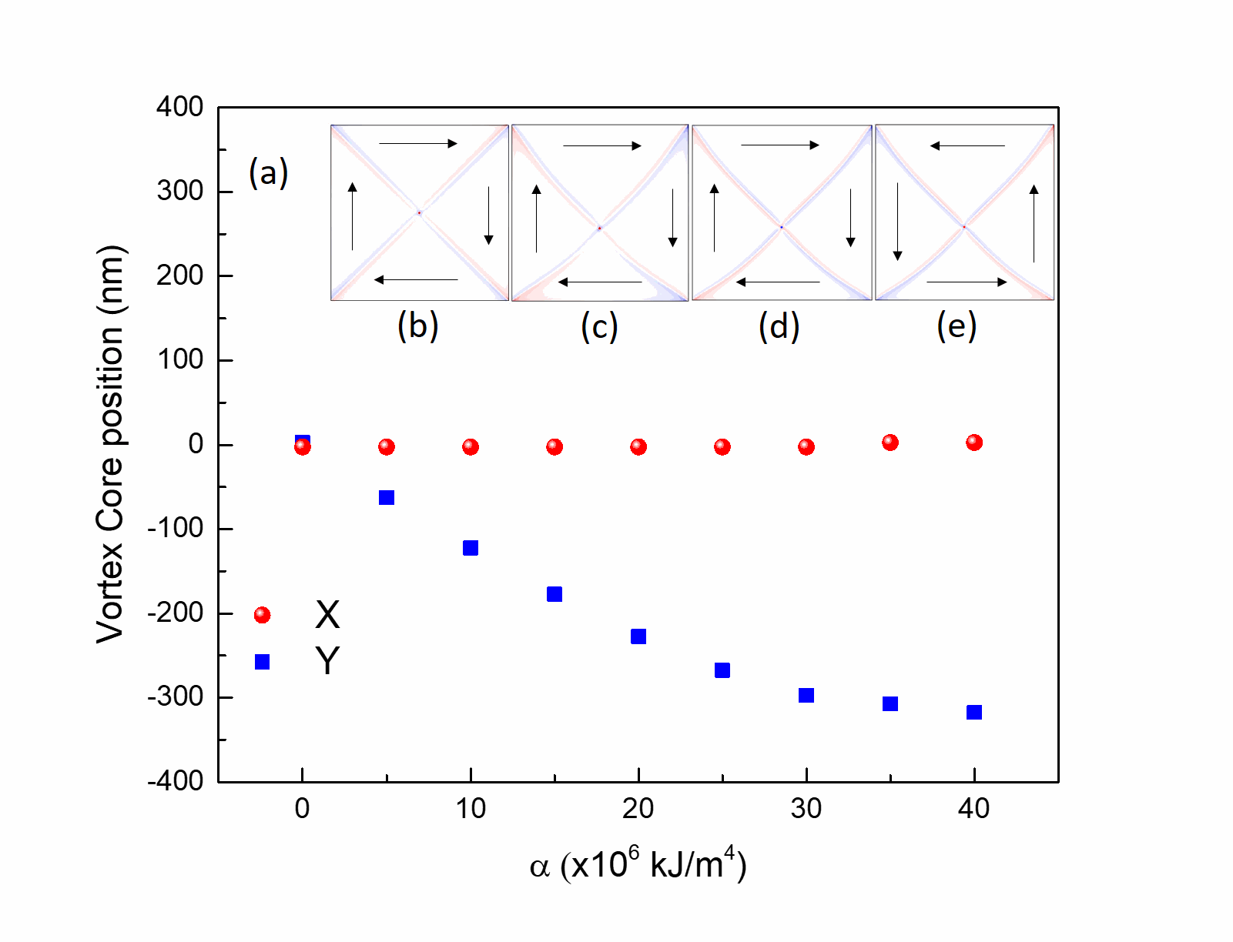
Figure 2: (a) Vortex core position as a function of the uniaxial anisotropy gradient α. The z component of the magnetization is shown in the insets for (b) α = 0, (c) α = 15 x10⁶ kJm⁻⁴, (d) α = 15 x10⁶ kJm⁻⁴ but for opposite chirality and (e) α = 15 x10⁶ kJm⁻⁴ but for opposite core polarization.

We note that the core displacement is almost linear in α for α ≤ 15 x 10⁶ kJm⁻⁴, whilst above this value the change in core position with further increases in α diminishes. This can be understood in terms of the competing free energy contributions in the Landau Lifshitz Gilbert (LLG) equation and Fig.3 shows how the magnetostatic (E_{MS}) and magnetoelastic (E_{ME}) energy depends on α. The difference in energy, E_{diff} = E_{MS} – E_{ME}, is also plotted. As can be seen from Fig.3, for low values of α the magnetoelastic energy is more sensitive to the strain gradient and rapidly increases with increasing α . However, around α = 20 x 10⁶ kJm⁻⁴, when the core is already ≈ 230 nm-off centre, the behaviour reverses and the magnetostatic contribution, which prefers the symmetric magnetization configuration with a central vortex core [22], increases more rapidly than the one forcing the core out of the centre. As a result, the displacement of the vortex core begins to saturate. When the shape anisotropy starts dominating over the magnetoelastic anisotropy, the vortex core is expected to reach the maximum displacement possible.

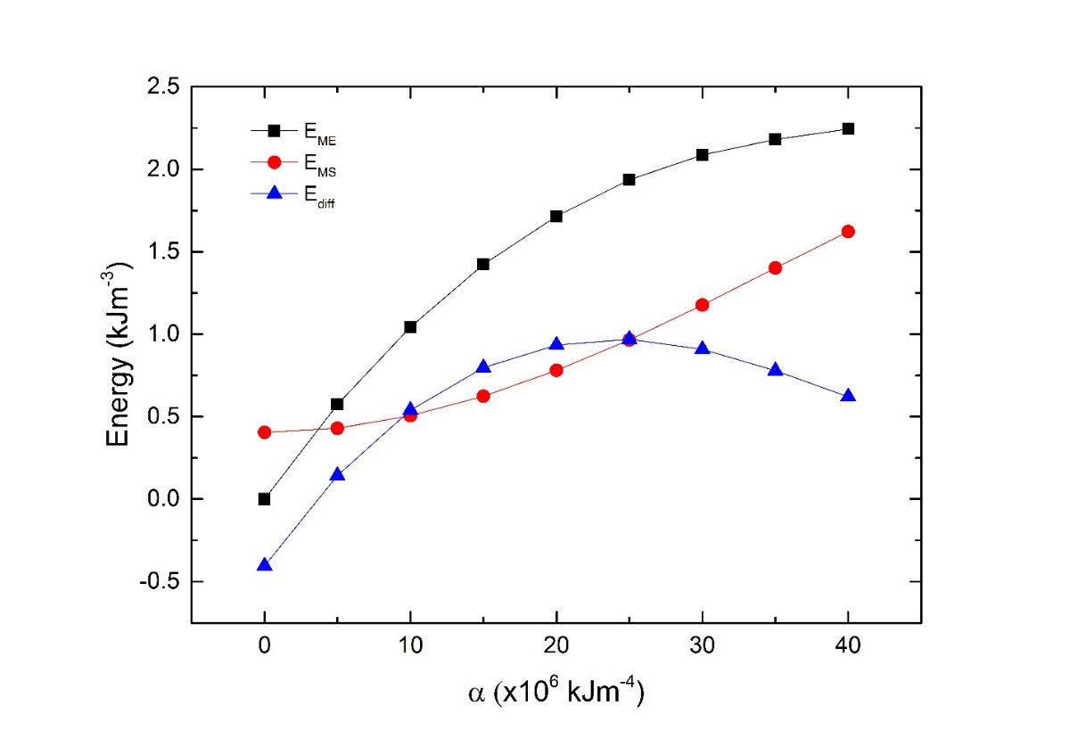
Figure 3: Magnetoelastic (black squares) and magnetostatic energies (red circles) for the 2μm square structure as a function of anisotropy gradient. The difference between the two terms is given by the blue triangles.
We next show how the uniform uniaxial anisotropy, C, which acts as an offset to the anisotropy gradient, modifies the translation of the vortex core. The vortex core position as a function of C is shown in Fig.4 with the inset showing how the strain induced anisotropy (K_{s}) varies with Y for several values of C. The uniaxial anisotropy gradient was set to $α=15×10^{6} kJm^{-4}$ to be within the linear displacement regime as shown previously in Fig.2a.
The vortex core displacement is maximised when C is set to zero so that the strain gradient is antisymmetric about Y = 0 nm. Increasing C (C > 0 kJ/m³) reduces the effect of the strain gradient on core displacement. For example for C = 15 kJm⁻³ the core displacement is 145nm compared to 180nm for C = 0 kJm⁻³. We note that for C ≥ 15kJm⁻³ the structure experiences a tensile strain along x over the whole structure. This is a key finding as a tensile strain gradient across the whole structure is easier to fabricate experimentally than one which goes from compressive to tensile. Although a reduction of the core displacement is seen for positive values of C, the core displacement is still significant (> 100nm).
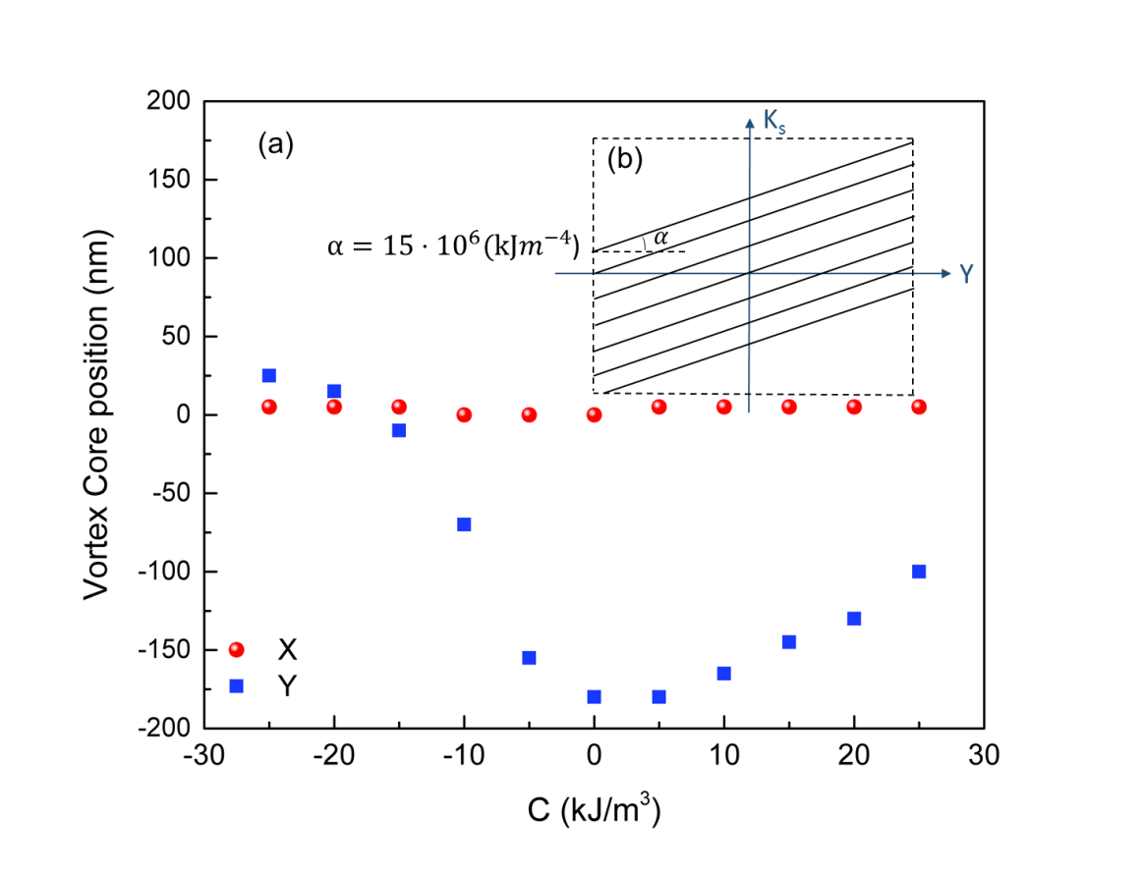
Figure 4: Vortex core position as a function of uniaxial anisotropy offset, C. The uniaxial anisotropy gradient was set to 15 x 10⁶ kJm⁻⁴. The inset demonstrates the role of C.

For negative values of the uniaxial anisotropy offset (C) the situation changes. As C becomes negative the reduction in vortex core displacement is far greater than for the equivalent positive C. For C = -15 kJm⁻³ the core displacement due to the strain gradient is only -10nm in the y direction. Further increases in the magnitude of C in this direction (more negative) results in the vortex core moving in the positive y direction. The asymmetry of this situation can be conveniently explained by looking at the domain configurations for $α=15×10^{6} kJm^{-4}$ and C = ± 15 kJm⁻³.

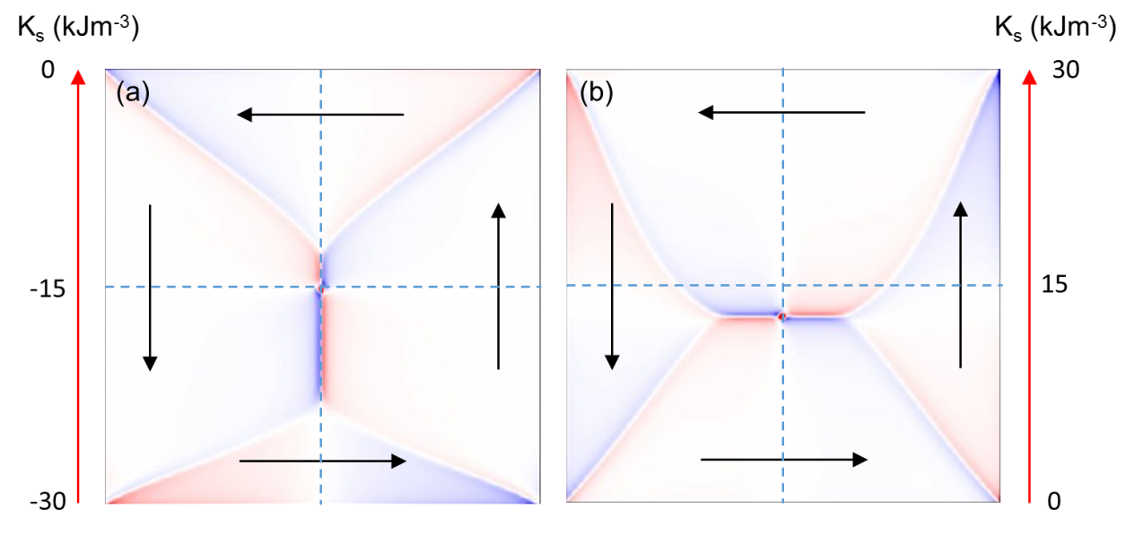
2
4
3
1
4
2
3
1
Figure 5: The z component of the magnetization for (a) C = -15 kJm⁻³ and (b) C = +15 kJm⁻³. The colours represent the magnetization in the positive (red) and negative (blue) z-direction.

Fig.5a shows the domain configuration for $α=15×10^{6} kJm^{-4}$ and C = -15 kJm⁻³. This translates into a strain induced uniaxial anisotropy going from 0 kJm⁻³ at y = 1000nm to -30kJm⁻³ at y= -1000nm. The effect of this anisotropy profile is to enlarge the domains (2&4) whose magnetization points along the |y| directions to the extent where they dominate the central region of the structure where the core resides. Domains with magnetization directed along x are expelled from this region leaving only a very narrow stripe at the centre of the structure which resembles a domain wall. Thus the strain induced anisotropy, which is directed in x, has very little effect in this region due to the absence of significant M_{x}, the x-component of the magnetization. As a consequence, the vortex displacement is small. However, for $α=15×10^{6} kJm^{-4}$ and C = +15 kJm⁻³, the anisotropy profile enlarges domains (1&3) where M is aligned along the tensile strain direction. Domains (2&4) are reduced to the extent that in the central region they now resemble a domain wall running in the x-direction. As there is now significant M_{x} in the central region the strain induced anisotropy gradient enlarges domain 3 preferentially to domain 1 (although both increase in area) translating the core in the negative y-direction.
For the case where the strain gradient is inverted the displacement of the core is in the positive direction and shows mirror symmetry about y = 0 as shown in Fig.6.

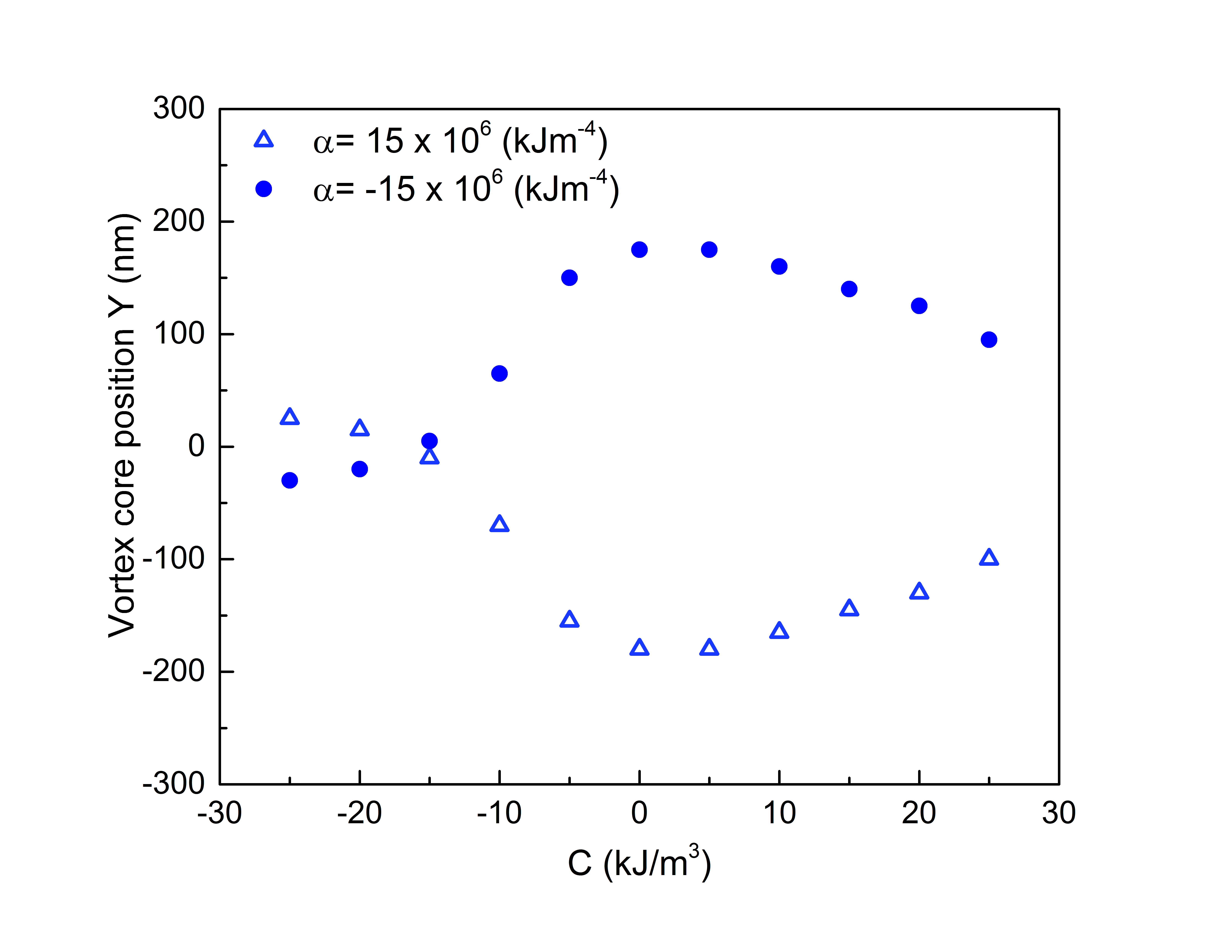
Figure 6: Y component of the vortex core position as a function of uniaxial anisotropy (offset) for positive (triangles) and negative (circles) uniaxial anisotropy gradients.
We next turn to the case where cubic anisotropy is also present. For epitaxial FeGa grown on GaAs a strong cubic anisotropy is present of the order K_{c} ≈ 32 kJm⁻³. Fig.7 shows the position of the vortex core as a function of uniaxial anisotropy gradient (α) and offset (C) for the case of no cubic magnetocrystalline anisotropy (MCA), which are shown by the blue squares, and for the case where a cubic MCA of 32 kJm⁻³ is included in the simulations. As can be seen, the general form of the data is the same for both cases which is expected given the symmetry of the cubic MCA.

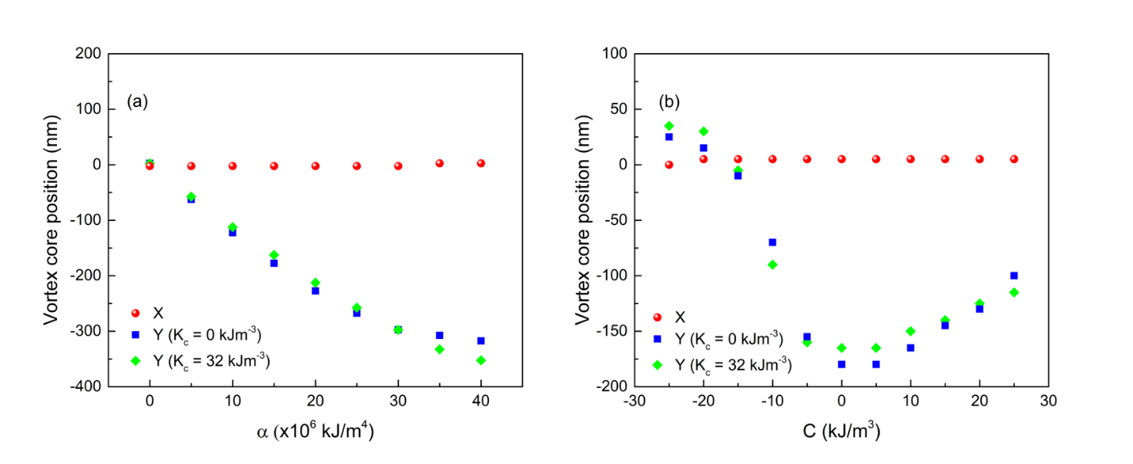

Figure 7: Vortex core position as a function of (a) uniaxial anisotropy gradient α for C = 0 and (b) uniaxial anisotropy offset C for α = 15 x 10⁶ kJm⁻⁴. The blue squares / green diamonds denote the y co-ordinate of the vortex core for the cases of no cubic MCA and a cubic MCA of 32 kJm⁻³ respectively.

In order to demonstrate the universality of core displacement via a strain gradient Fig. 8a shows the relative change in the y-component of the vortex core position as a function of uniaxial anisotropy gradient (α) and size (D) of the square structure. The effect is quite general for structures exhibiting vortex cores although within certain regions of this phase space the vortex core configuration is no longer the ground state magnetic configuration and is therefore not relevant to our discussion. Vertical linescans through Fig.8a at different values of α show that the relative change in the core position is linearly dependent on the size of the square structure for a given value of α (Fig.8b).

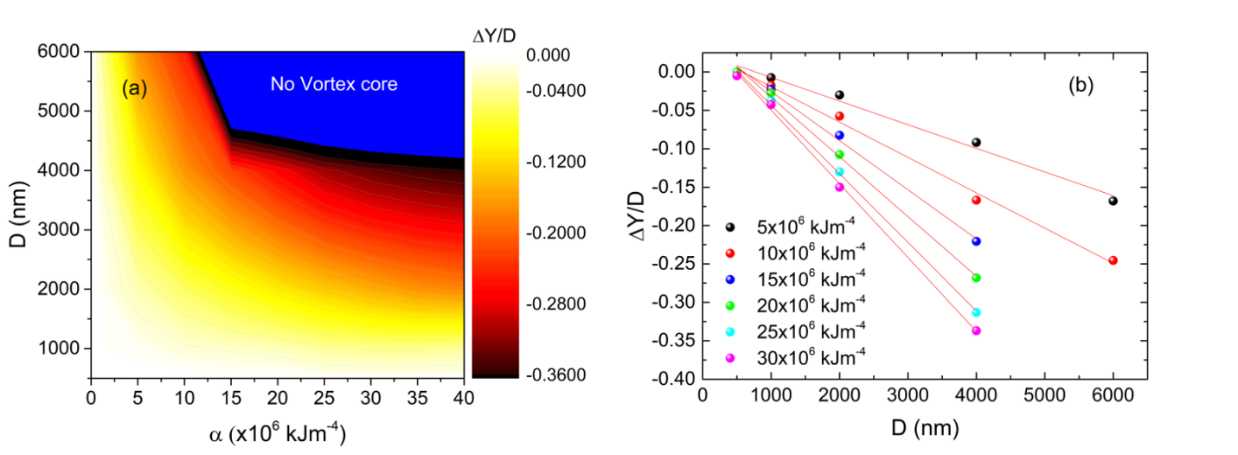
Figure 8: (a) 2D map of the relative displacement of the vortex core in the y-direction as a function of structure size (D) and strain gradient (α). (b) Horizontal linescans through (a) demonstrating the linear dependence of ΔY/D with D for several α.

As expected, as the size of the structure increases the competition between the magnetostatic energy and the strain induced anisotropy energy if tilted in favour of the later allowing for larger relative displacements.
Finally we demonstrate that circular planar structures show an almost identical response to α and C, as can be seen in Fig.9, compared to square planar structures. The displacement for the disc structure is smaller than for a square structure of similar diameter by a factor ≈ 2 which is expected from the form of equation 1. For the disc, the magnetization curls around the structure in a continuous way which reduces the area of magnetization parallel to the strain (M_{i} ∙ ε_{ii}), compared to the square structure, and with it the displacement of the vortex core.
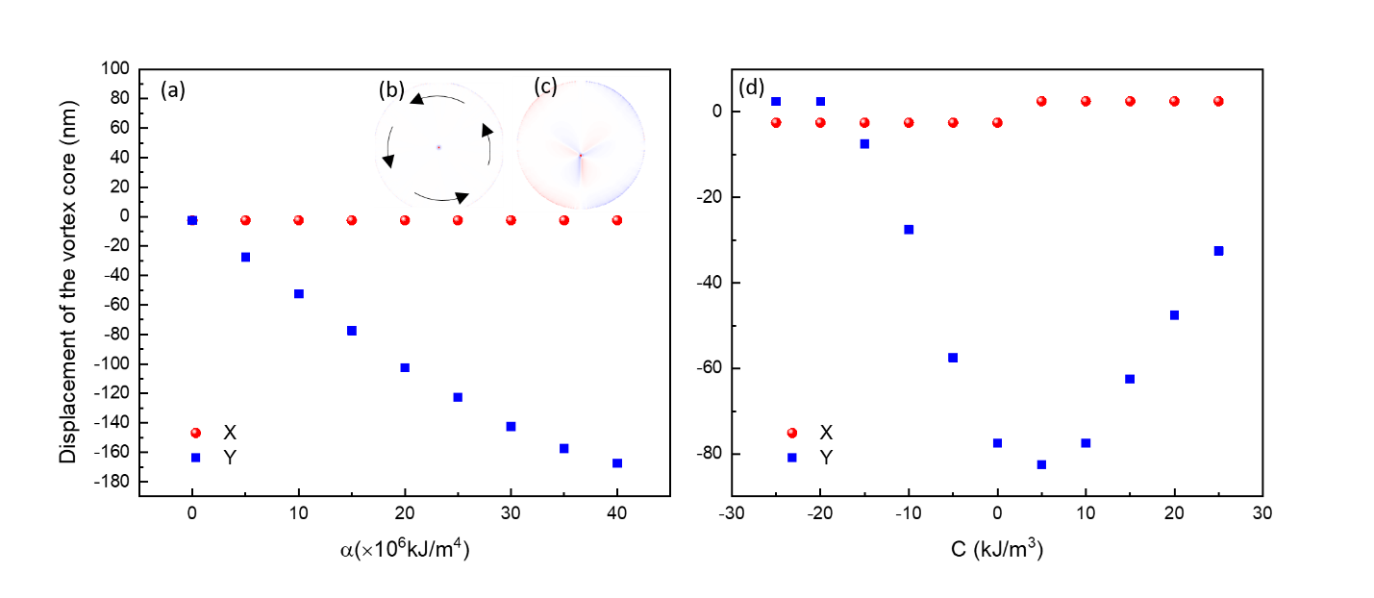
Figure 9: (a) Vortex core position as a function of the uniaxial anisotropy gradient α for a 2 micron diameter disc structure with K_{c} = 0 kJm⁻³. The z component of the magnetization is shown in the insets for (b) α = 0 and (c) α = 15 x10⁶ kJm⁻⁴. (d) Vortex core position as a function of uniaxial anisotropy offset, C for the structure shown in (b). The uniaxial anisotropy gradient was set to 15 x 10⁶ kJm⁻⁴
Summary
In summary, we demonstrate that a strain gradient induced anisotropy in magnetostrictive micro-structures allows for the displacement of the vortex core which is symmetry-forbidden when only a uniform strain is present. Due to the strong restoring force of the shape anisotropy, the strain induced changes are reversible and volatile. With manipulation of the position and polarity of the vortex core now possible, as well as the chirality of the vortex [25], voltage controlled strain induced anisotropies provide a key tool to manipulate magnetic domains and topological defects in confined geometries.

Acknowledgements
We gratefully acknowledge the use of the POLARIS HPC cluster of the N8.

*corresponding author: stuart.cavill@york.ac.uk

References

[1] S. Ladak, D. E. Read, G. K. Perkins, L. F. Cohen and W. R. Branford. Nature Physics 6, 359 (2010)

[2] N. Nagaosa and Y. Tokura. Nature Nanotechnology 8, 899 (2013)

[3] T. Shinjo, T. Okuno, R. Hassdorf, K. Shigeto and T. Ono. Science 289, 930 (2000)

[4] L. E. Sadler, J. M. Higbie, S. R. Leslie, M. Vengalattore and D. M. Stamper-Kurn. Nature 443, 312 (2006)

[5] S. Seki, X. Z. Yu, S. Ishiwata and Y. Tokura. Science 336, 198 (2012)

[6] X. Z. Yu et al. Nature Mater. 10, 106 (2011).

[7] S. Woo et al. Nature Materials 15, 501(2016)

[8] O. Tchernyshyov and G. W. Chern Phys. Rev. Lett 95, 197204 (2005), M. Y. Im et al. Nat. Comms 3, 983 (2012)

[9] A. Wachowiak, J. Wiebe, M. Bode, O. Pietzsch, M. Morgenstern and R. Wiesendanger. Science 298, 577 (2002)

[10] T Tanigaki et al. Nano Lett. 15, 1309 (2015)

[11] R. Hertel, Nat. Nanotechnol. 8, 318 (2013)

[12] V. Pribiag, I. N. Krivorotov, G. D. Fuchs, P.M. Braganca, O. Ozatay, J. C. Sankey, D. C. Ralph, and R. A. Buhrman, Nat. Phys. 3, 498 (2007)

[13] K. Lee, S.-K. Kim, Y.-S. Yu, Y.-S. Choi, K. Yu. Guslienko, H. Jung, and P. Fischer, Phys. Rev. Lett. 101, 267206 (2008)

[14] K. Ando, S. Takahashi, J. Ieda, H. Kurebayashi, T. Trypiniotis, C. H.W. Barnes, S. Maekawa, and E. Saitoh. Nat. Mater. 10, 655 (2011)

[15] W. Zhu, D. Xiao, Y. Liu, S. J. Gon, and C. Duan, Sci. Rep. 4, 4117 (2014)

[16] T. A. Ostler, R. Cuadrado, R.W. Chantrell, A.W. Rushforth and S. A. Cavill. Phys. Rev. Lett 115, 067202 (2015)

[17] D. E. Parkes, R. Beardsley, S. Bowe, I. Isakov, P. A. Warburton, K. W. Edmonds, R. P. Campion, B. L. Gallagher, A. W. Rushforth and S. A. Cavill. Appl. Phys. Lett 105, 062405 (2014)

[18] S. Finizio et al. Phys. Rev. Applied 1, 021001 (2014)

[19] D. E. Parkes, S. A. Cavill, A. T. Hindmarch, P. Wadley, F. McGee, C. R. Staddon, K.W. Edmonds, R. P. Campion, B. L. Gallagher, and A.W. Rushforth, Appl. Phys. Lett. 101, 072402 (2012).

[20] Calculations performed with cell sizes of 2nm showed no difference, to within the resolution of the cell size, to those performed with 5nm cell size. Thus all simulations were performed at the larger cell size in order to reduce computational time.

[21] M. J. Donahue and D. G. Porter, Interagency Report NISTIR 6376, National Institute of Standards and Technology, Gaithersburg, MD, September 1999.

[22] C. Kittel. Rev. Mod. Phys. 21, 541 (1949)

[23] A. E. Clark, et al. J. Appl. Phys. 93, 8621 (2003).

[24] Yahagi et al, Phys. Rev. B, 90, 140405(R) (2014): For Fig.1d we set B₁ = 0 Jm⁻³,
B₂ = 1.6 MJm⁻³, ε_{xy} = ε_{yx} = 0.9 x 10⁻³ and all other terms in the strain matrix equal to zero.

[25] R. P. Beardsley, S. Bowe, D. E. Parkes, C. Reardon, K. W. Edmonds, B. L. Gallagher, S. A. Cavill and A. W. Rushforth. Sci. Reports 7, 7613 (2017)

Figure Captions

Figure 1: Z-component of the magnetization for a 2micron square planar structure for (a) zero strain induced anisotropy (b) negative (compressive) strain induced uniform anisotropy in the x-direction, (c) positive (tensile) strain induced uniform anisotropy in the x-direction and (d) shear induced anisotropy.

Figure 10: (a) Vortex core position as a function of the uniaxial anisotropy gradient α. The z component of the magnetization is shown in the insets for (b) α = 0, (c) α = 15 x10⁶ kJm⁻⁴, (d) α = 15 x10⁶ kJm⁻⁴ but for opposite chirality and (e) α = 15 x10⁶ kJm⁻⁴ but for opposite core polarization.

Figure 3: Magnetoelastic (black squares) and magnetostatic energies (red circles) for the 2μm square structure as a function of anisotropy gradient. The difference between the two terms is given by the blue triangles.

Figure 11: Vortex core position as a function of uniaxial anisotropy offset, C. The uniaxial anisotropy gradient was set to 15 x 10⁶ kJm⁻⁴. The inset demonstrates the role of C.

Figure 5: The z component of the magnetization for (a) C = -15 kJm⁻³ and (b) C = +15 kJm⁻³. The colours represent the magnetization in the positive (red) and negative (blue) z-direction.

Figure 6: Y component of the vortex core position as a function of uniaxial anisotropy (offset) for positive (triangles) and negative (circles) uniaxial anisotropy gradients.

Figure 7: Vortex core position as a function of (a) uniaxial anisotropy gradient α for C = 0 and (b) uniaxial anisotropy offset C for α = 15 x 10⁶ kJm⁻⁴. The blue squares / green diamonds denote the y co-ordinate of the vortex core for the cases of no cubic MCA and a cubic MCA of 32 kJm⁻³ respectively.

Figure 8: (a) 2D map of the relative displacement of the vortex core in the y-direction as a function of structure size (D) and strain gradient (α). (b) Horizontal linescans through (a) demonstrating the linear dependence of ΔY/D with D for several α.

Figure 9: (a) Vortex core position as a function of the uniaxial anisotropy gradient α for a 2 micron diameter disc structure with K_{c} = 0 kJm⁻³. The z component of the magnetization is shown in the insets for (b) α = 0 and (c) α = 15 x10⁶ kJm⁻⁴. (d) Vortex core position as a function of uniaxial anisotropy offset, C for the structure shown in (b). The uniaxial anisotropy gradient was set to 15 x 10⁶ kJm⁻⁴

Fig.1
I. Azaceta et al.

Fig. 2
I. Azaceta et al.

I. Azaceta et al.
Fig.3

I. Azaceta et al.
Fig. 4

I. Azaceta et al.
Fig. 5

I. Azaceta et al.
Fig. 6

I. Azaceta et al.
Fig. 7

I. Azaceta et al.
Fig. 8

I. Azaceta et al.
Fig. 9

