Graphite Oxide- and Graphene Oxide-supported Catalysts for Microwave-assisted Glucose Isomerisation in Water
Iris K.M. Yu ^{a,b}, Xinni Xiong ª, Daniel C.W. Tsang ^{a,*}, Yun Hau Ng ^{c}, James H. Clark ^{b}, Jiajun Fan ^{b}, Shicheng Zhang ^{d}, Changwei Hu ^{e}, Yong Sik Ok ^{f}
ª Department of Civil and Environmental Engineering, Hong Kong Polytechnic University, Hung Hom, Kowloon, Hong Kong, China
^{b} Green Chemistry Centre of Excellence, Department of Chemistry, University of York, York, YO10 5DD, UK
^{c} School of Energy and Environment, City University of Hong Kong, Tat Chee Avenue, Kowloon, Hong Kong, China
^{d} Shanghai Key Laboratory of Atmospheric Particle Pollution and Prevention (LAP³), Department of Environmental Science and Engineering, Fudan University, Shanghai 200433, China
^{e} Key Laboratory of Green Chemistry and Technology, Ministry of Education, College of Chemistry, Sichuan University, Chengdu 610064, China
^{f} Korea Biochar Research Center, O-Jeong Eco-Resilience Institute (OJERI) & Division of Environmental Science and Ecological Engineering, Korea University, Seoul 02841, Republic of Korea
*Corresponding author: dan.tsang@polyu.edu.hk

Table of content
Oxygen functionalities on GIO/GO are involved in the formation of active Al sites potentially with microwave-absorbing ability, which facilitate glucose-fructose isomerisation in water.
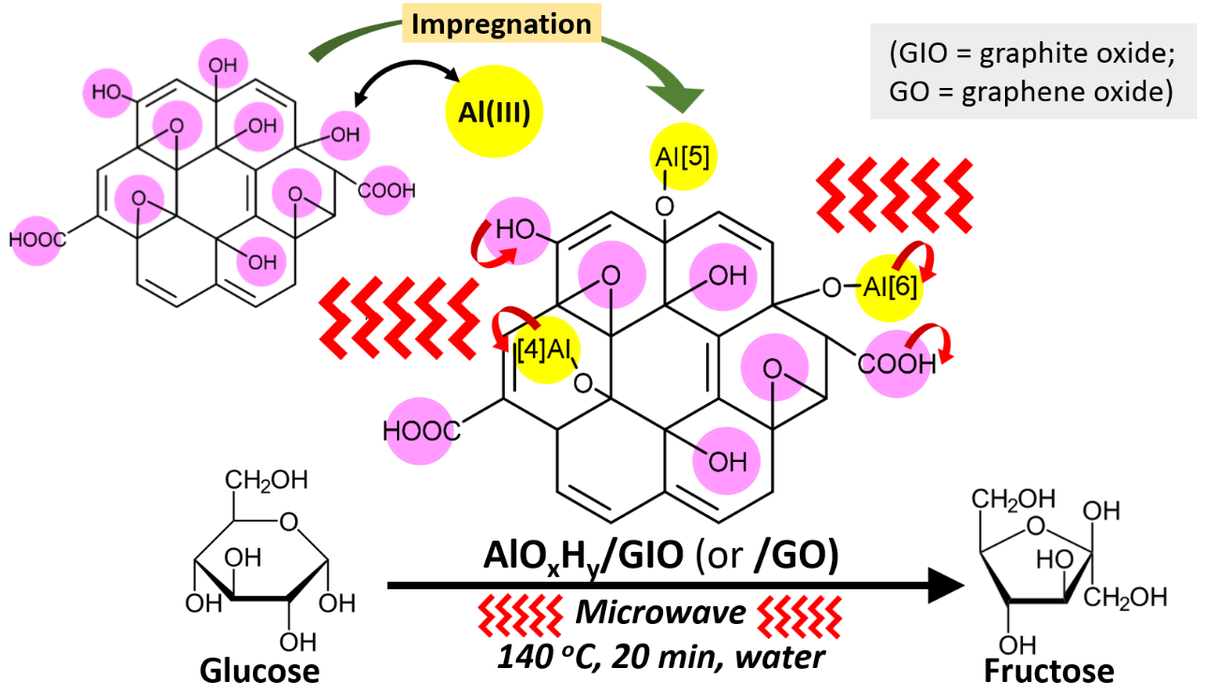

Abstract
Graphite (G), graphite oxide (GIO), and graphene oxide (GO) were evaluated for the first time as carbonaceous supports to synthesise heterogeneous Lewis acid catalysts, via simple AlCl₃ pretreatment followed by one-step thermal modification. The GIO- and GO-supported Al catalysts were active towards catalytic isomerisation of glucose in water as the greenest solvent. The highest fructose yield of 34.6 mol% was achieved under microwave heating at 140 ºC for 20 min. The major active sites were characterised as amorphous Al hydroxides (e.g., β-Al(OH)₃, γ-Al(OH)₃, and γ-AlO(OH)) with octahedral coordination, as revealed by ²⁷Al NMR, XPS, SEM, TEM-EDX, Raman, ESR, and XRD analyses. The transformation of octahedral Al to pentahedral/tetrahedral coordination was observed when the activation temperature increased. Oxygen-containing functional groups on the GIO and GO surfaces, e.g., C-O-C, -OH, and -COOH, contributed to the formation of microwave-absorbing active sites. In contrast, the G-supported catalyst may contain microwave-transparent Al hydroxides, accounting for its low catalytic activity under microwave irradiation. This study elucidates the significance of surface chemistry of carbonaceous supports in generating active species for a Lewis acid-driven reaction. The revealed intertwined relations between modification conditions, physicochemical properties, and catalytic performance will be useful for designing effective carbon-supported catalysts for sustainable biorefineries.
Keywords: carbon-supported catalysts; metal impregnation; sustainable biorefinery; value-added chemicals; waste valorisation.

Introduction
Using renewable biomass to produce substitutes for traditional petroleum-derived products helps both combating climate change and mitigating energy crisis.¹⁻⁵ While glucose is largely available in natural polymers in biomass (e.g., cellulose and starch), isomerisation of glucose to fructose is an important reaction because fructose with a more reactive five-membered ring structure allows for rapid downstream upgrading, e.g., dehydration to hydroxymethylfurfural (HMF).⁶⁻⁸ Enzymatic isomerisation in conventional practice can take place in water at low temperature, yet the high production cost of enzymes and their high susceptibility to deactivation may appear as potential drawbacks. Alternatively, Lewis acids (i.e., electron pair acceptors) or Brønsted bases (i.e., OH⁻) catalyse time-efficient isomerisation via different hydrogen transfer pathways.⁹ Lewis acids also facilitate catalytic transfer hydrogenation, an important pathway to synthesise bio-based products, e.g., γ-valerolactone (from levulinic acid) ¹⁰ and 2-methylfuran (from furfural),¹¹ which are platform chemicals and fuel additives drawing significant attentions in recent years.¹²
The use of homogeneous Lewis acids (e.g., AlCl₃ and SnCl₄) suffers from difficult material separation and recycling despite the good catalytic performance.¹³ There has been significant research focusing on the development of solid-supported alternatives, such as Al-, Sn-, and Zr-containing zeolite, silica/silicate, and metal-organic frameworks (MOFs).^{9, 14, 15} However, the use of expensive precursors (e.g., organic linkers for MOFs) and complex multistep synthesis (e.g., hydrothermal heating and calcination) may hinder their large scale applications.
Using carbon as a catalyst support has shown significant potential in view of its relatively simple preparation and high abundance from biomass waste streams. Such substitution for inorganic supports tends to favour sustainability, by reducing metal use in a catalytic process and closing the carbon loop when a renewable carbon source is employed. As an emerging area, different functionalised carbons, such as biochar ¹⁶⁻¹⁸, (reduced) graphene oxide ¹⁹, and carbon nanotube ²⁰ have been explored to catalyse various biorefinery reactions.
However, the physicochemical properties of carbonaceous materials vary more easily than that of mineral-based supports during modification and hence they are less predictable in general. For instance, metal impregnation at 500-700 ºC was found to alter the content and speciation of oxygen and carbon in biochar.²¹ An oxidised surface is often present on carbon materials due to either thermochemical process or air exposure, of which the potential contribution to catalyst synthesis needs to be unveiled. In environmental applications, oxygen-containing functional groups increase the hydrophilicity of carbon-based sorbents and serve as binding sites for heavy metals.^{22, 23} Herein, we hypothesise that functionalising carbonaceous materials is a possible means to manoeuvre catalytic site activity via controlled interplay between carbon surface and impregnating agents. Interactions between supported Ru or Pt nanoparticles and carbon surfaces have been speculated to account for the shift of binding energies for the metals,^{20, 24} highlighting the need to elucidate the roles of carbons beyond a simple physical support.
Graphite (G), graphite oxide (GIO), and graphene oxide (GO) are employed in this study. G undergoes oxidation via the Hummers’ method to form GIO ²⁵, while the latter is subjected to exfoliation to give GO.²⁶ By comparing their performance as catalyst supports, the significance of oxygen functionalities and layered structures can be singled out for investigation, which is difficult for biochar or activated carbon supports with inherent oxidised surface and heterogeneous matrix.^{21, 27} The graphene-family materials have been widely applied in the development of capacitor, electrode, thermal emitter, and catalyst because of their tuneable electrical conductivity and surface area. ²⁸⁻³¹ Their potential was recently explored in the context of biorefineries,³² such as hydrolysis of glucans,²⁶ dehydration of monosaccharides,³³ oxidation of HMF,³⁴ and esterification of fatty acids.³⁵ Sulfonation and impregnation of metallic nanoparticles (e.g., Pd and Ru) have been the most common methods of modification in these studies, but these are not appropriate for Lewis acid-type catalysts.
Here, we report for the first time the synthesis of Al-impregnated G, GIO, and GO catalysts via simple heating in air and their catalytic activities as Lewis acids. Aluminium was selected in consideration of its higher abundance and less environmental impact of mining practice compared to Sn.³⁶ The carbon-supported catalysts were evaluated for glucose isomerisation, a selected model reaction of Lewis acid catalysis, in water as a green solvent. The roles of surface chemistry in active site formation were scrutinised, which is critical for the top-down science-informed customization of effective carbonaceous supports. As a future industrialised technique, microwave heating was employed to elucidate electromagnetic wave interactions with the solid catalysts.³⁷ Our synthesised catalysts achieved high fructose yields of up to 34.6 mol% under mild conditions, owing to the presence of octahedral Al species and oxygen functionalities exhibiting microwave absorption. Such new knowledge fosters the innovation of solid catalysts using renewable carbonaceous supports, promoting sustainable biorefineries in a wider context.

Materials and methods

Chemicals
Graphite was used as a catalyst support and the precursor of GIO and GO. The impregnation agent AlCl₃∙6H₂O (ACS grade) was purchased from Anaqua. Acetone (99.5%) from Duksan Pure Chemicals was used to make the reaction medium. The model compounds for the catalytic reaction and calibration of the analytical equipment include cellobiose (≥98%), levulinic acid (98%), and formic acid (98%) from Alfa Aesar; fructose (≥ 99%) and maltose monohydrate (≥98%) from Wako; glucose (≥99.5%), HMF (≥99%), and furfural (99%) from Sigma Aldrich; and levoglucosan from Fluorochem. All chemicals were used as received.

Synthesis of Al-modified carbons
GIO was produced following the Hummers’ method.²⁵ In brief, 10 g graphite and 5 g NaNO₃ were added to 230 ml concentrated H₂SO₄ (98%) in an ice bath under stirring, following by the slow addition of 30 g KMnO₄. The mixture was agitated at ~35 ºC for 30 min. Then, 460 ml water was added and stirring at 98 ºC was maintained for 15 min, followed by further dilution with water and the removal of residual KMnO₄ using H₂O₂. The mixture was centrifuged, and the collected residue was washed with deionised water by repetitive centrifugation and decantation. The washed residue was oven-dried to give GIO. GO was obtained by suspending the dried GIO in deionised water for 5-h sonication and then oven-drying.²⁶
For Al modification, G, GIO, and GO (10 g) were suspended and stirred for 4 h in a 200 mL-solution of AlCl₃ (0.185 M, i.e., initial elemental Al loading of 10 wt% with respect to carbon support). Afterwards, they were placed in an oven at 103 ºC until a constant mass was attained indicating complete evaporation of water. The oven-dried AlCl₃-treated carbon supports are denoted as G-Al, GIO-Al, and GO-Al. Then, the dried material was heated in a Carbolite muffle furnace at 200 or 500 ºC for 2 h in air, with a ramp rate of 10 ºC min⁻¹. The G-Al modified at 200 ºC is denoted as G-Al200 and so forth. All prepared samples were stored in a sealed container in a desiccator before characterisation and catalytic evaluation.

Characterisation of unmodified and modified carbons
Morphology, topography, and elemental distribution were revealed by scanning electron microscopy and transmission electron microscopy coupled with energy dispersive X-ray spectroscopy (SEM and TEM-EDX; [TESCAN VEGA3] and [Oxford X-Max 80T], respectively). Brunauer–Emmett–Teller (BET) surface areas and pore volumes were determined by nitrogen adsorption−desorption isotherm measurements at -196 °C using a gas sorption analyser (Micromeritics ASAP 2020). The samples were degassed at 80 °C for 16 h before analysis. Thermogravimetric analysis (TGA) was performed to study the thermal behaviour of samples, using the Rigaku Thermo plus EVO2 at a ramp rate of 10 ºC min⁻¹ to 1000 ºC under argon purging. Crystalline fractions were evaluated by X-ray diffraction (XRD; Rigaku SmartLab), scanning from 2θ = 10° to 70° at a rate of 5° min⁻¹ at 45 kV and 200 mA.
As for chemical analysis, X-ray photoelectron spectroscopy (XPS) was carried out using the PHI 5000 Versaprobe II with monochromated Al Kα radiation (1486.6 eV). The pass energy of 187.9 eV at 1.6 eV per step was adopted for survey scans (0 to 1200 eV), and 58.7 eV at 0.125 eV per step was used for the narrow scans of C 1s, O 1s, and Al 2p. The shift of binding energy was corrected by the C 1s level at 284.8 eV. Curve fitting was performed using the program XPSPEAK41 with 30% Lorentzian-Gaussian function and a Shirley baseline. The reported binding energies for various components are shown in Table S1. Micro-Raman spectroscopy (Renishaw) was performed using a laser source with 532 nm wavelength and an objective of 50x. ²⁷Al nuclear magnetic resonance (NMR) spectroscopy was conducted using the JEOL JNM-ECZ500R with the magnetic field strength of 11.6 T at 500 MHz. The ²⁷Al spectra were obtained at 7.5 kHz magic angle spinning (MAS) in single pulse experiments with the relaxation delay of 5 s. Curves were fitted using the program DMfit. Electron spin resonance (ESR) spectroscopy (JES-FA300, JEOL) was conducted using a centre field at 323.3 mT with a sweep width of 25 mT and sweep time of 1 min, under microwave irradiation at 9.06 GHz and 0.998 mW.

Catalytic conversion
The catalytic conversion of glucose was performed following the procedure reported in previous studies.^{21, 38-40} Catalyst (0.25 g) and glucose (0.5 g) were added to 10 ml water or a mixture of acetone and water (acetone/H₂O; 1:1 v/v). The catalyst dosage resulted in observable product yields for the sake of distinguishable comparison between different catalytic systems in this study, which can be optimised in the future. The mixture was placed in a sealed Teflon vessel, following by heating to 140 ºC with a ramp time of 5 min under magnetic stirring in an Ethos Up Microwave Reactor (Milestone, maximum power: 1900 W). The temperature was held for 1 and 20 min. After the reaction, cooling was achieved by mechanical ventilation for 40 min. Catalytic conversion under the selected conditions was carried out in an oil bath representing conventional heating (Memmert ONE10). For product analysis, all liquid samples were diluted with deionised water (1:3 v/v) and filtered through a mixed cellulose ester filter (0.22 µm).

Catalysis sample analysis
High-performance liquid chromatography (HPLC) was performed using a Chromaster instrument equipped with a refractive index detector (Hitachi, Japan) and an Aminex HPX-87H column (Bio-Rad) at an analytical temperature of 50 ºC.⁴¹⁻⁴³ The mobile phase was 0.01 M H₂SO₄ at a flow rate of 0.5 ml min⁻¹. The yield and selectivity of the products as well as glucose conversion were calculated in terms of the carbon content.
$Product yield \left(mol\%\right)=\frac{P_{f}(mg/ml)×n_{p}/{MW}_{P}}{{Glu}_{i} (mg/ml)×n_{Glu}/{MW}_{Glu}}×100$, (1)
$Product selectivity \left(mol\%\right)=\frac{P_{f}(mg/ ml)×n_{p}/{MW}_{P}}{{(Glu}_{i}-{Glu}_{f})(mg/ml)×n_{Glu}/{MW}_{Glu}}×100$, (2)
$Glucose conversion \left(mol\%\right)=\frac{{{Glu}_{i}-Glu}_{f}(mg/ml)}{{Glu}_{i}(mg/ml)}×100$, (3)
where, P_{f} represents the concentration of the products; n_{p} and n_{Glu} are number of carbons in the corresponding product and glucose, respectively; MW_{p} and MW_{Glu} are molecular mass of the corresponding product and glucose, respectively; and Glu_{i} and Glu_{f} represent the initial and final concentration of glucose, respectively.

Results and discussion

Catalyst characterisation

Transformation and roles of carbon supports
The nitrogen adsorption–desorption isotherms are shown in Fig. S1a&b. Most of the prepared carbonaceous materials resulted in a typical type IV isotherm with type H3 hysteresis loops, which is characteristic of mesoporous materials with slit-shaped pores.⁴⁴ After chemical oxidation, the BET surface area increased from 11.4 m² g⁻¹ for G to 24.3 m² g⁻¹ for GIO, with the O content increasing from 3.4% to 29.7%, proving oxidation via the Hummers’ method (Table 1&2). The surface area further increased to 55.1 m² g⁻¹ for GO as a result of GIO exfoliation via ultrasonication, consistent with a recent study (35 m² g⁻¹).²⁶ The stacked carbon sheets had more spacing and/or were well separated after exfoliation as depicted by the SEM images (Fig. S2a-c). We pretreated the carbon materials with AlCl₃ to produce G-Al, GIO-Al, and GO-Al, which were then thermally activated to give GIO-Al200, GO-Al200, and so forth, where “200” represents the activation temperature. GIO-Al200 had a significantly lower surface area (3.4 m² g⁻¹) and did not show micropores in contrast to GIO. Similar observation was noted in the comparison between GO and GO-Al200, implying possible blocking of micropores by the impregnated Al species, as previously reported for Al-grafted silica.⁴⁵
The TGA results showed that while G was thermally stable, GIO had only 34% remaining at 1000 ºC (Fig. 1a&b). The latter had its most significant mass loss at 180–280 ºC that could be the thermally susceptible functionalities. XRD analysis suggested the transformation of the crystalline G to the amorphous GIO, while Raman spectra evidenced an increase in the intensity ratio of D peak to G peak (I_{D}/I_{G}) from 0.41 to 0.85 (Fig. 2 & Table 2), pointing to the disruption in graphitic structure by the Hummer’s method. The thermal behaviour of GO resembled that of GIO (Fig. 1a&b), implying the negligible compositional changes induced by the exfoliation in this study.
The significant mass loss from G-Al at 100-180 ºC can be ascribed to the evaporation of unreacted AlCl₃ (Fig. 1a&b). The residues of G-Al at 1000 ºC amounted to 32% of the initial mass, which was lower than the predicted value of 47% assuming complete volatilisation of the added AlCl₃ hexahydrate. This suggests a loss of some of the carbon-containing moieties from G-Al, which, in comparison, was minor for G (95% residue at 1000 ºC). The I_{D}/I_{G} ratio decreased from 0.41 for G to 0.3 for G-Al500 (Table 2), indicating that AlCl₃ facilitated the decomposition of distorted fraction in G. Nevertheless, there exist smaller chemical interactions between G and Al in comparison to that between GIO or GO and Al, in view of the steeper TGA curve for G-Al (before ~200 ºC; Fig. 1a). After thermal activation, GIO-Al500 and GO-Al500 were less thermally stable than G-Al500 (Fig. 1c&d) and gave no characteristic XRD peaks (Fig. 2b), presenting more vulnerable and amorphous structures.
The successful loading of Al species was confirmed by TEM-EDX mapping (Fig. 3). A higher surface Al content of 12.5–19.8% was estimated for GO-Al200/500 compared to that for GIO-Al200/500 (5.9–10.3%) according to the XPS results (Table 2 & Fig. 4a), consistent with the ²⁷Al NMR signal intensities (Fig. 5a). The more effective impregnation process on GO as the support could be ascribed to its higher surface area, which may have facilitated its contact with Al for thermochemical reactions (Table 1). The resultant Al components could be β-Al(OH)₃, γ-Al(OH)₃, Al-O-C, and γ-AlO(OH), according to the XPS fitting (Fig. 4b-f) and binding energies reported in the literature (Table S1). Based on the ²⁷Al NMR curve fittings (Fig. 5b-e), they may appear in five types of configuration, including aluminium carbide (Al₄C₃) and Al in four-, five-, and six-coordination (Al[4], Al[5], Al[6]), with the chemical shifts at 111–120, 39–85, 20–52, and -21–37 ppm, respectively. ⁴⁶ The symbol Al[6]* denoted the six-coordinated Al species with a lower chemical shift than the typical Al[6] (~0 ppm) in this study. These chemical features were similar to those of Al-impregnated biochars in our recent study²¹ and they may also appear when other carbonaceous materials are used as supports in the same Al modification.
GIO and GO contained a wide variety of oxygen-containing groups such as carboxyl, hydroxyl, and epoxy groups (XPS fittings in Fig. S3&4), while there were no detectable Mn or K residuals. We infer that these oxygen functionalities could have been involved in the formation of the Al-O matrix. This was substantiated by TEM-EDX mapping, showing negligible Al signals in the areas with low O signals (e.g., the wall-like structures indicated by the blue boxes; Fig. 3c&d). During AlCl₃ pretreatment at room temperature, Al(III) may form complex with the oxygen moieties on GIO/GO, similar to biochar-assisted removal of Al from the environment.⁴⁷ Such pre-anchoring of Al species before thermal activation may enable controllable and selective distribution of active sites over the carbon surface. In comparison, G was mainly characterised by sp2-bonded carbon (Fig. S3&4) and with low O content (3.4%; Table 2). The latter increased to 16.8% in G-Al500 possibly because of the oxidation of carbon in air during synthesis, given that weak van der Waals force exists between the graphite surface and O₂.⁴⁸ Then, Al(III) may react with the newly formed oxygen-containing groups to form Al oxides/hydroxides (Fig. 4b). Such different mechanisms of Al species formation may alter the chemical profile and hence activity of the resultant GIO/GO catalysts.

Surface characteristics under different modification temperatures
Although the surface area decreased from 24.3 m² g⁻¹ for GIO to 3.4 m² g⁻¹ for GIO-Al200, it significantly increased to 74 m² g⁻¹ for GIO-Al500, along with the new formation of micropores (33 m² g⁻¹) and mesopores (41 m² g⁻¹) (Table 1). A similar trend in the porosity development was observed for GO, GO-Al200, and GO-Al500. While pore blocking occurred as the material was subjected to thermal modification at 200 ºC (Section 3.1.1), increasing the temperature to 500 ºC may have created new pores. The lower volatile content in GIO/GO-Al500 was illustrated by TGA, i.e., more residues in GIO/GO-Al500 (64–71%) compared to their 200 ºC-modified counterparts (50–60%) at 1000 ºC (Fig. 1c&d). The modification temperature did not lead to notable changes in surface morphology according to SEM (Fig. S2e-h) and TEM images (Fig. 3d & S5).
The Al content increased at a higher modification temperature as a result of more significant weight loss of carbonaceous fraction (e.g., 12.5% for GO-Al200 to 19.8% for GO-Al500; Table 2), with an increase in the proportion of bayerite (β-Al(OH)₃) (Fig. 4c-f). It was observed that the NMR spectra generally showed downfield shifts when the modification temperature increased (Fig. 5). For instance, Al[6] decreased from 57.3% in GIO-Al200 to 17.7% in GIO-Al500, in company with an increase in Al₄C₃ (46.5%). Similarly, Al₄C₃ emerged (12.1%) and Al[4] (22.7%) and Al[5] (18.4%) increased in the spectra of GO-Al500, relative to that of GO-Al200. A similar trend was reported for the transformation of Al sites in amorphous alumina thin films, concluding that Al[6] decreased and Al[4] increased as the deposition temperature rose from 350 to 500 ºC.⁴⁹ This may arise from the dehydroxylation of Al[6] under intensive heating.^{49, 50} Such phenomenon was noted for Ti-Beta zeolites in a recent study.⁵¹ We herein remark that such temperature-induced dehydroxylation of Al sites is also feasible when carbon supports are used.

Catalytic conversion

Change of active species with modification temperature
The synthesised carbon materials were evaluated as solid catalysts for the isomerisation of glucose to fructose. A fructose yield of 10.1 mol% (87 mol% fructose selectivity and 11.6 mol% glucose conversion) was achieved over GIO-Al200, in water as an environmentally benign reaction medium on microwave heating at 140 ºC for 1 min (Fig. 6a & S6a). The detectable side products (e.g., disaccharide and HMF) were present in small quantities (<3 mol%; Fig. S7). With a higher modification temperature of 500 ºC (i.e., GIO-Al500), the fructose yield decreased to 2.3 mol%. The difference enlarged when the reaction time was increased to 20 min, i.e., fructose yield of 34.6 mol% for GIO-Al200 > 15 mol% for GIO-Al500 (Fig. 6b). A similar observation was noted for the comparison between GO-Al200 and GO-Al500, implying that a high modification temperature may lead to the loss of active sites in the catalysts.
To further elucidate the active sites, the ²⁷Al NMR curve fitting results were correlated to the fructose yield (Fig. 7a). The latter increased with the increasing ratio of (Al[6]+Al[6]*) to (Al₄C₃+Al[4]+Al[5]), regardless of the reaction media and reaction temperatures. This suggested that Al[6] and Al[6]* were more catalytically active than Al₄C₃, Al[4], and Al[5] towards glucose isomerisation. There is little information about carbon-supported Al active sites in the literature. In the case of zeolites, Lewis acidity can be derived from the extra framework Al in octahedral coordination, which resulted from calcination or steaming of hydrated zeolites.⁵² Therefore, Al[6] (and Al[6]*) on the Al-impregnated GIOs/GOs may contribute to Lewis acidity in the studied systems, facilitating glucose isomerisation via an intramolecular 1,2-hydride shift.⁷ They tended to be amorphous in view of the lack of XRD peaks and high I_{D}/I_{G} ratios (Fig. 2b & Table 2). However, fructose production appeared to be limited by other factors when the proportion of Al[6] exceeded a certain amount, as suggested by the plateaus in Fig. 7a. While there was no pattern of the fructose yield in relation to the total surface Al content (Fig. S8a), the fructose yield versus β-Al(OH)₃ and γ-Al(OH)₃ and Al-O-C tended to exhibit volcano-shaped curves (Fig. S8b&c). This implied that an optimal formula of Al speciation, instead of an increasing amount of total Al or specific Al species, is conducive to the maximisation of catalytic activity. We speculate that the Al hydroxides on the carbon supports exist with multiple coordination. Average pore diameter may also contribute to the catalytic performance as larger pore size facilitates faster mass transfer (Fig. 7b) ²¹, while the BET surface area and total pore volume may play a less important role (Fig. S8e&f). The two-dimensional trace of fructose yield (Fig. 7c) suggests that pore size (or mesoporous volume) may become a significant factor only after reaching a certain level of octahedral Al, indicating the higher importance of the latter.
As for the significance of the operating parameters, fructose yield strongly depended on the reaction time, i.e., 20 min resulted in higher yields than 1 min (Fig. 7d). In comparison, there was no clear relation between the choice of reaction medium and fructose yield (i.e., randomly scattered data points; Fig. 7d). This contrasts with our previous results, which showed that acetone/H₂O generally facilitated a faster reaction of hydrolysis-isomerisation-dehydration in series compared to the water systems.^{21, 53-55} There is a need for more investigations into the synergy between solid catalysts and green solvents.
In this study the highest fructose yield of 34.6 mol% (selectivity of 63.4 mol%) was obtained using GIO-Al200 as the catalyst under microwave heating at 140 ºC for 20 min in water (Fig. 6b). It performs better than biochar-supported Al (BC-Al) catalysts (22–25 mol% fructose at 160 ºC) in our previous study,²¹ despite its lower surface Al content (5.9% vs 13.1% for BC-Al). The difference in Al speciation possibly accounts for such discrepancy in performance. According to the XPS analysis, while GIO-Al200 was dominated by Al hydroxides and Al-O-C linkages (Fig. 4c), BC-Al catalysts contained alumina (Al₂O₃) of up to 31%.²¹ Further investigation is needed to evaluate the catalytic activity of different Al species, respectively.
In comparison to mineral-based catalysts, GIO-Al200 shows higher performance than Fe/β zeolite (22 mol% fructose)⁵⁶ and is comparable to MOF-based Cr catalysts (20-59 mol% fructose)⁵⁷. It is noted that the use of Al in this study with significantly lower toxicity than Cr is preferable from a health and safety perspective. Although selective modification of carbon supports is more difficult than that of minerals in general, the former has potential benefits such as electron shuttling ability⁵⁸ and relatively high hydrothermal stability (e.g., compared to MOFs).⁵⁹ In addition, carbon materials can be sourced from renewable biomass, of which the savings of environmental footprints should be quantified in comparison to mineral-based alternatives through life-cycle assessment.

Roles of organic oxygen-containing functional groups
It should be noted that GIO-/GO-Al500 resulted in higher fructose yields than G-Al500, e.g., 18-21 > 4.2 mol% at 140 ºC for 20 min in acetone/H₂O (Fig. 6b). This underscores the significance of the carbon support in determining the activity of the catalysts. As the Al content of G-Al500 (7.1%) was comparable to that of the modified GIOs (5.9-10.3%) (Table 2), it may not be the major performance-limiting factors and the Al speciation may be more important as discussed in Section 3.2.1.
In contrast to the modified GIOs and GOs, the ²⁷Al NMR analysis of G-Al500 showed negligible resonance signals, despite the successful impregnation of Al evidenced by XPS and TEM-EDX, pointing to different electromagnetic properties of the materials. ESR spectroscopy showed that they had comparable g-factor (1.99467-1.99477) and linewidth (0.423-0.445 mT), which was indicative of their similar electron spin state (Fig. 8). Nevertheless, a lower signal intensity for G-Al500 was noted when compared to GIO-/GO-Al500, possibly because the former absorbed less microwave-frequency irradiation (GHz) employed for ESR analysis. We infer that Al components in G-Al500 could be more microwave-transparent than those on the modified GIOs/GOs. In supplementary tests performing conventional oil-bath heating, both G-Al500 and GIO-Al500 yielded limited amounts of fructose (≤ 2 mol%; Fig. S9). This underlines that the favourable features of GIO-/GO-Al500 were microwave-specific. Synergistic responses of the catalysts toward microwave irradiation may pertain to the oxygen supply in the formation of Al components (Section 3.1.1). That is, oxygen-containing groups on pristine GIO/GO, e.g., carboxyl, hydroxyl, and epoxy groups, could be conducive to creating microwave-active Al sites for glucose isomerisation. Water as the reaction medium is a good microwave absorber, which contributed to heat production upon microwave irradiation. However, it tends to be microwave-transparent with an increasing temperature due to the changing dielectric properties.⁶⁰ Further study is needed to evaluate the behaviours of solvents and carbonaceous materials in response to microwave under the catalytic conditions.
In addition, G-Al500 had a lower oxygen content (16.8%) compared to GIO- and GO-Al500 (33-48%) (Table 2). Only a small fraction of the oxygen (7.2%) was associated with the carbon in G-Al500 and the majority were bonded with Al according to the fitting of the O 1s XPS curve (Fig. S4d). In contrast, the modified GIOs and GOs, which gave a better catalytic performance, had 44-90% of their oxygen atoms involved in O-C=O, C=O, C-OH, and C-O-C functionalities (Fig. S4e-h). A recent study revealed that the oxygen functional groups on reduced GO were beneficial to microwave absorption.⁶¹ Microwave was suggested to activate –CH₂OH groups in carbohydrates and generate localised hotspot to accelerate their reaction.^{62, 63} Although good microwave absorption was expected for G-Al500 rich in sp2-bonded carbons (i.e., 20.1% out of the 76% C content; Table 2 & Fig. S3d),⁶⁴ it may be more beneficial to have microwave hotspots located at the oxygen moieties for the catalytic conversion based on the current evidences. Introducing oxygen groups could also regulate the surface charge density which determines the reflection, transmission, and absorption of microwave.⁶⁵ Besides, the higher oxygen contents of the modified GIOs and GOs would render them more hydrophilic for better dispersibility in the aqueous solutions.
It has been suggested that acrolein could be adsorbed on the oxidised carbon nanotubes (o-CNT) by interacting with their surface nucleophilic oxygen species or through conjugated π–π interactions.⁶⁶ The H-C=O group of acrolein was then activated by the electrophilic oxygen groups in the vicinity on the surface of o-CNT. In the current study, similar adsorption and activation of glucose by oxygen functional groups may occur on the Al-modified GIOs/GOs, which warrants future examination. However, these groups should only play a complementary role because the GIO support by itself cannot catalyse fructose production (Fig. 6b). The primary catalytic activity was provided by the Al species (Section 3.2.1). Herein, we highlight the significance of oxygen functionalities in both catalyst synthesis and catalytic conversion as shown in Fig. 9.

Conclusions
Aluminium-impregnated G, GIO, and GO catalysts were prepared via simple AlCl₃ pretreatment followed by one-step thermal modification for the purpose of elucidating the significant roles of Al functionalities and carbon surface chemistry. The GIO- and GO-supported Al were catalytically effective for the isomerisation of glucose to fructose. The major active sites were characterised as amorphous octahedral Al hydroxides, providing Lewis acidity and responding to microwave irradiation. Their formation may involve the oxygen-containing functional groups on the GIO and GO support surfaces. In contrast, the G-supported Al facilitated minor fructose production probably due to the lack of oxygenated surface. In addition, the Al sites shifted from octahedral to pentahedral/tetrahedral coordination as the modification temperature was increased. This study proposes the use of GIO and GO as the Al catalyst supports for glucose isomerisation for the first time, and achieves the highest yet reported fructose yield of 34.6 mol% under microwave heating at 140 ºC for 20 min in water. New knowledge addressing the cause-effect relationships between synthesis, properties, and performance are important for designing high-performance carbon-supported catalysts for achieving efficient biorefineries in the context of sustainable development.

Acknowledgements
The authors appreciate the financial support from the Hong Kong Research Grants Council (PolyU 15217818) and Hong Kong Environment and Conservation Fund (K-ZB78). We also acknowledge the support of the University Research Facility on Chemical and Environmental Analysis (URFCE) of PolyU.
Declarations of interest: none

Reference
1. C. O. Tuck, E. Pérez, I. T. Horváth, R. A. Sheldon and M. Poliakoff, Science, 2012, 337, 695-699.
2. Y. Zhu, C. Romain and C. K. Williams, Nature, 2016, 540, 354.
3. S. S. Chen, T. Maneerung, D. C. W. Tsang, Y. S. Ok and C.-H. Wang, Chem. Eng. J., 2017, 328, 246-273.
4. Y. Geng, J. Sarkis and R. Bleischwitz, Nature, 2019, 565, 153-155.
5. Y. Zhang, H. He, Y. Liu, Y. Wang, F. Huo, M. Fan, H. Adidharma, X. Li and S. Zhang, Green Chem., 2019, 21, 9-35.
6. I. K. M. Yu and D. C. W. Tsang, Bioresour. Technol., 2017, 238, 716-732.
7. V. Choudhary, S. H. Mushrif, C. Ho, A. Anderko, V. Nikolakis, N. S. Marinkovic, A. I. Frenkel, S. I. Sandler and D. G. Vlachos, J. Am. Chem. Soc., 2013, 135, 3997-4006.
8. M. Sajid, X. Zhao and D. Liu, Green Chem., 2018, 20, 5427-5453.
9. H. Li, S. Yang, S. Saravanamurugan and A. Riisager, ACS Catal., 2017, 7, 3010-3029.
10. S. Xu, D. Yu, T. Ye and P. Tian, RSC Adv., 2017, 7, 1026-1031.
11. M. J. Gilkey, P. Panagiotopoulou, A. V. Mironenko, G. R. Jenness, D. G. Vlachos and B. Xu, ACS Catal., 2015, 5, 3988-3994.
12. S. Dutta, I. K. M. Yu, D. C. W. Tsang, Y. H. Ng, Y. S. Ok, J. Sherwood and J. H. Clark, Chem. Eng. J., 2019, 372, 992-1006.
13. I. K. M. Yu, D. C. W. Tsang, A. C. K. Yip, S. S. Chen, Y. S. Ok and C. S. Poon, Bioresour. Technol., 2016, 219, 338-347.
14. L. Ren, Q. Guo, P. Kumar, M. Orazov, D. Xu, S. M. Alhassan, K. A. Mkhoyan, M. E. Davis and M. Tsapatsis, Angew. Chem. Int. Ed., 2015, 54, 10848-10851.
15. R. Oozeerally, D. L. Burnett, T. W. Chamberlain, R. I. Walton and V. Degirmenci, ChemCatChem, 2018, 10, 706-709.
16. X. Xiong, I. K. M. Yu, L. Cao, D. C. W. Tsang, S. Zhang and Y. S. Ok, Bioresour. Technol., 2017, 246, 254-270.
17. S. S. Chen, I. K. M. Yu, D.-W. Cho, H. Song, D. C. W. Tsang, J.-P. Tessonnier, Y. S. Ok and C. S. Poon, ACS Sustainable Chem. Eng., 2018, 6, 16113–16120.
18. L. Cao, I. K. M. Yu, D. C. W. Tsang, S. Zhang, Y. S. Ok, E. E. Kwon, H. Song and C. S. Poon, Bioresour. Technol., 2018, 267, 242-248.
19. M. Zhang, K. Su, H. Song, Z. Li and B. Cheng, Catal. Commun., 2015, 69, 76-80.
20. P. Priecel, N. A. Endot, P. D. Cara and J. A. Lopez-Sanchez, Ind. Eng. Chem. Res., 2018, 57, 1991-2002.
21. I. K. M. Yu, X. Xiong, D. C. W. Tsang, L. Wang, A. J. Hunt, H. Song, J. Shang, Y. S. Ok and C. S. Poon, Green Chem., 2019, 21, 1267-1281.
22. A. U. Rajapaksha, S. S. Chen, D. C. W. Tsang, M. Zhang, M. Vithanage, S. Mandal, B. Gao, N. S. Bolan and Y. S. Ok, Chemosphere, 2016, 148, 276-291.
23. Y. Sun, I. K. M. Yu, D. C. W. Tsang, X. Cao, D. Lin, L. Wang, N. J. Graham, D. S. Alessi, M. Komárek and Y. S. Ok, Environ. Int., 2019, 124, 521-532.
24. L. Xin, F. Yang, S. Rasouli, Y. Qiu, Z.-F. Li, A. Uzunoglu, C.-J. Sun, Y. Liu, P. Ferreira and W. Li, ACS Catal., 2016, 6, 2642-2653.
25. W. S. Hummers Jr and R. E. Offeman, J. Am. Chem. Soc., 1958, 80, 1339-1339.
26. E. G. Mission, A. T. Quitain, M. Sasaki and T. Kida, Green Chem., 2017, 19, 3831-3843.
27. X. Yang, I. K. M. Yu, D.-W. Cho, S. S. Chen, D. C. W. Tsang, J. Shang, A. C. K. Yip, L. Wang and Y. S. Ok, ACS Sustainable Chem. Eng., 2019, 7, 4851-4860.
28. Y. Zhu, S. Murali, W. Cai, X. Li, J. W. Suk, J. R. Potts and R. S. Ruoff, Adv. Mater., 2010, 22, 3906-3924.
29. X. Li, X. Huang, S. Xi, S. Miao, J. Ding, W. Cai, S. Liu, X. Yang, H. Yang and J. Gao, J. Am. Chem. Soc., 2018, 140, 12469-12475.
30. S.-J. Kwon, T.-H. Han, T. Y. Ko, N. Li, Y. Kim, D. J. Kim, S.-H. Bae, Y. Yang, B. H. Hong and K. S. Kim, Nat. Commun., 2018, 9, 2037.
31. R.-J. Shiue, Y. Gao, C. Tan, C. Peng, J. Zheng, D. K. Efetov, Y. D. Kim, J. Hone and D. Englund, Nat. Commun., 2019, 10, 109.
32. S. Zhu, J. Wang and W. Fan, Catal. Sci. Technol., 2015, 5, 3845-3858.
33. H. Han, H. Zhao, Y. Liu, Z. Li, J. Song, W. Chu and Z. Sun, RSC Adv., 2017, 7, 3790-3795.
34. G. Lv, H. Wang, Y. Yang, T. Deng, C. Chen, Y. Zhu and X. Hou, ACS Catal., 2015, 5, 5636-5646.
35. A. T. Quitain, Y. Sumigawa, E. G. Mission, M. Sasaki, S. Assabumrungrat and T. Kida, Energy Fuels, 2018, 32, 3599-3607.
36. C.-M. Lam, I. K. M. Yu, S.-C. Hsu and D. C. W. Tsang, J. Clean. Prod., 2018, 199, 840-848.
37. E. C. GAUDINO, G. Cravotto, M. Manzoli and S. Tabasso, Green Chem., 2019, DOI: 10.1039/C8GC03908A.
38. X. Xiong, I. K. M. Yu, S. S. Chen, D. C. W. Tsang, L. Cao, H. Song, E. E. Kwon, Y. S. Ok, S. Zhang and C. S. Poon, Catal. Today, 2018, 314, 52-61.
39. I. K. M. Yu, A. Hanif, D. C. W. Tsang, J. Shang, Z. Su, H. Song, Y. S. Ok and C. S. Poon, Chem. Eng. J., 2019, in press.
40. I. K. M. Yu, D. C. W. Tsang, A. C. K. Yip, Z. Su, K. De Oliveira Vigier, F. Jérôme, C. S. Poon and Y. S. Ok, ACS Sustainable Chem. Eng., 2019, 7, 1437-1446.
41. I. K. M. Yu, D. C. W. Tsang, A. C. K. Yip, S. S. Chen, Y. S. Ok and C. S. Poon, Chemosphere, 2017, 184, 1099-1107.
42. I. K. M. Yu, D. C. W. Tsang, A. C. K. Yip, S. S. Chen, L. Wang, Y. S. Ok and C. S. Poon, Bioresour. Technol., 2017, 237, 222-230.
43. I. K. M. Yu, T. M. Attard, S. S. Chen, D. C. W. Tsang, A. J. Hunt, F. Jérôme, Y. S. Ok and C. S. Poon, ACS Sustainable Chem. Eng., 2019, 7, 2821-2829.
44. Z. A. ALOthman, Materials, 2012, 5, 2874-2902.
45. M. Baca, E. De La Rochefoucauld, E. Ambroise, J.-M. Krafft, R. Hajjar, P. P. Man, X. Carrier and J. Blanchard, Microporous Mesoporous Mater., 2008, 110, 232-241.
46. T. Bräuniger, C. V. Chandran, U. Wedig and M. Jansen, Z. Anorg. Allg. Chem., 2011, 637, 530-535.
47. L. Qian and B. Chen, Environ. Sci. Technol., 2013, 47, 8759-8768.
48. H. Ulbricht, G. Moos and T. Hertel, Phys. Rev. B, 2002, 66, 075404.
49. V. Sarou-Kanian, A. N. Gleizes, P. Florian, D. Samélor, D. Massiot and C. Vahlas, J. Phys. Chem. C, 2013, 117, 21965-21971.
50. X. Liu, J. Phys. Chem. C, 2008, 112, 5066-5073.
51. M. J. Cordon, J. W. Harris, J. C. Vega-Vila, J. S. Bates, S. Kaur, M. Gupta, M. E. Witzke, E. C. Wegener, J. T. Miller and D. W. Flaherty, J. Am. Chem. Soc., 2018, 140, 14244-14266.
52. A. Corma and H. García, Chem. Rev., 2002, 102, 3837-3892.
53. I. K. M. Yu, D. C. W. Tsang, S. S. Chen, L. Wang, A. J. Hunt, J. Sherwood, K. D. O. Vigier, F. Jérôme, Y. S. Ok and C. S. Poon, Bioresour. Technol., 2017, 245, 456-462.
54. I. K. M. Yu, D. C. W. Tsang, Z. Su, A. C. K. Yip, J. Shang, Y. S. Ok, K.-H. Kim and C. S. Poon, ACS Sustainable Chem. Eng., 2018, 6, 14264-14274.
55. I. K. M. Yu, D. C. W. Tsang, A. C. K. Yip, A. J. Hunt, J. Sherwood, J. Shang, H. Song, Y. S. Ok and C. S. Poon, Green Chem., 2018, 20, 2064-2074.
56. S. Xu, L. Zhang, K. Xiao and H. Xia, Carbohydr. Res., 2017, 446, 48-51.
57. Q. Guo, L. Ren, P. Kumar, V. J. Cybulskis, K. A. Mkhoyan, M. E. Davis and M. Tsapatsis, Angew. Chem., 2018, 130, 5020-5024.
58. A. Kappler, M. L. Wuestner, A. Ruecker, J. Harter, M. Halama and S. Behrens, Environ. Sci. Technol. Lett., 2014, 1, 339-344.
59. D.-M. Chen, N.-N. Zhang, J.-Y. Tian, C.-S. Liu and M. Du, J. Mater. Chem. A, 2017, 5, 4861-4867.
60. I. Singh Hudiara, IETE Tech. Rev., 1998, 15, 221-223.
61. Y. Chen, A. Zhang, L. Ding, Y. Liu and H. Lu, Compos. Part B: Eng., 2017, 108, 386-392.
62. J. Fan, M. De Bruyn, V. L. Budarin, M. J. Gronnow, P. S. Shuttleworth, S. Breeden, D. J. Macquarrie and J. H. Clark, J. Am. Chem. Soc., 2013, 135, 11728-11731.
63. N. Sweygers, N. Alewaters, R. Dewil and L. Appels, Sci. Rep., 2018, 8, 7719.
64. J. A. Cuenca, E. Thomas, S. Mandal, O. Williams and A. Porch, Carbon, 2015, 81, 174-178.
65. O. Balci, E. O. Polat, N. Kakenov and C. Kocabas, Nat. Commun., 2015, 6, 6628.
66. B. Zhong, H. Liu, X. Gu and D. S. Su, ChemCatChem, 2014, 6, 1553-1557.
67. Z. Li, C. Lu, Z. Xia, Y. Zhou and Z. Luo, Carbon, 2007, 45, 1686-1695.

Table 1. Physical properties of the prepared samples.
Catalyst | BET surface area (m² g⁻¹) | t-Plot micropore surface area (m² g⁻¹) | t-Plot external surface area (m² g⁻¹) | Total pore volume, V_{total} (cm³ g⁻¹) | Micropore volume, V_{micro} (cm³ g⁻¹) | V_{micro} / V_{total} (%) | Average pore diameter (nm)
G | 11.4 | - | 12.4 | 0.036 | - | - | 12.7
GIO | 24.3 | 9.1 | 15.3 | 0.025 | 0.005 | 20.2 | 4.1
GO | 55.1 | 24.4 | 30.7 | 0.044 | 0.014 | 31.4 | 3.2
G-Al500 | 16.9 | 0.1 | 16.7 | 0.058 | - | - | 13.7
GIO-Al200 | 3.4 | - | 3.8 | 0.015 | - | - | 18
GIO-Al500 | 74 | 33 | 41 | 0.118 | 0.019 | 15.8 | 6.4
GO-Al200 | 13.2 | - | 14.2 | 0.064 | - | - | 19.5
GO-Al500 | 120 | 22.7 | 97.3 | 0.34 | 0.013 | 3.7 | 11.3

Table 2. Elemental composition of the prepared samples based on X-ray photoelectron spectroscopy (XPS) results and intensity ratio of the D peak to G peak (I_{D}/I_{G}) from Raman spectra.
Sample | Atomic (%) |  |  | I_{D}/I_{G} ratio
Sample | C 1s | O 1s | Al 2p | I_{D}/I_{G} ratio
G | 96.5 | 3.4 | - | 0.41
GIO | 70.3 | 29.7 | - | 0.85
G-Al500 | 76 | 16.8 | 7.1 | 0.3
GIO-Al200 | 67.6 | 26.5 | 5.9 | 0.95
GIO-Al500 | 57 | 32.7 | 10.3 | 0.98
GO-Al200 | 48 | 39.4 | 12.5 | 0.93
GO-Al500 | 32 | 48.2 | 19.8 | 0.99

Figure 1. (a&c) Thermogravimetry (TG) and (b&d) derivative TG (DTG) patterns of the prepared samples.

Figure 2. (a) Raman spectra and (b) X-ray diffraction (XRD) patterns of the prepared samples. XRD peaks were assigned to different carbon planes with reference to Li et al.⁶⁷.
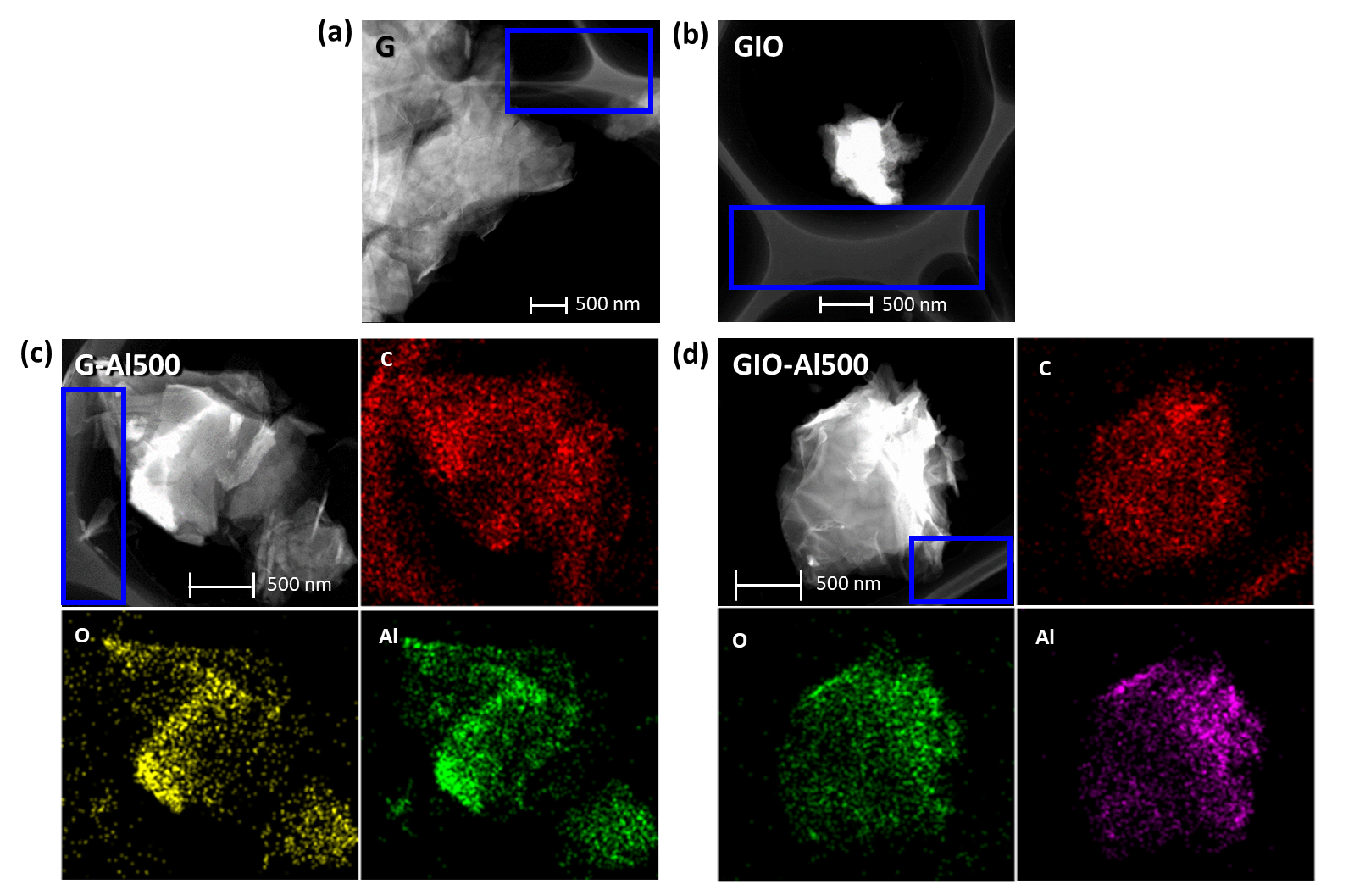
Figure 3. Transmission electron microscopy (TEM) images of (a) G and (b) GIO, and TEM-EDX mappings of (c) G-Al500 and (d) GIO-Al500. Examples of the wall-like structures are indicated in the blue boxes.

Figure 4. (a) Al 2p X-ray photoelectron spectroscopy (XPS) spectra of the prepared samples and curve fitting for the Al 2p XPS spectra of (b) G-Al500, (c) GIO-Al200, (d) GIO-Al500, (e) GO-Al200, and (f) GO-Al500. Al components were conjectured with reference to binding energies reported in the literature summarised in Table S1.

Figure 5. (a) ²⁷Al nuclear magnetic resonance (NMR) spectra of the prepared samples and curve fitting for the ²⁷Al NMR spectra of (b) GIO-Al200, (c) GIO-Al500, (d) GO-Al200, and (e) GO-Al500. Remark: Al[4], Al[5], and Al[6] represent Al in four-, five-, and six-coordination, respectively; Al[6]* refers to Al in six-coordination with lower chemical shift; ²⁷Al NMR of G-Al500 resulted in negligible signals.
Figure 6. Fructose yield and selectivity resulted from the catalytic conversion of glucose over different catalysts for (a) 1 min and (b) 20 min (conditions: 0.5 g glucose and 0.25 g catalyst in 10 ml water or acetone/H₂O (1:1 v/v) at 140 ºC).

Figure 7. Fructose yield as a function of the (a) coordination modes determined by ²⁷Al nuclear magnetic resonance (NMR) spectrum fitting and (b) average pore diameter as well as (c) the two dimensional presentation; (d) fructose yield in relation to the choice of reaction time and media (conditions: 0.5 g glucose and 0.25 g catalyst in 10 ml water or acetone/H₂O (1:1 v/v) at 140 ºC for 1 and 20 min).

Figure 8. Electron spin resonance (ESR) spectra of G-Al500, GIO-Al500, and GO-Al500.
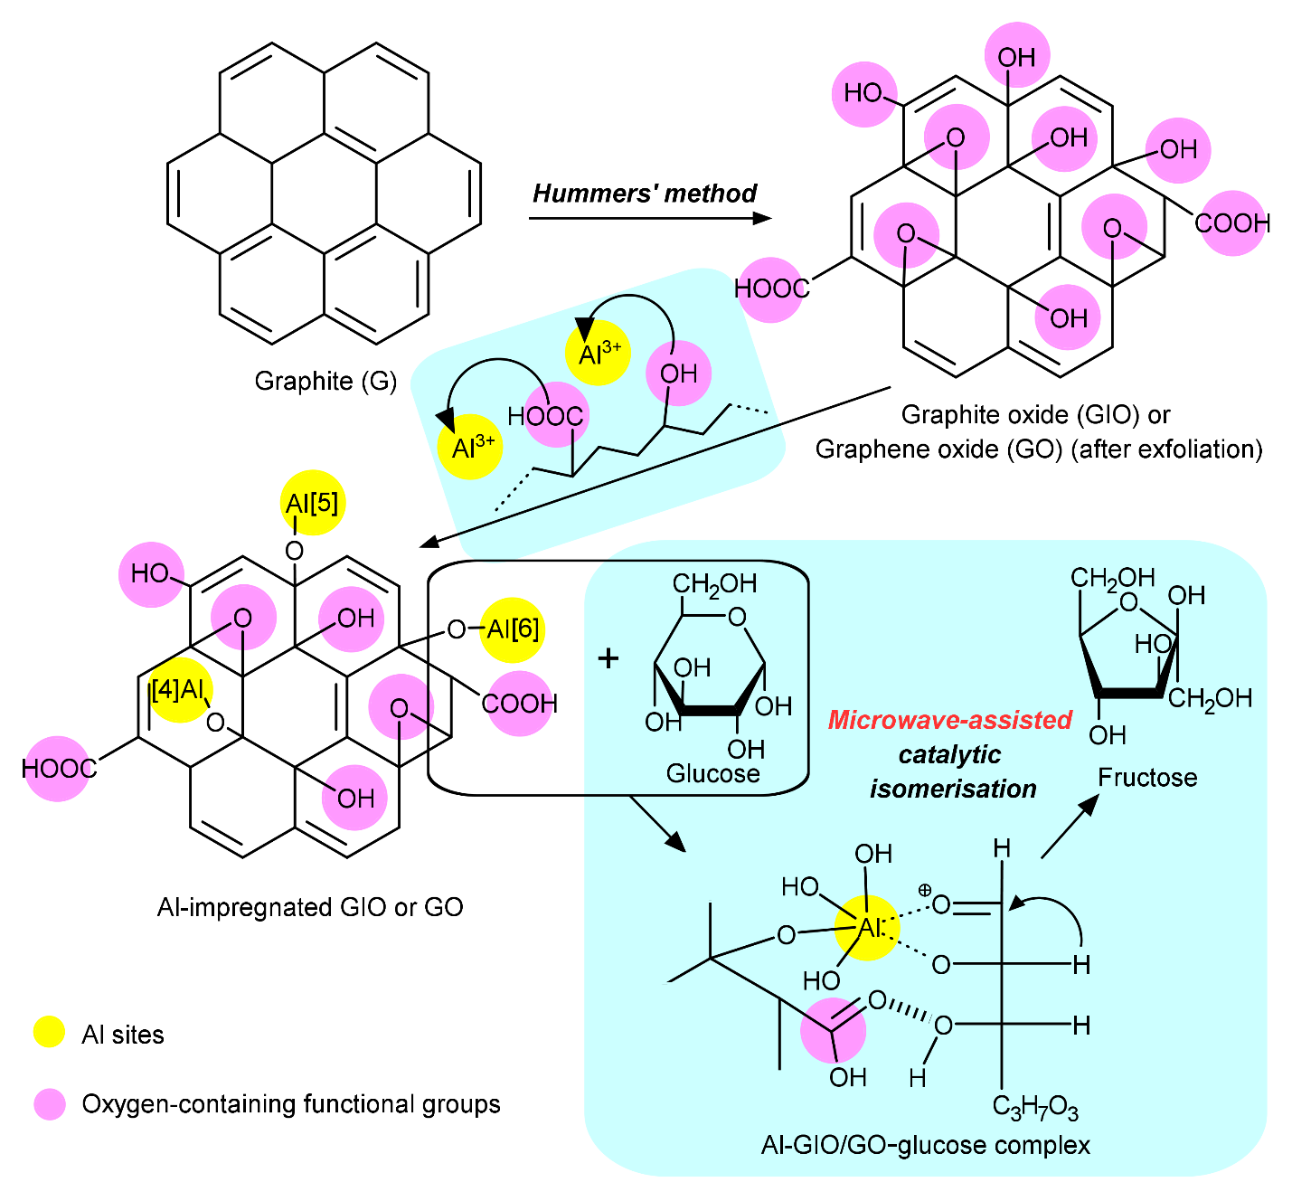
Al Impregnation
Figure 9. Proposed roles of oxygen-containing functional groups during Al impregnation (i.e., facilitating microwave-active Al site formation) and catalytic isomerisation (i.e., promoting adsorption and/or activation of glucose and microwave absorption).

