Solvent applications of short-chain oxymethylene dimethyl ether oligomers
Anna Zhenova,† Alessandro Pellis,† Roxana A. Milescu,† Con Robert McElroy,† Robin J. White*,‡,§ and James H. Clark∗,†
† Green Chemistry Centre of Excellence, Department of Chemistry, University of York, Heslington, York, YO10 5DD, UK; E-mail: james.clark@york.ac.uk; Phone: +44 (0)1904 322559
‡ Fraunhofer Institute for Solar Energy Systems ISE, Heidenhofstr. 2, 79110 Freiburg, Germany
§ TNO (Netherlands Organisation for Applied Scientific Research), Locatie Eindhoven, High Tech Campus 25, 5656 AE Eindhoven, Netherlands; E-mail: robin.white@tno.nl

KEYWORDS solvents, green solvents, polymer dissolution, peroxides, ethers

ABSTRACT Short-chain oxymethylene dimethyl ethers, or OMEs (molecular formula: H₃CO-(CH₂O)_{n}-CH₃, where n = 3-5), have previously been studied as diesel-like fuels and fuel additives. OMEs can be produced from sustainably-sourced methanol, and tests indicate that they are not genotoxic nor mutagenic. In this report, their potential as solvents has been investigated in order to expand the bio-derived solvent space. According to traditional solvatochromic parameters, a commercial mixture of OME₃₋₅ and its individual components (OME₃, OME₄, and OME₅) have solvation properties similar to problematic industrial ether solvents such as 1,4-dioxane. Peroxide formation, one of the chief dangers of classical ether solvents, was found to occur much more slowly in OMEs than in conventional solvents such as tetrahydrofuran (THF), demonstrating an improved safety profile. The commercial OME₃₋₅ mixture was found to be broadly miscible with organic solvents, but immiscible with water, suggesting potential application in aqueous extractions. It performed well in the dissolution of polystyrene and removal of paints and coatings, indicating OME₃₋₅ may suitable to replace dichloromethane (DCM) in polymer recycling, polymer welding, and cleaning applications. To further demonstrate applicability as a solvent, this mixture was shown to facilitate a model Suzuki coupling reaction at rates similar to cyclopentyl methyl ether (CPME), which is currently marketed as a green ether. Finally, OME₃₋₅ proved a suitable solvent for enzymatic polymerization, giving high yields, moderately high degrees of polymerization, and remarkably narrow dispersity values.

INTRODUCTION
Short-chain oxymethylene dimethyl ethers (OMEs; molecular formula: H₃CO-(CH₂O)_{n}-CH₃, with n = 1-6) are a class of synthetic linear oxygenates currently under consideration as sustainable oxygenated fuels, especially as diesel substitutes or additives. Their combustion leads to remarkably low soot and NO_{x} emissions.¹ OMEs can be synthesized from methanol, which in turn can be sourced from biomass-derived syngas or captured CO₂ and renewable H₂, opening pathways for sustainable synthesis of this fuel candidate (Scheme 1).^{1–7}
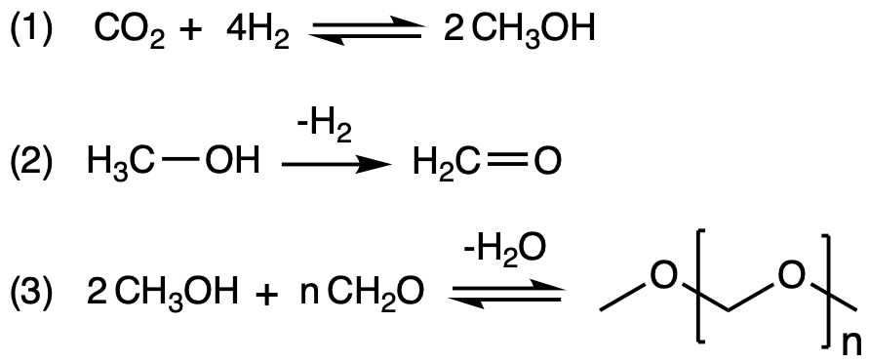
Scheme 1. A generalized synthesis of OMEs based on CO₂ and H₂ (1). Methanol is partially dehydrogenated (2) to provide a mixed methanol/formaldehyde feed, acting as the source for both end caps (3).
In general, OME synthesis produces a mixture of oligomers, with chain length and distribution strongly influenced by the choice of synthetic route. The composition of the OME mixture can therefore be tuned for a specific application, and the chain length distribution can then be narrowed via molecular size reforming.^{3,5,6,8–11} This capacity to tune the composition, and therefore the properties, of an OME mixture is important for designer fuel production and other applications, such as OME solvents. Individual OMEs can be isolated, typically via distillation, but the process is energy-intensive and costly, putting the price of pure OMEs well above the solvent range. A tailored mixture, on the other hand, could potentially be cost-competitive with traditional solvents. For example, White et al. have recently reported the synthesis of OME₃₋₅ from a gaseous formaldehyde/methanol stream.¹² The overall production cost for this process was modeled and estimated to be 951 USD per ton of OME₃₋₅ at a scale of 35 kt per annum, on par with the rough price of acetone (USD 900-1300/ton).¹³
Applications of OMEs outside the fuel sector have not previously been explored in any depth, with the exception of their use as physical sorbents for CO₂.^{2,14} Their wide liquid range, low viscosity (Table 1), and the option to tune the product mixture makes OMEs potential solvents for a number of applications. In addition, the closely related compound OME₁, or methylal, is a well-known, effective solvent used in applications such as aerosols, paints, extraction, synthesis, and many others.¹⁵ Given the potential cost parity of OME₃₋₅ with traditional solvents, its promising physical properties, and the efficacy of OME₁ as a solvent, this study examines the application of this mixture as an alternative ether-like solvent.
Compound | MP  (°C) | BP  (°C) | FP  (°C) | Density (ρ)  (g/cm³, 15°C) | Viscosity (μ)  (cP, 25°C) | Surface Tension (γ)  (mN/m, 20°C)
OME₃ | -43¹⁶ | 156¹⁶ | 20¹⁷ | 1.04¹⁶ | 1.13¹⁷ | 28.8¹⁶
OME₄ | -10¹⁶ | 202¹⁶ | 77¹⁷ | 1.08¹⁶ | 1.88¹⁷ | 30.7¹⁶
OME₅ | 18¹⁶ | 242¹⁶ | 103¹⁷ | 1.11¹⁶ | 2.93¹⁷ | 32.6¹⁶
OME₃₋₅ | -19¹⁸ | 157-259¹ | 70¹⁹ | 1.07¹ | - | 30.7¹⁹
Table 1. Physical properties of OMEs.
FP = flash point.

PREDICTING SOLVENT BEHAVIOR
A commercially available sample of OME₃₋₅ was supplied by ChemCom Industries. GC-FID and GC-MS analysis of this mixture indicated the bulk was composed of OME₃ (43%), OME₄ (24%), OME₅ (10%), and a branched derivative of OME₁ (10%) (Figure 1, Table S1). The rest of the mixture is made up of smaller fractions (<5% each) of longer-chain OMEs and their derivatives, with fractions under 1% not being tabulated. This composition suggests that the OME₃₋₅ mixture will resemble short-chain OMEs (n≤5) in physical properties and solvation abilities. The water content of this batch was found to be 0.12% (±0.04) by Karl Fischer titration.
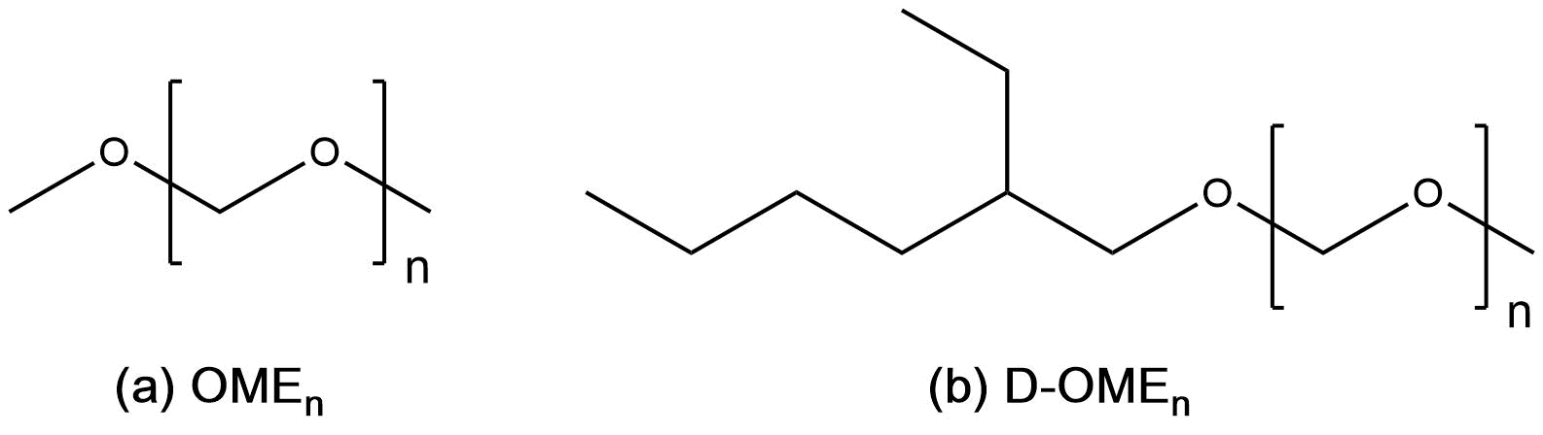
Figure 1. The investigated mixture is composed of predominantly OME₃₋₅ (77%), longer chain OMEs (n > 5) (a); and derivatives (b) of varying chain lengths (10%).
Hansen Solubility Parameters (HSP) are useful predictors of a solvent’s behavior, quantifying three components of intermolecular interaction: dispersion forces (δ_{D}), polarity (δ_{P}), and hydrogen bonding ability (δ_{H}). To identify potential applications of the OME₃₋₅ mixture, its HSP were predicted using HSPiP software.²⁰ The HSP of each component of the mixture were predicted individually, then linearly combined using the proportions determined by GC. Comparing the resulting values with those of conventional solvents indicates which solvents OME₃₋₅ could potentially replace (Table 2). The D-OME value indicates how far each solvent is from OME₃₋₅ in the three-dimensional Hansen space; lower values indicate that OME₃₋₅ may behave like this solvent. The high δ_{P} of OME₃₋₅ suggests it could be considerably more polar than other ether-type solvents, but otherwise its HSP are similar to those of 1,4-dioxane and THF.
Solubility behavior can also be predicted with Kamlet-Abboud-Taft (KAT) parameters, which are measured by using three solvatochromic dyes that probe a solvent’s intermolecular interactions (Figure S1).²¹ The wavelength of maximum absorption for each dye is measured using UV-Vis spectrometry and used to calculate the hydrogen bond acidity (α), hydrogen bond basicity (β), and dipolarity/polarizability (π*). KAT parameters for the OME₃₋₅ mixture were measured and compared with known values for conventional ether solvents (Table 2).^{22,23} Values for ∆-OME indicate how far each solvent is from OME₃₋₅ in the three-dimensional KAT space, giving an experimental predictor of how similar the two solvents are. A lower ∆-OME value suggests more similarity between OME₃₋₅ and the conventional solvent. Notably, the KAT parameters of OME₃₋₅ are nearly identical to those of 1,4-dioxane, suggesting that these two solvents will behave very similarly. In contrast to the computationally-predicted Hansen parameters, the empirical KAT π* value of OME₃₋₅ is in line with those of the other ethers.
Table 2. Hansen solubility parameters and Kamlet-Abboud-Taft solvatochromic parameters for OME₃₋₅ mixture and common ethers.
 | δ_{D} | δ_{P} | δ_{H} | D-OME | α | β | π* | Δ-OME
OME₃₋₅ | 15.6 | 7.1 | 6.1 | 0.0 | 0.00ª | 0.36^{b} | 0.55^{b} | 0.00
1,4-dioxane | 17.5 | 1.8 | 9.0 | 7.1 | 0.00ª | 0.37^{c} | 0.55^{c} | 0.01
THF | 16.8 | 5.7 | 8.0 | 3.3 | 0.00ª | 0.58^{d} | 0.59^{d} | 0.22
2-MeTHF | 16.9 | 5.0 | 4.3 | 3.8 | 0.00ª | 0.58e | 0.53e | 0.22
CPME | 16.7 | 4.3 | 4.3 | 4.0 | 0.00ª | 0.53e | 0.42e | 0.21
Diphenyl ether | 19.4 | 3.4 | 4.0 | 8.7 | 0.00ª | 0.13^{c} | 0.66^{c} | 0.25
Diethyl ether | 14.5 | 2.9 | 4.6 | 5.0 | 0.00ª | 0.47^{c} | 0.27^{c} | 0.44

D-OME = distance from OME₃₋₅ in the Hansen space, Δ-OME = distance from OME₃₋₅ in the KAT space. HSP values were drawn from HSPiP database or predicted by HSPiP. ªAssumed value. ^{b} This work. ^{c} Kamlet et al.²¹ ^{d} Byrne et al.²² ^{e} Jessop et al.²⁴

SAFETY AND STABILITY

In developing new green solvents, safety testing is critical. In the case of OMEs, a number of tests have been performed previously for an OME₂₋₈ mixture, namely OECD 471 (bacterial mutation), OECD 473 (mammalian mutation in vitro), and OECD 474 (mammalian mutation in vivo) (Data provided by industrial partner).²⁵ The results indicate that the OME₂₋₈ mixture is neither genotoxic nor mutagenic, implying that the OME₃₋₅ mixture (a subset of OME₂₋₈) is similarly safe on these endpoints according to CLP criteria. However, further testing will be required going forwarded to further establish the safety of OME mixtures, particularly with respect to toxicity and aquatic toxicity.
Another key safety issue relating to the use of ether solvents is their gradual autoxidation to unstable peroxides, creating an explosion hazard when the solvent evaporates or is otherwise concentrated.²⁶ While the high boiling point of OME₃₋₅ slows evaporation, making peroxide concentration less likely, it is still important to know how quickly peroxides form in the solvent. To this end, the peroxide formation potentials of the individual OMEs (purchased at >99% purity) and the OME₃₋₅ mixture were assessed and compared with other ether solvents. Tetrahydrofuran (THF) was used as an example of a conventional ether, and cyclopentyl methyl ether (CPME) as a solvent which is marketed as a safer ether solvent and ostensibly forms no peroxides.²⁷
In order to assess peroxide formation potential, solvents without peroxide formation inhibitors were exposed to conditions that promote peroxide formation, comprising strong UV radiation and a bubbling stream of air.²² The peroxide concentration was measured at intervals and compared against control samples stored in the dark, and these measurements used to estimate rates of peroxide formation in each solvent (Table 3). The volume of solvent lost to evaporation was <10% for each sample and did not significantly impact the results. Based on these results, it is clear that the OME₃₋₅ mixture forms peroxides far more slowly than THF; indeed, the rate of formation is similar to that of CPME. The bulk of peroxide formation in the OME mixture is likely due to the presence of short-chain OME_{n≤3}, as the longer-chain OMEs form peroxides even more slowly.
Table 3. Peroxide formation test results (mg peroxide/L solvent)
 |  | Time (h)
Solvent | Sample | 0 | 2 | 4 | Rate (mg/L/h)
THF | Control | 10 | 10 | 10 | 0
 | Test | 10 | 30 | 30-100 | 14
CPME | Control | 3 | 3 | 3 | 0
 | Test | 3 | 10 | 10 | 2
OME₃₋₅ | Control | 10 | 10 | 10 | 0
 | Test | 10 | 10 | 10-30 | 3
OME₃ | Control | 3 | 3 | 3 | 0
 | Test | 3 | 3-10 | 10 | 2
OME₄ | Control | 1-3 | 1-3 | 1-3 | 0
 | Test | 1-3 | 3 | 3-10 | 1
OME₅ | Control | <1 | <1 | <1 | 0
 | Test | <1 | 1-3 | 3 | 1

Wang and Shen reported the decomposition of OME₅ at 65°C in the presence of hydrochloric or phosphoric acid, suggesting that the OME₃₋₅ mixture may not be a suitable solvent for acid-catalyzed reactions.²⁸ To confirm this, the OME mixture was exposed to a selection of Brønsted and Lewis acids in low concentrations of 1.0 mol.% and stirred at 50°C (Figure 2). In most cases, the mixture formed a solid mass either immediately or over the course of 72 h stirring. Aluminum chloride gradually formed a cloudy white mixture. Hydrochloric acid showed no obvious reaction at 1.0 mol.%, but at a higher concentration of 20.0 mol.%, it also caused solidification. These results suggest that the various OMEs are acid-labile and are likely not suitable for acid-catalyzed reactions.
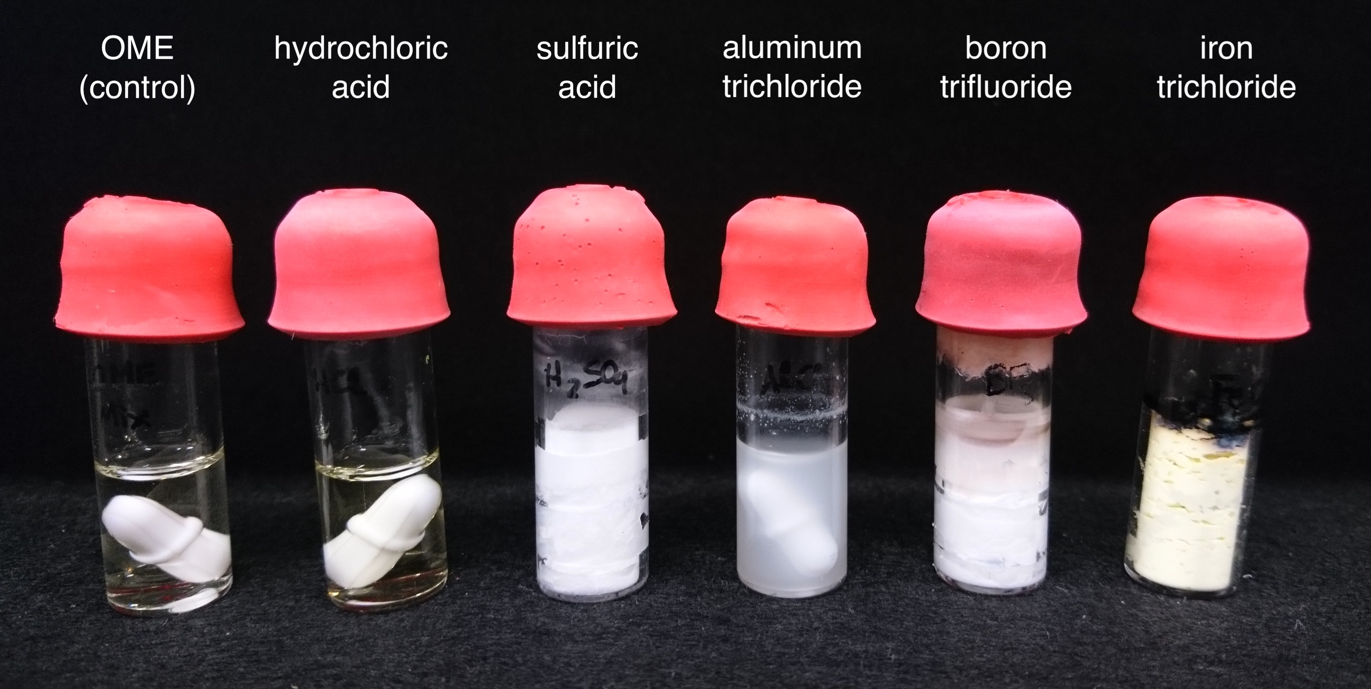
Figure 2. Samples of OME₃₋₅ mixture treated with 1.0 mol% of various acids. Stirrer bars have been left in all vials for consistency, as removal from solidified samples proved impractical.
No data is currently available on base stability, but it is expected that OME₃₋₅, like other ethers, could be cleaved by strong bases.²⁹ This could be a concern for reactions involving organolithium reagents.
Due to the novelty of using OME₃₋₅ as a solvent, its long-term stability and recyclability are not yet known. However, OMEs can be purified via distillation, suggesting that they could also be recycled in this way. For industrial use, it would be valuable to assess thermal stability and recyclability.

ORGANIC REACTION MEDIUM
The miscibility of OME₃₋₅ with a broad range of organic solvents was tested to assess the mixture’s suitability for use in extractions and separations (Table S2). The solvents were considered miscible if they could be mixed in equal proportions at room temperature without turbidity or layer separation. Surprisingly, this sample of OME₃₋₅ was found to be miscible with most organic solvents, the only exceptions being ethanolamine and ethylene glycol. It is, however, immiscible with water, opening potential application possibilities in aqueous extractions and separations.
To demonstrate the applicability of OME₃₋₅ as a solvent for pharmaceutical and fine chemical synthesis, representative Suzuki-Miyaura reactions were performed, monitoring yield directly from the reaction mixture via GC-FID. The palladium-catalyzed coupling of an organohalide with a boronic acid is a cost-effective choice for many laboratories and industries to form C-C bonds (Figure 3).³⁰ It is traditionally performed in solvents such as 1,4-dioxane and THF, making it a good match for the solubility parameters of OME₃₋₅. To test whether OME₃₋₅ is suitable for such reactions, two model coupling reactions were carried out (Figure 3). The first reaction (Figure 3a), which produces biphenyl, is a simple model in that the homocoupling product is identical to the cross-coupling product. The second reaction (Figure 3b) produces diphenylmethane and has two competing homocoupling side reactions which produce biphenyl and dibenzyl. These competing reactions can reduce product yield, and the role of the ether solvent becomes both more complex and more important. For example, CPME is known to outperform traditional ether solvents in this coupling, giving the fastest reaction with the least homocoupling.³¹
The results in OME₃₋₅ were compared against 1,4-dioxane, which is closest to OME₃₋₅ in the KAT space, and CPME, which is considered a safer, more environmentally friendly, and sometimes more effective ether solvent^{27,32}. In reaction 3a), formation of the biphenyl product was promoted equally by all three solvents. Reaction 3b) showed that when homocoupling byproducts compete with the primary cross-coupling product, OME₃₋₅ can promote the reaction more quickly than dioxane, though not as well as CPME. After 24 hours, the product yield was similar in all three solvents, with slight differences in formation of the homocoupling products (Figure S2). Both OME₃₋₅ and CPME formed less biphenyl side product than dioxane, with the preference for dibenzyl being particularly pronounced in OME₃₋₅.
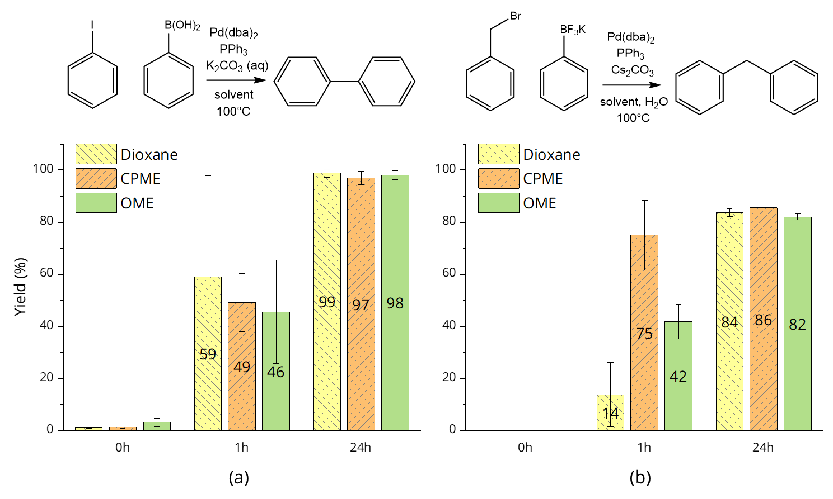
Figure 3. Reaction yields of Suzuki-Miyaura coupling reactions to produce a) biphenyl and b) diphenylmethane in 1,4-dioxane, CPME, and OME₃₋₅ solvents. Yields were calculated via analysis of reaction mixture by GC-FID, and the standard error is given based on three repetitions.
Greener solvents are also in demand for biocatalytic reactions, which are growing in popularity for industrial processes. Recently, studies have compared the performance of solvents such as tetramethyloxolane (TMO) and 2-methyl THF against more traditional choices such as toluene and THF in simple esterification reactions between 1-hexanol and dodecanoic acid³³, as well as between the bulkier 2-phenylpropionic acid and ethanol³⁴ and for the polycondensation of aliphatic and furan-derived bio-based monomers.³⁵ For enzymatic polymerizations, however, the traditional solvent of choice is diphenyl ether (DPE), due to its low volatility at the enzyme’s operational temperature of 85°C and its ability to dissolve a variety of substrates.^{36,37} Due to the similar KAT parameters of OME₃₋₅ and DPE, as well as the high boiling points of OMEs, the OME₃₋₅ mixture was tested as a renewably-sourced solvent for enzymatic polymerization reactions.
A polycondensation (transesterification) reaction was performed with a bio-based diester (dimethyl adipate) and three diols with carbon chain lengths of 4 (1,4-butanediol), 6 (1,6-hexanediol), and 8 (1,8-octanediol) atoms respectively, in order to study the impact of diol chain length on reaction progress. From the ¹H-NMR of the purified products (Figure S3), no major differences were observed between solvents, with all monomer conversions reaching >95% (Figure 4a). These data are in accordance with previous results from reactions carried out without solvent, which show similarly high conversions.³⁸
Significant differences between solvent systems begin to appear when examining the isolated yield of each reaction. Figure 4b compares isolated yields for reactions with diols of various chain lengths in traditional solvent DPE as well as new solvent OME₃₋₅. In all cases, the isolated yields from reactions performed in OME₃₋₅ were significantly higher than those performed in DPE. The yields cannot be compared to solventless reactions, as in a solventless reaction, an easy, one-step work-up with THF is used to recover the polymers.^{39,40} When using high-boiling solvents, a multi-step recovery procedure is necessary. This removes the unreacted monomer and some of the shorter-chain polymers, reducing the apparent yield.
The shortest chain length, C₄, gave the lowest yield by a large margin, with C₆ and C₈ diols giving more than double the isolated yield of C₄. This may be due to the formation of shorter-chain polymer products in this reaction, some of which are partially soluble in the methanol used for washing, or it could be due to the biocatalyst interacting more readily with the more hydrophobic C₆ and C₈ diols.

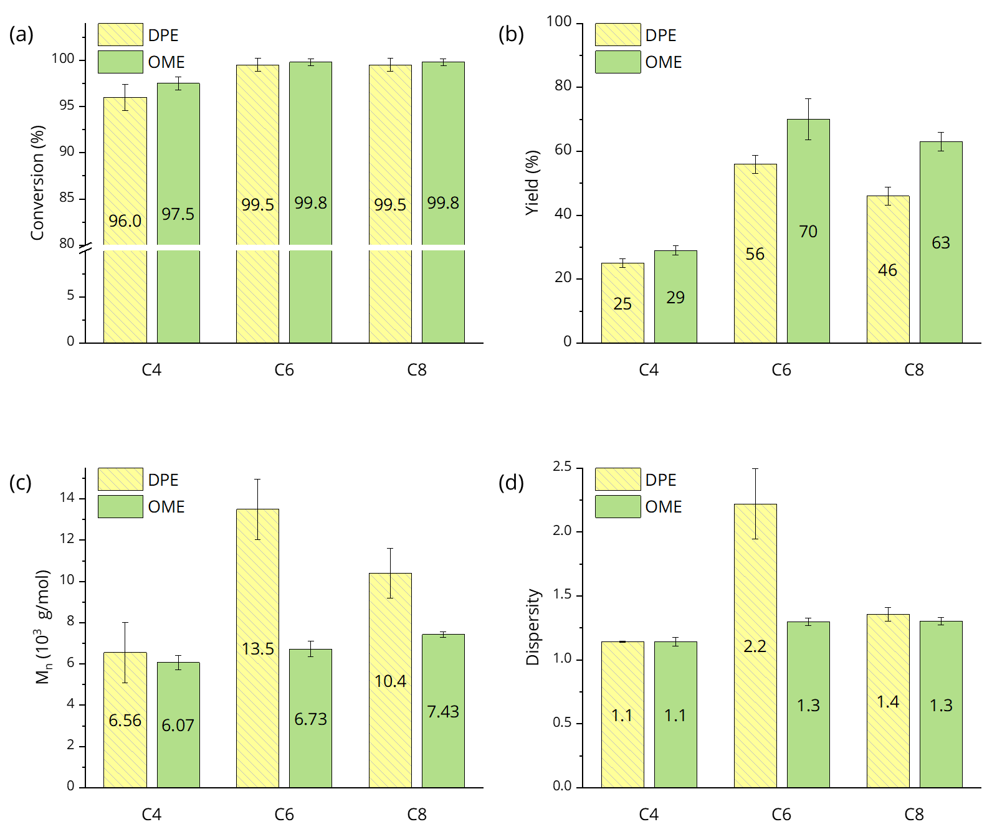
Figure 4. Results of reactions between dimethyl adipate and diols of various chain lengths catalyzed by Candida antarctica lipase B in DPE and OME solvents, showing (a) monomer conversion, (b) isolated yield, (c) number-averaged molecular weight, and (d) polymer dispersity. C₄ = 1,4-butanediol, C₆ = 1,6-hexanediol and C₈ = 1,8-octanediol. Results are presented as average of two independent experiments ± standard deviation.
In solventless reactions, the number-average molecular weights (M_{n}) of the polymers produced have been reported to be in the range of 6500-7500 g·mol⁻¹, depending on the diol used.³⁸ While the OME₃₋₅ reactions in the current study yielded comparable M_{n}, reactions performed in DPE resulted in significantly higher M_{n} for the C₆ and C₈ chain lengths (Table 4, Figure 4c). This indicates that DPE is promoting higher degrees of polymerization, particularly for C₆ diols, where the DPE M_{n} is double that of solventless or OME₃₋₅ polymerization. However, in most cases, the dispersity (Đ) of polymers obtained in OME₃₋₅ is significantly narrower than either the solventless or DPE reactions (Figure 4d), meaning there is less variation in polymer chain length.
Table 4. Comparison between dimethyl adipate reactions carried out in solventless conditions, DPE, or OME₃₋₅.
Diol | M₀ (g mol⁻¹) |  | Solventlessª |  | DPE |  | OME₃₋₅
C₄ | 200.13 | M_{n} (g mol⁻¹)^{b} | 6630 | 6560 |  | 6070
 |  | Đ^{b} | 1.71 | 1.14 |  | 1.14
 |  | DP^{c} | 33 | 30 |  | 30
C₆ | 228.18 | M_{n} (g mol⁻¹)^{b} | 6710 | 13500 |  | 6730
 |  | Đ^{b} | 2.05 | 2.22 |  | 1.30
 |  | DP^{c} | 29 | 59 |  | 29
C₈ | 256.23 | M_{n} (g mol⁻¹)^{b} | 7140 | 10400 |  | 7430
 |  | Đ^{b} | 1.76 | 1.36 |  | 1.30
 |  | DP^{c} | 28 | 41 |  | 29

ª Pellis et al.³⁸ ^{b} Calculated via GPC, calibrating with polystyrene standard and using toluene as a reference ^{c} Calculated by dividing M_{n} by M₀.

It is also worth noting that with the OME₃₋₅ mixture, a 5-10% w/w reduction in solvent was observed over the course of the reaction, while in DPE, <5% w/w loss was detected. This difference can be explained by removal of some of the more volatile OMEs when vacuum is applied to remove the methanol byproduct.
The marked differences between reactions performed in DPE and OME₃₋₅ are likely due to a combination of factors, including enzyme selectivity, solvent and monomer hydrophobicity, solvent geometry, and other solvent properties.⁴¹ The complexity and dynamic nature of the biocatalytic system necessitates detailed molecular modelling studies to elucidate the individual effects of these factors.
In short, enzymatic polymerizations in OME₃₋₅ are possible, and while average molecular weights of the polymers produced in this way are lower, the yields are significantly higher than reactions in DPE. Compared to solventless reactions with adipic acid esters in previous studies,³⁸ OME₃₋₅ gives similar molecular weight and degree of polymerization, but also facilitates a significant reduction in dispersity, producing much more consistent chain lengths. The molecular weight trends with respect to diol chain length in the OME₃₋₅ reactions mirror those found in solventless reactions.³⁸ Polymerizations performed in OME₃₋₅ could be very useful when polyesters with moderately high molecular weights and narrow dispersity are desired.

POLYMER DISSOLUTION
Polymer dissolution and processing with green solvents is also a growing field of interest, with the goal being to reduce the polymer industry’s environmental impact and create healthier, less-damaging polymers.⁴² The OME₃₋₅ mixture was tested as an affordable, bio-derived solvent for processing a variety of polymers at 5% w/v (Figure 5). Polystyrene dissolves readily in this solvent, suggesting potential application as a safer, less volatile replacement for dichloromethane polystyrene extraction and related applications. A higher-volume application could be polystyrene dissolution for recycling, as green solvent systems for this are not yet well developed.⁴³ OME₃₋₅ appears to have no effect on polypropylene, polyethersulfone, or polyvinylpyrrolidone. It shows some interaction with Solvay’s Torlon, which is a polyamide-imide, but does not fully dissolve it.
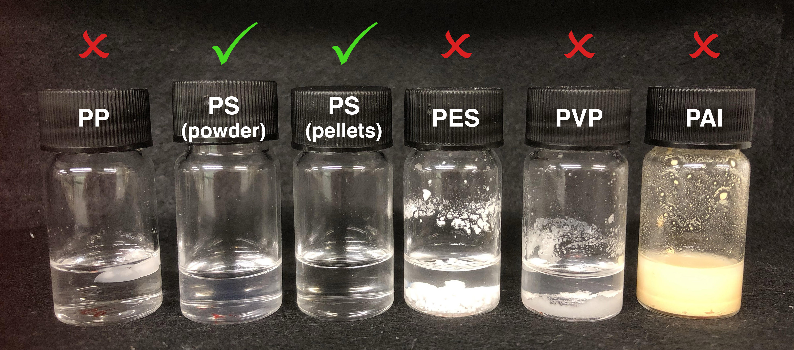
Figure 5. OME₃₋₅ tested in dissolution of various polymers at 5% w/v. Checkmarks indicate full dissolution occurred, while crosses indicate samples with undissolved polymer.
Additionally, OME₃₋₅ was tested for efficacy in removing polymer-based paints from porous ceramic material, simulating its behavior in graffiti removal. In this application, OME₃₋₅ performed quite well for acrylic paint, showing performance similar to that of NMP (Figure 6). For cellulose paint, OME₃₋₅ performed moderately well, leaving some dye behind.
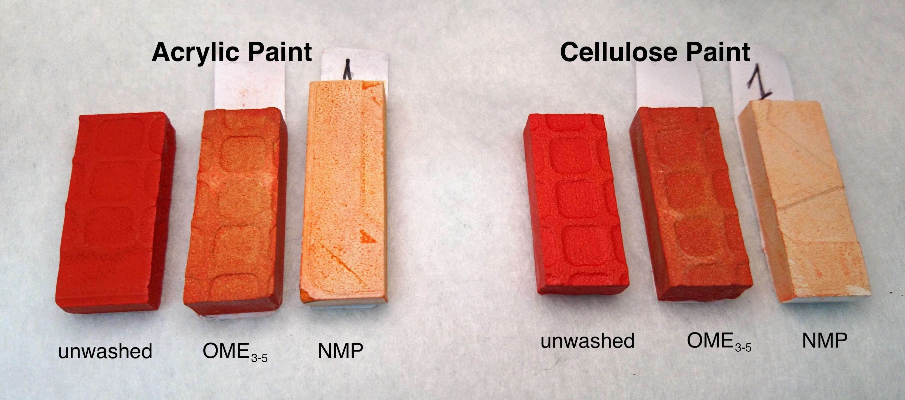
Figure 6. Efficacy of OME₃₋₅ in removing graffiti-like paint. OME₃₋₅-cleaned tiles are shown between uncleaned tiles and tiles cleaned with NMP.

CONCLUSION

In conclusion, a new field of application has been opened for OME₃₋₅ and, by extension, short-chain liquid OMEs in general. The potential of OME₃₋₅ as a solvent has been shown for diverse applications such as pharmaceutical and fine chemical synthesis, biocatalytic reactions, polymer dissolution and processing, and removal of paints and coatings. As reported previously, the OME₃₋₅ mixture can be produced at a cost competitive with traditional solvents, and its use as a solvent could complement the diesel additive applications that are currently being explored, increasing demand and facilitating manufacturing scale-up. Future work remains in studying the toxicity and aquatic toxicity of these solvents, but they appear safe in terms of genotoxicity and mutagenicity. In terms of safe handling, OME₃₋₅ forms peroxides much more slowly than THF. This report demonstrates that OME₃₋₅ should be considered as a new ether solvent for a wide range of products and processes, expanding the palette of bio-based solvent options.

ASSOCIATED CONTENT
Supporting Information.
The following files are available free of charge.
Supporting information (PDF):
Experimental details; Composition of OME mixture; Results of solvent miscibility tests; Solvatochromic dye structures; Suzuki-Miyaura reaction side product formation; Enzymatic polymerization product NMR

AUTHOR INFORMATION

Corresponding Author
* Robin White, TNO (Netherlands Organisation for Applied Scientific Research), Locatie Eindhoven, High Tech Campus 25, 5656 AE Eindhoven, Netherlands; E-mail: robin.white@tno.nl
* James Clark, Green Chemistry Centre of Excellence, Department of Chemistry, University of York, Heslington, York, YO10 5DD, UK; E-mail: james.clark@york.ac.uk; Phone: +44 (0)1904 322559

Author Contributions
The manuscript was written through contributions of all authors. All authors have given approval to the final version of the manuscript.

ACKNOWLEDGMENT
Anna Zhenova acknowledges financial support from GlaxoSmithKline, the University of York Wild Scholarship Fund, and the SCI Scholarship. Alessandro Pellis thanks the FWF Erwin Schrödinger individual fellowship (grant agreement J 4014-N34) for financial support. Robin J. White acknowledges financial support from the Fraunhofer Society and Fraunhofer Institute for Solar Energy Systems ISE through the Attract Award. We thank Richard Gammons for assistance in measuring water content by Karl Fischer titration.

ABBREVIATIONS
OME, oxymethylene dimethyl ether; HSP, Hansen solubility parameters; KAT, Kamlet-Abboud-Taft parameters; CPME, cyclopentyl methyl ether; THF, tetrahydrofuran; NMP, N-methyl-2-pyrrolidinone; DPE, diphenyl ether; DP, degree of polymerization; PAI, polyamide-imide; PES, polyethersulfone; PP, polypropylene; PS, polystyrene; PVP, polyvinylpyrrolidone

REFERENCES
(1) Härtl, M.; Gaukel, K.; Pélerin, D.; Wachtmeister, G. Oxymethylene Ether as Potentially CO2-neutral Fuel for Clean Diesel Engines Part 1: Engine Testing. MTZ Worldwide 2017, 78 (2), 52–59. https://doi.org/10.1007/s38313-016-0163-6.
(2) Niethammer, B.; Wodarz, S.; Betz, M.; Haltenort, P.; Oestreich, D.; Hackbarth, K.; Arnold, U.; Otto, T.; Sauer, J. Alternative Liquid Fuels from Renewable Resources. Chemie Ingenieur Technik 2018, 90 (1–2), 99–112. https://doi.org/10.1002/cite.201700117.
(3) Ouda, M.; Yarce, G.; White, R. J.; Hadrich, M.; Himmel, D.; Schaadt, A.; Klein, H.; Jacob, E.; Krossing, I. Poly(Oxymethylene) Dimethyl Ether Synthesis – a Combined Chemical Equilibrium Investigation towards an Increasingly Efficient and Potentially Sustainable Synthetic Route. React. Chem. Eng. 2017, 2 (1), 50–59. https://doi.org/10.1039/C6RE00145A.
(4) Zhang, X.; Kumar, A.; Arnold, U.; Sauer, J. Biomass-Derived Oxymethylene Ethers as Diesel Additives: A Thermodynamic Analysis. Energy Procedia 2014, 61, 1921–1924. https://doi.org/10.1016/j.egypro.2014.12.242.
(5) Held, M.; Tönges, Y.; Pélerin, D.; Härtl, M.; Wachtmeister, G.; Burger, J. On the Energetic Efficiency of Producing Polyoxymethylene Dimethyl Ethers from CO2 Using Electrical Energy. Energy Environ. Sci. 2019. https://doi.org/10.1039/C8EE02849D.
(6) Peter, A.; Fehr, S. M.; Dybbert, V.; Himmel, D.; Lindner, I.; Jacob, E.; Ouda, M.; Schaadt, A.; White, R. J.; Scherer, H.; et al. Towards a Sustainable Synthesis of Oxymethylene Dimethyl Ether by Homogeneous Catalysis and Uptake of Molecular Formaldehyde. Angewandte Chemie International Edition 2018, 57 (30), 9461–9464. https://doi.org/10.1002/anie.201802247.
(7) Deutz, S.; Bongartz, D.; Heuser, B.; Kätelhön, A.; Langenhorst, L. S.; Omari, A.; Walters, M.; Klankermayer, J.; Leitner, W.; Mitsos, A.; et al. Cleaner Production of Cleaner Fuels: Wind-to-Wheel – Environmental Assessment of CO2-Based Oxymethylene Ether as a Drop-in Fuel. Energy Environ. Sci. 2018, 11 (2), 331–343. https://doi.org/10.1039/C7EE01657C.
(8) Burger, J.; Siegert, M.; Ströfer, E.; Hasse, H. Poly(Oxymethylene) Dimethyl Ethers as Components of Tailored Diesel Fuel: Properties, Synthesis and Purification Concepts. Fuel 2010, 89 (11), 3315–3319. https://doi.org/10.1016/j.fuel.2010.05.014.
(9) Schmitz, N.; Homberg, F.; Berje, J.; Burger, J.; Hasse, H. Chemical Equilibrium of the Synthesis of Poly(Oxymethylene) Dimethyl Ethers from Formaldehyde and Methanol in Aqueous Solutions. Ind. Eng. Chem. Res. 2015, 54 (25), 6409–6417. https://doi.org/10.1021/acs.iecr.5b01148.
(10) Wu, Q.; Wang, M.; Hao, Y.; Li, H.; Zhao, Y.; Jiao, Q. Synthesis of Polyoxymethylene Dimethyl Ethers Catalyzed by Brønsted Acid Ionic Liquids with Alkanesulfonic Acid Groups. Ind. Eng. Chem. Res. 2014, 53 (42), 16254–16260. https://doi.org/10.1021/ie502409t.
(11) Zheng, Y.; Liu, F.; Guo, L.; Wang, T.; Wang, J. Molecular Size Reforming of Undersized and Oversized Polyoxymethylene Dimethyl Ethers. RSC Adv. 2016, 6 (81), 77116–77125. https://doi.org/10.1039/C6RA08255F.
(12) Ouda, M.; Mantei, F.; Hesterwerth, K.; Bargiacchi, E.; Klein, H.; White, R. J. A Hybrid Description and Evaluation of Oxymethylene Dimethyl Ethers Synthesis Based on the Endothermic Dehydrogenation of Methanol. React. Chem. Eng. 2018, 3 (5), 676–695. https://doi.org/10.1039/C8RE00100F.
(13) Independent Chemical Information Services. Chemicals A-Z. ICIS Chemical Market Reporter. August 28, 2006.
(14) Schappals, M.; Breug-Nissen, T.; Langenbach, K.; Burger, J.; Hasse, H. Solubility of Carbon Dioxide in Poly(Oxymethylene) Dimethyl Ethers. J. Chem. Eng. Data 2017, 62 (11), 4027–4031. https://doi.org/10.1021/acs.jced.7b00718.
(15) Carretier, E.; Moulin, P.; Beaujean, M.; Charbit, F. Purification and Dehydration of Methylal by Pervaporation. Journal of Membrane Science 2003, 217 (1), 159–171. https://doi.org/10.1016/S0376-7388(03)00125-X.
(16) Deutsch, D.; Oestreich, D.; Lautenschütz, L.; Haltenort, P.; Arnold, U.; Sauer, J. High Purity Oligomeric Oxymethylene Ethers as Diesel Fuels. Chemie Ingenieur Technik 2017, 89 (4), 486–489. https://doi.org/10.1002/cite.201600158.
(17) Kang, M.-R.; Song, H.-Y.; Jin, F.-X.; Chen, J. Synthesis and Physicochemical Characterization of Polyoxymethylene Dimethyl Ethers. Journal of Fuel Chemistry and Technology 2017, 45 (7), 837–845. https://doi.org/10.1016/S1872-5813(17)30040-3.
(18) Jacob, E.; Maus, W. OME1: A Potentially Sustainable Diesel Fuel; Vienna, 2014; Vol. 35, pp 325–347.
(19) Lautenschütz, L.; Oestreich, D.; Seidenspinner, P.; Arnold, U.; Dinjus, E.; Sauer, J. Physico-Chemical Properties and Fuel Characteristics of Oxymethylene Dialkyl Ethers. Fuel 2016, 173, 129–137. https://doi.org/10.1016/j.fuel.2016.01.060.
(20) Abbott, S. Hansen Solubility Parameters in Practice; 2012.
(21) Kamlet, M. J.; Abboud, J. L. M.; Abraham, M. H.; Taft, R. W. Linear Solvation Energy Relationships. 23. A Comprehensive Collection of the Solvatochromic Parameters, .Pi.*, .Alpha., and .Beta., and Some Methods for Simplifying the Generalized Solvatochromic Equation. J. Org. Chem. 1983, 48 (17), 2877–2887. https://doi.org/10.1021/jo00165a018.
(22) Byrne, F.; Forier, B.; Bossaert, G.; Hoebers, C.; Farmer, T. J.; Clark, J. H.; Hunt, A. J. 2,2,5,5-Tetramethyltetrahydrofuran (TMTHF): A Non-Polar, Non-Peroxide Forming Ether Replacement for Hazardous Hydrocarbon Solvents. Green Chem. 2017, 19 (15), 3671–3678. https://doi.org/10.1039/C7GC01392B.
(23) Sherwood, J.; Bruyn, M. D.; Constantinou, A.; Moity, L.; McElroy, C. R.; Farmer, T. J.; Duncan, T.; Raverty, W.; Hunt, A. J.; Clark, J. H. Dihydrolevoglucosenone (Cyrene) as a Bio-Based Alternative for Dipolar Aprotic Solvents. Chem. Commun. 2014, 50 (68), 9650–9652. https://doi.org/10.1039/C4CC04133J.
(24) Jessop, P. G.; Jessop, D. A.; Fu, D.; Phan, L. Solvatochromic Parameters for Solvents of Interest in Green Chemistry. Green Chem. 2012, 14 (5), 1245–1259. https://doi.org/10.1039/C2GC16670D.
(25) Bastiaensen, E., ChemCom Industries B.V. OME Safety Data, 2019.
(26) Kelly, R. J. Review of Safety Guidelines for Peroxidizable Organic Chemicals. Chemical Health & Safety 1996, 28–36.
(27) Watanabe, K.; Yamagiwa, N.; Torisawa, Y. Cyclopentyl Methyl Ether as a New and Alternative Process Solvent. Org. Process Res. Dev. 2007, 11 (2), 251–258. https://doi.org/10.1021/op0680136.
(28) Wang, H.; Shen, J. Decomposition of Polyoxymethylene Dimethyl Ethers and Synthesis of Bisphenol F. Catalysis Today 2017, 298, 263–268. https://doi.org/10.1016/j.cattod.2017.01.041.
(29) Elschenbroich, C. Organometallics, 5th ed.; John Wiley & Sons, 2016.
(30) Wilson, K. L.; Murray, J.; Jamieson, C.; Watson, A. J. B. Cyrene as a Bio-Based Solvent for the Suzuki–Miyaura Cross-Coupling. Synlett 2018, 14 (5), 650–654. https://doi.org/10.1055/s-0036-1589143.
(31) Molander, G. A.; Elia, M. D. Suzuki-Miyaura Cross-Coupling Reactions of Benzyl Halides with Potassium Aryltrifluoroborates. J Org Chem 2006, 71 (24), 9198–9202. https://doi.org/10.1021/jo061699f.
(32) Prat, D.; Wells, A.; Hayler, J.; Sneddon, H.; McElroy, C. R.; Abou-Shehada, S.; Dunn, P. J. CHEM21 Selection Guide of Classical- and Less Classical-Solvents. Green Chem. 2016, 18 (1), 288–296. https://doi.org/10.1039/C5GC01008J.
(33) Paggiola, G.; Hunt, A. J.; McElroy, C. R.; Sherwood, J.; Clark, J. H. Biocatalysis in Bio-Derived Solvents: An Improved Approach for Medium Optimisation. Green Chem. 2014, 16 (4), 2107–2110. https://doi.org/10.1039/C3GC42526F.
(34) Iemhoff, A.; Sherwood, J.; McElroy, C. R.; Hunt, A. J. Towards Sustainable Kinetic Resolution, a Combination of Bio-Catalysis, Flow Chemistry and Bio-Based Solvents. Green Chem. 2018, 20 (1), 136–140. https://doi.org/10.1039/C7GC03177G.
(35) Pellis, A.; P. Byrne, F.; Sherwood, J.; Vastano, M.; W. Comerford, J.; J. Farmer, T. Safer Bio-Based Solvents to Replace Toluene and Tetrahydrofuran for the Biocatalyzed Synthesis of Polyesters. Green Chemistry 2019, 21 (7), 1686–1694. https://doi.org/10.1039/C8GC03567A.
(36) Jiang, Y.; J. Woortman, A. J.; Ekenstein, G. O. R. A. van; Loos, K. A Biocatalytic Approach towards Sustainable Furanic–Aliphatic Polyesters. Polymer Chemistry 2015, 6 (29), 5198–5211. https://doi.org/10.1039/C5PY00629E.
(37) Pellis, A.; Comerford, J. W.; Weinberger, S.; Guebitz, G. M.; Clark, J. H.; Farmer, T. J. Enzymatic Synthesis of Lignin Derivable Pyridine Based Polyesters for the Substitution of Petroleum Derived Plastics. Nature Communications 2019, 10 (1), 1762. https://doi.org/10.1038/s41467-019-09817-3.
(38) Pellis, A.; Comerford, J. W.; Maneffa, A. J.; Sipponen, M. H.; Clark, J. H.; Farmer, T. J. Elucidating Enzymatic Polymerisations: Chain-Length Selectivity of Candida Antarctica Lipase B towards Various Aliphatic Diols and Dicarboxylic Acid Diesters. European Polymer Journal 2018, 106, 79–84. https://doi.org/10.1016/j.eurpolymj.2018.07.009.
(39) Pellis, A.; Ferrario, V.; Cespugli, M.; Corici, L.; Guarneri, A.; Zartl, B.; Acero, E. H.; Ebert, C.; Guebitz, G. M.; Gardossi, L. Fully Renewable Polyesters via Polycondensation Catalyzed by Thermobifida Cellulosilytica Cutinase 1: An Integrated Approach. Green Chem. 2017, 19 (2), 490–502. https://doi.org/10.1039/C6GC02142E.
(40) Pellis, A.; Vastano, M.; Quartinello, F.; Acero, E. H.; Guebitz, G. M. His-Tag Immobilization of Cutinase 1 From Thermobifida Cellulosilytica for Solvent-Free Synthesis of Polyesters. Biotechnology Journal 2017, 12 (10), 1700322. https://doi.org/10.1002/biot.201700322.
(41) Douka, A.; Vouyiouka, S.; Papaspyridi, L.-M.; Papaspyrides, C. D. A Review on Enzymatic Polymerization to Produce Polycondensation Polymers: The Case of Aliphatic Polyesters, Polyamides and Polyesteramides. Progress in Polymer Science 2018, 79, 1–25. https://doi.org/10.1016/j.progpolymsci.2017.10.001.
(42) Erdmenger, T.; Guerrero-Sanchez, C.; Vitz, J.; Hoogenboom, R.; S. Schubert, U. Recent Developments in the Utilization of Green Solvents in Polymer Chemistry. Chemical Society Reviews 2010, 39 (8), 3317–3333. https://doi.org/10.1039/B909964F.
(43) García, M. T.; Gracia, I.; Duque, G.; Lucas, A. de; Rodríguez, J. F. Study of the Solubility and Stability of Polystyrene Wastes in a Dissolution Recycling Process. Waste Management 2009, 29 (6), 1814–1818. https://doi.org/10.1016/j.wasman.2009.01.001.

For Table of Contents Use Only
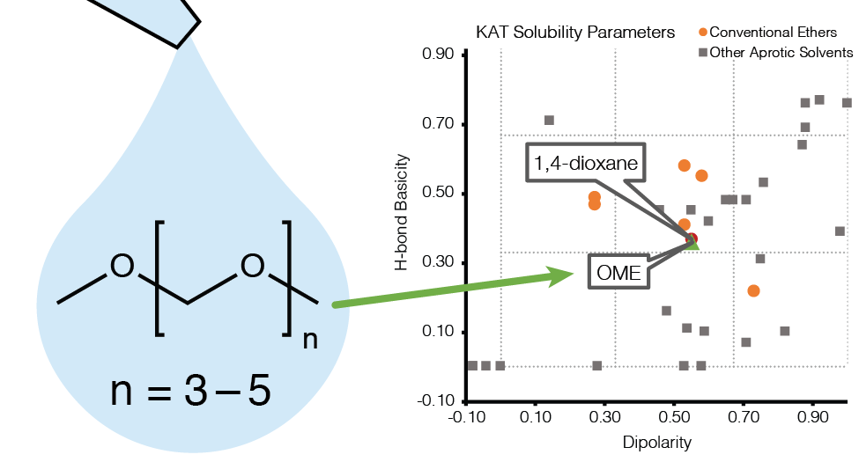
SYNOPSIS Oxymethylene dimethyl ethers present a safer CO₂- or bio-based alternative to 1,4-dioxane and other hazardous ether solvents in various commercially relevant and emerging applications.

