Principles into Policy: assessing the impact of Conservation Principles in local planning policy

Gill Chitty* and Claire Smith
Department of Archaeology, University of York, York, UK
*gill.chitty@york.ac.uk orcid.org/0000-0001-6521-3785

Gill Chitty is Director of Studies for Conservation in the Department of Archaeology, University of York, and Associate Dean in its Faculty of Arts & Humanities. She has worked in the UK heritage conservation sector for over 40 years with national agencies, local authorities and heritage organisations. Before joining the University in 2012, Gill worked as Head of Conservation at the Council for British Archaeology and as a consultant for English Heritage and Cadw.

Claire Smith is undertaking a collaborative, AHRC-funded PhD researching statutory and non-statutory heritage lists in England with the University of York and Historic England. She previously worked as a Listed Buildings Caseworker at the Council for British Archaeology.
Principles into Policy: assessing the impact of Conservation Principles in local planning policy
The arc of policy change in heritage conservation in England - from the 1967 Civic Amenities Act to the National Planning Policy Framework 2018 - spans significant shifts in the underpinning principles supporting conservation policies. While national policies can be interpreted as inflections of changing policy frameworks enacted in international and European arenas, the interplay is complex and causal relationships may be impossible to demonstrate conclusively. This paper takes the instance of English Heritage (now Historic England)’s Conservation Principles, Policies and Guidance for the sustainable management of the historic environment (2008) and considers its international hinterland and its legacy. While it has no formal status in the heritage protection or planning system in England, this research examines its sustained presence in local heritage planning policy. An examination of local heritage strategy documents shows that Conservation Principles, and the body of early 21st-century European and international thought that it reflects, are embedded in current practice in local authority policy-making. This impact is notable, in the context of an English statutory planning and heritage protection system unchanged for 30 years, and attests to the agency of innovative international conservation principles despite the inertia of national heritage reform.
Keywords: conservation; heritage protection; local planning; policy-making; principles;

Introduction
In this paper we engage with the relationship between policy and practice for managing heritage through the planning system in England as it has played out in the first decades of the 21st century. We present a brief retrospective context for current practice, reflecting on the arc of policy change from the 1960s, and a detailed analysis of the ways in which evolution of heritage policy - national and international - is evidenced and embedded in practice in contemporary local planning. As observed at the 2018 AHRC Heritage/Rescue conference that stimulated this volume, much of our practice in the cultural and heritage sectors operates within a system based on policy rather than governed by statutory legislation. Such policies may be national, as set out by Government departments and promoted by government agencies; regionally evolved in local government, within frames set by national bodies; or independently devised to support institutional strategies. In the UK heritage sector, for example, the policies of the National Trust and the National Lottery Heritage Fund have notably played a formative role in shaping policy on public engagement, and for the wider public benefit of working and place-making in heritage, with powerful social and economic outcomes. The global context in which these national policy spheres are situated includes broader currents of policy formation on international platforms notably through UNESCO, the European Union and the Council of Europe. These contextualising frameworks for new principles can be attributed a formative role in policy-making but they also emerge iteratively out of consensus on progressive new thinking aggregated from individual and shared acts of innovative practice and research through, for example, EU Framework programmes like Horizon 2020.
Understanding how the relationship between policy formation and progressive change in practice is enacted in these entangled, iterative and plural relationships is challenging but a critical engagement through case studies, as offered here, can provide a meaningful way to think forward to future approaches. What strategies for policy enactment can we say make effective, lasting and impactful change in local practice? This paper chose the instance of English Heritage (now Historic England)’s Conservation Principles, Policies and Guidance for the sustainable management of the historic environment (2008) as a case study. It is of particular interest because it represented, in the early 2000s, a radical platform for introducing international thinking about understanding heritage and its value for society into a landscape of English heritage policy and legislation that was focused narrowly on protection. It is unique in shaping local heritage practice in this respect and yet has no formal status as policy in statutory heritage protection or the planning system in England. This research examines its presence as a sustained influence in local heritage planning and considers its international hinterland and legacy.
Diffusionist models for policy transfer into practice are clearly over-simplistic. While national policies can sometimes be interpreted as inflections of changing policy frameworks enacted in international and European arenas, the interplay is so much more complex. Direct, causal relationships may be occasionally be acknowledged or evident, but more often they are impossible to demonstrate conclusively or may be simply not exist. For example, one might look for evidence of policy transfer between the Venice Charter (1964) , an internationally adopted canon of ‘principles guiding the preservation and restoration of ancient buildings’, and the introduction in England and Wales three years later of Circular 53/67. This was national government’s policy on the implementation of the 1967 Civic Amenities Act ‘for the protection and improvement of buildings of architectural or historic interest’. Delafons, a contemporary biographer of British preservation politics in the civil service through the 1960s - 1980s, attributes this with introducing a significant ‘shift of emphasis from negative control to creative planning for preservation’ , but he makes no reference to the Venice Charter, suggesting that the drivers lay in the personal interests of Conservative politicians and the model of French zones proteges.
By contrast, Delafons’ narrative of early 1970s heritage policy in England indicates that it was directly reflective of European thinking and a proactive conservation response to the Council of Europe’s Architectural Heritage Year (1975). Government policy Circulars encouraged local authorities to prepare ‘townscape and conservation studies, measures to reduce traffic and parking in architecturally sensitive areas [and] restoration of old buildings’ to contribute ‘to enhancing the national architectural heritage’. The adoption of the European Charter of Architectural Heritage later that year signalled two significant policy shifts in the UK: firstly towards ‘integrated conservation’ - the idea of heritage as ‘a capital of spiritual, cultural, social and economic value’ integrated in ‘the context of people’s lives’. Secondly, and essential to its success, was the principle of ‘the cooperation of all’: citizens being ‘entitled to participate in decisions affecting their environment’ and heritage as a common property for which all are responsible. These phrases prefigure, and indeed ultimately paved the way for, the Council of Europe’s framing of the 2005 (Faro) Convention on the Value of Cultural Heritage for Society thirty years later. The intervening period saw increasing socially-centred valorisation of heritage develop in the values-based approaches that characterised a millennial shift in conservation practice. Emanating from Australia and the USA, in the work of James Semple Kerr (1982 onwards), the ICOMOS Australia Burra Charter (1999), and the research of the Getty Conservation Institute (2000), new discourses of value have become central to internationally established conservation practice.
Contexts for understanding these shifts in international policy and their expression in national and local policy direction are well-researched, theorised and critiqued and, interestingly for this study, also self-documented by the actors of heritage policy change themselves. Fairclough describes the consultative process for English Heritage’s review of government policies in 2000, and the drivers behind the wide-ranging, participative project that resulted in the sector’s Power of Place, and the Government’s responding policy document in Historic Environment: a force for our future (2001). Clark provides an insightful overview of the adoption of values-based approaches to conservation in the UK from an insider perspective, in first the Heritage Lottery Fund and then English Heritage, mapping the incremental sequence of change in policy and practice. Drury accounts for the process of developing Conservation Principles in terms of ‘the need for a consistent and coherent framework for making decisions about managing heritage values’ in English Heritage without resort to ‘ICOMOS Australia’s Burra Charter to fill a perceived gap’. The international lineage of Conservation Principles is openly acknowledged and was, it is said, explicitly designed to follow the ‘general pattern of the Burra Charter and Conservation Plan documents... and the definition of authenticity borrowed from Nara [Document]’. The self-conscious choice of internationally framed, socially inclusive and values-centred approaches is clearly evident.
Planned statutory reform for heritage in England, with the Draft Heritage Protection Bill in 2008, might have embedded some of these changes in approach in new legislation but, while that was not taken forward, Conservation Principles remained in place. It was never adopted as public policy, however, and still has no formal status in the planning system in England. As a guidance document it lacks official weight in policy- or decision-making for local authorities and yet, as this research into local planning strategies aims to demonstrate, Conservation Principles is embedded in current local policy formation. It would appear to have made a lasting and impactful change in practice, evidenced over ten years since its publication, without support from national Government policy, from the short-lived Planning Policy Statement 5 (2010) through to the National Planning Policy Framework (NPPF) in its 2012 and current 2018 iterations.
Looking more closely at the context of drafting Conservation Principles, the messages from the 2008 document about its intentions and purpose are somewhat mixed. The introduction states that it was intended as internal advice for English Heritage staff and to ensure a consistent approach in their casework and policy development, rather than aimed at local planning authorities. This conflicts with aspiration elsewhere for the document to be read and used widely by various actors in the heritage sector, and with Lord Bruce-Lockhart’s foreword which reveals a longer-term hope that Conservation Principles would become a formative component of a ‘progressive framework for managing change in the historic environment’, its success resting on its wider take-up in the sector. How far either of these goals has been achieved has never been evaluated and, after a decade of use and consultation on a revised Conservation Principles document at the end of 2017, it is timely to consider the legacy of Conservation Principles in practice and in particular its relationship to local planning policy.

Method: examining heritage strategies
Conservation Principles has been a popular subject for review in critical heritage studies that, inter alia, highlight its intertextual relationship with many other national and international policy documents and the complexity of interwoven discourses in each fresh policy iteration. Accepting the slipperiness of this intertextual complexity, but looking beyond it to find a meaningful index for evaluating the adoption and impact of this particular document, one approach at the most basic level of analysis would be to enumerate instances of direct references to the document in local planning policies. However, given that it has no formal place in local authority policy or decision-making, this kind of raw quantification would be unlikely to represent its actual impact: local authorities have no need to refer to it. More recent formal guidance covering similar topics, such as Historic England’s Good Practice Advice Note 2: Managing Significance in Decision-Taking in the Historic Environment, would more likely warrant direct reference on the basis of alignment with the NPPF introduced in 2012.
For this research, therefore, the rationale has been to focus on examining how the ‘principles’ section of Conservation Principles, the six key themes providing ‘a comprehensive framework for the sustainable management of the historic environment’, has become embedded in local authority practice. The links sought here are tricky to evidence to the exclusion of other influences, given the intertextual relationships at play and that it was by no means alone in articulating more inclusive, participatory and values-based approaches in UK heritage management. The approach has therefore been to use textual analysis to identify explicit policy positions or verbatim references from which a relationship can be inferred with the Conservation Principles 2008 text. To do this, a sample of heritage strategies from across England was selected for detailed analysis. Heritage strategies are defined in this study as documents produced for, or by, local planning authorities to set out their approach to heritage considerations in their work. Some local authorities (e.g. Isles of Scilly 2004, Stockport 2008 and Torbay 2004 updated 2011) adopted strategies prior to 2012, but the majority were produced in response to the government’s request for local authorities to set out ‘a positive strategy for the conservation and enjoyment of the historic environment’ in the 2012 publication of the NPPF. Most were adopted in the last five years and the sample includes both drafts and formally adopted documents which have weight in supporting a local plan policy, or as a supplementary planning document. Using heritage strategies allows the researcher to interrogate data without involvement in its production, negating potential bias. Strategies, both draft and adopted, give agency to local authorities as organisations, representing the collective and authorised view on heritage from a local management level: its definition, how the management role is perceived, the involvement of other parties and priorities for conservation.
The total pool of local authorities with standalone heritage strategies (i.e. not integrated with a cultural or other strategy) available for sampling was 46 out of 326 local planning authorities (14%). The figure rose to 91 strategies if those combining heritage within a cultural strategy are counted. A sample of 12 was selected from the pool of 46 for in-depth coding using heterogeneity ‘group characteristics’ sampling where characteristics of the local authority area are used to capture variety in local planning authorities, and thereby study the breadth of the national picture. The characteristics used were: geographic location, local authority type (e.g. London borough, district, or unitary); urban to rural as categorised by DEFRA; quality of life, indicated by Indices of Deprivation; and numbers of heritage assets and listed building consents in 2018.
The heritage strategies were examined for direct references, quotes or summaries of Conservation Principles. They were then coded for the first four of the six Conservation Principles:
- The historic environment is a shared resource
- Everyone should be able to participate in sustaining the historic environment
- Understanding the significance of places is vital
- Significant places should be managed to sustain their values
The last two of the six principles – ‘Decisions about change must be reasonable, transparent and consistent’ and ‘Documenting and learning from decisions is essential’ – are fairly generic ones that could be considered basic good practice in local authority planning and these were therefore excluded from the coding. Finally, other features of Conservation Principles were selected from the heritage strategies in an inductive manner, illuminating phrases and processes which were derived from the 2008 guidance. The variety in the strength of links with Conservation Principles, seeming without a geographic or chronological rationale, prompted an investigation into the 46 standalone heritage strategies using text searches for key phrases, retrieving the context of the searches and checking the meaning and relevance of the result. The text searches looked for direct references to Conservation Principles but also matched key phrases from the document to explore how embedded the guidance may or may not have become within local planning practice.

Findings

Local authorities’ definitions of heritage
Analysis of the Heritage Counts data for the 46 local planning authorities with standalone heritage strategies revealed two aspects of interest. Firstly, authorities with both high and low numbers of statutorily-designated heritage assets and listed building consent (LBC) cases produce heritage statements. Secondly, the rationale for creation of a heritage strategy is not led primarily by the need for management of statutorily designated assets, nor is the council’s role in and definition of heritage limited to national designation, as the results below show. A full range of local authorities is represented in the 46, slightly weighted toward those with the lower numbers of designated assets and LBC applications: 15 of the local authorities with strategies had twenty LBC applications or less in 2018; 11 authorities had over 150. This is an important counter to the argument that heritage strategies will tend to be produced by those authorities who have high numbers of designated assets or high levels of development on designated sites. Local authorities with locally designated heritage or non-designated heritage are motivated to create heritage strategies too. Blackpool City Council has only 47 listed buildings, but over 250 heritage assets on the local list, and its heritage strategy seeks to manage local heritage as much as nationally and internationally recognised heritage. This broader interpretation of heritage is entirely consistent with the Conservation Principles approach, which avoids the terms of designation and speaks instead of ‘the heritage significance of a place’, an inclusive concept relevant to all heritage – whether designated or not. In this regard, local planning practice is in closer alignment with Conservation Principles than with the NPPF which is bound by statutory limitations.
Broader definitions of heritage found in local strategies also support the view that they are not designed solely for managing built or material assets. Nottingham’s heritage strategy encompasses social history, myths and legends, traditions and customs and recognises: ‘Much of Nottingham’s heritage is intangible’. Sources for definitions vary. Stroud’s heritage strategy quotes Conservation Principles’s definition of heritage: ‘all inherited resources which people value for reasons beyond mere utility’; it also quotes the International Cultural Tourism Charter, beginning, ‘Heritage is a broad concept and includes the natural as well as the cultural environment.’; Fylde’s resorts to a dictionary definition. What is apparent is that the source is not UK legislation or policy, which does not offer a definition unbound by designation criteria. While some heritage strategies, such as Fylde’s, recognise a broader definition of heritage but explicitly choose to confine the strategy to the built environment in alignment with their statutory planning duties, others are, to varying extents, seeking applicability to a more inclusive, locally-defined meaning of heritage.

Conservation Principles in heritage strategies
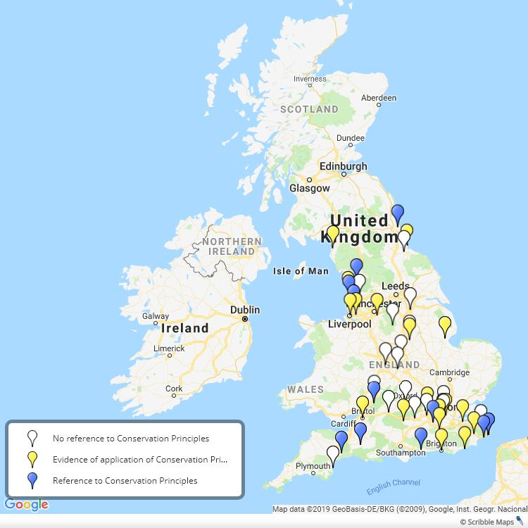
Fig. 1 Distribution map showing the sample of 46 local planning authorities with stand-alone heritage strategies with those referencing Conservation Principles, and those analysed in depth that show some evidence of its application, highlighted.

In the sample of 46 strategies examined, 12 mentioned Conservation Principles directly. However, 39 of these were published after Conservation Principles, meaning 31 percent of the strategies that could have possibly mentioned it, did so: a surprisingly high proportion given that four of those mentioning Conservation Principles were written in 2018 or later – ten years after the publication of Conservation Principles.
It is also notable that heritage strategies which did not directly mention Conservation Principles can be shown to adopt some of its ideas. For example, the phrase ‘shared resource’ from the first principle appeared in five heritage strategies, either referring to heritage or the historic environment. Of these five, Brighton and Hove, Knowsley and Tower Hamlets did not reference Conservation Principles, yet the concept and phrase seems precise enough to assume that Conservation Principles is the source, whether consciously or otherwise. From the in-depth coding, it was noted that Allerdale and Nottingham, neither of which reference Conservation Principles, use multiple phrases that align closely with the principles. For example, Nottingham’s strategy includes, ‘ensuring that people from all generations and communities can contribute to, share in and enjoy a common cultural heritage’; and ‘To manage it effectively we now need to understand its significance’. It is possible, of course, that heritage practitioners have adopted the lexicon and discourse of Conservation Principles without necessarily applying them directly in the local policies. Further in-depth analysis is likely to demonstrate more of this intertextual influence.

Understanding significance
Understanding significance, the third of the principles, appeared in half of the heritage strategies – 23 of the 46 – always in relation, or as a precursor, to successful management. A proximity search, where ‘understanding’ and ‘significance’ appear within five words of each other, was used to capture all relevant phrases; for example, ‘understanding the significance’ or ‘understanding the local heritage significance’. Applying contextual analysis to the text searches for ‘understanding significance’ shows that the idea is often prioritised in heritage strategies, being found as an aim, objective or theme of the heritage strategy and therefore the weight attributed to it should be greater than its numerical count. For example, the first of the five objectives of Stroud’s heritage strategy is understanding; it is also the first key point in the aim of Elmbridge’s document. While there appears to be a strong connection between the third principle and practice, understanding significance is a theme that has developed through several documents prior to the publication of Conservation Principles, and has been advocated in other documents since 2008. It is at the core of Clark’s 2001 publication, Informed Conservation, where the aim of understanding heritage is to define its significance in preparation for managing change. Clark’s guidance document for English Heritage is focused on detailing a management process suitable for working on heritage sites or in development management, and in this practical respect was a forerunner of Conservation Principles. While it may have other antecedents, ‘understanding significance’ is not a phrase used in the NPPF (2018): paragraph 190 requires local authorities to assess the significance of heritage assets affected by planning applications but provides nothing on the process. Neither does Good Practice Advice Note 2: Managing Significance in Decision-Taking in the Historic Environment explain a process for understanding significance, but refers to two sources to provide a method: the first is Conservation Principles and the second is British Standard 7913: 2013 Guide to the Conservation of Historic Buildings. Of these two documents that provide the practical route to assessment of significance, the financial cost of the British Standard document can act as a barrier for some heritage professionals while Conservation Principles is open access and still freely available as a PDF online. Evidencing its widespread use, Conservation Principles is still the third most frequently downloaded document of Historic England’s advice and guidance suite. Conservation Principles is set apart from the Good Practice Advice Note and the NPPF in that it offers a practical process for assessing significance, guiding the practitioner through the rationale for understanding significance and then how to achieve sufficient understanding to underpin management decisions. This process can be found within heritage strategies. Bristol’s heritage strategy, for example, which, again, does not directly reference Conservation Principles, articulates the process of understanding significance and then ‘demonstrating’ or explaining the significance following the Conservation Principles model. This methodology, whether developed directly from Conservation Principles, or through the stream of intertextual exchanges that have foregrounded understanding, found in texts like Informed Conservation, is evidently a useful and practical one which still works in a local authority context. While in the next section we examine the use of the values terms from Conservation Principles, it is perhaps the methodology of understanding significance as a precursor to managing change at heritage sites that is the most vital legacy flowing from Conservation Principles and its precursors.

Conservation Principles values
As noted earlier, values-centred heritage management practice was already well-established in many of the approaches that informed Conservation Principles. In order to identify its distinctive contribution to a values-led approach, analysis focused on the four value groups defined in Conservation Principles: aesthetic, historical, evidential and communal. These differ from the terminology of current legislation, which uses architectural or historic ‘interest’ to define values in listed buildings; and are different again from the NPPF which lists archaeological, architectural, artistic or historic interest as components of significance. They also differ from the Burra Charter’s definition of cultural significance with its grouping of aesthetic, historic, scientific, social or spiritual values. Interestingly, these were cited in two local strategies, with Chichester’s strategy defining cultural significance as per the Burra Charter in its glossary but also separately defining each of Conservation Principles’ four values.
LPA | Aesthetic  value | Evidential value | Communal value
Ashford
Boston |  | 🗶 | 🗶
Chichester
Dover
East Devon
Folkestone and Hythe
Fylde
Hartlepool | 🗶
Lancaster
Medway | 🗶 | 🗶
South Somerset
Table 1 Local planning authorities’ use of the values terms from Conservation Principles. Note that this only counts instances where the word ‘value’ is included.

Setting aside ‘historical value’ temporarily, due to the many related forms of the word historic or historical, the above table shows that, where used, the values terms are often found as a set. This is often in a summary of the four values. The more interesting findings are from the three local authorities where one or two terms are used. In Medway’s strategy, the lexicon of Conservation Principles has been adopted into general criteria for assessing significance for local designation, with ‘communal value’ alongside aesthetic interest, archaeological interest and historic association as possible criteria for local listing. This suggests an intention to provide local recognition for heritage sites with communal value which would otherwise not be afforded protection through the narrower scope of national designation. Boston uses the phrase ‘aesthetic value’ but none of the other value terms, and Hartlepool, which uses ‘evidential’ and ‘communal value’, does not use ‘aesthetic’. These instances might indicate that terms from Conservation Principles are entering common use in the lexicon of conservation practice but equally this may simply be a generic usage, since neither strategy summarises the Conservation Principles values.

There is similar ambivalence in establishing a clear link between usage of ‘historical value’ and Conservation Principles because the words historic or historical are, as can be expected, commonly used in heritage strategies, and because definitions of significance, from the NPPF or Burra Charter for example, also include ‘historic’ or ‘historical’. However, for the sake of completeness, the graph below shows the numbers of local authorities using particular phrases including ‘historical value’ as per Conservation Principles and ‘historic interest’ as per the Planning (Listed Buildings and Conservation Areas) Act and NPPF.

Fig. 2 Graph showing the number of heritage strategies using specific terms which are equivalent to ‘historical value’ in Conservation Principles.

Comparison with NPPF terms

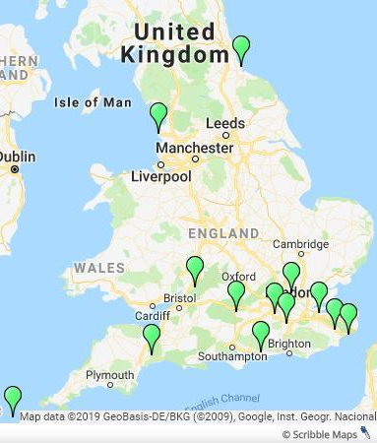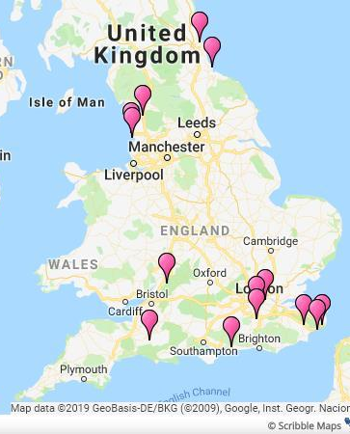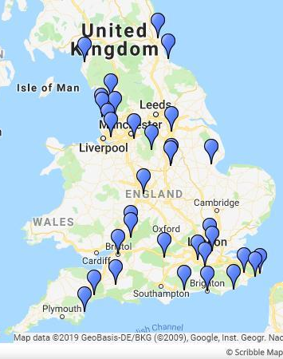
Fig. 3 Distribution maps showing the local planning authorities using the terms ‘archaeological interest’ (green), ‘architectural interest’ (pink) and ‘historic interest’ (blue).

In order to provide a comparative set of data for the value terms, the same method of analysis was applied to the NPPF’s equivalent phrases. It was expected that in strategies published after 2012, the NPPF’s terms would be used much more frequently as adopted strategies would be in alignment with national policy. The 34 strategies that use the phrase ‘historic interest’ includes a significant increase due to legislative quotations and by its general usage. In the summarising table below, the problematic ‘historical/historic value/interest’ phrases have again been left out as they confuse the analytical picture. ‘Archaeological interest’ and ‘architectural interest’ were used in 13 and 14 strategies respectively – a comparable figure to those using Conservation Principles’ phrases – but none of the heritage strategies used the phrase ‘artistic interest’ on its own. The seven strategies depicted on the map list all the interests in the same order as they appear in the NPPF, and are the only ones to use ‘artistic’. This suggests a prioritising of the ‘interests’ with some being seen as less useful or appropriate than others. Conversely, Conservation Principles values are often used equally or as a set.
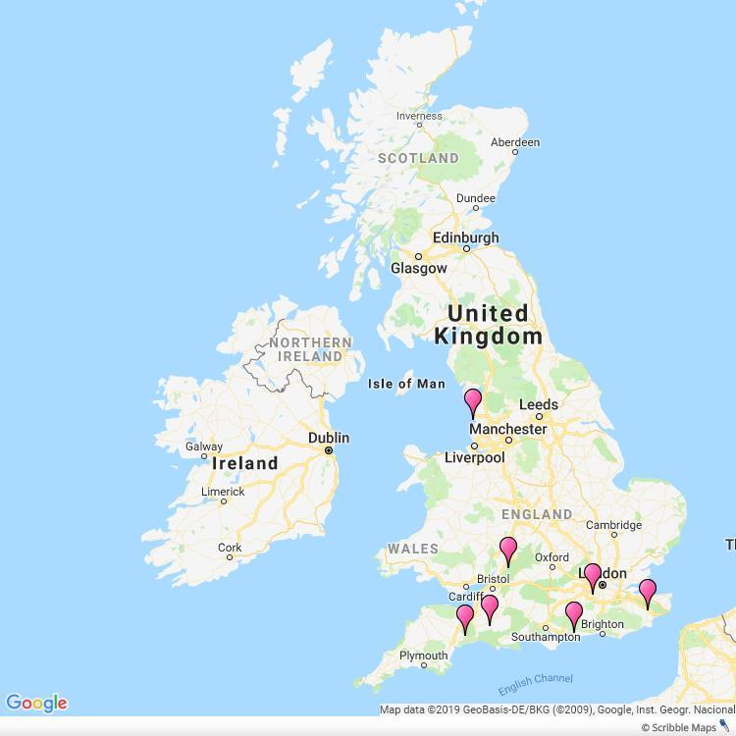
Fig. 4 Distribution map showing the seven local authorities that list the four NPPF terms as a set: Ashford, Chichester, East Devon, Elmbridge, Fylde, South Somerset and Stroud

The 2017 revision of Conservation Principles
The redraft of Conservation Principles which went out to consultation at the end of 2017 battled with the differences between terms in the NPPF and Conservation Principles, with ‘interests’ (NPPF) being chosen over ‘values’ (Conservation Principles) and the description components for articulating significance also being aligned with the NPPF: archaeological, architectural, artistic or historic. While the draft moved toward the NPPF’s terms, it stated that these were just one way of articulating significance keeping the 2008 Conservation Principles words as part of ‘the palette of terms which may be used’, corresponding with the approach of Good Practice Advice Note 2: Managing significance in decision-taking in the historic environment. The ‘palette’ approach is reflected in local practice, as the overlap in local authorities using both Conservation Principles and NPPF terms shows – it is not considered to be a binary choice. However, this research indicates that practice in local planning is to employ the value groupings from Conservation Principles 2008 as often as those from the NPPF: surprising given expectation that current national planning policy would have greater weight in informing contemporary local policy than a guidance document from 2008. When strategies utilise the NPPF’s terms, they do so on a selective basis with ‘artistic interest’ never being used on its own. The redraft of Conservation Principles recognised this weakness in the NPPF terms and grouped architectural and artistic interest together. Arguably the most significant difference with the suggested move from Conservation Principles ‘values’ to the NPPF’s ‘interests’, however, is that there is no equivalent for ‘communal value’.
Interestingly three local heritage strategies use the term, ‘social value’, even though this does not appear in English legislation, policy or guidance. This suggests that at least some local authorities are engaged with recent critiques of heritage values, seeking more relevant meanings of heritage than those provided in national policy, and filling the gap by turning to established international frameworks, just as Drury stated in 2008. Finally, it is worth noting that in 24 of the 46 heritage strategies, these terms did not appear at all: either alternative phrases were used (such as ‘aesthetic significance’) or suggesting that local authorities were not communicating elements of significance in their heritage strategies.

LPA | Aesthetic value | Evidential value | Communal value | Archaeological interest | Architectural interest | Artistic interest | Social value
Ashford | ✔ | ✔ | ✔ | ✔ | ✔ |  | ✔
Boston | ✔
Chichester | ✔ | ✔ | ✔ | ✔ | ✔ |  | ✔
Dover | ✔ | ✔ | ✔ |  | ✔
East Devon | ✔ | ✔ | ✔ | ✔
Folkestone and Hythe | ✔ | ✔ | ✔ | ✔ | ✔
Fylde | ✔ | ✔ | ✔ |  | ✔
Hartlepool |  | ✔ | ✔ | ✔ | ✔
Lancaster | ✔ | ✔ | ✔ |  | ✔
Medway |  |  | ✔ | ✔
South Somerset | ✔ | ✔ | ✔ |  | ✔
Blackpool |  |  |  | ✔
Elmbridge |  |  |  | ✔
Enfield |  |  |  | ✔
Isles of Scilly |  |  |  | ✔
Merton |  |  |  |  | ✔
North Tyneside |  |  |  |  | ✔
Reigate and Banstead |  |  |  | ✔ | ✔
Stroud |  |  |  | ✔ | ✔
Tower Hamlets |  |  |  |  | ✔
West Berkshire |  |  |  | ✔
Allerdale |  |  |  |  |  |  | ✔
Table 2 Local planning authorities’ chosen terms.

Participation: a wider agenda
The final principle considered was ‘Everyone should be able to participate in sustaining the historic environment’. The words ‘participate’ or ‘participation’ alone were not considered to correlate meaningfully to Conservation Principles as participation in heritage has been a theme in many earlier international heritage conservation texts, from the 1975 onwards, through to the production of Power of Place in England in 2000 which emphasised that debate about the historic environment, ‘must not be exclusive; everyone should be able to participate easily’; and continuing with a series of government policies documents where a cross-over with social inclusion and community agendas make participation a recurring theme. At the same time, outside public policy, the Heritage Lottery Fund (now the National Lottery Heritage Fund) and National Trust have enacted successful policies promoting inclusive voluntary participation in the historic environment through grant-giving programmes and volunteering. Recent decades have therefore seen a prevalence of participatory discussion which makes a distinctive discourse from Conservation Principles difficult to discern. For example, an objective from Merton’s heritage strategy is; ‘Enabling everyone, alone or collectively, to benefit from Merton’s cultural heritage, contribute towards its enrichment, and participate in decisions about its future.’ While this is close to the Conservation Principles line, it is not undoubtedly derived from the document.

Conclusion
This research aims to provide insights into the usage of Conservation Principles, as a point of reference and an actively used instrument in local planning policy, in order to understand better what makes impactful and lasting change in heritage practice. It is not about the proportion of local planning authorities in England who have included a reference to Conservation Principles within a local heritage strategy, but about the effective use of the document within local planning policy. What is striking about the findings is that Conservation Principles can, and does, have a quantifiable presence in local policy strategies at all, regardless of the number of instances in which it appears. Given that there is no onus on local planning authorities to draw on Conservation Principles, its existential effect within local planning policy is a remarkable statement of its influence and the weight given to it in heritage conservation practice. While its presence is evident from this analysis of heritage strategy texts, the influence of Conservation Principles’ methodology could be expected to extend further into the daily practice of development planning and management. Further research, for example, examining conservation officer correspondence and interviews with heritage professionals, might illuminate the extent of its influence in development management practice.
Why is Conservation Principles found as underpinning in heritage strategies at all? When asked to identify the key changes in heritage protection over the past ten years, one conservation officer’s comment sums it up as: ‘Conservation Principles. I find that useful.’ Conservation Principles gives heritage practitioners good overarching principles and backs them up with a practical method for assessing significance and a structure for how to manage change. It provides a process that works in practice to guide from a first encounter with a site of unknown heritage significance, to an understanding of how to manage change at that site in an informed and transparent way. That process is arguably the most vital part of its influence, although Conservation Principles is not the sole proponent of those ideas.
The research also investigated the values terms used by Conservation Principles and provided a comparison with the terms to describe ‘interests’ in the NPPF. Findings indicate both are used in roughly equal measure in local policy, and it is questionable why the current national planning policy terms have not overridden the guidance from 2008 and in fact are used with reasonably equivalent frequency. It appears that Conservation Principles endures in use while national policy has changed around it, which potentially points to the need to better understand how it is used in practice and its potential as a model to build on to underpin future public policy.
How and why has Conservation Principles remained resiliently relevant alongside the changing the national policy surrounding it? Part of the answer evidently lies in its usefulness for local practice in heritage management. The other part of the answer appears to be that it is supported by ideologies and an ethos that have developed, been endorsed and sustained over the last three decades, while the English statutory planning and heritage protection system has remained largely unchanged. It attests to the agency of innovative international conservation principles despite the inertia of national heritage reform. Conservation Principles shares, ‘text semantics and thematic continuity’ not only with locally produced policy documents but with the international forebears from which is derives its inspiration, as Waterton, Smith and Campbell discuss in relation to the Burra, Athens and Venice charters. In doing so, Conservation Principles not only connects international thinking directly with English conservation guidance, but allows local authority policy makers to ‘leap the gap’ - to draw upon stable, internationally supported canons and principles in heritage decision-making which are lacking in English national planning policy. The fact that local heritage strategies are still strongly engaged with Conservation Principles for this role, and that it has yet to be superseded by effective further guidance, shows the success of the document: the ‘perceived gap’ in intellectual underpinning for conservation practice that the Burra Charter was filling before 2008 might still exist if Conservation Principles were not fulfilling it.

Bibliography
Australia ICOMOS. The Burra Charter: The Australia ICOMOS Charter for Places of Cultural Significance, 2013. Burwood: Australia ICOMOS, 2013.

Avrami, E., R. Mason, and M. de la Torre. Values and Heritage Conservation. Los Angeles: The Getty Conservation Institute, 2000.

Blackpool Council. “Built heritage strategy 2016 – 2020: a future for the past” Blackpool Council, 2013. https://www.blackpool.gov.uk/Your-Council/The-Council/Documents/Built-Heritage-Strategy-October-2016.pdf

Boston Borough Council. “Heritage Strategy for the Borough of Boston.” Boston Borough Council, 2017. https://moderngov.boston.gov.uk/documents/s5489/Appendix%20A%20-%20Heritage%20Strategy%20for%20the%20Borough%20of%20Boston.pdf

Bristol City Council. “Our inherited city: Bristol heritage framework 2015 – 2018”. Bristol City Council, 2015. https://www.bristol.gov.uk/documents/20182/0/Our+Inherited+City+-+Bristol+Heritage+Framework/d429a15b-ce0f-4048-92a0-da30a9ba9536

Chichester District Council. “Historic Environment Strategy and Action Plan.” Accessed June 7, 2019. http://www.chichester.gov.uk/CHttpHandler.ashx?id=27915&p=0

Clark, K. Informed Conservation: understanding historic buildings and their landscapes for conservation. London: English Heritage, 2001.

Clark, K. “Values-Based Heritage Management and the Heritage Lottery Fund in the UK”, APT Bulletin: The Journal of Preservation Technology, 45:2/3 (2014), 65-71

Council of Europe. 1975. European Charter of the Architectural Heritage. Accessed 10 June 2019. https://www.icomos.org/en/charters-and-texts/179-articles-en-francais/ressources/charters-and-standards/170-european-charter-of-the-architectural-heritage

Council of Europe. 2005. Convention on the Value of Cultural Heritage for Society (Faro Convention). Accessed 10th June 2019. https://www.coe.int/en/web/culture-and-heritage/faro-convention

DCLG. National Planning Policy Framework. London: HMS, 2012; 2018.

De la Torre, M. “Values in Heritage Conservation: A Project of the Getty Conservation Institute”, APT Bulletin: The Journal of Preservation Technology, 45:2/3 (2014), 19-24

DEFRA. 2014. “2011 Rural-Urban Classification of Local Authorities and other geographies” Accessed 3rd June 2019. https://www.gov.uk/government/statistics/2011-rural-urban-classification-of-local-authority-and-other-higher-level-geographies-for-statistical-purposes

Drury, P. “A sense of value.” Conservation Bulletin 60, Spring (2009): 7-10

East Devon District Council. 2019. East Devon Heritage Strategy 2019-2031. Accessed 4th June 2019. http://eastdevon.gov.uk/planning/planning-policy/heritage-strategy-and-draft-local-list-guide/

Emerick, K. Conserving and Managing Ancient Monuments: Heritage, Democracy, and Inclusion. Newcastle: Boydell & Brewer, 2014.

English Heritage. Conservation Principles - Policies and Guidance for the Sustainable Management of the Historic Environment. London: English Heritage, 2008.

English Heritage. Power of Place. London: English Heritage, 2000.

Fairclough, G. “The Roots of England’s culture”, Conservation Bulletin 37 March (2000): 24-25

Fylde Council. “Built heritage strategy for Fylde: 2015 to 2032.” Fylde Council, 2015. http://www4.fylde.gov.uk/heritage-strategy.pdf

Hartlepool Borough Council. “Strategy for the Historic Environment.” Hartlepool Borough Council, 2016. https://www.hartlepool.gov.uk/download/downloads/id/2939/hlp03_21_strategy_for_the_historic_environment_dec_2016pdf.pdf

Historic England. Good Practice Advice Note 2: Managing significance in decision-making in the historic environment. London: Historic England, 2015.

Historic England. 2018. “Heritage Counts” Accessed 30th May 2019 https://historicengland.org.uk/research/heritage-counts/indicator-data/

Historic England. 2018. “Most popular advice and guidance documents” Historic England. Accessed 18th May 2019. https://historicengland.org.uk/advice/find/most-popular/

HM Government. Planning (Listed Buildings and Conservation Areas) Act. London: HMSO 1990.

ICOMOS. International Charter for the Conservation and Restoration of Monuments and Sites (The Venice Charter). Paris: ICOMOS 1964.

Jones, S. “Wrestling with the Social Value of Heritage: Problems, Dilemmas and Opportunities.” Journal of Community Archaeology & Heritage 4 (1): 21–37 (2017).

Merton Council. “Merton Heritage Strategy 2015 – 2020.” Merton Council, 2015. https://www2.merton.gov.uk/merton_heritage_strategy_2015_-_2020.pdf

MHCLG. 2015. “English indices of deprivation 2015” Accessed 3rd June 2019. https://www.gov.uk/government/statistics/english-indices-of-deprivation-2015

Nottingham City Council. “Nottingham Heritage Strategy: a future heritage for the city.” Nottingham City Council, 2015. http://locusconsulting.co.uk/wp-content/uploads/2015/06/Nottingham-Heritage-Strategy.pdf

Orbaşli, A. 2017. “Conservation Theory in the Twenty-First Century: Slow Evolution or a Paradigm Shift?” Journal of Architectural Conservation 23 (3): 157–70.

Patton, M. 2015. Qualitative research and evaluation methods. 4 edn London: Sage. Accessed 29th August 2018. https://www.vlebooks.com/vleweb/Product/Index/952318.

Pendlebury, J. 2013. “Conservation Values, the Authorised Heritage Discourse and the Conservation-Planning Assemblage.” International Journal of Heritage Studies 19 (7): 709–27.

Stroud District Council. “A Heritage Strategy for Stroud District: valuing our historic environment and assets.” Stroud District Council, 2018. https://www.stroud.gov.uk/environment/planning-and-building-control/conservation-listed-buildings-trees-and-hedgerows/a-heritage-strategy-for-stroud-district

Waterton, E. 2010. Politics, Policy and the Discourses of Heritage in Britain. Springer.

Waterton Emma, Laurajane Smith and Gary Campbell. “The Utility of Discourse Analysis to Heritage Studies: The Burra Charter and Social Inclusion”, International Journal of Heritage Studies, 12:4 (2006): 339-355. doi: 10.1080/13527250600727000

. ICOMOS, The Venice Charter
. Delafons, Politics and Preservation, 100, quoting Ministry of Housing and Local Government Circular 53/67
. Delafons, op cit, 95-96.
. Delafons, op cit, 111
. Council of Europe, European Charter of the Architectural Heritage
. Council of Europe, Convention on the Value of Cultural Heritage for Society (Faro Convention)
. Australia ICOMOS, Burra Charter; Kerr, The Conservation Plan; Avrami, Mason, and De la Torre, Values and Heritage Conservation; De la Torre, Values in Heritage Conservation: A project of the Getty Conservation Institute
. Pendlebury, “Conservation values, the authorised heritage discourse and the conservation-planning assemblage”; Orbasli, “Conservation theory in the twenty-first century: slow evolution or a paradigm shift?”, Waterton, Politics, Policy and the Discourses of Heritage in Britain; Waterton, Smith and Campbell, “Utility of Discourse Analysis”, 155.
. Fairclough, Graham, “Roots of England’s culture”
. English Heritage, Power of Place; DCMS, A Force for our Future
. Clark, “Value-based Heritage Management and the Heritage Lottery Fund in the UK”
. Drury, “A Sense of Value”, 8.
. Emerick, Conserving and Managing Ancient Monuments, 186.
. Historic England, Conservation Principles, 13.
. Historic England, Conservation Principles, foreword.
. See for example Pendlebury, “Conservation values, the authorised heritage discourse and the conservation-planning assemblage”; Waterton, Politics, Policy and the Discourses of Heritage in Britain.
. Historic England, Conservation Principles, 7.
. See, for example, Heritage Lottery Fund policies.
. DCLG, National Planning Policy Framework, 30.
. Only heritage strategies available online are included and, given standard local government practice to put documents online for consultation and accessibility, it is expected that the sample captures most current strategies.
. This excludes the City of London heritage strategy and others which act as umbrella strategies for several local planning authorities
. Patton, Qualitative research, 266.
. DEFRA, 2011 Urban-rural classification.
. MHCLG, English indices of deprivation.
. Historic England, Heritage Counts.
. Historic England, Conservation Principles, 7
. Historic England, Heritage Counts.
Additionally, the average number of listed buildings for the 326 local planning authorities in England in 2018 was 1161 while the average for those with heritage strategies was 943.
. Historic England, Heritage Counts
. Blackpool Council, Built Heritage Strategy, 3
. Nottingham City Council, Nottingham Heritage Strategy, 2.
. ibid., 9.
. Stroud District Council, Stroud’s Heritage Strategy, 1.
. Fylde Council, Built Heritage Strategy, 7.
. Fylde Council, Built Heritage Strategy, 7.
. Nottingham City Council, Nottingham Heritage Strategy, 9, 18.
. Clark, Informed Conservation, 7; 8; 12.
. Clark, Informed Conservation, 23.
. Anonymous, pers. comm. 18th February 2019.
. Historic England, Popular Advice and Guidance.
. Bristol City Council, Our Inherited City, 34.
. Planning Act 1990.
. DCLG, National Planning Policy Framework, 71.
. Australia ICOMOS, Burra Charter; cited by Chichester and Liverpool.
. Chichester District Council, Chichester Historic Environment Strategy, 46.
. Boston Borough Council, Heritage Strategy, 9.
. Hartlepool Borough Council, Strategy for Historic Environment, 21.
. Historic England, Conservation Principles draft, 1.
. Historic England, GPA Note 2, 4
. Heritage strategies of Allerdale Borough Council, Ashford Borough Council and Chichester District Council.
. See Jones; “Wresting with the social value of heritage: problems, dilemmas and opportunities”
. Drury “A Sense of Value,” 8.
. Council of Europe, Architectural Heritage Charter
. English Heritage, Power of Place, 4.
. DCMS, The Historic Environment: a force for our future (2001), People and places: a social inclusion policy for the historic environment (2002) and Heritage Protection for the Twenty-first Century (2007).
. Merton Council, Merton Heritage Strategy, 10.
. Anonymous, comment contributed as part of a focus group for PhD research.
. Clark, Informed Conservation.
. Waterton, Smith and Campbell, “Utility of Discourse Analysis”, 344.
. Drury, “A Sense of Value,” 8.

