Pre-Columbian fisheries catch reconstruction for a subtropical estuary in Southern America

Thiago Fossile¹, Jessica Ferreira², Dione da Rocha Bandeira^{3,4}, Levy Figuti⁵, Sérgio Dias-da-Silva¹, Niklas Hausmann⁶, Harry K. Robson⁶, David Orton⁶, André Carlo Colonese⁶

1 Programa de Pós-graduação em Biodiversidade Animal, Universidade Federal de Santa Maria, Av. Roraima, 1000, Camobi, Santa Maria, 97105-900, Rio Grande do Sul, Brazil
2 Depto de Ciências Biológicas - Meio Ambiente e Biodiversidade, Universidade da Região de Joinville, Rua Paulo Malschitzki 10, Zona Industrial Norte, 89219-710, Joinville, Santa Catarina, Brazil.
3 Museu Arqueológico de Sambaqui de Joinville, Rua Dona Francisca 600, Centro, 89201-220, Joinville, Santa Catarina, Brazil
4 Universidade da Região de Joinville, Programa em Patrimônio Cultural e Sociedade, Rua Paulo Malschitzki 10, Zona Industrial Norte, 89219-710, Joinville, Santa Catarina, Brazil.
5 Museu de Arqueologia e Etnologia da Universidade de São Paulo, Av. Prof. Almeida Prado, 1466, São Paulo, Brasil
6 BioArCh, Department of Archaeology, University of York, York, YO10 5DD, United Kingdom

Abstract: Small-scale fisheries provide food and livelihoods for thousands of people along the Brazilian coastline. However, considerable uncertainties still surround the extent to which artisanal and subsistence fisheries contribute to the total of national landings and their historical ecological significance. Fisheries monitoring is deficient in Brazil and historical records are limited to irregular accounts spanning the last few decades, while this coastline has supported human populations for at least 6000 years. Here, we estimate Pre-Columbian subsistence catches for a large subtropical estuary in southern Brazil. Our results suggest that prehistoric populations may have extracted volumes of fish biomass higher or comparable to historical subsistence fisheries in the region, and that the latter are underestimated. If a long-term perspective is required to evaluate the current economic value and status of fisheries in subtropical and tropical South America, this should go beyond the historical time interval and integrate the contribution of Pre-Columbian archaeology.

Keywords: Atlantic Forest; Archaeology; shell mounds; subsistence fisheries; fisheries catch reconstructions

1. Introduction
Small-scale fisheries (artisanal and subsistence (D. Pauly & Zeller, 2015)) are crucial sources of food and livelihoods for million people in Latin America (Salas, Chuenpagdee, Charles, & Seijo, 2011), many of which live in rural areas and use ecological knowledge that are deeply rooted in the past (Begossi et al., 2017; A. Diegues, 1997; A. C. Diegues, 2006; Silvano & Begossi, 2012). Brazil has one the world’s longest coastlines (ca. 7,491 km), with some of the most diverse biomes on earth (the Amazon and the Atlantic Forests), and a variety of human populations that depend on coastal ecosystems for food (Vasconcellos, Diegues, & Kalikoski, 2011). Small-scale fisheries currently account for ca. 50% of the total freshwater and marine landings in the country (de Melo Alves Damasio, Lopes, Guariento, & Carvalho, 2015; Vasconcellos et al., 2011), but the numbers were even higher (>80%) before fiscal incentives to the industrial sector became commonplace after 1967 (A. C. Diegues, 2006). Nevertheless, considerable uncertainties still surround the extent to which artisanal and subsistence fisheries exploited coastal resources in historical times, which prevents a full recognition of the status of marine ecosystems (Jackson et al., 2001; Pinnegar & Engelhard, 2008) as well as the economic and cultural sectors themselves (Elfes et al., 2014). Fisheries monitoring is historically deficient in this region, limited to irregular and geographically scattered statistics spanning the last few decades (Bender et al., 2014; de Melo Alves Damasio et al., 2015; Elfes et al., 2014; Kátia M. F. Freire & Pauly, 2010). Moreover, this coastline has supported human populations for at least 6000 years, through fishing, hunting and harvesting of estuarine and marine environments (Bastos et al., 2015; Colonese et al., 2014; M. D. Gaspar, 1998; Lima et al., 2004). Recent studies reveal that Pre-Columbian populations of the Atlantic Forest coastal zone potentially overexploited key taxonomic groups, causing a population decline (Lopes et al., 2016), but the scale of this exploitation remains a matter of debate.

Anthropogenic impact on marine ecosystems is unarguably one of the most pressing issues in marine conservation (Pinsky, Jensen, Ricard, & Palumbi, 2011; Roberts, 2010; Worm et al., 2009). There is a growing consensus that our understanding of this process is historically distorted (Daniel Pauly & Zeller, 2016), biased towards statistical records that fail to integrate a broad range of fishing practices (D. Pauly, 1995; Zeller & Pauly, 2018), and the legacy of longstanding human use of aquatic environments in most parts of the world (Jackson et al., 2001; Pinnegar & Engelhard, 2008). Fish and shellfish remains from archaeological contexts can offer valuable qualitative and quantitative information for reconstructing the scale of human exploitation of aquatic resources in the past, notably throughout prehistory (Erlandson & Rick, 2008; Jackson et al., 2001; Lotze & Worm, 2009; McKechnie et al., 2014; Plank, Allen, Nims, & Ladefoged, 2018). This is particularly true for South America, where historical records span the last 500 years. Yet there has been little attempt to integrate zooarchaeological research with contemporary debates in conservation biology in Brazil (Lopes et al., 2016; Silva, Pádua, Souza, & Duarte, 2017; Souza, Fernandes, & Silva, 2003; Souza, Lima, Duarte, & Silva, 2016).

Here, we report the results of the taxonomic analysis of fish remains from Cubatão I, an archaeological shell mound in Babitonga Bay (Santa Catarina state). The results demonstrate that numerous taxa were exploited, and provide snapshots of ecological niches used by coastal groups during a time interval of ca. 150 years, between ca. 2460-2310 and 2310-2090 cal BP. Babitonga Bay has the highest concentration of Pre-Columbian shell mounds and middens of the entire Brazilian coastline (>170 sites), many of which have been previously radiocarbon dated. Following recent catch reconstruction approaches (K. M. F. Freire et al., 2015; Daniel Pauly & Zeller, 2016; Zeller & Pauly, 2018), we used the density of fish remains from Cubatão I and the total volume of sites in this region to derive conservative estimates of minimum fish catches in Babitonga Bay over a period of ca. 6000 years. This approach, which conceptually does not differ from generic estimates used on modern fisheries statistics (Orton, Morris, & Pipe, 2017; Stamatopoulos, 2002), reveals annual Pre-Columbian fisheries catches similar or higher than local historical estimates for subsistence fisheries of the second half of the 20th century. Our results suggest that the widely overlooked historical subsistence fisheries catches along the Brazilian coastline since 1950s are likely underestimated.

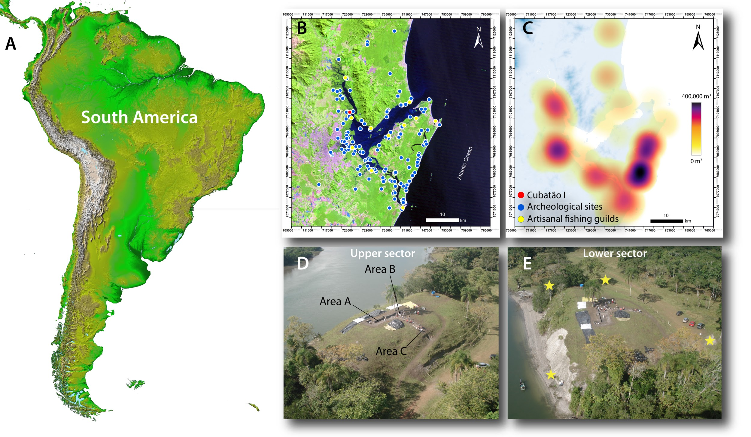
Figure 1. (A) Location of Babitonga Bay in southern Brazil; (B) location of Cubatão I along with other shell mounds and middens, and modern artisanal fishing guilds (Colônias de pesca) in Babitonga Bay; (C) heat map of volume of sites (m³) showing site clusters, which may represent fishing communities; (D) overview of Cubatão I showing the upper sector and specific areas (A, B and C) that were analysed in this study, and (E) the lower sector, showing the erosion of the archaeological deposits by fluvial activity. Yellow stars represent areas where radiocarbon dates in the lower sector were obtained.

1.2. Pre-Columbian coastal exploitation in Babitonga Bay
Babitonga Bay (ca. 130 km²), on the northeast coast of Santa Catarina state (26º 07’W and 26º 27’S), drains an area of ca. 1.567 km² (Vieira, Horn Filho, Custodio Bonetti, & Bonetti, 2008), and is surrounded by dense subtropical forests, restinga vegetation and the highest mangrove ecosystem in southern Brazil (Gerhardinger et al., 2018; Knie, 2002; Vieira et al., 2008). Thousands of archaeological shell mounds and middens, also known as sambaquis, have been recorded along the Brazilian coast (Wagner, Hilbert, Bandeira, Tenório, & Okumura, 2011) demonstrating a reliance of aquatic resource procurement. They are associated with sedentary or semi-sedentary foragers and horticulturalists that exploited a variety of fish and shellfish in the context of everyday lifeways and mortuary practices (e.g. funerary feasting) since at least 6000 years ago (De Blasis, Fish, Gaspar, & Fish, 1998; M. Gaspar, DeBlasis, Fish, & Fish, 2008; Souza et al., 2016; Wagner et al., 2011). Fish, in particular, was the prevailing source of dietary protein at several sites from the Middle to Late Holocene (Bastos, Lessa, Rodrigues-Carvalho, Tykot, & Santos, 2014; Pezo-Lanfranco et al., 2018). Babitonga Bay witnesses the introduction of ceramics at ca. 1,500 cal BP by groups associated with the ceramic tradition Taquara/Itarare. This time interval coincided with the widespread use of domestic crops (Verônica Wesolowski, Ferraz Mendonça de Souza, Reinhard, & Ceccantini, 2010), but faunal remains (Dione R. Bandeira, 1992; Dione Rocha Bandeira, 2004) and bone collagen stable isotope analyses (Bastos et al., 2014; Pezo-Lanfranco et al., 2018) indisputably demonstrate that aquatic resources continued to be the dominant source of dietary protein. The longstanding history of subsistence fishing persisted in the area with the European colonisation and urbanisation of Babitonga Bay, which nowadays is home to several artisanal fishing guilds (Colônias de pesca), some of which are in areas previously occupied by sambaquis (Fig. 1B).

Cubatão I, located in a tributary of the Palmital River, is ca. 10 m high by ca. 80 m in length, and has been the subject of systematic archaeological excavations between 2007 and 2009 (D. da R. Bandeira, Oliveira, & Santos, 2009; L. Figuti, 2009; Venera & Severino, 2010) (Fig. 1B-E). Excavations on the upper sector of the site (ca. 54.7 m²) encountered two main archaeological deposits: Deposit 1 was ca. 20-30 cm deep and contained both prehistoric and historical remains, and Deposit 2 was an underlying sedimentary context rich in bivalve shells (notably Anomalocardia flexuosa), vertebrate faunal remains, artefacts (stone and bone tools) and numerous human burials (n = 21 individuals). Deposit 2 was excavated to a depth of ca. 80 cm and has been radiocarbon dated from ca. 2430 ± 40 to 2660 ± 40 yr BP (Supplementary information 1). More recently, fluvial erosion due to changes in land management, has progressively affected the NE perimeter of the site exposing a stratigraphic sequence of ca. 8 m (Fig. 1D). At the base of the sequence, several well-preserved plant artefacts were found in waterlogged conditions, including baskets, nets, ropes, knots made of aerial roots of Philodendron sp. (Peixe, de Melo Junior, & da Rocha Bandeira, 2007; Sá, 2015) and wooden artefacts made from a variety of taxa (Melo Júnior, Silveira, & Bandeira, 2016). The lowermost sedimentary record in the exposed stratigraphic sequence (lower sector) has been radiocarbon dated between ca. 2975 ± 30 and 3110 ± 70 yr BP. Archaeological deposits at the perimeter of the site are relatively contemporaneous with the dated plant remains, with radiocarbon dates ranging from ca. 2890 ± 70 to 3480 ± 60 yr BP.

2. Materials and methods
2.1. Chronological model for the Pre-Columbian occupation of Babitonga Bay
The time and duration of Pre-Columbian occupation of Cubatão I and the whole Babitonga Bay was modelled using 106 radiocarbon (¹⁴C) dates assembled from the literature, generated on a range of archaeological materials (marine shells, human and faunal bones, and charcoal, Supplementary information 1 and 2). The radiocarbon dates were calibrated (BP) using OxCal v. 4.3 (Ramsey, 2009). Charcoal samples were calibrated using the 100% atmospheric calibration curve for the southern hemisphere, SHCal13 (Hogg et al., 2013); shells were calibrated using the 100% Marine13 curve (Reimer et al., 2013), applying an estimated average local marine radiocarbon reservoir correction value (ΔR) of 23 ± 52 according to (Angulo, de Souza, Reimer, & Sasaoka, 2008); http://calib.org/marine/). Radiocarbon dates on human bone collagen samples were calibrated using a combination of the marine (Marine13) and terrestrial curves (SHCal13), taking into account the relative contribution of marine carbon to collagen according to (Pezo-Lanfranco et al., 2018) and the same ΔR value reported above. A threshold of 60% (agreement index, A_{model}) was used to assess the agreement between the calibrated (likelihoods) and modelled dates (probability distributions) (Ramsey, 1995, 2009). A single uniform phase of all calibrated dates for Babitonga Bay was used to summarise the marginal probability distributions (SPD) (Ramsey, 2017).

2.2. Fish composition and relative abundance
Faunal remains were recovered from Deposits 1 and 2, in areas A (ca. 3 m²), B (ca. 2.3 m²) and C (ca. 1 m²) (Fig. 1C), from bulk sediments via dry and wet sieving over a 1 and 0.5 cm mesh (L. Figuti, 2009). Area A and B contained several human burials, the fills of some were analysed for their faunal compositions. These included burial 9, an adult male (area A); burial 2, a child whose sex could not be determined; burial 5, an adult woman; burial 11, a old woman in area B (L. Figuti, 2009). Some of the recovered faunal remains from these deposits may be associated with mortuary practices (Daniela Klokler, 2014b).

The faunal remains were identified through side-by-side comparison with the reference collections house at the Museu Arqueológico de Sambaqui de Joinville and via specialised literature (Helfman, Collette, Facey, & Bowen, 2009; Homberger & Walker, 1994; Lagler, Bardach, Miller, & Dora, 1977; Lepiksaar, 1994; Liem, 2001; Moyle & Cech, 2004; Radu, 2005). The nomenclature followed the World Register of Marine Species (http://www.marinespecies.org/index.php), while the ecological and trophic level (TL) attributions were obtained via FishBase (http://www.fishbase.org/). Both fish and mammal remains were quantified by the number of identified specimens (NISP) and minimum number of individuals (MNI). The identifications were based on a combination of cranial and postcranial elements such as lower and upper jaws (articular, dentary, and premaxilla), olfactory region (prevomer), mandibular arches (quadrate), orbital or otic regions (cranial fragments), occipital region, cranial appendix (otolith), pectoral and fin skeleton, mesethmoid and caudal vertebrae. Considering the problems of quantifying elasmobranchs, a minimum number of 60 vertebrae per individual was considered (Torben C. Rick, Erlandson, Glassow, & Moss, 2002), and in the case of rays, their teeth (Berkovitz & Shellis, 2017) were used to calculate the MNI. Fish density values (MNI/m³), a proxy for deposition and consumption rate, were estimated for all three areas. Taphonomical features such as fragmentation, exposure to heat and butchering marks were also recorded. The faunal remains were quantified and registered in the software Archaeobones version 2.2 (Claudio Ricken, 2015; C. Ricken, Silva, & Malabarba, 2012). Shannon diversity index (H) was used to explore taxonomic diversity using the abundance and evenness of taxa within archaeological spits. Correspondence Analysis (CA) was employed to infer exploited habitats and environmental conditions from taxonomic composition, abundance and frequency of fish remains through the stratigraphy of areas A, B and C. Statistical analyses were performed using PAST 3.06 (Hammer, Harper, & Ryan, 2001) and C2 data analysis 1.4.2 (Juggins, 2007).

2.3. Estimating catches
A bottom-up approach was used to derive the total catches (t) for the Pre-Columbian fisheries in Babitonga Bay. First, the minimum fish density value for Cubatão I (MNI/m³) was adopted as a reference for extrapolating values from other sites. This assumption is supported by previous studies obtaining similar density values from other sites in Babitonga Bay (see below). Two methods were then used to convert the MNI/m³ to fish wet-weight/m³: (1) archaeological otolith metrics (Supplementary information 1), and (2) a modern survey of fish populations in Babitonga Bay.

First, complete whitemouth croaker (Micropogonias furnieri) otoliths (right/left MNI = 37), from areas A, B and C, were measured to estimate their maximum lengths (OL) according to previous studies (Bervian, Fontoura, & Haimovici, 2006; Lopes et al., 2016; Waessle, Lasta, & Favero, 2003). In short, otoliths were measured using a Zeiss Stemi 200 magnifier with a Dino-Eye coupled camera, and DinoCapture software (University of the Region of Joinville). Some specimens (>13 mm) were measured with a digital caliper, and then cross-calibrated with the above stereomicroscope. Individual OL values were converted into total fish lengths (T. Length) using the following equation reported in (Lopes et al., 2016):

(Eq. 1) T. Length (mm) = 24.342 + 22.570 OL (mm) (r = 0.98; n = 93)

Modern otoliths (n = 31) from the teleostean fish otoliths collection of the Oceanographic Institute of the University of São Paulo (Rossi-Wongtschowski et al., 2016) were also measured to derive the relationship between OL and fish wet-weight. Otoliths were measured using a Zeiss Discovery V12 magnifier coupled with a AxioCam camera, and the AxioVision 4.8 software calibrated for individual measurements and a digital caliper. Some specimens (>11 mm) were measured with a digital caliper, and then cross-calibrated with the above stereomicroscope. The OL (mm) and fish wet-weight (g) of modern otoliths show a strong covariation (98% of variance) that is better explained as a potential regression model (Eq. 2):

(Eq. 2) Mass (g) = 0.1011OL (mm)^{3.0422} (R² = 0.98; n = 31)

Eq 2 is statistically similar (p = 0.468, t = 0.8388) to regressions reported for whitemouth croaker from estuaries in southern South America (Waessle et al., 2003). The maximum total length of archaeological whitemouth croaker at Cubatão I corresponded to an average fish wet-weight of 334 ± 289 g.

The otolith metric based-estimates was in good agreement with the average fish wet-weight reported by (L. O. Santos, 2009) for Babitonga Bay. The average value (232 ± 1361 g) was obtained from a variety of Actinopterygii (n = 74) and Elasmobranchii (n = 2) captured by bottom trawling during two months of each season of the year, so seasonal changes in fish productivity and spawning are factored into the average value. The survey-based value was then used for each individual specimen (MNI) from Cubatão I as the minimum average wet-weight.

The volume (Vm³) of 127 sites was calculated using the following equation for spherical cap:

(Eq. 3) Vm³ = 1/6πh(3r² + h²)

where h corresponds to height and r, the estimated radius at the base of the site (Supplementary information 1). The aggregated fisheries catches for all the sites was then estimated according to a generic formula:

(Eq. 4) Catch (t) = fish wet-weight/m³ * aggregated volume of sites (m³)

Finally, the results were compared with estimated historical subsistence catches (t/years⁻¹) for the coast of Santa Catarina state, based on non-monetary marine fish acquisition (K. M. F. Freire et al., 2015):

(Eq. 5) Total consumption (freshwater and marine) = number of registered fishers * fecundity rate (+2) * consumption per capita

and

(Eq. 6) Subsistence catch (marine) = total consumption * proportion of non-commercial ‘fish’ acquisition

where (+2) represents a fisher and the partner

The number of officially registered fisherers (professional and artisanal) was obtained for the period from 1950 to 1969 (IBGE 1950-1971) when the majority of fishing along the Brazilian coast was small-scale in nature (A. C. Diegues, 2006). The fecundity rate by decade for the region (south) was used to estimate the number of individuals by family. We used values reported in (K. M. F. Freire et al., 2015) for 1950 (5.7) and 1960 (5.9). Consumption per capita (3.1 kg/year⁻¹) was also taken from (K. M. F. Freire et al., 2015) for this time interval. For the proportion of non-commercial fish we considered the percentage of marine fish obtained through donation, removal from the business or own production, using data from 2002 (23.3% of non-commercial marine fish) for southern Brazil reported by the Household Budget Survey (Pesquisa de Orçamentos Familiares, IBGE) (Supplementary information 1).

As for other historical reconstructions and contemporary fisheries statistics (Engelhard et al., 2016; Zeller & Pauly, 2018), our estimates are based on a number of assumptions, and are inevitably affected by sampling and taphonomic biases. It assumes that the minimum density value at Cubatão I (MNI/m³) can be conservatively expected for all sites in Babitonga Bay. This assumption is supported by similar density values reported for other sites in the region (Dione R. Bandeira, 1992; Dione Rocha Bandeira, 2004). It is worth noting that higher density values were recorded at Cubatão I (Area B and C, see below), and others have estimated much higher fish density values for sambaquis in southern Brazil. For example, at the site of Jabuticabeira II, (D. Klokler, 2008) estimated fish density values ranging from 1000 to 16000 MNI/m³, corresponding to fish wet-weight/m³ ranging from 13.2 to 1267 kg/m³. Using otolith metrics she estimated fish wet-weight/m³ ranging from ca. 112 to 275 kg/m³. These figures are significantly higher than the conservative value used in this study (97 MNI/m³; 22.5 kg/m³). Equally important, we assume that variations in the composition of fish at some sites in Babitonga Bay has no impact on the average wet-weight of fish. This is substantiated by otolith metric data from Cubatão I, as well as from other sites along the Atlantic Forest coast (Daniela Klokler, 2016b; Lopes et al., 2016) containing captures with average wet-weight much larger than the average used in our reconstructions (Daniela Klokler, 2016b; Lopes et al., 2016). One must also consider that our estimates are limited to visible and relatively well-preserved sites that survived the widespread historical exploitation of sambaquis for lime production until the late 1960’s (the number of demolished sites is currently unknown). Many sites used in this study have been partially destroyed since historical times (Oliveira, 2000, unpublished master dissertation), or suffered post-deposition physical deformations (Holdaway et al., 2017). Consequently, the original volume of sites must have been higher in the past. Finally, it is reasonable to assume that fish were also consumed and discarded elsewhere, in contexts that are absent in our records (e.g. acquisition and residential sites). We are therefore confident that our estimates are highly conservative and represent minimum values of catches.

3. Results
3.1. Age and duration of pre-Columbian fisheries at Babitonga Bay
The Bayesian model for Cubatão I showed good agreement with the spatial and stratigraphic expectation of the dates (A_{model} 65.8; Fig. 2) and placed the earliest phase of the site (lower sector) between ca. 3520-3070 and 3170-2730 cal BP (95% probability). The chronological interval of the excavated fraction of Deposit 2 (upper sector) was modelled between ca. 2460-2310 and 2310-2090 cal BP (95% probability), with an estimated median duration of 150 years for this deposit. The apparent chronological gap between the lower and upper phases is possibly due to a lack of radiocarbon dates for the stratigraphic deposits connecting both sectors; there is no evidence for a hiatus in occupation. The model estimates that Cubatão I was formed over an interval of ca. 740-1330 (95% probability) years, and most likely ca. 910-1160 (68% probability) years, with a median of ca. 1040 years. During this interval the site reached a volume of ca. 29,009 m³, which conservatively corresponds to a median accumulation rate of ca. 27.9 m³/year⁻¹.

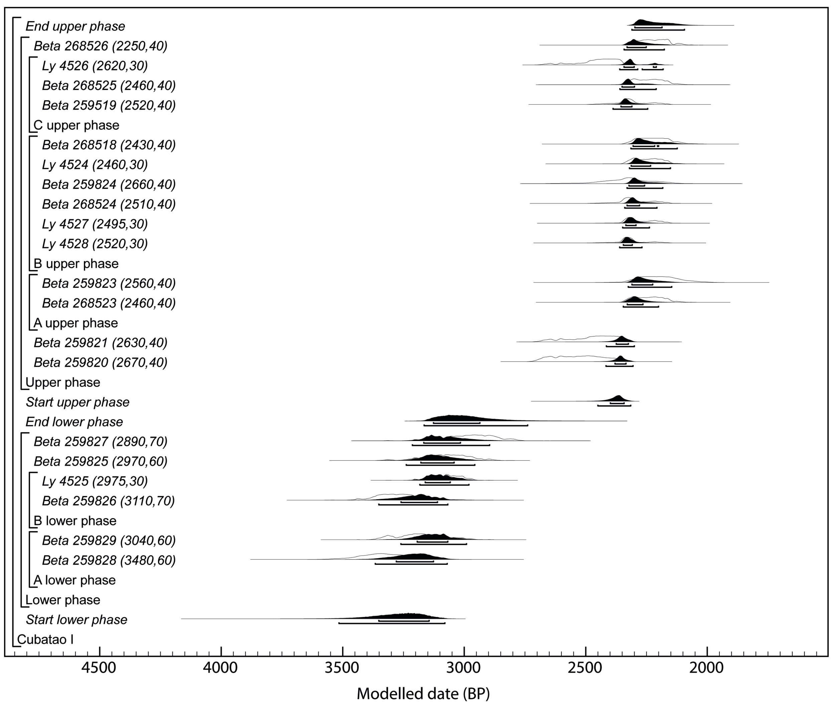
Figure 2. Probability distributions of radiocarbon dates from the lower and upper sectors of Cubatão I.

The chronological model for Babitonga Bay produced a good agreement with the distribution of radiocarbon dates by site (A_{model} 102.6), placing the start of Pre-Columbian fisheries in the region of ca. 6530-6140 cal BP (95% probability). From this time, numerous sambaquis were formed along the estuary and the adjacent coastal area until ca. 730-500 cal BP (95% probability), corresponding with a time interval of ca. 5690 years (median). The model also reveals that sambaquis and ceramic producing groups cohabited the region for a period of ca. 670-1170 years (95% probability). The earliest evidence of Taquara/Itarare ceramics was chronologically modelled to ca. 1770-1350 cal BP (95% probability), and extended until ca. 620-200 cal BP (95% probability). The median estimate for duration of the Pre-Columbian coastal occupation at Babitonga Bay was ca. 5850 years, during which a variety of sites ranging from ca. 7 m³ to 400,868 m³ were formed, corresponding to an aggregated volume of ca. 3,252,673 m³ (Fig. 3).

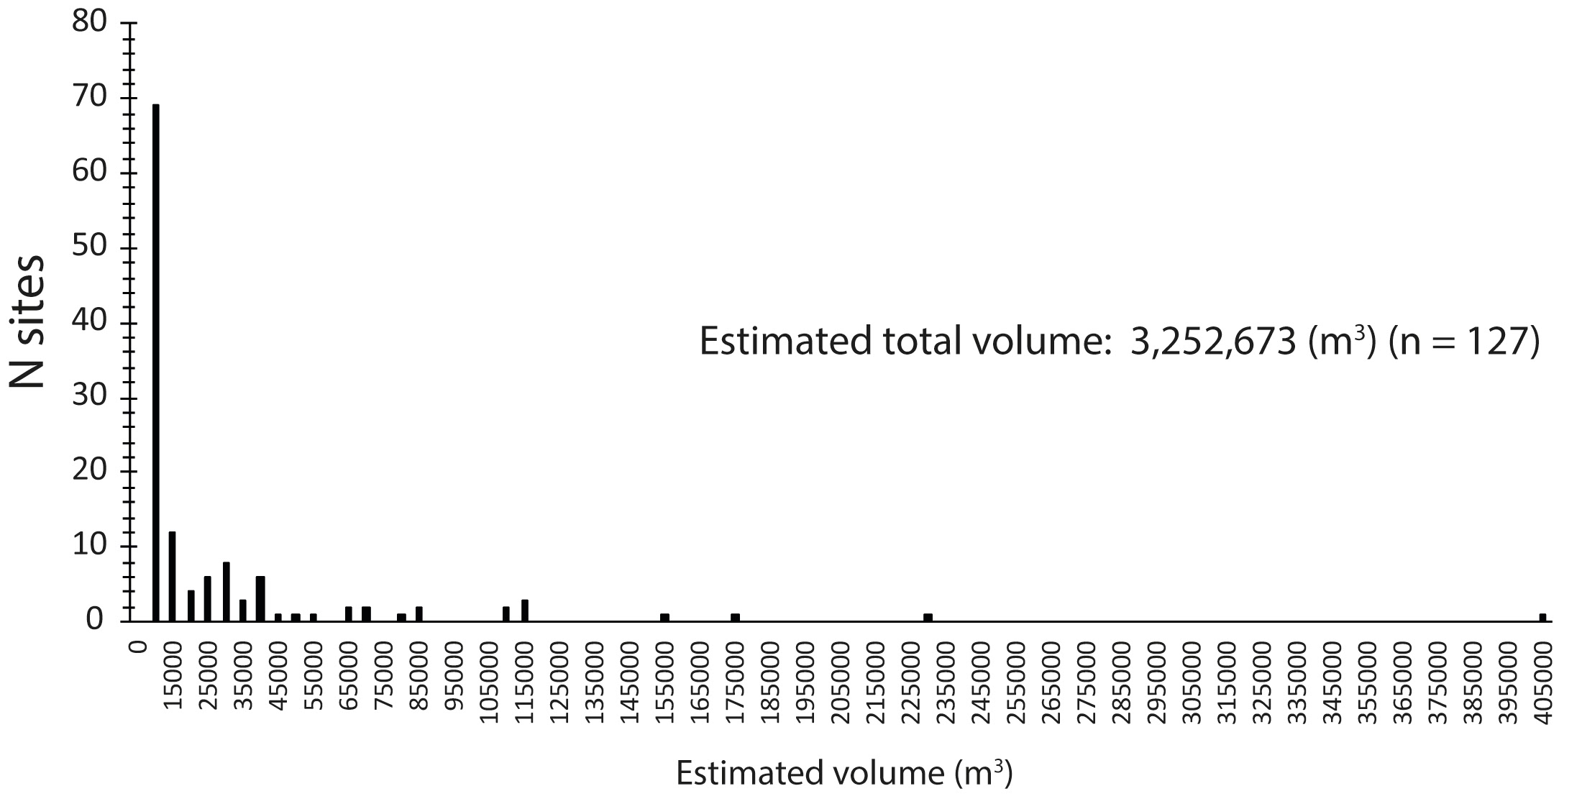
Figure 3. Estimated volume of Pre-Columbian shell mounds and middens in Babitonga Bay.

3.2. Fish remains from Cubatão I
A total of 5186 faunal remains were analysed from areas A, B and C (Fig. 4A-C), as well as the fills from the inhumation burials of 2, 9, 5 and 11. Of these, 99.8% of the remains were identified as fish with the remainder (0.2%) corresponding to terrestrial mammals (Supplementary information 3). The fish remains were dominated by postcranial elements with few diagnostic traits (67.7%), followed by cranial (22.6%) and undetermined fragments (9.7%). Therefore, the majority of the remains could not be identified beyond the class/sub-class level (Actinopterygii, 60%). Moreover, the lack of a complete reference collection coupled with the high fish diversity in this region (Reis et al., 2016) made identifications of postcranial elements problematic. Nevertheless, a total of 38 taxa indicating a minimum of 22 species and 19 families of fish were identified. Terrestrial mammals were scarcely represented by phalanges of tayassuidae (NISP = 6) and incisors of rodents (NISP = 2), all recovered from the superficial Deposit 1.

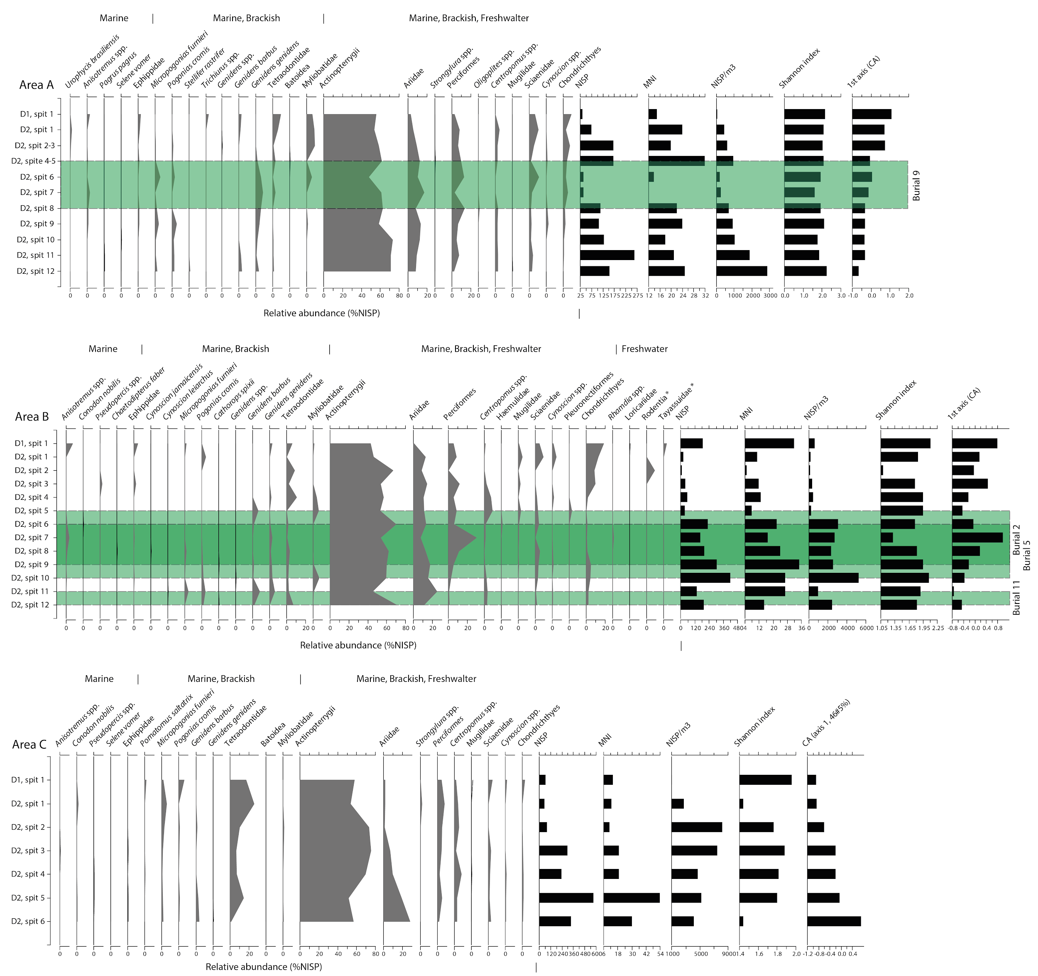
Figure 4. Relative abundance of marine and terrestrial faunal remains*, including their density for the volume of sediment, species diversity and the environmental gradient represented by first axis of the correspondence analysis for areas A, B and C. The green bands indicate the stratigraphic position of human burials in the areas.

A total of 4994 specimens were recovered from areas A (NISP = 1308), B (NISP = 2029) and C (NISP = 1657), of which 1332 were found in deposits containing human burials in areas A (burial 9, NISP = 272), and B (burial 5, NISP = 445; burial 11, NISP = 322; burial 2, NISP = 293). A further 192 specimens were directly associated with burials 11 (NISP = 183) and 9 (NISP = 9), but they lacked stratigraphic control. In the three areas the majority of the identified fish belonged to Ariidae (catfishes; up to 37% area B), Tetraodontidae (pufferfishes; up to 25%, area C) and Sciaenidae (drums, croakers; up to 17%); the remainder (21%) could not be identified to the species or genus levels. Fish density values (MNI/m³) were 97 for area A, 167 for area B and 471 for area C. Previous studies in Babitonga Bay (i.e. at Enseada I, Bupeva II and Itacoara) have obtained similar fish density values to those of area A (Dione R. Bandeira, 1992; Dione Rocha Bandeira, 2004).

Identifiable faunal remains from burials 2, 5, 9, 11 were dominated by Ariidae (15% NISP), Perciformes (7% NISP), and others (Supplementary information 3). In general, trophic level values were similar between areas A, B and C and human burials, ranging from 2.0 (Mugilidae, grey mullets) to a maximum of 4.9 (Chondrichthyes), without substantial changes throughout the stratigraphy. However, both areas A and B show stratigraphic differences in the abundance and density values, as well as in the taxonomic composition of the fish assemblages that roughly corresponded with funerary events. For example, in both areas there was a decrease in the abundance of Ariidae from the bottom to the uppermost part of Deposit 2, which corresponded with an increase of Tetraodontidae, Myliobatidae (sting rays) and Chondrichthyes. In Area A, burial 9 was identified from spit 8 to 4 (in stratigraphic order), where a decrease in fish abundance was observed (Fig. 4A). In area B, burial 11 was found between spits 12 and 11, while burial 2 and burial 5 were recovered in the above spits, 9 to 5 and 10 to 6 respectively (Fig. 4B).

3.3. Pre-Columbian catches
Considering the minimum fish density value at Cubatão I (ca. 97/m³; area A), the total volume of the site could be converted to a minimum total catch of ca. 652.10 t over ca. 1040 years, which represents ca. 0.63 t/year⁻¹. By simple extrapolation on the aggregate volume of sites in Babitonga Bay (ca. 3,252,673 m³), the same fish density value offers a total estimated catch of ca. 73,117.49 t over ca. 5850 years, representing ca. 12.5 t/year⁻¹. The summed probability distribution (SPD) of all calibrated radiocarbon dates from Babitonga Bay is highly irregular (Fig. 5). This suggests that deposition at sambaquis - and hence estimated catch - may have varied considerably over time, although fluctuations are also likely to reflect sampling and taphonomic biases, as well as the shape of the calibration curve (Contreras & Meadows, 2014; Ramsey, 2017; J. W. Rick, 1987).

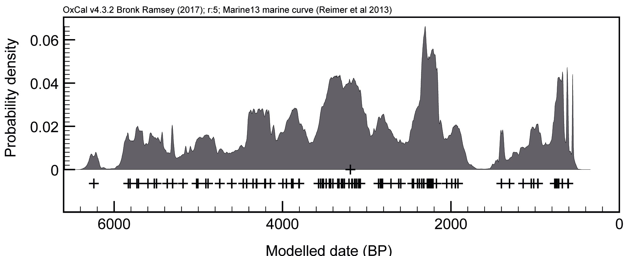
Figure 5. SPD of single uniform phase of calibrated dates from Babitonga Bay. The black cross represents the medians of the posterior distribution for each date.

4. Discussion
4.1. Fish remains from Cubatão I
Vertebrate faunal remains from Cubatão I were heavily dominated by fish and included a variety of taxa, many of which are nowadays widespread and relatively abundant in the region (Gerhardinger, Herbst, Cunha, & Costa, n.d.). Terrestrial resources, by contrast, were scarcely represented at the site, but have been identified in other assemblages from contemporaneous shell mounds and middens in the region (e.g. Enseada I, (Dione R. Bandeira, 1992); Bupeva II, (Dione Rocha Bandeira, 2004). However this is not a generalised pattern, with some Late Holocene sites containing a relatively higher abundance of large terrestrial mammals (Dione Rocha Bandeira, 2004; Bryan, 1993). This appears to be the case for sites with ceramic artefacts and may reflect changes in cultural preferences (Bastos et al., 2014). However, this is the time when the submerged seafloor became progressively exposed and drylands expanded with a regional decrease of sea level stand (Angulo, Lessa, & Souza, 2006; Behling & Negrelle, 2001; França et al., 2013), which may have favoured encounter rates with large mammals at closer distances to coastal localities.

Despite variations in food procurement strategies, zooarchaeology and bone collagen stable isotope analysis indisputably reveal that aquatic resources were the prevailing source of dietary protein and, in most cases, also calories in Babitonga Bay (Bastos et al., 2014; Pezo-Lanfranco et al., 2018). Our results indicate that fish at Cubatão I were possibly obtained through generalised fishing strategies throughout the year from shallow marine, brackish and freshwater environments (i.e. Arridae, Tetraodontidae and Sciaenidae, Rhamdia spp. and Loricariidae) (L. G. Fischer, Pereira, & Vieira, 2011; Shipp, 2002). These taxa might have been captured using nets, spears and potentially traps, as supported by the presence of plant artefacts and bone points at the site (Peixe et al., 2007). It is unclear whether hooks were used as the earliest evidence in the region is dated to ca. 2300 cal BP (Dione Rocha Bandeira, 2004).

Previous studies on sambaquis in the Babitonga Bay region similarly demonstrate a generalised fishing strategy that was adapted to the local environment. Sites overlooking the open sea (i.e. Enseada I and Bupeva II) have a higher frequency of largehead hairtail (Trichiurus lepturus) and barred grunt (Conodon nobilis) (Dione R. Bandeira, 1992; Dione Rocha Bandeira, 2004), while sites along the main estuarine channel (i.e. Forte Marechal Luz) and at the bottom of the bay (i.e. Espinheiros II) show a higher incidence of pufferfishes (Lagocephalus laevigatus) and whitemouth croaker (Bryan, 1993; Levy Figuti & Klokler, 1996). Finally, fluvial sites (i.e. Itacoara) were dominated by catfishes (Ariidae and Rhamdia spp.) and trahira (Hoplias sp.) (Dione Rocha Bandeira, 2004).

The spatial distribution of sites, which are generally organised in clusters of large mounds surrounded by smaller satellite sites in relatively distinct ecological zones, may be associated with the emergence of discrete communities, perhaps organised around central sites with prominent political and symbolic connotations (Fig. 1C; (DeBlasis, Kneip, Scheel-Ybert, Giannini, & Gaspar, 2007). These sites would materialise community identities and territoriality, possibly through the cult of ancestors, in a time interval of considerable population growth (De Blasis et al., 1998; M. Gaspar et al., 2008). Beyond their nutritional importance, fish and other aquatic organisms would have played a central role in a community’s religion, as supported by the deposition of fish in funerary contexts (Cardoso, 2018; Daniela Klokler, 2014a, 2016a). Fish used in funerary feasts could explain the stratigraphic differences in the taxonomic composition, abundance and density values in areas A and B (Dietler, 2011; Daniela Klokler, 2014b; Rowley-Conwy, 2018).

4.2. Pre-Columbian catches
Our estimates suggest that Pre-Columbian groups in Babitonga Bay exploited a minimum of ca. 73,117.49 t of fish over ca. 6000 years, or ca. 12.5 t/year⁻¹. Considering the average value of consumed fish per capita (74 kg/year⁻¹) recently reported for coastal indigenous populations around the world (Cisneros-Montemayor, Pauly, Weatherdon, & Ota, 2016), our estimates equate to an average number of ca. 988,074.19 people in the region over ca. 6000 years, or ca. 168,90 people year⁻¹. These numbers are almost certainly underestimated and the overall population may have been much higher as implied by other lines of evidence (Fish, De Blasis, Gaspar, & Fish, 2000; V. Wesolowski & Neves, 2002). Nevertheless, these groups depended on fish as their main source of food for thousands of years, and consumed levels of marine protein that are well above values currently reported for the Brazilian population (A. C. Diegues, 2006). Regular captures of fish for their nutritional, social and cultural values by numerous stationary populations in this region may ultimately have had ecological implications, as recently reported in other areas along the Brazilian coast (Lopes et al., 2016). Interestingly, the estimated annual catch for Babitonga Bay is just below the reconstructed subsistence catches for the Santa Catarina state in the 1950-1960s (representing 70% to 6%), but the number of officially registered fishers in Babitonga Bay corresponds to ca. 9.2% of the total registered fishers in the Santa Catarina state (Projeto de Caracterização Socioeconômica da Atividade de Pesca e Aquicultura - PCSPA, available at: http://pmap-sc.acad.univali.br/index.html). By adjusting for this difference, the estimated annual Pre-Columbian catches are higher than historical estimates between 1950 and 1964, when most of the fisheries were small-scale in nature (Fig. 6). This may indicate that historical subsistence catches along the Brazilian coast (K. M. F. Freire et al., 2015) are underestimated, therefore their historical socio-economic value and ecological significance remains unclear.

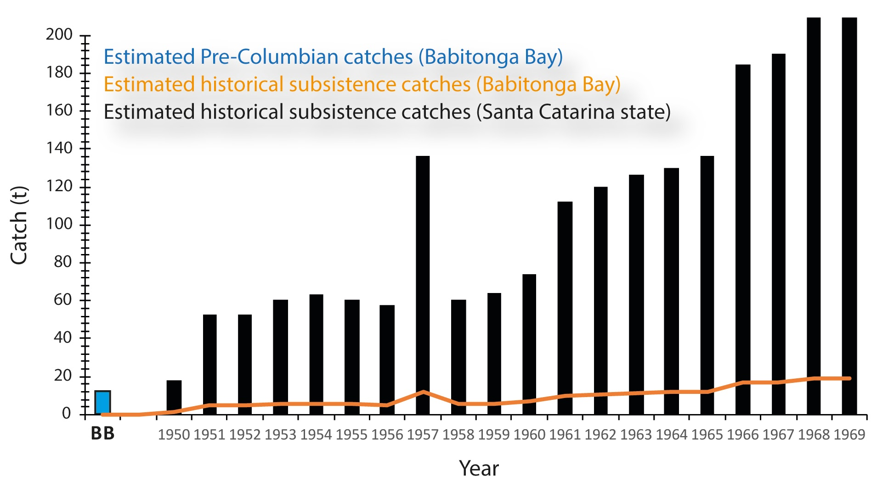
Figure 6. Annual subsistence catches from non-monetary acquisition based on household budgets for the Santa Catarina state and Babitonga Bay, along with the reconstructed annual Pre-Columbian catches for Babitonga Bay (BB).

5. Conclusion
Our attempt to estimate Pre-Columbian subsistence catches for a large estuarine site and surrounding environment along the subtropical Atlantic Forest coast reveals that prehistoric populations may have extracted volumes of fish higher than or comparable to reconstructed historical subsistence fisheries in the region. Small-scale fisheries may provide a much higher contribution to landings than conventionally reported in national statistics, thus unreliable estimations may adversely impact fisheries management and marine conservation efforts. The perception that substantial fish catches along the Brazilian coastline are primarily the outcome of recent decades of technological development and market oriented economies, which have ignored thousands of years of human interaction with coastal and marine ecosystems in this region. A thorough recognition of the socio-economic and ecological importance of small-scale fisheries along the Atlantic Forest coastline of Brazil thus requires an understanding of the scale of human use of marine resources that transcends historical records. This information can be potentially extracted from Pre-Columbian shell mounds and middens locally known as sambaquis.

Acknowledgements
The authors thank the Museu Arqueológico de Sambaqui de Joinville (MASJ) for supporting the archival and taxonomic analyses, as well as the team from the Laboratory of Archeology and Archaeological Heritage (LAPArq/Univille), and University of the Region of Joinville (Univille) for giving us access to the laboratories and equipment used during this study. We wish to thank the team from the Laboratory of Ichthyofauna and Growth (LABIC/USP) for access and supporting us with whitemouth croaker otoliths, and Claudio Ricken, Luiz Henrique Rosa da Silva, and William Felipe Dutra for all the support with the software Archaeobones. HKR should like to acknowledge the British Academy for funding. Figure 1 was partially produced with data available from the US Geological Survey, NASA Land Processes Distributed Active Archive Center (LP DAAC) Products and Google Maps.

Figure captions

Figure 1. (A) Location of Babitonga Bay in southern Brazil; (B) location of Cubatão I along with other shell mounds and middens, and modern artisanal fishing guilds (Colônias de pesca) in Babitonga Bay; (C) heat map of volume of sites (m³) showing site clusters, which may represent fishing communities; (D) overview of Cubatão I showing the upper sector and specific areas (A, B and C) that were analysed in this study, and (E) lower sector, showing the erosion of the archaeological deposits by fluvial activity. Yellow stars represent areas where radiocarbon dates in the lower sector were obtained.

Figure 2. Probability distributions of radiocarbon dates from the lower and upper sectors of Cubatão I.

Figure 3. Estimated volume of Pre-Columbian shell mounds and middens in Babitonga Bay.

Figure 4. Relative abundance of marine and terrestrial faunal remains*, including their density for the volume of sediment, species diversity and the environmental gradient represented by first axis of the correspondence analysis for areas A, B and C. The green bands indicate the stratigraphic position of human burials in the areas.

Figure 5. SPD of single uniform phase of calibrated dates from Babitonga Bay. The black cross represents the medians of the posterior distribution for each date.

Figure 6. Annual subsistence catches from non-monetary acquisition based on household budgets for the Santa Catarina state and Babitonga Bay, along with the reconstructed annual Pre-Columbian catches for Babitonga Bay (BB).

Authorship
TF, ACC, DB, designed the study, analysed and interpreted data, wrote the manuscript; JF, analysed data; LF, provided data, critically reviewed the manuscript; SD, critically reviewed the manuscript; NH, analysed data; HKR, DO, critically reviewed the manuscript. All authors gave approval on the version submitted for publication.

References

IBGE. 1950. Anuário estatístico do Brasil - 1950. Ano XI. https://biblioteca.ibge.gov.br/visualizacao/periodicos/20/aeb_1950.pdf
IBGE. 1952. Anuário estatístico do Brasil - 1952. Ano XIII. https://biblioteca.ibge.gov.br/visualizacao/periodicos/20/aeb_1952.pdf.
IBGE. 1953. Anuário estatístico do Brasil - 1953. Ano XIV. https://biblioteca.ibge.gov.br/visualizacao/periodicos/20/aeb_1953.pdf.
IBGE. 1954. Anuário estatístico do Brasil - 1954. Ano XV. https://biblioteca.ibge.gov.br/visualizacao/periodicos/20/aeb_1954.pdf.
IBGE. 1955. Anuário estatístico do Brasil - 1955. Ano XVI. https://biblioteca.ibge.gov.br/visualizacao/periodicos/20/aeb_1955.pdf
IBGE. 1956. Anuário estatístico do Brasil - 1956. Ano XVII. https://biblioteca.ibge.gov.br/visualizacao/periodicos/20/aeb_1956.pdf
IBGE. 1957. Anuário estatístico do Brasil - 1957. Ano XVIII. https://biblioteca.ibge.gov.br/visualizacao/periodicos/20/aeb_1957.pdf
IBGE. 1958. Anuário estatístico do Brasil - 1958. Ano XIX. https://biblioteca.ibge.gov.br/visualizacao/periodicos/20/aeb_1958.pdf
IBGE. 1960. Anuário estatístico do Brasil - 1960. Ano XXI. https://biblioteca.ibge.gov.br/visualizacao/periodicos/20/aeb_1960.pdf
IBGE. 1961. Anuário estatístico do Brasil - 1961. Ano XXII. https://biblioteca.ibge.gov.br/visualizacao/periodicos/20/aeb_1961.pdf
IBGE. 1962. Anuário estatístico do Brasil - 1962. Ano XXIII. https://biblioteca.ibge.gov.br/visualizacao/periodicos/20/aeb_1962.pdf
IBGE. 1963. Anuário estatístico do Brasil - 1963. Ano XXIV. https://biblioteca.ibge.gov.br/visualizacao/periodicos/20/aeb_1963.pdf
IBGE. 1964. Anuário estatístico do Brasil - 1964. Ano XXV. https://biblioteca.ibge.gov.br/visualizacao/periodicos/20/aeb_1964.pdf
IBGE. 1965. Anuário estatístico do Brasil - 1965. v. 26. https://biblioteca.ibge.gov.br/visualizacao/periodicos/20/aeb_1965.pdf
IBGE. 1966. Anuário estatístico do Brasil - 1966. v. 27. https://biblioteca.ibge.gov.br/visualizacao/periodicos/20/aeb_1966.pdf
IBGE. 1967. Anuário estatístico do Brasil - 1967. v. 28. https://biblioteca.ibge.gov.br/visualizacao/periodicos/20/aeb_1967.pdf
IBGE. 1968. Anuário estatístico do Brasil - 1968. v. 29. https://biblioteca.ibge.gov.br/visualizacao/periodicos/20/aeb_1968.pdf
IBGE. 1970. Anuário estatístico do Brasil - 1970. v. 31. https://biblioteca.ibge.gov.br/visualizacao/periodicos/20/aeb_1952.pdf
IBGE. 1971. Anuário estatístico do Brasil - 1971. v.32. https://biblioteca.ibge.gov.br/visualizacao/periodicos/20/aeb_1952.pdf
Angulo, R. J., de Souza, M. C., Reimer, P. J., & Sasaoka, S. K. (2008). Reservoir Effect of the Southern and Southeastern Brazilian Coast. Radiocarbon, 47(1), 67–73. Retrieved from https://journals.uair.arizona.edu/index.php/radiocarbon/article/view/2801
Angulo, R. J., Lessa, G. C., & Souza, M. C. de. (2006). A critical review of mid- to late-Holocene sea-level fluctuations on the eastern Brazilian coastline. Quaternary Science Reviews, 25(5), 486–506. doi:10.1016/j.quascirev.2005.03.008
Bandeira, D. da R., Oliveira, E. L., & Santos, A. M. P. (2009). Estudo estratigráfico do perfil nordeste do Sambaqui Cubatão I, Joinville/SC. Revista Do Museu de Arqueologia E Etnologia, (19), 119–142.
Bandeira, D. R. (1992). Mudança na estratégia de subsistência: O sítio arqueológico Enseada I - um estudo de caso (Mestre em Antropologia Social). (D. Werner & P. I. Schmitz, Eds.). Universidade Federal de Santa Catarina (UFSC).
Bandeira, D. R. (2004). Ceramistas Pré-coloniais da Baía da Babitonga - Arqueologia e Etnicidade (Doctor in History). Universidade Estadual de Campinas.
Bastos, M. Q. R., Lessa, A., Rodrigues-Carvalho, C., Tykot, R. H., & Santos, R. V. (2014). Carbon and nitrogen isotope analysis: diet before and after the arrival of ceramic at Forte Marechal Luz Site. Revista do Museu de Arqueologia e Etnologia, 0(24), 137–151.
Bastos, M. Q. R., Santos, R. V., Tykot, R. H., Mendonça de Souza, S. M. F., Rodrigues-Carvalho, C., & Lessa, A. (2015). Isotopic evidences regarding migration at the archeological site of Praia da Tapera: New data to an old matter. Journal of Archaeological Science: Reports, 4, 588–595. doi:10.1016/j.jasrep.2015.10.028
Begossi, A., Salivonchyk, S., Hallwass, G., Hanazaki, N., Lopes, P. F. M., & Silvano, R. A. M. (2017). Threatened fish and fishers along the Brazilian Atlantic Forest Coast. Ambio, 46(8), 907–914. doi:10.1007/s13280-017-0931-9
Behling, H., & Negrelle, R. R. B. (2001). Tropical Rain Forest and Climate Dynamics of the Atlantic Lowland, Southern Brazil, during the Late Quaternary. Quaternary Research, 56(3), 383–389. doi:10.1006/qres.2001.2264
Bender, M. G., Machado, G. R., Silva, P. J. de A., Floeter, S. R., Monteiro-Netto, C., Luiz, O. J., & Ferreira, C. E. L. (2014). Local ecological knowledge and scientific data reveal overexploitation by multigear artisanal fisheries in the southwestern Atlantic. PloS One, 9(10), e110332. doi:10.1371/journal.pone.0110332
Berkovitz, B. K. B., & Shellis, R. P. (2017). The Teeth of Non-Mammalian Vertebrates. Elsevier Science.
Bervian, G., Fontoura, N. F., & Haimovici, M. (2006). Statistical model of variable allometric growth: otolith growth in Micropogonias furnieri(Actinopterygii, Sciaenidae). Journal of Fish Biology, 68(1), 196–208. doi:10.1111/j.0022-1112.2006.00890.x
Bryan, A. L. (1993). The Sambaqui at Forte Marechal Luz, State of Santa Catarina, Brazil. (A. L. Bryan & R. Gruhn, Eds.). Oregon State University.
Cardoso, J. M. (2018). O Sítio Costeiro Galheta IV: uma perspectiva zooarqueológica (Master in Arqueology). (L. Figuti, Ed.). Universidade de São Paulo.
Cisneros-Montemayor, A. M., Pauly, D., Weatherdon, L. V., & Ota, Y. (2016). A Global Estimate of Seafood Consumption by Coastal Indigenous Peoples. PloS One, 11(12), e0166681. doi:10.1371/journal.pone.0166681
Colonese, A. C., Collins, M., Lucquin, A., Eustace, M., Hancock, Y., de Almeida Rocha Ponzoni, R., … Craig, O. E. (2014). Long-term resilience of late holocene coastal subsistence system in Southeastern South america. PloS One, 9(4), e93854. doi:10.1371/journal.pone.0093854
Contreras, D. A., & Meadows, J. (2014). Summed radiocarbon calibrations as a population proxy: a critical evaluation using a realistic simulation approach. Journal of Archaeological Science, 52, 591–608. doi:10.1016/j.jas.2014.05.030
DeBlasis, P. A. D. de, Kneip, A., Scheel-Ybert, R., Giannini, P. C. F., & Gaspar, M. D. (2007). Sambaquis e paisagem: dinâmica natural e arqueologia regional no litoral do sul do Brasil. Arqueología Suramericana, 3(1), [29] – 61.
De Blasis, P., Fish, S. K., Gaspar, M. D., & Fish, P. R. (1998). Some references for discussion of complexity among the Sambaqui moundbuilders from the southern shores of Brazil. Revista de Arqueología Americana, (15), 75–105.
de Melo Alves Damasio, L., Lopes, P. F. M., Guariento, R. D., & Carvalho, A. R. (2015). Matching Fishers’ Knowledge and Landing Data to Overcome Data Missing in Small-Scale Fisheries. PloS One, 10(7), e0133122. doi:10.1371/journal.pone.0133122
Diegues, A. (1997). Tradition and change in Brazilian fishing communities: towards a social anthropology of the sea. NUPAUB-USP.
Diegues, A. C. (2006). Artisanal Fisheries in Brazil. International Collective in Support of Fishworkers (ICSF).
Dietler, M. (2011). Feasting and Fasting. In T. Insoll (Ed.), The Oxford Handbook of the Archaeology of Ritual and Religion. Oxford University Press. doi:10.1093/oxfordhb/9780199232444.013.0014
Elfes, C. T., Longo, C., Halpern, B. S., Hardy, D., Scarborough, C., Best, B. D., … Dutra, G. F. (2014). A regional-scale Ocean Health Index for Brazil. PloS One, 9(4), e92589. doi:10.1371/journal.pone.0092589
Engelhard, G. H., Thurstan, R. H., MacKenzie, B. R., Alleway, H. K., Bannister, R. C. A., Cardinale, M., … Lescrauwaet, A.-K. (2016). ICES meets marine historical ecology: placing the history of fish and fisheries in current policy context. ICES Journal of Marine Science: Journal Du Conseil, 73(5), 1386–1403. doi:10.1093/icesjms/fsv219
Erlandson, J. M., & Rick, T. C. (2008). Archaeology, marine ecology, and human impacts on marine environments. In T. C. Rick & J. M. Erlandson (Eds.), Human Impacts on Ancient Marine Ecosystems: A Global Perspective (pp. 1–19). University of California Press.
Figuti, L. (2009). Construindo o sambaqui: a ocupação e os processos de construção de sitio na bacia do Canal do Palmital, Santa Catarina. FAPESP.
Figuti, L., & Klokler, D. (1996). Resultados preliminares dos vestígios zooarqueológicos do sambaqui Espinheiros II (Joinville, SC). Revista Do Museu de Arqueologia E Etnologia, 6, 169–187.
Fischer, L. G., Pereira, L. E. D., & Vieira, J. P. (2011). Peixes Estuarinos e Costeiros. On 2 ed. (L. G. Fischer, Ed.). Luciano Gomes Fischer.
Fish, S. K., De Blasis, P., Gaspar, M. D., & Fish, P. R. (2000). Incremental events in the construction of sambaquis, southeastern Santa Catarina. Revista do Museu de Arqueologia e Etnologia, (10), 69–87. doi:10.11606/issn.2448-1750.revmae.2000.109378
França, M. C., Cohen, M. C. L., Pessenda, L. C. R., Rossetti, D. F., Lorente, F. L., Buso Junior, A. Á., … Macario, K. (2013). Mangrove vegetation changes on Holocene terraces of the Doce River, southeastern Brazil. Catena, 110, 59–69. doi:10.1016/j.catena.2013.06.011
Freire, K. M. F., Aragão, J. A. N., Araújo, A. R. R., Ávila-da-Silva, A. O., Bispo, M. C. S., Canziani, G. V., … Others. (2015). Reconstruction of catch statistics for Brazilian marine waters (1950-2010). Fisheries Centre Research Reports, 23(4), 3–30.
Freire, K. M. F., & Pauly, D. (2010). Fishing down Brazilian marine food webs, with emphasis on the east Brazil large marine ecosystem. Fisheries Research, 105(1), 57–62. doi:10.1016/j.fishres.2010.02.008
Gaspar, M. D. (1998). Considerations of the sambaquis of the Brazilian coast. Antiquity, 72(277), 592–615. doi:10.1017/S0003598X00087020
Gaspar, M., DeBlasis, P., Fish, S. K., & Fish, P. R. (2008). Sambaquis (shell mound) societies of coastal Brazil. In H. Silverman & W. Isbell (Eds.), Handbook of South American Archaeology (pp. 319–335). Springer New York.
Gerhardinger, L. C., Herbst, D. F., Cunha, S. M. B., & Costa, M. D. de P. (n.d.). Diagnóstico da Ictiofauna do Ecossistema Babitonga. On in press. in press. in press.
Gerhardinger, L. C., Zank, S., de Carvalho, F. G., Herbst, D. F., Cunha, S., & Cremer, M. J. (2018). Governabilidade estrutural do subsistema natural do Ecossistema Babitonga (Santa Catarina: Brasil). Revista CEPSUL - Biodiversidade e Conservação Marinha, 7(0), eb2018001. Retrieved from http://www.icmbio.gov.br/revistaeletronica/index.php/cepsul/article/view/829
Hammer, Ø., Harper, D., & Ryan, P. D. (2001). PAST: Paleontological Statistics Software Package for education and data analysis. Palaeontologia Electronica 4.
Helfman, G., Collette, B. B., Facey, D. E., & Bowen, B. W. (2009). The Diversity of Fishes: Biology, Evolution, and Ecology. John Wiley & Sons.
Hogg, A. G., Hua, Q., Blackwell, P. G., Niu, M., Buck, C. E., Guilderson, T. P., … Zimmerman, S. R. H. (2013). SHCal13 Southern Hemisphere Calibration, 0–50,000 Years cal BP. Radiocarbon, 55(4), 1889–1903.
Holdaway, S. J., Fanning, P. C., Petchey, F., Allely, K., Shiner, J. I., & Bailey, G. (2017). Temporal variability in shell mound formation at Albatross Bay, northern Australia. PloS One, 12(8), e0183863. doi:10.1371/journal.pone.0183863
Homberger, D. G., & Walker, W. F. (1994). Vertebrate Dissection. On 9th (ninth) Edition (56033rd edition). Cengage Learning.
Jackson, J. B., Kirby, M. X., Berger, W. H., Bjorndal, K. A., Botsford, L. W., Bourque, B. J., … Warner, R. R. (2001). Historical overfishing and the recent collapse of coastal ecosystems. Science, 293(5530), 629–637. doi:10.1126/science.1059199
Juggins, S. (2007). C2 Version 1.5 User guide. Software for ecological and palaeoecological data analysis and visualisation (Version 1.4.2). Newcastle University.
Klokler, D. (2008). Food for Body and Soul: Mortuary Ritual in Shell Mounds (Laguna - Brazil) (PhD). University of Arizona.
Klokler, D. (2014a). A ritually constructed shell mound. The Cultural Dynamics of Shell-Matrix Sites. University of New Mexico Press, Albuquerque, 151–162.
Klokler, D. (2014b). A Ritually Constructed Shell Mound: Feasting at the Jabuticabeira II Site. In M. Roksandic, S. M. Souza, S. Eggers, M. Burchell, & D. Klokler (Eds.), The Cultural Dynamics of Shell-Matrix Sites (pp. 151–162). University of New Mexico Press.
Klokler, D. (2016a). Animal para toda Obra: fauna ritual em sambaquis. Revista Habitus - Revista do Instituto Goiano de Pré-História e Antropologia, 14(1), 21–34. doi:10.18224/hab.v14.1.2016.21-34
Klokler, D. (2016b). Otólitos, para que te quero? Revista de Arqueologia, 29(1), 03–17. doi:10.24885/sab.v29i1.440
Knie, J. L. W. (2002). Atlas ambiental da região de Joinville: complexo hídrico da Baía da Babitonga. Florianópolis: FATMA/GTZ.
Lagler, K. F., Bardach, J. E., Miller, R. R., & Dora, R. (1977). Ichthyology. On 2nd edition. John Wiley & Sons, New York, xv.
Lepiksaar, J. (1994). Introduction to osteology of fishes for paleozoologists. J. Lepiksaar. Göteborg, 71–79.
Liem, K. F. (2001). Functional Anatomy of the Vertebrates: An Evolutionary Perspective. Harcourt College Publishers.
Lima, T. A., Macario, K. D., Anjos, R. M., Gomes, P. R. S., Coimbra, M. M., & Elmore, D. (2004). The earliest shellmounds of the central-south Brazilian coast. Nuclear Instruments & Methods in Physics Research. Section B, Beam Interactions with Materials and Atoms, 223-224, 691–694. doi:10.1016/j.nimb.2004.04.128
Lopes, M. S., Bertucci, T. C. P., Rapagnã, L., Tubino, R. de A., Monteiro-Neto, C., Tomas, A. R. G., … Aguilera Socorro, O. (2016). The Path towards Endangered Species: Prehistoric Fisheries in Southeastern Brazil. PloS One, 11(6), e0154476. doi:10.1371/journal.pone.0154476
Lotze, H. K., & Worm, B. (2009). Historical baselines for large marine animals. Trends in Ecology & Evolution, 24(5), 254–262. doi:10.1016/j.tree.2008.12.004
McKechnie, I., Lepofsky, D., Moss, M. L., Butler, V. L., Orchard, T. J., Coupland, G., … Lertzman, K. (2014). Archaeological data provide alternative hypotheses on Pacific herring (Clupea pallasii) distribution, abundance, and variability. Proceedings of the National Academy of Sciences of the United States of America, 111(9), E807–E816. doi:10.1073/pnas.1316072111
Melo Júnior, J. C. F. de, Silveira, E. R. da, & Bandeira, D. da R. (2016). Archaeobotany of the southern Brazilian shellmount: integrating evidences on the paleoenvironment and the use of forest resources. Boletim Do Museu Paraense Emílio Goeldi. Ciências Humanas, 11(3), 727–744. doi:10.1590/1981.81222016000300011
Moyle, P. B., & Cech, J. J. (2004). Fishes: an introduction to ichthyology (Vol. 726). Pearson Prentice Hall Upper Saddle River, NJ.
Oliveira, M. (2000, unpublished master dissertation). Os Sambaquis da Planície costeira de Joinville, litoral norte de Santa Catarina: Geologia, paleogeografia e conservação in situ.
Orton, D., Morris, J., & Pipe, A. (2017). Catch Per Unit Research Effort: Sampling Intensity, Chronological Uncertainty, and the Onset of Marine Fish Consumption in Historic London [Data set]. doi:10.5334/oq.29
Pauly, D. (1995). Anecdotes and the shifting baseline syndrome of fisheries. Trends in Ecology & Evolution, 10(10), 430. doi:10.1016/S0169-5347(00)89171-5
Pauly, D., & Zeller, D. (2015). Catch Reconstruction: concepts, methods and data sources. (D. Pauly & D. Zeller, Eds.). Sea Around Us (www.seaaroundus.org). University of British Columbia.
Pauly, D., & Zeller, D. (2016). Catch reconstructions reveal that global marine fisheries catches are higher than reported and declining. Nature Communications, 7, 10244. doi:10.1038/ncomms10244
Peixe, S. P., de Melo Junior, J. C. F., & da Rocha Bandeira, D. (2007). Paleoetnobotânica dos macrorestos vegetais do tipo trançados de fibras encontrados no sambaqui Cubatão I, Joinville--SC. Revista Do Museu de Arqueologia E Etnologia, (17), 211–222.
Pezo-Lanfranco, L., Eggers, S., Petronilho, C., Toso, A., da Rocha Bandeira, D., Von Tersch, M., … Colonese, A. C. (2018). Middle Holocene plant cultivation on the Atlantic Forest coast of Brazil? Royal Society Open Science, 5(9), 180432. doi:10.1098/rsos.180432
Pinnegar, J. K., & Engelhard, G. H. (2008). The ‘shifting baseline’ phenomenon: a global perspective. Reviews in Fish Biology and Fisheries, 18(1), 1–16. doi:10.1007/s11160-007-9058-6
Pinsky, M. L., Jensen, O. P., Ricard, D., & Palumbi, S. R. (2011). Unexpected patterns of fisheries collapse in the world’s oceans. Proceedings of the National Academy of Sciences of the United States of America, 108(20), 8317–8322. doi:10.1073/pnas.1015313108
Plank, M. J., Allen, M. S., Nims, R., & Ladefoged, T. N. (2018). Inferring fishing intensity from contemporary and archaeological size-frequency data. Journal of Archaeological Science, 93, 42–53. doi:10.1016/j.jas.2018.01.011
Radu, V. (2005). Atlas for the identification of bony fish bones from archaeological sites. Contrast.
Ramsey, C. B. (1995). Radiocarbon Calibration and Analysis of Stratigraphy: The OxCal Program. Radiocarbon, 37(2), 425–430. doi:10.1017/S0033822200030903
Ramsey, C. B. (2009). Bayesian Analysis of Radiocarbon Dates. Radiocarbon, 51(1), 337–360. doi:10.1017/S0033822200033865
Ramsey, C. B. (2017). Methods for Summarizing Radiocarbon Datasets. Radiocarbon, 59(6), 1809–1833. doi:10.1017/RDC.2017.108
Reimer, P. J., Bard, E., Bayliss, A., Warren Beck, J., Blackwell, P. G., Ramsey, C. B., … van der Plicht, J. (2013). IntCal13 and Marine13 Radiocarbon Age Calibration Curves 0–50,000 Years cal BP. Radiocarbon, 55(4), 1869–1887. Retrieved from https://journals.uair.arizona.edu/index.php/radiocarbon/article/view/16947
Reis, R. E., Albert, J. S., Di Dario, F., Mincarone, M. M., Petry, P., & Rocha, L. A. (2016). Fish biodiversity and conservation in South America. Journal of Fish Biology, 89(1), 12–47. doi:10.1111/jfb.13016
Ricken, C. (2015). Fish remains in hunter-gatherers archaeological sites of Rio Grande do Sul, Brazil (PhD in Animal Biology). (L. R. Malabarba, Ed.). Universidade Federal do Rio Grande do Sul.
Ricken, C., Silva, L. H. R., & Malabarba, L. R. (2012). Software Archaeobones para gerenciamento de dados zooarqueológicos. In L. A. Borrero & F. M. Larraín (Eds.) (p. 2). Presented at the II Encuentro Latinoamericano de Zooarqueología, Santiago, Chile.
Rick, J. W. (1987). Dates as Data: An Examination of the Peruvian Preceramic Radiocarbon Record. American Antiquity, 52(1), 55–73. doi:10.2307/281060
Rick, T. C., Erlandson, J. M., Glassow, M. A., & Moss, M. L. (2002). Evaluating the Economic Significance of Sharks, Skates, and Rays (Elasmobranchs) in Prehistoric Economies. Journal of Archaeological Science, 29(2), 111–122. doi:10.1006/jasc.2000.0637
Roberts, C. (2010). The Unnatural History of the Sea. Island Press. Retrieved from https://market.android.com/details?id=book-kPUdwlxmda0C
Rossi-Wongtschowski, C., Chalom, A., Siliprandi, C. C., Brenha-Nunes, M. R., Conversani, V., Santificetur, C., & Giaretta, M. B. (2016). COSS-Brasil: Coleção de Otólitos de Peixes Marinhos da Região Sudeste-Sul do Brasil. Retrieved from www.usp.br/cossbrasil
Rowley-Conwy, P. (2018). Zooarchaeology and the elusive feast: from performance to aftermath. World Archaeology, 50(2), 221–241. doi:10.1080/00438243.2018.1445024
Sá, J. C. (2015). Etnoarqueologia e Arqueologia Experimental: desatando informações sobre nós e amarrações no Sambaqui Cubatão I, em Joinville - SC (Undergraduate in Archaeology). (A. M. P. Santos & D. R. Bandeira, Eds.). Universidade da Região de Joinville (Univille).
Salas, S., Chuenpagdee, R., Charles, A., & Seijo, J. C. (2011). Coastal fisheries of Latin America and the Caribbean region: issues and trends. In S. Salas, R. Chuenpagdee, A. Charles, & J. C. Seijo (Eds.), Coastal fisheries of Latin America and the Caribbean (pp. 1–12). FAO Fisheries and Aquaculture Technical Paper.
Santos, L. O. (2009). Ictiofauna demersal em diferentes setores da Baía da Babitonga, Santa Catarina, Brasil (Masters in Coastal and Oceanic Systems). (H. L. Spach & J. M. de Souza Conceição, Eds.). Universidade Federal do Paraná.
Shipp, R. L. (2002). Tetraodontidae. In K. E. Carpenter (Ed.), The Living Marine Resources of the Western Central Atlantic: Bony fishes. pt. 2. Opistognathidae to Molidae. Sea turtles and marine mammals (Vol. 3, pp. 1988–1998). Food and Agriculture Organization of the United Nations. Retrieved from http://www.fao.org/tempref/docrep/fao/009/y4162e/y4162e70.pdf
Silva, E. P., Pádua, S. C., Souza, R. C. C. L., & Duarte, M. R. (2017). Shell Mounds of the Southeast Coast of Brazil: Recovering Information on Past Malacological Biodiversity. In M. Mondini, A. S. Muñoz, & P. M. Fernández (Eds.), Zooarchaeology in the Neotropics: Environmental diversity and human-animal interactions (pp. 47–60). Cham: Springer International Publishing. doi:10.1007/978-3-319-57328-1_4
Silvano, R. A. M., & Begossi, A. (2012). Fishermen’s local ecological knowledge on Southeastern Brazilian coastal fishes: contributions to research, conservation, and management. Neotropical Ichthyology: Official Journal of the Sociedade Brasileira de Ictiologia, 10(1), 133–147. doi:10.1590/S1679-62252012000100013
Souza, R. C., Fernandes, F. D. C., & Silva, E. P. da. (2003). A study on the occurrence of the brown mussel Perna perna on the sambaquis of the Brazilian coast. Revista Do Museu de Arqueologia E Etnologia, (13), 3. doi:10.11606/issn.2448-1750.revmae.2003.109462
Souza, R. C., Lima, T. A., Duarte, M. R., & Silva, E. P. (2016). Changes in patterns of biodiversity of marine mollusks along the Brazilian coast during the late Holocene inferred from shell-mound (sambaquis) data. Holocene, 26(11), 1802–1809. doi:10.1177/0959683616645946
Stamatopoulos, C. (2002). Sample-Based Fishery Surveys - A Technical Handbook. On Fishery Information, Data and Statistics Unit. (FAO Fisheries Department, Ed.). Retrieved from http://www.fao.org/docrep/004/Y2790E/y2790e00.htm
Vasconcellos, M., Diegues, A. C., & Kalikoski, D. C. (2011). Coastal fisheries of Brazil. In S. Salas, R. Chuenpagdee, A. Charles, & J. C. Seijo (Eds.), Coastal fisheries of Latin America and the Caribbean (pp. 73–116). FAO Fisheries and Aquaculture Technical Paper.
Venera, J. I., & Severino, J. R. (2010). Joinville: primeiros habitantes. Casa Aberta Editora.
Vieira, C. V., Horn Filho, N. O., Custodio Bonetti, C. V. D. H., & Bonetti, J. (2008). Morphosedimentary characterization and zoning of Babitonga Bay estuarine complex, Santa Catarina State. Boletim Da Sociedade Paranaense de Matematica. 3rd Serie, 62, 85–105.
Waessle, J. A., Lasta, C. A., & Favero, M. (2003). Otolith morphology and body size relationships for juvenile Sciaenidae in the Río de la Plata estuary (35-36°S). Scientia Marina, 67(2), 233–240. doi:10.3989/scimar.2003.67n2233
Wagner, G., Hilbert, K., Bandeira, D., Tenório, M. C., & Okumura, M. M. (2011). Sambaquis (shell mounds) of the Brazilian coast. Quaternary International: The Journal of the International Union for Quaternary Research, 239(1), 51–60. doi:10.1016/j.quaint.2011.03.009
Wesolowski, V., Ferraz Mendonça de Souza, S. M., Reinhard, K. J., & Ceccantini, G. (2010). Evaluating microfossil content of dental calculus from Brazilian sambaquis. Journal of Archaeological Science, 37(6), 1326–1338. doi:10.1016/j.jas.2009.12.037
Wesolowski, V., & Neves, W. A. (2002). Economy, nutrition, and disease in prehistoric coastal Brazil: A case study for the State of Santa Catarina. In R. H. Steckel & J. C. Rose (Eds.), The Backbone of History. Health and Nutirtion in the Western Hemisphere (pp. 346–400). Cambridge: Cambridge University Press.
Worm, B., Hilborn, R., Baum, J. K., Branch, T. A., Collie, J. S., Costello, C., … Zeller, D. (2009). Rebuilding global fisheries. Science, 325(5940), 578–585. doi:10.1126/science.1173146
Zeller, D., & Pauly, D. (2018). The ‘presentist bias’ in time-series data: Implications for fisheries science and policy. Marine Policy, 90, 14–19. doi:10.1016/j.marpol.2018.01.015

