Fruits, fish and the introduction of pottery in the Eastern European plain: lipid residue analysis of ceramic vessels from Zamostje 2

Author names and affiliations
Bondetti, Manon^{a,b}, Scott (Chirkova), Sofiaª, Lucquin, Alexandreª, Meadows, John^{c,d}, Lozovskaya, Olga^{e}, Dolbunova, Ekaterina^{f,g}, Jordan, Peter^{b}, Craig, Oliver Eª

a BioArCh, University of York, Environment Building, Wentworth Way Heslington, York YO10 5DD, United Kingdom.
Emails: sofia.s.chirkova@gmail.com; alexandre.lucquin@york.ac.uk; oliver.craig@york.ac.uk
b Arctic Centre and the Groningen Institute of Archaeology, University of Groningen, Aweg 30, 9718CW Groningen, The Netherlands. Email: p.d.jordan@rug.nl
c Center for Baltic and Scandinavian Archaeology, Foundation of the Schleswig-Holstein State Museums Schloss Gottorf, 24837 Schleswig, Germany.
d Leibniz-Laboratory for AMS Dating and Stable Isotope Research, Christian-Albrechts-University Kiel, Max-Eyth-Str. 11-13, 24118 Kiel, Germany.
E-mail: jmeadows@leibniz.uni-kiel.de
e Institute for the History of Material Culture, Russian Academy of Sciences, 18 Dvortsovaya emb. 191186 Saint-Petersburg Russia. Email: olozamostje@gmail.com
f The State Hermitage museum, 34 Dvortsovaya emb. Saint-Petersburg 190000, Russia. Email: katjer@mail.ru
g The British Museum, Great Russell St, London WC1B 3DG, United Kingdom.

Corresponding author
Manon Bondetti
BioArCh, University of York, Heslington, York YO10 5DD, UK.
Arctic Centre, University of Groningen, Aweg 30, 9718CW Groningen, the Netherlands.
manon.bondetti@york.ac.uk
Abstract
The Neolithization of Northern Eurasia is marked by the emergence of pottery among hunter-gatherer societies. The driving forces behind the adoption of ceramic cooking vessels among non-agricultural societies remain unclear, although previous research, mainly in North East Asia (e.g. Japan, Korea and the Russian Far East), suggests that it was adopted as a specialist technology for processing aquatic resources, linked to the intensification of fishing activities and a move to sedentism. The stratified site of Zamostje 2 in the forest zone of the Volga-Oka region includes both aceramic Mesolithic and two early ceramic horizons dating to Early Neolithic (EN) and Middle Neolithic (MN). This provides a unique opportunity to look at the impacts of the adoption of pottery on the wider economy and determine whether pottery function changes over time. This was achieved through the analysis of lipids from 167 potsherds dating from the earliest phases (mid-6th millennium cal BC) to the MN (5th millennium cal BC). Contrary to our expectations, the pottery from the EN phase was used to process a broad range of foodstuffs including terrestrial resources, such as forest fruits, in addition to freshwater fish. In contrast, pottery from the MN phase was used exclusively for processing aquatic resources. The results show that in this case, pottery was adopted as a more general-purpose cooking container, at least in the earliest phases of use, and that a specialist function only emerged later.

Keywords: early pottery; hunter-fisher-gatherers; lipid residue analyses; Early Neolithic (EN); Middle Neolithic (MN); Zamostje 2.

- Introduction: Hunter-Gatherers Pottery and Neolithization of Northern Eurasia
Archaeologists now acknowledge two contrasting processes of Neolithization. The classic definition of the Neolithic arose in Western Europe and involved the emergence of farming in the Near East, and the dispersal of a package of innovations including domestic crops and animals, village life and pottery into Northwest Europe. In contrast, archaeologists working in other parts of Eurasia define the onset of the Neolithic by the emergence of pottery cooking containers among hunter-gatherer societies, along with an increase in sedentism, emergence of new subsistence strategies with food storage and fishing intensification, and settlement at strategic locations giving access to high biomass (Barnett and Hoopes, 1995; Kuzmin, 2006; Keally et al., 2007; Jordan and Zvelebil, 2009; Gibbs, 2015; Jordan et al., 2016). The earliest hunter-gatherer ceramic cooking vessels derive from East Asia. So far, the oldest pottery, securely dated, appears to have been made towards the end of the Late Pleistocene epoch, between 16,000 and 13,000 cal BC in South China, Japan, and the Amur River basin in the Russian Far East (Serizawa, 1979; Habu, 2004; Kudo, 2004; Kuzmin, 2006; 2017; Keally et al., 2007; Boaretto et al., 2009; Jordan and Zvelebil, 2009; Hommel, 2012). Although debated, it is suggested that pottery technology spread westward across Eurasia during the Holocene, eventually influencing several Northern European Mesolithic cultures (van Berg and Cauwe, 1998; Dolukhanov et al., 2005; 2009; Haaland, 2009; Jordan and Zvelebil, 2009; Gronenborn, 2011; Hartz et al., 2012; Jordan et al., 2016). Its adoption may have had a major impact on prehistoric populations’ lifeways as it became an essential everyday technology to cook and store foods. However, the motivations for the emergence, adoption and spread of pottery are still an ongoing debate in archaeology. The main questions are: (1) What was the function of the earliest ceramic vessels and did function change over time? (2) Was the adoption associated with substantial changes in economy, technology, society? (3) Did the adoption coincide with major environmental changes?

The increase of pottery abundance and its spread across large parts of Eurasia appears to occur in the Early Holocene, ca. 9700 to 5000 cal BC, and corresponds with a period of climate amelioration (Alley et al., 1993; Smith et al., 2011; Cummings, 2014). In Eurasia, numerous environmental changes occurred and rich new ecotopes emerged at this time. New vegetation (e.g. tundral, deciduous woodland) and fauna (e.g. reindeer, deer, wild boar, elk) spread to areas now free of ice (Khotinsky, 1993; Cummings, 2014; Zhilin, 2014) creating new opportunities for hunting and gathering. In the Postglacial landscapes, numerous chains of lakes were also formed and the rise of temperature and humidity that followed considerably enriched and diversified the productivity of the lacustrine ecosystems (Kulkova et al., 2001),. In particular, the emergence of pottery appears to correlate with an increasing emphasis on exploitation of aquatic resources, combined with establishment of riverside and lake-edge settlements across large parts of Eastern and Western Siberian (Chairkina and Kosinskaia, 2009; Haaland, 2009; McKenzie, 2009), as well as Eastern Europe and the Baltic Sea Basin (Jordan and Zvelebil, 2009; Pesonen and Leskinen, 2009). These combined developments make it plausible to suggest that early pottery may have been linked to the processing of fish and other aquatic resources, and that ceramic cooking vessels may have offered certain advantages over other perishable container technologies.

Recent research has employed organic residue analysis of early pottery containers to clarify vessel function and explore some of the motivations that may have led to its emergence among hunter-fisher-gatherer societies (Jordan and Zvelebil, 2009). One clear pattern emerging from many of these regional studies is the apparent association between pottery and the processing of aquatic resources, including Northern and North-Eastern Europe (Craig et al., 2007; Isaksson, 2009; Oras et al., 2017), Sakhalin Island in the Russian Far East (Gibbs et al., 2017), Japan (Craig et al., 2013; Lucquin et al., 2016a; Lucquin et al. 2018), Korea (Shoda et al., 2017) and even in north-eastern North America (Taché and Craig, 2015). Interestingly, the close association between pottery and the processing of aquatic resources is observed even at sites where the faunal, botanical and artefactual evidence indicate exploitation of a much wider range of food resources (Lucquin et al., 2016a; Lucquin et al. 2018; Shoda et al., 2017; Jordan and Gibbs, 2018).

One area neglected by organic residue analysis is the vast forest zone of the Eastern European Plain. This extends from the Ukraine and western Belarus through European Russia to the Ural Mountains in the East. This region clearly participated in the wider uptake of pottery by local hunter-gatherers but the driving forces of its adoption are not yet properly understood. Our study analyses the function of pottery from a key Upper Volga site, Zamostje 2. This site is an ideal case-study due to its significant assemblage of well-preserved artefacts and ecofacts and an uninterrupted and well-dated stratigraphic sequence. Crucially, it captures the introduction of the first pottery culture in the Upper Volga Region, Central Russia, and its subsequent development during the MN (Lyalovo Culture). This gives us a rare opportunity to evaluate the economic impact of this technological change but also, using organic residue analysis, to reconstruct the use of early pottery and therefore to help understanding the motivations behind its adoption.

Our goals were twofold. Firstly, we aimed to determine whether the newly introduced pottery had a specific function, that is to say, was adopted for a specific reason. Secondly, we aimed to examine the evolution of pottery use over time from its emergence until the typological change concurrent with the MN. In this study we test the hypothesis that pottery was introduced within hunter-gatherer societies mainly for the processing of aquatic resources to then become a more general cooking container, as has been demonstrated elsewhere, e.g. Japan (Lucquin et al., 2016a).

- The multi-layer waterlogged site of Zamostje 2, Central Russia (Upper Volga Region)
Zamostje 2 is located ca. 110 km north of Moscow in the Sergiev Posad Region along the Dubna River (Fig. 1). The site was established on the edge of a vast lake basin with numerous river channels and was occupied during the Atlantic period from ca. 6600-4000 cal BC (Radu and Desse-Berset, 2013; Kulkova, 2014; Lozovski et al., 2014). Two anthropogenic activity peaks are recorded, attributable to five successive cultural layers from the Late (Lower and Upper Layers from ca. 6500 to 5900 cal BC) and Final Mesolithic (from ca. 5900 to 5700 cal BC) to the Early (ca. 5700–5400 cal BC) and MN (ca. 5000-4000 cal BC) (Fig. 4) (Lozovski, 1996; Lozovski and Lozovskaya, 2013; Lozovski et al., 2013a; 2013b; 2014; Mazurkevich et al., 2013; Meadows et al., 2015).

Pottery constitutes the most numerous artefact in the Neolithic layers at Zamostje 2. In total, 18,300 sherds have been recovered from the EN layer, far more than similar sized excavations from contemporary sites in the Eastern European forest zone (Lozovski, 2003; Lozovski et al., 2014; Mazurkevich et al., 2013; Mazurkevich and Dolbunova, 2015). In total, 26,911 sherds were recovered from the MN layer (Lozovski et al., 2015). The Upper Volga сulture (UVC), attributed to the EN (Fig. 2; Fig. 4), was the first pottery culture in this region and consisted of several ceramic stages (Kostyleva, 1986; 1987; 1994; 2003. Dolbunova et al., 2017. The ceramic material associated with the central zone of UVC culture, includes pottery that is either undecorated or decorated by rows of pointed impressions (Early Stage), “false-cord” decoration, incised lines, teethed-stamp impressions (end of Early Stage) (Kostyleva, 1994), short-teethed stamp impressions (Middle Stage) and finally different lengths of comb stamps (Late Stage) (Hartz et al., 2012; Mazurkevich et al., 2013; Lozovski et al., 2014; Dolbunova et al., 2017). It is not clear whether these styles evolved within the region or developed from external influence(s) (Smirnov 2004; Mazurkevich et al., 2013).

Overall, the Zamostje 2 pottery assemblage is very fragmented, preventing an accurate quantification of the size and capacity of vessels through the different phases. The whole early Neolithic layer is “compressed” within a rather narrow horizon which complicated identification of specific functional/household areas or any specific “cultural” context, as well as identifying particularities of pottery type location. The EN phase comprises a wide range of pottery forms, mainly flat-bottomed cooking vessels and some bowls, most likely due to the extended period of time over which this material was deposited. Within the undecorated pottery, two completely different technological and morphological traditions were distinguished, which might indicate influences fromdifferent regions (Mazurkevich et al., 2013). Firstly, pottery which appeared here in the first half of the 6th millennium cal BC (Zaretskaya and Kostyleva, 2008) bears similarities with the pottery of the Middle Volga culture, Late Elshanian culture and Rakushechny Yar culture (Kostyleva, 2003). Later ceramic stage (Late Stage) might reflect influences from the Volga-Kama area.

The MN Phase is defined by the appearance of Lyalovo culture pottery vessels, characterised by pit and pit-comb ornaments across the whole of their exterior surfaces (Fig. 2e). This pottery style may appear to originate in the Volga–Oka interfluve (Lozovski et al., 2015; Vybornov et al., 2018). In contrast to the preceding UVC with a high proportion of flat-bottomed ware, Lyalovo complex vessels have roundish and conical bases (Lozovski et al., 2015; Vybornov et al., 2018). Nonetheless, vessels reconstruction, based on similar types of vessels found on other sites in this region, does not indicate a significant form change from early Neolithic to Lyalovo culture (Gurina and Krainov, 1996; Lozovski, 1996). On other Lyalovo culture sites some vessels were found fulfilled with fish scales (Gurina and Krainov, 1996).

Gathering practices were an important component of the Zamostje 2 inhabitants’ lifeways. Up to 51 plant macrofossil taxa have been recovered and identified, including seeds and fruits (Fig. 3; Fig. 4). Most of the identified plant remains are from edible species or species that conceivably had a medicinal purpose (Berihuete Azorin and Lozovskaya, 2014; Berihuete, 2018). Of the mammalian fauna, elk (Alces alces) and beaver (Castor fiber) were preferentially targeted, with both easily accessible for hunting at the lake edge environment. Combined, these two species represent 70 to 90% of the mammal remains from Zamostje 2 (Leduc and Chaix, 2014; 2018). Birds such as waterfowl and forest species (mainly duck (Anatidae) and capercaillie (Tetrao urogallus) respectively) were exploited, with a rise of the latter in the Neolithic period, but this does not seem to have been a major economic activity (Mannermaa, 2013; Mannermaa and Treuillot, 2014). However, fishing at Zamostje 2 seems to have been a substantial subsistence activity, with hundreds of thousands of fish bones recovered (Lozovski et al., 2013a; Radu and Desse-Berset, 2013; Leduc and Chaix, 2014; 2018), as well as numerous fishing structures (e.g. fish traps, screens and fences) and fishing related tools (Fig. 3) (harpoons, barbed points, hooks, floats, small knots from nets, knives for fish processing) (Clemente et al., 2002; Lozovski and Lozovskaya, 2013; Lozovski et al., 2013b; Radu and Desse-Berset, 2013). From this evidence, two major fishing practices have been suggested. The first, during the earlier occupation of the site (i.e. Late Mesolithic), involved the use of hand nets from boats on the lake, whilst the second, from the Final Mesolithic, involved the inhabitants of Zamostje 2 fishing on flooded channels or ponds with hooks and harpoons and started to use stationary wooden structures (fish fences and traps) to conduct a more “passive fishing” (Gyria et al., 2013; Lozovski et al., 2013b) (Fig. 4). Apart from that, general food procurement, based on hunting, fishing and gathering, seems to have remained stable from the Late Mesolithic to Neolithic, despite the introduction of pottery.

- Material and Methods
  - Sampling strategy
A total of 240 samples were subjected to organic residue analysis, representing no fewer than 166 vessels. Of the pottery studied, 114 (63 from EN; 51 from MN) had charred residues indicating they had been used for cooking. A further 52 vessels (32 from EN; 20 from MN) without foodcrusts were selected. Pot sherds assigned from the Early to Late stage of EN (76 potsherds; 67 foodcrusts) and to the MN (45 potsherds; 52 foodcrusts) (Supplementary Material Table S1) were chosen in order to examine whether there was a temporal change in pottery use. In addition, lipids of modern plants (Viburnum opulus L..), ruminants (elk), wild non-ruminants (beaver) and fish (pike (Esox lucius), perch (Perca fluviatilis), cyprinids (Cyprinidae) and bream (Abramis brama)) from the region were also analysed for comparison with the archaeological samples (Supplementary Material Table S1).

  - Lipid residue extraction
Lipids were extracted and methylated from all samples following a modified one step acidified methanol protocol (Craig et al. 2013; Papakosta et al. 2015). A selection of samples (Supplementary Material Table S1) was subjected to solvent extraction following published methodologies (Charters et al., 1993; Regert et al., 1998; Stern et al., 2000; Gregg, 2009; Papakosta et al., 2015) in order to facilitate the detection of any triacylglycerols or wax esters. All extracts were analysed by Gas Chromatography-Mass Spectrometry (GC-MS) using different columns and modes to identify characteristic compounds (e.g. aquatic biomarkers). Where the lipid yield was sufficient, the methalonic acid extracts were subsequently analysed by Gas Chromatography-Combustion-Isotope Ratio Mass Spectrometry (GC-C-IRMS) in order to determine the carbon isotope values of the two most abundant fatty acids (C16:0 and C18:0). Foodcrusts were also analysed by Elemental Analysis-Isotope Ratio Mass Spectrometry (EA-IRMS) to determine their stable nitrogen (δ15N) and carbon (δ13C) isotope values, as described previously (Craig et al., 2007; Lucquin et al., 2016a; Shoda et al., 2017). Further information is available in the Supplementary Materials.

- Organic residue analysis of Early and Middle Neolithic potsherds
  - Lipid quantification and characterisation
All the charred surface deposits (EN, n = 67; MN, n = 52) and absorbed residues (EN, n = 76; MN, n = 45) were extracted with the acidified methanol protocol and analysed by GC-MS and GC-C-IRMS to obtain specific compositional information. Additional solvent extraction (n = 27) was carried out where enough lipids were present. Over 78% of the samples analysed provided interpretable lipid yields (potsherds >5ug/g; foodcrusts >100ug/g) (Evershed, 2008a; Lucquin et al., 2018), confirming the excellent preservation conditions at the Zamostje 2 site.

In general, the lipid profiles obtained (Fig. 5; Supplementary Material Table S1) contained saturated fatty acids, ranging from C_{10:0} to C_{30:0}, mainly dominated by C_{16:0}. Monounsaturated fatty acid from C_{14:1} to C_{24:1} and branched fatty acids (C₁₃-C₂₅) were also identified. Dicarboxylic acids are present in more than 63% of the samples, mainly C₉ (azelaic acid), although a few samples (n = 8) contained a broader range (C₇-C₂₂). Cholesterol and its derivatives were broadly represented (n = 126 samples) in the samples, confirming that animal resources have been processed in the vessels.

A range of plant biomarkers such as diterpenes, mainly methyl dehydroabietate and 7-oxo-Dehydroabietate, which are markers of pine resin (Regert, 2004; Mitkidou et al., 2007; Jerković et al., 2011), terpenoids, plant sterols and their derivatives were identified (n = 140 samples) (Fig. 5). Interestingly, α-Amyrin, β-Amyrin, β-Amyrone terpenoids, common among angiosperm triterpenoids (Phillips et al., 2006; Courel, 2016), were identified. In some foodcrusts, these compounds were one of the most dominant peaks (Fig. 5), which in some cases may obtain up to 498 µg/g. These compounds are found in a wide range of plants and conceivably present in the sedimentary environment. However, their unusually high relative abundance (Fig. 5) shows they are most likely endogenous and derived directly from prehistoric plant processing. Such biomarkers could be ascribed to the Viburnum berry, whose remains are macroscopically visible in some of the charred residues (Fig. 2d) (Berihuete-Azorín, 2015). The analysis of modern Viburnum both undertaken here (Supplementary Material Table S1) and previously published (Powers and Powers, 1940) confirms that amyrin derivatives are present in Viburnum. There is a striking consistency between samples that contain the visible remains of Viburnum berries and amyrin derivatives. Indeed, 100% of samples containing Viburnum berries also contained terpenoid markers and the relative amount of amyrins in the total lipid extracts is significantly higher in the samples with visible Viburnum (mean = 3.6% of total lipid extracted) compared to those without visible Viburnum (mean = 1.9%; Mann-Whitney U=82, z=2.3, p=0.02).

The presence of visible Viburnum has been reported at other UVC sites (Engovatova 2000) suggesting it was widely exploited during this period. The fruits are rich in minerals and sugars and may have held medicinal properties due to the presence of antioxidants and its astringent and antispasmodic properties (Rop et al., 2010; Hakki Kalyoncu et al., 2013; Berihuete, 2018). Whilst they can be consumed raw, cooking removes their naturally sour taste (PFAF). Also, the fresh fruits can be used to obtain red dye (Berihuete, 2018, PFAF) .

In addition, biomarkers for aquatic products were identified (Fig. 6, Supplementary Material Table S1) in many of the samples. The co-occurrence of ω-(o-alkylphenyl) alkanoic acids (APAAs) with 18 and 20 carbon atoms and isoprenoid fatty acids (phytanic, pristanic and 4,8,12-trimethyltridecanoic acid (TMTD)) are considered reliable indicators for aquatic processing in archaeological ceramics (Cramp and Evershed, 2014). Indeed, C₂₀ APAAs result from thermal transformation of C_{20:x} mono and polyunsaturated fatty acids, only present in appreciable concentrations in freshwater and marine animals (Evershed, 2008b; Baeten et al., 2013; Cramp and Evershed, 2014).

Whilst TMTD is mainly formed in aquatic resources, phytanic and pristanic acids are found in both aquatic and ruminant resources (Ackman and Hooper, 1968; Cramp and Evershed, 2014; Heron and Craig, 2015). To further distinguish the phytanic origin we examined the ratio of its diastereomers (3S,7R,11R,15-phytanic (SRR) and 3R,7R,11R,15-phytanic acid (RRR)) since the SRR-isomer is usually predominant (>75.5% relative abundance) in aquatic animals (Lucquin et al., 2016b). Therefore, the detection of APAAs C18 and C20 along with either TMTD or a SRR% above 75.5% was used to confirm the presence of aquatic products in pots. In total, 68% of the samples analysed satisfied the full molecular criteria for the processing of aquatic products in archaeological pottery.

Interestingly, the results indicate an increase in the processing of aquatic resources during the MN. In total, 81% of these samples contained the full set of aquatic biomarkers, compared to only 55% of the EN samples (Table 1). An increase in the proportion of samples containing aquatic biomarkers appears to begin at the end of the EN (Table 1). The occurrence of plant biomarkers follows an opposite trend, with a higher proportion of EN vessels yielding these compounds compared to the Lyalovo vessels (Table 1). The main plant biomarkers, amyrin derivatives, decline gradually through the EN and are absent in the MN pottery.

  - Stable carbon isotope analysis of individual fatty acids
To provide more information about the origin of the lipid residues, stable carbon isotope analysis of palmitic (C_{16:0}) and stearic (C_{18:0}) acids was undertaken using GC-C-IRMS. Analyses were carried out on all samples yielding sufficient quantities of fatty acids; 170 samples in total, which included 100 EN and 70 MN samples. In Figure 7, the δ¹³C values of the C_{16:0} acid are plotted against the difference (Δ¹³C) between the carbon isotope values and (C_{18:0}-C_{16:0}). This approach enables us to distinguish ruminant adipose and dairy fats from other non-ruminant sources (Dudd, 1999; Craig et al., 2012; 2013; Cramp et al., 2014; Colonese et al., 2015; Taché and Craig, 2015; Lucquin et al., 2016a). We also include some modern samples from the Zamostje 2 area (Supplementary Material Table S1). In the majority of cases the observed values are consistent with a non-ruminant source. The large carbon isotope range and negative correlation between δ¹³C_{16:0} and Δ¹³C is however perplexing, and points to a mixture of different sources, which could include freshwater fish with different isotope values, plants or non-ruminant terrestrial animals, such as beaver, which are abundant in the faunal assemblage. Analysis of the collagen extracted from the bones of pike (Esox lucius; n = 10) and cyprinids (Cyprinidae, n = 10), shows a wide range of δ¹³C values (pike between -23.3 and -19.5‰; cyprinids between -27.2 and -22.3‰) (Meadows et al. In prep). The more enriched δ¹³C_{16:0} values could have been obtained by the processing of ruminants consuming C₄ plants (Gregg, 2009; Craig et al., 2012). However, the absence of C₄ plants in this region means that ruminant products do not adequately explain the variation; two modern local elk samples are plotted to illustrate this point. There is also no difference in the fatty acid carbon isotope value by period or by presence/absence of aquatic-derived lipids. However, the δ¹³C_{16:0} and δ¹³C_{18:0} values of EN samples show a greater variability compared to the MN (Mann-Whitney test U=2846, z=2.07, p=0.04; U=2780, z=2.28, p=0.02 respectively), which presumably reflects the wider range of foodstuffs processed in these vessels.

  - Bulk isotope analysis of charred surface deposit
Bulk stable isotope values and the elemental analysis for the charred surface deposits (n = 108) are plotted in Figure 8 and reported in Table S1 (Supplementary Material). The bulk δ¹³C isotope values from Zamostje 2 range from -23.3 to -29.6‰ and are indicative of a range of terrestrial C₃ plants, terrestrial mammals and freshwater fish, but these data are also influenced by the relative degree of preservation of lipids, carbohydrates and proteins making them difficult to interpret (Craig et al., 2007; 2011; 2013; Yoshida et al., 2013; Heron et al., 2016). Conversely, the nitrogen present in the charred products is derived from proteins and therefore the δ¹⁵N values reflect the trophic level of the organisms processed in the vessels. Thus, high δ¹⁵N values, above ca. +7.0-9.0 ‰, are usually characteristic of aquatic resources (Dufour et al., 1999; Craig et al., 2013; Choy et al., 2016), whereas lower ones are consistent with terrestrial organisms (Yoneda et al., 2004; Craig et al., 2007; Yoshida et al., 2013). The atomic C:N ratio is indicative of the amount of protein versus other macromolecules (carbohydrates and lipids). Generally animal tissues, enriched in protein, will have lower C:N ratios compared to plant tissues, enriched in carbohydrates such as starch and cellulose (Yoneda et al., 2004; Yoshida et al., 2013; Choy et al., 2016; Heron et al., 2016; Lucquin et al., 2016a).

Interestingly, there is a clear correlation between the bulk δ¹⁵N, C:N ratio (Table 2) and molecular characterization of these samples. Pottery vessels with high C:N ratios tend to have lower δ¹⁵N values, indicating that they are mainly derived from plant products, supported by a greater proportion containing amyrins (Fig 8a). Samples with lower C:N ratios and higher δ¹⁵N values have a greater proportion of aquatic-derived lipids (Fig 8b), suggesting they were used for processing fish. Furthermore, there is a clear difference in δ¹⁵N and C:N ratios between EN and MN pottery. The former has more variable values, indicating that a wider range of foodstuffs were processed, which must include mixtures of aquatic and plant products (and possibly terrestrial animals). The later pots have a greater proportion of aquatic products, consistent with increasing specialisation focused on fish processing. These data contrast with the lipid-specific carbon isotope measurements made on the same samples which show no clear difference between periods (Fig 7). The reason for this is that the bulk isotope measurements reflect greater variation in the contribution of other macronutrients (carbohydrates and proteins) to the potsherds compared to the lipid-specific measurements.

- Discussion
The main aim of our study was to examine the function of pottery recovered from Zamostje 2 following its introduction, during the early Neolithic period (ca. 5700-5400 cal BC), and its subsequent development in the MN (Lyalovo period, after 5000 cal BC). Based on expectation from previous studies of pottery use by Eurasian hunter-gatherers (Craig et al., 2007; 2013; Taché and Craig, 2015; Lucquin et al., 2016a; Gibbs et al., 2017; Oras et al., 2017; Shoda et al., 2017), we hypothesized that the first pottery in this region would have been used for processing aquatic resources. The organic residue analyses we undertook refute these assumptions. All the evidence shows that pottery at Zamostje 2 initially was used to process a wide range of foodstuffs, certainly including aquatic and terrestrial plants products and possibly also terrestrial animals. It is only in the MN that a different pattern emerges, with almost all the samples analysed showing a clear aquatic molecular and isotopic signature, pointing to specialisation in the use of pottery at this time.

The new evidence we have generated from the use of pottery contrasts with faunal analyses so far undertaken on the Zamostje 2 assemblage. These data show that fishing was a significant economic activity even before the introduction of pottery, during the Mesolithic period (ca. 6500-5700 cal BC), and that the importance of this activity did not fundamentally change throughout the EN period. Research on the MN faunal assemblage is not complete, but the quantity of fish bone compared to terrestrial species remains similarly high (Radu and Desse-Berset, 2013). Locally, the paleoenvironmental records show dense forest cover during EN with greater afforestation of the lake shores, and a change to a more marshy landscape during the MN (Ershova and Lozovskaya, 2018). More broadly, the introduction of pottery is not associated with significant change in climate and occurs several centuries after the warming events marking the Holocene Thermal Maximum, ca. 6000–2000 cal BC (Heikkilä and Seppä, 2010). In summary, resources available in the Neolithic inhabitants of Zamostje 2 were readily available to the Mesolithic hunter-gatherers that preceded them. How then do we explain the appearance of pottery at Zamostje 2 and its changing use in the MN?

One hypothesis is that the pottery use reflects a change in culinary practices rather than any major shift in the economic strategy. Indeed, there is evidence that fish were prepared and consumed without being cooked or extensively processed during the aceramic Mesolithic phases. Human and dog coprolites at the site frequently contained fish bone, suggesting that fish was eaten whole (Engovatova and Hrustalyov, 1996; Lozovski et al., 2013a; Radu and Desse-Berset, 2013). The eggs of parasitic worms (Diphylobothrium latum) have also been interpreted to suggest that fish had not been subjected to prolonged heat treatment (Engovatova and Hrustalyov, 1996; Lozovski et al., 2013a). In this scenario, the routine practice of cooking fish in pottery only occured in the Middle Neolithic, but certainly fish were regularly consumed in other ways well before.

If one accepts this scenario, two interpretations of this shift occurring in the MN can be proposed. It could be, firstly, related to a “simple” change in culinary practices brought by the new population, which also introduced a new pottery tradition. On the other hand, it can reflect new economic strategies, such as changes in the scale of exploitation or changes in the seasonal occupation of the site. Analysis of the fish bones, recovered from the EN and MN layers, shows that fishing mainly occurred during the spring and summer (Lozovski et al., 2013a; Radu and Desse-Berset, 2013). As the residue data we have generated show that new type of pottery containers found from the end of 6th millennia-5th millennia (later EN/Lyalovo culture) were used almost exclusively for fish processing, we suggest that the site became a more specialised seasonal fishing station at this point. Indeed, processing fish in pottery to make storable products (e.g. fermenting or rendering to make oils) may have been needed to deal with the seasonal surplus, although further analysis of terrestrial faunaand artefactual remains from the MN layers, which are lacking at the moment, is needed to confirm or refute this hypothesis. In contrast, during the Mesolithic and EN, Zamostje 2 appears to have been occupied all year round (Lozovski et al., 2013a), which would be more in keeping with a broader range of products identified in the EN pottery, such as Viburnum fruits that ripen in autumn (Berihuete, 2018).

Finally, the lack of a major shift in subsistence strategies associated with the introduction of pottery suggests it was incorporated into existing cultural and economic practices rather than having a major transformative effect. Pottery may have simply fulfilled a range of functional niches previously occupied by perishable containers, such as baskets, pits or other organic containers, such as those made from wood, tree bark or animal tissue. Ethnographic evidence shows that foodstuffs can be easily heated in such artefacts, negating a specific need for pottery (Driver and Massey, 1957; Leroi-Gourhan, 1973). This ‘software’ to ‘hardware’ transition, although conspicuous by its visibility in the archaeological record, may have therefore had far less actual impacton hunter-gatherer lives than supposed, perhaps only resulting in marginal gains in terms of cooking performance and durability that out-weighed the production costs.

It is interesting to note, however, that at Zamostje 2, where the conditions are highly conducive to the preservation of wood and bark at least, relatively few containers have been found in the Mesolithic layers (Lozovski, 1996; Lozovski and Ramseyer, 1998; Lozovskaya and Lozovski 2016), and none are directly analogous in form to the ceramic vessels that emerge. Similarly, container finds from the Mesolithic wetlands sites excavated across the region are extremely rare (Burov, 1989; Koltsov, 1989; Oshibkina, 2006). While other forms of container that might not have survived can be proposed, alternative explanations evoking non-functional attributes of pottery (e.g. Hayden, 1998) are perhaps needed to explain its adoption in some regions of Eastern Europe (Mazurkevich and Dolbunova, 2015).

Conclusions
The new data generated from analysis of the Zamostje 2 pottery assemblage do not support our hypothesis that the introduction of pottery in Holocene Eurasian hunter-gatherer societies was driven by a specialist need to process aquatic resources. The zooarchaeological and artefactual data show that fishing was already well established before the arrival of pottery and remained important well after the onset of Holocene Thermal Maximum climate optimum. Interestingly, the first pottery of the Early Neolithic was used to process a variety of foodstuffs, including fruit and other terrestrial resources. A shift towards specialization in the ceramic use, focused on fish processing only appears ca 700 years later, in the Middle Neolithic. Therefore, at Zamostje there appears to be very little in the way of revolutionary change associated with the first pottery and the onset of the Neolithization. It is also striking that the new technology was adopted with minimal change in other aspects of the economy and society. It appears that pottery was simply adopted as a multi-functional cooking container. Surprisingly, there is little evidence of perishable containers in the Mesolithic deposits at Zamostje, despite the excellent potential for preservation, suggesting that pottery did not simply replace non-ceramic analogues. The use of pottery for processing and combining foods through sustained heating may instead have been linked to social motivations, e.g. preparing dishes for elaborate feasting (Hayden, 1998), or aesthetic reasons that are not directly related to a wider economic shift, as has been suggested for other prehistoric foragers (Saul et al., 2013). Clearly, further work will be needed across the Eastern European Plain to confirm whether the patterns of early pottery use noted at Zamostje are exceptional or perhaps part of a wider trend which involves pottery being adopted as a new way of cooking and combining a diverse array of foodstuffs.

Statistical
Statistical tests were performed using Past (version 3.21).

Acknowledgements
We thank Frits Steenhuisen (Arctic Centre), who produced the map for Figure 1, Marise Gorton (University of Bradford) for undertaking the bulk stable isotope analyses, Carl Heron (British Museum) for his research support, Matthew Von Tersch for his assistance with aspects of the laboratory work, Aurélie Manin for her help with the statistical aspects and Harry Robson for his insightful comments on the paper (BioArCh). This research was supported by the European Union's EU Framework Programme for Research and Innovation Horizon 2020 under Marie Curie Actions Grant Agreement No 676154 (ArchSci2020 program), the ERC Advanced Grant INDUCE (The Innovation, Dispersal and Use of Ceramics in NE Europe, ERC-ADG-2015 No 695539 ) and the Centre for Baltic and Scandinavian Archaeology (ZBSA).

Supplementary material
See annex

References
Ackman, R.G., Hooper, S.N., 1968. Examination of isoprenoid fatty acids as distinguishing characteristics of specific marine oils with particular reference to whale oils. Comparative biochemistry and physiology 24, 549–565.
Alley, R.B., Meese, D.A., Shuman, C.A., Gow, A.J., Taylor, K.C., Grootes, P.M., White, J.W.C., Ram, M., Waddington, E.D., Mayewski, P.A., Zielinski, G.A., 1993. Abrupt increase in Greenland snow accumulation at the end of the Younger Dryas event. Nature 362, 527–529.
Baeten, J., Jervis, B., De Vos, D., Waelkens, M., 2013. Molecular evidence for the mixing of Meat, Fish and Vegetables in Anglo-Saxon coarseware from Hamwic, UK. Archaeometry 55, 1150–1174.
Barnett, W., Hoopes, J.W. (Eds.), 1995. The emergence of pottery: technology and innovation in ancient societies. Smithsonian Institution Press, Washington DC.
Berg, P. van, Cauwe, N., 1998. The early pottery in Northern Asia: relation with the European peninsula. In: Derevyanko, A.P. (Ed.), Paleoekologiya Plejstotsena I Kul’tury Kamennogo Veka Severnoj Azii i Sopredel'nykh Territorij. Institute of Archaeology and Ethnography Press, Novosibirsk, pp. 464–475.
Berihuete Azorin, M., Lozovskaya, O.V., 2014. Evolution of plant use at the wetland site Zamostje 2, Russia: First results. In: Lozovski, V.M., Lozovskaya, O.V. (Eds.), Paleoenvironment and Models of Adaptations of Lake Settlements in the Mesolithic and Neolithic of the Forest Zone of Eastern Europe. Institute for the History of material culture the RAS, St Petersburg, pp. 74–79.
Berihuete-Azorín, M.M., 2016. More than a list of plants: A proposal of systematization of ethnobotanical information for archaeobotanical interpretation. Quaternary international, 404 , pp. 4–15.
Berihuete, M., 2018. First results of the archaeobotanical study of the Test pit 2 Profile column. In: Lozovskaya, O. (Ed.), Site Zamostje 2 and Landscape Evolution in the Volga-Oka Region during the Holocene. Russian Academy of Science, Institution for the History of Material Culture, Saint Petersburg, pp. 41–48.
Boaretto, E., Wu, X., Yuan, J., Bar-Yosef, O., Chu, V., Pan, Y., Liu, K., Cohen, D., Jiao, T., Li, S., Gu, H., Goldberg, P., Weiner, S., 2009. Radiocarbon dating of charcoal and bone collagen associated with early pottery at Yuchanyan Cave, Hunan Province, China. Proceedings of the National Academy of Sciences of the United States of America 106, 9595–9600.
Burov, G.M., 1989. Mesolithic wooden artifacts from the Vis I site in the European North East of the U.S.S.R. In: Bonsall, C. (Ed.), The Mesolithic in Europe. Proceedings of the Third International Symposium, Edinburgh, 1985. John Donald, Edinburgh, pp. “=391–401.
Chairkina, N.M., Kosinskaia, L., 2009. Early Hunter-Gatherer in the Urals and Western Siberia. In: Jordan, P., Zvelebil, M. (Eds.), Ceramics before Farming: The Dispersal of Pottery among Prehistoric Eurasian Hunter-Gatherers, Publications of the Institute of Archaeology, University College London. Left Coast Press, Walnut Creek, Calif, pp. 209–235.
Charters, S., Evershed, R.P., Goad, L.J., Leyden, A., Blinkhorn, P.W., Denham, V., 1993. Quantification and distribution of lipid in Archaeological ceramics: implications for sampling potsherds for organic residue analysis and the classification of vessels use. Archaeometry 35, 211–223.
Choy, K., Potter, B.A., McKinney, H.J., Reuther, J.D., Wang, S.W., Wooller, M.J., 2016. Chemical profiling of ancient hearths reveals recurrent salmon use in Ice Age Beringia. Proceedings of the National Academy of Sciences of the United States of America 113, 9757–9762.
Clemente, I., Risch, R., Gibaja, J.F. (Eds.), 2002. Análisis funcional: su aplicación al estudio de sociedades prehistóricas. Archaeopress.
Colonese, A.C., Farrell, T., Lucquin, A., Firth, D., Charlton, S., Robson, H.K., Alexander, M., Craig, O.E., 2015. Archaeological bone lipids as palaeodietary markers. Rapid Communications in Mass Spectrometry: RCM 29, 611–618.
Corr, L.T., Richards, M.P., Jim, S., Ambrose, S.H., Mackie, A., Beattie, O., Evershed, R.P., 2008. Probing dietary change of the Kwädąy Dän Ts’ìnchį individual, an ancient glacier body from British Columbia: I. Complementary use of marine lipid biomarker and carbon isotope signatures as novel indicators of a marine diet. Journal of Archaeological Science 35, 2102–2110.
Courel, B., 2016. Caractérisation de substances naturelles en contexte archéologique : apport des études moléculaires, isotopiques et de la datation au 14C (Phd dissertation). Université de Strasbourg.
Craig, O.E., Forster, M., Andersen, S.H., Koch, E., Crombé, P., Milner, N.J., Stern, B., Bailey, G.N., Heron, C.P., 2007. Molecular and isotopic demonstration of the processing of aquatic product in Northern European Prehistoric pottery. Archaeometry 49, 135–152.
Craig, O.E., Steele, V.J., Fischer, A., Hartz, S., Andersen, S.H., Donohoe, P., Glykou, A., Saul, H., Jones, D.M., Koch, E., Heron, C.P., 2011. Ancient lipids reveal continuity in culinary practices across the transition to agriculture in Northern Europe. Proceedings of the National Academy of Sciences of the United States of America 108, 17910–17915.
Craig, O.E., Allen, R.B., Thompson, A., Stevens, R.E., Steele, V.J., Heron, C., 2012. Distinguishing wild ruminant lipids by gas chromatography/combustion/isotope ratio mass spectrometry. Rapid communications in mass spectrometry: RCM 26, 2359–2364.
Craig, O.E., Saul, H., Lucquin, A., Nishida, Y., Taché, K., Clarke, L., Thompson, A., Altoft, D.T., Uchiyama, J., Ajimoto, M., Gibbs, K., Isaksson, S., Heron, C.P., Jordan, P., 2013. Earliest evidence for the use of pottery. Nature 496, 351–354.
Cramp, L.J.E., Evershed, R.P., 2014. Reconstructing Aquatic Resource Exploitation in Human Prehistory Using Lipid Biomarkers and Stable Isotopes. In: Holland, H.D., Turekian, K.K. (Eds.), Treatise on Geochemistry. Elsevier, Oxford, pp. 319–339.
Cramp, L.J.E., Jones, J., Sheridan, A., Smyth, J., Whelton, H., Mulville, J., Sharples, N., Evershed, R.P., 2014. Immediate replacement of fishing with dairying by the earliest farmers of the Northeast Atlantic archipelagos. Proceedings of the Royal Society B: Biological Sciences 281, 20132372.
Cummings, V., 2014. Hunter-Gatherers in the Post-Glacial World. In: Cummings, V., Jordan, P., Zvelebil, M. (Eds.), The Oxford Handbook of the Archaeology and Anthropology of Hunter-Gatherers. Oxford University Press.
Dolbunova, E., Kostyleva, E., Kulkova, M., Meadows, J., Mazurkevich, A., Lozovskaya, O., 2017. Сhronology of early Neolithic materials of the site Sakhtysh IIa (Central Russia). Documenta Praehistorica XLIV, 176–191.
Dolukhanov, P., Shukurov, A., Gronenborn, D., Sokoloff, D., Timofeev, V., Zaitseva, G., 2005. The chronology of Neolithic dispersal in Central and Eastern Europe. Journal of archaeological science 32, 1441–1458.
Dolukhanov, P.M., Mazurkevich, A.M., Shukurov, A., 2009. Early pottery makers in Eastern Europe: centres of origins, subsistence and dispersal. In: Jordan, P., Zvelebil, M. (Eds.), Ceramics before Farming: The Dispersal of Pottery among Prehistoric Eurasian Hunter-Gatherers, Publications of the Institute of Archaeology, University College London. Left Coast Press, Walnut Creek, Calif, pp. 237–253.
Driver, H.E., Massey, W.C., 1957. Comparative studies of North American Indians. Transactions of the American Philosophical Society 47, 165–456.
Dudd, S.N., 1999. Molecular and isotopic characterisation of animal fats in archaeological pottery. (Phd dissertation). University of Bristol.
Dufour, E., Bocherens, H., Mariotti, A., 1999. Palaeodietary Implications of Isotopic Variability in Eurasian Lacustrine Fish. Journal of Archaeological Science 26, 617–627.
Engovatova, A.V., Hrustalyov, A.V., 1996. Issledovania koprolitov so stoyanok kamennogo veka v Podmoskovye. Tverskoi Archeologicheskii Sbornik 2, “148–154.” (In Russian)
Engovatova, A. V. 2000. “O Haraktere Ispol’zovaniya Keramicheskih Sosudov Naseleniem Volgo-Okskogo Mezhdurech'ya v Neolite.” Tverskoi Archeologicheskii Sbornik 4: 210–12. (In Russian)
Ershova, E., 2013. Zamostje 2, 2013. Results of the botanical and pollen analysis. In: Lozovski, V., Lozovskaya, O., Clemente-Conte, I. (Eds.), Zamostje 2: Lake Settlement of the Mesolithic and Neolithic Fisherman in Upper Volga Region. Institute for the History of Material Culture RAS, St Petersburg, pp. 77–109.
Ershova, E., Lozovskaya, O., 2018. Paleoenvironment of Mesolithic and Neolithic settlements at Zamostje 2 according to botanical and pollen analysis. In: Lozovskaya, O. (Ed.), Site Zamostje 2 and Landscape Evolution in the Volga-Oka Region during the Holocene. Institution for the History of Material Culture RAS, St Petersburg, pp. 31–40.
Evershed, R.P., 2008a. Experimental approaches to the interpretation of absorbed organic residues in archaeological ceramics. World Archaeology 40, 26–47.
Evershed, R.P., 2008b. Organic residue analysis in Archaeology: the archaeological biomarker revolution. Archaeometry 50, 895–924.
Fernandes, R., Eley, Y., Brabec, M., Lucquin, A., Millard, A., Craig, O.E., 2018. Reconstruction of prehistoric pottery use from fatty acid carbon isotope signatures using Bayesian inference. Organic Geochemistry 117, 31–42.
Gibbs, K., 2015. Pottery Invention and Innovation in East Asia and the Near East. Cambridge Archaeological Journal 25, 339–351.
Gibbs, K., Isaksson, S., Craig, O.E., Lucquin, A., Grishchenko, V.A., Farrell, T.F.G., Thompson, A., Kato, H., Vasilevski, A.A., Jordan, P.D., 2017. Exploring the emergence of an “Aquatic” Neolithic in the Russian Far East: organic residue analysis of early hunter-gatherer pottery from Sakhalin Island. Antiquity 91, 1484–1500.
Gregg, M.W., 2009. Organic Residue Analysis and the Earliest Uses of Pottery in the Ancient Middle East (PhD dissertation). University of Toronto.
Gronenborn, D., 2011. Early pottery in Afroeurasia - Origins and possible routes of dispersal. In: Hartz, S., Lüth, F., Terberger, T. (Eds.), Early Pottery in the Baltic – Dating, Origin and Social Context. Presented at the International Workshop at Schleswig from 20th to 21st October 2006, Bericht der Römisch-Germanischen Kommission, Frankfurt, pp. 59–88.
Gurina, N.N., Krainov, D.A., 1996. Lyalovskaya culture. In: Oshibkina, S.V. (Ed.), Neolit Severny Evrazii. Moscow, Nauka, pp. 173–179. (In Russian)
Gyria, E., Maigrot, Y., Clemente-Conte, I., Lozovski, V., Lozovskaya, O., 2013. From bone fishhooks to fishing techniques: the example of Zamostje 2 (Mesolithic and Neolithic of the central Russian plain). In: Lozovski, V., Lozovskaya, O., Clemente-Conte, I. (Eds.), Zamostje 2: Lake Settlement of the Mesolithic and Neolithic Fisherman in Upper Volga Region. Institute for the History of Material Culture RAS, St Petersburg, pp. 111–119.
Haaland, R., 2009. Aquatic Resource Utilization and the Emergence of Pottery during the Late Paleolithic and Mesolithic. A Global Perspective from the Nile to China. In: Oestigaard, T. (Ed.), Water, Culture and Identity. Brick Press, pp. “213–236.”
Habu, J. (Ed.), 2004. Ancient Jomon of Japan. Cambridge University Press, Cambridge.
Hakki Kalyoncu, I., Ersoy, N., Yalcin Elidemir, A., Emin Karali, M., 2013. Some Physico-Chemical Characteristics and Mineral Contents of Gilaburu (Viburnum opulus L.) Fruits in Turkey. World Academy of Science, Engineering and Technology 7, pp. 424–426.
Hartz, S., Kostyleva, E., Piezonka, H., Terberger, T., Tsydenova, N., Zhilin, M.G., 2012. Hunter-Gatherer Pottery and Charred Residue Dating: New Results on Early Ceramics in the North Eurasian Forest Zone. Radiocarbon 54, 1033–1048.
Hayden, B., 1998. Practical and Prestige Technologies: The Evolution of Material Systems. Journal of Archaeological Method and Theory 5, 1–55.
Heikkilä, M., Seppä, H., 2010. Holocene climate dynamics in Latvia, eastern Baltic region: a pollen-based summer temperature reconstruction and regional comparison. Boreas 39, 705–719.
Hellevang, H., Aagaard, P., 2015. Constraints on natural global atmospheric CO2 fluxes from 1860 to 2010 using a simplified explicit forward model. Scientific reports 5, e17352.
Heron, C., Craig, O.E., 2015. Aquatic Resources in Foodcrusts: Identification and Implication. Radiocarbon 57, 707–719.
Heron, C., Habu, J., Katyama Owens, M., Ito, Y., Craig, O.E., 2016. Molecular and isotopic investigations of pottery and “charred remains” from Sannai Maruyama and Sannai Maruyama No. 9, Aomori Prefecture. Japanese Journal of Archaeology 4, 29–52.
Hommel, P.N., 2012. The Emergence of Ceramics among Hunter-gatherers in Northern Eurasia: The Neolithic Ceramics of the Upper Vitim Basin, Northern Transbaikal, Siberia (PhD dissertation). The University of Sheffield.
Isaksson, S., 2009. Vessels of change. A long-term perspective on pottery use in southern and eastern middle Sweden based on lipid residue analyses. Current Swedish Archaeology 17.
Jerković, I., Marijanović, Z., Gugić, M., Roje, M., 2011. Chemical profile of the organic residue from ancient amphora found in the Adriatic Sea determined by direct GC and GC-MS analysis. Molecules 16, 7936–7948.
Jordan, P., Gibbs, K. (Eds.), 2018. Ceramics in Circumpolar Prehistory: Technology, Lifeways and Cuisine. Cambridge University Press, Cambridge.
Jordan, P., Zvelebil, M., 2009. Ex Oriente Lux: The Prehistory of Hunter-Gatherer Ceramic Dispersals. In: Jordan, P., Zvelebil, M. (Eds.), Ceramics before Farming: The Dispersal of Pottery among Prehistoric Eurasian Hunter-Gatherers, Publications of the Institute of Archaeology, University College London. Left Coast Press, Walnut Creek, Calif, pp. 33–89.
Jordan, P., Gibbs, K., Hommel, P., Piezonka, H., Silva, F., Steele, J., 2016. Modelling the diffusion of pottery technologies across Afro-Eurasia: emerging insights and future research. Antiquity 90, 590–603.
Keally, C.T., Taniguchi, Y., Kuzmin, Y.V., Shewkomud, I.Y., 2007. Chronology of the beginning of pottery manufacture in East Asia. Radiocarbon 46, 345–351.
Khotinsky, N.A., 1993. Athropogenic Changes in the Landscapes of the Russian Plain during the Holocene. Grana 32, 70–74.
Koltsov, E.V. (ed.), 1989. Mezolit SSSR. Moscow, Nauka. (In Russian)
Kostyleva, E.L., 1986. Ranneneoliticheskii verkhnevolzhskii kompleks stoyanki Sakhtysh VIII. Sovetskaya arheologiya 4, “138–151.” (In Russian)
Kostyleva E.L., 1987. Chronologia, periodizatsia i lokalnye varianty verkhnevolzhskoi kultury Avtoreferat. diss.. kand. ist. nauk., Moscow. (In Russian)
Kostyleva, E.L., 1994. Ranneneoliticheskaya keramika Verkhnego Povolzh’ya. Tverskoi Archeologicheskii Sbornik 1, 53–57. (In Russian)
Kostyleva, E.L., 2003. Osnovnye voprosy neolitizatsii centra Russkoi ravniny (osobennosti neolitizatsii lesnoi zony). In: Timofeev, V.I. (Ed.), Neolit - Eneolit Yuga I Neolit Severa Vostochnoi Evropy. Novie Materiali, Issledovaniya, Problemi Neolitizatsii Regionov. Institute for the History of Material Culture RAS, St Petersburg, pp. 213–218. (In Russian)
Kudo, Y., 2004. Reconsidering the geochronological and archaeological framework of the late Pleistocene - early Holocene transition on the Japanese islands. Archäologie Arbeitsgemeinschaft, Tagung, Symposium, Kongress 5, pp. 253–268.
Kulkova, M.А., 2014. Pervye rezulʹtaty rekonstrukcii paleogeografii i zhiznedejatelʹnosti drevnego cheloveka na stojanke Zamostje 2 po dannym geohimicheskogo analiza. In: Lozovski, V.M., Lozovskaya, O.V. (Eds.), Paleoenvironment and Models of Adaptations of Lake Settlements in the Mesolithic and Neolithic of the Forest Zone of Eastern Europe. Institute for the History of Material Culture RAS, St Petersburg, pp. 74–79. (In Russian)
Kuzmin, Y.V., 2006. Chronology of the earliest pottery in East Asia: progress and pitfalls. Antiquity 80, 362–371.
Kuzmin, Y.V., 2017. The origins of pottery in East Asia and neighboring regions: An analysis based on radiocarbon data. Quaternary international 441, 29–35.
Leduc, C., Chaix, L., 2014. L’exploitation des ressources animales au Mésolithique et au Néolithique à Zamostje 2 : état actuel des données et perspectives. In: Lozovski, V.M., Lozovskaya, O.V. (Eds.), Paleoenvironment and Models of Adaptations of Lake Settlements in the Mesolithic and Neolithic of the Forest Zone of Eastern Europe. Institute for the History of Material Culture RAS , St Petersburg, pp. 80–85.
Leduc, C., Chaix, L., 2018. Animal exploitation during Mesolithic and Neolithic occupations at Zamostje 2 (Russia): preliminary results and perspectives of research. In: Lozovskaya, O. (Ed.), Site Zamostje 2 and Landscape Evolution in the Volga-Oka Region during the Holocene. Institute for the History of Material Culture RAS, Saint Petersburg, pp. 62–72.
Leroi-Gourhan, A., 1973. Milieu et technique. Albin Michel, Paris.
Lozovskaya, O., Lozovski, V., 2013. Barbed points from the site of Zamostje 2. In: Lozovski, V., Lozovskaya, O., Clemente-Conte, I. (Eds.), Zamostje 2: Lake Settlement of the Mesolithic and Neolithic Fisherman in Upper Volga Region. Institute for the History of Material Culture RAS, St Petersburg, pp. 77–109.
Lozovski, V., Lozovskaya, O., Clemente-Conte, I., Maigrot, Y., Gyria, E., Radu, V., Desse-Berset, N., Gassiot Ballbè, E., 2013a. Fishing in the Late Mesolithic and Early Neolithic of the Russian plain: the case of site Zamostje 2. In: Lozovski, V., Lozovskaya, O., Clemente-Conte, I. (Eds.), Zamostje 2: Lake Settlement of the Mesolithic and Neolithic Fisherman in Upper Volga Region. Institute for the History of Material Culture RAS, St Petersbourg, pp. 19–45.
Lozovski, V., Lozovskaya, O., Clemente-Conte, I., Mazurkevich, A., Gassiot Ballbè, E., 2013b. Wooden fishing structures on the Stone Age site Zamostje 2. In: Lozovski, V., Lozovskaya, O., Clemente-Conte, I. (Eds.), Zamostje 2: Lake Settlement of the Mesolithic and Neolithic Fisherman in Upper Volga Region. Institute for the History of Material Culture RAS, St Petersbourg, pp. 47–73.
Lozovski, V., Lozovskaya, O., Zaitсeva, G., Possnert, G., Kulkova, M., 2014 Early Neolithic Pottery Complex of the Upper Volga culture from site Zamostje 2: typological composition and chonological frames. Samarsky nauchny vestnik, 3, pp. 122–136. (in Russian)
Lozovski, V.M., Lozovskaya, O.V., Zaitсeva, G.I., Klimov, A.A., 2015. Komplex yamochno-grebenchatoi keramiki lyalovskogo gorizonta stoyanki Zamostje 2. In: Lozovski, V., Lozovskaya, O., Vybornov, A.A. (Eds.), Neolithic Cultures of Eastern Europe: Chronology, Paleoecology and Culture Traditions. Institute for the History of Material Culture RAS, St Petersburg, pp. 97–100. (In Russian)
Lozovski, V.M., 2003. Perehod ot lesnogo mezolita k lesnomu neolitu v Volgo-Okskom mezhdurech’e (po materialam stoyanki Zamostje 2). In: Timofeev, V. I., Sinitsyna, G.V. (Eds.), Neolit-eneolit yuga i neolit severa Vostochnoi Evropy. ., pp. 219–240. (In Russian)
Lozovski, V.M., 1996. Zamostje 2 : les derniers chasseurs-pêcheurs préhistorique de la plaine Russe, Editions du CEDARC, Guides archéologiques du “Malgré-tout.”
Lozovski, V.M., Lozovskaya, O.V., 2016. New Evidence of the Fishing Economy of Stone Age Waterlogged Sites in Central and NorthWestern Russia: The Example of Zamostje 2. In: Uino, P, Nordqvist, K. (Eds.), New Sites, New Methods. Proceedings of the Finnish-Russian Archaeological Symposium, Iskos, 21. The Finnish Antiquarian Society, Helsinki, pp. 85–100.
Lozovski, V.M., Ramseyer, D., 1998. Les objets en bois du site mésolithique de Zamostje 2 (Russie). ArchéSitula 25, 5–18.
Lozovski, V.M., Lozovskaya, O.V., Zaitceva, G.I., Kulkova, M.A., 2014. Radiocarbon chronology of cultural layers of Mesolithic and Neolithic periods on the site Zamostje 2. In: Mazurkevich, A.N., Polkovnikova, M.E., Dolbunova, E.V. (Eds.), Archaeology of Lake Settlements IV-II mill. BC: Chronology of Cultures, Environment and Paleoclimatic Rhythms. Institute for the History of Material Culture RAS, St Petersburg, pp. 63–64.
Lozovskaya, O., Lozovski, V.M., 2016. The Use of Wood at the Zamostje 2 Site. In: Uino, P., Nordqvist, K. (Eds.), New Sites, New Methods. Proceedings of the Finnish-Russian Archaeological Symposium, Iskos, 21. The Finnish Antiquarian Society, Helsinki, pp. 59–74.Lucquin, A., Gibbs, K., Uchiyama, J., Saul, H., Ajimoto, M., Eley, Y., Radini, A., Heron, C.P., Shoda, S., Nishida, Y., Lundy, J., Jordan, P., Isaksson, S., Craig, O.E., 2016a. Ancient lipids document continuity in the use of early hunter–gatherer pottery through 9,000 years of Japanese prehistory. Proceedings of the National Academy of Sciences 113, 3991–3996.
Lucquin, A., Colonese, A.C., Farrell, T.F.G., Craig, O.E., 2016b. Utilising phytanic acid diastereomers for the characterisation of archaeological lipid residues in pottery samples. Tetrahedron letters 57, 703–707.
Lucquin, A., Robson, H.K., Eley, Y., Shoda, S., Veltcheva, D., Gibbs, K., Heron, C.P., Isaksson, S., Nishida, Y., Taniguchi, Y., Nakajima, S., Kobayashi, K., Jordan, P., Kaner, S., Craig, O.E., 2018. The impact of environmental change of the use of early pottery by East Asian hunter-gatherers. Proceedings of the National Academy of Sciences 115, 7931–793.
Mannermaa, K., 2013. Fowling in lakes and wetland at Zamostje 2, Russia c. 7900-6500 uncal bp. In: Lozovski, V., Lozovskaya, O., Clemente-Conte, I. (Eds.), Zamostje 2: Lake Settlement of the Mesolithic and Neolithic Fisherman in Upper Volga Region. Institute for the History of Material Culture RAS, St Petersburg, pp. 215–229.
Mannermaa, K., Treuillot, J., 2014. L’exploitation des ressources aviaires à Zamostje 2 du Mésolithique récent au Néolithique ancien : une approche interdisciplinaire. In: Lozovski, V.M., Lozovskaya, O.V. (Eds.), Paleoenvironment and Models of Adaptations of Lake Settlements in the Mesolithic and Neolithic of the Forest Zone of Eastern Europe. Institute for the History of Material Culture RAS, St Petersburg, pp. 86–96.
Mazurkevich, A., Dolbunova, E., 2015. The oldest pottery in hunter-gatherer communities and models of Neolithisation of Eastern Europe. Documenta Praehistorica 42, 13–66.
Mazurkevich, A., Dolbunova, E., Kulkova, M., 2013. Early Neolithic ceramic complexes of the site Zamostje 2: Technology, Typology and Chronology. In: Lozovski, V., Lozovskaya, O., Clemente-Conte, I. (Eds.), Zamostje 2: Lake Settlement of the Mesolithic and Neolithic Fisherman in Upper Volga Region. Institute for the History of Material Culture RAS, St Petersburg, pp. 159–181.
McKenzie, H.G., 2009. Review of early Hunter-Gatherer Pottery in Eastern Siberia. In: Jordan, P., Zvelebil, M. (Eds.), Ceramics before Farming: The Dispersal of Pottery among Prehistoric Eurasian Hunter-Gatherers, Publications of the Institute of Archaeology, University College London. Left Coast Press, Walnut Creek, Calif, pp. 167–208.
Meadows, J., Lozovskaya, O., Bondetti, M., Drucker, D., Moiseyev, V., 2018. Human palaeodiet at Zamostje 2, central Russia: results of radiocarbon and stable isotope analyses, Same Issue, In Prep.
Meadows, J., Lozovski, V.M., Lozovskaya, O.V., Lubke, H., Zaitceva G I Kulkova Mariya, 2015. Place of Zamostje 2 site pottery assemblage within the overall chronology of Upper Volga-Type Pottery. In: Lozovski, V., Lozovskaya, O., Vybornov, A. (Eds.), Neolithic Cultures of Eastern Europe: Chronology, Paleoecology and Cultural Traditions. Institute for the History of Material Culture RAS, St Petersburg, , pp. 87–91.
Mitkidou, S., Dimitrakoudi, E., Urem-Kotsou, D., Papadopoulou, D., Kotsakis, K., Stratis, J.A., Stephanidou-Stephanatou, I., 2007. Organic residue analysis of Neolithic pottery from North Greece. Microchimica Acta 160, 493–498.
Oras, E., Lucquin, A., Lõugas, L., Tõrv, M., Kriiska, A., Craig, O.E., 2017. The adoption of pottery by north-east European hunter-gatherers: Evidence from lipid residue analysis. Journal of Archaeological Science 78, 112–119.
Oshibkina, S.V., 1996. Ponyatie o neolite. In: Oshibkina S. (ed.), Neolit Severnoi Evrazii. M.: Nauka, 6–9. (In Russian)
Oshibkina, S.V., 2006. Mezolit Vostochnogo Prionezh’ya. Kul’tura Veret'e. Tula. (In Russian)
Papakosta, V., Smittenberg, R.H., Gibbs, K., Jordan, P., Isaksson, S., 2015. Extraction and derivatization of absorbed lipid residues from very small and very old samples of ceramic potsherds for molecular analysis by gas chromatography–mass spectrometry (GC–MS) and single compound stable carbon isotope analysis by gas chromatography–combustion–isotope ratio mass spectrometry (GC–C–IRMS). Microchemical Journal o 123, 196–200.
Pesonen, P., Leskinen, S., 2009. Pottery of the Stone Age Hunter-Gatherers in Finland. In: Jordan, P., Zvelebil, M. (Eds.), Ceramics before Farming: The Dispersal of Pottery among Prehistoric Eurasian Hunter-Gatherers, Publications of the Institute of Archaeology, University College London. Left Coast Press, Walnut Creek, Calif, pp. 299–318.
PFAF https://pfaf.org/user/Default.aspx Consulted 09.11.2018
Phillips, D.R., Rasbery, J.M., Bartel, B., Matsuda, S.P., 2006. Biosynthetic diversity in plant triterpene cyclization. Current Opinion in Plant Biology 9, 305–314.
Powers, J.L., Powers, W.E., 1940. The isolation and identification of alpha- and beta-amyrin from the bark of Viburnum opulus. Journal of Pharmaceutical Association 29, 175–178.
Radu, V., Desse-Berset, N., 2013. Fish and fishing at the site of Zamostje 2. In: Lozovski, V., Lozovskaya, O., Clemente-Conte, I. (Eds.), Zamostje 2: Lake Settlement of the Mesolithic and Neolithic Fisherman in Upper Volga Region. Institute for the History of Material Culture RAS, St Petersburg, pp. 195–213.
Regert, M., 2004. Investigating the history of prehistoric glues by gas chromatography-mass spectrometry. Journal of Separation Science 27, 244–254.
Regert, M., Bland, H.A., Dudd, S.N., Bergen, P.F. van, Evershed, R.P., 1998. Free and bound fatty acid oxidation products in archaeological ceramic vessels. Proceedings of the Royal Society B: Biological Sciences 265, 2027–2032.
Rop, O., Reznicek, V., Valsikova, M., Jurikova, T., Mlcek, J., Kramarova, D., 2010. Antioxidant properties of European cranberrybush fruit (Viburnum opulus var. edule). Molecules 15, 4467–4477.
Saul, H., Madella, M., Fischer, A., Glykou, A., Hartz, S., Craig, O.E., 2013. Phytoliths in pottery reveal the use of spice in European prehistoric cuisine. PloS one 8, e70583.
Serizawa, C., 1979. Cave sites in Japan. World archaeology 10, 340–349.
Shoda, S., Lucquin, A., Ahn, J.-H., Hwang, C.-J., Craig, O.E., 2017. Pottery use by early Holocene hunter-gatherers of the Korean peninsula closely linked with the exploitation of marine resources. Quaternary Science Reviews 170, 164–173.
Smirnov, A. S. 2004. “Faktologicheskaya Osnova Arheologicheskogo Issledovaniya (na Primere Verhnevolzhskoi Rannneneoliticheskoi Kul’tury).” Rossiskaya Archeologija 2. (In Russian)
Smith, D.E., Harrison, S., Firth, C.R., Jordan, J.T., 2011. The early Holocene sea level rise. Quaternary Science Reviews 30, 1846–1860.
Stern, B., Heron, C., Serpico, M., Bourriau, J., 2000. A comparison of methods for establishing fatty acid concentration gradients across potsherds: A case study using Late Bronze Age Canaanite amphorae. Archaeometry 42, 399–414.
Taché, K., Craig, O.E., 2015. Cooperative harvesting of aquatic resources and the beginning of pottery production in north-eastern North America. Antiquity 89, “177–190.”
Vybornov, A.A., Kondratiev, S.A., Tolpygina, I.G., 2018. Chronology of pit-comb ware in the Middle Volga Region (Russia): 14С dates of organic substances within pottery matrix. Estonian Journal of Archaeology 22, 83–95.
Yoneda, M., Suzuki, R., Shibata, Y., Morita, M., Sukegawa, T., Shigehara, N., Akazawa, T., 2004. Isotopic evidence of inland-water fishing by a Jomon population excavated from the Boji site, Nagano, Japan. Journal of Archaeological Science 31, 97–107.
Yoshida, K., Kunikita, D., Miyazaki, Y., Nishida, Y., Miyao, T., Matsuzaki, H., 2013. Dating and Stable Isotope Analysis of Charred Residues on the Incipient Jomon Pottery (Japan). Radiocarbon 55, 1322–1333.
Zaretskaya N.E., Kostyleva E.L. 2008. Radiouglerodnaya hronologiya nachal'nogo etapa verhnevolzhskoi ranneneoliticheskoi kul'tury (po materialam stoyanki Sakhtysh 2-a). Rossiiskaya arheologiya 1: 5–14. (In Russian)
Zhilin, M.G., 2014. Early Mesolithic Hunting and Fishing Activities in Central Russia: A Review of the Faunal and Artefactual Evidence from Wetland Sites. Journal of Wetland Archaeology 14, 91–105.

Figures and Tables
Figure 1. Location of Zamostje 2 along the Dubna River.
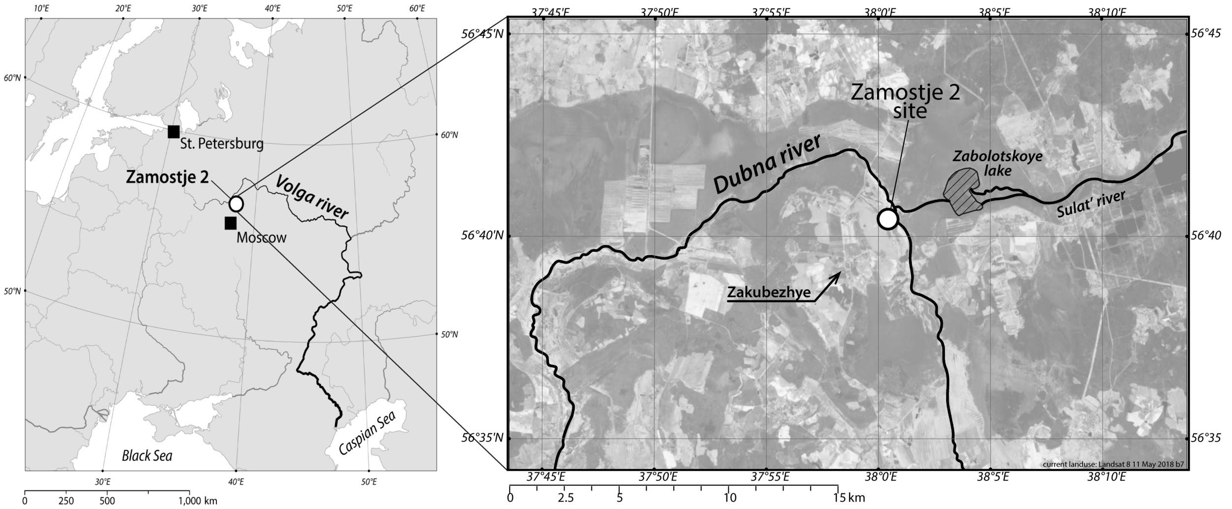
Figure 2. Pottery from Zamostje 2: EN sherds with (a, b) long-comb decorations (stage III), (c) covered by incised lines (stage I.2); (d) Ceramic from EN layer (stage I.2) with remains of Viburnum (Viburnum opulus L.) berries in the crust, (e) MN Pottery with pit ornamentation.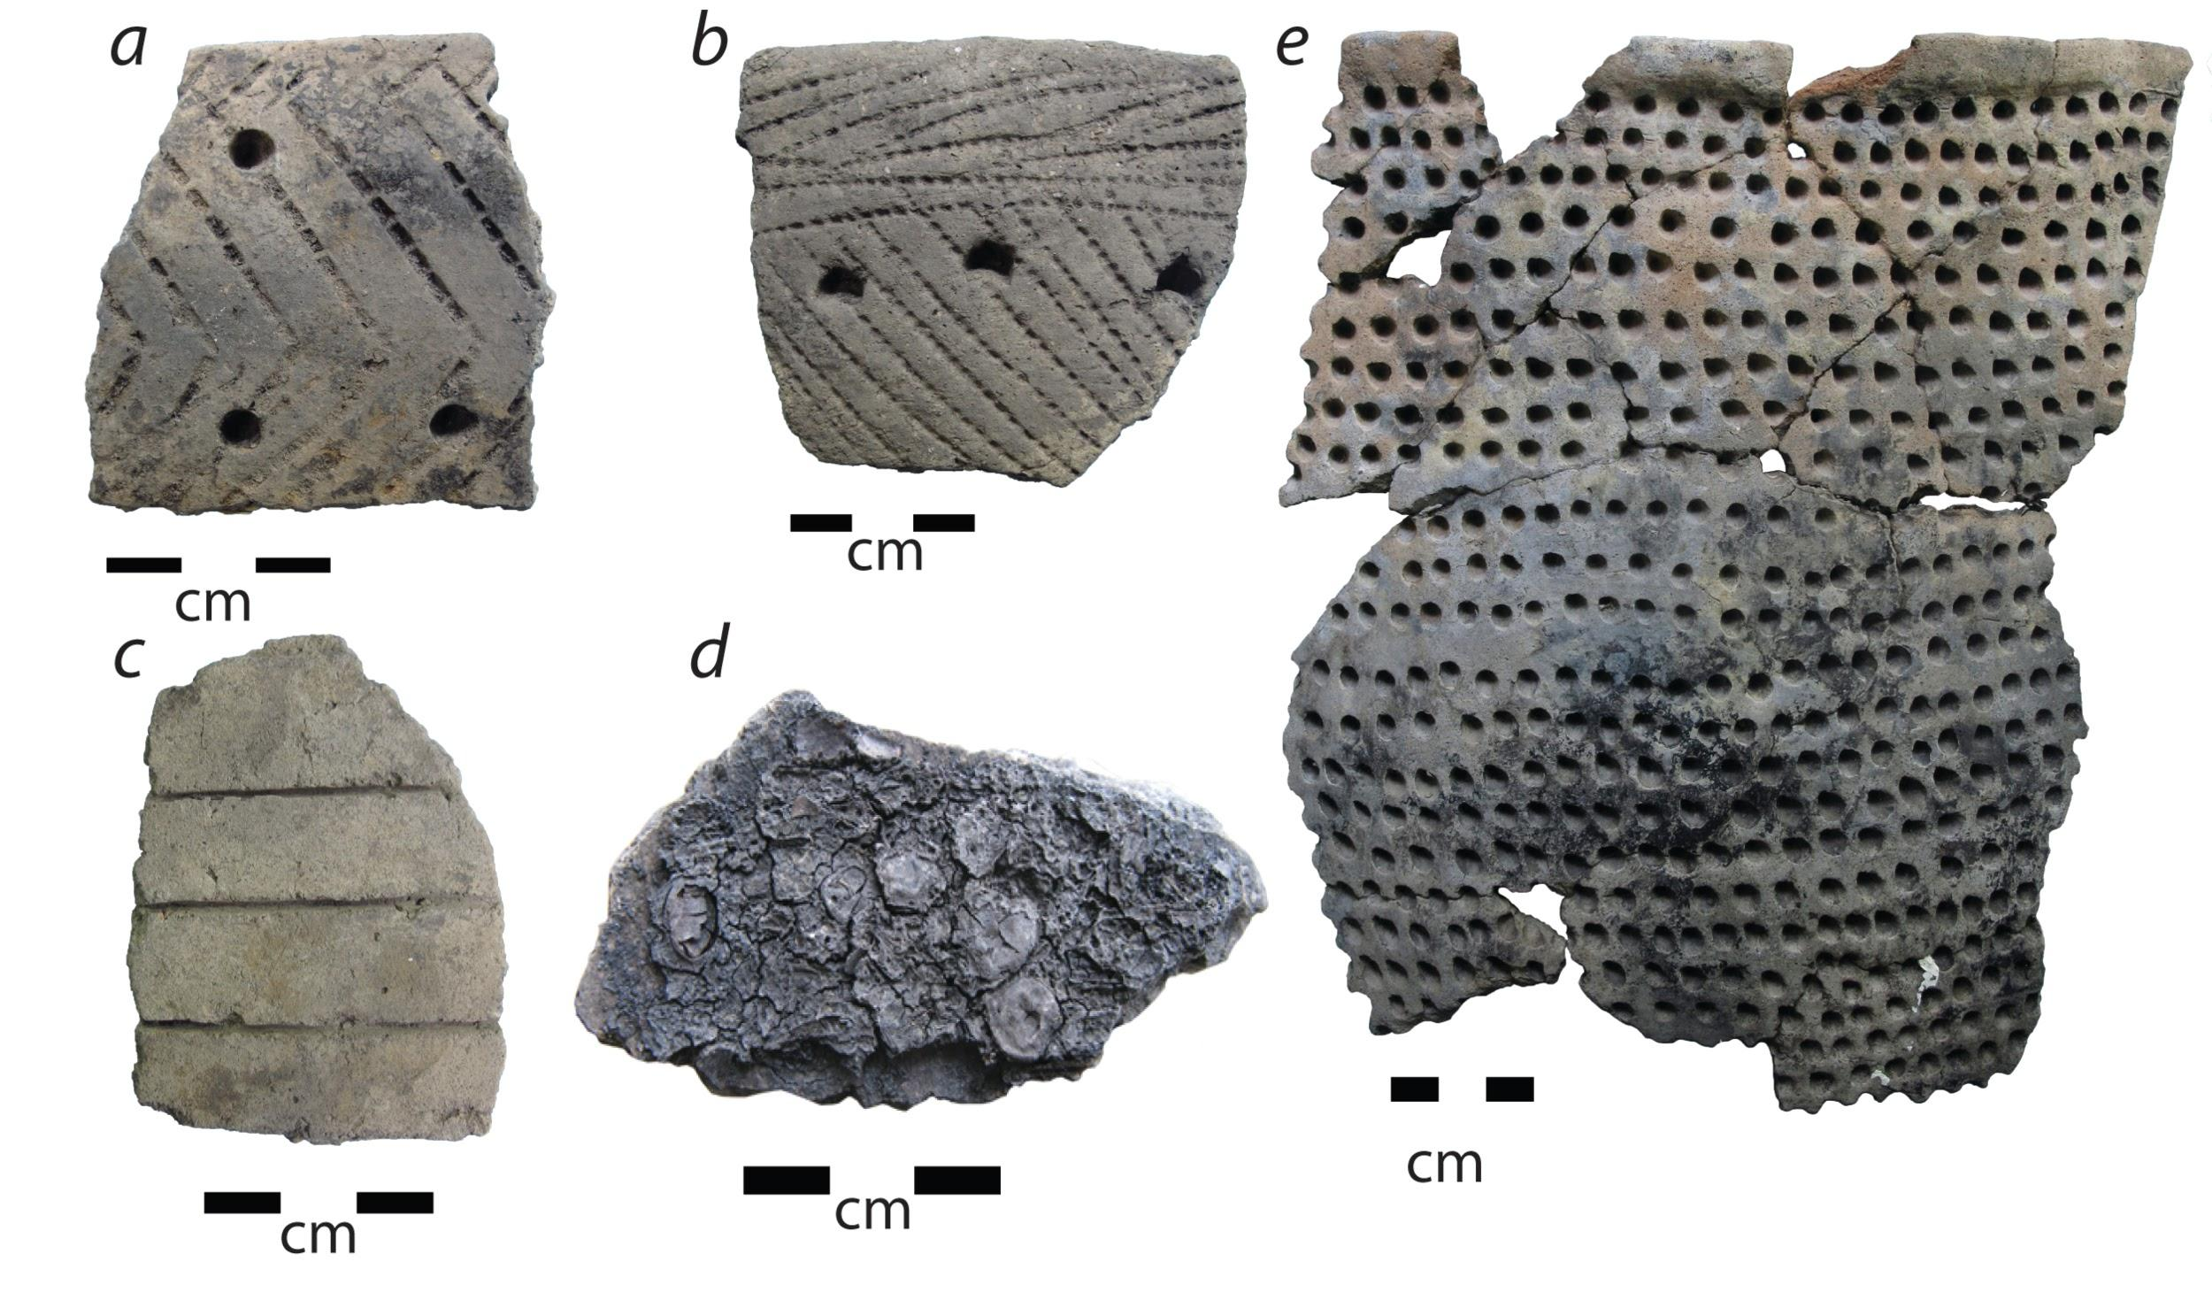

Figure 3. Plant and faunal remains and artefacts from Zamostje 2: (a) bone hooks from the EN, Final Mesolithic and mixed layers (from left to right), (b) bone net needles from the Upper Mesolithic, (c) floats from the Lower and Upper Mesolithic layer (from top to bottom), (d) tool made from beaver mandible from the Lower Mesolithic layer, (e) elk head figures made from elk antler from the Lower Mesolithic layer, (f) and (g) pine cone and nut remains from the Lower Mesolithic and mixed layer respectively, (h) barbed point from the EN.
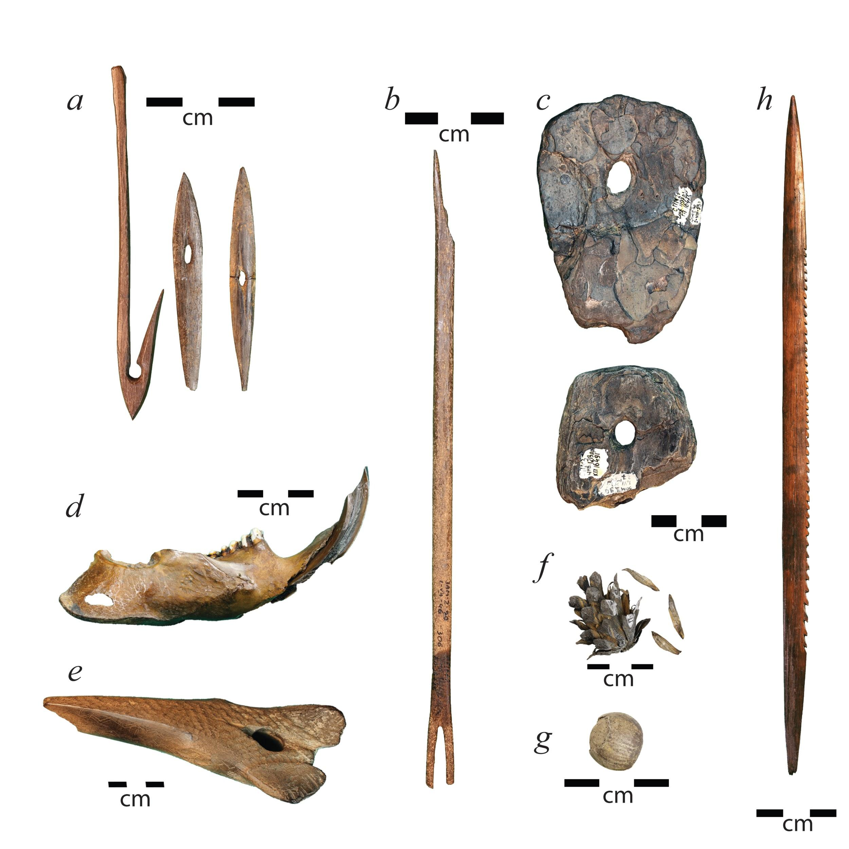

Figure 4. Summary of archaeological evidence changes in Zamostje 2: dates, pottery cultures, subsistence strategies and environmental conditions. Based on the following references: (Lozovski, 1996; Clemente et al., 2002; Ershova, 2013; Gyria et al., 2013; Lozovski and Lozovskaya, 2013; 2016; Lozovski et al., 2013a; 2013b; 2014; Mannermaa, 2013; Radu and Desse-Berset, 2013; Berihuete Azorin and Lozovskaya, 2014; Leduc and Chaix, 2014; 2018; Mannermaa and Treuillot, 2014; Meadows et al., 2015; Berihuete, 2018; Ershova and Lozovskaya, 2018).

Figure 5. Total ion current of an acid/methanol extract of the foodcrusts sample from pot LN10642, Zamostje 2. Partial gas chromatogram of lipid showing saturated fatty acids (FA), diacids (DC), branched chain fatty acids (br), long-chain unsaturated fatty acids, sterols and triterpenes whose amyrin derivatives are indicated.

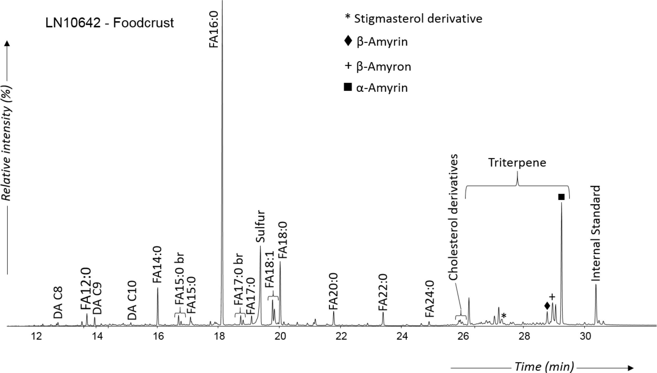

Figure 6. SIM chromatogram indicating the aquatic biomarkers from sample LN10642 analysed on the DB-23 column. The ω-(o-alkylphenyl) alkanoic acids were identified with ions m/z 105, 262, 290, 318, with the last three ions corresponding to the carbon length C₁₆, C₁₈, and C₂₀respectively. 4,8,12- trimethyltridecanoic acid was monitered with ions m/z 87, 270 and phytanic acid with ions m/z 101, 171, 326. The m/z 101 ion chromatogram shows the diastereomers of phytanic acid (SRR and RRR), which allowed us to calculate the relative abundance these diastereomers.
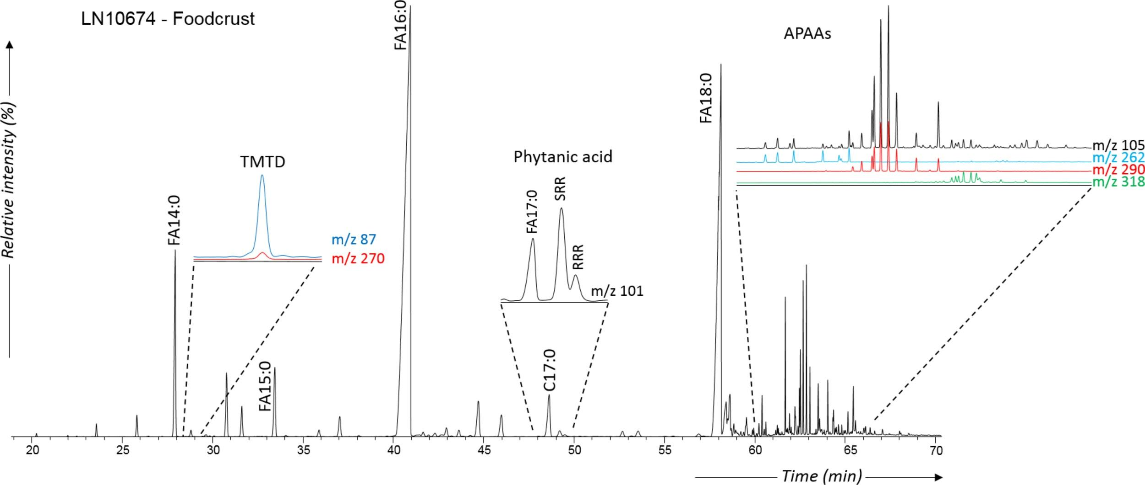
Figure 7. Δ¹³C (δ¹³C_{18:0}−δ¹³C_{16:0}) values against δ¹³C_{16:0} values obtained from foodcrusts and sherds from (A) EN (n = 85) and (B) MN (n = 66) pottery. Crosses indicate modern elk from the Zamostje 2 region. Samples with the full and partial set of aquatic biomarkers are shown by filled circles. NEED TO BE PRINTED IN COLOR

Figure 8. Plot of δ¹⁵N bulk isotope values against C:N ratio obtained from foodcrusts samples from Early (n = 56) in orange and MN (n = 53) in green showing (A) samples in which amyrin derivatives were detected by filled diamonds, (B) samples with the full set of aquatic biomarkers by filled circles.

Table 1. Table summarizing the proportion of plant and aquatic biomarkers detected in the samples according to the period and comparing the proportion of the main plant biomarkers (amyrin and derivatives) and aquatic biomarkers through the different EN stages and MN.

Period | Stage | Samples analysed | Yielding lipids (%)* | Yielding triterpenes (%) | Yielding amyrin and derivatives (%) | Yielding diterpenes (%) | Yielding plant sterols (%) | Yielding aquatic biomarkers (%)
Early Neolithic | Early stage | 52 |  |  | 52 |  |  | 53
 | Middle stage | 44 |  |  | 47 |  |  | 49
 | Late stage | 10 |  |  | 30 |  |  | 73
Total |  | 143 | 82 | 65 | 45 | 32 | 22 | 55
Middle Neolithic |  | 97 | 86 | 23 | 0 | 23 | 12 | 81

Table 2. Mann-Whitney U test showing correlation between the bulk δ¹⁵N, C:N ratio and molecular characterization. The test revealed a significant difference of δ¹⁵N and C:N ratio between EN and MN samples, samples with or without the full set of aquatic biomarkers and samples with or without amyrin derivatives. However, there is no correlation between δ¹³C values and periods or molecular characterization of samples.
Category | δ¹⁵N (‰) | δ¹³C (‰) | C:N ratio
Period (EN vs. MN) | U=118; z=8.2; p<0.01 | U=1217; z=1.3;  p = 0.2 | U=339; z=6.8; p<0.01
Aquatic biomarkers  (presence vs. absence) | U=457; z= 3.9; p<0.01 | U=949; z=0.1;  p=0.9 | U=397; z=4.3; p<0.01
Amryin derivatives  (presence vs. absence) | U=156; z=7.4; p<0.01 | U=1126; z=1.0; p= 0.3 | U=198; z=7.1; p<0.01

