Pentaerythritol Derived Tetrapode Exhibiting a Nematic-Like Mesophase at Ambient Temperatures
Miss Jodie L. Hann ª, Dr Richard J. Mandle ª*
Richard.mandle@york.ac.uk
ª Department of Chemistry, University of York, York, UK, YO10 5DD
Abstract
The nematic liquid-crystalline phase exhibits average orientational order, with no positional organisation. So-called modulated nematic phases exhibit this same orientational order with an additional spatially periodic modulation of the nematic director, the most common of which is the twist-bend nematic phase. We report a pentaerythritol derived tetrapode which exhibits a nematic-like mesophase at ambient temperature, and we denote this new mesophase ‘N_{X}’ to indicate a nematic phase of unknown structure. X-ray scattering experiments refute the possibility of positional order, yet optical textures are consistent with a periodic structure. We suggest that the mesophase exhibited by this material is new type of nematic-like mesophase with some form of modulated structure. We find the N_{X} phase to exhibit an electrooptic response consistent with a nematic-like phase.
Introduction
The nematic mesophase possesses only an average orientational order without any positional order (e.g. layers). As nematic phases form the cornerstone of the display industry, as such the discovery of new nematic modifications, while rare, sparks much interest. The twist-bend nematic phase (TB or N_{TB}), predicted by Dozov ^{[1]} and principally observed in bent liquid crystalline dimers, ^{[2-8]} is understood to possess a helical structure with a pitch length of a few nanometers. ^{[9-11]} The TB phase is an example of a modulated nematic-like phase in which the average orientational order is also augmented with an additional periodic structure while still lacking positional order. The TB phase exhibits a electrooptic response on a timescale of a few microseconds, ^{[12]} and also provides a simple route to materials with defined nanostructures via in situ photopolymerisation ^{[13]} which may find use in photonics. ^{[14-17]} Other modulated nematic-like phases are known to exist: Mertelj et al recently discovered a nematic-like mesophase with a periodic splay modulated structure (N_{S}), ^{[18]} and we recently reported a novel nematic-like phase in binary mixtures of bent-dimers and a high helical twisting power additive. ^{[19]}
Typically, modulated nematic phases are found at elevated temperatures and as such they are of minimal practical use. Appending multiple mesogenic units to a central scaffold has been shown to be a useful strategy to give materials with significantly reduced melting points. ^{[20-23]} The manner of attachment of the mesogenic units to the central scaffold, e.g. lateral versus terminal, has been shown to control the type of phase exhibited (nematic versus smectic), ^{[24]} whereas the chemical makeup of the central scaffold does not appear to influence the mesomorphic behaviour of the resulting materials. ^{[23]} We considered that combining this approach with the structural units of a bent LC dimer (in the present case, one half of the dimer CB6OCB) ^{[25]} could lead to the first room temperature modulated nematic phases. We observed that one such material exhibits a previously unreported nematic modification, and this is the subject of this present communication.
Experimental
The intermediate i1 was synthesised in 3 steps as described by Al-Janabi et al. ^{[26]} the intermediate i2 [CAS: 35638-19-8] was purchased from Frontier Scientific. The synthesis of 1 was trivial from i1 and the tetraacid i2 as shown in Scheme 1. Full experimental details are given in the ESI to this article. Quantum chemical calculations were performed using Gaussian G16 rev A03, ^{[27]} with select output files rendered in Qutemol. ^{[28]}
Scheme One
Results and Discussion
We studied the liquid-crystalline behaviour of 1 by polarised optical microscopy (POM), differential scanning calorimetry (DSC) and small angle X-ray scattering (SAXS). Phase identification was made by POM and SAXS, transition temperatures were determined by POM and DSC, and associated enthalpies of transition were measured by DSC (Table 1).
No. |  | Tg | N_{X}-I
1 | T | -6.6 | 43.6
 | ΔH | - | 7.8
Table 1: Transition temperatures (T, °C) and associated enthalpies of transition (ΔH, kJ mol⁻¹) for 1 as determined by DSC at a heat/cool rate of 10 °C min⁻¹. MP = melting point, Tg = glass transition, N_{X} -I = clearing point

The tetrapode 1 is a viscous liquid crystal at ambient temperature (21 °C, see Figure SI-1 in ESI and the graphical abstract) and undergoes a glass transition at – 6.6 °C. The material clears into the isotropic liquid at 43.6 °C and this is accompanied by an associated enthalpy of 7.8 kJ mol⁻¹. Typically, as is common with high molecular weight liquid-crystalline materials, cooling into the liquid-crystalline phase from the isotropic liquid gave small domains from which no phase assignment could be made. To obtain informative optical textures we annealed samples of 1 between untreated glass for a period of one week at 41 °C. The optical textures of 1 are reminiscent of the TB phase, being comprised of block-like regions, focal-conics, rope-like textures and parabolic defects, with additional homeotropic regions (Figure 1). The optical textures are sufficiently distinct from those of the nematic phase that we can discount the possibility of 1 exhibiting this phase – at no point do we observe the schlieren texture which is characteristic of the nematic state. The formation of focal-conic and parabolic defects is associated with structural periodicity, either through a spatially modulated structure (e.g. TB phase) or positional order (e.g. SmA phase). We note that it is not possible for these optical textures to exist without a periodic structure. The optical textures are different to those of the smectic A phase exhibited by structurally similar materials reported previously, see compound 4 in ref ^{[24]} and compound “T-CN” in ref ^{[21]}. Similarly, the optical textures – while similar to - are distinct from those of the TB phase formed on cooling from the isotropic liquid; we do not observe the blocky texture of the TB phase for example. Shearing the N_{X} phase of 1 leads to a uniformly birefringent texture whereas shearing generally gives a homeotropic texture in the TB phase. We studied 1 by DSC (DSC traces for 1 are given in the SI), finding the enthalpy associated with the N_{X}-iso phase transition (ΔH_{Nx-I} = 7.8 kJ mol⁻¹) to be larger than that reported previously for the TB-Iso transition; values of ΔH_{TB-I} range from 0.8 kJ mol⁻¹ ^{[29]} to 2.2 kJ mol⁻¹. ^{[30]}
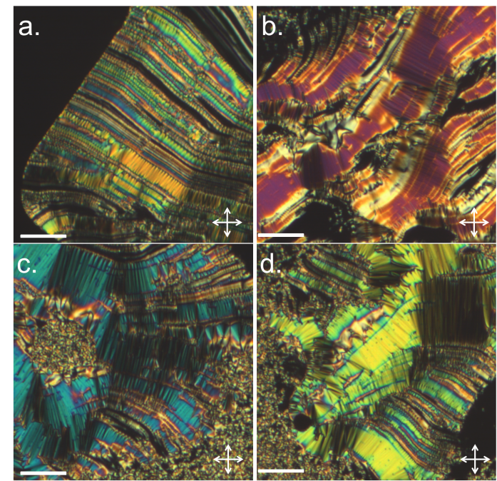
Figure 1: Photomicrographs of 1 in the N_{X} phase: (a) rope like texture; (b) blocky texture and homeotropic regions; (c) fan texture, rope texture and parabolic defects; (d) fan texture and rope texture. The scale bar is 100 μm; all photographs were taken at ambient temperature (21 °C).
SAXS was employed to confirm the nematic-like (i.e. lack of positional order) nature of the mesophase exhibited by 1. Data was collected as a function of temperature, the scattering pattern of an empty capillary was used as a background. As shown in Figure 2, the lack of Bragg scattering refutes the possibility of 1 exhibiting a smectic phase at the temperatures studied (25 – 50 °C, Figure 2). Instead, we observed only diffuse scattering peaks at small and wide angles corresponding to d-spacings of 12.7 Å and 4.8 Å, respectively. Note, that the scattering at small angles is weak (Figure 2e). At the Iso-N_{X} transition there is a small change in the position of the wide-angle scattering peak (ΔQ ≈ 0.04 Å⁻¹), whereas the small-angle peak is unchanged in both intensity and position (see also Figure SI-3 in the ESI). We did not observe scattering at smaller angles, down to a lower Q value of 0.05 Å⁻¹; this corresponds to a lower limit for any possible layer spacing of around 125 Å. The fully extended, end-to-end molecular length of 1 is 50 Å (B3LYP/6-311G(dp) level of DFT) which suggests that the spacing of a hypothetical layered structure would be well within the Q range accessible to us, even if it were a bilayer type system with a spacing of c.a. 2x the molecular length.Lamellar nematic and isotropic phases (Lam_{N} and Lam_{iso} respectively) both exhibit Bragg scattering and can be excluded as possibilities. ^{[31]} We considered the possibility that potential smectic layers may be in a homeotropic orientation relative to the incident beam (Figure 2a), and that this could lead to a lack of Bragg scattering. Rotating the sample capillary 90 ° would therefore give planar orientation (Figure 2b), however we note that there was no change in scattering pattern upon rotation of the sample (Fig SI-4). SAXS studies on structurally related tetrapodes that exhibit smectic A phases do show Bragg scattering, ^{[21, 32]} therefore absence in 1 is not due to some behavioural peculiarity of tetrapodes but rather indicative of a nematic or nematic-like phase. We also considered that a layered structure may evolve slowly and therefore be absent in SAXS experiments; the capillary containing compound 1 was annealed at ambient temperature (19±2 °C) for a period of six months and periodically examined by X-ray scattering and optical microscopy. We did not observe Bragg scattering at any point and we therefore conclude there is no positional organisation in the N_{X} phase of 1. Studies by SAXS therefore support the identification of a phase with no positional molecular organisation (i.e. a nematic or nematic-like phase) and rule out the possibility of 1 exhibiting a smectic or lamellar phase.
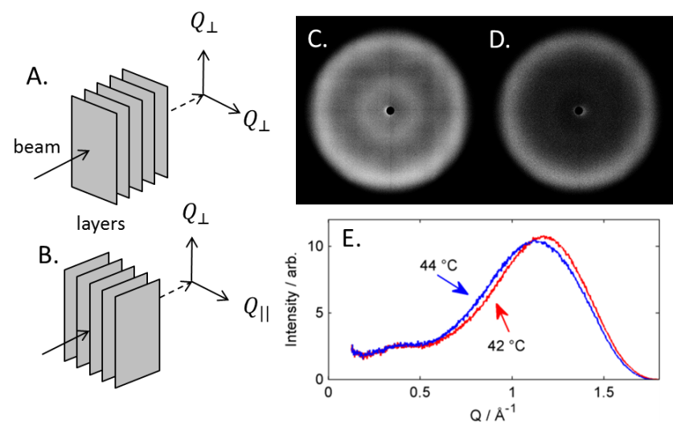
Figure 2: Sketches of layer orientation relative to incident X-ray beam in: (A) a homeotropic sample, (B) a planar sample. Unaligned 2D SAXS patterns for 1 at 42 °C; (C) raw 2D SAXS pattern, and (D) background subtracted 2D SAXS pattern. Plot of integrated intensity as a function of the scattering vector Q (Å⁻¹) for 1 at 44 °C (blue dots) and 42 °C (red dots) (E).

Between any two mesogenic units of 1 there are 25 atoms giving an overall bent shape – framing the molecular structure in this way we can think of 1 as two dimers joined by a single quaternary carbon rather than four independent units appended to a central scaffold. Some conformations are anticlastic, with each dimer pair bending in opposing directions. Using the procedure outlined by Archbold et al ^{[7]} we generated a library of conformers for 1 using the AM1 semi-empirical method, before calculating the probability of a given bend angle between two opposing mesogenic units as shown in Figure 3c. The probability weighted bend-angle is 98 °, however the distribution of bend angles is rather broad due to the sheer number of conformers – we find the FWHM of a Gaussian fit to the major peak (Figure 3c) to be 45 °, far larger than that of simple LC dimers such as CB9CB (19 °C) and CB8OCB (31 °C). ^{[8]} There is also a significant population of hairpin conformers, defined here as those with a bend-angle of less than 60 °. The flexibility of the material and large number of conformers it can adopt probably contribute significantly to the absence of a crystalline solid (the material forms a glass on cooling) and low clearing point.
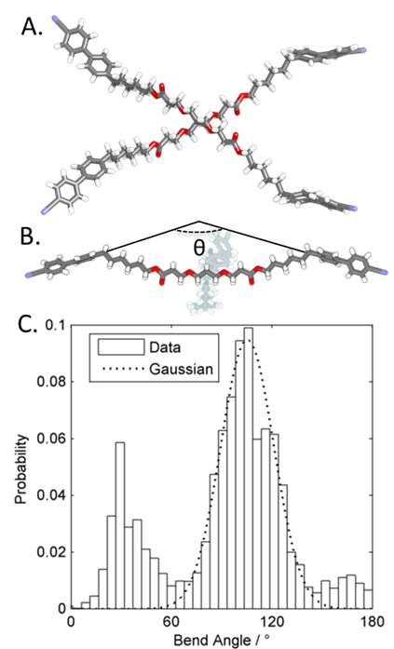
Figure 3: (A) The DFT(B3LYP/6-311G(dp)) optimised geometry of 1 viewed from above the plane of the mesogenic units (B) the DFT(B3LYP/6-31G(dp)) optimised geometry 1 viewed side on, with one opposing pair of arms greyed out. (C) Histogram plot of probability of a given bend angle, i.e. the angle between two opposing mesogenic units, with a Gaussian fit to the major peak centered at 98 °.
Many previous examples of tetrapodes and dendrimers – which variously exhibit nematic, smectic A, and smectic C phases -incorporate long alkyl spacers between the central scaffold and/or multiple siloxanes, which exhibit effectively free rotation about the Si-O-Si bond. ^{[33]} The ability of materials incorporating these functionalities to be deformed to a more rod-like shape may facilitate the formation of lamellar phases. The use of a relatively short, methylene-linked spacer in 1 prevents the material organising into a rod-like shape and forming conventional nematic and smectic phases, instead leading to the observed N_{X} phase.
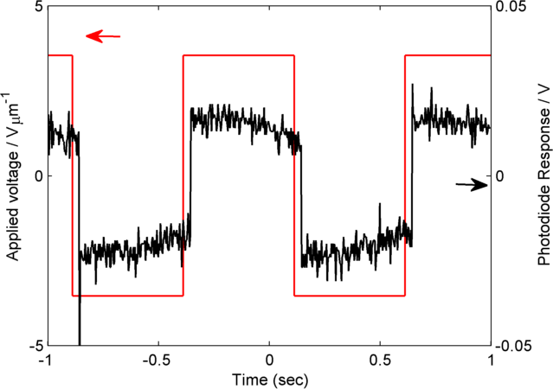
Figure 4: Plot of applied voltage (V μm⁻¹, left) and photodiode response (V, right) as a function of time (s) for compound 1 in a 5μm cell with planar alignment layers while under an applied electric field (square waveform, amplitude of 10 V_{pp,} frequency of 2Hz)
Lastly, we studied the behaviour of 1 under applied electric fields. After filling into a 5 μm cell with ITO electrodes by capillary action, we applied an electric field (square waveform, 10 V_{pp}, 2 Hz) while holding the temperature at 30 °C. The sample was illuminated under crossed polarisers, and a photodiode was used to measure the optical response as a function of applied voltage. The measured optical response is not particularly fast, with around 40 ms between the application of the electric field and the optical response. Nevertheless, the observation of a Fréedericksz transition at (relatively) small applied voltage is consistent with the idea of the N_{X} phase lacking positional order, i.e. a nematic or nematic-like phase rather than a smectic phase.
Conclusions
The pentaerythritol derived tetrapode 1 exhibits a nematic-like phase at room temperature (N_{X}) which undergoes a direct transition to the isotropic liquid without an intervening ‘true’ nematic phase; the observation of optical textures that require a periodic structure strongly suggest this to be a new form of modulated nematic-like phase. X-ray scattering indicates the phase lacks positional order, and as such the phase is “nematic-like”, with no positional organisation. The structure of 1 is a radical departure from that of materials used to generate modulated nematic phases such as the TB or splay nematic phases. For many applications the ability to operate at typical ambient temperatures (i.e. 0 °C to 40 °C) is essential, in that regard 1 (and its mixtures, homologues and analogues) could accelerate the development of technologies utilising modulated nematic mesophases, provided the inherently high viscosity and slow electrooptic response can be overcome.
Acknowledgements
RJM and JLH acknowledge funding from the Department of Chemistry at the University of York via a Departmental Vacation Bursary for JLH. The Bruker D8 SAXS/WAXS equipment used in this research was funded by the EPSRC via EP/K039660/1.
Keywords: Liquid Crystals, Nematics, Soft Matter, X-ray Scattering
References
[1] I. Dozov, Europhys Lett 2001, 56, 247-253.
[2] P. J. Barnes, A. G. Douglass, S. K. Heeks, G. R. Luckhurst, Liq Cryst 1993, 13, 603-613.
[3] M. Cestari, S. Diez-Berart, D. A. Dunmur, A. Ferrarini, M. R. de la Fuente, D. J. Jackson, D. O. Lopez, G. R. Luckhurst, M. A. Perez-Jubindo, R. M. Richardson, J. Salud, B. A. Timimi, H. Zimmermann, Phys Rev E Stat Nonlin Soft Matter Phys 2011, 84, 031704.
[4] M. Sepelj, A. Lesac, U. Baumeister, S. Diele, H. L. Nguyen, D. W. Bruce, J Mater Chem 2007, 17, 1154-1165.
[5] R. J. Mandle, Soft Matter 2016, 12, 7883-7901.
[6] R. J. Mandle, C. T. Archbold, J. P. Sarju, J. L. Andrews, J. W. Goodby, Sci Rep 2016, 6, 36682.
[7] C. T. Archbold, R. J. Mandle, J. L. Andrews, S. J. Cowling, J. W. Goodby, Liq Cryst 2017, 44, 2079-2088.
[8] E. E. Pocock, R. J. Mandle, J. W. Goodby, Soft Matter 2018, 14, 2508-2514.
[9] C. Zhu, M. R. Tuchband, A. Young, M. Shuai, A. Scarbrough, D. M. Walba, J. E. Maclennan, C. Wang, A. Hexemer, N. A. Clark, Phys Rev Lett 2016, 116, 147803.
[10] D. Chen, J. H. Porada, J. B. Hooper, A. Klittnick, Y. Shen, M. R. Tuchband, E. Korblova, D. Bedrov, D. M. Walba, M. A. Glaser, J. E. Maclennan, N. A. Clark, Proc Natl Acad Sci U S A 2013, 110, 15931-15936.
[11] V. Borshch, Y. K. Kim, J. Xiang, M. Gao, A. Jakli, V. P. Panov, J. K. Vij, C. T. Imrie, M. G. Tamba, G. H. Mehl, O. D. Lavrentovich, Nat Commun 2013, 4, 2635.
[12] V. P. Panov, R. Balachandran, M. Nagaraj, J. K. Vij, M. G. Tamba, A. Kohlmeier, G. H. Mehl, Appl Phys Lett 2011, 99, 261903.
[13] V. P. Panov, S. P. Sreenilayam, Y. P. Panarin, J. K. Vij, C. J. Welch, G. H. Mehl, Nano Lett 2017, 17, 7515-7519.
[14] J. Xiang, Y. Li, Q. Li, D. A. Paterson, J. M. D. Storey, C. T. Imrie, O. D. Lavrentovich, Adv Mater 2015, 27, 3014-3018.
[15] Y. Wang, Z.-g. Zheng, H. K. Bisoyi, K. G. Gutierrez-Cuevas, L. Wang, R. S. Zola, Q. Li, Materials Horizons 2016, 3, 442-446.
[16] H. K. Bisoyi, Q. Li, Accounts of Chemical Research 2014, 47, 3184-3195.
[17] L. Wang, Q. Li, Adv Funct Mater 2016, 26, 10-28.
[18] A. Mertelj, L. Cmok, N. Sebastian, R. J. Mandle, R. R. Parker, A. C. Whitwood, J. W. Goodby, M. Copic, Phys Rev X 2018, 8.
[19] R. J. Mandle, J. W. Goodby, Soft Matter 2018, 14, 8846-8852.
[20] K. Merkel, A. Kocot, J. K. Vij, G. H. Mehl, T. Meyer, Phys Rev E 2006, 73.
[21] D. Filip, C. Cruz, P. J. Sebastiao, A. C. Ribeiro, M. Vilfan, T. Meyer, P. H. J. Kouwer, G. H. Mehl, Phys Rev E 2007, 75.
[22] H. Sasaki, Y. Takanishi, J. Yamamoto, A. Yoshizawa, J Phys Chem B 2015, 119, 4531-4538.
[23] I. M. Saez, J. W. Goodby, Liquid Crystalline Functional Assemblies and Their Supramolecular Structures 2008, 128, 1-62.
[24] I. M. Saez, J. W. Goodby, J Mater Chem 2003, 13, 2727-2739.
[25] D. A. Paterson, M. Gao, Y. K. Kim, A. Jamali, K. L. Finley, B. Robles-Hernandez, S. Diez-Berart, J. Salud, M. R. de la Fuente, B. A. Timimi, H. Zimmermann, C. Greco, A. Ferrarini, J. M. D. Storey, D. O. Lopez, O. D. Lavrentovich, G. R. Luckhurst, C. T. Imrie, Soft Matter 2016, 12, 6827-6840.
[26] A. Al-Janabi, R. J. Mandle, J. Goodby, Rsc Adv 2017, 7, 47235-47242.
[27] M. J. Frisch, G. W. Trucks, H. B. Schlegel, G. E. Scuseria, M. A. Robb, J. R. Cheeseman, G. Scalmani, V. Barone, G. A. Petersson, H. Nakatsuji, X. Li, M. Caricato, A. V. Marenich, J. Bloino, B. G. Janesko, R. Gomperts, B. Mennucci, H. P. Hratchian, J. V. Ortiz, A. F. Izmaylov, J. L. Sonnenberg, Williams, F. Ding, F. Lipparini, F. Egidi, J. Goings, B. Peng, A. Petrone, T. Henderson, D. Ranasinghe, V. G. Zakrzewski, J. Gao, N. Rega, G. Zheng, W. Liang, M. Hada, M. Ehara, K. Toyota, R. Fukuda, J. Hasegawa, M. Ishida, T. Nakajima, Y. Honda, O. Kitao, H. Nakai, T. Vreven, K. Throssell, J. A. Montgomery Jr., J. E. Peralta, F. Ogliaro, M. J. Bearpark, J. J. Heyd, E. N. Brothers, K. N. Kudin, V. N. Staroverov, T. A. Keith, R. Kobayashi, J. Normand, K. Raghavachari, A. P. Rendell, J. C. Burant, S. S. Iyengar, J. Tomasi, M. Cossi, J. M. Millam, M. Klene, C. Adamo, R. Cammi, J. W. Ochterski, R. L. Martin, K. Morokuma, O. Farkas, J. B. Foresman, D. J. Fox, Wallingford, CT, 2016.
[28] M. Tarini, P. Cignoni, C. Montani, Ieee T Vis Comput Gr 2006, 12, 1237-1244.
[29] C. T. Archbold, E. J. Davis, R. J. Mandle, S. J. Cowling, J. W. Goodby, Soft Matter 2015, 11, 7547-7557.
[30] A. A. Dawood, M. C. Grossel, G. R. Luckhurst, R. M. Richardson, B. A. Timimi, N. J. Wells, Y. Z. Yousif, Liq Cryst 2016, 43, 2-12.
[31] X. H. Cheng, M. Prehm, M. K. Das, J. Kain, U. Baumeister, S. Diele, D. Leine, A. Blume, C. Tschierske, J Am Chem Soc 2003, 125, 10977-10996.
[32] G. H. Mehl, J. W. Goodby, Chem Ber 1996, 129, 521-525.
[33] F. Weinhold, R. West, Organometallics 2011, 30, 5815-5824.

TOC ENTRY
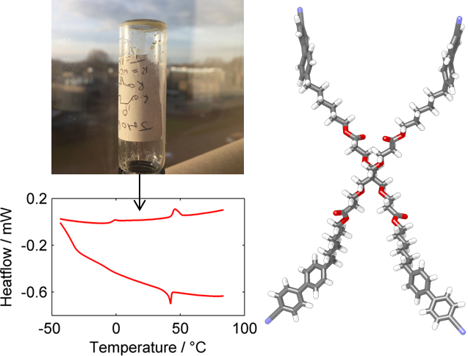
X-Marks the spot: An X-shaped material comprised of four mutually appended mesogenic units is found to exhibit an unusual liquid crystalline phase at ambient temperatures. The mesophase observed is nematic-like, lacking positional order, but displays properties consistent with a periodic organisation.

