Endotic Englishness: Meades, Perec and the everyday curiosities of place

DARYL MARTIN

By reading Georges Perec alongside another post-war writer with whom he has affinities – Jonathan Meades – this chapter brings ‘everyday curiosities’ into focus. These curiosities, which both Perec and Meades exemplify and inspire, revolve around memory, materiality and place – interconnected themes that are illustrated and unpacked in the course of this chapter. Meades is a writer whose work since the 1980s has encompassed novels, short stories, food writing and architectural criticism for literary journals and British broadsheet newspapers. Since the 1990s, he is best known for his sequence of BBC film essays, primarily on architecture. These films avoid the clichés of much mainstream arts broadcasting and instead offer visually inventive commentaries on built environments and their cultural histories. The originality of his approach across media, and the variety of forms in which he contributes creative and robust critiques of architecture and its orthodoxies, indicates the ease with which Meades crosses intellectual traditions. The scope and span of Meades’s interests, I will argue in this chapter, share the interdisciplinary reach of Perec’s work, and similarly illustrate the value of adopting a curiosity-driven approach to our everyday materialities and landscapes, in order to re-animate our understanding of them.

Meades and Perec make for an odd couple, at first sight. Their writings cover different geographies and have different affects – their work is temperamentally dissimilar, with nothing in Perec’s oeuvre matching the abrasiveness of Meades’s early novels and stories. And yet, Meades’s ongoing interests in dissecting conventional understandings of Englishness in its many varieties, and topography more generally, makes for an intriguing point of comparison with some of Perec’s literary and documentary strategies. By suggesting a connection between the two writers, I do not wish to claim a sustained influence on Meades by Perec; although Meades has read Perec, there are no substantive grounds for making such a strong claim. In interviews, Meades has professed the influence of figures associated with the Nouveau Roman, especially Alain Robbe-Grillet, and writers such as Michel Tournier, rather than pointing to Perec or other members of the Oulipo group. There may well be writers who have inspired both Meades and Perec, but this chapter does not embark on a genealogy of their common literary reference points. Rather, I want to place their work into dialogue with each other in order to show how both writers use similar techniques for rendering a sense of place, and describing the materialities that accumulate to compose a sense of historical time. Their works argue that moments of cultural memory should be sought within the fragments of everyday material cultures, rather than the extraordinary events that bolster glossed over narratives of particular places. At root, Meades and Perec act as advocates for retaining a ‘space for curiosity’ in how we describe, imagine and interpret our social worlds.

I begin by drawing on examples within both writers’ work that show the inter-relatedness of individual memories and cultural histories, and reflect on the unreliability of authorship in autobiographical writing. Then, I move on to compare how their work treats the role of everyday materialities, or the stuff of material culture, in the shaping of our understandings of place. Finally, I suggest an affinity between both writers in their delight in banal landscapes: for both Meades and Perec, ostensibly boring places are valuable in helping us to look at our social worlds more precisely, with greater curiosity and understanding. Throughout the chapter, I will draw from Meades’s recent memoir An Encyclopaedia of Myself and his landscape photography collection Pidgin Snaps. I will read these alongside Perec’s varied writings on space, memory and the anthropology of everyday materialities, in order to locate resonances between these apparently unrelated writers.

Memory

An Encyclopaedia of Myself is a memoir of post-war life in Wiltshire which is limited to the first two decades of Meades’s life. In offering a deeply textured sense of place inscribed through the micro-memories and embodied perspectives of a child, Meades avoids any tendency to neatly subsume the detail of events and spaces within an overarching narrative trajectory. In her review of the book, Bee Wilson suggests that Meades’s memoir is ‘not so much an autobiography as a series of detailed inventories of English provincial life in the 1950s’, and that despite its title, ‘this is not an encyclopedia of Meades himself so much as of a particular people and its strange and complicated value system’. Meades’s eye for the particularities and vanities of provincial England at the time is sharp; we get eight chapters in his memoir devoted to the non-family army majors of his locale that tell us little of Meades’s upbringing but rather more about their own humdrum routines. The effect of such excessive description of individuals marginal to the experience of Meades as a child is not to further any narrative line. The overall effect of such dense character detail is to disrupt narrative development and, instead, conjure up a mood rather than conform to biographical conventions. The evocation of an atmosphere rather than a narrative line in Meades’s memoir is also achieved through an encyclopedic structure, with the chapters arranged in alphabetical order, abandoning the typical trajectories of biographical genres.

The fallibility and inconstancy of memory is a theme shared between Meades – who writes that his ‘earliest memory is loitering in False Memory Lane’, within a chapter devoted to multiple first memories – and Perec, who acknowledged that his autobiographical book on cultural memory, I remember, was ‘stuffed with mistakes’. In its subtle epigraph – ‘Nothing wilfully invented. Memory invents unbidden’ – Meades recalls the sincere unreliability of the author and subverts the misery memoir tradition through his borrowing, then disavowal, of its major tropes. The unreliable author, constrained by the contingencies of subjective recall, is also a feature found in Perec’s W or the memory of childhood, a book which frustrates typical expectations of childhood memoirs. In the preface to the Vintage edition of this book, Perec identifies the centrality of remembrance, and its failures, to literary practice itself, locating his autobiography as resting on ‘the points of suspension on which the broken threads of childhood and the web of writing are caught’. The falsity of memory in these works is also indicative of a common ludic sensibility and writing strategies that frustrate formulaic genre norms. Like his television essays, which subvert expectations of how documentary films should be structured, Meades’s memoir shares with Perec a systematically playful approach. The chapter titles are red herrings, spurs to a discombobulated rendering of the past: so, the opening chapter ‘Abuser, Sexual’ indicates only that the younger Meades was not subject to abuse (and there then follows a list of various paedophile stereotypes who did not subject him to abuse). We have lists by Meades not only of names from his youth, but also of names that he did not encounter in his youth:

Why were people called Salmon, Pike, Gudgeon, Whiting, Chubb, Grayling, Roach, Haddock, Spratt, Bass? But not Tench, Minnow, Eel, Lamprey, Perch, Carp, Huss, Plaice…
Why were people called Hill, Vale, Field, Wood, Ford, Rivers (always plural), Bridge, Brook, Park, Street? But not Road, Track, Path, Stream, Ditch, Garden, Copse, Canal.

For Meades the younger (and the older writer), these are the idiosyncrasies of English culture that pique his curiosity; this curiosity forms the basis for his account of his youth, rather than a need to present a neat narrative of his family history. The literary playfulness continues further: Meades inserts a faux indexing system of organisation which mirrors Perec’s use of indexes as ‘anti-indexes’ in a book such as I remember, in order to ‘to make plain not the neat orderliness, but the unending messiness of life itself’. As David Bellos notes, the purpose in Perec’s somewhat estranged and erratic presentation of the past in I remember was ‘not to give a documentary history of the popular culture of his teenage years, but to give an honest and authentic map of his memory of those years’ - errors, fiction and all. Such purpose is similarly present in An Encyclopaedia of Myself: in the chapter ‘No food, future food’, Meades presents a roll call of forgotten food combinations and flavours which echoes Perec’s ‘repeat-formula’ in I remember, with the recurring phrase ‘I would miss’ followed by further detail of his mother’s, father’s and friends’ cooking. Such passages corroborate Wilson’s description of the book as ‘an attempt to pin down what can be recollected of an obsolete way of life before it disappears entirely’. As I will show in the next section, more often than not, Meades’s evocation of this time and place is most powerfully mediated through references to popular culture, its everyday expressions and materialities.

Materialities

Meades’s memoir is an account in which we learn about many personal events in the first two decades of his life, with experiences of school, unjust accusations of shop-lifting and early sexual adventures recounted - maggots and all. We are party to intimate information about family members, including extra-marital affairs. Nevertheless, although we receive such detail, far more is understood about Meades’s family through the description of the types of foods they cooked, how they dressed, and so on. We understand Meades’s father more fully through the detail of his attitudes to cheeses and curries than we do through information about his career as a biscuit salesman. Similarly, our knowledge of his mother is only slimly constituted through details of her teaching work, and far more through the litany of the types of meals, indigenous to prewar English life, made by her throughout the 1950s, until changing fashions introduced new packaged foods. To evidence this changing food culture, and to much the same effect as Perec’s descriptive strategies in his early novel Things, Meades provides painstaking lists of these new branded goods, as in the ‘Period product inventory’ of his nearest shop, which begins with:

Weston’s Wagon Wheels; Nestle’s segmental chocolate bars with green mint filling and green wrappers, Fry’s segmental chocolate bars with white mint filling and navy wrappers; Fry’s Turkish Delight; Crosse and Blackwell Russian Salad; Trex; Robinson’s Lemon Barley Water; Kia-Ora (which meant good health – it was everyone’s single word of Maori); Walls’ disgusting pork sausages; Millers’ even more disgusting pork pies… bottled sauces – A.1., HP, OK, Daddies, Heinz Salad Cream and ketchup… Rowntree’s Fruit Gums (which caused mouth ulcers) and Fruit Pastilles (which didn’t)...

And so the list goes on, spread over two pages. Such thorough detail situates the child and his curiosities in tension with his elders. So, if we get to know of his father through his opinions on particular cheeses, then relatedly we gain a keener sense of generational change through Meades’s own sheepish admission of a fondness for processed cheese and how he ‘succumbed, shamefully, to Primula, Dairylea triangles, citric Philadelphia, Huntley and Palmers cheese footballs’ as a boy. In many ways, Meades’s book is an essay in what David Matless has termed the ‘historical complexity of relationships between Englishness and the modern’. This underlying strain runs throughout the book, whether in the frequent discussions of cars at that time, changing fashions in clothing and music, or the wonderfully observed discussion of the Mistral typeface, a French font smuggled into provincial newsagents because of its use in the Playfair cricketing magazine.

The effect of Meades’s frequent lists that are meticulous in their description of food, clothing and the materialities of other consumer goods are similar to the uniform enumeration of French popular culture in Perec’s I remember. In his comments on Perec’s book, Howard Becker notes the representational potency of unembellished lists that lack any explication of their content. Perec’s flat descriptions of salvaged cultural references all add up to a ‘benevolent project’ that itemises the France of his youth at a time when it was opening to imported goods and trends, amongst more indigenous names and brands. For Michael Sheringham, I remember is central to unravelling the problematic of the everyday, where the ‘memories which truly render the “tissu du quotidien”… cannot be purely personal (what happened to me) or factual (what happened to be the case)’. Rather, the function of memory in tracing the everyday is less tied to questions of accuracy and more to the communication of common experience. Perec himself described the book as like a trampoline: to fiction, to something akin to nostalgia and ‘to a kind of sympathy’. This intriguing suggestion of sympathetic writing, tied to the sensation of nostalgia and the fictive documenting of the past, is found again in another interview, where Perec explains the book is ‘in sympathy with its readers’, because it ‘starts out from a common memory’. This is, Becker suggests, how an ethnographically rich portrait of a culture comes to be in Perec, through the clarity and verisimilitude of a list of ordinary things recognisable to the reader as the background of everyday habits, encounters and experiences. What we glimpse in Perec and, I argue, in Meades too is an elicitation of a complete culture through the cumulative effect of the everyday and its materialities.

Through their concentrated considerations of the materialities of culture in, respectively, postwar France and 1950s England, we see in Perec and Meades a distilled and somewhat elliptical continuation of Francis Ponge’s detailed focus on things as ‘mute objects of expression’. Through doing so, they train our curiosity for our surroundings in their materialities and mundanities. Although it would be a mistake to think of these writers as uninterested in larger historical figures and events - mention of political figures recur throughout I remember, and An Encyclopaedia of Myself is punctuated by furious asides about Tony Blair - there is an unmistakable kinship in both writers with quotidian geographies. It is to their shared impulses in recording banal landscapes that I turn to in the next section.

Curiosities

Meades’s reputation rests most recently on his television essays for the BBC, which primarily are films on architecture or, more correctly, on questions of place. As Owen Hatherley observes, Meades’s work is engaged in a defamiliarisation of those spaces which we feel we know so well that we no longer see them. ‘Architecture’, Hatherley writes, ‘isn’t quite mundane enough to be made strange’ and so, instead, the focus of Meades’s vision is on ‘Place, somewhere architecture happens’. Meades himself admits to an ‘obsessive preoccupation with places’ and, in particular, ‘British places, with their ingredients, with how and why they were made, with their power over us, with their capacity to illumine the societies that inhabit them and, above all, with the ideas that they foment’. His analysis is especially astute when focused on English places and spatial cultures. Throughout an Encyclopaedia of Myself, Uncle Hank’s and Uncle Wangle’s equation of Englishness with bucolic ideals and rural landscapes is a point of contention for their nephew. Against their valorisation of the limestone cottages of the Cotswolds - an aesthetic that is hardly typical of England more generally - Meades prefers scrappier, scrubbier places that are less homogenous, less gentrified and less culturally consecrated. The Vale of Evesham is highlighted as a more effervescent landscape than the Cotswolds because it is ‘an unofficial landscape’, an under-appreciated ‘accretion of intimate details, dense with incident’. It is a more eccentric landscape than that of the Cotswolds, with more visible markers of industrial history in its fields and towns. This landscape is, thus, a neat illustration of Matless’s arguments about the ‘conjunction of Englishness and modernism’ that undermines picturesque narratives of rural England. In line with this, Meades argues instead for the re-evaluation of neglected places; it is telling that in his memoir he very briskly passes over the most extraordinary architectural work in Salisbury, its Cathedral, in order to devote much more space to modest and ordinary buildings of the city.

Meades’s inclination towards the everyday buildings of his youth prompts comparison with Perec’s own preference for the interstitial spaces of Paris over its monumental architecture, and for the insignificant over the significant. This is famously stated in Perec’s An attempt at exhausting a place in Paris, his field-notes recorded in Place Saint-Sulpice over three days in October 1974. In his short introduction to the book, Perec declares that he will elide the already inventoried buildings of the street in favour of ‘that which is generally not taken note of, that which is not noticed, that which has no importance’. The resulting slim volume of notes has been justly admired as one of his most original contributions to documenting the infra-ordinary aspects of our social worlds, an endotic approach to ethnographic investigation and the overarching problematic of the everyday in contemporary culture. Much has been written in response to Perec’s attempt in this study to record meticulously the idiosyncracies of this particular place during these three days. For example, Paul Virilio likened Perec’s attempt to record everything to the working of CCTV and, indeed, Adair goes so far as to wonder if ‘Perec, then, [is] a camera?’ Leak suggests we understand Perec’s forensic textual descriptions of various places in their particularities as ‘snapshots’, urging us to see them anew, and to read their infra-ordinary aspects more precisely.

Perec suggested that our reading habits resemble those of ‘a pigeon pecking at the ground in search of breadcrumbs’. It thus seems appropriate to turn to Meades’s recent collection of landscape photography, Pidgin Snaps, in order to offer examples of his own attempts to document the interstitial spaces of town, city and country - in England but also elsewhere. When describing his photography, Meades equates the concentration needed to take images to that used in writing; for him, photography ‘makes the (potential) photographer look more intently. You don't passively survey: you gape, you stare. And you reinvent the world, you shape it’. He goes further, to argue that photographs are ‘a way of making the seemingly banal fascinating and calling into question the very idea of banality. Perhaps banality doesn't exist’. Meades’s suggestion of photography’s potential to question the idea of banality itself aligns perfectly with Perec’s imperatives in his ‘Approaches to what?’ essay, wherein he challenges us to see differently and to ‘question the habitual’, its spaces and its places . The unobtrusive image-making in Pidgin Snaps offers one example of how to answer Perec’s challenge of how best to notice and represent common things and our encounters with them.

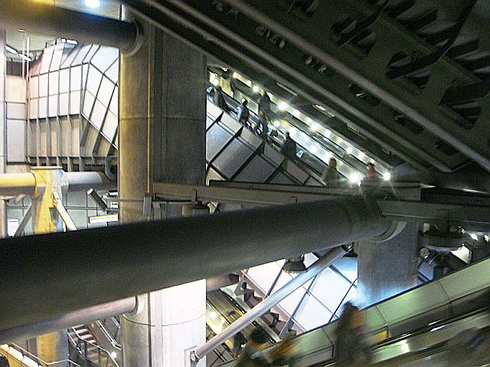

Figure 1: Westminster underground station, London. An example of a space which enables the everyday movement of thousands of people, and is designed to be taken in habitually, at speed. Yet slowing down our visual attention on this space, and looking with more curiosity, highlights the extraordinary social complexity of the place. Image originally published as postcard 1 in ‘Pidgin Snaps’, © Jonathan Meades.

So, this image of Westminster underground station (figure 1) in London, can prompt a closer inspection of a social space frozen in time, and make us see more creatively and critically. Following Becker’s advice, we can use photographs to cultivate a closer practice of repeated observation, looking actively for longer periods each time we look at the image. Attending to an initial enumeration of people, colours, light, spatial depth, the geometry of architectural elements and their materialities allows us to transpose our attention to a more creative, affective and empathic register in later viewings of the picture. When we itemise what we can see in this snapshot of the underground station, the embodied movements of those moving in the space and how these are shaped by the physical features of the station, then this act of attention gives us license to ask different types of question, related to the emotional and imaginative aspects of inhabiting spaces such as these. It stimulates our curiosity about the human experiences of this place, and the non-human networks that it enables. It allows us to move beyond interrogating how this space seems to be used at this moment and to more openly question why, for whom and for what reasons it might be used in these ways. It may even prompt us to reflect on the particular version of English high-tech architectural modernism that lurks beneath the heritage stage-set spaces of Westminster above ground. Looking carefully and repeatedly at photographs results in a greater retention of the image in one’s memory and, indeed, a more precise observation of what the eye might otherwise overlook.

Becker’s exercise in seeing puts us in mind of the fluctuating attention described in Perec’s accounts of observation and imaginative recall in his texts on the infra-ordinary, whether the popular cultural recount of I remember or the scrutiny of Saint Sulpice in the cold autumn. Behind both projects is Perec’s aspiration to create work which is attuned to the materialities of social worlds and spatial cultures, and which is in sympathy with its audiences. The translator of the Saint Sulpice study, Marc Lowenthal, notes that Perec’s attempts to ‘communicate everything, to describe everything’ speak to an underlying generosity in his work. This tendency to communicate comprehensively is also present in Meades’s work; although generosity is not a word typically associated with his writing, it should be. Again, Owen Hatherley’s commentary is astute, characterising Meades’s work as ‘so generous, so rich and so obviously contentious’ in its instinct to ‘praise things, especially things that are habitually ignored’. Meades focuses our attention on the overlooked, as can be seen in the image below (figure 2), which I read as his own attempt to concentrate our gaze on the everyday experiences of many Parisians and, in doing so, to question our knowledges of the habitual, the ordinary and the infra-ordinary life of the city today. Richard Phillips has argued that we best further Perec’s fieldwork not through imitating his working methods exactly, but rather by exploring infra-ordinary places and apparently boring landscapes with new observational approaches. Without suggesting a direct influence, I contend that Meades’s snapshots share an affinity with Perec’s portraits of place, given their essayistic mode, as they wander lightly between disparate sites, and with their attention on the unremarkable materialities of the everyday. Fleeting as it is, Meades’s image of Paris below is entirely in keeping with Perec’s curiosity about the city’s ordinary places, and yet it also moves us on, beyond the familiar city, by throwing into relief the new spatial forms and cultures that we routinely overlook.

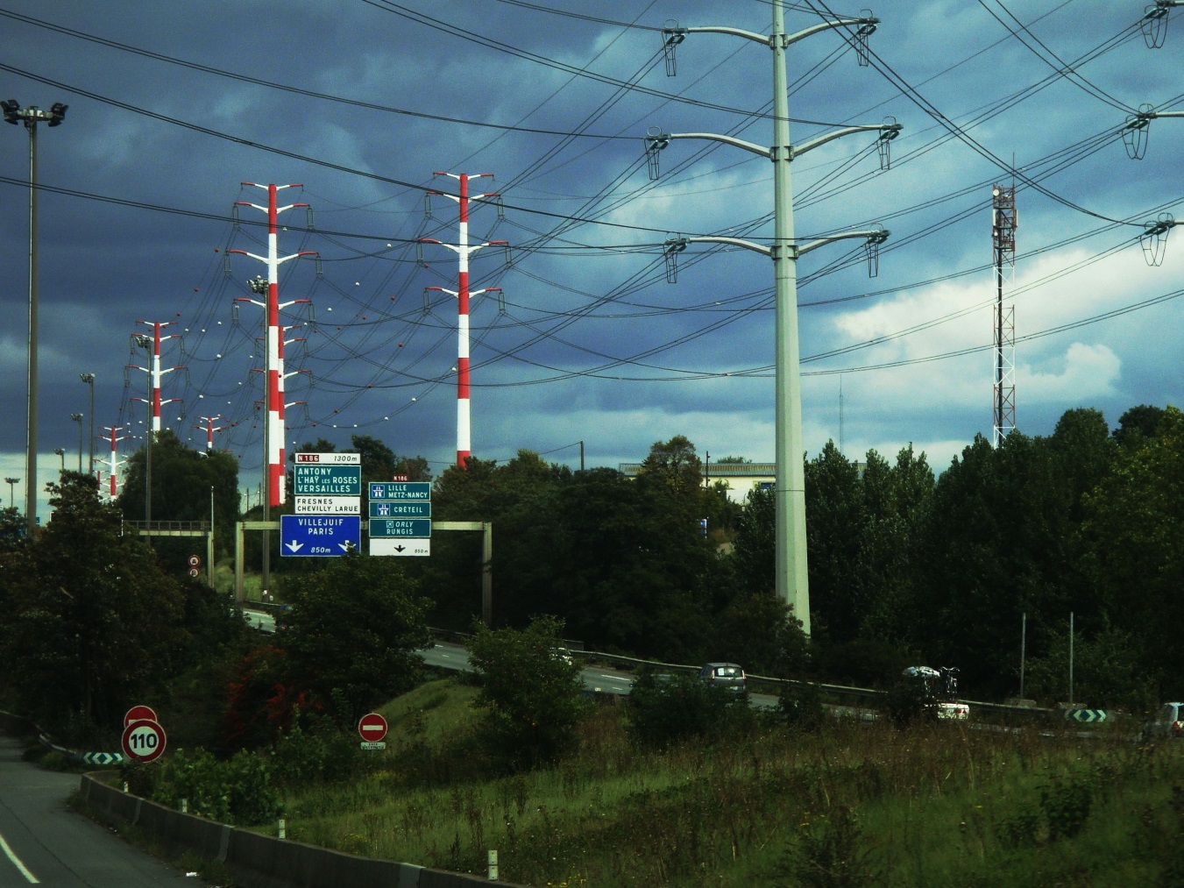

Figure 2: Parisian road network, to the south of the city. The infra-ordinary sites of urban experience today, often overlooked, may be found less in the culturally over-determined centres of cities, and more on their outskirts. Image originally published as postcard 44 in ‘Pidgin Snaps’, © Jonathan Meades.

Conclusion: emplacing curiosity

In this chapter, I have brought together two seemingly unrelated writers, Jonathan Meades and Georges Perec, in order to highlight their affinities and to consider their combined importance for contemporary notions of landscape, biography, materialities and their interrelations. Their works can help us to animate present-day understandings of the connections between biographies and buildings, people and place, everyday encounters and what Perec termed the endotic method of anthropological observation. Their works offer forensic analyses of the geographically near - or, to follow the meaning of Perec’s words, anthropologies of the inner ear - and move us within and beneath the surface of the everyday. I have outlined some shared analytical strategies that characterise their work, including their ludic approaches and writing tactics that disrupt genre conventions. The themes of memory and autobiography have been particularly important in teasing out the fecundity of their representations of places at particular cultural moments, and how these are brokered by mundane materialities and the stuff of everyday life. Separately and together, Meades and Perec perfectly illustrate Robert Walser’s dictum that that ‘We don’t need to see anything out of the ordinary. We already see so much’.

Perhaps the best lesson we can take from the example of both writers relates to their ceaseless curiosity about their everyday environments and social worlds. Sheringham describes Perec’s memory experiments in I remember as an example of a ‘curious practice’ that ‘both characterises and reveals the everyday’. The commitment to curiosity is defined by Phillips as ‘a quality of attention, with a strong visual element’. As he holds up Perec’s work elsewhere as an example of curiosity-driven work in its best sense, I would submit Meades as an illustration too of the importance of maintaining a space for curiosity in examining cities and other geographies. In An Encyclopaedia of Myself, the younger Meades castigates his familiar adults for, above all other failings, their incuriosity. Elsewhere, the older Meades keeps faith with his allegiance to curiosity and his commitment to the undervalued and overlooked in the built environment: the banal, he reminds us, ‘is a thing of joy. Everything is fantastical if you stare at it for long enough, everything is interesting’. This is an argument Perec understood well, despite the cold in October in Saint Sulpice, and it is an argument we do well to observe in our own field-working – not by slavishly repeating his empirical working practices per se, but by responding in kind to his instruction that we look and see things anew.

Bibliography

Adair, Gilbert. ‘The eleventh day: Perec and the infra-ordinary.’ The Review of Contemporary Fiction 29, no.1 (2009): 176-188.

Becker, Howard. ‘Photography and sociology.’ Studies in the Anthropology of Visual Communication 1, no.1 (1974): 3-26.

Becker, Howard. ‘Georges Perec’s experiments in social description.’ Ethnography 2, no.1 (2001): 63-76.

Doyle, Martin. ‘Brought to book: Jonathan Meades on the trial and execution of Tony Blair.’ Irish Times, June 24th (2014) Accessed August, 2018. https://www.irishtimes.com/culture/books/brought-to-book-jonathan-meades-on-the-trial-and-execution-of-tony-blair-1.1842517

Hatherley, Owen. ‘Joe, Jerry and Bomber Blair.’ London Review of Books 35 no.5 (2013): 27-30.

Highmore, Ben. ‘Georges Perec and the significance of the insignificant.’ In The afterlives of Georges Perec, edited by Rowan Wilken and Justin Clemens, 105-119. Edinburgh: Edinburgh University Press, 2017.

Leak, Andrew. ‘Paris: created and destroyed.’ AA Files 45/46 (2001): 25-31.

Lee, Joanne. ‘On not staying put: Georges Perec’s “Inter(in)disciplinarity” as an approach to research.’ Literary Geographies 3, no.1 (2017): 11-26.

Lejeune, Philippe. ‘W or the memory of childhood.’ The Review of Contemporary Fiction 29, no.1 (2009): 163-175.

Licoppe, Christian. ‘An attempt at exhausting an augmented place in Paris: Georges Perec, observer-writer of urban life, as a mobile locative media user.’ In The afterlives of Georges Perec, edited by Rowan Wilken and Justin Clemens, 205-224. Edinburgh: Edinburgh University Press, 2017.

Matless, David. Landscape and Englishness. 2nd ed. London: Reaktion, 2016.

Meades, Jonathan. Filthy English. London: Jonathan Cape, 1984.

Meades, Jonathan. Pompey. London: Jonathan Cape, 1993.

Meades, Jonathan. Museum without Walls. London: Unbound, 2012.

Meades, Jonathan. Pidgin Snaps. London: Unbound, 2013.

Meades, Jonathan. An Encyclopaedia of Myself. London: Fourth Estate, 2014.

Miller, Daniel. Stuff. Cambridge: Polity, 2010.

Perec, Georges. Things: a story of the Sixties / A man asleep. New Hampshire: Verba Mundi, 1990.

Perec, Georges. Species of Spaces and Other Pieces. Edited and translated by John Sturrock. London: Penguin Books, 1999.

Perec, Georges. An Attempt at Exhausting a Place in Paris. Cambridge, MA: Wakefield Press, 2010.

Perec, Georges. W or the memory of childhood. London: Vintage, 2011.

Perec, Georges. I remember. New Hampshire: Verba Mundi, 2014.

Perec, Georges and Mortley, Kaye. ‘The Doing of Fiction.’ The Review of Contemporary Fiction 29, no.1 (2009): 94-101.

Phillips, Richard. ‘Space for curiosity.’ Progress in Human Geography 38, no.4 (2014): 493-512.

Phillips, Richard. “’Curiosity: care, virtue and pleasure in uncovering the new.’ Theory, Culture and Society 32, no.3 (2015): 149-161.

Phillips, Richard. ‘Georges Perec’s experimental fieldwork; Perecquian fieldwork.’ Social and Cultural Geography 19, no.2 (2018): 171-191.

Ponge, Francis. Mute objects of expression. New York: Archipelago Books, 2008.

Sheringham, Michael. Everyday life: theories and practices from surrealism to the present. Oxford: Oxford University Press, 2006.

Sutcliffe, Jamie. ‘Interview with Jonathan Meades.’ The White Review, March (2015) Accessed August, 2018. http://www.thewhitereview.org/feature/interview-with-jonathan-meades/.

Unbound. ‘Pidgin snaps.’ Accessed April, 2018. https://unbound.com/books/pidgin-snaps/.

Walker, Enrique and Virilio, Paul. ‘Paul Virilio on George Perec.’ AA Files 45/46 (2001): 15-18.

Walser, Robert. The walk. London: Serpent’s Tail, 2013.

Wilson, Bee. ‘Winklepickers, tinned salmon, hair cream.’ London Review of Books 38, no.14 (2014): 36-37.

See Lee, ‘On not staying put’ for a discussion of interdisciplinarity in Perec’s work.
See Phillips, ‘Space for Curiosity’ for a discussion of curiosity-driven writing and research.
See Meades, Filthy English, for examples of his early short stories, and Meades, Pompey for his first novel.
Meades, personal communication.
Sutcliffe, ‘Interview with Jonathan Meades’.
Doyle, ‘Brought to book’.
Phillips, ‘Space for Curiosity’.
See Miller, Stuff, on the importance of material culture in the shaping of our personal and social experience.
Wilson, ‘Winklepickers’, 36-37.
Meades, Encyclopaedia of Myself, 89.
Perec, Species of Spaces, 132.
Meades, Encyclopaedia of Myself.
Lejeune, ‘W or the Memory of Childhood’, 166.
Perec, W or the Memory of Childhood.
Meades, Encyclopaedia of Myself, 231.
In Perec, I remember, 15.
In Perec, I remember, 12.
In Perec, I remember, 9.
Wilson, ‘Winklepickers’, 37.
Meades, Encyclopaedia of Myself, 208.
Meades, Encyclopaedia of Myself, 107.
Meades, Encyclopaedia of Myself, 242-255.
Perec, Things.
Meades, Encyclopaedia of Myself, 19-20.
Meades, Encyclopaedia of Myself, 45-46.
Matless, Landscape and Englishness, 16.
Meades, Encyclopaedia of Myself, 227.
Becker, ‘Georges Perec’s experiments’, 69.
Adair, ‘The eleventh day’, 179.
Sheringham, Everyday life, 275.
Perec and Mortley, ‘The doing of fiction’, 100.
In Perec, Species of spaces, 128.
Becker, ‘Georges Perec’s experiments’, 68.
See Ponge, Mute objects.
Hatherley, ‘Joe, Jerry and Bomber Blair’, 27.
Meades, Museum without walls, xiii.
Meades, An encyclopaedia of myself, 65.
Matless, Landscape and Englishness, 15.
See Highmore, ‘Georges Perec and the significance of the insignificant’ for an extended discussion of this point.
Perec, An attempt, 3.
See, among others, classic and recent commentaries such as Becker, ‘Georges Perec’s experiments’; Sheringham, Everyday life; Highmore, ‘Georges Perec and the significance of the insignificant’; Licoppe, ‘An attempt at exhausting an augmented place’; Phillips, ‘Georges Perec’s experimental fieldwork’.
Walker and Virilio, ‘Paul Virilio on Georges Perec’, 17.
Adair, ‘The eleventh day’, 180.
Leak, ‘Paris’, 28.
Perec, Species of spaces, 176.
In Unbound, ‘Pidgin Snaps’.
In Unbound, ‘Pidgin Snaps’.
In Perec, Species of spaces, 210.
See Becker, ‘Photography and sociology’, 7.
See Becker, ‘Photography and sociology’, 7.
In Perec, An attempt, 50.
Hatherley, ‘Joe, Jerry and Bomber Blair’, 27.
See Phillips, ‘Georges Perec’s experimental fieldwork’, 189.
Walser, The walk, 28.
Sheringham, Everyday life, 275.
Phillips, ‘Curiosity’, 158.
See, for example, Phillips, ‘Georges Perec’s experimental fieldwork’.
Meades, An Encyclopaedia of Myself, 232.
Meades, Museum without walls, xiii.
See Phillips, ‘Georges Perec’s experimental fieldwork’, 189.

