Sequential Assembly of Mutually-Interactive Supramolecular Hydrogels and Fabrication of Multi-Domain Materials
Carmen C. Piras,^{[a]} David K. Smith*^{[a]}
[a] Prof. D. K. Smith and Dr C. C. Piras
Department of Chemistry
University of York
Heslington, York, YO10 5DD, UK.
E-mail: david.smith@york.ac.uk
Supporting information for this article is given via a link at the end of the document.

Abstract: We report a two-component self-sorting hydrogel based on acylhydrazide and carboxylic acid derivatives of 1,3:2,4-dibenzylidene-d-sorbitol (DBS-CONHNH₂ and DBS-COOH). A heat-cool cycle induces the self-assembly of DBS-CONHNH₂, followed by the self-assembly of DBS-COOH induced by decreasing pH. Although the networks are formed sequentially, there is spectroscopic evidence of interactions between them, which impact on the mechanical properties and significantly enhance the ability of these low-molecular-weight gelators (LMWGs) to form gels when mixed. The DBS-COOH network can be switched ‘off’ and ‘on’ within the two-component gel via a pH change. Using a photoacid generator, the two-component gel can be prepared combining the thermal trigger with photo-irradiation. Photopatterned self-assembly of DBS-COOH within a pre-formed DBS-CONHNH₂ gel under a mask yields spatially-controlled multi-domain gels. Different gel domains can have different functions, for example controlling the rate of release of heparin incorporated into the gel, or directing gold nanoparticle assembly. Such photo-patterned multi-component hydrogels have potential applications in regenerative medicine or bio-nano-electronics.
Introduction
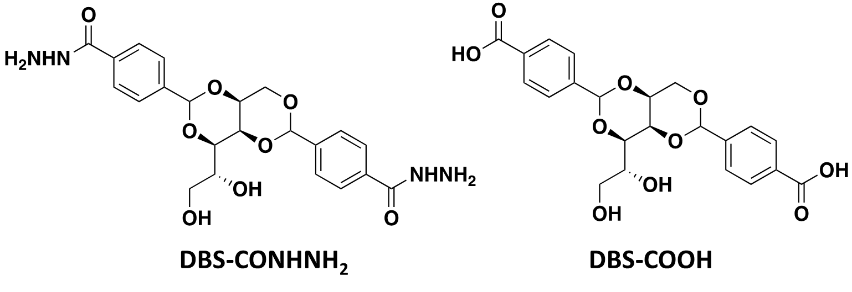
Supramolecular hydrogels based on low molecular weight gelators (LMWGs) have been the focus of intense attention over recent years.^{[1]} These gels form by the self-assembly of small molecules into nanofibrillar structures in water. Due to the high water content and their responsiveness to external stimuli, a broad range of applications has been reported including, drug formulation, cell culture, tissue engineering, optoelectronics, environmental remediation, energy storage and production.^{[2]} In the quest for more sophisticated high-tech applications, it is desirable to prepare more highly functional and versatile materials. For this reason, there has been increasing interest in multicomponent gels obtained by mixing different gelators.^{[3]} Such materials have the potential to combine the properties of the individual components and hence exhibit multi-functionality. When two LMWGs are combined, they can either interact with each other, co-assembling into a single network (i.e. one type of fibre) or self-sort, forming ‘orthogonal’ fibre networks within the gel (i.e. two types of fibre). Alternatively, the two gelators can disrupt one another’s assembly, leading to loss of gel properties. In well-designed gels, orthogonal self-sorted assembly can provide sophisticated control.^{[4]}
Combining the principles of self-sorting with photo-responsive gels,^{[5]} can be used to achieve spatially and temporally resolved gelation.^{[6]} For example, using two gelators with different pK_{a} values, one gel can be photo-patterned into the other by lowering pH in a stepwise manner with the second gelator being activated using a photo-acid, UV-light and a mask.^{[6a]} Alternatively, two self-sorted networks can be assembled, and then one of the networks selectively removed in a spatially-resolved manner, for example by photo-induced isomerisation.^{[6b]} Self-sorted gelators in which excitation of one network gave rise to emission that then triggered the disassembly of the second network have also been reported.^{[6c]}
In recent years, we have focussed on gelators based on the 1,3:2,4-dibenzylidene-d-sorbitol (DBS) framework, which has the advantage of low toxicity, low-cost, commercial relevance, and high versatility, having been described as the ‘gold standard’ of LMWGs, and can prepare smart gels with wide-ranging potential applications.^{[7]} Amongst these, 1,3:2:4-di(4-acylhydrazide)-benzylidene sorbitol (DBS-CONHNH₂, Fig. 1) is a thermally triggered LMWG that can bind dyes, heavy metals and pharmaceutical ingredients.^{[8]} This gel is biocompatible and supports the growth and proliferation of mouse fibroblast 3T3 cells.^{[9]} We have previously photopatterned polymer gels into a DBS-CONHNH₂ gel.^{[10]} If the DBS framework is modified with carboxylic acids (DBS-COOH, Fig. 1), it becomes pH-responsive.^{[11]} We have demonstrated that gels of this type can be photo-initiated by lowering pH with diphenyliodonium nitrate (DPIN).^{[6b]} Given DBS-CONHNH₂ and DBS-COOH have orthogonal activation methods, they are ideally suited for an investigation of self-sorting – examples of orthogonally triggered LMWGs that self-sort remain rare. This study provides unique insight into the ways in which self-sorted gel networks can interact with one another and also gives access to spatially resolved multi-domain gels with unique functionality in the different domains.
Figure 1. Structures of gelators.
Results and Discussion
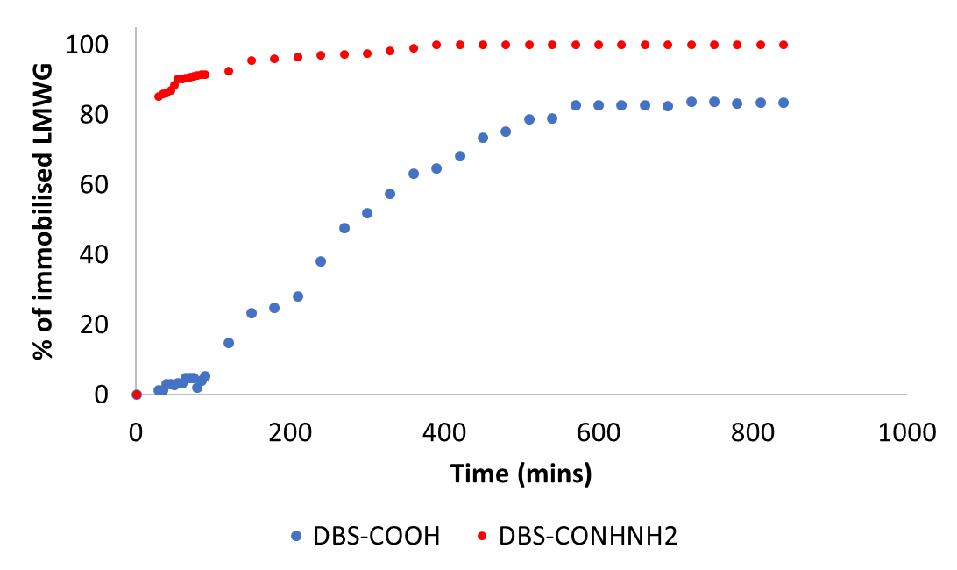
Synthesis of Gelators and Gel Formation. The two LMWGs, DBS-CONHNH₂ and DBS-COOH (Fig. 1), were synthesized in good yields using previously described procedures.^{[8a,11a]} In brief, DBS methyl ester was first prepared by acid-catalysed condensation of d-sorbitol with two equivalents of methyl-4-formyl benzoate. The product was reacted with hydrazine monohydrate to give DBS-CONHNH₂ or with NaOH to obtain DBS-COOH. Since DBS-CONHNH₂ is thermally triggered, gels in water (0.3% wt/vol) were obtained by sonication followed by a heat/cool cycle. In contrast, DBS-COOH, requires a pH trigger to form gels in water. After being dissolved in water by addition of the minimum required amount of NaOH, self-assembly was achieved by adding glucono-δ-lactone (GdL, 0.8% wt/vol), which hydrolyses to gluconic acid, gradually lowering pH and allowing controlled formation of homogeneous gels over a few hours.^{[12]}
A two-component gel was fabricated using a stepwise approach from a mixture of equal concentrations of the two gelators. A basic aqueous solution of DBS-COOH (0.3% wt/vol) was added to a suspension of DBS-CONHNH₂ (0.3% wt/vol) in water (1 mL final volume) and sonicated. Heating with a heat gun was then applied until complete dissolution of the DBS-CONHNH₂. The resulting solution was immediately transferred into a vial containing a known amount of GdL. A gel forms quickly on cooling, and the GdL then lowers the pH of the system, triggering the assembly of DBS-COOH. We tested different concentrations of the LMWGs and observed that gelation even occurred when the two gelators were combined at concentrations below their individual minimum gelation concentrations (MGCs). For example, a two-component gel could be formed using just 0.1% wt/vol of each gelator, significantly below the MGCs of DBS-CONHNH₂ (0.28% wt/vol) and DBS-COOH (0.2% wt/vol). This led us to hypothesise that a degree of interaction between the two networks may be present.
The kinetics of the pH change was monitored over time for DBS-COOH alone and the two component gel (ESI Section S3). In both cases, since prior to gelation DBS-COOH is dissolved in water by addition of NaOH (0.5 M, 60 μL), the initial pH is basic (ca. 12). This starts to drop immediately after addition of GdL (ca.6-7) until a final pH of ca. 4 is achieved (assuming enough GdL is added), which is the optimal pH for the self-assembly of DBS-COOH. The kinetics of gelation did not differ significantly between experiments performed on DBS-COOH alone and those on the two-component DBS-COOH/DBS-CONHNH₂ system.

Spectroscopic Characterisation of Gel Assembly. Self-assembly was monitored over time using ¹H NMR spectroscopy – if LMWGs are mobile in the liquid-like phase they can be observed by NMR, but as they assemble into ‘solid-like’ nanofibre networks they become NMR invisible.^{[13]} The presence of an internal standard enables a temporal experiment quantifying the immobilisation of each gelator. The gelator mixture was prepared as a hot solution (100°C) using equal concentrations (0.3% wt/vol each) of the two gelators in D₂O (in the presence of 2 μL/mL of DMSO as an internal standard) and immediately transferred into a NMR tube. ¹H NMR was measured at 25°C and indicated that in the mixed system, the immobilisation of DBS-CONHNH₂ starts immediately and is almost complete after 30 minutes (Fig. 2). It is assumed that immobilisation occurs concurrently with self-assembly, in-line with the visual observation that a gel forms on the same timescale. After 30 minutes, ¹H NMR indicates that ca. 85% of DBS-CONHNH₂ is assembled in the network. The process then continues more slowly over time until after 14 h, 100% is self-assembled. In contrast, the gelation of DBS-COOH is much slower, in response to the hydrolysis of GdL. After 30 min, <5% of DBS-COOH has assembled, only after 2 h has >10% assembled, and the overall process is only complete after ca. 10 h with 85% of gelator involved in network formation at this point. This clearly shows that assembly of these two components is stepwise, responding to each of the two triggers in turn.
Figure 2. ¹H NMR study of self-assembly of DBS-CONHNH₂ and DBS-COOH into the multicomponent gel over time demonstrating the stepwise assembly of DBS-CONHNH₂ (induced by cooling) folllowed by DBS-COOH (induced by a pH change).
On varying the GdL concentration, as expected, a different amount of DBS-COOH self-assembles. This is due to the influence of pH on the self-assembly of this LMWG, which requires pH values below the pka of DBS-COOH (pK_{a} = 5.4).^{[6b,11]} A larger amount of GdL induces more effective acidification, leading to more complete network formation. Using 0.4, 0.6, 0.8 and 1.0% wt/vol of GdL, the percentage of DBS-COOH immobilised increases from 3% to 14%, 88% and 93%, whereas the percentage of DBS-CONHNH₂ immobilised is more or less constant (87-100%). The amount of DBS-COOH immobilised can be correlated to the final pH reached in the presence of different amounts of GdL (ca. pH 12 for 0.4 % wt/vol of GdL, between pH 5 and 6 for 0.6 % wt/vol and ca. pH 4 for 0.8 and 1.0 % wt/vol). These experiments clearly demonstrate that the two networks are independent of one another and can be individually controlled.
¹H NMR studies were then conducted with different amounts of the two LMWGs, with one, or both, being present at a concentration below the MGC. This demonstrated that the two networks support each other. For example, when DBS-CONHNH₂ (0.1% wt/vol) was combined with 0.3% wt/vol of DBS-COOH, 100% of the DBS-CONHNH₂ was immobilised into a self-assembled gel network, even though it is well below its own individual MGC (0.28% wt/vol). When DBS-COOH (0.1% wt/vol) was combined with 0.3% wt/vol of DBS-CONHNH₂, both LMWGs were completely immobilised into gel networks (Table S3), even though DBS-COOH is below its own individual MGC (0.2% wt/vol). This clearly suggests that the gelators assist one another in forming self-assembled networks (see below).
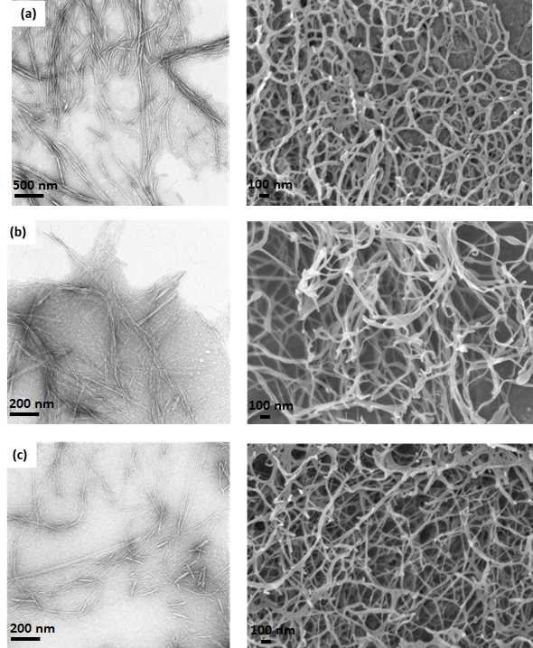
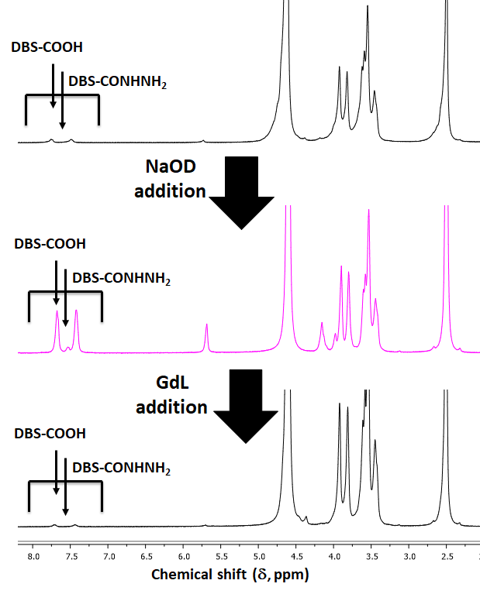
The possibility of individually addressing the two orthogonal networks within the gel by “switching on and off” one of the two components was also demonstrated by NMR. The two-component gel was prepared in D₂O using equal concentrations of the two LMWGs (0.3% wt/vol), GdL (0.8% wt/vol, for other concentrations see Table S4) and DMSO as internal standard (2 μL/mL). After gelation, the percentage of self-assembled DBS-CONHNH₂ was 100%, and of DBS-COOH was 88% (Fig. 3). We then selectively disrupted the DBS-COOH network, by adding deuterated NaOH (NaOD) to the top of the gel for 24 h. This diffuses into the gel, causing a pH increase to ca. 11. The percentage of immobilised DBS-COOH fell to just 6%, whereas the percentage of immobilised DBS-CONHNH₂ remained at 85%. This confirms the DBS-COOH network can be individually disassembled using a pH trigger (“switched off”) with only limited impact on the DBS-CONHNH₂ network. Subsequent acidification with GdL (0.8% wt/vol) for 24 hours reassembled (“switched on”) the DBS-COOH network to reform the two-component gel (100% self-assembled DBS-CONHNH₂, 92% self-assembled DBS-COOH). This provides clear evidence of the indvidual nature of the assembly/disassembly processes for each gelator.
Figure 3. ¹H NMR study of disassembly and re-assembly of the DBS-COOH network into the two-component gel, respectively by addition of NaOD and GdL.
IR spectroscopy of the xerogels focussed on key IR stretches for the two LMWGs, specifically the N-H and the C=O stretches (Table 1). Most significantly, the N-H stretch of DBS-CONHNH₂ is significantly perturbed in the presence of increasing amounts of DBS-COOH, shifting from 3182 cm⁻¹ to 3188 cm⁻¹ (3:1 ratio) to 3200 cm⁻¹ (1:1) to 3206 cm⁻¹ (1:3) (Table 1). Although this study is performed on the dried system, we suggest this progressive shift is indicative of non-covalent interactions between the two networks in the two-component system. It is known from our previous work that DBS-CONHNH₂ can directly interact with acid-functionalised pharmaceuticals via such non-covalent interactions,^{[8b,10]} so there is clearly potential for molecular-scale interactions with DBS-COOH. The C=O stretch was also perturbed in a similar way, shifting to longer wavenumber.
Table 1. IR Stretches of C=O and N-H bands in the xerogels.
Xerogel | N-H | C=O
DBS-COOH | - | 1689
DBS-CONHNH₂:DBS-COOH (1:3) | 3206 | 1709
DBS-CONHNH₂:DBS-COOH (1:1) | 3200 | 1683
DBS-CONHNH₂:DBS-COOH (3:1) | 3188 | 1678
DBS-CONHNH₂ | 3182 | 1662
Figure 4. TEM and SEM images of (a) DBS-CONHNH₂ hydrogel (scale bars: 500 nm (left) and 100 nm (right), (b) DBS-COOH hydrogel (scale bars: 200 nm (left) and 100 nm (right), (c) two-component gel (scale bars: 200 nm (left) and 100 nm (right).
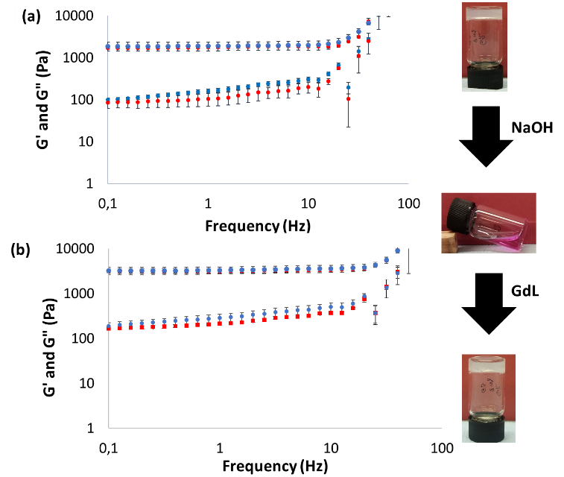
Nanoscale Characterisation of Gels. To gain more insight into nanoscale structuring, we performed transmission electron microscopy (TEM) and scanning electron microscopy (SEM). TEM samples were prepared on copper carbon grids, dried and stained using uranyl acetate negative stain. SEM samples were prepared by freeze drying in an attempt to minimise drying effects. These techniques indicate that the two gelators, both separately and in combination, self-assemble into entangled networks of nanofibrous structures with similar morphologies (Fig. 4a-c). The nanofibers formed by DBS-CONHNH₂ are wider with diameters of ca. 17-45 nm, whereas the fibres formed by DBS-COOH and those observed in the two-component gel have diameters of ca. 8-22 nm (Fig. S12). However, given the relative similarity in fibre diameters, it was not possible to unambiguously differentiate between the nanostructures formed by these gelators using electron microscopy. We note that the nanofibre dimensions are, as is always observed for DBS derivatives,^{[7]} larger than the molecular dimensions, indicating that individual molecular-scale fibrils aggregate into the observed nanofibres.

Macroscopic Characterisation of Gels. The macroscopic properties of the gels were studied in terms of thermal stability and rheological performance. The thermal stability of the gels was determined by studying the gel-sol transition temperature (T_{gel}) via a simple and reproducible tube inversion methodology. All studies were performed in triplicate and errors are ±2°C. The T_{gel} values of DBS-CONHNH₂ (0.4% wt/vol) and DBS-COOH (0.4% wt/vol) were ca. 86°C and 78.5°C respectively, while the two-component gel (0.2% wt/vol of each LMWG giving a total loading of 0.4% wt/vol) had significantly higher thermal stability >100°C. This is in-line with observations above indicating that the two-component system, although having sequentially assembled networks, forms a gel that is more than the simple sum of its parts, suggesting mutual interactions between the two gel networks benefit thermal stability.
Rheological performance was studied by oscillatory experiments using a parallel plate geometry (Table 2). The G’ value of DBS-CONHNH₂ (0.4% wt/vol) was 800 Pa and of DBS-COOH (0.4% wt/vol) gel was 435 Pa. However, the two-component gel at the same overall loading (0.2% wt/vol of each LMWG) was significantly stiffer with G’ of 1790 Pa. This again supports the view that the two gelators sequentially form networks that interact with each other, hence improving the mechanical properties. The stiffness of the two-component gel could be further tuned by changing (i) LMWG loading or (ii) GdL concentration (ESI Section 8.2). Increasing the concentration of each LMWG from 0.2 to 0.3% wt/vol, increased G’ from 1790 Pa to 3270 Pa as a result of more extensive network formation. Increasing the concentration of GdL from 0.8 to 1.0% wt/vol, increased G’ from 1790 Pa to 3790 Pa (LMWG loadings of 0.2% wt/vol each) and from 3270 Pa to 6860 Pa (LMWG loadings of 0.3% wt/vol each), as a result of better acidification and more efficient DBS-COOH network formation.
Finally, we wanted to ascertain the impact of “switching off” and then “on” again one of the two networks. We “switched off” the DBS-COOH network within a two-component gel by adding a small amount of NaOH 0.5 M (60 μL), which caused the gel to slowly collapse, losing the ability to self-support. We then “switched on” the DBS-COOH network again by GdL addition, causing the DBS-COOH network to re-assemble. The G’ value of the two-component gel (LMWG loadings of 0.2% wt/vol each) was effectively identical before and after the process (1790 and 1920 Pa respectively – Fig. 5a). A similar result was obtained for the gel prepared using a higher concentration of LMWGs (0.3% wt/vol each), with the initial and final G’ values being 3270 and 3390 Pa respectively (Fig. 5b) This confirms the DBS-COOH network can be individually controlled by “switching on” and “off” this component and that the gel can regain its original properties, when reformed. Notably this two-component gel switches from being self-standing, to not self-standing, and then back again, via the disassembly and reassembly of the DBS-COOH component. Controlling the shape of self-assembled hydrogels in this way is of considerable interest in fabricating LMWGs into a wide range of different shapes, as demonstrated in studies of self-healing gels.^{[14]} The results here clearly demonstrate the advantages of a two-component approach in providing reversibility and control.
Figure 5. Elastic (G’) and viscous modulus (G”) of multicomponent hydrogels prepared using (a) 0.2% wt/vol and (b) 0.3% wt/vol of each LMWG. The mechanical properties were measured before (red circles) and after (blue circles) the DBS-COOH network within the two-component gel was disassembled and reformed. In the imaged gels, phenolphthalein was added as an indicator to highlight the pH changes during the process.
Gel Formation by Photoactivation. We then exploited the pH response of DBS-COOH to prepare the multicomponent gel by photoactivation using a photoacid generator (PAG). We selected diphenyliodonium nitrate (DPIN) as PAG^{[15]} and investigated the self-assembly of DBS-COOH alone and in the two-component gel using DPIN instead of GdL as a pH trigger.
Photoactivated DBS-COOH gels were prepared by mixing a basic solution of this LMWG (0.3% wt/vol) with DPIN (0.8% wt/vol), followed by exposure to UV for 2 h under a long-wavelength UV light source, achieving a pH of ca. 4.4. For more detail of gel characterisation see below. The same approach was then applied to form a DBS-CONHNH₂/DBS-COOH two-component gel. DBS-CONHNH₂ (0.2 or 0.3% wt/vol) was dispersed in water and combined with a DPIN solution (0.8% wt/vol) and a basic solution of DBS-COOH (0.2 or 0.3% wt/vol). The resulting suspension was heated until complete dissolution of the solid and then exposed to UV for 2 h. After exposure to UV, an orange precipitate was formed rather than a gel. We hypothesized that the formation of this precipitate was due to a combination of factors, including ineffective acidification and the heat produced by the high-intensity UV lamp. The pH of the mixture was ca. 5.5, which is higher than the pKa of DBS-COOH. We, therefore also added a small amount of GdL (at a concentration below that needed for DBS-COOH self-assembly – 0.6% wt/vol) to help initial acidification. This gave a final pH of ca. 4.7 and led to gelation.
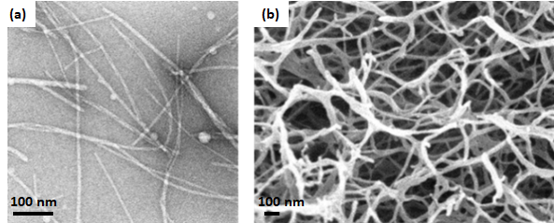
To confirm that self-assembly of the DBS-COOH network in the two-component gels was driven by photoactivation of DPIN rather than GdL hydrolysis, we monitored the process by NMR before and after exposure to UV. Samples were prepared in D₂O in NMR tubes with different GdL concentrations (0.4, 0.6, 0.8 and 1.0% wt/vol). The NMR results (Table S5) showed that in the presence of a GdL concentration of 0.4 or 0.6% wt/vol, without UV exposure, DBS-COOH immobilisation does not occur to any significant extent. With a GdL concentration of 0.4% wt/vol, the percentage of immobilised DBS-COOH was 0% before UV exposure and 84% after being exposed to UV for 2 h. Using a 0.6% wt/vol concentration of GdL, the percentage of immobilised DBS-COOH was 3% before UV exposure and 91% after being exposed to UV for 2 h. Therefore, a small amount of GdL (0.4 or 0.6% wt/vol) helps initial acidification, but is not responsible for self-assembly, which is achieved by photoactivation of DPIN.
To avoid the use of GdL altogether, we also explored another strategy. In this case, DBS-CONHNH₂ (0.3% wt/vol) was dispersed in an aqueous solution of DPIN (0.8% wt/vol), which was heated until complete dissolution of the solid. The hot solution was then left undisturbed to allow gel formation. Once a gel was obtained, a basic solution of DBS-COOH (0.3% wt/vol) was added on top of the gel allowed to diffuse in, and the second network was then subsequently induced by photoirradiation for two hours.
Table 2. Elastic (G’) and viscous (G”) moduli of hydrogels formed by stepwise approach without and with (*) photoactivation.
Gel | Concentration of each LMWG (% wt/vol) | G’ (Pa) | G” (Pa)
DBS-CONHNH₂ | 0.4 | 800 | 41.6
DBS-COOH | 0.4 | 434 | 26.3
DBS-COOH* | 0.4 | 32 | 3.47
Two-component gel | 0.2 | 1790 | 183
Two-component gel* | 0.2 | 969 | 56.7
Two-component gel | 0.3 | 3270 | 229
Two-component gel* | 0.3 | 2650 | 145

Using rheology to study mechanical properties indicated that the gels obtained by photoirradiation are much softer than those from GdL acidification (Table 2). The DBS-COOH gel (0.4 % wt/vol) displayed an elastic modulus (G’) of 434 Pa when prepared using GdL, which dropped to just 32 Pa when prepared using DPIN. This may be a result of slight differences in pH of the photoactivated gels, as previously reported by Adams and co-workers^{[15]} or could result from the presence of the by-product iodobenzene in the photoirradiated gel, weakening it. The DBS-CONHNH₂/DBS-COOH two-component gel (0.2% wt/vol of each LMWG) also had a lower G’ when prepared by photoactivation (G’ = 969 Pa) rather than GdL (G’ ≥ 1790 Pa). When the concentration of the LMWGs in the photoactivated two-component gel was increased (0.3% wt/vol of each), gel stiffness also increased (G’ = 2650 Pa). However, it was still lower than the gel prepared using GdL at the same concentration (G’ ≥ 3270 Pa). Interestingly, however, the gels obtained by photoactivation were more elastic and less brittle than those prepared using GdL. In particular, the DBS-CONHNH₂/DBS-COOH two-component gel (0.2% wt/vol of each LMWG) prepared using GdL has a linear viscoelastic region (LVR) that extends to ca. 12.6 % strain. This extends to ca. 31.6 % for the corresponding gel prepared by photoactivation. When the concentration of each gelator was increased to 0.3 % wt/vol, the LVR only extends to ca. 6.3 % for the gel prepared using GdL but ca. 31.7 % for the photoactivated gel. An extension of the LVR, although less marked, was also observed for the DBS-COOH gel on its own, having a crossover point at 12.6% when prepared with GdL, which extends to 19.9% strain when obtained by photoactivation.
The morphology of the self-assembled nanofibers of the DBS-CONHNH₂/DBS-COOH two-component gel obtained by photoactivation in the presence of a small amount of GdL (0.6% wt/vol), was similar to the gel prepared when GdL was used as the proton source, with fibre diameters of 10-30 nm (Fig. 6).
Figure 6. TEM (a) and SEM (b) of DBS-CONHNH₂/DBS-COOH multicomponent gel prepared by photoactivation. Scale bars: 100 nm.
Photopatterning of Two-Component Gels. We then investigated photopatterning of the two-component gels to achieve not only temporal, but also spatial control, leading to multidomain gels with different properties in the different domains. Photopatterning is a simple, yet efficient technique, which enables selective control of the self-assembly of DBS-COOH within the DBS-CONHNH₂ network only in the regions exposed to the UV light, by applying a photomask with a customizable design. Photopatterning is a key approach by which supramolecular gels can be shaped, structured and patterned,^{[6b,10,16]} constituting a key strategy to challenge the limitation that many supramolecular gels are simply homogeneous ‘vial-filling’ soft materials.^{[17]} In addition to using photomasks to create 2D patterns, in principle more complex 3D photo-patterned structures could also be achieved using two photon activation methods, as widely used in the field of polymer gels.^{[18]}
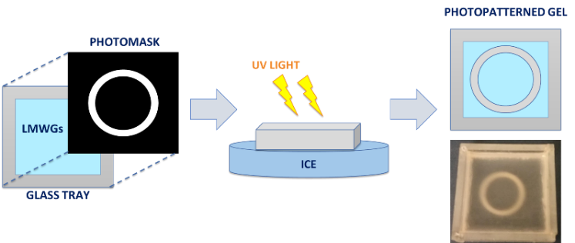
Figure 7. Schematic representation of photopatterning.
In this case, multidomain photopatterned gels were prepared as follows. A basic solution of DBS-COOH (0.3% wt/vol) was mixed with an aqueous suspension of DBS-CONHNH₂ (0.3% wt/vol), DPIN (0.8%wt/vol) and GdL (0.6% wt/vol). The mixture was sonicated and subsequently heated until complete dissolution of the solid particles. The resulting hot solution was transferred into a 5 x 5 cm glass tray and left for 15 minutes to allow thermally initiated formation of the DBS-CONHNH₂ network. A laser printed mask was then placed on top of the glass tray and the gel exposed to UV light for two hours. To avoid disruption of the pre-formed gel due to heating, ice was placed below the glass tray. After photoirradiation, a well-resolved pattern was observed within the gel indicating that the PAG was only activated in these regions, releasing insoluble iodobenzene and nitric acid to trigger assembly of the DBS-COOH network in these domains (Fig. 7).^{[6b]}

Heparin Release. To demonstrate how two-component gel formulation modifies function, we initially studied the ability of these gels to release heparin. Heparin is an anti-coagulant drug^{[19]} and a growth factor promoter of relevance for tissue engineering and regenerative medicine.^{[20]} Studies on heparin release from DBS-COOH and DBS-CONHNH₂ gels individually have been reported previously by us.^{[9,21]} We, therefore, applied our already optimised method based on the use of Mallard Blue (MalB),^{[22]} a high-affinity heparin binder, to analyse heparin release from the gels by UV-Vis spectroscopy. The DBS-CONHNH₂/DBS-COOH two-component gels loaded with heparin were prepared simply by adding heparin (1 mM) to the LMWG mixture prior to gelation. This can be considered to be a multi-component system. The properties of these gels were fully studied by IR, microscopy, thermal stability and rheology. In all cases, gelation still occurred in the presence of heparin, although there was some evidence that the components are not all truly orthogonal (see supporting info for full details).
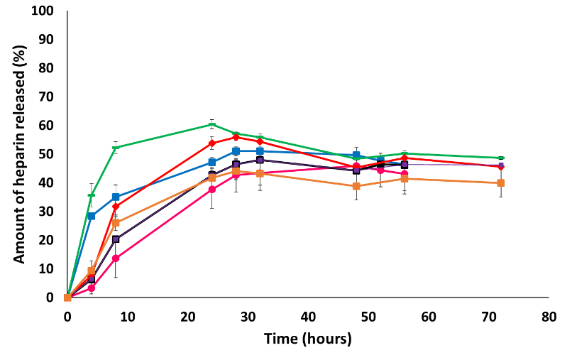
We studied heparin release from gels incubated at 37°C formed by the two LMWGs individually (0.4% wt/vol) and the DBS-CONHNH₂-DBS-COOH two-component gel (0.2% wt/vol each). Buffer (2 mL) was placed on top of each gel, aliquots were collected over time, added to MalB and analysed by UV spectroscopy. All experiments were performed in triplicate allowing analysis of errors. Heparin release was faster from the gels formed by the individual LMWGs rather than the DBS-CONHNH₂/DBS-COOH multicomponent gel (Fig. 8). After 8 hours, heparin release from DBS-CONHNH₂ was 52%, from DBS-COOH gel 32% but from the multicomponent gels was only ca. 20%. Release is therefore significantly slower for the multicomponent system than the individual gelators even though it has the same total LMWG loading. This supports our model in which mutual interactions between self-assembled nanofibres of the two networks give a modified stiffer gel, hence hindering release of the biopolymer. Similar results were obtained irrespective of whether DBS-COOH was activated by GdL or photoactivated by DPIN. At a higher concentration of the two LMWGs in the photoactivated multicomponent gel (0.3 % wt/vol each), heparin release after 8 hours was only ca. 14%.
Figure 8. Percentage of heparin released over time from DBS-CONHNH₂ gel (0.4% wt/vol – green), DBS-COOH gel (0.4% wt/vol – red), photoactivated DBS-COOH gel (0.4% wt/vol - blue), multicomponent gel (0.2% wt/vol of each LMWG – purple), multicomponent gel (0.3% wt/vol of each LMWG – orange), photoactivated multicomponent gel (0.2% wt/vol of each LMWG - black), photoactivated multicomponent gel (0.3% wt/vol of each LMWG – pink).
Clearly in a photopatterned system (e.g. Fig. 7), the much slower heparin release of the two-component system means heparin would be released at significantly different rates from the different domains patterned into the gel. Given we have previously demonstrated heparin release can impact cell growth on DBS-CONHNH₂ gels,^{[9]} this strategy has potential in tissue engineering, where controlled release from different gel domains may differentially stimulate stem cells with spatial resolution.^{[23]}

In Situ Formation of Au Nanoparticles. As a second demonstration that the different domains of these photopatterned gels can have different properties, we decided to control the in situ formation of Au nanoparticles (AuNPs). The development of gels with embedded precious metal nanoparticles is of particular interest given potential applications as conductive or catalytic materials.^{[24]} We have previously demonstrated that AuNP formation is spontaneously nucleated on DBS-CONHNH₂ gel fibres without external reductants,^{[8c]} with NPs forming on the gel fibres rather than in solvent pockets as a result of acyl-hydrazide-mediated reduction of the metal salt.
We formed DBS-CONHNH₂, DBS-COOH and the 1:1 two-component gel using GdL, and subsequently added a solution of AuCl₃ to the top of each to promote the formation of AuNPs over 72 h, giving rise to a multi-component system. The gels were then imaged by TEM to characterise AuNP formation. In the DBS-CONHNH₂ gel, NP formation occurred in close proximity to the fibres (Fig. 9a) as previously reported, while in the DBS-COOH gel, AuNPs were dispersed in solvent pockets (Fig. S15). We then studied AuNP formation in the two-component gel and found they were dispersed, and did not adhere to the fibres (Fig. 9b). We propose that mutual interactions between the sequentially assembled gel networks hinder direct interactions between the acyl hydrazide groups of the DBS-CONHNH₂ fibres and the metal ions, thus limiting AuNP formation on the fibres.
The gels described above were prepared without photoactivation. Hence, we did not consider the effects of UV-exposure on AuNP formation. Such effects are, however, well known.^{[25]} For example, Yang et al. demonstrated that exposure to UV can induce fragmentation, melting and aggregation of AuNPs.^{[26]} We reasoned that we could initially induce the formation of AuNPs in close proximity to the DBS-CONHNH₂ gel fibres throughout the sample, and then form the DBS-COOH network through UV-exposure, possibly causing modification of the AuNPs in the selected domains at the same time. The DBS-CONHNH₂ gel was first formed in a 5 x 5 cm glass tray. A solution of AuCl₃ was added on top of the gel and left to diffuse for 72 h, to allow the formation of AuNPs. The gel was then washed and a basic solution of DBS-COOH and DPIN added to the top of the gel to allow the diffusion of these components into the gel. After 72 h the gel was washed again, and a laser printed mask was placed on top of the tray. The gel was then exposed to UV light for 2 h to pattern-in the formation of the DBS-COOH network. AuNPs were then monitored by TEM, which indicated that, as expected, smaller AuNPs were in close proximity to the nanoscale DBS-CONHNH₂ network in the non-irradiated domains (Fig. 9c, Fig. S17), but this was not the case in the irradiated DBS-CONHNH₂/DBS-COOH multicomponent gel domains, where UV exposure can, in addition to assembling DBS-COOH, also induce NP fragmentation and aggregation (Figs. 9d and Fig. S17).^{[26]}
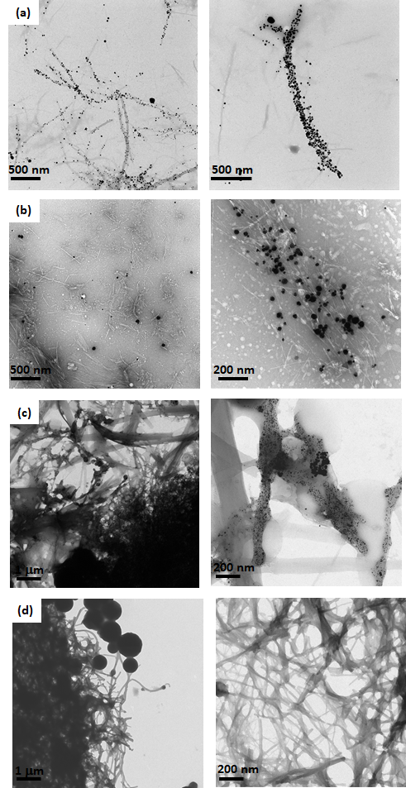
This NP-enlargement phenomenon can be explained by taking into consideration the mechanism of NP formation and the impact of subsequent photoirradiation. Initial AuNP formation involves nucleation and subsequent growth of NPs. As demonstrated by Mallick et al.,^{[27]} in the presence of additional solution phase gold salts, subsequent exposure of AuNPs to UV light, induces progressive NP growth to give larger aggregates, with the pre-existing AuNPs acting as ‘seed particles’. Given UV irradiation can also cause some fragmentation of AuNPs, this will release gold ions into solution and further facilitate the formation of larger AuNPs due to subsequent photo-reduction occurring at the surface of the ‘seeds’, hence enlarging them.
Figure 9a-d. TEM images of in situ formation of Au nanoparticles in: (a) DBS-CONHNH₂ gel (scale bars 500 nm); (b) DBS-CONHNH₂/DBS-COOH multicomponent gel (scale bars 500 nm left and 200 nm right); (c) Photopatterned DBS-CONHNH₂/DBS-COOH multicomponent gel (region not exposed to the UV light) - Scale bars: 1 μm (left) and 200 nm (right); (d) Photopatterned DBS-CONHNH₂/DBS-COOH multicomponent gel (region exposed to the UV light) - Scale bars: 1 μm (left) and 200 nm (right).
This methodology therefore fabricates multi-component multi-domain gels in which the different domains have different LMWG compositions, and the different domains being loaded with different types of AuNP depending on their ‘history’ – patterning thus has clear potential for spatially-resolved functional activity.
Conclusions
In conclusion, we have developed a new two-component hydrogel based on the self-assembly of DBS-CONHNH₂ and DBS-COOH. The two LMWG components form gels as a result of different triggers and assemble in a sequential way into nanofibrillar networks. The DBS-COOH network can be individually “switched on and off” by pH change. Although the two gelators assemble sequentially, there is clear evidence that the two networks interact synergistically within the two-component gel leading to a material with enhanced mechanical properties and thermal stability, an enhanced ability to form gels when mixed and different behaviour during the formation of AuNPs within the gel.
Since DBS-COOH is pH-activated, we used photoactivation to assemble the gel in the presence of a photoacid generator. The gels obtained by photoactivation displayed different properties than the gels obtained when GdL was used as a proton source, specifically being less stiff and more resistant to shear strain. Using photopatterning, we were able to achieve spatial control over the formation of the DBS-COOH network within a DBS-CONHNH₂ gel to generate patterned multi-component multi-domain gels with different properties in the different domains.
We demonstrated that the composition of the gel domain controls the release rate of bioactive compound heparin, with potential applications in tissue engineering. Furthermore, these multidomain gels were used for in situ formation of AuNPs, which were selectively formed in close proximity to fibres in domains only comprised of DBS-CONHNH₂, whereas in the irradiated multi-component DBS-CONHNH₂/DBS-COOH domains, the AuNPs were much larger and not located on the gel fibres. This indicates the potential of this photopatterned multi-domain technology to generate differentially structured soft nanocomposite materials with potential applications, for example, in bionanoelectronics.
Acknowledgements
We thank EPSRC for funding (EP/P03361X/1), Heather Fish for the overnight NMR study (Department of Chemistry, University of York) and Meg Stark (Bioscience Technology Facility, Department of Biology, University of York) for SEM and TEM imaging.
References
[1] a) R. G. Weiss, J. Am. Chem. Soc., 2014, 136, 7519-7530; b) E. R. Draper, D. J. Adams, Chem, 2017, 3, 390-410; c) D. B. Amabilino, D. K. Smith, J. W. Steed, Chem. Soc. Rev., 2017, 46, 2404-2420.
[2] a) N. M. Sangeetha, U. Maitra, Chem. Soc. Rev., 2005, 34, 821–836; b) A. R. Hirst, B. Escuder, J. F. Miravet, D. K. Smith, Angew. Chem. Int. Ed., 2008, 47, 8002–8018; c) S. Banerjee, R. K. Das, U. Maitra, J. Mater. Chem., 2009, 19, 6649–6687; d) S. S. Babu, V. K. Praveen, A. Ajayaghosh, Chem. Rev., 2014, 114, 1973-2129; e) X. Du, J. Zhou, J. Shi, B. Xu, Chem. Rev., 2015, 115, 13165-13307; f) B. O. Okesola, D. K. Smith, Chem. Soc. Rev. 2016, 45, 4226-4251; g) B. Hu, C. Owh, P. L. Chee, W. R. Leow, X. Liu, Y. L. Wu, P. Guo, X. J. Loh, X. Chen, Chem. Soc. Rev. 2018, 47, 6917-6929; h) D. K. Smith in Molecular Gels: Structure and Dynamics, Ed. R. G. Weiss, Royal Society of Chemistry, Cambridge, 2018, pp 300-371
[3] a) A. R. Hirst, D. K. Smith, Chem. Eur. J., 2005, 11, 5496-5508; b) L. E. Buerkle, S. J. Rowan, Chem. Soc. Rev., 2012, 41, 6089-6102; c) J. Raeburn, D. J. Adams, Chem. Commun., 2015, 51, 5170-5180; d) E. R. Draper, D. J. Adams, Chem. Soc. Rev., 2018, 47, 3395-3405.
[4] a) K. Sugiyasu, S.-i. Kawano, N. Fujita, S. Shinkai, Chem. Mater. 2008, 20, 2863-2865; b) J. R. Moffat, D. K. Smith, Chem. Commun., 2008, 316-318; c) A. Bimalendu, J. Nanda, A. Banerjee, Soft Matter 2011, 7, 8913-8922; d) A. Das, S. A. Ghosh, Chem. Commun. 2011, 47, 8922-8924; e) K. L. Morris, L. Chen, J. Raeburn, O. R. Sellick, P. Cotanda, A. Paul, P. C. Griffiths, S. M. King, R. K. O’Reilly, L. C. Serpell, D. J. Adams, Nat. Commun., 2013, 4, 1480; f) C. Colquhoun, E. R. Draper, E. G. B. Eden, B. N. Cattoz, K. L. Morris, L. Chen, T. O. McDonald, A. E. Terry, P. C. Griffiths, L. C. Serpell, D. J. Adams, Nanoscale, 2014, 6, 13719-13725; g) E. R. Draper, J. R. Lee, M. Wallace, F. Jackel, A. J. Cowan, D. J. Adams, Chem. Sci., 2016, 7, 6499-6505; h) N. Singh, K. Zhang, C. A. Angulo-Pachon, E. Mendes, J. H. van Esch, B. Escuder, Chem. Sci., 2016, 7, 5568-5572; i) S. Onogi, H. Shigemitsu, T. Yoshii, T. Tanida, M. Ikeda, R. Kubota, I Hamachi, Nat. Chem., 2016, 8, 743-752; j) E. R. Cross, S. Sproules, R. Schweins, E. R. Draper, D. J. Adams, J. Am. Chem. Soc. 2018, 140, 8667-8670; k) H. Shigemitsu, T. Fujisaku, W. Tanaka, R. Kubota, S. Minami, K. Urayama, I. Hamachi, Nat. Nanotechnol. 2018, 13, 165-172; l) A. M. Fuentes-Caparrós, F. de Paula Gómez-Franco, B. Dietrich, C. Wilson, C. Brasnett, A. Seddon, D. J. Adams, Nanoscale 2019, 11, 3275-3280; m) K. Zheng, H. Wang, H.-F. Chow, Chem. Sci. 2019, 10, 4015-4024.
[5] E. R. Draper, D. J. Adams, Chem. Commun. 2016, 52, 8196-8206.
[6] a) E. R. Draper, E. G. B. Eden, T. O. McDonald, D. J. Adams, Nat. Chem. 2015, 7, 848-852; b) D. J. Cornwell, O. J. Daubney, D. K. Smith, J. Am. Chem. Soc. 2015, 137, 15486-15492; c) X. Che, B. Bai, T. Zhang, C. Zhang, C. Zhang, P. Zhang, H. Wang, M. Li, New J. Chem., 2017, 41, 8614-8619.
[7] a) B. O. Okesola, V. M. P. Vieira, D. J. Cornwell, N. K. Whitelaw, D. K. Smith, Soft Matter, 2015, 11, 4768-4787; b) A. Singh, F.-I. Auzanneau, M. G. Corradini, G. Grover, R. G. Weiss and M. A. Rogers, Langmuir 2017, 33, 10907-10916.
[8] a) B. O. Okesola, D. K. Smith, Chem. Commun. 2013, 49, 11164-11166; b) E. J. Howe, B. O. Okesola, D. K. Smith, Chem. Commun. 2015, 51, 7451-7454; c) B. O. Okesola, S. K. Suravaram, A. Parkin, D. K. Smith, Angew. Chem. Int. Ed. 2016, 55, 183-187.
[9] V. M. P. Vieira, A. C. Lima, M. de Jong, D. K. Smith, Chem. Eur. J. 2018, 24, 15112-15118.
[10] P. R. A. Chivers, D. K. Smith, Chem. Sci. 2017, 8, 7218-7227
[11] a) D. J. Cornwell, B. O. Okesola, D. K. Smith, Soft Matter 2013, 9, 8730-8736; b) D. J. Cornwell, B. O. Okesola, D. K. Smith, Angew. Chem. Int. Ed. 2014, 53, 12461-12465.
[12] D. J. Adams, M. F. Butler, W. J. Frith, M. Kirkland, L. Mullen, P. Sanderson, Soft Matter 2009, 5, 1856-1862.
[13] a) B. Escuder, M. Llusar, J. F. Miravet, J. Org. Chem. 2006, 71, 7747-7752; b) M. Wallace, J. A. Iggo, D. J. Adams, Soft Matter 2015, 11, 7739-7747; c) S. M. Ramalhete, K. P. Nartowski, N. Sarathchandra, J. S. Foster, A. N. Round, J. Angulo, G. O. Lloyd, Y. Z. Khimyak, Chem. Eur. J. 2017, 23, 8014-8024.
[14] J. Li, L. Geng, G. Wang, H. Chu, H. Wei, Chem. Mater., 2017, 29, 8932-8952.
[15] J. Raeburn, T. O. McDonald and D. J. Adams, Chem. Commun., 2012, 48, 9355-9357.
[16] a) J. Eastoe, M. Sánchez-Dominguez, P. Wyatt, R. K. Heenan, Chem. Commun., 2004, 2608–2609; b) J. J. D. de Jong, P. R. Hania, A. Pugžlys, L. N. Lucas, M. de Loos, R. M. Kellogg, B. L. Feringa, K. Duppen, J. H. van Esch, Angew. Chem. Int. Ed., 2005, 44, 2373–2376; c) S. Matsumoto, S. Yamaguchi, S. Ueno, H. Komatsu, M. Ikeda, K. Ishizuka, Y. Iko, K. V. Tabata, H. Aoki, S. Ito, H. Noji, I. Hamachi, Chem. Eur. J. 2008, 14, 3977–3986.
[17] P. R. A. Chivers, D. K. Smith, Nat. Rev. Mater., 2019, https://doi.org/10.1038/s41578-019-0111-6.
[18] J.-F. Xing, M.-L. Zheng, X.-M. Duan, Chem. Soc. Rev., 2015, 44, 5031-5039.
[19] a) D. L. Rabenstein, Nat. Prod. Rep., 2002, 19, 312-331; b) S. Middeldorp, Thromb. Res. 2008, 122, 753-762; c) C. Loira-Pastoriza, A. Sapin-Minet, R. Diab, J. L. Grossiord, P. Maincent, Int. J. Pharm., 2012, 426, 256-262; d) M. R. Metanovic, I. Grabnar, M. Gosenca, P. A. Grabnar, Int. J. Pharm., 2015, 488, 127-135
[20] a) S. E. Sakiyama-Elbert, J. A. Hubbell, J. Controlled Rel., 2000, 69, 149-158; b) J. A. Beamish, L. C. Geyer, N. A. Haq-Siddiqi, K. Kottke-Marchant, R. E. Marchant, Biomaterials, 2009, 30, 6286-6294; c) C. McGann, K. Kiick, in Engineering Biomaterials for Regenerative Medicine. Ed. Bhatia, S. Springer, New York, 2012, pp 225-250; d) J. You, D.-S. Shin, D. Patel, Y. Gao, A. Revzin, Adv. Healthcare Mater., 2014, 3, 126-132. e) Y. Liang, K. L. Kiick, Acta Biomaterialia 2014, 10, 1588-1600.
[21] V. M. P. Vieira, L. L. Hay, D. K. Smith, Chem. Sci. 2017, 8, 6981-6990.
[22] a) S. M. Bromfield, A. Barnard, P. Posocco, M. Fermeglia, S. Pricl, D. K. Smith, J. Am. Chem. Soc., 2013, 135, 2911-2914; b) S. M. Bromfield, P. Posocco, M. Fermeglia, S. Pricl, J. Rodríguez-López, D. K. Smith, Chem. Commun., 2013, 49, 4830-4832.
[23] a) W. Lee, J. Park, Sci. Rep. 2016, 6, 29408; b) C. Yang, F. W. DelRio, H. Ma, A. R. Killaars, L. P. Basta, K. A. Kyburz, K. S Anseth, Proc. Natl. Acad. Sci. USA 2016, 113, E4439-E4445
[24] a) M. Kimura, S. Kobayashi, T. Kuroda, K. Hanabusa, H. Shirai, Adv. Mater. 2004, 16, 335-338; b) L.-s. Li, S. I. Stupp, Angew. Chem. Int. Ed. 2005, 44, 1833-1836; c) P. K. Vemula, G. John, Chem. Commun. 2006, 2218-2220; d) P. K. Vemula, U. Aslam, V. A. Mallia, G. John, Chem. Mater. 2007, 19, 138-140; e) R. N. Mitra, P. K. Das, J. Phys. Chem. C 2008, 112, 8159-8166; f) S. Dutta, A. Shome, T. Kar, P. K. Das, Langmuir 2011, 27, 5000-5008; g) J.-S. Shen, Y.-L. Chen, J.-L. Huang, J. D. Chen, C. Zhao, Y.-Q. Zheng, T. Yu, Y. Yang, H.-W. Zhang, Soft Matter 2013, 9, 2017-2023; h) S. Bhattacharya, S. K. Samanta, Chem. Rev. 2016, 116, 11967-12028; i) S. Paul, K. Basu, K. S. Das, A. Banerjee, ChemNanoMat 2018, 4, 882-887; j) P. Slavik, D. W. Kurka, D. K. Smith, Chem. Sci., 2018, 9, 8673-8681.
[25] a) K. Torigoe, K. Esumi, Langmuir 1992, 8, 59-63; b) K. Esumi, A. Suzuki, N. Aihara, K. Usui, K. Torigoe, Langmuir 1998, 14, 3157-3159; c) S. Eustis, H.-Y. Hsu, M. A. El-Sayed, J. Phys. Chem. B 2005, 109, 4811-4815; d) C. S. Love, V. Chechik, D. K. Smith, K. Wilson, I. Ashworth, C. Brennan, Chem. Commun. 2005, 1971-1973.
[26] S. Yang, Y. Wang, Q. Wang, R. Zhang, B. Ding, Coll. Surf. A 2007, 301, 174-183.
[27] K. Mallick, Z. L. Wang, T. Pal, J. Photochem. Photobiol. A, 2001, 140, 75-80

Entry for the Table of Contents (Please choose one layout)

Layout 1:

FULL PAPER
Combining two low-molecular weight gelators enables the self-assembly and photo-fabrication of multi-domain gels in which different domains have different properties and functions. |  | 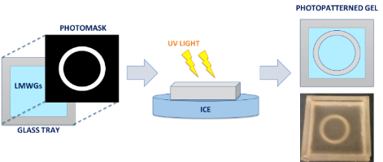 |  | Carmen C. Piras,^{[a} David K. Smith*^{[a]}  Page No. – Page No.  Sequential Assembly of Mutually-Interactive Supramolecular Hydrogels and Fabrication of Multi-Domain Materials

