Sequential Assembly of Mutually-Interactive Supramolecular Hydrogels and Fabrication of Multi-Domain Materials

Carmen C. Pirasª and David K. Smithª *

a: Department of Chemistry, University of York, Heslington, York, YO10 5DD, UK.

Email: david.smith@york.ac.uk

SUPPORTING INFORMATION

Contents

S1 General Experimental Methods
S2 Gel preparation
S3 pH studies
S4 NMR studies
S5 Infrared spectroscopy (IR)
S6 Transmission and Scanning Electron Microscopy (TEM and SEM)
S7 Thermal stability studies (T_{gel} determination)
S8 Rheology
S9 Heparin release studies
S10 References

S1 General Experimental Methods

All compounds used in synthesis and analysis were purchased from standard commercial suppliers and used as received. The synthesis of DBS-CONHNH₂ and DBS-COOH were performed in good yields applying previously reported methods.^{[1,2]} ¹H NMR spectra were recorded using a Jeol 400 spectrometer (¹H 400 MHz) or a 500 spectrometer (¹H 500 MHz). Samples were prepared in D₂O and chemical shifts (δ) are reported in parts per million (ppm). IR spectra of xerogels were recorded on a PerkinElmer Spectrum Two FT-IR spectrometer. TEM images were obtained on a FEI Tecnai 12 G² fitted with a CCD camera. Fibre sizes were measured using the ImageJ software. SEM images were taken using a JEOL JSM-7600F field emission SEM. T_{gel} values were obtained using a high precision thermoregulated oil bath using the tube inversion method. Rheology was measured on a Malvern Instruments Kinexus Pro+ Rheometer fitted with a 2 cm parallel plate geometry. UV-vis spectra were collected on a UV-2401 PC spectrophotometer. A high-powered UV lamp (λ = 315-405 nm) was used for activation of the photoacid generator diphenyliodonium nitrate (DPIN).

S2 Gel preparation

S2.1 DBS-CONHNH₂
S2.1.1 Preparation of DBS-CONHNH₂ hydrogels
DBS-CONHNH₂ (6.32 x 10⁻³ or 8.43 x 10⁻³ mmol – 0.3 or 0.4% wt/vol) was suspended in water (1 mL). The suspension was sonicated to help the dispersion of the solid particles and then heated until complete dissolution of the compound. The sample was left undisturbed to cool, allowing gel formation in few minutes.

S2.1.2 Preparation of heparin loaded DBS-CONHNH₂ gels in 10 mM TRIS-HCl/150 mM NaCl buffer
DBS-CONHNH₂ (8.43 x 10⁻³ mmol – 0.4% wt/vol in 1 mL final total volume) was suspended in 10 mM TRIS-HCl/150 mM NaCl buffer (0.5 mL) and 0.5 mL of a 2 mM stock solution of heparin in the same buffer was added to obtain a final heparin concentration of 1 mM. The suspension was sonicated to help the dispersion of the solid particles and then heated until complete dissolution of the compound. The sample was left undisturbed to cool, allowing gel formation in a few minutes.

S2.1.3 In situ formation of Au nanoparticles into DBS-CONHNH₂ hydrogels
DBS-CONHNH₂ (6.32 x 10⁻³ mmol – 0.3% wt/vol) was suspended in water (1 mL). The suspension was sonicated to help the dispersion of the solid particles and then heated until complete dissolution of the compound. The sample was left undisturbed to cool, allowing gel formation in a few minutes. Once the gel was formed, a 2.92 mM solution of AuCl₃ (1.4 mL) was added on top of the gel and let to diffuse through the gel for 72 hours to allow the in situ formation of Au nanoparticles. After 72 hours, the supernatant was removed and the gel was washed with water multiple times.

S2.2 DBS-COOH
S2.2.1 Preparation of DBS-COOH hydrogels using glucono-δ-lactone (GdL) as a pH activator
DBS-COOH (6.72 x 10⁻³ or 8.96 x 10⁻³ mmol – 0.3 or 0.4% wt/vol) was suspended in water (1 mL) and dissolved by addition of a 0.5 M solution of NaOH (60 μL). The solution was then transferred into another sample vial containing a GdL (0.045 mmol – 0.8% wt/vol, unless otherwise specified) and left undisturbed overnight to allow gel formation.

S2.2.2 Preparation of heparin loaded DBS-COOH gels using GdL as a pH activator
DBS-COOH (8.96 x 10⁻³ mmol – 0.4% wt/vol in 1 mL final total volume) was suspended in 10 mM TRIS-HCl/150 mM NaCl buffer (0.5 mL) and dissolved by addition of a 0.5 M solution of NaOH (60 μL). A 2 mM stock solution of heparin in the same buffer (0.5 mL) was added to obtain a 1 mM final heparin concentration. The solution was then transferred into another sample vial containing GdL (0.045 mmol – 0.8% wt/vol, unless otherwise specified) and left undisturbed overnight to allow gel formation.

S2.2.3 Preparation of DBS-COOH photoactivated hydrogels using diphenyliodonium nitrate (DPIN) as a pH activator
DBS-COOH (6.72 x 10⁻³ or 8.96 x 10⁻³ mmol – 0.3 or 0.4% wt/vol in 1 mL final total volume) was suspended in water (0.5 mL) and dissolved by addition of a 0.5 M solution of NaOH (60 μL). The solution was then mixed with 0.5 mL of a DPIN aqueous solution (0.023 mmol – 0.8% wt/vol in 1 mL final total volume), which was acidified by addition of a 1 M HCl solution (2.5 μL). The sample was subsequently placed in ice and exposed to UV light for 2 hours to allow gel formation.

S2.2.4 Preparation of photoactivated heparin loaded DBS-COOH gels using DPIN as a pH activator
DBS-COOH (8.96 x 10⁻³ mmol - 0.4% wt/vol in 1 mL final total volume) was suspended in 0.5 mL of a 2 mM heparin stock solution in 10 mM TRIS-HCl/150 mM NaCl buffer and dissolved by addition of a 0.5 M solution of NaOH (60 μL). The solution was then mixed with a DPIN solution in the same buffer (0.023 mmol in 0.5 mL - 0.8% wt/vol in 1 mL final total volume), which was acidified by addition of a 1 M HCl solution (2.5 μL). The sample (1 mM final heparin concentration) was subsequently placed in ice and exposed to UV light for 2 hours to allow gel formation.

S2.2.5 In situ formation of Au nanoparticles into DBS-COOH hydrogels obtained using GdL as a pH activator
DBS-COOH (6.72 x 10⁻³ mmol – 0.3% wt/vol) was suspended in water (1 mL) and dissolved by addition of a 0.5 M solution of NaOH (60 μL). The solution was then transferred into another sample vial containing GdL (0.045 mmol – 0.8% wt/vol, unless otherwise specified) and left undisturbed overnight to allow gel formation. Once the gel was formed, a 2.92 mM solution of AuCl₃ (1.4 mL) was added on top of the gel and let to diffuse through the gel for 72 hours to allow the in situ formation of Au nanoparticles. After 72 hours, the supernatant was removed and the gel was washed with water multiple times.

S2.3 DBS-CONHNH₂/DBS-COOH two-component gels

S2.3.1 Preparation of DBS-CONHNH₂/DBS-COOH two-component hydrogels using GdL as a pH activator
DBS-COOH (4.48 x 10⁻³ or 6.72 x 10⁻³ mmol, 0.2 or 0.3% wt/vol in 1 mL final total volume) was suspended in water (0.5 mL) and dissolved by addition of a 0.5 M solution of NaOH (60 μL). This solution was then added to a suspension of DBS-CONHNH₂ (4.21 x 10⁻³ or 6.32 x 10⁻³ mmol - 0.2 or 0.3% wt/vol in 1 mL final total volume) in water (0.5 mL). The suspension was sonicated to help the dispersion of the solid particles and subsequently heated until complete dissolution of the DBS-CONHNH₂. The hot solution was then transferred to another sample vial containing GdL (0.045 mmol – 0.8% wt/vol, unless otherwise specified) and left undisturbed overnight to allow gel formation.

S2.3.2 Preparation of heparin loaded DBS-CONHNH₂/DBS-COOH two-component gels using GdL as a pH activator
DBS-COOH (4.48 x 10⁻³ or 6.72 x 10⁻³ mmol, 0.2 or 0.3% wt/vol in 1 mL final total volume) was suspended in 10 mM TRIS-HCl/150 mM NaCl buffer (0.5 mL) and dissolved by addition of a 0.5 M solution of NaOH (60 μL). The solution was then added to a suspension of DBS-CONHNH₂ (4.48 x 10⁻³ or 6.32 x 10⁻³ mmol, 0.2 or 0.3% wt/vol in 1 mL final total volume) in a 2 mM solution of heparin in the same buffer (0.5 mL). The suspension (1 mM final heparin concentration) was sonicated to help the dispersion of the solid particles and subsequently heated until complete dissolution of the DBS-CONHNH₂. The hot solution was then transferred to another sample vial containing GdL (0.045 mmol – 0.8% wt/vol, unless otherwise specified) and left undisturbed overnight to allow gel formation.

S2.3.3 Preparation of DBS-CONHNH₂/DBS-COOH photoactivated two-component hydrogels using DPIN and GdL as pH activators
DBS-COOH (4.48 x 10⁻³ or 6.72 x 10⁻³ mmol - 0.2 or 0.3% wt/vol in 1 mL final total volume) was suspended in water (0.5 mL) and dissolved by addition of a 0.5 M solution of NaOH (60 μL). This solution was added to a DPIN aqueous solution (0.023 mmol in 0.5 mL – 0.8% wt/vol in 1 mL final volume) acidified by addition of HCl (1 M, 2.5 μL) in which DBS-CONHNH₂ (4.48 x 10⁻³ or 6.32 x 10⁻³ mmol - 0.2 or 0.3% wt/vol in 1 mL final total volume) was suspended. The resulting suspension was sonicated to help the dispersion of the solid particles and transferred to another sample vial containing GdL (0.034 mmol – 0.6% wt/vol). The sample was subsequently heated until complete dissolution of the DBS-CONHNH₂ and then placed in ice and exposed to UV light for 2 hours to allow gel formation.

S2.3.4 Preparation of DBS-CONHNH₂/DBS-COOH photoactivated two-component hydrogels using DPIN as a pH activator
DBS-CONHNH₂ (4.21 x 10⁻³ or 6.32 x 10⁻³ mmol - 0.2 or 0.3% wt/vol in 1 mL final total volume) was suspended in water (0.5 mL) and mixed with a DPIN aqueous solution (0.023 mmol in 0.5 mL – 0.8% wt/vol in 1 mL final total volume), which was acidified by addition of HCl (1 M, 2.5 μL). The suspension was sonicated to help the dispersion of the solid particles and subsequently heated until complete dissolution of the compound. The sample was then left undisturbed to cool, allowing gel formation in few minutes. Once a self-supporting gel was formed, a basic aqueous solution of DBS-COOH (4.48 x 10⁻³ or 6.72 x 10⁻³ mmol - 0.2 or 0.3% wt/vol, dissolved in 1 mL of water + 60 μL of NaOH 0.5 M) was added on top of the gel and allowed to diffuse through the gel for 48 hours. After 48 hours, the supernatant was removed. The sample was placed in ice and exposed to UV light for 2 hours to allow the formation of the second gel network.

S2.3.5 Preparation of photoactivated heparin loaded DBS-CONHNH₂/DBS-COOH two-component gels using DPIN and GdL as pH activators
DBS-COOH (4.48 x 10⁻³ or 6.72 x 10⁻³ mmol - 0.2 or 0.3% wt/vol in 1 mL final total volume) was suspended in 10 mM TRIS-HCl/150 mM NaCl buffer (0.5 mL) and dissolved by addition of a 0.5 M solution of NaOH (60 μL). The resulting solution was added to a DPIN solution in the same buffer (0.023 mmol in 0.5 mL – 0.8% wt/vol in 1 mL final total volume) acidified by addition of HCl (1 M, 2.5 μL) in which DBS-CONHNH₂ (4.21 x 10⁻³ or 6.32 x 10⁻³ mmol - 0.2 or 0.3% wt/vol in 1 mL final total volume) was suspended. The suspension (1 mM final heparin concentration) was sonicated to help the dispersion of the solid particles and then transferred to another sample vial containing GdL (0.034 mmol – 0.6% wt/vol). The sample was subsequently heated until complete dissolution of the DBS-CONHNH₂ and then placed in ice and exposed to UV light for 2 hours to allow gel formation.

S2.3.6 In situ formation of Au nanoparticles into DBS-CONHNH₂/DBS-COOH multicomponent hydrogels using GdL as a pH activator
DBS-COOH (4.48 x 10⁻³ mmol - 0.2% wt/vol in 1 mL final total volume) was suspended in water (0.5 mL) and dissolved by addition of a solution of NaOH 0.5 M (60 μL). The solution was added to a suspension of DBS-CONHNH₂ (4.21 x 10⁻³mmol - 0.2% wt/vol in 1 mL final total volume) in water (0.5 mL). The suspension was then sonicated to help the dispersion of the solid particles and subsequently heated until complete dissolution of the DBS-CONHNH₂. The hot solution was transferred to another sample vial containing GdL (0.045 mmol – 0.8% wt/vol) and left undisturbed overnight to allow gel formation. Once the gel was formed, a 2.92 mM solution of AuCl₃ (1.4 mL) was added o top of the gel and let to diffuse through the gel for 72 hours to allow the in situ formation of Au nanoparticles. After 72 hours, the supernatant was removed and the gel was washed multiple times with water.

S2.4 Photopatterning of DBS-CONHNH₂/DBS-COOH two-component gels
S2.4.1 Preparation of photopatterned DBS-CONHNH₂/DBS-COOH two-component hydrogels using DPIN and GdL as pH activators
DBS-COOH (0.034 mmol – 0.3% wt/vol in 5 mL final total volume) was suspended in water (2.2 mL) and dissolved by addition of a 0.5 M solution of NaOH (300 μL). The resulting solution was added to a DPIN aqueous solution (0.116 mmol in 2.5 mL – 0.8% wt/vol in 5 mL final total volume), which was previously acidified by addition of 1 M HCl (12.5 μL) and in which DBS-CONHNH₂ (0.032 mmol – 0.3% wt/vol in 5 mL final total volume) was suspended. The suspension was sonicated to help the dispersion of the solid particles and then transferred to another sample vial containing GdL (0.168 mmol – 0.6% wt/vol). The suspension was subsequently heated until complete dissolution of the DBS-CONHNH₂. The hot solution was then quickly transferred into a 5 x 5 cm glass tray. The sample was left undisturbed for 15 minutes to allow the formation of the DBS-CONHNH₂ network. A laser printed mask was then placed on top of the glass tray and the gel was exposed to UV light for two hours. To avoid the disruption of gelation due to heating effects, ice was placed below the glass tray.

S2.4.2 Preparation of photopatterned DBS-CONHNH₂/DBS-COOH two-component hydrogels using DPIN as a pH activator
DBS-CONHNH₂ (0.032 mmol – 0.3% wt/vol in 5 mL final total volume) was suspended in water (2.5 mL) and mixed with a DPIN solution (0.116 mmol in 2.5 mL – 0.8% wt/vol in 5 mL final total volume), which was acidified by addition of 1 M HCl (12.5 μL). The suspension was sonicated to help the dispersion of the solid particles and subsequently heated until complete dissolution of the compound. The sample was then quickly transferred into a 5 x 5 cm glass tray and left undisturbed for 15 minutes to allow the formation of the DBS-CONHNH₂ gel network. Once a stable gel was formed, a basic aqueous solution of DBS-COOH (0.022 mmol – 0.3% wt/vol in 3 mL final total volume, dissolved in 2.82 mL of water + 180 μL 0.5 M NaOH) was added on top of the gel and let to diffuse through the gel for 48 hours. After 48 hours, the supernatant was removed. A laser printed mask was then placed on top of the glass tray and the gel was exposed to UV light for two hours to allow the formation of the second gel network. To avoid the disruption of gelation due to heating effects, ice was placed below the glass tray.

S2.4.3 In situ formation of Au nanoparticles into DBS-CONHNH₂/DBS-COOH two-component photopatterned hydrogels
DBS-CONHNH₂ (0.032 mmol – 0.3% wt/vol in 5 mL final total volume) was suspended in water (5 mL). The suspension was sonicated to help the dispersion of the solid particles and then heated until complete dissolution of the compound. The hot solution was then transferred into a 5 x 5 cm glass tray and left undisturbed to cool, allowing gel formation. Once the gel was formed, a 4.40 mM solution of AuCl₃ (4 mL) was added o top of the gel and let to diffuse through the gel for 72 hours to allow the in situ formation of Au nanoparticles. After 72 hours, the supernatant was removed and the gel was washed with water multiple times. An aqueous solution of DBS-COOH (0.034 mmol – 0.3% wt/vol in 5 mL final total volume, dissolved in 2.70 mL of water + 300 μL of 0.5 M NaOH) and DPIN (0.116 mmol – 0.8% wt/vol in 5 mL final total volume, dissolved in 2 mL of water + 12.5 μL of 1 M HCl) was added on top of the gel and let to diffuse through the gel for 24 hours. After 24 hours, the supernatant was removed. A laser printed mask was then placed on top of the glass tray and the gel was exposed to UV light for two hours to allow the formation of the second gel network. To avoid the disruption of gelation due to heating effects, ice was placed below the glass tray.

S3 pH studies
The pH of DBS-COOH (0.4% wt/vol) and the DBS-CONHNH₂/DBS-COOH mixture (0.2% wt/vol of each LMWG) was monitored over time during gel formation. The gels were prepared as described in Sections S2.2.1 and S2.3.1 using variable GdL amounts (0.4, 0.6, 0.8 and 1.0% wt/vol) and the pH was checked at regular time intervals.
S3.1 pH monitoring over time of DBS-COOH in the presence of different GdL amounts

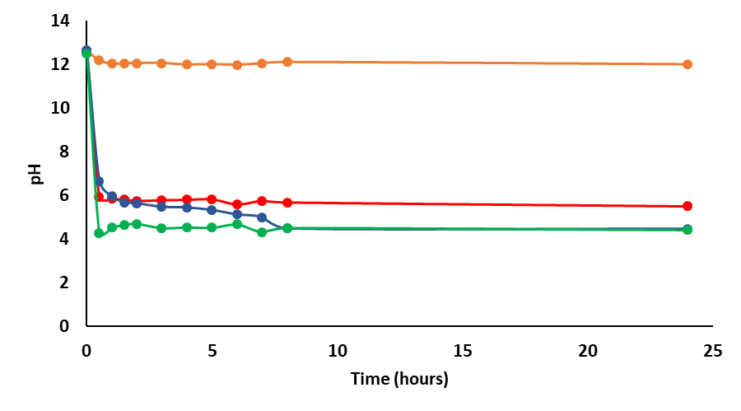

Figure S1. pH changes over time of DBS-COOH (0.4% wt/vol) during self-assembly prepared using different GdL amounts: 0.4% wt/vol (orange line), 0.6% wt/vol (red line), 0.8% wt/vol (blue line) and 1.0% wt/vol (green line).

S3.2 pH monitoring over time of DBS-CONHNH₂/DBS-COOH two-component gel in the presence of different GdL amounts
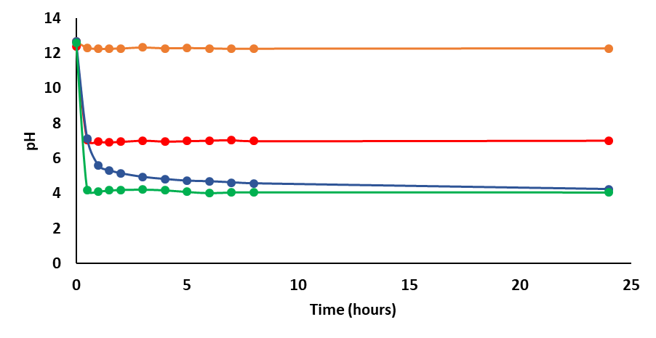
Figure S2. pH changes over time of DBS-CONHNH₂/DBS-COOH two-component gel (0.2% wt/vol of each LMWG) during self-assembly prepared using different GdL amounts: 0.4% wt/vol (orange line), 0.6% wt/vol (red line), 0.8% wt/vol (blue line) and 1.0% wt/vol (green line).

S4 NMR studies
S4.1 NMR monitoring of DBS-CONHNH₂/DBS-COOH two-component gel formation over time
The DBS-CONHNH₂/DBS-COOH two-component gel sample used for this study was prepared in a 0.7 mL volume as described in Section S2.3 using a 0.3% wt/vol concentration of each LMWG (4.41 x 10⁻³ mmol of DBS-CONHNH₂ and 4.70 x 10⁻³ mmol of DBS-COOH) and replacing water and NaOH with the corresponding deuterated solutions. DMSO (2 μL/mL) was added as an internal standard. The gel was formed in a NMR tube and placed in the spectrometer. The first spectrum was recorded after 30 minutes from sample preparation (Figure S3). Spectra were then recorded every 5 minutes for 90 minutes and then every 30 minutes for 12.5 hours. The concentration of the mobile components was calculated by comparison of the integrals of relevant peaks (DBS- COOH aromatic peak δ = 7.70 and DBS-CONHNH₂ aromatic peak δ = 7.55) to that of DMSO (δ = 2.50 ppm). The obtained data are reported in Table S1.

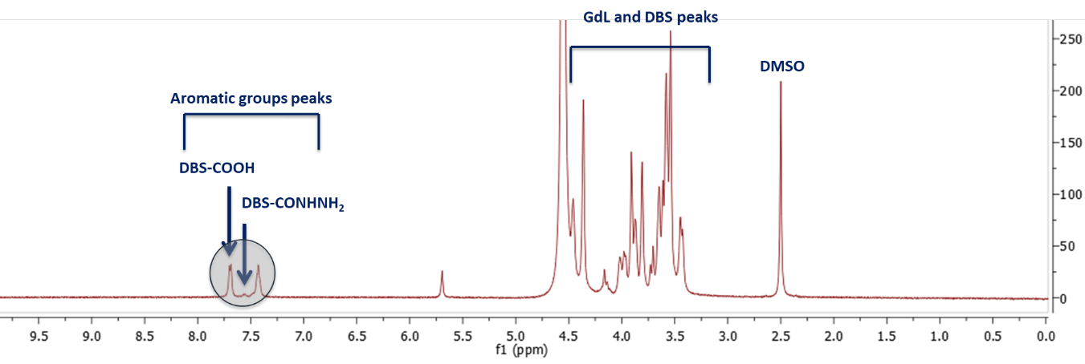

Figure S3. ¹H NMR of the DBS-COOH/DBS-CONHNH₂ two-component gel after 30 mins from sample preparation.

Table S1. Percentage of DBS-COOH and DBS-CONHNH₂ immobilised in the DBS-COOH/DBS-CONHNH₂ two-component gel over time.

Time  (mins) | % of immobilised DBS-COOH | % of immobilised DBS-CONHNH₂ | Time  (mins) |  | % of immobilised DBS-COOH | % of immobilised DBS-CONHNH₂
30 | 1.10 | 85.22 | 300 |  | 51.76 | 97.41
35 | 1.18 | 85.97 | 330 |  | 57.33 | 98.16
40 | 2.91 | 86.22 | 360 |  | 63.14 | 98.91
45 | 2.91 | 86.89 | 390 |  | 64.70 | 100.00
50 | 2.83 | 88.39 | 420 |  | 68.23 | 100.00
55 | 3.14 | 90.06 | 450 |  | 73.25 | 100.00
60 | 3.14 | 90.15 | 480 |  | 75.06 | 100.00
65 | 4.63 | 90.48 | 510 |  | 78.59 | 100.00
70 | 4.63 | 90.56 | 540 |  | 78.82 | 100.00
75 | 4.79 | 90.90 | 570 |  | 82.66 | 100.00
80 | 1.97 | 91.15 | 600 |  | 82.66 | 100.00
85 | 4.08 | 91.40 | 630 |  | 82.74 | 100.00
90 | 5.18 | 91.48 | 660 |  | 82.66 | 100.00
120 | 14.67 | 92.40 | 690 |  | 82.35 | 100.00
150 | 23.38 | 95.49 | 720 |  | 83.60 | 100.00
180 | 24.87 | 95.99 | 750 |  | 83.60 | 100.00
210 | 28.00 | 96.41 | 780 |  | 83.13 | 100.00
240 | 38.04 | 96.99 | 810 |  | 83.45 | 100.00
270 | 47.45 | 97.24 | 840 |  | 83.45 | 100.00

S4.2 NMR quantification of LMWGs immobilised in DBS-COOH/DBS-CONHNH₂ two-component gels prepared using different GdL concentrations
The gels used in this study were prepared as described in Section S3.1 using variable GdL concentrations and were analysed by ¹H NMR after 24 hours (Figure S4). The concentration of the mobile components was calculated by comparison of the integrals of relevant peaks (DBS-COOH aromatic peak δ = 7.70 and DBS-CONHNH₂ aromatic peak δ = 7.55) to that of DMSO (δ = 2.50 ppm). The obtained data are reported in Table S2.

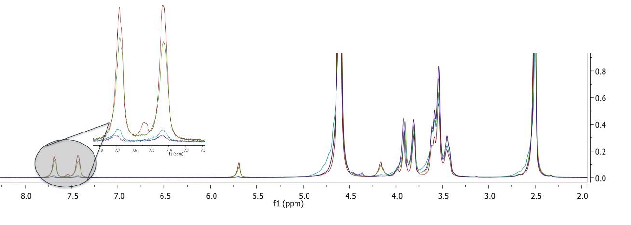
Figure S4. ¹H NMR of the DBS-COOH/DBS-CONHNH₂ two-component gel prepared with variable GdL concentrations: 0.4% wt/vol (red line), 0.6% wt/vol (green line), 0.8% wt/vol (blue line) and 1.0% wt/vol (purple line).

Table S2. Percentage of DBS-COOH and DBS-CONHNH₂ immobilised in the DBS-COOH/DBS-CONHNH₂ two-component gel prepared with variable GdL concentrations.

% of immobilised LMWGs | GdL concentration ( % wt/vol)
 | 0.4% | 0.6% | 0.8% | 1.0%
% of immobilised DBS-COOH | 3 | 14 | 82 | 93
% of immobilised DBS-CONHNH₂ | 87 | 97 | 100 | 100

S4.3 NMR quantification of LMWGs immobilised in DBS-COOH/DBS-CONHNH₂ two-component gels prepared using different ratios of DBS-COOH and DBS-CONHNH₂ and different GdL concentrations
The gels used in this study were prepared as described in Section S3.1 using variable GdL concentrations and different ratios of the two LMWGs (Figures S5 and S6). The concentration of the mobile components was calculated by comparison of the integrals of relevant peaks (DBS-COOH aromatic peak δ = 7.70 and DBS-CONHNH₂ aromatic peak δ = 7.55) to that of DMSO (δ = 2.50 ppm). The gels were analysed by ¹H NMR after 24 hours. The obtained data are reported in Table S3.

Figure S5. ¹H NMR of the DBS-CONHNH₂/DBS-COOH two-component gel prepared in a 3:1 ratio of DBS-CONHNH₂ (0.3 % wt/vol) and DBS-COOH (0.1 % wt/vol) using variable GdL concentrations: 0.4 % wt/vol (red line), 0.6 % wt/vol (green line), 0.8 % wt/vol (blue line) and 1.0 % wt/vol (purple line).

Figure S6. ¹H NMR of the DBS-CONHNH₂/DBS-COOH two-component gel prepared in a 1:3 ratio of DBS-CONHNH₂ (0.1 % wt/vol) and DBS-COOH (0.3 % wt/vol) using variable GdL concentrations: 0.4 % wt/vol (red line), 0.6 % wt/vol (green line), 0.8 % wt/vol (blue line) and 1.0 % wt/vol (purple line).

Table S3. Percentage of DBS-COOH and DBS-CONHNH₂ immobilised in the DBS-COOH/DBS-CONHNH₂ two-component gel prepared with: (a) a 3:1 ratio of DBS-CONHNH₂ (0.3% wt/vol) and DBS-COOH (0.1% wt/vol) and (b) a 1:3 ratio of DBS-CONHNH₂ (0.1% wt/vol) and DBS-COOH (0.3% wt/vol).
% of immobilised LMWGs |  | GdL concentration ( % wt/vol)
 |  | 0.4% | 0.6% | 0.8% | 1.0%
(a) | % of immobilised DBS-COOH | 100 | 100 | 100 | 100
 | % of immobilised DBS-CONHNH₂ | 100 | 100 | 100 | 100
(b) | % of immobilised DBS-COOH | 6 | 16 | 88 | 100
 | % of immobilised DBS-CONHNH₂ | 100 | 100 | 100 | 100

S4.4 NMR quantification of LMWGs immobilised in DBS-COOH/DBS-CONHNH₂ multicomponent gels in which the DBS-COOH network was disrupted and subsequently reformed
The gels used in this study were prepared as described in Section S3.1 using variable GdL concentrations. Once the multicomponent gel was formed, the DBS-COOH network was disrupted by adding a 0.5 M solution of NaOD (60 μL) to each gel by diffusion, and subsequently reformed by addition of the initial quantity of GdL used for each gel. The samples were analysed by ¹H NMR after 24 hours from each addition (Figure S7). The concentration of the mobile components was calculated by comparison of the integrals of relevant peaks (DBS-COOH aromatic peak δ = 7.70 and DBS-CONHNH₂ aromatic peak δ = 7.55) to that of DMSO (δ = 2.50 ppm). The obtained data are reported in Table S4.
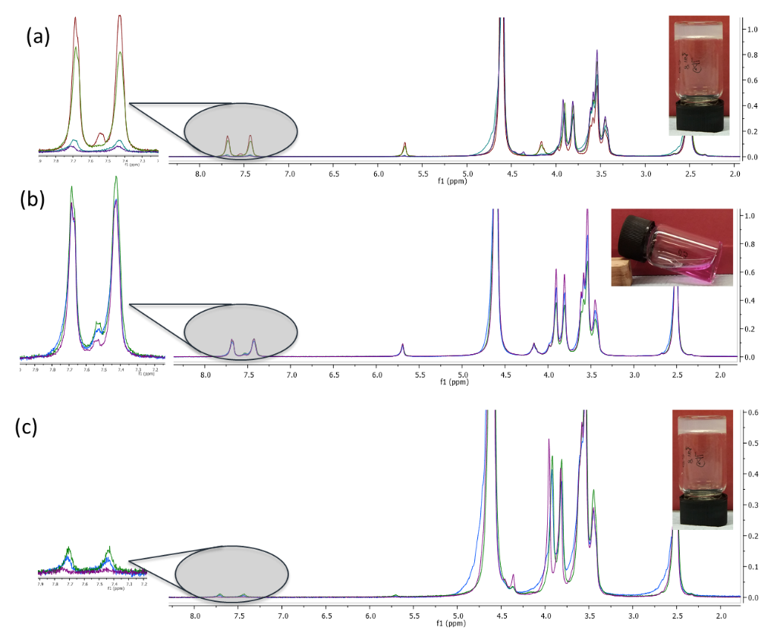

Figure S7. (a) ¹H NMR of the DBS-COOH/DBS-CONHNH₂ two-component gel prepared with variable GdL concentrations: 0.4 % wt/vol (red line), 0.6 % wt/vol (green line), 0.8 % wt/vol (blue line) and 1.0 % wt/vol (purple line). (b) ¹H NMR of the DBS-COOH/DBS-CONHNH₂ two-component gel 24 hours after addition of 0.5 M NaOD. (c) ¹H NMR of the DBS-COOH/DBS-CONHNH₂ two-component gel reformed using the intial GdL concentrations. Note: Phenolphthalein was used as an in indicator in the gel images to highlight the pH change.

Table S4. Percentage of DBS-COOH and DBS-CONHNH₂ immobilised in the DBS-COOH/DBS-CONHNH₂ two-component gel after: (a) preparation using variable GdL concentrations; (b) 24 hours from addition of NaOD; (c) being reformed by subsequent addition of the initial concentration of GdL.
% of immobilised LMWGs | GdL concentration ( % wt/vol)
 | 0.6 % |  |  | 0.8 % |  |  | 1.0 %
 | (a) | (b) | (c) | (a) | (b) | (c) | (a) | (b) | (c)
% of immobilised DBS-COOH | 14 | 2 | 89 | 82 | 6 | 92 | 93 | 10 | 0
% of immobilised DBS-CONHNH₂ | 97 | 79 | 100 | 100 | 85 | 100 | 100 | 89 | 100

S4.5 NMR quantification of LMWGs immobilised in photoactivated DBS-COOH/DBS-CONHNH₂ two-component gels prepared using DPIN and GdL as pH activators
The gels used in this study were prepared as described in Section S3.1 in the presence of DPIN (0.8 % wt/vol) and GdL in variable concentrations (0.4, 0.6, 0.8 and 1.0 % wt/vol). The gels were analysed by ¹H NMR before exposition to the UV light (Figure S8). The samples were then exposed to the UV light for 2 h and analysed again by ¹H NMR (Figure S8). The concentration of the mobile components was calculated by comparison of the integral of the DBS-COOH aromatic peak (δ = 7.70) to that of DMSO (δ = 2.50 ppm). The obtained data are reported in Table S5.

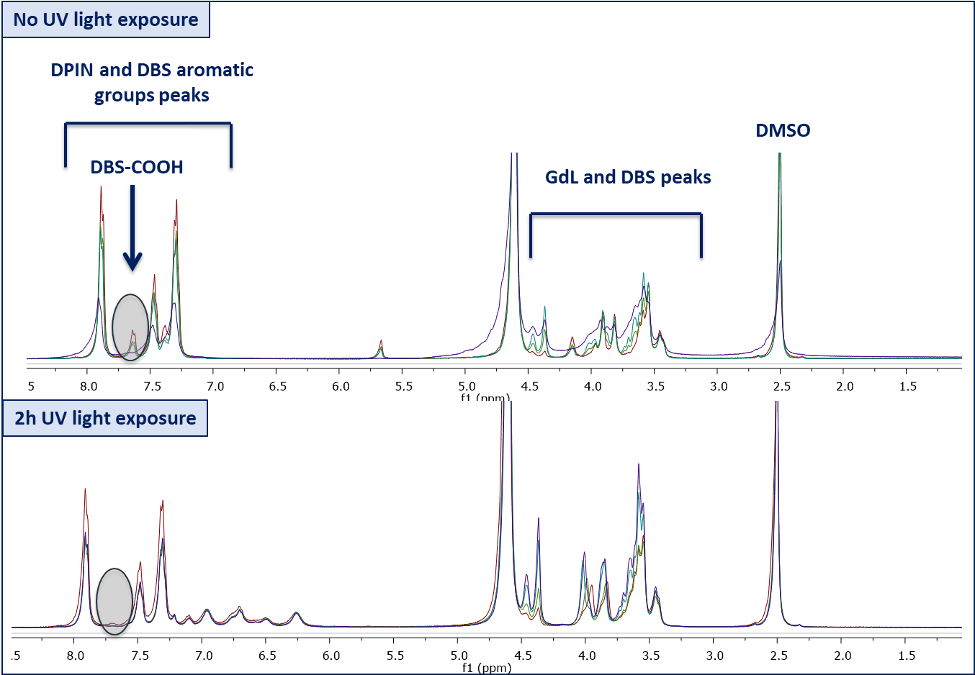

Figure S8. ¹H NMR of the photoactivated DBS-COOH/DBS-CONHNH₂ two-component gel prepared with DPIN (0.8% wt/vol) and variable GdL concentrations: 0.4% wt/vol (red line), 0.6% wt/vol (green line), 0.8% wt/vol (blue line) and 1.0% wt/vol (purple line).

Table S5. Percentage of DBS-COOH and DBS-CONHNH₂ immobilised in the photoactivated DBS-COOH/DBS-CONHNH₂ two-component gel prepared with DPIN and variable GdL concentrations, before and after exposure to the UV light.
% of immobilised DBS-COOH | GdL concentration ( % wt/vol)
 | 0.4% | 0.6% | 0.8% | 1.0%
Before UV light exposure | 0 | 3 | 12 | 37
After 2h UV light exposure | 84 | 91 | 94 | 94

S5 Infrared spectroscopy (IR)
S5.1 Preparation of xerogels
Xerogel samples for infrared were prepared by removing the solvent from the gels under high vacuum. The resulting powder was placed into the infrared spectrophotometer and the spectra recorded in the range of 450-4000 cm⁻¹.

S5.2 IR spectra

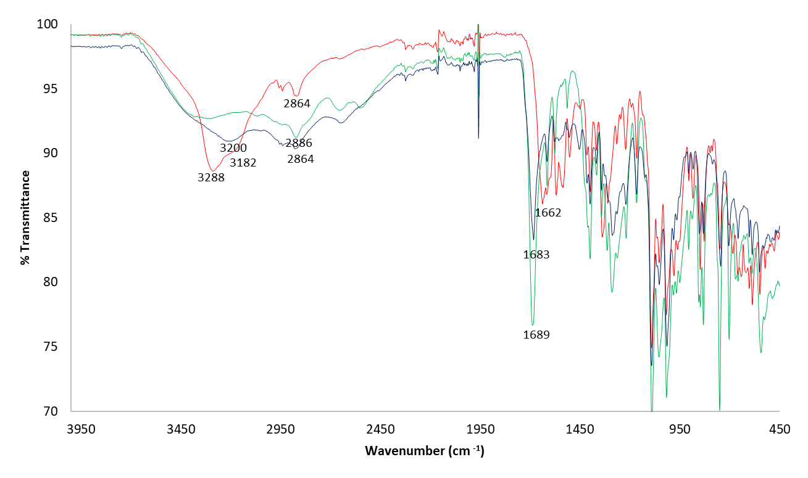

Figure S9. IR spectra of xerogels obtained from DBS-CONHNH₂ gel (0.4% wt/vol– red line), DBS-COOH gel (0.4% wt/vol– green line) and DBS-CONHNH₂/DBS-COOH two-component gel (0.2% wt/vol of each LMWG – blue line).

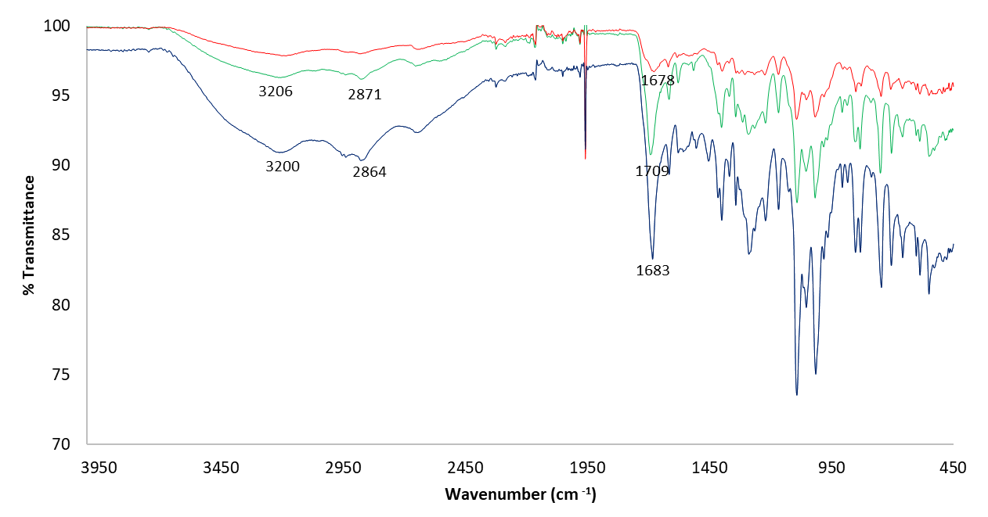

Figure S10. IR spectra of xerogels obtained from DBS-CONHNH₂/DBS-COOH two-component gel in a 1:1 ratio (0.2% wt/vol of each LMWG – blue line), in a 3:1 ratio (0.3% wt/vol of DBS-CONHNH₂ and 0.1% wt/vol of DBS-COOH – red line) and 1:3 ratio of the two LMWGs (0.1% wt/vol of DBS-CONHNH₂ and 0.3% wt/vol of DBS-COOH – green line).

S.5.3 IR of xerogels incorporating heparin
We employed IR spectroscopy of the xerogels incorporating heparin to investigate potential interactions between this molecule, the gels formed by the two DBS derivatives and the orthogonal self-assembled networks in the multicomponent gel. We saw that the IR spectrum of heparin and the heparin loaded DBS-COOH gel, basically corresponds to the overlap of the separate spectra of the two (Figure S9). This was previously observed for heparin loaded DBS-COOH gels and suggests that specific interactions between this bioactive compound and the gelator are limited.^{[3]} The IR spectrum of the heparin loaded DBS-CONHNH₂ gel has a visible shift in correspondence of the C=O stretch band which moves from 1662 cm⁻¹ to 1631 cm⁻¹ in the presence of heparin. The IR of the heparin loaded DBS-CONHNH₂/DBS-COOH multicomponent gel corresponds to the sum of the IR of each heparin loaded gel formed individually by the two gelators. However, some shifts are visible when comparing the spectra of the DBS-CONHNH₂/DBS-COOH multicomponent gel in the presence and absence of heparin. In particular, the N-H stretch band moves from 3200 to 3188 cm⁻¹ in the presence of heparin and the C=O stretch band moves from 1683 to 1692 cm⁻¹.

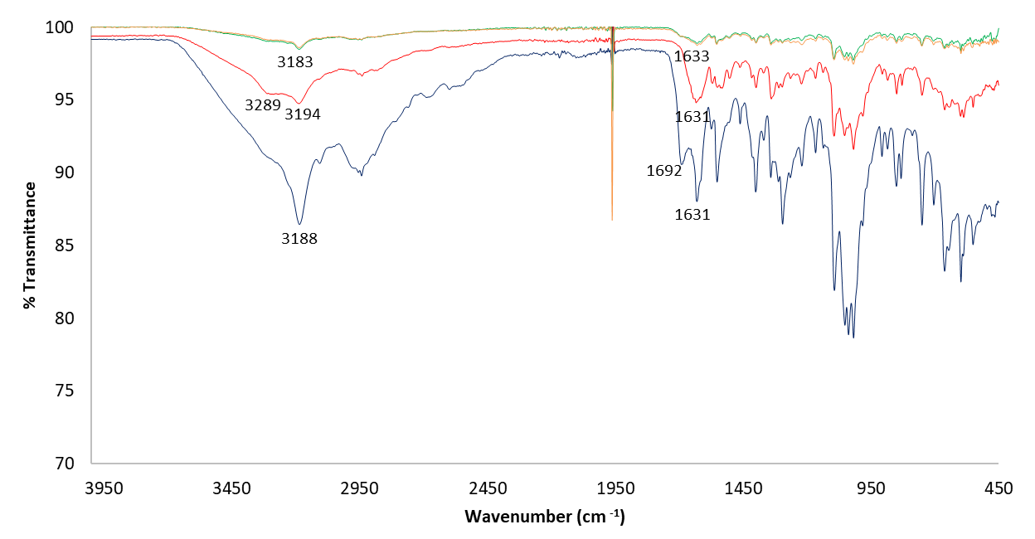

Figure S11. IR spectra of heparin (orange line) and xerogels formed by DBS-CONHNH₂ gel (0.4% wt/vol – red line), DBS-COOH gel (0.4% wt/vol – green line) and DBS-CONHNH₂/DBS-COOH multicomponent gel (0.2% wt/vol of each LMWG – blue line), all loaded with heparin (1 mM).

S6 Transmission and Scanning Electron Microscopy (TEM and SEM)
S6.1 Preparation of samples for TEM
Samples for TEM were obtained by adding a small amount of each sample on a copper grid. The excess of sample was removed with filter paper and allowed to set for 5 minutes. A negative stain (1% uranyl acetate) was then added and the samples were left to rest for 30 minutes before taking the images.

S6.2 Preparation of samples for SEM
Samples for SEM were obtained by freeze drying the gels on copper shim pieces. The freeze-dried samples were then mounted on stubs and the images recorded.

S6.3 TEM and SEM images
S.6.3.2 Fibre size measurements
The fibre width of the DBS-CONHNH₂, DBS-COOH and the DBS-CONHNH₂/DBS-COOH multicomponent gel networks was measured in the TEM images using the ImageJ Software. For each gel, 30 fibres were measured and the obtained values were reported in the graph below (Figure S12).
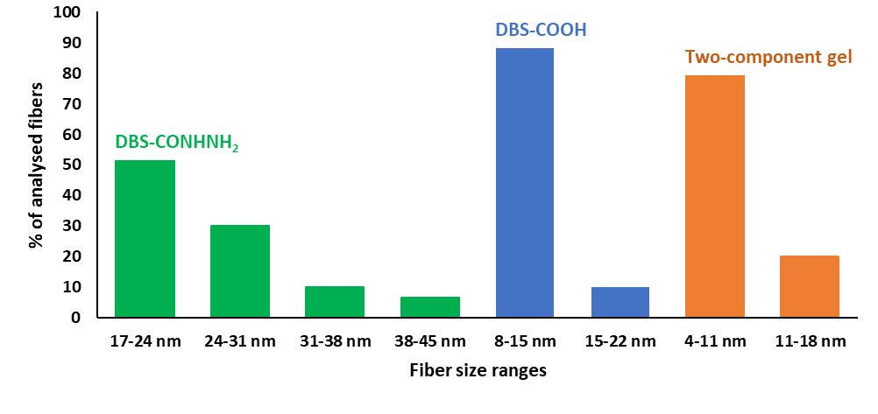
Figure S12. Fibre widths in DBS-CONHNH₂ gel (green), DBS-COOH gel (blue) and DBS-CONHNH₂/DBS-COOH two-component gel (orange)

S.6.3.1 TEM of heparin loaded gels
TEM was used to investigate the self-assembled nanoscale morphologies in the presence of heparin and to see if heparin could cause significant structural perturbation. TEM images of the three gel systems (DBS-CONHNH₂, DBS-COOH and the multicomponent gel) in the presence of heparin were very similar to those of the gels without heparin (Figure S13). This confirms that gel formation still occurs in the presence of heparin, with long twisted fibres being formed.

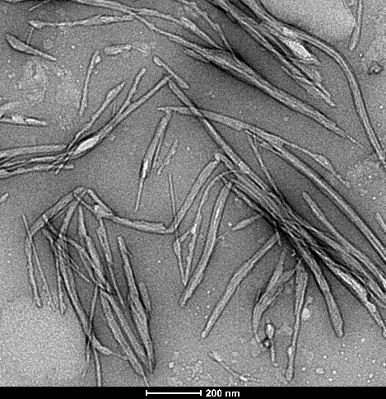
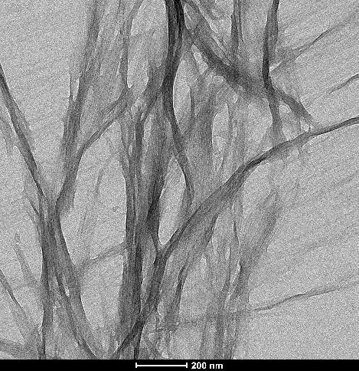
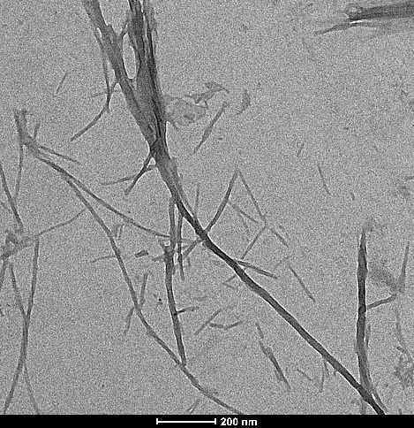

Figure S13. TEM of DBS-CONHNH₂ gel (left), DBS-COOH gel (centre) and DBS-CONHNH₂/DBS-COOH multicomponent gel (right), all loaded with heparin. Scale bars: 200 nm.

S.6.3.2 TEM of Au nanoparticle loaded gels

Figure S14. TEM of DBS-CONHNH₂ gel after in situ formation of Au nanoparticles. Scale bar: 1 μm.

Figure S15. TEM of DBS-COOH gel after in situ formation of Au nanoparticles. Scale bars: 2 μm.

Figure S16. TEM of DBS-CONHNH₂/DBS-COOH multicomponent gel after in situ formation of Au nanoparticles. Scale bar: 1 μm.

Figure S17. TEM of Au nanoparticles in DBS-CONHNH₂/DBS-COOH two-component gel – region not exposed to UV light. Scale bar: 1 μm.

Figure S18. TEM of Au nanoparticles aggregates in photopatterned DBS-CONHNH₂/DBS-COOH multicomponent gel. Scale bar: 1 μm.

S7 Thermal stability studies (T_{gel} determination)
S7.1 T_{gel} determination method
All the gels for T_{gel} determination were prepared as described in Section S2. For the gels prepared using GdL as a pH trigger, the amount of GdL added was 0.045 mmol (0.8% wt/vol), unless otherwise specified. All the photoactivated gels were prepared using GdL (0.034 mmol - 0.6% wt/vol) and DPIN (0.023 mmol – 0.8% wt/vol) as pH activators. All the gels were placed in a high precision thermoregulated oil bath with an initial temperature of 25ºC. The temperature was set to increase of 1ºC/ min until 100ºC was reached. Every minute the gels were checked by tube inversion method and T_{gel} was considered as the temperature at which the gel began to run down the sides of the vial. These experiments were performed in triplicate to ensure reproducibility and average is reported.

S7.2 T_{gel} Values

Table S6. T_{gel} values of gels formed by individual LMWGs and of the DBS-CONHNH₂/DBS-COOH two-component gel.
GEL | CONCENTRATION | T_{gel}
DBS-CONHNH₂ | 0.4 % wt/vol | 86 ºC
DBS-CONHNH₂ + heparin* | 0.4 % wt/vol | Above 100 ºC
DBS-COOH | 0.4 % wt/vol | 78.5 ºC
DBS-COOH + heparin* | 0.4 % wt/vol | Above 100 ºC
Two-component gel | 0.1 % wt/vol of each LMWG | 91.8 ºC
Two-component gel | 0.2 % wt/vol of each LMWG | Above 100 ºC
Two-component gel + heparin* | 0.2 % wt/vol of each LMWG | 98.2 ºC
Photoactivated two-component gel | 0.2 % wt/vol of each LMWG | Above 100 ºC
Photoactivated two-component gel + heparin* | 0.2 % wt/vol of each LMWG | Above 100 ºC

*Heparin was added in a 1 mM concentration

S7.3 T_{gel} values of heparin loaded gels
The macroscopic properties of the heparin loaded gels were then studied in terms of thermal stability. We observed that the presence of heparin affects the thermal stability of the gels individually formed by the two LMWGs, which become more resistant to heat, with T_{gel} values above 100ºC. The DBS-CONHNH₂/DBS-COOH two-component gel, in the absence of heparin, displays a T_{gel} above 100ºC, whereas in the presence of heparin the T_{gel} is 98.2ºC. It has to be noted that these gels were prepared in 10 mM TRIS-HCl/150 mM NaCl buffer, which was also used for the release studies. Therefore, it has to be taken into consideration that the use of a buffer and salts may also affect the properties of the resulting gels, including thermal stability.

S8 Rheology
S8.1 Methodology
Gel samples for rheology were prepared as described in Section S2 using bottomless vials as templates to obtain the intended gel dimensions. For the gels prepared using GdL as a pH trigger, the amount of GdL added was 0.045 mmol (0.8% wt/vol), unless otherwise specified. All the photoactivated gels were prepared using GdL (0.034 mmol - 0.6% wt/vol) and DPIN (0.023 mmol – 0.8% wt/vol) as pH activators. The measurements were carried out at 25°C using a 2 cm parallel plate and a gap of 2 mm. To avoid solvent evaporation and keep the sample hydrated, a solvent trap was used, and the internal atmosphere was kept saturated. Amplitude sweep experiments were performed in the range of 0.05-100% strain at a 1 Hz frequency to identify the linear viscoelastic region. Frequency sweep experiments were performed between 0.1 and 100 Hz using a shear strain of 0.25%. The measurements were repeated three times to ensure reproducibility and the average data are shown.

S8.2 Rheology data

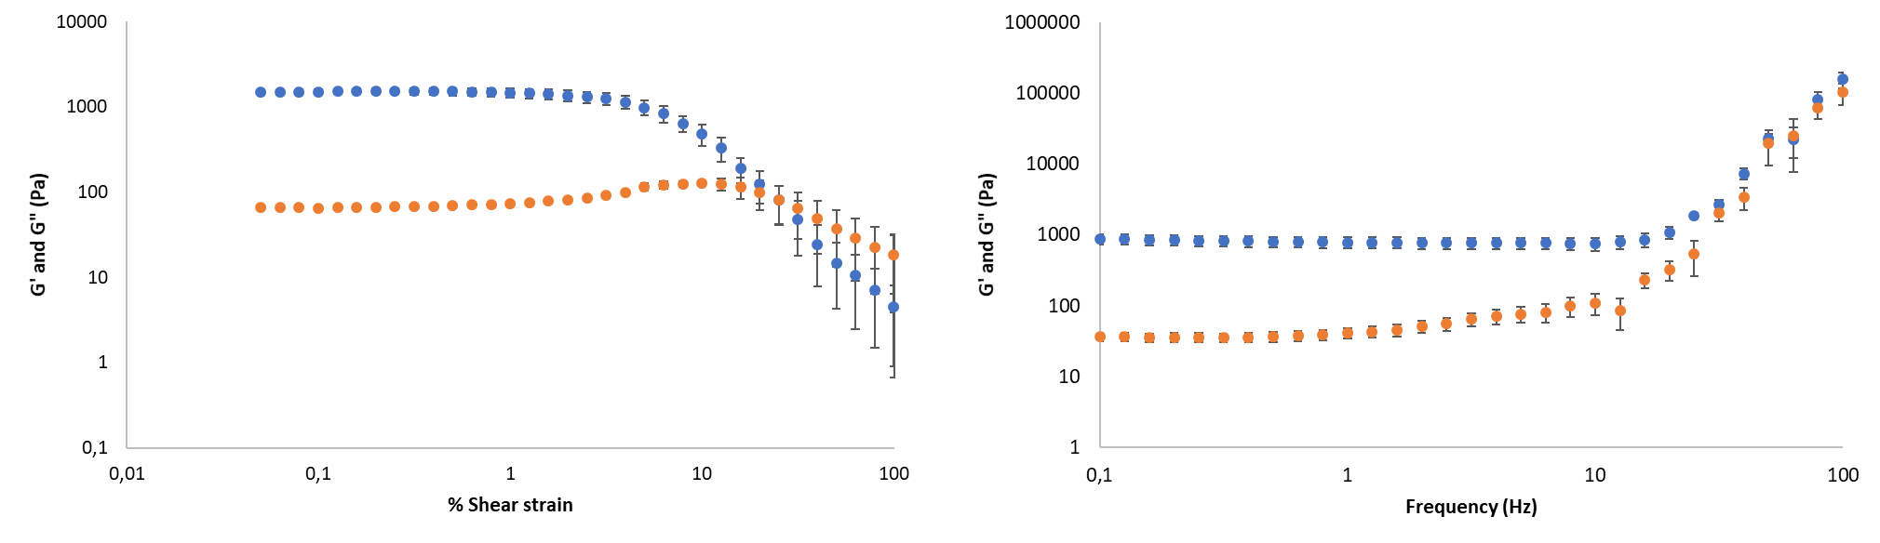
Figure S19. Elastic (G’, blue circles) and viscous (G”, orange circles) moduli of DBS-CONHNH₂ hydrogel (0.4% wt/vol) with increasing shear strain (left) and frequency (right).

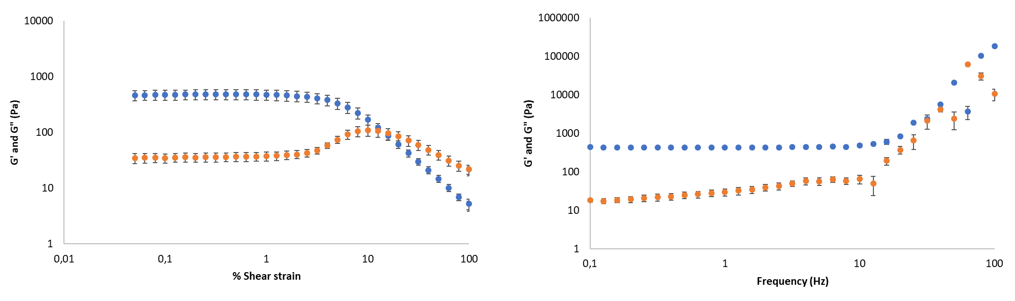

Figure S20. Elastic (G’, blue circles) and viscous (G”, orange circles) moduli of DBS-COOH hydrogel (0.4% wt/vol) with increasing shear strain (left) and frequency (right).

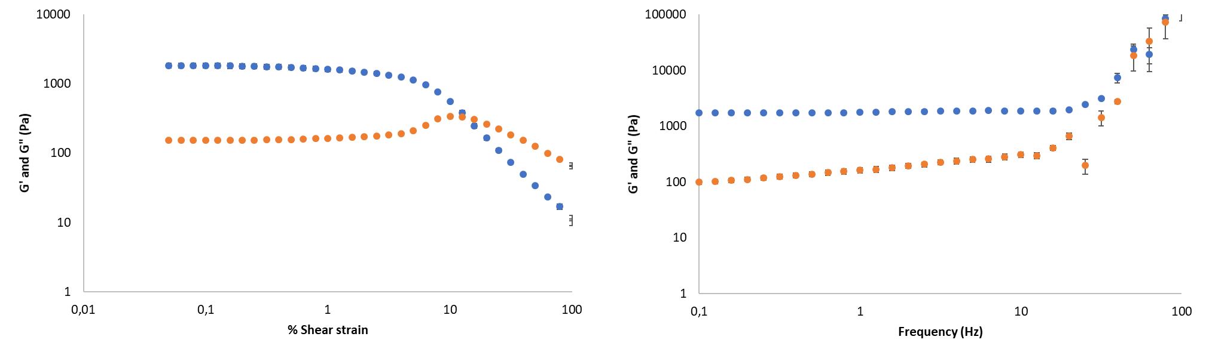

Figure S21. Elastic (G’, blue circles) and viscous (G”, orange circles) moduli of DBS-CONHNH₂/DBS-COOH two-component gel (0.2% wt/vol of each LMWG) with increasing shear strain (left) and frequency (right).

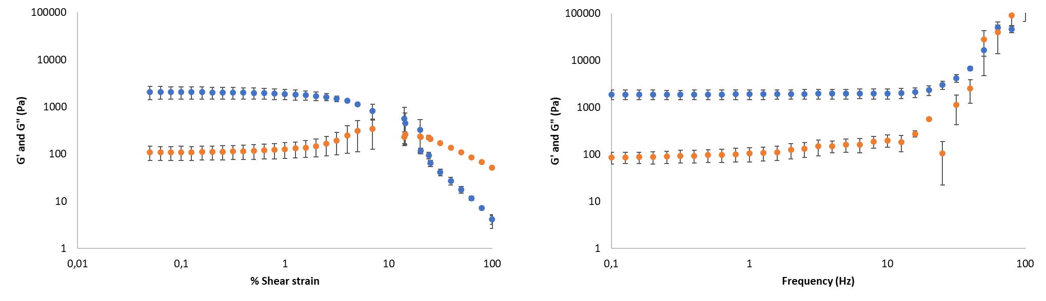

Figure S22. Elastic (G’, blue circles) and viscous (G”, orange circles) moduli of DBS-CONHNH₂/DBS-COOH two-component gel (0.2% wt/vol of each LMWG) with increasing shear strain (left) and frequency (right). The DBS-COOH network in this gel was disrupted by addition of NaOH (0.5 M, 60 μL) and subsequently reformed by addition of GdL. Rheology was measured after the gel was reformed.

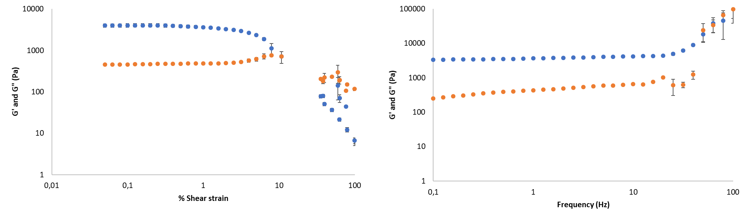

Figure S23. Elastic (G’, blue circles) and viscous (G”, orange circles) moduli of DBS-CONHNH₂/DBS-COOH two-component gel (prepared with 0.2% wt/vol of each LMWG and 1.0% wt/vol of GdL) with increasing shear strain (left) and frequency (right).

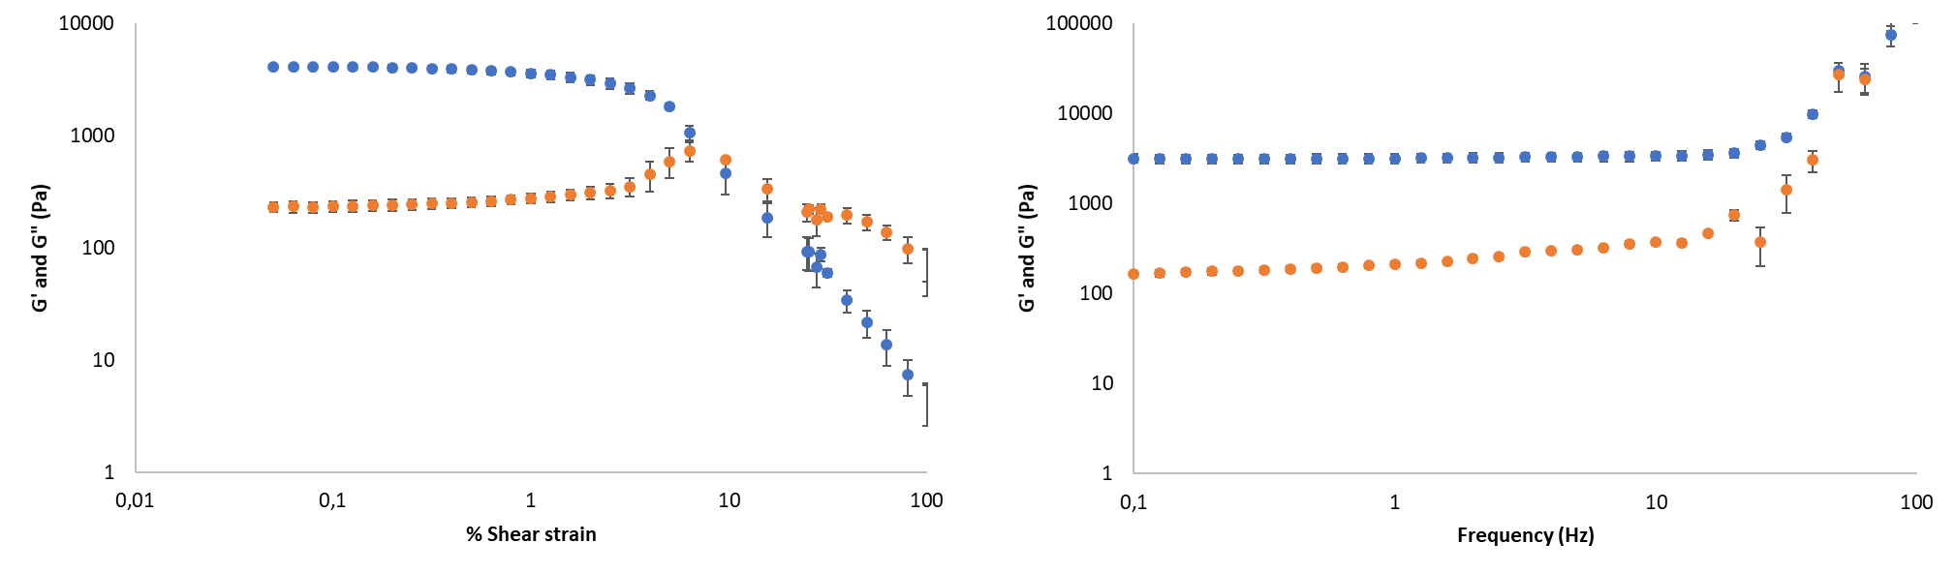

Figure S24. Elastic (G’, blue circles) and viscous (G”, orange circles) moduli of DBS-CONHNH₂/DBS-COOH two-component gel (0.3% wt/vol of each LMWG) with increasing shear strain (left) and frequency (right).

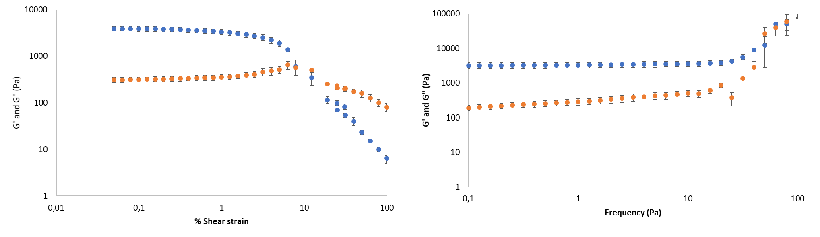
Figure S25. Elastic (G’, blue circles) and viscous (G”, orange circles) moduli of DBS-CONHNH₂/DBS-COOH two-component gel (0.3% wt/vol of each LMWG) with increasing shear strain (left) and frequency (right). The DBS-COOH network in this gel was disrupted by addition of NaOH (0.5 M, 60 μL) and subsequently reformed by addition of GdL. Rheology was measured after the gel was reformed.

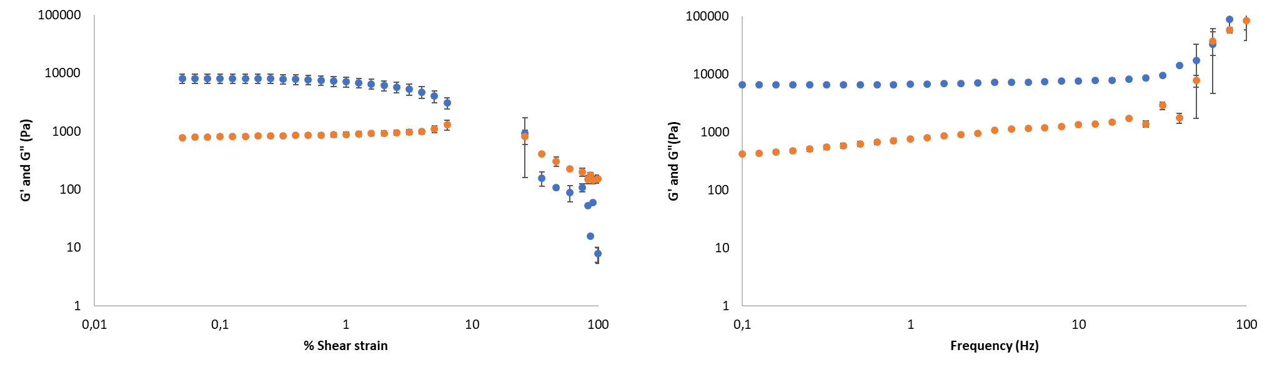

Figure S26. Elastic (G’, blue circles) and viscous (G”, orange circles) moduli of DBS-CONHNH₂/DBS-COOH two-component gel (prepared with 0.3% wt/vol of each LMWG and 1.0% wt/vol of GdL) with increasing shear strain (left) and frequency (right).

S8.3 Rheology of heparin loaded gels
Oscillatory rheology experiments were carried out to obtain information on the mechanical properties of the heparin loaded gels. These gels were prepared in 10 mM Tris-HCl/150 mM NaCl buffer and heparin was added to the LMWGs mixture before gel formation. The DBS-COOH gel did not show remarkable differences in the presence and absence of heparin, with the elastic modulus (G’) of the gel without heparin of 434 Pa and with heparin of 498 Pa (Figure S28). The hydrogels of DBS-CONHNH₂, by contrast, were stiffer in the presence of heparin (G’ = 1370 Pa - Figure S27) rather than without heparin (G’ = 800 Pa). Similarly, the heparin loaded multicomponent gel (prepared using 0.2% wt/vol of each LMWG and 0.8% wt/vol of GdL) was stiffer (G’ = 2530 Pa - Figure S29) than the multicomponent gel prepared in the same conditions without heparin (G’ = 1790). As observed for the gels prepared without heparin, the heparin loaded DBS-CONHNH₂/DBS-COOH multicomponent gel displays a higher elastic modulus than the heparin loaded gels formed by the two individual LMWGs. However, in this case, when the multicomponent gel was prepared using a higher GdL concentration (1.0 %wt/vol), the mechanical stiffness of the gel (G’ = 2600 Pa) was not significantly affected (Figure S30). Interestingly, the heparin loaded DBS-CONHNH₂/DBS-COOH multicomponent gel (prepared using 0.2% wt/vol of each LMWG and 1.0% wt/vol of GdL) has a lower G’ than the corresponding gel without heparin (2600 vs 3790 Pa). As observed for the gels prepared without heparin, the stiffness of the multicomponent gel loaded with heparin increases when the concentration of the two LMWGs is increased. When the gel was prepared using 0.3% wt/vol of each LMWG, the G’ increased to 6920 Pa (Figure S31), compared to the gel prepared using a 0.2% wt/vol concentration of each LMWG (G’ = 2600 Pa). This is higher than the stiffness of the corresponding gel without heparin (G’ = 3270 Pa). Also in this case, using a higher amount of GdL (1.0 % wt/vol) to obtain the gel prepared using 0.3 % wt/vol of each LMWG, did not induce an improvement of the rheological performance (G’ = 4160), which was again lower than the corresponding gel without heparin (G’ = 6860 Pa – Figure S32).

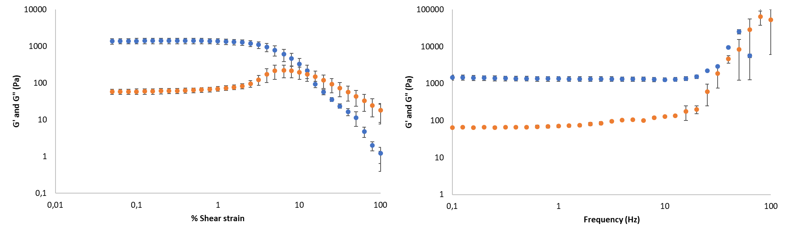
Figure S27. Elastic (G’, blue circles) and viscous (G”, orange circles) moduli of DBS-CONHNH₂ hydrogel (0.4% wt/vol) loaded with heparin (1 mM) with increasing shear strain (left) and frequency (right).

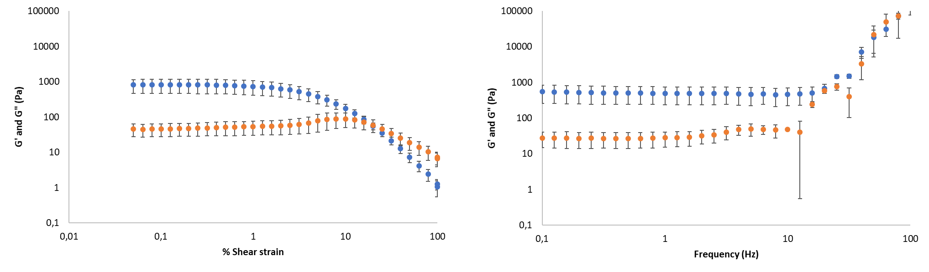
Figure S28. Elastic (G’, blue circles) and viscous (G”, orange circles) moduli of DBS-COOH hydrogel (0.4% wt/vol) loaded with heparin (1 mM) with increasing shear strain (left) and frequency (right).

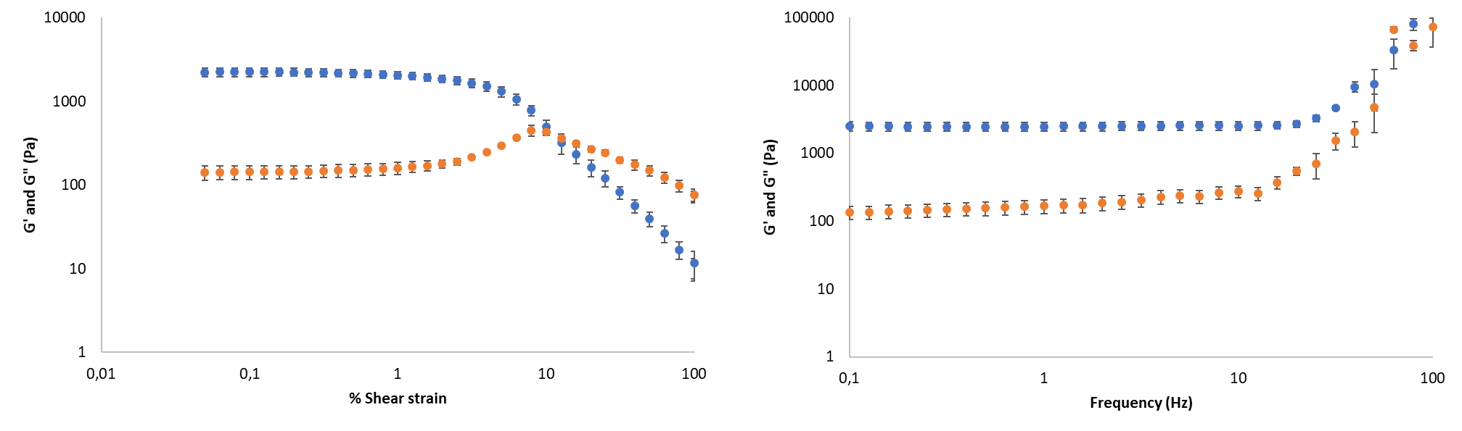

Figure S29. Elastic (G’, blue circles) and viscous (G”, orange circles) moduli of heparin-loaded (1 mM) DBS-CONHNH₂/DBS-COOH multicomponent gel (0.2% wt/vol of each LMWG) with increasing shear strain (left) and frequency (right).

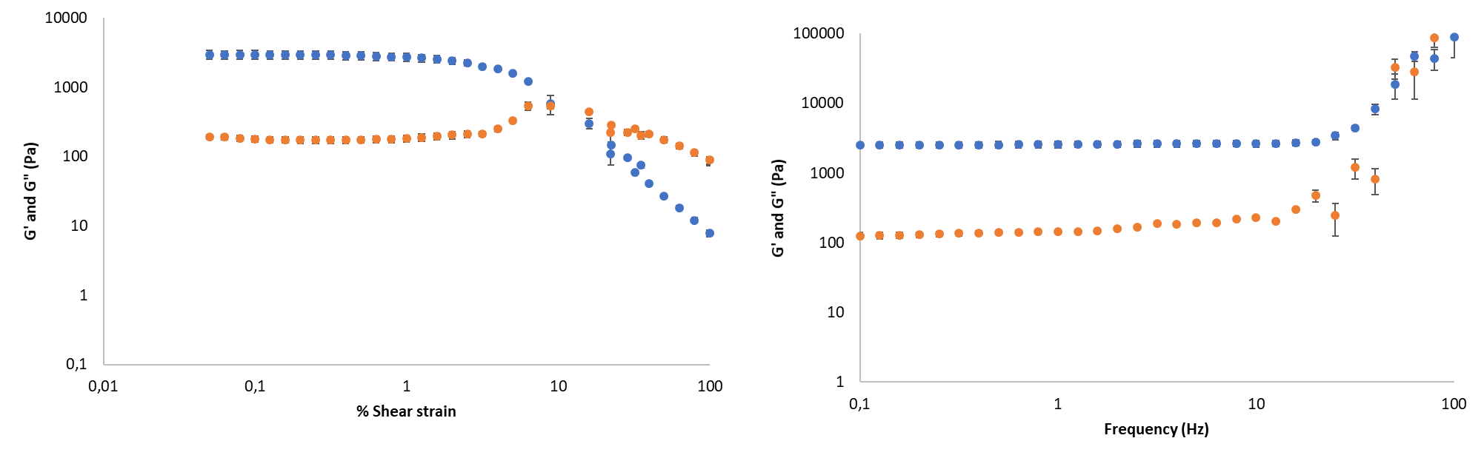
Figure S30. Elastic (G’, blue circles) and viscous (G”, orange circles) moduli of heparin-loaded (1 mM) DBS-CONHNH₂/DBS-COOH multicomponent gel (prepared with 0.2% wt/vol of each LMWG and 1.0% wt/vol GdL) with increasing shear strain (left) and frequency (right).

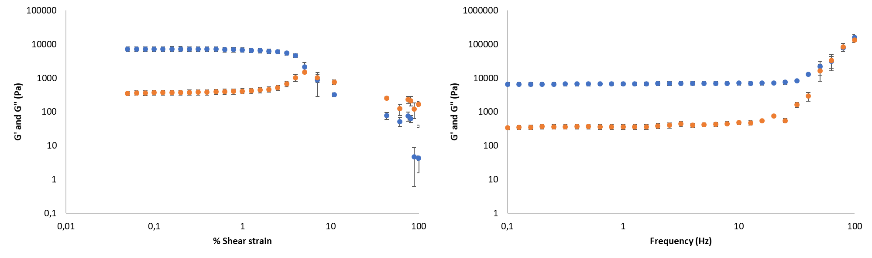

Figure S31. Elastic (G’, blue circles) and viscous (G”, orange circles) moduli of heparin-loaded (1 mM) DBS-CONHNH₂/DBS-COOH multicomponent gel (0.3% wt/vol of each LMWG) with increasing shear strain (left) and frequency (right).

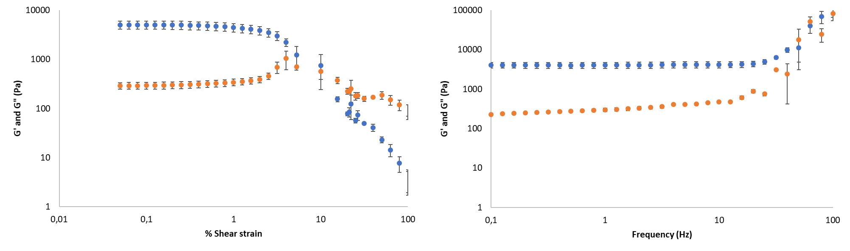

Figure S32. Elastic (G’, blue circles) and viscous (G”, orange circles) moduli of heparin-loaded (1mM) DBS-CONHNH₂/DBS-COOH multicomponent gel (prepared with 0.3% wt/vol of each LMWG and 1.0% wt/vol GdL) with increasing shear strain (left) and frequency (right).

S8.4 Rheology of photoactivated hydrogels

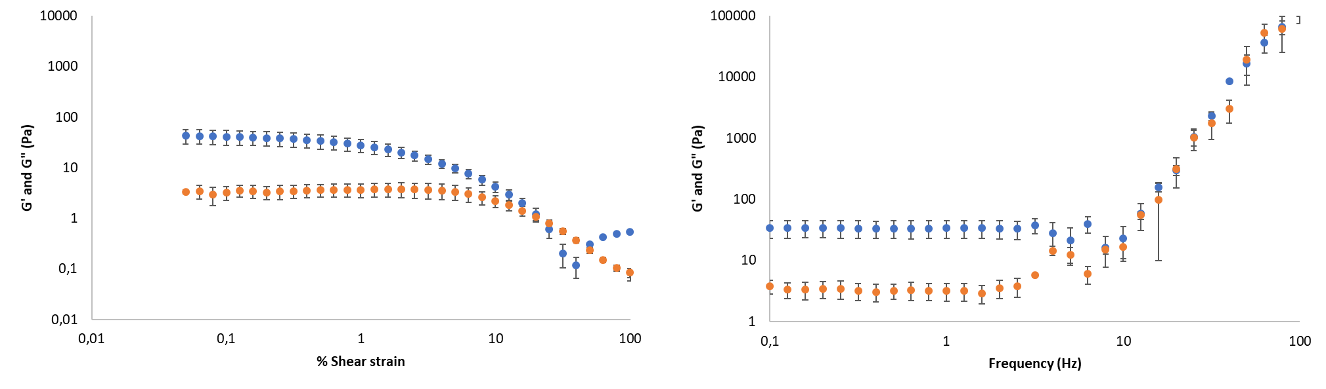
Figure S33. Elastic (G’, blue circles) and viscous (G”, orange circles) moduli of photoactivated DBS-COOH hydrogel (0.4% wt/vol) with increasing shear strain (left) and frequency (right).

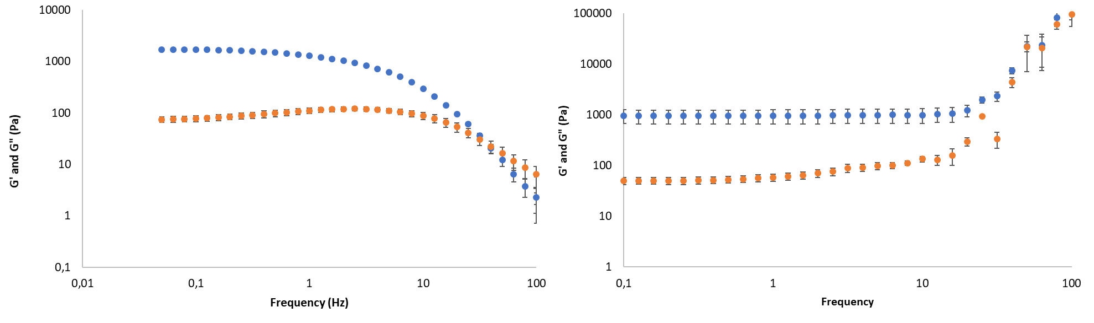
Figure S34. Elastic (G’, blue circles) and viscous (G”, orange circles) moduli of photoactivated DBS-CONHNH₂/DBS-COOH two-component gel (0.2% wt/vol of each) with increasing shear strain (left) and frequency (right).

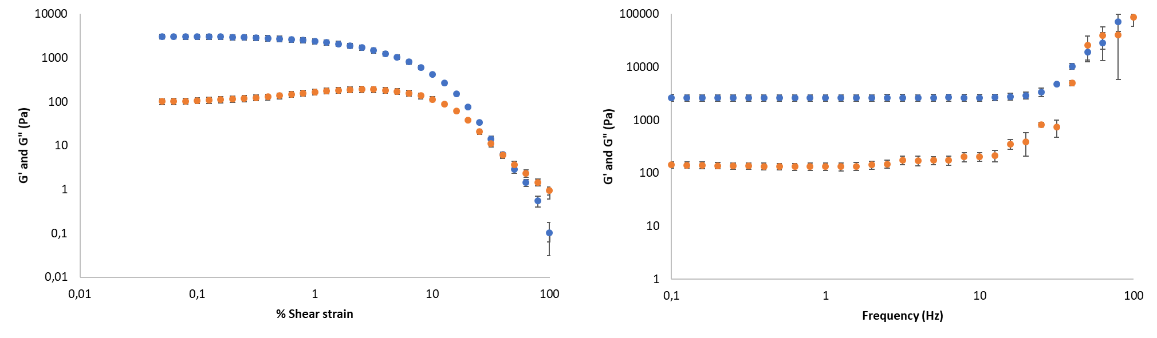

Figure S35. Elastic (G’, blue circles) and viscous (G”, orange circles) moduli of photoactivated DBS-CONHNH₂/DBS-COOH multicomponent gel (0.3% wt/vol of each LMWG) with increasing shear strain (left) and frequency (right).

S9 Heparin release studies
S9.1 Release assay
Gel samples for heparin release studies were prepared in 1 mL volume, as described in section S2, and incubated at 37 ºC for the duration of the study (56 or 72 hours). 2 mL of 10 mM Tris-HCl/150 mM NaCl buffer (pH 7.4) were placed on top of each gel and 65 μL aliquots of buffer were taken at regular time intervals. These aliquots were added to 1935 μL of MalB solution in 10 mM Tris-HCl/150 mM NaCl buffer (25.84 μM) and the UV-vis absorbance at 615 nm was monitored. To ensure reproducibility, the data were collected in triplicate and the average is shown. Control experiments with gels containing no heparin were also carried out. A calibration curve of heparin was obtained by adding 65 μL of known heparin concentrations in 10 mM Tris-HCl/150 mM NaCl buffer to 1935 μL of MalB solution in the same buffer and the absorbance spectra recorded.
S9.2 Heparin release data
Table S7. Percentage of heparin released over time from hydrogels.
Time (hours) | % of heparin released from hydrogels
 | DBS-CONHNH₂ (0.4% wt/vol) | DBS-COOH (0.4% wt/vol) | DBS-CONHNH₂/DBS-COOH multicomponent gel (0.2% wt/vol of each LMWG)* | DBS-CONHNH₂/DBS-COOH multicomponent gel (0.2% wt/vol of each LMWG)** | DBS-CONHNH₂/DBS-COOH multicomponent gel (0.3% wt/vol of each LMWG)* | DBS-CONHNH₂/DBS-COOH multicomponent gel (0.3% wt/vol of each LMWG)**
0 | 0 | 0 | 0 | 0 | 0 | 0
4 | 35.63 | 7.66 | 14.08 | 5.02 | 9.31 | 11.99
8 | 52.27 | 31.68 | 19.03 | 25.85 | 26.05 | 21.29
24 | 60.36 | 53.86 | 41.09 | 42.16 | 41.80 | 38.27
28 | 57.16 | 55.86 | 43.28 | 43.62 | 44.16 | 38.04
32 | 55.83 | 54.40 | 48.29 | 40.60 | 43.32 | 38.24
48 | 48.39 | 45.39 | 43.12 | 37.04 | 38.81 | 31.77
56 | 50.28 | 48.68 | 45.86 | 40.67 | 41.42 | 34.42
72 | 48.68 | 45.69 | 45.49 | 38.73 | 39.93 | 33.11

*These gels were prepared using 0.045 mmoles (0.8 % wt/vol) of GdL
***These gels were prepared using 0.056 mmoles (1.0 % wt/vol) of GdL

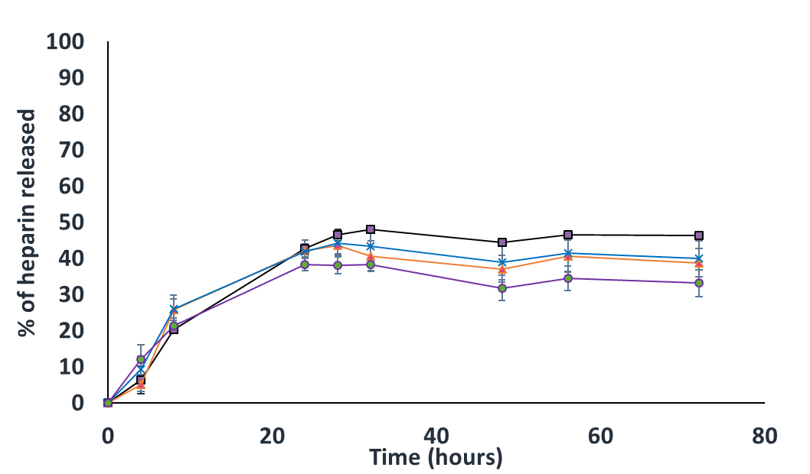

Figure S36. Percentage of heparin released over time from DBS-CONHNH₂/DBS-COOH multicomponent gel prepared using: 0.2% wt/vol of each LMWG and 0.8% wt/vol of GdL (black line), 0.2% wt/vol of each LMWG and 1.0% wt/vol of GdL (orange line), 0.3% wt/vol of each LMWG and 0.8% wt/vol of GdL (blue line) and 0.3% wt/vol of each LMWG and 1.0% wt/vol of GdL (purple line).

Table S8. Percentage of heparin released over time from photoactivated hydrogels.
Time (hours) | % of heparin released from photoactivated hydrogels
 | DBS-COOH (0.4 % wt/vol) | DBS-CONHNH₂/DBS-COOH multicomponent gel (0.3 % wt/vol of each LMWG)* | DBS-CONHNH₂/DBS-COOH multicomponent gel (0.2 % wt/vol of each LMWG)*
0 | 0 | 0 | 0
4 | 28.36 | 3.26 | 6.34
8 | 35.13 | 13.73 | 20.34
24 | 47.20 | 37.72 | 42.72
28 | 51.04 | 42.67 | 46.42
32 | 51.05 | 43.36 | 47.92
48 | 49.70 | 45.92 | 44.29
52 | 47.70 | 44.40 | 46.44
56 | 46.47 | 43.19 | 46.24

*These gels were prepared using GdL (0.6 % wt/vol) and DPIN (0.8 % wt/vol) as pH activators

S10 References
[1] B. O. Okesola, D. K. Smith, Chem. Commun. 2013, 49, 11164-11166.
[2] D. J. Cornwell, B. O. Okesola, D. K. Smith, Soft Matter 2013, 9, 8730-8736.
[3] V. M. P. Vieira, L. L. Hay, D. K. Smith, Chem. Sci. 2017, 8, 6981-6990.

