Addressing disparities in oral disease in Aboriginal people in Victoria: where to focus preventive programs

Authors
Jacqueline M. Martin-Kerry*, PhD BAppSci(Hons)
Research Fellow, Department of Health Sciences, University of York, Heslington, York, YO10 5DD

Martin Whelan, BDSc
Clinical Data Analyst, Dental Health Services Victoria, 720 Swanston Street, Carlton 3053 AUSTRALIA

John Rogers, BDS MPH PhD
Principal Population Oral Health Advisor, Manager Oral Health Promotion, Screening & Preventive Health Programs, Department of Health & Human Services, 50 Lonsdale Street, Melbourne Victoria 3000

Anil Raichur, BDS, MPH
Senior Policy Officer, Oral Health Promotion, Screening & Preventive Health Programs, Department of Health & Human Services, 50 Lonsdale Street, Melbourne Victoria 3000

Deborah Cole, BDSc, GradDipHealthAdmin, MBA, GradCertLead&CathCulture, FAICD, FAIM
Chief Executive Officer, Dental Health Services Victoria, 720 Swanston Street, Carlton 3053 AUSTRALIA

Andrea M. de Silva, PhD, MHN, BSc
Director, Research Innovation, Worksafe Victoria, 44 Malop Street, Geelong, Vic 3220
Adjunct Professor, School of Public Health and Preventive Medicine, Monash University

* Corresponding author

Conflicts of interest
The authors declare no conflicts of interest.

Acknowledgments
The Victorian Department of Health and Human Services provided funding for DHSV to undertake this project. We acknowledge the assistance of Jacqui Cooper, who undertook a student placement with DHSV, for reviewing the literature that formed the introduction of this paper.
Abstract
Objectives To determine where Aboriginal people living in Victoria attend public oral health services; whether they access Aboriginal-specific or mainstream public oral health services; and the gap between dental caries (tooth decay) experience in Aboriginal and non-Aboriginal people.
Methods The overall method included a retrospective analysis of routinely collected clinical data for Aboriginal patients attending Victorian public oral health clinics and the distribution of Aboriginal population across Victoria. Data were extracted from two databases: Titanium, the electronic data system used by Victorian public dental clinics; and the portal within the Australian Bureau of Statistics.
Results Approximately 27% of Aboriginal people attended public oral health services in Victoria across a two-year period, with only around one in five of those accessing care at Aboriginal-specific clinics. In relation to dental disease, in regional areas of Victoria six-year old Aboriginal children had significantly higher levels of dental caries than six-year old non-Aboriginal children. There was not a significant difference in other age groups.
Conclusions This study is the first to report important information about where Aboriginal people access oral health care in the public sector and the disparity in disease between Aboriginal and non-Aboriginal users of the public oral healthcare system. It highlights that Aboriginal people largely access mainstream public oral health care clinics in Victoria and shows the levels of dental caries in Aboriginal and non-Aboriginal people living in Victoria. These findings highlight how important it is for culturally-appropriate services and prevention programs to be provided across the entire public oral healthcare system. This information will be used to guide development of policy and models of care in Victoria aimed at improving the oral health of Aboriginal people living in Victoria.

Key words
Indigenous, Torres Strait Islander, public oral health care, oral health, dental caries

What is known about the topic?
- Aboriginal people generally have poorer overall health and oral health than non-Aboriginal people; however, most of the data is from rural and remote locations in Australia.

What does this paper add?
- This paper is the first to report how Aboriginal people access public oral health services in Victoria and shows the disparity in dental caries levels between Aboriginal and non-Aboriginal people.

Introduction
Oral health is fundamental to overall health, well-being and quality of life (National Advisory Committee on Oral Health 2004). Oral disease can result in debilitating pain, difficulty eating and speaking, embarrassment, and lower quality of life (UK Department of Health 1994). Both dental caries (tooth decay) and periodontal disease (gum disease) are preventable, and even reversible at early onset. Although not all Aboriginal people have poor oral health, current research suggests that in Australia, Aboriginal people now experience considerably poorer general health (Australian Institute of Health and Welfare 2015) and oral health (Roberts-Thomson and Australian Research Centre for Population Oral Health 2004; Slade et al. 2007; Slade GD 2007; Smith et al. 2007; Kruger et al. 2008a; Amarasena et al. 2014; Roberts-Thomson et al. 2014) than non-Aboriginal Australians. However these studies focus mainly on the oral health of Aboriginal people living in Queensland, South Australia and Western Australia. In this paper, 'Aboriginal' refers to both Aboriginal and Torres Strait Islander people. It has been noted that the history of how Aboriginal people have been treated in the past, with Australia failing to recognise Aboriginal people as humans within its constitution until 1967, has contributed to the disparity in health between Aboriginal and non-Aboriginal people (Jamieson et al. 2016).

There are approximately 700,000 Aboriginal people living in Australia, representing approximately three per cent of the Australian population (Australian Bureau of Statistics 2011). In Victoria, the Aboriginal population is estimated to be approximately 47,000 (Australian Bureau of Statistics 2011). This equates to almost one per cent of the Victorian population. At a national level, there is recognition of disparities in health outcomes between Aboriginal and non-Aboriginal populations. In regards to oral health, Aboriginal people have poorer oral health, which includes periodontal disease and dental caries, than the general population in Australia, although the data is limited. To address this health disparity, national (National Oral Health Plan 2015-2024(Brockton et al. 2000)) and State (Victorian government)(Victorian State Government 2014) policy have recognised the importance of prioritising services and programs for Aboriginal people to enable better access to public oral health services. A key action of the National Oral Health Plan is to provide culturally-appropriate and accessible oral health services through partnerships between mainstream and Indigenous-specific oral health services. Oral health care in Australia is largely delivered in the private sector and is separate to Medicare; creating a fragmentation from other areas of health (King et al. 2009). However, people with low income (as represented by those with health and pension concession cards), refugee and asylum seekers, and young children can access oral health care in the public (government-funded) sector. It has been identified that of all health conditions in Australia, poor oral health is the most strongly associated condition with socio-economic status (National Oral Health Plan, 2015).

Two recent systematic reviews of published data in peer-reviewed journals on oral health of Aboriginal people in Australia found studies to be lacking in terms of population coverage and currency (de Silva et al. 2015; de Silva et al. 2016). The available data focuses on Aboriginal people living in rural and remote locations of Australia (Roberts-Thomson and Australian Research Centre for Population Oral Health 2004; Kruger et al. 2008b; Kruger et al. 2010; Pulver et al. 2010; Amarasena et al. 2014; Dimitropoulos et al. 2018a; Dimitropoulos et al. 2018b; Butten et al. 2019). A recent Australian Institute of Health and Welfare (AIHW) publication has demonstrated that in contemporary Australia, the Aboriginal population is concentrated on the eastern coastline and that the largest clusters of Aboriginal people are in cities (Australian Institute of Health and Welfare 2015). There is no published information about the oral health status of Aboriginal people living in Victoria or how they access oral health care services (de Silva et al. 2015). Without this evidence, it is difficult to develop appropriate policies or models of care, to increase access to oral health care services and improve outcomes for Aboriginal people.

The aim of this study was to use existing oral health service data to describe where Aboriginal people attend for public oral health services in Victoria and to examine differences in the level of dental caries in Aboriginal and non-Aboriginal people living in Victoria.

Methods
This study involved a retrospective analysis of routinely collected clinical data for Aboriginal and non-Aboriginal patients attending dental clinics across the Victorian public oral health care service. These data are drawn from two sources:
- Titanium, the electronic data system used by Victorian public oral health clinics to capture clinical and administrative patient data. Data were extracted for Aboriginal and non-Aboriginal patients attending Victorian public oral health services for two financial years (2012/13 and 2013/14) by the Victorian Department of Health and Human Services.
- The 2011 Census dataset from the Australian Bureau of Statistics (ABS). The number of Aboriginal people living in Victoria was extracted by postcode.

Titanium data
Titanium data were summarised according to age, clinic location, course of care and types of oral health care provided. The main outcome measures analysed were the number of visits, reason for visit (emergency or non-emergency), clinic location and services (including the number and type of treatment received). Patients who identified as being Aboriginal or Torres Strait Islander when attending the oral health service are included in the Aboriginal patient data and those who did not are referred to as non-Aboriginal. We note however that Aboriginal people do not always identify as Aboriginal within health services or within Census data collection processes (Census 2016) and this will impact the data presented in this study.
Census data
The 2011 Census data were compared with Titanium data to examine the proportion of Aboriginal patients attending per public oral health clinic to describe how this population is accessing public oral health services. Data published by ABS estimate the Victorian Aboriginal population to be 47,333 (Australian Bureau of Statistics 2011). This is based on a number of adjustments made to the total population count through the Census. However, whilst the total population within Victoria can be adjusted, this was not possible at a more detailed level (e.g. for regions or postcodes within Victoria). The data available from ABS for analysis within this study is the actual count obtained on Census night 2011, which is 37,736 and this was made available by postcode for further analysis and mapping within this study. The geographical distribution of Aboriginal patients was mapped using the Geographical Information System software MapInfo®. To demonstrate the variation in service coverage across the state, the number of Aboriginal individuals treated over a two-year period has been mapped as a percentage of the Aboriginal population by agency catchment area. Postcodes have been notionally assigned to agencies to form catchment areas based on historical data of agencies that most individuals from each postcode accessed care from, noting individuals from a particular postcode may access care at any agency.

The level of disease (caries experience) was assessed using the decayed, missing and filled teeth index for deciduous/primary teeth (dmft) and permanent teeth (DMFT) from the Titanium data. Caries data were presented as mean dmft/DMFT and percentage with caries by age and Aboriginal status. The child age groups are as recommended by the World Health Organisation (WHO) (child ages of 5-6 years and 12 years)(World Health Organization 2012) and for adults, standard age groupings used by ABS were used (18-24 years, 25-44 and 45-64 and 65+ years). Confidence intervals (95%) were calculated for the dmft and DMFT data using Microsoft excel® 2010. Statistical significance was set at p<0.05.

Ethics approval
Ethics approval for the project was received from the Victorian Department of Health and Human Services Human Research Ethics Committee (Project 11/15). Approval to use state-wide data was obtained from the Dental Program within the Victorian Department of Health and Human Services. We discussed the project with the Aboriginal Health Branch at the Victorian Department of Health and Human Services. We also discussed the project with the Aboriginal Liaison Office at Dental Health Services Victoria.

Results
Where do Aboriginal people attend for public oral health services?
In the Titanium data there were 12,786 Aboriginal people (approximately 27% of Aboriginal people living in Victoria) who attended public oral health services over a two year period. Figures 1 and 2 map this data as a percentage of the estimated total Aboriginal population from the ABS data for that region. Mapping attendance according to agency catchment revealed wide variation across the state in terms of the proportion of Aboriginal people in any location that were accessing public oral health care. Three Aboriginal clinics with oral health services do not currently provide data to Titanium and so the estimate from Titanium will not provide the complete picture and will under-estimate the total numbers of Aboriginal people accessing public oral health care in Victoria. One of these clinics is metropolitan and two are rural.

The data revealed that around one third of the Aboriginal population in Victoria accessed public oral health services at a clinic that was not their nearest clinic, based on their residence. The largest proportion of clients who travelled beyond their local clinic was at the Royal Dental Hospital of Melbourne (RDHM). At the RDHM, 97.5% of Aboriginal clients that accessed non-specialist care in the Primary Care Unit were from outside the hospital’s catchment area. However, the RDHM has only a small catchment area (Carlton, Parkville and Melbourne CBD) that is surrounded by a number of inner city community dental clinics. The data indicate almost all Aboriginal individuals who attended the RDHM for non-specialist care were from outside the hospital’s catchment area despite the presence of community dental clinics offering the same service that are closer to their place of residence.

Differences in dental caries experience between Aboriginal and non-Aboriginal patients in Victoria
Mean dmft and DMFT data were derived using data from Titanium, analysed by region and state-wide. The percentage with dental caries experience is shown in Figure 3. There was a trend for Aboriginal children to have higher caries experience (proportion with a history of dental caries) than non-Aboriginal children up to 9-11 years of age. From 12 years of age, the trend was for caries experience in Aboriginal and non-Aboriginal to be similar, with both populations showing high levels of caries (above 60% at age 12 and above 70% for the 13-17 year age group). For adults aged 25 and over, more than 90% had some experience of dental caries.

When examining the mean dmft for 5-6 year olds (Figure 4), Aboriginal children in inner and outer regional areas of Victoria had a statistically higher mean dmft – in outer regional locations dmft 4.4 versus 2.6 for non-Aboriginal children. For 12 year old children (Figure 5), Aboriginal children had higher DMFT rates in major city locations and lower rates in inner and outer regional locations, however, these differences were not significant. For Aboriginal adults, the highest levels of caries prevalence and proportion of Aboriginal adults presenting to public oral health services with untreated caries were observed in regional areas (data not shown).

Discussion
This study has identified that approximately a quarter of Aboriginal people attended public oral health services in Victoria over the two year period. Approximately 21% of those attending public oral health services did so at an Aboriginal-specific clinic. Information about how Aboriginal people access oral health care is limited (Arrow 2016). Our study also showed significantly higher caries experience (dmft) in six year old Aboriginal children living in regional Victoria when compared to non-Aboriginal children. This supports previous studies showing higher caries experience in Aboriginal children of this age group in other regions of Australia including Western Australia, New South Wales, Northern Territory and Queensland (Jamieson et al. 2007; Christian and Blinkhorn 2012).

Reviews of existing literature on Aboriginal oral health showed no published studies of either oral health status or oral health needs of Aboriginal adults living in Victoria (de Silva et al. 2015; de Silva et al. 2016). There are very little data from the Victorian population to guide policy development to improve the oral health of this priority population. The majority of data published in peer-reviewed scientific literature are for Aboriginal people living in rural and remote locations, whereas in Victoria, many Aboriginal people live in metropolitan locations and access oral health care in these areas. This study is the first to describe access by Aboriginal people to public oral health services in Victoria and shows that approximately 27% of Aboriginal people were accessing public oral health services, with most accessing mainstream services. However, these calculations were based on the lower ABS estimate of Aboriginal population rather than the ABS adjusted estimate.

A number of important factors influence oral disease such as dental caries. These include living in an area of water fluoridation, oral hygiene behaviours, dietary patterns and habits as well as how oral health care is accessed (Ha et al. 2016). A number of these aspects such as dietary habits and oral hygiene behaviours, cannot be examined within the current study. It has however been shown in other studies that diets have changed and Aboriginal people (as well as non-Aboriginal people) consume foods with higher sugar content (Ha et al. 2017; Gwynn et al. 2019).

The ways that Aboriginal people access public oral health services are important for planning and policy development. It also has implications for the delivery of prevention programs for oral health as clearly these would need to be targeted within mainstream clinics as well as Aboriginal-specific oral health clinics. It is also important to ensure that culturally appropriate services are available within mainstream health care services. It is noteworthy that the number of Aboriginal individuals treated in the Victorian public oral health services has been steadily increasing (Dental Health Services Victoria, 2017). This increase can be attributed to the implementation of a number of initiatives by public oral health agencies and RDHM to improve oral health access for this priority population. Initiatives have included outreach services, employment of Aboriginal Community Development Officers and Aboriginal-specific dental sessions (Dental Health Services Victoria ; Rogers 2011).

In terms of dental caries experience, there was not a consistent pattern between levels in Aboriginal and non-Aboriginal people. This result is different to studies in other areas in Australia which have found a higher burden of disease in Aboriginal people (Slade et al. 2004; Smith et al. 2007; Amarasena et al. 2014; Durey et al. 2016). Caries levels were significantly higher for 5-6 year old Aboriginal children living in regional locations but not in major cities. No statistically significant differences were found in DMFT rates in 12 year olds. However the high caries experience in both Aboriginal and non-Aboriginal children is of concern and it is important to target prevention activities to all high risk children, particularly before they reach six years of age (Australian Governent 2015). In Victoria, there are already a number of programmes being delivered including early years interventions such as ‘Smiles 4 Miles’, and ‘Healthy Families Healthy Smiles’. These complement the free dental treatment for Victorian children aged under 13 years at the RDHM and other teaching dental clinics; however, it would appear from this study that more could be done to reach more children at high risk of dental caries. This may include delivering more community-based interventions to address oral health problems in young children. Previous studies have noted the varied success of oral health interventions within Aboriginal communities and that addressing equally important risk factors for oral disease such as unemployment, housing, education and poverty is required (Tsai et al. 2017). Any interventions or programmes to specifically improve the oral health of Aboriginal people should also consider these aspects.

Strengths and limitations of the study
This study provides important data on how Aboriginal people in Victoria access public oral health services and provides information on the prevalence of caries in Aboriginal and non-Aboriginal people accessing public dental services. It also highlights that most Aboriginal people accessing public oral health care are doing so through mainstream clinics.

The limitations of this study are:
- Dental caries data are limited to those attending public oral health services and are not necessarily representative of the general population. Public oral health services target lower socio-economic groups where disease levels are generally higher.
- The access measures are missing data for three Aboriginal oral health clinics.
- The lower Census figure of 37,736 was used and not the ABS adjusted total of 47,333 when determining proportions in Figures 1 and 2.
- We know that not all Aboriginal people will self-identify as Aboriginal and so the number of Aboriginal people accessing public oral health services reported in this study is likely to be under-estimated.

Conclusions
This study highlights how Aboriginal people in Victoria are accessing public oral health services and demonstrates that many are accessing mainstream services. The data also show that there was a significantly higher caries experience in five-six year old Aboriginal children in regional Victoria but not significant differences in other age groups. Young children in both populations had high levels of caries by age six in their primary teeth which suggests that introducing preventive programmes before this age would be beneficial. The finding that most Aboriginal people accessing public oral health services do so through mainstream, rather than Aboriginal-specific ones, suggests that any initiatives introduced to improve oral health in Aboriginal people need to be implemented in all public oral health clinics. However we acknowledge that those who seek treatment at Aboriginal-specific compared with mainstream clinics may have different needs. Further qualitative work to explore this aspect would be beneficial to support how best to implement future initiatives within public oral health clinics.

References:
Amarasena, N, Kapellas, K, Skilton, MR, Maple-Brown, LJ, Brown, A, O'Dea, K, Celermajer, DS, Jamieson, LM (2014) Associations with dental caries experience among a convenience sample of Aboriginal Australian adults. Australian Dental Journal 75, 126-33.
Arrow, P (2016) Service Use and Perceived Need among an Aboriginal Population in Western Australia. J Health Care Poor Underserved 27, 90-100.
Australian Bureau of Statistics (2011) 'Estimates of Aboriginal and Torres Strait Islander Australians, June 2011.' Available at http://www.abs.gov.au/ausstats/abs@.nsf/mf/3238.0.55.001 [Accessed 12/06/2015].
Australian Governent (2015) Australia's National Oral Health Plan 2015-2024, Healthy Mouths Healthy Lives. Available at www.nds.org.au/asset/view_document/979323603.
Australian Institute of Health and Welfare (2015) The health and welfare of Australia's Aboriginal and Torres Strait Islander people 2015. AIHW, Canberra.
Brockton, N, Little, J, Sharp, L, Cotton, SC (2000) N-acetyltransferase polymorphisms and colorectal cancer: a HuGE review. American Journal of Epidemiology 151, 846-61.
Butten, K, Johnson, NW, Hall, KK, Anderson, J, Toombs, M, King, N, O'Grady, KF (2019) Risk factors for oral health in young, urban, Aboriginal and Torres Strait Islander children. Aust Dent J 64, 72-81.
Christian, B, Blinkhorn, AS (2012) A review of dental caries in Australian Aboriginal children: the health inequalities perspective. Rural and Remote Health 12,
de Silva, AM, Martin-Kerry, JM, Geale, A, Cole, D (2015) Flying blind: trying to find solutions to Indigenous oral health. Australian Health Review
de Silva, AM, Martin-Kerry, JM, McKee, K, Cole, D (2016) Caries and periodontal disease in Indigenous adults in Australia: a case of limited and non-contemporary data. Aust Health Rev
Dental Health Services Victoria Dental Health Services Victoria Annual Report 2016-17. Victoria. Available at https://www.dhsv.org.au/__data/assets/pdf_file/0018/79200/DHSV-AR-2016-2017-complete.pdf.
Dental Health Services Victoria (2017) Dental Health Services Victoria Annual Report 2015-16. Available at https://www.dhsv.org.au/__data/assets/pdf_file/0009/64629/DHSV_AnnualReport_2015-16-for-web.pdf
Dimitropoulos, Y, Gunasekera, H, Blinkhorn, A, Byun, R, Binge, N, Gwynne, K, Irving, M (2018a) A collaboration with local Aboriginal communities in rural New South Wales, Australia to determine the oral health needs of their children and develop a community-owned oral health promotion program. Rural Remote Health 18, 4453.
Dimitropoulos, Y, Holden, A, Gwynne, K, Irving, M, Binge, N, Blinkhorn, A (2018b) An assessment of strategies to control dental caries in Aboriginal children living in rural and remote communities in New South Wales, Australia. BMC Oral Health 18, 177.
Durey, A, Bessarab, D, Slack-Smith, L (2016) The mouth as a site of structural inequalities; the experience of Aboriginal Australians. Community Dent Health 33, 161-3.
Gwynn, J, Sim, K, Searle, T, Senior, A, Lee, A, Brimblecombe, J (2019) Effect of nutrition interventions on diet-related and health outcomes of Aboriginal and Torres Strait Islander Australians: a systematic review. BMJ Open 9, e025291.
Ha, DH, Do, LG, Luzzi, L, Mejia, GC, Jamieson, L (2016) Changes in Area-level Socioeconomic Status and Oral Health of Indigenous Australian Children. J Health Care Poor Underserved 27, 110-124.
Ha, DH, Do, LG, Spencer, AJ, Thomson, WM, Golley, RK, Rugg-Gunn, AJ, Levy, SM, Scott, JA (2017) Factors Influencing Early Feeding of Foods and Drinks Containing Free Sugars-A Birth Cohort Study. Int J Environ Res Public Health 14,
Jamieson, LM, Armfield, JM, Roberts-Thomson, KF (2007) Dental caries trends among indigenous and non-indigenous Australian children. Community Dent Health 24, 238-246.
Jamieson, LM, Elani, HW, Mejia, GC, Ju, X, Kawachi, I, Harper, S, Thomson, WM, Kaufman, JS (2016) Inequalities in Indigenous Oral Health: Findings from Australia, New Zealand, and Canada. J Dent Res 95, 1375-1380.
King, M, Smith, A, Gracey, M (2009) Indigenous health part 2: the underlying causes of the health gap. Lancet 374, 76-85.
Kruger, E, Perera, I, Tennant, M (2010) Primary oral health service provision in Aboriginal Medical Services-based dental clinics in Western Australia. Australian Journal of Primary Health 16, 291-295.
Kruger, E, Smith, K, Atkinson, D, Tennant, M (2008a) The oral health status and treatment needs of Indigenous adults in the Kimberley region of Western Australia. The Australian Journal Of Rural Health 16, 283-289.
Kruger, E, Smith, K, Atkinson, D, Tennant, M (2008b) The oral health status and treatment needs of Indigenous adults in the Kimberley region of Western Australia. Australian Journal of Rural Health 16, 283-289.
National Advisory Committee on Oral Health (2004) Healthy Mouths Healthy Lives: Australia's National Oral Health Plan 2004-2013. South Australian Department of Health South Australia [Accessed 10/06/2015].
Pulver, LJ, Fitzpatrick, S, Ritchie, PJ, Norie, M (2010) Filling the Gap: An Evaluation of a Voluntary Dental Program Within an Aboriginal and Torres Strait Islander Community Controlled Primary Health Service. Aboriginal & Islander Health Worker Journal 34, 3-7.
Roberts-Thomson, KC, Australian Research Centre for Population Oral Health (2004) Oral health of Aboriginal Australians. Australian Dental Journal 49, 151-153.
Roberts-Thomson, KF, Do, LG, Bartold, PM, Daniels, J, Grosse, A, Meihubers, S (2014) Prevalence, extent and severity of severe periodontal destruction in an urban Aboriginal and Torres Strait Islander population. Australian Dental Journal 43.
Rogers, JG (2011) Evidence based oral health promotion resources Government of Victoria, Department of Health Melbourne Available at http://www.health.vic.gov.au/healthpromotion/evidence_res/evidence_index.htm
Slade GD, SA, Roberts-Thomson KF (2007) The National Survey of Adult Oral Health 2004-06. Australian Institute of Health & Welfare, Canberra.
Slade, GD, Spencer, AJ, Roberts-Thomson, KF (2004) Australia’s dental generations.
Slade, GD, Spencer, AJ, Roberts-Thomson, KF, (Editors)., (2007) Australia’s Dental Generations: the National Survey of Adult Oral Health 2004–06. Australian Institute of Health and Welfare, Canberra.
Smith, K, Kruger, E, Dyson, K, Tennant, M (2007) Oral health in rural and remote Western Australian indigenous communities: a two-year retrospective analysis of 999 people. International Dental Journal 57, 93-99.
Tsai, C, Blinkhorn, A, Irving, M (2017) Oral Health Programmes in Indigenous Communities Worldwide-Lessons learned from the field: A qualitative systematic review. Community Dent Oral Epidemiol 45, 389-397.
UK Department of Health (1994) An oral health strategy for England. London.
Victorian State Government (2014) 'Access to Victoria’s public dental care services.' Available at https://www2.health.vic.gov.au/primary-and-community-health/dental-health/access-public-dental-services [Accessed 1/10/2015].
World Health Organization (2012) Oral health surveys – basic methods. Geneva.

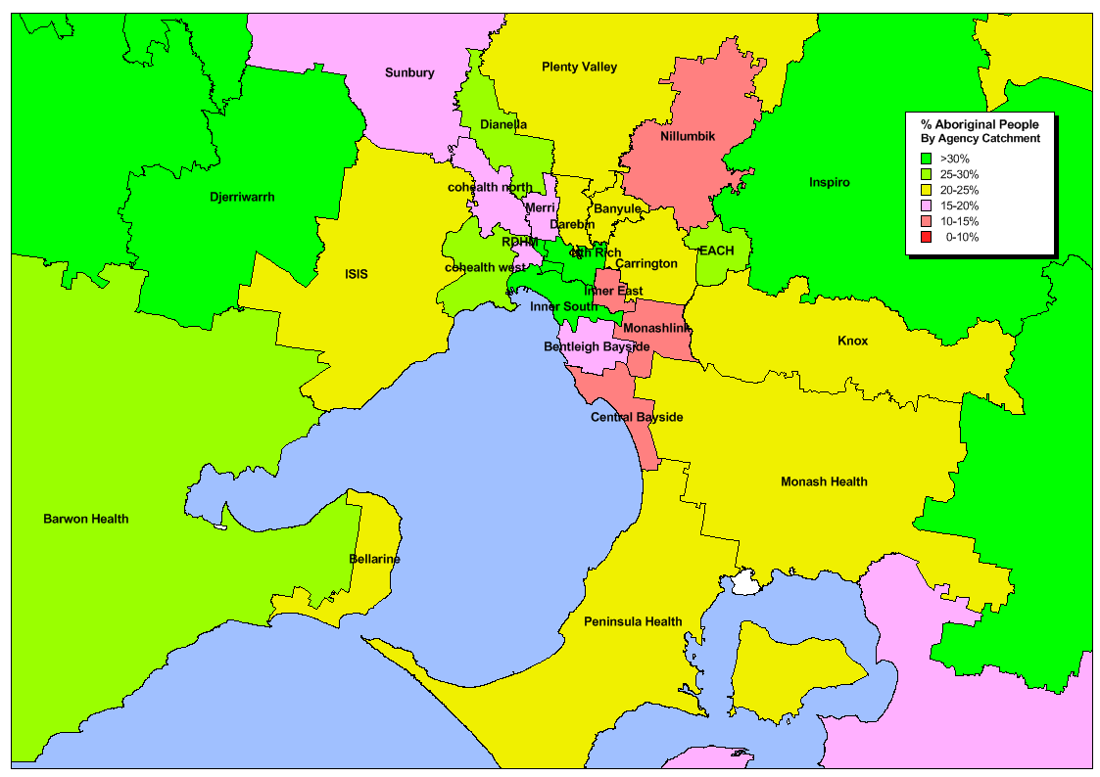

Figure 1: Percentage Aboriginal people by agency catchment (metropolitan Victoria)

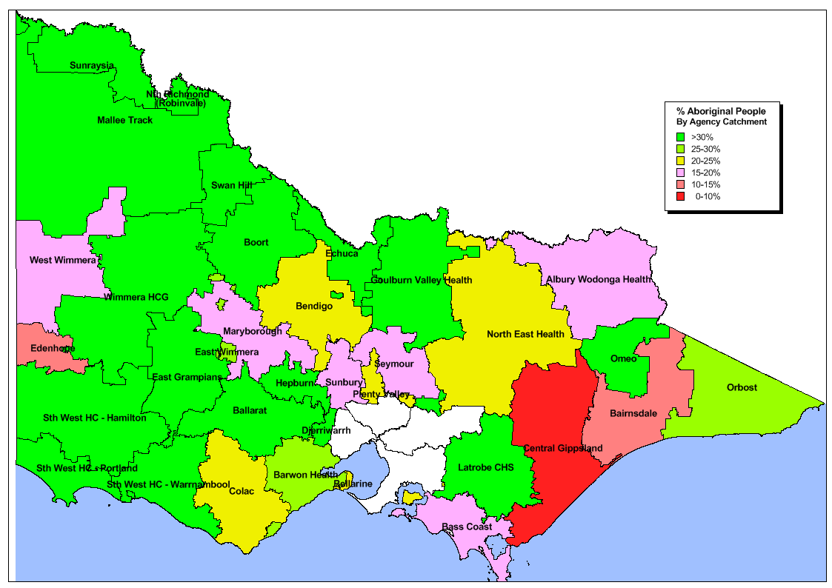

Figure 2: Percentage Aboriginal people by agency catchment (rural Victoria)

Figure 3: Percentage with a history of dental caries (% dmft+DMFT >0) for Aboriginal and non-Aboriginal individuals attending public dental services July 2012-June 2014 (state-wide) by age group. Numbers above bars represent the numbers in each age group

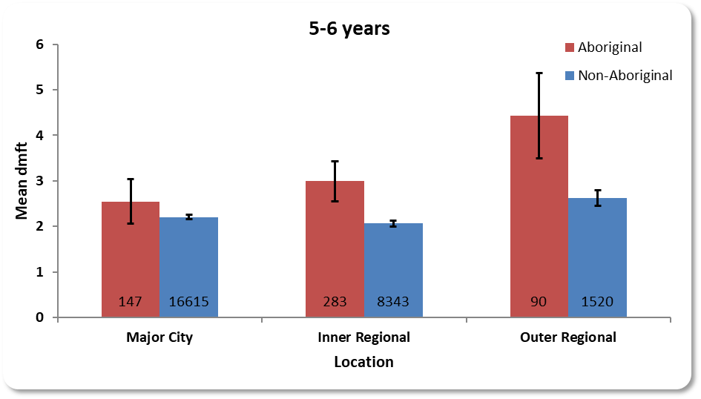

Figure 4: Average number of decayed, missing and filled primary teeth (dmft) for children aged 5-6 years attending public dental services by location in Victoria. Numbers at base of each bar represent the numbers in each group.

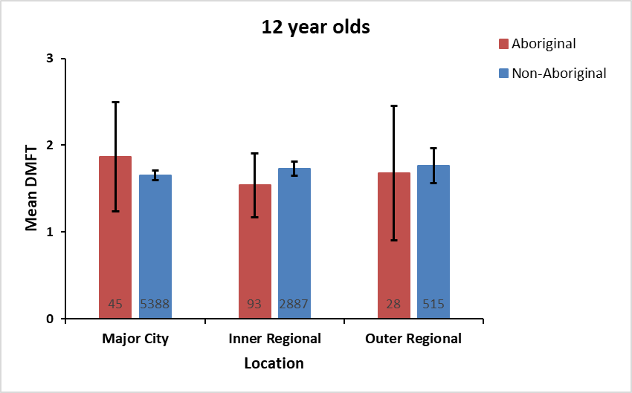

Figure 5: Average number of decayed, missing and filled permanent teeth (DMFT) for children aged 12 years attending public dental services by location in Victoria. Numbers at the base of each bar represent the numbers in each group.

