06 November 2018 for Climatic Change
Impacts of tropospheric ozone and climate change on Mexico wheat production
Jose Rafael Guarin¹, Lisa Emberson², David Simpson^{3, 4}, Ixchel M. Hernandez-Ochoa¹, Senthold Asseng¹
¹Department of Agricultural and Biological Engineering, University of Florida, Gainesville, FL 32611 USA
²Stockholm Environment Institute, Environment and Geography Dept., University of York, York, UK
³EMEP MSC-W, Norwegian Meteorological Institute, Oslo, NO
⁴Dept. Space, Earth & Environment, Chalmers University of Technology, Gothenburg, Sweden

Highlights
- O₃ impact will reduce wheat production in Mexico by 7-18% by the 2050s.
- Simulations showed large variability in O₃ impact across Mexico.
- The negative O₃ impact on wheat production in Mexico is comparable to, or even larger than, the future climate change impact.

Abstract
Wheat is an important staple crop sensitive to negative effects from elevated tropospheric ozone (O₃) concentrations, but the impacts of future O₃ concentrations on wheat production in Mexico are unknown. To determine these impacts, the O₃-modified DSSAT-NWheat crop model was used to simulate wheat production in Mexico using a baseline scenario with pre-industrial O₃ concentrations from 1980 to 2010 and five Global Climate Models (GCMs) under the Representative Concentration Pathway (RCP) 8.5 scenario from 2041 to 2070 paired with future O₃ concentrations from the European Monitoring and Evaluation Programme (EMEP) Meteorological Synthesizing Centre – West (MSC-W) model. Thirty-two representative major wheat-producing locations in Mexico were simulated assuming both irrigated and rainfed conditions for two O₃ sensitivity cultivar classifications. The simulations showed large variability (after averaging over 30 years) in yield loss, ranging from 7% to 26% because of O₃ impact, depending on the location, irrigation, and climate change emissions scenario. After upscaling and aggregating the simulations to the country scale based on observed irrigated and rainfed production, national wheat production for Mexico is expected to decline by 12% under the future RCP 8.5 climate change scenario with additional losses of 7% to 18% because of O₃ impact, depending on the cultivar O₃ sensitivity. This yield loss caused by O₃ is comparable to, or even larger than, the impact from projected future climatic change in temperature, rainfall, and atmospheric CO₂ concentration. Therefore, O₃ impacts should be considered in future agricultural impact assessments.

Key words
Crop model, wheat yield, emissions scenario, future impact, food security

1. Introduction
Tropospheric ozone (O₃) is a secondary pollutant formed from photochemical reactions between incoming solar radiation and primary pollutants such as nitrogen oxides (NO_{x} = NO + NO₂), volatile organic compounds (VOCs), carbon monoxide (CO), or methane (CH₄) (Simpson et al., 2014). O₃ is recognized as the most damaging air pollutant to crop growth and development because of its phytotoxicity and ubiquitous transport across the lower atmosphere (Ainsworth et al., 2012; Hauglustaine et al., 2005; Meehl et al., 2007). Future climate models project global O₃ concentrations to increase due to growth of O₃ precursor emissions. The largest O₃ concentration increases are expected in the tropics and subtropics, especially in Southeast Asia, India, and Central America (Cooper et al., 2014; Meehl et al., 2007; Wild et al., 2012). Additionally, global atmospheric carbon dioxide (CO₂) concentrations and temperature are expected to continue to increase, causing inevitable future changes in the climate (IPCC, 2013). These future climatic changes can directly affect O₃ concentrations, and by 2030 elevated O₃ could pose a large threat to global food security (Fowler et al., 2008). Under the Intergovernmental Panel of Climate Change (IPCC) highest emissions scenario, Representative Concentration Pathway (RCP) 8.5, the risk of O₃ injury in global vegetation is projected to increase by 70% from 2000 to 2100 (Sicard et al., 2017).
Wheat (Triticum aestivum L.) is the second most produced and most harvested crop in the world (FAOSTAT, 2017). Wheat contributes approximately 20% of the global total calories and proteins necessary for human diets (Shiferaw et al., 2013). In Mexico, wheat is one of the five highest produced crops and is a staple food for the population, e.g. 3.8 million tons cultivated on 720,000 ha for the 2015 to 2016 growing season (SAGARPA, 2016b). Wheat production is concentrated in Northwest Mexico. Approximately 65% of the total production comes from the northwestern states of Baja California and Sonora (Lobell et al., 2005), with >90% of the national production requiring irrigation because of the arid and semi-arid climate (SAGARPA, 2016a). Rainfed wheat production occurs in the areas with more moderate temperatures and higher rainfall, usually in the high elevation areas of the central and southern states and the northwestern Mediterranean climate of Baja California (Escobar, 2014).
Depending on the developmental stage of wheat, abiotic stresses such as O₃ stress and heat stress can cause severe damage to the crop (Ainsworth, 2017; Porter and Gawith, 1999). This is especially true during the reproductive stage of growth because of the increased sensitivity and higher demand of resources for seed development (Ferris et al., 1998; Leisner and Ainsworth, 2012). Wheat was reported to be the most sensitive crop to O₃ exposure when compared to 18 other major agricultural crops (Mills et al., 2007). Many studies have been conducted to determine O₃ impacts on wheat production (Feng and Kobayashi, 2009; Heagle, 1989; Mauzerall and Wang, 2001; Wang and Mauzerall, 2004), but few studies have estimated the O₃ impact on wheat production in Mexico (Avnery et al., 2011; Mills et al., 2018b; Van Dingenen et al., 2009). Van Dingenen et al. (2009) estimated the impact of O₃ on global crop production by 2030, assuming current air quality legislation is implemented, and found a slight improvement of wheat yield in Mexico (1.7%) due to small changes in future O₃ concentrations ranging between -3 to 3 parts-per-billion (ppb), depending on the season and area of Mexico. Mills et al. (2018b) used a more biologically relevant estimate based on O₃ uptake rather than O₃ concentrations to determine O₃ impact averaged over 2010 to 2012 on a global scale, and reported a 9.9% decrease in yields in the northern hemisphere with yield decreases in Mexico ranging from 10% to 25%.
Future climate change projections for Mexico vary in severity, but all projections estimate a warmer and drier climate by mid-century (Conde et al., 2011; Karmalkar et al., 2011). These warmer and drier conditions will likely result in more active photochemistry and higher O₃ concentrations (Zhang and Wang, 2016). An analysis of historical climate data found that the increased global mean temperature from 1980 to 2008 caused a 5.5% decline in global aggregated wheat production (Lobell et al., 2011). The increasing global temperature trend suggests a warming of up to 2°C by mid-century (IPCC, 2013), and global wheat production is estimated to decrease by 6% per 1°C increase if no adaptation strategies are applied (Asseng et al., 2015). Additionally, heat waves are expected to become more frequent in the future (Semenov and Shewry, 2011; Trnka et al., 2014), which may increase the likelihood of extreme O₃ concentration events (Hou and Wu, 2016). In Mexico, warming trends in Obregon, Sonora and Toluca, Mexico State have resulted in wheat yield declines of 2% to 3% per decade from 1980 to 2010 (Asseng et al., 2015). Hernandez-Ochoa et al. (2018) simulated the impact of climate change on wheat production in Mexico using five Global Climate Models (GCMs) under two RCPs, 4.5 and 8.5, with two wheat crop models, DSSAT-CROPSIM and DSSAT-NWheat, and projected that national wheat production is expected to decline by 7.2% for RCP 8.5 by mid-century.
The aim of this study is to determine the impact of O₃, in addition to climate change, on wheat production in Mexico using five GCMs under the highest emissions scenario, RCP 8.5, paired with two O₃ emissions scenarios using the Decision Support System for Agrotechnology Transfer (DSSAT) O₃-modified wheat model, DSSAT-NWheat v.4.6.1.01. DSSAT is a crop modeling platform that provides software that facilitates evaluation and application of crop models for various objectives (Jones et al., 2003). DSSAT-NWheat is a well-known and widely used model that was originally derived and validated as part of the Agricultural Production Systems Simulator (APSIM) framework (Asseng et al., 2004; Asseng et al., 1998; Asseng et al., 2000). NWheat has also been validated with controlled field experiments and various agronomic treatments at many global locations (Kassie et al., 2016; Liu et al., 2016). Recently, NWheat was modified with an O₃ impact subroutine that accounts for photosynthetic reduction and accelerated leaf senescence associated with O₃ stress (Guarin et al., 2018). Building on the study by Hernandez-Ochoa et al. (2018), we extend the climate change impact assessment by including the impact of O₃ stress on wheat production in Mexico.

2. Materials and Methods
2.1 Mexico wheat production representative locations
Wheat production in Mexico was simulated using 32 point-based representative locations across major wheat-producing areas. Locations were chosen based on observed five year (2010-2014) average yield levels that captured various environmental conditions for irrigated and rainfed wheat production (SAGARPA, 2016a). Many of the locations were in the northwestern states of Mexico because of the high volume of wheat production in that area. Table 1 shows the soil texture, temperature, and rainfall for both winter and summer wheat-growing seasons at the 32 representative locations. Soil data was based on the HC27 global soil profile distribution map from Koo and Dimes (2010) and was derived from the combination of three major texture types (clay, loam, sand), organic carbon levels (high, medium, low), and depths (shallow, medium, deep) (Hernandez-Ochoa et al., 2018). Most soils for the 32 representative locations were considered loamy and clay soils, with variable organic carbon content and depth.
Table 1. Locations representing wheat-growing areas in Mexico. Modified after: Hernandez-Ochoa et al. (2018).
# | State | Coordinates |  |  | Winterª |  | Summer^{b}
 |  | Latitude | Longitude | Soil Texture | Tmean (ºC) | Rainfall (mm) | Tmean (ºC) | Rainfall (mm)
1 | Sonora | 32.25 | -114.75 | Loam | 13.6 | 26 | 27.5 | 12
2 | Baja California | 31.75 | -116.25 | Loam | 13.7 | 200 | 24.0 | 14
3 | Chihuahua | 31.25 | -108.25 | Loam | 8.7 | 52 | 23.6 | 171
4 | Sonora | 30.75 | -112.75 | Loam | 13.2 | 49 | 28.8 | 75
5 | Chihuahua | 30.75 | -106.75 | Loam | 8.5 | 40 | 22.5 | 205
6 | Sonora | 30.25 | -111.25 | Loam | 14.1 | 64 | 28.5 | 205
7 | Baja California | 29.25 | -114.25 | Loam | 15.4 | 60 | 27.1 | 18
8 | Sonora | 29.25 | -111.25 | Loam | 14.1 | 50 | 28.5 | 209
9 | Coahuila | 29.25 | -102.25 | Loam | 12.6 | 51 | 24.6 | 139
10 | Chihuahua | 28.75 | -106.25 | Loam | 9.4 | 33 | 21.6 | 307
11 | Chihuahua | 28.25 | -104.25 | Clay | 10.4 | 32 | 19.3 | 245
12 | Coahuila | 28.25 | -101.75 | Loam | 15.1 | 65 | 25.5 | 198
13 | Coahuila | 28.25 | -101.25 | Loam | 15.1 | 67 | 25.5 | 208
14 | Sonora | 28.25 | -109.25 | Loam | 13.7 | 110 | 24.9 | 468
15 | Sonora | 27.75 | -110.25 | Loam | 16.7 | 55 | 28.7 | 195
16 | Coahuila | 27.75 | -103.25 | Loam | 13.0 | 37 | 22.2 | 150
17 | Chihuahua | 27.75 | -108.25 | Loam | 13.7 | 116 | 24.9 | 558
18 | Sinaloa | 26.25 | -108.25 | Clay | 17.7 | 87 | 25.8 | 566
19 | Baja California Sur | 25.25 | -111.25 | Loam | 19.1 | 36 | 27.5 | 153
20 | Coahuila | 25.25 | -101.75 | Loam | 14.9 | 36 | 22.1 | 221
21 | Durango | 25.25 | -106.25 | Clay | 14.2 | 133 | 21.3 | 705
22 | Nuevo Leon | 25.25 | -98.75 | Clay | 17.8 | 86 | 25.5 | 325
23 | Nuevo Leon | 24.25 | -100.25 | Loam | 18.0 | 61 | 22.7 | 212
24 | Durango | 24.25 | -104.75 | Clay | 15.2 | 40 | 19.6 | 350
25 | Zacatecas | 24.25 | -102.25 | Loam | 12.6 | 27 | 16.8 | 189
26 | Zacatecas | 23.75 | -103.25 | Loam | 12.6 | 27 | 16.8 | 276
27 | Michoacán | 20.25 | -100.25 | Clay | 13.8 | 38 | 16.3 | 459
28 | Hidalgo | 20.25 | -99.25 | Clay | 13.8 | 32 | 16.3 | 234
29 | Michoacán | 19.75 | -101.25 | Loam | 14.9 | 42 | 16.4 | 539
30 | Puebla | 18.25 | -97.25 | Sand | 16.0 | 92 | 19.0 | 681
31 | Oaxaca | 17.25 | -96.75 | Clay | 16.0 | 94 | 19.0 | 692
32 | Chiapas | 15.25 | -92.25 | Loam | 22.3 | 57 | 22.4 | 1111
ª Winter season period from December 10 to March 30 for the baseline scenario (1980-2010).
^{b} Summer season from July 1 to Sept 7 for the baseline scenario (1980-2010).

2.2 Future climate change impact
Climate change impact was estimated by comparing future scenarios from five GCMs (Table 2) to a historical baseline scenario. The climate change data was based on the methodology from Hernandez-Ochoa et al. (2018). The period from 1980 to 2010 was chosen as the historical baseline scenario based on protocols from the Agricultural Model Intercomparison and Improvement Project (AgMIP) (Guttman, 1989; Rosenzweig et al., 2013; WMO, 2017). The climate data for the baseline scenario was collected from climate datasets within the MINK gridded crop modeling system for the coordinates of the 32 representative locations (Robertson, 2017). For the future scenarios, five downscaled and bias-corrected GCM scenarios from the Inter-Sectoral Impact Model Intercomparison Project (ISI-MIP) were obtained from the Potsdam Climate Institute for the 2041 to 2070 period (Mueller and Robertson, 2014). The future climate change scenario selected, RCP 8.5, was the highest projected greenhouse gas concentration trajectory for future climate adopted by the IPCC (IPCC, 2013). Daily maximum and minimum temperature, rainfall, and solar radiation were collected for both the baseline and future scenarios. Solar radiation remained unchanged for the future scenarios. The baseline scenario used an atmospheric CO₂ concentration of 362 parts-per-million (ppm), corresponding to the 30-year mean of the baseline period (1980 to 2010), while the future scenarios used an atmospheric CO₂ concentration of 572 ppm based on the report from IPCC (IPCC, 2013).

2.3 Future O₃ concentration
O₃ impact was estimated by simulating wheat production for the baseline and future climate change scenarios with added O₃ concentrations, and then comparing the simulated production from the future emissions scenarios to the simulated production of the baseline scenario with pre-industrial O₃ levels (< 25 ppb). The EMEP MSC-W model (Table 2), version 4.17 (Simpson et al., 2012; Simpson et al., 2017), was used to simulate hourly O₃ data at each of the 32 representative locations for the 2010 and 2050 emissions scenarios. The EMEP model has previously been shown to provide good estimates of O₃-relevant metrics such as daily maximum or M7 (defined below) across a range of sites around the globe (Mills et al., 2018b; Stadtler et al., 2018). In order to allow for year-to-year variability, five years of meteorological data from 2008 to 2012 were used for each emissions scenario, creating a total of 10 different annual O₃ precursor emissions scenarios (referred to as O₃ emissions scenarios). These meteorological data were obtained from the European Centre for Medium Range Weather Forecasts Integrated Forecasting System (ECMWF-IFS) model (https://www.ecmwf.int/en/research/modelling-and-prediction). For each annual O₃ emissions scenario, daily 7-hour (9:00 – 15:59 h) mean (M7) O₃ concentration was calculated and repeated for 29 additional years. The 30 years of M7 O₃ concentrations were then added to the 30-year baseline scenario and RCP 8.5 scenario of the 5 GCMs, for each annual O₃ emissions scenario (Table 3). The M7 O₃ exposure index was used because it is the most commonly used O₃ index (Ashmore, 2005), and is the standard input for the NWheat crop model (Guarin et al., 2018). Figure 1 shows the annual average M7 O₃ concentrations for the two O₃ emissions scenarios (averaged for the five years) at the 32 representative locations in Mexico.

Table 2. The five Global Climate Models (GCMs) and the O₃ model used for the different scenario simulations. The GCMs provided daily maximum and minimum temperature, rainfall, and solar radiation. The O₃ model provided hourly O₃ concentrations used to calculate daily 7-hour mean (M7) O₃ concentrations. Modified after Hernandez-Ochoa et al. (2018).
Model Name | Model Acronym | Type
Geophysical Fluid Dynamics Laboratory – Earth System Model | GFDL-ESM2M | GCM 1
Institute Pierre Simon Laplace – Coupled Model | IPSL-CM5A-LR | GCM 2
Hadley Centre Global Environment Earth System Model | HadGEM2-ES | GCM 3
Model for Interdisciplinary Research on Climate – Earth System Model | MIROC-ESM-CHEM | GCM 4
The Norwegian Earth System Model | NorESM1-M | GCM 5
European Monitoring and Evaluation Programme Meteorological Synthesizing Centre – West Model | EMEP MSC-W | O₃

Table 3. Methodology for combining the baseline and future RCP 8.5 climate change scenarios with the 2010 and 2050 O₃ emissions scenarios. The 2010 and 2050 combined emissions scenarios were used as input for the NWheat crop model simulations.
Baseline Scenario with Pre-industrial O₃ |  |  |  |  |  | 2010 O₃ Emissions Scenario |  | 2010 Combined Emissions Scenarios
1980 |  |  |  |  | + | Year 1 | = | 1980 + Year 1 |  | 1980 + Year 2 |  | 1980 + Year 3 |  | 1980 + Year 4 |  | 1980 + Year 5
⁞ |  |  |  |  |  | Year 2 |  | ⁞ |  | ⁞ |  | ⁞ |  | ⁞ |  | ⁞
2010 |  |  |  |  |  | Year 3 |  | 2010 + Year 1 |  | 2010 + Year 2 |  | 2010 + Year 3 |  | 2010 + Year 4 |  | 2010 + Year 5
 |  |  |  |  |  | Year 4
 |  |  |  |  |  | Year 5
Future RCP 8.5 Scenario with Pre-industrial O₃ |  |  |  |  |  | 2050 O₃ Emissions Scenario |  | 2050 Combined Emissions Scenarios
GCM 1 | GCM 2 | GCM 3 | GCM 4 | GCM 5 | + | Year 1 | = | GCM 1
2041 | 2041 | 2041 | 2041 | 2041 |  | Year 2 |  | 2041 + Year 1 |  | 2041 + Year 2 |  | 2041 + Year 3 |  | 2041 + Year 4 |  | 2041 + Year 5
⁞ | ⁞ | ⁞ | ⁞ | ⁞ |  | Year 3 |  | ⁞ |  | ⁞ |  | ⁞ |  | ⁞ |  | ⁞
2070 | 2070 | 2070 | 2070 | 2070 |  | Year 4 |  | 2070 + Year 1 |  | 2070 + Year 2 |  | 2070 + Year 3 |  | 2070 + Year 4 |  | 2070 + Year 5
 |  |  |  |  |  | Year 5 |  | GCM 2
 |  |  |  |  |  |  |  | 2041 + Year 1 |  | 2041 + Year 2 |  | 2041 + Year 3 |  | 2041 + Year 4 |  | 2041 + Year 5
 |  |  |  |  |  |  |  | ⁞ |  | ⁞ |  | ⁞ |  | ⁞ |  | ⁞
 |  |  |  |  |  |  |  | 2070 + Year 1 |  | 2070 + Year 2 |  | 2070 + Year 3 |  | 2070 + Year 4 |  | 2070 + Year 5
 |  |  |  |  |  |  |  | GCM 3
 |  |  |  |  |  |  |  | 2041 + Year 1 |  | 2041 + Year 2 |  | 2041 + Year 3 |  | 2041 + Year 4 |  | 2041 + Year 5
 |  |  |  |  |  |  |  | ⁞ |  | ⁞ |  | ⁞ |  | ⁞ |  | ⁞
 |  |  |  |  |  |  |  | 2070 + Year 1 |  | 2070 + Year 2 |  | 2070 + Year 3 |  | 2070 + Year 4 |  | 2070 + Year 5
 |  |  |  |  |  |  |  | GCM 4
 |  |  |  |  |  |  |  | 2041 + Year 1 |  | 2041 + Year 2 |  | 2041 + Year 3 |  | 2041 + Year 4 |  | 2041 + Year 5
 |  |  |  |  |  |  |  | ⁞ |  | ⁞ |  | ⁞ |  | ⁞ |  | ⁞
 |  |  |  |  |  |  |  | 2070 + Year 1 |  | 2070 + Year 2 |  | 2070 + Year 3 |  | 2070 + Year 4 |  | 2070 + Year 5
 |  |  |  |  |  |  |  | GCM 5
 |  |  |  |  |  |  |  | 2041 + Year 1 |  | 2041 + Year 2 |  | 2041 + Year 3 |  | 2041 + Year 4 |  | 2041 + Year 5
 |  |  |  |  |  |  |  | ⁞ |  | ⁞ |  | ⁞ |  | ⁞ |  | ⁞
 |  |  |  |  |  |  |  | 2070 + Year 1 |  | 2070 + Year 2 |  | 2070 + Year 3 |  | 2070 + Year 4 |  | 2070 + Year 5

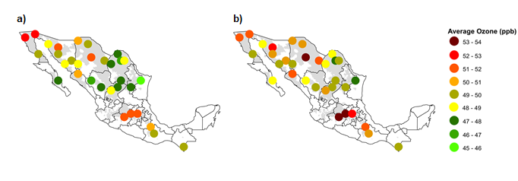
Figure 1. Annual average M7 O₃ concentrations for 5 years of data at each of the 32 Mexico locations for a) 2010 O₃ emissions scenario and b) 2050 O₃ emissions scenario from the EMEP MSC-W model. The shaded area indicates wheat-growing areas in Mexico.

2.4 O₃-modified crop model
The NWheat crop model simulates wheat development and growth, water and nitrogen (N) dynamics, and multiple stress responses in daily time steps using inputs of daily maximum and minimum temperature, rainfall, solar radiation, and M7 O₃ concentrations (Asseng et al., 2004; Keating et al., 2001). The life cycle of the crop is based on Zadoks growth scale and uses the radiation-use efficiency (RUE) approach for biomass accumulation (Asseng et al., 2004; Zadoks et al., 1974). To calculate the effects of abiotic stresses on crop growth, NWheat uses two subroutines to reduce photosynthesis and accelerate leaf senescence because these processes can affect crop growth at different rates depending on the duration and severity of the stress. The O₃ function in NWheat includes the two main responses of O₃ stress via stomatal uptake directly affecting photosynthesis by limiting daily dry matter (carbohydrate) production and via accelerated leaf senescence, which also indirectly impacts photosynthesis (Guarin et al., 2018). These two O₃ stress responses and their rate of impact can be influenced by other growing conditions. For example, water deficit stress may cause stomatal closure which limits O₃ uptake, or elevated atmospheric CO₂ may reduce the direct O₃ impact on photosynthesis but not leaf senescence (Biswas and Jiang, 2011; Biswas et al., 2013; Khan and Soja, 2003). The photosynthetic reduction effect of O₃ stress considers the interactive effects of O₃ concentrations with water deficit stress and CO₂ concentrations. The effect of O₃ stress accelerating leaf senescence operates in a similar way as the NWheat heat stress function where leaf senescence is accelerated above a set threshold. NWheat uses a minimum O₃ stress threshold of 25 ppb based on pre-industrial O₃ concentrations and previous National Crop Loss Assessment Network of the United States (NCLAN) studies indicating that O₃ damage usually occurs above this base threshold (Feng and Kobayashi, 2009; Heck et al., 1984; Lesser et al., 1990).

2.5 Crop model initial conditions and experimental setting
The crop model simulations were initialized one day before sowing every year. Sowing date was based on previous observations (Sayre et al., 1997) and expert knowledge. The sowing date was set on December 10th for the winter growing season and on July 1st for the summer growing season. All irrigated wheat simulations were sown in winter and the majority of rainfed simulations were sown in summer, except in Northwest Mexico (Baja California, Baja California Sur, Sonora, Chihuahua, and Sinaloa) where temperature and rainfall are more suitable for winter sowing. Planting density was 300 plants m⁻² at a depth of 5 cm. Due to limited soil water content data, initial water content was set at 100% field capacity (FC) in the first 30 cm of the soil profile to ensure germination and at 10% FC for the rest of the soil profile.
Initial mineral soil N was set to 25 kg ha⁻¹ with initial surface residue and root mass set to 3000 kg ha⁻¹ and 1000 kg ha⁻¹, respectively, for all simulations. The N fertilizer amounts for the irrigated wheat simulations ranged from 90 to 140 kg ha⁻¹ depending on location, and the N fertilizer amount for rainfed wheat was 10 kg ha⁻¹ at all representative locations. For the irrigated wheat simulations, two N fertilizer applications were split equally on day of sowing and 40 days after sowing. For the rainfed wheat simulations, a single application was applied on the day of sowing. The fertilizer applied was urea-N banded beneath the surface and incorporated at 5 cm. The irrigated treatment used automatic irrigation, set at 80% of maximum water available in the first 30 cm of the soil profile, to reduce the risk of water deficit stress in the crop. The wheat cultivars and genetic coefficients used were based on the site-specific cultivar selection and adapted coefficients from Hernandez-Ochoa et al. (2018). All cultivars were simulated with the two most common O₃ sensitivity cultivar classifications included in NWheat, O₃ tolerant and O₃ intermediate, based on previous O₃ exposure experiments (Guarin et al., 2018).

2.6 Sensitivity analysis and upscaling impacts to national level
To estimate the impact of various O₃ concentrations on national wheat production, a sensitivity analysis was conducted using the climate change data (section 2.2) paired with six different treatments consisting of constant daily M7 O₃ concentrations of 25, 40, 60, 80, 100, and 120 ppb for the entire growing season of each year. The pre-industrial M7 O₃ concentration of 25 ppb was considered as the control to evaluate the model with negligible effects of O₃ stress (i.e., same output as simulation with 0 ppb O₃).
Observed irrigated and rainfed 2015 district wheat production data in Mexico from SAGARPA (2016a) were used to upscale production from the 32 representative locations to the national scale. Each of the 32 representative locations was assigned to a wheat-producing district, depending on proximity and yield level. Wheat production change for each representative location was calculated by finding the percentage change of the simulated emissions scenario output versus the baseline scenario output. These calculated production changes were then applied to the observed 2015 district wheat production based on the assigned representative location. Future irrigated and rainfed wheat production were added together to report an aggregated national production for each emissions scenario. This process was done using both O₃ tolerant and O₃ intermediate cultivar classifications to estimate the O₃ impact on national production with different cultivar O₃ sensitivities.

3. Results
3.1 Simulated O₃ model concentrations
The simulated O₃ concentrations of the two emissions scenarios from the EMEP model were compared to 2010 observed O₃ data (Figure 2). Observed hourly O₃ data for 2010 were collected from the Red Automática de Monitoreo Atmosférico (RAMA) database for 22 weather stations in Mexico City located within approximately a 75 km radius. Observed O₃ data were collected only for Mexico City due to limited availability of national hourly O₃ data. Any missing daily M7 O₃ concentrations were filled with monthly average M7 O₃ concentrations. The annual average M7 O₃ concentrations of the simulated 2010 and 2050 O₃ emissions scenarios were 49 and 50 ppb, respectively, while the annual average of the 2010 observed data was 53 ppb. All three M7 O₃ concentrations had a standard error of approximately ±2 ppb. The higher observed M7 O₃ is likely the result of the data being solely from Mexico City, which has the highest air pollution emissions in the country (Molina et al., 2007; Molina and Molina, 2004).

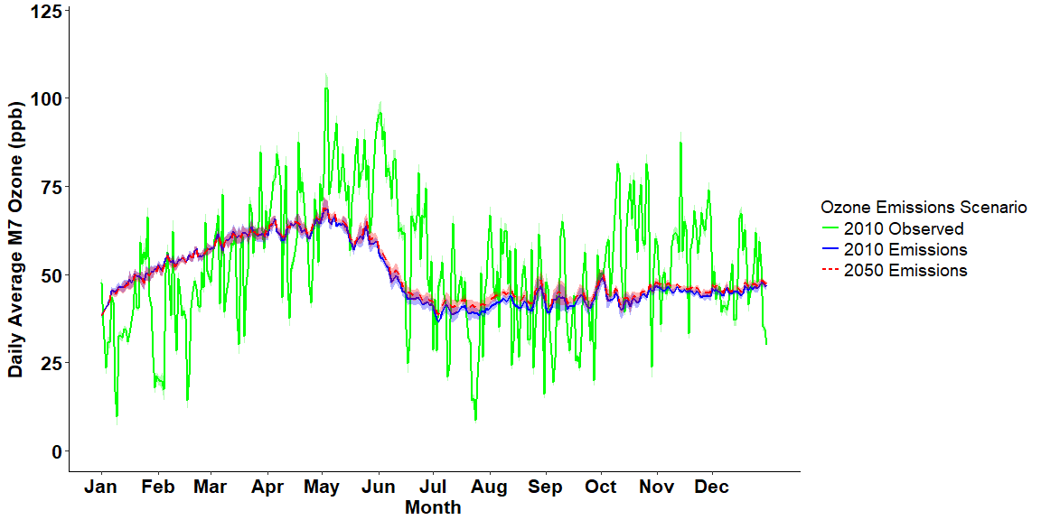
Figure 2. Daily M7 O₃ concentrations for 2010 observed O₃ averaged over 22 weather stations in Mexico City (all stations within ~75 km radius), and two simulated O₃ emissions scenarios averaged over five years of data for each scenario from the EMEP MSC-W model for the 32 representative wheat-growing locations in Mexico. The shaded area shows the standard error of the mean from the five years of data for each emissions scenario and from the 22 weather stations for the observed data.

3.2 Sensitivity analysis of seasonal M7 O₃ concentrations
Figure 3 shows the simulated national wheat production from the sensitivity analysis using the RCP 8.5 emissions scenario with various M7 O₃ concentrations ranging from 0 ppb to 120 ppb for the two O₃ sensitivity cultivar classifications. As seasonal M7 O₃ increased from 25 ppb to 120 ppb, the simulated total wheat production using the O₃ tolerant cultivar classification decreased from 3.28 Mt to 2.64 Mt (19.5% loss), and the simulated total production using the O₃ intermediate cultivar classification decreased from 3.28 Mt to 1.75 Mt (46.6% loss).

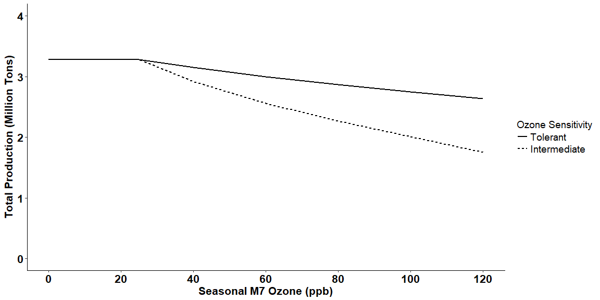
Figure 3. Sensitivity analysis showing the simulated total aggregated wheat production for Mexico using the RCP 8.5 emissions scenario with different seasonal M7 O₃ concentrations for two different O₃ sensitivity cultivar classifications. Aggregated production was upscaled from 32 representative wheat-growing locations based on 2015 Mexico production data.

3.3 Crop model simulated output
The NWheat simulations used the described experimental setting with varying irrigation and N management, cultivar O₃ sensitivities, and emissions scenarios (depending on the GCM and O₃ emissions). Figure 4 shows an example of the simulated yield and biomass at representative location 1, Sonora, for the year 2043 using the GFDL-ESM2M GCM emissions scenario with O₃ concentrations averaged over the five years of 2050 O₃ emissions scenarios for both irrigated and rainfed treatments using the “Bacanora” winter cultivar with both O₃ tolerant and O₃ intermediate cultivar classifications. The year 2043 with the “Bacanora” cultivar was chosen as an example because it was the highest yielding year and cultivar of the GFDL-ESM2M GCM 30-year scenario for both the irrigated and rainfed treatments. Location 1, Sonora, was selected because it is in Northwest Mexico, where the majority of wheat production is concentrated.
The high biomass and yield in the irrigated treatment compared to the rainfed treatment is caused by higher water and N availability throughout the growing season. The simulated yield and biomass differences between the O₃ tolerant (solid lines) and O₃ intermediate (dashed lines) cultivar classifications are the O₃ effect for the year 2043. The irrigated treatment had a larger negative effect from O₃ than the rainfed treatment because increased water availability can increase stomatal conductance, leading to higher O₃ uptake (Khan and Soja, 2003).

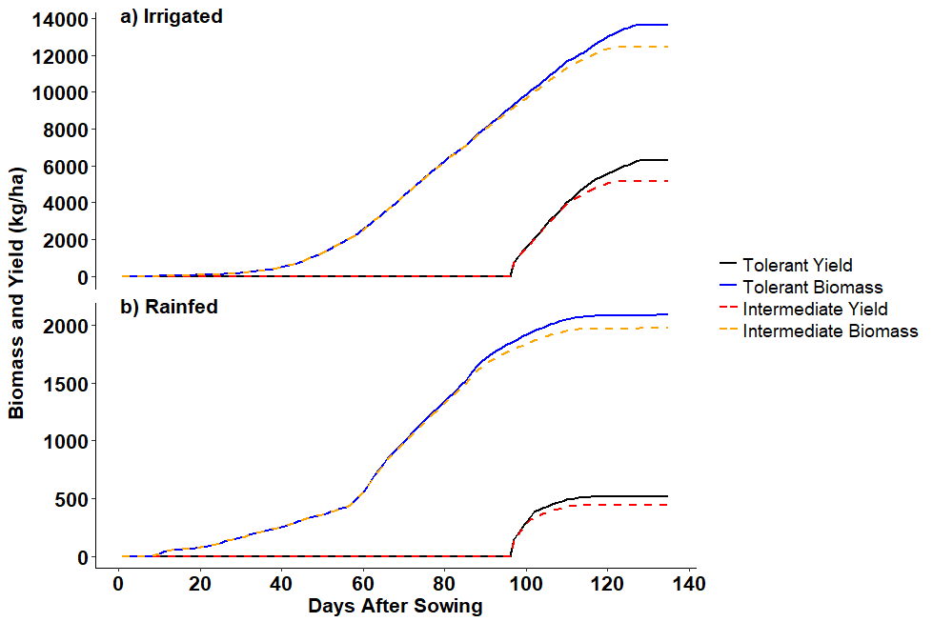
Figure 4. Simulated average biomass and yield for a) irrigated and b) rainfed treatments at location 1, Sonora, using the “Bacanora” cultivar under the O₃ tolerant (solid line) and O₃ intermediate (dashed line) cultivar classifications for the year 2043 using the GFDL-ESM2M GCM; averaged for all five of the 2050 O₃ emissions scenarios. Sowing date was December 10th. The standard error of the mean of the O₃ emissions scenarios is too small to visualize.

3.4 Simulated O₃ impact
Each of the 30-year combined climate change and O₃ emissions scenarios were input into NWheat to simulate wheat growth per year (Table 3). For the 2010 combined emissions scenarios, annual yields were averaged by representative location for the five years of O₃ emissions scenarios. For the 2050 combined emissions scenarios, annual yields of all five GCMs were first combined and then averaged by representative location for the five years of O₃ emissions scenarios. Wheat production change for the 32 representative locations was obtained by calculating the percent change from the yields of the baseline scenario with pre-industrial M7 O₃ concentration and the yields of each of the five years of O₃ emissions scenarios (Figure 5). These calculated production changes from the 32 representative locations were upscaled and aggregated using the 2015 observed district wheat production as described in the sensitivity analysis to obtain the national wheat production for the five years of O₃ emissions scenarios. The national wheat production of the five years of O₃ emissions scenarios was then averaged and compared to the national production of the baseline scenario with pre-industrial O₃ to determine total production loss (Figure 6). The national production change from the 2050 emissions scenario with pre-industrial O₃ was also compared to the baseline scenario with pre-industrial O₃ to determine the production change from climate change only, without an O₃ effect (Figure 6). Both O₃ sensitivity cultivar classifications were used to determine the different severity of O₃ effects at the representative locations (Figure 5) and at the national scale (Figure 6).

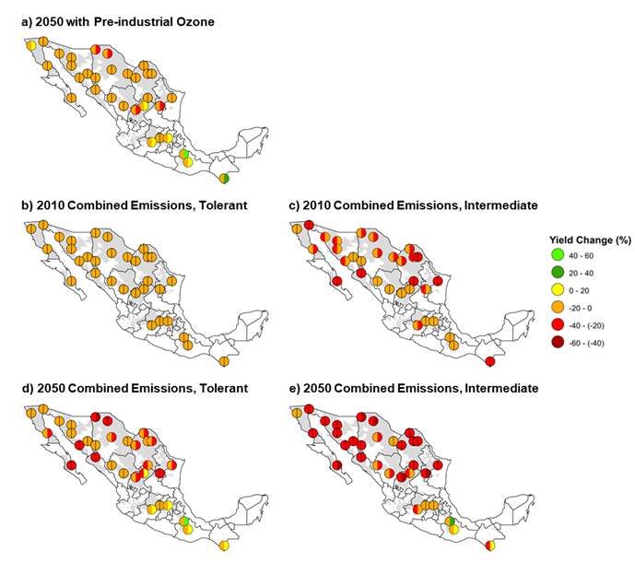
Figure 5. Simulated irrigated (left semi-circle) and rainfed (right semi-circle) total yield change from the baseline scenario with pre-industrial O₃ at 32 Mexico locations for (a) 2050 climate change scenario (RCP 8.5) with pre-industrial O₃, (b, c) 2010 combined emissions scenario (baseline + 2010 O₃), and (d, e) 2050 combined emissions scenario (RCP 8.5 + 2050 O₃) using both (b, d) O₃ tolerant and (c, e) O₃ intermediate cultivar classifications. The yield change for the 2050 climate change scenario with pre-industrial O₃ was the same for both the O₃ tolerant and O₃ intermediate cultivar classifications because there was no O₃ effect. The shaded areas indicate wheat-growing areas in Mexico.

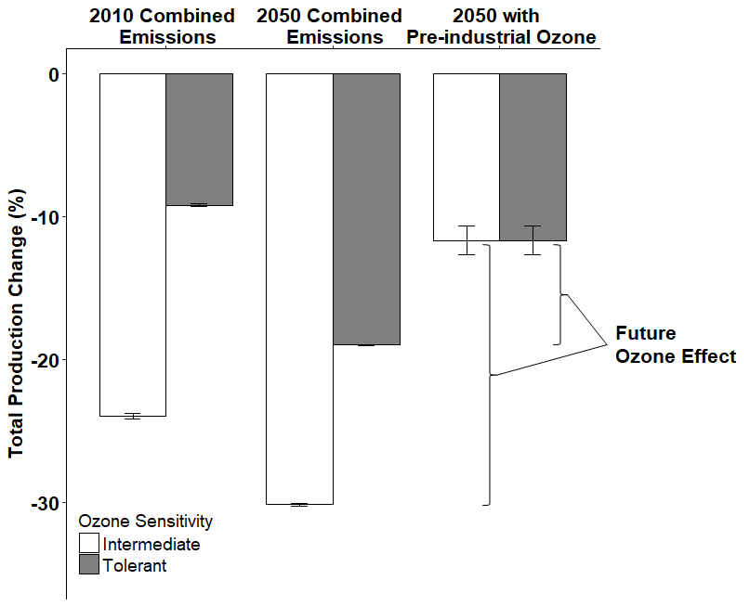
Figure 6. Simulated total aggregated production change from the baseline scenario with pre-industrial O₃ for Mexico using the 2010 combined emissions scenario (baseline + 2010 O₃), 2050 combined emissions scenario (RCP 8.5 + 2050 O₃), and the 2050 climate change scenario (RCP 8.5) with pre-industrial O₃ for two different O₃ sensitive cultivar classifications. Aggregated production was upscaled from 32 representative wheat-growing locations based on 2015 Mexico production data. 2010 and 2050 combined emissions were averaged over five years of O₃ emissions data. Error bars show the standard error of the mean of the five years of the 2010 and 2050 combined emissions scenarios and the five GCMs for the 2050 scenario with pre-industrial O₃.

4. Discussion
4.1 Simulated O₃ concentrations
The simulated M7 O₃ concentrations of the two O₃ emissions scenarios from the EMEP model (Figure 2) agree reasonably well with previously observed seasonal O₃ temporal trends for Mexico. In these trends, April and May had the highest O₃ concentrations followed by a decrease over the summer months because of increased precipitation and cloud cover (Barrett and Raga, 2016; Hernandez Paniagua et al., 2017). The elevated O₃ concentrations in April and May also agree with the observed peak O₃ season in the Northern Hemisphere (Cooper et al., 2014). The daily variability of the 2010 observed M7 O₃ concentrations was much higher than the daily variability of the M7 O₃ concentrations from the two simulated O₃ emissions scenarios. The high variability in the observed data was likely influenced by local NO sources (which titrate O₃ to NO₂), complex topography, and generally elevated air pollution in Mexico City resulting in more active photochemistry and increased O₃ concentration extremes compared to other areas of Mexico. Also, roughly 10% of the observed hourly O₃ data were missing, adding uncertainty to the observations. However, despite the high variability and uncertainty, the observed data support the temporal trends of the two simulated O₃ emissions scenarios.

4.2 Sensitivity analysis of Mexico wheat production
The sensitivity analysis showed that simulated total wheat production for Mexico decreased for both O₃ sensitivity cultivar classifications as seasonal M7 O₃ concentrations increased above 25 ppb (Figure 3). Under the O₃ tolerant cultivar classification, simulated total production loss increased from 4.0% to 19.5% as seasonal M7 O₃ increased from 40 ppb to 120 ppb, with an average production loss of 0.23% per ppb M7 O₃ increase above 25 ppb. The average production loss for the O₃ intermediate cultivar classification was 0.59% per ppb M7 O₃ increase above 25 ppb. These simulated production losses due to M7 O₃ agree with previous wheat production O₃ impact studies. For example, Guarin et al. (2018) found a 0.26% increase in yield loss using the O₃ tolerant cultivar classification and a 0.54% increase in yield loss using the O₃ intermediate cultivar classification. Ollerenshaw and Lyons (1999) reported an average yield loss of 0.26% per ppb M7 O₃ increase, Feng and Kobayashi (2009) reported an average yield loss of 0.67% per ppb M7 O₃ increase, and Pleijel et al. (2018) reported an average yield loss of 0.38% per ppb M7 O₃ increase. These studies covered different ranges of O₃ concentrations, treatments, and cultivar O₃ sensitivities so the exact yield loss per ppb O₃ will not be constant, especially over a large range of O₃ concentrations. The yield loss will depend on the O₃ sensitivity of the cultivar and the environmental growing conditions (Feng et al., 2010). Also, studies using daily O₃ indices, such as M7, estimate daily average changes in stomatal uptake, photosynthesis, and leaf senescence which may miss some co-variation in environmental interactions that occur at an hourly time step. However, most crop models only simulate interactions on daily time steps, and simulating crop growth and environmental interactions on an hourly time step requires additional computing power and time.

4.3 Future climate change and O₃ impact
Mexico national wheat production is estimated to decline by 11.7% because of future climate change (Figure 6), which is higher than the estimated decline of 7.2% from Hernandez-Ochoa et al. (2018) using two crop models. However, when using only the NWheat model, Hernandez-Ochoa et al. (2018) reported a similar production decline of 11.2% (this difference is due to slight adjustments in representative location coordinates). The larger production decrease is because the NWheat model places a higher emphasis on sensitivity to heat stress than other wheat crop models, which can lead to slightly larger simulated negative yield impacts in heat stress environments (Asseng et al., 2015).
After including O₃ concentrations in the model simulations, average production loss of all 32 representative locations varied from 7.4% to 26.2%. The lowest average losses (7.4%) were under the 2010 combined emissions scenario using the O₃ tolerant cultivar classification (Figure 5b) and the highest average losses (26.2%) were under the 2050 combined emissions scenario using the O₃ intermediate cultivar classification (Figure 5e). Irrigated production decreased in all locations for all emissions scenarios (left semi-circles of Figure 5), with the larger decreases under the emissions scenarios using the O₃ intermediate cultivar classification. This agrees with previous findings that increased stomatal conductance from increased water availability results in high yield loss from increased O₃ uptake (Biswas and Jiang, 2011; Khan and Soja, 2003).
Some locations in the southern states of Mexico had high rainfed production under the future emissions scenarios (Figure 5a, 5d, and 5e). This occurred due to simulated low rainfed yields for both the baseline and future emissions scenarios. For example, in Figure 5d at location 30, Puebla, the average simulated baseline rainfed yield was 530 kg ha⁻¹ and the average simulated emissions scenario rainfed yield was 780 kg ha⁻¹, which led to a production gain of approximately 47%. Although the percent increase is large, it is difficult to justify differences in small yield changes due to uncertainties in the input data and models. Puebla is one of the lower yielding representative locations, and the 250 kg ha⁻¹ yield difference is relatively small compared to other higher yielding areas. For some years, it is possible that O₃ stress reduced biomass earlier in the season leading to higher available water and N later in the season, resulting in higher yields, as shown with variable fertilizer N affecting water availability later in the season (Asseng and van Herwaarden, 2003; Fischer, 1979). It is also possible that low levels of O₃ stress (i.e., M7 O₃ concentrations slightly above 25 ppb) benefitted crop growth through hormesis (Calabrese, 2014). Overall, simulated rainfed production only contributed a small percent to the national aggregated production because of the low country production in rainfed areas (~ 9%) compared to irrigated areas (>90%).
After upscaling and aggregating production to the national scale, all emissions scenarios showed national wheat production losses (Figure 6). The simulated production losses from the 2010 combined emissions scenario using the O₃ tolerant and O₃ intermediate cultivar classifications, 9.2% and 24% respectively, strongly agree with the findings from Mills et al. (2018b) in which yield losses for Mexico were reported between 10% to 25% using averaged 2010 to 2012 M7 O₃ concentrations and a stomatal uptake model. This agreement is because the stomatal uptake model provides a stomatal flux-based metric that can be used to estimate yield losses using established flux-response metrics, similar to the M7 response relationship used in this study. The simulated production losses from the 2050 combined emissions scenario using the O₃ tolerant and O₃ intermediate cultivar classifications are 19.0% and 30.1%, respectively. These losses disagree with the estimated small wheat yield improvement in Mexico from 2000 to 2030 reported by Van Dingenen et al. (2009). However, this study assumed highest emissions scenarios while Van Dingenen et al. (2009) assumed scenarios using full implementation of air quality legislation. Figure 6 shows that future O₃ concentrations are estimated to further reduce the production loss from the RCP 8.5 emissions scenario (11.7%) by 7.3% and 18.5% for the O₃ tolerant and O₃ intermediate cultivar classifications, respectively. These results suggest that future O₃ impacts could be larger than future climate change impacts, emphasizing the need to account for O₃ effects in agricultural impact assessments and adaptation strategies. Additionally, simulations using the O₃ intermediate cultivar classification had additional 14.8% and 11.2% losses in total production compared to simulations using the O₃ tolerant cultivar classification for the 2010 and 2050 O₃ emissions scenarios, respectively (Figure 6). The additional national production losses of >10% due to higher cultivar O₃ sensitivity support the need for adaptive strategies to include O₃ resistant cultivars.

5. Conclusion
The O₃ impact on wheat production varied in severity depending on location, irrigation, O₃ emissions scenario, and cultivar O₃ sensitivity, but overall, the inclusion of O₃ concentrations in simulations decreased average production for all emissions scenarios. The national simulated wheat production loss due to future O₃ effects is equal to, or even larger than, the simulated production loss from future climatic changes in temperature, rainfall, and atmospheric CO₂ in Mexico. This suggests that potential yield benefits from increased irrigation practices in response to climate change (Roche, 2015) may be mitigated by increased O₃ impact on yield. This also emphasizes the importance of including O₃ effects in future decision making and the development of adaptation strategies. To reduce the future negative O₃ impact on Mexico wheat production, future adaptation strategies should focus on breeding O₃ resistant wheat cultivars, limiting emissions of O₃ precursors, and managing irrigation in high O₃ conditions.
For future assessments of O₃ impact, additional O₃ monitoring data and O₃ effects data should be collected for testing and evaluating O₃-modified crop models and the simulated impacts of elevated O₃ stress on growth and productivity. Limited O₃ data availability is often an issue in O₃ impact studies and is a main reason that O₃ effects are often not included in many crop simulation models (Lobell and Asseng, 2017). However, the Tropospheric Ozone Assessment Report (TOAR) is a new global database for O₃ observations that can help reduce O₃ data limitations (Mills et al., 2018a; Schultz et al., 2017). Additionally, the AgMIP (http://www.agmip.org/) collaborative modeling community allows for multi-model ensemble studies, which can reduce uncertainties within O₃ impact assessments (Martre et al., 2015) when multiple models that consider O₃ impacts become available.

Acknowledgements
We would like to thank Courtnay Cardozo for assistance with geospatial graphics and Liujun Xiao for assistance provided with data management. J.R.G. would like to thank the Florida Education Fund and the McKnight Doctoral Fellowship program for the support provided. The EMEP modeling relies on computer CPU support by the Research Council of Norway (Programme for Supercomputing) and is a contribution to the Swedish Climate Modelling Research Project MERGE.

References
Ainsworth EA (2017) Understanding and improving global crop response to ozone pollution. Plant Journal 90:886-897.
Ainsworth EA, Yendrek CR, Sitch S, Collins WJ, Emberson LD (2012) The effects of tropospheric ozone on net primary productivity and implications for climate change. in Merchant SS (ed.) Annual Review of Plant Biology, Vol 63. Annual Reviews, Palo Alto, pp. 637-661.
Ashmore MR (2005) Assessing the future global impacts of ozone on vegetation. Plant Cell and Environment 28:949-964.
Asseng S, Ewert F, Martre P, Rotter RP, Lobell DB, Cammarano D, Kimball BA, Ottman MJ, Wall GW, White JW, Reynolds MP, Alderman PD, Prasad PVV, Aggarwal PK, Anothai J, Basso B, Biernath C, Challinor AJ, De Sanctis G, Doltra J, Fereres E, Garcia-Vile M, Gayler S, Hoogenboom G, Hunt LA, Izaurralde RC, Jabloun M, Jones CD, Kersebaum KC, Koehler AK, Muller C, Kumar SN, Nendel C, O'Leary G, Olesen JE, Palosuo T, Priesack E, Rezaei EE, Ruane AC, Semenov MA, Shcherbak I, Stockle C, Stratonovitch P, Streck T, Supit I, Tao F, Thorburn PJ, Waha K, Wang E, Wallach D, Wolf I, Zhao Z, Zhu Y (2015) Rising temperatures reduce global wheat production. Nature Climate Change 5:143-147.
Asseng S, Jamieson PD, Kimball B, Pinter P, Sayre K, Bowden JW, Howden SM (2004) Simulated wheat growth affected by rising temperature, increased water deficit and elevated atmospheric CO2. Field Crops Research 85:85-102.
Asseng S, Keating BA, Fillery IRP, Gregory PJ, Bowden JW, Turner NC, Palta JA, Abrecht DG (1998) Performance of the APSIM-wheat model in Western Australia. Field Crops Research 57:163-179.
Asseng S, van Herwaarden AF (2003) Analysis of the benefits to wheat yield from assimilates stored prior to grain filling in a range of environments. Plant and Soil 256:217-229.
Asseng S, van Keulen H, Stol W (2000) Performance and application of the APSIM Nwheat model in the Netherlands. European Journal of Agronomy 12:37-54.
Avnery S, Mauzerall DL, Liu JF, Horowitz LW (2011) Global crop yield reductions due to surface ozone exposure: 2. Year 2030 potential crop production losses and economic damage under two scenarios of O-3 pollution. Atmospheric Environment 45:2297-2309.
Barrett BS, Raga GB (2016) Variability of winter and summer surface ozone in Mexico City on the intraseasonal timescale. Atmospheric Chemistry and Physics 16:15359-15370.
Biswas DK, Jiang GM (2011) Differential drought-induced modulation of ozone tolerance in winter wheat species. Journal of Experimental Botany 62:4153-4162.
Biswas DK, Xu H, Li YG, Ma BL, Jiang GM (2013) Modification of photosynthesis and growth responses to elevated CO2 by ozone in two cultivars of winter wheat with different years of release. Journal of Experimental Botany 64:1485-1496.
Calabrese EJ (2014) Hormesis: a fundamental concept in biology. Microbial Cell 1:145-149.
Conde C, Estrada F, Martinez B, Sanchez O, Gay C (2011) Regional climate change scenarios for Mexico. Atmosfera 24:125-140.
Cooper OR, Parrish DD, Ziemke J, Balashov NV, Cupeiro M, Galbally IE, Gilge S, Horowitz L, Jensen NR, Lamarque J-F, Naik V, Oltmans SJ, Schwab J, Shindell DT, Thompson AM, Thouret V, Wang Y, Zbinden RM (2014) Global distribution and trends of tropospheric ozone: An observation-based review. Elementa Science of the Anthropocene 2.
Escobar R (2014) El cultivo de secano. Universidad Autónoma Chapingo, Texcoco, México, pp. 61-113.
FAOSTAT (2017) Food and Agricultural Organization of the United Nations, FAOSTAT Statistics Database. FAO.
Feng ZZ, Kobayashi K (2009) Assessing the impacts of current and future concentrations of surface ozone on crop yield with meta-analysis. Atmospheric Environment 43:1510-1519.
Feng ZZ, Pang J, Nouchi I, Kobayashi K, Yamakawa T, Zhu JG (2010) Apoplastic ascorbate contributes to the differential ozone sensitivity in two varieties of winter wheat under fully open-air field conditions. Environmental Pollution 158:3539-3545.
Ferris R, Ellis RH, Wheeler TR, Hadley P (1998) Effect of high temperature stress at anthesis on grain yield and biomass of field-grown crops of wheat. Annals of Botany 82:631-639.
Fischer RA (1979) Growth and water limitation to dryland wheat yield in Australia: a physiological framework. Journal of the Australian Institute of Agricultural Science 45:83-94.
Fowler D, Amann M, Anderson R, Ashmore M, Cox P, Depledge M, Derwent D, Grennfelt P, Hewitt N, Hov O, Jenkin M, Kelly F, Liss P, Pilling M, Pyle J, Slingo J, Stevenson D (2008) Ground-level ozone in the 21st century: future trends, impacts and policy implications. Royal Society Policy Document 15/08, RS1276 edn, London, p. 132.
Guarin JR, Kassie B, Mashaheet AM, Burkey K, Asseng S (2018) Modeling the effects of tropospheric ozone on wheat growth and yield. European Journal of Agronomy (Under Review).
Guttman NB (1989) Statistical descriptors of climate. Bulletin of the American Meteorological Society 70:602-607.
Hauglustaine DA, Lathiere J, Szopa S, Folberth GA (2005) Future tropospheric ozone simulated with a climate-chemistry-biosphere model. Geophysical Research Letters 32:5.
Heagle AS (1989) Ozone and crop yield. Annual Review of Phytopathology 27:397-423.
Heck WW, Cure WW, Rawlings JO, Zaragoza LJ, Heagle AS, Heggestad HE, Kohut RJ, Kress LW, Temple PJ (1984) Assessing impacts of ozone on agricultural crops: 2. Crop yield functions and alternative exposure statistics. Journal of the Air Pollution Control Association 34:810-817.
Hernandez Paniagua IY, Clemitshaw KC, Mendoza A (2017) Observed trends in ground-level O-3 in Monterrey, Mexico, during 1993-2014: comparison with Mexico City and Guadalajara. Atmospheric Chemistry and Physics 17:9163-9185.
Hernandez-Ochoa IM, Asseng S, Kassie BT, Xiong W, Robertson R, Pequeno DNL, Sonder K, Reynolds M, Babar MD, Molero Milan A, Hoogenboom G (2018) Climate change impact on Mexico wheat production. Agricultural and Forest Meteorology 263:373-387.
Hou P, Wu SL (2016) Long-term Changes in Extreme Air Pollution Meteorology and the Implications for Air Quality. Scientific Reports 6:9.
IPCC (2013) Climate Change 2013: The Physical Science Basis. Contribution of Working Group I to the Fifth Assessment Report of the Intergovernmental Panel on Climate Change. in Stocker TF, Qin D, Plattner G-K, Tignor M, Allen SK, Boschung J, Nauels A, Xia Y, Bex V, Midgley PM (eds.), Cambridge, United Kingdom and New York, NY, USA, p. 1535.
Jones JW, Hoogenboom G, Porter CH, Boote KJ, Batchelor WD, Hunt LA, Wilkens PW, Singh U, Gijsman AJ, Ritchie JT (2003) The DSSAT cropping system model. European Journal of Agronomy 18:235-265.
Karmalkar AV, Bradley RS, Diaz HF (2011) Climate change in Central America and Mexico: regional climate model validation and climate change projections. Climate Dynamics 37:605-629.
Kassie BT, Asseng S, Porter CH, Royce FS (2016) Performance of DSSAT-Nwheat across a wide range of current and future growing conditions. European Journal of Agronomy 81:27-36.
Keating BA, Meinke H, Probert ME, Huth NI, Hills IG (2001) NWheat: Documentation and performance of a wheat module for APSIM. Tropical Agriculture Technical Memorandum:1-66.
Khan S, Soja G (2003) Yield responses of wheat to ozone exposure as modified by drought-induced differences in ozone uptake. Water Air and Soil Pollution 147:299-315.
Koo J, Dimes J (2010) HC27: Generic/Prototypical Soil Profiles. International Food Policy Research Institute, Washington, DC., and University of Minnesota, St. Paul, MN. Available online at http://harvestchoice.org/node/2239.
Leisner CP, Ainsworth EA (2012) Quantifying the effects of ozone on plant reproductive growth and development. Global Change Biology 18:606-616.
Lesser VM, Rawlings JO, Spruill SE, Somerville MC (1990) Ozone effects on agricultural crops: Statistical methodologies and estimated dose-response relationships. Crop Science 30:148-155.
Liu B, Asseng S, Liu LL, Tang L, Cao WX, Zhu Y (2016) Testing the responses of four wheat crop models to heat stress at anthesis and grain filling. Global Change Biology 22:1890-1903.
Lobell DB, Asseng S (2017) Comparing estimates of climate change impacts from process-based and statistical crop models. Environmental Research Letters 12:12.
Lobell DB, Ortiz-Monasterio JI, Asner GP, Matson PA, Naylor RL, Falcon WP (2005) Analysis of wheat yield and climatic trends in Mexico. Field Crops Research 94:250-256.
Lobell DB, Schlenker W, Costa-Roberts J (2011) Climate Trends and Global Crop Production Since 1980. Science 333:616-620.
Martre P, Wallach D, Asseng S, Ewert F, Jones JW, Rotter RP, Boote KJ, Ruane AC, Thorburn PJ, Cammarano D, Hatfield JL, Rosenzweig C, Aggarwal PK, Angulo C, Basso B, Bertuzzi P, Biernath C, Brisson N, Challinor AJ, Doltra J, Gayler S, Goldberg R, Grant RF, Heng L, Hooker J, Hunt LA, Ingwersen J, Izaurralde RC, Kersebaum KC, Mueller C, Kumar SN, Nendel C, O'Leary G, Olesen JE, Osborne TM, Palosuo T, Priesack E, Ripoche D, Semenov MA, Shcherbak I, Steduto P, Stoeckle CO, Stratonovitch P, Streck T, Supit I, Tao F, Travasso M, Waha K, White JW, Wolf J (2015) Multimodel ensembles of wheat growth: many models are better than one. Global Change Biology 21:911-925.
Mauzerall DL, Wang XP (2001) Protecting agricultural crops from the effects of tropospheric ozone exposure: Reconciling science and standard setting in the United States, Europe, and Asia. Annual Review of Energy and the Environment 26:237-268.
Meehl GA, Stocker TF, Collins WD, Friedlingstein P, Gaye AT, Gregory JM, Kitoh A, Knutti R, Murphy JM, Noda A, Raper SCB, Watterson IG, Weaver AJ, Zhao ZC (2007) Global Climate Projections. in Solomon S, Qin D, Manning M, Chen Z, Marquis M, Averyt KB, Tignor M, Miller HL (eds.) Climate Change 2007: The Physical Science Basis. Contribution of Working Group I to the Fourth Assessment Report to the Intergovernmental Panel on Climate Change. Cambridge University Press, Cambridge, United Kingdom and New York, NY, USA.
Mills G, Buse A, Gimeno B, Bermejo V, Holland M, Emberson L, Pleijel H (2007) A synthesis of AOT40-based response functions and critical levels of ozone for agricultural and horticultural crops. Atmospheric Environment 41:2630-2643.
Mills G, Pleijel H, Malley CS, Sinha B, Cooper OR, Schultz MG, Neufeld HS, Simpson D, Sharps K, Feng ZZ, Gerosa G, Harmens H, Kobayashi K, Saxena P, Paoletti E, Sinha V, Xu XB (2018a) Tropospheric Ozone Assessment Report: Present-day tropospheric ozone distribution and trends relevant to vegetation. Elementa-Science of the Anthropocene 6:46.
Mills G, Sharps K, Simpson D, Pleijel H, Broberg M, Uddling J, Jaramillo F, Davies WJ, Dentener F, Van den Berg M, Agrawal M, Agrawal SB, Ainsworth EA, Buker P, Emberson L, Feng ZZ, Harmens H, Hayes F, Kobayashi K, Paoletti E, Van Dingenen R (2018b) Ozone pollution will compromise efforts to increase global wheat production. Global Change Biology 24:3560-3574.
Molina LT, Kolb CE, de Foy B, Lamb BK, Brune WH, Jimenez JL, Ramos-Villegas R, Sarmiento J, Paramo-Figueroa VH, Cardenas B, Gutierrez-Avedoy V, Molina MJ (2007) Air quality in North America's most populous city - overview of the MCMA-2003 campaign. Atmospheric Chemistry and Physics 7:2447-2473.
Molina MJ, Molina LT (2004) Megacities and atmospheric pollution. Journal of the Air & Waste Management Association 54:644-680.
Mueller C, Robertson RD (2014) Projecting future crop productivity for global economic modeling. Agricultural Economics 45:37-50.
Ollerenshaw JH, Lyons T (1999) Impacts of ozone on the growth and yield of field-grown winter wheat. Environmental Pollution 106:67-72.
Pleijel H, Broberg MC, Uddling J, Mills G (2018) Current surface ozone concentrations significantly decrease wheat growth, yield and quality. Science of the Total Environment 613:687-692.
Porter JR, Gawith M (1999) Temperatures and the growth and development of wheat: a review. European Journal of Agronomy 10:23-36.
Robertson RD (2017) Mink: Details of a global gridded crop modeling system. International Food Policy Research Institute (IFPRI), Washington D.C.
Roche D (2015) Stomatal Conductance Is Essential for Higher Yield Potential of C-3 Crops. Critical Reviews in Plant Sciences 34:429-453.
Rosenzweig C, Jones JW, Hatfield JL, Ruane AC, Boote KJ, Thorburne P, Antle JM, Nelson GC, Porter C, Janssen S, Asseng S, Basso B, Ewert F, Wallach D, Baigorria G, Winter JM (2013) The Agricultural Model Intercomparison and Improvement Project (AgMIP): Protocols and pilot studies. Agricultural and Forest Meteorology 170:166-182.
SAGARPA (2016a) Anuario estadístico de la producción agrícola. Available at: http://infosiap.siap.gob.mx/aagricola_siap_gb/icultivo/index.jsp.
SAGARPA (2016b) Crece 19 por ciento rendimiento en produccion de trigo en Mexico. Comunicado de prense. Secretaria de Agricultura, Ganaderia, Desarrollo Rural, Pesca y Alimentacion, Ciudad de Mexico, Mexico, p. 2.
Sayre KD, Rajaram S, Fischer RA (1997) Yield potential progress in short bread wheats in northwest Mexico. Crop Science 37:36-42.
Schultz MG, Schroder S, Lyapina O, Cooper OR, Galbally I, Petropavlovskikh I, von Schneidemesser E, Tanimoto H, Elshorbany Y, Naja M, Seguel RJ, Dauert U, Eckhardt P, Feigenspan S, Fiebig M, Hjellbrekke AG, Hong YD, Kjeld PC, Koide H, Lear G, Tarasick D, Ueno M, Wallasch M, Baumgardner D, Chuang MT, Gillett R, Lee M, Molloy S, Moolla R, Wang T, Sharps K, Adame JA, Ancellet G, Apadula F, Artaxo P, Barlasina ME, Bogucka M, Bonasoni P, Chang L, Colomb A, Cuevas-Agullo E, Cupeiro M, Degorska A, Ding AJ, FrHlich M, Frolova M, Gadhavi H, Gheusi F, Gilge S, Gonzalez MY, Gros V, Hamad SH, Helmig D, Henriques D, Hermansen O, Holla R, Hueber J, Im U, Jaffe DA, Komala N, Kubistin D, Lam KS, Laurila T, Lee H, Levy I, Mazzoleni C, Mazzoleni LR, McClure-Begley A, Mohamad M, Murovec M, Navarro-Comas M, Nicodim F, Parrish D, Read KA, Reid N, Ries NRL, Saxena P, Schwab JJ, Scorgie Y, Senik I, Simmonds P, Sinha V, Skorokhod AI, Spain G, Spangl W, Spoor R, Springston SR, Steer K, Steinbacher M, Suharguniyawan E, Torre P, Trickl T, Lin WL, Weller R, Xu XB, Xue LK, Ma ZQ (2017) Tropospheric Ozone Assessment Report: Database and metrics data of global surface ozone observations. Elementa-Science of the Anthropocene 5:26.
Semenov MA, Shewry PR (2011) Modelling predicts that heat stress, not drought, will increase vulnerability of wheat in Europe. Scientific Reports 1:5.
Shiferaw B, Smale M, Braun HJ, Duveiller E, Reynolds M, Muricho G (2013) Crops that feed the world 10. Past successes and future challenges to the role played by wheat in global food security. Food Security 5:291-317.
Sicard P, Anav A, De Marco A, Paoletti E (2017) Projected global ground-level ozone impacts on vegetation under different emission and climate scenarios. Atmospheric Chemistry and Physics 17:12177-12196.
Simpson D, Arneth A, Mills G, Solberg S, Uddling J (2014) Ozone - the persistent menace: interactions with the N cycle and climate change. Current Opinion in Environmental Sustainability 9-10:9-19.
Simpson D, Benedictow A, Berge H, Bergstrom R, Emberson LD, Fagerli H, Flechard CR, Hayman GD, Gauss M, Jonson JE, Jenkin ME, Nyiri A, Richter C, Semeena VS, Tsyro S, Tuovinen JP, Valdebenito A, Wind P (2012) The EMEP MSC-W chemical transport model - technical description. Atmospheric Chemistry and Physics 12:7825-7865.
Simpson D, Bergstrom R, Imhof H, Wind P (2017) Updates to the EMEP MSC-W model, 2016-2017. Transboundary particulate matter, photo-oxidants, acidifying and eutrophying components. Status Report 1/2017. The Norwegian Meteorological Institute, Oslo, Norway, pp. 115-122.
Stadtler S, Simpson D, Schroder S, Taraborrelli D, Bott A, Schultz M (2018) Ozone impacts of gas-aerosol uptake in global chemistry transport models. Atmospheric Chemistry and Physics 18:3147-3171.
Trnka M, Rotter RP, Ruiz-Ramos M, Kersebaum KC, Olesen JE, Zalud Z, Semenov MA (2014) Adverse weather conditions for European wheat production will become more frequent with climate change. Nature Climate Change 4:637-643.
Van Dingenen R, Dentener FJ, Raes F, Krol MC, Emberson L, Cofala J (2009) The global impact of ozone on agricultural crop yields under current and future air quality legislation. Atmospheric Environment 43:604-618.
Wang XP, Mauzerall DL (2004) Characterizing distributions of surface ozone and its impact on grain production in China, Japan and South Korea: 1990 and 2020. Atmospheric Environment 38:4383-4402.
Wild O, Fiore AM, Shindell DT, Doherty RM, Collins WJ, Dentener FJ, Schultz MG, Gong S, MacKenzie IA, Zeng G, Hess P, Duncan BN, Bergmann DJ, Szopa S, Jonson JE, Keating TJ, Zuber A (2012) Modelling future changes in surface ozone: a parameterized approach. Atmospheric Chemistry and Physics 12:2037-2054.
WMO (2017) WMO Guidelines on the calculation of climate normals (WMO-No. 1203). World Meteorological Organization, Geneva, pp. 1-18.
Zadoks JC, Chang TT, Konzak CF (1974) A decimal code for the growth stages of cereals. Weed Research 14:415-421.
Zhang YZ, Wang YH (2016) Climate-driven ground-level ozone extreme in the fall over the Southeast United States. Proceedings of the National Academy of Sciences of the United States of America 113:10025-10030.

