Partitioning intraspecific variation in seed dispersal potential using a low-cost method for rapid estimation of samara terminal velocity
Sarah V. Wyse¹*, Philip E. Hulme¹, E. Penelope Holland²

¹Bio-Protection Research Centre, Lincoln University, Lincoln 7647, Canterbury, New Zealand
²Department of Biology, University of York, York, YO10 5DD, United Kingdom
*Corresponding author: sarah.wyse@lincoln.ac.nz

Summary
- Seed or samara terminal velocity is a key trait affecting the dispersal potential of wind-dispersed plants. However, this trait is often represented in dispersal models by a single mean value per species. This is despite considerable variation in dispersal traits within species and individuals that may have implications for both phenotypic selection and rates of spread. Methodological constraints may have acted as a barrier for robust assessments of intraspecific variation in seed terminal velocity.
- To quantify intraspecific variation in wind dispersal traits, we develop a low-cost, time-efficient method to measure the terminal velocity of a large number of samaras. We made three separate terminal velocity measurements for each of 750 Pinus radiata samaras, allowing partitioning of variation among individual cones, trees, and source populations. We use the mechanistic WALD model to assess the potential influence of observed variation in samara terminal velocity on predicted dispersal kernels under a variety of realistic conditions.
- We demonstrate a two-fold range in samara terminal velocity within P. radiata, with the highest variation occurring within individual cones, and the lowest among cones within individual trees. We identify a potential influence of source population on terminal velocity. Our modelling results demonstrate that this within-species variation is sufficient to affect the shape of the predicted dispersal kernels, particularly the kernel tails and therefore the likelihood of long-distance dispersal events. The effect of samara terminal velocity on dispersal is especially pronounced under environmental conditions that enhance seed dispersal.
- Our findings illustrate the scale of within-species variation in a key dispersal trait, and the likely effect of this variation on dispersal distance. We suggest that the high level of variation observed within individual cones of P. radiata is likely to reduce the potential for phenotypic selection, and may either be indicative of a ‘bet-hedging’ strategy, or simply the result of the constraints of cone morphology on samara development. To obtain accurate dispersal models for wind-dispersed species we highlight the necessity of capturing this variation for inclusion in future modelling approaches, and describe a device that can achieve such measurements easily and at low cost.

Key-words: alien, dispersal kernel, invasion, propagule, Raspberry Pi, seed, spread, WALD model, wing-loading
Introduction
The dispersal of propagules such as seeds and spores is the only process by which most plants are able to move away from their maternal parent to reach new localities. Dispersal can maintain gene flow among populations, allow range expansion and range shifts, and enable dispersing individuals to reach habitats appropriate for their establishment and growth (Rubio de Casas, Willis & Donohue 2012). As such, the process of dispersal is of considerable ecological and evolutionary importance, and plants have evolved numerous strategies and specialised structures to help maximise their dispersal potential (Beckman, Bullock & Salguero-Gómez 2018).
On average, 10-30% of the seed-plant flora in any one community rely on the wind for dispersal of seeds away from their maternal parent’s zone of influence; a value that may reach as high as 70% in some temperate plant communities (Willson, Rice & Westoby 1990). Seeds adapted to wind-dispersal (anemochory) have structures that increase drag and therefore slow their rate of fall, maximising time spent in the air and thus potential dispersal distance (Nathan et al. 2011b). These seeds typically fall into one of two categories: plumed seeds, which generally belong to small-seeded herbs; and winged seeds (samaras), which are common amongst larger-seeded trees (Fenner & Thompson 2005). When released, a plumed seed or samara reaches a constant falling speed (terminal velocity) that is dictated by the morphological characteristics of the seed and its associated dispersal structures. Seed terminal velocity is a key biological trait influencing a plant’s potential dispersal distance, alongside seed releasing height, and is a central biological parameter in wind-dispersal models (Nathan et al. 2011a; Nathan et al. 2011b; Caplat, Nathan & Buckley 2012; Tamme et al. 2014).
Of all dispersal mechanisms, wind-dispersal has been the subject of most modelling efforts to describe plant spread (Caplat, Nathan & Buckley 2012), and to predict the effects of changing environmental conditions on seed dispersal (Nathan et al. 2011a). However, these models tend to use single mean values of seed terminal velocity and other dispersal traits to represent a species as a whole (e.g., Nathan et al. 2011a; Heydel et al. 2015; Hemrová et al. 2017): within-species variation in dispersal traits is often not captured, or just from a few individuals, and within-individual variation tends to be overlooked entirely (Teller, Marden & Shea 2015). As recent work highlights (Teller, Marden & Shea 2015; Herrera 2017; Snell et al. 2019), within-species and within-individual variation in dispersal traits may be considerable, and has the capacity to significantly affect predictions of seed dispersal. Such variation may also have important evolutionary and ecological implications. For example, high levels of within-individual variation may be indicative of ‘bet-hedging’, allowing the individual to exploit environmental variation, yet could reduce heritability and the ability of the trait to respond to selection (Herrera 2017). Conversely, low within-individual variation and high between-individual variation would suggest high heritability and therefore provide the ability for strong phenotypic selection. Despite the importance of quantifying intraspecific variation in dispersal traits, studies capturing adequate within- and between-individual variation are rare (Snell et al. 2019).
Methods used to measure seed or samara terminal velocity must therefore allow sufficiently high number of samples to enable this variation to be captured within, and between, individuals as well as among source populations. The method must also assess the speed of the seed’s descent only once it has reached its terminal velocity: a distinction that is of particular importance for auto-rotating samaras such as from the genera Pinus and Acer that also require a short distance to settle into a stable auto-rotation. Previously used techniques include: (1) using a stopwatch to measure the time taken for a seed released from a known height to reach the ground; (2) filming a seed’s fall in front of a marked scale and analysing the video footage, manually or with image analysis software, to obtain distance travelled in a known time period (Nathan et al. 1996); or (3) detecting when a falling seed passes through two fans of laser light a known distance apart (Askew et al. 1997). Of these methods, that developed by Askew et al. (1997) leads in terms of speed and accuracy. While it has been used to capture the variation in Pinus sylvestris terminal velocity (Debain, Curt & Lepart 2003), for example, there has been limited uptake of their method over the last 20 years, likely due to the prohibitive (for many) cost, or technical challenges of constructing the device. Many studies continue to use the simpler and less appropriate stopwatch-based methods (Skarpaas & Shea 2007; Groom 2010; Marchetto et al. 2010; Marchetto et al. 2014; Teller, Marden & Shea 2015), or the more labour-intensive methods of video-footage analysis (Tremlová & Münzbergová 2007; Wright et al. 2008; Münzbergová et al. 2010; Caplat, Nathan & Buckley 2012). These methodological constraints have acted as a barrier to developing standardised and repeatable protocols for adequately assessing seed terminal velocity within and between individuals.
The advent of new technologies can improve the ease and affordability of automated solutions for repeated trait measurements. Here we introduce a Raspberry Pi-based device designed to conduct standardised, rapid, repeated measurements of terminal velocity. The device is simple to build and operate, and we provide production instructions and software for other users to customise further. We use this method to quantify the scale of intra-specific variation in samara terminal velocity in the wind-dispersed conifer Pinus radiata D. Don. We partition trait variation among individual samaras, cones, trees, and populations, and the extent to which this is influenced by samara morphology. Finally, we demonstrate the influence of intra-specific samara trait variation on seed dispersal predictions.

Materials and methods
Study species and sites
Pinus radiata has been planted over vast areas in the Southern Hemisphere, where it is of considerable economic importance as a timber species (Lavery & Mead 1998; Richardson & Rejmánek 2004). However, the species has also naturalised throughout its introduced range, and is considered an alien invasive species in Australia, Chile, New Zealand, and South Africa (Richardson, Williams & Hobbs 1994). Pinus radiata produces serotinous cones with wind-dispersed seeds, and regenerates readily following disturbances such as fire and deforestation (Bustamante & Simonetti 2005).
We collected closed, ripe cones from mature P. radiata trees at three sites in Canterbury, New Zealand. Five cones were collected from each of five similarly aged trees per site, located either in shelterbelts (i.e. windbreaks) or as lone individuals, giving a total of 15 trees and 75 cones. Sites were a minimum of 19 km apart, and occurred along an elevation gradient: 3-35 m, 281-304 m, and 558-624 m above sea level. Mean annual temperature at the sites ranged from 9-12 °C (low site = 12 °C, mid site = 11 °C, high site = 9 °C), and annual precipitation ranged from 665-1265mm (low site = 665 mm, mid site = 910 mm, high site = 1265 mm) (Fick & Hijmans 2017).
Cones were opened by placing in an oven at 60 °C until the scales released. We selected 10 samaras per cone for the terminal velocity measurements, giving 750 samaras in total for the study: samaras were chosen randomly, but visually inspected to ensure the seeds were filled, and the wings complete and undamaged.

Terminal velocity measurement system overview
Samara terminal velocity was measured using a custom-built device (Fig. 1). Each samara was dropped individually, wing-first as it would when exiting a cone, from a height of 2.6 m (see Fig. 1 caption for technical details). A Raspberry Pi Camera Module V2, connected to a Raspberry Pi 3 Model B (PB Technologies Ltd.), captured the final stages of the samara’s fall in a series of images at 90 images per second. The vertical height captured in the camera’s field of view was proportional to the distance of the subject from the camera, and therefore differed depending on whether the samara landed towards the front or the back of the device. The location at which the samara landed was therefore recorded for each trial. For a seed falling in the centre of the device, the camera captured 176 mm of the samara’s fall (range: 120 – 230 mm for a samara falling at the very front – the very back of the device).
The Camera Module was controlled from the Raspberry Pi using the PiCamera library in Python 3.5.3 (Pérez, E. & D. 2011). The Python script (provided: see Data Accessibility) specified the camera settings and started the camera when the samara was ready to be dropped. The camera captured 400 images at a rate of 90 per second, each immediately written out as JPEG files, with the first image used as a reference image. The Python program then compared images 2-400 with this reference image to determine which images contained the falling samara in the field of view. The time difference between when the first and last of these images containing the samara were written out was used as the time in which the samara was in view. The location at which the samara landed was manually entered at the request of the script, to allow calculation of the height of the field of view (i.e. distance travelled). Terminal velocity was simply calculated as distance travelled divided by time taken, and written to an output file along with a samara ID number manually entered when the script was initiated. The time taken for one complete terminal velocity measurement, from starting the script and dropping the samara until the terminal velocity result was written to the output file, was approximately 35 – 40 seconds. Three repeat measurements were made per samara, giving 2250 measurements in total in the dataset. Mean terminal velocity was calculated for each samara.

Data analysis
Each samara was scanned on a flatbed scanner (Canon imageRUNNER Advance C5560i) at a resolution of 600 dpi. Samara area and length of the major axis were calculated from these images in Python 3.6.5 using the ndimage and measure modules in the scipy and skimage libraries, respectively (van der Walt et al. 2014) (provided: see Data Accessibility). Samaras (i.e. seed + wing) and seeds (wing removed) were weighed to the nearest 0.1 mg. Wing loading was calculated for each samara as samara mass divided by area.
Using the lmer function from the R package lme4 (Bates et al. 2015), we performed a linear mixed model (LMM) to investigate the variation in samara terminal velocity within the different grouping variables (cone, tree, site), and for an effect of site on samara terminal velocity. Linear mixed models were also used to examine the influence of three traits (samara area, seed mass, and wing loading [fixed predictors]) on samara terminal velocity, as well as the relationship between seed mass and samara area, while accounting for the nested nature of the data (random effects = cone within tree within site). For these latter LMMs, we calculated R² values based on the fixed predictors alone (marginal R²) and incorporating the random effects (conditional R²) using the r.squaredGLMM function in the MuMIn package (Barton 2018). All analyses were conducted in R version 3.5.0 (R Core Team 2018).
The WALD model (Katul et al. 2005; Thompson & Katul 2008) is a mechanistic model that reduces the processes of uplift and transport of a wind-dispersed seed into a one-dimensional dispersal kernel, describing the probability of a seed landing x m from its source tree (Caplat, Nathan & Buckley 2012). The model has been shown to successfully predict the distributions of wind-dispersed seeds of the wilding conifer Pinus nigra in New Zealand (Caplat, Nathan & Buckley 2012), as well as several other wind-dispersed species (Teller, Marden & Shea 2015). The WALD model (Equations 1-3) includes the environmental parameters: Ū, the mean horizontal wind speed (ms⁻¹); σ_{w}, the standard deviation of the vertical wind speed; h_{c}, the canopy height of the surrounding area (m); and κ, a turbulence coefficient (Caplat, Nathan & Buckley 2012). Two key biological parameters are also included in the model: h_{r} the seed release height (m); and v_{t}, the samara terminal velocity (ms⁻¹).
$P_{WALD}\left(x\right)= \sqrt{\frac{γ}{2πx^{3}}}exp\left[-\frac{γ({x - μ)}^{2}}{2xμ^{2}}\right]$ (1)
where
$γ=\frac{\overline{U}h_{r}^{2}}{{2κh}_{c}σ_{w}}$, (2)
and
$μ=\frac{{\overline{U}h}_{r}}{v_{t}}$. (3)

We examined the potential influence of our observed variation in P. radiata samara terminal velocity on seed dispersal by using the WALD model to predict the likely seed dispersal kernels for the range of terminal velocity values recorded for all 750 P. radiata samaras (Fig. 2a), under different potential typical and extreme scenarios for each parameter. We integrated the dispersal kernels resulting from each combination of parameter values to obtain the cumulative probabilities of seeds dispersing distances between 1 – 400 m, and hence the quantile locations for the different scenarios, using the integrate function from the stats package (R Core Team 2018).
Wind velocity values were taken from the range and point estimates recorded by Caplat, Nathan and Buckley (2012) at Mt Barker, Canterbury, New Zealand. Data were obtained from anemometers located at 3.7 m, 8.3 m, and 13.1 m up each of two towers at the Mt Barker site, and comprised 20-minute average, variance, and covariance of wind vectors from 24 June – 24 September 2009. These data represent the most appropriate wind dataset available for parameterising the WALD model in Canterbury, New Zealand. From these data, we obtained point estimates of 1.87 ms⁻¹ and 0.6 ms⁻¹ for Ū and σ_{w}, respectively. Maximum and minimum values were 0.61 ms⁻¹ and 7.74 ms⁻¹ for Ū, and 0.17 ms⁻¹ and 2.09 ms⁻¹ for σ_{w}. The h_{c} values used were: 0.5 m, representing scenarios where seeds are moving over tussock grasslands; 10 m, representing seeds moving over young forest; and 47 m, the mean maximum height of a P. radiata plantation across seven sites in New Zealand (García 1999). Our potential h_{r} values were also derived from this mean maximum height, and were 4.7 m, 23.5 m, and 42.3 m: 10%, 50%, and 90% of the height of a typical ‘tall’ P. radiata in New Zealand. The turbulence coefficient (κ), was held constant at 0.4 (the von Kármán constant).

Results
The mean terminal velocity values per samara for the 750 P. radiata samaras were approximately log-normally distributed, with a median value of 0.91 ms⁻¹ and a range of 0.65 – 1.42 ms⁻¹ (Fig. 2a). There was also variation among individual measurements per samara: the standard deviations of these three measurements were log-normally distributed (Fig. 2b) and represented on average less than 5% of the recorded range of terminal velocity values.
The variance in samara terminal velocity differed among the levels of the nested random variables (Fig. 3a), being highest among samaras within cones, and lowest among cones within trees. The variance among trees was between that of the samara and cone variance, but with considerable uncertainty around this value. The terminal velocity values were similar between the low- and mid-elevation sites, whilst the samaras from the high elevation sites tended to have lower terminal velocity, although the variation around these values was high (Fig. 3b).
Samaras with low terminal velocities tended to have large surface areas (R²_{marginal}: 0.214; R²_{conditional}: 0.471; Fig. 4a), with low values for wing loading (R²_{marginal}: 0.300; R²_{conditional}: 0.440; Fig. 4b). However, seed mass explained little of the variation in terminal velocity (R²_{marginal}: 0.0002; R²_{conditional}: 0.335; Fig. 4c), which may relate to the strong relationship between seed mass and samara area (R²_{marginal}: 0.464; R²_{conditional}: 0.712; Fig. 4d): heavier seeds had larger wings.
Terminal velocity influenced dispersal distance as predicted by the WALD model, with lower terminal velocity samaras predicted to have larger potential dispersal distances (Fig. 5). With all parameters set to typical central values (Fig. 5a), the median dispersal distance for samaras with terminal velocities of 0.77 (5% quantile), 0.91 (median), and 1.14 ms⁻¹ (95% quantile) were 51 m, 44 m, and 36 m, respectively. The difference among these samaras was more pronounced at the tails of the dispersal kernels, with the furthest-dispersing 5% of samaras likely to reach distances greater than 114 m, 93, and 70 m respectively.
Increasing the height at which seeds were released from a parent tree (h_{r}; Fig. 5b, c) and the mean horizontal wind speed (Ū; Fig. 5d, e) both resulted in increases in predicted median dispersal distances, and 95% and 99% quantiles. In contrast, as the standard deviation of vertical wind speed (σ_{w}; Fig. 5f, g) and canopy height (h_{c}; Fig. 5h, i) increased, median dispersal distance (50% quantile) was reduced, although the furthest-dispersing seeds (95% and 99% quantiles) were predicted to travel further. Mathematically, a one-unit increase in h_{c} will produce an identical result to a one-unit increase in σ_{w} (Equation 2).
Where the environmental and other biotic parameters resulted in greater dispersal distances, the influence of variation in samara terminal velocity on dispersal distance was more pronounced (Fig. 5). For example, with a mean horizontal wind speed of 7.74 ms⁻¹, the median dispersal distances for samaras with terminal velocities of 0.77, 0.91, and 1.14 ms⁻¹ were 209 m, 180 m, and 147 m, respectively. In these conditions, the furthest-dispersing 5% of samaras were predicted to travel beyond 471 m, 382 m, and 288 m, respectively.

Discussion

Single-board computers such as Raspberry Pi and Arduino are being increasingly used for scientific applications in ecology, including monitoring systems for soil (Lavanya, Rani & Ganeshkumar in press), water quality (Vijayakumar & Ramya 2015), and wildlife (Whytock & Christie 2017). Their ability to combine small yet powerful hardware running free and open-source software with a wide range of electronic gadgets makes it possible to create low-cost, highly customizable and easily maintained prototypes and products. Here, we further demonstrate their scientific utility: as a simple, low-cost solution for conducting standardised and reproducible seed trait measurements. While we present terminal velocity data obtained with this device for P. radiata samaras, our testing has shown that it is also capable of measuring the terminal velocity of the much smaller samaras of species such as Pinus contorta (one-quarter the size of P. radiata), as well as faster-falling samaras, for example Pinus coulteri (Wyse, unpublished data). The method will also be suitable for comparable winged seeds from other genera with little or no modification. The method is yet to be tested with plumed seeds, but the code and design can be easily modified allowing users to customise the device. Simple physical modifications, such as choice of background colour (here we used white to contrast with the dark brown samaras) may also be necessary for some species, while species that require a greater vertical distance to reach terminal velocity would require a longer tube. A suggested rule of thumb for the vertical distance required to reach terminal velocity is the square of the terminal velocity (Greene & Johnson 1990; Askew et al. 1997). The device could potentially also be extended to measure the terminal velocity of very small seeds (or possibly spores) by addition of lenses to magnify the falling propagules, akin to the telescope that Gómez-Noguez et al. (2017) mounted in front of a camera to measure the terminal velocity of fern spores.
The use of methodologies that allow repeatable and time-efficient measurements of terminal velocity enable sample sizes sufficient to capture the trait variation within and between individuals of a species. For P. radiata, we have demonstrated a two-fold range in samara terminal velocity. This range is of a similar scale to that recorded among samaras within a single Pinus sylvestris stand in southern France (0.43 – 1.14; Debain, Curt & Lepart 2003), indicating that the level of variation we observed in this trait is not unique to P. radiata. Additionally, we have shown that the majority of variation in samara terminal velocity occurs within individuals, which could indicate low maternal genetic control over these traits and therefore low heritability (Herrera 2017). Alternatively, the high within-cone variation in terminal velocity may be dictated by cone morphology and its influence on the potential development of both seeds and their wings. Given that cone morphology is genetically controlled, as shown by different P. radiata populations in the native range exhibiting considerable between-population differences in cone traits (Rogers 2002), the within-cone trait variation itself may be a heritable trait. Either way, this level of within-individual variation may indicate a ‘bet-hedging’ strategy (Herrera 2017). For pioneer species such as P. radiata and many other Pinus species (Keeley & Zedler 1998; Bustamante & Simonetti 2005), selection should favour increasing variance in seed dispersal capacity (Nathan et al. 1996), to improve the likelihood that seeds will land in the spatially-unpredictable habitats favourable to germination and establishment.
Pinus species can have a prolific reproductive output (Ledig 1998), with a one hectare stand of P. radiata estimated to produce nearly 2 × 10⁶ seeds in its first 40 years (Ledig 1998). Given this high level of seed production, over the lifetime of a P. radiata stand the upper and lower ends of the terminal velocity distribution are likely to translate to tens of thousands of samaras with dispersal kernels that differ considerably from the mean. The differences in the predicted dispersal kernels for samaras of mean terminal velocity compared to those at the extremes of the distribution are particularly apparent for the upper tail of the dispersal kernel, representing long-distance dispersal scenarios (Fig. 5). Greene and Johnson (1992) have suggested that within-individual variation is unlikely to be sufficient to have a significant effect on dispersal distance. However, we suggest that while this variation may only have a small effect on median dispersal distance in many scenarios, ignoring variation in terminal velocity may considerably underrepresent the dispersal capacity of a species in terms of the rarer but functionally important longer-distance events. This effect may be pronounced in sites or situations where the abiotic conditions favour greater dispersal potential.
As previous authors describe (Greene & Johnson 1992; Debain, Curt & Lepart 2003; Teller, Marden & Shea 2015), wind properties (i.e. horizontal wind speed and the standard deviation of vertical wind speed) are major determinants of dispersal kernels for wind-dispersed seeds. The variation in wind conditions occurring during the period of seed release for a species will play a considerable role in determining the distribution of the seed rain from a parent plant (Greene & Johnson 1992). Yet it is also clear that wind and samara terminal velocity will have a compounding influence on dispersal, as wind conditions favouring greater dispersal distances will increase the influence of samara terminal velocity on a dispersal kernel. Likewise, seed-release height has long been recognised as another important variable influencing dispersal distance (Cremer 1977), and our results suggest that within-cone variation in terminal velocity higher in a tree’s canopy will have a larger effect on dispersal potential than from lower cones, or shorter trees.
As we strive to build accurate predictive models for seed dispersal, it is evident that, alongside site-specific abiotic conditions, detailed data capturing trait variation for a species of interest are required. Further, our data provide some indication that populations of P. radiata from different locations may differ in samara terminal velocity. It is uncertain whether this possible site effect could be genetic or environmental in origin, but it serves to highlight that, when developing dispersal models, species trait variables should be parameterised from the site of interest where possible. The mean value of samara terminal velocity for our high elevation site (0.89 ms⁻¹) was similar to that measured for P. radiata in South Africa (0.88 ms⁻¹; van Wilgen & Siefgried 1986); both being lower than the mean samara terminal velocities for the low- and mid-elevation sites measured here (0.94 ms⁻¹, 0.95 ms⁻¹, respectively.). In contrast, Greene and Johnson (1993) provide an estimate of 0.82 ms⁻¹ for this species. Varying mean values of terminal velocity have also been reported for other species such as Liriodendron tulipifera (Magnoliaceae; 1.21, 1.56, and 1.89 ms⁻¹) and Pinus taeda (1.16 – 1.62 ms⁻¹; Sharpe & Fields 1982), but these authors did not attempt to partition this variation among different sources.
As previous authors (Farmer Jr. 1997; Debain, Curt & Lepart 2003; Groom 2010) discuss, the terminal velocity of a samara is correlated with, and presumably determined by, its morphology. As per this previous work, we also found samara wing loading to be the most effective predictor of terminal velocity. However, there was variation in terminal velocity unaccounted for by wing loading alone, and we suggest that terminal velocity should be measured directly to achieve the greatest accuracy in dispersal models. Contrary to results for P. sylvestris (Debain, Curt & Lepart 2003), we found little evidence of a relationship between seed mass and samara terminal velocity, likely a result of the strong relationship between seed mass and samara area. Thus in P. radiata, larger wings compensate for larger seeds. We therefore have little evidence for a potential dispersal-competition trade-off within this species, as the large seeds capable of producing seedlings that are more competitive may not be inherently poor dispersers (Skarpaas et al. 2011). Rather, there may simply be a trade-off in terms of seed production, as larger seeds and their associated wings would require a greater investment in the cone, as well as in the samara itself.
For several wind dispersed Asteraceae, seed morphology and hence terminal velocity can vary depending on location in the inflorescence (Vogel 1979; Teller, Marden & Shea 2015). However, the link between seed morphology, location and terminal velocity has not previously been explored in conifers, and we recommend that this should be considered in future research. Owing to the conical shape of a P. radiata cone, scales from the basal end of the cone are larger than those at the apical end. Thus, samaras from scales nearer the apex will be smaller than those from towards the base. Depending on whether seed mass and wing area differ among locations in a cone in a proportional manner, there may be a difference in wing loading, and therefore in terminal velocity, between samaras from different locations in the cone. Cone shape may therefore potentially drive the high within-cone variation we found here. Given that pines often exhibit considerable variation in cone shape (Forde 1964; Gil et al. 2002; Singh & Thapliyal 2012) it is likely to be a key character required to understand seed dispersal.

Conclusions
Seed or samara terminal velocity is an important plant trait influencing the dispersal potential of wind-dispersed plants, but in models is often represented by a single mean value for a species or individual. Here, we have demonstrated that there is considerable variation in this trait among samaras of P. radiata, the majority of which occurs within individual cones. Our results also suggest that there may be variation between populations of this species growing in sites with differing environmental conditions. Thus, as with environmental data, trait data used to parameterise dispersal models should be derived from individuals growing in or near the location of interest. It is evident that the variation in samara terminal velocity exhibited by this species could translate to large differences in dispersal kernels for individual samaras, particularly under conditions that enhance dispersal distance, such as stronger winds and increased turbulence. These differences are especially apparent for the tails of the dispersal kernels, which represent long-distance dispersal scenarios and are some of the most ecologically important dispersal events. We therefore recommend that future studies aiming to model dispersal of wind-dispersed plants should capture the variation in seed terminal velocity, both among and within individuals of the species of interest, and we present a simple, low-cost method that achieves this.

Acknowledgements
The research was funded through grant C09X1611 “Winning against Wildings” from the New Zealand Ministry of Business, Innovation and Employment. We wish to thank the indefatigable P.S. Eater for their contributions to the study. We are also grateful to two anonymous reviewers for their constructive comments on an earlier version of the manuscript.

Data accessibility
Data associated with this manuscript are archived and made publically available on FigShare (DOI: 10.6084/m9.figshare.8051918). R and Python code used in the manuscript to control the Raspberry Pi and calculate terminal velocity, calculate the area and dimensions of samaras, and predict dispersal kernels using the WALD model are also archived and made publically available on FigShare (DOI: 10.6084/m9.figshare.8051930). The code is also hosted on GitHub (https://github.com/swyse/SeedTerminalVelocity_RaspberryPi_MEE).

Author contributions
SVW and PEH devised the project, conceived the experimental design and planned the experiments. SVW and EPH conceived the technical methods and designed the device. SVW constructed the device, and collected and analysed the data. All authors contributed to writing and revising the manuscript, led by SVW.

References

Askew, A.P., Corker, D., Hodkinson, D.J. & Thompson, K. (1997) A new apparatus to measure the rate of fall of seeds. Functional Ecology, 11, 121-125.
Barton, K. (2018) MuMIn: Multi-Model Inference. R package version 1.42.1. https://CRAN.R-project.org/package=MuMIn.
Bates, D., Mächler, M., Bolker, B. & Walker, S. (2015) Fitting linear mixed-effects models using lme4. Journal of Statistical Software, 67, 1-48.
Beckman, N.G., Bullock, J.M. & Salguero-Gómez, R. (2018) High dispersal ability is related to fast life-history strategies. Journal of Ecology, 106, 1349-1362.
Bustamante, R.O. & Simonetti, J.A. (2005) Is Pinus radiata invading the native vegetation in Central Chile? Demographic responses in a fragmented forest. Biological Invasions, 7, 243-249.
Caplat, P., Nathan, R. & Buckley, Y.M. (2012) Seed terminal velocity, wind turbulence, and demography drive the spread of an invasive tree in an analytical model. Ecology, 93, 368-377.
Cremer, K.W. (1977) Distance of seed dispersal in eucalypts estimated from seed weights. Australian Forest Research, 7, 225-228.
Debain, S., Curt, T. & Lepart, J. (2003) Seed mass, seed dispersal capacity, and seedling performance in a Pinus sylvestris population. Ecoscience, 10, 168-175.
Farmer Jr., R.E. (1997) Seed ecophysiology of temperate and boreal zone forest trees. St. Lucie Press, Florida.
Fenner, M. & Thompson, K. (2005) The Ecology of Seeds. Cambridge University Press, Cambridge.
Fick, S.E. & Hijmans, R.J. (2017) Worldclim 2: new 1-km spatial resolution climate surfaces for global alnd areas. International Journal of Climatology, 37, 4302-4315.
Forde, M.B. (1964) Variation in natural populations of Pinus radiata in California. Part 3. Cone characters. New Zealand Journal of Botany, 2, 459-485.
García, O. (1999) Height growth of Pinus radiata in New Zealand. New Zealand Journal of Forestry Science, 29, 131-145.
Gil, L., Climent, J., Nanos, N., Mutke, S., Ortiz, I. & Schiller, G. (2002) Cone morphology variation in Pinus canariensis Sm. Plant Systematics and Evolution, 235, 35-51.
Gómez-Noguez, F., León-Rossano, L.M., Mehltreter, K., Orozco-Segovia, A., Rosas-Pérez, I. & Pérez-García, B. (2017) Experimental measurements of terminal velocity of fern spores. American Fern Journal, 107, 59-71.
Greene, D.F. & Johnson, E.A. (1990) The aerodynamics of plumed seeds. Functional Ecology, 4, 117-125.
Greene, D.F. & Johnson, E.A. (1992) Can the variation in samara mass and terminal velocity on an individual plant affect the distribution of dispersal distances? The American Naturalist, 139, 825-828.
Greene, D.F. & Johnson, E.A. (1993) Seed mass and dispersal capacity in wind-dispersed diaspores. Oikos, 67, 69-74.
Groom, P.K. (2010) Implications of terminal velocity and wing loading on Hakea (Proteaceae) seed dispersal. Journal of the Royal Society of Western Australia, 93, 175-179.
Hemrová, L., Bullock, J.M., Hooftman, D.A.P., White, S.M. & Münzbergová, Z. (2017) Drivers of plant species’ potential to spread: the importance of demography versus seed dispersal. Oikos, 126, 1493-1500.
Herrera, C.M. (2017) The ecology of subindividual variability in plants: patterns, processes, and prospects. Web Ecology, 17, 51-64.
Heydel, F., Cunze, S., Bernhardt-Römermann, M. & Tackenberg, O. (2015) Seasonal synchronization of seed release phenology promotes long-distance seed dispersal by wind for tree species with medium wind dispersal potential. Journal of Vegetation Science, 26, 1090-1101.
Katul, G.G., Porporato, A., Nathan, R., Siqueira, M., Soons, M.B.D., Poggi, D., Horn, H.S. & Levin, S.A. (2005) Mechanistic analytical models for long-distance seed dispersal by wind. American Naturalist, 166, 368-381.
Keeley, J.E. & Zedler, P.H. (1998) Evolution of life histories in Pinus. Ecology and biogeography of Pinus (ed. D.M. Richardson), pp. 219-250. Cambridge, UK, Cambridge University Press.
Lavanya, G., Rani, C. & Ganeshkumar, P. (in press) An automated low cost IoT based Fertilizer Intimation System for smart agriculture. Sustainable Computing: Informatics and Systems, https://doi.org/10.1016/j.suscom.2019.01.002.
Lavery, P.B. & Mead, D.J. (1998) Pinus radiata: a narrow endemic from North America takes on the world. Ecology and biogeography of Pinus (ed. D.M. Richardson), pp. 432-449. Cambridge, UK, Cambridge University Press.
Ledig, F.T. (1998) Genetic variation in Pinus. Ecology and biogeography of Pinus (ed. D.M. Richardson), pp. 251-280. Cambridge, UK, Cambridge University Press.
Marchetto, K.M., Jongejans, E., Jennis, M.L., Haner, E.M., Sullivan, C.T., Kelly, D. & Shea, K. (2010) Shipment and storage effects on the terminal velocity of seeds. Ecological Research, 25, 83-92.
Marchetto, K.M., Shea, K., Kelly, D., Groenteman, R., Sezen, Z. & Jongejans, E. (2014) Unrecognised impact of a biocontrol agent on the spread rate of an invasive thistle. Ecological Applications, 24, 1178-1187.
Münzbergová, Z., Hadincová, V., Wild, J., Herben, T. & Marešová, J. (2010) Spatial and temporal variation in dispersal pattern of an invasive pine. Biological Invasions, 12, 2471-2486.
Nathan, R., Horvitz, N., He, Y., Kuparinen, A., Schurr, F.M. & Katul, G.G. (2011a) Spread of North American wind-dispersed trees in future environments. Ecology Letters, 14, 211-219.
Nathan, R., Katul, G.G., Kuparinen, A., Soons, M.B.D., Thompson, S.E. & Trakhtenbrot, A. (2011b) Mechanistic models of seed dispersal by wind. Theoretical Ecology, 4, 113-132.
Nathan, R., Safriel, U.N., Noy-Meir, I. & Schiller, G. (1996) Samara's aerodynamic properties in Pinus halepensis Mill., a colonizing tree species, remain constant despite considerable variation in morphology. Preservation of our world in the wake of change. Israel Society for Ecology and Environmental Quality Sciences, Jerusalem, Israel, 223-226.
Pérez, F., E., G.B. & D., H.J. (2011) Python: an ecosystem for scientific computing. Computing in Science and Engineering, 13, 13-21.
R Core Team (2018) R: A language and environment for statistical computing. R Foundation for Statistical Computing, Vienna, Austria. URL https://www.R-project.org/.
Richardson, D.M. & Rejmánek, M. (2004) Conifers as invasive aliens: a global survey and predictive framework. Diversity and Distributions, 10, 321-331.
Richardson, D.M., Williams, P.A. & Hobbs, R.J. (1994) Pine invasions in the Southern Hemisphere: determinants of spread and invadability. Journal of Biogeography, 21, 511-527.
Rogers, D.L. (2002) In situ genetic conservation of Monterey pine (Pinus radiata D. Don): information and recommendations. Report No. 26. University of California Division of Agriculture and Natural Resources, Genetic Resources Conservation Program, Davis CA USA.
Rubio de Casas, R., Willis, C.G. & Donohue, K. (2012) Plant dispersal phenotypes: a seed perspective of maternal habitat selection. Dispersal Ecology and Evolution (eds J. Clobert, M. Baguette, T.G. Benton & J.M. Bullock). Oxford University Press, Oxford.
Sharpe, D.M. & Fields, D.E. (1982) Integrating the effects of climate and seed fall velocities on seed dispersal by wind: a model and application. Ecological Modelling, 17, 297-310.
Singh, O. & Thapliyal, M. (2012) Variation in cone and seed characters in blue pine (Pinus wallichiana) across natural distribution in western Himalayas. Journal of Forestry Research, 23, 235-239.
Skarpaas, O. & Shea, K. (2007) Dispersal patterns, dispersal mechanisms, and invasion wave speeds for invasive thistles. American Naturalist, 170, 421-430.
Skarpaas, O., Silverman, E.J., Jongeians, E. & Shea, K. (2011) Are the best dispersers the best colonizers? Seed mass, dispersal and establishment in Carduus thistle. Evolutionary Ecology, 25, 155-169.
Snell, R.S., Beckman, N.G., Fricke, E., Loiselle, B.A., Carvalho, C.S., Jones, L.R., Lichti, N.I., Lustenhouwer, N., Schreiber, S., Strickland, C., Sullivan, L.L., Cavazos, B.R., Giladi, I., Hastings, A., Holbrook, K., Jongejans, E., Kogan, O., Montaño-Centellas, F., Rudolph, J., Rogers, H.S., Zwolak, R. & Schupp, E. (2019) Consequences of intraspecific variation in seed dispersal for plant demography, communities, evolution, and global change. AoB Plants, DOI: 10.1093/aobpla/plz1016.
Tamme, R., Götzenberger, L., Zobel, M., Bullock, J.M., Hooftman, D.A.P., Kaasik, A. & Pärtel, M. (2014) Predicting species' maximum dispersal distances from simple plant traits. Ecology, 95, 505-513.
Teller, B.J., Marden, J.H. & Shea, K. (2015) Covariation in abscission force and terminal velocity of windborne sibling seeds alters long-distance dispersal predictions. Methods in Ecology and Evolution, 6, 593-599.
Thompson, S. & Katul, G. (2008) Plant propagation fronts and wind dispersal: an analytical model to upscale from seconds to decades using superstatistics. American Naturalist, 171, 468-479.
Tremlová, K. & Münzbergová, Z. (2007) Importance of species traits for species distribution in fragmented landscapes. Ecology, 88, 965-977.
van der Walt, S., Schönberger, J.L., Nunez-Iglesias, J., Boulogne, F., Warner, J.D., Yager, N., Gouillart, E., Yu, T. & the scikit-image contributors (2014) scikit-image: image processing in Python. PeerJ, 2, e453.
van Wilgen, B.W. & Siefgried, W.R. (1986) Seed dispersal properties of three pine species as a determinant of invasive potential. South African Journal of Botany, 52, 546-548.
Vijayakumar, N. & Ramya, R. (2015) The real time monitoring of water quality in IoT environment. IEEE Sponsored 2nd International Conference on Innovations in Information, Embedded and Communication Systems (ICIIECS).
Vogel, H. (1979) A better way to construct the sunflower head. Mathematical Biosciences, 44, 179-189.
Whytock, R.C. & Christie, J. (2017) Solo: an open source, customizable and inexpensive audio recorder for bioacoustic research. Methods in Ecology and Evolution, 8, 308-312.
Willson, M.F., Rice, B.L. & Westoby, M. (1990) Seed dispersal spectra: a comparison of temperate plant communities. Journal of Vegetation Science, 1, 547-562.
Wright, S.J., Trakhtenbrot, A., Bohrer, G., Detto, M., Katul, G.G., Horvitz, N., Muller-Landau, H.C., Jones, F.A. & Nathan, R. (2008) Understanding strategies for seed dispersal by wind under contrasting atmospheric conditions. Proceedings of the National Academy of Sciences, 105, 19084-19089.

Figures
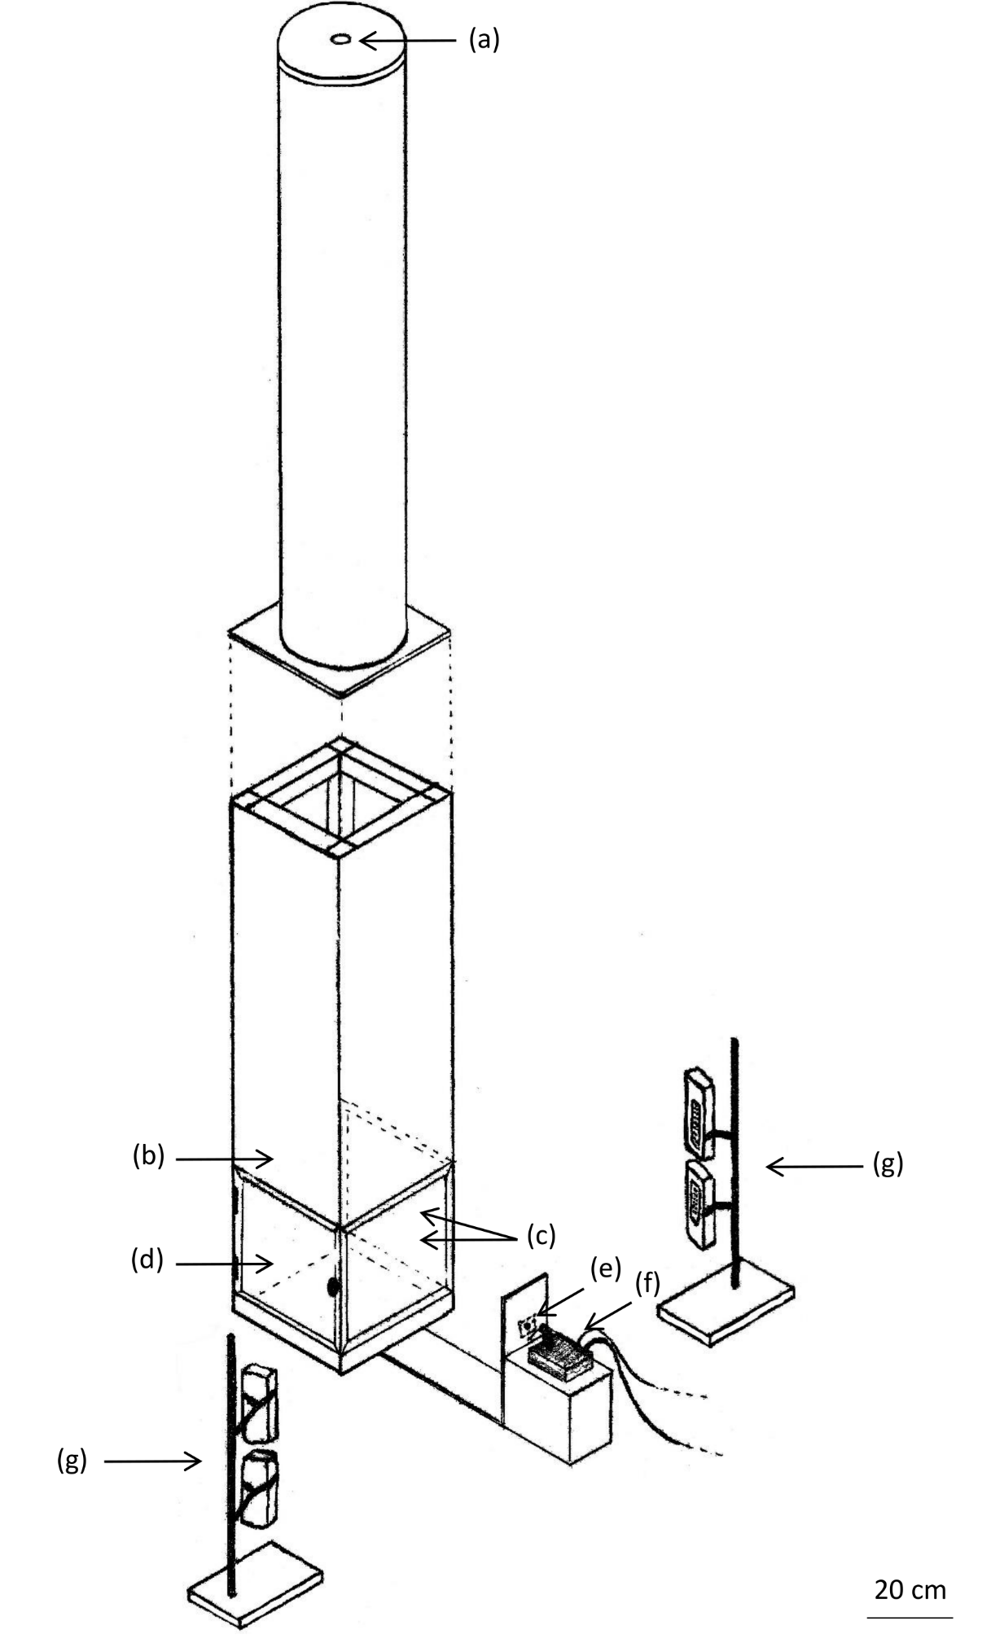
Fig. 1: General view of a device for measuring samara terminal velocity. (a) seed release location; (b) white-painted rear wall; (c) clear Perspex windows; (d) clear Perspex door for seed retrieval; (e) Raspberry Pi Camera Module V2; (f) Raspberry Pi 3 Model B; (g) battery-operated LED lights (Ever Bright 24 LED Work Light, The Warehouse Ltd.). The plastic pipe was 0.239 m in internal diameter and 1.4 m long. The wooden box connected to the pipe was 1.2 m in height with an internal width and depth of 0.286 m, and constructed from 12 mm medium-density fibreboard around a pine frame. For the lower 0.3 m, the front, left, and right sides of the box were made of clear 3 mm thick Perspex, with the left side attached with hinges to provide a door for seed retrieval. The base was lined with 12 mm thick foam to prevent damage to the samara on landing, therefore allowing repeated measurements per samara. Battery-powered LED lamps were chosen to provide a constant light source with no flicker. The camera module was positioned 340 mm from the front Perspex wall, 210 mm above the ground and set to sensor mode 7 (60.1-90 frames per second; 640 × 480 pixels).

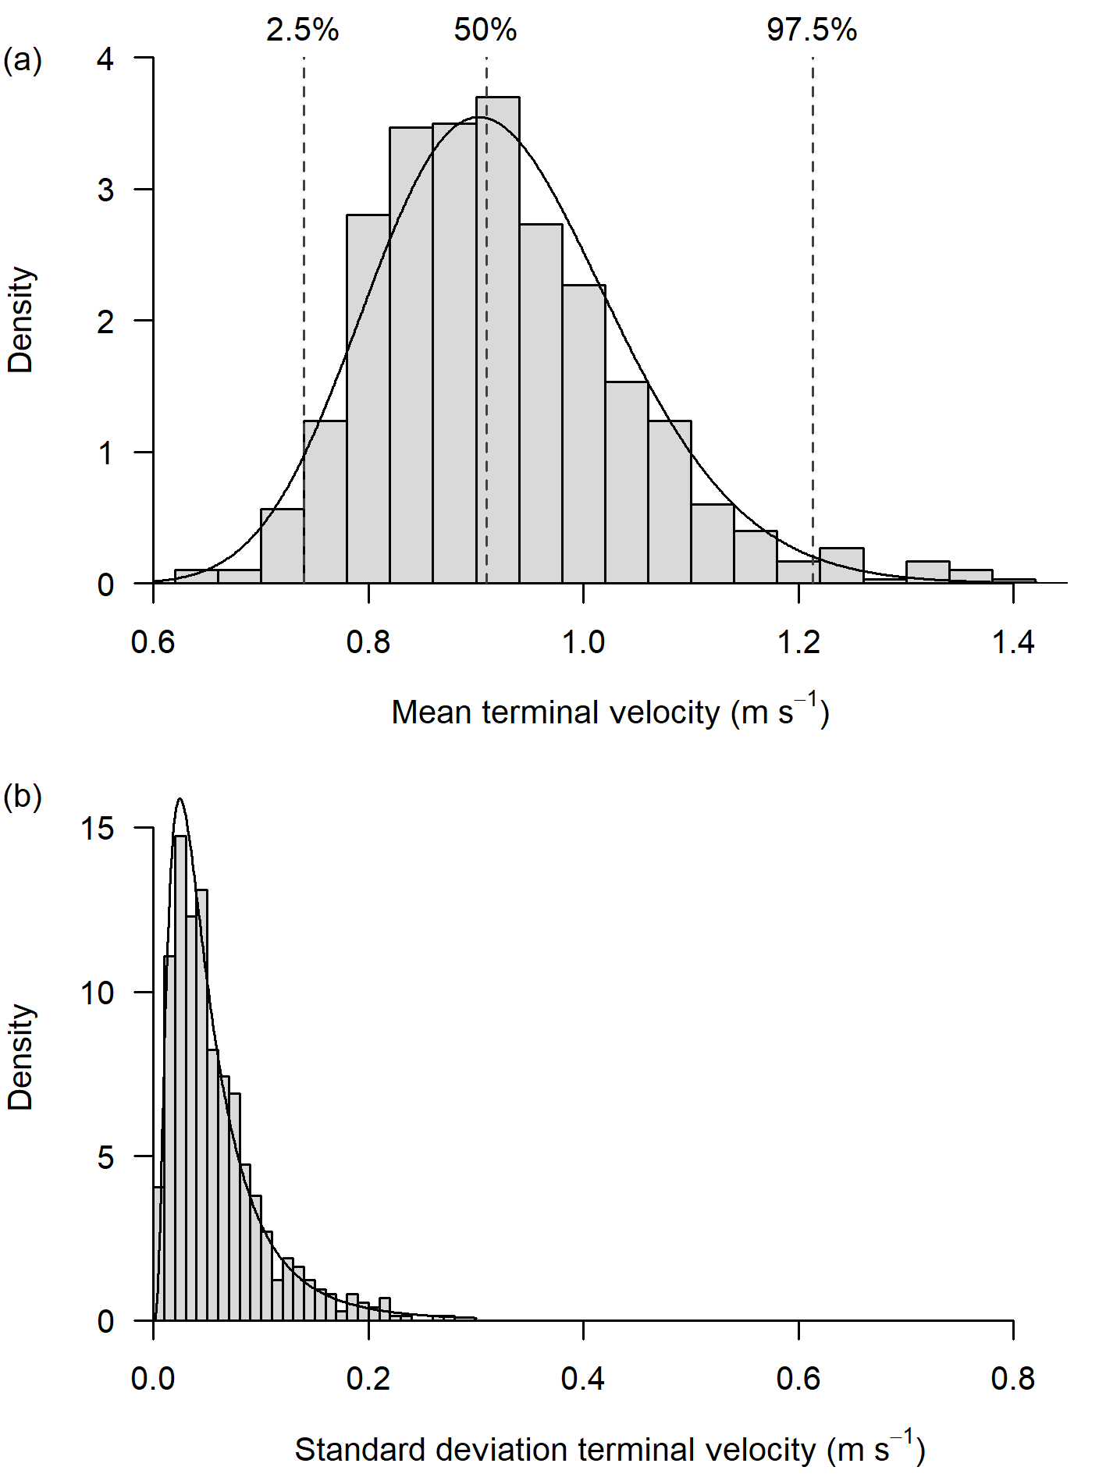
Fig. 2: Histograms of a) the mean and b) standard deviation of the three terminal velocity measurements taken for each of the 750 Pinus radiata samaras. Data distributions are approximately lognormal. Dashed lines in (a) show the 2.5%, 50%, and 97.5% quantiles.

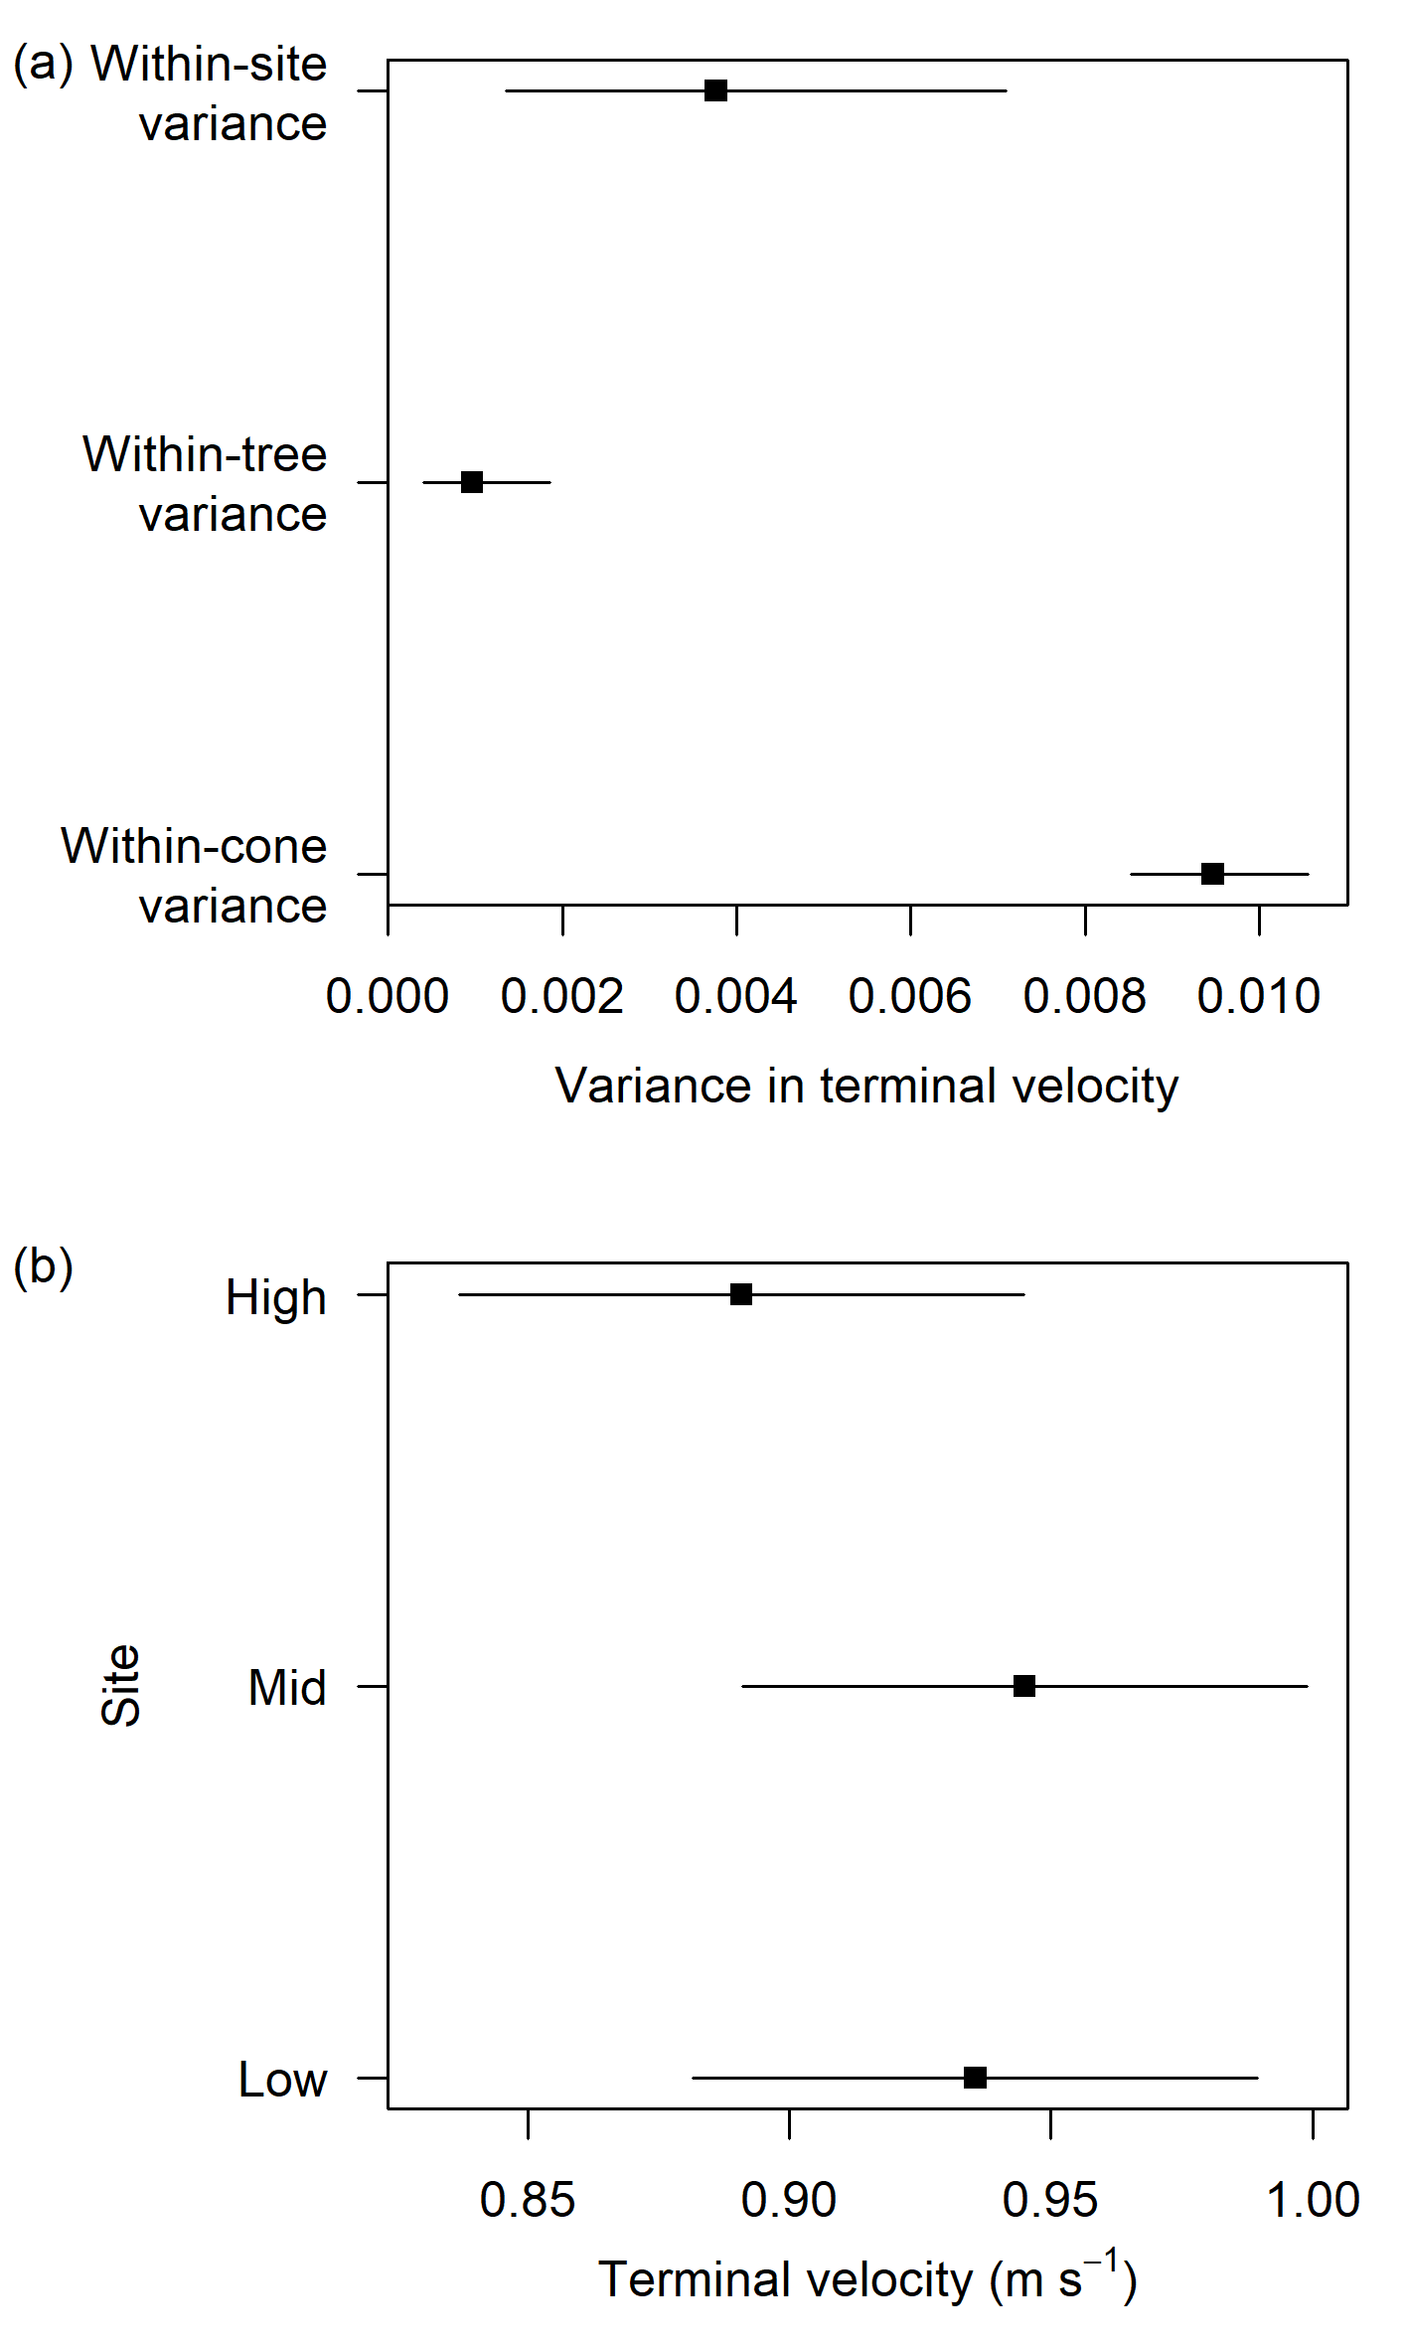
Fig. 3: Graphical summary of the results from the linear mixed model of seed terminal velocity for 750 Pinus radiata samaras. a) Samara terminal velocity variance estimates with 95% confidence intervals for the nested random variables: samaras within cones, cones within trees, trees within sites. b) Estimates and 95% confidence intervals of samara terminal velocity for the three levels of the site variable (fixed variable).

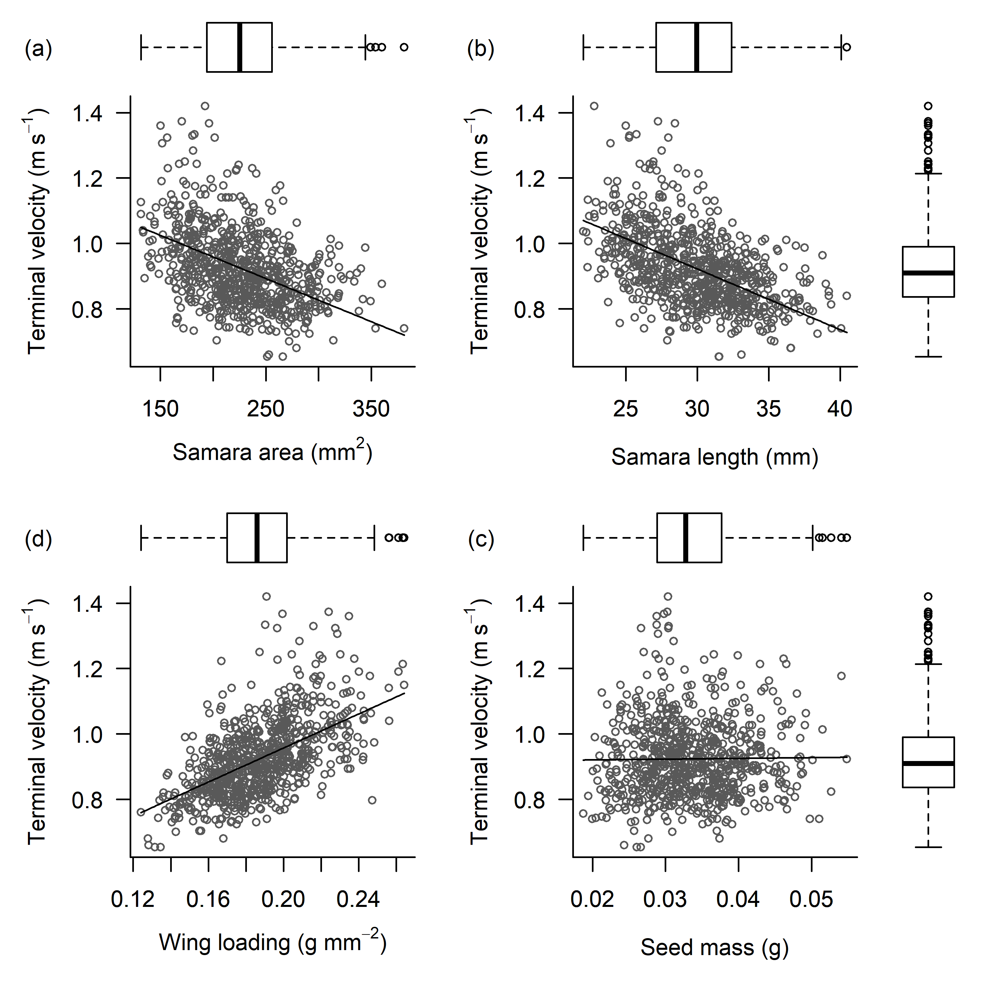
Fig. 4: Relationships between mean samara terminal velocity and other seed and samara traits for 750 Pinus radiata samaras. Lines depict the relationships between the respective predictor variables (fixed variables) and samara terminal velocity in linear mixed models, where cone, tree, and site are nested random variables. Boxplots depict the distribution of the data for each variable.

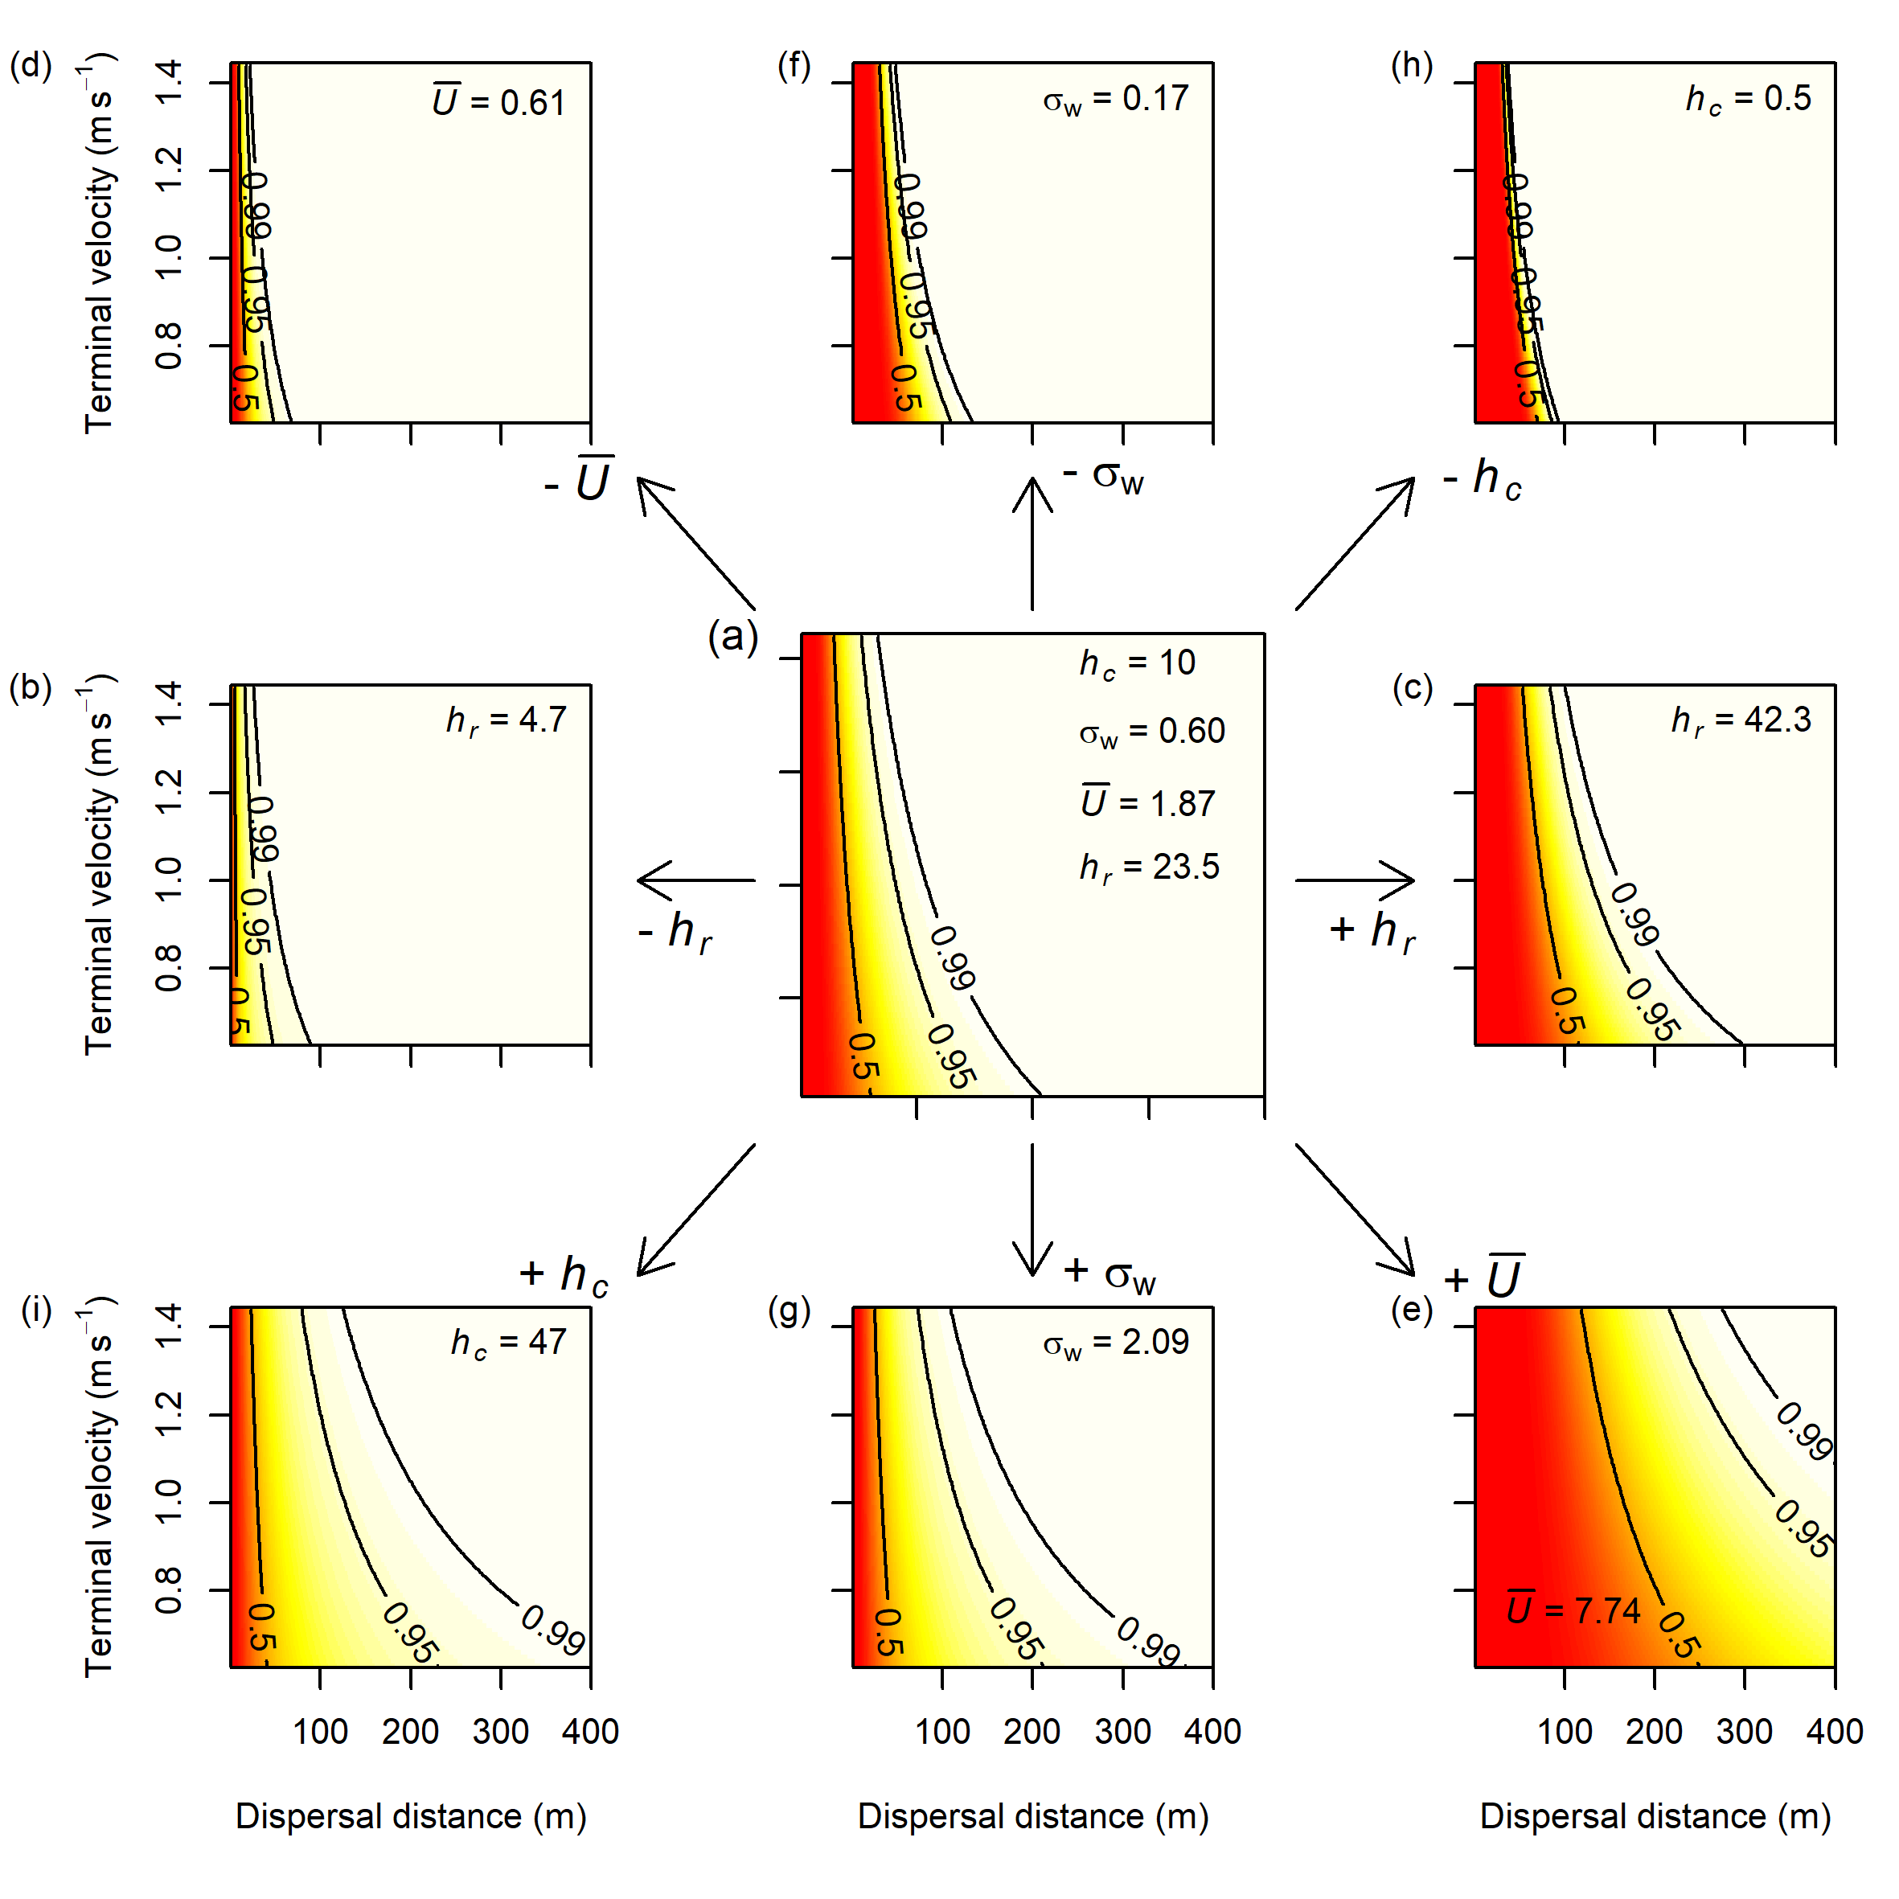
Fig. 5: Influence of samara terminal velocity, and modifying site- and species-specific variables on simulated seed dispersal distance. Colours and contours show the cumulative probability of a seed with Y terminal velocity dispersing X distance. Results obtained using the WALD model. The centre panel (a) depicts the results with typical values for canopy height (h_{c}; units: m), the standard deviation of vertical wind speed (σ_{w}; units: ms⁻¹), mean horizontal wind speed (Ū; units: ms⁻¹), and seed release height (h_{r}; units: m). Surrounding panels show the influence of increasing or decreasing one parameter at a time to their potential extremes: centre left (b) and centre right (c) show the effects of h_{r}; top left (d) and bottom right (e) show the effects of Ū; centre top (f) and centre bottom (g) show the effects of σ_{w}; and top right (h) and bottom left (i) show the effect of h_{c}. For the outside panels, all parameter values are equal to those in (a), except for the one modified parameter specified.

