**The capability of Rare Earth Elements geochemistry to interpret complex archaeological stratigraphy**

Gianni Gallello1,2,3*, Cruz Ferro-Vázquez1 , Simon Chenery4, Carol Lang1,5, Senna Thornton-Barnett1, Tabitha Kabora1, Mark E. Hodson2 , Daryl Stump1,2

1Department of Archaeology, University of York, King’s Manor, York, YO1 7EP, UK.

2Department of Environment and Geography, University of York, Wentworth Way, Heslington, York YO1 5NG, UK

3Department of Analytical Chemistry, University of Valencia, 50 Dr. Moliner Street, 46100 Burjassot, Valencia, Spain

4British Geological Survey, Environmental Science Centre, Nicker Hill, Keyworth (Nottingham) NG12 5GG, UK.

5School of Archaeology, Geography and Environmental Science, University of Reading, Whiteknights, Reading, RG6 6AB UK.

*Corresponding author: Gianni Gallello

Tel. : +34697636957

E-mail: [gianni.gallello@york.ac.uk](mailto:gianni.gallello@york.ac.uk)

**Abstract**

In this study rare earth elements (REE) signatures (REE ratios, cerium and europium anomalies) are applied to a complex soil stratigraphic sequence from the site of Konso, Ethiopia, with the aim of determining whether REE can distinguish the strata observed in the field. Forty soil samples were taken from a depositional sequence that includes overlapping human induced and ‘natural’ erosional and depositional processes. The samples were analyzed by Inductively Coupled Plasma Mass Spectrometry (ICP-MS) to determine trace elements and REE, with concentrations of major elements determined using X-ray fluorescence (XRF). Cluster Analyses (CA) were used to observe differences between strata. The mechanisms that influenced REE values and fractionations were related to OM accumulation, pyrogenic SOM, redox, secondary CaCO3 precipitation, suggesting the addition of proxies to the REE, Sc and Y data processing. This produced a clustering of samples that more accurately reflected the stratigraphic field observations. It is expected that this approach, combining the analysis of REE concentrations with an understanding of the mechanisms driving them in a given site or profile, will be replicable for other stratigraphic sequences. The results demonstrate that REE signatures are not just able to detect stratigraphic differences defined through field observations but also highlight variations within the same deposits. REE analysis could therefore become a powerful geoarchaeological tool, even for studies of complex stratigraphies.

**Keywords**

Rare earth elements, agricultural terraces, organic matter, Konso, anthropogenic deposits, stratigraphy

**Highlights**

REE can discern different archaeological strata, even for complex soil stratigraphies.

REE methodological approach is applied for the first time to Konso UNESCO site.

Combining REE with known drivers accurately matches deposits defined by excavation

REE could have a significant role for interpretation of archaeological stratigraphy

1. **Introduction**

For many years rare earth elements (REE) had been employed to trace sediment sources as they were thought to show stability in erosion and sedimentation processes and to be immobile in soil [1-4]. However, it has long been recognised (e.g. Nesbitt, 1979) [5] that REE signatures (i.e. the sum of REE and evidence of fractionation using the ratios between light, medium and heavy REE) are affected by geological rock forming processes, and soil processes including weathering, leaching, adsorption, complexation and re-precipitation (e.g. McLennan, 1992 ) [6]. This suggests that analyses of REE could potentially perform two important roles in examinations of archaeological strata: (1) provenancing the sources of redeposited sediments on archaeological sites; and (2) providing proxies for past human activities that are known to modify REE ratios in both in situ soils and redeposited material. Based on this recognition that REE ratios can be modified by multiple human activities (e.g. Laveuf and Cornu, 2009) [7], REE analyses have recently started to be employed to help in the identification of anthropogenic deposits on archaeological sites by comparing the REE values from known anthropogenic strata to layers with no evidence of human influence [8-9]. In the current paper the capacity of this approach is tested using a complex stratigraphic sequence at the UNESCO World Heritage Site of Konso in southwest Ethiopia; ‘complex’ in this context referring to soil strata that are formed by both anthropic and ‘natural’ processes following Gasche and Tunca [10], and which in this case are known to have been subject to both transportation and post-depositional effects [11]. The aim is to provide information on the geochemical mechanisms controlling REE variability in archaeological soils, and to further test the capability of REE for discriminating between the contribution of anthropogenic activities and sedimentary processes.

**2. Research background**

The UNESCO World Heritage Site of Konso is located in the southern Ethiopian highlands and is centered at c. 37° 23' 30″ E, 5° 18' 30″ N (Figure 1). The landscape encompasses over 200 km2 of drystone agricultural terracing [12], and is characterized by a hilly landscape with steep slopes. By comparing genealogical evidence with wooden monuments erected to mark the transition between age-sets it has been estimated that the towns – and by inference the surrounding terraces – are at least 500 years old [13-14]. The area is bordered by the Sagan River in the East and South, and by the Woito River to the West. The region experiences a dry, Afro-montane climate with a bimodal rainfall pattern, and with rainfall ranging from 300-900mm annually. The soils in the study area are volcanic in origin and the geology of the Konso area is primarily basalt rocks.

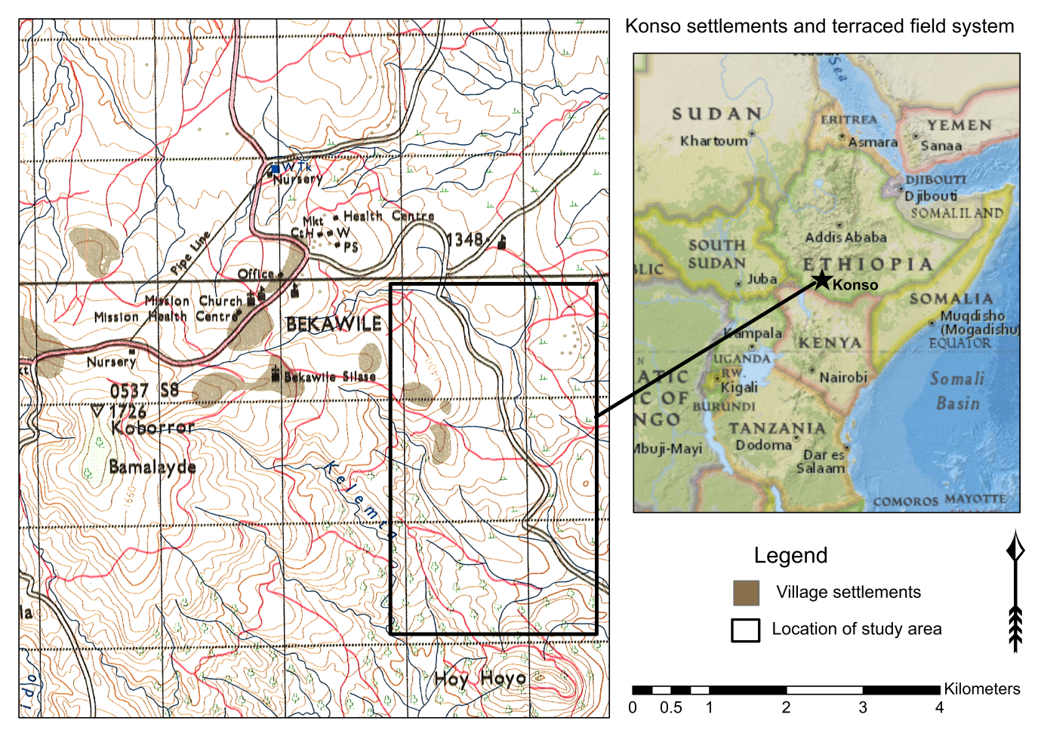

**Figure 1. Location of the area of study in Konso, Ethiopia.**

In August-October 2015, several of the current authors (Ferro-Vázquez, Kabora, Lang, Stump and Thornton-Barnett) conducted excavations in the Kilkilo river basin in the Sahayto area (Figure 1) in order to understand the evolution of the landscape. This work concluded that, at least within the Kilkilo river valley and probably elsewhere, widespread and severe soil erosion preceded the construction of terraces and had led to the loss of all the topsoil and most of the subsoil before the terraces were built [11]. It also demonstrated that sediments eroded from the hillsides were transported within water courses before being captured in artificial riverside sediment traps. This radically revises previous studies (e.g. Amborn, [13]; Beshah, [15]; FAO [16]; Förch [17]; Harrison [18]; Hallpike [14]; Watson [19]) by recognising that hillside terraces and the riverside sediment traps (sometimes referred to as checkdams, and known locally as ‘*yela*’) should be seen as soil creation features rather than soil conservation structures [11].

The 2015 excavation included the examination of a c.2m deep cross section through a group of sediment traps – referred to here as Section 102 (Figure 2). This section comprised a series of inclined drystone walls designed to capture fine alluvium transported by river flows, with these walls periodically raised by adding further stone courses as sediments were captured behind and in front of them; a technique very similar to that known from other archaeological sites such as Engaruka in Tanzania [20-21] and Petra in Jordan [22], as well as from agricultural systems that remain in use today [23]. In addition to recording stratigraphic data to determine the sequence of wall construction and sediment accumulation, this section was also analysed using soil micromorphology and geochemistry and the source of the organic matter determined [11].

The current study applies REE analyses to this same sample set from Section 102 to determine whether REE geochemistry can provide further information on sediment formation and post-depositional soil formation processes, and to assess whether REE signatures can distinguish between anthropogenic and non-anthropogenic effects. The sequence of artificially captured alluvial sediments at Konso provide an excellent setting for testing REE in complex stratigraphic sites because: (1) the deposition of this material blurs the boundary between ‘natural’ and anthropogenic processes; (2) the accumulated deposits are known to have been subject to post-depositional human activities having been farmed and irrigated; and (3) the location offers the opportunity to compare the REE results with a range of other geochemical and physical sediment properties determined on this same high-resolution sample set by Ferro-Vázquez et al. [11] (supplementary materials Table S1).

**3. Materials and Methods**

**3.1 Excavation and sample collection**

Section 102 was located next to a seasonal river, the bank of which was cut back to reveal the depositional sequence, as described by Ferro-Vázquez et al. [11]. Distinct deposits were defined in the field on the basis of the colour, texture and consistency of sediments, with inclusions and the sequence of deposition also used to define or infer separate depositional events. Each depositional event was assigned a unique record number, referred to here as ‘units’ (Figure 2). A total of 40 sediment samples was collected in a 2 m deep column spanning nine units, with the samples taken contiguously at 5 cm increments (Figure 2).

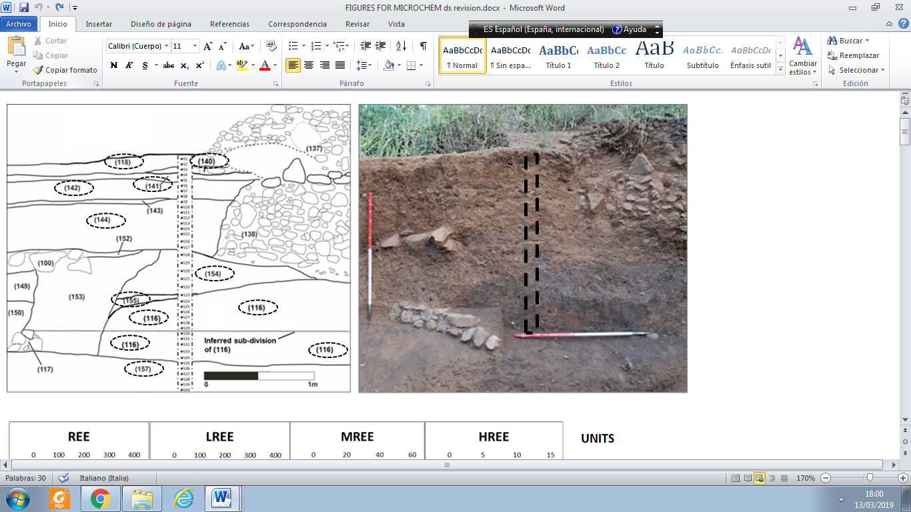

**Figure 2. Section 102. Scaled drawing of the east-facing section through former sediment traps showing stratified deposits (units). The sampled column from the top (S1-S40)** **and the related analysed units indicated by circles are shown on the left (the column being sampled every 5 cm). Photograph of the section prior to sampling is on right (scales 2 x 1m). Note the darker colour of the lowermost units 116 and 157.**

**3.2 Major elements and Zr analysis**

Soil samples were sieved to < 2mm, ground (<100 µm) and homogenised using a ball mill, and analysed using a portable X-ray fluorescence (pXRF) employing a S1 Titan energy dispersive X-ray fluorescence spectrometer (Bruker, Kennewick,Washington DC, USA) equipped with a Rhodium X-ray tube and X-Flash® SDD detector. The instrument was controlled using S1RemoteCtrl software (Geochem-trace programme) and S1Sync software (Bruker) was used to measure the concentration of Ca, K, P, Fe, Ti and Zr. The concentration of each element was calculated from the area of the corresponding peak in the spectra by using ARTAX software (Bruker). Reference standard soil NIM GBW07408 (China National Center for Standard Materials) was employed for evaluating the quality of the XRF method (supplementary materials Table S2).

**3.3 Trace elements and REE analysis**

Sieved and milled samples were digested by adding 1.35 ml HCl and 0.45 ml HNO₃ to 0.15g of soil sample in borosilicate tubes placed in a water bath at 100 ͦ C for 40 min. This method is an adaptation of the *aqua regia* extraction of the International Organization for Standardization (ISO 11466), specifically developed by Gallello [24] for the analysis of REE in soils from archaeological contexts, and is modified from the method employed by Guangping et al. [25] and Snäll [26]. This procedure minimally attacks the crystal structure of primary silicates and mainly dissolves the REE secondary minerals and organically bound pool. The extractions were carefully poured into polypropylene tubes of 50 ml, and diluted with ultra-pure water up to a volume of 25 ml. The solution was filtered through Whatman No 1 filter papers and analysed for Ba, Bi, Cd, Cr, Co, Cu, Pb, Li, Mn, Mo, Ni, Sr, Tl, V, Zn and REE (La, Ce, Pr, Nd, Sm, Eu, Gd, Tb, Dy, Ho, Er, Tm, Yb, Lu including Sc and Y) using a Perkin Elmer Elan DRCII ICP-MS. A multi-element stock solution containing the mentioned elements at a concentration of 100 µg/ml was used to prepare the calibration standards. Concentration ranges between 1 and 600 µg/l were used for trace elements (Ba, Bi, Cd, Cr, Co, Cu, Pb, Li, Mn, Mo, Ni, Sr, Tl, V, Zn, La, Ce, Pr, Nd), and concentration ranges between 1 and 100 µg/l for Sm, Eu, Gd, Tb, Dy, Ho, Er, Tm, Yb, Lu, Sc and Y. The stock solution was acquired from Sharlab S.L. (Barcelona). Soil NIM GBW07408 (China National Center for Standard Materials) was used as a standard reference material for evaluating the analytical quality of the method as reported in supplementary materials Table S3. This was chosen as a material with similar soil properties and chemical concentration characteristics of those analysed in this study. Rh was used as an internal standard. The employed mass isotopes of all the measured elements, limit of detection and the obtained R2 are reported in supplementary materials Table S4. The possible isobaric interferences (i.e BaO+) were automatically corrected by *ELAN* the employed ICP-MS software.

**3.4 REE data processing and Cluster analysis**

In this study REE were grouped according to their atomic weight, with La, Ce, Pr and Nd classified as light REE (LREE), Sm, Eu, Gd, Tb and Dy as medium (MREE), and Ho, Er, Tm, Yb and Lu as heavy (HREE) [27]. The relative abundance of the REE in the geological environment can be highly variable and mathematical constructs or transformations are frequently used to identify/clarify fractionation processes. In order to eliminate the Oddo-Harkins effect (even atomic number elements having higher abundance than odd atomic number elements), REE concentrations obtained from the analysed soil samples were normalized employing Post-Archean Australian Shale (PAAS) values taken from Taylor and McLennan [28].

The normalised ratios of (La/Yb)PAAS, (La/Gd)PAAS, (La/Sm)PAAS and (Sm/Yb)PAAS were used to determine relative enrichment or depletion of LREE, MREE, and HREE, with (La/Yb)PAAS indicating LREE enrichment over HREE, (La/Gd)PAAS and (La/Sm)PAAS demonstrating LREE enrichment over MREE, and (Sm/Yb)PAAS indicating MREE enrichment over HREE [29], where the enrichment is indicated by values >1.

Ce and Eu anomalies are used to evaluate differences between measured concentrations of Ce or Eu and the concentration expected based on neighbouring REE [30-34]. These anomalies arise from redox effects due to the Ce occurring in 3+ or 4+ valence state and Eu in 2+ or 3+ state. The Ce4+ or Eu2+ states having different geochemical behaviour to REE3+. Values >1 are expressed as Ce or Eu positive anomalies, anomalies close to 1 (±0.1) as an absence of Ce or Eu anomalies, and values <1 are Ce and Eu negative anomalies. The anomalies were calculated following the equation presented by Taylor and McLennan (1985) [28] and employed recently by Prajith et al. [35]:

Ce anomaly =3CePAAS/(2LaPAAS+NdPAAS)

Eu anomaly =EuPAAS/(SmPAAS × GdPAAS)1/2

PAAS indicates Post-Archean Australian Shale normalised values.

Unsupervised hierarchical Cluster Analysis (CA) was used to group the samples without using pre-defined class memberships. K-nearest neighbour and agglomerative HCA were employed for dendrogram calculation; other distance measurement methods were tested but provided similar results (not shown). Two CA were performed: one using only REE/REEPAAS, Sc/ScPAAS and Y/YPAAS, and a second also including pH and total C, N and Ca concentrations. These last variables are often employed as proxies for human activities in soils [36], and have been demonstrated to be important parameters for differentiating strata in this depositional profile [11]. Statistical analyses were carried out using the PLS Toolbox 8.2 for Eigenvector Research Inc., (Wenatchee, WA, USA) running in Matlab R2016b from Mathworks Inc. (Natick, MA, USA).

Significant (p<0.01) correlation coefﬁcients (r2) were used to measure the degree of linear association between variables.

**4. Results**

**4.1 Geochemical analyses**

Raw data on major elements, trace elements and REE are provided in supplementary materials Tables S5 and S6. Among the reported major elements, Fe (supplementary materials Table S5) is the most abundant, and shows a trend to decrease with depth from 0 to 35 cm, and to increase with depth from 35 cm to the bottom of the profile. Calcium (supplementary materials Table S5) abundances range from 2.1% to 4.5%, with the highest contents in unit 116 and the lowest in unit 157. Titanium (supplementary materials Table S5) values are highest in the two uppermost units samples S1 (1.82%), S2 (1.94%) and S3 (1.95%), with values ranging from 1.5%-1.8% in other units. Potassium (supplementary materials Table S5) content decreases with depth from 0.9% in the topsoil to 0.7% at 103 cm depth, corresponding to stratigraphic units 118, 140, 141, 142, 144 and 154. Phosphorus (supplementary materials Table S5) varies from less than the limit of detection (LOD) in some samples of units 116 and 157 to concentrations of 0.1% at 35 cm depth: i.e. the lower sample from unit 142. The concentrations of P and K (r2=0.75, p<0.01) are correlated in the samples corresponding to units 142, 144 and 154 (from 35 to 103 cm depth).

For trace elements (supplementary materials Table S6), Ba contents co-vary with Mn (r2=0.87, p<0.01) and Sr (r2=0.83, p<0.01), and are lower in the upper part of the profile, while units 116 and 157, at the base of the profile, have higher values and show an increasing trend with depth (r2=0.75 for Ba, r2=0.79 for Sr, and r2=0.53 for Mn, p<0.01). Bismuth, Cd, Co, Cr, Cu, Li, Mo, Ni, Pb, Tl, V, Zn and Zr do not follow an identifiable trend that would aid developing a stratigraphy. Therefore, these will not be considered further in the current study. Total and PAAS normalised REE are shown in supplementary materials Table S7, total REE have an overall trend of increasing with depth (r2=0.80, p<0.01), although the highest values are found in the samples corresponding to 145-155 cm depth (unit 116). The REE abundances correlate with the amount of Ba (r2=0.94, p<0.01), Mn (r2=0.90, p<0.01) and Sr (r2=0.90, p<0.01). Scandium and Y follow the same pattern (see supplementary materials Table S6) although the increase with depth is less evident (r2=0.76 and r2=0.79 respectively, p<0.01). Total REE (supplementary materials Table S6) and normalized REE (supplementary materials Table S7) values show an overall trend of increasing with depth: r2=0.80, p<0.01 for total REE and r2=0.78, p<0.01 for REE/REEPAAS. A weaker although also significant correlation was found for Y/YPAAS (r2=0.62, p<0.01) and Sc/ScPAAS (r2=0.58, p<0.01). The vertical variation for the sums of LREE, MREE and HREE (supplementary materials Table S6) are very similar to each other (r2>=0.9, p<0.01), and all strongly co-vary with total REE (see r2 correlations in supplementary materials Table S8).

REE shale normalized diagram shows difference between the samples (Figure 3) following the overall trend increasing with depth observed by the total REE (supplementary materials Table S6) and normalized REE (supplementary materials Table S7).

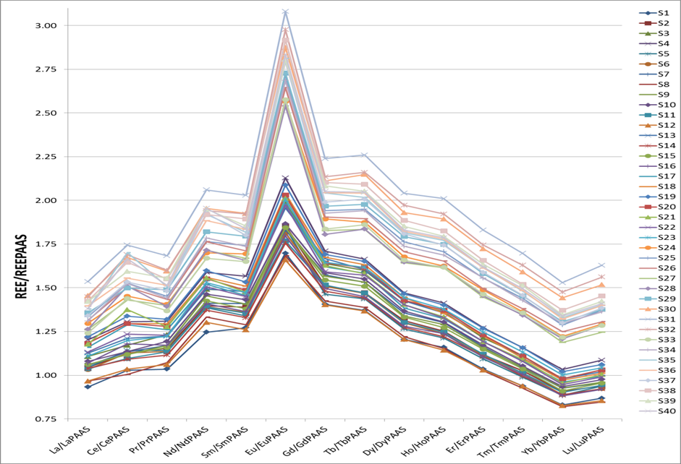

**Figure 3. REE shale normalized diagram for all the analysed samples.**

Slight differences in the pattern of LREE, MREE and HREE are highlighted by the REE ratios of (La/Yb)PAAS, (La/Gd)PAAS, (La/Sm)PAAS and (Sm/Yb)PAAS (Figure 4). The (La/Yb)PAAS and(Sm/Yb)PAAS have values >1 in all samples, showing an enrichment of LREE and MREE over HREE. The ratios are generally higher in the upper part of the profile (0-103 cm, corresponding to units 118, 140, 141, 142 and 154) than in the deeper part (103-200 cm, corresponding to units 155, 116 and 157) (Figure 4). The lowest ratios for (La/Yb)PAAS and (Sm/Yb)PAAS are found in samples S30, S31 and S32, located towards the base of unit 116 (between 145-155 cm), indicating a relatively higher abundance of HREE in these samples. The two lowermost samples from unit 144 (S16 to S22, at 71-103 cm), and all samples from unit 154, record the highest ratios, indicating a larger enrichment of LREE and MREE over HREE. The values of (La/Gd)PAAS, and (La/Sm)PAAS are <0.8 indicating a relative depletion of LREE compared to MREE.

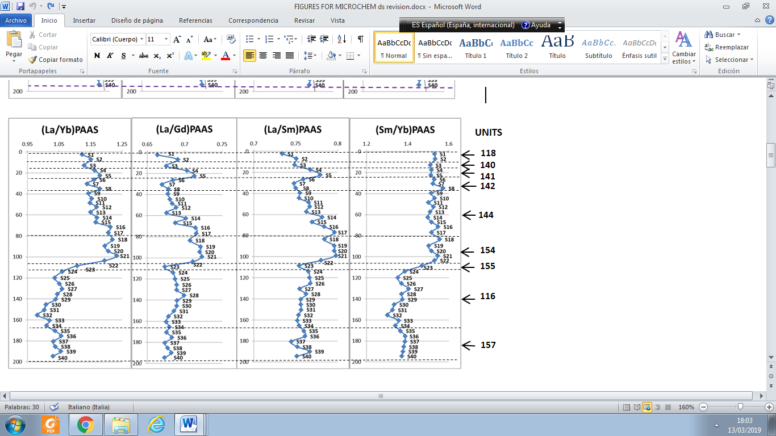**Figure 4. (La/Yb)PAAS, (La/Gd)PAAS, (La/Sm)PAAS, (Sm/Yb)PAAS ratio values. La, Sm, Gd Yb normalized with Post-Archean Australian Shale values (PAAS).**

***4.1.1 Eu and Ce anomalies***

Clear positive Eu anomalies (between 1.23 and 1.48) were obtained in all samples (Figure 5), with the highest values of 1.43 to 1.48 being measured in samples S24 to S40 (units 116 and 157) from the lowest 80 cm of the column. Within samples S7 to S22 (30-103 cm depth, units 142, 144 and 154) Eu anomalies is correlated with depth (r2=0.74, p<0.01). Cerium anomalies are near 1 in all the samples (0.92 to 1.09). A weak although significant trend of correlation with depth (r2=0.51, p<0.01) is also observed for Ce anomalies (supplementary materials Table S7), though variability is high, particularly in the lower part of the profile (S21-S40).

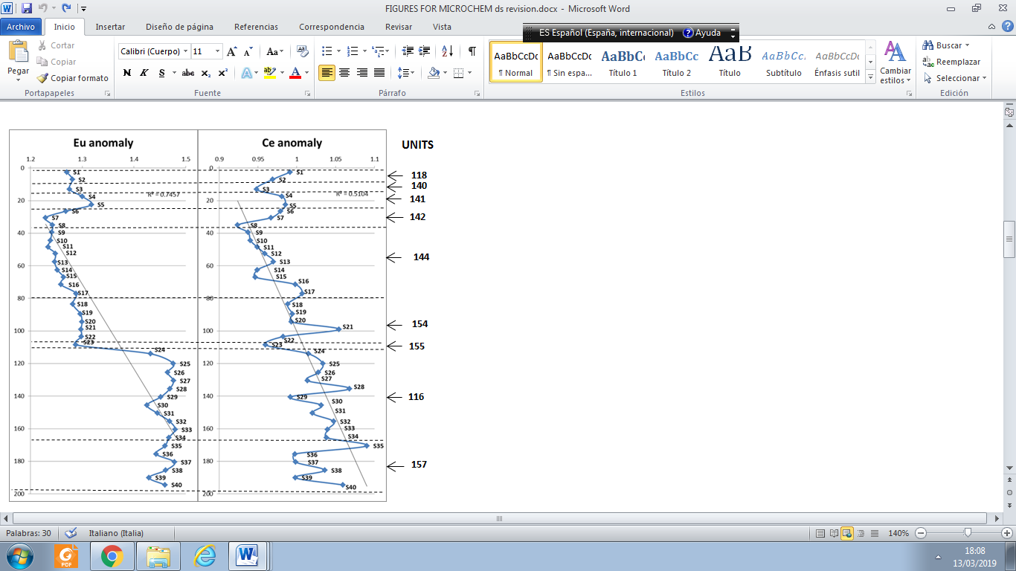

**Figure 5. Ce and Eu anomalies, PAAS normalised ratio.**

**4.2 Cluster Analysis**

The dendrogram in Figure 6 shows the distances between groups as calculated by Cluster Analysis (CA), and was obtained using REE/REEPAAS, Sc/ScPAAS and Y/YPAAS as variables. The CA classified the samples into two main groups: one comprising the samples from S1 to S23 (0-110 cm below ground level (bgl) ‑ units 118, 140, 141, 142, 144, 154 and 155), and a second comprising S24 to S40 (115-200 cm ‑ units 116 and 157). Within this lower group samples S30, S31 and S32 plot separately from the other samples from unit 116. The clustering within the upper group is generally consistent with the stratigraphic units as defined through field observations; all samples from unit 154 (S18-S22) cluster together, as most samples from unit 144 do (S9-S17). However, three samples from unit 144 cluster elsewhere. S12 clusters with samples from the upper 30 cm of the column; S17, from the boundary between 144 and 154 groups with the unit 154 samples; and S23, the only sample from unit 155, clusters with S13 from unit 144. The majority of samples from the uppermost units 118, 140, 141 and 142 (S1-S8) cluster close to one another but do not directly reproduce the stratigraphy observed in the field, and samples S3 and S4 both cluster at some distance from their stratigraphic neighbours.

**Figure 6. CA of soil samples using REE/REEPAAS, Sc/ScPAAS and Y/YPAAS as variables.**

The second cluster analysis includes C, N, Ca and pH in addition to REE/REEPAAS, Sc/ScPAAS and Y/YPAAS (Figure 7). As with the previous CA, this analysis clearly separates the samples taken from the two lowermost deposits (samples from S24 to S40; units 116 and 157) from all other samples, although here S36 from unit 157 does not precisely cluster with the samples of the same group. In contrast to the CA using only REE, Y and Sc as variables, this second analysis clusters all samples from unit 144 together (samples from S9 to S17), though as with the previous analysis S7 from the overlying unit 142 clusters with S9, and the sample on the boundary between units 144 and 154 (S17) clusters most closely with the unit 154 samples. Of the unit 154 samples, S18 to S21 group together, with S22 from this unit now clustering away from its stratigraphic neighbours. All samples from the uppermost units (from S1 to S8; units 118, 140, 141 and 142) loosely group together with the exception of S4 and S8 which again cluster away from their units.

D:\Gianni\ARTICLEKONSOD&CversionIII\KONSO TO BE SENT\coauthors revision\KONSO  SENT TO JAS\MICROCHEM\MICROCHEM TO BE SENT\MICROCHEM MAJOR REVISION\MICROCHEM MAJOR REVISION TO BE SEND\Figure 7 corretta.tif

**Figure 7. CA of the studied soil samples using REE/REEPAAS, Sc/ScPAAS and Y/YPAAS, Ca, N, C and pH as variables.**

**5. Discussion**

As briefly summarised above and shown in Figure 2, the depositional sequence evidenced within Section 102 is complex (for reasons returned to below), but the stratigraphy within the sample column itself is relatively straightforward: the lowermost sediment (unit 157) was the first to be deposited, with subsequent deposits accumulating in simple stratigraphic order until the deposition of the sediment that forms the current topsoil (unit 118). There is no evidence of deliberate truncation of deposits, and although there have possibly been some episodes of erosion of former palaeosurfaces (for example at the top of unit 116) there is no evidence of severe erosive events in this location. Moreover, whilst gravelly deposits 140, 141, 143 and 155 may have been washed into their current positions directly from the adjacent hillsides, all other sediments were accumulated in the same way and for the same purpose; all are alluvial and were deliberately collected behind artificial dry-stone walls in order to create fine-grained agricultural soils, all of which were farmed for a period before subsequently being buried by later alluvial layers [11].

However, having noted the relative simplicity of the stratigraphic sequence within the sample column, the method of sediment accumulation and the subsequent use of these deposits as agricultural soils mean that multiple mechanisms could influence REE values and ratios. For example, since all of these sediments have been transported from elsewhere, it is possible that the differences in the REE values and ratios reported here are wholly or partially inherited from different geological sources [6], or that they reflect different soil formation processes within the source areas prior to transportation [37]. The latter is a potential issue here because different weathering conditions can influence the type and quantity of secondary oxides, and these oxides can bind REE [38] thus affecting fractionation. Equally, transportation of sediments by water creates high potential for mineralogical fractionation by grain size or density [39]. Finally the fact that these sediments were subject to different irrigation regimes [11] creates the possibility of differential post-depositional mobility of REE [40], and differential adsorption/desorption of REE to Fe and Mn oxides forming under different redox conditions [7]. Post-depositional human activities associated with farming are also known to play an important role in REE ratios, such as the addition or removal of organic compounds, and the differential uptake of REE by plants [41].

Several of these mechanisms cannot be directly tested via the current dataset. Mineralogical and weathering effects at the source areas cannot be characterised (beyond the theoretical processes of basalt weathering under this environment) since the exact locations of sediment sources are not known. Similarly, although the depositional sequence within the sample column is clear, the broader sequence of sediment trap construction is more complex, because multiple traps could be built simultaneously, and long hiatuses in sediment accumulation may have occurred. Nevertheless, cross-referencing of REE data with stratigraphic evidence, field descriptions of soils and sample geochemistry (supplementary materials Table S1; Ferro-Vázquez et al. [11]) can account for variations in REE abundances and ratios, and thereby explain why the cluster analyses presented above broadly correspond to field observations of distinct depositional events.

**5.1. Processes behind REE capacity for reproducing the stratigraphy**

Both cluster analyses (CAs) divide the soil samples into two main clusters, with both producing a clear separation between samples from the two earliest stratigraphic units (116 and 157) and all other samples (Figures 6 and 7). In addition, both CAs distinguish samples from deposits 144 (samples S9-S17) and 154 (S18-S22) within this upper grouping, with the CA employing REE, Y, Sc, Ca, N, C and pH (Figure 7) more closely matching the definition of strata in the field. However, the CA using just REE, Y and Sc as variables also broadly groups these field-defined deposits, demonstrating that the values and ratios of REE, Y and Sc differ between these two stratigraphic units, and differ also from the deposits that pre- and post-date them. Furthermore a CA employing only Ca, N, C and pH as variables was tested (supplementary materials Figure S1) and the clustering obtained clearly did not help to differentiate between deposits. For the purposes of this discussion the units 118, 140, 141, 142, 144, 154 and 155 are referred to as the Upper Group and units 116 and 157 are called Lower Group. The Upper Group can be further sub-divided to include a Middle Group formed by units 144 and 154.

***5.1.1. The role of soil organic matter***

The ratios La/Yb and Sm/Yb indicate that there is a general enrichment of LREE and MREE over HREE in Section 102, but this enrichment is higher in the Upper Group than in the Lower Group. From field observations the most obvious difference between the Lower Group units, 116 and 157, and the rest is that these two deposits are darker (Figure 2) as a result of far higher amounts of soil organic matter (SOM), with pyrolysis-GCMS demonstrating that this SOM is to a large extent fire-derived [11].

That OM binds REE is widely known: the adsorption/desorption of REE to OM has been extensively demonstrated [7, 42, 43] and is consistent with the correlation between REE and C found in Section 102 (supplementary materials Table S8). In particular the amount of HREE is strongly correlated to C and also N (r2=0.80 for C and r2=0.78 for N; p< 0.01 for both) for the samples below 30 cm. This, together with the fact that the La/Yb and Sm/Yb ratios are inversely correlated to C across the whole profile (r2=0.77 and 0.85 respectively, p<0.01), suggests that SOM in Section 102 preferentially adsorbs (or retains) HREE over MREE and LREE. According to Laveuf and Cornu [7] HREE-OM complexes are generally more stable than those formed by LREE and MREE, usually leading to OM being enriched in HREE [44, 45]. Moreover, as REE can be adsorbed to both the carboxylic and phenolic groups of the OM, the type of OM (as a result of its origin or its degree of humification) has an influence on its adsorption/desorption of REE [42, 43]. This influences both the amount of REE that can be adsorbed and, importantly, go under fractionation. Different kinds of OM thus fractionate REE in different ways [7] because the LREE, MREE and HREE do not bind to humic substances by the same functional groups: the LREE and MREE preferentially adsorb to carboxylic groups, whereas the HREE preferentially bind to carboxy–phenolic and phenolic groups [46-48].

The analysis of pyrogenic SOM (Py-SOM) from Section 102 [11], (see also supplementary materials Table S1) shows that the units that are relatively enriched in HREE have much more Py-SOM (average ±SD 36.2±8.1%) than the deposits in the upper part of the profile (16.7±6.3%). This together with the positive correlation between abundances of Py-SOM and REE, in particular to HREE (r2=0.50, p<0.01), and the inverse covariation of HREE to La/Yb and Sm/Yb (r2=0.79 and 0.90, p<0.01) point to fire-derived OM preferentially binding HREE over LREE and MREE. Py-SOM is more resistant to degradation than fresh OM and has more binding positions [49]. It is also largely immobile in soils due to its hydrophobicity, high polarity [50], and large number of functional groups able to bind polyvalent cations which facilitates aggregation of humic substances, making them highly insoluble and producing an effective immobilization of REE. The Py-SOM is thus retaining larger amounts of HREE than LREE or MREE in the soil, and producing a lower enrichment in LREE and MREE over HREE in the lower part of the soil. This preferential adsorption of HREE to Py-SOM is consistent with results reported by Pourret and Houben [51], who further conclude that this effect is pH dependent. The effect of pH is returned to below as it is also a key driver of REE abundances and fractionation in the upper part of the soil profile. Importantly, this shows that even if exogenous REE concentrations in soil pore water are low, they are sufficient to influence the total pool of acid extractable endogenous REE.

In addition to HREE preferential retention, a marked relative enrichment of Eu over other MREE is evident in samples S24-40 (Figure 5), also reflecting the separation of units 116 and 157 in both CAs. Several mechanisms could account for this, including the preferential mobilization of Eu during weathering, the chemical reworking of sediments [52-54] or a greater proportion of feldspars within the source geology [54]. However, it is most likely that this too relates to SOM since humic acids have been shown to have an important role in Eu adsorption [41]. However, more specific analysis should be carried out to confirm this last hypothesis.

It seems clear that differences in fractionation of LREE, MREE and HREE (Figure 4) are the reason that the CA employing only REE, Y and Sc as variables (Figure 6) is able to distinguish the Py-SOM-rich deposits 116 and 157 from all other deposits, with the correlation between HREE and C, N and pH replicating this distinction in the second CA (Figure 7). Furthermore, this fractionation pattern strongly indicates that REE values in units 116 and 157 are related to post-depositional effects caused by the complexation of REE to SOM. Since the presence of SOM in these deposits directly relates to past human activities (in this case as the remnants of slash-and-burn agriculture that triggered hillside erosion) [11] it follows that these REE values and ratios are also a consequence of human activities, rather than simply being inherited from the source geology.

This conclusion that the HREE ratios are not inherited is further reinforced by the fact that the REE extraction protocol employed [24] minimises the contribution of the REE signature of primary minerals derived from the mineralogy of the source rocks, beyond the effect they may have on post-depositional weathering processes, since primary minerals are not totally dissolved by the *aqua regia* and therefore not detected. The method is thus highly appropriate for recognising the effects of anthropogenic soil formation on REE.

***5.1.2. The role of secondary minerals***

Manganese (supplementary materials Table S6) is much more abundant in the Lower Group than in the Upper Group. Manganese may, in this environment, be linked both to binding with OM and to the formation of Mn oxides. The proportion of Mn in the organic *vs* inorganic pools cannot be determined from the current dataset in the absence of a Mn speciation study. However, the previous micromorphological study of Section 102 (results presented in Ferro-Vázquez et al. [11]) demonstrates that Mn oxides are indeed present in units 116 and 157. Experiments of REE adsorption or co-precipitation with MnO2 have provided some evidence that HREE are more effectively adsorbed than LREE and MREE onto the MnO2 surface [55]. This is consistent with the correlation found in Section 102 between the concentration of Mn and La/Yb and Sm/Yb (r2=0.73 and 0.80 respectively, p<0.01), suggesting that the presence of MnO2 may contribute to the relative enrichment of HREE in these deposits. However, given that Mn can also form organic complexes and that its concentration is correlated to C and Py-SOM (r2=0.83 and 0.58 respectively, p<0.01), we cannot rule out the possibility that the covariation of Mn and La/Yb and Sm/Yb is spurious. The relative abundance of SOM in the 116 and 157 samples may account for the correlations between REE and Mn, with Mn abundances further elevated due to precipitation of oxides as a result of repeated reduction-oxidation cycles within these deposits [11].

No Ce anomalies were detected. It has been reported that in organic-rich sediments and in shallow organic-rich groundwater in an oxidizing environment [37], the interaction between REE-humate complexes and MnO2 prevents the preferential absorption of Ce (IV) necessary to develop positive Ce anomalies [55]. Although shallow organic-rich groundwater is not present in our case-study, Section 102 was formerly irrigated, was consequently subject to fluctuating redox conditions, and has high organic matter and Mn concentrations in units 116 and 157. This may account for the absence of a Ce anomaly in these units.

The amount of Fe oxyhydroxides and clays can also have an effect on REE fractionation. Under semi-arid environments at neutral to alkaline pH (as in Section 102) the formation of Fe oxides and 2:1 clays is expected as a result of basalt weathering, thus providing adsorption surfaces for binding REE [56, 42]. In Section 102, Fe oxides and phyllosilicates are proportionally more abundant in the Upper Group, where the organic content is lower, thus potentially contributing to the larger relative enrichment in LREE and MREE in the upper part of the profile, and thereby influencing the CAs [42]. Chang et al. [57] and Cidu et al. [58] note that Fe-bearing minerals have a stronger binding capability for LREE and MREE over HREE. However, we did not find a correlation between both either Fe (supplementary materials Table S5) and REE abundances (supplementary materials Table S7) or ratios in the Section 102 samples, suggesting that the effect of Fe-oxides in the overall REE fractionation pattern in this soil is not very important compared to the effect of other soil components such as the organic matter. As for the phyllosilicates, Laveuf and Cornu [7] report different REE enrichment patterns for different 2:1 clay minerals. The current study lacks data on the clay mineralogy of the sample set, but micromorphological evidence points to the presence of vertic properties [11] and thus the presence of smectite-type clays is inferred. These have been found to show adsorption preference for HREE over LREE and MREE [7]. The contrary to the La/Yb and Sm/Yb of the upper part of Section 102 with a fractionation capacity that depends on pH and on the competition with other ions [59]. Once again, the higher LREE enrichment in the upper units could thus result from the fact that Fe oxides and phyllosilicates are proportionally more abundant in the less organically-rich Upper Group.

Moreover, the lack of a significant correlation of La/Sm and La/Gd with soil Fe content indicates that the speciation of Fe oxides is playing a dominant role in fractionation. We lack data on the Fe-oxides mineralogy, so it is not possible to further characterise this effect in this work.

The La/Sm and La/Gd ratios of Section 102 are <1, indicating that MREE are enriched over LREE across the section as a whole; a pattern reported in other case-studies and experiments [7, 60]. Within the Section 102 samples neither La/Sm nor La/Gd are correlated with C and Py-SOM, suggesting that inorganic colloids (Fe-oxides and phyllosilicates) and carbonate dissolution/re-precipitation are driving the variations in fractionation of LREE and MREE. The important role of carbonate precipitation in the studied section has been already identified during the previously carried out micromorphological and geochemical analyses [11]. The depth curve of La/Sm has a large variability in the Upper Group and far less variation in the Lower Group. The effect of inorganic secondary materials and carbonate on the REE soil signature is expected to be more visible due to the lower amounts of OM in the Upper Group than in the Lower Group where the effect of the OM is larger. This is in agreement with Cidu et al. [58], who found MREE enrichment over LREE in the carbonate and Fe-oxide fractions of alkaline soils in Italy.

In the case of the Middle Group (units 144 and 154) it is probable that both SOM and carbonates phases are together affecting REE, Sc and Y concentrations; an inference based in part on the fact that the highest REE/REEPAAS ratios are found in the upper portion of the column, especially in unit 154. Here La/YbPAAS, La/GdPAAS, La/SmPAAS and Sm/YbPAAS values (Figure 4) show LREE enrichment over HREE, as well as MREE enrichment over HREE. This is possibly due to the presence of carbonate in this part of the section; unit 154 is the only deposit within the column to contain calcite inclusions as identified by the soil micromorphology [11]. However, there is no significant correlation of these REE ratios with proxies for carbonate (Ca/Sr). Although not specifically tested for here, it is thus possible that these ratios relate to the presence of P compounds (see P concentrations in supplementary materials Table S5), in particular phosphate which is the most likely P compound in these soil conditions [61]. Carbonate and phosphate minerals can form complexes with REE under alkaline conditions [7, 60], especially with LREE when compared to HREE [60, 62]. Since the carbonates are probably precipitates resulting from prolonged irrigation and evapo-transpiration [11], the REE ratios here can again be plausibly related to human influences.

***5.1.3. The role of pH***

The fractionation of LREE, MREE and HREE in the studied profile seems to depend primarily on the amount and kind of organic compounds and the amount of inorganic adsorption surfaces (primarily Mn and Fe oxides and phyllosilicates), coupled with the effect of the amount and speciation of competing metals and the dissolution/re-precipitation of carbonates and probably also phosphates. All these processes are pH-dependent. Although there is no correlation between the amounts of REE and pH in these soils, in general the pH is the controlling factor of the different fractionation patterns in the upper and lower part of the soil, albeit indirectly. The pH is crucial for the dissolution of carbonates, it regulates solubility of organic compounds, and it determines the weathering pathways, the adsorption capacity of the resultant species, and the speciation of dissolved metals that compete for those adsorption sites. The strength of a colloid-REE bond will be generally greater with increasing soil pH [7, 51, 60]. In particular, the adsorption capacity of Py-SOM typically increases as pH becomes alkali, most likely due to the deprotonation of hydroxyl-bearing surface functional groups [63-64], making them available for REE sorption. At the pH values found in Section 102 (7.9-8.7) the binding of REE to OM would be highly stable, thus limiting desorption.

In agreement with this, pH is correlated with La/Yb and Sm/Yb ratios (r2=0.54 and 0.64, p<0.01) in samples below 50 cm, reflecting a higher relative enrichment in LREE and MREE where pH is higher. In the lower part, coinciding with larger amounts of SOM, the pH is slightly lower, although still alkaline.

**5.2. Why some samples do not match the field-defined stratigraphy**

Having highlighted that samples from units 144, 154, 116 and 157 cluster with other samples from the same strata as defined in the field, it must be noted too that samples from S1 to S8 and S23 do not do so. Of these, Sample S3 (from unit 140) and S23 (unit 155) can be discounted as they are the only samples from their respective units. Both of these deposits are also far coarser than the majority of the fine-grained alluvial sediments that make up the majority of the profile, and as noted above may have been washed into their current positions from the adjacent hillsides rather than being deliberately sorted and captured from directed water flows. Both CAs group S4 and S5 from unit 141 at distance from one another, but unit 141 is also gravelly, and it is possible that gravelly deposit 143 is exerting an influence on the overlying sample S8 (unit 142). It is known that particle size can influence REE distribution with inconsistent binding of REE oxides in gravelly sediments [65], but the extraction method employed in the current study should limit this effect. At present it is thus thought most likely that these coarse deposits are simply more heterogeneous than the well-sorted alluvial layers. It is also possible that the shallow depths of samples from S1 to S8 (0-35 cm) may mean that recent cultivation and current vegetation are exerting an influence (e.g. Hu et al., 2006 [41]).

The CA using REE, Y and Sc as variables separates S30 to S32 as a subcluster distinct from the other unit 116 samples. This samples correspond to an inferred sub-division of unit 116: this inference being based on the conclusion that the sediment trap wall associated with this deposit must have been built in phases, since this wall is not self-supporting beyond three drystone courses (Figure 2 and 8). These three samples sit outside the depth trend of REE abundances (supplementary materials Table S7), and show the lowest enrichment values of MREE over HREE (Sm/Yb – Figure 4). This suggests that the REE results support this inferred sub-division.

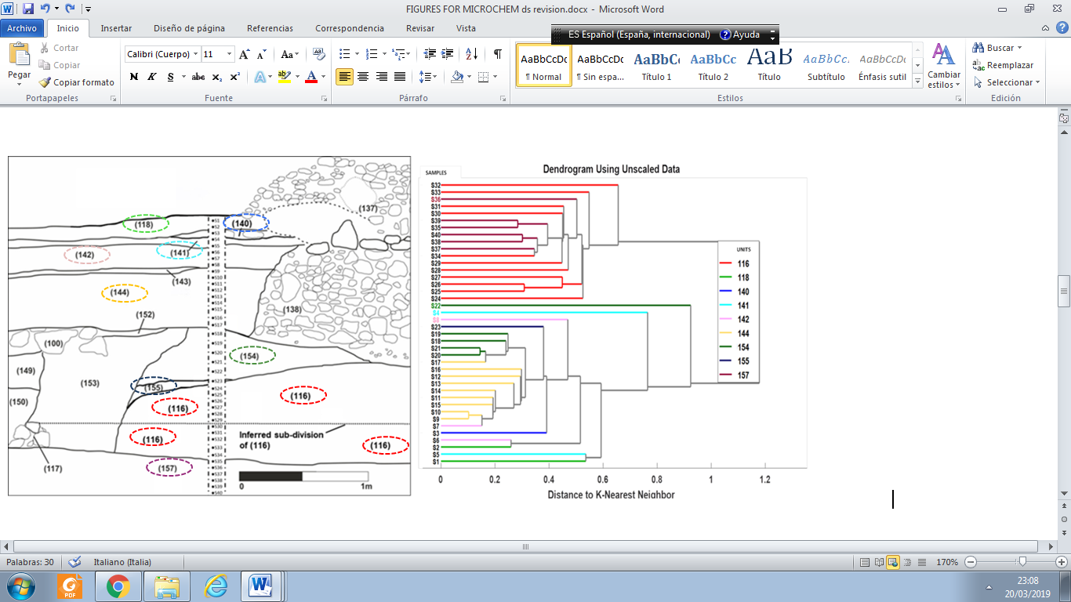

**Figure 8. Section 102, showing sampled column (S1-S40) and stratigraphic units and their relationship to the REE, Y, Sc, Ca, N, C and pH dendrogram. Note good correlations between cluster analysis and field observations for units 144, 154, 116 and 157.**

**6. Conclusions**

The work presented here confirms the capacity of REE signatures (abundances and calculated proxies for fractionation) to detect anthropogenically induced modifications of sediments, even within complex stratigraphies (Figure 8).

In the current study information from multiple sources (geochemistry, stratigraphy, soil micromorphology, pyrolysis) have been used to interpret the REE results and to define the mechanisms driving them. With further research and supported by other case studies it could be possible to use REE as a complementary technique in developing archaeological stratigraphic studies.

Identifying the mechanisms that influenced REE values and fractionations, in this case OM accumulation, pyrogenic SOM, redox, secondary CaCO3 precipitation, prompted the addition of proxies for these processes to the REE Sc and Y cluster analysis. Doing so produced a clustering of samples that more accurately reflects the stratigraphic field observations (Figure 8). It is expected that this approach, combining the analysis of REE concentrations with an understanding of the mechanisms driving them in a given site or profile, will be replicable for other stratigraphic sequences.

Finally, the cluster analysis based purely on REE, Sc and Y (Figure 6) identified a stratigraphic sub-division that had been just surmised in the field. This suggests that REE values and ratios could supply additional details not provided by other archaeological techniques.

**Acknowledgements**The authors acknowledge the financial support of the European Commission: Projects H2020-MSCA-IF-2015-704709-MATRIX; H2020-MSCA-IF-2014-657355-tRRACES; ERC-StG-2012-337128-AAREA.

**References**

[1] Nance, W.B., Taylor, S.R., 1977. Rare Earth Element Pattern and Crustal Evolution II. Archean Sedimentary Rocks from Kalgoorlie, Australia. Geochimica et Cosmochimica Acta, 41, 225-231.

[2] Piper, D.Z., 1974. Rare earth elements in the sedimentary cycle, a summary. Chemical Geology 14, 285 – 304.

[3] Taylor, S.R., Hallberg, J.A., 1977. Rare-earth elements in the Marda calc-alkaline suite: an Archaean geochemical analogue of Andean-type volcanism. Geochimica et Cosmochimica Acta 41, 1125-1129.

[4] Wildeman, T.E, Condie, K.C 1973. Rare earths in Archean graywackes from Wyoming and from the Fig Tree Group, South Africa. Geochimica et Cosmochimica Acta 37, 439-453.

[5] Nesbitt, H. W., 1979. Mobility and fractionation of rare earth elments during weathering of a granodiorite. Nature 279, 206-210.

[6] McLennan, S.M., 1992. Rare earth elements in sedimentary rocks: Influence of provenance and sedimentary processes. Geochemistry and Mineralogy of Rare Earth Elements, B. R. Lipin, & G. A. McKay (Eds.), vol. 21, Mineralogical Society of Amer, Washington DC, USA.

[7] Laveuf C., Cornu, S., 2009. A review on the potentiality of Rare Earth Elments to trace pedogenetic processes. Geoderma 154, 1-12.

[8] Gallello, G., Pastor, A., Diez, A., La Roca, N., Bernabeu, J., 2013. Anthropogenic units fingerprinted by REE in archaeological stratigraphy: Mas d’Is (Spain) case. Journal of Archaeological Science 40, 799-809.

[9] Gallello, G., Pastor, A., Diez, A., Bernabeu, J., 2014. Lanthanides revealing anthropogenic impact within a stratigraphic sequence. Journal of Archaeology <http://dx.doi.org/10.1155/2014/767085>.

[10] Gasche, H., Tunca, N., 1983. Guide to Archaeostratigraphic Classification and Terminology: Definitions and Principles. Journal of Field Archaeology 10, 325-335.

[11] Ferro-Vázquez, C., Lang, C., Kaal, J., Stump, D., 2017. When is a terrace not a terrace? The importance of understanding landscape evolution in studies of terraced agriculture. Journal of Environmental Management 202, 500-513.

[12] Kimura, B., 2006. Spatial distribution of historical Konso settlements. In: Proceedings of the XVth International Conference of Ethiopian Studies. Otto Harrassowitz Verlag ed. Hamburg. July 20-25, 2003.

[13] Amborn, H., 1989. Agricultural intensification in the Burji-Konso cluster of southwestern Ethiopia. Azania 24, 71-83.

[14] Hallpike, C.R., 2008. The Konso of Ethiopia: a Study of the Values of an East Cushitic People. AuthorHouse UK, Central Milton Keynes rev. ed. (Revised edition of 1st edition, 1972).

[15] Beshah, T., 2003. Understanding farmers: explaining soil and water conservation in Konso, Wolaita and Wello, Ethiopia. In: Tropical Resource Management Papers 41, ISBN 90-6754-691-7, 245.

[16] FAO, 1990. The Conservation and Rehabilitation of African Lands: an International Scheme. ARC/90/4, Food and Agriculture Organization of the United Nations, Rome.

[17] Förch, W., 2003. Case Study: The Agricultural System of the Konso in South Western Ethiopia. FWU Water Resources Publications 1, 1-15.

[18] Harrison, L., 1901. A journey from zeila to lake rudolf. Geographycal Journal 18, 258-275.

[19] Watson, E.E., 2009. Living Terraces in Ethiopia: Konso Landscape, Culture and Development. James Currey.

[20] Lang, C., Daryl, S., 2017. Geoarchaeological evidence for the construction, irrigation, cultivation, and resilience of 15th–18th century AD terraced landscape at Engaruka, Tanzania. Quaternary Research. doi:10.1017/qua.2017.54.

[21] Stump, D., 2006. The development and expansion of the field and irrigation systems at Engaruka. Tanzania. Azania Archaeological Research in Africa 41, 69-94.

[22] Beckers, B., Schütt, B., Tsukamoto, S., Frechen, M., 2013. Age determination of Petra's engineered landscape – optically stimulated luminescence (OSL) and radiocarbon ages of runoff terrace systems in the Eastern Highlands of Jordan. Journal of Archaeological Science 40, 333-348.

[23] Hill, J., Woodland, W., 2003. Contrasting water management techniques in Tunisia: towards sustainable agricultural use. The Geographical Journal 169, 342-357.

[24] Gallello, G., 2014. Western Mediterranean Archaeology: chemical element levels in archaeological materials as a methodological tool. Dissertation. Universitat de València. ProQuest editor, ISBN: 978-1-303-99720-4. 245.

[25] Guangping, X., Hannah, J.L., Bingen, B., Georgiev, S., Stein, H.J., 2012. Digestion methods for trace element measurements in shales: Paleoredox proxies examined. Chemical Geology 324-325, 132-147.

[26] Snäll, S. and Liljefors, T., 2000. Leachability of major elements from minerals in strong acids. Journal of Geochemical Exploration 71, 1-12.

[27] Samson, I.M., and Wood, S.A., 2005. The rare earth elements: behaviour in hydrothermal fluids and concentration in hydrothermal mineral deposits, exclusive of alkaline settings, in Linnen, R.L., and Samson, I.M., eds., Rare element geochemistry and mineral deposits. Geological Association of Canada, Short Course Notes, 269-297.

[28] Taylor, S.R., McLennan, S.M., 1985. The continental crust: Its composition and evolution. Blackwell Scientific Pub. (Eds.), Palo Alto, CA (USA).

[29] Manoj, M.C., Thakur, B., Prasad, V., 2016. Rare earth element distribution in tropical coastal wetland sediments: a case study from Vembanad estuary, southwest India. Arabian Journal of Geosciences 9, 197.

[30] German, C. R., Elderfield, H., 1990. Application of the Ce anomaly as a paleoredox indicator: the ground rules. Paleoceanography 5, 823-833.

[31] Morad, S., Felitsyn, S., 2001. Identification of primary Ce-anomaly signatures in fossil biogenic apatite: implication for the Cambrian oceanic anoxia and phosphogenesis. Sedimentary Geology 143, 259-264.

[32] Trueman, C. N., Behrensmeyer A. K., Potts R., Tuross, N., 2006. High-resolution records of location and stratigraphic provenance from the rare earth element composition of fossil bones. Geochimica et Cosmochima Acta 70, 4343-4355.

[33] Trueman, C.N., Tuross, N., 2002. Trace elements in recent and fossil bone apatite. In: Kohn, M.J., Rakovan, J., Hughes, J.M. (Eds.), Phosphates: Geochemical, Geobiological and Materials Importance. Mineralogical Society of America. Reviews in Mineralogy and Geochemistry 48, 489-521.

[34] Williams, C.T., Henderson, P., Marlow, C.A., Molleson, T.I., 1997. The environment of deposition indicated by the distribution of rare earth elements in fossil bones from Olduvai Gorge, Tanzania. Applied Geochemistry 12, 537-547.

[35] Prajith, A, Purnachandra Rao, V., Kessarkar, P.M., 2015. Controls on the distribution and fractionation of yttrium and rare earth elements in core sediments from the Mandovi estuary, western India. Continental Shelf Research 92, 59-71.

[36] Pastor, A., Gallello, G., Cervera, M.L., de la Guardia, M., 2016. Mineral Soil Composition Interfacing Archaeology and Chemistry. Trends in Analytical Chemistry 78, 48-59.

[37] Pourret, O., Tuduri, J., 2017. Continental shelves as potential resource of rare earth elements. Science Reports 7. doi:10.1038/s41598-017-06380-z.

[38] Zaharescu, D.G., Burghelea, C. I., Dontsova, K., Presler, J.K., Maier, R.M., Huxman, T., Domanik, K.J., Hunt, E.A., Amistadi, M.K., Gaddis, E.E, Palacios-Menendez, M.A., Vaquera-Ibarra M.A.,Chorover, J., 2017. Ecosystem Composition Controls the Fate of Rare Earth Elements during Incipient Soil Genesis. Scientific Reports 7 DOI: 10.1038/srep43208.

[39] Moni, C., Derrien, D. , Hatton, P.J. , Zeller, B. , Kleber, M., 2012. Density fractions versus size separates: does physical fractionation isolate functional soil compartments? Biogeosciences 9, 5181–5197.

[40] Aide, M.T., Aide, C., 2012. Rare Earth Elements: Their Importance in Understanding Soil Genesis. International Scholarly Research Network. doi:10.5402/2012/783876.

[41] Hu, Z., Haneklaus, S., Sparovek, G., Schnug, E., 2006. Rare earth elements in soils. Communications in soil science and plant analysis 37, 1381-1420.

[42] Mourier, B. , Poulenard, J., Carcaillet, C., Williamson, D., 2010. Soil evolution and subalpine ecosystem changes in the French Alps inferred from geochemical analysis of lacustrine sediments. Journal of Paleolimnology 44, 571-587.

[43] Tyler, G., Olsson, T, 2002. Conditions related to solubility of rare and minor elements in forest soils. Journal of Plant Nutrition and Soil Science 165, 594–601.

[44] Aubert, D., Stille, P., Probst, A., 2001. REE fractionation during granite weathering and removal by waters and suspended loads: Sr and Nd isotopic evidence. Geochimica et Cosmochimica Acta 65(3), 387-406.

[45] Aubert, D., Probst, A., Stille, P., 2004. Distribution and origin of major and trace elements (particularly REE, U and Th) into labile and residual phases in an acid soil profile (Vosges Mountains, France). Applied Geochemistry 19(6), 899-916.

[46]Marsac, R., Davranche, M., Gruau, G., Dia, A., 2010. Metal loading effect on rare earth element binding to humic acid: experimental and modelling evidence. Geochimica et Cosmochimica Acta 74(6), 1749-1761.

[47] Marsac, R., Davranche, M., Gruau, G., Bouhnik-Le Coz, M., Dia, A., 2011. An improved description of the interactions between rare earth elements and humic acids by modeling: PHREEQC-Model VI coupling. Geochimica et Cosmochimica Acta 75(19), 5625-5637.

[48] Marsac, R., Davranche, M., Gruau, G., Dia, A., & Bouhnik-Le Coz, M., 2012. Aluminium competitive effect on rare earth elements binding to humic acid. Geochimica et Cosmochimica Acta 89, 1-9.

[49] Madari, B. E., Lima, L. B., Silva, M. A. S., Novotny, E. H., Alcântara, F. A., Carvalho, M. T. M., Petter, F. A., 2013. Carbon Distribution in Humic Substance Fractions Extracted from Soils Treated with Charcoal (Biochar). Xu, Jianming, Wu, Jianjun, He, Yan (Eds.). In: Focuses on the functions of natural organic matter in a changing environment. Springer, Dordrecht.

[50] Knicker, H., 2011. Pyrogenic organic matter in soil: its origin and occurrence, its chemistry and survival in soil environments. Quaternary International 243(2), 251-263.

[51] Pourret, O., Houben, D., 2018. Characterization of metal binding sites onto biochar using rare earth elements as a fingerprint. Heliyon 4(2), e00543.

[52] Leybourne, M.I., Johannesson, K.H., 2008. Rare earth elements (REE) and yttrium in stream waters, stream sediments, and Fe–Mn oxyhydroxides: Fractionation, speciation, and controls over REE + Y patterns in the surface environment. Geochimica et Cosmochimica Acta 72, 5962-5983.

[53] Leybourne, M.I., Peter, J.M., Layton-Matthews, D., Volesky, J., Boyle, D.R., 2006. Mobility and fractionation of rare earth elements during supergene weathering and gossan formation and chemical modification of massive sulfide gossan. Geochimica et Cosmochimica Acta 70, 1097-1112 .

[54] Vermeire, M.L., Cornu, S., Fekiacova, Z., Detienne, M., Delvaux, B., Cornélis J.T., 2016. Rare earth elements dynamics along pedogenesis in a chronosequence of podzolic soils. Chemical Geology 446, 163-174.

[55] Davranche, M., Pourret, O., Gruau, G., Dia, A., Le Coz-Bouhni, M., 2005. Adsorption of REE(III)-humate complexes onto MnO2: Experimental evidence for cerium anomaly and lanthanide tetrad effect suppression. Geochimica et Cosmochimica Acta 69, 4825-4835.

[56] Aide, M., Smith-Aide, C., 2003. Assessing soil genesis by rare-earth elemental analysis. Soil Soil Science Society of America Journal. J 67, 1470-1476.

[57] Chang, C., Li, F., Liu, C., Gao, J., Tong, H., Chen, M., 2016. Fractionation characteristics of rare earth elements (REEs) linked with secondary Fe, Mn, and Al minerals in soils. Acta Geochimica 35(4), 329-339.

[58] Cidu, R., Antisari, L. V., Biddau, R., Buscaroli, A., Carbone, S., Da Pelo, S., Dinelli, E., Vianello, G., Zannoni, D., 2013. Dynamics of rare earth elements in water–soil systems: the case study of the Pineta San Vitale (Ravenna, Italy). Geoderma 193, 52-67.

[59] Coppin, F., Berger, G., Bauer, A., Castet, S., Loubet, M., 2002. Sorption of lanthanides on smectite and kaolinite. Chemical Geology 182(1), 57-68.

[60] Pourret, O., Davranche, M., Gruau, G., Dia, A., 2007. Competition between humic acid and carbonates for rare earth elements complexation. Journal of Colloid and Interface Science 305 (1), 25–31.

[61] Martin, C.E., McCulloch, M.T., 1999. Nd-Sr isotopic and trace element geochemistry of river sediments and soils in a fertilized catchment, New South Wales, Australia. Geochimica et Cosmochimica Acta 63 (2), 287–305.

[62] Panahi, A., Young, G.M., Rainbird, R.H., 2000. Behavior of major and trace elements (including REE) during Paleoproterozoic pedogenesis and diagenetic alteration of an Archaean granite near Ville Marie, Quebec, Canada. Geochimica et Cosmochimica Acta 64 (13), 2199–2220.

[63] Harvey, O. R., Herbert, B. E., Rhue, R. D., & Kuo, L. J. (2011). Metal interactions at the biochar-water interface: energetics and structure-sorption relationships elucidated by flow adsorption microcalorimetry. Environmental science & technology, 45(13), 5550-5556.

[64] Lu, H., Zhang, W., Yang, Y., Huang, X., Wang, S., & Qiu, R., 2012. Relative distribution of Pb2+ sorption mechanisms by sludge-derived biochar. Water research 46(3), 854-862.

[65] Kimoto, A., Nearing, M.A., Zhang, X.C., Powell, D.M., 2006. Applicability of rare earth element oxides as a sediment tracer for coarse-textured soils . Catena 65, 214-221.

**SUPPLEMENTARY MATERIALS**

**Table S1.** pH, C, N and Pyrogenic soil organic matter (SOM), values in the studied samples (Ferro-Vázquez et al., 2017). Unit of depth cms. Significant (p<0.01) correlation coefﬁcients (r2) were used to measure the degree of linear association between variables (depth vs C and N).

**Table S2.** Accuracy of pXRF analysis evaluated from the use of CRM soil NIM-GBW07408. Obtained values and certified values of the analysed elements. Values expressed as percentage (%). Values expressed as µg/g (*). Below the detection limits (<LOD). Note: P levels measured in the standard soil are below the limit of detection (<0.001). .

**Table S3.** Accuracy of ICP-MS analysis evaluated from the use of CRM soil NIM-GBW07408. Obtained values and certified values of the analysed elements. Values expressed as µg/g.

**Table S4.** Mass, instrumental detection limit and coefficient of determination of the element analyzed by ICP-MS. Note: LOD = Limit of detection. The star (*) marks the internal standard.

**Table S5.** Major elements composition of the studied samples in 102 section by pXRF. Note: Concentration of elements expressed as percentage (%).Unit of depth cms. Significant (p<0.01) correlation coefﬁcients (r2) were used to measure the degree of linear association between variables (depth vs Major Elements).

**Table S6.** REE and trace elements composition of the studied samples in 102 section by ICP-MS. Note: Concentration of elements in µg/g. Total sum of Rare Earth Elements (REE). Unit of depth cms. Significant (p<0.01) correlation coefﬁcients (r2) were used to measure the degree of linear association between variables (depth vs REE and trace elements).

**Table S7.** REE sample values normalized to the Post-Archean Australian Shale (PAAS). Ce and Eu anomalies, PAAS normalised ratio values and (La/Yb)PAAS, (La/Gd)PAAS, (La/Sm)PAAS, (Sm/Yb)PAAS ratio values (La, Sm, Gd Yb normalized with Post-Archean Australian Shale values “PAAS”) are also shown. Unit of depth cms. Significant (p<0.01) correlation coefﬁcients (r2) were used to measure the degree of linear association between variables (depth vs REE/REEPAAS and Eu, Ce anomalies).

**Table S8.** REE and trace elements, C, N and major elements composition of the studied samples in 102 section by ICP-MS. Note: Concentration of REE and trace elements in µg/g. C, N and mayor elements in percentage (%). Total sum of Rare Earth Elements (REE). Unit of depth cms. Significant (p<0.01) correlation coefﬁcients (r2) were used to measure the degree of linear association between variables (Total REE vs LREE, MREE, HREE and elements).

**Figure S1.** CA of the studied soil samples using Ca, N, C and pH as variables.