Hyperpolarizing Pyruvate *via* Signal Amplification By Reversible Exchange (SABRE)

Wissam Iali,† Soumya S. Roy,†,§ Ben. J. Tickner, Fadi Ahwal,& Aneurin J. Kennerley and Simon B. Duckett*

[*] Dr. W. Iali, Dr. S. S. Roy, B. J. Tickner, Dr. F. Ahwal, Dr. A. J. Kennerley and Prof. Dr. S. B. Duckett

Centre for Hyperpolarisation in Magnetic Resonance (CHyM), Department

of Chemistry, University of York, Heslington, York, YO10 5NY, UK

E-mail: simon.duckett@york.ac.uk

[†] These authors contributed equally to this work and are co-first authors.

[&] Designed the equipment

[§] Dr. S. S. Roy, Present address: Department of Inorganic and Physical Chemistry, Indian Institute of Science, Bangalore 560012, India

Supporting information for this article is given *via* a link at the end of the

document.

***Abstract:*** *Hyperpolarization methods that premagnetise agents such as pyruvate are currently receiving significant attention. This is because they produce sensitivity gains that allow disease tracking and interrogation of cellular metabolism by magnetic resonance. Here, we communicate how Signal Amplification by Reversible Exchange (SABRE) can provide strong 13C pyruvate signal enhancements in seconds through the formation of the novel polarization transfer catalyst [Ir(H)2(2-pyruvate)(DMSO)(IMes)]. By harnessing SABRE, strong signals for 1-13C and 2-13C pyruvate in addition to a long-lived singlet state in the 1,2-13C2 form are* *readily created, the latter can be observed five minutes after the initial hyperpolarization step. We also demonstrate how this development may help with future studies of chemical reactivity.*

Figure 1: Schematic depiction of the SABRE hyperpolarisation process in which *para-*hydrogen is used to hyperpolarise pyruvate *via* the polarisation transfer catalyst [Ir(H)2(2-pyruvate)(DMSO)(IMes)].

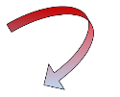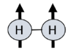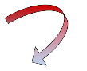

Pyruvate lies at the junction of many metabolic processes in living cells, being produced from glucose before it enters cellular energy production pathways.[1] Pyruvate converts to lactate under the anaerobic conditions associated with cancer offering a route to diagnose cellular abnormalities.[2] Clinical trials are progressing that harness this approach for the diagnosis of cancer by Magnetic Resonance Imaging (MRI).[3] These developments build from decades of research into hyperpolarization techniques such as Dynamic Nuclear Polarisation (DNP),[4] the method that has allowed the hyperpolarisation and subsequent *in vivo* detection of such biomolecules by MRI.[3b, 3c, 5]

Hyperpolarisation can also be created *via* *para*-hydrogen (*p*-H2) Induced Polarization (PHIP). This approach utilizes the reactivity and nuclear spin orientations of *p*-H2 to create highly visible hydrogenation products.[6] Molecules hyperpolarized using PHIP have been widely used in Nuclear Magnetic Resonance (NMR) spectroscopy and there are examples that feature *in vivo* imaging.[5, 6c, 7] While pyruvate has no readily accessible unsaturated precursor suitable for hydrogenation using PHIP, Aime and coworkers have developed an elegant route to form aqueous solutions of hyperpolarized pyruvate by incorporation of a rapidly hydrogenated and subsequently hydrolyzed side-arm.[8]

Here though, we hyperpolarize pyruvate based on the non-hydrogenative PHIP derived Signal Amplification by Reversible Exchange (SABRE) process which is shown in Figure 1.[9] The chemical identity of pyruvate is unaffected by this hyperpolarisation process, which has already achieved substantial levels of polarization (63 % in 1H,[10] 25% in 13C,[11] and 43% in 15N[12]) in a range of materials that predominantly bind to a metal polarization transfer catalyst through nitrogen centers.[13]

SABRE harnesses *p*-H2 which is one of a growing range of molecules that exists as a nuclear spin singlet. When this molecule binds to a transition metal center to form a dihydride complex it is possible to transfer polarization from *p*-H2 into a ligand if there are different hydrides coupling to the nucleus that receive it. The potentially long lifetime of such states makes them ideal fuels for polarization transfer[14] or indeed later detection.[13a, 13e, 15] *p*-H2 can be formed in > 95% purity by simply cooling H2 gas to < 40 K in the presence of a suitable conversion catalyst.[16]

In a remarkable development, Levitt and co-workers created a molecular spin singlet state by radio frequency excitation in 2004[17] and more recently demonstrated the existence of a coupled spin-1/2-nuclear 13C pair with a singlet state lifetime that exceeds one hour.[18] Levitt created a 1,2-13C2 singlet state in pyruvate using DNP [15b, 19] that had a reported lifetime of 70 s. Here, we use SABRE to create pyruvate hyperpolarization, including the singlet form of the 1,2-13C2 isotopologue in a process that proceeds spontaneously without the need for complex instrumentation or pulse sequences.

In order to achieve this goal we first overcome the challenge of weak iridium pyruvate binding that prevents typical hyperpolarisation of pyruvate using SABRE. The presence of an appropriate dimethyl sulfoxide (DMSO) coligand allows for the assembly of a highly reactive polarization transfer catalyst that overcomes poor pyruvate ligation. This is achieved by the reaction of [Ir(Cl)(COD)(IMes)] (IMes = 1,3-bis(2,4,6-trimethylphenyl)imidazol-2-ylidene and COD = *cis*,*cis*-1,5-cyclooctadiene), the well-known SABRE catalyst precursor,[20] with DMSO, H2, and sodium pyruvate to form [Ir(H)2(2-pyruvate) (DMSO)(IMes)]. The resulting high field NMR spectra and characterization data that confirm this product formation are detailed in the Supporting Information and its structure is represented in Figure 1. The pyruvate-1-[13C] (**1**), pyruvate-2-[13C] (**2**) and pyruvate-1,2-[13C2] (**3**) isotopologues of sodium pyruvate (**4**) are used in this work.

Because of the low symmetry of pyruvate, [Ir(H)2(2-pyruvate)(DMSO)(IMes)] yields two inequivalent hydride ligands such that at low magnetic fields an [AA’B] spin system is formed. Modelling the propagation of hyperpolarization from the *p*-H2 derived hydride ligands of this product into the bound pyruvate 13C nuclei predicts optimum polarization transfer at a magnetic field strength of ±(-*J*HH + *J*HC*)/* *[13a, 21] (Supporting Information). Here, *J*HH corresponds to the *J*-coupling between the hydride ligands, *J*HC* is (*J*HC + *J*H’C)/2, the combined hydride-carbon cross-coupling in the complex and  is the difference in magnetogyric ratios (H- C) of proton and carbon nuclei. The predicted field strengths are ~100 times lower than the Earth’s natural magnetic field and were achieved experimentally by housing the sample in a mu-metal shield in conjunction with a field top-up solenoid as detailed in the Supporting Information.[22] This approach reflects a variant of SABRE that has been called SABRE-SHEATH.[22-23]

|  |  |  |  |
| --- | --- | --- | --- |
| Substrate | Net 13C polarization (%) | Thermally-polarized lifetimes (*T*1) /s. | Hyperpolarized lifetimes (*T*1 and *T*LLS) /s. |
| **1** | C1: 0.96 | C1: 35.4 ± 0.5 | C1 *T*1: 32.5 ± 4.7 |
| **2** | C2: 0.60 | C2: 20.1 ± 0.5 | C2 *T*1: 18.2 ± 3.0 |
| **3** | C1: 1.85  C2: 1.65 | C1: 33.6 ± 0.5  C2: 21.2 ± 0.4 | *T*LLS (HF): 43.5 ± 0.8  *T*LLS (LF): 85.4 ± 8.5 |
| **4** | C1: 0.55  C2: 0.35  C3: 0.22 | C1: 31.4 ± 1.2  C2: 8.6 ± 1.5  C3: 3.3 ± 0.7 | C1 *T*1: 28.5 ± 5.5  C2 *T*1: 15.7 ± 1.9  C3 *T*1: 3.0 ± 2.5 |

Table 1: Hyperpolarization levels and lifetimes for isotopologues **1**-**4**.

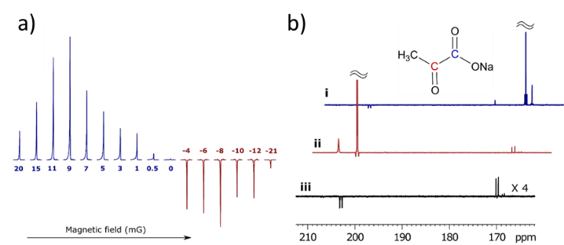

Figure 2: SABRE hyperpolarized NMR spectra of pyruvate. A) Plot showing how the intensity of the 13C NMR response of **1** varies with the magnetic field the sample experiences during polarization transfer, maximum polarization transfer efficiency (signal intensity) is achieved with a ∼9 mG field. (B) SABRE hyperpolarized 13C NMR spectra of (i) **1** and (ii) **2** after transfer in a 5 mG mixing field that show strongly enhanced signals from the labelled carbons. These spectra also reveal a singlet response originating from the 1.1% of **3** present; (iii) corresponding spectrum of **1** after hyperpolarization transfer in the Earth’s field (~500 mG) which selects signals from **3.**

A sample of **1**, [IrCl(COD)(IMes)] precatalyst, and DMSO with 3-bar *p*-H2 was therefore prepared. This was shaken in the mu metal shielded solenoid for 20 seconds at 9 mG. Upon transfer into a 9.4 T magnet strongly hyperpolarized 13C resonances corresponding to free pyruvate are observed. Subsequently, polarization transfer between +20 to -21 mG confirmed that ±9 mG reflects the maximum signal intensity as portrayed by both Figure 2a and the model. An overall 13C polarization level of *ca.* 1% results for a sample containing [Ir(Cl)(COD)(IMes)] (5 mM), DMSO and the corresponding pyruvate isotopologue in a 1:8:5 ratio after shaking with 3-bar of *p*-H2 for 20 seconds. When a similar sample containing **2** was examined, the corresponding maximum polarization level proved to be 0.6% when transfer took place at ±3 mG. This reduction in efficiency is due to a smaller *J*1H-13C transfer coupling and shorter spin-state lifetime (see Table 1) which results in more efficient signal decay during the slow polarization transfer step.[24] Close examination of the hyperpolarized 13C NMR spectra of **1** and **2** reveal peaks for catalyst bound pyruvate in [Ir(H)2(2-pyruvate)(DMSO)(IMes)] and pyruvate-1,2-[13C2] (**3**) as illustrated in Figure 2b. The detection of **3**, present at 1.1% natural abundance, confirms the impressive nature of the signal amplification that is achieved. The 13C relaxation times and polarization levels of these species are detailed in Table 1.[15b, 19] Values of 32.5 ± 4.7 s and 18.2 ± 3.0 s were obtained respectively for the in high-field relaxation times of the 13C signals of **1** and **2** which are close to the normal values of 35.4 ± 0.5 s and 20.1 ± 0.5 s respectively. Hence, the presence of the SABRE catalyst in these solutions does not significantly change their value. This reflects the fact that magnetization build up by this catalyst is slow due to slow ligand exchange and small propagating *J*HC values which differs from the typical response achieved when nitrogen containing heterocycles are examined.[10, 25]

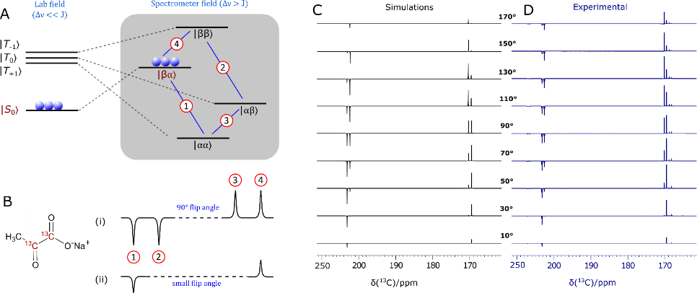

**Figure 3:** Demonstrating singlet character. A) Energy level diagram for the evolution of the two spin-1/2 1,2-13C2 coupled spin system of **3** after hyperpolarization and sample movement from low (left) to high field (right). B) Simulated NMR spectra resulting from (i) 90˚ and (ii) low flip angle excitations. C) Simulated and D) experimentally observed 13C NMR signal patterns for **3** after transfer in the Earth’s field (*ca.* 500 mG) as a function of flip angle pulse duration (10˚ to 170˚ in steps of 20˚) to confirm singlet state formation.

In contrast to the situation with **1** and **2**, isotopomer **3** is predicted to give a singlet based response after polarization transfer between 0 G and 1 kG (Figures 3a and 3b).[13a] This reflects the fact the metal dihydride complex that results is now of the [AA'BB'] type at low field.[22] This prediction was confirmed experimentally by monitoring the effect of excitation angle on the resulting signal profile as shown in Figures 3c and 3d. A close fit between the experimental and predicted data is observed. Furthermore, the singlet state forms with an amplitude 1740 times larger than the normal Zeeman polarization observed in this sample when detected at 11.75 T which reflects a purity of 1.75% relative to it; the sample contained [Ir(Cl)(COD)(IMes)] (5 mM), DMSO and **3** in a ratio 1:8:5. The lifetime of this magnetization was assessed after sample storage at both low and high field as a function of catalyst loading (see typical plots in Figure 4). These high-field observations (Figure 4a) indicate that cross-relaxation induced polarization transfer occurs within the spin-system during this period that makes the originally weaker resonance components increase in intensity (Figure 4b). The corresponding magnetic state lifetime is 85.4 ± 8.5 s with low-field storage (0.5 G) but at 11.7 T it reduces to 43.5 ± 0.8 s as a consequence of the change in characteristics of the underlying spin states. Consequently, harnessing states that start out as a singlet, rather than the quicker relaxing Zeeman terms, may improve the duration of signal visibility. This may provide interesting applications for SABRE hyperpolarized pyruvate. While the polarization levels that we demonstrate here are not as high as those that have been reported using PHIP-SAH[8] and DNP[1, 3b, 3c, 19, 26] this route can create singlet hyperpolarisation in a refreshable, lower cost alternative technique that may provide significant advantages in the future.

We demonstrate in Figure 5 that *in vitro* MRI detection of a 0.4 mM sample of **3** in a 70:30 D2O/ethanol-*d*6 mixture is possible. We also show a future potential use in hyperpolarized reaction monitoring in Figure 6. Here, hydrogen peroxide is added to a solution of SABRE hyperpolarized **3** in 70:30 D2O/ethanol-*d*6 and signals for hyperpolarized ethanoic acid and carbon dioxide are seen which encode concentration changes that take place over 25 s when a 10o flip angle is applied.

In conclusion, we have presented an approach to hyperpolarize pyruvate directly by SABRE in just a few seconds. This simple process harnesses a solenoid housed within a mu-metal shield to optimize the polarization transfer pathway within a novel [Ir(H)2(2-pyruvate)(IMes)(DMSO)] catalyst. The hyperpolarized 13C signals appear with intensities that are three orders of magnitude above their thermal values. Furthermore, when 1,2-13C2-pyruvate is employed the ready formation of a long-lived singlet state with low field lifetime 85.4 ± 8.5 s is achieved. We demonstrate that these polarization levels allow *in vitro* images to be collected of a 70:30 D2O/ethanol-d6 mixture and a simple organic transformation to be viewed. We expect that the signal gain can be improved by optimization of the ligand exchange processes within the polarization transfer catalyst and by using higher pressures of *p*-H2 with continuous bubbling.[22, 27] Furthermore, it is clear that the ligand sphere of the metal catalyst controls substrate binding. We therefore expect further refinements of this 'co-ligand' approach to extend SABRE to a much wider range of substrates which bind through oxygen or nitrogen. Hence this work reflects an important step in the future development of SABRE.

**Figure 6.** Hyperpolarised reaction monitoring. Resonances corresponding to ethanoic acid and CO2 appear after the addition of H2O2 to solutions of SABRE hyperpolarised pyruvate. This reaction can be monitored by recording a series of hyperpolarised 13C spectra with 10o flip angles.

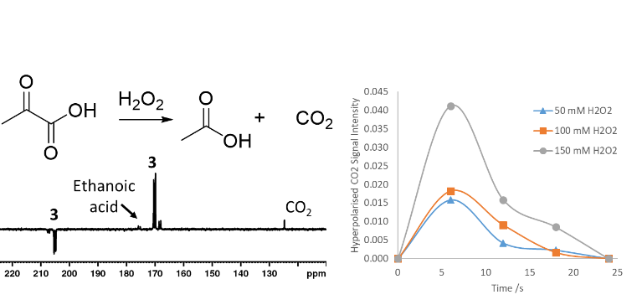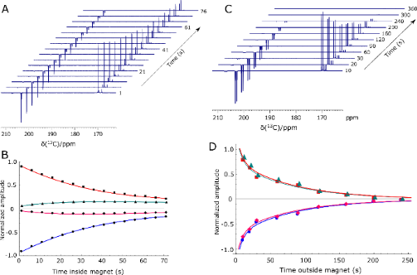

**Figure 4.** Determination of singlet lifetime. (A) Series of hyperpolarized 13C NMR spectra of **3** acquired 1 s to 76 s after sample insertion into the spectrometer with a 9˚ flip angle pulse, and (B) the corresponding signal intensity plot whose fitting (solid lines) yields a high-field (HF) lifetime, *TLLS*, of 43.5 ± 0.8 s. Similar data is shown in (C) and (D) after sample storage at 0.5 G (LF) time. These points yield a *T*LLS (LF) value of 85.4 ± 8.5 s.

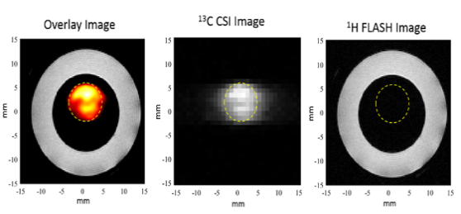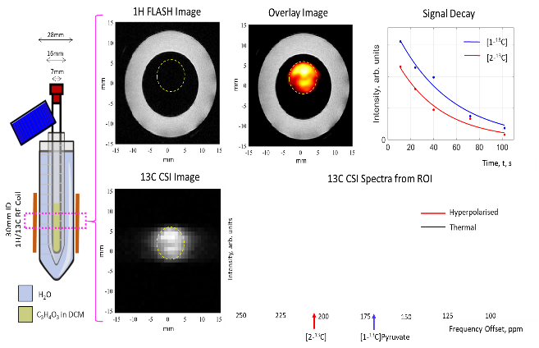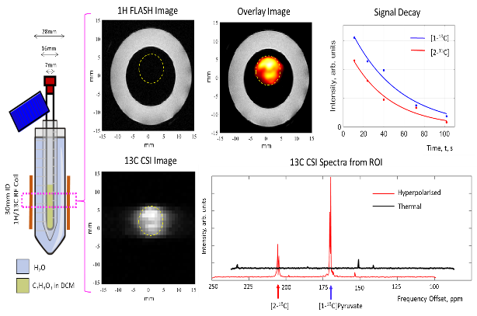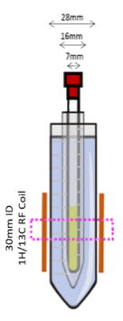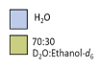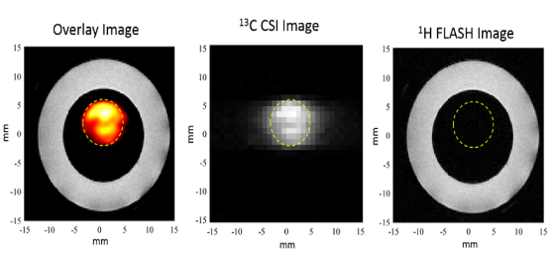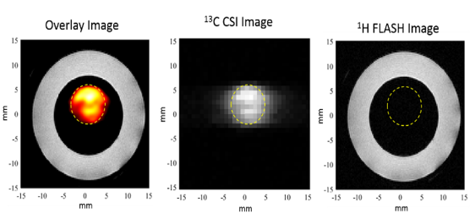

**Figure 5** Hyperpolarized image detection. Hyperpolarized 13C FLASH image (orange) overlaid onto a 1H FLASH image of water (white outer ring) originating from the sample (left). The 13C CSI image reflects a 32 x 32 mm region of this hyperpolarized solution at 1 mm resolution. The data was collected at 9.4 T using single-shot FLASH and EPI measurements and confirms that MRI detection is possible with these enhancement levels.

Acknowledgements

We are grateful to R. John, E. Fear, M.-C. Labarthe-Last and M. Kaestner for experimental help. Financial support from the Wellcome Trust (Grants 092506 and 098335), the MRC (MR/M008991/1) and the EPSRC (B.J.T. studentship and Impact Accelerator Award G0025101) is gratefully acknowledged. Competing interests: W.I., S.S.R., B.J.T., and S.B.D. are inventors on a University of York patent application on this work (patent no. GB1818171.9, filed 7 November 2018). All data needed to evaluate the conclusions in this paper are presented here or in the Supporting Information. Additional data are available from the authors upon reasonable request.

**Keywords:** Hyperpolarisation • Pyruvate • SABRE • Singlet state • catalysis

References

[1] L. R. Gray, S. C. Tompkins, E. B. Taylor, *Cell. Mol. Life Sci.* **2014**, *71*, 2577-2604.

[2] F. Hirschhaeuser, U. G. A. Sattler, W. Mueller-Klieser, *Cancer Res.* **2011**, *71*, 6921-6925.

[3] a) D. Saslow, C. Boetes, W. Burke, S. Harms, M. O. Leach, C. D. Lehman, E. Morris, E. Pisano, M. Schnall, S. Sener, *Cancer J. Clin.* **2007**, *57*, 75-89; b) S. J. Nelson, J. Kurhanewicz, D. B. Vigneron, P. E. Z. Larson, A. L. Harzstark, M. Ferrone, M. van Criekinge, J. W. Chang, R. Bok, I. Park, G. Reed, L. Carvajal, E. J. Small, P. Munster, V. K. Weinberg, J. H. Ardenkjaer-Larsen, A. P. Chen, R. E. Hurd, L.-I. Odegardstuen, F. J. Robb, J. Tropp, J. A. Murray, *Sci. Transl. Med.* **2013**, *5*, 198ra108; c) J. T. Grist, M. A. McLean, F. Riemer, R. F. Schulte, S. S. Deen, F. Zaccagna, R. Woitek, C. J. Daniels, J. D. Kaggie, T. Matys, *NeuroImage* **2019**, *189*, 171-179.

[4] J. H. Ardenkjaer-Larsen, B. Fridlund, A. Gram, G. Hansson, L. Hansson, M. H. Lerche, R. Servin, M. Thaning, K. Golman, *Proc. Natl. Acad. Sci. USA* **2003**, *100*, 10158-10163.

[5] K. Golman, R. in't Zandt, M. Lerche, R. Pehrson, J. H. Ardenkjaer-Larsen, *Cancer Res.* **2006**, *66*, 10855-10860.

[6] a) C. R. Bowers, D. P. Weitekamp, *J. Am. Chem. Soc.* **1987**, *109*, 5541-5542; b) T. C. Eisenschmid, R. U. Kirss, P. P. Deutsch, S. I. Hommeltoft, R. Eisenberg, J. Bargon, R. G. Lawler, A. L. Balch, *J. Am. Chem. Soc.* **1987**, *109*, 8089-8091; c) E. Y. Chekmenev, J. Hovener, V. A. Norton, K. Harris, L. S. Batchelder, P. Bhattacharya, B. D. Ross, D. P. Weitekamp, *J. Am. Chem. Soc.* **2008**, *130*, 4212-4213.

[7] P. Bhattacharya, E. Y. Chekmenev, W. H. Perman, K. C. Harris, A. P. Lin, V. A. Norton, C. T. Tan, B. D. Ross, D. P. Weitekamp, *J. Magn. Reson.* **2007**, *186*, 150-155.

[8] E. Cavallari, C. Carrera, M. Sorge, G. Bonne, A. Muchir, S. Aime, F. Reineri, *Sci. Rep.* **2018**, *8*, 8366.

[9] R. W. Adams, J. A. Aguilar, K. D. Atkinson, M. J. Cowley, P. I. P. Elliott, S. B. Duckett, G. G. R. Green, I. G. Khazal, J. Lopez-Serrano, D. C. Williamson, *Science* **2009**, *323*, 1708-1711.

[10] P. J. Rayner, M. J. Burns, A. M. Olaru, P. Norcott, M. Fekete, G. G. R. Green, L. A. R. Highton, R. E. Mewis, S. B. Duckett, *Proc. Natl. Acad. Sci.* **2017**, *114*, E3188-E3194.

[11] D. A. Barskiy, R. V. Shchepin, C. P. N. Tanner, J. F. P. Colell, B. M. Goodson, T. Theis, W. S. Warren, E. Y. Chekmenev, *ChemPhysChem* **2017**, *18*, 1493-1498.

[12] B. E. Kidd, J. L. Gesiorski, M. E. Gemeinhardt, R. V. Shchepin, K. V. Kovtunov, I. V. Koptyug, E. Y. Chekmenev, B. M. Goodson, *J Phys Chem C* **2018**, *122*, 16848-16852.

[13] a) T. Theis, G. X. Ortiz, A. W. Logan, K. E. Claytor, Y. Feng, W. P. Huhn, V. Blum, S. J. Malcolmson, E. Y. Chekmenev, Q. Wang, W. Warren, *Sci. Adv.* **2016**, *2*, e1501438; b) W. Iali, P. J. Rayner, S. B. Duckett, *Sci. Adv.* **2018**, *4*, eaao6250; c) D. A. Barskiy, R. V. Shchepin, A. M. Coffey, T. Theis, W. S. Warren, B. M. Goodson, E. Y. Chekmenev, *J. Am. Chem. Soc.* **2016**, *138*, 8080-8083; d) J. F. P. Colell, A. W. J. Logan, Z. J. Zhou, R. V. Shchepin, D. A. Barskiy, G. X. Ortiz, Q. Wang, S. J. Malcolmson, E. Y. Chekmenev, W. S. Warren, T. Theis, *J Phys Chem C* **2017**, *121*, 6626-6634; e) Z. Zhou, J. Yu, J. F. Colell, R. Laasner, A. W. Logan, D. A. Barskiy, R. V. Shchepin, E. Y. Chekmenev, V. Blum, W. S. Warren, *J Phys Chem Lett* **2017**, *8*, 3008-3014; f) N. Eshuis, R. L. E. G. Aspers, B. J. A. van Weerdenburg, M. C. Feiters, F. P. J. T. Rutjes, S. S. Wijmenga, M. Tessari, *Angew. Chem. Int. Ed.* **2015**, *54*, 14527-14530; g) S. Knecht, A. S. Kiryutin, A. V. Yurkovskaya, K. L. Ivanov, *J. Magn. Reson.* **2018**, *287*, 10-14; h) P. Spannring, I. Reile, M. Emondts, P. P. M. Schleker, N. K. J. Hermkens, N. G. J. van der Zwaluw, B. J. A. van Weerdenburg, P. Tinnemans, M. Tessari, B. Blumich, F. Rutjes, M. C. Feiters, *Chem.-Eur. J.* **2016**, *22*, 9277-9282; i) S. S. Roy, K. M. Appleby, E. J. Fear, S. B. Duckett, *J Phys Chem Lett* **2018**, *9*, 1112-1117.

[14] R. Eisenberg, *Accounts Chem. Res.* **1991**, *24*, 110-116.

[15] a) P. R. Vasos, A. Comment, R. Sarkar, P. Ahuja, S. Jannin, J. P. Ansermet, J. A. Konter, P. Hautle, B. van den Brandt, G. Bodenhausen, *Proc. Natl. Acad. Sci. USA* **2009**, *106*, 18469-18473; b) M. C. D. Tayler, I. Marco-Rius, M. I. Kettunen, K. M. Brindle, M. H. Levitt, G. Pileio, *J. Am. Chem. Soc.* **2012**, *134*, 7668-7671; c) S. S. Roy, P. J. Rayner, P. Norcott, G. G. R. Green, S. B. Duckett, *Phys. Chem. Chem. Phys.* **2016**, *18*, 24905-24911; d) S. S. Roy, P. Norcott, P. J. Rayner, G. G. R. Green, S. B. Duckett, *Chem.- Eur. J.* **2017**, *23*, 10496-10500; e) K. Shen, A. W. J. Logan, J. F. P. Colell, J. Bae, G. X. Ortiz Jr, T. Theis, W. S. Warren, S. J. Malcolmson, Q. Wang, *Angew. Chem.* **2017**, *129*, 12280-12284.

[16] a) S. Wagner, *Magn. Reson. Mat. Phys. Biol. Med.* **2014**, *27*, 195-199; b) D. Canet, C. Aroulanda, P. Mutzenhardt, S. Aime, R. Gobetto, F. Reineri, *Concepts Magn. Reson. Part A* **2006**, *28*, 321-330; c) P. M. Richardson, R. O. John, A. J. Parrott, P. J. Rayner, W. Iali, A. Nordon, M. E. Halse, S. B. Duckett, *Phys. Chem. Chem. Phys.* **2018**, *20*, 26362-26371.

[17] M. Carravetta, O. G. Johannessen, M. H. Levitt, *Phys. Rev. Lett.* **2004**, *92*, 153003.

[18] G. Stevanato, J. T. Hill-Cousins, P. Hakansson, S. S. Roy, L. J. Brown, R. C. D. Brown, G. Pileio, M. H. Levitt, *Angew. Chem. Int. Ed.* **2015**, *54*, 3740-3743.

[19] I. Marco-Rius, M. C. D. Tayler, M. I. Kettunen, T. J. Larkin, K. N. Timm, E. M. Serrao, T. B. Rodrigues, G. Pileio, J. H. Ardenkjaer-Larsen, M. H. Levitt, K. M. Brindle, *NMR Biomed.* **2013**, *26*, 1696-1704.

[20] M. J. Cowley, R. W. Adams, K. D. Atkinson, M. C. R. Cockett, S. B. Duckett, G. G. R. Green, J. A. B. Lohman, R. Kerssebaum, D. Kilgour, R. E. Mewis, *J. Am. Chem. Soc.* **2011**, *133*, 6134-6137.

[21] R. V. Shchepin, M. L. Truong, T. Theis, A. M. Coffey, F. Shi, K. W. Waddell, W. S. Warren, B. M. Goodson, E. Y. Chekmenev, *J Phys Chem Lett* **2015**, *6*, 1961-1967.

[22] M. L. Truong, T. Theis, A. M. Coffey, R. V. Shchepin, K. W. Waddell, F. Shi, B. M. Goodson, W. S. Warren, E. Y. Chekmenev, *J Phys Chem C* **2015**, *119*, 8786-8797.

[23] a) R. V. Shchepin, D. A. Barskiy, A. M. Coffey, T. Theis, F. Shi, W. S. Warren, B. M. Goodson, E. Y. Chekmenev, *ACS sensors* **2016**, *1*, 640-644; b) T. Theis, M. L. Truong, A. M. Coffey, R. V. Shchepin, K. W. Waddell, F. Shi, B. M. Goodson, W. S. Warren, E. Y. Chekmenev, *J. Am. Chem. Soc.* **2015**, *137*, 1404-1407.

[24] R. V. Shchepin, L. Jaigirdar, E. Y. Chekmenev, *J Phys Chem C* **2018**, *122*, 4984-4996.

[25] a) P. Norcott, M. J. Burns, P. J. Rayner, R. E. Mewis, S. B. Duckett, *Magn. Reson. Chem.* **2018**, *56*, 663-671; b) R. W. Adams, S. B. Duckett, R. A. Green, D. C. Williamson, G. G. R. Green, *J. Chem. Phys.* **2009**, *131*, 194505.

[26] a) M. J. Albers, R. Bok, A. P. Chen, C. H. Cunningham, M. L. Zierhut, V. Y. Zhang, S. J. Kohler, J. Tropp, R. E. Hurd, Y.-F. Yen, S. J. Nelson, D. B. Vigneron, J. Kurhanewicz, *Cancer Research* **2008**, *68*, 8607-8615; b) J. H. Ardenkjær‐Larsen, S. Bowen, J. R. Petersen, O. Rybalko, M. S. Vinding, M. Ullisch, N. C. Nielsen, *Magn. Reson. Med.* **2019**, *81*, 2184-2194.

[27] a) R. E. Mewis, K. D. Atkinson, M. J. Cowley, S. B. Duckett, G. G. R. Green, R. A. Green, L. A. R. Highton, D. Kilgour, L. S. Lloyd, J. A. B. Lohman, *Magn. Reson. Chem.* **2014**, *52*, 358-369; b) S. Lehmkuhl, M. Wiese, L. Schubert, M. Held, M. Küppers, M. Wessling, B. Blümich, *J. Magn. Reson.* **2018**, *291*, 8-13.

**Entry for the Table of Contents**

|  |  |  |
| --- | --- | --- |
| COMMUNICATION | | |
| yjtujkof Content |  | *Wissam Iali, Soumya S. Roy, Ben. J. Tickner, Fadi Ahwal, Aneurin J. Kennerley and Simon B. Duckett \**  Page No. – Page No.  Hyperpolarizing Pyruvate *via* SABRE: A Test-bed for Singlet Nuclear Polarization |
|  |

SABRE provides a refreshable low cost route to producing hyperpolarised singlet pyruvate