The Role of Criegee Intermediates in Secondary Sulfate Aerosol Formation in Nocturnal Power-Plant Plumes in the Southeast US

Daphne Meidan¹, John S. Holloway^{2,3}, Peter M. Edwards^{2,3,$}, William P. Dubé^{2,3}, Ann M. Middlebrook², Jin Liao^{2,3,^}, André Welti^{2,3,?}, Martin Graus^{2,3,#}, Carsten Warneke^{2,3}, Joost A. de Gouw^{2,3,%}, Thomas B. Ryerson², Ilana B. Pollack^{2,3,&}, Steven S. Brown^{2,4} and Yinon Rudich^{1,*}

¹Department of Earth and Planetary Sciences, Weizmann Institute, Rehovot 76100, Israel.

²Chemical Sciences Division, Earth System Research Laboratory, National Oceanic and Atmospheric Administration, Boulder, Colorado, 870305, USA.

³Cooperative Institute for Research in Environmental Sciences, University of Colorado, Boulder, CO 80309

⁴Department of Chemistry and Biochemistry, University of Colorado, Boulder, CO, 80309, USA

$Now at: Department of Chemistry, University of York, York UK

^Now at: Universities Space Research Association, Columbia, MD, USA and NASA Goddard Space Flight Center, Atmospheric Chemistry and Dynamic Laboratory, Greenbelt, MD, USA

?Now at: Leibniz Institute for Tropospheric Research, Department of Physics, Leipzig, Germany

#Now at: Department of Atmospheric and Cryospheric Sciences, University of Innsbruck, Austria

%Now at: Department of Chemistry and Biochemistry, University of Colorado, Boulder, CO, 80309, USA

&Now at: Department of Atmospheric Sciences, Colorado State University, Fort Collins, CO 80532

*Correspondence: Yinon.rudich@weizmann.ac.il

Abstract
Criegee Intermediates (CI) from ozonolysis of biogenic volatile organic compounds (BVOC) have been suggested to be important atmospheric oxidants. However, due to their low atmospheric concentrations, possible high reactivity with water vapor and unconstrained thermal decomposition rates, their impact on atmospheric oxidation of trace species such as SO₂ and NO₂ remains uncertain. In this study, we investigate the formation of Secondary sulfate aerosols (SSA) in nocturnal power plant plumes in the Southeastern US. At these high SO₂, NO_{x} and BVOCs concentrations, without photochemical OH production, the reactions of CI with SO₂ can compete with other SSA formation pathways. These specific conditions enable assessment of the current understanding of the relative role of CI in SO₂ oxidation. We present a plume dispersion model that includes nighttime gas phase chemistry that simulates the chemical evolution in the plume during nighttime. The model results are compared to aircraft measurements of key species in these power-plant plumes to evaluate the secondary chemistry and the CI impact on the SSA formation and loading. The results suggest that dark SSA formation increases by a factor of 3.2 when considering CI reactions with SO₂ and without thermal decay, accounting for up to 87% of the total sulfate aerosol in the plume. The effect decreases to 5.7% SSA from CI reaction out of the total sulfate aerosol, when a thermal decomposition rate of all CIs formed are set to the highest measured CH₂OO thermal dissociation rate, 200 s⁻¹. Yet, the CI chemistry still contributes to SSA formation through the additional OH produced by CI thermal decomposition. These results may change if different rate coefficients for larger (yet unmeasured) CI species are considered. The most important CI in the modeled scenario is the C1 (CH₂OO), which accounts for up to 50% of the CIs produced from isoprene. C4 CIs may contribute up to 45% of the CIs produced and are expected to have substantially slower thermal decomposition rates and water vapor reaction rate coefficients. This suggests that the model results may be a lower limit to the CI contribution to SSA. The conversion rate of SO₂ into SSA by CI and OH were calculated. Most of the SSA produced throughout the full night (55%) are from CI pathway; from this calculation, the daytime conversion of SO₂ into SSA by CI may be as high as 26%.

Introduction
Atmospheric aerosols have direct and indirect effects on Earth’s energy balance. Sulfate is a major inorganic aerosol species; it is produced from oxidation of sulfur dioxide (SO₂) and acts as an atmospheric cooling agent¹⁻². Coal-fired power plants emit high concentrations of sulfur compounds (SO₂ and primary sulfate aerosols) and nitric oxide (NO). Daytime photochemical production of sulfuric acid (H₂SO₄)³⁻⁴ occurs via oxidation of SO₂ by the photochemically produced hydroxyl radical (OH) and possibly by Criegee intermediates. It was previously hypothesized that CI chemistry may be important in several environments and can contribute to sulfate aerosol formation, especially where other oxidants are scarce. ⁵⁻⁸
Criegee intermediates (CI) are carbonyl oxides produced from the ozonolysis of volatile organic compounds (VOCs) by addition of ozone to double bonds, resulting in a primary ozonide. The ozonide dissociates and produces a stable carbonyl compound and a vibrationally excited CI. The excited CI can dissociate to OH and other radicals, depending on the specific CI, or can be stabilized by collisions. Rudolf Criegee hypothesized the formation of CIs from the gas phase ozonolysis of alkenes in 1949⁹, but only recently, Welz et al.¹⁰ generated and measured the simplest CI (CH₂OO). New experimental methods allow to study CIs reaction mechanisms, kinetics, and unimolecular decomposition pathways with important atmospheric constituents, such as SO₂, NO₂, H₂O and others.^{7, 10-12} However, as we have demonstrated in a previous study, to fully understand CIs impact on the atmosphere, major issues such the rate coefficients of CIs with water vapor, the unimolecular decomposition rate of large CIs, and the reactivity of the different CIs toward various atmospheric trace gases should be resolved.¹³
Experimental work on CI has mainly focused on generating CI from the iodoalkyl radical reaction with O₂.^{7, 10, 14} This method limits the variety of CI species that can be studied. Studies of CI production by ozonolysis are lacking, as they are difficult to control.¹⁵ Furthermore, larger types of CI and their reaction pathways are not yet observed nor studied.⁵ Theoretical calculations carried out for many CI types suggest that the reaction and decomposition rates vary extensively.¹⁶⁻¹⁸ Khan et al.⁸ summarized rate coefficients for the first generation CIs and two second generation CIs with water, water dimer and their unimolecular decay. They found that the decay rates of CI span a wide range of calculated and measured values for each CI type. For example, the simple CI (CH₂OO) decay rate coefficient has calculated values between 0.19 s⁻¹ up to 283 s⁻¹. The lower value does not impose limitations on the role of CI in atmospheric oxidation processes, whereas the higher value suggests that it has a limited atmospheric role. Experimental results suggest that the water dimer is probably the main loss pathway of the simple CI with rate coefficients ranging at 4-8.2×10⁻¹² cm³ s⁻¹. Reaction rate coefficients with the water monomer differ as well for different CI types, with a range of 2.5-130×10⁻¹⁷ cm³ s⁻¹ for the simple CI. Stone et al.¹⁹ placed an upper limit for the water vapor reaction at 9×10⁻¹⁷ cm³ s⁻¹. The rate coefficients of different CI conformers with water dimer and monomer may vary considerably. For example, CH₃CHOO rate coefficients with water monomer are 1×10⁻¹⁴ cm³ s⁻¹ and 2×10⁻¹⁹ cm³ s⁻¹ for anti and syn conformation, respectively.^{14,20} Due to experimental challenges, most experimental studies focus on a small number of CI types and do not cover all the CIs that are produced in the atmosphere.²¹ Variations of CI type reactivities may have significant influence on model results and will eventually determine if CIs will be irrelevant or very important in the atmosphere.
Approximately one third of the global annual VOC emissions consist of isoprene, making it the principal biogenic VOC (BVOC).²² Isoprene is mostly emitted by the biosphere and its emissions depend on temperature, solar flux and other physiological parameters.²³ Isoprene is emitted during daytime and is oxidized by ozone and OH and NO₃ radicals. During daytime, ozonolysis and reactions with the OH radical dominate isoprene atmospheric oxidation. While the daytime NO₃ mixing ratio is low due to photolysis and fast reaction with NO,²⁴⁻²⁵ it is the dominant atmospheric oxidant during nighttime. At nighttime, isoprene remaining in the residual layer from the previous day undergoes oxidation by ozone, NO₃ and to a lesser extent, OH. Isoprene emissions from vegetation in the Southeast US during summertime is amongst the highest in the world.²² These lead to high atmospheric mixing ratios of different CIs that may allow investigation of the role of CI in atmospheric chemistry in general, and on nocturnal sulfate aerosol formation, in particular.
Plumes from coal-fueled power plants contain high concentrations of SO₂. The high ozone and isoprene levels in the Southeast US lead to large formation rates for CIs that increase their potential to participate in SO₂ oxidation. The rate of this oxidation should be especially apparent at nighttime when OH mixing ratio decreases and photochemical secondary sulfate aerosol (SSA) production slows down. Concentrated SO₂ plumes from coal-fired electric power generation facilities that are released in the residual layer disperse mainly horizontally due to limited vertical dispersion.²⁶⁻²⁷ For these conditions, a one-dimensional Gaussian dispersion assumption can be used for modeling their evolution. It is possible to couple a Gaussian plume model, namely, a simplified dispersion model derived from advection-diffusion equation, with a chemical kinetic model to investigate the chemistry in such plumes.²⁸⁻²⁹ In this study we used a dispersion-kinetic plume model which is based on the Master Chemical Mechanism (MCM)³⁰ and the extent of the chemical scheme depends on the precursors. The horizontal plume dispersion is simulated with a one-dimensional diffusion equation. In the simulations we vary the dispersion coefficient, the chemical reactions and the reaction rates to study the mixing ratios and production pathways of important secondary pollutants in power plant plumes in the South Eastern USA. After the model development, observations from an aircraft P-3 flight on July 2, 2013 over the U.S. state of Alabama (Figure 1) were simulated to constrain the dispersion coefficients and the SO₂ and NO_{x} mixing ratios in the plume.

Figure 1: Left: P-3 flight track for July 2, 2013 over the U.S. state of Alabama (upper left inset) color and size coded by SO₂ mixing ratio on a log scale (lower right scale). Blue points show the location of coal-fired electric power generation facilities, sized by their relative SO₂ emissions (scale not shown). Barbs indicate wind direction. Right: Time series of SO₂, sulfate and aircraft altitude.
Model description
The mixing ratios of different species inside the plume depend on the crosswind dispersion and on the downwind chemical reactions. The dispersion part of the model is based on a one-dimensional diffusion equation solved with finite differencing method. The kinetic part is solved using a system of ordinary differential equations based on the chemical scheme from the Master Chemical Mechanism (MCM) version 3.3.1 according to the simulated chemical scheme.
Plumes from the Gaston plant sometimes occurred in pairs, possibly because the plant had two individual stacks at the time of these measurements in 2013. The width (FWHM) of one peak of the nighttime plume that is shown in Figure 3 was 710 m at a distance of 29.9 km from the source. Daytime intercepts of power plant plume in Huston Texas in 2006 showed a width of 9 km at a distance of 13 km from the plant, demonstrating the less efficient horizontal dispersion during nighttime.²⁷
Plumes have been plotted against their distance perpendicular to the wind direction, which was obtained from the plume intercept distance along the flight track corrected for the angle between the wind direction and the flight direction. Then the background levels were averaged and subtracted from the measured concentrations inside the plume (except for ozone). Then a Gaussian fitting was used to describe the measurements. Three stages for each plume were performed with the model (Figure 2):
- The “age” of the plume, namely the time from emissions to the time of intersection with the aircraft, was calculated according to the change of ozone concentration vs. NO₂ concentration in the plume (Figure S1 in the SI), as suggested by Brown el al.³¹ A simple NO_{x}, SO₂ and ozone chemical scheme was back-simulated from time of interaction to the source to find the initial mixing ratios of NO and SO₂ and the dispersion coefficient at the point source. NO_{x} emissions were presumed to be exclusively in the form of NO.³²
- A full chemical scheme (1975 reactions and 611 species) simulated the chemical evolution inside the plume up to the calculated plume age. Simulated SA was typically smaller than the measured, total sulfate aerosol (SA). Measured SA in excess of the simulation was interpreted as SA from primary emissions.
- Using the derived parameters, a full chemical scheme (same as the stage 2) run for a full night (10 hours) was simulated.
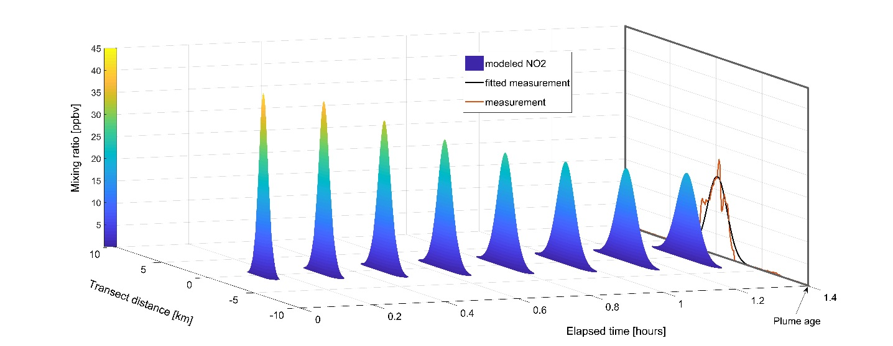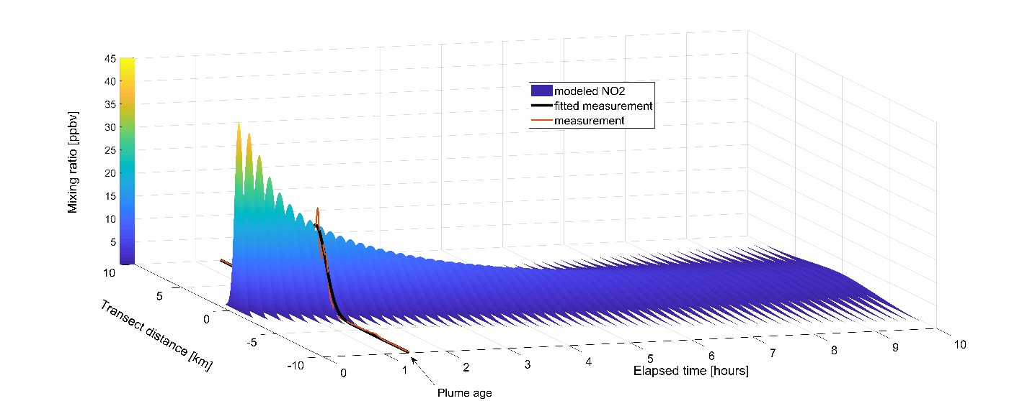
Figure 2: Top: first and second stages of the model, where the pollutant mixing ratios at the sources are determined. Bottom: plume evolution over a full night (10 hours) is simulated. The orange lines are the aircraft measurements and the black lines are the Gaussian fitted data.
Three chemical scenarios were investigated based on the MCM chemical scheme, taking isoprene as the sole precursor for CI chemistry:
“No CI”- CI reactions were not included in the chemical scheme.
“Welz”- rate coefficients for the reactions of CIs with NO₂ and SO₂ measured by Welz et al.¹⁰ (k_{NO2 + CI} =7×10⁻¹² and k_{SO2 + CI} =3.9×10⁻¹¹ molec⁻¹ cm³ s⁻¹) were used. The reaction with water vapor was based on the effective rate coefficient from the MCM (k_{H2O + CI} =1.6×10⁻¹⁷ molec⁻¹ cm³ s⁻¹) and consistent with the rate coefficient given by Oyang et al.¹¹ and Stone et al.¹⁹
“Decay”- same as the “Welz” scenario, but with additional CI decomposition reactions. The rate coefficients for the CI decay reactions were set to match the rates used in Percival et al.⁶ (200 s⁻¹) and the reaction products were an OH radical and another radical, depending on the type of CI.
In all scenarios, all types of CI had the same rate coefficient.

Measurements
The 2013 Southeast NEXUS campaign included a series of research flights of the NOAA P-3 aircraft in the Southeast U.S. with a major research goal of elucidating the chemical interactions between biogenic and anthropogenic emissions.³³ Three of the 18 research flights were dedicated night flights or day into night flights. The July 2 flight, which sampled over the U.S. state of Alabama, is shown in Figure 1. This flight sampled numerous plumes from coal-fired electric power generation plants, as illustrated by the SO₂ size and color code on the flight track, the locations of coal-fired power plants and the time series of SO₂. These SO₂ plumes were frequently associated with sulfate aerosol well in excess of background.
Instruments used in this study have been described in detail by Warneke et al.³³ Briefly, SO₂ was measured by pulsed UV fluorescence,³⁴ sulfate aerosol by an Aerosol Mass Spectrometer,³⁵ NO₂ and O₃ by cavity ring-down spectroscopy³⁶ and by chemiluminescence,³⁷ and isoprene by proton transfer reaction mass spectrometry.³⁸ Instrument accuracy, precision, limits of detection and sampling frequencies are given in Warneke et al.³³

Results and discussion
The plumes observed all have an inverse-correlation between ozone and NO₂ mixing ratios, indicating that all the measured plumes were influenced mainly by nighttime chemistry. If a plume was emitted before sunset, any SSA produced from photochemically produced OH present in the plume is considered as part of the primary emitted SSA. The age of the plume from emission to interception by the aircraft was determined according to this negative dependence of ozone vs. NO₂ mixing ratio as suggested by Brown el al.³¹ The slope modeled (and therefore the age) is in good agreement with the calculated age from the measurements (Figure S1 in the SI). Some of the observed plumes had depleted all the ozone, preventing an estimation for the plume age. All the plumes exhibited an increase in measured SA concentration, suggesting that the SA was either primarily emitted or produced from SO₂ oxidation. The results shown henceforth are from plume number 2 in Figure 1, this plume had all the necessary data i.e. the ozone mixing ratios decreased in the plume but were not zero, and the SO₄⁻ to SO₂ ratio was large so the SO₂ oxidation was significant. A comparison between the three plumes of the “Welz” scenario results are shown in Figure S3 in the SI. The simulated mixing ratio profiles of ozone, NO₂, SO₂ and SA at the plume age were compared with the measured data and the results are shown in Figure 3. All simulations fall within the 95% confidence bands of a Gaussian fit to the measurements.

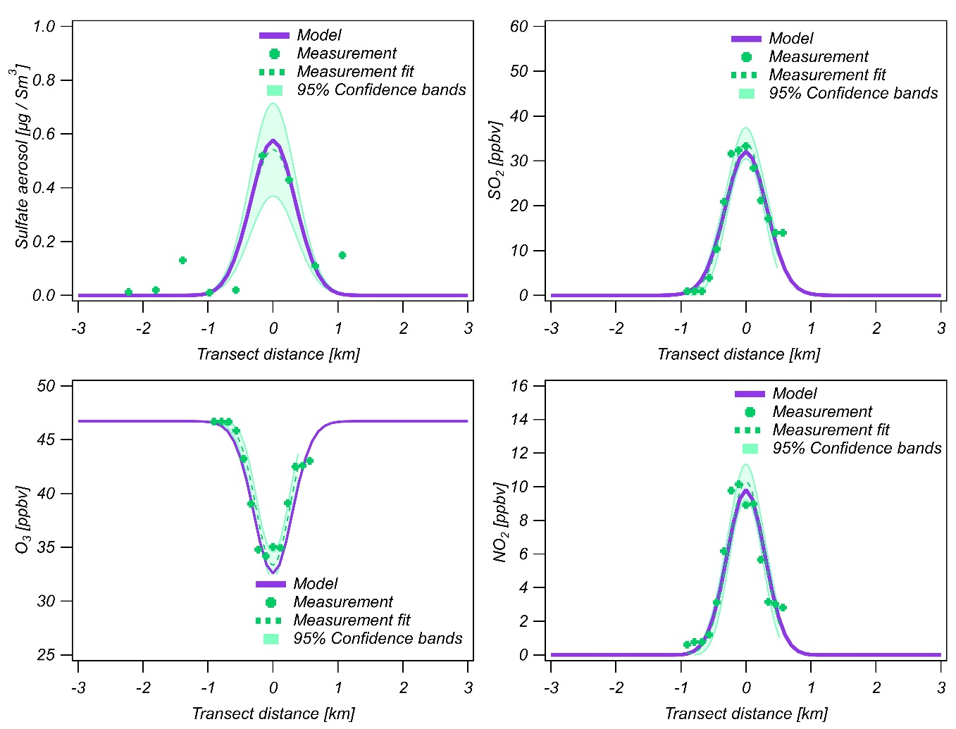
Figure 3: Comparison of model results with airborne measurements of sulfate aerosols (SA) (top left), SO₂ (top right), ozone (bottom left) and NO₂ (bottom right), at the time of intersecting the plume. All the model results are within the 95% confidence bands of the fit to the measurements. The SO₂ and NO₂ results were forced to fit the measurements at the plume age, as described in the first stage of the model. The ozone and sulfate aerosols are a product of the model simulation.
For studying these nighttime plumes in cloud-free conditions we consider three main gas-phase production pathways that can generate atmospheric secondary sulfate aerosols (SA): primary emission, secondary production by the SO₂ + OH reaction, and secondary production from the SO₂ + CI reaction. Under our measurement conditions, heterogeneous oxidation in cloud droplets was assumed to be negligible. Nighttime production of OH radical can occur through Criegee intermediates thermal decay or by alkene ozonolysis. As the model simulations show, nighttime oxidation by OH radicals in these plumes is small but nonzero.
Secondary sulfate aerosol (SSA) production by reactions of CIs depends on the reaction rate coefficients of the different CIs that form. Figure 4 shows model calculation of SA production in the plume under the three scenarios where: 1) “Welz”: the CIs react but decomposition is not considered, 2) “Decay”: As scenario “Welz” and all the CIs have the same unimolecular decay, k_{decay}=200s⁻¹ ^{6, 10, 39}, and 3) “No CI”: where no CI reactions or decomposition are included. The simulations with the “Welz” scenario show that CI reactions with SO₂ increase the total SA production by up to 28% from the plume age to the end of the simulation at 10 hours (Figure 5). As shown in Figure 2, the total SA concentration in the other scenarios does not significantly change between the plume age to the end of the simulation (10 hours), but the production pathways differ between the time of aircraft interception (“plume age”) and the end of the simulation i.e. the “Decay” scenario has a slight increase in SSA production through CI+SO₂ compared to the “No CI” scenario but not enough to make a significant change in the total SSA production (Figure 5). This indicates that the decomposition rates of different CIs have an important role in determining the extent of SSA production by CI+SO₂ reaction.

 | Plume age (2.5 hours) | 10 hours
Welz | 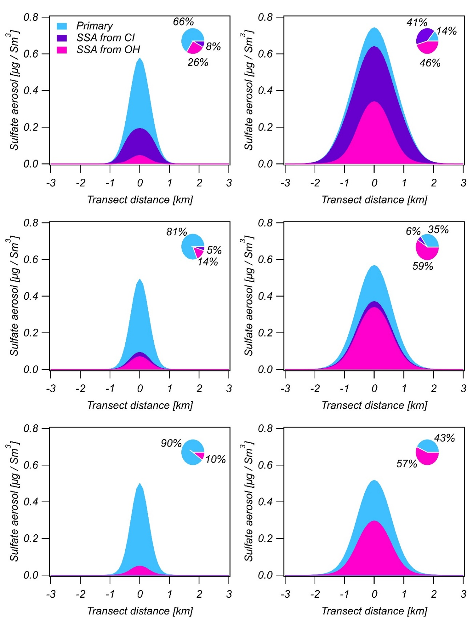
Decay
No CI
Figure 4: SSA production pathways at plume age i.e. 2.5 hours (left column) and after 10 hours (right column). Scenarios from top to bottom: “Welz”, “Decay” and “No CI”. SSA from CI in the Welz scenario results in 1.25 more total SA production while the other two scenarios show very little change. The inset in each plot indicates the contribution of each pathway in the plume center.
Welz | 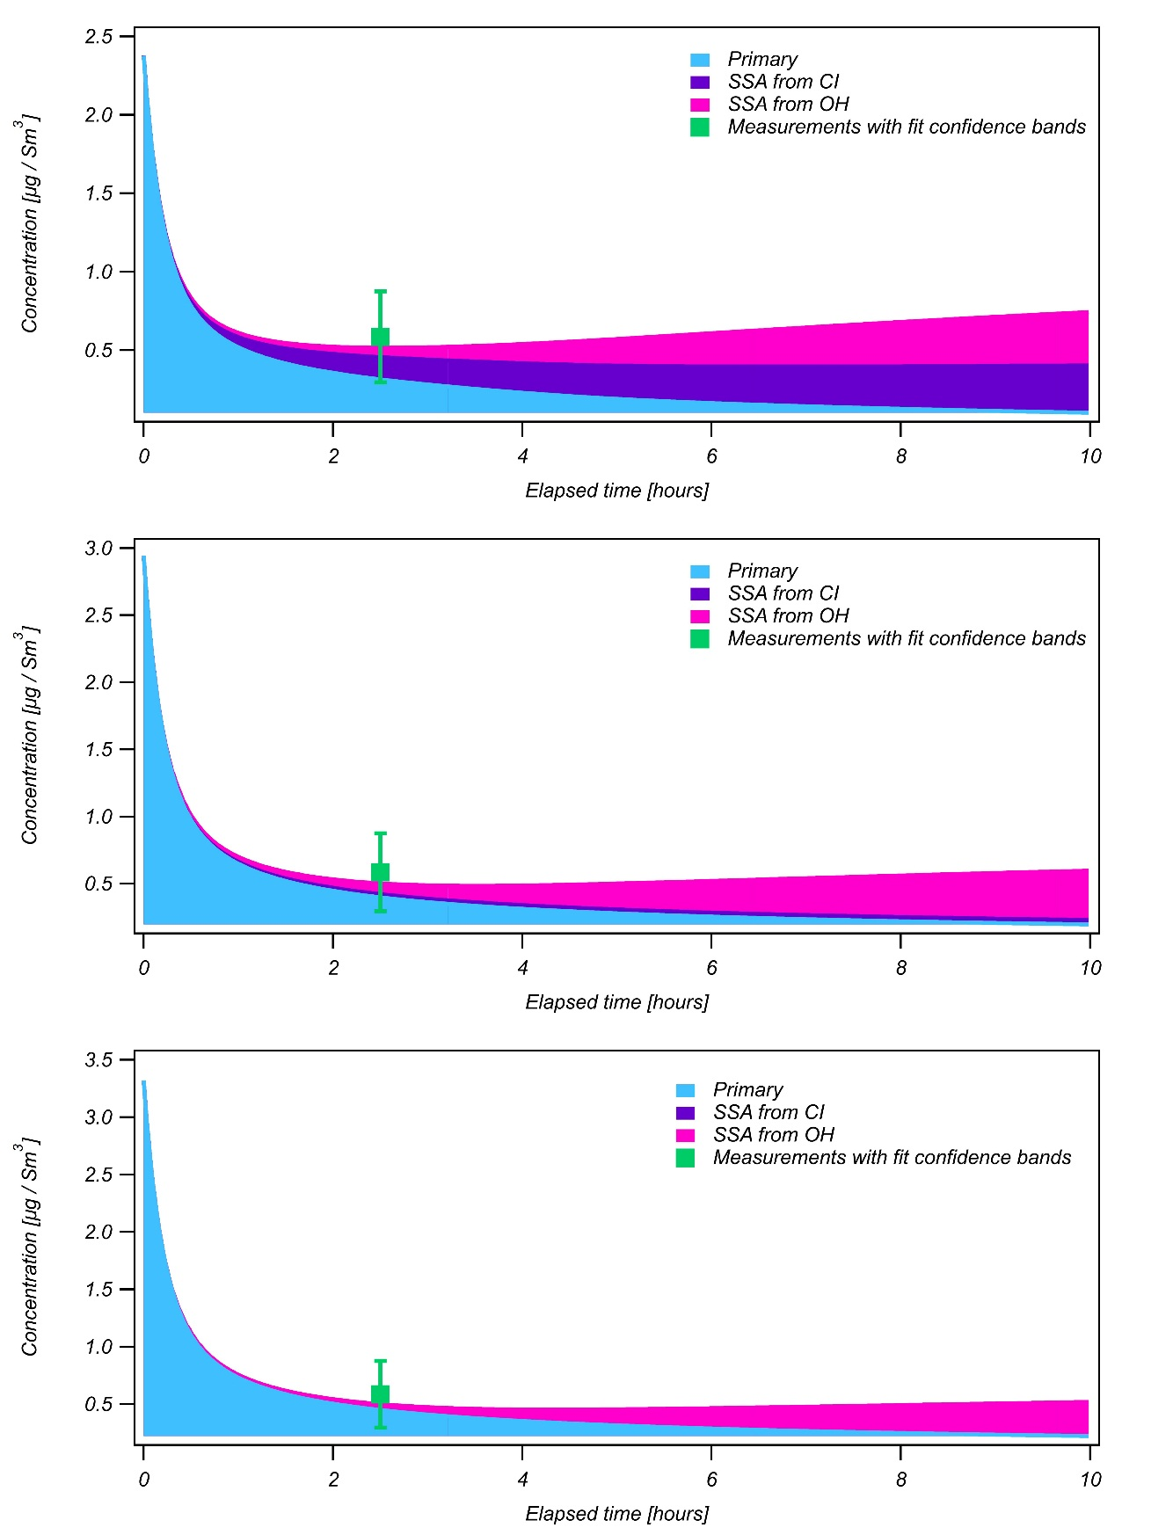
Decay
No CI
Figure 5: SSA production pathways at plume center. Scenarios from top to bottom: “Welz”, “Decay” and “No CI”. The green rectangular marks the measurements at plume age (2.5 hours).
The CI production is higher at plume edges since it is produced by the reaction of ozone with isoprene. Therefore, the most rapid OH production from CI decomposition occurs outside of the plume, where there is no more pollutants from the plume, because the isoprene is consumed in the plume primarily by NO₃ and O₃ is depleted at plume center by NO_{x} titration.⁴⁰ Consequently, the “Decay” scenario does not significantly change the SSA production (through additional OH) in comparison to the “No CI” scenario (Figure 5). However, the SSA plume produced from OH is wider in the “Decay” scenario compared with the other two scenarios.
The CIs produced in the model can be divided into two groups: first generation CIs that are produced from the ozonolysis of isoprene (formaldehyde oxide (CH₂OO), methacrolein oxide (MACROO) and methyl vinyl ketone oxide (MVKOO)) and second generation CIs which are produced from the ozonolysis of products of isoprene oxidized by OH or NO₃. Figure 6 illustrates a production pathway of a CI that is a product of NO₃ and isoprene reaction. These nitrate-containing CIs are produced in the plumes under high NOx conditions. The model results suggest that one of these CIs (NOAOO) is produced in the nighttime plume tail (after 10 hours) at a mixing ratio of about 3.5 x 10⁸ molec cm⁻³. However, there are no experimental or theoretical kinetics calculations on these CI types.
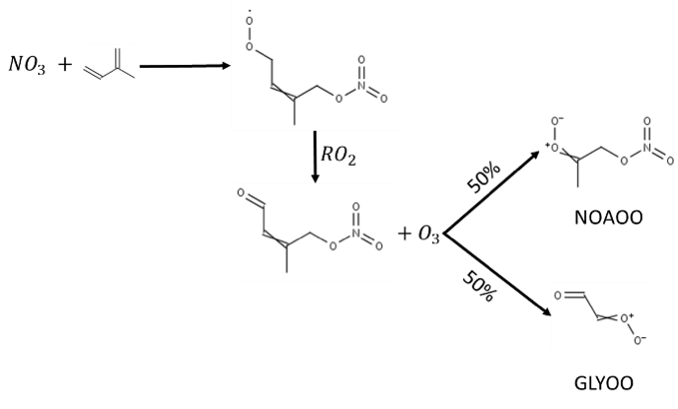

Figure 6: Second-generation CI production scheme.

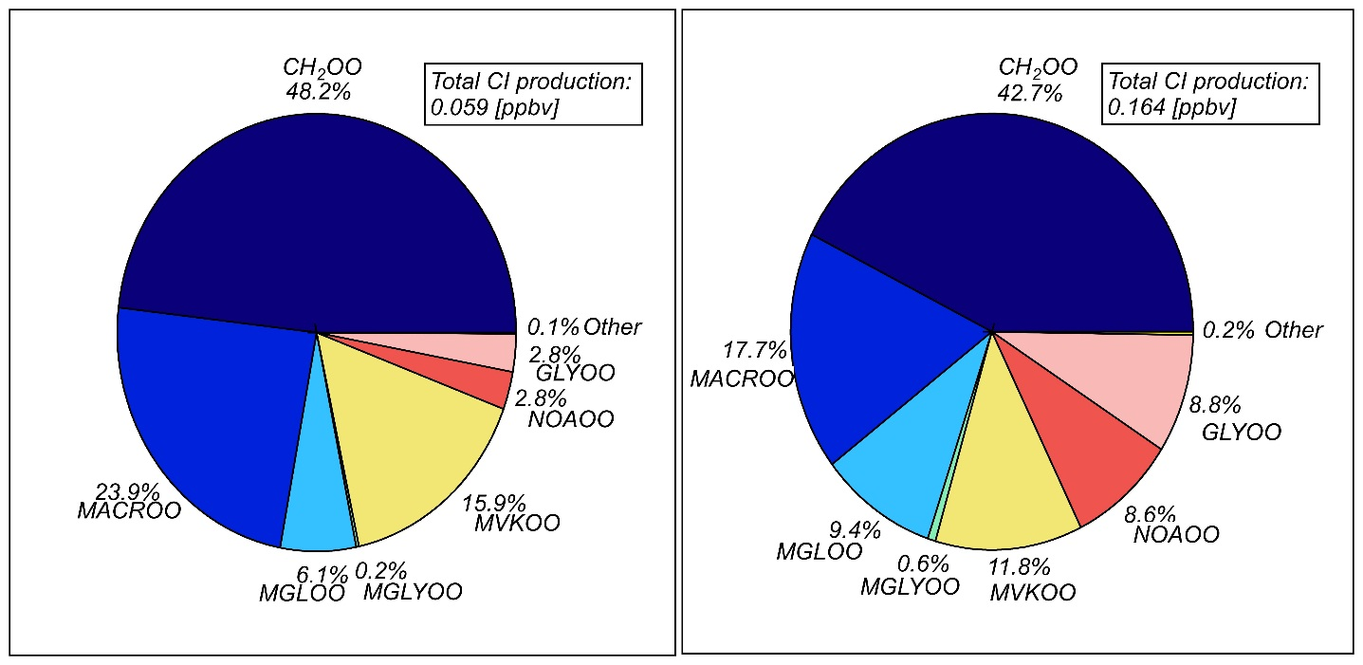
Figure 7: Integrated mixing ratio of dominant CIs: (left) at plume age and (right) after 10 hours of simulation. All the CI reaction rate coefficients in the model are the same as the simple CI (~50% of the CI production); however, larger CIs such as methacrolein oxide (MACROO) and methyl vinyl ketone oxide (MVKOO) may affect the chemical scheme if considered different reaction rate coefficients.
Figure 7 summarizes the main CIs produced in the simulation. The smallest CI contributes about 50% of the products. However, the two other first generation CIs (methyl vinyl ketone oxide and methacrolein oxide) are also important and may consist of up to 40% of the total CIs produced.

Zero NOx conditions
Coal fired power plants emit large quantities of both SO₂ and NOx, both of which can react with the CIs from ozonolysis of isoprene and other alkenes. Thus, the NOx in the plume competes for the CI reaction with SO₂. The NOx reactions further lead to the production of NO₃, which rapidly consumes isoprene, the source of CIs in the plume.⁴¹ Thus, the maximum potential effect of CIs on SO₂ oxidation can be tested by simulating the chemistry without NOx emissions. Figure 8 shows that in the absence on NOx, more first generation CIs are produced leading to higher total CI production (Figure 9). Figure 10 shows that at zero-NOx simulation, SSA production by CI reactions increases by 1.5 in the “Welz” scenario due to an increase of the total CI mixing ratio. The higher CI mixing ratio also influences the “Decay” scenario where the SSA production from CI increases compared to the simulation with NOx. SSA production from OH reaction decreased in all the scenarios when compared with the simulation with NOx since higher isoprene mixing ratios consume a larger fraction of the secondary OH, leaving less to react with SO₂.
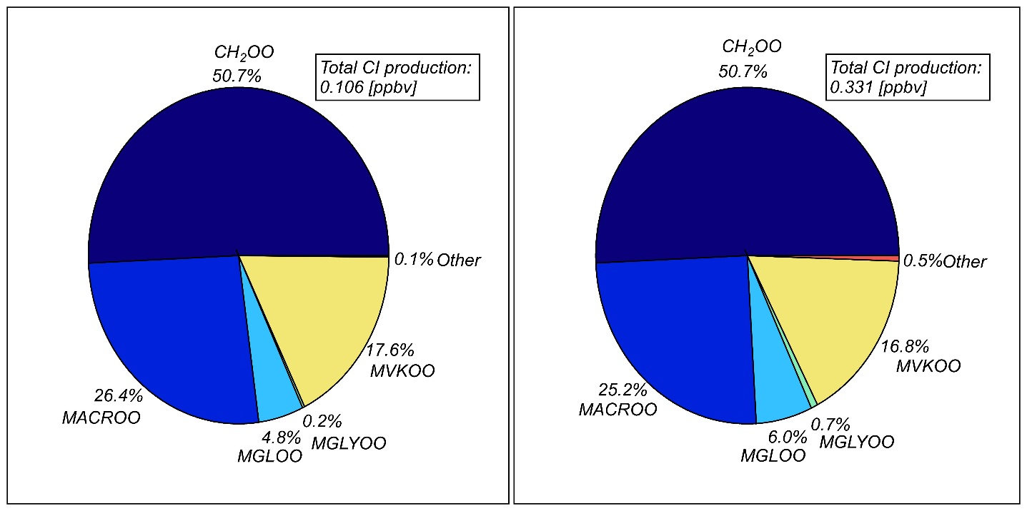
Figure 8: Integrated mixing ratio of dominant CIs produced in the simulation at (left) plume age and (right) after 10 hours of simulation with zero NOx conditions and the Welz scenario. The second generation CIs from NO₃ reactions are not formed; however, the total CI production is higher compared to simulation with NOx.
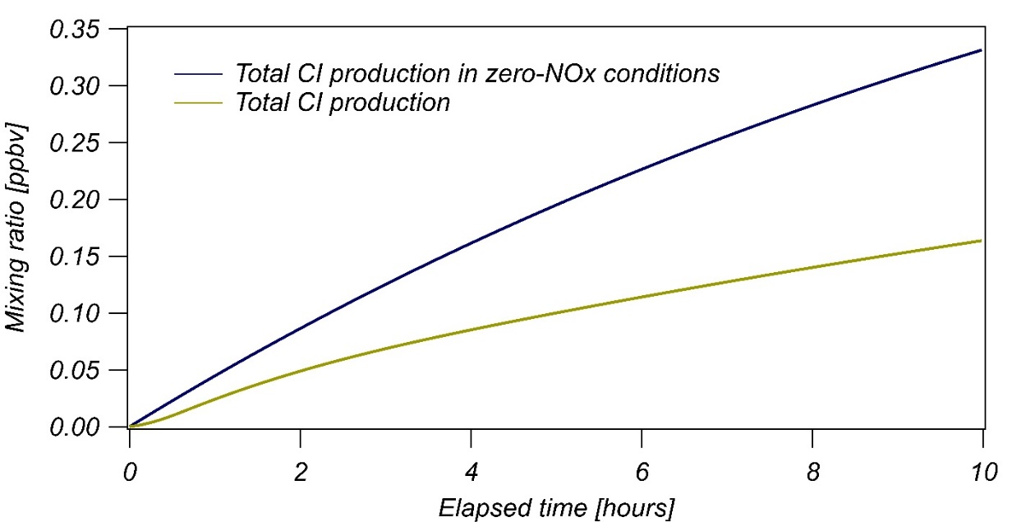
Figure 9: Total CI production in the presence and absence of NOx. In the case of zero-NOx, the CI production is almost 2 times higher.
 | Plume age (2.5 hours) | 10 hours
Welz | 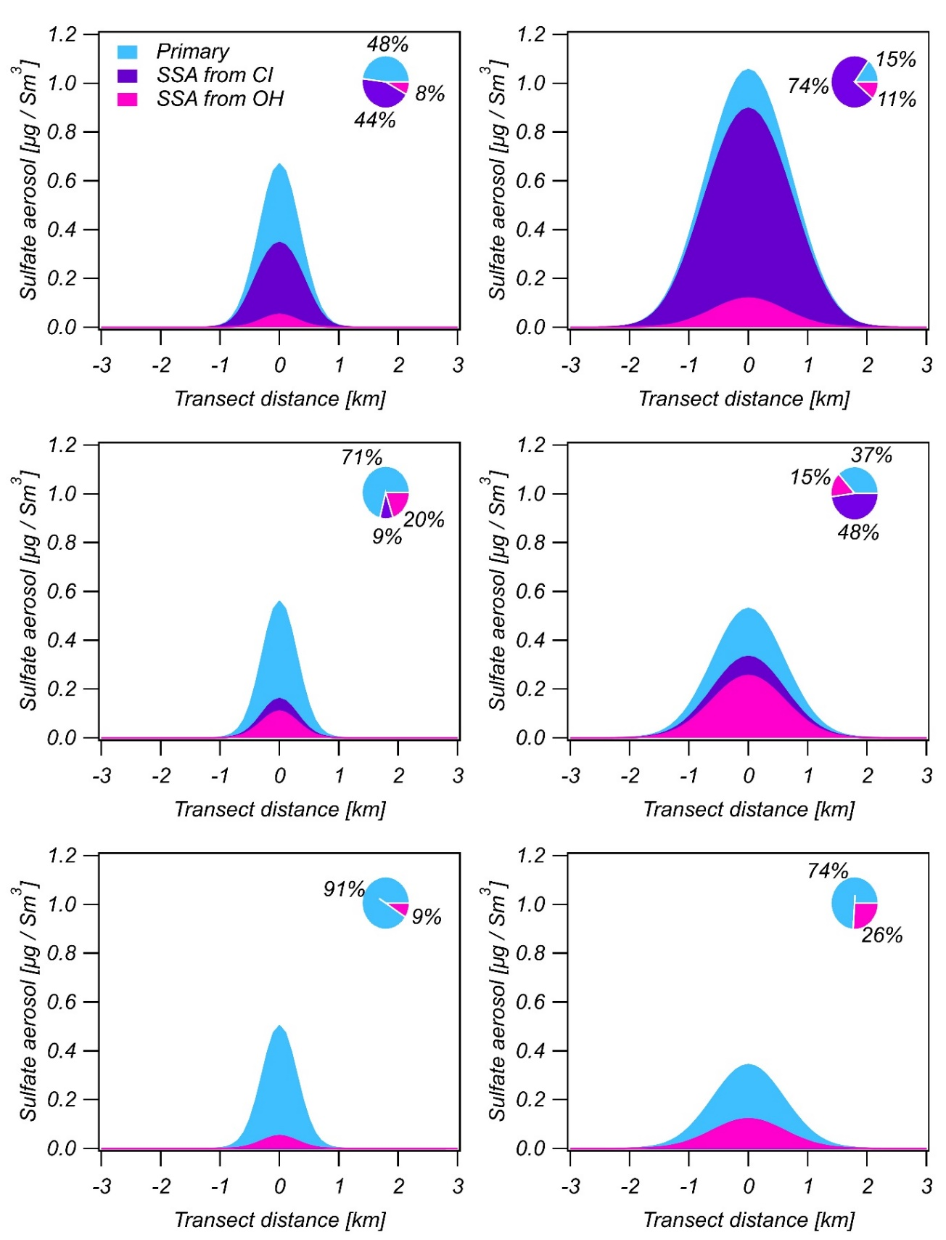
Decay
No CI
Figure 10: SSA production at plume age on the left and after 10 hours of simulations on the right. Scenarios from top to bottom: “Welz”, “Decay” and “No CI”. Without NOx, the SSA production from CI increases by 1.5 compared to NOx scenario due to the higher CI mixing ratio (shown in Figure 4). The inset in each plot indicates the contribution of each pathway in the plume center.
SO₂ oxidation efficiency
In the chemical scheme of the model, the SO₂ oxidation pathways (SO₂ + CI and SO₂ + OH) produce SO₃ that reacts rapidly (~530 s⁻¹) with water and produces SSA. Hence, the SSA production efficiency depends on the concentrations of the oxidants and SO₂ across the plume. Figure 11– top left shows that CIs are produced more efficiently outside the plume where the ozone is the main VOC oxidant. Additionally, after 10 hours of darkness the SO₂ is diluted and dispersed.
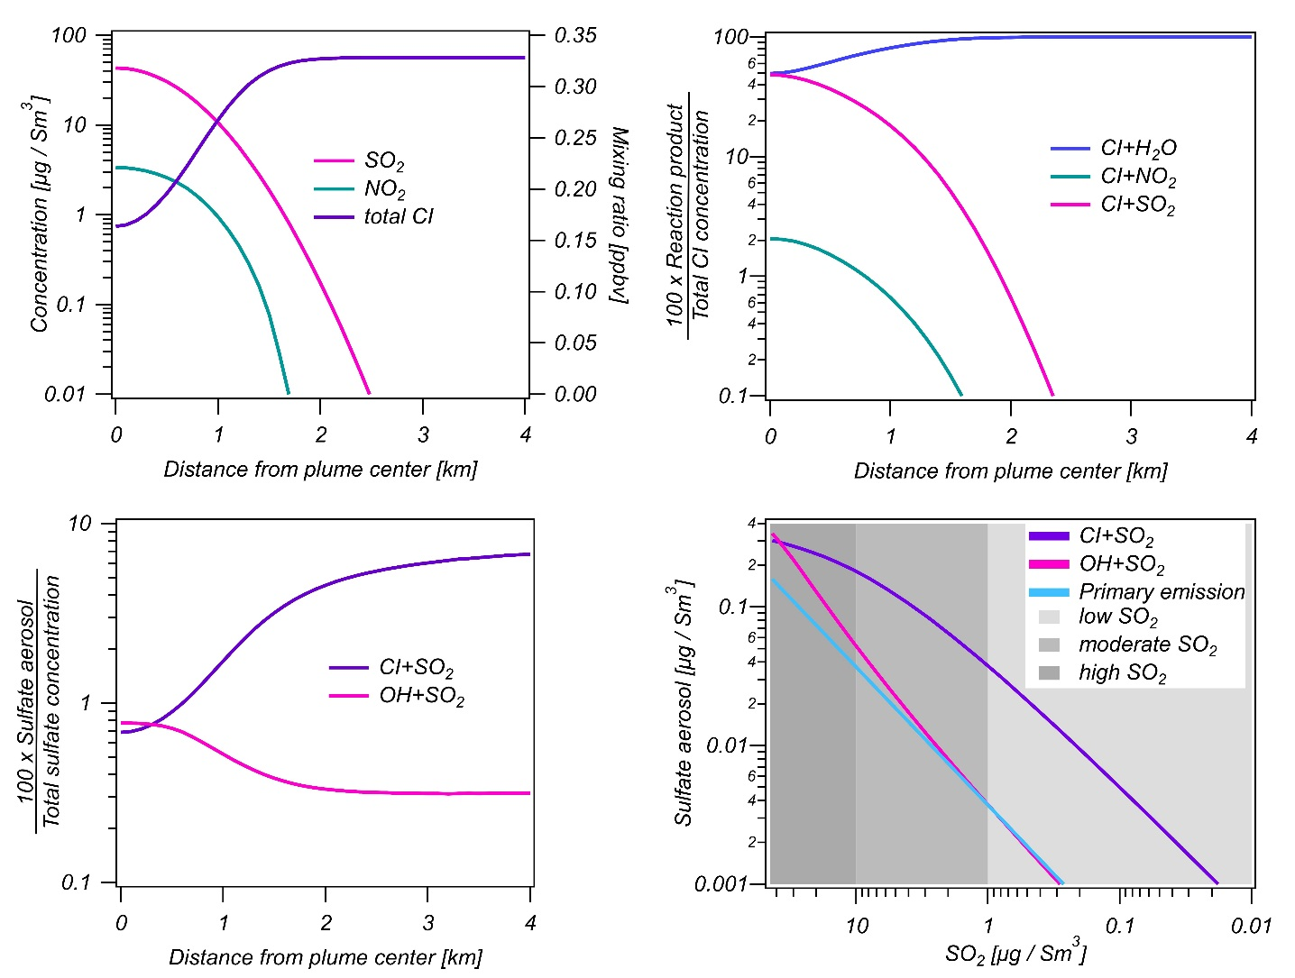
Figure 11: NO₂, SO₂ concentrations on the left axis and total CI mixing ratios on the right axis (top left), CI consumption by H₂O, NO₂ and SO₂ (top right), SO₂ oxidation efficiency as a function of distance from plume center (bottom left) and SSA production pathways as a function of available SO₂ (bottom right). All the plots are from the end of the simulations (10 hours), where the chemistry production is dominant. At plume center (high SO₂ mixing ratio), the water and SO₂ compete on the CI consumption. As the source contaminants dilute, most of the CI is consumed by water. As the SO₂ mixing ratio decreases, the SSA production from CI increases although the total SSA mixing ratio is small.
The main sinks for CI as a function of distance from plume center are shown in Figure 11- top right. The reaction of CI with NO₂ is minor compared to the reaction with water and SO₂. Closer to plume center, under high SO₂ concentration, the CI + SO₂ reaction is most competitive with the loss due to the reaction with water.
Figure 11 - bottom left shows the SO₂ oxidation efficiency. While the nocturnal OH radical production is low, the OH mixing ratio in the plume shows threefold increase upon addition of NOx to the model, mainly due to additional NOx chemistry e.g. OH production through hydroperoxyl radical with NO₃. Therefore, the SO₂ oxidation by OH is most efficient at the plume center. In contrast, the total CI mixing ratio increases further away from the plume center, where ozone is the main VOC oxidant (the first generation CIs production pathway). Therefore, the SO₂ oxidation by CI is most efficient at the plume edges. Relative to oxidation by OH, a larger fraction of the SO₂ is oxidized by CI outside of the plume and a smaller fraction inside the plume, but the larger fraction of SO₂ consumption by CI occurs at low SO₂, so overall the absolute mass of SO₂ oxidation is smaller outside of the plume.
Figure 12 shows the nighttime conversion rates of SO₂ to sulfate aerosols calculated from the model over 10 hours. The SO₂ and SSA concentrations were integrated over the plume width. Since CI reactions are not affected by photochemical reactions, we assume that the conversion rate will be similar during daytime. Therefore, the CI reaction with SO₂ will convert 1.5% of the SO₂ into SSA during 14 hours of daytime.
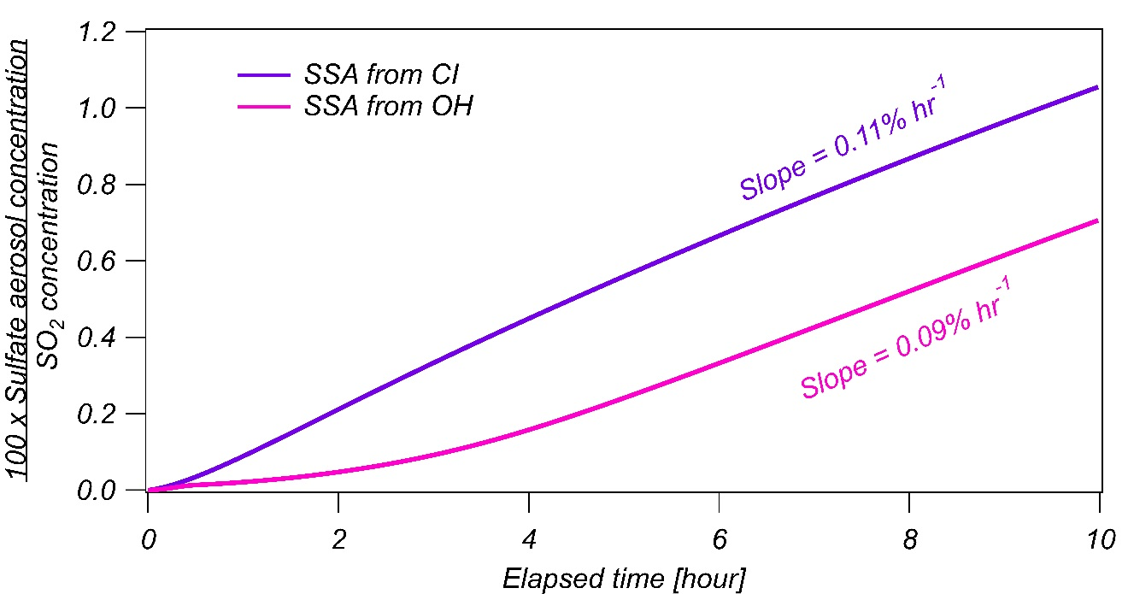
Figure 12: Nocturnal SO₂ conversation rate. The purple line indicates SSA produced by SO₂ + CI and the pink line indicates SSA produced by SO₂ + OH produced at nighttime. The slopes are the nocturnal conversion rates.
Daytime conversion rate of SO₂ through OH reaction can be calculated in the following manner:
- $k_{({SO}_{2}+OH)}\left[OH\right]×\left[{SO}_{2}\right]=\frac{∆\left[{SSA}_{OH}\right]}{∆t}$
Where $k_{({SO}_{2}+OH)}$ is the reaction rate coefficient when the ambient conditions are 300K and 1mbar and [SSA_{OH}], [OH] and [SO₂] is the concentration of sulfate aerosols produced from SO₂ + OH, OH and SO₂ respectively.
- ${{\frac{\left[{SSA}_{OH}\right]}{\left[{SO}_{2}\right]}\%}_{full day}=\left[OH\right]\frac{1}{{cm}^{3}}×k}_{\left({SO}_{2}+OH\right)}\frac{{cm}^{3}}{s}×100\%×14 hr$
$k_{({SO}_{2}+OH)}$ = 8.3x10⁻¹³ cm³ s⁻¹ ⁴² and average diurnal OH concentration is 1x10⁶ cm⁻³.⁴³⁻⁴⁴ Therefore, the OH reaction with SO₂ will convert about 4.2% of the SO₂ into SSA during 14 hours of daytime.
These simple considerations show that the daytime SSA produced in power plant plumes from CI may account for about 26% of the total SSA produced, which is not negligible. The contribution of nighttime CI production will be much higher (~55%) due to lower OH concentration.
This study analyzed nighttime oxidation of SO₂ by CI under conditions of concentrated SO₂ plumes in an area heavily impacted by high BVOC (mostly isoprene) emissions. The simulated conditions allow also to investigate the transition from areas with high SO₂ pollution to moderate and ultimately background levels of SO₂ i.e. 0.250 ppbv. This transition is shown in the bottom right panel of Figure 11. Polluted areas are represented in the graph by the darkest grey from 30 to 10 µg Sm³ SO₂. Rural areas with high biogenic emissions and low concentrations of anthropogenic pollutants are represented by the lightest grey, where the SO₂ concentration is less than 1 µg / Sm³ SO₂. It can be seen that in the background conditions, the CI loss is heavily dominated by the water reaction. At polluted conditions, the CI loss by the reaction with water and with SO₂ is nearly equal. The relative oxidation of SO₂ in 10 hours of darkness is <1% at plume center, but up to 8% at background SO₂ levels. This higher relative oxidation of SO₂ represents a smaller mass due to the lower SO₂ concentrations in the background. The integrated effect of CI on SO₂ oxidation may be as high as 55% of the SSA produced over a full night. Although considerably lower, CI may have an impact on daytime SO₂ oxidation in power plant plumes as well (~25%).

Conclusions
Varying kinetic parameters allows to gauge a range of conditions when the reaction rate coefficients and concentrations are not well known. Coupling a chemical kinetic scheme with a dispersion model and in-situ measurements can help understand the secondary chemistry in pollution plumes close to populated areas and estimate atmospheric oxidation processes. This study uses observations of SO₂ and sulfate aerosol by nighttime aircraft plume intercepts to demonstrate that loss of SO₂ by CI chemistry can be an important pathway. The scenarios studied in this work show that nocturnal SO₂ oxidation by CIs in power plant plume is important even under high RH conditions. We show different CI types that may be produced from isoprene and find that a nitrated CI may be a significant second-generation CIs. The simulation suggests that constraining the thermal dissociation rate coefficients for different CIs is critical for better constraining the role of CI chemistry on SO₂ oxidation.

Acknowledgements
This work was supported by Israel Science Foundation grant #2727/17 and by grant from Paul and Tina Gardner. Daphne Meidan acknowledges support by a research grant from Dana and Yossie Hollander.

References
1. Thomas F. Stocker, W. G. I. T. S. U., Climate change 2013 : the physical science basis : Working Group I contribution to the fifth assessment report of the Intergovernmental Panel on Climate Change. Cambridge, United Kingdom Cambridge University Press, 2014. ©2013: 2014.
2. Seinfeld, J. H.; Pandis, S. N., Atmospheric chemistry and physics: from air pollution to climate change. John Wiley & Sons: 2016.
3. Pirjola, L.; Kulmala, M.; Wilck, M.; Bischoff, A.; Stratmann, F.; Otto, E., FORMATION OF SULPHURIC ACID AEROSOLS AND CLOUD CONDENSATION NUCLEI: AN EXPRESSION FOR SIGNIFICANT NUCLEATION AND MODEL COMPRARISON. Journal of Aerosol Science 1999, 30 (8), 1079-1094.
4. Almeida, J.; Schobesberger, S.; Kürten, A.; Ortega, I. K.; Kupiainen-Määttä, O.; Praplan, A. P.; Adamov, A.; Amorim, A.; Bianchi, F.; Breitenlechner, M.; David, A.; Dommen, J.; Donahue, N. M.; Downard, A.; Dunne, E.; Duplissy, J.; Ehrhart, S.; Flagan, R. C.; Franchin, A.; Guida, R.; Hakala, J.; Hansel, A.; Heinritzi, M.; Henschel, H.; Jokinen, T.; Junninen, H.; Kajos, M.; Kangasluoma, J.; Keskinen, H.; Kupc, A.; Kurtén, T.; Kvashin, A. N.; Laaksonen, A.; Lehtipalo, K.; Leiminger, M.; Leppä, J.; Loukonen, V.; Makhmutov, V.; Mathot, S.; McGrath, M. J.; Nieminen, T.; Olenius, T.; Onnela, A.; Petäjä, T.; Riccobono, F.; Riipinen, I.; Rissanen, M.; Rondo, L.; Ruuskanen, T.; Santos, F. D.; Sarnela, N.; Schallhart, S.; Schnitzhofer, R.; Seinfeld, J. H.; Simon, M.; Sipilä, M.; Stozhkov, Y.; Stratmann, F.; Tomé, A.; Tröstl, J.; Tsagkogeorgas, G.; Vaattovaara, P.; Viisanen, Y.; Virtanen, A.; Vrtala, A.; Wagner, P. E.; Weingartner, E.; Wex, H.; Williamson, C.; Wimmer, D.; Ye, P.; Yli-Juuti, T.; Carslaw, K. S.; Kulmala, M.; Curtius, J.; Baltensperger, U.; Worsnop, D. R.; Vehkamäki, H.; Kirkby, J., Molecular understanding of sulphuric acid–amine particle nucleation in the atmosphere. Nature 2013, 502, 359.
5. Drozd, G. T.; Kurtén, T.; Donahue, N. M.; Lester, M. I., Unimolecular Decay of the Dimethyl-Substituted Criegee Intermediate in Alkene Ozonolysis: Decay Time Scales and the Importance of Tunneling. J. Phys. Chem. 2017, 121 (32), 6036-6045.
6. Percival, C. J.; Welz, O.; Eskola, A. J.; Savee, J. D.; Osborn, D. L.; Topping, D. O.; Lowe, D.; Utembe, S. R.; Bacak, A.; M c Figgans, G.; Cooke, M. C.; Xiao, P.; Archibald, A. T.; Jenkin, M. E.; Derwent, R. G.; Riipinen, I.; Mok, D. W. K.; Lee, E. P. F.; Dyke, J. M.; Taatjes, C. A.; Shallcross, D. E., Regional and global impacts of Criegee intermediates on atmospheric sulphuric acid concentrations and first steps of aerosol formation. Faraday Discuss. 2013, 165 (0), 45-73.
7. Huang, H.-L.; Chao, W.; Lin, J. J.-M., Kinetics of a Criegee intermediate that would survive high humidity and may oxidize atmospheric SO2. Proc. Natl. Acad. Sci. 2015, 112 (35), 10857-10862.
8. Khan, M. A. H.; Percival, C. J.; Caravan, R. L.; Taatjes, C. A.; Shallcross, D. E., Criegee intermediates and their impacts on the troposphere. Environmental Science: Processes & Impacts 2018.
9. Criegee, R., Mechanism of Ozonolysis. Angew. Chem. 1975, 14 (11), 745-752.
10. Welz, O.; Savee, J. D.; Osborn, D. L.; Vasu, S. S.; Percival, C. J.; Shallcross, D. E.; Taatjes, C. A., Direct Kinetic Measurements of Criegee Intermediate (CH2OO) Formed by Reaction of CH2I with O2. Science 2012, 335 (6065), 204-207.
11. Ouyang, B.; McLeod, M. W.; Jones, R. L.; Bloss, W. J., NO3 radical production from the reaction between the Criegee intermediate CH2OO and NO2. Phys. Chem. Chem. Phys. 2013, 15 (40), 17070-17075.
12. Kidwell, N. M.; Li, H.; Wang, X.; Bowman, J. M.; Lester, M. I., Unimolecular dissociation dynamics of vibrationally activated CH3CHOO Criegee intermediates to OH radical products. Nat. Chem. 2016, 8 (5), 509-514.
13. Meidan, D.; Brown, S. S.; Rudich, Y., The Potential Role of Criegee Intermediates in Nighttime Atmospheric Chemistry. A Modeling Study. ACS Earth and Space Chemistry 2017, 1 (5), 288-298.
14. Taatjes, C. A.; Welz, O.; Eskola, A. J.; Savee, J. D.; Scheer, A. M.; Shallcross, D. E.; Rotavera, B.; Lee, E. P. F.; Dyke, J. M.; Mok, D. K. W.; Osborn, D. L.; Percival, C. J., Direct Measurements of Conformer-Dependent Reactivity of the Criegee Intermediate CH<sub>3</sub>CHOO</div>. Science 2013, 340 (6129), 177-180.
15. Donahue, N. M.; Drozd, G. T.; Epstein, S. A.; Presto, A. A.; Kroll, J. H., Adventures in ozoneland: down the rabbit-hole. Phys. Chem. Chem. Phys. 2011, 13 (23), 10848-10857.
16. Vereecken, L.; Novelli, A.; Taraborrelli, D., Unimolecular decay strongly limits the atmospheric impact of Criegee intermediates. Phys. Chem. Chem. Phys. 2017, 19 (47), 31599-31612.
17. Anglada, J. M.; Sole, A., Impact of the water dimer on the atmospheric reactivity of carbonyl oxides. Phys. Chem. Chem. Phys. 2016, 18 (26), 17698-17712.
18. Long, B.; Bao, J. L.; Truhlar, D. G., Atmospheric Chemistry of Criegee Intermediates: Unimolecular Reactions and Reactions with Water. J. Am. Chem. Soc. 2016, 138 (43), 14409-14422.
19. Stone, D.; Blitz, M.; Daubney, L.; Howes, N. U. M.; Seakins, P., Kinetics of CH2OO reactions with SO2, NO2, NO, H2O and CH3CHO as a function of pressure. Phys. Chem. Chem. Phys. 2014, 16 (3), 1139-1149.
20. Lin, L.-C.; Chang, H.-T.; Chang, C.-H.; Chao, W.; Smith, M. C.; Chang, C.-H.; Jr-Min Lin, J.; Takahashi, K., Competition between H2O and (H2O)2 reactions with CH2OO/CH3CHOO. Phys. Chem. Chem. Phys. 2016, 18 (6), 4557-4568.
21. Taatjes, C. A., Criegee Intermediates: What Direct Production and Detection Can Teach Us About Reactions of Carbonyl Oxides. Annual Review of Physical Chemistry 2017, 68 (1), 183-207.
22. Guenther, A.; Karl, T.; Harley, P.; Wiedinmyer, C.; Palmer, P. I.; Geron, C., Estimates of global terrestrial isoprene emissions using MEGAN (Model of Emissions of Gases and Aerosols from Nature). Atmos. Chem. Phys. 2006, 6 (11), 3181-3210.
23. Guenther, A.; Hewitt, C. N.; Erickson, D.; Fall, R.; Geron, C.; Graedel, T.; Harley, P.; Klinger, L.; Lerdau, M.; McKay, W. A.; Pierce, T.; Scholes, B.; Steinbrecher, R.; Tallamraju, R.; Taylor, J.; Zimmerman, P., A global model of natural volatile organic compound emissions. 1995.
24. Brown, S. S.; deGouw, J. A.; Warneke, C.; Ryerson, T. B.; Dubé, W. P.; Atlas, E.; Weber, R. J.; Peltier, R. E.; Neuman, J. A.; Roberts, J. M.; Swanson, A.; Flocke, F.; McKeen, S. A.; Brioude, J.; Sommariva, R.; Trainer, M.; Fehsenfeld, F. C.; Ravishankara, A. R., Nocturnal isoprene oxidation over the Northeast United States in summer and its impact on reactive nitrogen partitioning and secondary organic aerosol. Atmos. Chem. Phys. 2009, 9 (9), 3027-3042.
25. Edwards, P. M.; Aikin, K. C.; Dube, W. P.; Fry, J. L.; Gilman, J. B.; de Gouw, J. A.; Graus, M. G.; Hanisco, T. F.; Holloway, J.; Hübler, G.; Kaiser, J.; Keutsch, F. N.; Lerner, B. M.; Neuman, J. A.; Parrish, D. D.; Peischl, J.; Pollack, I. B.; Ravishankara, A. R.; Roberts, J. M.; Ryerson, T. B.; Trainer, M.; Veres, P. R.; Wolfe, G. M.; Warneke, C.; Brown, S. S., Transition from high- to low-NOx control of night-time oxidation in the southeastern US. Nat. Geosci. 2017, 10, 490.
26. L., F. D.; E., M. E.; P., D. W.; C., A. K.; D., L.-H. F.; H., L. B.; R., G. J.; N., F. M.; S., H. J.; Carlena, E.; L., S. T.; Paul, W.; J., W. A.; D., M. D.; C., A. E.; S., H. R.; J., H. A.; J., B. N.; P., D. J.; M., W. G.; Solomon, B.; C., C. R.; A., T. J.; S., B. S., Wintertime Overnight NOx Removal in a Southeastern United States Coal-fired Power Plant Plume: A Model for Understanding Winter NOx Processing and its Implications. J. Geophys. Res.: Atmos. 2018, 123 (2), 1412-1425.
27. S., B. S.; P., D. W.; Prakash, K.; Greg, Y.; Jeff, P.; B., R. T.; Andrew, N. J.; B., N. J.; S., H. J.; A., W. R.; A., B. C.; J., F. G.; Michael, T.; D., P. D.; C., F. F.; R., R. A., Effects of NOxcontrol and plume mixing on nighttime chemical processing of plumes from coal-fired power plants. J. Geophys. Res.: Atmos. 2012, 117 (D7).
28. Karamchandani, P.; Koo, A.; Seigneur, C., Reduced Gas-Phase Kinetic Mechanism for Atmospheric Plume Chemistry. Environ. Sci. Technol. 1998, 32 (11), 1709-1720.
29. Kim, Y. H.; Kim, H. S.; Song, C. H., Development of a Reactive Plume Model for the Consideration of Power-Plant Plume Photochemistry and Its Applications. Environ. Sci. Technol. 2017, 51 (3), 1477-1487.
30. Jenkin, M. E.; Young, J. C.; Rickard, A. R., The MCM v3.3.1 degradation scheme for isoprene. Atmos. Chem. Phys. 2015, 15 (20), 11433-11459.
31. Brown, S. S.; Neuman, J. A.; Ryerson, T. B.; Trainer, M.; Dubé, W. P.; Holloway, J. S.; Warneke, C.; Gouw, J. A. d.; Donnelly, S. G.; Atlas, E.; Matthew, B.; Middlebrook, A. M.; Peltier, R.; Weber, R. J.; Stohl, A.; Meagher, J. F.; Fehsenfeld, F. C.; Ravishankara, A. R., Nocturnal odd‐oxygen budget and its implications for ozone loss in the lower troposphere. Geophys. Res. Lett. 2006, 33 (8).
32. J., P.; B., R. T.; S., H. J.; D., P. D.; M., T.; J., F. G.; C., A. K.; S., B. S.; P., D. W.; H., S.; C., F. F., A top-down analysis of emissions from selected Texas power plants during TexAQS 2000 and 2006. J. Geophys. Res.: Atmos. 2010, 115 (D16).
33. Warneke, C.; Trainer, M.; de Gouw, J. A.; Parrish, D. D.; Fahey, D. W.; Ravishankara, A. R.; Middlebrook, A. M.; Brock, C. A.; Roberts, J. M.; Brown, S. S.; Neuman, J. A.; Lerner, B. M.; Lack, D.; Law, D.; Hübler, G.; Pollack, I.; Sjostedt, S.; Ryerson, T. B.; Gilman, J. B.; Liao, J.; Holloway, J.; Peischl, J.; Nowak, J. B.; Aikin, K. C.; Min, K. E.; Washenfelder, R. A.; Graus, M. G.; Richardson, M.; Markovic, M. Z.; Wagner, N. L.; Welti, A.; Veres, P. R.; Edwards, P.; Schwarz, J. P.; Gordon, T.; Dube, W. P.; McKeen, S. A.; Brioude, J.; Ahmadov, R.; Bougiatioti, A.; Lin, J. J.; Nenes, A.; Wolfe, G. M.; Hanisco, T. F.; Lee, B. H.; Lopez-Hilfiker, F. D.; Thornton, J. A.; Keutsch, F. N.; Kaiser, J.; Mao, J.; Hatch, C. D., Instrumentation and measurement strategy for the NOAA SENEX aircraft campaign as part of the Southeast Atmosphere Study 2013. Atmos. Meas. Tech. 2016, 9 (7), 3063-3093.
34. B. Ryerson, T.; Buhr, M.; Frost, G.; D. Goldan, P.; Holloway, J.; Hübler, G.; T. Jobson, B.; C. Kuster, W.; A. McKeen, S.; Parrish, D.; Roberts, J.; Sueper, D.; Trainer, M.; Williams, J.; Fehsenfeld, F., Emissions lifetimes and ozone formation in power plant plumes. 1998; Vol. 103, p 22569-22583.
35. R., B.; B., E.; M., M. A.; C., W.; A., d. G. J.; F., D. P.; L., J. J.; A., B. C.; A., N. J.; B., R. T.; H., S.; E., A.; J., B.; A., F.; S., H. J.; J., P.; D., R.; J., W.; P., W.; G., W. A.; C., F. F., Organic aerosol formation in urban and industrial plumes near Houston and Dallas, Texas. J. Geophys. Res.: Atmos. 2009, 114 (D7).
36. L. Wagner, N.; Dubé, W.; A. Washenfelder, R.; J. Young, C.; Pollack, I.; B. Ryerson, T.; Brown, S., Diode laser-based cavity ring-down instrument for NO 3 , N 2 O 5 , NO, NO 2 and O 3 from aircraft. 2011; Vol. 4, p 1227-1240.
37. Pollack, I. B.; Lerner, B. M.; Ryerson, T. B., Evaluation of ultraviolet light-emitting diodes for detection of atmospheric NO2 by photolysis - chemiluminescence. Journal of Atmospheric Chemistry 2010, 65 (2), 111-125.
38. Joost, d. G.; Carsten, W., Measurements of volatile organic compounds in the earth's atmosphere using proton-transfer-reaction mass spectrometry. Mass Spectrom. Rev. 2007, 26 (2), 223-257.
39. Li, J.; Ying, Q.; Yi, B.; Yang, P., Role of stabilized Criegee Intermediates in the formation of atmospheric sulfate in eastern United States. Atmos. Environ. 2013, 79, 442-447.
40. L. Fry, J.; Brown, S.; Middlebrook, A.; M. Edwards, P.; Campuzano-Jost, P.; A. Day, D.; L. Jimenez, J.; M. Allen, H.; B. Ryerson, T.; Pollack, I.; Graus, M.; Warneke, C.; de Gouw, J.; A. Brock, C.; Gilman, J.; M. Lerner, B.; Dubé, W.; Liao, J.; Welti, A., Secondary Organic Aerosol (SOA) yields from NO<sub>3</sub> radical + isoprene based on nighttime aircraft power plant plume transects. 2018; p 1-36.
41. Edwards, P. M. A., K.; Dubé, W. P.; Fry, J. L.; Gilman, J. B.; De Gouw, J. A.; Graus, M. G.; Hanisco, T. F.; Holloway, J.; Hübler, G.; Kaiser, J.; Keutsch, F. N.; Lerner, B. M.; Neuman, J. A.; Parrish, D. D.; Peischl, J.; Pollack, I.; Ravishankara, A. R.; Roberts, J. M.; Ryerson, T. B.; Trainer, M.; Veres, P. R.; Wolfe, G. M.; Warneke, C.; Brown, S. S., Evidence of a nocturnal high to low NOx regime transition in the Southeast U.S. Nature Nat. Geosci. 2017, submitted.
42. Atkinson, R.; Perry, R. A.; Jr., J. N. P., Rate constants for the reactions of the OH radical with NO2 (M=Ar and N2) and SO2 (M=Ar). J. Phys. Chem. 1976, 65 (1), 306-310.
43. Heard, D. E.; Pilling, M. J., Measurement of OH and HO2 in the Troposphere. Chem. Rev. 2003, 103 (12), 5163-5198.
44. Mao, J.; Ren, X.; Brune, W. H.; Olson, J. R.; Crawford, J. H.; Fried, A.; Huey, L. G.; Cohen, R. C.; Heikes, B.; Singh, H. B.; Blake, D. R.; Sachse, G. W.; Diskin, G. S.; Hall, S. R.; Shetter, R. E., Airborne measurement of OH reactivity during INTEX-B. Atmos. Chem. Phys. 2009, 9 (1), 163-173.

