A new ultrasonic rheometer for space exploration in lander missions
M. Schirru^{[1]}, R.S. Dwyer-Joyce^{[1]}, L. Vergoz^{[2]}
[1] The Leonardo Centre for Tribology, Department of Mechanical Engineering, The University of Sheffield, Sheffield S13J0, UK.
[2] Kidney Genetics Group, Academic Unit of Nephrology, The Medical School, University of Sheffield, UK, l.vergoz@sheffield.ac.uk

Nomenclature |  | Abbreviations
η | Shear viscosity (mPas) | Arg | Arginine
$k_{m}$ | Matching layer wavenumber (1/m) | Ser | Serine
$t_{m}$ | Matching layer thickness (m) | Ala | Alanine
$z_{l}$ | Fluid impedance (Rayl) | Try | Tryptophan
$z_{m}$ | Matching layer impedance (Rayl) | Gly | Glycine
$z_{s}$ | Solid impedance (Rayl) | Leu | Leucine
$ρ_{l}$ | Fluid density $\left({kg}/{m^{3}}\right)$ | Val | Valine
f | Frequency (Hz)
Q | Quality factor
QCM | Quartz Crystal Microbalance
R | Reflection coefficient
δ | Penetration depth (nm)
ω | Rotational frequency (rad/s)

Abstract
Viscosity is a fundamental characteristic of liquid and viscoelastic materials. Viscosity measurements can give an insight in the mechanics and chemistry of biotic and geophysical samples, therefore lander exploration of extra-terrestrial planets will benefit from an integrated viscometer. However, conventional viscometers are unsuitable for space missions. A novel miniaturised ultrasonic sensor is here presented as a rheometer for the in situ analysis of viscoelastic samples in extra-terrestrial lander missions. The measurement accuracy of the ultrasonic rheometer was compared against a conventional viscometer for the measurement of aqueous solutions of L- and D- amino acids, with concentrations ranging from 1 to 10% (mass/volume). The instrument measured the viscosity of the aqueous solutions with a precision of 10% in a frequency range of 1.8 to 13.5 MHz. The instrument was further used to measure the viscosity of solutions of D-Serine and L-Serine 10% in water at sub-zero temperatures. Their viscosity was measured at the freezing point, demonstrating that this new rheometer can provide innovative means for the study of ice rheology in situ. The compact dimensions of this sensor and the high precision of the measurements make it an ideal tool for in situ mechanical characterisation of biotic and geological samples in alien worlds.
Introduction
Rheology is the science that studies the flow of matter by the determination of viscoelastic parameters such as viscosity and shear moduli and uses rheometers as measurements instruments. Exploration lander missions will benefit greatly from an integrated rheometer in the near future as viscoelastic parameters give an insight on the molecular structure of organic, inorganic, biotic and abiotic samples and deepen the understanding of geophysical formation. For example, rheological measurements will help understanding the mechanics of Titan oceans [1, 2], the composition of the surface gully of Europa [3, 4] the ocean composition of Europa [5, 6], and the composition of Jupiter satellites ice shells [7]. The importance of rheological measurement is however not limited to geophysics. Viscosity is, by definition, a universal characteristic of viscoelastic samples and is therefore of crucial importance for the characterisation of organic biotic samples. Rheological measurements of biotic samples can support vibrational spectroscopy and microscopy by determining if the sample is “soft” enough to permit microorganisms motility [8-9], or if the concentration of certain amino acid or proteins is compatible to host life as we know it [10]. Conventional instruments such as vibrational spectroscopy, microscopy and gas chromatography can precisely measure the sample composition, however reliable instruments are still lacking for mechanical sample characterisation.
The aim of this study was to introduce and bring to the attention of the space community a novel ultrasonic sensing technology for the non-invasive rheological characterisation of viscoelastic samples in lander missions. In particular, in this study we employed this sensor for the analysis of aqueous solutions of amino acids. The NASA Europa Lander Report [11] specifies the instruments’ specifications and the scope of future icy world lander expeditions, which essentially aim to search for alien life and determine if favourable conditions to support life exist. Therefore, this report served as the main guide for the present research work.
Usually, rheometers are not listed among possible instruments for space missions because they are not suitable payloads. Mechanical rheometers are conventionally too large, the sample preparation is complex, and the instrument has rotating elements [12]. Although experiments were run on board of the ISS to measure viscosity of liquid gallium [13], such studies are not suitable for the automated analysis of viscoelastic sample that is required in lander missions, considering that samples in solid phase might not flow at all or their flow might be extremely slow.
Vibrational ultrasonic viscometers are an alternative to conventional mechanical viscometers. This class of instruments can be constituted by light, miniaturised and reliable piezoelectric element. Ultrasonic viscometers were first developed in the early 1950s [14] and have since then evolved into reliable instruments for laboratory analysis, including the famous quartz crystal microbalance (QCM) [15]. Overall, even QCMs and bare piezo-elements are not suitable for extra-terrestrial operation in harsh environments. Indeed, QCMs require that the piezoelectric element is exposed to the harsh environment of the planet’s surface, involve a complex sample preparation and have a fragile setup (e.g., the surface might be coated with reactive surfaces) [16].
In this work, we are introducing a novel ultrasonic shear spectrometer for rheological analysis of viscoelastic samples. This instrument does not require complex sample preparation, is light weight, can operate for long period of times in harsh environments, and is reliable for long terms missions because does not involve moving parts. The instrument’s operating principle is based on the reflective shear viscometry technique used to monitor engine oil viscosity in situ in operating engines [17]. This method has been applied in several case studies in engineering and biological experiments to obtain viscosity-frequency spectra as means for sample characterisation [18-19]. This instrument presents clear advantages over conventional quartz crystal microbalances. Indeed, the sensor response can be easily correlated to the viscoelastic properties of the sample, the coating does not need to be designed to be reactive to a particular sample or reaction, and the piezo element is not in contact with the fluid to be analysed, hence the active piezoelectric transducer is not affected by the harsh environmental conditions.
Ultrasonic Reflectometry Theory
The mechanism of the instrument proposed here is based on ultrasonic reflectometry. The fundamental principles of this methodology have been discussed extensively in previous publications [20-22] and this section proposes a summary of the methodology. In particular, the instrument uses the reflection coefficient modulus from a three-layered stratified medium to provide accurate measurements [23].
Figure (1a) shows the classical configuration of a reflectance ultrasonic viscometer.
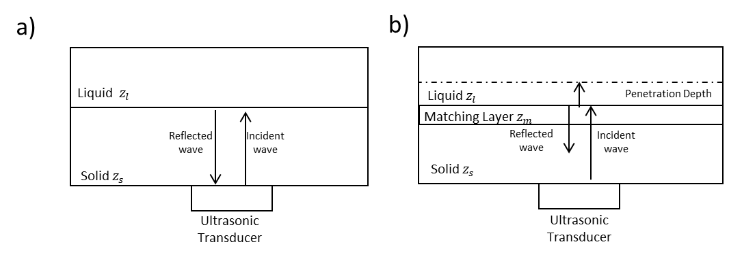
Figure 1: a) Reflection at a solid-liquid interface. The acoustic mismatch does not allow for sensing the liquid and all the ultrasonic energy is reflected back, b) Reflection at a solid-quarter wavelength acoustic lens-liquid interface. The matching layer allows for sensing the liquid viscoelastic properties and the ultrasonic energy is attenuated by the fluid resistance to oscillatory motion.

This setup has been first used in the early 1950s [14] and since then has become very popular to measure viscosity by means of ultrasound. In this configuration, the ultrasonic wave is produced by the ultrasonic transducer, propagates through the solid until it is incident to the solid-liquid interface. There, part of the wave is quickly dissipated in the liquid, within a distance called penetration depth, and part is reflected back. The amount of energy reflected is calculated as:
$$R=\frac{z_{s}-z_{l}}{z_{s}+z_{l}}$$ | (1)
Where $R$ is the reflection coefficient, $z_{l}$ is the modulus of the acoustic impedance of the liquid, $z_{s}$ is the acoustic impedance of the solid material. It can be noticed that when the acoustic impedance of the solid is much higher than the acoustic impedance of the liquid the reflection coefficient approaches the unit value. This means that almost all the acoustic energy is reflected without interacting with the liquid under test. This phenomenon is called acoustic mismatch [25-26]. To avoid acoustic mismatch with a setup like the one shown in Figure (1a) it is necessary to use plastic/polymeric materials that are acoustically similar to the liquid tested. This stopped researchers from implementing ultrasonic reflectance viscometry in most of industrial applications or engineering applications because plastic materials normally degrades over time or they are not resistant in harsh environments.
This is also the case of space applications in which the active ultrasonic element needs to be protected from the harsh environments and radiations by mean of a metal solid substrate. Figure (1b) shows a setup that overcome the previous limitation by the insertion of an acoustic lens, or matching material. Here the ultrasonic vibration is still produced by the piezoelectric element in contact with a solid medium. The ultrasonic wave propagates in the solid medium and through the quarter wavelength matching material, until it is incident to the fluid interface. The amount of energy reflected at the solid-liquid interface is a direct function of the resistance of the fluid medium to the applied shear oscillation, and is therefore a function of viscosity. The total reflection of an ultrasonic wave in a three-layered medium is expressed as [23]:

$$R=\frac{\left(z_{l}+z_{m}\right)\left(z_{m}-z_{s}\right)\left(cos⁡(k_{m}t_{m})+isin⁡(k_{m}t_{m})\right)+\left(z_{l}-z_{m}\right)\left(z_{m}+z_{s}\right)\left(cos⁡(k_{m}t_{m})+isin⁡(k_{m}t_{m})\right)}{\left(z_{l}+z_{m}\right)\left(z_{m}+z_{s}\right)\left(cos⁡(k_{m}t_{m})+isin⁡(k_{m}t_{m})\right)+\left(z_{l}-z_{m}\right)\left(z_{m}-z_{s}\right)\left(cos⁡(k_{m}t_{m})+isin⁡(k_{m}t_{m})\right)}$$ | (2)

Where $t_{m}$ is the matching layer thickness and $z_{m}$ is the matching layer acoustic impedance. From equation (2),when the thickness of the matching layer is a quarter wavelength ($t_{m}=\frac{λ_{m}}{4} )$equation (2) simplifies as [24]:
$$\left|R\right|=\sqrt{\frac{z_{m}^{4}+2z_{l}^{2}z_{s}^{2}-2z_{l}{z_{s}z}_{m}^{2}}{z_{m}^{4}+2z_{l}^{2}z_{s}^{2}+2z_{l}{z_{s}z}_{m}^{2}}}$$ | (3)

Therefore it is possible to notice that the reflection coefficient is equal to zero (total transmission) if the acoustic impedance of the matching layer is
$$z_{m}=\sqrt{z_{s}z_{l}}$$ | (4)

Figure (2) shows the increment in measurement sensitivity due to the presence of the matching layer.
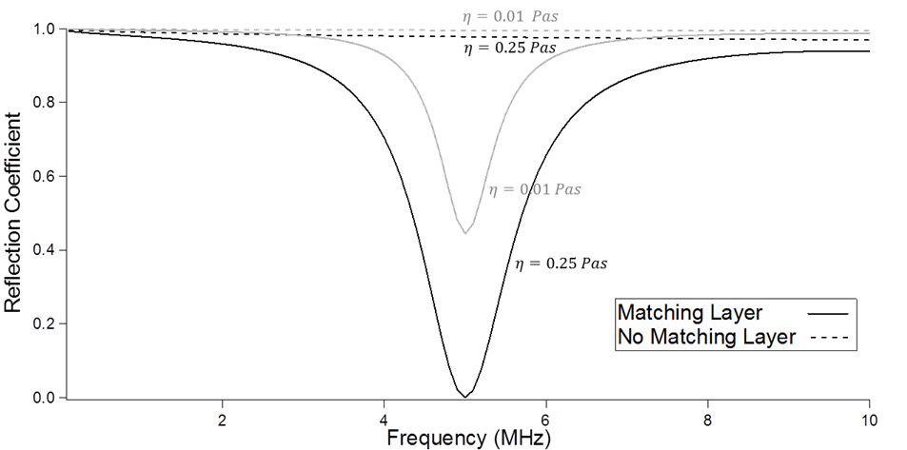
Figure 2: Increment in ultrasonic measurement sensitivity due to matching layer
In Figure (2), the reflection coefficient was measured using equation (1) for a steel-liquid interface and using equation (2) at a steel-matching layer-liquid configuration for two oils of different viscosity (0.01 and 0.25 Pas). This Figure shows that for specific frequencies, called resonance frequency, the measurement sensitivity increases and it is possible to distinguish clearly between the two liquids when the matching layer is present, while without matching layer there is not a clear differentiation between samples of different viscosity. A drop in the reflection coefficient indicates that more ultrasonic energy is dissipated at the interface with the liquid, meaning that the measurement is sensitive to the liquid viscosity. Figure (3) compares equations (2) and (3).
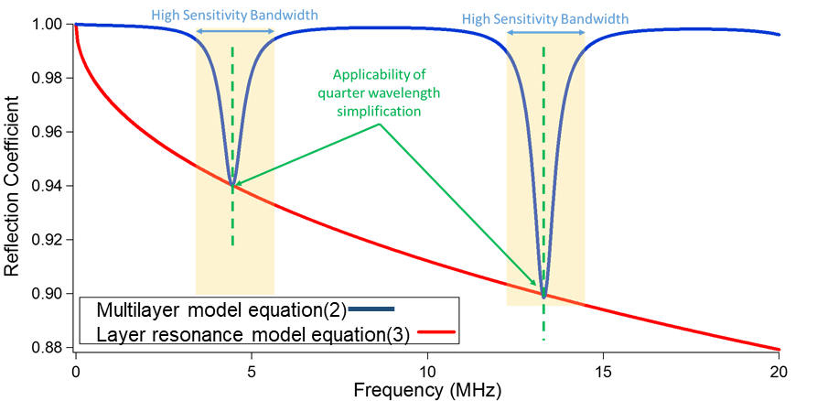
Figure 3: Ultrasonic shear reflection coefficient from a three-layered aluminium-polymer-liquid layered medium in case of a liquid with viscosity of 10 mPas. The sensitivity increases at the so-called resonance frequencies.
Noticeably, the reflection coefficient drops at harmonic frequencies due to the presence of the matching material. Equation (2) describes accurately the increment in sensitivity as frequency varies, on the other had equation (3) is valid only at the resonance frequency. In this work equation (3) is used for simplicity as it leads to great simplifications in the measurement of viscosity. From equation (3), it is possible to calculate the viscoelastic properties of the liquid as follows. First, the acoustic impedance of the liquid is calculated from equation (3) as:
$$\left|z_{l}\right|=\frac{z_{m}^{2}-z_{m}^{2}\sqrt{\left(-R^{2}+2R+1\right)\left(R^{2}+2R-1\right)}}{2\left(-z_{s}R^{2}+z_{s}\right)}$$ | (5)

The acoustic impedance is then correlated to the rheological parameters of the liquid. The acoustic impedance of the liquid is directly correlated to viscosity as [27]:
$$η=\frac{2\left|z_{l}^{2}\right|}{ρ_{l}ω}$$ | (6)
Barlow and Harrison [27] also defined the correlation between acoustic impedance and shear moduli based on a Maxwell model:
$$\left|z_{l}\right|=\left|\sqrt{ρ_{l}G}\right|$$ | (7)

Where G is the complex shear modulus of the liquid. The shear modulus of a liquid is a complex number defined as:
$$G=G^{'}+iG^{''}=η\frac{ω^{2}τ^{2}}{(1+ω^{2}τ^{2})}+i\left(\frac{ωη}{(1+ω^{2}τ^{2})}\right)$$ | (8)
Where G’ is the storage modulus and G’’ is the loss modulus. Substituting equation (8) in (7), it is possible to obtain a value for the Maxwell relaxation time as:

$$τ=\frac{1}{ω}\sqrt{\frac{z_{l}^{4}-ηρ_{l}\sqrt{{-η^{2}ω}^{2}ρ_{l}^{2}+ω^{2}z_{l}^{4}+z_{l}^{4}}}{\left(z_{l}^{2}+ηρ_{l}\right)\left(-z_{l}^{2}+ηρ_{l}\right)}}$$ | (9)

The shear modulus is then calculated by substituting equation (9) and (6) in equation (8).

Apparatus
Figure (3) schematically illustrates the ultrasonic viscometer apparatus. Four pairs of ultrasonic piezoelectric (PZT) shear mode transducers with a centre frequency ranging from 2MHz to 10MHz are bonded on the top face of an aluminium plate of area 50 mm by 80 mm and 30 mm of thickness. The thickness of the block was not relevant for computational purposes but is chosen to allow the optimal separation of reflected ultrasonic pulses. The transducers operate in pitch-catch mode. In this mode of operation, one transducer produces the ultrasonic wave (transmitter) and the second one receives the reflected echo wave (receiver). An arbitrary waveform function generator excites the pulser with a sinusoidal electric signal. Once hit by the electric signal, the pulser vibrates, emitting an ultrasonic wave that propagates through the solid until incident on the solid-liquid interface where part of the wave is transmitted and the rest is reflected back. The reflected signal is received by the second transducer, recorded on an oscilloscope and continuously analysed and stored in real time. This operation is repeated for all couple of ultrasonic sensors.
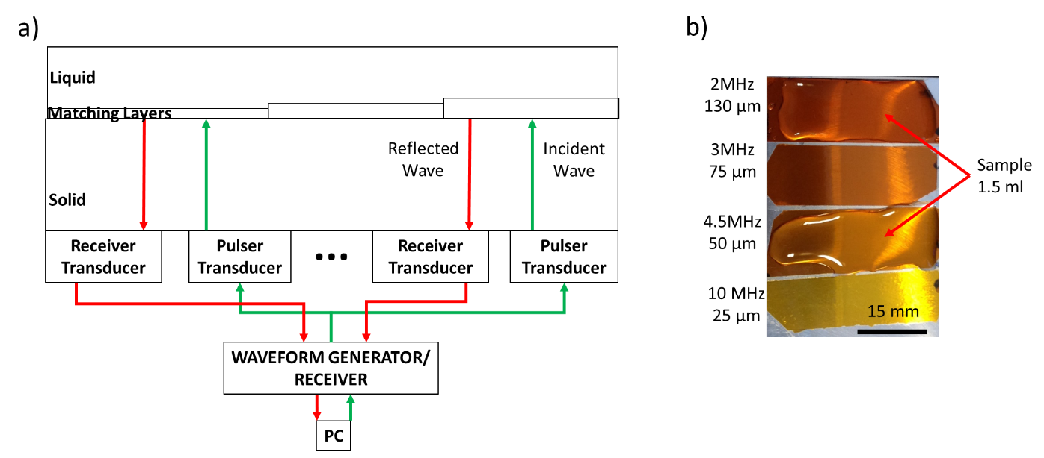
Figure 4: Schematic representation of the measurement apparatus (a) and top view of the ultrasonic viscometer showing the matching layers and the sample deposited on top of two layers (b)
In this apparatus, the quarter wavelength matching material consists of polyimide (Kapton) strips of different thicknesses. Kapton was chosen because it respects the acoustic requirements given in equation (3). Table (2) reports the thickness of the polyimide layers for each desired resonance frequency. The thickness of the layer is calculated as a quarter of the wavelength in the matching material to allow the use of equations (3)-(7) in the calculation of the viscoelastic properties of the samples as:
$$t_{m}=\frac{{nλ}_{m}}{4}$$ | (10)

In equation (9), $t_{m}$ is the thickness of the matching material,$c_{m}$ is the speed of sound in the layer and f is the operating oscillatory frequency and n is the odd resonance frequency integer (e.g. n=1 indicates the first resonance frequency, n=3 indicate the second resonance frequency and so on). As an example, if the transducer operating frequency is 4.5 MHz and the speed of sound in the layer is 850 m/s, the optimum thickness for the matching layer is 47 µm, for n=1. However, from equation (7), for n=3 and a thickness of 47 µm the resonance frequency would be also 13.5 MHz, thus showing that a single matching layer can be used for multi-frequencies applications. The matching layer thickness is then approximated to the closest commercially available coating thickness. Kapton polyimide is chosen as quarter wavelength layer because its mechanical and acoustic properties makes it a suitable acoustic lens and, at the same time, a resistant surface in a wide range of operating temperatures [28-30].
Resonance Frequency  (MHz) | Matching Layer Thickness (µm)
13.5 | 50
9 | 25
4.5 | 50
3 | 75
2 | 130
Table 1: Matching layer thicknesses for the ultrasonic viscometer

Samples tested
The samples were selected following the NASA Europa lander mission guidelines [11]. Currently, the main scope of a lander mission would be the assessment of life presence or the presence of conditions favourable to life proliferation in alien worlds. Therefore, the amino acids were chosen depending on the probability of encountering them in nature.
The main challenge for the instruments in these missions will be the ability to discriminate L- and D-forms and not only the different families of amino acids. Consequently, the synthetic amino acid forms were also analysed. The amino acids were dissolved in a solution of pure distilled water, dH₂O, at different concentrations. The samples are listed in table 2.
Sample | Concentration (m/v) | Viscosity (mPas) | Side chain
L-Serine | 1% | 1.28 | Polar, Neutral
L-Serine | 5% | 1.38 | Polar, Neutral
L-Serine | 10% | 1.6 | Polar, Neutral
D-Serine | 1% | 1.28 | Polar, Neutral
D-Serine | 5% | 1.26 | Polar, Neutral
D-Serine | 10% | 1.53 | Polar, Neutral
Glycine | 1% | 1.11 | Non-polar, Neutral (SH group)
Glycine | 5% | 1.12 | Non-polar, Neutral (SH group)
Glycine | 10% | 1.62 | Non-polar, Neutral (SH group)
L-Alanine | 1% | 1.11 | Hydrophobic, Neutral, Aliphatic
L-Alanine | 5% | 1.26 | Hydrophobic, Neutral, Aliphatic
L-Alanine | 10% | 1.40 | Hydrophobic, Neutral, Aliphatic
D-Alanine | 1% | 1.11 | Hydrophobic, Neutral, Aliphatic
D-Alanine | 5% | 1.17 | Hydrophobic, Neutral, Aliphatic
D-Alanine | 10% | 1.71 | Hydrophobic, Neutral, Aliphatic
L-Valine | 1% | 1.26 | Hydrophobic, Neutral, Aliphatic
L-Valine | 5% | 1.62 | Hydrophobic, Neutral, Aliphatic
D-Valine | 1% | 1.10 | Hydrophobic, Neutral, Aliphatic
D-Valine | 5% | 1.26 | Hydrophobic, Neutral, Aliphatic
L-Leucine | 1% | 1.17 | Hydrophobic, Neutral, Aliphatic
D-Leucine | 1% | 1.14 | Hydrophobic, Neutral, Aliphatic
L-Arginine | 1% | 1.29 | Polar, Basic
L-Arginine | 5% | 1.32 | Polar, Basic
L-Tryptophan | 1% | 1.12 | Hydrophobic, Neutral, Aromatic
Table 2: Concentration and viscosity of the tested amino acid samples
The viscosity of the samples was measured at the temperature of 25°C using a Brookfield DV1 viscometer. The accuracy of the measurement was ±5% and was determined by the reference measurement on pure water that gave an average viscosity of 1.05 mPas.
Signal processing and data analysis.
Equations (2)-(8) show that all the rheological parameters are calculated if the reflection coefficient is known. Figure (5) shows the experimental procedure to obtain the reflection coefficient, and the liquid viscoelastic parameters.
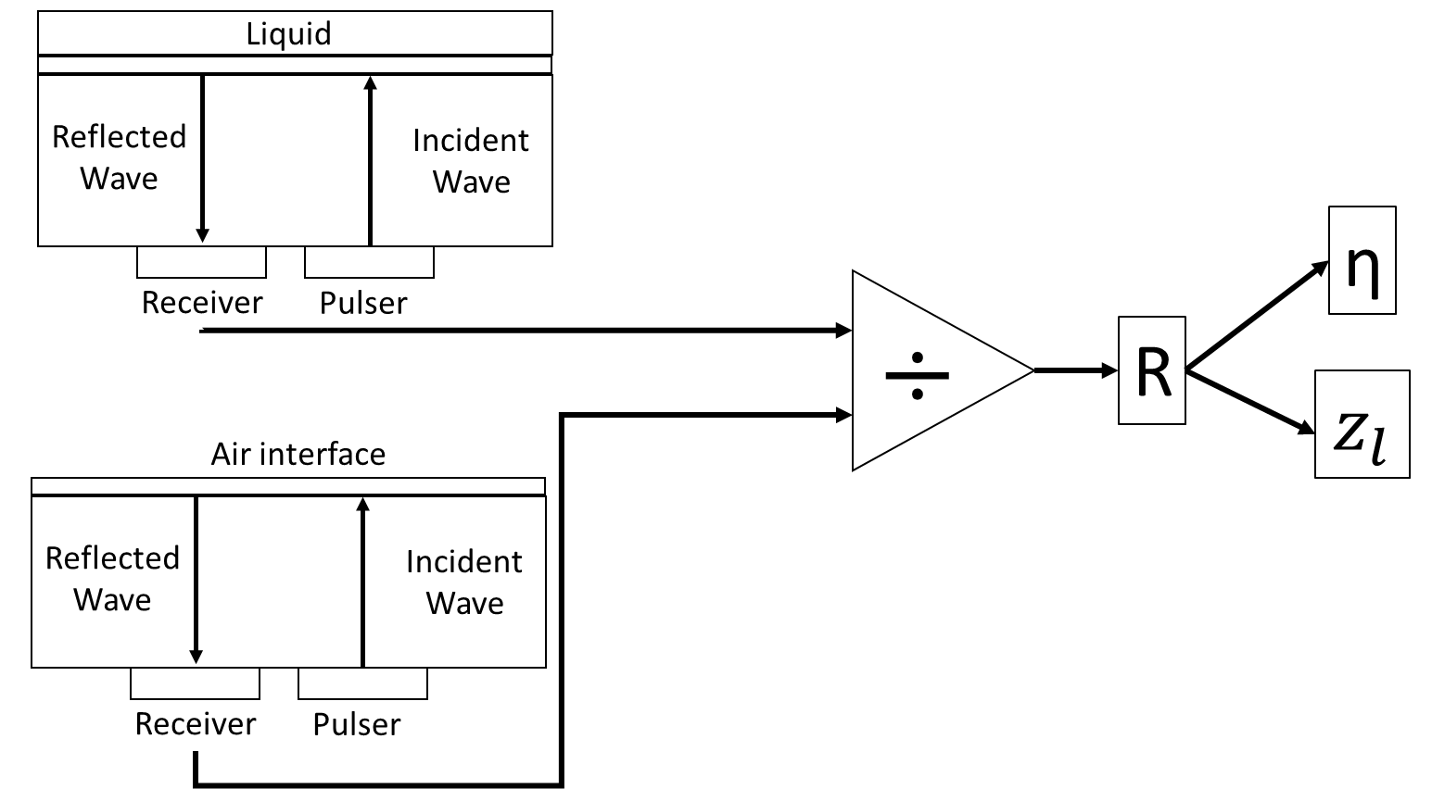
Figure 5: Reflection coefficient acquisition procedure
The reflection coefficient is found experimentally by dividing the frequency spectrum of the signal reflected from the solid-liquid interface ($A_{m}$) by a reference signal obtained from the solid-air interface ($A_{r}$).
$$R=\frac{A_{m}}{A_{r}}$$ | (11)

Where $A_{m}$ is the measurement amplitude, and $A_{r}$is the amplitude of the reference. Figure (6) shows the main characteristics of an ultrasonic signal. The time domain response is characterised by a phase shift between the reference and the measurement signal. The phase shift is function of the viscosity of the liquid, as suggested by previous studies [31]. The models in equations (2)-(8) use the amplitude of the frequency spectrum at the resonance frequency to calculate the reflection coefficient modulus.
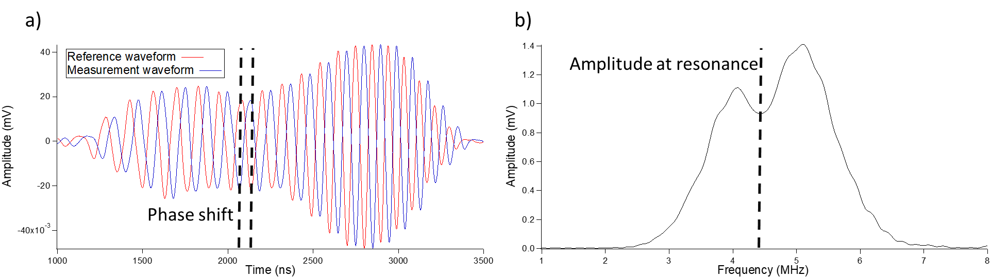
Figure 6: Ultrasonic reflection response in the time domain (a) and in the frequency domain (b)
Figure (7) shows an example of measurement conducted on a reference sample of distilled water, dH₂O. The acquired time domain signals were converted in the frequency domain, and the frequency spectra were divided to measure the reflection coefficient. The reflection coefficient graph in Figure (5) compares the ultrasonic measurement against the expected response in equation (1). Interestingly, the model and the measurement were in great agreement. The minimum reflection coefficient occurred at 4.35 MHz which is the value of reflection coefficient used in the viscosity measurement. This procedure was repeated for each pair of ultrasonic transducers. The reflection coefficients were then converted into the viscoelastic parameters using equations (3) - (5).
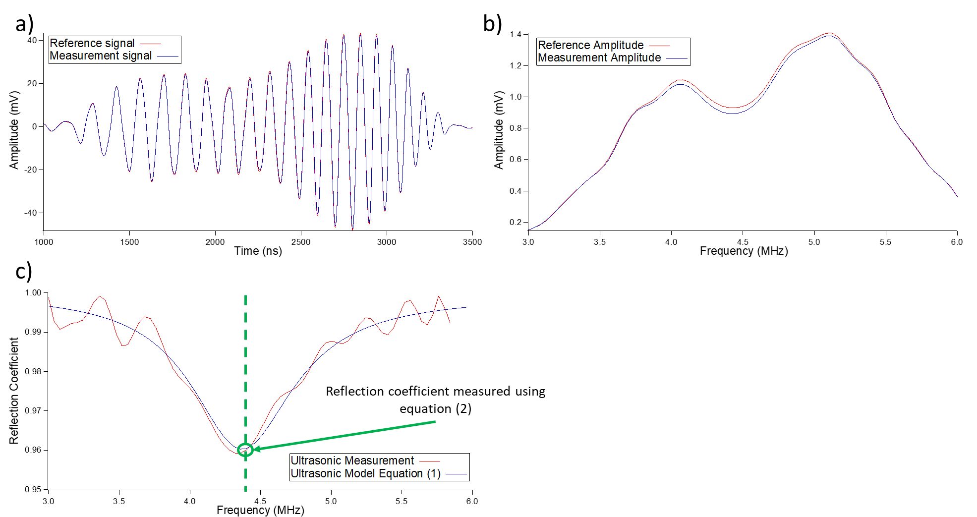
Figure 7:Ultrasonic signal processing from time domain to viscosity quantification
The tests were conducted by depositing 1.5 mL of solution on the surface of the ultrasonic viscometer and acquiring ultrasonic reflected signals at the repetition rate of 1 Hz over 30 minutes. Each acquisition was the average of 50 ultrasonic waves and the test was repeated twice for each sample. Each measurement was conducted over a period of time to give time for the amino acid solution to deposit fully on the sensor’s surface. In fact, the ultrasonic viscometer can only measure the average viscosity of the solution for a thickness that is equal to the penetration depth [32], as shown in Figure (8) and (9).
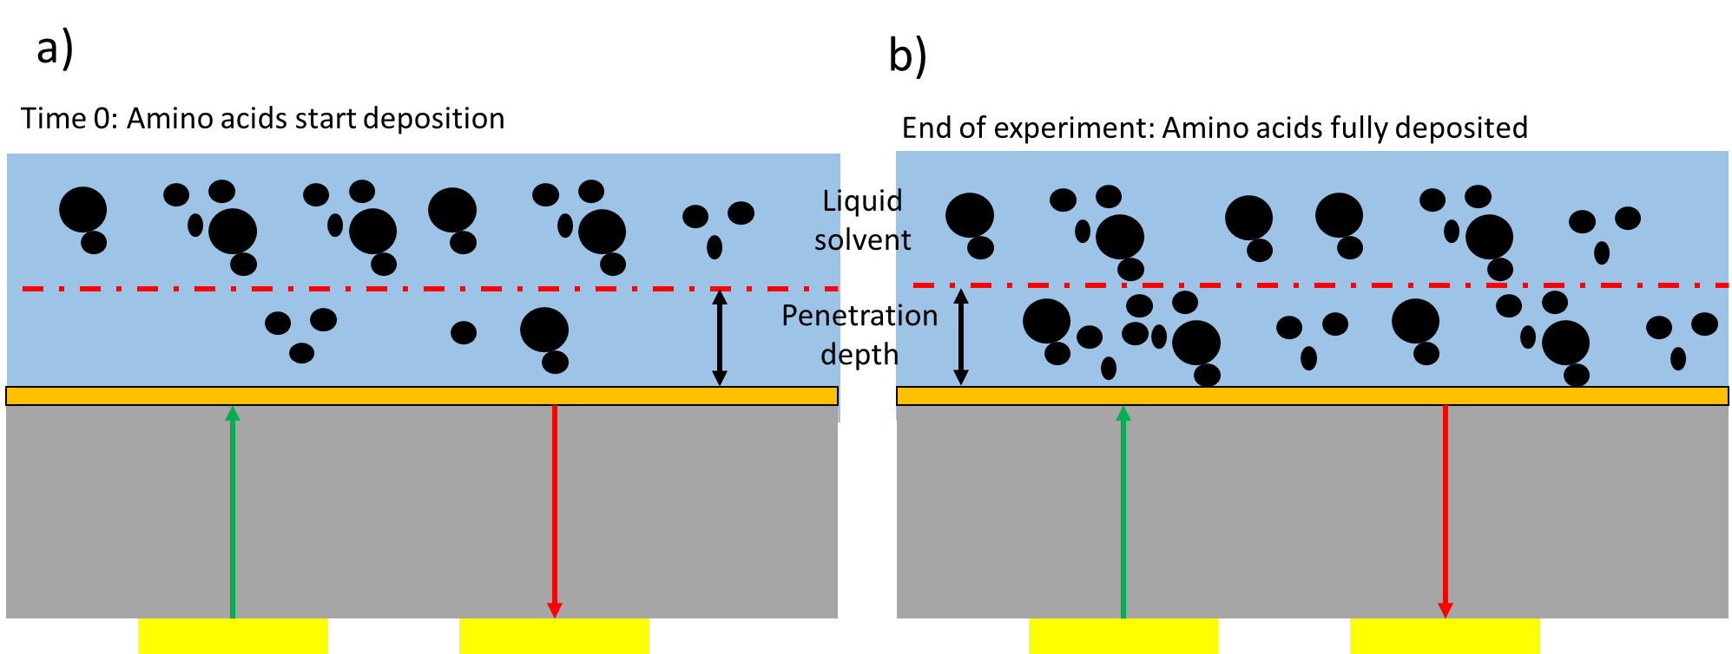
Figure 8: Schematic representation of the operating conditions of the ultrasonic viscometer. The ultrasonic viscometer can measure the average viscosity within the penetration depth, therefore the measurement is time dependent if the solution tested is heterogeneous
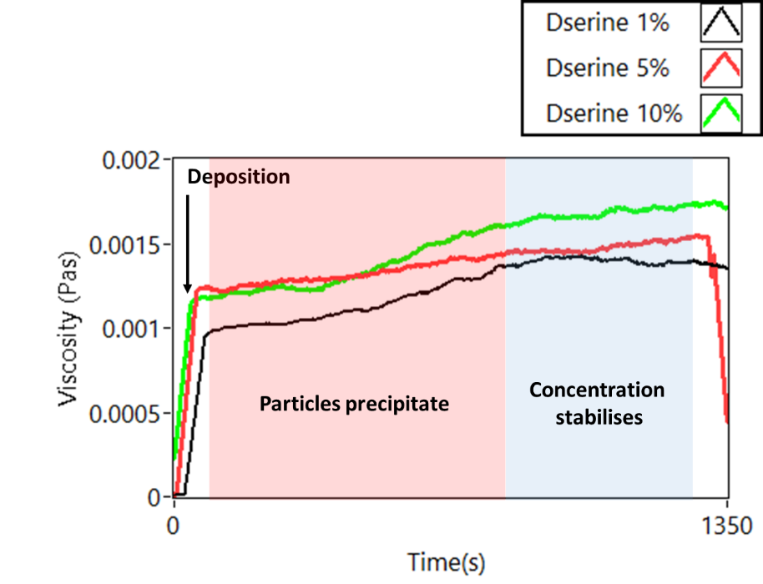
Figure 9: Time dependent measurement of viscosity for the D-Serine solutions
Figure (9) shows that once the particles have precipitated on the sensor surface, the viscosity values stabilises to a constant value. Further, it can be noticed that the results were discriminated by concentration, as expected.
Results
The amino acids aqueous solutions showed a Newtonian behaviour, i.e. the value of viscosity was constant and independent of the applied frequency, as demonstrated in Figure (10) for the L-Serine 1% sample.
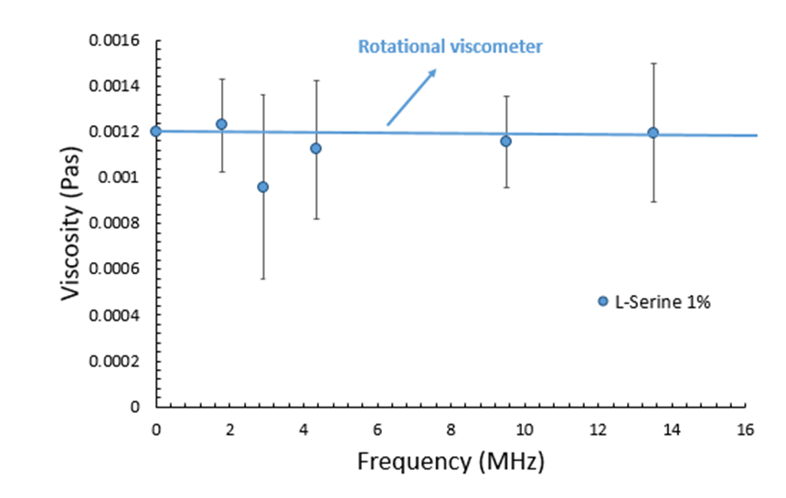
Figure 10: Frequency-Viscosity results for the L-Serine 1% solution
A similar Newtonian behaviour was measured for all the samples tested at the temperature of 25 °C. Therefore, the solutions of amino acids are good samples to validate the measurement of the ultrasonic viscometer against conventional viscometers. Figure (11) shows the average viscosity measured using the ultrasonic viscometer against the rotational viscometer.
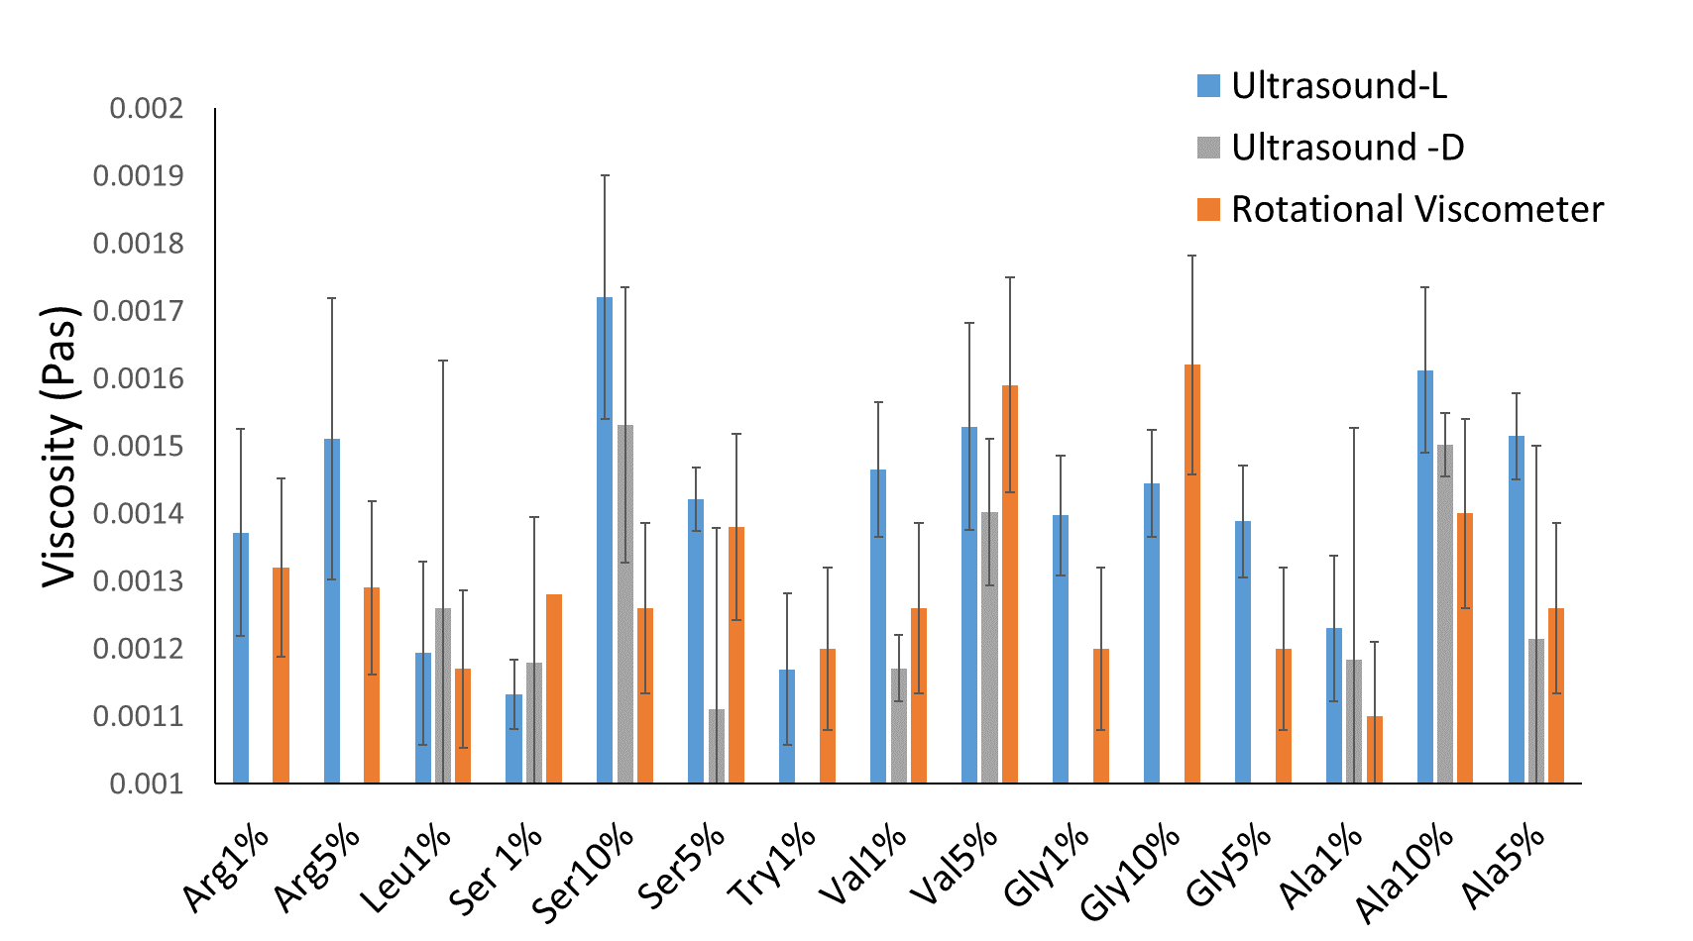
Figure 11: Average viscosity measured for the L- and D- amino acid aqueous solutions. The ultrasonic measurement sensitivity is compared with the rotational viscometer
Figure (11) shows that the ultrasonic measurements are in agreement with the rotational viscometer ones and that no significant change between L- and D- solutions is detected.
However, while the viscosity is constant, the acoustic impedance is a function of frequency. This is a linear function for Newtonian samples. Figure (12) shows, as an example, the frequency dependent acoustic impedance for the sample of L-Serine 1%.
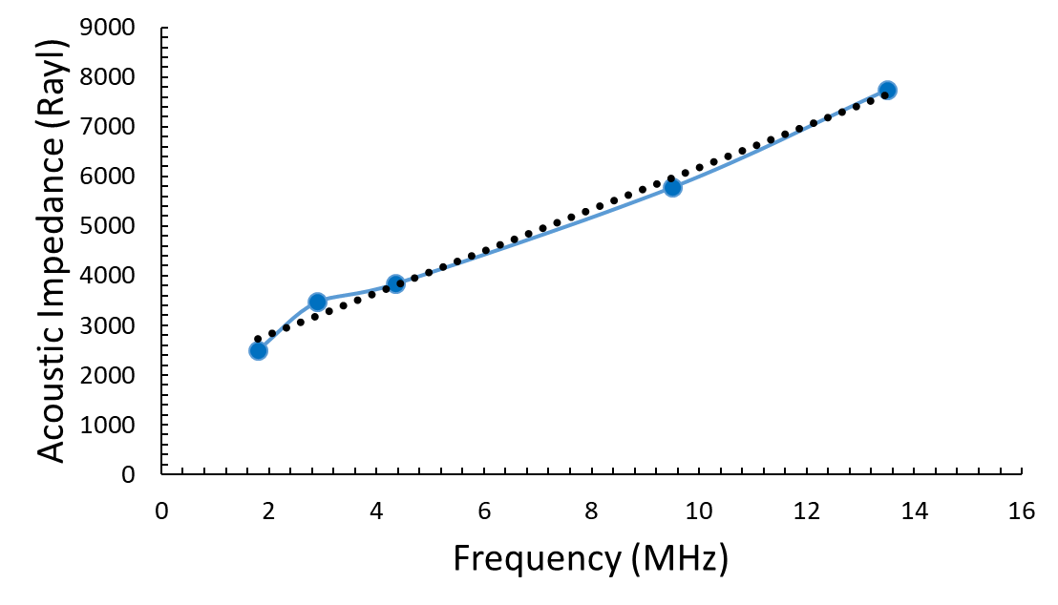
Figure 12: Frequency-Impedance curve for the sample L-Serine 1%
The slope of the ultrasonic shear impedances was measured for all the tested samples, as shown in Figure (13).
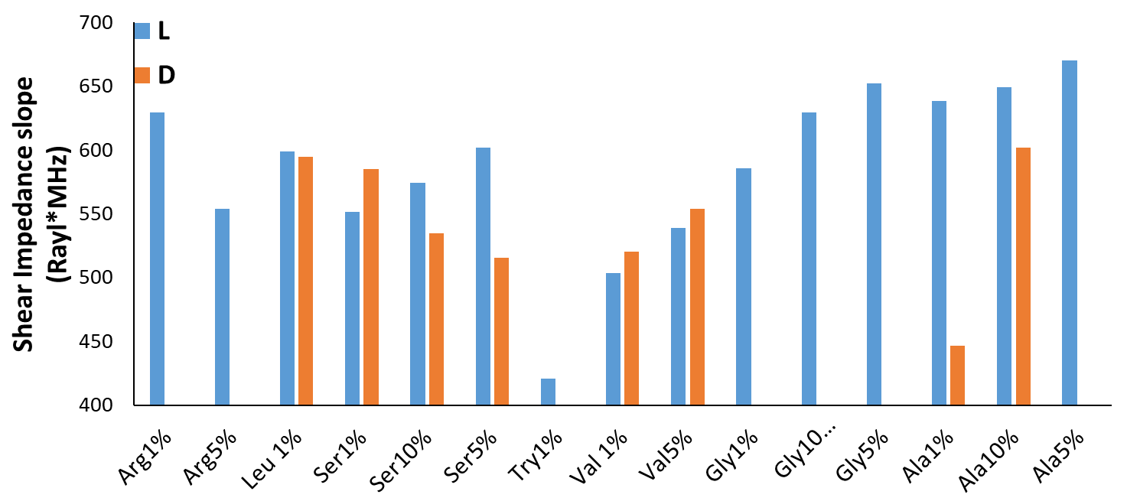
Figure 13: Average slope for the frequency-dependent ultrasonic viscosity measurements
Figure (14) shows a comparison between the slope of the shear acoustic impedance function at 1% concentration. This aimed at comparing all the tested amino acid families at the same concentration.
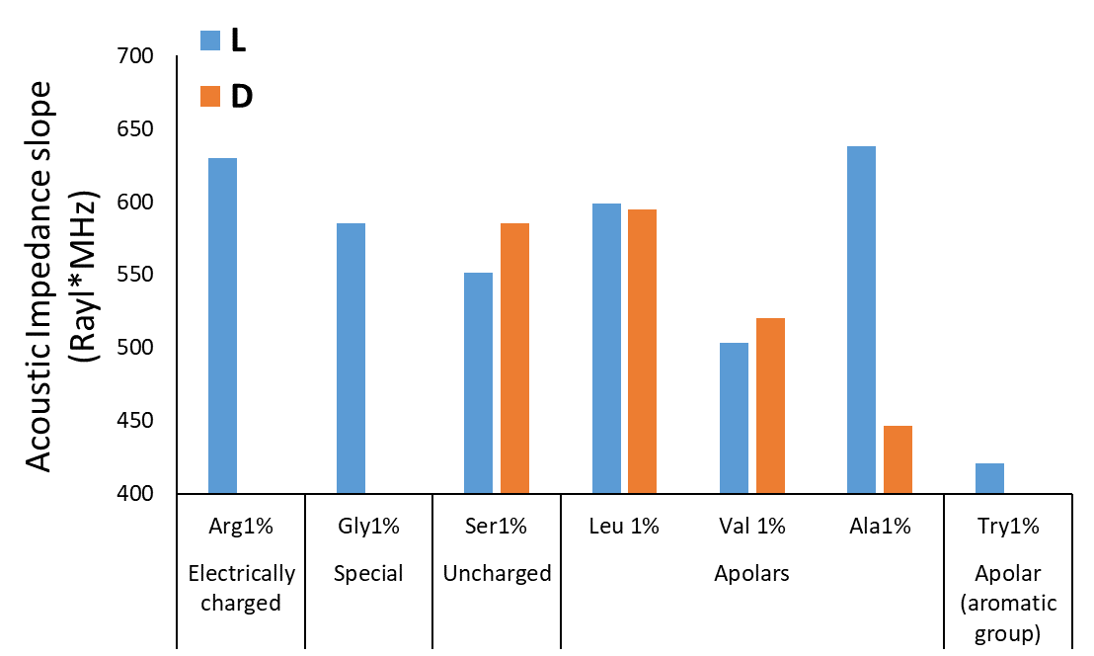
Figure 14: Comparison between the acoustic impedance slopes for the various amino acid groups tested
No clear difference or relation between D- or L- form is measured. However, it is possible to notice that the apolar aromatic group tested has a much lower slope than the other samples tested, thus suggesting that the complexity of the amino acid affects the rate of change of the acoustic impedance.
Ice rheology
The surface temperature of an icy moon like Europa never raises above -160 °C [33], therefore not all samples will have a liquid phase. Can this instrument operate in sub-zero temperature and can it be used to study the rheology of ice samples? To answer these questions, the ultrasonic viscometer was placed in a freezer and the 10% concentration Serine samples were frozen on the viscometer surface. The operating temperatures ranged from -3°C to -6°C. This temperature range is far from that of an icy moon surface, but it is low enough to freeze the amino acid solutions. The 10% concentration Serine samples were chosen because a high amino acid concertation would retard the freezing of the solution allowing to record the viscosity of the solution throughout phase change accurately. The operating procedure did not change, except for the fact that the viscometer was kept in a freezer for a few hours to allow the temperature to be uniform throughout the instrument. This aimed to obtain an accurate reference signal. The tests were conducted at the resonance frequency of 3 MHz and 4.35 MHz. Figure (15) shows the results for the experiment conducted on the 3 MHz matching layer.
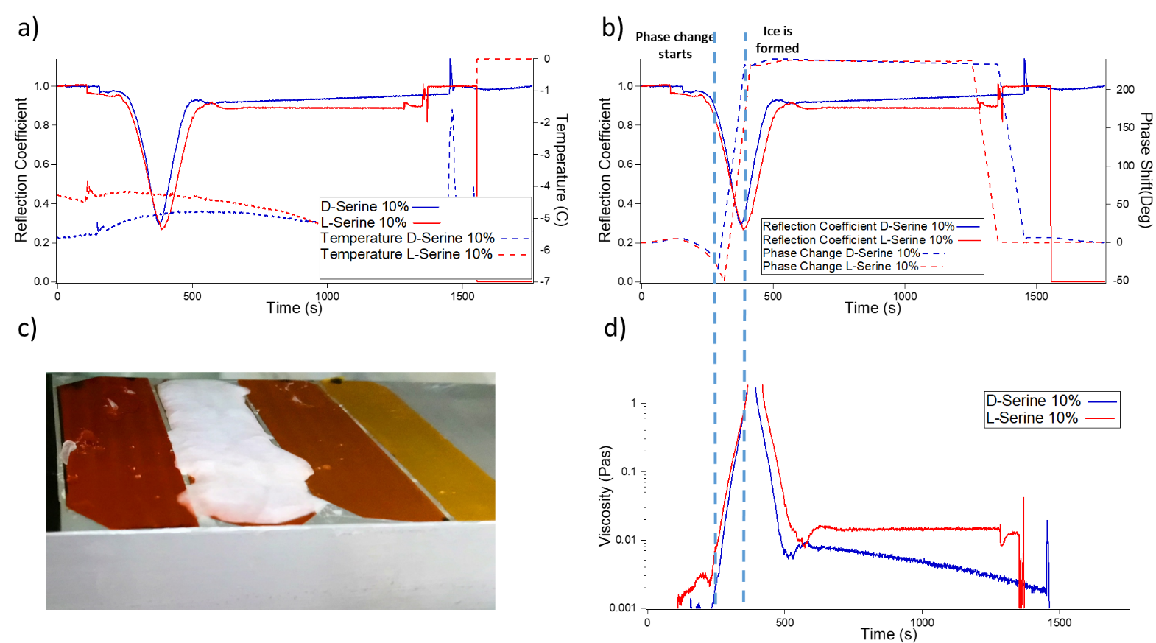
Figure 15: Reflection coefficient, phase and viscosity measured for the solutions of D and L Serine 10% at freezing temperature (respectively Figure a)b)d)). Figure (c) shows the frozen sample on the polyimide matching layer.
The ultrasonic viscometer measurement followed precisely the freezing of the sample as shown by the increment in viscosity. The freezing point is identified in Figure 16(b) as the moment when the reflection coefficient reaches its minimum value and the ultrasonic phase shift reaches its maximum absolute value.
Figure 15(d) shows that the apparent viscosity drops once the freezing point viscosity is measured. This is different from what is physically happening. Indeed, the ultrasonic signal amplitude starts increasing after the freezing point is reached. Therefore, the ultrasonic reflection coefficient increases and the model in equation (4) measures a decrement in viscosity because that model is based on the measurement of the reflection coefficient modulus. However, it can be noticed that the change in phase shift (see Figure 15(b)) is consistent with the liquid/solid state of the solution tested. It seems that a measurement of the apparent ice viscosity will be possible if a new model is developed to take into account both the ultrasonic phase shift and the modulus of the reflection coefficient.
Figure (16) shows the viscosity results for the experiment repeated at the resonance frequency of 4.35 MHz.
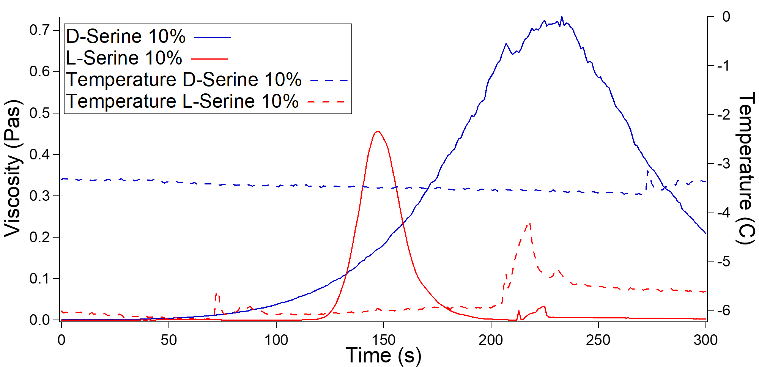
Figure 16: Viscosity measurement at the freezing point for the solutions of D and L Serine 10% at the resonance frequency of 4.35MHz
The D-Serine samples reached the freezing point slower than the L-Serine due to the difference in temperature between the two tests. Unsurprisingly, it can be noticed that the viscosity measured for the two solutions is much lower than the results for the same experiment at 3 MHz, and a difference between the D- and L- sample is measured. Icy solutions are expected to show a Non-Newtonian behaviour due to their complex structure and high viscosity. For Non-Newtonian shear thinning solutions, it is expected that the higher the excitation frequency, the lower the measured viscosity [17].
Conclusions
A prototype for an ultrasonic viscometer for future lander mission was developed. The instrument accuracy was tested by measuring the viscosity of Newtonian amino acids aqueous solutions at room temperature. The accuracy of the viscosity measurements performed with the proposed ultrasonic viscometer was in line with the one of conventional rotational viscometer, and the deviation was similar. This experiment also showed that the slope of the frequency dependent acoustic impedance is a function of the tested amino acid chemical structure complexity.
The instrument was then used to measure the viscosity of the aqueous D- and L- Serine solutions with concentration 10% at the freezing temperature. This preliminary work showed that the instrument can measure precisely when freezing occurs and the viscosity change from liquid to ice phase at freezing temperature. The current ultrasonic models are not able to measure the viscosity after freezing occurs, however the ultrasonic measurements showed that it will be possible to overcome this limitation by combining the amplitude of the reflection coefficient modulus with the phase shift of the ultrasonic time domain signal.
The results shown are particularly important because the viscosity of an ice sample is measured accurately, without requiring the sample to flow, and by means of a miniaturised sensor that is capable of operating in harsh environments at sub-zero temperature.

References
- Brophy, B. H., S. Singh, and V. F. Chevrier. "Effect of Sediment Concentration on Titan Fluid Dynamics." Lunar and Planetary Science Conference. Vol. 46. 2015.
- . Fortes, A. D. "Exobiological implications of a possible ammonia–water ocean inside Titan." Icarus 146.2 (2000): 444-452.
- Jones, E. G., and C. H. Lineweaver. "Using the phase diagram of liquid water to search for life." Australian Journal of Earth Sciences 59.2 (2012): 253-262.
- Miyamoto, Hideaki, et al. "Dynamics of unusual debris flows on Martian sand dunes." Geophysical Research Letters 31.13 (2004).
- Pappalardo, R. T., et al. "Geological evidence for solid-state convection in Europa's ice shell." Nature 391.6665 (1998): 365.
- McKinnon, William B. "Convective instability in Europa's floating ice shell." Geophysical Research Letters 26.7 (1999): 951-954.
- Ojakangas, Gregory W., and David J. Stevenson. "Thermal state of an ice shell on Europa." Icarus 81.2 (1989): 220-241.
- Lauga, Eric, and Thomas R. Powers. "The hydrodynamics of swimming microorganisms." Reports on Progress in Physics 72.9 (2009): 096601.
- Nadeau, Jay, et al. "Microbial morphology and motility as biosignatures for outer planet missions." Astrobiology 16.10 (2016): 755-774.
- Rothschild, Lynn J., and Rocco L. Mancinelli. "Life in extreme environments." Nature 409.6823 (2001): 1092.
- Europa Lander Study 2016 Report: Europa Lander Mission. JPL D-97667.
- Van Wazer, John R. Viscosity and flow measurement: a laboratory handbook of rheology. Interscience Publishers, 1963.
- Masaki, Tadahiko, et al. "Measurements of diffusion coefficients of metallic melt under microgravity—current status of the development of shear cell technique towards JEM on ISS." Measurement Science and Technology 16.2 (2005): 327.
- Mason, W. P., et al. "Measurement of shear elasticity and viscosity of liquids at ultrasonic frequencies." Physical Review 75.6 (1949): 936.
- Sauerbrey, Günter. "Verwendung von Schwingquarzen zur Wägung dünner Schichten und zur Mikrowägung." Zeitschrift für physik 155.2 (1959): 206-222.
- Kessler, Daniel, Peter J. Roth, and Patrick Theato. "Reactive surface coatings based on polysilsesquioxanes: controlled functionalization for specific protein immobilization." Langmuir 25.17 (2009): 10068-10076.
- Schirru, Michele. Development of an Ultrasonic Sensing Technique to Measure Lubricant Viscosity in Engine Journal Bearing In-Situ. Springer, 2017.
- Schirru, M., et al. "Viscosity measurement in a lubricant film using an ultrasonically resonating matching layer." Tribology Letters 60.3 (2015): 42.
- Boldock, Luke. The Influence of Stent Geometry on Haemodynamics and Endothelialisation. Diss. University of Sheffield, 2017.
- Brekhovskikh, Leonid. Waves in layered media. Vol. 16. Elsevier, 2012.
- Pialucha, Tom, and Peter Cawley. "The detection of thin embedded layers using normal incidence ultrasound." Ultrasonics 32.6 (1994): 431-440.
- Reddyhoff, Tom, Rob Dwyer-Joyce, and Phil Harper. "Ultrasonic measurement of film thickness in mechanical seals." Sealing Technology 2006.7 (2006): 7-11.
- Kinsler, Lawrence E., et al. "Fundamentals of acoustics." Fundamentals of Acoustics, 4th Edition, by Lawrence E. Kinsler, Austin R. Frey, Alan B. Coppens, James V. Sanders, pp. 560. ISBN 0-471-84789-5. Wiley-VCH, December 1999. (1999): 560.
- Kazys, R., et al. "Ultrasonic technique for monitoring of liquid density variations." Review of Scientific Instruments 86.1 (2015): 015003.
- Sheen, S. H., H-T. Chien, and A. C. Raptis. "An in-line ultrasonic viscometer." Review of progress in quantitative nondestructive evaluation. Springer, Boston, MA, 1995. 1151-1158.
- Franco, Ediguer E., et al. "Viscosity measurement of Newtonian liquids using the complex reflection coefficient." IEEE transactions on ultrasonics, ferroelectrics, and frequency control 55.10 (2008).
- Harrison, Gilroy, and A. John Barlow. "3. Dynamic Viscosity Measurement." Methods in Experimental Physics. Vol. 19. Academic Press, 1981. 137-178.
- Meserschmidt, Marc, Mathias Meyer, and Peter Luger. "Ultra-low-temperature X-ray data collection with a newly developed 0.1 mm Kapton-film cylinder for a closed-cycle helium cryostat." Journal of applied crystallography 36.6 (2003): 1452-1454.
- Hergenrother, Paul M. "The use, design, synthesis, and properties of high performance/high temperature polymers: an overview." High Performance Polymers 15.1 (2003): 3-45.
- Dhar, Lisa, et al. "Moduli determination in polyimide film bilayer systems: prospects for depth profiling using impulsive stimulated thermal scattering." Journal of applied physics 77.9 (1995): 4431-4444.
- Shah, Vimal V., and Krishnan Balasubramaniam. "Measuring Newtonian viscosity from the phase of reflected ultrasonic shear wave." Ultrasonics 38.9 (2000): 921-927.
- Buckin, Vitaly, and Evgeny Kudryashov. "Ultrasonic shear wave rheology of weak particle gels." Advances in colloid and Interface Science 89 (2001): 401-422.
- Spencer, John R., et al. "Temperatures on Europa from Galileo photopolarimeter-radiometer: nighttime thermal anomalies." Science 284.5419 (1999): 1514-1516.

