Across the Board: Michael North

Professor Michael North

[a] Professor M. North  
Green Chemistry Centre of Excellence  
Department of Chemistry  
University of York  
York, UK, YO10 5DD  
E-mail: Michael.north@york.ac.uk

**Abstract:** Abstract will be provided by the Editorial Office.

The Carbon Dioxide Refinery Concept

Readers of ChemSusChem will have noticed the large number of papers being published on the conversion of carbon dioxide into various chemicals. It is fair to say that there is now global interest amongst the scientific community in the concept of carbon dioxide utilization. A bewildering array of methodologies are being developed involving the use of either enzymes or synthetic catalysts; with energy input thermally, electrochemically, photochemically or using plasma. Just as importantly, policy makers are attracted by the concept of viewing carbon dioxide as a valuable resource rather than as a waste. As a result there have been a number of recent reports for non-scientists on the scope and limitations of using carbon dioxide as a feedstock. In 2017, at the request of the UK government’s chief scientific advisor, The Royal Society of London published a Policy Briefing document on the Potential and Limitations of Carbon Dioxide Utilization.[1] The following year, Mission Innovation published a report on Accelerating CCUS (carbon capture, utilization and storage).[2] The recommendations of this report were agreed by the G20 nations and the European Union. Most recently, the U.S. Department of Energy and Shell, requested the U.S. National Academies of Science, Engineering, and Medicine to produce a report on the commercial viability of carbon utilization technologies and to define a research agenda to address key challenges.[3]

One criticism which is sometimes made against carbon dioxide utilization is its perceived lack of scalability to a size where it could significantly impact on global carbon dioxide emissions. The basis of this criticism is that the market for even the largest scale chemicals (such as urea) is of the order of 108 tonnes per annum, whilst global carbon dioxide emissions are two orders of magnitude greater. This across the board article aims to show that by introducing the concept of a carbon dioxide refinery and applying the same principles as already apply to a petrochemical refinery, carbon dioxide utilization can be both environmentally and economically attractive.

It is informative to start by considering the operation of a petrochemical refinery. Crude oil is a complex mixture of mostly hydrocarbons and a petrochemical refinery first separates this mixture into its constituents, then further transforms some of these primary constituents into bulk chemicals which form the basis of the global chemicals industry. Figure 1[4] shows the outputs of such a refinery graphically. Only 3.4% of the total volume of crude oil processed is converted into chemicals, yet these account for 42% of the market value of the refinery outputs. Thus, converting crude oil into chemicals is a relatively small scale process, but a highly profitable one. In contrast, converting crude oil into fuels is a very large scale process, but one which produces products of comparatively low market value. Petrochemical refining has provided the basis for humankind’s enormous technological and economic growth over the last 100 years. However, crude oil is a finite resource, is not equally distributed and its combustion as fuel is responsible for about 30-50% of the anthropogenic carbon dioxide in the Earth’s atmosphere.[5] A petrochemical refinery is a perfect example of the: produce, use once, then throwaway society that exists today.

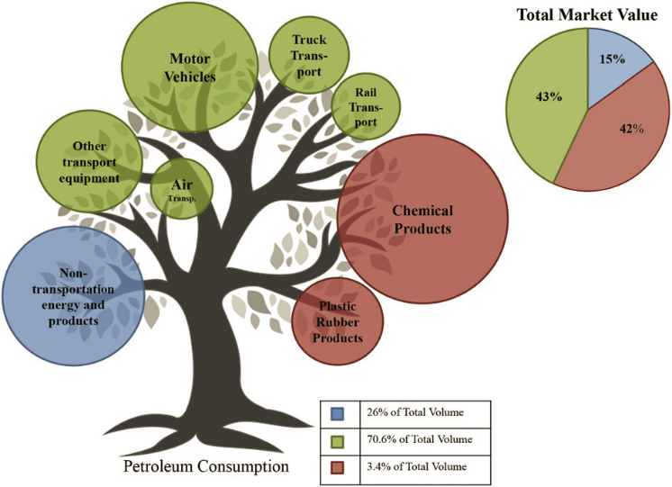

**Figure 1.** A ‘petroleum tree’ showing the outputs of a petrochemical refinery. Reproduced with permission from reference 4.

It is reasonable to assume that exactly the same relative scales and market values will apply to a hypothetical carbon dioxide refinery. Waste carbon dioxide is usually not a pure gas, but a complex mixture of many gases in which carbon dioxide is often a minor component. The exact composition of this gas mixture will depend on the source of the waste carbon dioxide. For example: coal burning power stations; blast furnaces; and cement production all produce at least 109 tonnes of waste carbon dioxide per annum, but mixed with different gases and with carbon dioxide concentrations of 12-33%.[5] Alternatively, carbon dioxide could be obtained directly from the Earth’s atmosphere where its concentration is around 400ppm (0.04%). Whether the carbon dioxide comes from a fixed source or from the atmosphere, the first role of a carbon dioxide refinery would be to separate the carbon dioxide from the other gases. This part of the process is referred to as carbon capture and can be achieved by methods based on chemisorption, physisorption or by use of membranes.[6] Some of these technologies are still at the development stage, whilst others are at pilot plant or already used commercially.

Once the carbon dioxide has been separated from other gases, there are a wide range of products that it can be converted into using methodologies which are either currently being developed or, in a few cases, already commercialized. Scheme 1 shows the conversion of carbon dioxide into fuels, whilst Scheme 2 highlights the potential to produce bulk chemicals from carbon dioxide.



**Scheme 1.** Conversion of CO2 into fuels or fuel precursors.



**Scheme 2.** Examples of conversion of CO2 into large-scale chemicals.

Of the reactions shown in Scheme 1. The reversible conversion of carbon dioxide into formic acid has attracted attention as a way of storing hydrogen for use within fuel cells. The synthesis of methanol is already a commercial process operated by Carbon Recycling International in Iceland. Methanol can be used as a liquid fuel in its own right, or dehydrated to dimethyl ether which can be used to replace diesel. The hydrogenation of carbon dioxide to methane is known as the Sabatier reaction and the methane can be directly incorporated into gas pipelines and used for domestic heating and cooking. Various technologies are being investigated for the conversion of carbon dioxide into carbon monoxide which could then be utilized via Fischer-Tropsch chemistry to produce liquid transport fuels. All of these process do require hydrogen and it is essential that this hydrogen is renewably sourced; almost certainly from water, rather than obtained by the current production process which involves the steam reforming of methane.

Scheme 2 shows just four examples of actual or potential large scale applications of carbon dioxide in the production of chemicals. The reaction between carbon dioxide and ammonia to produce urea is operated globally on a scale of ca 1.8x108 tonnes per annum with around 90% of the urea being used as fertilizer. The reaction between carbon dioxide and epoxides can be controlled, by choice of catalyst, to give cyclic or polymeric products. Cyclic carbonates are the electrolytes used in lithium ion batteries and are produced commercially on a scale of 2x105 tonnes per annum, though this is anticipated to rise significantly as the market for electric vehicles increases. Aliphatic polycarbonates, the alternating copolymers of carbon dioxide and epoxides, are currently being developed as replacements for aromatic polycarbonates derived from bis-phenol A and for which European production is around 7x105 tonnes per annum. By using a less specific catalyst, it is also possible to polymerize epoxides with only occasional incorporation of carbon dioxide leading to poly(ether-carbonates) which due to their terminal hydroxyl groups are also known as polyols and are used in the production of polyurethanes. This technology is being commercialized by Covestro and is currently at demonstration plant scale.[8] Polyhydroxyurethanes can also be prepared from bis-(cyclic carbonates) by a route that avoids the use of isocyanates. The European production of polyurethanes is around 3x106 tonnes per annum. The final example shown in Scheme 2; the synthesis of acrylic acid from carbon dioxide and ethane, is still at the research stage, but has attracted interest from BASF[9] due to the potential to use it to make polyacrylates on a scale of around 3x105 tonnes per annum in Europe alone.

Just as the production of fuels from carbon dioxide requires a renewable source of hydrogen, so the production of chemicals requires renewable sources of the other reactants. There are already commercialized examples of sustainable production routes to reactants needed for some of the examples shown in Scheme 2. Since 2010, ethene has been produced in Brazil from bioethanol obtained by fermentation of sugar cane[10] and in 2017, Croda opened a plant in America to produce ethylene oxide from bioethanol produced from corn husks.[11]

Schemes 1 and 2 form the basis of the proposed carbon dioxide refinery. The conversion of carbon dioxide into fuels has the potential to be carried out on a 1010 tonnes per annum scale, matching and replacing the production of fuel from a petrochemical refinery (Scheme 1). However, the products are of relatively low market value. In contrast, the conversion of carbon dioxide to chemicals (Scheme 2) will only be capable of dealing with about 3-4% of the available waste carbon dioxide, but produces products of much higher market value. Just as for a petrochemical refinery; only by carrying out both chemicals and fuel production is it possible for carbon dioxide utilization to both have an environmental benefit and be economically attractive. This is the concept of a carbon dioxide refinery as illustrated in Figure 2. Recently, the concept of ‘circular chemistry’ was introduced.[12] A carbon dioxide refinery fits within this definition and has the potential to enable a move from a linear to a circular economy for fuel and chemicals.



**Figure 2.** A CO2 refinery (within the black box) with its inputs and outputs.

Acknowledgements

The author thanks EPSRC for grant EP/P026435/1 CO2Chem Network: Establishing the UK as World Leaders in Carbon Dioxide Utilisation.

**Keywords:** CO2 utilization • refinery • circular economy • sustainable development • fuel

[1] <https://royalsociety.org/topics-policy/projects/low-carbon-energy-programme/potential-limitations-carbon-dioxide/> (Last accessed 5 March 2019)

[2] Accelerating CCUS, Mission Innovation, DoE, Washington, 2018 (<https://bit.ly/2UE82An>). (Last accessed 5 March 2019).

[3] D. T. Allen, C. Tran, E. Zeitler, *ACS Sustainable Chem. Eng.* **2019**, *7*, 3702−3709.

[4] N. Hernández, R. C. Williams, E. W. Cochran, *Org. Biomol. Chem.* **2014**, *12*, 2834–2849.

[5] J. Wilcox ‘Carbon Capture’ Springer, New York, 2012, Chapter 1.

[6] a) D. M. D’Alessandro, B. Smit, J. R. Long, *Angew. Chem. Int. Ed.* **2010**, *49*, 6058–6082; b) B. P. Spigarelli, S. K. Kawatra, *J. CO2 Utilization* **2013**, *1*, 69–87; c) E. S. Sanz-Pérez, C. R. Murdock, S. A. Didas, C. W. Jones, *Chem. Rev.* **2016**, *116*, 11840−11876.

[7] http://www.carbonrecycling.is/projects/ (Last accessed 6 March 2019)

[8] https://www.co2-dreams.covestro.com/en (Last accessed 6 March 2019).

[9] https://www.basf.com/global/documents/en/investor-relations/calendar-and-publications/presentations/2019/190110_BASF_RD_Webcast_ Presentation_Dr_Martin_Brudermueller.pdf (Last accessed 7 March 2019).

[10] http://plasticoverde.braskem.com.br/site.aspx/Im-greenTM-Polyethylene (Last accessed 6 March 2019).

[11] https://www.crodapersonalcare.com/en-gb/discovery-zone/learn/sustainability/sustainable-manufacturing/eco-plant (Last accessed 6 March 2019).

[12] T. Keijer, V. Bakker, J. C. Slootweg, *Nature Chem.* **2019**, *11*, 190–195.

|  |
| --- |
|  |
| Biographical Sketch. Michael North obtained his BSc in chemistry from the University of Durham and a D.Phil in organic chemistry from the University of Oxford. After a postdoctoral post at the University of Nottingham, he held academic posts at the Universities of Wales, London and Newcastle, before being appointed to the Chair in Green Chemistry at the University of York. His research interests include catalysis using Earth crust abundant metals, organocatalysis, CO2 utilization and synthesis of synthetic polymers from sustainable feedstocks. He received the 2014 Green chemistry award from the Royal Society of Chemistry.  C:\Users\mn703\MN york photo 2018.jpg |

**Entry for the Table of Contents** (Please choose one layout)

Layout 1:

|  |  |  |  |  |
| --- | --- | --- | --- | --- |
| MINIREVIEW | | | | |
| This across the board article introduces the concept of a carbon dioxide biorefinery as a way of making carbon dioxide utilisation both environmentally beneficial and financially attractive. |  |  |  | Michael North*  Page No. – Page No.  Across the Board: Michael North |
|  |  |