Improving Cardiac Rehabilitation Uptake: Potential health gains by socioeconomic status
Running title: Economic Evaluation of Cardiac Rehabilitation
Sebastian Hinde¹, Laura Bojke¹, Alexander Harrison², Patrick Doherty²
¹ Centre for Health Economics, University of York
² Department of Health Sciences, University of York
Corresponding author: Prof Patrick Doherty, Professor of Cardiovascular Health, Department of Health Sciences, University of York, Seebohm Rowntree Building, Heslington, York, YO10 5DD. patrick.doherty@york.ac.uk, 01904 321385.
Word count including tables, figures, and references: 4742

Abstract
Background
Globally cardiac rehabilitation (CR) is recommended as soon as possible after admission from an acute myocardial infarction or revascularisation. However, uptake is consistently poor internationally, ranging from 10% to 60%. The low level of uptake is compounded by variation across different socioeconomic groups. Policy recommendations continue to focus on increasing uptake and addressing inequalities in participation, however, to date there is a paucity of economic evidence evaluating higher CR participation rates and their relevance to socioeconomic inequality.
Methods
This study constructed a de-novo cost-effectiveness model of CR, utilising the results from the latest Cochrane review and national CR audit data. We explore the role of socioeconomic status by incorporating key deprivation parameters and determine the population health gains associated with achieving an uptake target of 65%.
Results
We find that the low cost of CR and the potential for reductions in subsequent MI and revascularisation rates combine to make it a highly cost-effective intervention. While CR is less cost-effectiveness for more deprived groups; the lower level of uptake in these groups makes the potential health gains, from achieving the target, greater. Using England as a model we estimate the expenditure that could be justified while maintaining the cost-effectiveness of CR, £68.4 million per year.
Conclusions
Increasing CR uptake is cost effective and can also be implemented to reduce known socioeconomic inequalities. Using estimation of potential population health gains and justifiable expenditure we have produced tools with which policy makers and commissioners can encourage greater utilisation of CR services.

Keywords: cardiac rehabilitation, myocardial infarction, economic evaluation, deprivation, inequality

Introduction
As the leading cause of death globally, heart disease was associated with an estimated 9.43 million deaths in 2016.¹ The links between heart disease, the obesity epidemic and physical inactivity is well established,²⁻⁵ and are the primary reason for the risk of heart disease related death being almost three times greater in high income countries than low.¹ As a result, cardiac rehabilitation (CR), which is a multi-component complex intervention, has been at the forefront of attempts to reduce the impact of heart disease on population health in the developed world.^{6, 7} Previous Cochrane^{8, 9} and clinical reviews¹⁰ have found that there are clear benefits from CR, which the National Institute for Health and Care Excellence (NICE) in England have indicated as being highly cost-effective.^{11, 12} As a result, in their latest guidance issued in 2013, NICE recommended that CR is offered as soon as possible after admission for acute Myocardial Infarction (MI),¹² a decision mirrored elsewhere in the world.^{6, 7, 13}
Despite the guidance by NICE and similar initiatives in Europe, Canada, and the US to improve the rate of uptake, the proportion of patients accessing CR remains stubbornly below stated national targets such as 65% in England and 70% in the US,^{6, 14} with uptake ranging from 10% to 60% globally.^{10, 15} The problem of sub-optimal uptake is compounded by poorer uptake in more deprived groups, further compounding inequalities in health.¹⁶
A number of interventions have been proposed to increase CR uptake rates, including improving the education of health professionals¹⁷ and improving the accessibility of rehabilitation centres and home provision.^{18, 19} However, little consideration has been given as to the level of expenditure that can be justified while maintaining the cost-effectiveness of the CR programme, or whether interventions should be stratified by deprivation group to reflect the role of deprivation in uptake and capacity to benefit.
To address these gaps in the evidence, this study explores three key aspects which are (1) determine if CR can be considered cost-effective given the contemporary evidence on its effectiveness, (2) establish what economic analysis can tell us about how much can be spent on interventions to increase uptake, while maintaining cost-effectiveness and (3) explore the role of deprivation in reducing both the potential to engage with CR and to gain from it.

Methods
In order to estimate the cost-effectiveness of CR, a scoping review of the current evidence relating to its effectiveness and cost-effectiveness was undertaken. The 2016 Cochrane review⁸ was identified as the most complete contemporary systematic review of the effectiveness evidence, exploring the impact of CR on four key aspects: the rate of repeat MI, revascularisation as either percutaneous coronary intervention (PCI) or coronary artery bypass grafts (CABG), hospitalisation, and mortality (cardiovascular and all cause). Incorporating 63 trials and 14,486 patients with heart disease, the review represents an authoritative overview of the findings of the CR literature. Details are published elsewhere⁸ but in brief the review found that CR led to a statistically significant reduction in cardiovascular mortality (but not total mortality as per the previous Cochrane review⁹), and hospitalisation, but an insignificant decrease in the rate of MI and revascularisation.
A recent systematic review of cost-effectiveness studies of CR identified a limited number of relevant studies.²⁰ Furthermore, while an economic evaluation was conducted to inform the NICE guidelines (CG172 and CG48) following MI ^{11, 12} it was not appropriate to replicate the original model as it fails to reflect current thinking around the mechanism of CR.⁸ Furthermore, up to date costings and evidence is now available, making the results of the NICE guidelines model inappropriate for current decision making. As a result a de-novo model, taking account of the modern era of cardiology, was constructed to fully incorporate the findings of the Cochrane review into an economic evaluation framework.

The population
We consider a patient population in keeping with the core studies in the CR field: the latest Cochrane review, the National Audit of CR (NACR), latest NICE guideline on CR and a European led, modern era, review of CR.^{8, 12, 21, 22} This constitutes all adults who have had a recent ST evaluation or non-ST elevation MI (STEMI or non-STEMI), PCI, or CABG, consisting of an estimated 121,499 patients in England in 2015/16.²¹ The modelled cohort has a starting age of 67 (the age at which they are eligible for CR) and a male to female ratio of 0.70.²¹

The intervention
In broad terms a CR services are defined ‘comprehensive, long term programmes involving medical evaluation, prescribed exercise, cardiac risk factor modification, education, and counselling’¹⁰, therefore constituting a range of potential modalities tailored to the patient’s needs rather than a single fixed intervention. The 2017 NACR found the majority of patients underwent a group based programme (between 70% and 85%) with a spread across the other modes of delivery such as home-based. Although there is significant variation in terms of intensity, frequency, and duration of CR within the mode of delivery, ^{20, 21} recent observational studies of routine practice suggest that patient benefit is equivalent following group based or home-based CR.²³⁻²⁵
Our approach to the mode of intervention was to be inclusive as per the Anderson review⁸ and the NICE guidance,¹² incorporating the full definition of CR, as is known to occur in clinical practice.²¹

The model
Decision modelling can be used as a quantitative means of combining evidence from a variety of sources to inform a particular decision problem.²⁶ In this case the Cochrane review alongside other sources of evidence, detailed below and in the supplementary appendix, are used within a Markov model structure to explore the impact of CR on the long term health of patients and the costs to the NHS, stratified by patient deprivation.
Figure 1 provides an overview of the model. As a starting point all patients are assumed to inhabit the ‘well’ state, the point at which after their first MI and/or revascularisation, they will begin CR if it is available. Due to the availability of CR at this point in the pathway only, we will not consider events prior to this point. We create two realisations of the potential patient pathway: one where CR is available and the patient undertakes it, and one where it is not available. In both realisations the patient can experience the same possible transitions, as shown in Figure 1, but the probability of them experiencing these is different in the presence of CR, as informed by the Cochrane Review⁸ and national audit estimates.²¹
[Figure 1 here]
Figure 1: schematic of model for both CR and non-CR
The model allows patients to stay in a ‘well’ state, experiencing no further cardiac events, or to require admission to hospital. During a hospitalisation a patient can require no further care and return to the well state, or they can be identified as having had a MI, and can then go on to have a PCI or CABG for the MI, alternatively they can require revascularisation (PCI or CABG) for a non-MI event. From all states patients can die from cardiovascular disease (CVD) related events, other causes, or in the case of revascularisations, surgical adverse events. The structure of the model is driven by the Cochrane analysis, designed around the meta-analyses conducted.
Parameter estimation
The full list of parameters which inform the base-case analysis are given in the Supplementary Appendix. The Cochrane review⁸ provided the informative evidence for many of the parameter estimates required for the model. We re-estimated the meta-analyses conducted in the Cochrane review in order to provide the most flexibility to inform the decision model, which requires transition probabilities rather than the risk ratios estimated in the review. Other model parameters were estimated from other published sources and data requests made to the NACR.
The NHS Reference Costs were used as the main source of unit cost evidence, supplemented with estimates from published literature. Patient quality of life was modelled using the utilities generated in the Lewis et al.²⁷ analysis applied as decrements to an age adjusted profile of ‘normal’ population quality of life scores.²⁸
The model is constructed in keeping with best practice as reported in the NICE Methods Guide²⁹ including the use of a discount rate of 3.5% for both costs and outcomes, a lifetime analytical horizon, and the use of a NHS and personal social services perspective combined with patient health outcomes measured in terms of quality adjusted life years (QALYs).
To estimate the additional expenditure justifiable to increase the rate of uptake while remaining cost-effective we use an estimate of the marginal productivity of the NHS of £12,936/QALY as reported by Claxton et al.³⁰ This was used to estimate the point at which increases in population health from an increase in CR uptake would no longer be worth the opportunity cost to the NHS of funding them in place of other activities.

The role of completion
In addition to issues of low level of uptake of CR, a number of patients who commence the programme do not finish it, estimated as 24.6% using the latest NACR data request. The variation in CR programmes means that the impact of a patient failing to complete can have different impacts. For example, under a cohort programme, where a group conducts the programme as a single class, it is not possible to replace someone who drops out during the course, therefore the place is lost. In contrast under a rolling programme, where patients join and complete the programme on a continuous basis, the drop-out can be replaced by another patient with only the loss of a few sessions.
To ensure a conservative approach to estimating the cost-effectiveness of CR, our base-case analysis assumes that all patients who fail to complete a CR programme entail the full cost of the programme to the NHS but receive none of the health benefits.

Incorporating uncertainty
To explore the role of uncertainty on our model we conducted probabilistic sensitivity analysis (PSA),²⁶ whereby distributions are fitted to all relevant model parameters to reflect the range of possible mean values for the cohort. The informative distributions used are detailed in the Supplementary Appendix. Such an approach explicitly incorporates the uncertainty reported in the Cochrane review regarding the effectiveness of CR. By repeatedly sampling from the informative distributions, the accumulated impact of the combined uncertainty can be reported. The result of this resampling is reported in terms of both the probability of CR being cost-effective as well as the impact of the uncertainty on the justifiable expenditure to increase CR uptake.

Incorporating the impact of deprivation
The role of social inequality and deprivation on cardiovascular health³¹⁻³³ and CR engagement³⁴⁻³⁶ is well documented. To consider the role of deprivation both on the cardiovascular health of patients as well as their propensity to engage with CR we modelled the correlation between a number of key parameters and an index of multiple deprivation (IMD). The parameters included were selected through a pragmatic search of the literature based on the identification of areas where deprivation was expected to have an impact a-priori. The values incorporated in the model are given in Table 1, with all odds ratios indexed against IMD 3 for modelling purposes. As expected a-priori the identified evidence suggests that the level of uptake and completion are worse in more deprived groups (IMD levels 1&2), who also experience poorer health outcomes, both for CVD and all other health concerns.

Table 1: Impact of multiple deprivation (IMD) on model parameters and cardiac rehabilitation (CR) engagement
IMD | CVD mortality | Non-CVD mortality | QoL decrement | Rate of recurrence | CR uptake | CR completion (probability)
1 * | 1.04 | 1.17 | 0.06 | 1.23 | 0.81 | 0.67
2 | 1.00 | 1.06 | 0.02 | 1.10 | 0.91 | 0.72
3 | 1.00 | 1.00 | 0.00 | 1.00 | 1.00 | 0.75
4 | 0.93 | 0.96 | -0.03 | 0.95 | 1.04 | 0.78
5 | 0.81 | 0.92 | -0.05 | 0.83 | 1.12 | 0.80
Source | ONS ³⁷ | ONS ³⁸ | Love-Koh ³⁹ | Smolina ⁴⁰ | NACR data | NACR data
*1 = most deprived

Results
Cost-effectiveness of the CR programme
The cost-effectiveness results generated by the model are given in Table 2, reporting: the total discounted costs and benefits for both CR and no CR strategies, the incremental cost-effectiveness ratio (ICER), and the probability of CR being cost-effective at a threshold value of £12,936/QALY, all stratified by IMD status.

Table 2: Cost-effectiveness of Cardiac rehabilitation (CR) by index of multiple deprivation (IMD)
IMD | no CR |  | CR |  | incremental |  | ICER /QALY | Probability CE
 | disc. Cost* | disc. QALY | disc. cost | disc. QALY | disc. cost | disc. QALY
1** | £7,696 | 3.80 | £8,420 | 4.03 | £724 | 0.22 | £3,240 | 0.996
2 | £7,328 | 4.22 | £8,046 | 4.49 | £718 | 0.27 | £2,630 | 0.997
3 | £6,863 | 4.42 | £7,577 | 4.72 | £714 | 0.30 | £2,395 | 0.998
4 | £6,760 | 4.75 | £7,443 | 5.07 | £683 | 0.32 | £2,133 | 0.996
5 | £6,340 | 5.12 | £6,983 | 5.44 | £643 | 0.32 | £1,991 | 1.000
*disc. – discounted, **1 = most deprived

Across all IMD categories CR is associated with greater total discounted costs and QALYs than no CR, resulting in an ICER that would conventionally be considered highly cost-effective with high certainty, as the mean ICERs are below £3,500/QALY for all IMD groups and the probability of cost-effective 99.6%. The results also demonstrate the impact of socioeconomic inequality on the cost-effectiveness of CR. The poorer quality of life, life expectancy, and recurrence rates of the more deprived results in the deprived cohort’s baseline expected QALYs much lower, 3.80 QALYs in IMD1 compared to 5.12 in IMD5, while their poorer completion rates make their propensity to gain under the current CR system less, incremental QALYs 0.22 compared to 0.32.
Scatter plots presenting the probabilistic simulations for each of the IMD groups, and a table of results under the assumption that completion rates are 100%, are provided in the Supplementary Appendix.
The benefit and justifiable cost of reaching 65% uptake
Table 3 provides estimates of the annual total health gains (in terms of QALYs) from achieving the 65% uptake target (assuming current rates of completion), alongside the justifiable expenditure to achieve the target, stratified by IMD. The total population health gain was calculated by combining the increased uptake required to achieve the target, the estimated size of the eligible population per year, and the QALY gain per person starting CR as reported in Table 2. The total justifiable expenditure represents an estimate of the additional cost that could be spent on a CR programme while maintaining its cost-effectiveness.

Table 3: Annual benefits and justifiable cost of reaching 65% target, by index of multiple deprivation (IMD)
IMD | current uptake (NACR data)* | Increment to 65% target |  | eligible population (NACR data 2015/16 data) |  | QALY gain per person of CR | Total QALY gain for reaching target | justifiable expenditure to reach target while cost effective
 |  |  |  |  |  |  |  | per person | whole pop
1** | 37.61% | 27.39% |  | 22,194 |  | 0.22 | 1,358 | £2,166 | £13,167,695
2 | 41.97% | 23.03% |  | 22,952 |  | 0.27 | 1,442 | £2,812 | £14,863,740
3 | 46.21% | 18.79% |  | 23,470 |  | 0.30 | 1,314 | £3,141 | £13,849,816
4 | 48.14% | 16.86% |  | 27,086 |  | 0.32 | 1,464 | £3,462 | £15,812,812
5 | 51.75% | 13.25% |  | 22,842 |  | 0.32 | 978 | £3,537 | £10,701,547
 |  |  |  |  |  | Total | 6,556 | N/A | £68,395,610
*the numerator for this estimate of uptake is calculated using only those programmes which upload their data to NACR, averaged across 2015 to 2018, we assume the same rate of uptake in these programmes as those who do not, this assumption is consistent with current NACR reporting.²¹ **1 = most deprived.

The table shows that while the potential health gains per person, and therefore the justifiable expenditure to achieve them, is less in the more deprived groups, as they have the greatest required increase in uptake to achieve a 65% target, the total justifiable expenditure to achieve it is similar to the less deprived. The exception is the IMD 5 group who, in spite of their large potential to gain from CR, have a relatively low total justifiable expenditure (£10.7 million) due to their significantly higher current uptake greatly reducing the total gain from achieve the target. The total justifiable expenditure of £68.4 million across all groups provides an estimate of the maximum annual expenditure that could be justified if intervention was able to increase uptake to 65% in all IMD groups.
Alongside estimating the probability of CR being cost-effective the PSA simulations can be used to show the impact of parametric uncertainty on the estimate of total justifiable annual cost to reach a 65% uptake target, this is shown in Figure 2. The figure shows the cumulative distribution functions of total justifiable cost to achieve the target, stratified by IMD group.

[Figure 2 here]
Figure 2: Cumulative distribution function for total justifiable cost, by index of multiple deprivation (IMD)

For IMD1-4 roughly 90% of the simulated values occur under £26.0 million, highlighting the large variation in the estimate, for IMD5 this is under £18.0 million. The distribution of IMD5 lies apart from the others due to the lower required increase in uptake to reach a 65% target, despite the relatively greater justifiable expenditure per person.
Summing across all IMD groups gives a total justifiable expenditure of £68.4 million if all groups achieve the target, with a 95% confidence interval of £44.1 to £94.6 million. If a 65% target was achieved our analysis suggests this would result is a reduction of roughly 21,000 hospital admissions and 8,500 deaths averted over 10 years. If a more optimistic target of 85% was set, there would be a reduction of almost 49,000 admissions over 10 years, and 19,500 fewer deaths over 10 years.

Discussion
We find that the low cost of CR and the potential for reductions in subsequent MI and revascularisation rates combine to make it a highly cost-effective intervention across all IMD groups. While the per patient lifetime costs to the NHS of providing CR to more deprived groups is greater than less deprived, and the expected QALY gains less, the lower level of current uptake in the more deprived groups makes the potential health gains from achieving a 65% target greater, and thus the total justifiable expenditure.
The main strength of this analysis is that this is the first economic evaluation of CR to incorporate the findings of the Cochrane review, alongside the incorporation of the role of deprivation on both cardio-vascular health and engagement with CR. This framework provides estimates of justifiable expenditure which can facilitate decision makers to invest in policies to increase CR uptake.
However, the analysis also has a number of weaknesses, primarily the failure to reflect different CR programmes and the potentially restrictive structure of the model. Ideally the economic evaluation would incorporate the range of different CR programme types to explore the relative cost-effectiveness of different approaches. However, the nature of the Cochrane review, which did not stratify by CR type, in addition to the recommendation that CR is flexible to patient preferences, made the incorporation of multiple programme types into the analysis both infeasible and potentially uninformative to decision makers. Furthermore, recent analyses suggests that outcomes and completion rates do not vary substantially between different modes of delivery.²³⁻²⁵
Similarly, the structure of the model is potentially an over-simplification of the post-event patient pathway, failing to explicitly reflect the full range of events, e.g. stroke, and long term non-fatal disability. However, the use of the Cochrane review to inform the parameter estimates limited the potential to incorporate a wider set of explicit patient events.
The most valuable element of this analysis is its ability to be used as a framework to demonstrate the business case for investment in interventions which increase the uptake of CR, particularly those which address the issue of inequality of uptake.[21] Furthermore, by demonstrating the impact of uncertainty around the patient pathway we allow decision makers to understand how the estimate of justifiable expenditure to reach a 65% target can be tailored to their aversion to risk.
Whilst the probabilistic analysis demonstrates that while CR is highly likely to be cost-effective, with a probability of being cost-effective of almost 100% for all IMD categories, the uncertainty in the parameter estimates results in a wide distribution in terms of the justifiable expenditure to increase CR uptake. Therefore, while there is little value in further research in terms of demonstrating the cost-effectiveness of CR, such research would be informative to the business case of interventions seeking to increasing uptake to ensure efficient spending.
Finally, the analysis focus on increasing CR uptake, however, there is the potential for the expenditure on CR programmes to be wasted if patients do not complete the programme. As a result, further discussion and research should be conducted to explore the role of non-completion on impacting the effectiveness and cost-effectiveness of CR, and the propensity of interventions to increase completion rates.
Conclusion
We conclude that CR, as it is currently delivered, is cost-effective across all IMD groups due to its low cost and high effectiveness in improving cardiovascular outcomes, as demonstrated by the Cochrane review. Furthermore, we show that there is a clear business case for spending money on incentives which increase CR uptake to a 65% target, stratified by IMD, with a justifiable expenditure of £68.4 million per year. Our analysis does, however, demonstrate that there is significant uncertainty around this justifiable expenditure, which originates from the uncertainty in the Cochrane reviews estimates of the effectiveness of CR. However, the lowest 95% confidence interval of the total justifiable expenditure is still £44.1 million, demonstrating the large potential benefit of increasing CR uptake regardless of the significant uncertainty.

Acknowledgements
The authors would like to acknowledge the British Heart Foundation National Audit of Cardiac Rehabilitation (NACR) and NHS Digital for their support in hosting the data. Clinical audit and associated research to improve uptake and the quality of service delivery is only possible through dedicated clinical staff entering data.

Funding
PD and AH are part funded by the British Heart Foundation (BHF) (grant reference 040/PSS/17/18/NACR). SH and LB were funded by the NIHR CLAHRC Yorkshire and Humber. www.clahrc-yh.nihr.ac.uk. The views expressed are those of the author(s), and not necessarily those of the BHF, NHS, the NIHR or the Department of Health and Social Care.

Conflict of Interests
The authors have no conflicts of interest pertaining to this study or paper.
Authors’ Contributions
PD and LB contributed to the conception and design of the work. SH conducted the mathematical modelling and analysis. AH provided data acquisition and interpretation. All authors contributed to the drafting of the submitted manuscript and gave final approval and agreement to be accountable for all aspects of work ensuring integrity and accuracy.

References
1. WHO. Global Health Observatory (GHO) data: Top 10 causes of death. http://wwwwhoint/gho/mortality_burden_disease/causes_death/top_10/en/ accessed 04/10/2018.
2. Carnethon MR. Physical Activity and Cardiovascular Disease: How Much is Enough? American journal of lifestyle medicine 2009; 3: 44S-49S. DOI: 10.1177/1559827609332737.
3. Soares-Miranda L, Siscovick DS, Psaty BM, et al. Physical Activity and Risk of Coronary Heart Disease and Stroke in Older Adults: The Cardiovascular Health Study. Circulation 2016; 133: 147-155. 2015/11/06. DOI: 10.1161/circulationaha.115.018323.
4. Berlin JA and Colditz GA. A meta-analysis of physical activity in the prevention of coronary heart disease. American journal of epidemiology 1990; 132: 612-628. 1990/10/01.
5. Powell KE, Thompson PD, Caspersen CJ, et al. Physical activity and the incidence of coronary heart disease. Annual review of public health 1987; 8: 253-287. 1987/01/01. DOI: 10.1146/annurev.pu.08.050187.001345.
6. Ades PA, Keteyian SJ, Wright JS, et al. Increasing Cardiac Rehabilitation Participation From 20% to 70%: A Road Map From the Million Hearts Cardiac Rehabilitation Collaborative. Mayo Clinic Proceedings 2017; 92: 234-242. DOI: 10.1016/j.mayocp.2016.10.014.
7. Piepoli MF, Hoes AW, Agewall S, et al. 2016 European Guidelines on cardiovascular disease prevention in clinical practice: The Sixth Joint Task Force of the European Society of Cardiology and Other Societies on Cardiovascular Disease Prevention in Clinical Practice (constituted by representatives of 10 societies and by invited experts)Developed with the special contribution of the European Association for Cardiovascular Prevention & Rehabilitation (EACPR). European heart journal 2016; 37: 2315-2381. 2016/05/26. DOI: 10.1093/eurheartj/ehw106.
8. Anderson L, Oldridge N, Thompson DR, et al. Exercise-Based Cardiac Rehabilitation for Coronary Heart Disease: Cochrane Systematic Review and Meta-Analysis. Journal of the American College of Cardiology 2016; 67: 1-12. 2016/01/15. DOI: 10.1016/j.jacc.2015.10.044.
9. Heran BS, Chen JM, Ebrahim S, et al. Exercise-based cardiac rehabilitation for coronary heart disease. The Cochrane database of systematic reviews 2011: Cd001800. 2011/07/08. DOI: 10.1002/14651858.CD001800.pub2.
10. Dalal HM, Doherty P and Taylor RS. Cardiac rehabilitation. BMJ : British Medical Journal 2015; 351. DOI: 10.1136/bmj.h5000.
11. NICE. MI – secondary prevention: Secondary prevention in primary and secondary care for patients following a myocardial infarction. NICE: London 2007; CG48.
12. NICE. Myocardial infarction: cardiac rehabilitation and prevention of further cardiovascular disease. NICE: London 2013; CG172.
13. Contractor AS. Cardiac rehabilitation after myocardial infarction. The Journal of the Association of Physicians of India 2011; 59 Suppl: 51-55. 2012/05/26.
14. Department of Health. Cardiovascular Disease Outcomes Strategy: Improving outcomes for people with or at risk of cardiovascular disease Department of Health: London 2013.
15. Bjarnason-Wehrens B, McGee H, Zwisler AD, et al. Cardiac rehabilitation in Europe: results from the European Cardiac Rehabilitation Inventory Survey. European journal of cardiovascular prevention and rehabilitation : official journal of the European Society of Cardiology, Working Groups on Epidemiology & Prevention and Cardiac Rehabilitation and Exercise Physiology 2010; 17: 410-418. 2010/03/20. DOI: 10.1097/HJR.0b013e328334f42d.
16. Al Quait A, Doherty P, Gutacker N, et al. In the modern era of percutaneous coronary intervention: Is cardiac rehabilitation engagement purely a patient or a service level decision? European journal of preventive cardiology 2017; 24: 1351-1357. 2017/06/22. DOI: 10.1177/2047487317717064.
17. Caulin-Glaser T and Schmeizl R. Impact of educational initiatives on gender referrals to cardiac rehabilitation. Journal of Cardiopulmonary Rehabilitation and Prevention 2000; 20: 302.
18. Cooper A, Jackson G, Weinman J, et al. Factors associated with cardiac rehabilitation attendance: a systematic review of the literature. Clinical rehabilitation 2002; 16: 541-552.
19. Lewin B, Robertson IH, Cay EL, et al. Effects of self-help post-myocardial-infarction rehabilitation on psychological adjustment and use of health services. Lancet (London, England) 1992; 339: 1036-1040. 1992/04/25.
20. Shields GE, Wells A, Doherty P, et al. Cost-effectiveness of cardiac rehabilitation: a systematic review. Heart 2018. DOI: 10.1136/heartjnl-2017-312809.
21. British Heart Foudation. The National Audit of Cardiac Rehabilitation: Annual Statistical Report 2017. British Heart Foundation: London 2018.
22. Rauch B, Davos CH, Doherty P, et al. The prognostic effect of cardiac rehabilitation in the era of acute revascularisation and statin therapy: A systematic review and meta-analysis of randomized and non-randomized studies - The Cardiac Rehabilitation Outcome Study (CROS). European journal of preventive cardiology 2016; 23: 1914-1939. 2016/10/24. DOI: 10.1177/2047487316671181.
23. Harrison AS and Doherty P. Does the mode of delivery in routine cardiac rehabilitation have an association with cardiovascular risk factor outcomes? European journal of preventive cardiology 2018: 2047487318798923. 2018/09/07. DOI: 10.1177/2047487318798923.
24. Harrison AS and Doherty P. Does the mode of delivery in Cardiac Rehabilitation determine the extent of psychosocial health outcomes? International journal of cardiology 2018; 255: 136-139. 2018/02/10. DOI: 10.1016/j.ijcard.2017.11.056.
25. Harrison AS, Tang L and Doherty P. Are physical fitness outcomes in patients attending cardiac rehabilitation determined by the mode of delivery? Open Heart 2018; 5. DOI: 10.1136/openhrt-2018-000822.
26. Drummond M, Sculpher, M., Claxton, K., Stoddard, G., Torrance, G. Methods for the Economic Evaluation of Health Care Programmes. Oxford 2015; Fourth Edition.
27. Lewis EF, Li Y, Pfeffer MA, et al. Impact of cardiovascular events on change in quality of life and utilities in patients after myocardial infarction: a VALIANT study (valsartan in acute myocardial infarction). JACC Heart failure 2014; 2: 159-165. 2014/04/12. DOI: 10.1016/j.jchf.2013.12.003.
28. Sullivan PW, Slejko JF, Sculpher MJ, et al. Catalogue of EQ-5D scores for the United Kingdom. Medical decision making : an international journal of the Society for Medical Decision Making 2011; 31: 800-804. 2011/03/23. DOI: 10.1177/0272989x11401031.
29. NICE. Guide to the methods of technology appraisal 2013. NICE: London 2013.
30. Claxton K, Martin S, Soares M, et al. Methods for the estimation of the National Institute for Health and Care Excellence cost-effectiveness threshold. Health technology assessment (Winchester, England) 2015; 19: 1-503, v-vi. 2015/02/19. DOI: 10.3310/hta19140.
31. Bhatnagar P, Wickramasinghe K, Williams J, et al. The epidemiology of cardiovascular disease in the UK 2014. Heart 2015. DOI: 10.1136/heartjnl-2015-307516.
32. Cooper RS. Social inequality, ethnicity and cardiovascular disease. International journal of epidemiology 2001; 30: S48.
33. Diez-Roux AV, Link BG and Northridge ME. A multilevel analysis of income inequality and cardiovascular disease risk factors. Social Science & Medicine 2000; 50: 673-687. DOI: https://doi.org/10.1016/S0277-9536(99)00320-2.
34. Grace SL, Abbey SE, Shnek ZM, et al. Cardiac rehabilitation II: referral and participation. General Hospital Psychiatry 2002; 24: 127-134. DOI: https://doi.org/10.1016/S0163-8343(02)00179-2.
35. Lane D, Carroll D, Ring C, et al. Predictors of attendance at cardiac rehabilitation after myocardial infarction. Journal of Psychosomatic Research 2001; 51: 497-501. DOI: https://doi.org/10.1016/S0022-3999(01)00225-2.
36. Tod AM, Lacey EA and McNeill F. ‘I’m still waiting...': barriers to accessing cardiac rehabilitation services. Journal of Advanced Nursing 2002; 40: 421-431. DOI: doi:10.1046/j.1365-2648.2002.02390.x.
37. ONS. How does deprivation vary by leading cause of death? ONS: Newport 2017.
38. ONS. National life tables: England 2014-2016. ONS: Newport 2018.
39. Love-Koh J, Asaria M, Cookson R, et al. The Social Distribution of Health: Estimating Quality-Adjusted Life Expectancy in England. Value in health : the journal of the International Society for Pharmacoeconomics and Outcomes Research 2015; 18: 655-662. 2015/08/25. DOI: 10.1016/j.jval.2015.03.1784.
40. Smolina K, Wright FL, Rayner M, et al. Long-term survival and recurrence after acute myocardial infarction in England, 2004 to 2010. Circulation: Cardiovascular Quality and Outcomes 2012; 5: 532-540.
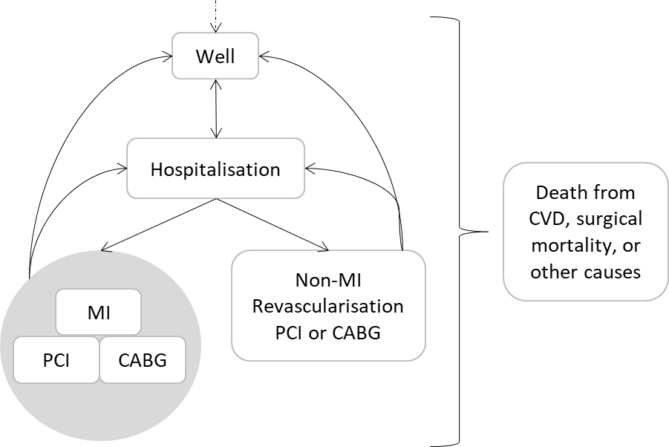

Figure 1: schematic of model for both CR and non-CR

Figure 2: Cumulative distribution function for total justifiable cost, by IMD

Supplementary Appendix
This supplementary appendix provides details of the parameter values used to inform the mathematical model alongside additional results generated.

Table 1-A: Base-case cohort values and core model assumptions
Parameter | Value | Source
Cohort age | 67 | NACR report ²¹
Male to female mix | 0.70 | NACR report ²¹
Discount rate, costs | 0.035 | NICE Methods Guide ²⁹
Discount rate, outcomes | 0.035 | NICE Methods Guide ²⁹
Time horizon | lifetime | NICE Methods Guide ²⁹
Cycle length | 6 months | Sufficient to reflect the patient pathway

Table 2-A: Transition probabilities (6 month using random effects model) and proportions
From | To | No CR |  | Source and notes
 |  | Mean | Distribution
Well | Hospitalisation | 0.147 | Gamma (SE - 0.049) | Anderson ⁸
Well | CVD mortality | 0.032 | Gamma (0.009) | Anderson ⁸
Hospitalisation | MI | 0.181 | Gamma (0.006) | Anderson ⁸
Hospitalisation | Non-MI revasc. | 0.360 | Gamma (0.011) | Anderson ⁸
MI | Hospitalisation | Same as well to hospitalisation |  | Assumption
MI | MI | 0.027 | Gamma (0.006) | Anderson ⁸
MI | MI revasc. | 0.091 | Beta (alpha-1434, beta-17119) | Smolina ⁴⁰, assumed the same for CR
MI | Proportion PCI to CABG | 0.893 | Fixed | NACR data request, assumed the same for CR
MI | CVD mortality | 0.032 | Gamma (0.009) | Anderson ⁸
Non-MI revasc. | Hospitalisation | Same as well to hospitalisation |  | Assumption
Non-MI revasc. | Non-MI revasc. | 0.053 | Gamma (0.011) | Anderson ⁸
Non-MI revasc. | Proportion PCI to CABG | 0.690 | Fixed | NACR data request, assumed the same for CR
PCI | Surgical mortality | 0.015 | Beta (7.5, 493) | Hamburger ⁴¹, assumed the same for CR
CABG | Surgical mortality | 0.022 | Beta (1484, 65966) | Gutacker ⁴², assumed the same for CR
All states | Non-CVD mortality | Age and gender adjusted life tables inflated by 1.32 to account for observed difference in Anderson from ONS, consistent with NICE approach |  | Anderson ⁸ and ONS ³⁸, assumed the same for CR

Table 3-A: Odds Ratios and standard errors applied as treatment effect, calculated from the Anderson summaries
 | OR | SE
Revasc-CABG | 0.946258 | 0.091974
Revasc-PCI | 0.889495 | 0.098003
Recasc-combined | 0.922927 | 0.070797
MI | 0.740435 | 0.076189
CV mortality | 0.908784 | 0.047836
All mortality | 0.814266 | 0.08611
hospitalisation | 0.919239 | 0.067066

Table 4-A: Unit costs used in model
Parameter | Unit Cost | Distribution | Source
Cost of CR | £747.67 | Fixed | Beswick ⁴³ inflated to 2016/17 prices using PSSRU HCHS pay and prices inflation⁴⁴
Cost of well state, per cycle | £0 | Fixed | Assumption
Cost of hospitalisation, per event | £1,243.05 | Random draw of categories | NHS Reference Costs 2015-16,⁴⁵ all ‘unspecified check pain’ categories, weighted by frequency
Cost of MI, per event | £4,023.05 | Gamma (SE – 276) | Hartwell ⁴⁶ inflated to 2016/17 prices, with hospitalisation cost deducted
Cost of CABG, per event | £14,326.68 | Random draw of categories | NHS Reference Costs 2015-16,⁴⁵ all CABG categories, weighted by frequency
Cost of PCI, per event | £3,000.05 | Random draw of categories | NHS Reference Costs 2015-16,⁴⁵ all angioplasty categories, weighted by frequency
Cost after events | £0 | Fixed | Assumption that all costs are included in the event costs

Table 5-A: Quality of Life (QoL) estimates used in the model
Parameter | QoL decrement | Distribution | Source
All decrements are applied to age adjusted ‘normal’ population values from Sullivan (2011)
Well | 0 | Fixed | Assumption
Hospitalisation | 0.05 | Gamma (SE – 0.023) | Lewis ²⁷
MI | 0.06 | Gamma (0.026) | Lewis ²⁷
CABG | 0.06 | Gamma (0.026) | Assumed same as MI
PCI | 0.06 | Gamma (0.026) | Assumed same as MI

Figure 1-A: Base-case Probabilistic Sensitivity Analysis (PSA) scatter plots stratified by IMD, with line showing a £20,000/QALY threshold
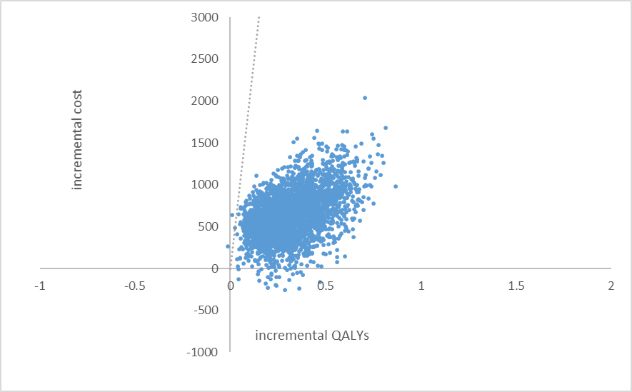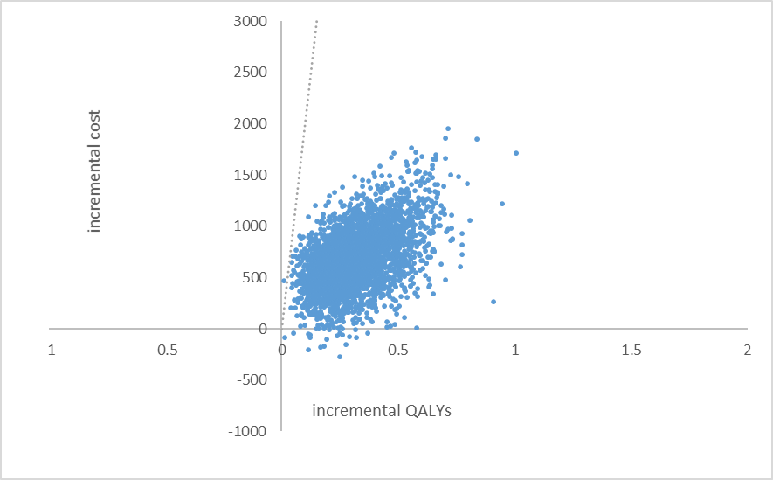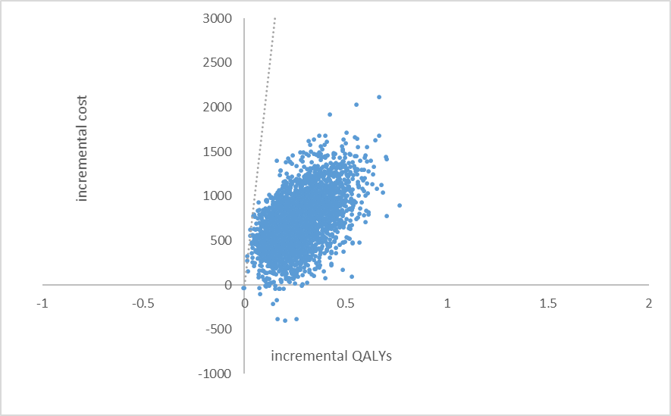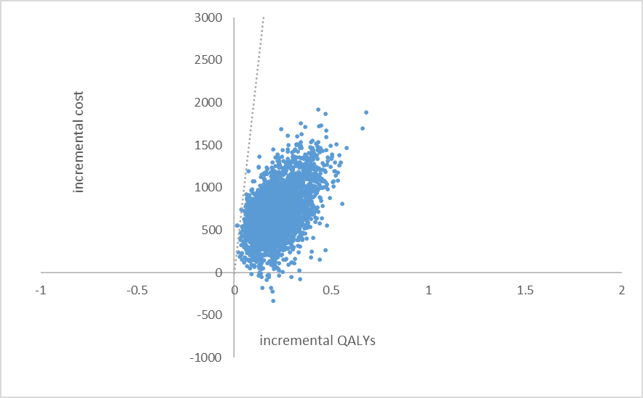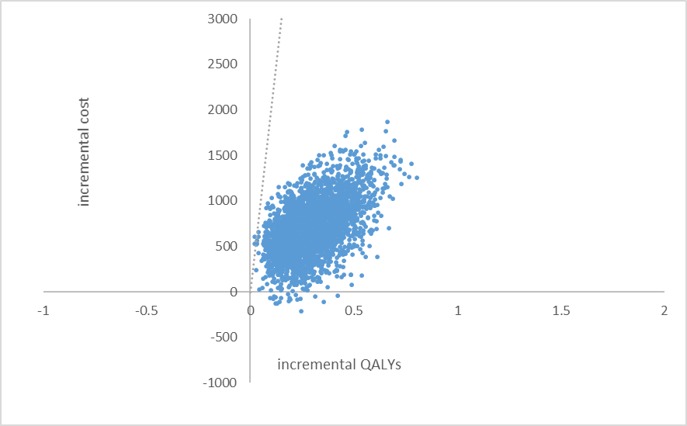
IMD1
IMD2
IMD3
IMD4
IMD5

Table 5-A: Results for 100% compliance scenario
IMD | no CR |  | CR |  | incremental |  | ICER /QALY | Prob. CE £12,936/QALY
 | disc. cost | disc. QALY | disc. cost | disc. QALY | disc. cost | disc. QALY
1 | £7,696 | 3.80 | £8,408 | 4.14 | £712 | 0.34 | £2,124 | 0.998
2 | £7,328 | 4.22 | £8,034 | 4.60 | £706 | 0.38 | £1,875 | 0.999
3 | £6,863 | 4.42 | £7,566 | 4.82 | £702 | 0.40 | £1,775 | 0.999
4 | £6,760 | 4.75 | £7,426 | 5.16 | £666 | 0.41 | £1,630 | 0.999
5 | £6,340 | 5.12 | £6,958 | 5.52 | £618 | 0.40 | £1,538 | 1.000

References
1. WHO. Global Health Observatory (GHO) data: Top 10 causes of death. http://wwwwhoint/gho/mortality_burden_disease/causes_death/top_10/en/ accessed 04/10/2018.
2. Carnethon MR. Physical Activity and Cardiovascular Disease: How Much is Enough? American journal of lifestyle medicine 2009; 3: 44S-49S. DOI: 10.1177/1559827609332737.
3. Soares-Miranda L, Siscovick DS, Psaty BM, et al. Physical Activity and Risk of Coronary Heart Disease and Stroke in Older Adults: The Cardiovascular Health Study. Circulation 2016; 133: 147-155. 2015/11/06. DOI: 10.1161/circulationaha.115.018323.
4. Berlin JA and Colditz GA. A meta-analysis of physical activity in the prevention of coronary heart disease. American journal of epidemiology 1990; 132: 612-628. 1990/10/01.
5. Powell KE, Thompson PD, Caspersen CJ, et al. Physical activity and the incidence of coronary heart disease. Annual review of public health 1987; 8: 253-287. 1987/01/01. DOI: 10.1146/annurev.pu.08.050187.001345.
6. Ades PA, Keteyian SJ, Wright JS, et al. Increasing Cardiac Rehabilitation Participation From 20% to 70%: A Road Map From the Million Hearts Cardiac Rehabilitation Collaborative. Mayo Clinic Proceedings 2017; 92: 234-242. DOI: 10.1016/j.mayocp.2016.10.014.
7. Piepoli MF, Hoes AW, Agewall S, et al. 2016 European Guidelines on cardiovascular disease prevention in clinical practice: The Sixth Joint Task Force of the European Society of Cardiology and Other Societies on Cardiovascular Disease Prevention in Clinical Practice (constituted by representatives of 10 societies and by invited experts)Developed with the special contribution of the European Association for Cardiovascular Prevention & Rehabilitation (EACPR). European heart journal 2016; 37: 2315-2381. 2016/05/26. DOI: 10.1093/eurheartj/ehw106.
8. Anderson L, Oldridge N, Thompson DR, et al. Exercise-Based Cardiac Rehabilitation for Coronary Heart Disease: Cochrane Systematic Review and Meta-Analysis. Journal of the American College of Cardiology 2016; 67: 1-12. 2016/01/15. DOI: 10.1016/j.jacc.2015.10.044.
9. Heran BS, Chen JM, Ebrahim S, et al. Exercise-based cardiac rehabilitation for coronary heart disease. The Cochrane database of systematic reviews 2011: Cd001800. 2011/07/08. DOI: 10.1002/14651858.CD001800.pub2.
10. Dalal HM, Doherty P and Taylor RS. Cardiac rehabilitation. BMJ : British Medical Journal 2015; 351. DOI: 10.1136/bmj.h5000.
11. NICE. MI – secondary prevention: Secondary prevention in primary and secondary care for patients following a myocardial infarction. NICE: London 2007; CG48.
12. NICE. Myocardial infarction: cardiac rehabilitation and prevention of further cardiovascular disease. NICE: London 2013; CG172.
13. Contractor AS. Cardiac rehabilitation after myocardial infarction. The Journal of the Association of Physicians of India 2011; 59 Suppl: 51-55. 2012/05/26.
14. Department of Health. Cardiovascular Disease Outcomes Strategy: Improving outcomes for people with or at risk of cardiovascular disease Department of Health: London 2013.
15. Bjarnason-Wehrens B, McGee H, Zwisler AD, et al. Cardiac rehabilitation in Europe: results from the European Cardiac Rehabilitation Inventory Survey. European journal of cardiovascular prevention and rehabilitation : official journal of the European Society of Cardiology, Working Groups on Epidemiology & Prevention and Cardiac Rehabilitation and Exercise Physiology 2010; 17: 410-418. 2010/03/20. DOI: 10.1097/HJR.0b013e328334f42d.
16. Al Quait A, Doherty P, Gutacker N, et al. In the modern era of percutaneous coronary intervention: Is cardiac rehabilitation engagement purely a patient or a service level decision? European journal of preventive cardiology 2017; 24: 1351-1357. 2017/06/22. DOI: 10.1177/2047487317717064.
17. Caulin-Glaser T and Schmeizl R. Impact of educational initiatives on gender referrals to cardiac rehabilitation. Journal of Cardiopulmonary Rehabilitation and Prevention 2000; 20: 302.
18. Cooper A, Jackson G, Weinman J, et al. Factors associated with cardiac rehabilitation attendance: a systematic review of the literature. Clinical rehabilitation 2002; 16: 541-552.
19. Lewin B, Robertson IH, Cay EL, et al. Effects of self-help post-myocardial-infarction rehabilitation on psychological adjustment and use of health services. Lancet (London, England) 1992; 339: 1036-1040. 1992/04/25.
20. Shields GE, Wells A, Doherty P, et al. Cost-effectiveness of cardiac rehabilitation: a systematic review. Heart 2018. DOI: 10.1136/heartjnl-2017-312809.
21. British Heart Foudation. The National Audit of Cardiac Rehabilitation: Annual Statistical Report 2017. British Heart Foundation: London 2018.
22. Rauch B, Davos CH, Doherty P, et al. The prognostic effect of cardiac rehabilitation in the era of acute revascularisation and statin therapy: A systematic review and meta-analysis of randomized and non-randomized studies - The Cardiac Rehabilitation Outcome Study (CROS). European journal of preventive cardiology 2016; 23: 1914-1939. 2016/10/24. DOI: 10.1177/2047487316671181.
23. Harrison AS and Doherty P. Does the mode of delivery in routine cardiac rehabilitation have an association with cardiovascular risk factor outcomes? European journal of preventive cardiology 2018: 2047487318798923. 2018/09/07. DOI: 10.1177/2047487318798923.
24. Harrison AS and Doherty P. Does the mode of delivery in Cardiac Rehabilitation determine the extent of psychosocial health outcomes? International journal of cardiology 2018; 255: 136-139. 2018/02/10. DOI: 10.1016/j.ijcard.2017.11.056.
25. Harrison AS, Tang L and Doherty P. Are physical fitness outcomes in patients attending cardiac rehabilitation determined by the mode of delivery? Open Heart 2018; 5. DOI: 10.1136/openhrt-2018-000822.
26. Drummond M, Sculpher, M., Claxton, K., Stoddard, G., Torrance, G. Methods for the Economic Evaluation of Health Care Programmes. Oxford 2015; Fourth Edition.
27. Lewis EF, Li Y, Pfeffer MA, et al. Impact of cardiovascular events on change in quality of life and utilities in patients after myocardial infarction: a VALIANT study (valsartan in acute myocardial infarction). JACC Heart failure 2014; 2: 159-165. 2014/04/12. DOI: 10.1016/j.jchf.2013.12.003.
28. Sullivan PW, Slejko JF, Sculpher MJ, et al. Catalogue of EQ-5D scores for the United Kingdom. Medical decision making : an international journal of the Society for Medical Decision Making 2011; 31: 800-804. 2011/03/23. DOI: 10.1177/0272989x11401031.
29. NICE. Guide to the methods of technology appraisal 2013. NICE: London 2013.
30. Claxton K, Martin S, Soares M, et al. Methods for the estimation of the National Institute for Health and Care Excellence cost-effectiveness threshold. Health technology assessment (Winchester, England) 2015; 19: 1-503, v-vi. 2015/02/19. DOI: 10.3310/hta19140.
31. Bhatnagar P, Wickramasinghe K, Williams J, et al. The epidemiology of cardiovascular disease in the UK 2014. Heart 2015. DOI: 10.1136/heartjnl-2015-307516.
32. Cooper RS. Social inequality, ethnicity and cardiovascular disease. International journal of epidemiology 2001; 30: S48.
33. Diez-Roux AV, Link BG and Northridge ME. A multilevel analysis of income inequality and cardiovascular disease risk factors. Social Science & Medicine 2000; 50: 673-687. DOI: https://doi.org/10.1016/S0277-9536(99)00320-2.
34. Grace SL, Abbey SE, Shnek ZM, et al. Cardiac rehabilitation II: referral and participation. General Hospital Psychiatry 2002; 24: 127-134. DOI: https://doi.org/10.1016/S0163-8343(02)00179-2.
35. Lane D, Carroll D, Ring C, et al. Predictors of attendance at cardiac rehabilitation after myocardial infarction. Journal of Psychosomatic Research 2001; 51: 497-501. DOI: https://doi.org/10.1016/S0022-3999(01)00225-2.
36. Tod AM, Lacey EA and McNeill F. ‘I’m still waiting...': barriers to accessing cardiac rehabilitation services. Journal of Advanced Nursing 2002; 40: 421-431. DOI: doi:10.1046/j.1365-2648.2002.02390.x.
37. ONS. How does deprivation vary by leading cause of death? ONS: Newport 2017.
38. ONS. National life tables: England 2014-2016. ONS: Newport 2018.
39. Love-Koh J, Asaria M, Cookson R, et al. The Social Distribution of Health: Estimating Quality-Adjusted Life Expectancy in England. Value in health : the journal of the International Society for Pharmacoeconomics and Outcomes Research 2015; 18: 655-662. 2015/08/25. DOI: 10.1016/j.jval.2015.03.1784.
40. Smolina K, Wright FL, Rayner M, et al. Long-term survival and recurrence after acute myocardial infarction in England, 2004 to 2010. Circulation: Cardiovascular Quality and Outcomes 2012; 5: 532-540.
41. Hamburger JN, Walsh SJ, Khurana R, et al. Percutaneous coronary intervention and 30‐day mortality: The British Columbia PCI risk score. Catheterization and Cardiovascular Interventions 2009; 74: 377-385.
42. Gutacker N, Bloor K, Cookson R, et al. Hospital surgical volumes and mortality after coronary artery bypass grafting: using international comparisons to determine a safe threshold. Health services research 2017; 52: 863-878.
43. Beswick AD, Rees K, Griebsch I, et al. Provision, uptake and cost of cardiac rehabilitation programmes: improving services to under-represented groups. Health technology assessment (Winchester, England) 2004; 8: iii-iv, ix-x, 1-152. 2004/10/06.
44. Curtis L, Burns, A. Unit Costs of Health and Social Care 2017. Personal Social Services Research Unit, University of Kent, Canterbury 2017.
45. Department of Health. NHS reference costs 2015 to 2016. Department of Health and Social Care: London 2016.
46. Hartwell D, Colquitt J, Loveman E, et al. Clinical effectiveness and cost-effectiveness of immediate angioplasty for acute myocardial infarction: systematic review and economic evaluation. Health technology assessment (Winchester, England) 2005; 9: 1-99, iii-iv. 2005/05/07.

