Simultaneous biomethanisation of endogenous and imported CO₂ in organically loaded anaerobic digesters
Bing Tao ª, Anna M. Alessi ^{b}, Yue Zhang ª, James P.J. Chong ^{b}, Sonia Heaven ª and Charles J. Banks ª
a. Water and Environmental Engineering Group, Faculty of Engineering and the Environment, University of Southampton, University Road, Southampton, UK, SO17 1BJ.
b. Department of Biology, University of York, Wentworth Way, York, UK, YO10 5DD.
Abstract
In-situ biomethanisation reduces the CO₂ in biogas to CH₄ via direct H₂ injection into an anaerobic digester, but volumetric methane production (VMP) is limited by organic loading. Ex-situ biomethanisation, where gaseous substrates are fed to pure or mixed cultures of hydrogenotrophic methanogens, offers higher VMP but requires an additional reactor and supply of essential nutrients. This work combined the two approaches in a novel hybrid application achieving simultaneous in-situ and ex-situ biomethanisation within an organically-loaded anaerobic digester receiving supplementary biogas. Conventional stirred-tank digesters were first acclimated to H₂ addition, increasing biogas methane content from 50% to 95% and VMP from 0.86 to 1.51 L L⁻¹ day⁻¹ at a moderate loading rate of 3 g organic chemical oxygen demand per L per day (g COD_{org} L⁻¹ day⁻¹). Externally-produced biogas was then added to demonstrate simultaneous biomethanisation of endogenous and imported CO₂. This further increased VMP to 2.76 L L⁻¹ day⁻¹ without affecting organic substrate degradation. In-situ CO₂ reduction can alter digester pH by reducing bicarbonate buffering: the combined process operated stably at around pH 8.0 with 3-5% CO₂ in the headspace. Microbial community analysis indicated the process was mediated by bacterial syntrophic acetate oxidation and highly enriched hydrogenotrophic methanogenic archaea (up to 97% of the archaeal population). This approach presents the opportunity to retrofit a single digester for H₂ injection to convert and upgrade biogas from several others, minimising capital and operating costs by utilising both existing infrastructure and waste-derived feedstock nutrients for simultaneous biogas upgrading and power-to-methane.
Keywords: CO₂ biomethanisation; Anaerobic digestion; Biogas upgrading; Power-to-gas; Hydrogenotrophic methanogens.

1 Introduction
Biomethanisation of CO₂ is a microbially-catalysed process that directly converts CO₂ and H₂ into CH₄ via hydrogenotrophic methanogenesis. It has attracted significant scientific attention in the past decade, as it offers one of the few viable alternatives for storing surplus electricity from renewable sources (e.g. photovoltaic and wind energy) when consumer demand is low. If this electricity is fed into the grid it can cause imbalances, leading to damage and power outages ¹. In many cases it is therefore not utilised, representing a loss of resource: but it can be used to produce H₂ by electrolysis of water in the so-called power-to-gas process. Subsequent conversion of this H₂ to CH₄ involves an energy loss, but provides a fuel gas with a higher volumetric energy density that is easier to handle and more compatible with current energy infrastructure.
Much of the research to date on the power-to-methane route has focused on reduction of imported CO₂ using pure or mixed cultures of hydrogenotrophic methanogens in bioreactors designed for this purpose ²⁻¹⁰. Since the CO₂ is from an external source, this type of process is known as ex-situ biomethanisation. The maximum reported volumetric methane production (VMP) for such a system at laboratory scale is 40 L CH₄ per L working volume of digester per day (L L⁻¹ day⁻¹) ². To achieve these high volumetric conversion rates and promote the mass transfer of H₂, which has a low solubility (~1.35 ×10⁻⁵ v/v) in aqueous media ¹¹, different reactor configurations have been investigated. These include conventional continuous stirred-tank reactors (CSTR) ^{5, 6, 12}; and also packed column reactors ^{7, 8} where extended gas-liquid contact times can be achieved, and biofilm/trickle bed reactors ^{3, 10} where the gases are directly in contact with the culture as a wetted biofilm.
Although high methane productivities can be achieved in these ex-situ processes, two main obstacles need to be overcome for successful commercialisation. Firstly, the reactor configurations have to be scaled up without loss in performance; and secondly, low-cost synthetic nutrient media for the growth of hydrogenotrophic methanogens have to be formulated, while the effluent generated may have to be treated in a downstream process. A recent review¹³ also concluded that in high rate reactors there is likely to be a trade-off between the conversion rate and the methane percentage of the product gas, as H₂ mass transfer becomes limiting: for example, one laboratory-scale study found that at a VMP of 40 L L⁻¹ day⁻¹ the methane percentage was 50%, compared to 95% at a VMP of 15 L L⁻¹ day⁻¹ ². If CO₂ reductive biomethanisation is to have a role in producing high calorific value fuel gas, the minimum methane content should typically be above 90%. In Europe a minimum of 95% CH₄ is required for direct gas grid injection ¹⁴. More research is thus required to optimise these ex-situ processes, but they offer a high potential for carbon utilisation if conversion rates can be further increased and process scale-up issues resolved.
Anaerobic digestion (AD) of biomass for energy production represents a significant CO₂ source, with production in Europe of around 18 billion m³ natural gas equivalent in 2015 ¹⁵. As the AD industry moves away from combined heat and power applications to biomethane as a source of heat and vehicle fuel, there is an increasing requirement for biogas upgrading. Conventional upgrading separates and discards the CO₂, with the loss of this portion of the feedstock carbon. An alternative is the direct injection of H₂ into a digester processing organic substrates. In this case the CO₂ present in the produced biogas is reduced in-situ to methane by an indigenous hydrogenotrophic methanogenic population. Conceptually this process is attractive, as no additional reactors are needed, and the nutrients required by the methanogens are already present in the organic feed. The additional CH₄ has an energy value of around 78% of the original H₂ ¹⁶, and there is a further saving of the energy required for conventional gas upgrading which is equivalent to approximately 10% of the original methane production ¹⁷. The resulting increase in methane output, with relatively little change in parasitic energy requirements for mixing and pumping etc, makes the process energetically attractive. The VMP, however, is limited by the digestion process itself, i.e. by the rate at which input volatile solids (VS) can be converted into biogas. Most commercial processes operate at organic loading rates (OLR) of 4-5 kg VS m⁻³ day⁻¹ and the volume of CO₂ produced that can be reacted with externally introduced H₂ is thus constrained by the applied carbon loading. The highest VMP achieved for in-situ biomethanisation to date is 1.53 L L⁻¹ day⁻¹ ¹⁸, although it has been reported that H₂ injection can upgrade the biogas quality to 96-98% CH₄ ^{19, 20}.
Although the applied organic loading rate is limited, it may be possible to increase the overall methane production capacity by increasing the input of gaseous carbon from external sources. This could be in the form of biogas from other digesters, in which case the biogas upgrading function for multiple digesters could be performed by a single unit. This depends upon the capacity to increase the gaseous carbon conversion through enriching the hydrogenotrophic population without detrimental effects on organic carbon conversion or digestion stability. Potential problems are that reduction of the headspace CO₂ content can cause pH swings in in-situ digesters due to changes in the bicarbonate equilibrium ²¹; while high H₂ partial pressures can suppress the degradation of propionic acid, as has been observed in previous studies ^{22, 23}.
If these issues can be avoided the concept has wide areas of application, in particular for enhancing methane yields from a given organic carbon input. Examples include the cultivation of energy crops, where the amount of photosynthetically-fixed carbon is determined by plant type and environmental conditions, and biomethanisation could thus increase methane yield by as much as 70% per hectare. Likewise, for waste and wastewater treatment plants receiving a fixed carbon load based on population equivalent, the methane output could be increased by 60% or more. The process thus represents a first move towards utilisation of CO₂ as opposed to capture for storage. Although there are many studies on both in-situ and ex-situ biomethanisation, to date no work on simultaneous hybridisation of these processes has been reported and the limitations on introduction of external CO₂ to an in-situ process in the form of imported biogas are not known.
In the current work, to demonstrate the novel simultaneous in-situ and ex-situ biomethanisation process, digesters were first run to provide baseline data on methane productivity and performance, then acclimated to H₂ addition to allow enrichment of the hydrogenotrophic population and establishment of in-situ biomethanisation. Once this had been achieved, an additional load of externally-produced CO₂ was added to realise ex-situ and in-situ biomethanisation simultaneously. In parallel with performance monitoring, characterisation of the microbial population was carried out to show any changes qualitatively, and where possible to quantify the increase in numbers of hydrogenotrophic methanogens. A lower limit for biogas CO₂ content to prevent the onset of instability as a result of pH increases due to deficiencies in bicarbonate buffering was also established.

2 Materials and Methods

2.1 Digester operation
Eight identical 1-L digesters (designated D1-8) were inoculated with 500 mL of digestate from Millbrook Wastewater Treatment Plant, Southampton, UK. The inoculum characteristics are summarised in Table S1. Each digester was mixed using a 3-blade impeller 40 mm in diameter which was shaft-driven by a geared DC motor at 200 rpm. The digesters were maintained at 37 ºC in a water bath. An organically-rich synthetic substrate was used as the feed, the composition of which is given in Table S2. The substrate was fed to the digesters at different concentrations but with the same volume addition to provide a constant hydraulic retention time (HRT) of 15 days. The four pairs of digesters received organic loading rates (OLR) of 2 (D1&2), 3 (D3&4), 4 (D5&6) and 5 (D7&8) g COD_{org} L⁻¹ day⁻¹. The feedstock was added manually once per day, resulting in a semi-continuous operating mode with a feed cycle of 24 hours.
The study consisted of three phases defined in terms of gaseous input. In phase I there was no H₂ injection, and the digesters were configured as conventional continuous stirred-tank reactors (CSTR) with daily organic feed input (Figure 1a). The digesters were operated for 4-6 HRT in this phase to ensure stable conditions and allow collection of baseline data on CO₂ production, pH and methanogenic community structure before progressing to phase II.
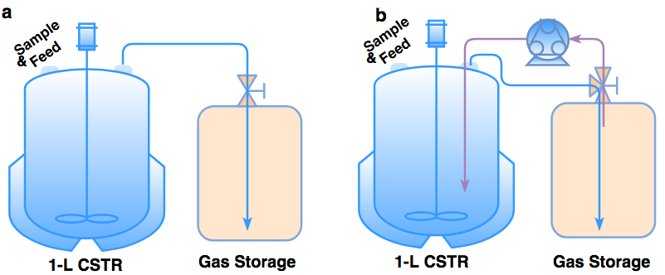
Figure 1 Schematic of digester configurations in phase I (a) and phase II and III (b)
In phase II, H₂ was introduced into the digesters incrementally to enrich the population of hydrogenotrophic methanogens, and to allow stoichiometric CO₂ reduction in proportion to the capacity of this population, without H₂ or VFA accumulation. The volume of H₂ injected into the digesters was calculated according to the CO₂ production at each applied OLR in phase I. The theoretical maximum volume of H₂ required (V_{H2,theo}) was taken as four times the baseline volume of CO₂ produced. At the beginning of phase II, 10% of V_{H2,theo} was injected, followed by 20%, 30%, 50%, 75% and 100%. In practice gas addition was achieved by dispensing the quantity of H₂ required for the daily feed cycle into gas-impermeable aluminium/mylar foil bags using an EL-Flow® Prestige mass flow controller (Bronkhorst, UK). Each day after the introduction of the organic substrate the gas bag containing H₂ was connected to the digester. Gas was pumped in at a rate of 8 mL min⁻¹ through a sparge tube located beneath the impeller, by means of a peristaltic pump. The digester headspace was connected directly into the gas bag, providing a continuous gas injection and recycling loop (Figure 1b) in which the residual H₂ was continuously diluted by enriched biomethane. At the end of each 24-hour feed cycle the gas bag was removed and the gas volume and composition were measured. Phase II was operated for 13-19 HRT in total.
In phase III, an external source of CO₂ (mixture of CH₄/CO₂ at 50/50 v/v, BOC Group, UK) was injected to simulate the addition of biogas from other digesters as a supplementary CO₂ source, with additional H₂ to balance this. The same operating procedure was used as in phase II except that at the beginning of each daily feed cycle, the gas bag also held the supplementary CH₄/CO₂ mix and the H₂ required to convert 100% of this additional imported CO₂ load as well as 95% of the endogenous CO₂. The volume of imported CO₂ added at the beginning of phase III was 25% of the phase I baseline endogenous CO₂. This was incrementally increased to 50%, 100%, 150%, 175% and 200%, corresponding to a total CO₂ availability (endogenous plus imported) rising from 125 to 300% of the baseline value. Phase III ran for 6-7 HRT in total.

2.2 Analytical methods
Total solids (TS) and volatile solids (VS) were determined by Standard Method 2540 G and total Chemical Oxygen Demand (tCOD) by Standard Method 5220 C ²⁴. Total Kjeldahl Nitrogen (TKN) was converted to total ammonium nitrogen (TAN) by acid digestion in a BÜCHI K-435 Digestion Unit, with H₂SO₄ and K₂SO₄ as the reactants and CuSO₄ as the catalyst. TAN was measured using a BÜCHI Distillation Unit K-350 with NaOH addition, followed by collection of the distillate in boric acid indicator and titration with 0.25 N H₂SO₄. Elemental composition (C, H, N, S) was determined using a FlashEA 1112 Elemental Analyser (Thermo Finnigan, Italy), following the manufacturer's recommended procedures and using a Birch Leaf standard. Digestate samples for dissolved inorganic carbon (DIC) analysis were centrifuged and then filtered through syringe membrane filters (0.2µm pore size), and the filtrate measured using a total organic carbon analyser (Shimadzu TOC-V_{CPH}) from filtered digestate samples, following the manufacturer's recommended procedures with sodium carbonate and sodium bicarbonate as standards. VFA concentrations in the digestate were measured by gas chromatography (Shimadzu GC-2010) using a flame ionisation detector and a capillary column (SGE BP-21) with nitrogen as the carrier gas. Samples were acidified to 10% formic acid and measured against mixed standards of 50, 250 and 500 mg L⁻¹ of acetic, propionic, iso-butyric, n-butyric, iso-valeric, valeric, hexanoic and heptanoic acids. Biogas composition was determined using a MG#5 Gas Chromatograph (SRI Instruments, USA) with a thermal conductivity detector (TCD). The instrument had two linked analytical lines with CH₄ and CO₂ separated by a Porapak Q column (80/100 mesh, 6ft), while H₂ was separated by a molecular sieve 5A column (6ft). The GC was calibrated with standard gases from BOC Ltd, UK: CH₄ (>99.95%), 65% CH₄/35% CO₂, 50% CH₄/50% CO₂ and CO₂ (>99.95%) (v/v). Biogas volumes were measured using a weight-based water displacement gasometer ²⁵. Gas volumes are reported at a standard temperature and pressure of 0 ºC and 101.325 kPa.
The response of the microbial community to the gradual increase in H₂ injection in digesters at 2 and 3 g COD_{org} L⁻¹ day⁻¹ was monitored by 16S rRNA amplicon sequencing. At the end of each increment in H₂ input, digestate samples were taken which were then subjected to DNA extraction, polymerase chain reaction (PCR) amplification and sequencing to determine the relative abundance of different microbial groups. Results reported are the average for duplicate digesters. Detailed methods and data analysis for microbial community profiling can be found in the supplementary information.

3 Results and Discussion

3.1 Phase I - conventional AD for determination of baseline conditions
The phase I digester operation established baseline values for performance and stability parameters at the applied OLR. After an initial period of acclimatisation to the synthetic feedstock, all digesters stabilised at their respective loadings (Figure S1). Table 1 shows average values for key parameters in each pair of digesters for the last 10 days of phase I when the digesters were regarded as being in steady state. At OLR from 2-4 g COD_{org} L⁻¹ day⁻¹ the daily biogas production (V_{Biogas}) was proportional to OLR and there were no significant differences in biogas composition between the digesters, indicating uninhibited digestion of the synthetic substrate. The measured biogas composition was very close to the theoretical value of 49% CH₄ / 51% CO₂ calculated from the feedstock elemental composition using the Buswell equation ²⁶. At the highest loading of 5 g COD_{org} L⁻¹ day⁻¹ digesters D7&8 showed a lower lower biogas methane content than D1-D6, reflected in a marginally lower specific methane production (SMP, L g⁻¹ COD_{org}), suggesting that the digesters may have been approaching their loading limit under these operating conditions.

Table 1. Summary of operational and performance parameters for digesters at steady state for the last 10 days of phase I (average of pair ± standard deviation)
Digester | pH | V_{biogas} | CH₄ | CO₂ | SMP | V_{CO2} | V_{H2,theo}
 |  | mL day⁻¹ | % v/v | % v/v | L g⁻¹ COD_{org} | mL day⁻¹ | mL day⁻¹
D1&2 (2) * | 7.12 ± 0.02 | 589 ± 22 | 50.0 ± 0.7 | 47.2 ± 0.6 | 0.294 ± 0.012 | 278 ± 11 | 1112 ± 43
D3&4 (3) | 7.32 ± 0.03 | 867 ± 18 | 50.0 ± 0.2 | 47.3 ± 0.3 | 0.289 ± 0.006 | 410 ± 8 | 1639 ± 35
D5&6 (4) | 7.38 ± 0.02 | 1159 ± 30 | 49.7 ± 0.2 | 47.9 ± 0.7 | 0.288 ± 0.007 | 555 ± 16 | 2220 ± 64
D7&8 (5) | 7.38 ± 0.02 | 1434 ± 36 | 48.5 ± 0.6 | 49.1 ± 0.9 | 0.278 ± 0.008 | 704 ± 24 | 2816 ± 97
*: Values in brackets denote digester OLR in g COD_{org} L⁻¹ day⁻¹

3.2 Phase II – in-situ biomethanisation of endogenously-produced CO₂
H₂ input started at 10% of V_{H2,theo} and was increased to the next level when complete conversion of H₂ had been achieved and maintained for at least a week. Monitoring of the VFA profile of the digesters was used as an indicator of the success of this gradual acclimatisation strategy; the results showed that throughout the transition period there was no propionate accumulation, in agreement with previous acclimatisation studies ^{19, 27}. The performance of reductive CO₂ biomethanisation was assessed based on the methane percentage in the product biogas, and also on the SMP. These are presented in Figure 2 for digesters D1-D4 operated at 2 and 3 g COD_{org} L⁻¹ day⁻¹, and in Figure 3 for D5-D8 operated at 4 and 5 g COD_{org} L⁻¹ day⁻¹. The results show the biogas methane content for all eight digesters increased from ~50-52%, to ~93-95% by the end of phase II. The maximum methane content of 99% was obtained in digester D3 on day 231 (Figure 3) at 100% of V_{H2,theo}. As expected, however, this performance could not be sustained due to a fall in bicarbonate buffering caused by the reduction of CO₂ partial pressure and an associated increase in pH, which rose to 8.45 and led to an accumulation of VFA in the digesters (Figure 4c). The H₂ input was therefore decreased to 95% of V_{H2,theo}, which resulted in 3-5% CO₂ remaining in the biogas, and sufficient bicarbonate buffering to prevent pH increasing beyond the optimum range for digestion.
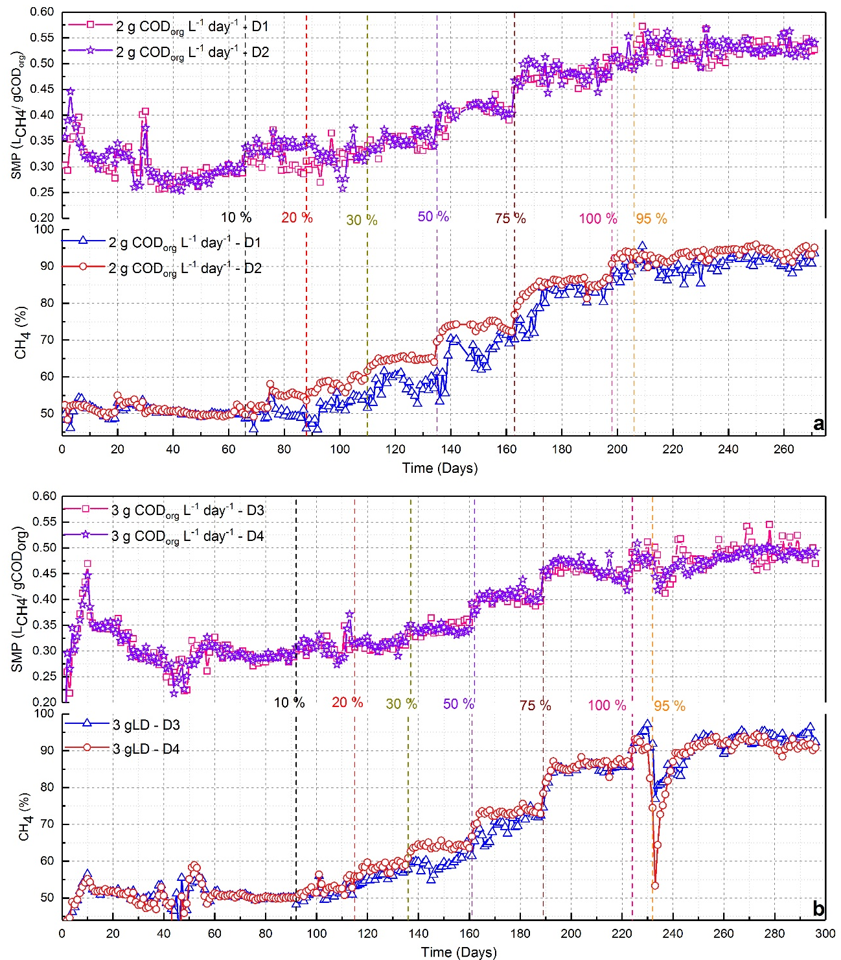
Figure 2 Biogas methane content and SMP in phases I and II as a function of time and H₂ input (vertical dashed lines) for digesters at (a) 2 and (b) 3 g COD_{org} L⁻¹ day⁻¹
During this final period no H₂ was detected and the biogas typically contained 95% CH₄ and 3-4% CO₂, with 1-2% unaccounted-for volume which could be attributed to water vapour and the common impurities of biogas such as H₂S, and NH₃ ²⁸. The methane content of 95% is comparable to the reported maximum range of 92-98% from other CO₂ biomethanisation processes ^{10, 19, 20, 29, 30}.
There were some notable differences between digesters operating at different loading rates, as shown from the total VFA concentration and its compositional profiles in Figure S2-3. For D7&8 at the highest loading rate of 5 g COD_{org} L⁻¹ day⁻¹ a longer H₂ acclimatisation period was needed, and some VFA accumulation was observed at the highest H₂ input. Total VFA concentrations were around 2 g L⁻¹ and mainly consisted of acetic acid (Figure S3b). These were persistent, and sufficient to cause a pH drop and some signs of instability in the digesters (Figure 3b, day 249 onwards), preventing the establishment of long-term stable operation at a methane concentration of ~95%. VFA accumulation was also seen in D5&6 at 4 g COD_{org} L⁻¹ day⁻¹ (Figure S3a), but this was eventually reduced, and stable operation was achieved (Figure 3a, day 327 onwards) with a biogas methane content of 95%. There is no definitive reason why acetic acid should be persistent in D7&8, although one possibility may be an enrichment of homoacetogenic bacteria converting H₂ and CO₂ into acetic acid coupled with a decreasing population of acetoclastic methanogens ³⁰. Even during phase I some signs of instability were observed in D7&8: it is likely that these digesters were challenged at the higher loading with a very readily degradable substrate, and simply did not have the capacity to convert this applied load effectively to gaseous end products at the applied HRT.
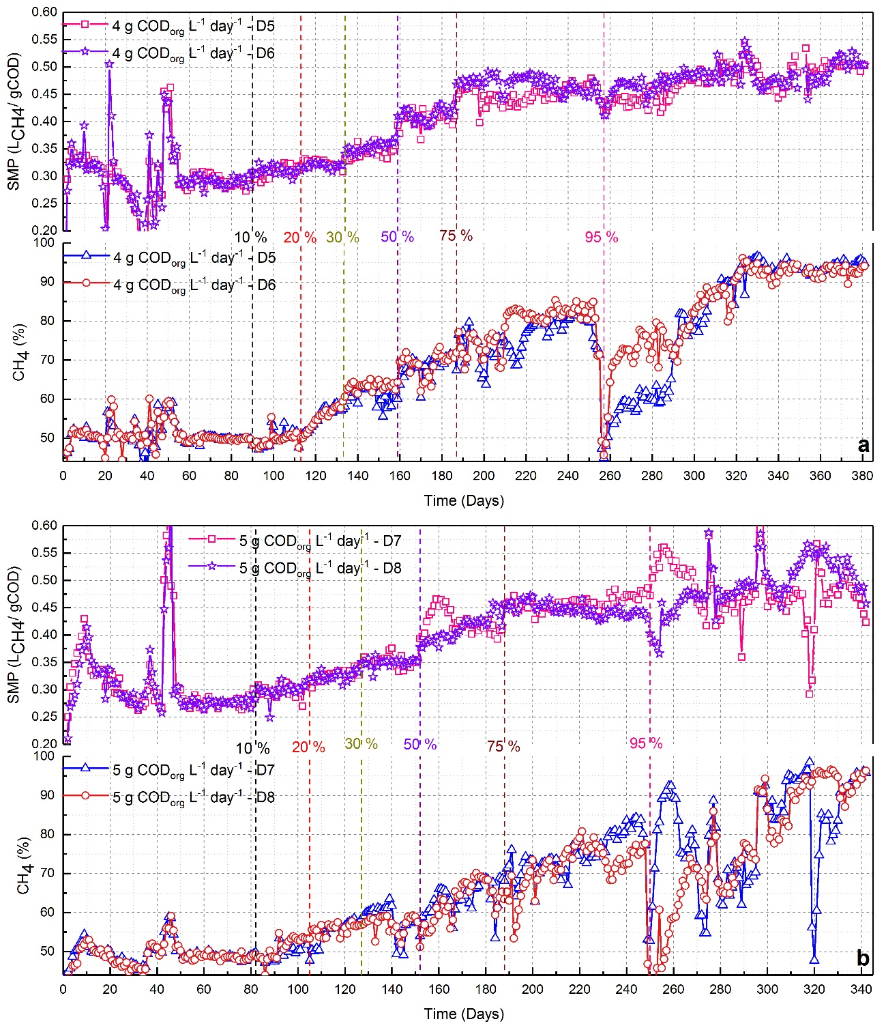
Figure 3 Biogas methane content and SMP in phases I & II as a function of time and H₂ input (vertical dashed lines) for digesters at (a) 4 and (b) 5 g COD_{org} L⁻¹ day⁻¹.
The SMP in phase I (without H₂ injection, as shown in Table 1) increased as a result of H₂ injection to 0.525, 0.502, 0.505 and 0.475 L g⁻¹ COD_{org} for digesters operated at 2, 3, 4 and 5 g COD_{org} L⁻¹ day⁻¹, respectively. This was lower than might be expected based simply on the phase I value plus additional SMP from organically-derived CO₂ present in the biogas. For a V_{H2,theo} of 95% the expected SMP values would be 0.552, 0.544, 0.548 and 0.544 L g⁻¹ COD_{org}⁻¹. This difference could be accounted for in part by a proportion of the organic carbon being used for the growth of extra biomass needed to realise the in-situ CO₂ biomethanisation ¹³. This is supported by a carbon mass balance calculation. The daily carbon input (C_{fed}) from the sucrose, yeast extract and urea was equal to 0.404 [0.606] g C for digesters operated at 2 g COD_{org} L⁻¹ day⁻¹ [with figures in brackets denoting values at 3 g COD_{org} L⁻¹ day⁻¹]. The daily carbon output consisted of the carbon in the biogas (C_{gas}), carbon output as total organic carbon in the digestate (mostly as microbial biomass, C_{biomass}), and carbon output as dissolved inorganic carbon (DIC) in the digestate (C_{inorganic}). In steady state conditions at the end of phase II the average output of C1 gases was 0.550 [0.799] L day⁻¹, corresponding to a daily C_{gas} output of 0.295 [0.428] g C for digesters operated at 2 [3] g COD_{org} L⁻¹ day⁻¹. The average VS concentration was 7.2 [9.9] g L⁻¹, giving a daily wastage of 0.24 [0.33] g VS. The digestate composition was not analysed; but if it is assumed that this VS is entirely composed of microbial biomass with a typical carbon content of 47% ³¹, the daily C_{biomass} output was 0.115 [0.158] g C. The average DIC concentration of the digesters was 0.295 [0.452] g L⁻¹, corresponding to a daily C_{inorganic} output of 0.010 [0.015] g C. Hence, the total daily output of carbon was around 0.420 [0.602] g C, equivalent to 104% [99%] of the input values. From Figure 4 it can be seen that the VS content of the digestate rose slightly during the course of phase II, while the ratio of gaseous carbon output to organic carbon input fell slightly, reflecting this growth in microbial population at the expense of carbon in the gaseous feed.
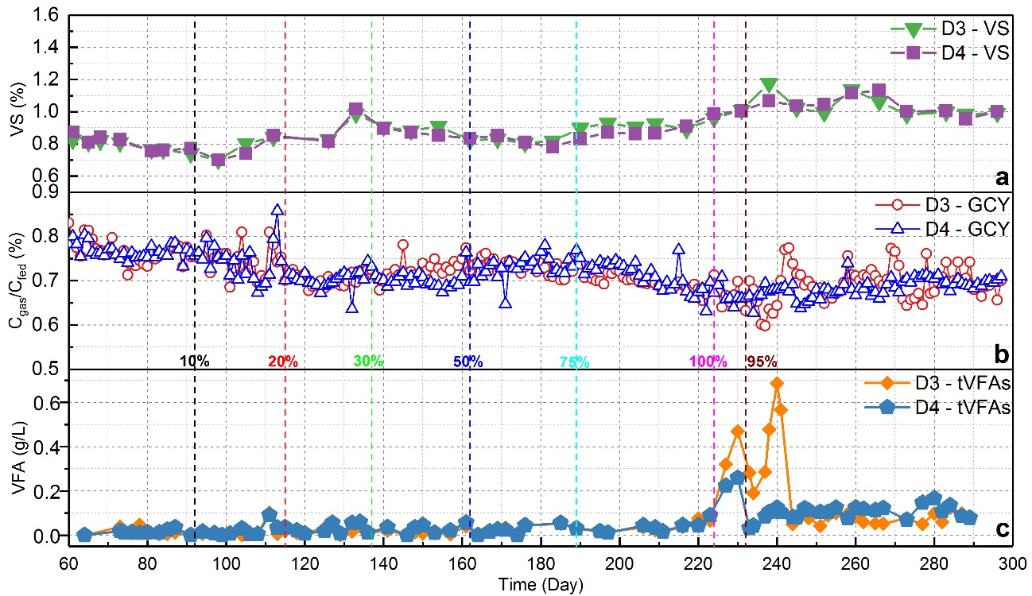
Figure 4 Monitoring parameters for digesters at 3 g COD_{org} L⁻¹ day⁻¹ during phase II: (a) volatile solids, (b) ratio C_{gas}/C_{fed} and (c) tVFA with H₂ input shown as vertical dashed lines
The mode of operation of the digesters with gas recirculation was successful in achieving a high conversion of endogenously-produced CO₂, indicating that there were no H₂ mass transfer limitations in this phase. This supports the findings of others who have also used gas recirculation to extend gas-liquid contact time as the main measure for facilitating mass transfer in both ex-situ and in-situ biogas upgrading systems ^{10, 18, 30}. The mass transfer of H₂ into the digestate might also be enhanced by the favourable concentration gradient created as a result of the activity of the growing population of hydrogenotrophic methanogens (as shown in section 3.4) which continually reduce the H₂ concentration in solution.
The digesters operated at 4 and 5 g COD_{org} L⁻¹ day⁻¹ were not progressed to Phase III due to the instabilities encountered at the end of phase II, which may have been associated with the relatively high organic loading rate for the specific feedstock type and operating conditions.

3.3 Phase III - simultaneous biomethanisation of endogenous and imported CO₂
The main aim of the research was realised by increasing the applied carbon load to the digester through adding externally-produced CO₂ in the form of biogas. The process thus simulated taking biogas from several digesters and using a single digester to convert the endogenously-produced and imported biogas CO₂ into an upgraded biomethane. A mixture of CH₄/CO₂ together with additional H₂ was injected into the digesters operated at 2 and 3 g COD_{org} L⁻¹ day⁻¹. The results in Figure 5 show that the SMP (excluding exogenous CH₄ in the injected biogas) increased in line with the imported CO₂ load applied, from 0.525 to 0.975 L g⁻¹ COD_{org} in digesters D1&2 at the end of phase III, and from 0.502 to 0.920 L g⁻¹ COD_{org} in digesters D3&4. Biogas methane concentrations remained stable at 93-96%. Comparing the SMPs at the end of phase I and III, methane productivities rose from 0.294 to 0.975 L g⁻¹ COD_{org} in D1&2 and from 0.289 to 0.920 L g⁻¹ COD_{org} in D3&4, an overall increase of more than 3-fold.
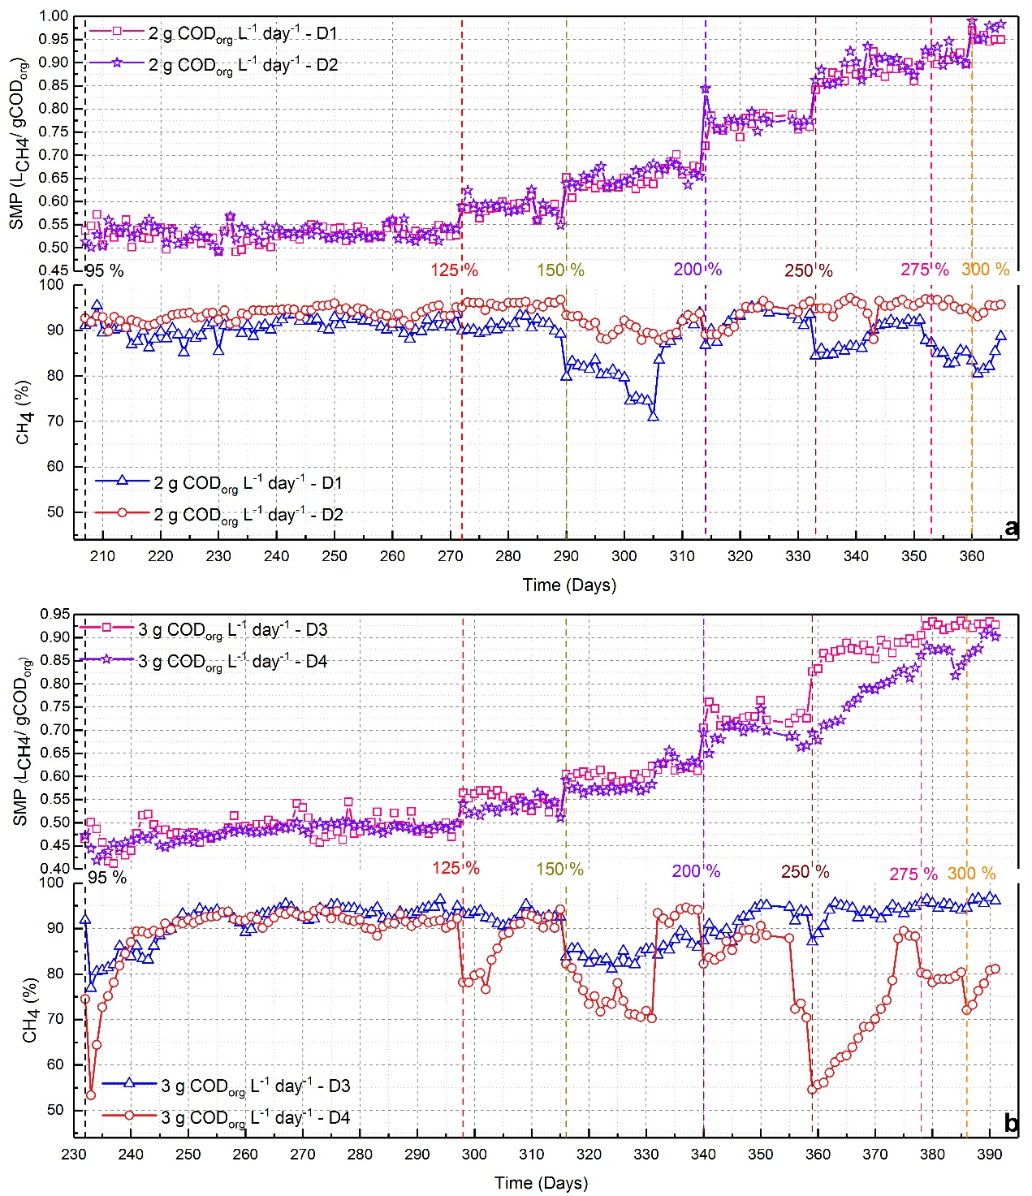
Figure 5 Biogas methane content and SMP (excluding exogenous CH₄) in phase III for digesters operated at 2 (a) and 3 g COD_{org} L⁻¹ day⁻¹ (b). Vertical dashed lines show total CO₂ availability (endogenous plus imported) as a % of endogenous CO₂ in phase I
3.4 Microbiological analysis of Phase I, II, and III digesters
Analysis of the microbial community using 16S rRNA sequencing for samples from the digesters at 2 and 3 g COD_{org} L⁻¹ day⁻¹ showed that the average relative abundance of archaea in the total microbial community increased from 1.12 ± 0.12% prior to H₂ injection to 4.41 ± 0.10% at the end of phase II in D1&2, and from 2.15 ± 0.01% to 4.76 ± 0.58% in D3&4 (Figure 6). Samples taken from the same digesters at the end of phase III with both endogenous and imported CO₂ showed a further enrichment of archaea to 6.26 ± 0.49% for D1&2 and 9.38 ± 0.53% for D3&4. A similar value was reported for a mixed culture ex-situ biomethanisation system receiving only gaseous feedstocks, where the archaea accounted for 7.3% of the total microbial community ³².
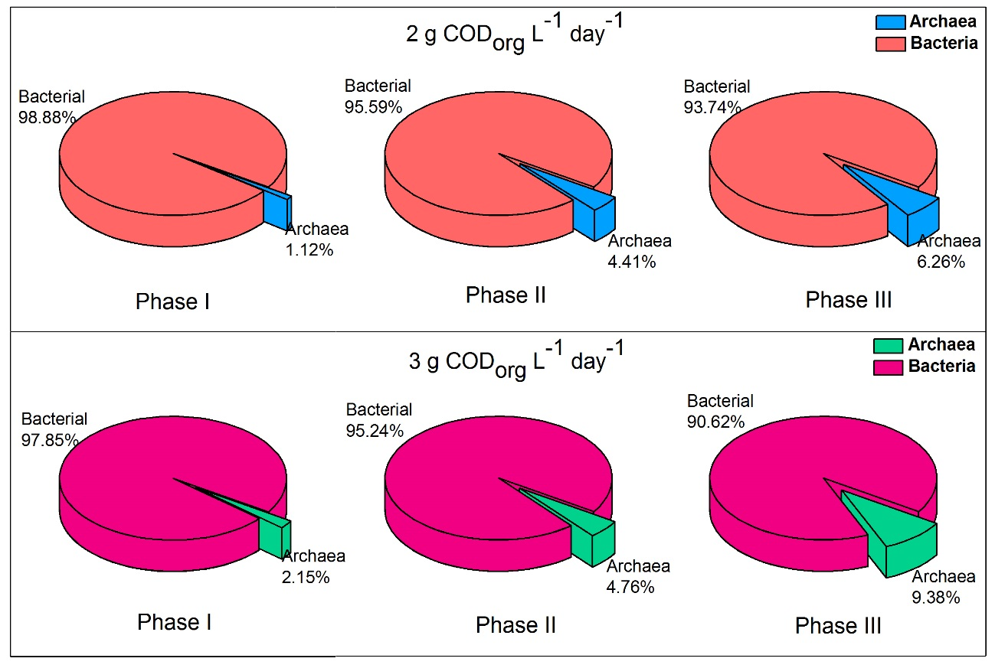
Figure 6 Relative abundance of archaea in the total microbial community at different phases for digesters operated at 2 and 3 COD_{org} L⁻¹ day⁻¹ (data represent mean for two digesters)
The archaeal community amplicon sequences were assigned to four of the seven orders of methanogens ³³, as shown in Figure 7 for the digesters at 2 and 3 g COD_{org} L⁻¹ day⁻¹. Prior to H₂ injection, the archaeal community in the digesters operated at 2 g COD_{org} L⁻¹ day⁻¹ was dominated by the hydrogenotrophic Methanomicrobiales (51.5 ± 4.7%) with acetoclastic Methanosaetaceae (the sole family detected from the order Methanosarcinales) (26.5 ± 1.67%), methylotrophic Thermoplasmatales (all from the order Methanomassiliicoccales ³⁴⁻³⁶, 18.6 ± 2.65%) and hydrogenotrophic Methanobacteriales (3.4 ± 0.46%) accounting for the balance of archaea. A similar distribution was seen for the digesters at 3 COD_{org} L⁻¹ day⁻¹. When external H₂ was injected the relative abundance of hydrogenotrophic methanogens increased, indicating gradual enrichment of this fraction of the community; by the end of phase II hydrogenotrophic methanogens collectively made up over 93% of the archaeal community and by the end of phase III this had increased to 97% at both 2 and 3 COD_{org} L⁻¹ day⁻¹. There was a significant reduction in the proportion of methanogens reliant on the cleavage of acetate (Methanosaetaceae) or known not to be hydrogenotrophic (Thermoplasmatales), the latter found in phase I in unusually high abundance for anaerobic digestion. The digesters at 4 and 5 g COD_{org} L⁻¹ day⁻¹ showed similar changes during phase II to those seen at 2 and 3 g COD_{org} L⁻¹ day⁻¹, as shown in Figure S4. Profiling of the archaeal community at genus level showed that at the end of phase II and III, the dominant methanogen was hydrogenotrophic Methanoculleus sp. (Figure S5), also reported by others as a highly abundant member of methanogens in CO₂ reductive biomethanisation systems ³⁷.
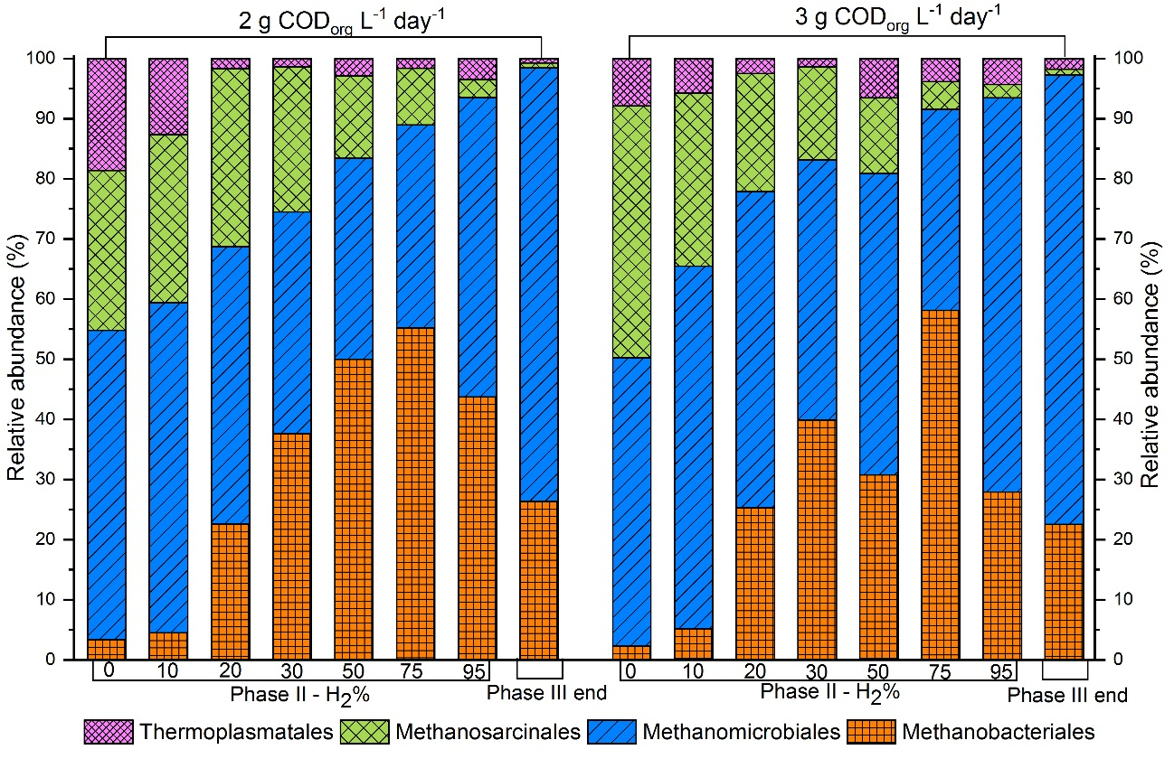
Figure 7. Average distribution of archaeal community in phase II and III for duplicate digesters operated at 2 and 3 g COD_{org} L⁻¹ day⁻¹
The limitations of 16S rRNA sequencing mean that the abundances of methanogens can only be expressed relative to the total archaea, making it challenging to pinpoint specific pathways within the system. If, however, it is assumed that the digestate VS content consists entirely of microbial biomass, and abundance correlates to % VS, the relative mass of acetoclastic and hydrogenotrophic methanogens can be estimated as shown in Table 2. Since the VS content at OLR 2 [3] g COD_{org} L⁻¹ day⁻¹ rose from 6.5 to 7.2 [7.6 to 9.9] g VS L⁻¹ between the end of phases I and II, while the estimated archaeal biomass only rose from 0.07 to 0.32 [0.16 to 0.47] g VS L⁻¹, it is clear that only a small proportion of this increase in VS can be accounted for by the growth in the methanogenic population. At the same time, the proportion of acetoclastic methanogens showed a decline.
Table 2 Estimated biomass concentration of methanogens in digesters operated at 2 and 3 g COD_{org} L⁻¹ day⁻¹ based on average digestate VS content in the final 10 days of phases I, II and III
Phase | 2 g COD_{org} L⁻¹ day⁻¹ |  |  | 3 g COD_{org} L⁻¹ day⁻¹
 | I | II | III | I | II | III
Digestate VS (% wt) | 0.65 | 0.72 | 0.74 | 0.76 | 0.99 | 0.99
Total microbial concentration (g kg⁻¹) | 6.50 | 7.20 | 7.40 | 7.60 | 9.90 | 9.90
Archaea fraction in total microbes (%) | 1.12 | 4.41 | 6.26 | 2.15 | 4.76 | 9.38
Archaea concentration (g kg⁻¹) | 0.07 | 0.32 | 0.46 | 0.16 | 0.47 | 0.93
Acetoclastic fraction in archaea (%) | 26.50 | 2.97 | 0.82 | 41.89 | 2.23 | 0.94
Hydrogenotrophic fraction in archaea (%) | 54.82 | 93.53 | 98.45 | 50.24 | 93.45 | 97.29
Acetoclastic concentration (mg kg⁻¹) | 18.55 | 9.50 | 3.77 | 67.02 | 10.48 | 8.74
Hydrogenotrophic concentration (mg kg⁻¹) | 38.37 | 299.29 | 452.87 | 80.38 | 439.22 | 904.79

It is possible that the decline in the acetoclastic population and pathway is compensated for by an increase in syntrophic acetate oxidation (SAO) in which acetate is oxidised into CO₂ and H₂, which are subsequently converted into CH₄ by the growing population of hydrogenotrophic methanogens ^{38, 39}. Some evidence that could support this is the population increase of the family Thermoanaerobacteraceae which includes two known SAO bacteria, namely Thermacetogenium phaeum and Tepidanaerobacter acetatoxydans ³⁹. An increase of approximately 8% in relative abundance of Thermoanaerobacteraceae was observed at the end of phase III in digesters operated at 2 and 3 g COD_{org} L⁻¹ day⁻¹ (Figure 8). An increase in hydrogenotrophic methanogens in the Methanoculleus genus with a concurrent rise in Thermoanaerobacteraceae was also observed in another biomethanisation study ³⁷.
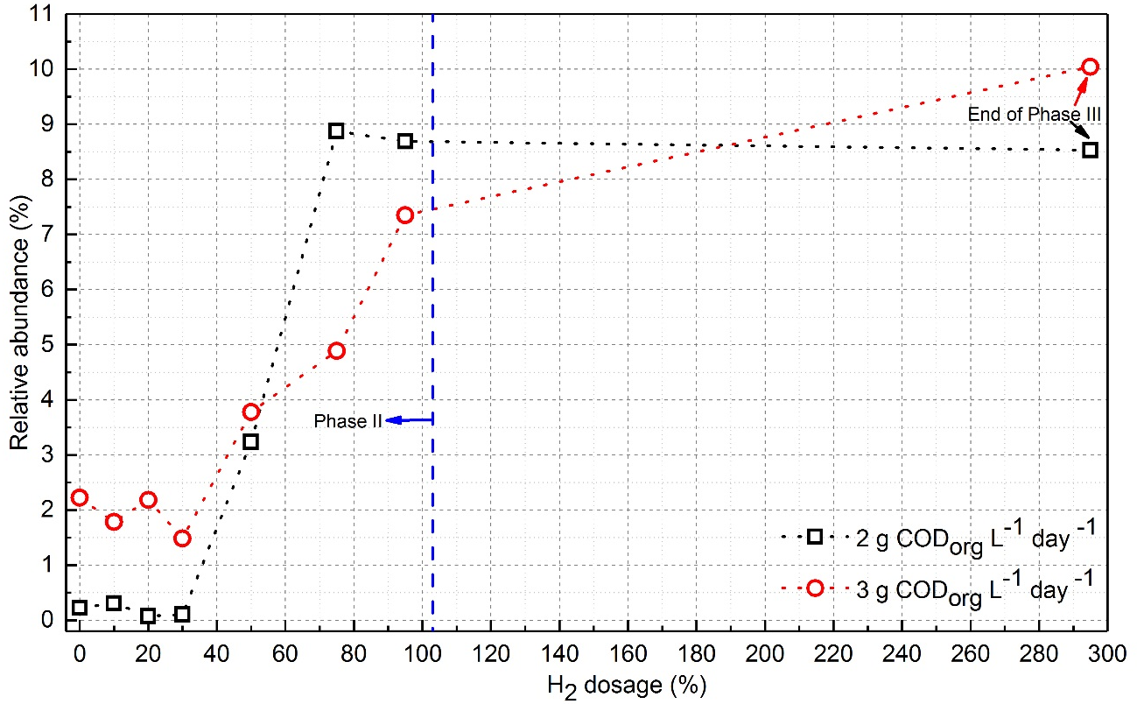
Figure 8 Relative abundance of bacteria family Thermoanaerobacteraceae to total microbial community during phase II and III in digesters operated at 2 and 3 COD_{org} L⁻¹ day⁻¹
3.5 Influence of H₂ injection on digester pH and bicarbonate buffering
The greatest risk to stable in-situ biomethanisation in CSTR-type digesters with suspended cultures is a rise in pH as a result of a fall in the bicarbonate buffering strength due to depletion of headspace CO₂ ²¹. The problem has been consistently encountered by others ^{10, 18, 19, 21}, and likewise in this study significant pH increases were observed in all eight digesters during phase II. The upper limit of pH at which anaerobic digestion is not inhibited is generally acknowledged to be around pH 8.5 ⁴⁰⁻⁴², and a pH near to this was recorded for digester D3 in phase II on day 231, when V_{H2,theo} reached 100% and almost complete CO₂ removal occurred. The CH₄ content of the biogas on that day exceeded 99%, but as mentioned above this was not sustainable, and VFA accumulation was evident as shown in Figure 4c and Figure S2b.
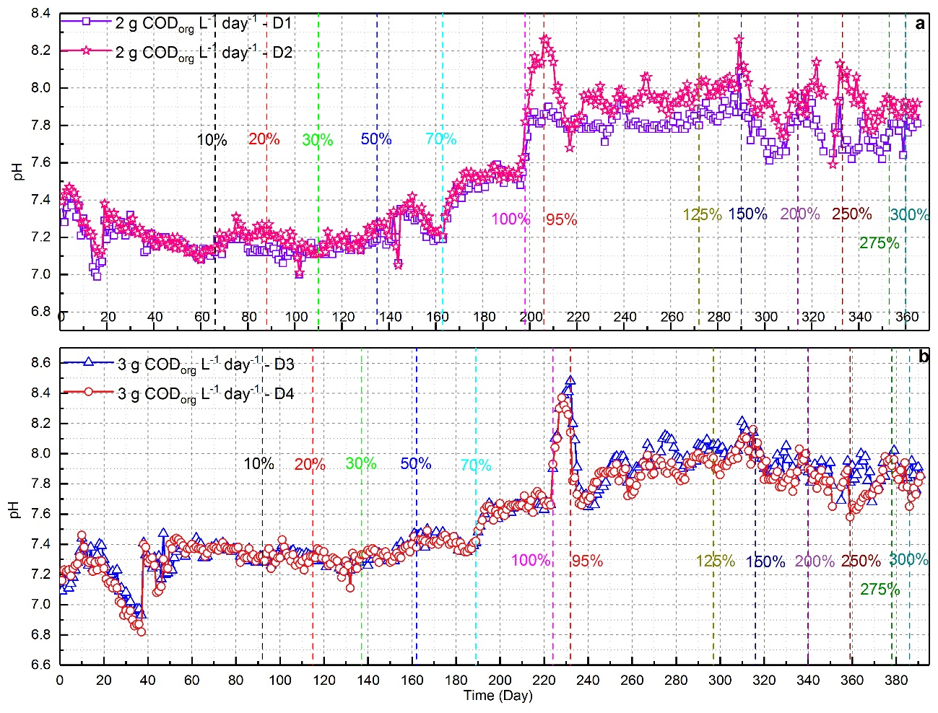
Figure 9 pH of digesters at (a) 2 and (b) 3 COD_{org} L⁻¹ day⁻¹ during phase II and III; H₂ inputs are shown by vertical dashed lines
Figure 9 shows the pH evolution against time in the digesters operated at 2 and 3 g COD_{org} L⁻¹ day⁻¹ and Figure S6 shows those of digesters operated at 4 and 5 g COD_{org} L⁻¹ day⁻¹. The pH of the digesters during phase III remained relatively stable with increasing external CO₂ load, although values were generally higher than those seen when using only endogenously-produced CO₂ in phase II. Digester pH is closely related to the partial pressure of CO₂ in the final biogas (P_{CO2}) as it is determined by the equilibria between carbonic acid, bicarbonate and carbonate alkalinity as well as ammonium/ammonia. Henry’s constant (K_{h}) regulates dissolution of CO₂ into the liquid phase and the hydration constant (k_{H}) determines the concentration of carbonic acid (H₂CO₃), which then dissociates into H⁺, HCO₃⁻ and CO₃²⁻ in two steps (Figure 10).
Figure 10. Schematic illustration of bicarbonate and ammonia buffering within AD
It is possible to estimate pH based on P_{CO2} for a closed system with pure water as the liquid phase, as all the constants used in the equations are defined and it can be assumed that the rule of charge neutrality applies. That system does not, however, fully represent the complex conditions in a digester, where all cations, anions, ammonia and VFA would need to be considered and any resulting expression would also be very complex. An empirical modelling approach was therefore adopted to relate pH to the change in P_{CO2} using data from digesters D1-D4.
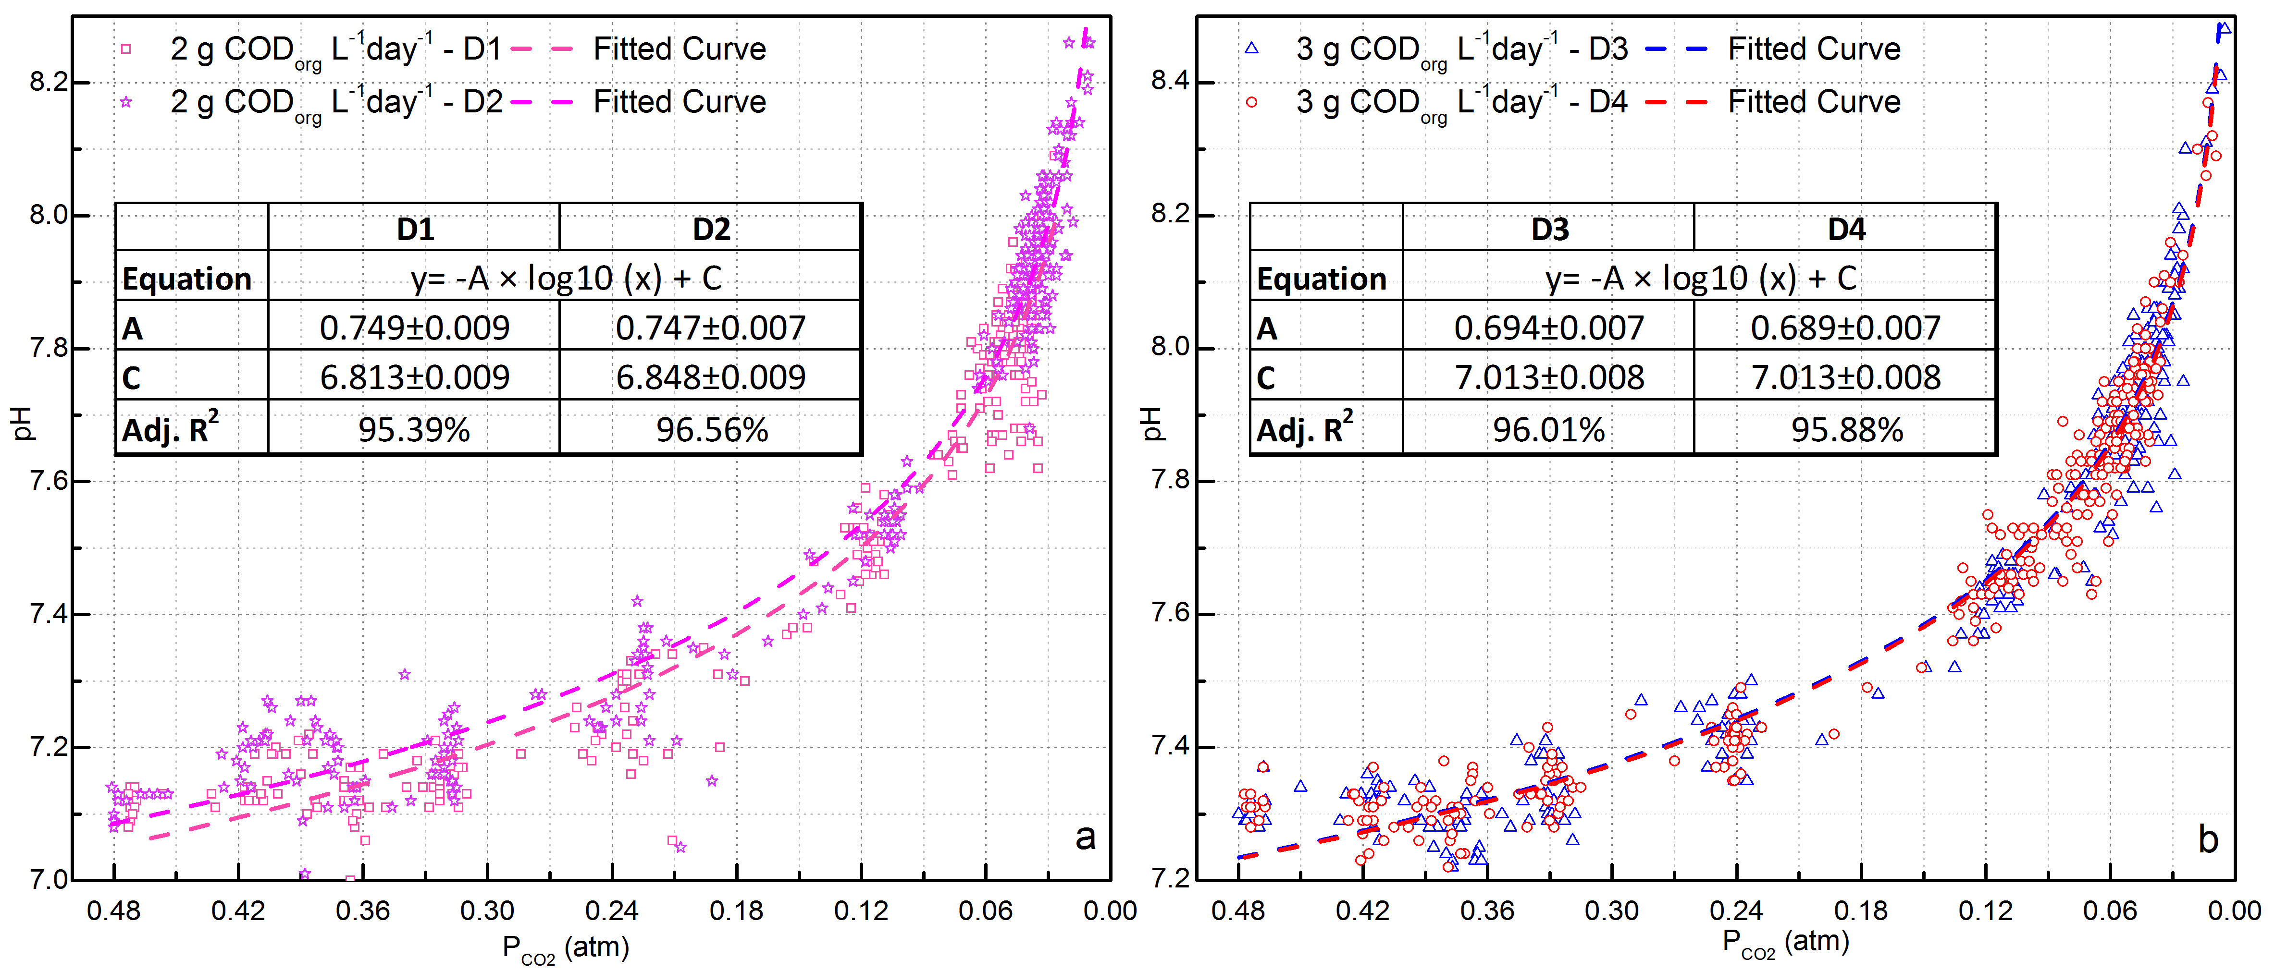
Figure 11. pH as a function of CO₂ partial pressures for digesters D1&2 (dots, a) and D3&4 (dots, b) during the three phases of experiment, with curve fitted to equation 4
Figure 11 shows the relationship of digester pH against P_{CO2} during the three phases. It is clear that at lower V_{H2,theo} additions while headspace CO₂ was still relatively high (up to 30%), pH remained fairly stable. At higher % V_{H2,theo} additions, however, pH rose sharply. The data were fitted to a logarithmic model, as in the definition of pH, with the following equation:
${pH}_{t}=-A∙\log_{10}{P_{CO2}}+C$ (4)
Where pH_{t} denotes the pH at P_{CO2,t}; C is a constant related to the digestate characteristics and A is an adjustment factor that may be related to the total alkalinity strength, especially total ammonia nitrogen (TAN) concentration. The good fit between the simulated curve and the experimental data confirms that the pH rise is essentially caused by the fall in P_{CO2} in the biogas. It also explains why pH levels were quite stable during the whole of phase III when methane content remained stable between 93-96%. This was achieved by controlling the P_{CO2} around 3%, which successfully maintained pH values below 8.0 in the digesters at 2 and 3 g COD_{org} L⁻¹ day⁻¹. In the digesters at 4 and 5 COD_{org} L⁻¹ day⁻¹ with TAN concentrations of 0.9 and 1.6 g N L⁻¹ respectively, the methane content was also successfully increased to 95% without triggering pH values above 8.1. This may not be the case for digesters with higher TAN concentrations, for example those running on food waste ⁴³, chicken manure ⁴⁴ or slaughterhouse waste ⁴⁵ feedstocks, which tend to operate at pH values above 8. In this situation the pH may exceed 8.5 before the biogas methane content reaches 95%, and measures such as ammonia removal may be required if a high methane content is targeted ^{44, 46}.

3.6 Volumetric methane production
The VMP values for digesters operated at 3 g COD_{org} L⁻¹ day⁻¹ were 0.86, 1.51 and 2.76 L L⁻¹ day⁻¹ at the end of phase I, II and III, respectively. The phase III VMP of 2.76 L L⁻¹ day⁻¹ exceeded that reported in other in-situ biomethanisation studies ^{18, 19, 27, 47} and in many ex-situ systems ^{3, 4, 6-8, 10, 12, 29, 30, 37}. It was, however, lower than the maximum previously reported VMP of 4.62 L L⁻¹ day⁻¹ [6] using a thermophilic CSTR system with gas diffusers. Kim et al [36] also achieved a VMP of 4.5-5.0 L L⁻¹ day⁻¹ with mass transfer promoted via gas recirculation and a gas dissolution device. There is no indication in the results reported here that the hydrogenotrophic metabolic capacity had been reached: this VMP simply reflects the highest loading applied in phase III, and it is possible that higher values could be obtained. With respect to other reactor types, the maximum reported VMP in up-flow digesters was 2.37 L L⁻¹ day⁻¹ ^{29, 30}, for packed bed digesters 1.79-8.14 L L⁻¹ day⁻¹ ^{8, 48}, for membrane reactors 3.80-8.84 L L⁻¹ day⁻¹ ^{9, 49}, and for trickle bed reactors 1.17-2.52 L L⁻¹ day⁻¹ ^{3, 4, 10}. All of these fall far short of the value reported by Savvas et al. [7] who achieved 40 L L⁻¹ day⁻¹ in a plug-flow biofilm reactor. While high methane productivities have been achieved in laboratory-scale reactors, there is as yet no large-scale commercialisation of any of the innovative designs proposed ¹².

3.7 Potential applications
The results confirm that the abundance of hydrogenotrophic methanogens in conventional anaerobic digesters can be enriched using the endogenously-produced CO₂ without affecting the functionality of the microbial community in degrading organic substrates. The VMP of test digesters operated at 3 COD_{org} L⁻¹ day⁻¹ was increased from 0.86 to 1.51 and then 2.76 L L⁻¹ day⁻¹ from phase I to III, with CO₂ content reducing from 47% to 5%. This indicates that industrial digesters working at conventional OLR and HRT on liquid or semi-solid feeds have the potential to triple their current VMP by reacting both endogenous and imported CO₂ with H₂, opening up new opportunities with potential commercial significance for the AD industry.
This approach could provide a cost-effective scenario for power-to-methane as it mitigates the need to construct dedicated bioreactors and may reduce the required capital investment. There is a further bonus in that in-situ systems both with and without external CO₂ additions do not require a supply of synthetic nutrient medium to sustain biomass growth, thus minimising operating expenditure. The most likely process limitation is the availability of carbon that can be converted, as this is dependent on the feedstock to the digestion plant or on that which can be imported from other sources. If the existing AD capacity in Europe were coupled to grid-based or local renewables, the biomethane production from existing organic feedstocks could potentially be increased by around 70%, corresponding to utilisation of around 26 M tonnes of CO₂ per year and decarbonising the equivalent amount of electricity production.
It should be noted that the presence of methane in the biogas reduces the partial pressure of convertible gases and thus the efficiency of gas-liquid mass transfer; hence, retrofitting would involve providing efficient mass transfer methods and devices (e.g. gas recirculation and diffusers) ^{10, 13}. In the current trial, however, simple recirculation was an effective strategy. Scale-up may give improved mass transfer due to greater hydrostatic pressures, while higher viscosity digestates in full-scale digesters may also increase gas-liquid contact times and thus aid H₂ mass transfer.
4 Conclusions
The study confirmed that hydrogen addition to a CSTR digester using simple recirculation of gases from the headspace could increase the methane content from 50% to over 95% if the system was acclimated gradually, allowing the hydrogenotrophic population to increase in relation to the increasing gaseous H₂ load applied. It was necessary to maintain some buffering from CO₂ partial pressure to prevent an inhibitory rise in pH, and stable operation with pH around 8.0 was achieved by maintaining 3-5% of P_{CO2}. Addition of imported CO₂ to digesters operated at 2 and 3g COD_{org} L⁻¹ day⁻¹ achieved simultaneous biomethanisation of CO₂ from endogenous and external sources. This allowed the volumetric methane production to increase from 0.86 L L⁻¹ day⁻¹ without H₂ to 2.76 L L⁻¹ day⁻¹ with an external CO₂ load equal to twice the endogenous CO₂. Analysis of the microbial community structure showed that methanogenic abundance increased by over 4-fold in response to the CO₂ and H₂ injection. Over 97% of the methanogenic community was shown to be hydrogenotrophic. The results showed that the capacity of a digester for CO₂ reduction can be increased beyond the constraints of the organic substrate, and that this did not interfere with substrate degradation. The implication is that a single modified digester could upgrade the biogas from multiple digesters, thus minimising capital and operating costs and providing a cost-effective solution for power-to-methane applications using existing anaerobic digestion infrastructure.

Conflicts of Interest
There are no conflicts of interest to declare.
Acknowledgements
The authors would like to acknowledge the Engineering and Physical Sciences Research Council (EPSRC) for support of the IBCat H2AD project (grant EP/M028208/1). James Chong is Royal Society Industry Fellow.
References
1. L. E. Jones, Renewable energy integration: practical management of variability, uncertainty, and flexibility in power grids, Academic Press, 2017.
2. S. Savvas, J. Donnelly, T. Patterson, Z. S. Chong and S. R. Esteves, Applied Energy, 2017, 202, 238-247.
3. M. Burkhardt and G. Busch, Applied energy, 2013, 111, 74-79.
4. M. Burkhardt, T. Koschack and G. Busch, Bioresource technology, 2015, 178, 330-333.
5. S. Kim, K. Choi and J. Chung, International Journal of Hydrogen Energy, 2013, 38, 3488-3496.
6. S. Kim, K. Choi, J.-O. Kim and J. Chung, New biotechnology, 2016, 33, 196-205.
7. A. Alitalo, M. Niskanen and E. Aura, Bioresource technology, 2015, 196, 600-605.
8. J. C. Lee, J. H. Kim, W. S. Chang and D. Pak, Journal of Chemical Technology and Biotechnology, 2012, 87, 844-847.
9. I. Díaz, C. Pérez, N. Alfaro and F. Fdz-Polanco, Bioresource technology, 2015, 185, 246-253.
10. L. Rachbauer, G. Voitl, G. Bochmann and W. Fuchs, Applied Energy, 2016, 180, 483-490.
11. N. Schill, W. Van Gulik, D. Voisard and U. Von Stockar, Biotechnology and bioengineering, 1996, 51, 645-658.
12. O. Y. Ako, Y. Kitamura, K. Intabon and T. Satake, Bioresource technology, 2008, 99, 6305-6310.
13. B. Lecker, L. Illi, A. Lemmer and H. Oechsner, Bioresource technology, 2017, 245, 1220-1228.
14. A. Petersson and A. Wellinger, IEA bioenergy, 2009, 20, 1-19.
15. European Biogas Association, Europran biogas association statistical report 2015, Brussels, 2015.
16. A. Bensmann, R. Hanke-Rauschenbach, R. Heyer, F. Kohrs, D. Benndorf, U. Reichl and K. Sundmacher, Applied energy, 2014, 134, 413-425.
17. P. Collet, E. Flottes, A. Favre, L. Raynal, H. Pierre, S. Capela and C. Peregrina, Applied energy, 2017, 192, 282-295.
18. I. Bassani, P. G. Kougias and I. Angelidaki, Bioresource Technology, 2016, 221, 485-491.
19. W. Wang, L. Xie, G. Luo, Q. Zhou and I. Angelidaki, Bioresource technology, 2013, 146, 234-239.
20. G. Luo and I. Angelidaki, Applied microbiology and biotechnology, 2013, 97, 3739-3744.
21. G. Luo, S. Johansson, K. Boe, L. Xie, Q. Zhou and I. Angelidaki, Biotechnology and Bioengineering, 2012, 109, 1088-1094.
22. S. Fukuzaki, N. Nishio, M. Shobayashi and S. Nagai, Applied and environmental microbiology, 1990, 56, 719-723.
23. E. Cazier, E. Trably, J.-P. Steyer and R. Escudié, Bioresource technology, 2015, 190, 106-113.
24. American Public Health Association, American Public Health Association (APHA): Washington, DC, USA, 2005.
25. M. Walker, Y. Zhang, S. Heaven and C. Banks, Bioresource Technology, 2009, 100, 6339-6346.
26. A. Buswell and H. Mueller, Industrial & Engineering Chemistry, 1952, 44, 550-552.
27. G. Luo and I. Angelidaki, Applied Microbiology and Biotechnology, 2013, 97, 1373-1381.
28. M. Persson, O. Jönsson and A. Wellinger, IEA Bioenergy task 37, 2006, 37, 1-34.
29. I. Bassani, P. G. Kougias, L. Treu, H. Porte, S. Campanaro and I. Angelidaki, Bioresource Technology, 2017, 234, 310-319.
30. P. G. Kougias, L. Treu, D. P. Benavente, K. Boe, S. Campanaro and I. Angelidaki, Bioresource technology, 2017, 225, 429-437.
31. S. Achinas and G. J. W. Euverink, Resource-Efficient Technologies, 2016, 2, 143-147.
32. S. Savvas, J. Donnelly, T. P. Patterson, R. Dinsdale and S. R. Esteves, Bioresource technology, 2017, 227, 93-101.
33. S. G. Shin, S. Lee, C. Lee, K. Hwang and S. Hwang, Bioresource technology, 2010, 101, 9461-9470.
34. G. Borrel, N. Parisot, H. M. Harris, E. Peyretaillade, N. Gaci, W. Tottey, O. Bardot, K. Raymann, S. Gribaldo and P. Peyret, BMC genomics, 2014, 15, 679.
35. K. Paul, J. O. Nonoh, L. Mikulski and A. Brune, Applied and Environmental Microbiology, 2012, AEM. 02193-02112.
36. G. Borrel, P. W. O’Toole, H. M. Harris, P. Peyret, J.-F. Brugere and S. Gribaldo, Genome biology and evolution, 2013, 5, 1769-1780.
37. I. Bassani, P. G. Kougias, L. Treu and I. Angelidaki, Environmental science & technology, 2015, 49, 12585-12593.
38. F. Mosbæk, H. Kjeldal, D. G. Mulat, M. Albertsen, A. J. Ward, A. Feilberg and J. L. Nielsen, The ISME journal, 2016.
39. M. Westerholm, J. Moestedt and A. Schnürer, Applied energy, 2016, 179, 124-135.
40. V. O'Flaherty, T. Mahony, R. O'Kennedy and E. Colleran, Process Biochemistry, 1998, 33, 555-569.
41. R. C. van Leerdam, F. A. de Bok, M. Bonilla-Salinas, W. van Doesburg, B. P. Lomans, P. N. Lens, A. J. Stams and A. J. Janssen, Bioresource Technology, 2008, 99, 8967-8973.
42. F. Ali Shah, Q. Mahmood, M. Maroof Shah, A. Pervez and S. Ahmad Asad, The Scientific World Journal, 2014, 2014.
43. C. Yirong, W. Zhang, S. Heaven and C. J. Banks, Journal of environmental chemical engineering, 2017, 5, 5131-5142.
44. F. Abouelenien, W. Fujiwara, Y. Namba, M. Kosseva, N. Nishio and Y. Nakashimada, Bioresource Technology, 2010, 101, 6368-6373.
45. Y. Zhang and C. Banks, Biochemical engineering journal, 2012, 68, 129-137.
46. A. Serna-Maza, S. Heaven and C. J. Banks, Bioresource technology, 2014, 152, 307-315.
47. G. Luo and I. Angelidaki, Biotechnology and Bioengineering, 2012, 109, 2729-2736.
48. E. C. Bugante, Y. Shimomura, T. Tanaka, M. Taniguchi and S. Oi, Journal of fermentation and bioengineering, 1989, 67, 419-421.
49. D.-H. Ju, J.-H. Shin, H.-K. Lee, S.-H. Kong, J.-I. Kim and B.-I. Sang, Desalination, 2008, 234, 409-415.

Corresponding author: Bing.Tao@soton.ac.uk; Phone: +44 (0)23 8059 3827.

