Making “a racket” but does anybody care? A study into environmental justice access and recognition through the political ecology of voice

Postprint acknowledgement: The Version of Record of this manuscript has been published and is available in Geoforum, 2019, 102: 142-156. https://doi.org/10.1016/j.geoforum.2019.03.024

CC-BY-NC-ND 4.0 license

There is now growing support for the United Nations to explicitly recognise the human right to a healthy environment, and to strengthen the fight for environmental justice. One key consideration is to explore how accessible environmental justice is for citizens in low- and middle-income countries, who are adversely affected by pollution problems. This article will evaluate citizen access to environmental justice through the state via a case-study of Peru. To do so, the article utilises the political ecology of voice (PEV) theoretical framework. PEV can be defined as the study of several economic, political, social, and geographical factors over a specific temporal period, and their impact upon the use of voice by different stakeholders. The research was centred on two communities affected by oil pollution events within Peru’s Loreto Region. It will show that Loreto’s rural population are subjected to “shadow environmental citizenship”, in which they have only peripheral access to environmental justice through the state, which also does not adequately recognise or support their right to seek redress. This in turn, forces people to seek access and recognition of environmental justice through more unorthodox or radical forms of action, or via the support of non-state actors.

Key Words: environmental justice; oil pollution; Peru; political ecology of voice; shadow environmental citizenship; political ecology

Introduction

The causes and impacts of pollution remain unevenly distributed throughout the world. Research from the Global Alliance on Health and Pollution found that in 2012, exposure to polluted air (both indoor and outdoor), soil and water, resulted in 8.4 million deaths in low- and middle-income countries (Global Alliance on Health and Pollution n.d., p.1). 10 per cent of deaths are attributable to contaminated sites and 8 per cent to water, sanitation and hygiene problems (World Health Organisation 2014, p.2) and of this combined percentage, an unspecified number stem from natural resource extraction such as oil. Evidence of oil pollution adversely affecting low- and middle-income countries can be seen in Nigeria’s Niger Delta Region (Gonzalez 2016), Ecuador’s Oriente Basin (Sawyer 2004), and Peru’s Loreto Region (Gonzalez 2018a).

There are now calls for the United Nations to explicitly recognise the human right to a healthy environment (Knox and Pejan 2018; Watts 2018), which would strengthen the fight for environmental justice surrounding oil pollution. This article’s focus on the human right to a healthy environment acknowledges the need for environmental justice research to explore basic human rights issues that remain insufficiently protected or unaddressed (Mehta et al., 2014). This is because environmental injustice and human rights are ‘inextricably interwoven’ (ibid. p.161; see also Adeola 2000). This article seeks to improve our understanding of environmental justice and social movements in low- and middle-income countries via a case-study of Peru’s Loreto Region. It will do so using an innovative theoretical framework termed the political ecology of voice (PEV), which will provide a study of access to, and recognition of, environmental justice.

Section 2 describes environmental justice and the factors which impact upon its societal accessibility, before discussing its effect on political mobilisation and the merits of using the PEV theoretical framework to study these interlinked issues. The methodology and case-study are described in Section 3, and the results in Section 4. Lastly, Section 5, the Discussion, will show that Peru’s rural population have only peripheral access to environmental justice through the state, which does not adequately recognise or support their right to redress, a situation termed “shadow environmental citizenship.” Shadow environmental citizenship forces communities to utilise unorthodox or radical voice actions, or rely on the support of non-state actors, in their efforts at gaining justice.

The (in)accessibility of environmental justice

To help us understand the production and diffusion of pollution, one must acknowledge its underlying links to the distribution of power. Environmental externalities ‘are often what the rich and powerful do to the weak and hungry’ (Bhaskar and Glyn 1995, p.4), and are a symptom of ecological distribution conflicts where poor and marginalised groups will suffer a higher burden of economic activity than others (Martinez-Alier 2005). To help understand why certain people and places suffer (Blowers 2003), environmental racism suggests that the most politically oppressed and powerless members of society, are the ones who are selectively victimised by powerful elites (Johnston 1994). This is evident in low to high-income country case-studies (Vitug 1993; Hvalkof 2000; Agbola and Alabi 2003; Williams and Mawdsley 2006; Pearce and Kingham 2008; Van Valen 2013; Schnegg and Kiaka 2018). These marginalised citizens ‘have little clout’ (Princen 1997, p.238) or opportunity (Tilly 1978) at gaining some tangible form of “justice.”

Justice provides local people and environmental activities with a crucial terminology in their opposition to pollution issues, resistance against land dispossession, and struggles for an equitable distribution of natural resources revenues (Sikor and Newell 2014). Nevertheless, what justice means in one context, how it can be accessed, and by whom, all influence our ability as people to seek redress for pollution and other issues. The initial focus of environmental justice research was on the uneven distribution of environmental burdens on disadvantaged communities (Holifield et al., 2018). The term has now broadened to incorporate a focus on participation (that is, who exactly participates in decision-making processes and how?) and recognition (i.e. what kind of visions and values matter?) (Fraser 1997; Schlosberg 2004; Ramos 2015; Popke et al., 2016; Rodríguez-Labajos and Özkaynak 2017).

Peoples access, or indeed exclusion, to participatory mechanisms for environmental justice is particularly important (Cappelletti and Garth 1978). Recent research (Routledge et al., 2018), has argued for an alternative climate justice agenda occurring through grassroots mobilisation in collaboration with state action; ‘[T]he state is both a terrain of struggle and possibility, essential for transcending capitalism and implementing a climate justice agenda’ (ibid., p.80, original emphasis). Whilst this terrain is constantly being remodelled (ibid.,), one must seek to understand what makes access to environmental justice a struggle rather than a possibility, in low- and middle-income countries.

Ribot and Peluso’s (2003) theory of access for resources is extremely useful to draw on. ‘Access is about all possible means by which a person is able to benefit from things’ (ibid., p.156, original emphasis). This encompasses an exploration of power which is utilised and distributed through different processes, mechanisms and social relations that occur in a specific cultural and political-economic environment in which access to resources is sought (ibid.,). These ‘webs of access’ relations (ibid., p.154) are not static but instead constantly changing over time. Similarly, one is required to explore these contextually and temporally specific political-economic, material, and cultural factors, to understand people’s access to environmental justice.

Several important access mechanisms are described, which have a bearing on access to state-based environmental justice. The first is access to authority, which shapes an individual’s ability to seek environmental justice. Those with privileged access to individual or institutional authority will have greater scope at gaining redress than poor or marginalised groups (ibid.,) who will also suffer from political neglect (Amoaka 2016; Smith and Rhiney 2015).

Access to authority is consequently intrinsically linked to social and economic selectivity (Robbins 2000; Yakovleva 2011; Gonzalez 2018b). Legal, customary, and conventional authorities may have overlapping authoritative jurisdictions enabling them to take advantage of their different social identities, to gain enhanced authoritative access (Ribot and Peluso 2003). In relation to economic selectivity, high-income, middle and upper-class citizens, can bear the participatory costs e.g. money, time and effort, and are less hindered by material hurdles e.g. access to mass communication devices like mobile phones, affordable childcare, reliable and affordable transportation, than low-income households (Blaikie 1985; Laurian 2004; Derrickson and MaCkinnon 2015).

This is especially true of low-income rural households who will have greater accessibility issues “reaching” the state than those in urbanised environments (Titheridge et al., 2014; Smith and Rhiney 2015). Accessibility, in relation to human mobility and state capacity is more challenging in remote areas (Kuklina and Holland 2018), which have dispersed populations, a scattered pattern of service outlets, and limited virtual connectivity (Nutley 1980; Velega et al., 2012; Mehta et al., 2014; Salemink et al., 2017). Subsequently, accessing environmental justice is more difficult for those in ‘spaces of vulnerability’ (Sharma-Wallace 2016, pp.174-175), such as peri-urban and rural localities (Howitt 2001; Harding 2007).

Two further structural and relational access mechanisms also require mentioning. Access to resources is often facilitated through social identity or membership of a community e.g. surrounding age, gender, ethnicity or any other identity attribute (Ribot and Peluso 2003; see also Elmhirst 2011). Research has found that non-state actors such as non-governmental organisations (NGOs), can determine access to environmental justice along identity lines (Buckingham and Kulcur 2009; Bell 2016). There is also access via the mediation of other social relations such as patronage, friendship, trust, obligation, and reciprocity (Ribot and Peluso 2003). These aspects are important to reflect on in relation to people’s access to state-based environmental justice.

Therefore, the terrain of the state has a significant impact on citizens ability to access environmental justice, a situation which can galvanise people into achieving their ends. Tarrow (2011) and other authors have extensively written about “contentious politics” whereby collective actors unite to confront elites surrounding their claims, environmental or otherwise (Yenneti et al., 2016; Boix and Stokes 2009; Scott and Barnett 2009; Devlin and Yap 2008). This contentious collective action underlies social movements, because it is the main and usually only option that most people possess to demonstrate their concerns against more powerful and better-equipped states (Tarrow 2011). Here, consideration must be given to the reaction of citizens if state-based environmental justice is inaccessible but also how successful these contentious political actions are.

To study this issue of (in)accessible environmental justice, the paper will utilise the PEV framework. This has combined political ecology, a framework that ‘emphasises the central role of power dynamics and socio-political processes in natural resource management’ (Green 2016, p.95), and environmental problems with Albert Hirschman’s voice theory. Hirschman’s work requires a summary so that a reader has a stronger understanding of the PEV framework.

In a 1970 text, Hirschman set out two possible consumer actions taken in response to unacceptable situations stemming from economic actors (Hirschman 1970). Exit, i.e. consumers stop purchasing a firm’s products, is normally a silent, private decision and activity (Hirschman 1995). Voice is a public, messy action, driven by the different levels that encompass it, i.e. from violent protest down to faint grumbling, that can occur individually or collectively (Hirschman 1970). Voice is principally an active action although it can occur passively, e.g. muted remarks (Zuindeau 2009), through horizontal and vertical situations such as speaking with one’s peers, and conversations with higher level actors respectively (O’Donnell 1986). In scenarios where public interest (Hirschman 1982) or public happiness is affected, such as an automobile safety problem, food hazard (Hirschman 1981) or, as PEV reasons, an environmental issue, voice can be understood ‘as an active expression of protest against a disagreeable issue’ (Gonzalez 2018b, p.650).

PEV studies explore ‘a specific temporal, economic, political, social and geographical environment in which various stakeholders (e.g. citizens, community-based organisations … and … NGOs) utilise their voice over an environmental issue’ (Gonzalez 2015, p.466). The 2015 article outlines the contextual influences surrounding voice application by stakeholders and their incorporation with four broad themes within political ecology; power, scale, space and time (ibid.,). The framework was developed for PhD research into the ability and willingness of Peruvian citizens to hold the oil company Petroperu accountable for pollution via a case-study of the Loreto Region. PhD PEV papers have explored the freedom of voice for hydrocarbon impacted stakeholders (Gonzalez 2018b) and oil company-community engagement (Gonzalez 2018a). This paper focuses on citizen use of orthodox formal voice ‘defined as legal or socially acceptable forms of non-violent voice action in horizontal/vertical situations, for example, electoral voting, petitions, discussions, debates, lectures’ (Gonzalez 2018b, p.650). It is explored through PhD PEV results that focus on two case-study Peruvian villages’ efforts at seeking access to, and recognition of, environmental justice.

The framework has several strengths when studying environmental justice. Political mobilisation studies highlight that changes to political opportunities such as institutional access or capacity for repression ‘provide the openings’ that lead to contentious politics and the prospect of collective action (Tarrow 2011, p.33). Where PEV differs is through its recognition that voicing over environmental issues can occur individually or collectively and involves a wide array of different actors e.g. individual (citizen), collective (citizens, CBO, NGOs) or institutional (business, state) (Gonzalez 2015). Focusing on the action of voice itself and how and why an articulation occurs i.e. through different active or passive means, enables a researcher to understand the multifaceted, spatially diverse but often interlinked impacts which affect the ability of stakeholders to achieve a predetermined outcome; in this case, access to and recognition of environmental justice. By contextualising PEV’s application, an investigation provides analysis into different interlinked facets of voice e.g. freedom of voice, which provide a wholistic analysis of a single study environment. Here, citizen access to environmental justice requires exploration of material (locality, infrastructure, political engagement, economic means) and immaterial (social identity, social relations) factors which operate in a temporally dynamic environment, a situation which PEV can aptly accommodate. The framework also acknowledges the importance of contextual specificity when studying voice (ibid., p.473), so a summary of the Peruvian case-study is now provided.

3. Methods

3.1 Study region and study sites

This research was conducted over three and half-months’ fieldwork in 2015 in Peru’s Loreto Region. Loreto has an overall population of approximately 1 million people, 45 per cent of whom live in the regional capital Iquitos, whilst the remainder dwell in over 2,000 smaller, remote, river-edge communities (Brierly et al., 2014). The Regional Government of Loreto (GOREL) is situated in Iquitos and Loreto’s local government is split into provincial and then smaller district administrations (Fernandini and Sousa 2015). Each province and district have their own provincial and district capitals. In Loreto, there are eight provinces split into 53 districts (see Figure 1).

Loreto is integral to Peru’s oil operations which now accommodate the country’s largest proven oil reserves (World Energy Council n.d.). These are principally located in Blocks 8 and 192, the longest-running Loreton oil blocks. However, these sites, along with the North Peruvian Pipeline, have been the major oil pollution sources, causing significant socio-environmental impacts on predominantly indigenous citizens (Congress of the Republic of Peru 2012-2013; Directorate General for Environmental Health and Food Safety 2006; Napolitano and Ryan 2007; Orta-Martinez et al., 2007; Reátegui-Zirena et al., 2012). In 2016 alone, seven oil spills from the North Peruvian Pipeline were reported in Loreto and neighbouring regions which spilt an estimated 10,000 barrels of oil (Law in Action n.d.; Peru Support Group 2016a; b; c; d).

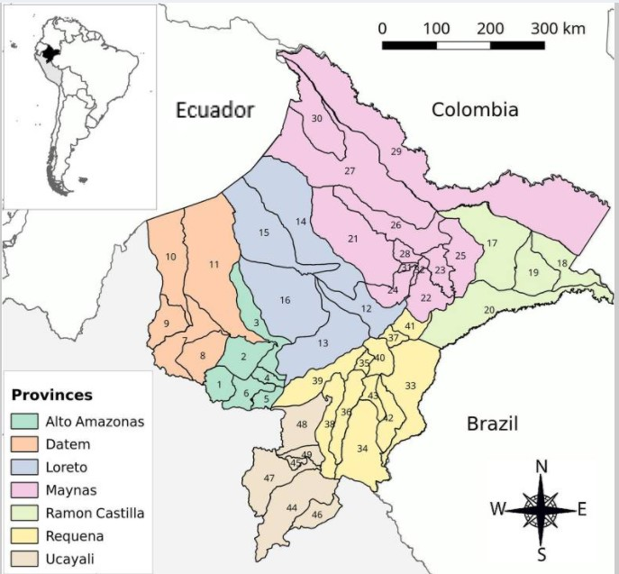
Figure 1: Loreto Region approximate case-study localities and key information (based on map from Soto-Calle et al., 2017).

Relevant numbered case-study districts: 16: Urarinas, 28: Punchana.

Key:
Iquitos, regional capital. Also serves as Maynas provincial capital.
Barrio Florido case-study village. Located in Puchana district, Maynas province.
Punchana, district capital of Punchana district, Maynas province. Barrio Floridio’s local government location.
Cuninico case-study village. Located in Urarinas district, Loreto province.
Concordia, legally, the district capital of Urarinas district, Loreto province.
Maypuco, de facto district capital of Urarinus district, Loreto province. Cuninico’s local government location.
National Protected Areas.
Regional Protected Blocks.
North Peruvian Pipeline (orange) and Northern Branch Pipeline (yellow).

This study was focused on two oil communities affected by pollution caused by Petroperu, a state-controlled national resource extraction industry (Gonzalez 2017, p.78). The first, Barrio Florido, is a non-indigenous community of roughly 800 inhabitants situated on the banks of the Amazon River and adjacent to the Iquitos Petroperu refinery in Puchana district, Maynas province (see Figure 1). Two recent oil pollution incidents were reported. The first occurred in 2009 when heavy rain caused four oil barrels to spill into the Ramirez River, a small creek situated between the refinery and the village that feeds into the Amazon River. The second spill was in 2011 when an unknown oil quantity from several storage tanks connected to the refinery’s storm drain system leaked into the Ramirez River.

The second village, Cuninico, is a Cocama (or Kokáma) indigenous community numbering between 450-500 inhabitants located on the banks of the Marañón River, Urarinas district, Loreto province (see Figure 1). In June 2014, the North Peruvian Pipeline burst causing a 2,000-barrel oil spill which burst into the dredged floatation channel that follows it and flows into the Amazon river network (Fraser 2016a; Segovia 2014; see Figure 2).

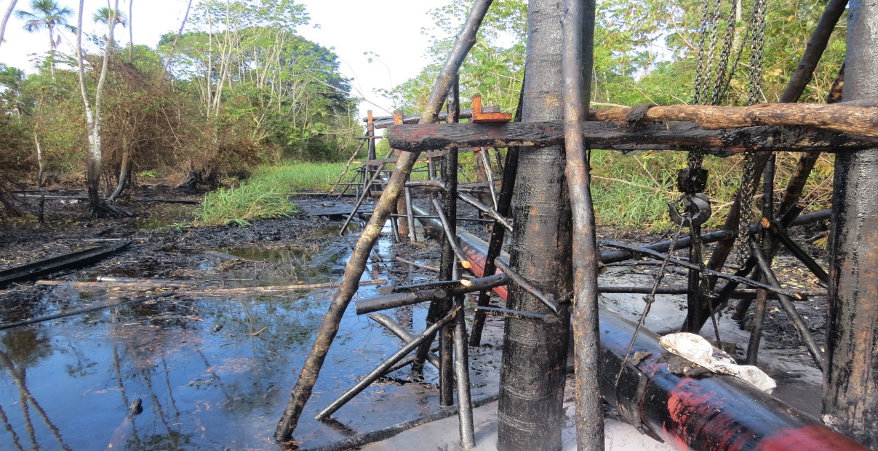
Figure 2: View of the North Peruvian Pipeline after the completion of repairs to the 2014 rupture that affected Cuninico. Its poor condition is obvious from this photo (Figure 2 provided by a Cuninico resident given to them by a Petroperu engineer and used with their permission, Summer 2014).

3.2 Methodology

Data were collected through a multi-method qualitative approach incorporating semi-structured interviews and micro-geography interview analysis (Elwood and Martin 2000). The semi-structured interviews were anonymised, and audio recorded (with participant consent), and were conducted with a paid local interpreter. The questions were based upon an interview guide tested through pilot interviews and refined through contact summary sheets (see Miles and Huberman 1994). Each participant was given a coded category made up of their broad professional occupation, ethnicity, geographical location and interviewee and organisation (if relevant) number (n) (Appendix A).

The four professional occupational bands (Appendix B, C) were based on the International Labour Organisation’s International Standards Classification of Occupations (ISCO) and resolution ISCO-08 (International Labour Organisation 2007a). The major and sub-major professional groupings were amalgamated into wider bandings which allowed examination of a participant’s occupation and therefore how economic means impacts access, without delving into unnecessary occupational intricacy. A further Band (5) has been added to acknowledge non-economically active roles.

Contact was made with possible participants and case-study community gatekeepers, found through a Google internet search. These were three NGOs, E-Tech International (NGO1R1), The Peru Mission (NGO2R1) and Alianza Arkana (NGO7R1) and an indigenous environmental watch-dog CBO, Red Ambiental Loretana (CBO1R1). All, except E-Tech International are based in Iquitos. A theoretical sampling approach was taken to data collection supported through the snowballing effect (Taylor and Bogdan 1998). 110 semi-structured interviews were conducted with 105 interviewees from the various stakeholder groups and other citizens of interest but only those directly cited in this article are listed in Appendix A.

A team of paid UK translators created the interview transcripts. These were analysed through QSR Nvivo 10 in which data were coded through concepts, categories and propositions (typologies) via a weak form of inductive or conventional content analysis (Patton 1987; Miles and Huberman 1994; Taylor and Bogdan 1998). Inductive analysis was combined predominantly with analyst-based typologies alongside indigenous or emic typologies (Patton 1987) so that participants were “heard” and utilised in a way that did not alter their voice. Emotive phrases have been written in Spanish alongside a bracketed English translation to connect with the original participant’s voice and fieldwork context. The coding process was supported through development of a loose research storyline based upon the PEV framework.

4. Results

To fully understand Peruvian citizen access to environmental justice, it is important to summarise the wider PEV contextual environment in which it operates. Two major influences are apparent. The first is Peru’s political (or state) environment and the freedom of voice which means exploring societal legal rights and the possibility for this action. The second is oil company-community engagement and the latter’s ability to report environmental pollution issues.

Peru’s political environment has seen it consolidate democracy and adhere to regional and international norms, which legally provide citizens with the freedom of voice. However, a contextual focus onto the PEV political environment vis-à-vis hydrocarbon development finds a more restrictive, suppressive vocal environment. This is caused by ‘the state’s aggressive hydrocarbon and wider development agenda … categorised as a “selva [rainforest] hydrocarbon and development vision” (SHDV)’ (Gonzalez 2018b, p.657). The SHDV seeks to implement Loreton oil exploitation at the deliberate expense and dispossession of its indigenous peoples, whose own power and rights in these spaces is weaker than other citizens and actors, like the state or extractive industries (Cardozo 2011; Pinedo 2017). A similar situation is seen in other Latin American contexts where decisions surrounding land and mineral use adhere to and promote a neoliberal or rentier capitalist development discourse (Anthias and Radcliffe 2015; Wilson and Bayón 2017).

These communities are also adversely affected by their Petroperu relationship. Research (Gonzalez 2018a) has found that Petroperu’s power vis-à-vis communities is almost absolute which allows them to dictate whether meaningful participation occurs (Organisation for Economic Co-operation and Development 2015). In this study, Petroperu pursued an intentional policy of community decoupling and established ‘a climate of fear’ to suppress citizen voice, and prevent them reporting oil spill incidents (Gonzalez 2018a, p.326). Importantly, despite Petroperu’s state-control, it remains a non-state actor as is not designed to provide core state services e.g. healthcare, education or energy. However, research indicates that companies often do provide these services (Gonzalez 2018a; Enns and Bersaglio 2015) and to understand why, studies must explore the state’s presence in these localities. This paper will now set out the Peruvian state’s Loreton presence.

4.1 State selva presence and civil society development

During interviewee discussions about Loreton state presence, a key word utilised was ‘centralisation’ (CBO1R1; IUA3; NGO2R1b), focused predominantly on Iquitos but also other bigger towns where subgerencia [local government] offices for the provincial and district capitals were based. However, as one moved further away from Iquitos and other urban centres, state presence in Loreto’s smaller communities was described as ‘invisible’ (IJ1; NGO1R1), ‘absent’ (CBO4R3; NSI4R1; RGR3), ‘inaccessible’ (NSI4R1) and ‘almost negligible’ (NGO2R1b), especially surrounding education, health, legal services and other infrastructure. ‘The people here would say the state doesn’t reach …. In Spanish, they’d say ‘el estado no lo alcanza’ it doesn’t reach those places’ (NGO2R1b). Both case-study communities highlight this.

In Barrio Florido, residents lack basic sanitary systems whilst clean water access is problematic. The village has a water tower, filled every week through water provided by Petroperu (Gonzalez 2018a), but this affords insufficient capacity forcing residents to utilise untreated river water. The village primary school, sinking into the ground and in need of repair (Figure 3), is nearby a small medical post which opens sporadically and lacks the necessary medicines. A low bridge connecting the village had been built by residents and improved by The Co-operation Fund for Social Development, a government agency, but is now dilapidated (Figure 4). Barrio Florido has electricity, but it is supplied by the refinery. Former GOREL administrations had installed electrical meters (now broken) for each house and provided tin roofs for only some resident dwellings (Figures 4 and 5).

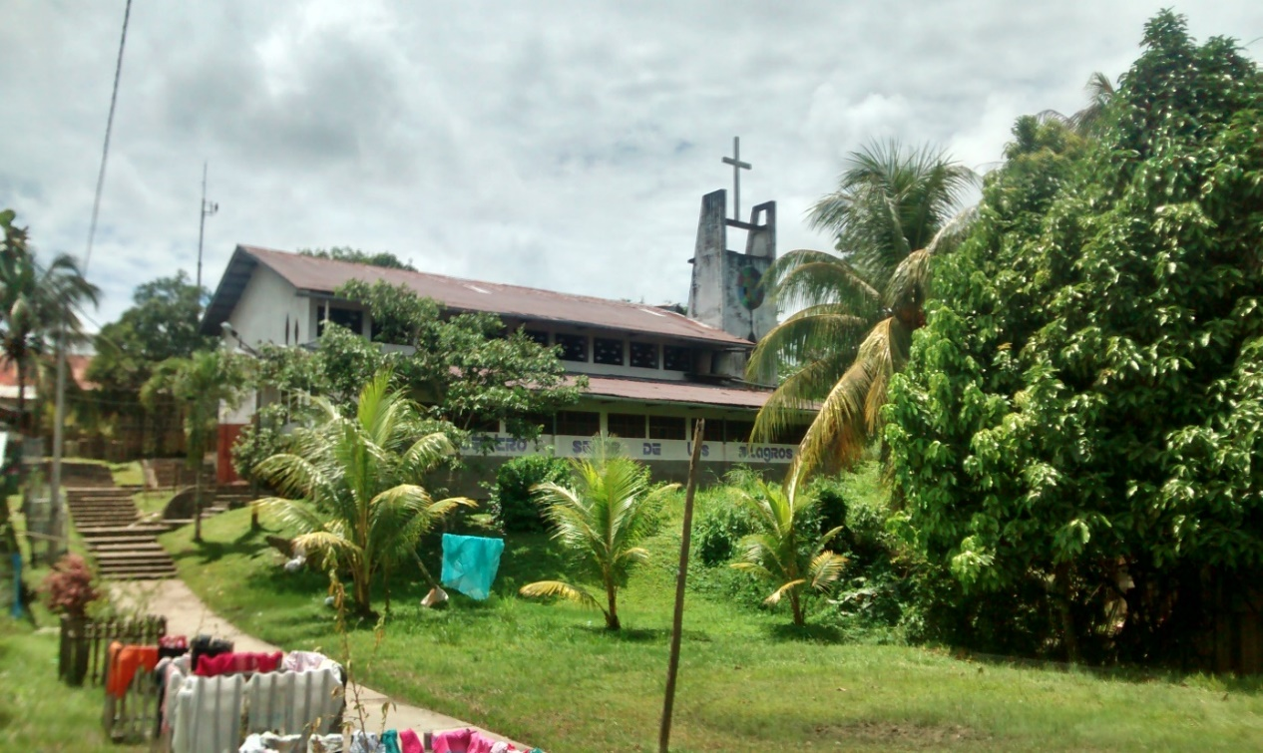

Figure 3: Barrio Florido’s school building.

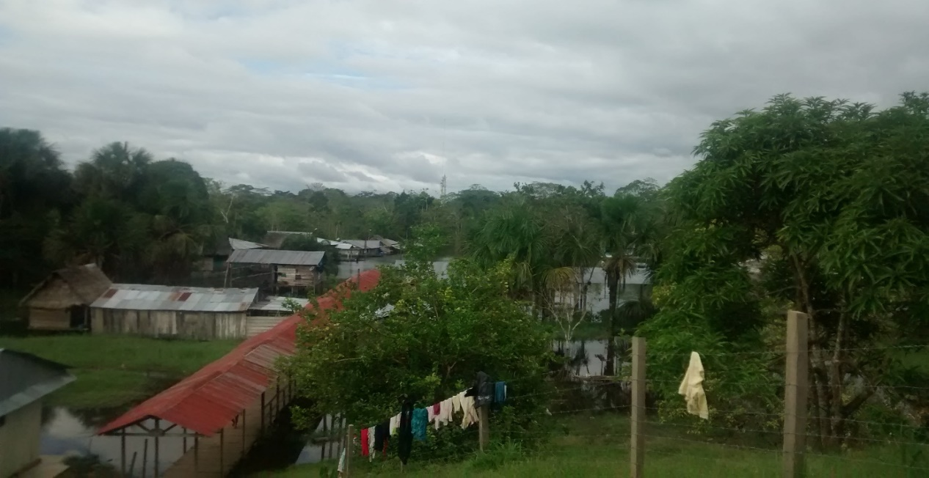

Figure 4: Barrio Florido’s bridge taken from the small hill at the top of the village.

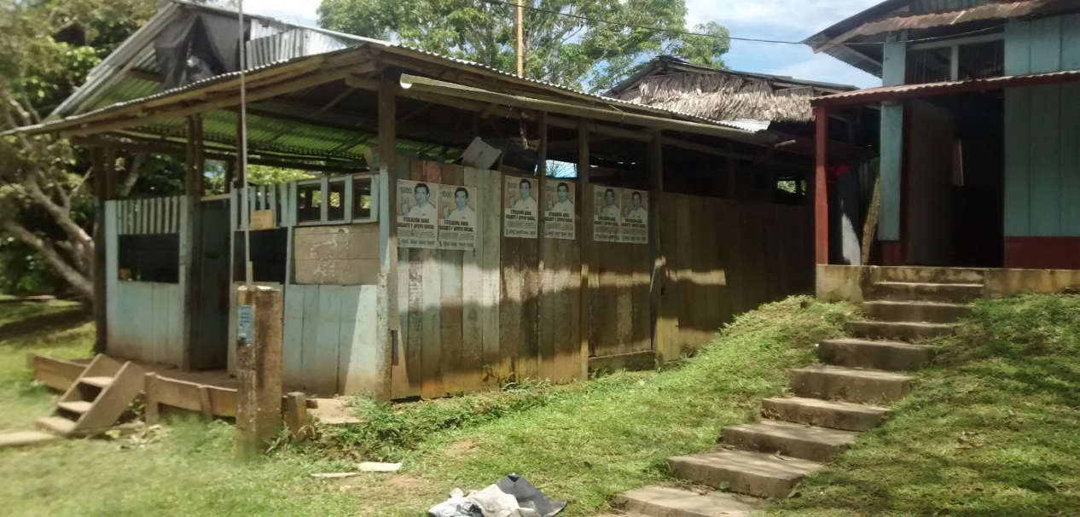

Figure 5: A typical Barrio Florido dwelling. The absence of state infrastructure and citizen poverty is obvious.

Similarly, in Cuninico, all residents lack clean water and basic sanitary systems, while unconnected electrical pylon and street lights run alongside a small cement pathway through the village centre (Figures 6 and 7). Only three families have generators for electrical power and there is a single generator for Cuninico’s moloqua (community hall). There are no secondary school, legal services, or medical facilities, the latter forcing residents to travel upriver to Maypuco (Urarinas district capital, Loreto province) on a 45-minute riverboat journey. All dwellings are constructed from wood, many with thatched roofs (Figure 8). Overall, Peru’s development in communities where ‘there is nothing new’ (MRBF19) can be summarised by one Barrio Florido resident; ‘como un cero a la izquierda’ (we are a waste of space, here there is nothing) (MRBF15).

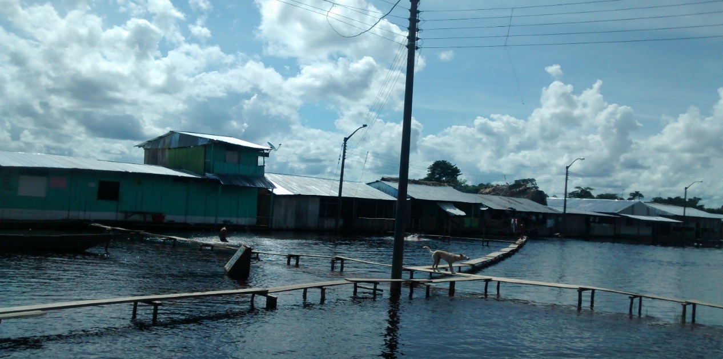

Figure 6: Unconnected electrical lights run throughout Cuninico. This view, taken from the moloqua looks out onto the central public space during the annual Marañón River flooding.

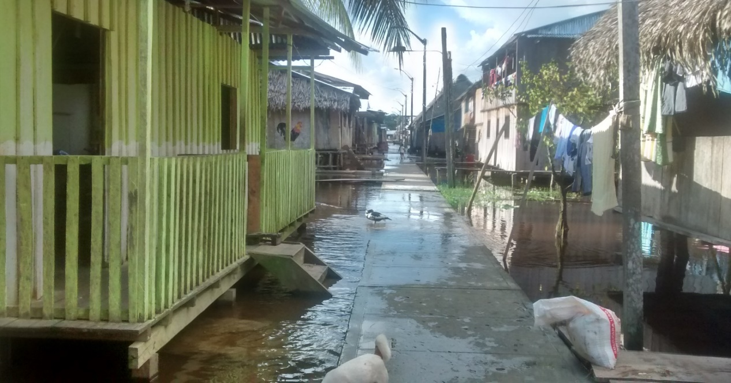

Figure 7: View of the Cuninico main street, where the small cement pathway is located.
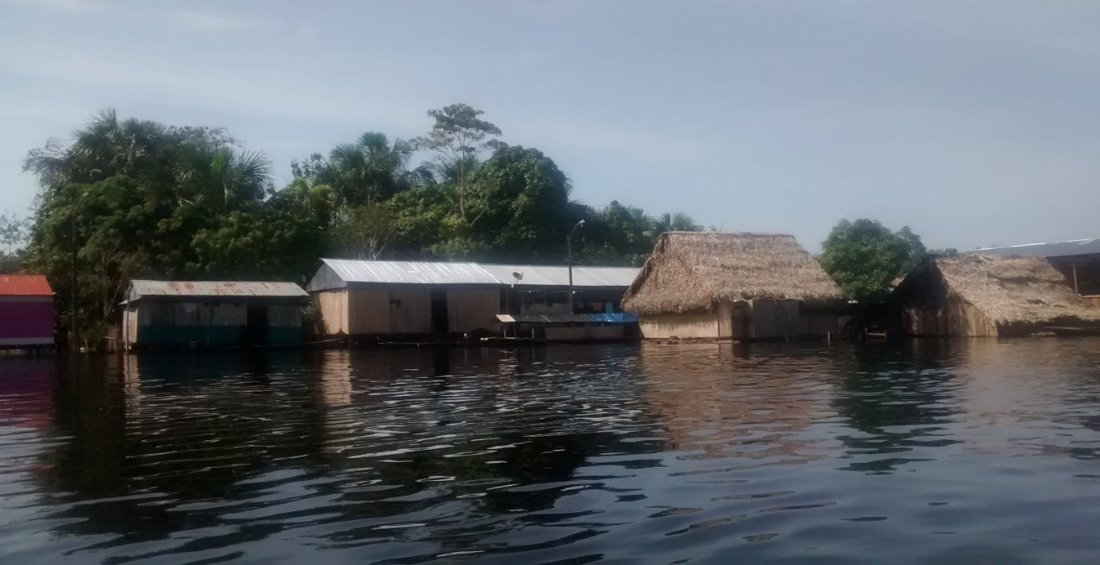

Figure 8: Cuninico dwellings. Their basic construction, many made of wooden planks and thatched roofs highlights their poverty.

One can see that government development of selva communities extends only to the provision of ‘token gestures [i.e. tin roofs] that don’t really affect the way the whole economy operates in Loreto’ (NGO1R1) and do ‘nothing to improve the situation of people’s lives’ (CBO4R3). The Alianza Arkana spokesperson felt this situation was caused by a ‘lack of political will’ (NGO7R1). However, it is perhaps more pertinent to suggest a misplaced political will.

As Section 3’s opening described, Peru’s political elites are focused on the SHDV (Gonzalez 2018b). Whilst this would seem to offer benefits to an overlooked Peruvian region, The Peru Mission representative was unsure ‘if people are included in that’ vision (NGO2R1c). This is evident from the absence of state ‘invest[ment] in human capital’ for indigenous people (RGR2), which will impact on their knowledge of their rights and subsequent participation in environmental justice politics (Lopez 2011). This is because the state ‘doesn’t care about the indigenous people’ (CBO4R3), highlighting institutional discrimination. As an Iquitos lawyer reflected, ‘the state … plays a very important role in the defence of their [indigenous peoples] lands [pause] [but] they haven’t done it with the due respect when they … exploit[ed] their lands [for] hydrocarbon’ (ILP2). Furthermore, there is also ‘political disinterest …[in] ensuring that the indigenous communities in the [selva] are [pause] in a good state … and maintaining their quality of life’ (IUS2). Discrimination and political disinterest shape the PEV environment of Loreto citizens and their access to environmental justice in several ways.

To begin with, discrimination and political disinterest explain Loreto’s chronic selva civil underdevelopment. Cuninico residents have struggled to improve the community because ‘in the past, nobody has listened to us’ (IRC7). ‘[W]henever we ask for something, suddenly the mayor isn’t available’ (IRC7). ‘That’s why we’re here, in this state of abandonment’ (IRC7) leaving them reliant on each other and non-state actor support, in this case, the Catholic Church. Likewise, in Barrio Florido, inhabitants were dismissive of state development. ‘In the ten years that I’ve been living here I haven’t seen improvement’ (MRBF26) or ‘any benefits from the government’ (MRBF1). ‘They [only] help you with the bare minimum’ (MRBF26) such as supplying tents and packets of rice during the annual flooding. ‘[M]eaningful donations from the regional government’ haven’t been seen by residents (MRBF13).

Politicians ‘never pay attention to the communities needs’ (ILP1) and this is apparent from case-study interviews. Barrio Florido holds two assembly meetings each month to discuss what they need and write documents to the government requesting support. Projects include building a pavement, football field and materials for a tourism viewpoint and repairing the school. These plans have been denied or so far not materialised with the local mayor ‘talk[ing] a lot and offer[ing] empty promises’ (MRBF30).

This selva civil underdevelopment, especially of technology and transport is ‘a major barrier to the folk in the rainforest being able to have their voices … heard’ (NGO2R1c) and accessing environmental justice. From a technological perspective, it is linked to a wider bureaucratic and formalised culture of dialogue in Peru by government personnel. Formal typed and printed introductory letters are required to garner interviews, but the process is slow. ‘A document may have to go through different sectors and it may take days to transfer, even though it can be done in hours’ (IUA2). The documentation also requires printing and administrative payment costs and thus saw one interviewee conclude that ‘the bureaucracy goes hand in hand with corruption’ (ILP2), an issue which ‘affects the environment … on a huge level’ (CBO1R1). Rurally-located Loreton citizens, with weaker education (see Brierley et al., 2014) and limited technological access will face difficulty producing these letters.

The absence of ICT connectivity also means that important virtual state environmental justice mechanisms are inaccessible to selva citizens. The Agency for Environmental Assessment and Enforcement’s (OEFA) National Information System on Environmental Complaints, ‘allows citizens that become aware of any environmental damage, to report and alert the Government, be it in person, via the internet or by post’ (OEFA n.d.). Whilst the absence of selva ICT connectivity means that people can still make a report in person at OEFA’s Iquitos office, limited public transport and citizen poverty makes this difficult.

A non-public transport system operates on Loreto’s waterways. The vessels can be divided into two categories: motonaves fluviales (or lancha) which are larger, slower, cargo and passenger-carrying boats and smaller botes fluviales (or bote) such as speed boats (delizadores or rápido) and canoes (Vuori 2009, p.30). However, as the E-Tech interviewee noted, ‘mobility [remains] a huge issue in the area’ (NGO1R1) and other rural regions (International Fund for Agricultural Development 2013) and is one of the reasons ‘why the indigenous people are greatly abandoned’ (ILP2). A GOREL manager of health and environment jokingly stated that if selva communities want to travel to Iquitos ‘they use the boats of the [oil] compan[ies]’ (RGR1). Indeed, research indicates that while communities like Barrio Florido situated near Iquitos have four or five 30-minute weekly boat services, longer journeys are extremely infrequent. Downriver services on the River Marañón provide Cuninico with only one weekly 11-hour service to Nauta, the port city 98km from Iquitos, while other major rivers have a service twice a month or less (Vuori 2009). Reaching the state is thus difficult.

Transport costs are also high. For Cuninico, a return journey to Nauta costs 90 soles by lancha or 180 soles by bote whilst Barrio Florido has a twelve soles bote return price to Iquitos. These are ‘very expensive’ costs (IRC3) for impoverished people. Appendix B and C detail Barrio Florido and Cuninico residents’ employment statistics. In Barrio Florido, 29 of the 30 interviewees provided employment details. The majority are reliant on a single source of low-paid, male income and whilst no salary figures were obtained, data shows that Loreto’s per capita family income is only 500 soles per month (Clancy and Kerremans n.d., see also Trading Economics n.d.) and had a 2010 poverty rate of 49.1 per cent (USAID/Peru 2012).

In Cuninico, 27 of the 29 interviewees had employment data taken and again lower skilled professions were the largest employment segment with 16 residents in Band 5, 14 as houseparents. Their main employment is as subsistence farmers, fishers, hunters and gatherers. Though specific income figures were not requested, it can be accurately gauged from other Loreton selva research; a 2014 study found that of the 179 inhabitants in ten remote communities along the Amipiyacu and Yaguasyacu Rivers, ‘87.7 [per cent] (N=157) reported earning >1 US$ per day’ (Brierley et al., 2014, p.181).

Given this economic situation, rural people cannot afford Loreto’s river transport costs. In Cuninico, whilst ‘a few people who have business go there [to Iquitos] once a month …. mostly, because of the cost of the journey, they send their produce by boat and don’t travel with it, and then their money gets sent back to them’ (IRC3). In Barrio Florido, where transport costs to Iquitos are markedly cheaper, residents rely on their volunteer authorities, discussed in Section 4.3, to liaise with the government. Consequently, one finds that generally ‘the people in the jungle haven’t got the money to get down here [to Iquitos]’ (NGO2R1b).

‘Why isn’t there … [an affordable] public transport system in the Amazon? A state-run public transport system that allows people’ greater access and mobility. ‘It’s like the key problem’ (IJ1). This question posed by a journalist was answered by other interviewees who shared a similar conclusion. A retired Cuninico resident with children in Lima felt that the poor selva transport links allowed ‘[t]he state [to take] advantage that there is no means of communication’ in comparison to those living in more accessible regions, like the sierra (mountain highland region):

[T]hey get the trucks. They all reach the congress. They just park in parque unversitarios [a central Lima park] and stay there …. From la sierra … because of the mines. They travel three-four times. They protest, and they reach the congress and they are heard but from here there are no means of transport (IRC28).

Amongst my participants whose professional employment in government, academic and NGO sectors was linked to the selva, six interviewees (IUA1; IUA2; IUA3; NGO5R1; RGR1; RGR2) suggested that access is difficult for the government and citizens due to the geographical distances, travel costs and poor logistical capabilities which limits state selva engagement. However, a spokesperson from Red Ambiental Loretana (CBO1R1) and a judge in the Superior Courts of Justice (judicial district of Loreto) (NSI7R1) disputed this. The Red Ambiental Loretana participant believed that a ‘justification’ on the part of the government for their community engagement is that ‘there’s difficult access and everything else. But given the time that the petrol companies have been in Loreto … one would have thought regional or national government[s] would have done something about making it easier accessibly’ (CBO1R1).

The judge in the Superior Courts of Justice ties this back to the interlinked impacts of political disinterest and discrimination:

[T]he issue regarding communication with the communities is political will …. When someone wants to go somewhere, they go either by air or using the river …. Yes, the area is large [and the] … region is rather difficult for the indigenous and for us, but not for the state or companies that have a lot of resources and can do it …. The problem is that there has always been asked “who is there?” A small group of indigenous, so they don’t care …. So, the issue … is the lack of will to respect as part of the state policy (NSI7R1).

4.2 State selva community engagement

‘But they [the government] don’t want a dialogue with the people here, not ever’ (Cuninico female resident IRC7).

The absence of technological access and affordable public river transport means that selva communities are wholly reliant on state representatives reaching them. However, interviewees indicate highly sporadic, often, non-existent communication with the government at local, regional or national levels. ‘The government doesn’t come,’ stated one female Barrio Florido resident (MRBF7), even after recent elections. ‘They don’t remember us’ said a young male student in Cuninico (IRC25). As IRC11 concluded; ‘I am 66 years of age and I’ve never seen anyone’ (IRC11). Barrio Florido residents had slightly less intermittent interaction with government representatives, who would sometimes be ‘present’ (MRBF3) for celebratory events like Mother’s Day or when campaigning for approaching elections. Equally, Cuninico residents would occasionally see candidates campaigning for forthcoming elections or have the local mayor stop by, often only once per year.

There appear to be two factors behind this political detachment. One must consider the impact of socio-spatial inequality. In Peru, societal integration perpetuates indigenous cultural inferiority vis-à-vis the Hispanic culture and rural areas vis-à-vis urban areas (Paulston 1971). In Loreto, this manifests itself through urban resident efforts to ‘divorce themselves’ from the selva and their own indigenous heritage (NGO2R1c) even though an estimated ‘80 per cent of Iquitos is indigenous’ (CBO4R3). This socio-spatial divorce reinforces rural-indigenous discrimination which several interviewees believed made some state professionals reluctant to engage with selva indigenous people. GOREL politicians ‘get a nice office with air conditioning and don’t want to leave it’ and ‘get their hand[s] dirty’ (NGO2R1b) in the selva. ‘[T]hey don’t go. They seem comfortable where they are’ (NGO4R1). A GOREL employee working on intercultural affairs felt that the Peruvian state has low compliance for the prior consultation law because state officials ‘feel … they live apart from the indigenous people’ making many of them ‘indifferent’ to the law and ‘not … up for the job’ of community support (RGR4).

This reluctance stemming from discrimination means ‘they don’t see anything because they don’t want to see anything’ (CBO4R3) and therefore cannot sympathise with selva communities. This was not lost on local people. In Barrio Florido, a resident found that politicians were not ‘humble’ (MRBF24) and once elected ‘don’t even know you’ (MRBF25). Upon being asked why GOREL does not visit Cuninico, a Cocama thought it was ‘[b]ecause … well, they’ve forgotten us, they don’t value us, they see us like wild, irrational animals … like dogs or something’ (IRC1). ‘[W]e are outsiders to them …. so they don’t have to look after us’ (IRC4). This situation further weakens citizen efforts at gaining environmental justice.

Secondly, whilst politicians are disinterested in the plight of selva communities, sporadic communication appears to occur when it serves their electoral ambitions. In Barrio Florido, ‘they sit on that couch and they do nothing, but when it’s about getting votes .... ma’am a signature for this petition’ (MRBF21) ‘but they never honour their promises’ (MRBF15). Equally, a Cuninico man recounted how politicians visited for elections ‘[b]ut after that, they disappear’ (IRC15). IRC22 noted that her husband would ‘go to the sessions and listen’ to the mayor promise things. ‘“Let’s go make your medical centre, give you your water”’ and a ‘school’ (IRC22), none of which materialised. Furthermore, if one compares their geographical locality and travel distances to remoter selva communities accessed by non-state actors, politicians can reach the selva but only choose to do so when it serves their electoral interests.

The feasibility of accessing environmental justice is further complicated by the modus operandi of the Peruvian political system. The formalised culture of state dialogue means that exchanges are ‘very official … and bureaucratic,’ usually occurring through an institutional – organisational format rather than institutional – individual citizen arrangement (NGO2R1b). Consequently, citizens often require the support of CBO groups to raise issues with the government, groups which not every community has established or has access to. Interviewees also described the importance of amiguismo i.e. nepotism. ‘A lot depends here … on… “amiguismo,” having a friend in power … then you have … fast and easy access’ to the state (NGO2R1b). This is mainly caused by the absence of a permanent Peruvian civil service which enables the hiring of government staff on a contractual basis. Not only does this contribute to its low productivity and professionalism (World Bank 2003, ch.5; Lopez-Calix 2006), it also allows nepotism appointments to flourish; ‘the cousin [pause] gives work to the other cousin’ (ILP2).

The Peru Mission interviewee admits that they personally tend ‘to use friends to … [organise] interviews … because I know that that’s how it works’ (NGO2R1b) here. Amiguismo is particularly important given that government employees lack institutional email and instead use personal contact information. For instance, NSI3R1, who works for the National Service of Protected Areas by the State (SERNANP) in Loreto, is contacted personally by friends in the selva about oil pollution incidents. ‘We’re [SERNANP] not very close to the people; I work for the state. They [local people] used to tell me what was going on because we were friends.’ Such personalised access hinders universal state accessibility. For selva-based people, their ability to establish amiguismo-based relationships are severely curtailed by the selva civil underdevelopment, their economic poverty and urban socio-spatial divorce, which leaves state representatives reluctant to engage with selva communities. Access to environmental justice is therefore highly difficult.

4.3 Mistrust and informal governance

These access factors have two overarching impacts. Firstly, citizen trust in the government was absent. Barrio Florido residents felt that the government was not on their side. ‘No, not me, not me, I always depend on myself and have no hope on them’ (MRBF15). Political apathy was present; ‘I voted clean [blank] [pause]. What’s it worth to vote for the right person if they offer [things] and never come’ (MRBF24). In Cuninico, inhabitants described a feeling of abandonment by the government and of being forgotten by the ‘liars’ (IRC3) and Regional President ‘rat’ (IRC9). This mistrust will inevitably affect the willingness of these communities to voice to the state with any conviction and may see people seek alternative unorthodox or radical voice actions (see Gonzalez 2015).

Secondly, these communities ‘don’t really live within the legal framework of modern society’ (NGO3R1). In both communities, there are local, informal, voluntary systems of governance that fill the vacuum caused by selva civil underdevelopment and political detachment. In Cuninico, there is an apu (village leader) and deputy administer justice. Likewise, Barrio Florido has an agent, judge and teniente (lieutenant) who are unpaid and rely on tips from residents. While these serve as important local informal power structures, these will not improve state accessibility to environmental justice, reinforcing their isolation and government mistrust.

Significantly, these range of issues mean that the state is almost wholly inaccessible for selva communities which impacts on their ability to gain access to, and recognition of, environmental justice.

4.4 Selva access and recognition of environmental justice surrounding oil pollution incidents

‘[I]t [GOREL] talks about helping us, but it’s all a lie, this is the truth, the reality. Anybody that comes, they’ll see, this is the reality of it’ (Cuninico resident IRC7).

In Barrio Florido, their choice of action in the face of environmental pollution highlights their inability to access environmental justice through an orthodox formal voice method. After the 2009 and 2011 contamination events, two residents chose to ring the radio to try and alert the authorities which led to the arrival of radio and TV channels. This is not illegal access (Ribot and Peluso 2003, p.164) but rather an ‘unorthodox informal voice action in which vertical or horizontal voicing’ to one or more actors, in this case the state, occurs irregularly (Gonzalez 2018a, p.328).

This action was driven by several factors. Firstly, there was concern about the oil pollution’s potential impact on resident health: ‘I called my neighbour and ask him “do you smell it? There is a pretty bad smell I was even afraid of using my kitchen, what do you know, [a lo mejor exploto] I could have exploded, who knows!” [laughs] that’s what I told him, and he said “yeah, they are killing us here”’ (MRBF13).

As Hirschman evaluates, ‘everyone has a strong motivation to defend the quality of life at his own station’ (Hirschman 1970, p.53).

Secondly, though not directly suggested by an interviewee, phoning the radio was influenced by their knowledge of other hydrocarbon-related events in Saramuro and Trompeteros:

So, we ... in a very ignorant way … went there [to the refinery] and thought that we could take advantage because we were listening to Saramuro or Trompeteros, there is Pluspetrol and … whatever that community asks for, they just give it to them, and we thought that here it would be the same … (MRBF13).

As another inhabitant explained, for the government to ‘listen to you [pause] you have to … make a racket …. in the news, you see Huancayo, in those places where they close roads and that’s how the government listens to you’ (IRC14; see Post 2015). The radio became their attempt at making a racket to be heard. It was their way of trying to access environmental justice.

In Cuninico, their environmental justice access was extremely limited. Residents confirmed that they were unable to alert the regional or national government about the oil spill due to their lack of knowledge about whom to contact, a phone number to ring, and their absence of IT capabilities. Unlike Barrio Florido, no radio or TV channels were alerted about the incident, showing their limited involvement in wider Peruvian civic society. Whilst their geographical proximity to Maypuco allowed the Cocama to travel there to alert the local government, their institutional effectiveness i.e. staff competency, equipment and transport capability, has been questioned by interviewees (CBO1R1). Instead, it was the community’s difficult but ultimately successful contact of Petroperu and two Catholic Church priests who operate along the Marañón River and serve Cuninico’s spiritual needs, that helped draw the wider state’s attention to the spill rather than the local government (Gonzalez 2018a). Consequently, their access to environmental justice was based on contact with non-state actors i.e. Petroperu and the Catholic Church, rather than the state.

Importantly, both communities actively sought environmental justice. In Barrio Florido, the villagers ‘demand’ (MRBF4) Petroperu ‘claim responsibility when there’s pollution’ (MRBF2). After the first radio call, MRBF13 described a meeting between the community and Petroperu in which residents ‘exposed the whole environmental problem, the pollution, everything they had done .... We tried to come to an agreement but that isn’t something you can solve from day to night.’ Interestingly, the community ‘thought that we were going to have free water and energy, we wanted everything for free in exchange for this pollution’ (MRBF13); a more immediate, tangible and necessary form of justice given their chronic selva underdevelopment and the absence of state support discussed below.

Similarly, in Cuninico, interview testimony shows that residents recognised and sought to gain environmental justice. Residents ‘went into a lawsuit for costs and damages because of the water contamination. Some people got sick because of it’ (IRC15). Another stated that ‘we are continuing this process and we want to see and win this case to be able to solve our lives that we are living now, because here we see people who now have black spots in their skin, others have allergies’ (IRC13). This search for environmental justice was also part of wider efforts to challenge discrimination: ‘That’s why we demand that the government recognises us as human beings. That we are Peruvians. We are indigenous people‚ but we are human beings’ (IRC2).

However, the state’s reaction to these pollution incidents highlights the inequality of environmental justice. In Barrio Florido, both oil spills did see GOREL politicians and civil service department staff, including Ministry of Environment of Peru, Supervisory Agent for Investment in Energy and Mining and the Office of the Peruvian Human Rights Ombudsman, arrive to investigate. Water samples on both occasions were taken by Directorate General for Environmental Health and Food Safety staff but the results were not widely distributed; only one resident was aware that the first spill results did not indicate Ramirez River contamination. Political detachment undoubtedly increased inhabitants’ mistrust of the state response. For example, MRBF13 believed that Environmental Health staff ‘would take [samples] from a different place above the contaminated one’ and ‘never got samples from the polluted area.’

The community appeared to lack government support or interest in their search for justice. Aside from their Petroperu negotiations, residents had ‘wanted to sue as well’ but could not do so ‘because they [Petroperu] have good lawyers and we couldn’t get anything’ (MRBF3). The failure by the legal prosecutor’s agency (Office of the Peruvian Human Rights Ombudsman) to confirm with residents whether Petroperu had a legal case to answer, ‘reinforced popular views of the justice system as corrupt and as a tool for the powerful to preserve their privileges, rather than as a mechanism for conflict resolution or to seek redress in the face of injustice’ (Burt 2007, p.50). As a Loreton public prosecutor for anti-corruption lamented, ‘you tell me, can you trust the justice system? …. I feel helpless here, there is a legal vacuum …. because there isn’t justice’ (NSI5R1).

In Cuninico, the response by political representatives and civil service departments, specifically the National Authority of Water, Directorate General for Environmental Health and Food Safety and OEFA, was poor. Residents confirmed that neither state agencies or politicians were willing to share information with Cuninico about the contamination and water quality. At the time of my first research trip in May 2015, no politicians had returned to Cuninico. The residents were ‘in a dire situation, we need food and water’ (IRC2) and medical assistance but had seen ‘[n]othing, in terms of support nothing’ from any level of government after the spill (IRC13). ‘They know perfectly well in which state the area is in’ (IRC2) but were ‘incapable of helping us, of having a conscience’ by sending ‘us some basic supplies, a bit of water, on behalf of the regional government’ (IRC7). Technically, one can argue that the state did respond through Petroperu’s limited food and clean water provisions, but these lasted only five months from August-December 2014. Since then, residents have been forced to use boiled rain or river water, with clean water access remaining an ongoing issue (Fraser 2016b; Fraser and Tarabochia 2016).

Interviewees acknowledge that the ‘big consequences’ from the spill are ones which ‘not even the state wants to assume’ (CBO4R1a). The government ‘pay no attention to us, no matter the situation’ (IRC13). ‘They don’t want to face up to it all’ (IRC2) stated another resident, a reference perhaps to the severity and scale of the spill which would force politicians, at least initially, to enter the selva. However, it also alludes to the failure of the state to support or recognise their environmental justice claim which has instead been implemented through the assistance of non-state actors, principally the Catholic Church’s Commission for Justice and Peace – Human Rights of the Vicariate of Iquitos. ‘[T]here isn’t any other entity that worries about Cuninico’ (IRC14). The state’s absence of ‘conscience’ (IRC7) shows that the government ‘has forgotten’ them (IRC25). These ‘rich people’ are indifferent to their suffering; ‘what does it matter, one more or less [indigenous person], what is the difference?’ (IRC27).

5. Discussion

This PEV study has shown the immense difficulties which rural, marginalised and impoverished Peruvian people face in gaining access to, and recognition of, environmental justice through the state. Their contentious politics and ‘struggle to achieve visibility and recognition for their environmental concerns’ (Derrickson and MacKinnon 2015, p.7) mirrors the situation facing marginalised communities around the world.

The inaccessibility of environmental justice for rural, indigenous Peruvian people is particularly evident. Many of these material and immaterial access factors are interlinked. A significant root cause is Peru’s ‘pervasively discriminatory society’ (Bertelsmann Stiftung 2016, p.12) and ‘silent racism’ (de la Cadena 1998), which have left indigenous people with ‘fifth category’ societal status (CBO4R3) and only a limited voice in the Peruvian political system (Thorp and Paredes 2010, p.204). Consequently, whilst the state aggressively pursues its neoliberal extractive agenda in Loreto i.e. the SHDV (Gonzalez 2018b), it is unwilling to improve rural civic services which is leading to chronic selva underdevelopment as these localities are predominantly populated by indigenous people. For example, how is it that OEFA only has one decentralised Loreton office in Iquitos for people to report environmental pollution problems to in a region larger than Germany? This situation is, of course, not unique to the Peruvian selva and can be seen in other low- and middle-income societies (Metha et al., 2014). Discrimination is also the primary driver behind the absence of ‘fluid communication’ (IUA3) i.e. political detachment, leaving communities to operate beyond the state political system via their local informal governance structures, a situation reinforced by amiguismo. Similarly, the absence of state recognition and support pertaining to their environmental concerns indicates that Peru’s state apparatus or ‘political opportunity structure’ (Heijden 2006) is creating a space of racialised, unequal environmental injustice (Holifield et al., 2010).

In their research surrounding oil enclave development, Enns and Bersaglio (2015) surmise that the presence of oil companies has introduced new forms of rural community inequality and marginalisation, termed ‘crude citizenship.’ In a similar manner, I contend that Loreto’s rural population have been left in a situation in which communities have only peripheral access to environmental justice through the state, which also does not adequately recognise or support their right to seek redress. In effect, they have been left with what I call “shadow environmental citizenship.” As both case-studies show, shadow environmental citizenship results in numerous forms of justice being sought. For Cuninico, residents and the Catholic Church pursued legal justice. In Barrio Florido, residents sought legal justice, but were forced to seek Petroperu service provision instead. Thus, one finds that shadow environmental citizenship compels Peruvian communities to rely on their links to non-state actors. It also fuels more unorthodox or radical voice actions by people attempting to gain access to, and recognition of, myriad forms of justice. The participatory explosive nature of radical voice actions (Hirschman 1971, p.42), is a form of illegal access that ‘operates through coercion’ and seeks to pose ‘counter threats to those who control access’ (Ribot and Peluso 2003, p.164); in this case, to environmental justice.

One can see clear evidence of this in Peru; the most recent figures from the Office of the Peruvian Human Rights Ombudsman indicate that there were 196 social conflicts across the country, 79 per cent of which stem from mining and hydrocarbon projects (Peru Support Group 2018). As a representative from the NGO Nature and Culture International evaluated, ‘if the communities don’t protest, then the state at times wouldn’t even know that they exist or ... they wouldn’t even take into consideration their needs’ (NGO6R1). ‘That is precisely why native communities … have to take over the [oil] wells …. Only then [will] people realise they are demanding something’ (NSI7R1). The illegality of these access actions allows the state, through a discriminatory narrative, to suggest that they are the work of ‘intransigents’ (CBO3R1) who are an impediment to Peru’s neoliberal progress, when it is often local people attempting to voice their concerns. There is therefore an attempt by the Peruvian state to deny environmental justice to its rural population who are left languishing with shadow environmental citizenship. Instead, this PEV study indicates that the Peruvian state must become a ‘terrain of possibility’ (Routledge et al., 2018, p.79) for environmental justice that is universally accessible and equitable for all.

Acknowledgements
I wish to thank my interviewees, two Loreton interpreters, Carlos and Benjamin for their invaluable assistance in the field and my team of UK translators Ana, Daniella, Jessica, Maria, Miranda, Sarah, Sjamme and Vanessa.

Funding
This research has been supported by a Royal Holloway, University of London Irene Marshall Scholarship and Paul Broome Development Research Prize.

References
Abington, C. and M. Jelavich. 2014. State-level employment, accessibility and rurality. International Journal of Business & Economic Development 2 (3), 18-22.
Adeola, F. 2000. Cross-national environmental injustice and human rights issues. A review of evidence in the developing world. American Behavioural Scientist 43 (4), 686–706.
Agbola, T. and M. Alabi. 2003. Political economy of petroleum resources development, environmental injustice tand selective victimisation: a case study of the Niger Delta region of Nigeria. In Agyeman, J., R. D. Bullard, and B. Evans. eds. Just sustainabilities: development in an unequal world. Earthscan Publications Limited, London, pp. 269-288.
Agency for Environmental Assessment and Enforcement (OEFA). n.d. Environmental complaints service. http://www.oefa.gob.pe/en/sinada.
Aldrich, S., Walker, R., Simmons, C., Caldas, M. and Perz, S. 2012. Contentious land change in the Amazon’s arc of deforestation. Annals of the Association of American Geographers 10 (2), 103-128.
Amoako, C. 2016. Brutal presence or convenient absence: the role of the state in the politics of flooding in informal Accra, Ghana. Geoforum 77, 5-16.
Anthias, P. and S. A. Radcliffe. 2015. The ethno-environmental fix and its limits: indigenous land titling and the production of not-quite neoliberal natures in Bolivia. Geoforum 64, 257-269.
Bell, K. 2016. Bread and roses: a gender perspective on environmental justice and public health. International Journal of Environmental Research and Public Health 13. https://www.ncbi.nlm.nih.gov/pubmed/27754351.
Bertelsmann Stiftung. 2016. BTI 2016 — Peru country report. https://www.bti-project.org/fileadmin/files/BTI/Downloads/Reports/2016/pdf/BTI_2016_Peru.pdf.
Bhaskar, V. and A. Glyn. 1995. Introduction. In Bhaskar, V. and A. Glyn. eds. The north the south and the environment: ecological constraints and the global economy. Earthscan Publications Limited, London, pp. 1-8.
Blaikie, P. 1985. The political economy of soil erosion in developing countries. New York: Longman.
Blowers, A. 2003. Inequality and community and the challenge to modernisation: evidence from nuclear oases. In Agyeman, J., R. D. Bullard, and B. Evans, B. eds. Just sustainabilities: development in an unequal world. Earthscan Publications Limited, London, pp. 64-80.
Boix, C. and Stokes, S. C. (eds.) The Oxford handbook of comparative politics. Oxford: Oxford University Press.
Brierley, C. K., N. Suarez., G. Arora., and D. Graham. 2014. Healthcare access and health beliefs of the indigenous in remote Amazonian Peru. The American Journal of Tropical Medicine and Hygiene 90 (1), 180-183. https://www.ncbi.nlm.nih.gov/pmc/articles/PMC3886418/.
Buckingham, S. and R. Kulcur. 2009. Gendered geographies of environmental injustice. Antipode 44 (4), 659-683.
Burt, J-M. 2007. Political violence and the authoritarian state in Peru: silencing civil society. Palgrave Macmillan, Basingstoke.
Cappelletti, M. and B. Garth. 1978. Access to justice: the newest wave in the worldwide movement to make rights effective. Buffalo law review 27, 181-292.
Cardodo, M. 2011. Economic displacement and local attitudes towards protected area establishment in the Peruvian Amazon. Geoforum 42, 603-614.
Clancy, C. and S. Kerremans. n.d. Oil dependency and the Peruvian Amazon: how oil companies have exploited the rainforest of Loreto. With testimonies of the Kichwa people from the Tigre River. Chaikuni Institute. http://chaikuni.org/chaikuni/wp-content/themes/chaikuni/downloads/oil-dependency.pdf.
Congress of the Republic of Peru. 2012-2013 Vulneración de derechos fundamentales de los pueblos Amazónicos asentados en las cuencas de los Ríos Pastaza, Tigre, Corrientes y Maranón. Comisión de Justicia y Derechos Humanos, Informe de Representación Legislatura 2012-2013. http://www.marisolpereztello.pe/wp-content/uploads/2013/08/cuencas-informe-ddhh-Final.pdf (in Spanish).
De la Cadena, M. 1998. Silent racism and intellectual superiority in Peru. Bulletin of Latin American Research 17 (2), 143-164.
Derickson, K. D. and D. MacKinnon. 2015. Toward an interim politics of resourcefulness for the anthropocene. Annuals of the Association of American Geographers 105 (2), 304–312.
Devlin, J. F. and Yap, N. T. 2008. Contentious politics in environmental assessment: blocked projects and winning coalitions. Impact Assessment and Project Appraisal 26 (1), 17-27.
Directorate General for Environmental Health and Food Safety (DIGESA). 2006. Evaluación de resultados del monitoreo del río Corrientes y Pastaza, en la intervención realizada del 18 al 30 de julio del 2006. https://docplayer.es/27012826-Asunto-evaluacion-de-resultados-del-monitoreo-del-rio-corrientes-y-pastaza-en-la-intervencion-realizada-del-18-al-30-de-julio-del-2006.html (in Spanish).
Docherty, L., R. Goodlad, and R. Paddison. 2001. Civic culture, community and citizen participation in contrasting neighbourhoods. Urban Studies 38 (12), 2225-2250.
Elmhirst, R. 2011. Migrant pathways to resource access in Lampung’s political forest: gender, citizenship and creative conjugality. Geoforum 42 (2), 173-183.
Elwood, S. A. and D. G. Martin. 2000. “Placing” interviews: location and scales of power in qualitative research. The Professional Geographer 52 (4), 649-657.
Enns, C. and B. Bersaglio. 2015. Enclave oil development and the rearticulation of citizenship in Turkana, Kenya: Exploring ‘crude citizenship.’ Geoforum 67, 78-88.
Fernandini, P. W. and R. F. Sousa. 2015. The distribution of powers and responsibilities affecting forests, land use, and REDD+ across levels and sectors in Peru. A legal study. Centre for International Forestry Research (CIFOR), Bogor, Indonesia. http://www.cifor.org/library/5649/the-distribution-of-powers-and-responsibilities-affecting-forests-land-use-and-redd-across-levels-and-sectors-in-peru-a-legal-study/.
Fraser, B. 2016a. Oil in the forest: a rash of spills in the Amazon has scientists and villagers scrambling to understand oil's effects on the ecosystem. Science 353 (6300). http://barbara-fraser.com/wp-content/uploads/2016/09/Oil-in-the-Amazon.pdf.
Fraser, B. 2016b. Cuninico: the fight for clean water continues. Mongabay. 19 December https://news.mongabay.com/2016/12/cuninico-the-fight-for-clean-water-continues/.
Fraser, B. and Tarabochia, M. L. 2016. Amazon oil spill puts Peruvian communities at risk. Mongabay. 26 June. https://news.mongabay.com/2016/06/breaking-oil-spill-in-peruvian-amazon-puts-local-communities-at-risk/.
Fraser, N. 1997. Justice interruptus: critical reflections on the “postsocialist” condition. Routledge, London.
Global Alliance on Health and Pollution (GAHP). n.d. Pollution. The silent killer of millions in poor countries. http://worstpolluted.org/docs/pollution1.pdf.
Gonzalez, A. 2015. The political ecology of voice (PEV); an innovative approach to examining environmental pollution and the accountability of economic actors. Journal of Political Ecology 22, 466-485. https://journals.uair.arizona.edu/index.php/JPE/article/view/21119.
Gonzalez, A. 2016. The land of black gold, corruption, poverty and sabotage: overcoming the Niger Delta’s problems through the establishment of a Nigerian Non-Renewable Revenue Special Fund (NNRSF). Cogent Social Sciences 2 (1), 1-22. https://www.cogentoa.com/article/10.1080/23311886.2015.1126423.
Gonzalez, A. 2017. Access, engagement, suppression, and empowerment: a political ecology of voice (PEV) study into Peruvian citizen ability and willingness to report Petroperu environmental pollution incidents. PhD Royal Holloway, University of London.
Gonzalez, A. 2018a. Control, fear and suppression: a political ecology of voice (PEV) study into resource extraction industry-community engagement in Peru’s Loreto Region. The Extractive Industries & Society, 5 (3), 319-329.
Gonzalez, A. 2018b. “A salute to the bandido”: a political ecology of voice (PEV) exploration into Peru’s freedom of voice surrounding hydrocarbon development. Society & Natural Resources 31 (6), 649-665.
Green, K. E. 2016. A political ecology of scaling: struggles over power, land and authority. Geoforum 74, 88-97.
Harding, A. ed. 2007. Access to environmental justice: a comparative study. Martinus Nijhoff Publishers, Leiden.
Heijden, Van Der A. 2006. Globalisation, environmental movements and international political opportunity structures. Organisation & Environment 19 (1), 28-45.
Higgs, G. and M. Langford. 2013. Investigating the validity of rural-urban distinctions in the impacts of changing service provision: the example of postal service reconfiguration. Geoforum 47, 53-64.
Hill, D. 2016. Peru's new president summoned to Amazon by indigenous protestors. The Guardian. 28 September. https://www.theguardian.com/environment/andes-to-the-amazon/2016/sep/27/perus-president-amazon-indigenous-protestors.
Hill, K. 2013. The science of earth and the human policies that change it. Scitable [Blog]. 13 May. http://www.nature.com/scitable/blog/student-voices/the_science_of_earth_and.
Hirschman, A. O. 1970. Exit, voice, and loyalty: responses to decline in firms, organizations and states. Harvard University Press, Cambridge, Massachusetts.
Hirschman, A. O. 1971. A bias for hope: essays on development and Latin America. Yale University Press, New Haven.
Hirschman, A. O. 1981. Essays in trespassing: economics to politics and beyond. Cambridge University Press, Cambridge, UK.
Hirschman, A. O. 1982. Shifting involvements: private interest and public action. Martin Robertson, Oxford.
Hirschman, A. O. 1995. A propensity to self-subversion. Harvard University Press, Cambridge, Massachusetts.
Holifield, R., J. Chakraborty, and G. Walker. 2018. The Routledge handbook of environmental justice. Routledge, Abingdon.
Holifeld, R., M. Porter, and G. Walker. Eds. 2010. Spaces of environmental justice. John Wiley & Sons, Chichester.
Howitt, R. 2001. Rethinking resource management: justice, sustainability and indigenous peoples. Routledge, London.
Hvalkof, S. 2000. Outrage in rubber and oil: extractivism, indigenous peoples, and justice in the Upper Amazon. In Zerner, C. ed. People, plants, & justice: the politics of nature conservation. Columbia University Press, New York, pp. 83-116.
International Fund for Agricultural Development (IFAD). 2013. Enabling poor rural people to overcome poverty in Peru. IFAD, Rome. https://www.ifad.org/documents/10180/f81cc4d3-14ac-412f-9b2a-9701b2fa6a14.
International Labour Organization (ILO). 2007a. Resolution concerning updating the international standard classification of occupations. ILO, Geneva. http://www.ilo.org/public/english/bureau/stat/isco/docs/resol08.pdf.
International Labour Organisation (ILO). 2007b. International Standard Classification of Occupations (ISCO-08) Part 3: Group definitions. https://www.ilo.org/public/english/bureau/stat/isco/isco08/.
Johnston, B. R. 1994. Who pays the price? The sociocultural context of environmental crisis. Island Press, Washington.
Kari, H. K. 2007. Availability and accessibility of ICT in rural communities of Nigeria. The Electronic Library 25 (3), 363-372.
Knox, J. H and R. Pejan. 2018. The human right to a healthy environment. Cambridge University Press, Cambridge, UK.
Kuklina, V. and Holland, E. C. 2018. The roads of the Sayan Mountains: theorising remoteness in eastern Siberia. Geoforum 88, 36-44.
Laurian, L. 2004. Public participation in environmental decision making: findings from communities facing toxic waste cleanup. Journal of the American Planning Association 70 (1), 53-65.
Law in Action. n.d. How many oil barrels have spilled in the Amazon. 2 October. http://www.alphabetics.info/international/how-many-oil-barrels-have-spilled-in-the-amazon/.
Lopez, J. 2011. Community organisers not activists: responding to the social and environmental justice movement. https://nature.berkeley.edu/classes/es196/projects/2011final/LopezJ_2011.pdf.
Lopez-Calix, J. R. 2006. Public expenditures in the social sectors. In D. Cotlear. (ed.) A new social contract for Peru: an agenda for improving education, health care, and the social safety net. World Bank, Washington. http://documents.worldbank.org/curated/en/267341468296414845/A-new-social-contract-for-Peru-an-agenda-for-improving-education-health-care-and-the-social-safety-net.
Martinez-Alier, J. 2005. Ecological Distribution Conflicts and Indicators of Sustainability. International Journal of Political Economy 34 (1), 13-30.
Mehta, L., J. Allouche., A. Nicol, and A. Walnycki. 2013. Global environmental justice and the right to water: the case of peri-urban Cochabamba and Delhi. Geoforum 54, 158-166.
Miles, M. and A. M. Huberman. 1994. Qualitative data analysis: an expanded sourcebook. Second edition. SAGE Publications Limited, Thousand Oaks, California.
Napolitano, D. A. and A. S. S. Ryan. 2007. The dilemma of contact: voluntary isolation and the impacts of gas exploitation on health and rights in the Kugapakori Nahua Reserve, Peruvian Amazon. Environmental Research Letters 2 (4), 1-12.
Nutley, S. D. 1980. Accessibility, mobility and transport-related welfare: the case of rural Wales. Geoforum 11 (4), 335-352.
O’Donnell, G. 1986. On the fruitful convergences of Hirschman’s exit, voice, and loyalty and shifting involvements: reflections from the recent Argentine experience. In Foxley, A., M.S. McPherson., G. A. O’Donnell, and A. O. Hirschman (eds.) Development, democracy, and the art of trespassing: essays in honour of Albert O. Hirschman. University of Notre Dame Press, Notre Dame, Indiana, pp. 249-268.
Okafor, F. C. 1984. Accessibility to general hospitals in rural Bendel State, Nigeria. Social Science and Medicine 18 (8), 661-666.
Organisation for Economic Co-operation and Development (OECD). 2015. Due diligence guidance for meaningful stakeholder engagement in the extractives sector. https://www.oecd.org/daf/inv/mne/OECD-Guidance-Extractives-Sector-Stakeholder-Engagement.pdf.
Orta-Martinez, M., D. A. Napolitano., G. J. MacLennan., C. O’Callaghan., S. Ciborowski. and X, Fabregas. 2007. Impacts of petroleum activities for the Achuar people of the Peruvian Amazon: summary of existing evidence and research gaps. Environmental Research Letters 2 (4), 1-10.
Patton, M. Q. 1987. How to use qualitative methods in evaluation. SAGE Publications Limited, Newbury Park, London.
Paulston, R. G. 1971. Society, schools and progress in Peru. Pergamon Press Limited, Oxford.
Pearce, J. and S. Kingham. 2008. Environmental inequalities in New Zealand: a national study of air pollution and environmental justice. Geoforum 39 (2), 980-993.
Peru Support Group. 2016a. Petroperu admits to jungle spill. http://www.perusupportgroup.org.uk/news-article-1129.html.
Peru Support Group. 2016b. Communities blockade River Marañón in protest at oil spills http://www.perusupportgroup.org.uk/article-1208.html.
Peru Support Group. 2016c. Oil spills alarm Amazon populations. http://www.perusupportgroup.org.uk/news-article-1053.html.
Peru Support Group. 2016d. New oil spill puts Petroperu in the dock. http://www.perusupportgroup.org.uk/news-article-1135.html#1135.
Peru Support Group. 2018. Social conflict on the rise. https://perusupportgroup.org.uk/news-article-1609.html.
Pinedo, D. 2017. The making of the Amazonian subject; state format and indigenous mobilisation in lowland Peru. Latin American and Caribbean Ethnic Studies 12 (1), 2-24.
Popke, J., S. Curtis, and D. W. Gamble. 2016. A social justice framing of climate change discourse and policy: adaptation, resilience and vulnerability in a Jamaican agricultural landscape. Geoforum 73, 70-80.
Post, C. 2015. La Praya: protestors suspend strike in central Peru. Peru Reports. 13 August http://perureports.com/2015/08/13/la-oroya-protesters-suspend-strike-in-central-peru/.
Pouliot, M. and M. Elias. 2013. To process or not to process? Factors enabling and constraining shea butter production and income in Burkina Faso. Geoforum 50, 211-220.
Princen, T. 1997. The shading and distancing of commerce: when internalisation is not enough. Ecological Economics 20 (3), 235-253.
Ramos, H. 2015. Mapping the field of environmental justice: redistribution, recognition and representation in ENGO Press Advocacy. The Canadian Journal of Sociology 40 (3), 355-376.
Reátegui-Zirena, E. G., P. M. Stewart., A. Whatley, and F. Chu-Koo. 2012. Acute toxicity and mutagenicity of Peruvian crude oil and oil-contaminated samples from the Peruvian Amazon. Instituto de Investigaciones de la Amazonia Peruana (IIAP), Iquitos, Peru. Troy University, Troy, Alabama. http://www.iiap.org.pe/Upload/Publicacion/PUBL964.pdf.
Ribot J. C. and N. L. Peluso. 2003. A theory of access. Rural Sociology 68 (2), 153-181.
Robbins, P. 2000. The rotten institution: corruption in natural resource management. Political Geography 19 (4), 423-443.
Rodríguez-Labajos, B. and B. Özkaynak. 2018. Environmental justice through the lens of mining conflicts. Geoforum 84, 245-250.
Routledge, P., A. Cumbers, and K. D. Derickson. 2018. States of just transition: realising climate justice through and against the state. Geoforum 88, 78-86.
Salemink, K., D. Striker, and G. Bosworth. 2017. Rural development in the digital age: a systematic literature review on unequal ICT availability, adoption, and use in rural areas. Journal of Rural Studies 54, 360-371.
Sawyer, S. 2004. Crude chronicles: indigenous politics, multinational oil and neoliberalism in Ecuador. Duke University Press, Durham, North Carolina.
Schlosberg. D. 2004. Reconceiving environmental justice: global movements and political theories. Environmental Politics 13 (3), 517-540.
Schnegg, M. and R. D. Kiaka. 2018. Subsidised elephants: community-based resource governance and environmental (in)justice in Namibia. Geoforum 93, 105-115.
Scott, D. and Barnett, C. 2009. Something in the air: civic science and contentious politics in post-apartheid South Africa. Geoforum 40 (3), 373-382.
Segovia, R. 2014. The view from the field: another spill in the Marañón basin. E-Tech International: New Mexico. http://www.etechinternational.org/s/CuninicoArticle081514.pdf.
Sharma-Wallace, L. 2016. Toward an environmental justice of the rural-urban interface. Geoforum 77, 174-177.
Sikor, T. and Newell, P. 2014. Globalising environmental justice? Geoforum 54, 151-157.
Smith, R-A, J. and K. Rhiney. 2016. Climate (in)justice, vulnerability and livelihoods in the Caribbean: the case of the indigenous Caribs in northeastern St. Vincent. Geoforum 73, 22031.
Soto-Calle, V., A. Rosas-Aguirre., A. Llanos-Cuentas., E. Abatih., R. DeDeken., H. Rodriguez., A. Rosanas-Urgell., D. Gamboa., U. D’Alessandro., A. Erhart, and N. Speybroeck. 2017. Spatio-temporal analysis of malaria incidence in the Peruvian Amazon Region between 2002 and 2013. Scientific reports 7, 40350. https://www.ncbi.nlm.nih.gov/pmc/articles/PMC5238441/.
Strasser, R., S. M. Kam, and S. M. Regalado. 2016. Rural health care access and policy in developing countries. Annual Review of Public Health 37, 395-412.
Tarrow, S. G. 2011. Power in movement: social movements and contentious politics. Third edition. Cambridge University Press, Cambridge.
Taylor, S. J. and R. Bogdan. 1998. Introduction to qualitative research methods: a guidebook and resource. Third edition. John Wiley & Sons Incorporated, New York.
Tilly, C. 1978. From mobilisation to revolution. First edition. Newberry Award Records Incorporated, New York.
Titheridge, H., N. Christie., R. Mackett., D. O. Hernández, and R. Ye. 2014. Transport and poverty: a review of the evidence. UCL Transport Institute. https://www.ucl.ac.uk/transport-institute/pdfs/transport-poverty.
Thorp, R. and M. Paredes. 2010. Ethnicity and the persistence of inequality: the case of Peru. Palgrave Macmillan, Basingstoke.
Trading Economics. n.d. Peru average monthly wages. http://www.tradingeconomics.com/peru/wages.
United Nations. 1966. International Covenant on Economic, Social and Cultural Rights. https://www.ohchr.org/EN/ProfessionalInterest/Pages/CESCR.aspx.
USAID/Peru. 2012. Country development cooperation strategy 2012-2016. USAID/Peru, Lima. https://www.usaid.gov/sites/default/files/documents/1862/PeruCDCS_0.pdf.
van Deth, J. W. 1997. Introduction: social involvement and democratic politics. In J. W. van Deth (eds.) Private groups and public life: social participation, voluntary associations and political involvement in representative democracies. Routledge, London, pp. 1-23.
Van Valen, G. 2013. Indigenous agency in the Amazon: the Mojos in liberal and rubber-boom Bolivia, 1842-1932. The University of Arizona Press, Tuscon.
Velega, N. R., M. Beecroft., J. D. Nelson., D. Cosar, and P. Edwards. 2012. Transport poverty meets the digital divide: accessibility and connectivity in rural communities. Journal of Transport Geography 21, 102-112.
Vitug, M. D. 1993. The politics of logging: power from the forest. Philippine Centre for Investigative Journalism, Philippines.
Vuori, M. 2009. Accessibility as a determinant of opportunities. A case study from Peruvian Amazonia. Master’s thesis, University of Helsinki. https://helda.helsinki.fi/bitstream/handle/10138/29023/accessib.pdf?sequence=1.
Watts, J. 2018. UN moves towards recognising human right to a healthy environment. The Guardian. 9 March. https://www.theguardian.com/environment/2018/mar/09/un-moves-towards-recognising-human-right-to-a-healthy-environment.
Williams, G. and E. Mawdsley. 2006. Postcolonial environmental justice: government and governance in India. Geoforum 37 (5), 660-670.
Wilson, E., S. Best., E. Blackmore, and S. Ospanova. 2016. Meaningful community engagement in the extractive industries: stakeholder perspective and research priorities. International Institute for Environment and Development (IIED) (UK). http://pubs.iied.org/pdfs/16047IIED.pdf.
Wilson, J. and M. Bayón. 2017. The nature of post-neoliberalism: building bio-socialism in the Ecuadorian Amazon. Geoforum 81, 55-65.
World Bank 2003. Restoring fiscal discipline for poverty reduction in Peru: a public expenditure review. World Bank, Washington. https://openknowledge.worldbank.org/handle/10986/15118.
World Energy Council. n.d. Oil in Peru. https://www.worldenergy.org/data/resources/country/peru/oil/.
World Health Organisation. 2014. Burden of disease from household air pollution for 2012. WHO: Geneva. http://www.who.int/phe/health_topics/outdoorair/databases/FINAL_HAP_AAP_BoD_24March2014.pdf.
Yakovleva, N. 2011. Oil pipeline construction in Eastern Siberia: implications for indigenous people. Geoforum 42 (6), 708-719.
Yenneti, K., Day, R. and Golubchikov, O. 2016. Spatial justice and the land politics of renewables: dispossessing vulnerable communities through solar energy mega-projects. Geoforum 76, 90-99.
Zuindeau, B. 2009. Responding to environmental risks: what can Albert Hirschman contribute? Ecological Economics 69 (1), 155-165.

Appendix

Appendix A: Grouping of interviews

Case-study interviewees:
Barrio Florido
Coded as: Mestizo resident of Barrio Florido n (MRBFn):
MRBF1-MRBF30

Cuninico
Coded as: Indigenous resident of Cuninico n (IRCn):
IRC1-IRC29

State representatives

National Government
Coded as: National state institution n representative n (NSInRn)
- NSI2R1. National Environmental Monitoring Agency (OEFA).
- NSI3R1. National Service of Protected Areas by the State (SERNANP).
- NSI4R1. Office of the Peruvian Human Rights Ombudsman (DDP).
- NSI5R1. Public Prosecutor Specialised in Crimes of Corruption for the dencentralised judicial district of Loreto (PPEDC).
- NSI7R1. Judge (justice), Superior Courts of Justice, judicial district of Loreto.

Regional government:
Coded as: Regional Government of Loreto (GOREL) representative n (RGRn)
- RGR1. Manager of health and environment.
- RGR2. Loreto regional councillor.
- RGR3. Loreto municipal councillor.
- RGR4. Regional development and intercultural advisor.

CBO:
Coded as: CBO n representative n (CBOnRn)
- CBO1R1. Red Ambiental Loretana. Indigenous environmental watch-dog organisation.
- CBO4R1-3. Catholic Church (The Apostolic Vicariate of Iquitos) and Commission for Justice and Peace - Human Rights of the Vicariate of Iquitos.

NGO:
Coded as: NGO n representative n (NGOnRn)
- NGO1R1. E-Tech International.
- NGO2R1. The Peru Mission.
- NGO3R1. Earthwatch Institute.
- NGO4R1-2a, b. ProNaturaleza (Peruvian Foundation for the Conservation of Nature).
- NGO5R1. Peruvian Society of Environmental Law (SPDA).
- NGO6R1. Nature and Culture International (NCI).
- NGO7R1. Alianza Arkana.

Other citizen voices:
- Three academics. Coded as: Iquitos university academic n (IUAn):
IUA1. Anthropologist researcher at Research Institute of the Peruvian Amazon. Formerly government civil servant in the office of the Prime Minister.
IUA2. Chemical engineering researcher at National University of the Peruvian Amazon.
IUA3. Researcher at Research Institute of the Peruvian Amazon.
- Three non-case study selva residents from three different villages. Coded as: non-case study selva citizen n (NCSSCn).
NCSSC2. Missionary father living with communities in Trompeteros district, Loreto province.
- Two legal professionals. Coded as: Iquitos legal professional n (ILPn).
ILP1. Iquitos teacher and human rights lawyer (working pro bono) for indigenous communities.
ILP2. Iquitos lawyer.
- Two university students. Coded as: Iquitos university student n (IUSn).
IUS2. PhD student and judicial assistant.
- One journalist. Coded as: Iquitos journalist n (IJn)
IJ1. Environmental journalist for an international newspaper based in Iquitos.

Appendix B: Barrio Florido interview participant categorisation by gender, age group, ethnicity and occupation
Gender |  | Male | Female
Age | 16-29 | MRBF16, MRBF17, MRBF27 | MRBF4, MRBF21, MRBF22
 | 30-39 | MRBF6, MRBF15, MRBF26 | MRBF8, MRBF13, MRBF19, MRBF23
 | 40-49 | MRBF1, MRBF2, MRBF12, MRBF30 | MRBF9, MRBF20, MRBF24, MRBF25
 | 50+ | MRBF3, MRBF11, MRBF14, MRBF18, MRBF29 | MRBF5, MRBF7, MRBF10, MRBF28
Ethnicity | Mestizo (mixed-race) | MRBF1, MRBF2, MRBF3, MRBF6, MRBF12, MRBF14, MRBF16, MRBF17, MRBF18, MRBF26, MRBF27, MRBF30 | MRBF4, MRBF5, MRBF7, MRBF8, MRBF9, MRBF10, MRBF13, MRBF21, MRBF22, MRBF23, MRBF24, MRBF25, MRBF28
 | Indigenous | MRBF11
 | Other (incl. Asian)
 | White
 | Black
Occupation | (Band 1) Manager | MRBF2
 | (Band 1) Professional | MRBF3, MRBF6
 | (Band 2) Technical/associate professionals |  | MRBF25
 | (Band 2) Clerical support | MRBF12
 | (Band 3) Service and sales | MRBF18
 | (Band 3) Skilled agriculture | MRBF14, MRBF27
 | (Band 3) Craft/trade | MRBF1, MRBF15
 | (Band 3) Plant, machine operator | MRBF21
 | (Band 4) Elementary (e.g. labourer) | MRBF16 | MRBF7
 | (Band 5) Studying | MRBF17
 | (Band 5) Houseparent |  | MRBF5, MRBF8, MRBF9, MRBF10, MRBF13, MRBF19, MRBF20, MRBF21, MRBF22, MRBF23
 | (Band 5) Retired | MRBF11, MRBF29 | MRBF28
 | (Band 5) (Unemployed) |  | MRBF4

Appendix C: Cuninico interview participant categorisation by gender, age group, ethnicity and occupation
Gender |  | Male | Female
Age | 16-29 | IRC17, IRC18, IRC25 | IRC12, IRC16, IRC22
 | 30-39 | IRC13, IRC15, IRC19 | IRC20, IRC23, IRC24
 | 40-49 | IRC1, IRC2, IRC3, IRC5, IRC8, IRC14 | IRC4, IRC7, IRC10, IRC26
 | 50+ | IRC6, IRC9, IRC11, IRC21 | IRC27, IRC28, IRC29
Ethnicity | Mestizo (mixed-race)
 | Indigenous | IRC1, IRC2, IRC3, IRC5, IRC6, IRC8, IRC9, IRC11, IRC13, IRC14, IRC15, IRC17, IRC18, IRC19, IRC21, IRC25 | IRC4, IRC7, IRC10, IRC12, IRC16, IRC20, IRC22, IRC23, IRC24, IRC26, IRC27, IRC28, IRC29
 | Other (incl. Asian)
 | White
 | Black
Occupation | (Band 1) Manager | IRC2
 | (Band 1) Professional | IRC14, IRC15
 | (Band 2) Technical/associate professionals | IRC18
 | (Band 2) Clerical support
 | (Band 3) Service and sales
 | (Band 3) Skilled agriculture | IRC3, IRC5, IRC6, IRC11, IRC21
 | (Band 3) Craft/trade
 | (Band 3) Plant, machine operator
 | (Band 4) Elementary (e.g. labourer) | IRC17, IRC19
 | (Band 5) Studying | IRC25
 | (Band 5) Houseparent | IRC9 | IRC4, IRC7, IRC10, IRC12, IRC16, IRC20, IRC22, IRC23, IRC24, IRC26, IRC27, IRC28, IRC29
 | (Band 5) Retired
 | (Band 5) (Unemployed) | IRC1

One must acknowledge that provisions are already in place which imply a right to a health environment e.g. the 1966 International Covenant of Social, economic and cultural rights (Article 11 and 12) (United Nations 1966) but the suggested framework (see Watts 2018) would enshrine this further.
This term, taken from the PhD thesis, is slightly different to the 2015 published version (Gonzalez 2015) to make clear that states can enter partnership with other actors but retain a controlling business stake.
Contextual accuracy is integral to PEV. Consequently, it is important to specify the type of extractive company within a study to help improve accuracy and prevent sweeping conclusions being made across the whole sector (Gonzalez 2017; 2015).
The information presented in Appendix A maintains interview anonymity. Where necessary, certain occupational roles e.g. Loreto Regional Councillor of [X] have been generalised.
For further Band information see International Labour Organisation ISCO-08 Part 3: Group definitions (International Labour Organisation 2007b).
The Peru Mission interviewee (NGO2R1) had three interviews labelled a, b and c with a similar categorisation used for ProNaturaleza (NGO4R2), and Catholic Church representative 1 (CBO4R1).
Every few months, Barrio Florido removes excess vegetation from the Petroperu pipeline. They are paid 4,000-6,000 soles and have their work converted into electrical consumption laid out in ‘convent’ signed between the refinery and local leaders (MRBF6). Electricity is provided from 6am until 1.30pm on weekdays and from 8am to 4pm at weekends and if a resident dies.
Figures 3-8 all taken by researcher between March-April 2015 and have been used with resident permission.
NCSSC2, a missionary father working with indigenous communities in the Trompeteros district (Loreto province) requires a three-and-a-half-day lancha journey or a 15-hour rápido journey from Nauta.
An OEFA interviewee described GOREL as ‘completely crap’ (NSI2R1) whilst a former employee thought its personnel were ‘awful … imbeciles …. very unconscious, and very irresponsible’ (IUA1).

