Charnel practices in medieval England: new perspectives

Elizabeth Craig-Atkins,*¹ Jennifer Crangle,¹ P. S. Barnwell,² Dawn M. Hadley¹

with contributions by Allan T. Adams,³ Ian Atkins,⁴ Jessica-Rose McGinn¹ and Alice James
Abstract
Studies of English medieval funerary practice have paid limited attention to the curation of human remains in charnel houses. Yet analysis of architectural, archaeological and documentary evidence, including antiquarian accounts, suggests that charnelling was more widespread in medieval England than has hitherto been appreciated, with many charnel chapels dismantled at the sixteenth-century Reformation. The survival of a charnel house and its human remains at Rothwell, Northamptonshire permits a unique opportunity to analyse charnel practice at a medieval parish church. Employing architectural, geophysical, and osteological analysis, we present a new contextualisation of medieval charnelling. We argue that the charnel house at Rothwell, a subterranean room constructed during the thirteenth century, may have been a particularly sophisticated example of an experiment born out of beliefs surrounding Purgatory.
Keywords: charnel; human remains; medieval; church architecture; Purgatory

The curation of human skeletal remains was an important facet of medieval funerary practice, and the proliferation of charnel houses during the Middle Ages is a European-wide phenomenon (Walker Bynum, 1995, pp. 203). However, English charnel houses have received little scholarly attention in comparison with their continental counterparts. This is arguably because few survive intact, and almost all have long since been cleared of their human remains (Gilchrist & Sloane, 2005, pp. 41–42). This paper presents the first comprehensive multidisciplinary evaluation of a surviving English parish charnel house, integrating new architectural, archaeological and osteological evidence. Setting this evidence within its regional and national context, we respond to assertions that ‘much about the development of the charnel house is obscure’ (Walker Bynum, 1995, p. 204) and ‘how … charnels were used remains unclear’ (Harding, 1992, p. 128). Our research provides important new insights into the relationship between the living and the material remains of the dead during the medieval period, and presents a model for the future study of medieval charnel practice.

Medieval charnel houses
The first documented medieval charnel houses appear in Germany in the mid-twelfth century and they proliferate across the continent during the thirteenth and fourteenth centuries (Walker Bynum, 1995, pp. 203-204). While studies of continental charnel houses are more numerous than those of their English counterparts (e.g. Enlart, 1929; Höpflinger 2015; Müller and Höpflinger 2016; Musgrave, 1997; Zoepfl, 1948), many continental examples have undergone significant alteration since the medieval period, or were post-medieval foundations. For example, the charnel house at Sedlec, Kutná Hora, Czech Republic, probably originated with the construction of the Gothic church in the fifteenth century, but the charnel was rearranged into its current form in 1870. The charnel ‘Golden Chamber’ of St Ursula’s Cologne, Germany was rearranged in the seventeenth century, while the bones in the Catacombs of Paris, France derive from clearance of several urban cemeteries which began in the late eighteenth century (Koudinaris, 2011 pp. 57, 96, 105-8). Such well-known examples do not reflect medieval practices, although continental scholarship readily acknowledges that charnel houses were a widespread feature of medieval religious and community practice, providing ‘a source of spiritual salvation and comfort’ (Musgrave, 1997, p. 65).
In England, charnel houses have, in contrast, often been regarded as meeting a functional need for somewhere to store human remains disturbed by intense use of burial grounds, especially in growing towns (Harding, 1992, p. 128; Garland, Janaway & Roberts, 1988, p. 236; Marshall, 2002, p. 40; Orme, 1991, p. 169; Rodwell 2012, pp. 25-8). Nonetheless, a handful of studies have recognised that charnel houses played a significant role in medieval funerary practices. An account of the motivation for the construction of a charnel house appears in a charter of 1300 from the Abbey of Bury St Edmunds, Suffolk. Seeing the disorderly state of the monastic cemetery, the abbot requested the ‘charnel chapel to be built, as an act of piety and charity … of shaped stone, and in future bones could be placed in it or buried under it vaults’, and provided with two chaplains to serve this ‘most celebrated place’ (Gransden, 2015, pp. 222-223). The chapel, which survives in ruins, was a substantial structure (18.0m by 6.7m internally) comprising three vaulted alcoves and plastered internal walls; three now blocked arched openings in the north and south walls were probably passageways to permit ready access to the bones. The chaplains must have celebrated Mass either in an upper storey – if there was one, but it is difficult to say from the surviving fabric – or amidst the bones. By the sixteenth century the charnel house had gone out of use, and the building was reused as an ale-house, smithy and private mausoleum (Gransden, 2015, p.222-223).
The charnel house at St Paul’s Cathedral, London, must have existed before 1278, when a chantry for Roger Beyvin was established in the chapel above it (Rousseau, 2011, p. 75). The construction and maintenance of this chapel was a community affair, with contributions made in 1282 by the mayor of London and the commonality of Londoners for its upkeep and for a chaplain who would pray for named individuals and ‘all the faithful departed’ (Rousseau, 2011, p. 75). Again, this charnel house had disappeared by the sixteenth century. John Stow’s 1549 Survey of London records that the year before ‘the bones of the dead couched up in a Charnill under the chappell were conveyed from thence into Finsbury field … amounting to more than 1000 cartloads’, and the buildings were then demolished (Rousseau, 2011, p.77; Stow, 1603/1971, p. 329).
At Exeter cathedral, Devon, a chantry priest was endowed in 1322 by Bishop Walter Stapledon to chant services ‘in the chapel which is situated in the churchyard … commonly called “charnere”’. This building was described in the 1540s by Leland as a two-storey structure, with the lower storey below ground (Orme, 1991, p. 165). Excavation in the 1970s of the heavily robbed remains of this building suggested it was at least 12.0m by 6.5m internally and that the subterranean crypt was entered from the chapel above via stairs. The excavation report describes the 3m deep crypt as containing an orderly pile of skulls and long bones c.1m deep; it is regrettable that there are no surviving photographs or plans of this deposit (Henderson & Bidwell, 1976, p. 169; pers. comm. Royal Albert Memorial Museum, Exeter).
The 1316 foundation charter for the ‘Carnary Chapel’ in the cemetery at Norwich cathedral states that ‘in the carnary beneath the said Chapel of St John we wish that human bones, completely stripped of flesh, be preserved seemly to the time of the general Resurrection’ (Gilchrist and Sloane, 2005, p. 42). The chapel was staffed by secular priests, and the charnel vault beneath was administered by the sacrist, who received a large share of the offerings made in the chapel above (Gilchrist, 2005, p. 102). Gilchrist likens the circular windows in the lower room of this surviving two-storey structure to thirteenth-century foramina shrines, pierced with round holes to provide access to the relics within, and she has argued that the chapel ‘invoked the cult of saints’ relics and promoted dialogue between the living and the dead’ (Gilchrist, 2005, pp. 105, 250–251). The Carnary Chapel was purchased by the adjacent Great Hospital in 1550, and was being used as a school by 1554, with the lower room let to grocers and wine merchants (Gilchrist, 2005, p. 208).
These examples all suggest that charnel houses were constructed for the respectful storage of human remains. Their founders also endowed chaplains to oversee prayers for the dead and acts of charitable piety. They were substantial structures, comprising a subterranean charnel room with a chapel above. However, these few documented charnel houses derive from high-status religious complexes, and offer little insight into how charnel houses may have operated at a parish level (see Gilchrist and Sloane, 2005, p. 41). Moreover, their potential for further research is limited: in some cases the buildings have been cleared and demolished; in others they were converted for secular use, resulting in substantial changes to their fabric. The rare example of a charnel house still containing human remains beneath the church of Holy Trinity in Rothwell, Northamptonshire is, then, of critical importance to developing new insights into medieval charnelling at the parish level (Figure 1). It offers unique opportunities to undertake new architectural and archaeological examination of a charnel house within its original funerary and ecclesiastical context; to evaluate the antiquarian literature describing medieval features which no longer survive; and to analyse the skeletal remains to assess their origin, population structure and the chronology of charnelling.

Holy Trinity, Rothwell, Northamptonshire
The charnel house at Rothwell is first mentioned in 1712, when John Morton, rector of the nearby church of Oxenden, described ‘the great Multitude of Men and Women’s Sculls that lye heap’d up in the famous Charnel-House at Rowel’ (p. 474). The circumstances of its discovery were clarified in 1855 by Mathew Bloxam, who claimed that, some 150 years earlier, workmen digging a grave in the south aisle of the nave of the church, ‘broke through the crown of a vault and discovered – what had long before hid in oblivion – a vaulted crypt, in which were piled up … a collection of human sculls and bones to the height of upwards of four feet’ (p. 2). Numerous antiquarian papers discussed the Rothwell charnel house, but their interpretations were largely based on guesswork, fanciful claims or misunderstanding, and the only detailed modern study is a histological analysis of the impact of damp on bone degradation (Garland et al., 1988). Since the charnel house is not mentioned in medieval documents, to provide fresh insight we undertook a programme of research comprising the following approaches: 1) a new architectural survey of the charnel house and church; 2) osteological analysis, including radiocarbon dating; 3) geophysical survey using ground penetrating radar (GPR); 4) critical analysis of the antiquarian record; 5) survey of regional comparisons in other parish churches; and 6) examination of the context of the charnel house within contemporary concepts of Purgatory.

Figure 1. Location of the charnel house of Holy Trinity church, Rothwell. Illustration: ATA and IA.

The crypt and its architectural relationship to the church
The crypt, of two equal bays, is 9m (east-west) by 4.5m (north-south) with a rib-vaulted ceiling. While difficult to date conclusively, it is likely to be thirteenth-century, given that the arches have two centres rather than the four of the later Perpendicular period. (Figure 2). A scar in the masonry of the roof of the west bay may derive from collapse of this section, seemingly corroborating Bloxam’s (1855) account of the rediscovery of the charnel. Auguring in the 1980s established that the floor comprised homogenous clay to a depth of at least 1m, apparently a natural deposit (Garland et al., 1988). The walls are constructed of semi-dressed and coarse rubble stonework, and the only entrance is in the west wall. The surrounding fabric suggests that the doorway is in its original position, but while some features are consistent with a thirteenth-century date, the imposts had clearly been reset and the stops at the bottom of the jambs are not of this date, suggesting later reworking, probably in the eighteenth century. The south wall incorporates two large splayed openings, one placed central to each bay, now infilled with breeze blocking; the openings were presumably once barred since there are no rebates for glazing or shutters. The internal openings have plain chamfer mouldings and shallow pointed arches. The flat sills are, however, modern replacements of splayed ones visible in early twentieth-century photographs. Outside the windows were once large light wells; archive photographs taken during installation of a ventilation system in the late 1990s reveal they were bounded by neatly coursed stonework on the eastern and western sides (Figure 3).
Figure 2. Measured plan of the surviving structure and fabric of the charnel house. Illustration: ATA.

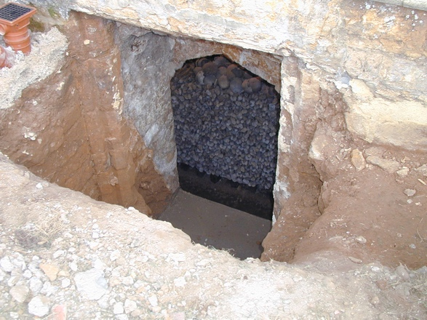
Figure 3. Exterior view of the east window into the charnel house photographed during archaeological work in the late 1990s. The openings were unblocked and soil cleared from the light wells, revealing their architectural form and an uninterrupted view of the bones within. Reproduced with permission of Holy Trinity Church.

The walls and ceiling of the crypt have traces of gypsum plaster badly degraded by damp (Garland et al. 1988, p. 252). Ephemeral traces of painting are visible on the east wall, which comprise red and black paint distributed in long strokes separated by solid beige fields. Antiquarian accounts claim that it depicted the Resurrection (e.g. Bloxam, 1855, p. 2; Sharp, 1879, p. 58; Wallis, 1888, p. 36). None of them provides an illustration, but Bull (1912) reported seeing ‘representation of a small foot and the calf of a leg’ (p. 228). We enhanced these areas using polynomial texture mapping photography, which revealed additional detail and original brushstrokes. However, this method also confirmed how little of the original painted plaster surface remains, meaning that the original subject of this image cannot now be reconstructed (Figure 4). The painting has prompted speculation that there was once an altar there (Sharp, 1879, p. 58) and we were given permission to remove the human remains stacked against the east wall to explore this possibility, but this revealed no trace of possible altar footings.

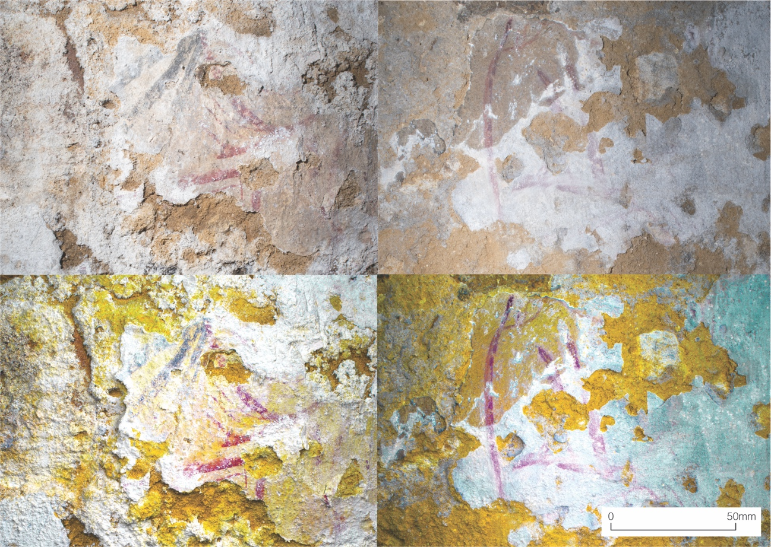
Figure 4. Paired images of the two best-surviving sections of wall painting from the eastern wall of the charnel house. Top: unprocessed photograph. Bottom: false-colour polynomial texture maps of the same surfaces. The PTM image shows enhanced contrast between colours and detail of texture of both the plaster and brush-strokes. Yellow indicates areas of increased depth, where plaster has degraded and fallen from the wall. Images: IA.

A staircase of 17 steps, first described in 1855 (Bloxam, 1855, p. 2), descends through 180º clockwise to the charnel house from the west wall of the south porch. However, these steps are clearly not the original means of access to the crypt since the brick-built porch and brick-vaulted top of the staircase are both post-medieval alterations, and medieval slabs containing indents for brasses were reused for six of the treads (Figure 5). The stone coursing of the upper walls is notably poorer than that at the bottom of the stairs, suggesting it is later, and perhaps contemporary with the reconstructed porch. The stairs probably existed by 1712, as Morton had entered the charnel house, removing some of the bones, but they may have been relatively recent. Indeed, the form of the doorway into the crypt suggests some eighteenth-century reconstruction to facilitate access.
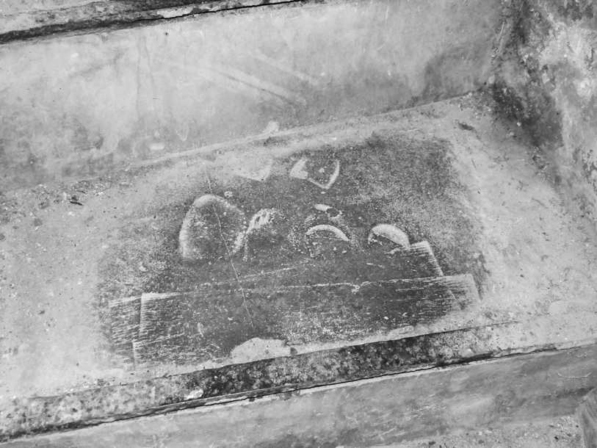
Figure 5. Example of a section of grave cover reused as a tread of the staircase into the charnel house. The lobular recess would have originally held a brass insert. Photograph: ECA.

At the foot of the stairs blocking of the north wall suggests the location of a former access route to the crypt. Antiquarians speculated that this was the entrance to a tunnel heading outside the church (e.g. Wallis, 1888, p. 34), but, in fact, it seems far more likely that it led towards the nave of the church. To assess this, we undertook a GPR survey, which revealed a void in the south aisle where such a staircase from the crypt may have ascended (James, 2017). Figure 6. While the GPR results do not show this void communicating directly with the crypt, this could be explained by rubble infilling the base of the stair. Such a deduction is consistent with the visible blocking in the wall at the bottom of the stairs.
Figure 6. Schematic interpretation of the results of GPR survey in the southern cemetery and south aisle of Holy Trinity Church, Rothwell. Image: AJ, ATA and IA.

Holy Trinity was a church of some significance and wealth in the medieval period. Its origins were as a minster, and the earliest architectural phases discernible, of the late pre-Conquest period, reveal it to have been cross-shaped, comprising an unaisled nave, with three small porticus at the east end and a central tower, typical of late Anglo-Saxon minsters (Barnwell, 2016, pp. 158–167). The subsequent architectural development of the church is complex and mostly not of direct relevance to the current argument, but rebuilding on an exceptional scale during the 1270s and 1280s provides the context for the construction of the crypt. The detailed sequencing of the rebuilding cannot be recovered, but our new analysis suggests it can be treated as one, possibly slightly extended, phase. The chancel was flanked by four-bay chapels in the form of aisles; that to the south, now partially demolished but evidenced by the blocked arches of the former arcade, was perhaps slightly earlier than that to the north. The transepts were upgraded, that at the south also being enlarged to extend further south than now, on the evidence of a compound column embedded in the south wall, and the nave aisles were replaced with the present ones, wider and taller than their twelfth-century predecessors, that at the south with the porch, which was later remodelled. The nave arcades were raised, and the tower arch modified, reflecting the new proportions of the arcades. The late thirteenth-century date for this rebuilding is suggested by the form of the south aisle windows, of three lancets under an arch, the re-set south window of the south transept, with a spherical triangle over two lights, and the tower arch with naturalistic foliage on the capitals (Historic England Archive, NBR no. 107400; Bailey, Pevsner & Cherry, 2013, pp. 552–555; new analysis by P.S. Barnwell during the current research). The south wall of the crypt provides the foundation for the outer wall of the widened aisle making it almost certain the two are contemporary. If the crypt had pre-dated the present south aisle its vault would have had to have supported the south wall of the narrower, twelfth-century aisle, which seems unlikely. Thus, a thirteenth-century date for construction of the charnel house is indicated by its architectural relationships to the more securely-dated church above and by characteristics of its own form.
In the south wall of the aisle is a piscina, for the washing of vessels used during Mass. This reveals the location of a former altar, though it is not clear which, if any, of the five altars referred to in late medieval wills it was (Serjeantson & Longden, 1913, p. 400). The altar stood above the east end of the crypt, mirroring the juxtaposition of chapel and charnel characteristic of free-standing charnel houses, such as those at Norwich and Exeter, and probably also Bury St Edmunds and St Paul’s (Figure 7). The close relationship between crypt and altar is reinforced by a now blocked slot behind the vaulting at the east end of the crypt; it rose to the church floor in front of the altar, perhaps permitting light to shine directly onto the wall painting below or to facilitate the transmission into the crypt of the sound of the Mass. This evidence suggests provision for liturgical activities in the chapel related to the charnel, to which we shall return.
Figure 7. Cutaway illustration of the charnel house of Holy Trinity church showing the relationship with both extant and conjectured features of the medieval chapel located directly above. Illustration: ATA.

The charnel
The disarticulated human skeletal remains are now stacked in two wooden crates placed centrally within each bay, which were installed in the late 1990s, with most of the crania placed on wooden shelves lining the north and south walls (Figure 8). A 1915 sketch reveals that the arrangement they enclose was already in place by then (Percival, 1915, p. 10), which is how the bones had been restacked in 1911, on the advice of anatomist F. G. Parsons (1910, p. 485), as a means of mitigating the deleterious effects of the damp environment. Some of the smaller bones were apparently then reburied in the cemetery (Bull, 1912, p. 226). However, antiquarian reports and early twentieth-century photographs reveal an earlier arrangement for the charnel. The long bones were formerly stacked with the long axis perpendicular to the north, south and east walls of the crypt, divided by even bands of crania, with other skeletal elements placed behind (Bloxam, 1855, p. 2; Parsons, 1910, p.485; Sharp, 1879, pp. 58–59, 66) (Figure 9).
We believe that this orderly arrangement of the charnel reflects its medieval form. Certainly, it is consistent with the description of the medieval charnel excavated at Exeter discussed above, and arrangements recorded in more detail at two other charnel houses where the medieval form of the charnel has been excavated in situ. For example, at St Mary Spital, London the charnel comprised a collapsed stack of crania and long bones against one wall of the well-preserved remains of a subterranean room (11m by 5.6m) comprising six vaulted bays. This room was connected by masonry stairs to a chapel above, which became a private house in 1540 (Gilchrist & Sloane 2005, p. 41; Thomas, 2004, pp. 34-35 ). At St Peter’s, Leicester the charnel was in a freestanding room, 3.3m by 2.4m, adjacent to the parish church. The building was demolished in the sixteenth or seventeenth century, but excavation revealed that the earliest phases of charnel comprised long bones mainly stacked perpendicular to the walls, with skulls interspersed with them. This arrangement is identical to that at Rothwell prior to restacking (Gnanaratnam, 2009, p. 78) (Figure 10).
Figure 8. Photograph of the interior of the charnel house showing the current arrangement of human remains in two central stacks with crania arranged on shelves on the north and south walls. Photograph: JC.
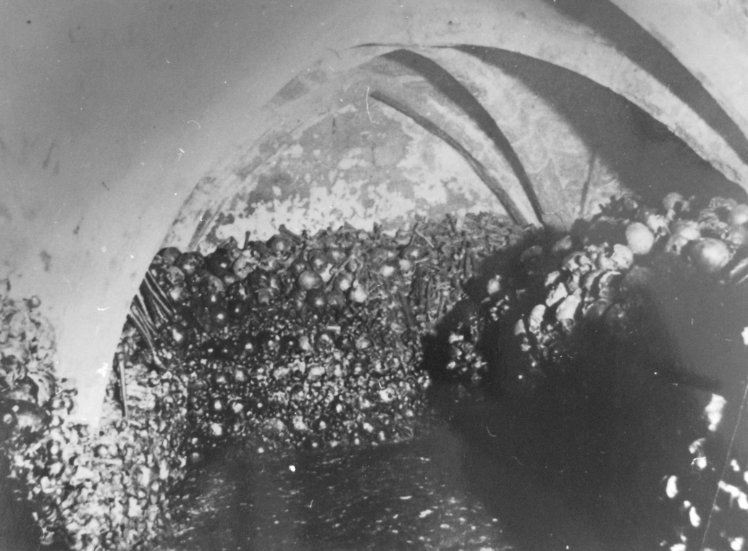
Figure 9. Early twentieth-century photograph of charnel house showing the arrangement of human remains prior to documented restacking in 1911. The lower levels comprised regular piles of long bones, long axes perpendicular to the wall, divided by even bands of crania and other skeletal elements placed behind. Reproduced with permission of Rothwell Heritage Centre.
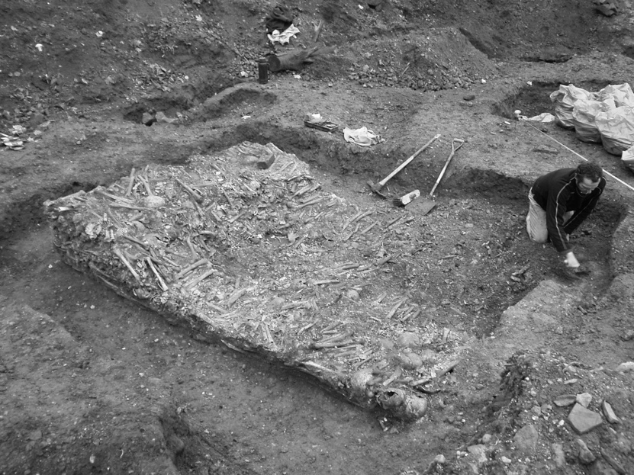
Figure 10. The charnel house at St Peter’s, Leicester, part way through excavation. The earliest phases of charnel were long bones stacked perpendicular to the walls with skulls interspersed among them. Reproduced with permission of University of Leicester Archaeological Service.
The date of the Rothwell charnel has attracted much speculation. The anatomist Parsons (1910, p. 485) used craniometrics to identify brachycephalic (rounded) and dolichocephalic (longer) head shapes, both of which he assigned to the later medieval period. Subsequent authors speculated that they represent two chronologically-different burial populations, medieval and post-medieval (Trevor, 1967, p. 3); but the basis of this argument is unsound (Stout, 2013). Material culture reportedly found among the bones during the 1911 restacking, including mid-thirteenth-century tiles depicting an animal, knight in armour and priest (Percival, 1915), has also been used to date the charnel, but this was probably residual from cemetery soils brought in with the bones. We undertook radiocarbon dating of five crania, selected with the permission of the Church of England, to provide the first empirical dating evidence for the human remains (Table 1). Three yielded dates from the late thirteenth to early fifteenth centuries, one of which presented the only osteological evidence for perimortem trauma observed among the visible skeletal remains: multiple, radiating cranial fractures across the parietals indicate death from a blow to the head. Despite the small number of dates obtained, they enable significant refinement of the chronology of the site and refute antiquarian associations of the bones with a single mortality event – such as the Black Death (1348) or various local battles (Wallis, 1888, p. 35). The other two crania yielded dates spanning the eighteenth and nineteenth centuries, one of which displays evidence for anatomization in the form of a single transverse saw cut, probably arising from an autopsy. These two late dates were unexpected, but given the anatomised cranium they may derive from the deposition of unwanted medical specimens by the various visiting nineteenth-century surgeons and anatomists, such as Parsons. Perhaps their perception of the former role of the room for the storage of the Christian dead sanctioned its use centuries later.

Sample description | Radiocarbon lab ID number | Uncalibrated date  (years before present, bp, where present is 1950) | Calibrated date/s  (years AD to two standard deviations, with associated probability in parentheses)
Cranium with perimortem radiating fractures across parietals. Indeterminate sex, adult | UBA-32256 | 590±26 | 1300-1368 (72.1%)  1381-1411 (27.9%)
Male, adult. Labelled ‘20’ | UBA-32257 | 563±33 | 1305-1364 (55.4%)  1384-1428 (44.6%)
Probable female, adult. Labelled ‘115’ | UBA-32258 | 717±27 | 1257-1300 (96.4%)  1369-1380 (3.6%)
Cranium with evidence of anatomical dissection. Probable male, adult | UBA-32259 | 144±25 | 1669-1708 (16.9%)  1718-1781 (31.3%)  1798-1827 (12.3%)  1831-1888 (21.9%)  1911-1945 (17.5%)
Probable male, adult. Labelled ‘33’ and ‘154’ | UBA-32260 | 213±26 | 1646-1682 (35.6%)  1737-1758 (6.8%)  1761-1804 (45.1%)  1936-1950 (12.5%)

Table 1. Results of radiocarbon dating of five crania from Rothwell charnel House. Dating was undertaken by Chronos radiocarbon lab, based at Queen’s University Belfast. Dates were converted into calendrical dates using calibration curve Intcal 13.14c.

The skeletal material presents staining consistent with long-term contact with soil, and its disarticulated state is consistent with having been brought into the church after a period of earthen burial during which the interosseous ligaments had completely decayed. Some antiquarians attributed the charnelling to disturbance of the cemetery in 1593, when a range of almshouses known as the Jesus Hospital was constructed by local gentleman Owen Ragsdale just beyond the south-east corner of the present churchyard; they believed that the crypt had formerly been a ‘funeral chapel’ (Parsons, 1910; Wallis, 1888, p. 36). This interpretation assumes that the medieval churchyard extended beyond its current footprint, but all evidence suggests it was rather smaller. The southern boundary of the churchyard, c.47m to the south of the church, encompasses an area of land purchased from a local landowner on 19 April 1867 (Diocesan Faculty Records, Northamptonshire Record Office PD/CC/7 Acc. no. 1980/246). To assess whether the area might have been used for burial at a much earlier date, we undertook a GPR survey (James, 2017). The low density of sub-surface anomalies located is consistent with its use for limited interments, suggesting that it was not within the medieval churchyard, contrary to antiquarian speculation. GPR also demonstrated that a boundary shown on the 1819 Enclosure Map c.17m south of the church was substantial and coincides with a drop in ground level of 1.5m. It therefore seems unlikely that the charnel derived from a distinct disturbance event that contracted the churchyard; rather, the intermittent disturbance of burials in a small and over-crowded churchyard may have been instrumental in a gradual accumulation of charnel.
The Church of England prohibits the large-scale dismantling or removal of the charnel from Rothwell for study. Therefore, standard osteological methods could not be used to reassess the number of individuals represented (e.g. White & Folkens, 2005, p. 339). Nevertheless, it was possible to estimate a minimum number of individuals (MNI). There are exactly 500 crania on the shelves lining the crypt walls, with another c.175 on the surface of the stacks and piles. Early twentieth-century photographs and a collapsed section of the east section reveal few cranial elements, suggesting it is unlikely that many more crania were hidden within the stacks. The number of long bones is more difficult to calculate, relying on the numeration of small visible sections which must be multiplied to represent the complete stacks, and then divided by the number of long bones in the complete skeleton to achieve a MNI. If all the long bones were femora, which is evidently untrue based on osteological inspection, the MNI estimate would be 6,835. If all bones of the upper and lower limb were present in equal numbers, the MNI estimate drops to 1,367. The true figure lies between these two values. Despite its imprecision, the long bone count provides conclusive evidence that there are more individuals than the number of skulls, and that the MNI is most likely in the low thousands. Our assessment accords with that of c. 2,500 published by Garland and colleagues some thirty years ago (1988, p. 239), which presumably used similar, if unspecified, methods.
Our analysis also has the merit of revealing that antiquarian assessments of the scale of charnel may sometimes contain much of merit. In the 1870’s Samuel Sharp undertook a visit ‘accompanied by gentlemen of the medical profession’ in order to ‘obtain correct information’ on the human remains, about which he ‘had entertained very erroneous impressions’ (Sharp, 1879, p. 57). The result of this visit was a calculation based on approximate measurements of the volume of the bone piles, which he assessed at 1275 cubic feet (36.1 cubic meters). He produced two calculations, one based on the numbers of complete skeletal remains and another just on skulls that could be fitted into a cubic foot and cubic yard respectively, and concluded that there was a maximum number of between 3543 and 3825 skeletons in the crypt. He was entirely confident that claims by Sir George Whyte-Melville (1862) that it contained the remains of over 30,000 people were unbelievable, and suggested that to house such numbers of remains the crypt would have needed to be four times as large as it is.
Antiquarian assertions about the charnel abound, such as Whyte-Melville’s (1862) claim that it represents battle victims, including Vikings identifiable by their ‘most stalwart size’ and evidence of weapon wounds. However, Whyte-Melville evidently misinterpreted taphonomic damage and distortion to crania arising from waterlogging and pressure from overburden of earth, as our analysis of accessible skeletal remains identified only two examples of cranial trauma: the aforementioned individual we radiocarbon dated, and one other well-healed example, which was, therefore, not fatal. We selected a sample of 104 crania, based on adequate levels of preservation and completeness from the shelves lining the room, and undertook a demographic assessment utilizing standard methods (White & Folkens, 2005). This identified 45 males, 46 females and 16 individuals that could not be assigned a sex (McGinn, 2015). Assessment of age at death based on closure of the latero-anterior cranial sutures (Meindl & Lovejoy, 1985) suggested adults of varied ages are represented, although this method is not sufficiently precise to provide a full demographic profile. Among the 500 crania displayed on the shelves, only one was immature, which may be accounted for by the likelihood of immature crania fragmenting due to their thin and porous bone and lack of fusion at the sutures. Immature bones are, however, visible within the stacks, suggesting children are not absent from the population. The results are consistent with the unpublished osteological analysis of the charnel from Leicester, which focused on the femoral heads of 84 individuals, identifying 22 males, 18 females and seven immature individuals (mostly adolescents with only one infant) (Jacklin, 2009, pp. 106–107). In sum, our analysis of the accessible skeletal material at Rothwell, the first using modern analytical techniques, indicates a population of several thousand men and women of all ages with no indications of selective inclusion based on any aspect of skeletally-observable identity, shared lifeways or manner of death.

Rothwell in its regional context
To set the Rothwell charnel house in its contemporary context, other medieval crypts in Northamptonshire were examined as part of our project. The crypts at Oundle and Irthlingborough are both below the south transept, while that at St Peter’s, Brackley is beneath the east bay of a two-bay chancel chapel (Historic England Archive NBR nos. 107382, 107346 and 107378, respectively). That at Oundle dates to c. 1280, contemporary with Rothwell, while the other two are perhaps early fourteenth-century. All three have deeply splayed openings in more than one of the exterior walls, and all are covered by vaults: two bays at Oundle, as at Rothwell; a single quadripartite bay at Irthlingborough; a single octopartite bay with central column at Brackley. On the basis of current stair positions, the entrance at Oundle appears always to have been external, but at the others it was internal. At none of the three is there any evidence of additional means of communication with the church above, like the slot at Rothwell, although in all three it is almost certain that there was an altar located directly above, Oundle having a piscina in the transept.
At Kingsthorpe (Historic England Archive, NBR no. 44022; Royal Commission on Historical Monuments of England [RCHME], 1975–84, vol. 5, microfiche, pp. 304–309), Towcester (Historic England Archive, NBR no. 44031) and Northampton, All Saints (RCHME, 1975–84, vol. 5, microfiche pp. 344–353 with plan on p. 63), crypts underlie eastern extensions of the chancels with which they are contemporary, dating from the second half of the fourteenth or the early fifteenth century. These later crypts are similar in form to their earlier counterparts, save that the vaulting is more elaborate as would be expected in the Perpendicular era. Those at Kingsthorpe and Towcester are both located beneath the high altar, with no evidence for communication between crypt and altar; a recess to the east and side wall benches at Towcester is the result of twentieth-century alterations. Access at Kingsthorpe appears always to have been from outside, while at Towcester it was not altogether conveniently contrived through what was probably a vestry to the north of the chancel. At Northampton, the crypt was partly blocked off following rebuilding after the great town fire of 1675, but appears to conform broadly to the same type: it lay under the medieval chancel, had a ribbed vault with a central octagonal column and window-like openings to the east, and appears to have been built at the same time as the pre-fire chancel. There is no definite evidence that any of these crypts was ever used for charnel, but the similarities of form and location in relation to the church above are striking, and suggest a common function.

Towards a theological context for charnel houses
The theological context for the use of charnel houses in medieval English parish churches has not previously been considered in any detail. Our research at Rothwell offers, for the first time, sufficient insight into the form and function of a parish charnel house to present such a discussion.
The obvious context for the late-medieval construction of semi-subterranean rooms in which to house charnel is the maturation, during the middle of the thirteenth century of what became, in 1274, the Doctrine of Purgatory, the defining belief of late-medieval western Christianity. Belief in Purgatory was far from new in 1274; all that formally changed then was that it became non-negotiable (Le Goff, 1984). At its simplest, the belief was that on death the body remained in this world until the Last Judgement or Second Coming, while the soul was separated from it: the most virtuous souls went to Heaven, where they awaited the Last Judgement in a state of contentment, but not complete fulfilment because they remained separated from their bodies; irredeemably wicked souls went straight to Hell, to be burnt by fire and tortured by demons for eternity; most souls fell between the two extremes and were therefore sent to Purgatory, where they were purified by fire before they joined the virtuous in Heaven (Tugwell, 1990, pp. 110–155). The actions of the living could reduce the time a soul spent in Purgatory, and such a soul was guaranteed ultimate salvation. More than that, the living, by helping souls in Purgatory, performed a work of charity which counter-balanced some of their own sins as well as helping the dead. While those in Purgatory could do nothing further to help themselves, they therefore provided a vehicle for assisting the living; and, while alive, they could have enhanced that possibility by arranging the funding of works of prayer or worship once they had died. The most powerful form of ‘good work’ was the endowment of celebrations of the Mass, the central act of worship which re-performed the crucifixion of Christ, brought Christ’s living presence into the church, and gave those who participated in it by seeing it various benefits; the participants, in turn, prayed for the donor of the Mass, thereby reducing their time in Purgatory (e.g. Burgess, 1991). It was from this that the idea of the chantry evolved during the thirteenth century: an endowment to secure the services of a priest to chant Masses in the name of the deceased. The wealthy could endow a perpetual chantry which paid a priest to chant Mass daily or weekly for ever; the less wealthy could endow ‘temporary’ or fixed-term chantries for as long as they could afford, right down to a short sequence of Masses in the days or weeks following death, or annually on the anniversary of death (e.g. Burgess, 1991).
Allied to this were the implications of medieval beliefs concerning the fate of the body and the significance of images. Because the body remained on earth to be re-united with the soul at the Last Judgement, the dead were in some way present. It follows that a person buried near an altar could still benefit from the Masses being chanted there, and some kind of memorial would prompt the prayers of living worshipers, to mutual benefit. From this arose the desire to be buried within the church, which, until the thirteenth century, was restricted to the influential (Saul, 2009, p. 114). However, there was insufficient space for everyone who wished to be buried inside the building in an individual grave, still less with a monument, even a floor slab; burial within the church was the preserve of those who could afford to pay for it. This may provide a context for the provision of charnel houses: created to allow a larger number of people than would otherwise have been possible to benefit from burial in proximity to an altar. Various features of the Rothwell crypt are consistent with this view. Although there was no altar in the crypt itself, it was located below an aisle which contained an altar. Those whose remains were in the crypt were not, however, merely proximate to the altar, but, by means of the slot which rose from the east end to near the altar, could ‘hear’, and therefore participate in, the Masses chanted above (see also Crangle, 2016, p. 210). Furthermore, assuming antiquarian reports that the painting on the east wall was of the Resurrection are correct, the little light which would have percolated down through the slot would have illuminated it and reminded those semi-present in the crypt of the certainty of salvation and of the means of achieving it which was performed at the altar above: it was not uncommon for effigies on tombs to be associated with wall paintings which only they, not the living, could ‘see’ (e.g. the tomb of Alice de la Pole at Ewelme, Oxfordshire: Rosewell, 2008, Figs. 212–215). At the same time, the openings in the south wall let in sufficient light for passers-by to see the bones within, prompting prayer for them, to mutual benefit.
Rothwell may, then, have been a particularly sophisticated example of an experiment born out of beliefs surrounding Purgatory. The intention may have been a means of sharing the benefits of church burial more widely than would otherwise have been possible, while addressing the problem of space within the cemetery. As later medieval wills reveal, some people continued to request individual burial in particular places within the church (Serjeantson & Longden, 1913, p. 400), but the crypt offered the possibility either for everyone to benefit, or for members of a burial club or guild to do so. That such an arrangement in parish churches was not ubiquitous is not surprising: it was expensive to build; it required lasting management for exhuming and moving decomposed skeletons; and because the benefits of burial within the church were not available immediately there had to be time for decomposition, so it was imperfect. But it may perhaps reveal an attempt to grapple with the challenges posed by the new belief and to find an egalitarian solution to the problem of space within the church.
The fact that some other communities, such as Kingsthorpe and Towcester, built crypts at a later date may indicate that it was an experiment which did not entirely fail. By the late fourteenth and the fifteenth century, however, there may have been an additional factor: the rise of interest in the macabre, and the popularity of images and stories of death as an antidote to the contemporary love of life and of worldly possessions (Ariès, 1981, pp. 110–132). One manifestation of this is the depiction in wall paintings of the Three Living and the Three Dead, of which there are about twenty known treatments in England, including ones nearby at Raunds, Northamptonshire, and at Peakirk in the Soke of Peterborough (Carleton Williams, 1942). The subject derived from a series of late thirteenth-century Franco-Flemish poems (Glixelli, 1914), and shows the encounter of three rich men, hunting or travelling, with three dead men, often depicted as skeletons, who caution them ‘as you are so were we; as we are so you will be’. A more particular, and much rarer, manifestation of the same culture is the so-called transi tomb (Saul, 2009, pp. 211–234), in which a conventional effigy is paired with a shrouded one or a cadaver, an example of which is found at Towcester – the tomb of Archdeacon William Sponne, rector from 1422 to 1448, and founder of a chantry college in the church (Thompson, 1911, pp. 99, 113, 155). It is possible, that there was a link between this kind of culture and late medieval interest in charnel houses in which the dead could be seen, perhaps particularly at Towcester where the crypt was built during or immediately after Sponne’s tenure of the parish. Interestingly, two grave covers currently in the Rothwell Lady Chapel, almost contemporary with the crypt, may reflect something of a similar interest in the dead, for they depict emaciated corpses partially visible in their coffins (Figure 11).

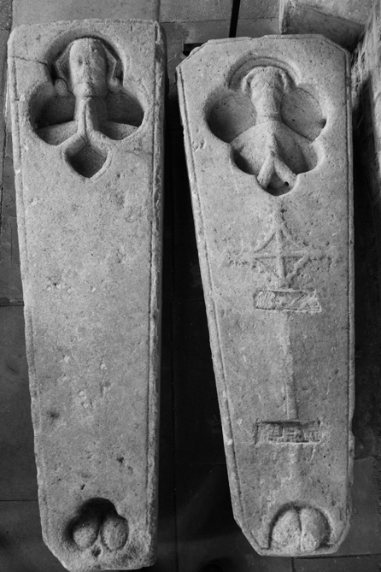
Figure 11. Two stone grave covers of thirteenth-century character, currently stored in the Lady Chapel of Holy Trinity, Rothwell. Their original location is unknown. The emaciated heads and shoulders, with hands held in prayer, and feet of both are visible through the coffins. Photograph: JC.

Conclusions
Current understanding of medieval English charnel houses is based on a small number of well-documented examples situated within high-status ecclesiastical contexts, none of which survive intact. The extent, nature and significance of charnelling at parish level is poorly understood, and this is why the rare survival of a medieval parish charnel house with human remains still within is so significant for our understanding of the role of charnel practices in medieval Europe. In this paper, analysis of the fabric of Rothwell church and charnel house, the human remains, and the funerary landscape beyond have contributed to a range of novel insights. The thirteenth-century room was well-lit, decorated with a wall painting and accessible, probably from the nave. Skeletonised human remains stacked around the walls represented all sectors of the medieval population with no evidence of selectivity. Although the bones were most likely removed from their graves as the space was needed again for new interments, their subsequent treatment suggests charnelling held both theological and liturgical significance. The bones would have been able to hear the Mass taking place in the chapel above, thus receiving the benefits of this experience in addition to prayers offered for the unnamed dead which would have offered salvation for their souls in Purgatory. The human remains could also be seen from outside by passers-by, who might be stimulated to imagine their own fate after death and take time to offer prayers for their ancestors, and hope future generations would do the same for them; sentiments prompted more widely by wall-paintings and funerary monuments.
Despite the translation and reburial of human remains being commonplace in the Middle Ages (Crangle, 2016), no rite for it has been preserved amongst English liturgical texts. However, the most likely form of rite would have involved a re-enactment, with the exhumed bones, of the Office of the Dead, perhaps followed by a Mass of Requiem, as was often provided on the anniversary of a person’s death, followed by immediate reburial using an adapted version of the burial rite of the Use of Sarum (Collins, 1958, pp. 152–162), the set of liturgical texts and customs used throughout southern England (Barnwell et al. in prep.).
Many charnel houses seem to have gone out of use as a result of the Reformation, being cleared of charnel and sometimes demolished in the sixteenth century (Crangle, 2015, pp. 377–379; Litten, 1991, p. 8). The surviving example at Rothwell is therefore crucial for the development of models with which to interpret more partial evidence elsewhere. The Rothwell charnel house may also have gone out of use at the Reformation, to be rediscovered only towards the end of the eighteenth century, but it appears that intense local fascination with the charnel, reflected in much antiquarian discussion, prevented it from being cleared out unlike so many other examples. Our survey of Northamptonshire crypts has revealed that several churches in the vicinity had rooms of similar form, location and, potentially, function to that at Rothwell, raising new questions about the scale of parish charnelling. Moreover, antiquarian accounts of English charnel houses written before they were cleared or destroyed hold the key to finding more examples of medieval charnelling, so long as their projections of their own contemporary concerns into the past are recognised, as we have shown here (Crangle, 2016, pp. 165–166, 378–381). Indeed, our study of Rothwell suggests that there would be considerable merit in re-examination of the antiquarian accounts of charnel houses across the country within their architectural context (e.g. Fisher 1898; Green, 1796; Hasted, 1799, pp. 152-188; discussed in Crangle, 2016, pp. 165–166). This study of Rothwell has offered a new, evidence-based model with which to evaluate the surviving evidence in a more critical manner and to enable the integration of evidence from charnel houses in England into wider narratives of medieval charnelling across Europe.

Acknowledgements
We would like to thank the Revd. Canon John Westwood, the churchwardens and congregation of Holy Trinity Church, Rothwell, and all the Rowellians who have supported our work, especially Mick Coggins, Sara Coggins, Bryan Doughty, Mark Payne, Alistair and Carolyn McKay, Keith Brown and his colleagues at Rothwell Heritage Centre. Northamptonshire Records Office and Royal Albert Memorial Museum, Exeter provided exceptional support in exploring Diocesan and excavation records. We are grateful to Leicester Archaeological Services and MOLA for permission to include information from unpublished reports, and to the Diocese of Peterborough for permission to move bones and undertake radiocarbon dating, which was conducted at the Chronos Laboratory, Queen’s University, Belfast. We would like to thank Greer Dewdney and Leo Rotaru for their assistance, and Julian Richards, Caroline Jackson and Glynis Jones for feedback on an earlier draft of this paper.

References

Ariès, P. (1981). The hour of our death. Harmondsworth: Penguin.

Bailey, B., Pevsner, N., & Cherry, B. (2013). The Buildings of England: Northamptonshire. New Haven & London; Yale.

Barnwell, P. S. (2016). The cure of souls in England, c.950–c.1150. In P. S. Barnwell (Ed.), Places of worship in Britain and Ireland 950–1150 (pp. 154–175). Donington: Shaun Tyas.

Barnwell, P. S., Craig-Atkins, E., & Hadley, D.M. (in prep). Towards a liturgical context for medieval charnelling.

Bloxam, M. H. (1855). On the charnel vault at Rothwell, Northamptonshire and on other charnel vaults elsewhere. Northampton: Dicey.

Bull, F. E. (1912). Rothwell church. Proceedings of the Society of Antiquaries, 24, 225–229.

Burgess, C. R. (1991). Benefactions of mortality: The lay response in the late medieval urban parish. In D. M. Smith (Ed.), Studies in clergy and ministry in medieval England (pp. 46–65). York: Borthwick Institute of Historical Research.

Carleton Williams, E. (1942). Mural paintings of the three living and the three dead in England. Journal of the British Archaeological Association, 3rd series, 7, 31–40.

Collins, E. J. (Ed.) (1958). Manuale ad usum perceebris ecclesie Sarisburiensis [Manual of the use of the distinguished and eminent church of Salisbury]. London: Henry Bradshaw Society.

Crangle, J. (2015). Why did England change its mind? Perceptions regarding human remains before, during and after the Reformation. In A. Eusterschulte & H. Wälzholz (Eds.), Anthropological reformations: Anthropology in the era of reformation (pp. 371–381). Göttingen: Vandenhoeck & Ruprecht.

Crangle, J. (2016). A study of post-depositional funerary practices in medieval England (Doctoral dissertation). Retrieved from http://etheses.whiterose.ac.uk/13315/

Enlart, C. (1929). Manuel d’archéologie française depuis les temps merovingiens jusqu’à la renaissance [Manual of French archaeology from the Merovingian Period to the Renaissance]. Pt 1, Vol 2 Paris: Picard.

Fisher, A. H. (1898). The cathedral church of Hereford: a description of its fabric and a brief history of the episcopal see. London: G. Bell.

Garland, A. N., Janaway, R. C., & Roberts, C. A. (1988). A study of the decay processes of human skeletal remains from the parish church of the Holy Trinity, Rothwell, Northamptonshire. Oxford Journal of Archaeology, 7(2), 235–252.

Gilchrist, R. (2005). Norwich cathedral close. The evolution of the English cathedral landscape. Woodbridge: The Boydell Press.

Gilchrist, R., & Sloane, B. (2005). Requiem: The medieval monastic cemetery in Britain. London: Museum of London Archaeological Service.

Glixelli, S. (Ed.) (1914). Les cinq Poèmes des trois morts et trois vifs [The five poems of the three living and three dead]. Paris: Champion.

Gnanaratnam, T. (2009). The excavation of St Peter’s church and graveyard, Vaughan Way, Leicester 2004–2006, Vol. 1 (Report No. 2009–156). Leicester: University of Leicester Archaeological Service.

Gransden, A. (2015). A history of the abbey of Bury St Edmunds 1257–1301. Woodbridge: The Boydell Press.

Green, V. (1796). The history and antiquities of the city and suburbs of Worcester. London: W. Bulmer.

Harding, V. (1992). Burial choice and burial location in later medieval London. In S. Bassett (Ed.), Death in towns: Urban responses to the dying and the dead, 100-1600 (pp. 119–135). Leicester: Leicester University Press.

Hasted, E. (1799). The history and topographical survey of the county of Kent: Volume 8. Canterbury: W. Bristow.

Henderson, C. G., & Bidwell. P. T. (1982). The Saxon minster at Exeter. In S. Pearce (Ed.), The early Church in Western Britain and Ireland: Studies presented to C. A. Ralegh Radford (pp. 145–175). Oxford: British Archaeological Reports.

Höpflinger, A-K. (2015). Gender equality in death? The normative dimension of Roman Catholic ossuaries. Religion and Gender 5(1): 18-34.

Jacklin, H. (2009). The excavation of St Peter’s church and graveyard, Vaughan Way, Leicester 2004–2006, Vol. 3 (Report No. 2009–049). Leicester: University of Leicester Archaeological Service.

James, A. (2017). Holy Trinity Church, Rothwell, Northamptonshire: Geophysical Survey Report (Report No. 17_1401). Barnard Castle: Northern Archaeology Associates.

Koudinaris, P. (2011). The empire of death: A cultural history of ossuaries and charnel houses. London: Thames and Hudson.

Le Goff, J. (1984). The birth of Purgatory. London: Scholar Press.

Litten, J. (1991). The English way of death: The common funeral since 1450. London: Robert Hale Ltd.

Marshall, P. (2002). Beliefs and the dead in Reformation England. Oxford: Oxford University Press.

McGinn, J.-R. (2015). Exploring the paleodemographic character of the charnelled population at the Parish Church of the Holy Trinity, Rothwell, Northamptonshire (Unpublished master’s thesis). University of Sheffield, UK.

Meindl, R. S., & Lovejoy, C. O. (1985). Ectocranial suture closure: A revised method for the determination of skeletal age at death based on the lateral-anterior sutures. American Journal of Physical Anthropology, 68(1), 57–66.

Morton, J. (1712). The natural history of Northampton-shire; With some account of the antiquities. London: Knaplock & Wilkin.

Müller, Y. and Höpflinger, A-K. (2016) Ossarium: Beinhäuser der Schweiz [Ossarium: Charnel Houses of Switzerland]. Zürich: Pano.

Musgrave, E. (1997). Momento mori: The function and meaning of Breton ossuaries. In P. Jupp & G. Howarth (Eds.), The changing face of death: Historical accounts of death and disposal (pp. 62–75). Basingstoke: Macmillan.

Orme, N. (1991). The charnel chapel of Exeter Cathedral. In F. Kelly (Ed.), Medieval art and architecture at Exeter cathedral (pp.162–171). Leeds: British Archaeological Association Conference Transactions.

Parsons, F. G. (1910). Report on the Rothwell crania. Journal of the Royal Anthropological Institute of Great Britain and Ireland, 40, 483–504.

Percival, S. (1915). The bones of Rothwell: Their date and origin. Kettering: Northants. Printing Co.

Royal Commission on the Historical Monuments of England (1975–84), An Inventory of Historic Monuments in the County of Northampton. London: HMSO.

Rodwell, W. (2012). The archaeology of churches. Stroud: Amberley.

Rosewell, R. (2008). Medieval wall paintings in English and Welsh churches. Woodbridge: The Boydell Press.

Rousseau, M.-H. (2011). Saving the souls of medieval London: Perpetual chantries at St Paul’s Cathedral, c.1200–1548. London: Ashgate.

Saul, N. (2009). English church monuments in the Middle Ages: History and representation. Oxford: Oxford University Press.

Serjeantson, R. M., & Longden, H. I. (1913). The parish churches and religious houses of Northamptonshire: Their dedications, altars, images and lights. The Archaeological Journal, 70, 217–452.

Sharp, S. (1879). The Rothwell crypt and bones. The Archaeological Journal, 36(1), 56–69.

Sheingorn, P. (1987). The Easter sepulchre in England. Kalamazoo, MI: Medieval Institute Publications.

Stout, A. (2013). Cultural history, race and peoples. In L. Nilsson Stutz, L. & S. Tarlow (Eds.), The Oxford handbook of the archaeology of death and burial (pp. 17-26). Oxford: Oxford University Press.

Stow, J. (1603/1971). A survey of London. London: Clarendon Press.

Thomas, C. (2004). Life and death in London’s East End. London: Museum of London Archaeology Service.

Thompson, A. H. (1911). The chantry certificates for Northamptonshire. Reports and Papers of the Associated Architectural Societies, 31(1), 87–112.

Trevor, J. C. (1967). Rothwell parish church, Northamptonshire: The bone crypt [Pamphlet]. Small collections of deposited records, 4th series (Ref. ZB0837/11 Acc. No. 1989/328), Northamptonshire Archives, Northampton.

Tugwell, S. (1990). Human immortality and the redemption of death. London: Darton, Longman & Todd.

Walker Bynum, C. (1995). The resurrection of the body in Western Christianity, 200–1336. New York, NY: Columbia University Press.

Wallis, R. B. (1888). Rothwell bones. Olla Podrida, 15(2), 33–37.

White, T. D. & Folkens, P. A. (2005). The human bone manual. London: Elsevier.

Whyte-Melville, G. (1862, January 11). The bones at Rothwell. A lecture delivered to the Moulton Religious and Useful Knowledge Society. Northampton Mercury.

Zoepfl, F. (1948). Beinhaus. In O. Schmitt (Ed.), Reallexikon zur Deutschen Kunstgeschichte [Encyclopaedia of German art history] (pp. 204–214). Stuttgart: J.B. Metzler.

Table 1. Results of radiocarbon dating of five crania from Rothwell charnel house, undertaken by Chronos radiocarbon lab, Queen’s University Belfast. Dates were converted into calendrical dates using calibration curve Intcal 13.14c.
Sample description | Radiocarbon lab ID number | Uncalibrated date  (years before present, bp, where present is 1950) | Calibrated date/s  (years AD to two standard deviations, with associated probability in parentheses)
Cranium with perimortem radiating fractures across parietals. Indeterminate sex, adult | UBA-32256 | 590±26 | 1300-1368 (72.1%)  1381-1411 (27.9%)
Male, adult. Labelled ‘20’ | UBA-32257 | 563±33 | 1305-1364 (55.4%)  1384-1428 (44.6%)
Probable female, adult. Labelled ‘115’ | UBA-32258 | 717±27 | 1257-1300 (96.4%)  1369-1380 (3.6%)
Cranium with evidence of anatomical dissection. Probable male, adult | UBA-32259 | 144±25 | 1669-1708 (16.9%)  1718-1781 (31.3%)  1798-1827 (12.3%)  1831-1888 (21.9%)  1911-1945 (17.5%)
Probable male, adult. Labelled ‘33’ and ‘154’ | UBA-32260 | 213±26 | 1646-1682 (35.6%)  1737-1758 (6.8%)  1761-1804 (45.1%)  1936-1950 (12.5%)

