Low-cost photoionization sensors as detectors in GCxGC systems designed for ambient VOC measurements.

Xiaobing Pang a*, Haijun Lan b, Daiqi Ye a, Marvin D. Shaw c, Alastair C. Lewis c

a  Key Laboratory for Aerosol-Cloud-Precipitation of China Meteorological Administration, Nanjing University of Information Science and Technology,

Nanjing, 210044, China

b MOE Key Laboratory of Bioinorganic and Synthetic Chemistry, School of Chemistry, Sun Yat-Sen University, No. 135, Xingang Xi Road, Guangzhou, Guangdong 510275, China

c  Wolfson Atmospheric Chemistry Laboratories, Department of Chemistry, University of York, York, YO10 5DD, UK

**Abstract:**

Conventional volatile organic compound (VOC) monitoring based on thermal desorption - gas chromatography-mass spectrometry (TD-GC-MS) or gas chromatography-flame ionization detector (TD-GC-FID) is relatively cumbersome and expensive. In this study commercial off the shelf low-cost and low-power photo-ionization detector (PID) sensors are used as simple detectors in VOC analysis systems based on GC, including a miniaturised GCxGC device with portable, low-cost, and low-energy-consumption features. PID sensors produce a voltage signal positively proportional to VOC concentration, which when incorporated into a TD-GC system gave limit of detection of 0.02 ppbV for isoprene. To test PID performance in real-world applications, PID sensors were deployed as (i) a second alternative detector in a GC-Quadruple Time Of Flight Mass spectrometry (GC-Q-TOF-MS), and (ii) the main detector in a compact two-dimensional gas chromatograph (GC×GC). PID sensors with 10.6 eV and 11.7 eV lamps were used to measure eight toxic chemicals including organic sulfide and organic phosphonates via GC; two species were ionized by a 10.6 eV lamp and four species by the 11.7 eV lamp. Commercially available low-cost PIDs designed for standalone could be straightforwardly and effectively re-used as detectors in compact GCxGC systems, in this work showing excellent VOC sensitivity, fast response and low operational demands compared to comparable field instruments based on GC-FID or MS.

*Keywords: Photo-Ionization Detector (PID);* Flame Ionization Detector *(FID); Volatile Organic Compounds (VOCs); Gas Chromatography (GC);* Two-dimensional Gas Chromatography *(GC× GC); Quadruple Time-Of-Flight Mass Spectrometry (Q-TOF-MS).*

**1 Introduction**

Photoionization detectors (PID) can detect many different volatile organic compounds (VOCs) at concentrations from sub parts per billion (ppb) to parts per million (ppm). Each VOC has its own threshold energy of light (Ionisation Potential, IP) needed to ionise to a molecular ion. Different UV lamps within a PID sensor generate different photon energies, eg: Xenon lamp producing 9.6 eV photon energy (Aleixandre and Gerboles, 2012), deuterium lamps producing 10.2 eV, Krypton lamps producing 10.6 eV and Argon lamps producing 11.7 eV(Haag and Wrenn, 2013). If the photon energy is greater than VOC IPs, PID sensor ionise all VOCs, becoming more universal in nature, although each VOC gives a different response factor per mole. (Jian et al., 2014). Unsaturated and aromatic VOCs are more susceptible to ionisation and give larger signal responses for detection. Whilst PID has been used for many years with GC using relatively expensive and bespoke detectors designed specifically for GC., there has recently been a growth in the availability of low cost PID sensors, used as inexpensive, and portable / handheld detectors for VOCs. Many different commercial low cost PID sensors are available e.g. PID-AH sensor from Alphasense Ltd, UK, MiniPID 2 sensor from Ion Science Ltd, UK, and 4RPID-3.3V sensor from SUSA Technology, UK. Costs are typically a few hundred USD, and sometimes less. Simple PID sensors are then used as bulk VOC monitoring solutions for industrial hygiene and safety, environmental contamination and remediation, hazardous materials handling, ammonia detection, lower explosive limit measurements, chemical weapons, arson investigation, indoor air quality and cleanroom facility maintenance (Giannoukos et al., 2016; Kim et al., 2005; Murray and Southard, 2002; Stetter and Li, 2008). Many chemical warfare agents (i.e., nerve agents and related compounds) and toxic hazardous VOCs can be detected by PID sensors with a 10.6 eV lamp except phosgene, which requires an 11.7 eV lamp, and HCN and ClCN, which cannot be detected by PID (Haag and Wrenn, 2013). A simple PID sensor was successfully deployed as the detector of a microfabricated planar glass GC for VOC measurements chosen due to its simplicity, size (Lewis et al., 2010). A PID sensor was also used as the detector for miniaturized GC to real-time detections of benzene, trimethyl benzene, ethyl benzene, and xylene (BTEX) (Nasreddine et al., 2016) and fast GC to total OH reactivity measurements (Nölscher et al., 2012). A smart device using PID sensor was developed for the real-time detection of VOCs produced by hydrocarbons such as oil spills on the sea’s surface combined with buoys or autonomous underwater vehicles (Moroni et al., 2016; Tonacci et al., 2015a; Tonacci et al., 2015b). The VOC species measured by PID sensor in above mentioned studies were generally limited in BTEX compounds or one VOC species and the PID sensors often showed obvious tailing effects in the gas chromatograms produced. Here we further explore the potential exploitation of low cost PIDs for VOC with further focus on comprehensive two-dimensional gas chromatography (GC×GC), since this offers well-documented additional separation capacity over a standard GC-FID or GC-MS (Lewis et al., 2000). The technical advantages of using a compact PID are more than simply cost: They are typically very small (a few cm-3), have low energy consumption (1-10 mW), and have advantages over the FID detector since they do not require fuel gases (Karlik et al., 2002).

In this study we test PID sensors as parallel secondary detectors in a GC-Q-TOF-MS system to evaluate response factors and response times relative to MS, and quantify this for seventeen species of VOCs and six toxic reagents used in insecticides and chemical weapons. To evaluate utility in more representaive field conditions a PID sensor was utilised as the detector in a compact GC×GC system, which was developed to be suitable for the ambient measurement of VOCs in the atmosphere at low ppb level. The design for a compact GC×GC seeks to minimise instrument size and power consumption and maximise the device portability and autonomy, achieving high analyte selectivity for complex VOC mixture analysis using GCxGC, rather than using the additional dimensionality brought by mass spectrometry. Several commercial GC-PIDs available, for example from Defiant Technologies, USA, IUT Technologies GmbH, Germany, Alphasense Ltd, UK, and SRI Instruments, USA. For comparison it worth considering that more compact field portable GC-MS systems do exist (eg Torion T-9 from PerkinElmer), and hence any GCxGC-PID system would need to have competitive or better performance to to be considered a step forward. Portable GC-MS, and GC/μTCD have already been deployed to determine environmental volatile and semi-volatile organic compounds (VOCs/SVOCs), explosives, chemical warfare agents, hazardous substances and for use in food safety and industrial applications (Henry, 1997; Nagashima et al., 2015).

**2. Experimental**

**2.1 PID as a stand-alone detector and a GC detector**

A commercially available PID sensor (PID-AH, Alphasense, UK) with a data acquisition device (LabJack U3, USA) was employed as a stand-alone detector for total VOC measurements. As the most abundant biogenic VOC in the atmosphere isoprene is an important target for any PID sensor. A calibration curve was constructed by measuring a series of mole fractions from 2 to 30 ppb of isoprene generated from a binary gas standard (CK Gas Products). The isoprene flow was controlled by a three-way solenoid valve and passed over the PID in a short pulse of gas. Having determine linear response off-line, the PID sensor then acted as the parallel secondary detector in a GC system (7890, Agilent, USA), with a Quadruple Time-Of-Flight Mass Spectrometry (GC-Q-TOF-MS, 7250, Agilent, USA)., The sensor was placed in in an auxiliary olfactometry port receiving approximately half of the column eluent. (Fig. 1). High purity helium was used as the carrier gas for GC. A BPX5 column (50 m × 0.32 mm × 1.0μm, length × internal diameter × film thickness) was employed in the GC with two split outlets. One half of GC flow went directly into the PID sensor through one split outlet and another half went into the Q-TOF-MS. The GC oven was programmed at 40°C for 3 min, then ramped at 15°C min-1 to 125°C, then at 20°C min-1 to 250°C and held for 5 minutes. A standard VOC mixtures (National Physical Laboratory, NPL, UK) including benzene, 2,2,4-trimethylpentane, heptane, toluene, octane, ethylbenzene, m-xylene, p-xylene, oxylene, 1,3,5-trimethylbenzene, 1,2,4-trimethylbenzene and 1,2,3-trimethylbenzene were introduced into a thermal desorption (TD) unit (Markes Unity, Series 2 Thermal Desorption Unit, UK) prior to injecrtion and separation on the GC column. One litre of sample gas was pre-concentration on the absorbent material in the TD unit at 100 mL min-1. The trap was purged for 1 minute at 100 mL min-1 and heated from -30 °C to 300 °C at the maximum heating rate of the TD unit and held for 3 minutes.

Six toxic chemical reagents including ethane (ethoxymethyl) thio, 2-chloroethylethylsulfide, diethyl-methyl-phosphonate, diethylethylphosponate, diethylphosphoramidate, malathion, were purchased from Sigma-Adrich and dissolved in ethanol at 1μg mL-1 level. The ethanol solution was injected into the GC/Q-TOF-MS through its inlet port. The GC program was the same as the above. Two low cost PID sensors, one with a 10.6 eV UV lamp and another with an 11.7 eV UV lamp, were tested as potential GC detectors for those chemical reagents.

**2.2. PID as a detector for a compact two-dimensional gas chromatography**

A self-designed compact GC × GC suitable for the measurement of ambient VOCs at ppb levels was used as a test device for field applications. The detailed description of the device can be seen in the previous study (Lewis et al., 2010). Key features of the compact GC × GC are a custom-built miniature thermal desorption trap to collect and pre-concentrate VOCs from the sample gas stream, a copper oven conducting direct column heating system and a valve-modulated interface to modulate two dimensional GC. A heated two position 1/16’’ diaphragm valve is used to enable flow modulation between two columns. The analytes from the outlet of the second column were detected by a PID sensor with a 10.6 eV UV lamp (PID-AH, Alphasense, UK).

The components of the GC× GC are controlled by a Compact RIO computer (NI, USA) and using self-written LabVIEW software (LabVIEW 2010, NI, USA). The whole instrument weighs 15 kg with a average power consumption of 110 W over each analytical cycle when powered by 12 VDC batteries. A photograph and the detailed description of device components are shown in Fig. 2. The major components includes pressure regulators for carrier gas，two micro-diaphragm valves for flow modulation to create GCxGC separations, a miniaturised thermal desorption unit，a temperature controller for GC columns, GC column holders for primary and secondary GC columns, PID sensor (Alphasense, PID-AH) , power supply, compact RIO computer (cRIO, National Instruments), respectively. The primary column holder in the copper oven contains a coil of 18.5 metres of BPX5 column (0.15 mm i.d., 0.25 mm film thickness, SGE) and the second holder in the copper oven contains 6.5 metres of BP20 column (0.25 mm i.d., 0.25 mm film thickness, SGE). The output of the secondary column directly flows to the PID sensor which is fixed on the wall in the cooper oven.

The GCxGC device was tested in a summer field campaign from 3 August to 12 August 2012 in London, UK alongside a high precision reference instrument based on TD-GC-FID. The detailed GC-FID VOC measurements follow a method described in a previous study (Hopkins et al., 2003). One liter air samples were collected hourly for GC x GC and dried by passing the sample through Nafion tubing sealed in a box filled with molecular sieve prior to the TD trap.

**3. Results and discussions**

**3.1 Performances of PID sensors during lab testing.**

Fig. 3 shows the linear calibration curve of a simple low cost PID based on the response to changing isoprene. Based on three times of signal to noise ratio on PID chromatograph the limit of detection (LOD) was calculated to be 23 pp for isoprene, more than sufficient for ambient isoprene detection (typical concentrations of isoprene vary between 0.2 and 5 ppb in daytime).

A VOC gas standard containing 12 components (National Physical Laboratory, NPL) at a concentration of approximate 4 ppb was tested on the GC-Q-TOF-MS with a PID sensor in its olfactometry port. The GC chromatograms obtained from MS and PID sensor are shown in Fig. 4. PID shows good symmetrical peak shape compared with those obtained with the Q-TOF-MS, despite the sensor being essentially unheated and with no make-up gases. Compared with the MS chromatogram there are strong signal responses to alkanes and aromatics slightly wider peaks, a modest amount of peak tailings and slightly higher noise signals in the baseline. The possible reason for this slight degradation is the dead volume within the inlet of the PID and the effects of a lateral flow, since it is not a flow-through device. The higher baseline noise in PID chromatogram is a function of the much simpler and lower cost electronics used in the built in sensor A/D processor.

Six toxic chemicals relevant to the manufacture of chemical weapons and insecticides were tested usig the sensor. These were: ethane (ethoxymethyl)thiol, 2-chloroethylethylsulfide, diethyl-methyl-phosphonate, diethyl ethylphosponate, diethyl phosphoramidate, malathion. The molecular formula and retention times are shown in Table 1. These were separated by GC and measured by both MS and PID sensors with 11.7 eV (Argon lamp) and 10.6 eV lamps (Krypton lamp). Fig. 5 shows that the PID with an 11.7 eV lamp can detect four species whilst the PID with a 10.6 eV lamp can only detect two species. 2-chloroethyethylsulfide and ethane (ethoxymethythiol). Compared with the chromatograms from MS detector, the peak tailing is more pronounced, reflecting the more sticky nature of compounds of this type, and th lackof direct sensor heating. It demonstrates however proof of concept sensor PID response to phosphonates when included in a GC system. The choice of lamp clearly impacts on what can be detected, however there are also issues to consider around lamp lifetimes. Usually the argon lamp is more expensive and has a shorter lifetime because the UV window is made from Lithium Fluoride, which is prone to degradation. Sometimes argon lamps used in single-shot manner for critical safety applications (Haag and Wrenn, 2013).

3**.2. PID performance as a GC×GC detector**

A PID sensor had been used in our lab as a simple GC detector for VOC measurements and its performance demonstrated to be similar to an FID detector (Lewis et al., 2010). Here we test performance as a simple detector for field GC×GC and compare against a high precision reference instrument when measuring ambient air.

A home-made thermal desorption (TD) unit was incorporated within the miniaturised GC×GC device, comprising a quartz tube (1 mm i.d., 3 mm o.d, 18 cm length) connected to the sample inlet lines by compression fittings with graphite ferrules. The tube was packed with 4 mg adsorbent (Carbopack B 60–80 mesh, Supelco) held in place by quartz wool plugs. The quartz tube was laid on a semiconductor Peltier cooling plate and surrounded by a coil of thermocoax heating wire.

The software for the compact GC×GC is written in LabVIEW with the user specifying the experimental parameters at the start of each run through the control software (eg temperature program for each column, the volume of sample, run time). Once deployed onto the cRIO, the program runs autonomously. Progress and results are displayed continuously on the host PC. The cRIO 9022 containing a two gigabyte memory has been programmed to save data automatically at the end of each experiment. Data files are saved in a LabVIEW format which can be converted to .txt or .csv data files. For this work, data files were typically 2 MB for one hour analysis meaning the cRIO has sufficient capacity to save more than one month of recorded PID data. 100 Hz PID output was continuously recorded as a one-dimensional array. In order to visualise a two-dimensional plot the one dimensional data was transformed into two dimensional data by stacking 1-D chromatograms from each modulation period side-by-side. The abscissa of the resulting plot represents the first dimension retention and the ordinate second dimension retention.

The compact GC×GC-PID was tested with a seventeen component VOC standard (National Physical Laboratory, Teddington, UK). In the standard each component had a mixing ratio ~4 ppb. Experimental conditions were as described in earlier sections and in each case 1000 mL of the standard was sampled. A two dimensional chromatogram is shown in Fig. 6 for the 17 component NPL standard. 14 peaks are observed in the GC×GC-PID chromatogram and 16 species of VOCs are identified. Fewer than 17 species were detected since the PID sensor was not sensitive to some low molecular weight alkanes in the standard. The calibration curves for GC×GC-PID were established based on g a series of VOC standard gases at different concentrations. The calibration curves of eleven species of VOCs are shown in Fig. 7 and most correlation co-efficiencies are higher than 0.99. The linear range for the eleven VOC species is good at low concentrations from 17 ppt to 382 ppt including for limonene, isoprene, *a*-pinene, β-pinene, myrcene, 3-carene, benzene, toluene, ethyl benzene, m/p-xylene, o-xylene. Reproducibility of PID performance for the above eleven VOC species was investigated by repeat measurement of the 11 component VOC standard at different concentrations. The PID reproducibility on VOC measurements is shown in Fig. 8. Most PID reproducibility was satisfactory but the deviation of repeated measurements from No. 21 to No. 24 is large. The PID reproducibility for isoprene is excellent during the whole measurement process.

The compact GC×GC-PID was deployed in a field campaign from 3 August to 12 August 2012 alongside the reference TD-GC-FID apparatus (Hopkins et al., 2003). The GCxGC-PID demonstrated an excellent sensitivity to ambient VOCs including isoprene, acetone, benzene, toluene, *o*-xylenen, *m*-xylene, *p*-xylene, ethylbenzne, respectively. Concentrations of toluene, *o*-xylenen, *m*-xylene, *p*-xylene, ethylbenzne, measured by the compact GC×GC-PID were then compared with those measured by the reference GC-FID device. The comparisons shown in Fig. 9 indicate that the VOC data from PID sensor show good consistency with the reference measurements although the PID values are a little higher than those from the reference instruments possibly due to the peak tailing effects, and a higher trap blank value at the start of the experiment.

The whole GCxGC-PID device weighed 15 kg, had dimensions of 400 x 200 x 400 mm (W x H x L) with an average power consumption of 110 W. For comparison, the reference GC-FID device (GC-6890, Aglient, USA) weighted 49 Kg, has dimensions of 580 x 500 x 540 mm (W x H x L) with an average power consumption of more than 3,000 W. A water trap attached to the reference GC-FID has dimensions of 250 x 400 x 400 mm (W x H x L) and weighs more than 20Kg. The GC-FID also required a compressor and a hydrogen generator. Whilst the species measured by the two approaches are not exactly comparable it demonstrates the large advantage in operation that can be gained from use of simple detectors with GCxGC.

**4. Conclusions**

In this work commercially available low-cost PID sensors have been used as simple miniaturised detectors for VOC detection when coupled to single column and comprehensive GC. The growth in demand for simple PIDs for handheld hazard detectors has driven a large improvement in sensor quality and perfoance and this can potentially be exploited through their application in more complex GC systems that offer molecular speciation, rather than bulk measurements of VOCs. WE show that simple PID sensors offer potential as GC detectors (possibly even one-shot and disposable) for toxic chemicals, tested here on organic sulfide and organic phosphonates. Solving issues of peak tailing for these types of compounds may require better sensor heating, and improved flow through characteristics. The simple nature of a PID sensor helped realise a field portable GC×GC-PID system for hydrocarbon-like VOCs in ambient air. The performance of such a system was comparable with a well-tested reference instrument based on TD-GC-FID. The combination of narrow peak shapes from GCxGC and the excellent sensitivity of the PID sensor produced a system with detection limits frequently less than 50 ppt in ambient air. Whilst the overall size and footprint of the GCxGC-PID was still substantial, at around 15kg, the power savings over GC-FID were considerable and there were substantial operational advantages in eliminating the need for H2 and air supplies.

**Acknowledgements**

This work was originally supported by the Natural Environment Research Council, though grant NE/F015240/1 to ACL and MDS, and the UK Defence Science and Technology Laboratory (CDE36976). Further financial support was provided to XP, HL, DY from a National Key Research and Development of China (2017YFC0209701) grant. We gratefully acknowledge the provision of reference GC-FID reference data from Dr Jim Hopkins at Univeristy of York.

**References**

Aleixandre M, Gerboles M. Review of small commercial sensors for indicative monitoring of ambient gas. Chem. Eng. Trans 2012; 30.

Cordero C, Schmarr H-G, Reichenbach SE, Bicchi C. Current Developments in Analyzing Food Volatiles by Multidimensional Gas Chromatographic Techniques. Journal of Agricultural and Food Chemistry 2018; 66: 2226-2236.

Giannoukos S, Brkić B, Taylor S, Marshall A, Verbeck GF. Chemical Sniffing Instrumentation for Security Applications. Chemical Reviews 2016; 116: 8146-8172.

Haag WR, Wrenn C. The PID Handbook - Theory and Applications of Direct-Reading Photoionization Detectors (PIDs), 3rd. Ed., . San Jose, CA: RAE Systems Inc. 2013.

Henry C. Product Review: Taking the Show on the Road: Portable GC and GC/MS. Analytical Chemistry 1997; 69: 195A-200A.

Hopkins JR, Lewis AC, Read KA. A two-column method for long-term monitoring of non-methane hydrocarbons (NMHCs) and oxygenated volatile organic compounds (o-VOCs). Journal of Environmental Monitoring 2003; 5: 8-13.

Jian R-S, Sung L-Y, Lu C-J. Measuring real-time concentration trends of individual VOC in an elementary school using a sub-ppb detection μGC and a single GC–MS analysis. Chemosphere 2014; 99: 261-266.

Karlik JF, McKay AH, Welch JM, Winer AM. A survey of California plant species with a portable VOC analyzer for biogenic emission inventory development. Atmospheric Environment 2002; 36: 5221-5233.

Kelley LE, Cadwallader KR. Identification and Quantitation of Potent Odorants in Spearmint Oils. Journal of Agricultural and Food Chemistry 2018; 66: 2414-2421.

Kim K, Lee J, Hong Y, Choi Y. Evaluation of a PID-based portable detection system for TVOC as an indoor pollution analyzer. Proceedings for the Indoor Air 2005 Conference, Beijing, China, 2005.

Lewis AC, Carslaw N, Marriott PJ, Kinghorn RM, Morrison P, Lee AL, et al. A larger pool of ozone-forming carbon compounds in urban atmospheres. Nature 2000; 405: 778.

Lewis AC, Hamilton JF, Rhodes CN, Halliday J, Bartle KD, Homewood P, et al. Microfabricated planar glass gas chromatography with photoionization detection. Journal of Chromatography A 2010; 1217: 768-774.

Moroni D, Pieri G, Salvetti O, Tampucci M, Domenici C, Tonacci A. Sensorized buoy for oil spill early detection. Methods in Oceanography 2016; 17: 221-231.

Murray GM, Southard GE. Sensors for chemical weapons detection. IEEE Instrumentation & Measurement Magazine 2002; 5: 12-21.

Nagashima H, Kondo T, Nagoya T, Ikeda T, Kurimata N, Unoke S, et al. Identification of chemical warfare agents from vapor samples using a field-portable capillary gas chromatography/membrane-interfaced electron ionization quadrupole mass spectrometry instrument with Tri-Bed concentrator. Journal of Chromatography A 2015; 1406: 279-290.

Nasreddine R, Person V, Serra CA, Le Calvé S. Development of a novel portable miniaturized GC for near real-time low level detection of BTEX. Sensors and Actuators B: Chemical 2016; 224: 159-169.

Nölscher AC, Sinha V, Bockisch S, Klüpfel T, Williams J. Total OH reactivity measurements using a new fast Gas Chromatographic Photo-Ionization Detector (GC-PID). Atmos. Meas. Tech. 2012; 5: 2981-2992.

Steinemann A. Fragranced consumer products: sources of emissions, exposures, and health effects in the UK. Air Quality, Atmosphere & Health 2018.

Stetter JR, Li J. Amperometric Gas SensorsA Review. Chemical Reviews 2008; 108: 352-366.

Tonacci A, Corda D, Tartarisco G, Pioggia G, Domenici C. A Smart Sensor System for Detecting Hydrocarbon Volatile Organic Compounds in Sea Water. CLEAN – Soil, Air, Water 2015a; 43: 147-152.

Tonacci A, Lacava G, Lippa MA, Lupi L, Cocco M, Domenici C. Electronic Nose and AUV: A Novel Perspective in Marine Pollution Monitoring. Marine Technology Society Journal 2015b; 49: 18-24.

Wang CM, Barratt B, Carslaw N, Doutsi A, Dunmore RE, Ward MW, et al. Unexpectedly high concentrations of monoterpenes in a study of UK homes. Environmental Science: Processes & Impacts 2017; 19: 528-537.



**Table 1.** Molecular formula and retention time (RT) of toxic chemicals detected by GC-PID in this study.

|  |  |  |
| --- | --- | --- |
| **Retention time (mins)** | **Compound** | **Molecular formula** |
| 7.3 | Ethane (ethoxymethyl)thio | C5H12OS |
| 7.6 | 2-Chloroethylethylsulfide | C4H9ClS |
| 8.5 | Diethyl-methyl-phosphonate | C5H13O3P |
| 9.5 | Diethylethylphosponate | C6H15O3P |
| 10 | Diethylphosphoramidate | C4H12NO3P |
| 12.7 | Malathion | C10H9O6PS2 |

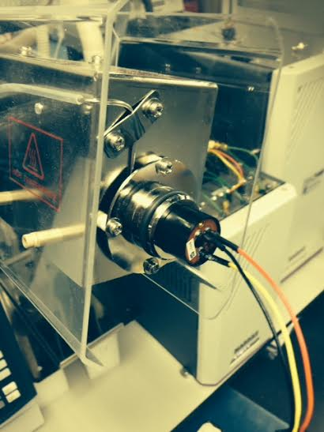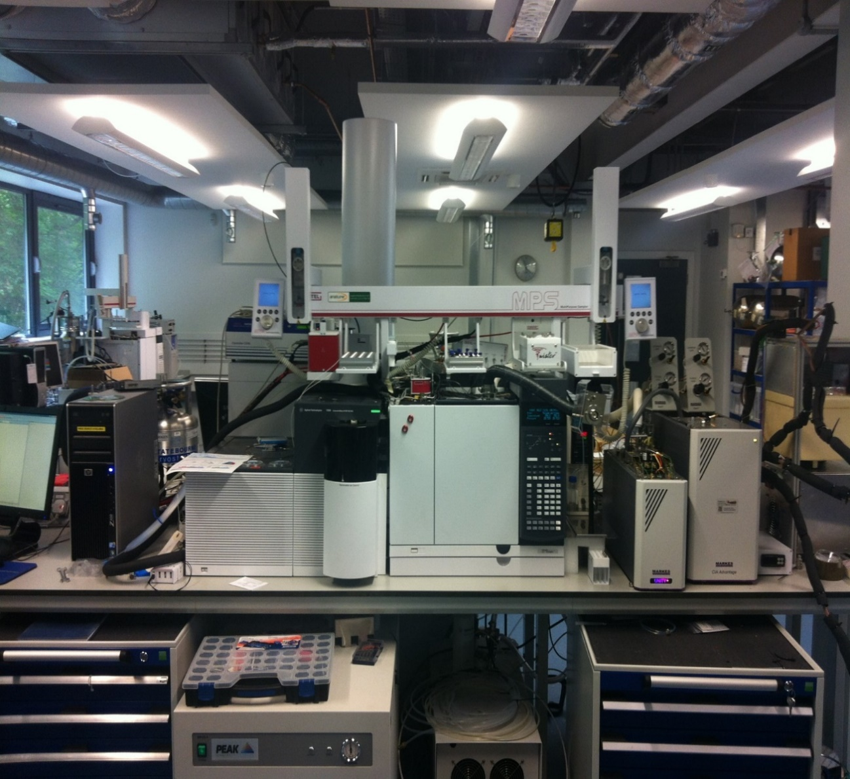

**Fig. 1.** PID sensor employed as a parallel detector for VOCs in an Agilent 7200 GC-QTOF-MS (left panel) system equipped with an olfactometry port (red square in left panel), of which the PID was placed in the outlet (right panel).

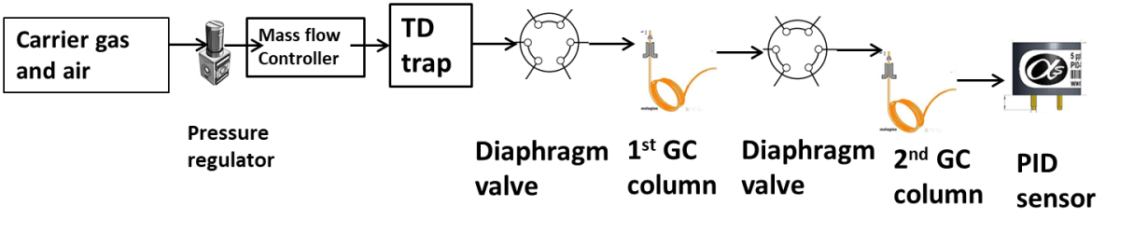

**Fig. 2.** Schematic diagram of the gas flows within the compact GCxGC-PID used for field measurements of VOCs..

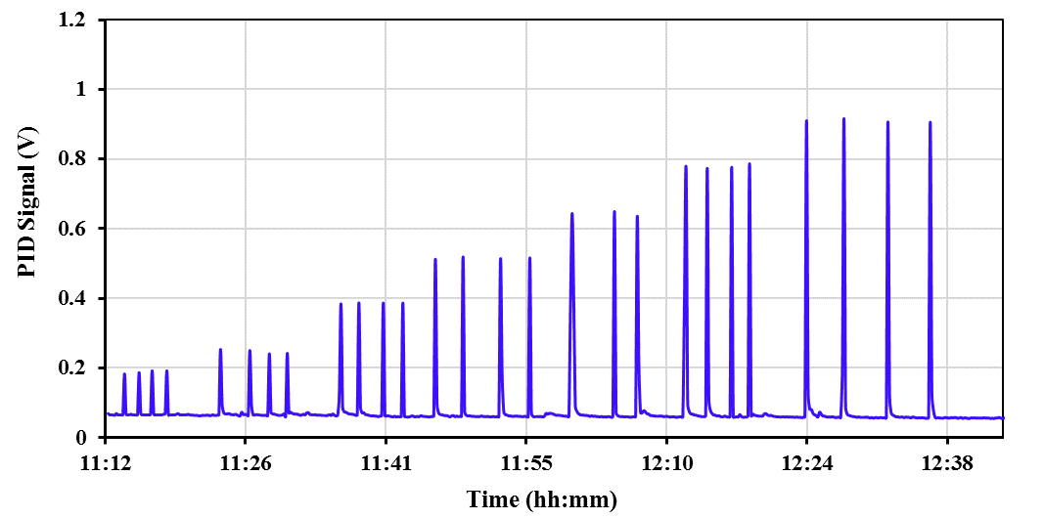

2 ppb

5 ppbV

10 ppbV

15 ppbV

20 ppbV

25 ppbV

30 ppb

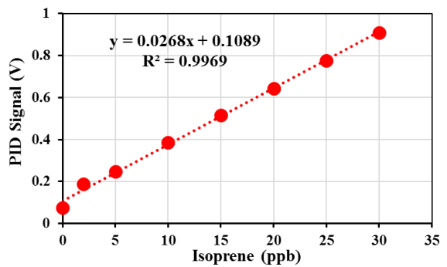

**Fig. 3.** PID responses to pulsed introduction of isoprene in N2 gas at different concentrations from 2 ppb to 30 ppb, with calibration curve in the inserted panel.

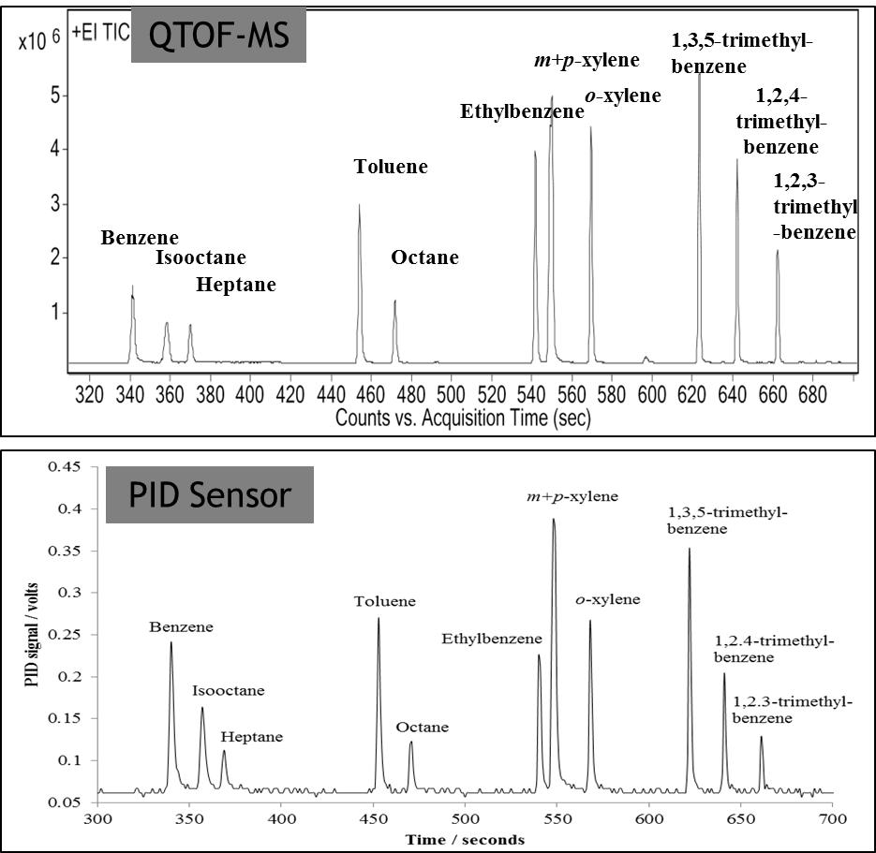

**Fig. 4.** GC chromatograms obtained by GC-PID sensor (bottom panel) and GC-Q-TOF-MS (top panel). The sensorshows symmetrical peak shape broadly comparable to that obtained with the Q-TOF-MS (up panel) to a VOC standard containing 12 species at 5 ppb level.

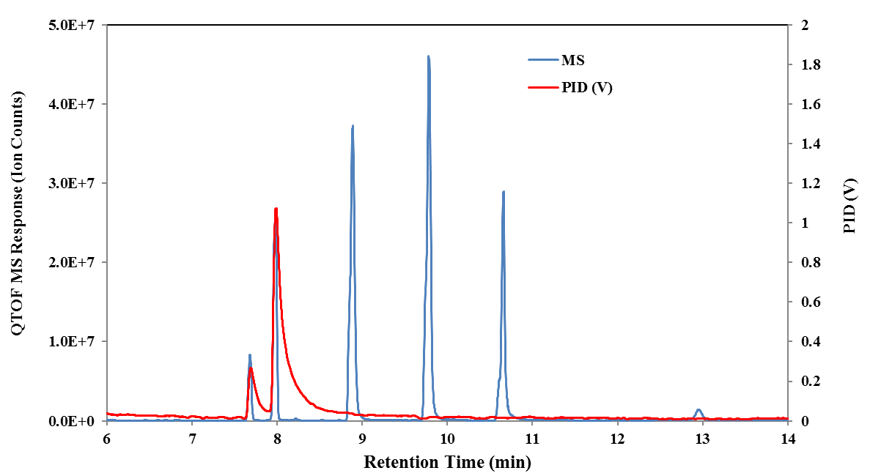

**Fig. 5.** PID sensor performance for toxic chemical measurements with an 11.7 eV Argon lamp (left panel) and a 10.6 eV Krypton lamp (right panel). The PID with an 11.7 eV Argon lamp can detect four species including ethane (ethoxymethythiol) (RT at 7.3 min), 2-chloroethyethylsulfide (RT at 7.5 min), diethyl-methyl-phosphonate (RT at 8.5 min) and diethylethyl-phosponate (RT at 9.2 min) whilst the PID with a 10.6 eV Krypton lamp can detect two species including ethane (ethoxymethythiol) and 2-chloroethyethylsulfide. Overlaid in both ases is the MS response

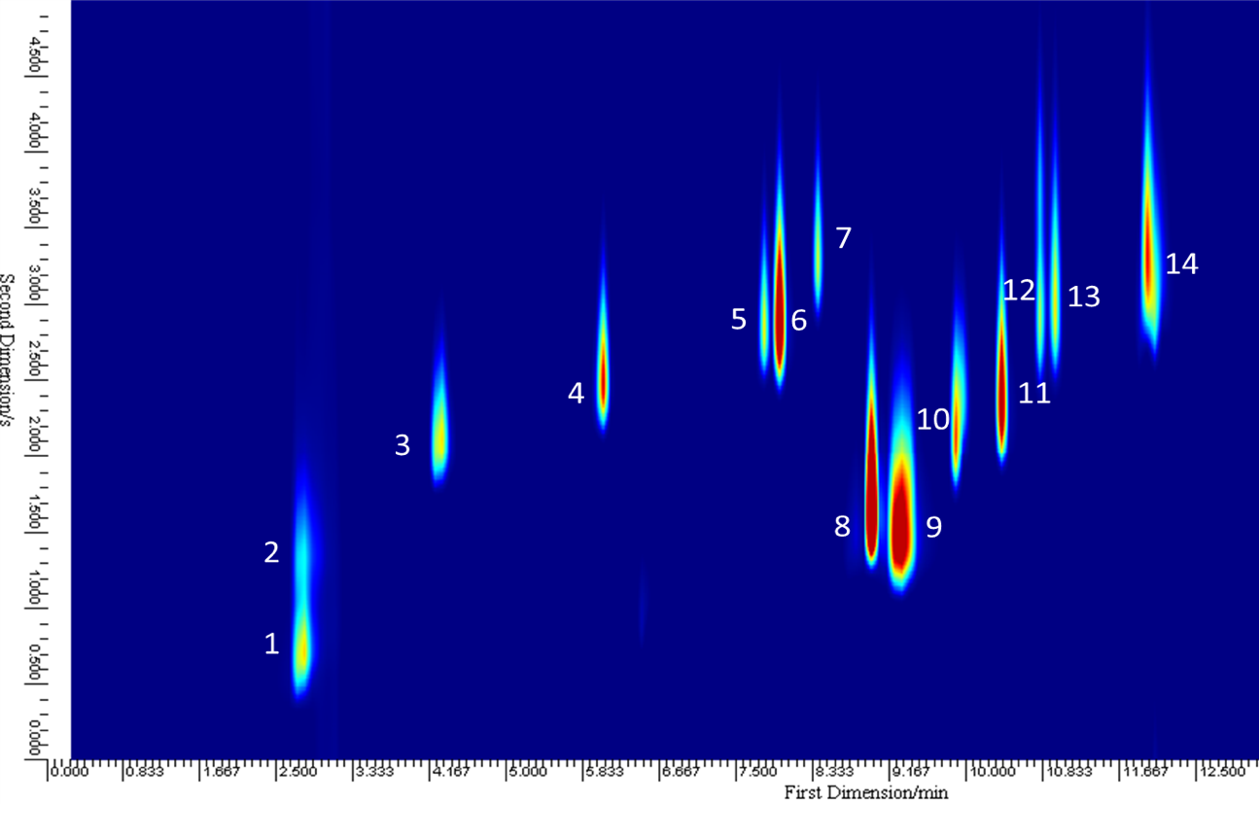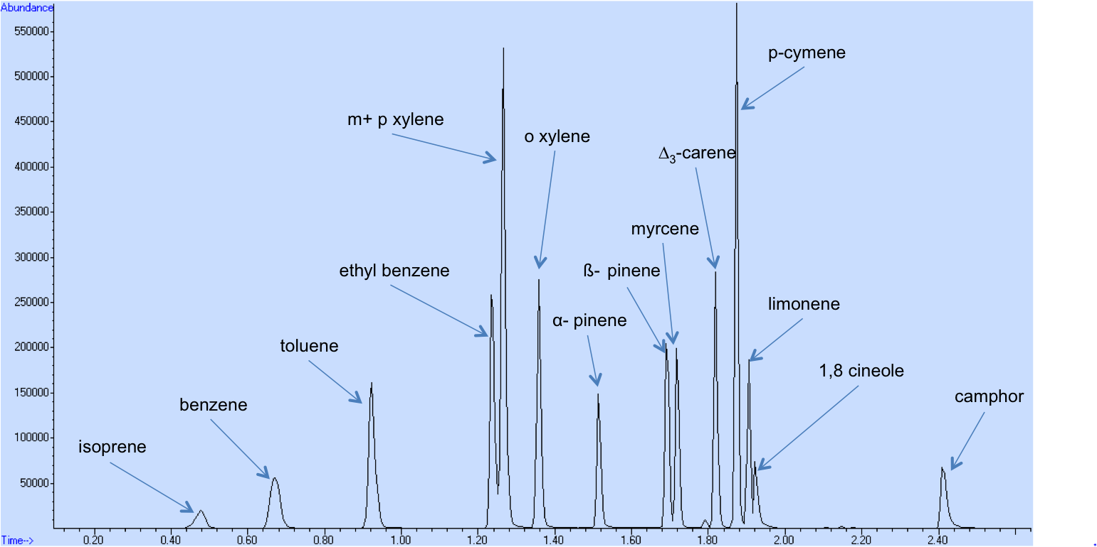

& acetone

**Fig. 6.** GC×GC-PID chromatogram (a) of a 17 component VOC standard and its GC-PID chromatogram (b) at 5 ppb using a PID sensor as the detector in a compact GC×GC device. Numbered peaks in GC×GC-PID chromatogram are identified as follows: (1) isoprene; (2) acetone; (3) benzene; (4) toluene; (5) ethyl benzene; (6) m/p-xylene; (7) o-xylene; (8) α-pinene; (9) β-pinene and myrcene; (10) *Δ*3-carene; (11) *p*-cymene; (12) limonene; (13) 1,8-cineole and (14) camphor.

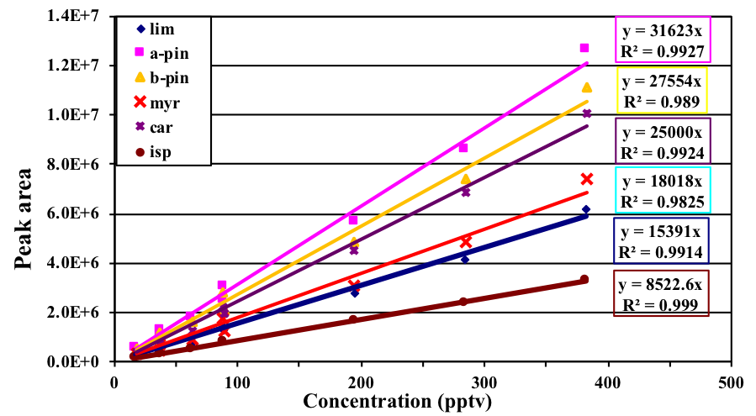

**(a)**

**(b)**

**Fig. 7.** PID sensor as the detector in compact GC × GC shows linear responses to eleven VOC species at various concentrations diluted from standard gases at 17, 37, 63, 89, 195, 285, 382 ppt. Panel (a), limonene, isoprene, *a*-pinene, β-pinene, myrcene, 3-carene; panel (b), benzene, toluene, ethyl benzene, m/p-xylene, o-xylene.

**85 ppt**

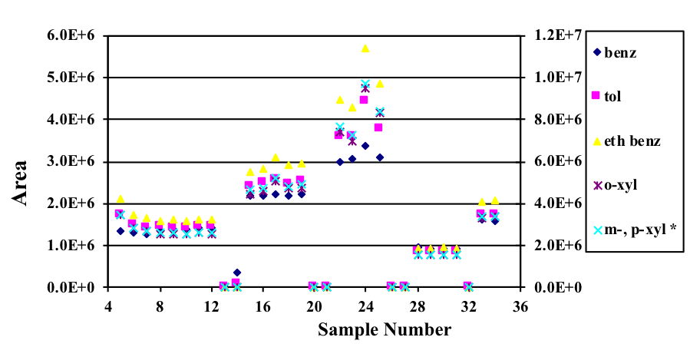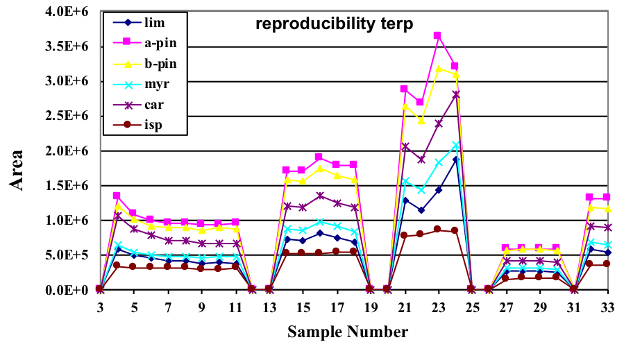

**61ppt**

**(a)**

**36ppt**

**17ppt**

**36ppt**

**85 ppt**

**(b)**

**61 ppt**

**36ppt**

**36 ppt**

**17 ppt**

**Fig. 8.** Reproducibility of PID performance as the detector in the compact GC × GC to 11 component VOC standard at various concentrations. In panel (a), PID measurement reproducibility for limonene, isoprene, *a*-pinene, β-pinene, myrcene, 3-carene are shown. In panel (b), PID reproducibility for benzene, toluene, ethyl benzene, m/p-xylene, o-xylene are shown.

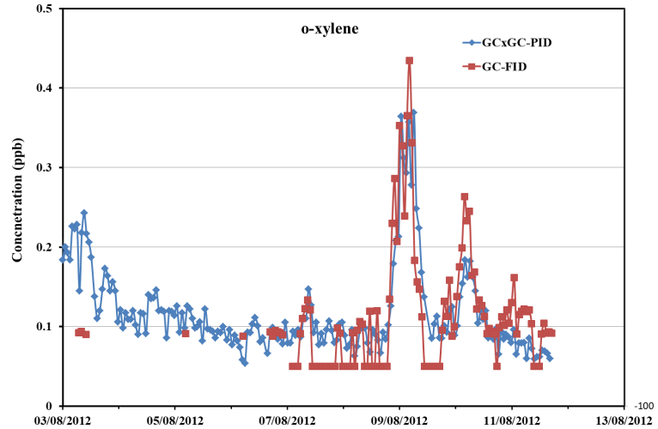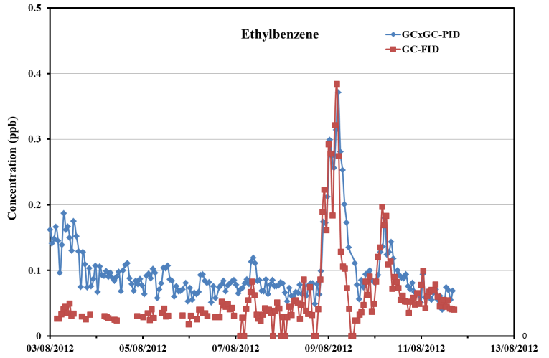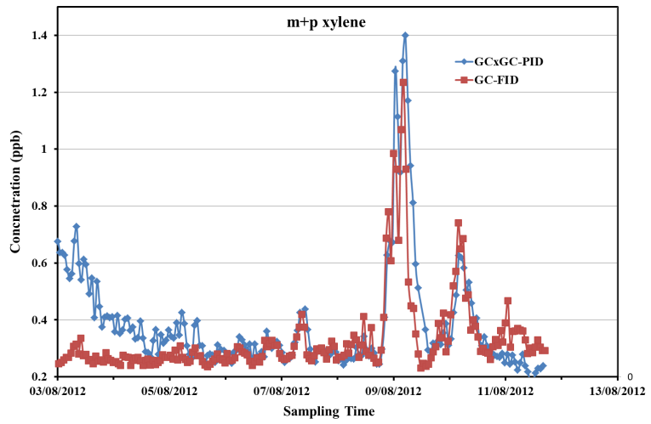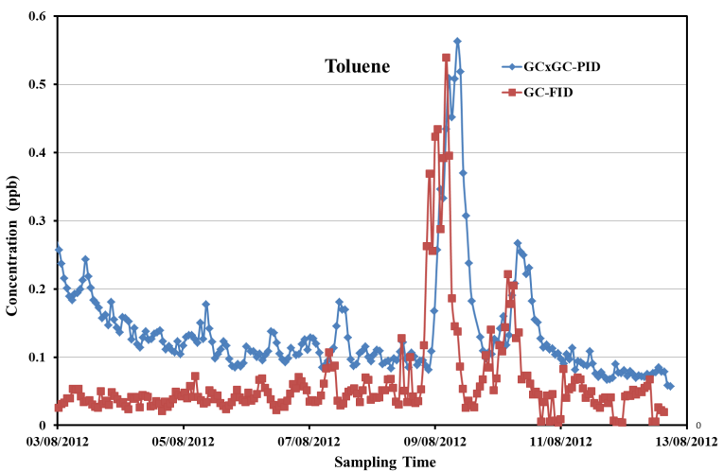

**Fig. 9.** Comparisons of o-xylene, ethylbenzene, m+p xylene, toluene ambient air measurements between the compact GCxGC-PID (red) and a reference TD-GC-FID (blue) during a summer campaign in London from 3 August 2012 to 12 August 2012.