Statistical thermodynamics of casein aggregation: Effects of salts and water
Kaja Harton¹ and Seishi Shimizu^{1*}

¹York Structural Biology Laboratory, Department of Chemistry, University of York, Heslington, York YO10 5DD, United Kingdom

KEYWORDS: statistical thermodynamics; Kirkwood-Buff theory; hydration; cosolvents; aggregation, casein, milk

AUTHOR INFORMATION
Corresponding Author:
Seishi Shimizu
York Structural Biology Laboratory, Department of Chemistry, University of York, Heslington, York YO10 5DD, United Kingdom
Tel: +44 1904 328281. Email: seishi.shimizu@york.ac.uk

ABBREVIATIONS
KB, Kirkwood-Buff.

ABSTRACT

Salts, when added to milk, profoundly influence casein aggregation. Even though this well-known phenomenon has been widely exploited, there are still many unanswered questions. How do salts affect casein aggregation? Does water contribute significantly to the aggregation change? The key to answering these questions comes from statistical thermodynamics, i.e. the principles of physics that can link macroscopic data to the collective behaviour of molecules. We present two theoretical approaches. A rigorous approach which demands far more measurements than reported hitherto; and an approximate, pragmatic approach. It bases on stoichiometric models (isodesmic model for aggregation equilibria and von Smoluchowski model for kinetics) that can yield information on protein-water and protein-salt interactions from ‘real-life’ experimental measurements on model systems available in a variety of formats. Using experimental data from the literature, casein aggregation, in the absence of κ-casein, has been shown to be modulated by protein-salt interaction, while the contribution from water structure changes has been shown to be negligible.

1. Introduction

Aggregation of casein, which accounts for 90 % of milk proteins [1,2], has been exploited since antiquity [3,4] to improve nutritional properties, portability, and shelf-life of milk [5]. Both thermodynamics and kinetics of casein aggregation are affected strongly by the presence of salts, even in dilution [6–10]. Moreover, it is known that caseins form complexes with salts which are called caseinates [11]. Therefore, salts not only perturb the conformational state stability of monomers and aggregates [6–10], but also directly interact with both forms. These observations have been known empirically for centuries and used accordingly. Yet, because of a notorious difficulty in understanding biomolecular solvation in aqueous solution mixtures, their mechanism on the molecular scale has eluded the grasp for decades [3,6,12,13]. We adapt a recent breakthrough in statistical thermodynamics to yield the molecular behaviour of biomolecules, basing on experimental data of the influence of salt concentration on the aggregation rate constant and aggregate size.

Due to the complexity of milk solution, analysis of the effect of salt is a problem far more difficult than salt induced changes of an individual protein molecule. Towards a complete understanding, the following three questions should be addressed:
- How salts affect aggregation on a molecular scale and what is the role of water;
- How to quantify effect of a salt on milk aggregation;
- How to predict the effect of salt on milk protein aggregation.
As we will show, none of the above questions has been answered clearly from the perspective of solvation: how water and salts interact with protein molecules to influence the aggregation? This paper intends to provide a clear answer to the first two questions, as a crucial stepping stone towards answering the third question.

The effect of salts on casein aggregation has been explained via two contending hypotheses based on water structure and preferential salt interaction.

Water structure hypothesis [14] is the most common explanation [15] how biomolecules and cosolvents interact in a solution. It pre-supposes that proteins are fully hydrated by layer(s) of water molecules and that the hydrophobic forces are the dominant driving force for protein aggregation and stability [14–18]. According to this hypothesis, cosolvents are never in direct contact with the biomolecule, which is ‘protected’ by hydration layers [14,15]. Hence, according to this hypothesis, salts influence the protein structure and stability indirectly, by either enhancing the clathrate water structure, strengthening the hydrophobic effect and hence promoting protein aggregation (kosmotropy) or breaking the clathrate, weakening the hydrophobic effect and thereby attenuating protein aggregation (chaotropy) [14,17–23].

Preferential interaction hypothesis assumed originally that water and/or cosolvents form a ‘fluctuating cloud’ [24] of molecules that interact with the biomolecule(s). Both water and cosolvents contribute to this interaction. Quantifying both interactions independently was achieved by the fluctuation adsorption-solvation theory (FAST), based directly on the principles of statistical thermodynamics [25–27]. Using thermodynamic data, FAST has shown conclusively that protein aggregation is promoted by exclusion of cosolvents from the protein, while the cosolvent accumulation enhances the dissociation of the aggregate [26,28].

The basic assumption of the water structure hypothesis, namely the lack of direct contact between cosolvents and biomolecules, has been shown to be contradictory to the experimental data and the principles of statistical thermodynamics [25,28]. Moreover, cosolvent modulation of protein hydration has been shown to contribute to protein stability and binding in a negligible manner [13,26,29]. The water structure hypothesis has thus been repealed and superseded by the preferential interaction hypothesis, which now has a support from the principles of statistical thermodynamics [13].

However, preferential interaction determinable via FAST, at the present stage, is not sufficient to tackle casein aggregation in the presence of salts. This is because the theory has focused mainly on (i) an isolated protein in solution for the study of protein stability, (ii) self-association of proteins in dilution or binding of a protein and a ligand in dilution, or (iii) protein gelation in semi-dilute region [25–27]. Treating casein-aggregation requires extension of preferential interaction theory beyond dilute solution limit, in which the effect of salts on protein self-aggregation can be treated. In addition, the majority of data available in food science literature are often highly empirical, posing challenges to the extraction of thermodynamic insights therefrom.

To this end, the aim of this paper is two-fold:
- To establish a rigorous theory of salt effect on concentrated protein aggregation
- To develop a realistic and approximate treatment of 1 applicable to the ‘real-life’ experiments in food science
FAST, as the theoretical foundation, is a rigorous theory that can quantify all the relevant interactions in terms of the Kirkwood-Buff (KB) integrals (Section 2.1) and can clarify the number of independent measurements required to determine all these integrals. However, as will be shown in Section 2.2, the number of measurements turns out to be far beyond what has been reported in the literature [16,30–32], which will lead to a limited clarification on the relationship between protein-salt and protein-protein interactions. This necessitates an approximate, yet practical theory to obtain molecular insights directly from the data gathered and analysed by food and dairy scientists, which will be presented in Section 2.3 onwards.

Indeed, the analyses of casein aggregation equilibria and kinetics have benefitted greatly by stoichiometric approaches, such as the isodesmic model for equilibria [33,34] and von Smoluchowski model for kinetics. They have a clear advantage in being able to simplify the macromolecular degrees of freedom [35]. Their traditional weakness, however, is their inability to deal with solvation. Yet, this problem can be overcome from how equilibria and rates depend on salt concentration.

2. Statistical thermodynamics of casein aggregation

2.1. Theoretical foundation

Here, we construct a rigorous statistical thermodynamic theory that describes how salts affect casein aggregation. Let us first set the scene. Consider a three-component solution consisting of a protein (i = p), water (i = 1), and cosolute (i = 2) molecules. Such a system (one-phase three-component solvent mixture), according to the Gibbs phase rule has f = 3 −1 + 2 = 4 degrees of freedom. This information will later be crucial when counting up how many independent measurements are necessary to obtain inter-species affinity information [25–27].

Let us divide three-component solution into two parts: ‘protein’s vicinity’ (which contains a protein molecule whose centre of mass position is fixed) and the ‘bulk’ (which is far away from the protein). Following our previous papers on FAST [27,36,37], in order to circumvent the difficulty arising from particle identity, let us mark the fixed protein as ‘solute’ (i = u). Since the centre-of-mass of the ‘solute’ protein is now fixed, this ‘solute’ protein is distinguishable from the rest of the proteins [27,37]. The affinity between species i and a fixed ‘solute’ protein can be quantified through the concentration difference between the two parts. To explore the consequence of such concentration difference to protein aggregation, let us write down the Gibbs–Duhem equations for each part, vicinity
(represented by *) and the bulk under constant temperature:
$c_{u}^{*}dμ_{u}^{*}+c_{p}^{*}dμ_{p}+c_{1}^{*}dμ_{1}+c_{2}^{*}dμ_{2}-dP=0$ (1)
$c_{p}dμ_{p}+c_{1}dμ_{1}+c_{2}dμ_{2}-dP=0$ (2)
where c_{i} and μ_{i} represent the number density and the chemical potential of the species i, and P is the pressure. Here, $c_{u}^{*}$ in particular, expresses the number density of the fixed ‘solute’ protein in the vicinity part [27,37]. Subtracting Eq. (2) from Eq. (1) yields:
$c_{u}^{*}dμ_{u}^{*}+\left(c_{p}^{*}-c_{p}\right)dμ_{1}+\left(c_{1}^{*}-c_{1}\right)dμ_{1}+\left(c_{2}^{*}-c_{2}\right)dμ_{2}=0$ (3)
Thus, the Gibbs-Duhem equations (1) and (2) have now been rewritten explicitly in terms of the concentration change ($c_{i}^{*}-c_{i}$) in the solute’s vicinity. The Kirkwood-Buff integral (KBI) of the species i around the solute defined as [25,38,39]:
$G_{ui}=\frac{c_{i}^{*}-c_{i}}{c_{u}^{*}c_{i}}$, (4)
which has the following microscopic expression through solute-water distribution function, $g_{ui}(r)$, as a function of protein-solvent distance r:
$G_{ui}=4π\int_{0}^{∞}{\left[g_{ui}\left(r\right)-1\right]}r^{2}dr$ (5)
KBIs are represented by integration of $g_{ui}\left(r\right):$ the overall change in solvent distribution around the solute from the bulk solution. $g_{ui}(r)$ is determined by all interactions – direct and indirect – present between solute and species $i$, being mediated by all surrounding molecules. Structural information of proteins is already taken into account; (i) the excluded volume – which species $i$ cannot penetrate – has $g_{ui}\left(r\right)=0$, which contributes negatively to KBI; (ii) the attraction between the protein solute and species $u$, which is influenced by protein structure and conformation. For these reasons, $G_{ui}$ determined by all the microscopic interactions in the system constitutes the minimum information necessary to understand the structural thermodynamics of the solution mixture. Note that the KBIs are defined universally for any molecule, regardless of whether the protein is globular or intrinsically disordered.

From Eqs. (3) and (4), we obtain the following:
$-dμ_{u}^{*}={{{c_{p}G}_{up}dμ_{p}+ c}_{1}G}_{u1}dμ_{1}+{c_{2}G}_{u2}dμ_{2}$ (6)
which is the fundamental relationship for solvation free energy $μ_{u}^{*}$ represented in terms of $μ_{1}$,$μ_{2}$, and $μ_{p}$. They are the remaining three degrees of freedom, because out of four degrees of freedom guaranteed by the Gibbs phase rule, we have already imposed the isobaric condition before Eqs. (1) and (2). Note, that casein aggregation takes place under isobaric conditions in most real-life situations, hence P should be chosen as one of the independent variables. To this end, the recurrent use of Eq. (2) can transform Eq. (6) into the following form:
$-dμ_{u}^{*}=c_{p}\left(G_{up}-G_{u2}\right)dμ_{p}+c_{1}\left(G_{u1}-G_{u2}\right)dμ_{1}+G_{u2}dP$ (7)

Now, to complete the derivation of the fundamental equation we identify the fixed solute as a protein molecule, u = p. It is established that such a treatment leads to the formulae identical to those derived rigorously from statistical thermodynamics [27,37,39]. In addition, we employ a well-known relationship [13,26,40] between the chemical potentials of a free ($μ_{u}$) and a fixed protein ($μ_{u}^{*}$)
$dμ_{p}^{*}=dμ_{p}-RT\frac{dc_{p}}{c_{p}}$ (8)
(Note that $μ_{p}^{*}$ is a statistical thermodynamic quantity; protein’s centre-of-mass position is fixed in space. Hence, $μ_{p}^{*}$, frequently referred to as the ‘pseudochemical potential’ [40], is different from the thermodynamic ‘standard chemical potential’, namely the chemical potential in the pure phase [40].) Eq. (8) can be used to eliminate either μ_{p}* or μ_{p}. We choose μ_{p}* and adopt μ_{p} as a variable, because the determination of μ_{p}* from phase equilibria is difficult beyond sparingly soluble solutes, while the determination of μ_{p} as a function of c_{p}, albeit requiring extensive measurements, is still possible in principle. Hence, combining Eqs. (7) and (8), we obtain
$\left[1+c_{p}\left(G_{pp}-G_{p2}\right)\right]dμ_{p}^{*}=\frac{RT}{c_{p}}dc_{p}-c_{1}\left(G_{p1}-G_{p2}\right)dμ_{1}-G_{p2}dP$ (9)
which will serve as the fundamental equation for casein aggregation.

2.2. Need for approximation

Under constant temperature, there are 4 −1 = 3 degrees of freedom according to the Gibbs phase rule [26,27,41], which is the same number as the KBIs (G_{pp}, G_{p1}, G_{p2}) in Eq. (9). To determine these three KBIs, the following relationships can be used that can be derived from Eq. (9):
${\left(\frac{∂μ_{p}}{∂c_{p}}\right)}_{μ_{1},P}=\frac{RT}{c_{p}\left[1+c_{p}\left(G_{pp}-G_{p2}\right)\right]}$ (10)
${\left(\frac{∂μ_{p}}{∂μ_{1}}\right)}_{c_{p},P}=-\frac{c_{1}\left(G_{p1}-G_{p2}\right)}{1+c_{p}\left(G_{pp}-G_{p2}\right)}$ (11)
${\left(\frac{∂μ_{p}}{∂P}\right)}_{μ_{1},c_{p}}=-\frac{G_{p2}}{1+c_{p}\left(G_{pp}-G_{p2}\right)}$ (12)

Applying Eqs. (10)-(12) to analyse experimental data will yield the three KBIs that quantitatively characterize all the inter-species affinities that are responsible for the salt-induced change of casein aggregation. Indeed, the current approach, which is mathematically equivalent to the classical matrix inversion approach [27,37,42–44], has been applied to a limited number of concentrated ternary solutions consisting of small molecules [45–47]. However, this approach faces severe difficulties:
- Measuring μ_{p} as a function of c_{p}, μ₁ and P requires a four-dimensional plot, requiring vast quantity of experiments.
- Even when G_{pp}, G_{p1}, G_{p2} have been obtained as a function of solution composition, there is no explicit theoretical link explaining why G_{pp} changes due to G_{p1} and G_{p2}.
From an experimental perspective, to obtain such an information [45–47] one needs to keep measuring the osmotic coefficient, density and isothermal compressibility while systematically changing the composition of the ternary solutions in a scale unprecedented for casein solutions.

To overcome these two difficulties, a drastic simplification of the theory is indispensable. Here, we focus on a simpler case of three component system (water, casein, salt) – previous papers have demonstrated that FAST can readily be generalised to any system, with larger number of components [41,44]. However, it requires more KBIs to be determined. In turn, it requires more thermodynamic data, more than is available in the literature. Hence, this paper focuses on demonstrating how statistical thermodynamics can be applied to casein aggregation through use of simpler system.

2.3. Simplification comes from traditional aggregation models

The rigorous theory developed in Sections 2.1 and 2.2 requires far more extensive experimental results than what has typically been undertaken in the field; the number of measurements required turned out to be enormous, hence is impractical, in addition to the lack of a clear cause-and-effect between casein-casein and casein-solvent interactions obtainable by theory.

We show that these problems can be overcome by adopting the stoichiometric aggregation models that have been used widely in the literature. It is a synthesis of, and compromise between, discreteness in the aggregation model and the continuous nature of solvation characterised by KBIs. The aggregation models yield a single equilibrium constant ($K$) or rate constant ($k$) of the reaction. The modulation of $K$ and $k$ by salts can be treated in a continuous manner with statistical thermodynamics [13,25]. Thus, we can clearly establish the roles of salts and water in the framework adopted commonly by food and dairy scientists.

The aggregation unit sub-steps are defined as follows
- Aggregation equilibria $K$ in the isodesmic model (Figure 1): association of an additional protein to a pre-formed aggregate. $K$ is independent of the size of the pre-formed aggregate [33,34].
- Rate constant $k$ from von Smoluchowski model for kinetics (Figure 2): the aggregate increases by one unit [8,16,30], in which a ‘unit’ can either be a monomer or a cluster of monomers. k is the same regardless of the size of the unit and aggregate [16,35,48].
Note that application of the isodemic model in this case is restricted to dilute solutions, below the CMC of casein, with limited number of casein species at dilute salt concentrations.
The early support for the isodemic model came from the light scattering data of dilute α_{s2} casein that implied that ‘association does not reach a constant level’ [49]. In addition, the majority (80%) of the dilute β casein A is in the monomeric form [32], which is consistent with the isodesmic model. The isodesmic approach is thus a reasonable model to evaluate the initial stage of aggregation of casein.

Using a relationship derived in our previous papers, we can obtain the change of protein-water and protein-salt KBIs, that accompany the unit aggregation sub-step, from the $c_{2}$ dependence of $K$, as
${\left(\frac{∂\ln{K}}{∂c_{2}}\right)}_{T,P}=ΔG_{p2}-ΔG_{p1}$ (13)
And $ΔG_{p2}$ and $ΔG_{p1}$ are determinable independently by complementing Eq. (13) with the change of partial molar volume that accompanies the aggregation sub-step, $ΔV_{p}$, as
$-ΔG_{p1}=ΔV_{p}$ (14)
The $c_{2}$ dependence of the rate of the aggregation sub-step, yields
${\left(\frac{∂\ln{k}}{∂c_{2}}\right)}_{T,P}=ΔG_{p2}^{‡}-ΔG_{p1}^{‡}$ (15)
where $ΔG_{p2}^{‡}$ and $ΔG_{p1}^{‡}$ represent the change of protein-water and protein-salt KBIs that accompany the change from the reactant to the transition state of the unit sub-process. Using the activation volume, these two KBIs can be determined independently
$-ΔG_{p1}^{‡}=ΔV_{p}^{‡}$ (16)

Thus, the analysis of reaction equilibria and kinetics has been made much simpler, and in conformity to the practice in food and dairy science, by the adoption of stoichiometric models.

2.4. Determining isodesmic binding constants from empirical data

The isodesmic model assumes (i) casein aggregation as an infinite series of stoichiometric reactions of binding a monomer to an $n$-mer ($n≥1$) and (ii) binding constant $K$ is the same regardless of $n$. Hence,
$K=\frac{c_{p,n+1}}{c_{p,n}c_{u,1}}$ (17)
where $c_{p,n}$ is the molar concentration of the casein $n$-mer. Applying Eq. (17) successively from $n=1$ yields:
$c_{p,n+1}=K^{n}c_{p,1}^{n+1}$ (18)
which is the aggregate size distribution according to this model.

The empirical data reported in the literature can now be used to extract the isodesmic $K$, such as the fraction of casein monomer, $α$, defined as
$α=\frac{c_{p,1}}{c_{p}}=\frac{c_{p,1}}{\sum_{n}{nc_{p,n}}}$ (19)
Using the aggregate size distribution (Eq. (18)), Eq. (19) can be rewritten via simple algebra (Appendix A) as
$α=\frac{c_{p,1}}{\sum_{n}{nK^{n-1}c_{p,1}^{n}}}=\frac{1}{\sum_{n}{nK^{n-1}c_{p,1}^{n-1}}}={\left(1-Kc_{p,1}\right)}^{2}$ (20)
Combining Eqs. (19) and (20), the isodesmic $K$ can be calculated straightway from $α$ and total casein concentration $c_{p}$ as
$K=\frac{1-\sqrt{ α}}{c_{p,1}}=\frac{1-\sqrt{α}}{c_{p}α}$ (21)
Thus, Eq. (21) links empirical measure of monomer fraction to the isodesmic $K$, and consequently, to the KBIs describing solute-solvent interactions.

3. Understanding the effect of salts

3.1 Effect of salts on casein aggregation

Through statistical thermodynamics we showed that role of water and salts on casein aggregation can be quantified directly from the commonly used stoichiometric models [8,16,30,48,50–52]. Now, we aim to quantify the protein-water and protein-salt KBIs directly from the literature data basing on Eqs. (13)-(16), using the following published experimental evidence:
- the volume change on aggregation, $ΔV$
- the activation volume, $ΔV_{p}^{‡}$
And to answer following questions, by quantitatively analysing obtained information:
- how the aggregation constant $K$ depends on the concentration of NaCl, NaSCN, TFA (trifluoroacetic acid), NaClO₄ [32]
- how the aggregation rate $k$ depends on the concentration of NaCl and CaCl₂ [30].
To deal with dissociative cosolvent species, such as salts, we follow a well-established approach. Let’s consider the (averaged) ions as the species 2; the number of cations or anions cannot be changed independently due to the charge neutrality requirement [37,43]. Hence, as in previous KB approaches to ionic solutions [37,43], cations and anions of varying size asymmetry have been assumed to be treated as single species, as a collection of indistinguishable ions.

First, we shall show that $ΔG_{p1}$ and $ΔG_{p1}^{‡}$ (water-protein interactions) are negligible compared to $ΔG_{p2}$ and $ΔG_{p2}^{‡}$. For $ΔG_{p1}$, the attempted measurement on $ΔV_{p}$ based on the pressure-dependence of $K$ have yielded a very small number that cannot be determined precisely [53]. This means $ΔV_{p}≃0$ compared to the dramatic effect that salts play on aggregation equilibria. There is no exact data on $ΔV_{p}^{‡}$ available in the literature, beyond the statements that it is ‘minimal’ or ‘negligible’ [54,55], or is too small to be recorded experimentally [56], suggesting that $ΔV_{p}^{‡}≃0$ as well. This conclusion can be underscored further by an order-of-magnitude analysis of the pressure- versus salt-concentration dependence of the “aggregation time” [31] whose inverse gives some estimate on the rate of aggregation. By using Eq. (16) as
$\left(\frac{∂\ln{k}}{∂\left(\frac{P}{RT}\right)}\right)=ΔG_{p1}^{‡}$ (22)
Comparing Eq. (22) with Eq. (15) provides a simple and useful approach to comparing pressure and salt concentration effects as shown in Table 1: dependence of $k$ on $c_{2}$ should be compared with that on $\frac{P}{RT}$. According to Lopez-Fandino et al. [31], a 60% reduction in the ‘aggregation time’ is observed in the presence of 4 mM of CaCl₂, whereas a 25% reduction is observed under 100 MPa. When combined with statistical thermodynamics, it is sufficient evidence to conclude the negligibility of $ΔG_{u1}^{‡}$ compared to $ΔG_{u2}^{‡}$ (cf. aim 2 in Introduction). As has been shown by Eq. (15), the $c_{2}$ dependence of $\ln{k}$ yield $ΔG_{u2}^{‡}-ΔG_{u1}^{‡}$ whereas $\frac{P}{RT}$ dependence of $\ln{k}$ yields $ΔG_{u1}^{‡}$ according to Eq. (22). This means that all we have to do is to compare the $c_{2}$- versus $\frac{P}{RT}$-dependencies of the rates of reaction. As shown in Table 1, even a ${10}^{9}$ times larger $\frac{P}{RT}$ as compared to $c_{2}$ cannot even generate a comparable aggregation time reduction. To emphasise, when compared per mol dm⁻³, 25% decrease over the change of $\frac{P}{RT}$ by $4×{10}^{7} mol dm^{-3}$ is negligibly slower than a 60% decrease over the change of $c_{2}$ by $1.2×{10}^{-2} mol dm^{-3}$. Thus, our simple order-of-magnitude analysis, founded firmly on statistical thermodynamics, establishes that $ΔG_{u1}^{‡}$ is indeed negligible.

Thus, we have arrived at the following simplification:
${\left(\frac{∂\ln{K}}{∂c_{2}}\right)}_{T,P}≃ΔG_{p2}$ (23)
${\left(\frac{∂\ln{k}}{∂c_{2}}\right)}_{T,P}≃ΔG_{p2}^{‡}$ (24)
Negligibility of $ΔG_{u1}$ and $ΔG_{u1}^{‡}$ based on robust, order-of-magnitude argument is an evidence against the water structure hypothesis. We have shown that $ΔG_{p1}$ makes an inconsequential contribution, while $ΔG_{p2}$is dominant. This constitutes a counter-argument against the assumption that protein hydration change is the principal contributor [14,17,19]. $ΔG_{p2}$ is determined from the protein-salt radial distribution function (Eq. (5)), which is determined by protein-salt interactions in aqueous solutions – thus contribution of water is strictly in its mediation of protein-salt interaction [57].

The availability of analysable casein aggregation thermodynamics data in the literature is limited. The only data usable for analysis are the purified $β$ casein A for the thermodynamics, and a mixture of all caseins (except for the $κ$-casein) for kinetics [30,32]. Data represent trends in the change rather than exact measures. Yet, thanks to the robustness of our theoretical foundation, they are powerful enough to question the validity of the water structure hypothesis.

Table 2 summarises $ΔG_{p2}$ of aggregation equilibria, calculated from the c₂ dependence of ln $K$ obtained via linear regression (Figure 3). This analysis bases on the measurement fraction of monomer to aggregate, as explained by Eq. (21). Note, that while the increase of salt concentration changes the monomer concentration $c_{u,1}$, it does not affect the casein concentration $c_{u}$. Hence, we have plotted $\ln{K^{'}=}\ln{c_{u}K}$ and calculated its salt concentration dependence for each of salts to obtain KBIs. In the data used, the fraction of monomeric casein amounted to 80% [32], which makes the isodesmic model a reasonable start-up due to its peak distribution at $n=1$. This common measurement reveals key insight into the molecular behaviour of casein molecules.

The positive $ΔG_{p2}$ (the extent of aggregation) of NaCl, TFA (trifluoroacetic acid) and NaClO₄, taken together with the definition of KBI (Eq. (5)) and the direction of aggregation reaction (Figure 1), show that these salts’ accumulation increases as casein aggregate becomes larger. Hence, these salts enhance casein aggregation by favourably accumulating onto larger aggregates. NaSCN, on the other hand, exhibits negative $ΔG_{p2}$, suggesting that NaSCN is bound less as casein aggregation proceeds.

Three salts from the above list (NaCl, NaSCN and NaClO₄), when added to aqueous caffeine solution affect caffeine aggregation (also analysed via the isodesmic model [58]) differently from casein aggregation (Table 3). This again underscores the cumulative evidence that cosolvents effect cannot be rationalized without an explicit consideration of cosolvent-solute affinity.

The effect of salts on aggregation kinetics is summarised in Table 4. Values were calculated as in equation (24), translating dependence of rate of aggregation vs. cosolvent concentration to $ΔG_{p2}^{‡}$. Application of the transition state theory reveals interesting insights on the aggregation mechanism, despite scarcity of data. The insight is even more compelling when matched with aggregation equilibria from thermodynamic approach. Ca²⁺ significantly accelerates the aggregation process via increased accumulation around the intermediate states on the way to aggregation (positive$ΔG_{p2}^{‡}$) is well expected. However, the negative $ΔG_{p2}^{‡}$ for NaCl, shows the affinity to the intermediate state is weaker, thereby slowing down the aggregation kinetics, contrary to the isodesmic evidence where NaCl affinity to larger aggregates was revealed.
Due to high sensitivity of casein aggregation on pH of the solution [59–62], both experiments were conducted in a imidazole - CaCl₂/ NaCl buffer. This comparison again shows that considering salt-aggregate interaction explicitly for all possible aggregation states is essential for elucidating aggregation patterns on a molecular scale.

Our FAST approach is based on the determination of KBIs from experimental data with minimum assumptions. Albeit it is a different method to the ones used previously, it supports the conclusions attained by a combination of simple models employed widely in colloid science. A successful fit of α_{s1} casein precipitation based on ‘the underlying assumption that the binding of calcium to the casein reduces the charge on the casein, thereby reducing the energy barrier to precipitation’ [48] was used as a support of this assumed scenario in our narrative. Despite the difference of the caseins used, the positive $ΔG_{p2}^{‡}$ for calcium ion has been interpreted as the binding of calcium on the transition state and the subsequent acceleration of aggregation. Via Eq. (15) it can be linked to reduction of the activation free energy [63] with minimum assumptions.

However, note that the data used in Table 4 were for the fully-rennetted caseins, and would be relevant only for the initial stage of casein aggregation. Recent studies on the rates of casein aggregation revealed anomalous temperature dependence of the rate of aggregation. To apply FAST to such cases, a better treatment of the reaction kinetics via a full incorporation of the transition state theory [63] would be necessary.

Overall, what should be noted is that even simple and rudimentary experiments may yield significant insight into molecular interactions. Our method is a useful tool in analysing protein behaviour, hence making basic experiments a powerful source of molecular knowledge.

3.2. Ramification for the colloidal stability of caseinates
The chief aim of this paper is to elucidate the effect of salts on the equilibria and rates of casein aggregation in simplified model systems. Nonetheless, the approach furnished here can be extended to the colloidal stability of any protein, what we will show on the example of caseinates, salt complexes of caseins, and the effect of salts thereupon.
Using statistical thermodynamic as a device, we will show how through interactions of solute-solute one can analyse the effect of salts on these molecules. For a measure for caseinate-caseinate interaction, we can adopt the osmotic second virial coefficient, $B_{2}$, as has been widely doney [64,65]. It has a direct link to the caseinate-caseinate KBI, $G_{cc}$, via $G_{cc}=-2B_{2}$ [40,66]. (Note that caseinate is denoted as $c$ from here onwards.) In principle, this would mean that salt effect on caseinate aggregation can be understood by how $G_{cc}$ depends on salt concentration, $c_{2}$. Such a derivative, as we have shown before [67], would involve a complex formula consisting of three-body KBIs, which are difficult to interpret and require a combination of thermodynamic data.

Our aim, therefore, is to provide a tractable scheme based on a simple model: the leitmotiv of this paper. Let us consider binding reaction of two caseinates in bulk solution, whose concentration is $c_{c}$. Defining a dimer inevitably involves a cutoff distance, $R$, and the volume contained therein, $V_{R}$. Let us assume that the excess number of solvent around a solute, $c_{c}G_{cc}$, can entirely be confined within $V_{R}$. Under this condition, the total number of solutes within the cutoff distance is expressed as $c_{c}G_{cc}+c_{c}V_{R}$. Multiplying this to casein concentration
$K=\frac{c_{c}(c_{c}G_{cc}+c_{c}V_{R})}{c_{c}^{2}}=G_{cc}+V_{R}$ (25)
When the caseinate-caseinate interaction is strong with high radial distribution function peaks dominating $G_{cc}$, Eq. (25) leads to $K≃G_{cc}$ [26]. A negative $G_{cc}$ would yield small $K$, corresponding to weak binding constant, provided that $V_{R}$ is larger than $G_{cc}$. The major problem in forcing KBI to conform to binding constants is the difficulty in determining the cutoff distance. Hence, we have consistently advocated the use of KBIs instead of binding constants for the paradox-free elucidation of non-specific solvation interactions.

Despite such limitations, linking $G_{cc}$ to binding constant yields a useful tool for a simple elucidation of the salt effects on caseinate aggregation. As the Ca²⁺ concentration increases, $G_{cc}=-2B_{2}$ changes its sign from positive to negative [68], which means that we are dealing with a small $G_{cc}$. Under this condition,
$\ln{K}≃\ln{V_{R}}+\frac{G_{cc}}{V_{R}}$ (26)
so that, using Eq. (13), we obtain
$\frac{1}{V_{R}}\left(\frac{∂G_{cc}}{∂c_{2}}\right)=ΔG_{c2}-ΔG_{c1}≃ΔG_{c2}$ (27)
where $ΔG_{ci}$ refers to the change of KBI between caseinate and species $i$ that accompanies caseinate aggregation. Mounting evidence suggests that the volume change accompanying biochemical reactions are usually very small [13], hence $ΔG_{c1}$ has been neglected. Despite the inherent difficulty of determining $V_{R}$, as has been pointed out [13,36], Eq. (27) is useful to draw a qualitative interpretation out of the salt concentration dependence of $G_{cc}$. To demonstrate this, let us qualitatively examine the observation by Dickinson and coworkers [68] that $G_{cc}$ decreases upon Ca²⁺ addition. Ca²⁺ thus decreases caseinate aggregation. Since the left-hand side of Eq. (22) is negative, it follows that $ΔG_{c2}<0$, meaning that caseinate aggregate−Ca²⁺ KBI is smaller than caseinate monomer−Ca²⁺ KBI. This means that
- Ca²⁺ is more excluded from caseinate aggregate than from caseinate monomers,
- Ca²⁺ interacts more with caseinate monomers than with caseinate aggregate
Considering the reduction of surface area that accompanies caseinate aggregation, the scenario 1 is unlikely, yet correlates with the reduction of interaction in the scenario 2. Thus, the favorable caseinate-Ca²⁺ interaction, and its reduction upon caseinate aggregation, is the key in the stabilization of caseinates.

4. Conclusion

Salts affect the aggregation of casein [6–10]. A simple observation it may be, understanding its mechanism on a molecular scale has long posed a challenge due to the elusive nature of protein solvation in multi-component solutions, in which a number of interactions (such as protein-water, protein-salt, water-salt, salt-salt and water-water) are at work. Without statistical thermodynamics linking the macroscopic and microscopic worlds, it is impossible to draw a clear conclusion on what is the dominant force in aggregation [25–27].

We have provided two alternative approaches to solving this question. The first one is a rigorous approach, extending our previous theory for dilute proteins. It comes directly from the very principles of statistical thermodynamics; it involves no approximation nor model assumptions. Yet, the use of this theory demands far more measurements than reported in the literature. The second is an approximate and pragmatic approach. This one bases on the existing stoichiometric models (isodesmic model for aggregation equilibria [33,34] and von Smolchowski model for kinetics [35]). Due to the drastic simplification that it can bring to dealing with protein-protein interaction, it provides a tractable way of yielding protein-water and protein-salt interactions quantitatively from the published experimental data.

By supplementing the stoichiometric models with statistical thermodynamics and with experimental data from literature on casein aggregation (that do not involve $κ$-casein), we have shown that casein aggregation is predominantly modulated by protein-salt interaction. The contribution from water structure changes was determined to be negligible based on a number of available experimental evidence. The classical, textbook hypothesis of “water structure” enhancement and breaking as the dominant contribution for aggregation modulation [14–18] turned out to be contradictory to our statistical thermodynamic analysis.

Our intention was to make it possible to draw molecular insights from a wider variety of experimental data, by adapting our statistical thermodynamic analysis to be usable to analyse highly empirical data, such as the monomer fraction and aggregation time. Our approach presented herein is quite general, and is applicable to any protein aggregates and any cosolvents/cosolutes/additives, through which the existing wealth of data in food and dairy science literature [69] can now be interpreted on a molecular basis.

The breadth of our analysis was limited by the availability of the literature data. Due to universality of out approach, other important factors, such as phosphate and κ-casein, also can be quantified via KBIs once extensive thermodynamic measurements have been performed. Interactions between different types of caseins can also be quantified, in principle, from FAST. Nevertheless, the more components there is to be considered, the more thermodynamic measurements have to be carried out, which is the fundamental bottleneck. As we have shown, combining rigorous statistical thermodynamics with simplified model approaches may be important in reducing the measurements necessary to achieve this goal. The thermodynamic models we have employed in this paper, such as the isodesmic model, suffer from limited applicability, e.g. it applies only to dilute protein concentration below CMC, and under low salt concentrations. Extending our theory to more concentrated micelle solutions under increased ionic strength would require a thermodynamic model for polydisperse micelles consisting of multiple components.

In computer simulations, KBIs have been established firmly as the indispensable bridge between the microscopic interactions on an atomistic scale and the solution structure governed by chemical thermodynamics [70,71]. The radial distribution function (Eq. (5)) contains all the information about intermolecular interactions, including the charges and ionic strengths. Once the KBIs have been quantified or estimated, we have shown that what remains to be done towards a full molecular-based elucidation of aggregation in the presence of cosolvents: the elucidation of KBIs based on microscopic interactions.

Appendix A

Here we derive Eq. (20). To do so, let us note that denominator of Eq. (20)
$\sum_{n}{n{\left(Kc_{p,1}\right)}^{n-1}=\sum_{n}{nx^{n-1}}}$ (A1)
where $x=Kc_{p,1}$ has been introduced. Eq. (A1) can also be expressed as
$\sum_{n}{nx^{n-1}}=\frac{d}{dx}\sum_{n}{x^{n}}=\frac{d}{dx}\frac{1}{1-x}=\frac{1}{{\left(1-x\right)}^{2}}$ (A2)
Putting back $x=Kc_{p,1}$ in Eq. (A2) will conclude the derivation.

References
[1] A. Bouchoux, P.E. Cayemitte, J. Jardin, G. Gésan-Guiziou, B. Cabane, Casein micelle dispersions under osmotic stress, Biophys. J. 96 (2009) 693–706. doi:10.1016/j.bpj.2008.10.006.
[2] T. Considine, H.A. Patel, S.G. Anema, H. Singh, L.K. Creamer, Interactions of milk proteins during heat and high hydrostatic pressure treatments — A Review, Innov. Food Sci. Emerg. Technol. 8 (2007) 1–23. doi:10.1016/j.ifset.2006.08.003.
[3] C. Guo, B.E. Campbell, K. Chen, A.M. Lenhoff, O.D. Velev, Casein precipitation equilibria in the presence of calcium ions and phosphates, Colloids Surfaces B Biointerfaces. 29 (2003) 297–307. doi:10.1016/S0927-7765(03)00018-3.
[4] T.W. Allen, Homeri Odyssea Libri I-XII, Oxford University Press, Oxford, 1920.
[5] H. Singh, A. Waungana, Influence of heat treatment of milk on cheesemaking properties, Int. Dairy J. 11 (2001) 543–551. doi:10.1016/S0958-6946(01)00085-1.
[6] C. Balny, P. Masson, F. Travers, Some recent aspects of the use of high-pressure for protein investigations in solution, High Press. Res. 2 (1989) 1–28. doi:10.1080/08957958908201029.
[7] P.H. von Hippel, D.F. Waugh, Casein: Monomers and Polymers, J. Am. Chem. Soc. 77 (1955) 4311–4319. doi:10.1021/ja01621a041.
[8] H. Holthoff, S.U. Egelhaaf, M. Borkovec, P. Schurtenberger, H. Sticher, Coagulation rate measurements of colloidal particles by simultaneous static and dynamic light scattering, Langmuir. 12 (1996) 5541–5549. doi:10.1021/la960326e.
[9] M.L. Green, R.J. Marshall, The acceleration by cationic materials of the coagulation of casein micelles by rennet, J. Dairy Res. 44 (1977) 521–531. doi:10.1017/S0022029900020471.
[10] P.F. Fox, B.F. Walley, Influence of sodium chloride on the proteolysis of casein by rennet and by pepsin, J. Dairy Res. 38 (1971) 165. doi:10.1017/S0022029900019282.
[11] C.A. Zittle, E.S. DellaMonica, R.K. Rudd, J.H. Custer, Binding of calcium to casein: Influence of pH and calcium and phosphate concentrations, Arch. Biochem. Biophys. 76 (1958) 342–353. doi:10.1016/0003-9861(58)90159-0.
[12] R. Stenner, N. Matubayasi, S. Shimizu, Gelation of carrageenan: Effects of sugars and polyols, Food Hydrocoll. 54 (2016) 284–292. doi:10.1016/j.foodhyd.2015.10.007.
[13] S. Shimizu, R. Stenner, N. Matubayasi, Gastrophysics: Statistical thermodynamics of biomolecular denaturation and gelation from the Kirkwood-Buff theory towards the understanding of tofu, Food Hydrocoll. 62 (2017) 128–139. doi:10.1016/j.foodhyd.2016.07.022.
[14] H.S. Frank, F. Franks, Structural approach to the solvent power of water for hydrocarbons; Urea as a structure breaker, J. Chem. Physis. 48 (1968) 537–3726. doi:10.1063/1.1668057.
[15] A. Burrows, J. Holman, A. Parsons, G. Pilling, G. Price, Chemistry³, 3rd ed., Oxford, 2017.
[16] T.A.J. Payens, On enzymatic clotting processes II. The colloidal instability of chymosin-treated casein micelles, Biophys. Chem. 6 (1977) 263–270. doi:10.1016/0301-4622(77)85007-2.
[17] T.A.J. Payens, Association of caseins and their possible relation to structure of the casein micelle, J. Dairy Sci. 49 (1966) 1317–1324. doi:10.3168/jds.S0022-0302(66)88088-8.
[18] S. Moelbert, B. Normand, P. De Los Rios, Kosmotropes and chaotropes: modelling preferential exclusion, binding and aggregate stability, Biophys. Chem. 112 (2004) 45–57. doi:10.1016/j.bpc.2004.06.012.
[19] P.S. Low, G.N. Somero, Activation volumes in enzymic catalysis: their sources and modification by low-molecular-weight solutes., Proc. Natl. Acad. Sci. U. S. A. 72 (1975) 3014–8. doi:10.1073/pnas.72.8.3014.
[20] K.D. Collins, Ions from the Hofmeister series and osmolytes: effect on proteins in solution and in the crystallisation process, Methods. 34 (2004) 300–311. doi:10.1016/j.bpc.2007.03.009.
[21] K.D. Collins, G.W. Neilson, J.E. Enderby, Ions in water: Characterizing the forces that control chemical processes and biological structure., Biophys. Chem. 128 (2007) 95–104. doi:10.1016/j.bpc.2007.03.009.
[22] Y. Zhang, P.S. Cremer, Interactions between macromolecules and ions: the Hofmeister series, Curr. Opin. Chem. Biol. 10 (2006) 658–663. doi:10.1016/j.cbpa.2006.09.020.
[23] Y. Marcus, Effect of ions on the structure of water: Structure making and breaking, Chem. Rev. 109 (2009) 1346–1370. doi:10.1021/cr8003828.
[24] S.N. Timasheff, Protein hydration, thermodynamic binding, and preferential hydration, Biochemistry. 41 (2002) 13473–13482. doi:10.1021/bi020316e.
[25] S. Shimizu, Estimating hydration changes upon biomolecular reactions from osmotic stress, high pressure, and preferential hydration experiments, Proc. Natl. Acad. Sci. 101 (2004) 1195–1199. doi:10.1073/pnas.0305836101.
[26] S. Shimizu, N. Matubayasi, Preferential solvation: Dividing surface vs excess numbers, J. Phys. Chem. B. 118 (2014) 3922–3930. doi:10.1021/jp410567c.
[27] S. Shimizu, N. Matubayasi, A unified perspective on preferential solvation and adsorption based on inhomogeneous solvation theory, Phys. A Stat. Mech. Its Appl. 492 (2018) 1988–1996. doi:10.1016/j.physa.2017.11.113.
[28] S. Shimizu, Molecular origin of the cosolvent-induced changes in the thermal stability of proteins, Chem. Phys. Lett. 514 (2011) 156–158. doi:10.1016/j.cplett.2011.08.038.
[29] S. Shimizu, C.L. Boon, The Kirkwood-Buff theory and the effect of cosolvents on biochemical reactions, J. Chem. Phys. 121 (2004) 9147–9155. doi:10.1063/1.1806402.
[30] D.G. Dalgleish, Coagulation of renneted bovine casein micelles: Dependence on temperature, calcium ion concentration and ionic strength, J. Dairy Res. 50 (1983) 331–340. doi:10.1017/S0022029900023165.
[31] R. Lopez-Fandino, M. Ramos, A. Olano, Rennet Coagulation of Milk Subjectted to High Pressures, J. Agric. Food Chem. 45 (1997) 3233–3237. doi:10.1021/jf960879v.
[32] W.H. Sawyer, J. Puckridge, The dissociation of proteins by chaotropic salts, J. Biol. Chem. 248 (1973) 8429–8433. doi:10.1074/jbc.248.24.8429.
[33] Z. Chen, A. Lohr, C.R. Saha-Möller, F. Würthner, Self-assembled π-stacks of functional dyes in solution: Structural and thermodynamic features, Chem. Soc. Rev. 38 (2009) 564–584. doi:10.1039/b809359h.
[34] C. Frieden, Protein aggregation processes: In search of the mechanism, Protein Sci. 16 (2007) 2334–2344. doi:10.1110/ps.073164107.
[35] M.L. Green, S. V Morant, Mechanism of aggregation of casein micelles in rennet-treated milk, J. Dairy Res. 48 (1981) 57–63. doi:10.1017/S0022029900021452.
[36] S. Shimizu, J.J. Booth, S. Abbott, Hydrotropy: Binding models vs. statistical thermodynamics, Phys. Chem. Chem. Phys. 15 (2013) 20625–20632. doi:10.1039/c3cp53791a.
[37] J.E.S.J. Reid, A.J. Walker, S. Shimizu, Residual water in ionic liquids: clustered or dissociated?, Phys. Chem. Chem. Phys. 17 (2015) 14710–14718. doi:10.1039/c5cp01854d.
[38] J.G. Kirkwood, F.P. Buff, The statistical mechanical theory of solutions. I, J. Chem. Phys. 19 (1951) 774–777. doi:10.1063/1.1748352.
[39] D.G. Hall, Kirkwood-Buff theory of solutions. An alternative derivation of part of it and some applications, Trans. Faraday Soc. 67 (1971) 2516–2524. doi:10.1039/tf9716702516.
[40] A. Ben-Naim, Molecular theory of solutions, Oxford University Press, Oxford, 2006.
[41] S. Shimizu, N. Matubayasi, Unifying hydrotropy under Gibbs phase rule, Phys. Chem. Chem. Phys. 19 (2017) 23597–23605. doi:10.1039/c7cp02132a.
[42] M. Kang, P.E. Smith, Kirkwood–Buff theory of four and higher component mixtures, J. Chem. Phys. 128 (2008) 244511. doi:10.1063/1.2943318.
[43] J.E.S.J. Reid, R.J. Gammons, J.M. Slattery, A.J. Walker, S. Shimizu, Interactions in water ionic liquid mixtures: Comparing protic and aprotic systems, J. Phys. Chem. B. 121 (2017) 599–609. doi:10.1021/acs.jpcb.6b10562.
[44] P.E. Smith, On the Kirkwood-Buff inversion procedure, J. Chem. Phys. 129 (2008) 124509.
[45] E. Matteoli, L. Lepori, Kirkwood–Buff integrals and preferential solvation in ternary non-electrolyte mixtures, J. Chem. Soc., Faraday Trans. 91 (1995) 431–436. doi:10.1039/FT9959100431.
[46] J. Rösgen, R. Jackson-Atogi, Volume exclusion and H-bonding dominate the thermodynamics and dolvation of trimethylamine-N -oxide in aqueous urea, J. Am. Chem. Soc. 134 (2012) 3590–3597. doi:10.1021/ja211530n.
[47] J. Rösgen, Synergy in protein–osmolyte mixtures, J. Phys. Chem. B. 119 (2015) 150–157. doi:10.1021/jp5111339.
[48] D.S. Horne, D.G. Dalgleish, Electrostatic interaction and the kinetics of protein aggregation: as alpha s1 casein, Int. J. Biol. Macromol. 2 (1980) 154–160. doi:10.1016/0141-8130(80)90067-7.
[49] T.H.M. Snoeren, B. Van Markwijk, R. Van Montfort, Some physicochemical properties of bovine alpha s2 casein, Biochim. Biophys. Acta. 622 (1980) 268–276. doi:10.1016/0005-2795(80)90037-9.
[50] D.G. Dalgleish, J. Brinkhuis, T.A.J. Payens, The coagulation of differently sized casein micelles by rennet, Eur. J. Biochem. 119 (1981) 257–261. doi:10.1111/j.1432-1033.1981.tb05602.x.
[51] M.J. Kronman, R.E. Andreotti, Inter- and intramolecular interactions of alpha-lactalbumin. I. the apparent heterogeneity at acid pH., Biochemistry. 3 (1964) 1145–51. doi:10.1021/bi00896a024.
[52] J.M. Andreu, S.N. Timasheff, The measurement of cooperative protein self-assembly by turbidity and other techniques, Methods Enzymol. 130 (1986) 47–59. doi:10.1016/0076-6879(86)30007-7.
[53] T.A.J. Payens, K. Heremans, Effect of pressure on the temperature-dependent association of casein, Biopolymers. 8 (1969) 335–345. doi:10.1002/bip.1969.360080305.
[54] T. Huppertz, P.F. Fox, A.L. Kelly, Properties of casein micelles in high pressure-treated bovine milk, Food Chem. 87 (2004) 103–110. doi:10.1016/j.foodchem.2003.10.025.
[55] A.J.R. Law, J. Leaver, X. Felipe, V. Ferragut, R. Pla, B. Guamis, Comparison of the effects of high pressure and thermal treatments on the casein micelles in goat’s milk, J. Agric. Food Chem. 46 (1998) 2523–2530. doi:10.1021/jf970904c.
[56] W.L. Hurley, P.K. Theil, Perspectives on immunoglobulins in colostrum and milk., Nutrients. 3 (2011) 442–74. doi:10.3390/nu3040442.
[57] S. Shimizu, W.M. McLaren, N. Matubayasi, The Hofmeister series and protein-salt interactions, J. Chem. Phys. 124 (2006) 234905. doi:10.1063/1.2206174.
[58] S. Shimizu, Caffeine dimerization: effects of sugar, salts, and water structure, Food Funct. 6 (2015) 3185–3402. doi:10.1039/c5fo00610d.
[59] S.G. Anema, H. Klostermeyer, Heat-induced, pH-dependent dissociation of casein micelles on heating reconstituted skim milk at temperatures below 100°C, J. Agric. Food Chem. 45 (1997) 1108–1115. doi:10.1021/jf960507m.
[60] S.G. Anema, E.K. Lowe, S.K. Lee, Effect of pH at heating on the acid-induced aggregation of casein micelles in reconstituted skim milk, LWT - Food Sci. Technol. 37 (2004) 779–787. doi:10.1016/j.lwt.2004.03.003.
[61] T.K. Głąb, J. Boratyński, Potential of Casein as a Carrier for Biologically Active Agents, Top. Curr. Chem. 375 (2017) 71. doi:10.1007/s41061-017-0158-z.
[62] Y. Liu, R. Guo, pH-dependent structures and properties of casein micelles, Biophys. Chem. 136 (2008) 67–73. doi:10.1016/j.bpc.2008.03.012.
[63] S. Shimizu, N. Matubayasi, Ion hydration: Linking self-diffusion and reorientational motion to water structure, Phys. Chem. Chem. Phys. 20 (2018) 5909–5917. doi:10.1039/c7cp07309g.
[64] J. Lyklema, Fundamentals of Interface and Colloid Science, Vol IV: Particulate Colloids, Academic Press, London, 2005. doi:10.1017/CBO9781107415324.004.
[65] P.C. Hiemenz, R. Rajagopalan, Principles of colloid and surface chemistry., Marcel Dekker, New York, 1997.
[66] T.W.J. Nicol, N. Matubayasi, S. Shimizu, Origin of non-linearity in phase solubility: solubilisation by cyclodextrin beyond stoichiometric complexation, Phys. Chem. Chem. Phys. 18 (2016) 15205–15217. doi:10.1039/C6CP01582D.
[67] S. Shimizu, N. Matubayasi, Hydrotropy: Monomer-micelle equilibrium and minimum hydrotrope concentration, J. Phys. Chem. B. 118 (2014) 10515–10524. doi:10.1021/jp505869m.
[68] E. Dickinson, M.G. Semenova, L.E. Belyakova, A.S. Antipova, M.M. Il’in, E.N. Tsapkina, C. Ritzoulis, Analysis of light scattering data on the calcium ion sensitivity of caseinate solution thermodynamics: Relationship to emulsion flocculation, J. Colloid Interface Sci. 239 (2001) 87–97. doi:10.1006/jcis.2001.7480.
[69] C.G. De Kruif, Casein micelle interactions, Int. Dairy J. 9 (1999) 183–188. doi:10.1016/S0958-6946(99)00058-8.
[70] V. Pierce, M. Kang, M. Aburi, S. Weerasinghe, P.E. Smith, Recent applications of Kirkwood–Buff theory to biological systems, Cell Biochem. Biophys. 50 (2008) 1–22. doi:10.1007/s12013-007-9005-0.
[71] L. Martínez, S. Shimizu, Molecular interpretation of preferential interactions in protein solvation: A solvent-shell perspective by means of minimum-distance distribution functions, J. Chem. Theory Comput. 13 (2017) 6358–6372. doi:10.1021/acs.jctc.7b00599.

Figure 1. Isodesmic aggregation: clustering of monomers to form an aggregate. The reaction constant K is independent of the number of monomers involved.
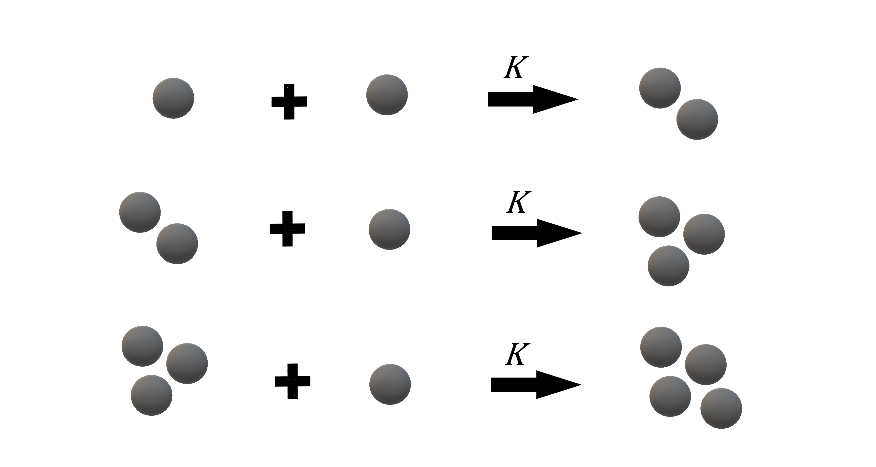

Figure 2. Von Smoluchowski kinetic aggregation, association of units (one or more monomers) into a cluster. $k$ represents the reaction constant and is the same for all reactions.
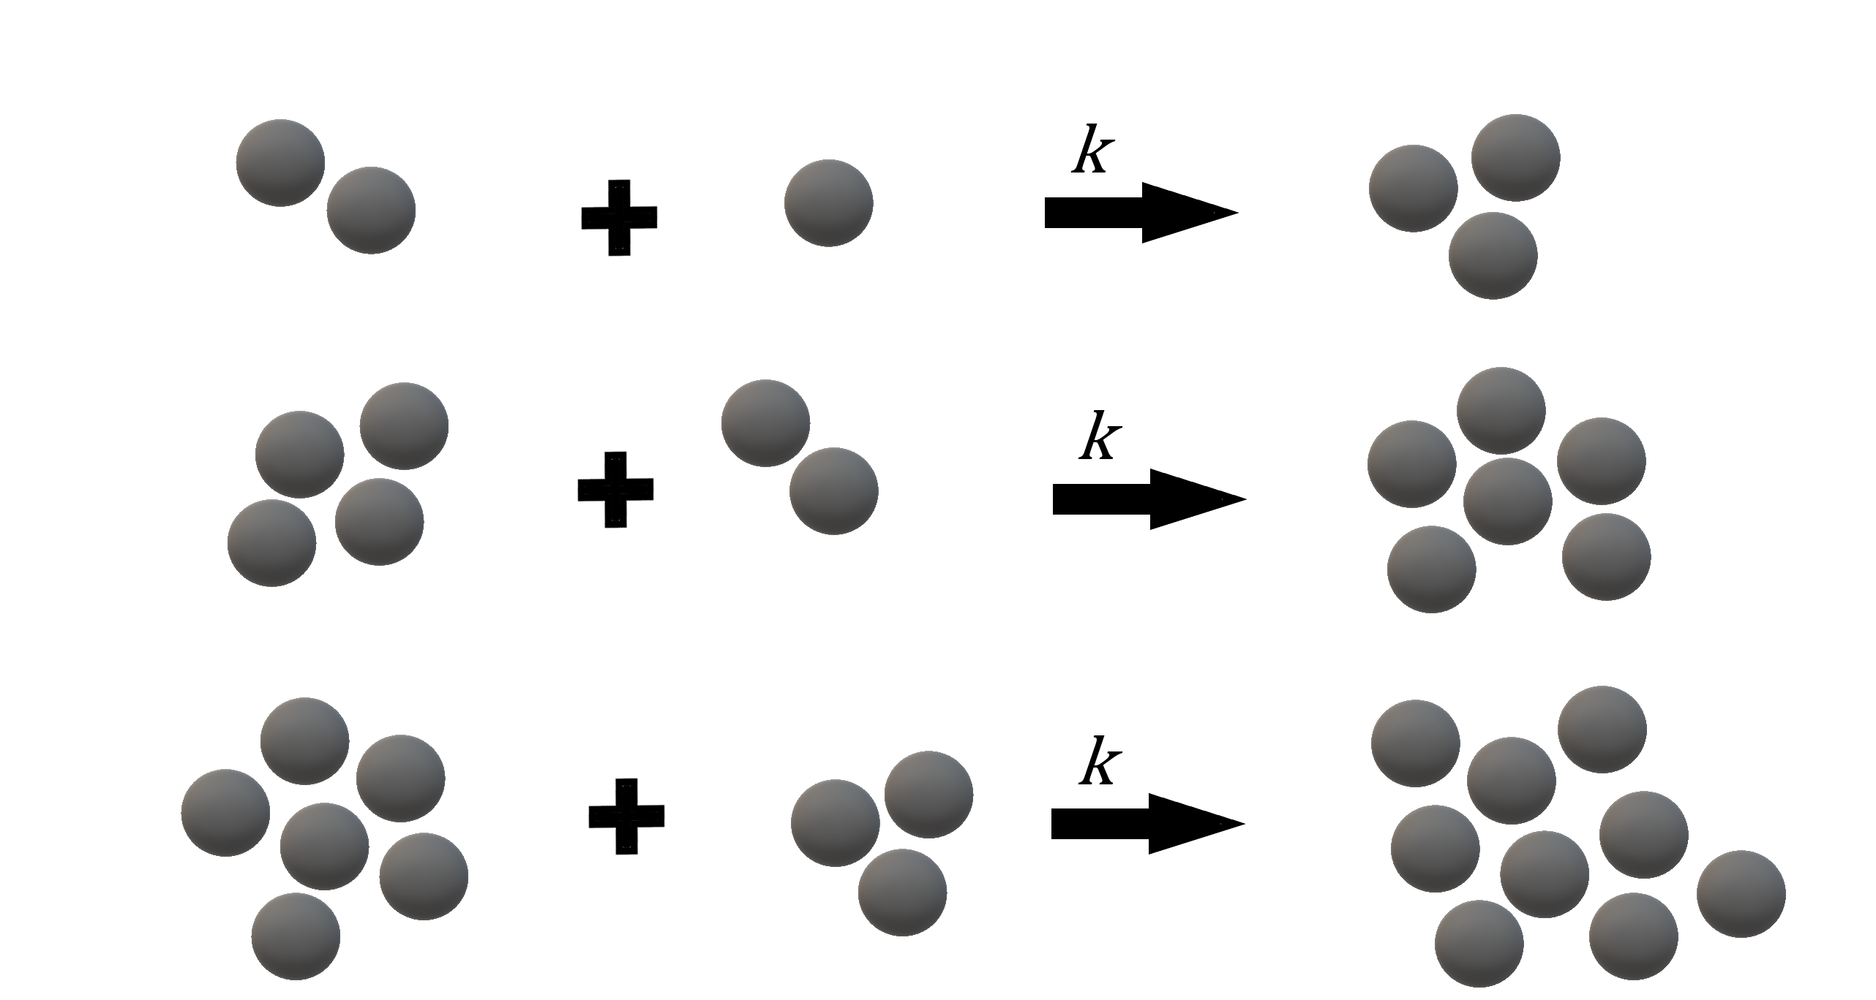

Figure 3 The schematic explanation on how to calculate $ΔG{}_{u2}$ based on Eqs. (23) and (24).

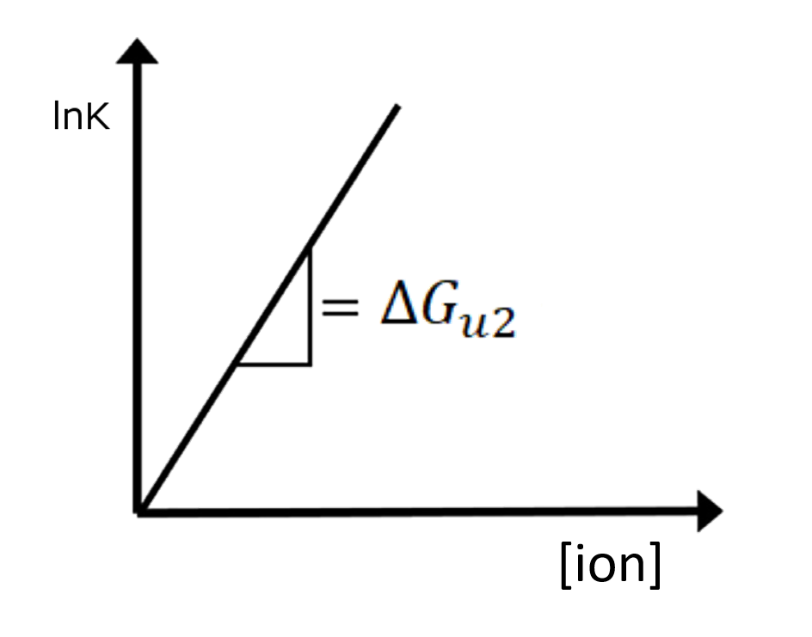

Figure 4. Linear regression for $\ln{K'}$ of isodesmic aggregation against ion concentration for the calculation of $ΔG_{u2}$ (Table 2) based on the experimentally [32] determined $K^{'}$. The slope is the $ΔG{}_{p2}$
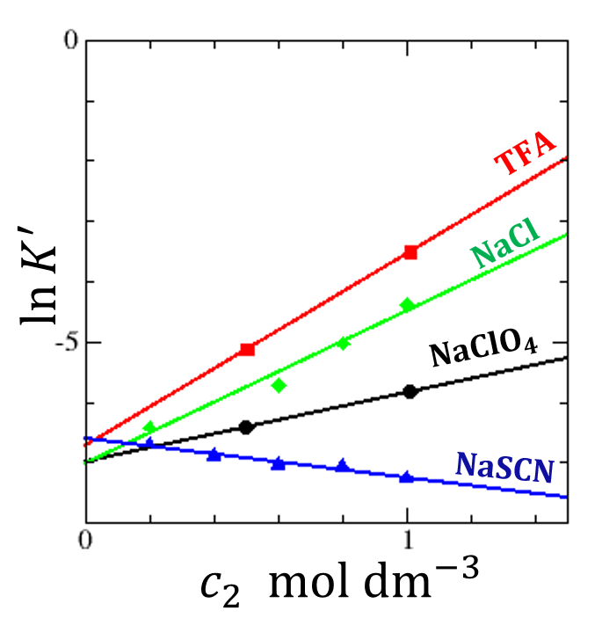

Table 1. An order-of-magnitude analysis for the negligibility of $ΔG_{u1}$ based on Lopez-Fandino et al. [31].

Condition | Aggregation time reduction | Comparative parameters
4 mM CaCl₂ | $∼60$% | $c_{2}=1.2×{10}^{-2}$mol dm⁻³ (ion concentration)
100 MPa | $∼25$% | $\frac{P}{RT}=\frac{{10}^{8}}{8.314×298}=4×{10}^{4}$ mol m⁻³ = $4×{10}^{7}$ mol dm⁻³.

Table 2. Effect of salts on purified β-casein A aggregation equilibria for isodesmic aggregation. $ΔG_{u2}$ of various salt calculated using published data [32]. TFA (trifluoroacetic acid) was included for comparison.

 | $$ΔG_{p2 }\left[dm^{3}mol^{-1}\right]$$
NaCl | 2.52
NaSCN | -0.65
TFA | 3.17
NaClO₄ | 1.15

Table 3. Effect of salts on caffeine and casein aggregation. +: enhance aggregation, -: weaken aggregation, (+): weak enhancement of aggregation.
 | NaCl | NaSCN | NaClO₄
Caffeine aggregation | (+) | − | −
Casein aggregation | + | − | +

Table 4. Effect of salts on casein aggregation kinetics for von Smoluchowski aggregation. Casein used is all casein proteome without $κ$-casein only. $ΔG_{u2}^{‡}$ of various salt calculated using published data [30]. Experiments were conducted in imidazole-CaCl₂/NaCl buffer.

 | $$ΔG_{u2}^{‡} [{dm}^{3}{mol}^{-1}]$$
NaCl | -2.15
CaCl₂ | 48.40

