History, sources and volumes of oil pollution in the Mediterranean Sea
Andrey Kostianoy and Angela Carpenter
Abstract
This chapter presents a brief review of history, sources and volumes of oil pollution in the Mediterranean Sea. Historical records show 16 major oil spills occurred between May 1966 and September 2017, and resulted in oil spills ranging between 6,000 and 144,000 tonnes; the largest spill came from the MT Haven tanker after an explosion on board on April 11, 1991. Sources of oil pollution are typical for other seas and include shipping, oil and gas platforms, ports and oil terminals, land-based sources, military conflicts, natural oil seeps, and even atmospheric inputs. Shipping activities are the main cause for oil pollution in the Mediterranean Sea because oil and gas production and exploration is not so important, unlike in the Gulf of Mexico or the Caspian Sea. If we exclude major oil spill accidents from ships, which are very rare events in the Mediterranean, different expert reports and estimates provide total volumes of oil pollution ranging from 1,600 to 1,000,000 tonnes per year. The 625 times difference in values means that we still do not know the real volume of oil pollution entering the Mediterranean Sea and this is a big problem that should be addressed.
Keywords
Mediterranean Sea, oil pollution, oil seeps, shipping, oil installations, ports, oil terminals, aerial surveillance, satellite monitoring.

Contents
- Introduction
- History of oil pollution in the Mediterranean Sea
- Sources of oil pollution in the Mediterranean Sea
  - Shipping
  - Oil and gas platforms
  - Ports and oil terminals
  - Land-based sources
  - Military conflicts
  - Natural oil seeps
  - Atmosphere
- Volumes of oil pollution in the Mediterranean Sea
- Conclusions
References

- Introduction

Historically, the Mediterranean was a center of European civilization. Since the times of Ancient Egypt, Rome and Greece the Mediterranean Sea has connected the countries of Southern Europe, Africa and Near East by shipping routes which played a major role in the development of trade and international relations between countries, unfortunately including numerous wars. Today, maritime transport in the Mediterranean is a strong economic sector, with 15% of global shipping activity by number of calls (10% by vessel deadweight) and around 18% of global crude oil shipments taking place in the region [1]. The extensive maritime transport of large quantities of crude oil comes: a) from the Middle East to ports in Europe and North America via the Suez Canal; b) between the Mediterranean and the Red Sea; c) through the Strait of Gibraltar; and, d) between the Black Sea and the Mediterranean through the Turkish Straits. For example, in 2006 crude oil loaded and discharged at Mediterranean ports amounted to 220 and 255 million tonnes, respectively [2].
Intensive shipping activities in the Mediterranean poses a potential danger to the marine environment due to oil pollution which may arise due to different reasons. In the pre-industrial era when the main fleet was still under sail and the internal combustion engine was not yet invented, we can speculate that the only source for oil pollution in the Mediterranean Sea was natural seepages from the bottom. This is a natural factor which is related to a presence of petroleum and gas deposits found in geological formations beneath the Earth’s surface or bottom of the seas, and its intensity is related to seismic activity which is, in turn, related to tectonics of the lithospheric plates.
By the mid 19th century the shipping industry was in transition from sail-powered boats to steam-powered boats and from wood construction to an ever-increasing metal construction. Since the 1910s diesel engines have been used in ships and their number has increased significantly. While there is no evidence of oil pollution in the Mediterranean at the beginning of the 20th century, this lack of evidence does not mean that ship technologies at the time were available to prevent oil pollution from ships; we can only speculate that this is because there are no records on oil pollution available for these times. It is evident however that WWI and WWII added to oil pollution of the Mediterranean significantly because several thousands of ships, submarines were sunk and aircraft shot down over the sea.
Records on accidents from ships and related oil pollution in the Mediterranean appeared during the 1960s, and it is clear that major incidents with oil spills larger than 6,000 tonnes occurred almost yearly until 1981. Since then significant progress in technologies of ship construction, operation and routing resulted in a sharp decrease of a frequency of accidents with ships in the Mediterranean, After 1981 there were only four major accidents, unfortunately including the biggest ever oil spill in the region of 144,000 tonnes resulting from the MV Haven accident off Genoa, Italy. Unfortunately, operational oil spills of a size of about 1-10 tonnes released by ships of different types occur almost daily in different parts of the sea and these remain a major oil pollution problem for the Mediterranean as their number may reach 1,500-2,500 every year. Finally, the Mediterranean Sea faces a new problem which is a recent intensification of oil and gas development in the Eastern Mediterranean. In the coming years potential oil pollution from these new sources should also be taken into account.
This chapter presents a brief review of history, sources and volumes of oil pollution in the Mediterranean Sea.

- History of oil pollution in the Mediterranean Sea

If we look on the list of the world top 180 major (over 6,000 tonnes) oil spills since early 1960’s the first serious incident in the Mediterranean Sea was on 15 May 1966 with the Fina Norvege and resulted in 6,000 tonnes oil spilled close to Sardinia, Italy. On 1 November 1970 an incident with the Marlena resulted in 15,000 tonnes oil spilled near Sicily, Italy. The next incident occurred on 11 June 1972 with the Trader and resulted in a 37,000 tonne oil spill. Then, on 25 April 1976, came the next serious incident which was with the Ellen Conway which resulted in 31,000 tonnes oil spill close to the Port of Arzew, Algeria. On 30 June 1976 was the Al Dammam spill with 15,000 tonnes oil spilled close to Agioi Theodoroi, Greece. Next year, on 10 August 1977 a serious incident occurred with the URSS 1 in the Bosporus Strait and resulted in a 20,000 tonne oil spill. On 25 December 1978 came the Kosmas M. spill when 10,000 tonnes of was oil spilled close to Asbas, Antalya, Turkey. Next year, on 2 March 1979 an incident occurred with the Messiniaki Frontis and resulted in a spill of 16,000 tonnes of oil close to Crete, Greece [3].
A more serious incident was with the MT Independența ("Independence"), a large Romanian crude oil carrier which on November 15, 1979 collided with a Greek freighter at the southern entrance of Bosphorus Strait, Turkey, and exploded. She caught fire and grounded. Almost all of the tanker's crew members died. It was estimated that 30,000 tons of crude oil burned and that the remaining 64,000 tons spilled into the sea. The Independența burned for weeks, causing heavy air and sea pollution in the Istanbul City area and the Sea of Marmara [3].
The following year another serious incident happened with the Irenes Serenade in Navarino Bay, Greece on 23 February 1980, where 100,000 tonnes of oil was spilled to the sea. This incident was ranked number 9 out of the world top 20 with the Atlantic Empress spill (1979, off Tobago, West Indies, 287,000 tonnes) in first place [4].
Then on 29 December 1980 a spill of 37,000 tonnes resulted from an incident with the Juan Antonio Lavalleja which grounded during a storm close to the Port of Arzew, Algeria [3].
Other incidents occurring in the Mediterranean include a spill of 18,000 tonnes from the Cavo Cambanos on 29 March 1981 close to Corsica and a spill of around 12,200 tonnes of heavy fuel oil and slops from a collision between the oil/bulk/ore carrier Sea Spirit and the LPG carrier Hesperus west of Gibraltar in 1990 [5]. While that incident took place outside the Mediterranean Sea, oil entered the region carried by winds and currents, presenting a serious threat to the coasts and waters of Spain, Morocco and Algeria [6].
In April 1991 off Genoa, Italy, the MV Haven (Fig.1), the biggest oil spill ever recorded in the Mediterranean, was one of only two of the 20 top largest oil spills occurring globally since the late 1960s. In this case 144,000 tonnes of oil was spilled in the sea (number 5 out of the top 20) (see Table 2 in [7], and [4]).

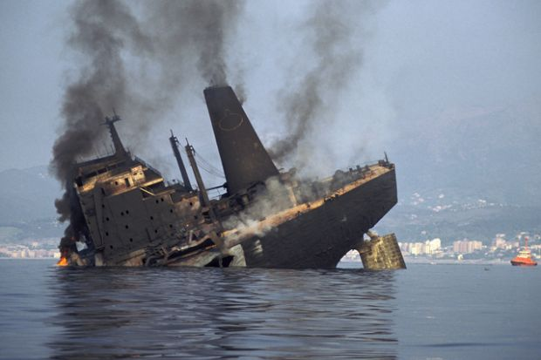

Fig. 1. MT Haven tanker after explosion on April 11, 1991 off the coast of Genoa, Italy (http://www.takepart.com/photos/worlds-worst-oil-spills/10-mt-haven-tanker-oil-spill)

In 2000, incident with Castor off Nador, Morocco due to structural failure in a storm conditions resulted in a gasoline spill of 9,900 tonnes [8].
In July 2006, along the coast of Lebanon, between 15,000 and 30,000 tonnes of heavy fuel oil was spilled into the sea after the Jiyeh power-plant be bombed by the Israeli Air Force on July 14 and 15, during the 2006 Israel-Lebanon conflict. A 10 km wide oil spill covered 170 km of coastline, killed fish, and threatened the habitat of endangered green sea turtles [9, 10, 11].
The most recent spill to occur in the Mediterranean Sea came from the ship-wreck of the Agia Zoni II tanker, near the port of Piraeus and off the coast of Salamina, Greece on 10 September 2017. In that case the oil tanker, loaded with fuel oil and marine gas oil, sank [12]. The vast majority of oil on board was contained through the deployment of oil spill clean-up units [13] and the volume of oil spilled was estimated at between 700-2,500 tonnes [12].
More cases of oil pollution in the Mediterranean Sea can be found in [8, 14, 15], but they are much smaller and have a size ranging from 50 to 2,000 tonnes.

- Sources of oil pollution in the Mediterranean Sea

Different expert reports and publications provide quite different assessment of oil pollution sources and their share in total volumes of oil coming to the sea or ocean. Very often it is difficult to compare these shares because there is no consensus between them. For example, The US National Research Council (NRC) Report “Oil in the Sea III: Inputs, Fates, and Effects” [16] developed a new methodology for estimating petroleum inputs to the sea from both natural and human sources. Oil inputs from human activities are categorized as those that originate from: (1) petroleum extraction, exploration, and production activities; (2) petroleum transportation, including tanker spills and (3) petroleum use, including runoff from highways and discharges from recreational vehicles.
The NRC report shows that although the public often associate oil in the ocean with tanker accidents, natural seeps are the largest source of oil in the sea, accounting for about 60% of the total in North American waters and 45% worldwide. Historically, oil and gas exploration, petroleum production, and transportation-related spills have been significant sources of oil in the oceans. New technologies have reduced oil pollution from ships and platforms. During the past decades, improved production technology and safety training of personnel have dramatically reduced both blowouts and daily operational oil spills. Today, accidental spills from platforms represent only about 1% of petroleum discharged in North American waters, for example, and about 3% worldwide [16].
Although the amount of oil transported over the oceans continues to rise, transportation-related spills have gone down. Most tankers now have double-hulls or segregated tank arrangements that dramatically reduce spillage. Transportation spills now account for less than 4% of the total petroleum released in North American waters and less than 13% worldwide [16].
The conclusion of the NRC Report was surprising to many: oil from individual cars and boats, lawn mowers, jet skis, marine vessels, and airplanes contribute the most oil pollution to the ocean. This includes land runoff from oil slicks on urban roads and hydrocarbons deposited from the atmosphere. According to the Report's estimates, use-related oil pollution dwarfs that from oil and gas production activities, accounting for about 87% of the oil from human activity in North American waters [16].
An Oceana Report dated 2003 or 2004 estimated that in the Mediterranean, 75% of hydrocarbons discharged every year is a result of tanker operations [17]. By contrast, a UNESCO GOOS Report states that in the Mediterranean Sea about 50% of oil comes from routine ship operations and the remaining 50% comes from land-based sources via surface runoff [18].
The Global Marine Oil Pollution Information Gateway shows shares of oil pollution from another two reports [19]. The Australian Petroleum Production and Exploration Association (APPEA) claims the following distribution of the inputs from different sources:
- Land-based sources (urban runoff and discharges from industry): 37%
- Natural seeps: 7%
- The oil industry - tanker accidents and offshore oil extraction: 14%
- Operational discharges from ships not within the oil industry: 33%
- Airborne hydrocarbons: 9%
In a report in 1993, the Joint Group of Experts on the Scientific Aspects of Marine Environmental Protection (GESAMP) estimated a total input of oils to the world ocean at 2.3 million tonnes per year and ranked the sources as follows:
- Land-based sources (urban runoff, coastal refineries): 50%
- Oil transporting and shipping (operational discharges, tanker accidents): 24%
- Offshore production discharges: 2%
- Atmospheric fallout: 13%
- Natural seeps: 11%
Girin and Daniel [8] and Girin and Carpenter [14] report that the overall oil pollution in the Mediterranean waters is the sum of four different sources (without indication of shares), namely:
- Accidental spills on the land, from storage tanks, road/rail/pipe-line accidents, acts of war or vandalism, with the oil being carried to the sea by rivers. There are no statistics at national level of those spills, which are generally very small. Oil spills from pipelines around in the Mediterranean did definitely occur, but the number, volume and location of those spills cannot be assessed due to a lack of accessible documentation.
- Ships and coastal storage accidents or acts of war, releasing without warning a large quantity of oil in a particular place. These are quite rare: less than one per decade on average for spills over 10 tonnes.
- Operational spills from shipping: these take place weekly as an overall average and are estimated as being up to daily on some heavy traffic routes, where they are most concentrated. They are voluntary and individually small (less than 10 tonnes). There is no information available on the contribution of the tanker, cargo, container, fishing, leisure, cruise and defence fleets to the total input of oil in the Mediterranean. The same applies to offshore oil exploration and exploitation activities.
- Natural seeps on the sea bed: there is some evidence to suggest that natural spills occur in some places, indicative of the presence of fossilized oil and gas seeping from underground reservoirs.
Hildebrand et al. [20] summarize that the most commonly identified sources of oil pollution at sea include: a) natural sources; b) offshore oil production; c) maritime transportation; d) the atmosphere; e) waste, i.e. municipal and industrial; f) urban and rural run-off; and, g) ocean dumping.
For the Mediterranean Sea we have identified the following sources of oil pollution that will be described in more details below: shipping, oil and gas platforms, ports and oil terminals, land-based sources, military conflicts, natural oil seeps, and the atmosphere, which in general cover all the above mentioned sources.

  - Shipping

Shipping activities pose a threat to the marine environment of the Mediterranean. The diversity of shipping in the region includes fishing fleets, ro-ro ferries, leisure craft, military vessels, large container carriers, bulk carriers and tankers, and also fixed “vessels”, including offshore oil exploration and exploitation vessels [14]. The numbers presented by REMPEC with regard to merchant vessels showed that there were more than 325,000 voyages in the Mediterranean Sea in 2007 and in 2013 (two-thirds of them were internal - Mediterranean to Mediterranean) (Fig. 2). The Mediterranean Sea accounted for 15% of global shipping activity by number of calls and 10% by vessel deadweight tonnes [20].

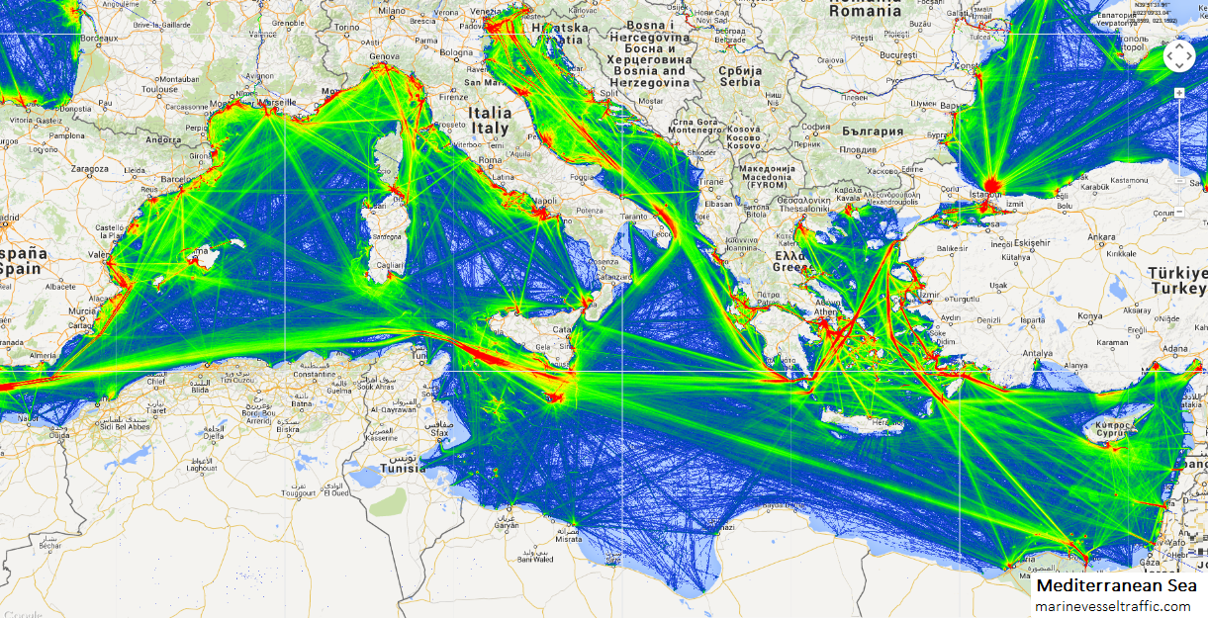

Fig.2. Density map of ship traffic in the Mediterranean Sea (http://www.marinevesseltraffic.com/MEDITERRANEAN-SEA/ship-traffic-tracker, accessed on 27 August 2018)

Operational oil spills can be voluntary or not, resulting from a human decision, a human error or a technical failure. It seems that they are the most numerous type of spill, with numbers totalling several hundred thousand tonnes yearly. An Oceana Report from the early 2000s (around 2003 or 2004) estimated that the total amount of crude oil passing through EU waters could be over 1 billion tonnes and that the Mediterranean Sea was most affected by dumping of hydrocarbons in the sea from ships, with nearly 490,000-650,000 tonnes being released annually [17]. A GESAMP 2007 Report indicated that there were more than 200 accidental spills from ships annually in the region, and that this reflects the high commercial activity taking place in the region [21].
On the other hand, EMSA Pollution Preparedness and Response Reports for the years 2011 to 2013 mentioned that between February and December 2011 there were acquired some 2,143 satellite SAR images showing 2,048 possible oil spills detected: 749 of those spills were identified as Class A – most probably oil (mineral or vegetable/fish oil) while 1,299 were identified as Class B – less probably oil [22, 23]. However, these numbers do not represent the real state of oil pollution in the Mediterranean Sea because the number of processed satellite images varied from 3 to 454 per year per country in 2007-2010 [1], thus temporal and spatial coverage of the Mediterranean is incomplete.
In 2017 it was noted that the rate of accidents has gone down in the Mediterranean despite an increase in shipping traffic, and it was concluded that the international regulatory framework, both through the IMO and regional cooperation activities, has had a positive impact on reducing accidents. Despite this, however, it was considered that the risk of spills from oil tankers and also vessels transporting hazardous noxious substances (HNS) cannot be completely eliminated, while illicit spills continue to occur and require ongoing monitoring to identify the source of such spills [10].
Looking at the oil spill maps generated thanks to satellite monitoring of the whole Mediterranean Sea in 1999-2004 performed by European Commission – Joint Research Centre (Ispra, Italy) (see Fig. 9 in Part 4 of this chapter), of French waters in 2000-2009 (see Fig.1 in [8]) and Eastern Mediterranean in 2007-2011 (see Fig.8 in [24]) it is clear that operational oil spills continues to be a major problem for the Mediterranean Sea environment, and one that needs to be resolved.

  - Oil and gas platforms

Oil and gas exploration activities pose a threat to the marine environment, the seabed, and sea-bottom habitats and species, both during the exploration phase and the production phase [25], since oil contamination can persist in the marine environment for many years, depending on the oil type, the location of a spill, and the area in which the contamination occurs [26, 27].
Hydrocarbon exploration activities in Greece date back to the early 20th century. In the Aegean Sea a small number of significant oil discoveries were made in the mid 1970s at Prinos (with a smaller gas discovery at South Kavala) with production continuing to the present day. Initial estimated reserves for the Prinos fields were 90 Mbl, which have now been increased to 290 Mbls, with 110 Mbls already having been produced since 1981 [28].
Today, the Eastern Mediterranean Sea, and the east coast of Italy in the Adriatic Sea is the location of the majority of oil and gas exploration and exploitation activities (Fig. 3). In 2002 it was estimated that there was a reserve of around 50 billion barrels of oil and 8 trillion m³ of gas in the region (about 4% of world reserves) and, in 2005, there were over 350 wells drilled for offshore production in the waters off Italy, Egypt, Greece, Libya, Tunisia and Spain of which the majority were located along the Northern and Central Adriatic coasts of Italy (around 90 of the 127 offshore platforms for the extraction of gas in Italian waters in 2007) [29, 30].

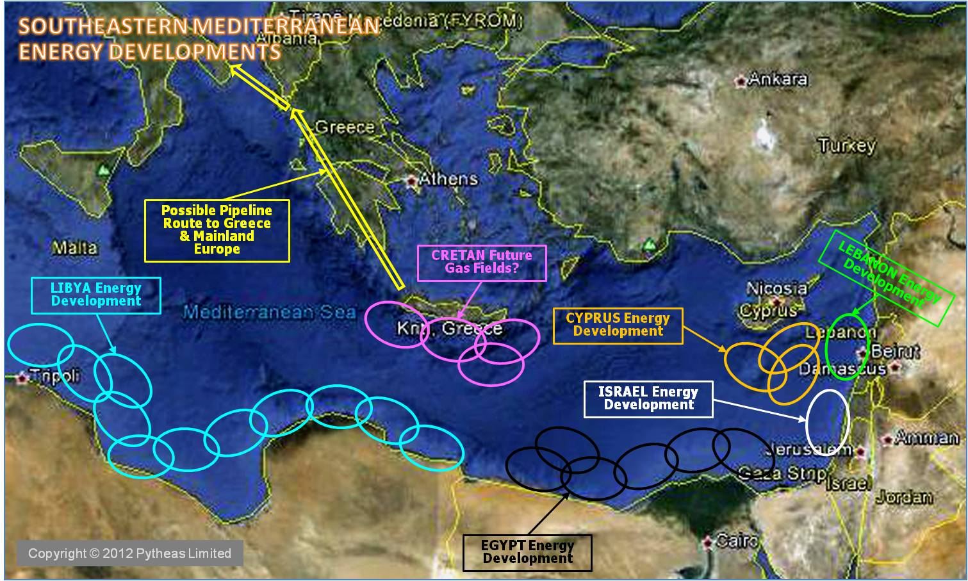

Fig. 3. Oil and gas exploration and exploitation activities in the Eastern Mediterranean (http://www.greekamericannewsagency.com/english-menu/english/politics/30945-egypt-has-joined-greece-and-greek-cyprus-in-calling-for-turkey-to-stop-exploration-work-off-the-cyprus-coast)

In 2011, gas was discovered in the Leviathan Gas Field (Fig.4), 135 km off the coast of Israel, with an estimated volume of 16 trillion cubic feet of gas (approximately 453 million m³) [31]. In August 2017 a contract was signed to drill two wells and complete four production wells in the Leviathan Gas Field [32].

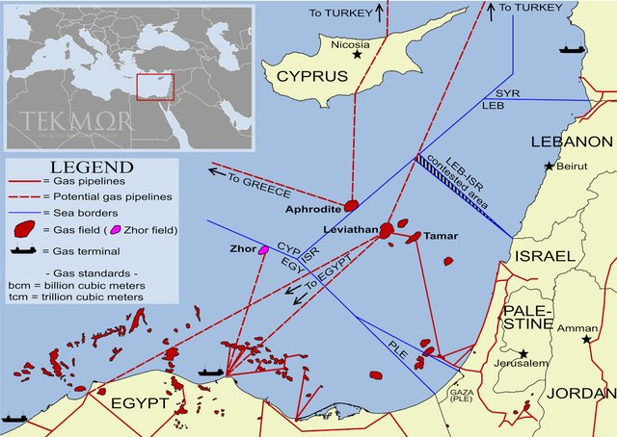

Fig. 4. Gas fields, active and potential gas pipelines, and gas terminals in the Southeastern Mediterranean (https://www.vestifinance.ru/articles/97771)

There have also, in the last decade, been significant exploration activities off the coast of Cyprus, following the development of new technologies to assess and reach previously inaccessible reserves, worth an estimated $131 billion [33]. Most recently, the drilling of up to 25 new wells and installation of two new platforms were planned up to 2021 in the Prinos and Prinos North oil fields in the Gulf of Kavala offshore of northern Greece [34].

  - Ports and oil terminals

The Mediterranean has about 150 coastal cities and ports of different size. The busiest ports by cargo tonnage are: Port of Marseille, France (88 mln t), Port of Algeciras, Spain (77 mln t), Port of Valencia, Spain (65 mln t), Port of Genoa, Italy (50 mln t), Port of Trieste, Italy (48 mln t), Port of Barcelona, Spain (43 mln t).
In 2006 crude oil loaded at Mediterranean ports amounted to 220 million tonnes. The top 20 Mediterranean crude oil loading ports measured by number of calls accounted for 99% of all crude oil loaded in the Mediterranean. The major 10 crude oil load ports are: Sidi Kerir (74,339,769 t), Arzew (40,240,000 t), Ras Lanuf (14,065,500 t), Es Sider Term (14,640,000 t), Marsa el Brega (6,136,000 t), Bejaia (6,750,000 t), Zueitina Term (7,570,000 t), Skikda (6,650,000 t), Zawia Term (6,800,000 t), Ceyhan (BTC) (6,480,000 t) [2].
The total volume of crude oil discharged at Mediterranean ports during 2006 amounted to 255 million tonnes. The top 20 Mediterranean crude oil discharge ports measured by number of calls accounted for 85 per cent of all crude oil discharged in the Mediterranean. The major 10 crude oil discharge ports are: Trieste (33,838,000 t) (Fig.5), Fos (35,195,000 t), Augusta (20,341,500 t), Genoa (15,189,500 t), Sarroch (12,774,000 t), Algeciras (12,337,500 t), Savona (7,583,000 t), Venice (6,151,000 t), Tutunciftlik (10,541,000 t), and Port de Bouc (5,889,000 t) [2].

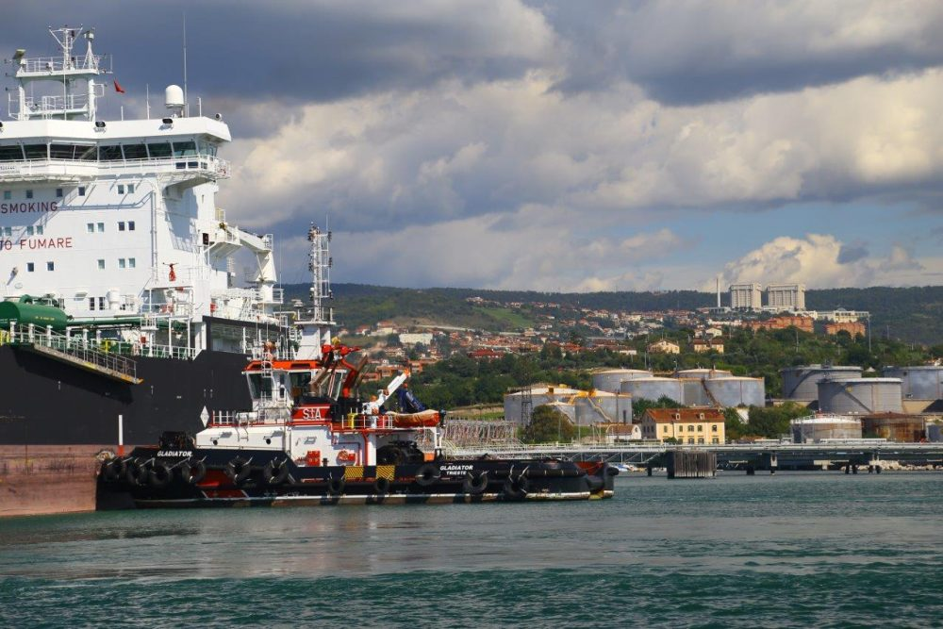

Fig 5. Crude oil terminal in Trieste (https://blog.omv.com/en/trieste-crude-oil-terminal-and-transalpine-pipeline/)

All ports and oil terminals present a potential danger of oil pollution. For example, along the coasts of the Western Mediterranean, more than 17 major oil ports and 15 refineries are found especially along the Italian and Spanish coasts. For Italian ports facing the Western Mediterranean, the total quantity of crude oil handled during the 2007 was estimated to be around 80 million tonnes [35]. Algeria is one of the top three oil producers in Africa, is a potential source of oil pollution on the southern shore of the Western Basin of the Mediterranean Sea since it has six coastal terminals for the export of petroleum products in Oran, Arzew, Algiers, Bejaia, Skikda and Annaba, together with five oil refineries (three in coastal cities - Skikda, Arzew and Algiers), located along its coastline [36].
Between 1988 and 1997, some 22,563 tonnes of oil entered the Mediterranean Sea each year from coastal refinery effluent sources of which it was estimated that around 2,971 tonnes per year came from Algerian coastal refineries (the largest volume for an individual country [21].

  - Land-based sources

Land-based sources include: (i) discharges of oil with rivers and floods; (ii) discharges of untreated or insufficiently treated municipal sewage and storm water (urban runoff); (iii) discharges of untreated or insufficiently treated waste water from coastal industries; (iv) accidental or operational discharges of oil from coastal refineries, oil storage facilities, oil terminals, and reception facilities; (v) emissions of gaseous hydrocarbons from oil-handling onshore facilities (terminals, refineries, filling stations) and from vehicles exhausts (traffic) [19]. It is very difficult to estimated volumes of oil coming to the sea from the above mentioned land-based sources, thus this information for the Mediterranean Sea is lacking, except for some estimates of the impact of refineries.
Oil can enter the marine environment from coastal oil refineries through effluent outputs. A 2007 report estimated that, between 1988 and 1997, some 22,563 tonnes of oil entered the Mediterranean Sea in this way each year [21]. The largest sources came from coastal refineries in: Algeria with 2,970.71 tonnes per year (tpy); Egypt (2,982.78 tpy); France (2,075.59 tpy); Greece (2,216.82 tpy); Italy (2,713.39 tpy); Spain (1,458.88 tpy); Syria (1,330.62 tpy); and Turkey (3,999.70 tpy) [21; Table 27]. The figures for France, Spain and Turkey include all their coastal waters, not just those located in the Mediterranean. As noted at 3.3 above, Algeria has six coastal oil terminals and five oil refineries (three of which are in coastal cities). These installations have a serious impact on the marine environment [36].

  - Military conflicts
Historically, the Mediterranean Sea was an arena of numerous sea battles, military conflicts and wars which inevitably are accompanied by oil pollution as a result of sinking of war and merchant ships, aircrafts, and damages to coastal infrastructure. During World War I (August 2014 – November 2018) there were sporadic naval battles in the Mediterranean between the Central Powers' navies of Austria-Hungary, Germany and the Ottoman Empire on one side, and the Allied navies of Italy, France, British Empire, Greece, Japan, and America on the opposing side. During WWI more than 850 war and merchant ships were damaged and sank in Mediterranean waters. German submarines were very active and sank tenths of the Allied ships every month. On 9 November 1918, HMS Britannia (17,500 tons) of the Royal Navy (UK) was on a voyage in the western entrance to the Gibraltar Strait when she was torpedoed off Cape Trafalgar by the German submarine UB-50, and sank (Fig. 6). HMS Britannia was sunk two days before the Armistice was signed on 11 November 1918 ending the First World War [37].

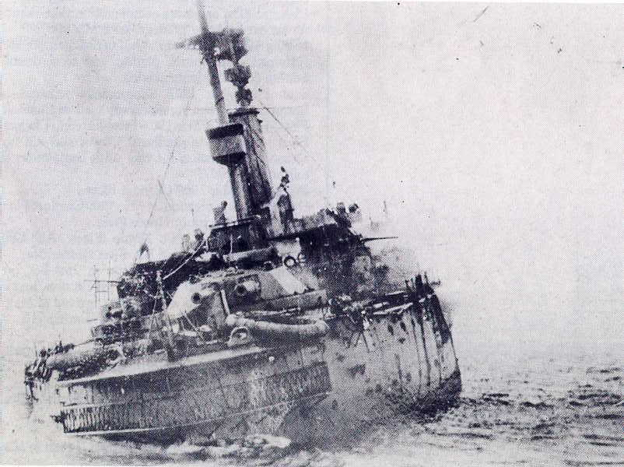

Fig. 6. HMS Britannia sinking in the Atlantic Ocean off Cape Trafalgar near Gibraltar Strait on 9 November 1918. [37].

During World War II (September 1939 – May 1945), “the Battle of the Mediterranean” was the name given to the naval operations in the Mediterranean Sea that occurred between 10 June 1940 and 2 May 1945. The Mediterranean Sea was an arena of naval battles between the British Royal Navy supported by other Allied naval forces from Australia, the Netherlands, Poland, Greece, Canada, USA (the latter from 1942), and the Italian Royal Navy (Regia Marina) and German Navy (Kriegsmarine) supported by Vichy French Fleet. German submarines sank 95 Allied merchant ships totalling some 449,206 tons, and 24 Royal Navy warships including two carriers (Fig. 7), one battleship, four cruisers and 12 destroyers at the cost of 62 U-boats (submarines) [38]. Up to September 1943, the total losses from the Allied naval forces were 76 warships and 48 submarines, while losses on the Italian/German/France (Vichy) side amounted to 94 warships and 159 submarines. To these numbers can be added more than 1,000 aircraft shot down coming from both sides. In total, 2,304 Italian/German/France (Vichy) ships were sunk by Allied forces, with a combined tonnage of 3,130,969 tonnes [39].

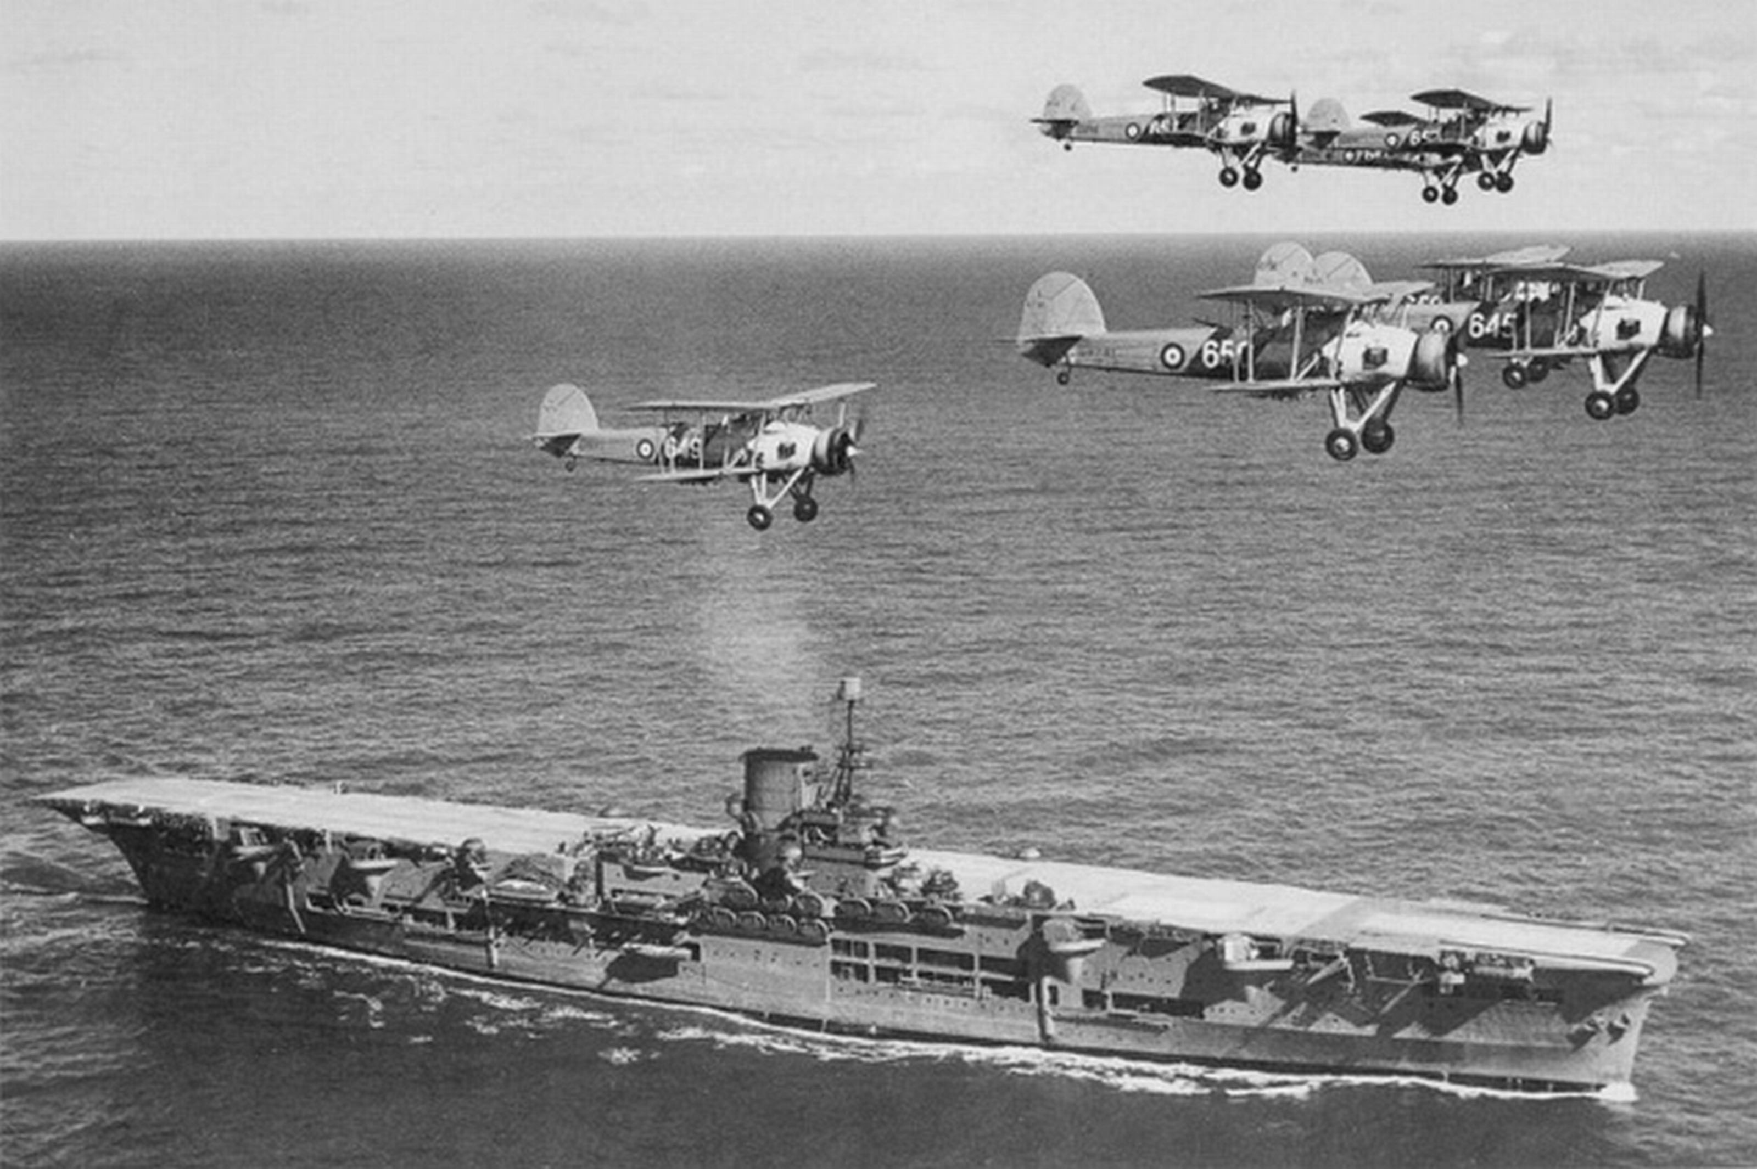

Fig.7. Aircraft carrier HMS Ark Royal of UK Royal Navy sank on 14 November 1941 in 40 km from Gibraltar after being torpedoed by German submarine U-81 [40].

Decades of corrosion of metal will inevitably lead to leakages of fuel and oil from tanks of the sunken warships and aircraft, and such leaks will sporadically appear on the sea surface as oil spills.
The most recent serious military incident in the Mediterranean Sea region resulted in a large oil spill and occurred in 2006. In July 2006 on the coast of Lebanon around 15,000-30,000 tonnes of heavy fuel oil was spilled into the sea after the Jiyeh power-plant be bombed by the Israeli Air Force on July 14 and 15 during the 2006 Israel-Lebanon conflict. A 10 km wide oil spill covered 170 km of coastline, killed fish, and threatened the habitat of endangered green sea turtles (Fig.8) [9, 10, 11].

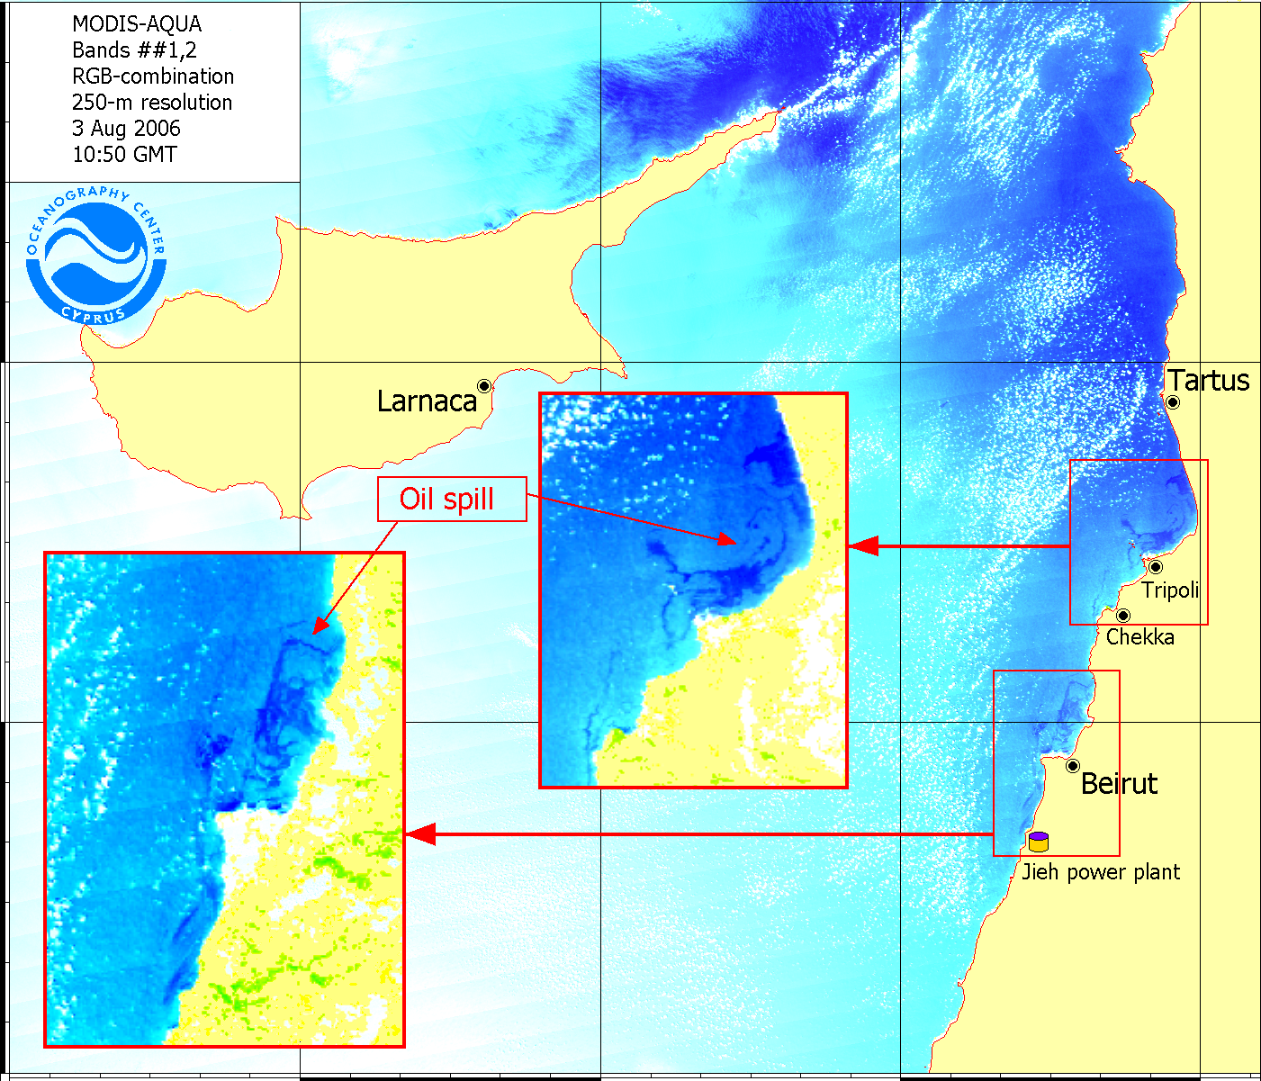

Fig. 8. Oil pollution along the coasts of Lebanon on 3 August 2006. Image courtesy by D.M. Soloviev, Cyprus Oceanography Center.

However, even in times of peace, military fleets produce more sea and air pollution during routine operations, naval patrol or exercises than civil fleets, while navy bases are usually more polluted than civilian ports because warships are primarily designed for military operations and not for protection of the marine environment.

  - Natural oil seeps

Natural oil seeps from the sea bottom is a very important source of oil pollution in different parts of the world ocean, namely in the Gulf of Mexico and the Southern Caspian Sea. Although the public often associate oil in the ocean with tanker accidents, natural oil seeps are the largest single source of oil in the sea, accounting for about 60% of the total in North American waters and 45% worldwide. Oil and gas extraction activities are often concentrated in regions where oil and gas seeps are observed [16].
However it seems that this is not a frequent phenomenon in the Mediterranean Sea as it is not often mentioned in the scientific literature. Only recently, to support oil and gas exploration in the Eastern Mediterranean, Airbus Defence and Space, Geo-Intelligence reassessed the area by the analysis of satellite radar data in order to produce a map with the location of potential offshore oil seeps [41]. Slicks on the sea surface are an indicator of the potential location of oil/gas reserves under the sea floor. Based on the interpretation of the satellite radar data, a number of oil slicks have been identified in the Levantine Basin, with particular concentrations adjacent to the Lebanon and Israel coasts, southward of Cyprus, and offshore from the Nile Delta [41]. Also, it is well known from other regions, for example the Southern Caspian Sea, that the frequency of appearance of oil seeps is directly related to seismic activity in the region.
Indeed, a satellite seep study undertaken by “Infoterra” over the East Mediterranean Sea has discovered over 200 seep features. Combining this information with seismic data has provided additional support for the presence of a working petroleum system in the deep Levantine Basin. Often the seeps have a close correlation to Direct Hydrocarbon Indicators, with bright spots, flat spots and gas chimneys seen on the seismic data [42, 43].
The EU-funded GASTIME (Gas seeps and submarine slides in the eastern Mediterranean: Toward comprehensive geohazard prevention) project performed in 2012-2016 set out to study the shaping mechanisms behind gas seepage deep in the Levantine Basin and their connection to slope stability.
The CGG NPA Satellite Mapping seepage database contains extensive satellite coverage across the Northern Aegean Sea made in 2015. Seepage detection by SAR (Synthetic Aperture Radar) is a proven technique for mapping surface oil seeps which could provide the first indication of petroleum systems in these basins. The 2015 NPA’s Aegean SAR seepage study has identified many clusters of repeating definite seepage, which confirm the existence of a working petroleum system in this part of the basin, and further enhances the prospectivity of the Eastern Mediterranean region for oil and gas exploration [28].
Unfortunately the above mentioned research does not provide values of volumes of oil pollution in different parts of the Mediterranean Sea caused by natural oil seeps.

  - Atmosphere

Hydrocarbons enter the ocean not only as "wet" oil products but also as gaseous air pollutants. Hydrocarbons from vapors deriving from the loading and unloading of oil at different stages from extraction to consumption, in the form of non-methane volatile organic compounds (nmVOCs), is one of the examples. Polycyclic aromatic hydrocarbons (PAHs) from incomplete combustion (exhaust gases and flue gases) is another category of gaseous hydrocarbons that enter the marine environment as oil pollution [19]. It is difficult to estimate how much oil comes to the Mediterranean Sea from the atmosphere and we did not find any such data in the publications. It does, however, seems that this specific source of oil could be very important in the industrial areas around the Mediterranean Region, and such inputs need to be assessed properly because some reports assign 9-13% of marine oil pollution to this source [16, 19, 44].

- Volumes of oil pollution in the Mediterranean Sea

In this section we have tried to understand what the total volume of oil pollution in the Mediterranean Sea is by collecting appropriate information from different sources. The most obvious incidents usually occur from tankers and oil platforms which result in large oil spills and serious pollution of the marine environment.
The major oil spill from the MV Haven in April 1991 off Genoa resulted in a spill of 144,000 tonnes of oil, the second incident was the Irenes Serenade spill in Navarino Bay, Greece in 1980, where 100,000 tonnes of oil was spilled [4]. If we calculate the total amount of oil spilled to the Mediterranean during major incidents (>6,000 tonnes) from ships between 1966 to 2017, this gives us a value of 537,600 tonnes in total during 52 years. Thus, on average, due to major accidents involving ships we have about 10,000 tonnes of oil pollution yearly. We have to note that over recent decades these events have occurred more and more rarely, and since 1990 there have only been four of them.
WWF [45] based on European Space Agency data estimates that 100,000 tonnes of crude oil are spilled each year in the Mediterranean Sea as a result of illegal washing operations from the 250-300 oil tankers crossing the Mediterranean Sea daily.
As noted in section 3, an Oceana Report from the early 2000s estimated that the total amount of crude oil passing through EU waters could be over 1 billion tons and that the Mediterranean Sea was most affected by dumping of hydrocarbons in the sea from ships, with nearly 490,000-650,000 tonnes being released annually. It is believed that in the Mediterranean, 75% of hydrocarbons discharged every year is a result of tanker operations [17].
UNESCO GOOS Report states that oil pollution in the Mediterranean Sea is estimated at 400,000–1,000,000 tonnes a year. Of this about 50% comes from routine ship operations and the remaining 50% comes from land-based sources via surface runoff [18].
Ferraro et al. [46] and Kostianoy [9] reported that studies of operational pollution carried out by European Commission – Joint Research Centre (Ispra, Italy) in the Mediterranean Sea for the years 1999–2004 with the help of satellites in the framework of the OCEANIDES Project give in average 1,700 oil spills yearly. The concentration of oil spills clearly shows the main shipping routes in the Mediterranean Sea, which can be considered as proof that shipping activities are a major cause of oil pollution (Fig. 9). This number of oil spills, which should be regarded as a lower limit because of irregular in time and space coverage of the Mediterranean by satellite data, may be equal to 1,700-10,000 tonnes of oil yearly.

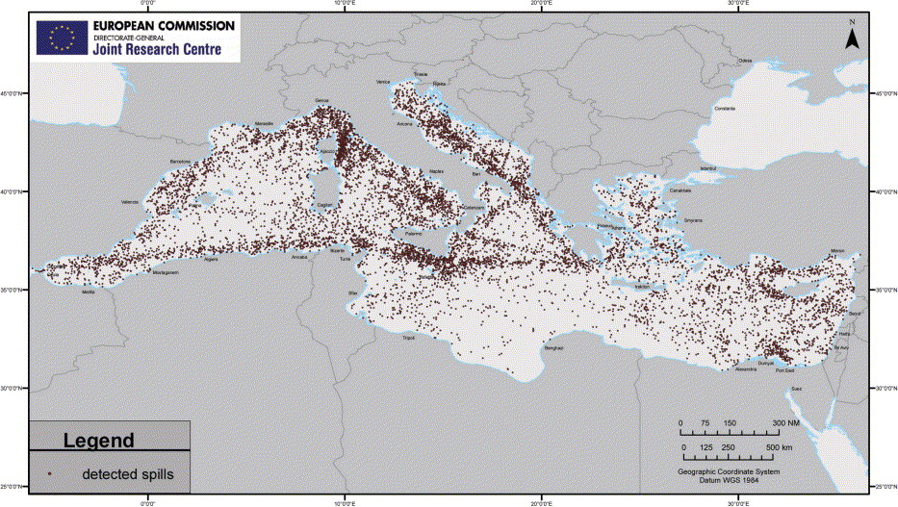

Fig. 9. Potential oil spills detected by satellite monitoring in 1999-2004 by European Commission – Joint Research Centre (Ispra, Italy) (https://www.sciencedirect.com/science/article/pii/S0025326X06005005?via%3Dihub)

The Barcelona Convention – Mediterranean 2017 Quality Status Report. Results and Status, including trends (CI19), notes that between 1 January 1994 and 31 January 2013, approximately 32,000 tonnes of oil entered the Mediterranean Sea as a result of accidents, that figure including 13,000 tonnes originating from an incident at the Jiyeh power-plant in Lebanon in July 2006 [10, 11]. This value seems to contradict to the previous report stating that between 2000 and 2009 it was estimated that 4,200 tonnes of oil was spilled in Western Mediterranean waters, 100 tonnes in the Adriatic Sea, 5,500 tonnes in the Central Mediterranean, and 19,200 tonnes in the Eastern Mediterranean [14, 47]. Thus 29,000 tonnes in total during 10 years (2000-2009) in comparison with 32,000 tonnes during 20 years (1994-2013) which comprise the 2000-2009 period. These values give us 1,600-2,900 tonnes per year.
To marine sources we can add land-based sources. For example, we know that between 1988 and 1997, some 22,563 tonnes of oil entered the Mediterranean Sea each year from coastal refinery effluent sources [21].
Cucco and Daniel [15] showed that in the Western Mediterranean, the Central Mediterranean (the Sicily Channel) and the Eastern Mediterranean roughly the same quantities (between 4,000 and 6,000 tonnes) of oil are spilled every year, Thus, it gives us about 15,000 tonnes yearly in total for the whole Mediterranean Sea.
Girin and Daniel [8], based on air surveillance of oil pollution in French waters, made an estimate of 10,560 oil spills or 63,360 tonnes of oil for the whole Mediterranean Sea every year.
Hildebrand et al. [20] states that the United Nations Environment Programme/Mediterranean Action Plan (UNEP/MAP) has estimated that the Mediterranean Sea receives about 129,000 tonnes of mineral oil per year and due to its geographical position and warm waters, it takes more than 80-90 years to clean up.
In the end, if we exclude major oil spill accidents from ships, which are very rare events in the Mediterranean now, we get total volumes of oil pollution ranging from 1,600 to 1,000,000 tonnes per year. The 625 times difference in values means that we still do not know the real volume of oil pollution entering the Mediterranean Sea and the share from different sources, and this is a big problem. We think that 1,600 tonnes is far too small an amount while 1,000,000 tonnes is far too large an amount for yearly oil pollution inputs to the Mediterranean Sea, and the truth is as usually somewhere in the middle – of the order of 50,000-100,000 tonnes, as mentioned by ESA, UNEP and other reports. If we divide 1 mln tonnes by 365 days we will get 2,740 tonnes per day and bearing in mind 2,000 ships sailing the Mediterranean Sea daily, we have 1.4 tonnes of oil or oil products released by every ship daily. This value seems to be unrealistic, but we pay attention to the fact that this amount (1 mln t) in the above mentioned calculation does not include land sources, oil platforms, natural seepages and the atmosphere, amounts of which are unknown.
The uncertainty in oil pollution volume estimates is a typical problem for other seas also. For example, for the Baltic Sea which is also one of the world’s busiest waterways (about 40 ports and oil terminals, 9% of the world’s trade and 11% of the world’s oil transportation, compared to 15% and 18% , respectively for the Mediterranean Sea), the estimates range from 20 to 60,000 tonnes yearly [48].
Despite this, the good news is that experts in the Mediterranean countries and international organizations are not raising the alarm about increasing levels and trends in oil pollution and degradation of marine environment, which means that the Mediterranean Sea waters appear to have the ability to self-purify which allows, in general, for Mediterranean waters to be quite clean and attractive for tourism and generally safe for the marine environment and ecosystems.

- Conclusions

Fortunately, since accident with the MV Haven in 1991 the Mediterranean Sea is rarely mentioned in the chronicles of major oil spills. This was not the case in the previous 1970s when large accidents occurred almost yearly. We can speculate that in the pre-industrial times we could expect oil pollution only from natural oil seepages from the bottom which is related with geological processes. It seems that serious anthropogenic pollution of the Mediterranean Sea started with WWI and continued during WWII when several thousands of ships, submarines and aircrafts were sunk. It is evident that there are no records on the amount of oil pollution during wartime.
Today, oil pollution of the Mediterranean Sea may result from releases of crude oil and oil products from tankers, offshore platforms, drilling rigs, wells, pipelines as well as from releases of bunker fuel, waste oil, bilge water from cargo, ferry, tourist, military, fishery, leisure and other ships. Oil pollution may occur as a result of accidents or during routine operations in the sea or in the ports and oil terminals. Releases of oil products into the sea may be legal, illegal or accidental. Oil enters the Mediterranean Sea also from the land-based sources, via river runoffs, from the atmosphere, and from the ocean bottom due to natural seepages. Oil pollution is often divided into the chronic (permanent pollution by small volumes of oil due to anthropogenic or natural causes) or accidental (rare, but high levels of pollution due to a catastrophe involving a ship, offshore platform or pipeline).
In this chapter we have discussed the following sources of oil pollution: shipping activities, oil and gas platforms, ports and oil terminals, land-based sources, military conflicts, natural oil seeps, and even atmosphere. Unfortunately we could not identify real amounts of oil pollution from individual sources, as in the above mentioned reports they are sparse, diverse and sometimes contradictory. Accordingly, we could not estimate correctly the shares of these sources as a proportion of the total amount of oil pollution in the Mediterranean Sea which ranges from 1,600 to 1,000,000 tonnes a year.
We also have to note that the share in percentages of sources/reasons of oil pollution varies significantly (10-100 times) between scientific publications, regions of the world ocean, and different time periods, but one of the largest belongs to different kinds of shipping activities – 20-50%, while, for example, natural oil seepages give from 0.45% up to 46% [48].
Almost 1000 times difference in the estimates of total oil pollution of the Mediterranean Sea is not something striking because similar range of values was found for the Baltic Sea also [48]. This means that that we still do not know the real values of oil pollution in both seas, and this is a big problem that should be addressed.
Fortunately, the Mediterranean Sea has its own reserves to fight against oil pollution. Microbes play a significant role in the degradation of crude oil, often being the dominant factor controlling the fate of toxic hydrocarbons in aquatic environments. All together they can degrade as much as 40 to 80% of a crude oil spill in addition to evaporation and other factors. Several factors influence biodegradation rates: oil composition, water temperature, nutrient availability, oxygen levels, and salinity. Kostianoy and Lavrova [49] suggested that the total amount of hydrocarbons, which the bacterioneuston can oxidize during the vegetation period in the Baltic Sea, is estimated as of 1,200-5,000 tonnes. This estimate shows a capability of the Baltic Sea to a complete self-cleaning from anthropogenic oil pollution by natural processes. This fact may also explain, at least partially, why we do not observe, in general, accumulation of oil pollution in the Mediterranean Sea, which is almost 7 times larger than the Baltic Sea, but it will be interesting to know how much biodegradation can help really.

Acknowledgements. The research by A.G. Kostianoy was partially supported in the framework of the Shirshov Institute of Oceanology RAS budgetary financing (Project N 149-2018-0003).

References
[1] Carpenter A. (2018) European Maritime Safety Agency Activities in the Mediterranean Sea. - In: A. Carpenter and A.G. Kostianoy (eds.), Oil Pollution in the Mediterranean Sea: Part I – The International Context. Hdb Env Chem., Springer.
[2] REMPEC (2008) Study of Maritime Traffic Flows in the Mediterranean Sea http://www.rempec.org/admin/store/wyswigImg/file/Prevention/Maritime%20Study/Study%20of%20Maritime%20Traffic%20Flows%20in%20the%20MedSea_Unrestricted.pdf (accessed on 15 August 2018).
[3] Fingas M. (2012) The Basics of Oil Spill Cleanup. CRC Press, 286 p. (available at https://books.google.ru/books?id=17aJlF2bGS8C&pg=PA13&lpg=PA13&dq=the+Cavo+Cambanos+in+1981&source=bl&ots=KrUtOxeXYJ&sig=RjdSe44KItqUlgDpHqXwVSexw14&hl=ru&sa=X&ved=2ahUKEwiM-e_BiefcAhWidpoKHYbLA0YQ6AEwAHoECAEQAQ#v=onepage&q=the%20Cavo%20Cambanos%20in%201981&f=false)
[4] ITOPF (2015). Oil Tanker Spill Statistics 2014. Pub: London: International Tanker Owners Pollution Federation Limited (ITOPF). Available at: http://www.itopf.com/fileadmin/data/Documents/Company_Lit/Oil_Spill_Stats_2014FINALlowres.pdf
[5] REMPEC (2002). Protecting the Mediterranean against Maritime Accidents and Illegal Discharges from Ships. REMPEC, Malta 2002. Available at: http://www.rempec.org/admin/store/wyswigImg/file/Information%20resources/Publications/World-Summit_2002_%28E%29_-_light.pdf
[6] REMPEC (2011). Statistical analysis: Alerts and accidents database, Regional Information System – RIS C2. REMPEC, 2011. Available at: http://www.rempec.org/admin/store/wyswigImg/file/Tools/Operational%20tools/Alerts%20and%20accidents%20database/Statistics%20accidents%202011%20EN%20FINAL.pdf
[7] Carpenter, A. and Kostianoy, A. (2018). Introduction to Part II: National Case Studies. In: A. Carpenter and A.G. Kostianoy (eds.), Oil Pollution in the Mediterranean Sea: Part II – National Case Studies. Hdb Env Chem.
[8] Girin M., Daniel P. (2018) Oil pollution in French waters. – In: A. Carpenter and A.G. Kostianoy (eds.), Oil Pollution in the Mediterranean Sea: Part II – National Case Studies. Hdb Env Chem., Springer.
[9] Kostianoy A.G. (2008) Satellite monitoring of oil pollution in the European Coastal Seas. – OCEANIS, V.34, N 1/2, P.111-126.
[10] UNEP MAP (2017). Barcelona Convention – Mediterranean 2017 Quality Status Report Land and Sea-based Pollution: Common Indicator 19 etc. Conclusions (CI19). Available at: https://www.medqsr.org/conclusions-ci19
[11] UNEP MAP (2017). Barcelona Convention – Mediterranean 2017 Quality Status Report. Results and Status, including trends (CI19). Available at: https://www.medqsr.org/results-and-status-including -trends-ci19
[12] World Maritime News (2018). ITOPF: Two Large Oil Spills Reported in 2017. Article posted January 22, 2018. https://worldmaritimenews.nom/archives/241402/itopf-two-large-oil-spills-reported-in-2017/ Accessed June 2018
[13] World Maritime News (2017). Tanker Sinks off Greece, Oil Clean-Up Ops Launched. Article posted September 12, 2017. Available at: https://worldmaritimenews.nom/archives/229593/tanker-sinks-off-greece-oil-clean-up-ops-launched/
[14] Girin, M. and Carpenter, A. (2017). Shipping and oil transportation in the Mediterranean Sea. - In: A. Carpenter and A.G. Kostianoy (eds.), Oil Pollution in the Mediterranean Sea: Part I – The International Context. Hdb Env Chem. DOI 10.1007/698_2017_6
[15] Cucco A., Daniel P. (2018) Numerical modeling of oil pollution in the Western Mediterranean Sea. - In: A. Carpenter and A.G. Kostianoy (eds.), Oil Pollution in the Mediterranean Sea: Part I – The International Context. Hdb Env Chem., Springer.
[16] Transportation Research Board and National Research Council. (2003). Oil in the Sea III: Inputs, Fates, and Effects. Washington, DC: The National Academies Press. https://doi.org/10.17226/10388.
[17] Oceana (undated). The dumping of hydrocarbons from ships into the seas and oceans of Europe: The other side of oil slicks. Oceana. Available at: https://eu.oceana.org/sites/default/files/reports/oil-report-english.pdf
[18] UNESCO (2003). – The integrated, strategic design plan for the coastal ocean observations module of the Global Ocean Observing System. GOOS Report N 125, IOC Information Documents Series N 1183, 190 p.
[19] Global Marine Oil Pollution Information Gateway (2018) http://oils.gpa.unep.org/facts/sources.htm (accessed on 14 August 2018)
[20] Hildebrand L., Bellefontaine N., Johansson T. (2018) The International Maritime Organization and Oil Pollution in the Mediterranean Sea. - In: A. Carpenter and A.G. Kostianoy (eds.), Oil Pollution in the Mediterranean Sea: Part I – The International Context. Hdb Env Chem., Springer.
[21] GESAMP Joint Group of Experts on the Scientific Aspects of Marine Pollution (2007). Estimated of Oil Entering the Marine Environment from Sea-Based Activities. Rep. Stud. GESAMP #75. London: IMO. Available at: http://www.gesamp.org/data/gesamp/files/media/Publications/Reports_and_studies_75/gallery_1042/object_1042_large.pdf
[22] EMSA (2012). Pollution Preparedness and Response Activities of the European Maritime Safety Agency– Report 2012. Lisbon: EMSA. Pub: 01.2012. Available at: http://www.emsa.europa.eu/oil-recovery-vessels/opr-documents/opr-reports/item/230-the-pollution-preparedness-a-response-activities-of-the-european-maritime-safety-agency-report.html
[23] EMSA (2013). Pollution Preparedness and Response Activities of the European Maritime Safety Agency– Report 2013. Lisbon: EMSA. Pub: 01.2013. Available at: http://www.emsa.europa.eu/oil-recovery-vessels/opr-documents/opr-reports/item/230-the-pollution-preparedness-a-response-activities-of-the-european-maritime-safety-agency-report.html
[24] Kirkos G., Zodiatis G., Loizides L. (2018) Oil pollution in waters of Cyprus. - – In: A. Carpenter and A.G. Kostianoy (eds.), Oil Pollution in the Mediterranean Sea: Part II – National Case Studies. Hdb Env Chem., Springer.
[25] Carpenter, A (2018). Oil Pollution in the North Sea: the impact of governance measures on oil pollution over several decades. - Hydrobiologia, North Sea Open Science Conference Proceedings (Published online 12 March 2018). DOI: https://doi.org/10.1007/s10750-018-3559-2
[26] Tansel, B. (2014). Propagation of impacts after oil spills at sea: categorization and quantification of local vs regional and immediate vs delayed impacts. International Journal of Disaster Risk Reduction, 7, pp 1-8. DOI: http://dx.doi.org/10.1016/j.ijdrr.2013.11.001
[27] Kingston, P.F. (2002). Long-term environmental impacts of oil spills. Spill Science and Technology Bulletin, 7:1-2, pp 55-61.
[28] CGG (2015) Aegean 2015 seepage study. https://www.cgg.com/data/1/rec_docs/3079_15FY-NP-341-V1_Aegean_Seep_2015_300.pdf
[29] Laubier, L (2005). Mediterranean Sea and Humans: Improving a Conflictual Partnership. In Handbook of Environmental Chemistry, Vol. 5, Part K (2005), 3-27. DOI: 10.1007/b107142
[30] Trabucco, B., Maggi, C., Manfra, L., Nonnis, O., DiMento, R., Mannozzi, M. and Lamberti, C.V. (2012). Monitoring of Impacts of Offshore Platforms in the Adriatic Sea (Italy). Advances in Natural Gas Technology, Chapter 11, pp 285-300. Ed. H. El-Megren, IntechOpen.
[31] Galil, B. and Herut, B. (2011). Marine environmental issues of deep-sea oil and gas exploration and exploitation activities off the coast of Israel. IOLR Report H15/2011, Annex II. Available at: http://www.sviva.gov.il/subjectsEnv/SeaAndShore/MonitoringandResearch/SeaResearchMedEilat/Documents/IOL_deep_sea_drilling_Israel2011_1.pdf
[32] Offshore Technology (2017). Noble Energy hires Ensco’s drillship for offshore work in Israel. Offshore-Technology Com, Bews 22 August 2017. Available at: https://www.offshore-technology.com/news/newsnoble-energy-hires-enscos-drillship-for-offshore-work-in-israel-5907504/
[33] Pappas, J. (2013). Mediterranean Sea plays offer new opportunities. Offshore Magazine, Volume 73, Issue 7. Available at: https://www.offshore-mag.com/articles/print/volume-73/issue-7/offshore-mediterranean/mediterranean-sea-plays-offer-new-opportunities.html
[34] Offshore Staff (2018). Energean, BP extend offtake agreement for the Prinos oil field offshore Greece. Offshore Magazine, February 2018. Available at: https://www.offshore-mag.com/articles/2018/02/energean-bp-extend-offtake-agreement-for-the-prinos-oil-field-offshore-greece.html
[35] Astiaso Garcia, D., Bruschi, D., Cumo, F., and Gugliermetti, F. (2013). The Oil Spill Hazard Index (OSHI) elaboration. An oil spill hazard assessment concerning Italian hydrocarbons maritime traffic. Ocean and Coastal Management, 80, 1–11. http://doi.org/10.1016/j.ocecoaman.2013.03.016
[36] Benmecheta, A. and Belkhir, L. (2016). Oil Pollution in the Waters of Algeria. In: A. Carpenter and A.G. Kostianoy (eds.), Oil Pollution in the Mediterranean Sea: Part II – National Case Studies, Hdb Env Chem, Springer, Berlin, Heidelberg. DOI: 10.1007/698_2016_57
[37] Mediterranean U-boat Campaign (World War I) https://en.wikipedia.org/wiki/Mediterranean_U-boat_Campaign_(World_War_I) (accessed on 15 August 2018).
[38] Mediterranean U-boat Campaign (World War II) https://en.wikipedia.org/wiki/Mediterranean_U-boat_Campaign_(World_War_II)
(accessed on 15 August 2018).
[39] Battle of the Mediterranean https://en.wikipedia.org/wiki/Battle_of_the_Mediterranean (accessed on 15 August 2018).
[40] HMS Ark Royal https://en.wikipedia.org/wiki/HMS_Ark_Royal_(91) (accessed on 15 August 2018).
[41] Hall M. (2013) Insights from space. – GEOExPro, V.10, N3 (available on https://www.geoexpro.com/articles/2013/09/insights-from-space)
[42] Peace, D.G. and M. Johnson (2001). Structural styles and associated natural oil seeps in the eastern Mediterranean. - Abstracts, American Association of Petroleum Geologists, Annual Meeting, Poster.
[43] Roberts G. and Peace D. (2007) Hydrocarbon plays and prospectivity of the Levantine Basin, offshore Lebanon and Syria from modern seismic data. - GeoArabia, Vol. 12, No. 3, P. 99- 124.
[44] Tsapakis M., Apostolaki M., Eisenreich S., and Stephanou E.G. (2006). Atmospheric deposition and marine sedimentation fluxes of Polycyclic Aromatic Hydrocarbons in the Eastern Mediterranean Basin. - Environ. Sci. Technol., 40 (16), pp 4922–4927. DOI: 10.1021/es060487x
[45] WWF (2001) Mediterranean states commit to stop sea pollution http://wwf.panda.org/wwf_news/?2413/ (Accessed 24 August 2018)
[46] Ferraro G, Bernardini, A., David, M., Meyer-Roux, S., Muellenhof, H., Petrovic, M., Tarchi, D. and Topouzelis, K. (2007). Towards an operational use of space imagery for oil pollution monitoring in the Mediterranean basin: A demonstration in the Adriatic Sea. - Mar. Pollut. Bull. 54(4)
[47] UNEP-MAP (2012). State of the Mediterranean Marine and Coastal Environment, UNEP-MAP – Barcelona Convention, Athens, 2012. Available at: https://wedocs.unep.org/bitstream/handle/20.500.11822/364/sommcer_eng.pdf?sequence=4&isAllowed=y
[48] Kostianoy A.G., Lavrova O.Yu. (2014) Introduction. – In: Oil Pollution in the Baltic Sea. (Eds.) A.G. Kostianoy and O.Yu. Lavrova, Springer-Verlag, Berlin, Heidelberg, New York. V27., P.1-14.
[49] Kostianoy A.G., Lavrova O.Yu. (2014) Conclusions. – In: Oil Pollution in the Baltic Sea. (Eds.) A.G. Kostianoy and O.Yu. Lavrova, Springer-Verlag, Berlin, Heidelberg, New York. V27. P.249-264.

A G Kostianoy Shirshov Institute of Oceanology, Russian Academy of Sciences, 36, Nakhimovsky Pr., Moscow 117997, Russia. Email: kostianoy@gmail.com S.Yu. Witte Moscow University, 12, Build. 1, Second Kozhukhovsky Pr. Moscow, 115432 Russia
A Carpenter Visiting Researcher, School of Earth and Environment, University of Leeds, Leeds LS2 9JT, United Kingdom. Email: a.carpenter@leeds.ac.uk

