Predicting water levels in ephemeral wetlands under climate change scenarios

Alex James^{1,2}, Rachelle N Binny^{2,3}, William G Lee³, John Payne³, Nick Stringer¹, E Penelope Holland^{3,4}

¹ University of Canterbury, Christchurch, New Zealand.
² Te Pūnaha Matatini, New Zealand.
³ Manaaki Whenua, Lincoln, New Zealand.
⁴ University of York, York, UK.

Corresponding author: Alex James (alex.james@canterbury.ac.nz)

Key Words: kettlehole, stochastic model, climate change

Abstract
Ephemeral wetlands or kettle holes contain an often unique biodiversity of flora and fauna. In New Zealand they can be an important breeding ground for iconic taonga species such as kakī/black stilt. Understanding the possible effects of climate change on the holes is a challenge as there is often limited information on the local hydrology, restricting the applicability of established hydrological models. We present a mathematical model that is parameterized using only recent rainfall data and water level. We assess the efficacy of our model to predict water levels under current climatic conditions and then explore the effects of a range of simple climate change scenarios. Our simple but effective modelling approach could be easily used in other situations where complex data and modelling expertise are unavailable.

1 Introduction

A kettle hole is a small (typically < 4 ha), shallow (typically < 2 m), sediment-filled depression formed by retreating glaciers or draining floodwaters. Kettle holes are typically ephemeral wetlands with maximum flooding in winter and dry in summer, matching precipitation and ground conditions. In these habitats vegetation patterns reflect inter-annual variation in water level fluctuations and the depth of fine sediment. For some periods of the year, kettle holes may be completely dry.

Kettle holes have a distinct turf of flora located across the different flooding zones. As each kettle hole is unique in its size, depth, location and water regime, the compositions of these flora communities are exclusive to each, and adapted to the local flooding regime (Tanentzap, Lee, & Schulz, 2013). These plants grow, flower and seed during the (sometimes short) periods of dryness (Casanova & Brock, 2000; Deil, 2005).

In New Zealand, ephemeral wetlands are currently under threat of invasion by numerous exotic weeds and grasses that pose a serious risk to the national rare ecosystems and associated biota, including threatened and rare native flora (e.g. Acaena rorida, Macmillan, 1991). Plant responses to flooding are species-specific (Tanentzap & Lee, 2017), with exotic plants rarely being as well adapted as native plants to the intermittent submersion of the kettle hole environment (Tanentzap et al., 2014). They also provide an important feeding area for iconic native taonga species (animals of special cultural significance and importance to Māori) including the kaki/black stilt (Himantopus novaezelandiae) and ngutuparore/wrybill (Anarhynchus frontalis). However, changes (particularly reductions; Tanentzap et al., 2014) in the intensity and frequency of flooding regimes of these kettle holes could destabilise the fragile ecosystem and facilitate the invasion of exotic flora, ultimately leading to the decline or extinction of indigenous biota.

Modelling the effect of precipitation on groundwater is notoriously complex (Ala-aho, Rossi, Isokangas, & Kløve, 2015; Cherkauer & Zager, 1989) and involves a detailed knowledge of local and regional topography and rainfall drivers. Water enters the catchment area as rain and this can have an immediate effect of increasing the water level in a lake. In the absence of direct rain the water level can still rise, as water travels downslope through the catchment area and pools in the lake. Water can leave the system by a number of mechanisms including evaporation from the surface of the lake, seepage into the water table and evapotranspiration from surrounding vegetation. Modelling techniques are often based on diffusion models with analysis conducted numerically using finite element software or similar (Gambolati, 1996). However, most kettle holes are small (< 4 ha), shallow (< 2 m), and have simple shapes with small catchments (two to ten times the size of the kettle hole itself), reflecting the undulating topography of the moraines. Models able to deal with complex topography may be more expensive than is necessary (mathematically and computationally) to gain useful predictions for these systems. This study will therefore take a more pragmatic and parsimonious approach, developing a theoretical model that uses relatively cheap and accessible input data, in order to facilitate predictions of water levels in ephemeral wetlands with simple shapes such as kettle holes.

Our longer-term aim is to explore the effect of water regimes on native and exotic plant communities in ephemeral wetlands, for which both ecologists and land managers need to understand how water levels may change in order to make informed decisions to preserve native biodiversity, e.g. through managing grazing intensity. Two key features of precipitation regimes are total (or mean) variability of precipitation; that is, the total amount of rain falling, and whether it falls as frequent, light rain, or in few, heavy deluges. The ability of a kettle hole to collect and release water is likely to depend on both features and therefore affect its flooding regime, with consequences for the local flora and fauna as a result of fluctuations in available niche space over time. Both features of precipitation may change with climate change, with increases in total rainfall and extreme rainfall expected in some relevant parts of New Zealand (Ministry of Environment, 2018), making it important for biodiversity management to understand how climate change may affect kettle hole flooding regimes in the future.

We develop a two-step model that first predicts the status of a kettle hole (i.e. whether it is completely dry or contains some water) and then predicts the depth or level of water provided the lake is not completely dry. We parameterise and test our model using eight years of water level and rainfall data for six kettle holes in the Mackenzie region of South Island, New Zealand. We use this model to predict the average water level in each lake over the course of one year for a typical rainfall pattern. Finally, we use predictions from established climate change models to forecast future water levels in these wetlands under the likely impact of climate change.

2 Materials and Methods

2.1 Model
The water level in a particular lake is modelled using a two-step stochastic process. The first step is an alternating renewal process to determine whether the lake contains water. Given the presence of water we then use an auto-regressive model to determine the level. In brief, the probability of a kettle hole containing water tomorrow depends on whether it contains water today, whether it was raining today or yesterday, the season, and how long it is since it last switched from dry to wet or vice versa. Given that a kettle hole contains water, the depth of that water depends on the same variables plus the current depth of water.

2.1.1 Predicting lake status
We start by predicting the daily status of each kettle hole lake, i.e. whether the lake contains water, using an alternating renewal process, i.e. a series of time points where the lake status switches status from wet to dry and vice-versa. The probability of each switch is predicted with a logistic regression models. We define the transition matrix
$$T= \left(\begin{matrix}T_{00} & T_{01} \\ T_{10} & T_{11}\end{matrix}\right),$$
which contains the daily probability $T_{ij}$ that tomorrow the lake will be in state $j$ given that it is currently in state $i$. For example, $T_{01}$ is the probability that tomorrow the lake will contain water (state 1) given that today it is empty (state 0). These transitions depend on a number of variables:
- Rainfall over the past two days (today and yesterday), $α_{0}R_{i}+ α_{1}R_{i-1}$,
- Seasonal effects via a periodic term, $β_{1}\sin{\frac{2πt}{365}+ β_{2}\cos{\frac{2πt}{365}}}$, where $t$ is the day of the year),
- Days since last transition, $γD$.
The inclusion of the final variable, days since last transition, makes the model non-Markov, i.e. the process is no longer independent of previous events. This variable is included to account for the effect of ground water changes during prolonged dry or wet periods. Second order interactions for all terms are also included except for two cases (Tekapo 1, predicting wet days, Tekapo 2 predicting dry days) in which the interaction terms prevent the model from converging. Summary best fit parameter values and associated p-values for each lake are given in Appendix 1.

2.1.2 Predicting water level
Once the status of a lake is determined, we then predict the water level on the days that the lake contains water, $X_{i}$. This prediction model contains two steps:
Step 1: linear regression with an auto-regressive term. The model variables are:
- Rainfall over the past two days, $α_{0}R_{i-1}+ α_{1}R_{i-2}$,
- Seasonal effects via a periodic term, $β_{1}\sin{\frac{2πt}{365}+ β_{2}\cos{\frac{2πt}{365}}}$, where $t$ is the day of the year),
- Days since last transition, $γD$.
- Current water level, $X_{i-1}$.
All second order interaction terms were included for all lakes. At this step the model can be run as a stochastic process for a given rainfall time series and initial water level (taken from the data). On each day the lake status model will give a probability of the lake containing water, $P_{wet}$, either $T_{01}$ or $T_{11}$ depending on the status the previous day. If $Y_{i}<P_{wet}$, where $Y_{i}\sim U(0,1)$, the water level is calculated. If the model predicts a negative water level this is benchmarked at zero. The predicted level determines the status and level on the next day and so on. Note that the two variables, days since last transition, $D$, and current water level, $X_{i}$, are now taken from the predicted time series not the original data. Taking the mean daily value over repeated simulations results in an average predicted water level for each day and interquartile range.
Step 2: scaling the resulting time series. When applied to the entire eight year series the model output from step 1 gives a good prediction of the shape of the observed water level time series but the mean is not accurate. To correct this, the mean of the expected series is scaled to match the mean of the data series. Note that when running repeated simulations each simulation is not scaled separately, rather scaling is done only once in order to find the scaling factor $F$ that makes the mean of the predictions match the mean of the data. Model statistics and parameter values are given in Appendix 1. Note that it is possible to improve the predictions for any individual lake by removing certain terms or by adding terms for rainfall on previous days with a greater lag (e.g. 2 or 3 days previous, etc.). However, on the grounds of parsimony and general applicability, we choose to include the same variables in all six lake models.

2.2 Modelling rainfall
As our intention is to examine the effect of changes in rainfall patterns on the water level, we first develop a reliable model of rainfall. We model the three rainfall time series for the different areas separately. A daily rainfall time series is not a memoryless process, i.e. the probability of rain on a given day is dependent on rainfall in the previous days. However, once the precipitation pattern is established as being in a wet period the amount of rain each day has only a small correlation with the rainfall of the previous day. To capture these properties we developed a hierarchical rainfall model that was similar in design to the water level model. We first establish whether the weather is in a wet or dry period using an alternating renewal process (based on rainfall over recent days, analogous to step 1 of the water level model), then, given that it is raining, predict the amount of rain that day. This two-step process has a long history of being a simple yet effective model of daily rainfall (Geng, Penning de Vries, & Supit, 1986) (Geng, Buishand).

To incorporate seasonality the data are partitioned by month. We test two candidate distributions for the length of wet and dry periods: negative binomial and Poisson. Although slightly more months are better fitted (as measured by AIC) by the negative binomial distribution, there are some months that can only be fitted by a Poisson because the sample variance is bigger than the sample mean. Overall, the choice of distribution has little effect on the model outcome so we choose a Poisson distribution for the sake of simplicity.

The daily rainfall during a wet period is initially fitted with three candidate distributions: Weibull, Gamma and Lognormal, and again the data are aggregated by month to allow for seasonality. All candidate distributions are truncated at a minimum value of ${10}^{-3}$mm which is the sensitivity threshold of the rainfall sensors. In 35 of the 36 cases (12 month periods, three rainfall series) the Weibull provides the best fit to the data as measured by AIC.

2.3 Modelling climate change
Predicted changes in precipitation due to climate change for the Mackenzie region of New Zealand have two consistent features – a higher number of dry days and more intense rainfall events (Ministry for the Environment, 2018). Changes to total annual rainfall are less clear. In the climate change scenarios for some areas, total annual rainfall is relatively unchanged, whereas in other areas it shows a small increase. To account for these uncertainties we test the effect of three climate change scenarios on the water levels:
- Intense: longer dry period, more intense rainfall but no increase in total annual rainfall.
The expected length of a dry period is doubled for all months, resulting in approximately 20% more dry days per year. The scale parameter in the Weibull distribution is altered to keep the expected annual rainfall the same.
- Heavy: increased annual rainfall with no change in pattern (i.e. expected length of dry periods). The scale parameter in the Weibull distribution is increased by 20% in all months.
- Heavy and intense: longer dry periods and more intense rainfall with increased annual rainfall (i.e. a combination of the first two scenarios). As in scenario 1 with an additional increase of 20% in the Weibull scale parameter.
Note that the intention with these changes is to alter certain aspects of the rainfall distribution but keep others unchanged. Using simple models, with only a few parameters such as here, this can only be approximated. Table 3 shows the summary statistics for the standard rainfall model and each of the climate change scenarios.

3 Data

Water level data was collected for six kettle holes in the Mackenzie District of South Island, New Zealand, an area in the rainshadow zone created by the Southern Alps and characterised by a relatively flat basin landscape (Figure 1). The six kettle holes come in three pairs dictated by their physical location. Table 1 presents the physical characteristics of each lake. The footprint of a kettle hole is the area of land covered when the water level is at its seasonal highest. The catchment area is the immediate area surrounding a kettle hole, over which rainfall has the potential to affect the water level.

A capacitance probe, situated in the lowest point of each kettle hole, recorded the level of water every hour from November 2006 until December 2014. To avoid small-scale fluctuations due to sensor accuracy and water level changes, the data were amalgamated to give the mean water level for each kettle hole on each calendar day. Three corresponding time series of daily rainfall (mm), one for each pair of kettle holes, were provided from nearby weather stations. Figure 2 shows a time series of the water level and rainfall for each of the six lakes over the (approximately) eight year observation period. Periods of missing data are shaded pink. Gaps in both the water level and the rainfall data sets arise from limitations and failures of the recording equipment.

4 Results

Using the best fit parameters, water level predictions for four (Ohau 2, Tekapo 1, Wairepo 1, Wairepo 2) of the six kettle holes are very good with coefficients of determination $r^{2}>0.59$ (Figure 3). The prediction for the fifth lake (Ohau 1) is reasonable, $r^{2}≈0.35$. The final kettle hole (Tekapo 2) gives very poor predictions with $r^{2}<0.05$. Predictions for this kettle hole are always very poor regardless of variable choice.

Figure 4 shows a summary of the water levels over the course of a year. The monthly mean and interquartile range of the water level data are calculated using the daily levels from all available years (i.e. approximately 240 data points per month, consisting of 30 days in each of eight years). The corresponding analysis for the model is calculated from the mean eight year time series averaged over 1000 simulations, i.e. the time series shown in Figure 3. The root mean square error (RMSE) is the difference between the mean monthly rainfall in the data and that predicted by the model as a percentage of the maximum water level. From this analysis, all six models give a reasonable fit to the data. Even Tekapo 2, which had a low correlation in the time series of Figure 3, shows a much improved fit under this analysis which is less prone to small daily discrepancies.

Whilst there is a large variance in water level for each month, each pair of lakes does show a distinct pattern. The Ohau and Wairepo lakes are empty for the late summer/autumn period (January-May) and reach their highest levels in late winter/early spring (July-October). The Tekapo lakes are quite likely to contain water all year round, although the water levels do drop in late summer. Summary statistics for each kettle hole are given in Table 2. Table 2 also shows the probability that a kettle hole will have a low water level (less than 25% of the maximum level) or a high water level (higher than 75% level). The model predictions for the probabilities of high and low water levels in the six kettle holes are a good match with the data; within 5% for all six high water predictions, and within 5% for two and 10% for two low water predictions.

Table 3 shows the summary statistics for the “standard” rainfall model. The simulated data is an excellent match for the number of dry days each year. It also corresponds well with the length of a dry period. The predictions of expected rainfall, given that it is raining, are all within 5% of the data. Similarly, the expected total rainfall over all days is within 6% in all three sets of kettle holes. The final statistic of interest is the probability of a very wet day, i.e. higher than the 90th percentile daily rainfall amount $R_{90}$. Again, all three simulated rainfall series show a very good match in this respect.

Figure 5 (red line) shows the water level monthly averages, similar to those of Figure 4, but driven by the simulated rainfall time series (using the “standard” rainfall model) rather than the actual rainfall data. These results are calculated from the monthly averages of 100 simulated four year water level time series from each of 100 simulated rainfall time series (i.e. 10,000 four year simulations). In all six cases, the model output using simulated rainfall data shows very little difference to the model output using the actual rainfall data.

We also investigated the predicted impacts of climate change on the water level in kettle holes (Figure 6). Under a climate change scenario where intensity of rainfall is increased, but total annual rainfall remains the same, there is very little change in the expected monthly rainfall. This is realistic because the expected length of dry period each month is longer and hence there are fewer wet days, but on wet days there is increased rainfall (so that annual rainfall is unchanged), meaning there will be little change in the monthly average. However, an ‘intense’ regime also has little effect on the water level for each kettle hole. On the other hand, a small increase in the total annual rainfall (under both the ‘heavy’ and ‘heavy and intense’ regimes) considerably increases the water level in all kettle holes except Tekapo 2.

5 Discussion

We have shown that it is possible to adequately predict kettle hole water levels under a rainfall scenario using a simple model fitted to a water level time series. Key metrics such as the probability of low, or high, water levels during wet periods are predicted with high accuracy. Since these correspond to key factors defining disturbance levels (e.g. intensity and frequency of submersion), the model described in this paper is fit for purpose as an appropriate tool for ecologists and managers exploring the effect of disturbance on diversity and community composition of ephemeral wetlands in New Zealand (e.g. Tanentzap et al., 2013).

The model uses a two-step process of wet/dry state plus water level when wet. This approach is generally applicable to any ephemeral wetland or ecosystems with seasonal abiotic drivers. Given the good fit of the model to these data, and in the spirit of parsimony, it does not seem necessary to add any further parameters requiring more input data to a model applicable to all six kettle holes shown here, and generalizable to other kettle holes. However, predictions could be improved for specific locations by incorporating specific rainfall lag terms, which may be related to an effect of kettle hole depression and catchment area ratio. The Tekapo pair of kettle holes are both at higher elevation with smaller surface area than the other four, and are located further from the Wairepo and Ohau pairs. They are also both deep (0.72 m and 1.44 m at $D_{75}$ compared to ≤ 0.45 m), and Tekapo 2 in particular has a greater difference between $D_{25}$ and $D_{75}$ compared to the other kettle holes (0.96 m at Tekapo 2; 0.48 m at Tekapo 1; 0.15 - 0.30 m at all others). These attributes could be contributing to the poorer predictions at Tekapo 2, since a similar volume of water results in a larger level change than at Wairepo and Ohau. However, Tekapo 1 does not suffer the same reduction in predictive power.

A key result of this analysis for assessing climate change impacts is that a more intense rainfall regime that results in more variable but not increased total rainfall has little effect on the water level regime in each kettle hole. Although there are 20% more dry days, longer dry periods within each month, and larger rainfall events, the run-off through ground water, evaporation or evapotranspiration is not greatly compromised by these events, and therefore the monthly average water levels do not change. However, an increase of 20% in total rainfall (the heavy, and heavy and intense, scenarios) with the same number of dry days and length of dry periods) generally results in higher water levels during wet periods. Thus, intensity, at least within the range of change tested here, does not affect water levels significantly on a monthly time scale.

The consequences of predicted water level changes for vegetation composition and patterns in the ephemeral wetlands appear to be a relatively minor reassembly of existing participants. Tanentzap et al. (2013) used theoretical and statistical models to show that the intensity (deeper submergence) and frequency (fewer intervening dry days) of disturbance influences α diversity of plant communities, using empirical data from the same six kettle holes. Increased intensity and frequency could change community composition without significantly reducing α diversity, by a shift from disturbance-resistant species to those with intermediate resilience-resistance. However, high disturbance, and specifically long periods of disturbance, may reduce diversity. Our results indicate that a change in intensity of rainfall is unlikely to change the disturbance regime resulting from variable water levels in the kettle hole. However, if total rainfall increases, disturbance to plant communities due to submergence is likely to increase because of prolonged periods of deeper water that in extreme cases could mean that the lake never fully dries out. This may reduce α diversity (Tanentzap & Lee, 2017). However, flooding confers resistance to invasion and accounts for more variability in invasion than grazing or soil nutrients (Tanentzap et al., 2014). More frequent, deeper water resulting in a larger zonation pattern is likely to protect native plants and competitively exclude invaders, as long as it does not become permanent standing water. A clearer understanding of what rainfall regimes are most likely to occur in the medium to long term, combined with linking this hydrology model to a turf community model, could help managers predict outcomes for diversity and composition of plants in topographically simple ephemeral wetlands under climate change, both in the Mackenzie Basin of New Zealand and elsewhere in the world.

Acknowledgments, Samples, and Data
The authors thank the reviewers for useful comments and suggestions for improving the manuscript. The authors have no real or perceived conflicts of interest or other affiliations that may be perceived as having a conflict of interest with respect to the results of the paper.
Supporting data can be obtained from the Manaaki Whenua data repository.

References

Ala-aho, P., Rossi, P. M., Isokangas, E., & Kløve, B. (2015). Fully integrated surface–subsurface flow modelling of groundwater–lake interaction in an esker aquifer: Model verification with

stable isotopes and airborne thermal imaging. Journal of Hydrology, 522, 391-406. doi:https://doi.org/10.1016/j.jhydrol.2014.12.054

Casanova, M. T., & Brock, M. A. (2000). How do depth, duration and frequency of flooding influence the establishment of wetland plant communities? Plant Ecology, 147(2), 237-250. doi: https://doi.org/10.1023/a:1009875226637

Cherkauer, D. S., & Zager, J. P. (1989). Groundwater interaction with a kettle-hole lake: Relation of observations to digital simulations. Journal of Hydrology, 109(1), 167-184. doi:https://doi.org/10.1016/0022-1694(89)90013-9

Deil, U. (2005). A review on habitats, plant traits and vegetation of ephemeral wetlands–a global perspective. Phytocoenologia, 35(2-3), 533-706.

Gambolati, G, (1996).Analytic element modelling of groundwater flow. Eos Transactions American Geophysical Union, 77(11). pp103-103.

Geng, S., Penning de Vries, F. W. T., & Supit, I. (1986). A simple method for generating daily rainfall data. Agricultural and Forest Meteorology, 36(4), 363-376. doi:https://doi.org/10.1016/0168-1923(86)90014-6

Macmillan, B. H. (1991). Acaena rorida and Acaena tesca (Rosaceae) — two new species from New Zealand. New Zealand Journal of Botany, 29(2), 131-138. doi: https://doi.org/10.1080/0028825X.1991.10416716

Ministry for the Environment (2018). Climate change projections for New Zealand: Atmosphere projections based on simulations from the IPCC Fifth Assessment, 2nd edition. Wellington, NZ: Ministry for the Environment.

Tanentzap, A. J., & Lee, W. G. (2017). Evolutionary conservatism explains increasing relatedness of plant communities along a flooding gradient. New Phytologist, 213, 634-644.

Tanentzap, A. J., Lee, W. G., Monks, A., Ladley, K., Johnson, P. N., Rogers, G. M., . . . Hayman, E. (2014). Identifying pathways for managing multiple disturbances to limit plant invasions. Journal of Applied Ecology, 51(4), 1015-1023. doi: https://doi.org/10.1111/1365-2664.12271

Tanentzap, A. J., Lee, W. G., & Schulz, K. A. C. (2013). Niches drive peaked and positive relationships between diversity and disturbance in natural ecosystems. Ecosphere, 4(11), 1-28.

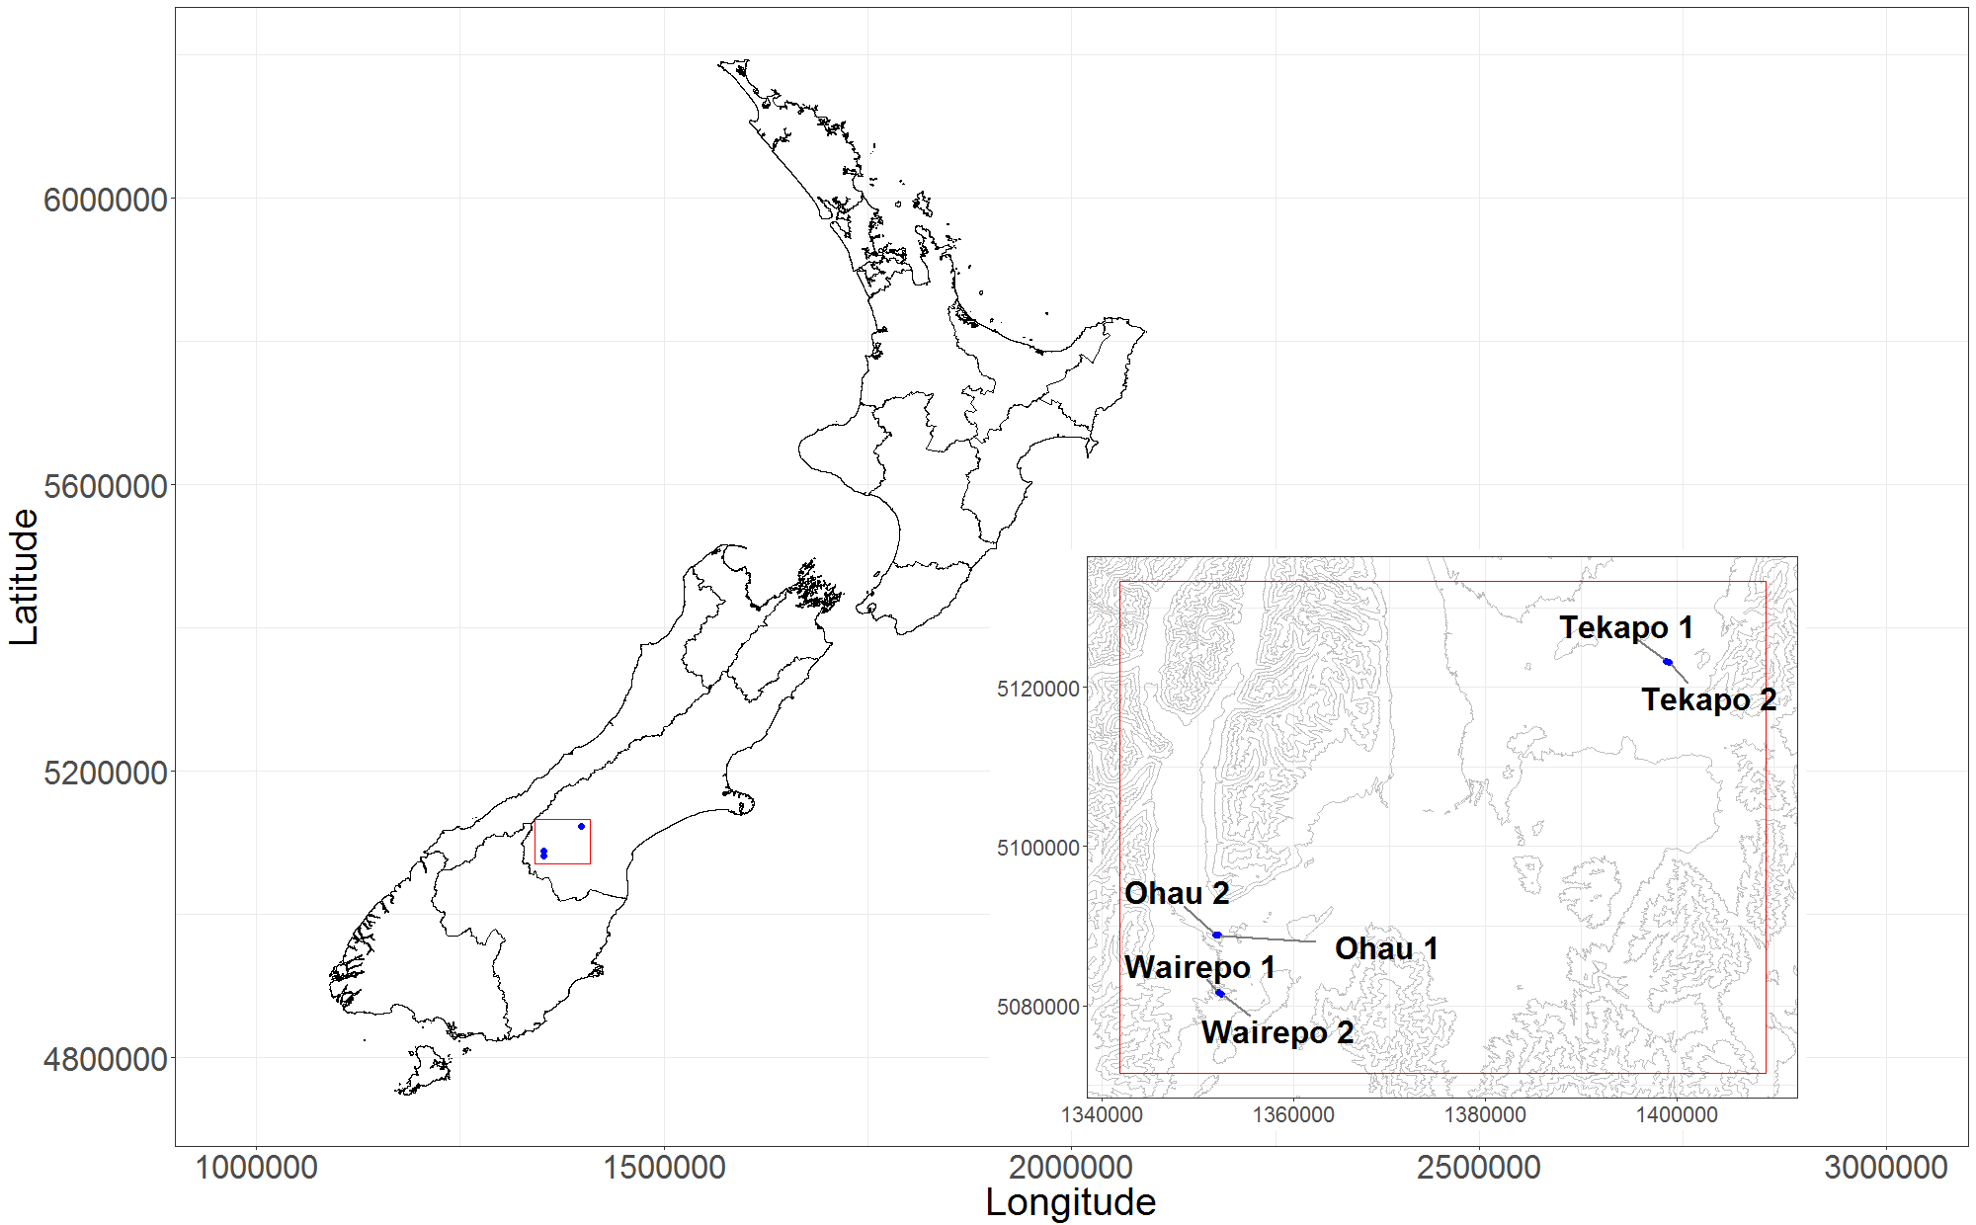
Figure 1: Data came from the Mackenzie basin in the South Island of New Zealand. The location of the six kettle holes in the Mackenzie region of South Island, New Zealand. Despite being close to the Southern Alps the lakes are all located in relatively flat landscapes.

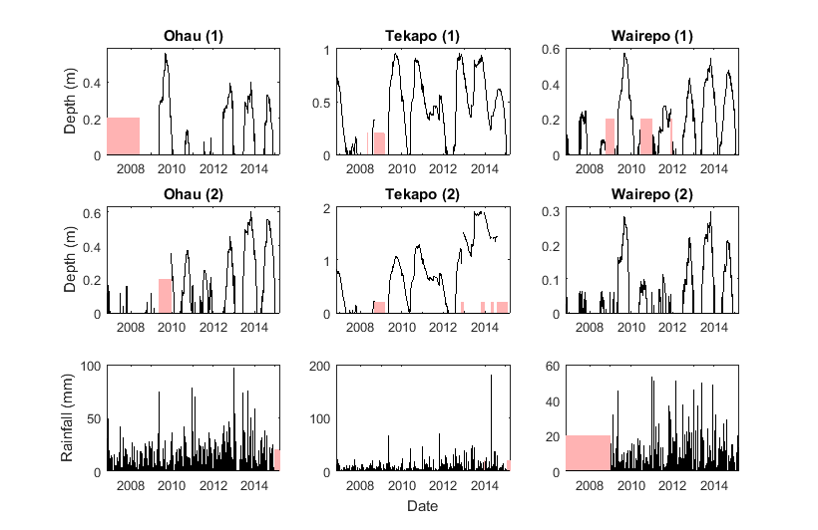
Figure 2: Six datasets over an 8 year period. The water level (m) of each of the six kettle holes and the corresponding rainfall (mm) for each pair. Unavailable data periods are shaded pink.
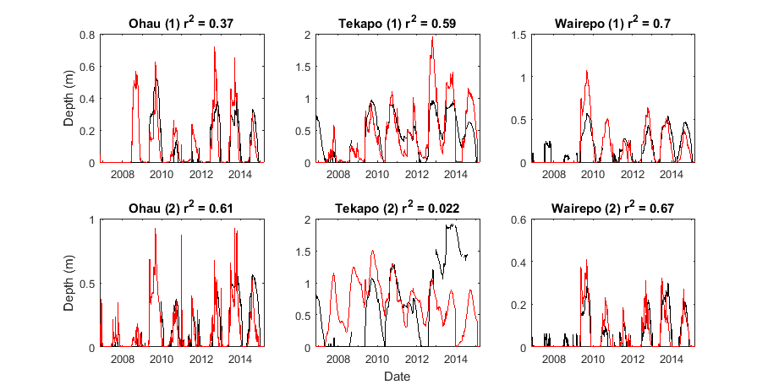
Figure 3: The model is a very good predictor of water level for four of the six kettle holes. The water level (black line) and model predictions (red lines) for the six kettle holes. The prediction is the average output of 1000 runs of the hierarchical status and level model.

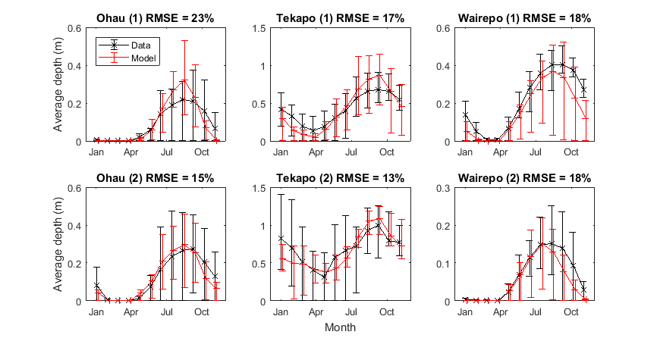
Figure 4: The model is a good predictor of mean monthly water level for all six kettle holes. Mean monthly water levels: data (black) and model prediction (red). Error bars show the interquartile range of the rainfall over each month, i.e. approximately 240 data points (30 days, eight years). The root mean square error (RMSE) is the difference between the mean monthly rainfall in the data and as predicted by the model as a percentage of the maximum water level. Note that even the dataset that showed a very poor correlation in the time series of Figure 3, shows a good match under this analysis.

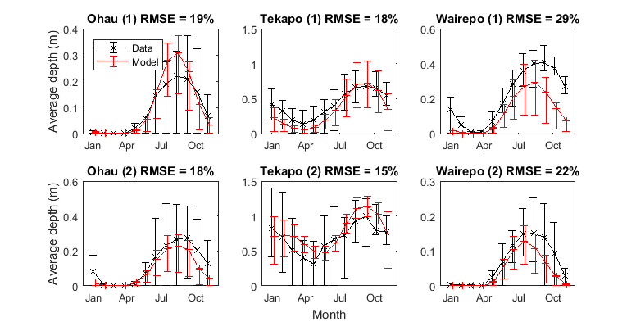
Figure 5: The simulated rainfall data also gives good predictions of water levels. Mean monthly water levels: data (black) and model prediction (red) using simulated rainfall series. Error bars show the interquartile range of the rainfall over each month, i.e. approximately 240 data points (30 days, eight years). The root mean square error (RMSE) is the difference between the mean monthly rainfall in the data and as predicted by the model as a percentage of the maximum water level. All three rainfall models give predictions similar to the actual rainfall time series.

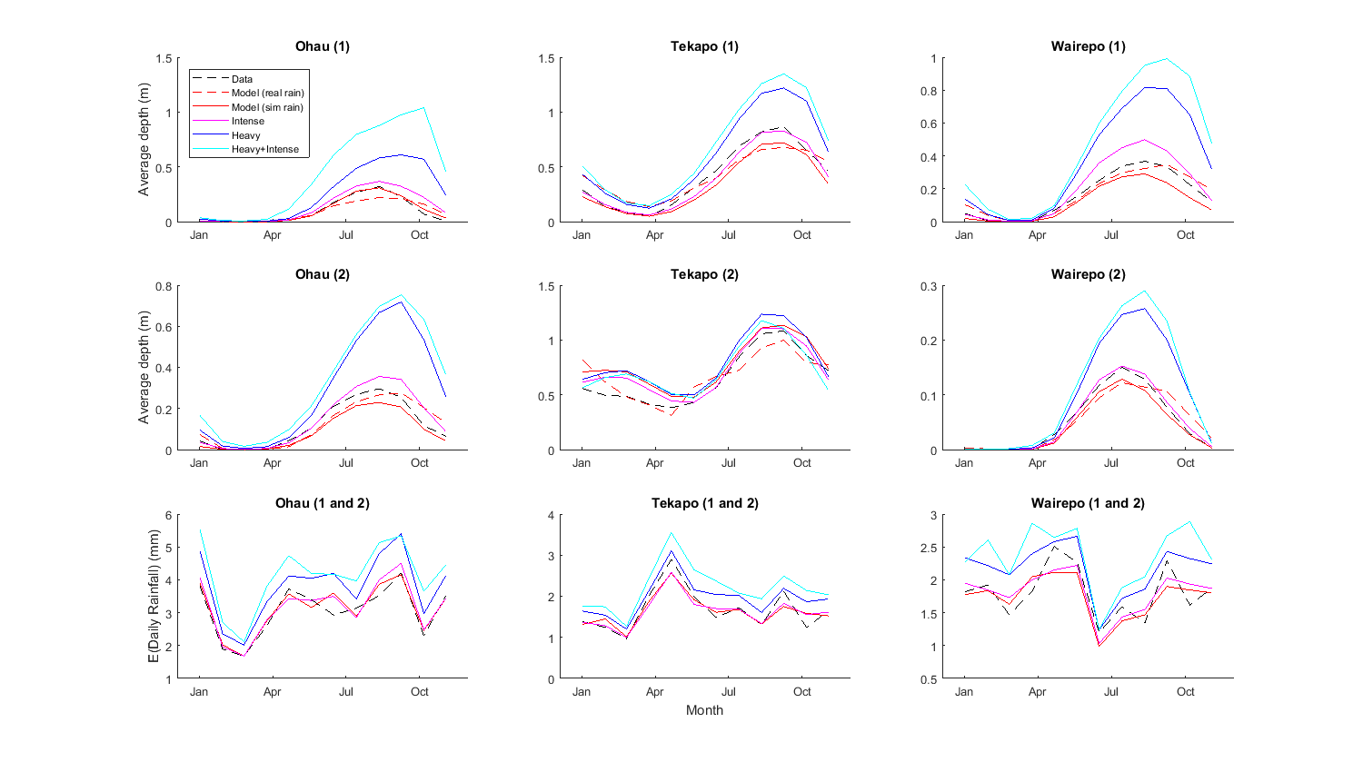
Figure 6: Higher annual rainfall due to climate change will have the greatest effect on kettle hole water depth. Mean monthly water levels calculated from the real water level data (black dashed) and from the model prediction using the real rainfall timeseries (red dashed) and using the simulated rainfall series (‘standard’ rainfall model) (red solid). Also shown, are model predictions using simulated rainfall series for each of the three climate change scenarios: ‘intense’ (pink solid), ‘heavy’ (blue solid) and ‘heavy and intense’ (cyan solid). Bottom row shows the expected daily rainfall for each scenario. Increasing rainfall intensity (pink solid) does not change the expected rainfall significantly and has almost no effect on the water levels. In contrast, a small increase in the annual rainfall amount (blue and cyan solid) increases the water levels in five of the six kettle holes.

Kettle hole | Footprint  (ha) | Catchment  (ha) | Position  (Westing, Northing) | Altitude  (m asl)
Ohau 1 | 3.035 | 12.547 | (1352222.145, 5088831.280) | 601
Ohau 2 | 2.053 | 8.174 | (1351884.387, 5088914.252) | 602
Raingauge | -- | -- | (1394159.21, 5108793.15) | 533
Tekapo 1 | 0.684 | 1.362 | (1398768.770, 5123318.310) | 774
Tekapo 2 | 0.768 | 2.35 | (1399171.287, 5123174.921) | 772
Raingauge | -- | -- | (1344815.85, 5127753.15) | 762
Wairepo 1 | 14.922 | 44.774 | (1352221.628, 5081717.107) | 601
Wairepo 2 | 1.815 | 7.354 | (1352451.747, 5081454.017) | 600
Raingauge | -- | -- | (1370516.18, 5101868.77) | 473

Table 1: Geographical information about each of the six kettle holes studied and raingauge locations. Note that the kettle holes come in three pairs determined by their locational proximity.

Kettle hole | Correlation |  | $D_{25}$ (m) | $$P(Depth<D_{25})$$ |  | $D_{75}$ (m) | $$P(Depth>D_{75})$$
 | Time series  ($r^{2}$) | Monthly average  (RMSE/max(level)) |  | Data | Model |  | Data | Model
Ohau 1 | 0.37 | 23% | 0.14 | 71% | 75% | 0.42 | 4% | 7%
Ohau 2 | 0.61 | 15% | 0.15 | 70% | 74% | 0.45 | 9% | 7%
Tekapo 1 | 0.59 | 17% | 0.24 | 32% | 50% | 0.72 | 22% | 24%
Tekapo 2 | 0.02 | 13% | 0.48 | 40% | 32% | 1.44 | 10% | 2%
Wairepo 1 | 0.70 | 18% | 0.14 | 46% | 63% | 0.43 | 13% | 13%
Wairepo 2 | 0.67 | 18% | 0.07 | 66% | 74% | 0.22 | 7% | 6%

Table 2: Summary statistics for each kettle hole: Correlation for the times series ($r^{2}$ ) and the monthly averages (RMSE); $D_{25}$ low water level (25% of maximum); time spent below the low water level for data and model; $D_{75}$ high water level (75% of maximum); time spent above the high water level. For three of the six lakes the model has a good correlation ($r^{2}>0.5)$ with the actual time series. In all six cases the predicted monthly average has a relatively low error. In four out of six cases the model is within 10% when predicting the amount of time the lake spends with low (<25% of maximum) water levels. In five of six cases the model is within 3% when predicting the amount of time the lake has high (>75% of maximum) water levels.

Site | Summary statistic | Data | Model
 |  |  | Standard | Intense | Heavy | Intense + Heavy
Ohau | P(dry day) | 0.61 | 0.60 | 0.75 | 0.60 | 0.75
 | E(daily rainfall|wet day) (mm) | 7.94 | 7.93 | 12.9 | 9.62 | 14.2
 | E(daily rainfall) (mm) | 3.07 | 3.17 | 3.25 | 3.85 | 3.58
 | P(rainfall>$R_{90}$) | 0.10 | 0.10 | 0.22 | 0.14 | 0.24
Tekapo | P(dry day) | 0.61 | 0.60 | 0.75 | 0.61 | 0.75
 | E(daily rainfall|wet day) (mm) | 4.24 | 4.03 | 6.2 | 4.88 | 6.82
 | E(daily rainfall) (mm) | 1.66 | 1.76 | 1.56 | 1.91 | 1.72
 | P(rainfall>$R_{90}$) | 0.10 | 0.10 | 0.19 | 0.14 | 0.21
Wairepo | P(dry day) | 0.52 | 0.52 | 0.67 | 0.52 | 0.67
 | E(daily rainfall|wet day) (mm) | 3.79 | 3.67 | 5.46 | 4.52 | 6.01
 | E(daily rainfall) (mm) | 1.81 | 1.76 | 1.82 | 2.18 | 1.99
 | P(rainfall>$R_{90}$) | 0.10 | 0.08 | 0.15 | 0.11 | 0.17

Table 3: Summary statistics for the rainfall models. The standard model, intended to mimic the current rainfall patterns, is close to the data in all four key aspects; probability of a dry day, expected rainfall given that it is raining, overall expected rainfall, probability of a very wet day (top 10%). The intense rainfall model has more dry days, wetter wet days, similar overall rain and more very wet days. The heavy rainfall model has the same number of dry days, wetter wet days, more overall rain and a similar number of very wet days. The intense and heavy model has more dry days, wetter wet days, more overall rain and more very wet days.

Supplementary Materials – model details
Ohau 1
 | Wet model |  | Dry model |  | Level model
Variable | Coefficient | p-value | Coefficient | p-value | Coefficient | p-value
Intercept | 1.49E+00 | 1.47E-02 | -4.71E+00 | 1.22E-09 | 1.00E+00 | 0.00E+00
$$R_{i-1}$$ | -3.58E-02 | 5.66E-01 | -1.18E-01 | 4.47E-02 | -7.37E-05 | 1.19E-01
$$R_{i-2}$$ | 9.82E-01 | 3.93E-01 | 2.17E-01 | 6.64E-07 | 6.17E-04 | 4.33E-33
$$\sin\left(\frac{2πt}{365}\right)$$ | 2.81E-01 | 7.92E-01 | 2.24E+00 | 1.51E-01 | 3.64E-05 | 9.50E-01
$$\cos\left(\frac{2πt}{365}\right)$$ | -1.05E+00 | 9.15E-02 | 1.39E+00 | 1.19E-01 | -8.52E-05 | 8.73E-01
$$D$$ | 8.28E-02 | 8.40E-02 | -4.05E-02 | 2.44E-03 | 1.32E-06 | 7.10E-01
$$X$$ |  |  |  |  | 8.82E-01 | 0.00E+00
$$X^{2}$$ |  |  |  |  | 8.53E-01 | 2.07E-37
$$R_{i-1}:R_{i-2}$$ | -5.33E-03 | 7.84E-01 | -2.90E-03 | 1.88E-01 | 8.96E-06 | 1.27E-09
$$R_{i-1}: \sin\left(\frac{2πt}{365}\right)$$ | 1.43E-01 | 2.08E-01 | 2.42E-02 | 7.05E-01 | 7.36E-05 | 1.95E-01
$$R_{i-1}: \cos\left(\frac{2πt}{365}\right)$$ | 9.55E-02 | 1.02E-01 | 1.12E-01 | 2.66E-02 | -7.44E-05 | 3.48E-02
$$R_{i-1}:D$$ | 1.95E-03 | 4.00E-01 | 1.79E-03 | 5.90E-05 | 7.58E-07 | 2.12E-02
$$R_{i-1}:X$$ |  |  |  |  | 2.01E-03 | 7.92E-03
$$R_{i-1}:X^{2}$$ |  |  |  |  | -3.12E-03 | 1.33E-01
$$R_{i-2}: \sin\left(\frac{2πt}{365}\right)$$ | 2.80E-01 | 4.36E-01 | -8.84E-02 | 8.77E-02 | 1.27E-05 | 8.12E-01
$$R_{i-2}: \cos\left(\frac{2πt}{365}\right)$$ | -1.01E+00 | 4.05E-01 | -9.70E-02 | 3.18E-02 | -2.38E-04 | 5.78E-12
$$R_{i-2}:D$$ | 1.12E-04 | 9.01E-01 | -1.08E-03 | 3.91E-02 | -3.97E-06 | 1.18E-28
$$R_{i-2}:X$$ |  |  |  |  | 1.74E-03 | 1.46E-02
$$R_{i-2} :X^{2}$$ |  |  |  |  | -6.18E-04 | 7.54E-01
$$\sin\left(\frac{2πt}{365}\right): \cos\left(\frac{2πt}{365}\right)$$ | -3.19E-01 | 8.02E-01 | -3.32E+00 | 5.45E-02 | -4.37E-04 | 4.91E-01
$$\sin\left(\frac{2πt}{365}\right):D$$ | -9.35E-03 | 6.94E-01 | -3.42E-02 | 3.71E-02 | -1.71E-06 | 7.15E-01
$$\sin\left(\frac{2πt}{365}\right):X$$ |  |  |  |  | -2.54E-02 | 1.85E-01
$$\sin\left(\frac{2πt}{365}\right):X^{2}$$ |  |  |  |  | 7.15E-02 | 2.91E-01
$$\cos\left(\frac{2πt}{365}\right):D$$ | -7.57E-02 | 1.03E-01 | -4.19E-02 | 1.19E-03 | 1.78E-06 | 6.42E-01
$$\cos\left(\frac{2πt}{365}\right):X$$ |  |  |  |  | -8.03E-02 | 1.33E-06
$$\cos\left(\frac{2πt}{365}\right):X^{2}$$ |  |  |  |  | 2.21E-01 | 4.98E-05
$$D:X$$ |  |  |  |  | 4.91E-04 | 1.28E-02
$$D:X^{2}$$ |  |  |  |  | -1.96E-03 | 5.22E-03
$$X:X^{2}$$ |  |  |  |  | 2.35E-01 | 1.89E-01
$$F$$ |  |  |  |  | 4.87

Ohau 2
 | Wet model |  | Dry model |  | Level model
Variable | Coefficient | p-value | Coefficient | p-value | Coefficient | p-value
Intercept | 1.99E+00 | 4.21E-10 | -4.33E+00 | 6.96E-21 | 9.99E-01 | 0.00E+00
$$R_{i-1}$$ | 2.10E-02 | 6.46E-01 | 8.76E-02 | 3.50E-04 | 3.11E-04 | 5.58E-09
$$R_{i-2}$$ | -4.23E-02 | 1.48E-01 | 1.38E-01 | 2.63E-05 | 5.17E-04 | 1.64E-18
$$\sin\left(\frac{2πt}{365}\right)$$ | -2.15E-02 | 9.65E-01 | -1.58E-01 | 7.79E-01 | 1.07E-03 | 6.82E-02
$$\cos\left(\frac{2πt}{365}\right)$$ | 2.03E-01 | 5.66E-01 | -6.54E-01 | 2.17E-01 | -5.75E-04 | 3.09E-01
$$D$$ | 5.40E-02 | 8.15E-04 | -1.91E-02 | 3.71E-02 | -7.52E-06 | 1.37E-01
$$X$$ |  |  |  |  | 9.11E-01 | 0.00E+00
$$X^{2}$$ |  |  |  |  | 8.58E-01 | 1.09E-51
$$R_{i-1}:R_{i-2}$$ | 2.13E-03 | 3.64E-01 | -2.02E-03 | 1.85E-01 | 1.53E-05 | 1.08E-12
$$R_{i-1}: \sin\left(\frac{2πt}{365}\right)$$ | 6.33E-02 | 2.56E-01 | -3.63E-02 | 1.81E-01 | -3.41E-04 | 1.75E-08
$$R_{i-1}: \cos\left(\frac{2πt}{365}\right)$$ | -2.72E-02 | 5.28E-01 | 1.04E-02 | 6.46E-01 | -1.16E-06 | 9.76E-01
$$R_{i-1}:D$$ | -8.99E-05 | 7.90E-01 | 2.03E-04 | 4.77E-01 | -1.57E-06 | 6.34E-04
$$R_{i-1}:X$$ |  |  |  |  | 1.70E-04 | 7.62E-01
$$R_{i-1}:X^{2}$$ |  |  |  |  | -1.35E-03 | 2.34E-01
$$R_{i-2}: \sin\left(\frac{2πt}{365}\right)$$ | -1.85E-02 | 6.41E-01 | 2.58E-03 | 9.32E-01 | -8.91E-05 | 1.54E-01
$$R_{i-2}: \cos\left(\frac{2πt}{365}\right)$$ | 2.20E-02 | 3.84E-01 | -3.52E-02 | 2.31E-01 | -5.72E-05 | 1.43E-01
$$R_{i-2}:D$$ | 4.37E-04 | 5.43E-01 | -1.61E-04 | 6.37E-01 | -1.31E-06 | 4.70E-03
$$R_{i-2}:X$$ |  |  |  |  | 2.31E-03 | 4.00E-05
$$R_{i-2} :X^{2}$$ |  |  |  |  | -3.08E-03 | 4.87E-03
$$\sin\left(\frac{2πt}{365}\right): \cos\left(\frac{2πt}{365}\right)$$ | -4.01E-01 | 5.23E-01 | -1.84E+00 | 1.13E-02 | -6.33E-04 | 3.39E-01
$$\sin\left(\frac{2πt}{365}\right):D$$ | -1.95E-02 | 3.94E-02 | -1.53E-02 | 1.84E-02 | -3.03E-06 | 5.71E-01
$$\sin\left(\frac{2πt}{365}\right):X$$ |  |  |  |  | 6.58E-04 | 9.48E-01
$$\sin\left(\frac{2πt}{365}\right):X^{2}$$ |  |  |  |  | 1.33E-02 | 6.24E-01
$$\cos\left(\frac{2πt}{365}\right):D$$ | -4.68E-02 | 6.17E-03 | -5.98E-03 | 5.49E-01 | -6.65E-06 | 2.74E-01
$$\cos\left(\frac{2πt}{365}\right):X$$ |  |  |  |  | -4.64E-02 | 1.13E-09
$$\cos\left(\frac{2πt}{365}\right):X^{2}$$ |  |  |  |  | 8.33E-02 | 2.32E-05
$$D:X$$ |  |  |  |  | 9.83E-05 | 4.11E-01
$$D:X^{2}$$ |  |  |  |  | -1.97E-04 | 5.27E-01
$$X:X^{2}$$ |  |  |  |  | -1.51E-01 | 1.20E-01
$$F$$ |  |  |  |  | 5.46

Tekapo 1
 | Wet model |  | Dry model |  | Level model
Variable | Coefficient | p-value | Coefficient | p-value | Coefficient | p-value
Intercept | 3.95E+00 | 1.55E-18 | -4.38E+00 | 7.28E-04 | 9.98E-01 | 0.00E+00
$$R_{i-1}$$ | 9.15E-01 | 2.82E-01 | 1.16E-01 | 5.41E-01 | 1.51E-04 | 2.45E-01
$$R_{i-2}$$ | 4.02E-02 | 7.74E-01 | 3.46E-01 | 1.29E-01 | 1.84E-03 | 7.24E-35
$$\sin\left(\frac{2πt}{365}\right)$$ | -1.02E+00 | 2.58E-02 | -1.66E+00 | 2.85E-01 | 2.00E-03 | 2.01E-02
$$\cos\left(\frac{2πt}{365}\right)$$ | 1.09E-01 | 7.90E-01 | -9.26E-01 | 5.79E-01 | 6.50E-04 | 3.76E-01
$$D$$ | 4.22E-03 | 2.94E-02 | -7.68E-02 | 1.81E-01 | -2.26E-05 | 1.58E-06
$$X$$ |  |  |  |  | 9.73E-01 | 0.00E+00
$$X^{2}$$ |  |  |  |  | 5.71E-01 | 1.39E-76
$$R_{i-1}:R_{i-2}$$ |  |  | -2.74E-05 | 9.99E-01 | 3.60E-05 | 7.75E-18
$$R_{i-1}: \sin\left(\frac{2πt}{365}\right)$$ |  |  | -1.47E-01 | 4.46E-01 | -5.88E-05 | 4.54E-01
$$R_{i-1}: \cos\left(\frac{2πt}{365}\right)$$ |  |  | 5.76E-02 | 8.45E-01 | -6.24E-04 | 4.00E-16
$$R_{i-1}:D$$ |  |  | 9.99E-04 | 7.73E-01 | -1.50E-06 | 2.00E-12
$$R_{i-1}:X$$ |  |  |  |  | 3.32E-03 | 1.37E-06
$$R_{i-1}:X^{2}$$ |  |  |  |  | -2.78E-03 | 3.61E-04
$$R_{i-2}: \sin\left(\frac{2πt}{365}\right)$$ |  |  | 2.83E-01 | 2.13E-01 | -8.84E-04 | 7.64E-29
$$R_{i-2}: \cos\left(\frac{2πt}{365}\right)$$ |  |  | -6.39E-02 | 8.01E-01 | -8.71E-05 | 2.43E-01
$$R_{i-2}:D$$ |  |  | -2.30E-04 | 9.36E-01 | -1.48E-06 | 6.65E-12
$$R_{i-2}:X$$ |  |  |  |  | 1.34E-03 | 5.81E-02
$$R_{i-2} :X^{2}$$ |  |  |  |  | -1.92E-03 | 1.09E-02
$$\sin\left(\frac{2πt}{365}\right): \cos\left(\frac{2πt}{365}\right)$$ |  |  | -1.40E+00 | 5.12E-01 | 1.12E-03 | 1.76E-01
$$\sin\left(\frac{2πt}{365}\right):D$$ |  |  | -6.96E-02 | 2.61E-01 | 9.52E-06 | 2.34E-04
$$\sin\left(\frac{2πt}{365}\right):X$$ |  |  |  |  | -1.04E-02 | 1.13E-01
$$\sin\left(\frac{2πt}{365}\right):X^{2}$$ |  |  |  |  | -6.02E-03 | 4.68E-01
$$\cos\left(\frac{2πt}{365}\right):D$$ |  |  | -1.41E-02 | 8.44E-01 | 1.03E-05 | 6.87E-10
$$\cos\left(\frac{2πt}{365}\right):X$$ |  |  |  |  | -4.34E-02 | 2.84E-21
$$\cos\left(\frac{2πt}{365}\right):X^{2}$$ |  |  |  |  | 3.74E-02 | 1.17E-11
$$D:X$$ |  |  |  |  | 5.97E-05 | 1.41E-03
$$D:X^{2}$$ |  |  |  |  | -3.25E-05 | 7.46E-02
$$X:X^{2}$$ |  |  |  |  | 1.49E-01 | 1.97E-10
$$F$$ |  |  |  |  | 1.10

Tekapo 2
 | Wet model |  | Dry model |  | Level model
Variable | Coefficient | p-value | Coefficient | p-value | Coefficient | p-value
Intercept | 4.19E+00 | 1.29E-17 | -3.78E+00 | 1.51E-15 | 1.00E+00 | 0.00E+00
$$R_{i-1}$$ | 5.66E-02 | 6.38E-01 | 1.38E-02 | 7.07E-01 | -1.80E-03 | 1.00E-04
$$R_{i-2}$$ | 2.22E-02 | 9.57E-01 | 1.14E-01 | 4.11E-03 | 1.20E-03 | 1.62E-02
$$\sin\left(\frac{2πt}{365}\right)$$ | 7.85E-01 | 2.09E-01 | -9.41E-01 | 4.27E-02 | -6.88E-04 | 7.77E-01
$$\cos\left(\frac{2πt}{365}\right)$$ | 8.95E-01 | 1.13E-01 | -6.87E-01 | 2.30E-01 | -3.91E-04 | 8.75E-01
$$D$$ | 6.45E-03 | 5.98E-02 | -1.24E-02 | 6.75E-02 | -5.31E-05 | 2.77E-04
$$X$$ |  |  |  |  | 1.13E+00 | 0.00E+00
$$X^{2}$$ |  |  |  |  | 1.43E-01 | 6.93E-13
$$R_{i-1}:R_{i-2}$$ | 6.02E-02 | 4.41E-01 |  |  | 3.05E-05 | 2.53E-02
$$R_{i-1}: \sin\left(\frac{2πt}{365}\right)$$ | 7.19E-02 | 3.72E-01 |  |  | 1.08E-04 | 6.93E-01
$$R_{i-1}: \cos\left(\frac{2πt}{365}\right)$$ | 8.61E-02 | 3.46E-01 |  |  | -2.19E-03 | 1.81E-16
$$R_{i-1}:D$$ | -4.83E-04 | 1.41E-01 |  |  | 1.89E-06 | 7.66E-02
$$R_{i-1}:X$$ |  |  |  |  | 5.64E-03 | 1.03E-07
$$R_{i-1}:X^{2}$$ |  |  |  |  | -2.04E-03 | 1.40E-03
$$R_{i-2}: \sin\left(\frac{2πt}{365}\right)$$ | 3.30E-01 | 4.10E-01 |  |  | 5.41E-04 | 5.12E-02
$$R_{i-2}: \cos\left(\frac{2πt}{365}\right)$$ | 9.18E-03 | 9.75E-01 |  |  | 2.64E-05 | 9.20E-01
$$R_{i-2}:D$$ | 8.93E-03 | 3.10E-01 |  |  | 3.14E-06 | 3.21E-03
$$R_{i-2}:X$$ |  |  |  |  | -2.81E-03 | 8.64E-03
$$R_{i-2} :X^{2}$$ |  |  |  |  | 2.15E-03 | 4.10E-04
$$\sin\left(\frac{2πt}{365}\right): \cos\left(\frac{2πt}{365}\right)$$ | 1.99E+00 | 3.28E-02 |  |  | 3.88E-03 | 1.23E-01
$$\sin\left(\frac{2πt}{365}\right):D$$ | -7.92E-03 | 3.39E-02 |  |  | 2.14E-05 | 4.20E-02
$$\sin\left(\frac{2πt}{365}\right):X$$ |  |  |  |  | -3.54E-02 | 1.42E-04
$$\sin\left(\frac{2πt}{365}\right):X^{2}$$ |  |  |  |  | 2.05E-02 | 1.79E-03
$$\cos\left(\frac{2πt}{365}\right):D$$ | -4.21E-03 | 2.17E-01 |  |  | 6.06E-06 | 4.30E-01
$$\cos\left(\frac{2πt}{365}\right):X$$ |  |  |  |  | -1.96E-02 | 3.02E-03
$$\cos\left(\frac{2πt}{365}\right):X^{2}$$ |  |  |  |  | 8.61E-03 | 3.22E-02
$$D:X$$ |  |  |  |  | 7.74E-06 | 8.57E-01
$$D:X^{2}$$ |  |  |  |  | 8.00E-05 | 3.69E-03
$$X:X^{2}$$ |  |  |  |  | 4.31E-01 | 0.00E+00
$$F$$ |  |  |  |  | 3.32

Wairepo 1
 | Wet model |  | Dry model |  | Level model
Variable | Coefficient | p-value | Coefficient | p-value | Coefficient | p-value
Intercept | 3.76E+00 | 1.32E-04 | -4.88E-02 | 9.84E-01 | 1.00E+00 | 0.00E+00
$$R_{i-1}$$ | 1.91E+00 | 2.70E-01 | 4.74E-02 | 6.26E-01 | 3.62E-04 | 1.49E-06
$$R_{i-2}$$ | 2.66E-01 | 6.16E-01 | 4.09E-01 | 7.98E-03 | 1.08E-03 | 2.61E-32
$$\sin\left(\frac{2πt}{365}\right)$$ | -2.38E+00 | 5.44E-02 | -4.78E+00 | 1.39E-01 | -2.25E-03 | 8.52E-02
$$\cos\left(\frac{2πt}{365}\right)$$ | -1.50E+00 | 1.08E-01 | -2.66E+00 | 2.92E-01 | -1.98E-03 | 3.46E-02
$$D$$ | 3.79E-03 | 7.65E-01 | -7.05E-02 | 4.79E-01 | -5.66E-05 | 8.13E-08
$$X$$ |  |  |  |  | 9.03E-01 | 0.00E+00
$$X^{2}$$ |  |  |  |  | 7.79E-01 | 1.90E-21
$$R_{i-1}:R_{i-2}$$ | -8.90E-03 | 9.14E-01 | -3.64E-03 | 2.07E-01 | 2.68E-05 | 1.31E-15
$$R_{i-1}: \sin\left(\frac{2πt}{365}\right)$$ | -2.63E-01 | 8.35E-01 | 4.41E-02 | 6.93E-01 | -2.55E-04 | 1.70E-03
$$R_{i-1}: \cos\left(\frac{2πt}{365}\right)$$ | -2.02E+00 | 2.48E-01 | -4.62E-02 | 5.37E-01 | -1.36E-04 | 1.32E-02
$$R_{i-1}:D$$ | 4.35E-03 | 7.02E-01 | 8.59E-05 | 9.57E-01 | 6.28E-07 | 3.71E-01
$$R_{i-1}:X$$ |  |  |  |  | 1.25E-03 | 2.16E-01
$$R_{i-1}:X^{2}$$ |  |  |  |  | -3.93E-03 | 5.08E-02
$$R_{i-2}: \sin\left(\frac{2πt}{365}\right)$$ | -4.72E-01 | 4.02E-01 | -1.67E-01 | 2.41E-01 | -1.02E-04 | 2.28E-01
$$R_{i-2}: \cos\left(\frac{2πt}{365}\right)$$ | -1.93E-01 | 5.29E-01 | -1.58E-01 | 1.06E-01 | -2.40E-04 | 3.44E-05
$$R_{i-2}:D$$ | 2.70E-02 | 3.27E-01 | -6.28E-04 | 7.37E-01 | -3.31E-06 | 4.01E-06
$$R_{i-2}:X$$ |  |  |  |  | 1.03E-03 | 2.90E-01
$$R_{i-2} :X^{2}$$ |  |  |  |  | -3.98E-04 | 8.32E-01
$$\sin\left(\frac{2πt}{365}\right): \cos\left(\frac{2πt}{365}\right)$$ | 1.68E+00 | 1.94E-01 | 7.39E-01 | 8.62E-01 | -3.67E-04 | 7.50E-01
$$\sin\left(\frac{2πt}{365}\right):D$$ | -5.62E-03 | 5.16E-01 | 3.60E-02 | 7.25E-01 | 7.55E-06 | 4.49E-01
$$\sin\left(\frac{2πt}{365}\right):X$$ |  |  |  |  | 1.91E-02 | 2.10E-01
$$\sin\left(\frac{2πt}{365}\right):X^{2}$$ |  |  |  |  | -4.52E-02 | 1.79E-01
$$\cos\left(\frac{2πt}{365}\right):D$$ | 6.25E-03 | 6.22E-01 | 1.29E-02 | 8.21E-01 | -2.51E-06 | 7.50E-01
$$\cos\left(\frac{2πt}{365}\right):X$$ |  |  |  |  | -2.90E-02 | 3.71E-04
$$\cos\left(\frac{2πt}{365}\right):X^{2}$$ |  |  |  |  | 6.76E-02 | 1.49E-04
$$D:X$$ |  |  |  |  | 7.44E-04 | 8.17E-11
$$D:X^{2}$$ |  |  |  |  | -1.70E-03 | 1.01E-09
$$X:X^{2}$$ |  |  |  |  | 8.12E-02 | 4.49E-01
$$F$$ |  |  |  |  | 3.05

Wairepo 2
 | Wet model |  | Dry model |  | Level model
Variable | Coefficient | p-value | Coefficient | p-value | Coefficient | p-value
Intercept | 1.84E+00 | 4.18E-04 | -3.55E+00 | 5.24E-09 | 1.00E+00 | 0.00E+00
$$R_{i-1}$$ | 2.34E+00 | 7.64E-02 | -3.06E-01 | 2.65E-02 | 4.41E-05 | 3.65E-01
$$R_{i-2}$$ | 2.90E-01 | 3.74E-01 | 3.91E-01 | 1.56E-05 | 9.59E-04 | 7.28E-75
$$\sin\left(\frac{2πt}{365}\right)$$ | -7.64E-03 | 9.91E-01 | 2.13E-01 | 7.91E-01 | -2.08E-04 | 6.11E-01
$$\cos\left(\frac{2πt}{365}\right)$$ | -1.42E+00 | 1.52E-02 | -1.91E-01 | 8.02E-01 | -5.98E-04 | 1.53E-01
$$D$$ | 1.42E-02 | 4.33E-01 | -1.19E-01 | 1.53E-03 | -1.60E-05 | 3.99E-03
$$X$$ |  |  |  |  | 7.69E-01 | 0.00E+00
$$X^{2}$$ |  |  |  |  | 2.03E+00 | 1.33E-38
$$R_{i-1}:R_{i-2}$$ | -2.93E-02 | 6.07E-01 | 8.51E-03 | 3.69E-02 | 9.07E-06 | 5.22E-05
$$R_{i-1}: \sin\left(\frac{2πt}{365}\right)$$ | 1.86E+00 | 5.09E-02 | 2.02E-01 | 2.49E-02 | 1.69E-04 | 3.00E-04
$$R_{i-1}: \cos\left(\frac{2πt}{365}\right)$$ | -2.55E+00 | 7.98E-02 | 1.29E-01 | 2.35E-01 | -1.10E-04 | 2.59E-03
$$R_{i-1}:D$$ | 3.99E-03 | 1.29E-01 | 1.45E-03 | 1.96E-01 | -1.78E-06 | 7.30E-05
$$R_{i-1}:X$$ |  |  |  |  | 7.10E-03 | 9.38E-09
$$R_{i-1}:X^{2}$$ |  |  |  |  | -1.70E-02 | 6.15E-03
$$R_{i-2}: \sin\left(\frac{2πt}{365}\right)$$ | -4.52E-01 | 3.23E-01 | -2.26E-01 | 4.63E-03 | -5.31E-04 | 1.72E-30
$$R_{i-2}: \cos\left(\frac{2πt}{365}\right)$$ | -4.51E-02 | 8.71E-01 | -1.50E-01 | 6.86E-02 | -3.31E-04 | 1.07E-19
$$R_{i-2}:D$$ | 2.04E-03 | 7.98E-01 | -1.08E-03 | 2.81E-01 | -1.33E-06 | 2.33E-03
$$R_{i-2}:X$$ |  |  |  |  | -1.47E-03 | 1.93E-01
$$R_{i-2} :X^{2}$$ |  |  |  |  | 1.91E-03 | 7.33E-01
$$\sin\left(\frac{2πt}{365}\right): \cos\left(\frac{2πt}{365}\right)$$ | 5.66E-01 | 5.75E-01 | 1.04E+00 | 4.73E-01 | 1.31E-03 | 1.10E-02
$$\sin\left(\frac{2πt}{365}\right):D$$ | -1.72E-02 | 2.46E-01 | 7.04E-02 | 3.26E-02 | 1.19E-05 | 6.97E-02
$$\sin\left(\frac{2πt}{365}\right):X$$ |  |  |  |  | 4.64E-02 | 5.85E-03
$$\sin\left(\frac{2πt}{365}\right):X^{2}$$ |  |  |  |  | -2.93E-01 | 1.81E-03
$$\cos\left(\frac{2πt}{365}\right):D$$ | -5.80E-03 | 7.30E-01 | -8.87E-02 | 1.04E-03 | -7.65E-06 | 9.63E-02
$$\cos\left(\frac{2πt}{365}\right):X$$ |  |  |  |  | -1.05E-01 | 9.36E-18
$$\cos\left(\frac{2πt}{365}\right):X^{2}$$ |  |  |  |  | 5.42E-01 | 9.89E-17
$$D:X$$ |  |  |  |  | 1.41E-03 | 8.06E-10
$$D:X^{2}$$ |  |  |  |  | -7.23E-03 | 2.53E-09
$$X:X^{2}$$ |  |  |  |  | -1.76E+00 | 2.77E-04
$$F$$ |  |  |  |  | 3.19

