Probing Conformational Heterogeneity at the Ionic Liquid-Vacuum Interface by Reactive-Atom Scattering
Eric J. Smoll, Jr.,¹ Simon M. Purcell,² Lucia D’Andrea,³ John M. Slattery,³ Duncan W. Bruce,³ Matthew L. Costen,² Kenneth G. McKendrick,² Timothy K. Minton^{1,}*
¹Department of Chemistry and Biochemistry, Montana State University, Bozeman, Montana 51717, U.S.
²Institute of Chemical Sciences, School of Engineering and Physical Sciences, Heriot-Watt University, Edinburgh EH14 4AS, U.K.
³Department of Chemistry, University of York, Heslington, York YO10 5DD, U.K.
*To whom correspondence should be addressed. Email: tminton@montana.edu

Abstract:
The atomic-level description of liquid interfaces has lagged behind that of solid crystalline surfaces, because existing experimental techniques have been limited in their capability to report molecular structure in a fluctuating liquid interfacial layer. We have moved toward a more detailed experimental description of the gas-liquid interface by studying the F-atom scattering dynamics on a common ionic liquid, 1-butyl-3-methylimidazolium bis(trifluoromethylsulfonyl)imide. When given contrast by deuterium labeling, the yield and dynamical behavior of reactively scattered HF isotopologues can resolve distinct signatures from the cation butyl, methyl, and ring groups, which help to quantify the relative populations of cation conformations at the liquid-vacuum interface. These results demonstrate the importance of molecular organization in driving site-specific reactions at the extreme outer regions of the gas-liquid interface.

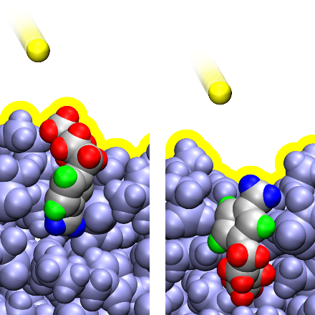
TOC Graphic:

Room-temperature ionic liquids (RTILs) are a chemically and structurally diverse set of molecular salts, with low melting points and vapor pressures, that may be chemically tuned for a wide variety of potential technological applications.¹⁻⁶ Following the discovery of nanoscale structuring in the RTIL bulk⁷⁻¹¹ and at interfaces,¹²⁻¹⁵ a broad effort to characterize and understand the nature of this structuring was launched, in order to guide the design of RTILs with desired properties.¹⁶⁻¹⁷ The RTIL interface with vacuum has emerged as an important benchmark system for the study of liquid interfacial structure, because the properties of this interface are completely dictated by intermolecular interactions of the RTIL without complications induced by the presence of a second phase. In addition, most RTILs are stable under ultra-high vacuum conditions, minimizing the presence of volatile impurities and permitting the use of a wide variety of powerful surface science methods traditionally restricted to solids.¹⁸⁻¹⁹ In analogy with the surface sites of crystalline solids, a distribution of stable ion conformations at the liquid-vacuum interface might show distinct, site-specific chemical or physical properties²⁰⁻²³ or reveal local contributions to collective properties of the fluctuating interface.²⁴⁻²⁷
Experiments capable of quantifying the relative populations of preferred ion conformations are crucial to the development and verification of realistic models of the liquid-vacuum interface of RTILs and other molecular liquids. Methods like sum-frequency generation (SFG) and angle-resolved X-ray photoelectron spectroscopy (ARXPS) have made important contributions to our understanding of the average orientation of specific ions at the liquid-vacuum interface of common RTILs.²⁸⁻³¹ A smaller number of studies using molecular dynamics (MD) simulations and low-energy ion scattering (LEIS) have addressed the distribution or relative populations of ion conformations at such interfaces.³²⁻³⁵ Our own investigations of the RTIL-vacuum interface with the use of reactive-atom scattering have revealed general features of the interface through signatures in the scattering dynamics.³⁶⁻³⁹ Unlike studies of inelastic scattering on interfaces with noble gas atoms, reactive-atom scattering is intrinsically chemically specific because the scattered reaction product carries a surface atom that the probe atom must have come into contact with before the product exited the interface. In the study reported here, we have achieved site-specific information by reactive-atom scattering through the first uses of an isotopically-labeled RTIL and a fluorine probe atom for such an experiment. Our primary data are angle- and velocity-resolved distributions of reactively scattered products from deuterium-labeled variants of the common RTIL, 1-butyl-3-methylimidazolium bis(trifluoromethylsulfonyl)imide ([C₄mim][Tf₂N]). We have demonstrated the surface specificity of the reactive atom probe, and we have derived quantitative information about the relative number density and local environment of specific cation functional groups accessible to the probe. We have further conducted polarizable molecular dynamics (MD) simulations of the liquid-vacuum interface and compared the MD predictions with the experimental results. The good agreement between the two implies a robust quantitative understanding of the relative populations of cation conformations that expose or hide the methyl group from vacuum.
The experiments were carried out with the use of a molecular-beam apparatus configured for beam-surface scattering studies, as described in previous publications.⁴⁰⁻⁴¹ A pulsed beam of high-velocity F atoms was directed at the continually refreshed liquid-vacuum interface of a [C₄mim][Tf₂N] isotopologue (Fig. 1) at an incident angle θ_{i}. For a given θ_{i}, a rotatable mass spectrometer was used to monitor F, HF, and DF products that scattered at a particular final angle θ_{f}. Number density distributions of scattered products were collected as a function of flight time from the interface to the electron-impact ionizer of the detector; these distributions are referred to as time-of-flight (TOF) distributions. Details of the experimental methods are provided in the Methods section below and in the Supporting Information (SI.I.A). The four deuterium-labeled isotopologues of [C₄mim][Tf₂N] allow H-atom abstraction reactions at the cation butyl, methyl, and imidazolium ring groups (hereafter referred to as “butyl,” “methyl,” and “ring”) to be distinguished. For example, scattering from the butyl group can be distinguished as HF scattering from d₆-[C₄mim][Tf₂N]. Scattering signals from the methyl and ring can be similarly distinguished using other isotopologues of [C₄mim][Tf₂N].
Representative TOF distributions are shown in Fig. 2 for F, HF, and DF that scattered from the liquid-vacuum interface of d₆-[C₄mim][Tf₂N]. All three TOF distributions can be understood as the superposition of three distinct contributions. The TOF distribution at shorter flight times is produced by impulsive scattering (IS) trajectories where the incident atom or the product has insufficient interaction at the interface for thermal equilibrium to be attained before the atom or product scatters from the surface. The distribution at intermediate flight times is produced by trajectories that exchange sufficient energy with the surface that the scattered species emerge with a Maxwell-Boltzmann (MB) velocity distribution characteristic of thermal desorption (TD) at the temperature of the interface. TOF signals detected at flight times that are too long to associate with IS or TD are labeled as long-time (LT) signals. The origin of the LT signal is currently unclear; this signal might be a signature of a hydrogen-atom abstraction reaction in a higher density region of the liquid-vacuum interface or it may be an experimental artifact (see discussion in SI.II.D). The high incident energy of the F atoms (⟨E_{i}⟩ = 384 kJ mol^{─1}) promotes spatially localized collisions and high IS yields, as well as large temporal separations between IS and TD distributions at a liquid temperature of 323 K.^{38, 42} The translational energy distributions of the HF (or DF) products that have been derived from the IS components of the TOF distributions (not shown) do not extend beyond the incident translational energy, suggesting that the high exothermicity of the reaction (~140 kJ mol^{–1}) is mostly released in internal excitation of the scattered product and the surface. Despite the extreme reactivity of atomic fluorine, the likelihood of direct scattering without reaction is high. For example, the IS F flux is approximately 71% of the combined F and HF flux from [C₄mim][Tf₂N] at θ_{i} = 60° and θ_{f} = 70°.
HF and DF TOF distributions have been used to derive site- and pathway-specific scattering signals following a procedure described in (SI.II.A&B). The experimental data collected in this study provide a means to estimate the H/D isotope effects (SI.II.B), and the appropriate isotope effect corrections have been applied to the DF signals such that they can be used to determine the relative site-specific HF product distributions from an undeuterated cation (ultimately limited by the accuracy of the isotope effect corrections). Therefore, unless it is important to note that a particular result is derived from DF TOF distributions, explicit references to IS, TD, and LT HF results implicitly include any corrected DF data that were used in the derivation of those results.
IS and TD HF flux percentages originating from the butyl, methyl, and ring groups are shown in Fig. 3. Butyl is the dominant source of IS and TD HF (86-95%), followed by methyl (4-12%) and the ring (≤3%). Thus, the HF yield from butyl is larger than expected from stoichiometry (60%), and the yields from methyl and the ring are successively smaller than expected from stoichiometry (20% each).
Fig. 3 contains important information on the surface specificity of IS and TD HF scattering. In principle, the surface specificity of the TD HF signal is complicated by the presence of two contributing pathways. (1) Incident F atoms may come into thermal equilibrium at the vacuum-liquid interface before abstracting a hydrogen atom and desorbing as HF or (2) incident F atoms may form HF in an initial non-thermal reaction before trapping and subsequent desorption of HF. If pathway (1) is dominant, then the similarity between the IS and TD HF flux percentages could indicate that IS HF and thermal F atoms at the liquid-vacuum interface probe a similar set of liquid atoms. If pathway (2) is dominant, then the observed TD HF flux percentages are simply inherited from initial IS HF. There is no ambiguity in the observed IS HF, as it must involve a non-thermal H-atom abstraction. It is important to note that the IS HF flux percentage from the ring is difficult to interpret because the strong sp² C-H bonds and the competing process of F-atom addition to the imidazolium ring is expected to reduce the reactivity of this group relative to the butyl and methyl. F atoms that penetrate into the tightly packed region beneath the outermost interfacial atoms should experience a large number of highly inelastic collisions; therefore, the hyperthermal translational energy of IS HF is strong dynamical evidence that IS HF must be highly surface specific. If a significant fraction of incident F atoms were to penetrate ballistically deep into the liquid-vacuum interface and react to form HF, this signal would be expected to grow as the incident translational energy along the macroscopic interfacial normal increases. Note that a decrease in incident angle from 60° to 30° results in an increase of ~140 kJ mol⁻¹ or 74% in translational energy in the normal direction. However, the site-resolved IS HF flux percentages are largely insensitive to θ_{i}, indicating that the IS HF hydrogen-atom abstraction event is restricted to hydrogen atoms that are directly accessible to an incident F atom. Therefore, the IS HF flux from a specific C-H bond type should be approximately proportional to its number density at the liquid-vacuum interface. This conclusion is also supported by the highly non-stoichiometric IS HF flux percentages from the chemically similar butyl and methyl groups. F atoms that penetrate sufficiently deeply to sample the bulk composition would be expected to sample butyl and methyl C-H bonds stoichiometrically. The observation that all butyl and methyl C-H bonds are not sampled stoichiometrically suggests that the liquid-vacuum interfacial structure of [C₄mim][Tf₂N] is responsible for the large IS HF flux percentage from butyl relative to methyl. This result is consistent with previous studies, which have concluded that [C_{n}mim]⁺ cations with n ≥ ~4 orient the alkyl group toward the vacuum²⁹ forming a nonpolar layer of alkyl groups above an ionic layer containing the positively charged imidazolium ring and charged portion of the anion.¹⁷ Despite the preponderance of accessible butyl groups at the interface, the substantial IS HF yield from methyl suggests that these groups are also accessible at the interface.
Further investigation of the distribution of cation conformations at the liquid-vacuum interface was performed with a polarizable molecular dynamics (MD) simulation of the [C₄mim][Tf₂N] liquid-vacuum interface (see SI.II.C for details). The atoms on the simulated liquid-vacuum interface that are accessible to a gas-phase probe atom were identified by an algorithm in which a sheet of probe spheres was dropped onto the interface.³²⁻³³ Interfacial atoms that come into van der Waals contact with a probe sphere are assumed to be accessible to gas-phase F atoms. Using this method, we found that the methyl groups are approximately 17% of the total number of butyl and methyl groups accessible to the vacuum. This value is in good agreement with an estimate of ~20% obtained from a simple model of the experimental results that is built on reasonable assumptions about the distribution of cation orientations at the liquid-vacuum interface and the equal accessibility and reactivity of all C-H bonds for a butyl or methyl group exposed to the vacuum (see Section SI.II.G). A more direct comparison between the MD simulation and the experiment is in the ratio of butyl to methyl H atoms that are accessible to the vacuum, the experimental value of which is 13.3 ± 3 when averaged over all three incident angles used (see Fig. 3). If we assume that all butyl and methyl C-H bonds are equally reactive, the ratio of butyl to methyl H atoms selected by the sheet of probe spheres in the MD simulation is slightly larger, 19 ± 5, although still in agreement within the error limits of the two results. Our polarizable MD simulations show that the subset of [C₄mim][Tf₂N] cations that expose methyl atoms to the vacuum tend to adopt one of two conformations (see Figs. S12-S14), with the N-CH₃ bond oriented roughly parallel to the interface or perpendicular to it and projecting toward the vacuum. The cation conformations were quantified with the angles θ_{Methyl} and θ_{Butyl}. θ_{Methyl} is defined as the angle between the interfacial normal (a vector normal to the interface and pointing toward the vacuum) and the N-C vector where C is the methyl carbon. θ_{Butyl} is defined as the angle between the interfacial normal and the vector between the butyl methylene carbon attached to N and the last butyl methyl carbon. Although the conformation distributions are broad and overlapping, we estimate that 81%, 12%, and 7% of cations at the liquid-vacuum interface are in orientations I (θ_{Methyl} > 90°, θ_{Butyl} < 90°), II (θ_{Methyl} ~ 90°, θ_{Butyl} < 90°), and III (θ_{Methyl} < 90°, θ_{Butyl} > 90°), respectively. This cation conformation distribution yields a value of ~17% for the fraction of methyl groups as a percentage of the total methyl and butyl groups exposed to the vacuum,
$$100\%\frac{II+III}{\left(I+II\right)+\left(II+III\right)}=100\%\frac{12+7}{\left(81+12 \right)+\left(12+7\right)}≈17\% ,$$which is consistent with the fraction determined by the sphere-drop method. The cation conformation distribution obtained from our polarizable MD simulation is qualitatively similar to the cation conformation distribution derived from a slightly different analysis procedure applied to classical MD simulations of [C₄mim][PF₆] at 298.15 K, where 75.3%, 17.2%, and 7.5% of surface cations were reported to be in conformations I, II, and III, respectively.^{32-33, 43} The near quantitative agreement between the experimentally-derived conformation distribution and the predictions of the MD simulation simultaneously adds confidence in the ability of both the simulations and reactive-atom scattering to report conformational heterogeneity at the liquid-vacuum interface.
The product angular distributions provide additional experimental information about interfacial structure. The HF angular distributions in Fig. 4A-C show that IS HF flux from butyl, methyl, and the ring approaches a cos(θ_{f}) angular distribution as the incident angle decreases. A notable exception to this trend is in the angular distribution for IS HF from the ring, which will be discussed below. As demonstrated in SI.II.E, the IS HF angular distribution from methyl can be well described as a linear combination of a cos(θ_{f}) function and the IS HF angular distribution from butyl, for each θ_{i}. As θ_{i} decreases, the weight of the cos(θ_{f}) term increases. Thus, the scattering dynamics of IS HF from any cation group appear to be intrinsically similar and primarily differ in the importance of one or more processes that damp the angular distribution toward a cos(θ_{f}) distribution. A likely explanation is that collisions before, during, or after the IS HF reactive event may tend to randomize the scattering angle and produce a cos(θ_{f}) component in the resulting angular distribution. The involvement of such secondary collisions is consistent with the increase in cos(θ_{f}) character in the IS HF angular distributions with decreasing θ_{i} and the general observation that TD increases at the expense of IS at lower θ_{i} (see SI.II.E&F). Furthermore, this explanation is consistent with the conclusion from the product yields that the butyl groups tend to project toward the vacuum. The IS HF from butyl possesses the least cos(θ_{f}) character at all θ_{i} (excluding the IS HF from the ring at θ_{i} = 30°), implying that the fewest multiple-bounce trajectories are involved in the production of IS HF from butyl and therefore that the most accessible C-H bonds at the interface are on the butyl group.
The interpretation of the ratios of IS to TD HF flux builds upon the idea that secondary collisions control important dynamical signatures of interfacial structure (see SI.II.F). In this context, the increasing importance of secondary collisions is assumed to be responsible for the correlation between lower relative cos(θ_{f}) character in the IS HF angular distributions and higher IS to TD HF flux ratios (see SI.II.E). The IS/TD HF flux ratio from butyl (3.7) is approximately 3 times larger than the IS/TD HF flux ratio from methyl (1.2) at θ_{i} = 60º, indicating that H-atom abstraction reactions at butyl sites are more direct than those at methyl sites. This observation is consistent with the conclusion reached from both the IS and TD HF product yields and the IS HF angular distributions that the majority of cations at the liquid-vacuum interface orient such that the butyl group protrudes into the vacuum. Thus, relative to the liquid-atom density around a butyl C-H bond, the average liquid-atom density around a given methyl C-H bond is higher and the likelihood of secondary collisions with butyl, or other protruding groups, is higher.
The dependence of the IS HF angular distributions on θ_{i} provide another independent signature of interfacial structure. As noted in the context of Fig. 4A-C, all the IS HF angular distributions approach a cos(θ_{f}) functional form as θ_{i} decreases from 60º to 30º, with the exception of the distribution from the ring at θ_{i} = 30º. Even within the uncertainty in the angular distribution from the ring at θ_{i} = 30º that results from the subtraction method used to derive it, this distribution exhibits a peculiar shape that has a maximum at low θ_{f} and is narrower than a cos(θ_{f}) function. Similar IS product angular distributions with θ_{i} ≤ 30º have been observed in earlier experiments and simulations of non-reactive hyperthermal scattering of atoms from ice and self-assembled monolayer (SAM) interfaces.⁴⁴⁻⁴⁹ In these earlier studies, the narrow IS angular distribution with a maximum at low θ_{f} has been identified as a signature of trajectories that penetrate the interfacial region via pores or channels before scattering into the vacuum. At the liquid-vacuum interface of [C₄mim][Tf₂N], the intermolecular space between ordered cations and anions may serve a similar purpose. By analogy with these earlier studies, the angular distributions in Fig. 4A may indicate that IS HF from the ring comes from penetration trajectories but IS HF from butyl and methyl do not. This supposition is consistent with our earlier conclusion that methyl IS HF signal originates from methyl groups exposed to the vacuum. If the ring is less accessible than exposed methyl or butyl groups, then the IS and TD HF flux percentages from the ring would be expected to be low, as was observed (Fig. 3). In addition, reduced H-atom abstraction probability from the ring relative to butyl and methyl may contribute to the low HF flux percentages from the ring.
The experimental scattering dynamics have thus revealed two basic cation conformations at the interface, and the experimental conclusions have been corroborated by the polarizable MD simulation, which in turn provides further detail of the interfacial structure. High site-specific HF IS yields from butyl and the incident-angle dependence of the cos(θ_{f}) character in the IS HF flux from butyl indicate that the predominant cation conformation orients the butyl group toward the vacuum. The detection of IS HF from methyl in relatively low yields with the absence of a penetration signature imply minority conformations with the methyl group oriented toward the vacuum. Although equivocal, additional evidence from the incident-angle dependence of the LT DF yields (SI.II.D) suggests that the methyl group is directed toward the liquid bulk. The two conformations deduced from the experimental results are captured in the MD simulations, represented in the snapshots shown in Fig. 4D-F. The polarizable MD simulations predict a ratio of exposed butyl to methyl H atoms of 19 ± 5 (see SI.II.C), in reasonable agreement with the experimental ratio of 13 ± 3 (derived from data in Fig. 3A). When the relative conformation population is represented as a percentage of exposed butyl groups, the MD and experimental results are 77% and 80%, respectively.
Isotopic labeling reduces the dynamical assumptions necessary to interpret reactive-atom scattering from liquid interfaces and advances the utility of this analytical tool. Even on a fluctuating and thermally disordered [C₄mim][Tf₂N] liquid-vacuum interface, product yields and dynamical signatures can resolve differences between C-H bonds that are a few angstroms apart on the [C₄mim]⁺ cation. We have leveraged this sensitivity to obtain the relative population and local environment of two cation functional groups on [C₄mim][Tf₂N]. While the experiments themselves have revealed details of liquid-vacuum interfacial structure, they have also validated atomistic simulations, which have further quantified the relative population of distinct cation conformations at the liquid-vacuum interface. This site-specific atomic probe provides a description of this structurally complex molecular environment that complements the description provided by alternative probes, whose conclusions typically depend on highly averaged quantities.

Methods:
Gas-liquid scattering experiments: All experiments were carried out with the use of a crossed molecular beams apparatus configured for beam-surface scattering. A laser detonation source was used to atomize SF₆ into a pulsed beam of hyperthermal neutral atomic fluorine and sulfur (2 Hz repetition rate). This beam was directed into a vacuum chamber (base pressure < $5.0×{10}^{-7}$ Torr) where a chopper wheel was used to transmit F and S atoms within a narrow velocity range, with a corresponding average translational energy and energy width (full width at half maximum) for F atoms of $〈E_{i}〉$ = 384 kJ mol⁻¹ and FWHM = 49.8 kJ mol⁻¹, respectively. The pulsed hyperthermal beam was directed at the liquid-vacuum interface of a [C₄mim][Tf₂N] isotopologue prepared by rotating a stainless-steel wheel through a liquid reservoir and scraping the film to a uniform thickness of 125 μm. The rotation frequency of the wheel was 0.25 Hz and the liquid temperature was held at 323 ± 1 K. The experiments focused on the interactions of the incident F atoms at the liquid-vacuum interface. F, HF, or DF products that scattered from the liquid-vacuum interface were detected by a quadrupole mass spectrometer detector that can rotate in a plane defined by the F-atom beam axis and global surface normal of the liquid film. For specific sets of incident and final angles, θ_{i} and θ_{f}, respectively, number density distributions ($N\left(t\right)$, also referred to as time-of-flight or TOF distributions) of mass-selected products were collected as a function of flight time from the liquid surface to the electron bombardment ionizer (34.4 cm) of the detector. The TOF distributions carry information about inelastic and reactive scattering pathways at the interface. The methods used to analyze the TOF distributions and further details about the experiment may be found in the Supplementary Information.
Molecular dynamics simulations: Molecular dynamics (MD) simulations were used to model the composition and structure of the [C₄mim][Tf₂N] liquid-vacuum interface. First, a classical MD simulation of the [C₄mim][Tf₂N] liquid bulk was performed with GROMACS 2018.1 using the Canongia Lopes and Pádua (CLAP) additions to the OPLS-AA forcefield. 640 ion pairs were propagated at 323.15 K with 3D periodic boundary conditions in an isothermal-isobaric (or number, pressure, temperature = NPT) ensemble. Next, a snapshot of the bulk production run trajectory was extracted and edited to extend the z-axis of the periodic boundary condition unit cell by a factor of 3. These initial coordinates were used to launch a classical MD simulation of a vacuum-liquid-vacuum slab system at 323.15 K with 3D periodic boundary conditions in a canonical (or number, volume, temperature = NVT) ensemble. A snapshot of the NVT production run trajectory of the slab was used to construct initial coordinates for a polarizable core-shell MD simulation with parameters specifically developed to augment the non-polarizable CLAP model with an electronic degree of freedom.⁵⁰⁻⁵¹ These polarizable MD simulations were executed with a branch of GROMACS 2016 that implements a dual-thermostat extended Lagrangian algorithm.⁵² One Nosé-Hoover thermostat was applied to all shell particles to maintain a temperature of 1K. A second Nosé-Hoover thermostat was applied to all hydrogen atoms and core particles to maintain a temperature of 323.15 K. Long-range van der Waals interactions were included with a PME method. The PME method was also used to include long-range electrostatics with a correction term for slab boundary conditions. After energy minimization, the system was equilibrated by propagating all particles in an NVT ensemble for 2 ns with a 1 fs timestep. Following equilibration, a 10 ns NVT trajectory was recorded with a 1 fs timestep for all data analysis. Additional details are provided in the Supplementary Information.

Acknowledgments:
This work was supported by the National Science Foundation (CHE – 1566616) and the Engineering and Physical Sciences Research Council (EP/K032062/1). We thank Profs. György Lendvay and Gilbert Nathanson for helpful discussions.

Supporting Information Available:
- Experimental design and procedure
- Ionic liquid synthesis
- Data analysis procedure
- Demonstration of self-consistent IS and TD from independent experiments, isotope effects in the production of IS HF, and the derivation of site-specific scattering signals
- Molecular dynamics simulations
- Thermalized, self-consistent LT DF scattering from the methyl and ring
- Cosine character in the site-resolved IS HF flux angular distributions
- IS/TD HF flux ratios
- Cation inversion ratio

Competing Interests:
The authors declare no competing interests.

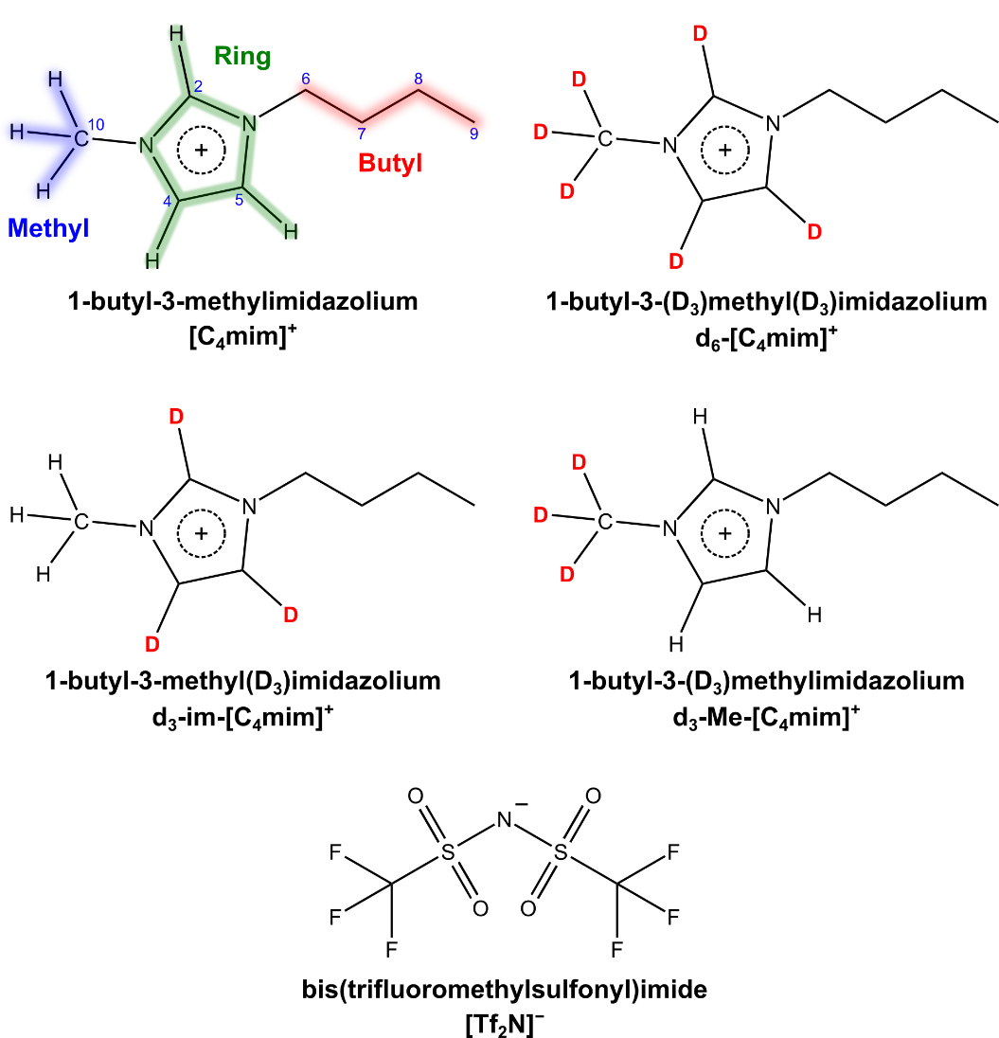
Figure 1: Ionic liquid ion structures, with names and abbreviations, of the four ionic liquid isotopologues that were prepared for this study. The numbering scheme used to index carbon atoms in the cation are explicitly shown for [C₄mim]⁺. See SI.I.B. for details of the ionic liquid synthesis.

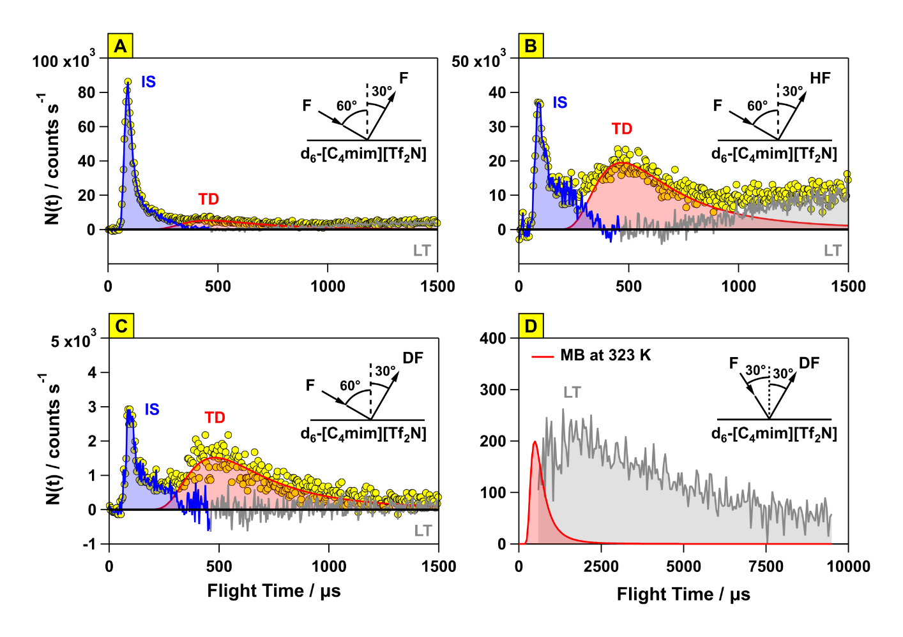
Figure 2: Representative time-of-flight (TOF) distributions of scattered F, HF, and DF are shown in yellow. F atoms traveling at ~6300 m s⁻¹ (⟨E_{i}⟩ = 384 kJ mol⁻¹) were directed toward the liquid-vacuum interface of d₆-[C₄mim][Tf₂N] at an incident angle of 60° for panels A-C and 30° for panel D. The TOF distributions have been separated into components corresponding to products that were impulsively scattered (IS) and thermally desorbed (TD). The residual TOF distributions show significant amplitude at long flight times (LT) beyond 700 μs. Panel D compares the LT DF TOF distribution with the TOF predicted by a Maxwell-Boltzmann (MB) distribution at 323 K.

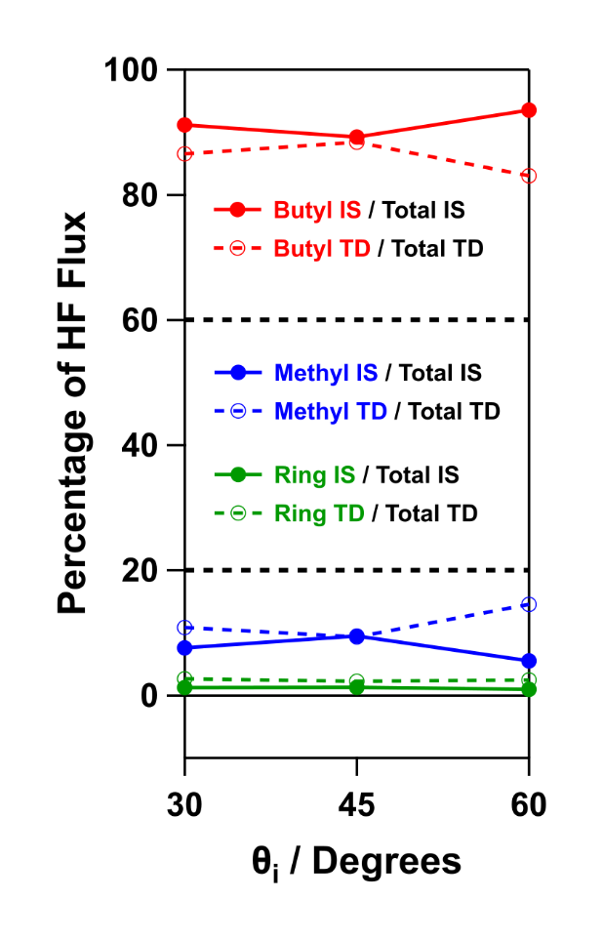
Figure 3: Site-resolved IS and TD HF flux percentages from the cation as a function of F-atom incident angle are expressed, respectively, as a fraction of total IS flux (solid circles with solid lines) or as a fraction of total TD flux (open circles with dashed lines). Black dashed lines mark the HF flux percentage predicted by stoichiometry for butyl (60%) and methyl or the ring (20%).

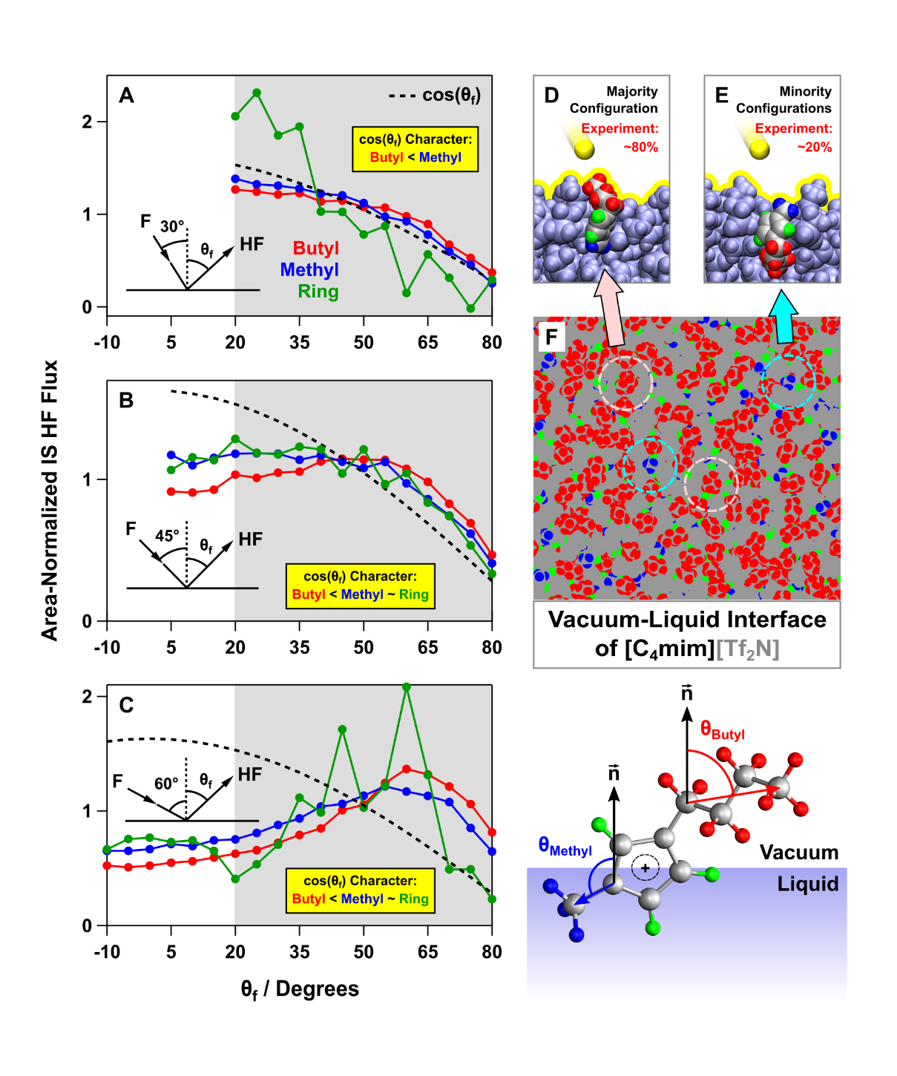
Figure 4. (A-C) IS HF angular distributions from the [C₄mim]⁺ butyl, methyl, and imidazolium ring groups. Each point represents the relative integrated product flux derived from a TOF distribution at a given θ_{i} and θ_{f}. Each trace has been scaled so the Cartesian area between θ_{f} = 20° and θ_{f} = 80° (range shown in gray) has a value of 1.0. (D, E) Side views of two cations at the liquid-vacuum interface, from a classical MD simulation. The majority configuration exposes the cation butyl group to vacuum, and the minority configuration exposes the cation methyl group to vacuum (yellow sphere: F-atom; yellow line: liquid-vacuum interface; light-blue: liquid atoms that do not belong to the cation). (F) Top-down view of the liquid-vacuum interface predicted by classical MD simulation (see SI.II.B) rendered as a series of opaque spheres, with all non-hydrogen atoms shown in gray. Representative surface sites that expose the butyl or methyl to vacuum are identified with dashed blue or pink circles, respectively. Note that the angular distributions from the ring at θ_{i} = 30° and 60° are noisier than the others because they are derived by subtraction (IS DF from d₆-[C₄mim][Tf₂N] minus IS DF from d₃-Me-[C₄mim][Tf₂N]). The n vector is labeled as macroscopic surface normal. θ_{Methyl} is defined as the angle between the interfacial normal (a vector normal to the interface and pointing toward the vacuum) and the N-C vector where C is the methyl carbon. θ_{Butyl} is defined as the angle between the interfacial normal and the vector between the butyl methylene carbon attached to N and the last butyl methyl carbon.

References and Notes:
(1) Welton, T. Room-temperature ionic liquids. Solvents for synthesis and catalysis. Chem. Rev. 1999, 99, 2071-2084.
(2) Hallett, J. P.; Welton, T. Room-temperature ionic liquids: Solvents for synthesis and catalysis. 2. Chem. Rev. 2011, 111, 3508-3576.
(3) Zhang, Q.; Shreeve, J. n. M. Energetic ionic liquids as explosives and propellant fuels: A new journey of ionic liquid chemistry. Chem. Rev. 2014, 114, 10527-10574.
(4) Armand, M.; Endres, F.; MacFarlane, D. R.; Ohno, H.; Scrosati, B. Ionic-liquid materials for the electrochemical challenges of the future. In Materials for sustainable energy, Dusastre, V., Ed. World Scientific: Singapore, 2010; pp 129-137.
(5) Zhou, F.; Liang, Y.; Liu, W. Ionic liquid lubricants: Designed chemistry for engineering applications. Chem. Soc. Rev. 2009, 38, 2590-2599.
(6) Karadas, F.; Atilhan, M.; Aparicio, S. Review on the use of ionic liquids (ILs) as alternative fluids for CO₂ capture and natural gas sweetening. Energy Fuels 2010, 24, 5817-5828.
(7) Urahata, S. M.; Ribeiro, M. C. C. Structure of ionic liquids of 1-alkyl-3-methylimidazolium cations: A systematic computer simulation study. J. Chem. Phys. 2004, 120, 1855-1863.
(8) Wang, Y.; Voth, G. A. Unique spatial heterogeneity in ionic liquids. J. Am. Chem. Soc. 2005, 127, 12192-12193.
(9) Canongia Lopes, J. N. A.; Pádua, A. A. H. Nanostructural organization in ionic liquids. J. Phys. Chem. B 2006, 110, 3330-3335.
(10) Wang, Y.; Voth, G. A. Tail aggregation and domain diffusion in ionic liquids. J. Phys. Chem. B 2006, 110, 18601-18608.
(11) Triolo, A.; Russina, O.; Bleif, H.-J.; Di Cola, E. Nanoscale segregation in room temperature ionic liquids. J. Phys. Chem. B 2007, 111, 4641-4644.
(12) Lynden-Bell, R. M. Gas-liquid interfaces of room temperature ionic liquids. Mol. Phys. 2003, 101, 2625-2633.
(13) Bhargava, B. L.; Balasubramanian, S. Layering at an ionic liquid-vapor interface: A molecular dynamics simulation study of [bmim][PF₆]. J. Am. Chem. Soc. 2006, 128, 10073-10078.
(14) Lynden-Bell, R. M.; Del Pópolo, M. Simulation of the surface structure of butylmethylimidazolium ionic liquids. Phys. Chem. Chem. Phys. 2006, 8, 949-954.
(15) Yan, T.; Li, S.; Jiang, W.; Gao, X.; Xiang, B.; Voth, G. A. Structure of the liquid-vacuum interface of room-temperature ionic liquids: A molecular dynamics study. J. Phys. Chem. B 2006, 110, 1800-1806.
(16) Hayes, R.; Warr, G. G.; Atkin, R. Structure and nanostructure in ionic liquids. Chem. Rev. 2015, 115, 6357-6426.
(17) Lovelock, K. R. J. Influence of the ionic liquid/gas surface on ionic liquid chemistry. Phys. Chem. Chem. Phys. 2012, 14, 5071-5089.
(18) Steinrück, H.-P. Surface science goes liquid! Surf. Sci. 2010, 604, 481-484.
(19) Smith, E. F.; Rutten, F. J. M.; Villar-Garcia, I. J.; Briggs, D.; Licence, P. Ionic liquids in vacuo: Analysis of liquid surfaces using ultra-high-vacuum techniques. Langmuir 2006, 22, 9386-9392.
(20) Zambelli, T.; Wintterlin, J.; Trost, J.; Ertl, G. Identification of the "active sites" of a surface-catalyzed reaction. Science 1996, 273, 1688-1690.
(21) Rendulic, K. D. The influence of surface defects on adsorption and desorption. Appl. Phys. A 1988, 47, 55-62.
(22) Hendriksen, B. L. M.; Ackermann, M. D.; van Rijn, R.; Stoltz, D.; Popa, I.; Balmes, O.; Resta, A.; Wermeille, D.; Felici, R.; Ferrer, S.; Frenken, J. W. M. The role of steps in surface catalysis and reaction oscillations. Nat. Chem. 2010, 2, 730-734.
(23) Dahl, S.; Logadottir, A.; Egeberg, R. C.; Larsen, J. H.; Chorkendorff, I.; Törnqvist, E.; Nørskov, J. K. Role of steps in N₂ activation on Ru(0001). Phys. Rev. Lett. 1999, 83, 1814-1817.
(24) Shin, S.; Willard, A. P. Three-body hydrogen bond defects contribute significantly to the dielectric properties of the liquid water–vapor interface. J. Phys. Chem. Lett. 2018, 9, 1649-1654.
(25) Sciortino, F.; Geiger, A.; Stanley, H. E. Effect of defects on molecular mobility in liquid water. Nature 1991, 354, 218-221.
(26) Sciortino, F.; Geiger, A.; Stanley, H. E. Network defects and molecular mobility in liquid water. J. Chem. Phys. 1992, 96, 3857-3865.
(27) Nilsson, A.; Pettersson, L. G. M. The structural origin of anomalous properties of liquid water. Nat. Commun. 2015, 6, 8998.
(28) Rivera-Rubero, S.; Baldelli, S. Surface characterization of 1-butyl-3-methylimidazolium Br⁻, I⁻, PF₆⁻, BF₄⁻, (CF₃SO₂)₂N⁻, SCN⁻, CH₃SO₃⁻, CH₃SO₄⁻, and (CN)₂N⁻ ionic liquids by sum frequency generation. J. Phys. Chem. B 2006, 110, 4756-4765.
(29) Santos, C. S.; Baldelli, S. Gas-liquid interface of room-temperature ionic liquids. Chem. Soc. Rev. 2010, 39, 2136-2145.
(30) Martinez, I. S.; Baldelli, S. On the arrangement of ions in imidazolium-based room temperature ionic liquids at the gas-liquid interface, using sum frequency generation, surface potential, and surface tension measurements. J. Phys. Chem. C 2010, 114, 11564-11575.
(31) Lovelock, K. R. J.; Villar-Garcia, I. J.; Maier, F.; Steinrück, H.-P.; Licence, P. Photoelectron spectroscopy of ionic liquid-based interfaces. Chem. Rev. 2010, 110, 5158-5190.
(32) Hantal, G.; Voroshylova, I.; Cordeiro, M. N. D. S.; Jorge, M. A systematic molecular simulation study of ionic liquid surfaces using intrinsic analysis methods. Phys. Chem. Chem. Phys. 2012, 14, 5200-5213.
(33) Hantal, G.; Cordeiro, M. N. D. S.; Jorge, M. What does an ionic liquid surface really look like? Unprecedented details from molecular simulations. Phys. Chem. Chem. Phys. 2011, 13, 21230-21232.
(34) Villar-Garcia, I. J.; Fearn, S.; De Gregorio, G. F.; Ismail, N. L.; Gschwend, F. J. V.; McIntosh, A. J. S.; Lovelock, K. R. J. The ionic liquid-vacuum outer atomic surface: A low-energy ion scattering study. Chem. Sci. 2014, 5, 4404-4418.
(35) Nakajima, K.; Ohno, A.; Hashimoto, H.; Suzuki, M.; Kimura, K. Observation of surface structure of 1-alkyl-3-methylimidazolium bis(trifluoromethanesulfonyl)imide using high-resolution Rutherford backscattering spectroscopy. J. Chem. Phys. 2010, 133, 044702.
(36) Tesa-Serrate, M. A.; Marshall, B. C.; Smoll, E. J., Jr.; Purcell, S. M.; Costen, M. L.; Slattery, J. M.; Minton, T. K.; McKendrick, K. G. Ionic liquid-vacuum interfaces probed by reactive atom scattering: Influence of alkyl chain length and anion volume. J. Phys. Chem. C 2015, 119, 5491-5505.
(37) Tesa-Serrate, M. A.; Smoll, E. J., Jr.; D’Andrea, L.; Purcell, S. M.; Costen, M. L.; Bruce, D. W.; Slattery, J. M.; Minton, T. K.; McKendrick, K. G. Hiding the headgroup? Remarkable similarity in alkyl coverage of the surfaces of pyrrolidinium- and imidazolium-based ionic liquids. J. Phys. Chem. C 2016, 120, 27369-27379.
(38) Marshall, B. C.; Smoll, E. J., Jr.; Purcell, S. M.; Costen, M. L.; McKendrick, K. G.; Minton, T. K. Scattering dynamics of oxygen atoms on imidazolium tetrafluoroborate ionic liquid surfaces: Dependence on alkyl chain length. J. Phys. Chem. C 2016, 120, 12472-12483.
(39) Wu, B.; Zhang, J.; Minton, T. K.; McKendrick, K. G.; Slattery, J. M.; Yockel, S.; Schatz, G. C. Scattering dynamics of hyperthermal oxygen atoms on ionic liquid surfaces: [emim][NTf₂] and [C₁₂mim][NTf₂]. J. Phys. Chem. C 2010, 114, 4015-4027.
(40) Minton, T. K.; Giapis, K. P.; Moore, T. Inelastic scattering dynamics of hyperthermal fluorine atoms on a fluorinated silicon surface. J. Phys. Chem. A 1997, 101, 6549-6555.
(41) Zhang, J.; Garton, D. J.; Minton, T. K. Reactive and inelastic scattering dynamics of hyperthermal oxygen atoms on a saturated hydrocarbon surface. J. Chem. Phys. 2002, 117, 6239-6251.
(42) Smoll, E. J., Jr.; Tesa-Serrate, M. A.; Purcell, S. M.; D'Andrea, L.; Bruce, D. W.; Slattery, J. M.; Costen, M. L.; Minton, T. K.; McKendrick, K. G. Determining the composition of the vacuum-liquid interface in ionic-liquid mixtures. Faraday Discuss. 2018, 206, 497-522.
(43) The majority of the quantitative discrepancy between our cation conformation distribution and this nonpolarizable MD simulation of [C₄mim][PF₆] is probably the result of trends associated with anion size and temperature. Increasing anion size from [Cl]⁻ to [PF₆]⁻ and increasing temperature from 298.15 to 330.15 K are observed to increase conformation I at the expense of conformation II.
(44) Gibson, K. D.; Isa, N.; Sibener, S. J. Experiments and simulations of hyperthermal Xe interacting with an ordered 1-decanethiol/Au(111) monolayer: Penetration followed by high-energy, directed ejection. J. Phys. Chem. A 2006, 110, 1469-1477.
(45) Tasic, U.; Troya, D. Theoretical study of the dynamics of hyperthermal collisions of Ar with a fluorinated alkanethiolate self-assembled monolayer. Phys. Chem. Chem. Phys. 2008, 10, 5776-5786.
(46) Gibson, K. D.; Killelea, D. R.; Becker, J. S.; Yuan, H.; Sibener, S. J. Energetic ballistic deposition of volatile gases into ice. Chem. Phys. Lett. 2012, 531, 18-21.
(47) Gibson, K. D.; Killelea, D. R.; Yuan, H.; Becker, J. S.; Pratihar, S.; Manikandan, P.; Kohale, S. C.; Hase, W. L.; Sibener, S. J. Scattering of high-incident-energy Kr and Xe from ice: Evidence that a major channel involves penetration into the bulk. J. Phys. Chem. C 2012, 116, 14264-14273.
(48) Pratihar, S.; Kohale, S. C.; Yang, L.; Manikandan, P.; Gibson, K. D.; Killelea, D. R.; Yuan, H.; Sibener, S. J.; Hase, W. L. Chemical dynamics simulations of high energy xenon atom collisions with the {0001} surface of hexagonal ice. J. Phys. Chem. C 2013, 117, 2183-2193.
(49) Tasić, U. S.; Yan, T.; Hase, W. L. Dynamics of energy transfer in collisions of O(³P) atoms with a 1-decanethiol self-assembled monolayer surface. J. Phys. Chem. B 2006, 110, 11863-11877.
(50) Bernardes, C. E. S.; Shimizu, K.; Lopes, J. N. C.; Marquetand, P.; Heid, E.; Steinhauser, O.; Schröder, C. Additive polarizabilities in ionic liquids. Phys. Chem. Chem. Phys. 2016, 18, 1665-1670.
(51) Pádua, A. A. H. Resolving dispersion and induction components for polarisable molecular simulations of ionic liquids. J. Chem. Phys. 2017, 146, 204501.
(52) Lemkul, J. A.; Roux, B.; van der Spoel, D.; MacKerell, A. D. Implementation of extended Lagrangian dynamics in GROMACS for polarizable simulations using the classical Drude oscillator model. J. Comput. Chem. 2015, 36, 1473-1479.

