Title Page
Persian Paintings as Documents of Social History: Images of Craftsmen at Work
Abstract
The virtual absence of written sources about the construction process in the medieval period makes Persian paintings a useful primary source. A small sub-set of paintings depict the process of building, six of which are examined in close detail, from a broad geographic range and dating from the period spanning the fourteenth to the sixteenth centuries. These include a painting attributed to Siyah Qalam, paintings from Herat, and a series of images from the Akbar-nāme. By taking a wide view, observations about building sites, based on multiple unconnected examples, can help to illuminate the poorly understood construction process across the pre-modern Iranian world.
Keywords
Painting, Construction, Behzād, Siyah Qalam, Akbar-nāme
Acknowledgments
The genesis of this article came as a result of a conversation with Professor Robert Hillenbrand, and the article is dedicated to him. It would not have been possible to write this article without the support of the Leverhulme Trust and the University of Edinburgh.

Persian Paintings as Documents of Social History: Images of Craftsmen at Work

This article addresses a selection of previously published, and in some cases well known, paintings datable to the period spanning the fifteenth and sixteenth centuries. They are used as tools to illuminate the rather murky world of construction and site management in late medieval and early modern Iran, Central Asia and India. This approach to understanding the working methods of builders can be applied in parallel to the reverse engineering of standing structures and the close examination of tool marks on building materials. All three methods, along with the study of contemporary written sources, where available, are required in order to get as full a picture as possible of the construction process in the wider Iranian world in the pre-modern period. The focus here is on the visual analysis of paintings from across a broad temporal and spatial span in order to contribute to the wider understanding of the working methods of craftsmen and labourers.
From the fourteenth century onwards, the depiction of Islamic architecture in Persian painting was almost ubiquitous. The sheer diversity of the representations of architecture in Persian painting can be seen in the catalogue for an exhibition of items from the collection of the Aga Khan. The exhibition was largely focused on the images of architecture in painting, along with a number of examples of architectural revetments removed from buildings. In contrast, depictions of the process of erecting buildings are far less common. By conducting close visual analysis on a selection of paintings, an understanding of the tools and working methods which are otherwise virtually undocumented, can emerge. Through these examples of contemporaneous evidence, little-known aspects of social history in the pre-Modern Islamic world can become somewhat better known.
When it comes to the study of the practical process of construction, contemporary written sources from the medieval period are virtually non-existent. The earliest surviving treatise on architecture is an Ottoman document dated to the seventeenth century. Although there is a twelfth-century manual of sizes and spans of various building materials from Spain, and al-Kāshī’s fifteenth-century manual on measuring muqarnas, neither give much information about the nature of site supervision, hierarchy, tools and methods. In addition to the close study of surviving structures, analysis of paintings depicting the construction process makes it possible to build up a picture of the roles and relative importance of the differently skilled craftsmen, labourers and administrators. In conjunction with archaeological findings, the paintings provide importance evidence for understanding a little more about the people, tools and processes involved in the erection of monumental architecture across the wider Iranian world in the late medieval and early modern periods.
It may seem somewhat paradoxical to use manuscripts which were, in many cases, among the most elite of artistic remains and produced for royal courts in order to understand the working methods and dress of lowly tradesmen, craftsmen and labourers. However, it was these individuals, largely nameless and undocumented, who were responsible for the construction of the monuments to vanity and, in some cases megalomania, that are depicted in the paintings. Although there was a tendency towards the erection of ever-larger buildings in the post-Mongol period across the Islamic world, no other dynasty was as consistent in the pursuit of such a goal as the Timurids. An example of this can be seen in the painting of the construction of the Timurid Great Mosque in Samarkand, which is the second of the images examined below.
A major imbalance of proportion between the depiction of the buildings and the craftsmen erecting them is to be expected in such small format images, given the sheer scale of the subject structures. However, the accuracy of the depiction of the tools, processes and hierarchical divisions should not be doubted, as the same items and techniques can be seen in images produced at great distances, both in terms of time and space, from each other. In the selected images craftsmen can be seen working with wood, stone and brick, as well as the necessary mortar to affix the materials together, and the scaffolding required to access the upper reaches of buildings. In most of the images, alongside the depiction of many different tools, the hierarchy of trades and supervisors is clearly delineated in the sartorial details. In addition, the diversity of both clothing styles and skin colour shows the wide geographic area from which craftsmen and labourers were drawn for construction projects in the medieval and early-modern period across Iran, Central Asia and India.
I. The Corpus
There is a very limited corpus of painted images which show the construction process, with Titley only listing three pre-eighteenth-century images of building scenes in her encyclopaedic catalogue of the collections of the British Library and the British Museum. One of these, showing the building of the Castle of Khavarnak, is examined in detail below.
The first of the paintings under discussion is H.2153, fol.141v, held in the Topkapı Sarayı Müzesi in Istanbul. It is one of a group of images categorised as the work of Siyah Qalem (black pen) compiled together in one of the Yaʿqub Beg albums, and is perhaps the most enigmatic and intriguing, as well as the oldest, of the images to be addressed in this article.
The second painting to be examined is the double-page image of the building of the Great Mosque at Samarkand, from Sultan-Husayn’s copy of the Zafarnāma by Sharaf al-Dīn ʿAlī Yazdī. Held by the library of John Hopkins University in Baltimore, the image is generally assumed to be an early work of Kamāl ud-Dīn Behzād, and was painted in Herat between the years of 1480 and 1485. The third image to be discussed is similar in both style and composition to the double-page Samarkand mosque painting, but it is a single-page image and was executed slightly later, being dated to 1494-95. The painting depicts the construction of the Castle of Khwarnaq. It is from Sultan ʿAlī Mirza Barlas’s copy of Nizamī’s Khamsa and is now in the British Library in London. In contrast to the depiction of actual structures, a page from a Falnāme (Book of Divinations) of Jaʿfar al-Sādiq, made for the Safavid ruler Tahmāsp I between 1550 and 1560, depicts Iskander overseeing the building of the wall to keep Gog and Magog out. In the painting, attributed to ʿAbdal-Aziz, the tools and processes are depicted fairly accurately, but with the work being done by divs. This is an example of the artist bridging the world between reality and fantasy, using the standard means of depicting an otherwise commonly seen activity.
The final four paintings to be examined are Persian in style, but were executed in India. They are from the earliest surviving copy of the Akbar-nāme, held in the Victoria and Albert Museum in London. The first image, depicting the construction of the Mughal Emperor Akbar’s new city, Fatehpur Sikri, appears to have been designed by Tulsi and painted by Bahwani. The second image, painted by Miskina, along with Sarwan and Tulsi Kurd, depicts the use of both stone and brick, and shows the construction of the water gate of the Agra fort, which was begun in 1564. They all appear to date from between 1586 and 1589, and are from the second volume of the Akbar-nāme, covering events which occurred during the period from 1560 to 1578. The final two paintings are from the same volume, with one depicting the building of Agra and the other Akbar supervising the construction of Fatehpur Sikri. The first volume is missing, while the third is either missing or was never finished. These images represent just a sampling of the corpus of Mughal paintings depicting the construction process, of which thirteen are known to survive.
II. Siyah Qalam and Central Asia
Much ink has been spilled concerning the origin and provenance of the so-called Siyah Qalam paintings, now pasted into a series of four albums in the Topkapı Sarayı Müzesi in Istanbul, but little is known with any degree of certainty. Rogers attributes a number of images in both H.2153 and H.2160 to the fifteenth century, and posits production sites as far afield as east of Herat to Tabriz. In contrast, Çağman has argued that the paintings were all produced at some point in the fourteenth century, somewhere in Central Asia. Leaving aside the details of the production of the painting, it is the depiction of craftsmen on the verso of folio 141, in the album catalogued H.2153, which is of interest in this context.
The painting, which measures 26.8 centimetres by 35.2 centimetres, features nine figures, two of which are kneeling and holding hands, and which appear to have a supervisory role (Fig. 1). They are the only figures wearing shoes and although all the figures have belts, theirs are the most elaborate. The remaining seven figures are barefoot, and are engaged in various activities related to the construction of buildings. Although it has previously been described as a carpentry scene, the use of metal rings, bar chains and leather straps to carry the large panels, as well as the need for two men to move them, makes it far more likely that the panels shown in the painting are heavy marble, or another form of stone revetment, rather than wood. There is also a mason’s mallet shown on the ground.
The figures are mostly bearded and there is some rather enigmatic eye contact between the protagonists. They all appear to be casting suspicious glances at each other, and as a result the artist has been able to introduce a degree of individuality and emotion into a scene in which most of the figures are otherwise very similar in appearance and execution. A number of tools are depicted, including saws, the aforementioned mason’s mallet and what appears to be either a square or an angle finder. However, only one figure is using a tool, namely the seated figure sawing wood, using his foot as a brace. The rest of the figures are carrying materials, one with a log and the rest with what appear to be marble panels. There is a degree of conformity regarding the clothing of the figures, with the pattern being executed in the same manner across the different colour tones. All have the same exaggerated folds, but with five in black, three in red and one in reddish-brown, with no clear distinction in terms of dress between the various roles or hierarchy. Where there is a significant variation is in the style of headgear, with four very different types depicted. These include a white cap with back spots, a black fur rim and a tassel on top, worn by four of the figures, along with long black hats, worn by three. One figure is obscured, one has a red hat with a tassel, and one wears a black fur hat with three upward-pointing lobes. The significance of the differences in headgear, if any, remains unclear, but one might speculate that they were an indication of different tribal or regional origins.
While the albums are well studied, this individual painting has received very little scholarly attention. It has been pointed out that the saw, in the lower left of the image, is of the same shape as one used for a rather brutal operation in an illustrated Shah-nāma, dated 1494 and now in the Bodleian Library in Oxford. In addition, the depiction of four of the figures with red beards has led to the suggestion that the figures are evidently Northerners, and most probably Russians who were prisoners. This, Rogers argues, would make the image an example of reportage. However, so little is known about the image that it seems hard to be certain as to the specific origin of the individual masons. Apart from these observations very little visual analysis appears to have been conducted on the painting. The surface of the image is very creased, worn and abraded, but the image remains remarkably clear.
The appearance of the log being carried under the right arm of the figure on the far right of the composition hints at the existence of managed forests in the region in which the painting was produced. The branches have not recently been cut off, as the bark can be seen to have been depicted as having grown out around the previously removed limbs. The significance of this seemingly minor detail is that it provides evidence of a programme of forest management and silviculture, rather than there having been haphazard removal of trees from forests at random for use in the construction business. The same thing can also be seen in the poles used for the scaffold in the arch in the painting showing the construction of the Castle of Khwarnaq (Fig. 4). It is little details such as this which allow for glimpses into the otherwise virtually undocumented construction business of the wider Iranian world in the late medieval period.
In addition to the main section of the painting, depicting the craftsmen, there is a secondary image affixed to the same folio, but orientated at ninety degrees (Fig. 2). It features two standing figures, in red robes and black hats, engaged in some sort of discourse, and holding unusual-looking objects. While unrelated to the content of the craftsmen image, it is clearly by the same hand, indicated by the identical treatment of the robes, and by the figure on the right also having a distinctive red beard. The recto of H.2153 141 depicts demons rather than humans, but interestingly they too are shown at work. They use a two-man (or in this case a two-demon) saw to cut vertically through the stump of a tree. It is unusual in the corpus of Siyah Qalam paintings in that it shows part of the ground rather than having the figures floating in free space, as seen in most of the other images in the manuscript. It also appears to be the only other image in the album to depict one of the processes related to the construction of buildings. The depiction of div-like creatures working on construction projects is seen later, including in a painting produced for Shah Tahmasp I which shows Iskandar supervising the construction of a wall to keep out Gog and Magog, and is clearly part of a longer-term tradition.
It has been argued that the images in Hazine 2153 originally took the form of scrolls and should thus be seen as independent pictures in their own right, not illustrations to literary works. This is in contrast to the later images of building work addressed here, all of which are, without doubt, illustrations to texts rather than possibly having been stand-alone works of art when first conceived.
Figure 1: Craftsmen at work, H.2153, fol.141v, Topkapı Sarayı Müzesi, Istanbul
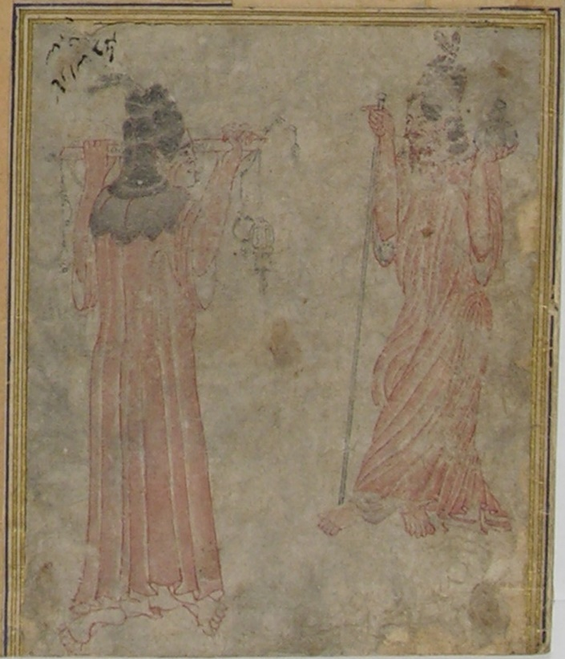
Figure 2: Detail of H.2153, fol.141v showing two standing figures, Topkapı Sarayı Müzesi, Istanbul
III. The Building of the Great Mosque of Samarkand
Unlike the later images to be discussed, the double-page painting showing the construction of the Great Mosque of Samarkand does not feature such a clear sartorial delineation of the hierarchy of the different craftsmen and labourers. A wide array of individuals, including labourers, craftsmen and supervisors, are shown wearing white turbans with a red centre, a style of head dress later referred to as a qizilbash. However, the labourers or seated workers are for the most part depicted wearing caps.
A wide array of tools are depicted, including a rare image of a medieval plane, in the hand of the carpenter in the top-centre of the left-hand image (Fig. 3). The dress of the craftsmen shown holding the plane is of a type not seen in any of the other images. His grey tunic is done up on the left-hand side with a series of three black bows running vertically. In addition, another carpenter, dressed in blue, is using a pistol-grip saw of a kind not commonly seen in paintings of craftsmen. Beside the brick cutter on the left of the left-hand page is a square and what appears to be a short rule. As with the other images of craftsmen that are discussed in this article, there is a wide ethnic diversity to be seen in the painting, indicated by the array of skin tones, as well as the different styles of dress and facial hair. In the context of the construction of the Samarkand mosque, this diversity is also attested to in the written sources, including the text of Sharaf al-Dīn’s Zafarnāme, to which the painting is an illustration. The mosque was built following Timur’s campaign in India in 1398, from where the elephant in the bottom left corner of the left-hand page is likely to have been brought. It has been previously noted that the five well-dressed men standing in the upper section of the painting, three of which have a staff in their hands, are the Timurid princes and emirs responsible for overseeing the construction of the mosque. As is common in Persian paintings of the period, the figures do not diminish in size from the foreground to the background and there is no diminution in scale of the structures depicted as the picture plane recedes.
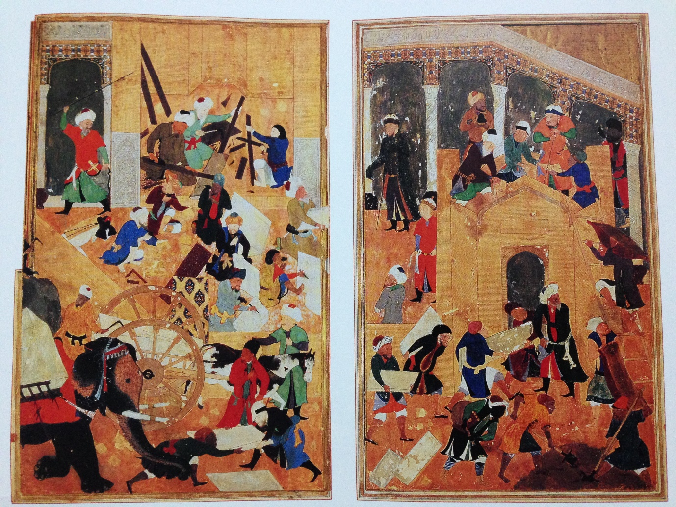
Figure 3: The Building of the Great Mosque of Samarkand, Herat 1480-85, John Hopkins University, Baltimore, John Work Garrett Collection, folios 359v-360r
IV. Building the Castle of Khwarnaq
The image described as The Building of the Castle of Khwarnaq (Fig. 4), while executed on a single rather than a double page, clearly draws on the composition of the earlier The Building of the Great Mosque of Samarkand painting. The similarities include the pair shovelling mortar in the foreground, the large brick iwan with a ladder on the right-hand side, brick cutters kneeling in the centre-left and craftsmen laying bricks at the apex of the arch. The two brick cutters in the Khwarnaq painting are shown using two different tools, one looks like a small axe, while the other has a double-headed picking hammer, There is a wide range of skin tones visible in the array of workers, indicating, as with other images, the diverse geographic origins of the craftsmen working on construction sites. The veracity of the processes depicted in the image can be checked against surviving unfinished and damaged structures of the period, such as the Khwaja Aḥmad Yasawi tomb complex in Turkistan (formerly Yasi), in southern Kazakhstan (Fig. 5). It was begun in 1389 but never completed, and has a vast entrance iwan which retains embedded wooden scaffold supports, of the kind seen in the Khwarnaq painting.
The painting includes a mix of both bearded and clean-shaven figures. Two of the labourers, one mixing mortar and another carrying a basket full of mortar, appear to be branded on the lower right leg. Both brands consist of a horseshoe shape, with the fully clothed figure in the lower left corner having a dot within the horseshoe, and the topless figure at the base of the ladder having the dot located lower down. The significance of these marks is unclear, but they appear to be ownership marks on slaves, and demonstrate an astonishing level of detail, given the fact that the entire painting measures only 17 centimetres by 12.4 centimetres. The artist has depicted two stages of brick cutting, with a seated pair of workers at the base of the wall on the left rough-cutting the bricks, while a bricklayer stands on the top of the scaffolding fine-tuning a brick to fit in a specific space. Unlike the other paintings depicting the construction process, Or. 6810, folio 154 verso does not appear to include an obvious supervisor or site manager.
The sartorial hierarchy of the construction site is displayed in the Khwarnaq image by the two most highly skilled individuals, namely the two bricklayers, being the only two figures wearing turbans. The figure on the scaffold is one of only two in the composition shown wearing footwear. Although the other figure wearing shoes, shown standing at the base of the scaffolding about to throw a brick up to the next level, appears to be a labourer, his tan boots do not stand out in the same way as the rather sharp black shoes of the upper figure laying bricks. Despite this one exception, it appears to be the case that in the context of the medieval Islamic building site, the wearing of shoes was generally a marker of seniority and greater wealth,.
While not depicting a contemporary structure, as the slightly earlier painting of the Samarkand mosque does, the Khwarnaq painting from Nizami’s Khamsa successfully creates the impression of a dynamic building site, with a large workforce depicted in great detail undertaking multiple roles in the construction process.
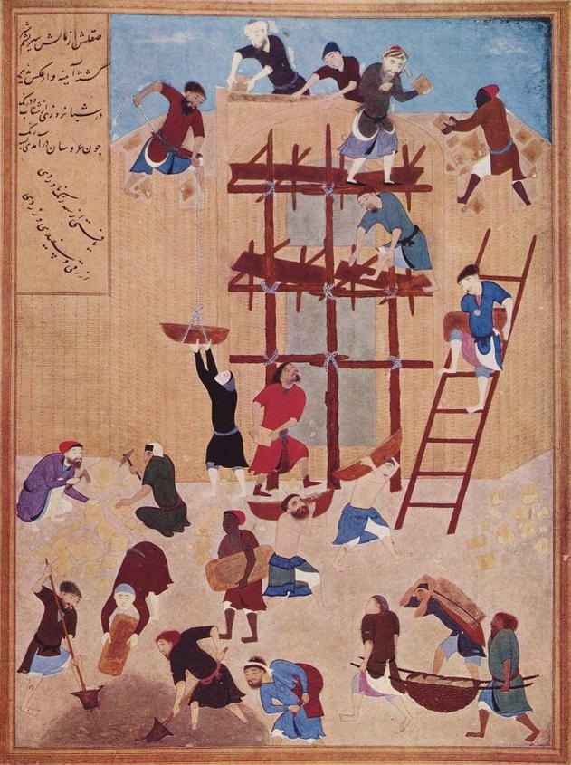
Figure 4: The Building of the Castle of Khwarnaq (Herat 1494-95), British Library, London, Or. 6810, folio 154v
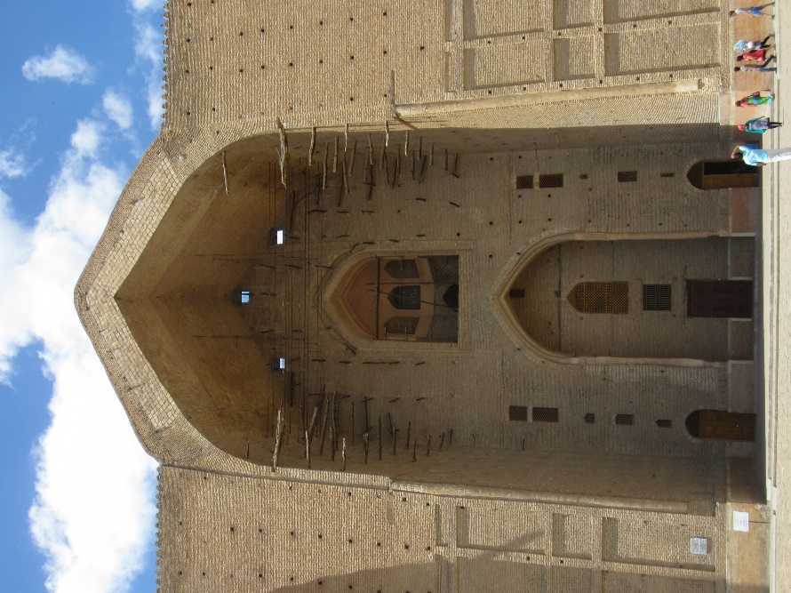
Figure 5: The unfinished south portal of the Ahmad Yasawi complex (1389), in Turkistan, Kazakhstan
Another painting from the same period which shows construction work can be found in the Metropolitan Museum of Art, New York. Painted in Herat in 1487 and illustrating a copy of ʿAṭṭār’s Mantiq al-tair (Language of the Birds), the image, attributed to Kamāl ud-Dīn Behzād, depicts work on a low tomb within an enclosed graveyard in the upper portion (Fig. 6). Two workers can be seen mixing mortar, with one using a long-handled shovel and the other pouring water from an amphora. As with almost all the other images under discussion, excepting the Siyah Qalam painting, the shovel has a widened top to provide a step on each side. Another worker is carrying a stone slab, while one is passing another slab to a figure standing in the grave, with a superintendent with rather more elaborate headgear looking on. It is a common pattern across the images of building sites for the figures to be depicted with significantly different styles of dress, facial hair and headgear. In addition, the worker shown passing the slab into the hole has far darker skin than the other five. Unlike most other images, all but one of the figures whose feet are visible is wearing shoes. The significance of this is unclear, as in most of the other paintings with similar subject matter it is only the more senior figures that are depicted wearing any kind of footwear. Another aspect which makes this painting slightly more unusual is the fact that it is not an elite or monumental building which is being depicted, but the construction of a simple low grave. Furthermore, it is only the upper section of the painting, with the main element of the composition consisting of a funeral procession (Fig. 7).
Figure 6: Detail of Funeral Procession from the Language of the Birds, Metropolitan Museum of Art, New York, acc. no. 63.210.35
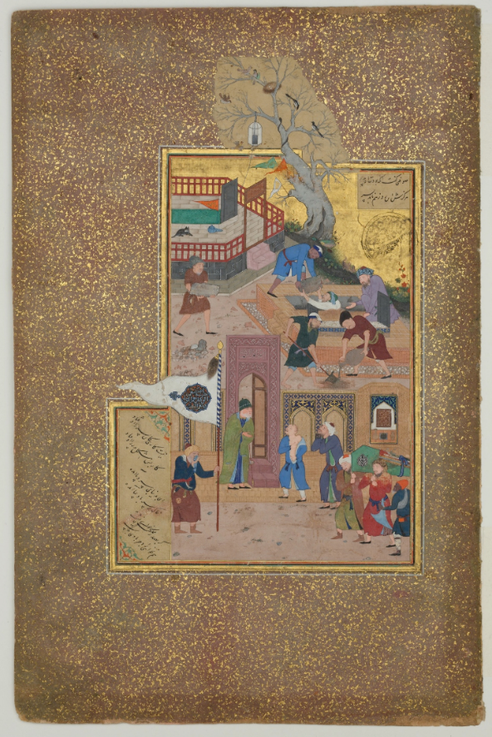
Figure 7: Funeral Procession from the Language of the Birds, Metropolitan Museum of Art, New York, acc. no. 63.210.35
V. The Akbar-nāme and Mughal India
The final group of paintings showing craftsmen working on construction sites which will be examined here were produced in Mughal India in the late-sixteenth century. All four are from an early manuscript of the Akbar-nāme, held by the Victoria and Albert Museum in London, which contains four paintings showing building scenes. While the paintings themselves were executed in the Persian style, the main material for the construction of monumental buildings in India was stone rather than brick, and it is the techniques of stone working which dominate the images. Unlike the earlier paintings, which depict either fantastic, unidentified, or largely historical scenes, the following examples show contemporaneous events, and thus can be seen as closer to reportage.
The first painting to be addressed depicts the construction of the city of Fatehpur Sikri, near Agra (Fig. 8). The main elements which are relevant to this discussion are the depiction of the scaffold frame in the doorway, the working of stones, mixing mortar, and its transport in baskets to the stone setters. As with the other images examined above, there is a clear delineation of site hierarchy, and this is primarily indicated sartorially. The poor, unskilled labourers wear the dhoti (Indian loincloth), while the more skilled stone setters are better dressed, and the supervisory figures are shown wearing even finer clothing. There is less variation in the styles of headgear than can be seen in the paintings examined earlier, with almost all but the lowliest of labourers depicted wearing a white turban. There is also a greater degree of homogeneity regarding the skin colour and styles of facial hair, with most figures being either bearded or moustachioed. This does suggest that, unlike the construction of the Timurid mosque in Samarkand, the Mughals were using more local labour, rather than bringing large numbers of craftsmen from distant lands.
On the far left centre of the image is a sāqīyā (Persian wheel). The depiction of such a device for drawing water from wells for use in palaces demonstrates the complex hydraulic engineering works executed in the process of palace construction.
At the bottom of the painting, above the now black oxidised but originally silver river, two stone masons are shown with chisels and hammers working on a large stone slab. Beside them another craftsman mixes mortar, while a well-dressed supervisor holding a rod directs the labourers carry baskets of material on their heads. The image is given a certain dynamism by the addition of a wall bisecting the picture plane diagonally, thus forcing the action to the bottom and the right, and leading the eye up the image in a zig-zag pattern. The technique of leading the eye of the viewer diagonally up the image can be seen in all four of the Mughal images under discussion, although in the other three it is through the use of a large ramp partially bisecting the picture plane.
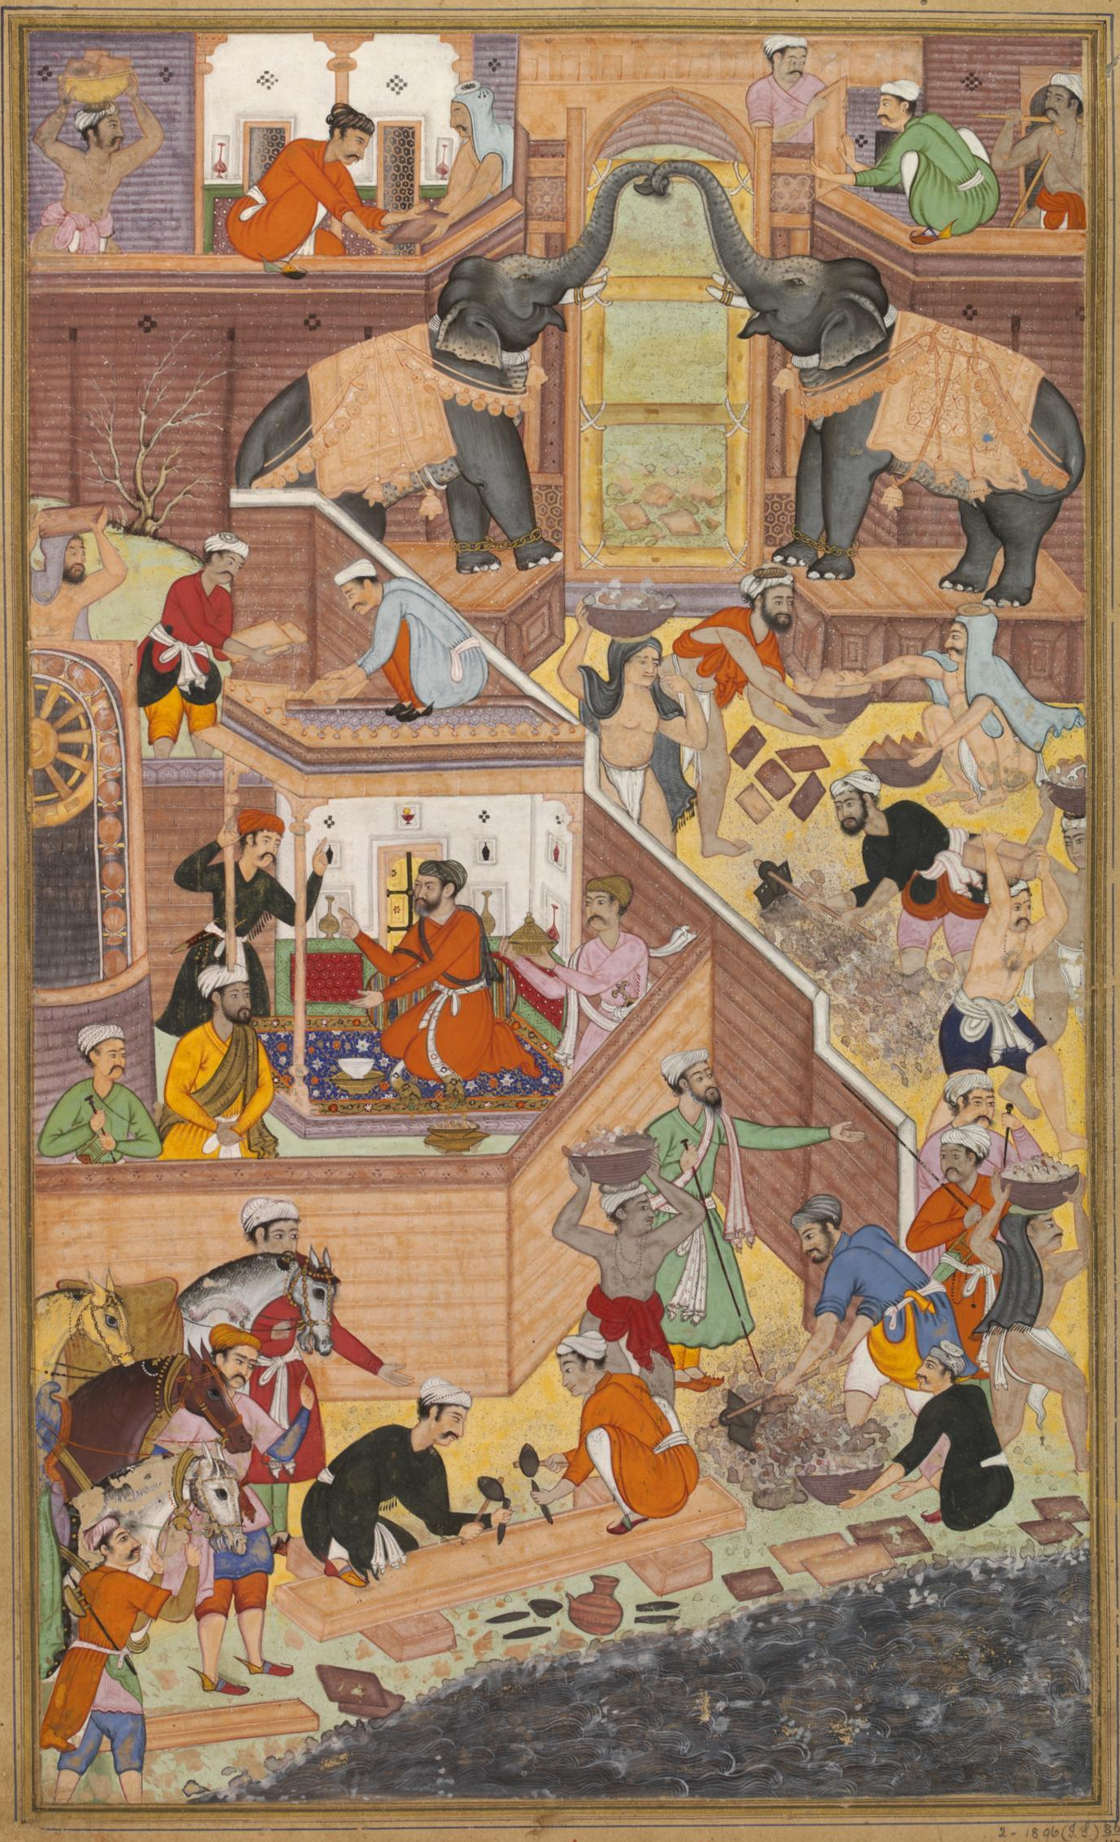
Figure 8: Building Fatehpur Sikri, from a copy of the Akbar-nāme, The Victoria and Albert Museum, London, I.S 2-1896 folio 86
The second painting to be discussed from the Victoria and Albert Museum’s copy of the Akbar-nāme shows the construction of the water gate at Agra fort (Fig. 9), a structure which was erected in 1564. The image depicts a wide array of craftsmen involved in the construction process, but it is the depiction of the splitting and moving of large stones, as well as the transportation and preparation of materials, that are of particular interest. The large stones at the bottom left have a series of iron wedges inserted into small holes, which are being driven in with a large hammer, in order to force the rock to split in a straight line. The finished blocks can be seen being carried up the ramp, with two pairs of rather burly looking men, each pair carrying a large pole, with rope slings around the stone, on their shoulders.
There is a clear sartorial hierarchy in the image, with the labourers being barefoot and clad in simple dhotis, while the more skilled workers and supervisors are depicted wearing shoes and far better quality clothing. Unlike the earlier images, the painting of the construction of the water gate shows a proportion of the workforce to be women. Paintings such as this are the only evidence for the presence of female labour being used on Mughal construction sites, as none of the literary sources mention them. Three of the women are shown carrying mortar in wicker baskets on their heads, while the fourth, at the top right of the image, appears to be sieving lime for the production of mortar. Pictured just below her is a man dressed in a similar manner to the bricklayers, who is a watercarrier, shown dispensing water from a skin to a labourer wearing a black cloth on his head. The relatively fine clothing suggests the water carrier had a higher status than the dhoti wearing labourers, of which there are sixteen, representing nearly half of the total number of individuals in the painting.
The gate itself still has the large square put-logs projecting out, with a scaffolding plank laying between them, in a similar manner to the surviving elements at the unfinished Yasawi Mausoleum complex in Turkistan, shown in Figure 5. In addition, the centring built to allow for the construction of the arch is depicted as well. Although the majority of the building is in stone, above the entrance arch a dome is shown being built from brick, with concentric rings of bricks being set in place by the brick-layers.
At the bottom of the painting a boat is depicted, loaded with sang ghulūla (irregular chunks of stone). These were the raw materials for the ashlars which were, according to ʿĀrif Qandahāri, brought to the site along the river from Delhi in the north.
It is images such as this which demonstrate the syncretic and hybrid nature of Mughal architecture, and the Islamic architecture of many of the other Indian Sultanates, which brought together brick forms and glazed decoration from Iran and Central Asia, and integrated them into the indigenous lithic traditions of India.
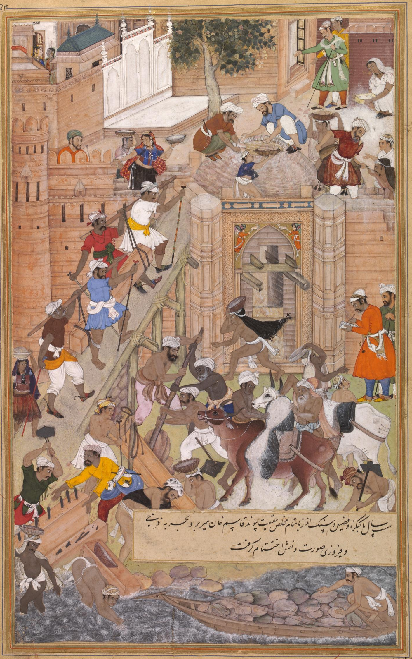
Figure 9: Building the water gate at Agra Fort, from a copy of the Akbar-nāme, The Victoria and Albert Museum, London, I.S 2-1896 folio 46
Another image of the construction of the Agra fort, from the same volume, follows a very similar compositional convention as the water gate image. It has a ramp running up diagonally from the bottom left, stones being split in the corner, and the preparation of mortar in the central foreground area, along with oxen and boats used for the delivery of materials (Fig. 10 (L)). The one major difference is the lack of any women involved in the workforce in the folio 45 painting. The fourth image, showing Akbar supervising the construction of Fatehpur Sikri, follows a similar compositional convention as the other three paintings in the manuscript (Fig. 10 (R)). The painting, by Tulsi the elder with portraits by Madhev the younger, includes two women, on the lower right, but they wear a different style of dress to that shown in folio 46, with no bright colours or bare midriffs. Instead they are depicted wearing long monochrome dresses and long white shawls on their heads. The painting has the widest ranging display of sartorial hierarchy of any of the images see thus far. The ruler and his courtiers watching the workers are depicted in their finery, while the moderately well-dressed supervisors and masons are shown working alongside the barely clad labourers. What is rather unusual is the choice by the artists as to which figures to depict wearing shoes. Alongside Akbar and his courtiers; the youth leading the oxen, one of the masons splitting stones and the supervisor, along with a figure about to pick up a two-man device for carry materials are all shown wearing black, pointed slippers. This suggests that one should not read too much into this particular detail in this painting, although it is still worth noting that all the labourers are depicted barefoot.
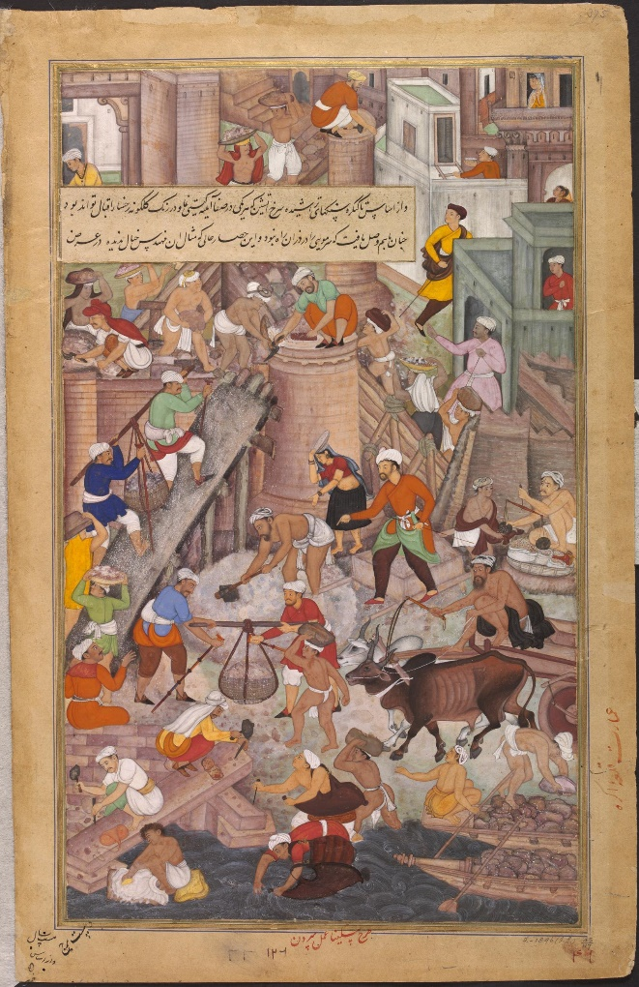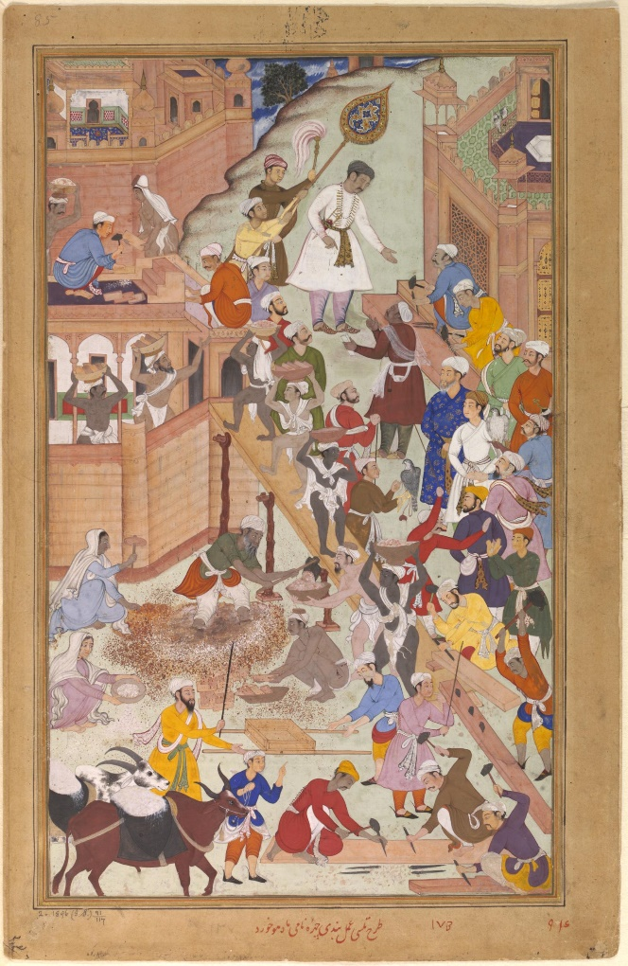
Figure 10: Building Agra fort, I.S 2-1896 folio 45 (L), and Akbar supervising the construction of Fatehpur Sikri, I.S 2-1896 folio 91 (R), both from the Akbar-nāme in the Victoria and Albert Museum, London
Conclusion
A similar methodological approach to the study of medieval material culture of the Mediterranean has been employed in order to glean some specific details concerning the tools and processes involved in the construction process of the twelfth and thirteenth centuries. The late twelfth-century mosaics on the upper sections of the nave of the Norman cathedral in Monreale, Sicily, while ostensibly depicting the construction of the Tower of Babel, actually show contemporaneous craftsmen working with wood, mortar, stone and brick. While in different media and on different scales, the value of the mosaics and the paintings lies in their ability to demonstrate the specific tools, processes and individuals responsible for erecting buildings in the medieval period. It is clear that some underlying themes and commonalities, concerning dress, tools and hierarchy, can be seen to run through the details shown in the selected paintings, drawn from a across a large chronological and geographical span. There is much that cannot be gleaned from a study of the paintings, or the buildings themselves in many cases, including the organization of the hierarchical structure and the fiduciary systems. However, in the absence of much written evidence, the pictorial record, if examined in close detail, can be seen to provide useful contemporaneous insights into the construction process and social hierarchy in the eastern Islamic world in the pre-modern period.
Author
Institution, 2017
Bibliography
Alfieri, B. M. 2000. Islamic Architecture of the Indian Subcontinent, Laurence King Publishing, London
Andrews, P. A. 1985. “The Turco-Mongol Context of Some Objects Shown in the Istanbul Picture Albums”, in Grube, E. and Sims, E (eds.), Between China and Iran; Paintings from Four Istanbul Albums. Colloquies on Art and Archaeology in Asia, No. 10, Percival David Foundation of Chinese Art, London
Arık, R. 2007. “Tiles from the Kubad-Abad Excavations”, in Böhlendorf-Arslan, B., Uysal. A. O. and Witte-Orr, J. (eds.), Çanak, Late Antique and Medieval Pottery and Tiles in Mediterranean Archaeological Contexts, BYZAS 7, Ege Yayınları, Istanbul, 489-500
Beach, M. C. 1987. Early Mughal Painting, Harvard University Press, Cambridge, MA / Oxford
Beach, M. C. 2012. The Imperial Image: Paintings for the Mughal Court, Mapin Publishing, Ahmedabad
Çağman, F. 1985. “On the Contents of the Four Istanbul Albums H.2152, 2153, 2154 and 2160”, in Grube, E. and Sims, E. (eds.), Between China and Iran; Paintings from Four Istanbul Albums. Colloquies on Art and Archaeology in Asia, No. 10, Percival David Foundation of Chinese Art, London, 31-36
Çağman, F. 2005. “Glimpses into the Fourteenth-Century World of Central Asia: The Paintings of Muhammad Siyah Qalam”, in Roxburgh, D. J. (ed.), Turks: A Journey of a Thousand Years, 600-1600, Royal Academy of Arts, London, 148-156
Dickie, J. 1978. “Allah and Eternity: Mosques, Madrasas and Tombs”, in Michell, G. Architecture of the Islamic World: Its History and Social Meaning, Thames and Hudson, London, 15-47
Dold-Samplonius, Y. 1992. “Practical Arabic mathematics: measuring the muqarnas by al-Kāshī”, Centaurus 35, Issue 3, 193-242
Graves, M. S. and Junod, B. (eds.), 2011. Treasures of the Aga Khan Museum: Architecture in Islamic Arts, Aga Khan Trust for Culture, Geneva
Grabar, O. 2000. Mostly Miniatures: An Introduction to Persian Painting, Princeton University Press, Princeton, NJ and Oxford
Grabar, O. and Holod, R. 1979-80. “A Tenth-Century Source for Architecture”, Harvard Ukrainian Studies 3/4, Part 1. Eucharisterion: Essays presented to Omeljan Pritsak on his Sixtieth Birthday by his Colleagues and Students, 310-319
Grube, E. 1985. “The Problem of the Istanbul Album Paintings”, in Grube, E. and Sims, E. (eds.), Between China and Iran; Paintings from Four Istanbul Albums. Colloquies on Art and Archaeology in Asia, No. 10, Percival David Foundation of Chinese Art, London, 1-30
Grube, E. and Sims, E. (eds.), 1985. Between China and Iran; Paintings from Four Istanbul Albums. Colloquies on Art and Archaeology in Asia, No. 10, Percival David Foundation of Chinese Art, London
Keyvani, M. 1980. Artist and guild life in the later Safavid period, Ph.D thesis, University of Durham
Koch, E. 2006. The Complete Taj Mahal and the Riverfront Gardens of Agra, Thames and Hudson, London
Lentz, T. W. and Lowry, G. D. 1989. Timur and Princely Vision: Persian Art and Culture in the Fifteenth Century, Los Angeles County Museum of Art, Los Angeles, CA
Lewcock, R. 1978. “Materials and Techniques”, in Michell, G. Architecture of the Islamic World: Its History and Social Meaning, Thames and Hudson, London, 129-143
Lukens, M. G. 1967. “The Language of the Birds: The Fifteenth Century Miniatures”, The Metropolitan Museum of Art Bulletin XXV/9, 317-338
Man’kovskaia, L. and Golombek, L. 1985. “Towards the Study of Forms in Central Asian Architecture at the End of the Fourteenth Century: The Mausoleum of Khvāja Aḥmad Yasavī”, Iran 23, 109-127
McClary, R. P. 2017. “Craftsmen in Medieval Anatolia: Methods and Mobility”, in Patricia Blessing, P. and Goshgarian, R. (eds), Architecture and Landscape in Medieval Anatolia, 1100-1500, Edinburgh University Press, Edinburgh, 27-58.
Morgan, D. 1988. Medieval Persia 1040-1797, Longman, Harlow
Ousterhout, R. 1999. Master Builders of Byzantium, Princeton University Press, Princeton, NJ
Qaisar, A. J. 1988. Building Construction in Mughal India: The Evidence from Painting, Oxford University Press, New Delhi
Richards, D. S. (tr.), 2007. The Chronicle of Ibn al-Athīr for the Crusading Period from al-Kāmil fī ‘l-tarīkh. Part 2. The Years 541-589/1146-1193: The Age of Nur al-Din and Saladin, Ashgate, Aldershot
Rogers, J. M. 1972. Patronage in Seljuk Architecture, Unpublished D. Phil. Thesis, The University of Oxford, Oxford
Rogers, J. M. 1986. Topkapı Saray Museum: The Albums and Illustrated Manuscripts, Thames and Hudson, London
Roxburgh, D. J. 2000. “Kamal al-Din Bihzad and Authorship in Persianate Painting,” Muqarnas XVII, 2000, 119–14
Roxburgh, D. J. (ed.) 2005. Turks: A Journey of a Thousand Years, 600-1600, Royal Academy of Arts, London
Seyler, J. 1990. “Codicological Aspects of the Victoria and Albert Akbarnāma and Their Historical Implications”, Art Journal 49/4, 379-387
Sims, E. 2002. Peerless Images: Persian Painting and its Sources, Yale University Press, New Haven & London
Stronge, S. 2002. Painting for the Mughal Emperor: The Art of the Book 1560-1660, V&A Publishing, London
Tavernier, J. B. (Crooke, W. ed.) 1925. Travels in India 1640-67, Vol. 1, Oxford University Press, Oxford
Thomson, J. and Canby, S. R. 2003. Hunt for Paradise: Court Arts of Safavid Iran 1501-1576, Skira, Milan
Titley, N. M. 1977. Miniatures from Persian Manuscripts, British Museum Publications Limited, London

For a recent example of such an approach, in the context of Persianate architecture in Rūm Seljuq Anatolia, see McClary 2017: 27-58.
See Graves and Junod 2011.
Rogers 1972: 9. For an exception to the general dearth of primary written sources see Grabar and Holod 1979-80: 310-319. The article addresses a section of Maqdisī’s tenth-century text entitled Kitāb al-Baʿd wa al-Tarīkh (Book of Creation of History).
The Ottoman text was written by Sarar Efendī. See Lewcock 1978: 133.
See Grabar and Holod 1979-80: 311.
See Dold-Samplonius 1992: 193-242 for a translation and detailed study of al-Kāshī’s work on measuring muqarnas, from his miftāḥ al-Ḥisāb (Key of Arithmetic).
Examples include the workshop and kilns, complete with iron tools, excavated at the mid-thirteenth century Rūm Saljūq Kubadabad Palace, near Beyşehir in south-west Turkey. See Arık 2007: 496-7.
While there are numerous travellers’ accounts which mention construction projects, many are notoriously unreliable. Perhaps the most egregious example is the patently false claim by Tavernier that brick scaffolding was used for the construction of the Taj Mahal, and that it cost more than the entire work (Tavernier 1925: 91).
Accession number Or.6810, f.154v, see Titley 1977: 225. The other two images are also in the British Library. One is Or.4615, f.117b, an image of the Turanians building the city of Dārābgīrd under the sea, in a Mughal copy of Dārābname by Abu Ṭāhir Ṭarasūsī dated to c. 1580-5 (ibid., 8-11), and the other is Add.18576, f.118a, an image of Iskander watching the wall being built in the Land of Jūj and Mājūj, in a Safavid copy of Ḳiṣāṣ al-anbiyā by al-Nīsabūrī, dated to the sixteenth century (ibid., 67).
See Çağman 2005: 148-156 for an overview of the history and, often contested, interpretation of this strange corpus of paintings.
John Work Garret Collection, fols. 359v – 360r.
Sims 2002, 180. For an overview of Behzād’s style see Roxburgh 2000: 119-146.
Sims 2002: 181.
Accession number Or. 6810, fol. 154v.
The paucity of documentary sources concerning craftsmen and guilds extends into the Safavid period as well (Keyvani 1980: 6).
The painting, accession number Per 395.1, is in the Chester Beatty Library in Dublin and measures 59.4 cm x 45 cm. See Thomson and Canby 2003, 126 and 129, fig. 4.37.
For the best study of Mughal building practices, drawing on both paintings and contemporary written sources, see Qaisar 1988.
Accession number I.S 2-1896.
Koch 2006: 83.
There is some discussion as to the date of the paintings, but Seyller (Seyller 1990: 384) concludes that all 197 of the original paintings were probably executed between 1586 and 1587. In contrast, Beach (Beach 1987: 114) suggests that the paintings all date from the mid-1590s at the earliest. More recently Strong has argued for a dating range in the period 1590 to 1595 (Stronge 2002: 82-3).
Beach 1987: 114. Ibid., 134 states that the basic subject of Akbari painting was the depiction of contemporary events. If one accepts such a view, it makes it possible to view the details show in the four construction scenes discussed here as examples of verisimilitude.
Accession number I.S 2-1896, folio 45 and folio 91 respectively.
Seyller 1990: 380.
Qaisar 1988: 6. There are three depicting Agra (the two described here, plus V&A IS 2-1896 45/117), three depicting Fatehpur Sikri, with the remaining seven not connected to any specific town or building. For two of the unidentified images (V&A 1595-1965 and BM Add. 5600, f.372a). see ibid., pls. 7 and 8.
For the most in-depth study of the Istanbul albums see the twenty-one articles in Grube and Sims 1985. Grube 1985: 17-30 consists of a full bibliographical survey of the literature on the Istanbul albums. Unfortunately there is nothing specifically addressing H.2153, folio 141v in the survey.
Rogers 1986: 116.
Çağman 2005: 155. The dating is based, in part, on the clothing, metal details and style of painting.
Andrews 1985: 112. Çağman 2005: 173 refers to it as Preparations for Building a Wooden Structure.
Rogers concurs (Rogers 1986: 154), referring to the image as being of a mason’s yard.
What might initially appear as vague and seemingly random associations with Byzantine manuscript painting styles become rather more plausible when another image in the album, folio 106v depicting two Orthodox monks in similar robes, is taken into account. See Rogers 1986: 146.
The white caps with black spots are most likely meant to represent leopard fur. A similar style image in folio 38v in the same album, showing a figure with a full leopard skin executed in the same technique, seems to confirm this hypothesis. See Çağman 2005: 168, fig.119.
The hat with three lobes has been described by Çağman as being reminiscent of Mongol headgear (in Roxburgh 2005: 408).
A brief catalogue description can be found in Roxburgh 2005: 409, written by Feliz Çağman. It is important to note that this is only found in the paperback edition, with the catalogue descriptions being absent from the hardback edition, even though it was published at the same time.
Andrews 1985: 112. A detail of MS Elliot 323, fol. 17r is shown in ibid., fig. 354.
Rogers 1986: 154.
Contemporary chronicles give occasional snippets of information, with Ibn al-Athīr stating in his al-Kamil fi l-Ta’rikh that a large fire in the store yards in Baghdad in 583/1187 destroyed large stocks of timber (Richards 2007: 342).
Roxburgh 2005: 409.
The album contains 199 folios, with 546 paintings and drawings (Çağman 1985: 32-3). For colour images of a selection of the paintings see; Çağman 2005: 157-187, figs. 100-143, and Rogers 1986: 119, 153 and 132-9, figs. 81-90.
Chester Beatty Library, accession number Per 395.1. Another similar image is in the British Library (Add. 1857, f.118a). See Titley 1977, 67.
Çağman 2005: 153.
Further details about the construction of the mosque, and Timur’s direct involvement in the construction process, can be found in Clavijo’s contemporary account. The relevant passage is reproduced in Lentz and Lowry 1989: 36.
The campaign into India had been described as simply a vast plundering expedition (Morgan 1988: 90).
Sims 2002: 180.
Accession number Or.6810, fol.154v, in the British Museum, London.
See Man’kovskaia and Golombek 1985: 109-127 for a detailed study of the complex.
Accession number 63.210 folio 35r.
Dickie 1978: 30.
For a study of the painting, and comparisons with a similar work in the Walters Art Gallery, Baltimore (accession number 10678) which is also from Herat and dated to the late fifteenth century, see Lukens 1967: 317-8.
Accession number I.S 2-1896.
Beach has noted, in reference to the painting of Akbar inspecting the construction of Fatehpur Sikri, that the figures are depicted twisting and turning in a different and more animated manner that can be seen in earlier paintings produced in Iran (Beach 2012: 55). Despite such changes, the overall style can still be seen as part of the wider tradition of Persian painting.
I.S 2-1896 folio 86
The device consists of a large wheel with a rope chain filled with water pots. For details of the device and its introduction to India see Qaisar 1988: 32.
Koch, 2006: 83. She adds that the water gate was built under the supervision of Qasim Khān, who was the chief engineer. It is possible that he is the figure depicted half way up on the right-hand side of the painting, writing a note on a piece of paper, as a dark-skinned labourer kneels before him, possibly awaiting payment. The painting measures 32.8cm x 20cm (Stronge 2002: 82-3).
For a full description of all the different processes shown in the painting see Koch 2006: 82.
Of the thirty-six figures shown to be engaged in the construction process, four of them are women. In addition, two females are shown in the upper right of the image, but they are inside the fort, and do not part of the workforce.
Qaisar 1988: 12.
Qaisar 1988: 16, citing a translation of ʿĀrif Qandahāri’s Tarīkh-i Qandahāri.
For a good overview of the development of Islamic architecture in India see Alfieri 2000.
The painting, attributed to Miskina and Sarwan, is folio 45 of I.S.2:1896 in the Victoria and Albert Museum, London.
Stronge 2002: 84.
See Ousterhout 2009. Throughout the book he combines structural analysis with the use of medieval paintings, manuscripts and mosaics showing construction scenes, in order to better understand Byzantine architectural practices. Images analysed include one illustrating the laying out of a construction site with ropes (ibid., 6, fig.31), manuscript paintings showing brick kilns (ibid., 129-132, figs 96 and 98), and construction scenes in mosaic from the Capella Palatina in Palermo and the Church of San Marco in Venice (ibid., 46-48, figs 29 and 30).

