Mechanistic insight into catalytic redox neutral C-H bond activation involving manganese(I) carbonyls: Catalyst activation, turnover and deactivation pathways reveal an intricate network of steps
Lars Anders Hammarback,^{[a]} Alan Robinson,^{[b]} Jason M. Lynam,^{[a]}* and Ian J. S. Fairlamb^{[a]}*
[a] Department of Chemistry, University of York, York, North Yorkshire, YO10 5DD, United Kingdom
[b] Syngenta Crop Protection AG, Münchwilen, Breitenloh 5, 4333, Switzerland.
KEYWORDS. C-H bond functionalization, alkenylation, in operando measurements.
ABSTRACT: Manganese(I) carbonyl catalyzed C-H bond functionalization of 2-phenylpyridine, and related compounds containing suitable metal directing groups, has recently emerged as a potentially useful synthetic methodology for the introduction of various groups to the ortho-position of a benzene ring. Preliminary mechanistic studies have highlighted that these reactions could proceed via numerous different species and steps, moreover potentially different catalytic cycles. The primary requirement for typically 10 mol% catalyst, oftentimes the ubiquitous precursor catalyst, BrMn(CO)₅, has not yet been questioned, nor significantly improved upon, suggesting catalytic deactivation may be a serious issue to be understood and resolved. Several critical questions are further raised by the species responsible for providing a source of protons in the protonation of vinyl-manganese(I) carbonyl intermediates. In this study, using a combination of experimental and theoretical methods, we provide comprehensive answers to the key mechanistic questions concerning the Mn(I) carbonyl catalyzed C-H bond functionalization of 2-phenylpyridine and related compounds. Our results enable the explanation of alkyne substrate dependencies, i.e. internal versus terminal alkynes. We have found that there are different catalyst activation pathways for BrMn(CO)₅, e.g. terminal alkynes lead to the generation of Mn^{I}-acetylide species, whose formation is reminiscent of Cu^{I}-acetylide species proposed to be of critical importance in Sonogashira cross-coupling processes. We have unequivocally established that alkyne, 2-phenylpyridine and water can facilitate hydrogen-transfer in the protonation step leading to the liberation of protonated alkene products.

INTRODUCTION
Manganese is a versatile, earth abundant element, with considerable potential as a catalyst for applied chemical synthesis. The organometallic chemistry of Mn^{I} has been a rich area of study for >40 years, e.g. cyclomanganation and stoichiometric reactions of manganacycles. Catalysis has been slow to develop, but since Chen and Wang’s publication in 2013, the emergence of promising redox neutral Mn^{I}-catalyzed C-H bond functionalization methodologies, involving cyclomanganation and formal insertion of various unsaturated substrates (e.g. alkenes, alkynes, carbonyls, isocyanates, cyanide reagents) have been reported (Scheme 1a, e.g. 1 + 2 → 3). Mn catalysis is complementary to transformations typically associated with platinum group metals (PGMs), which coupled with other major breakthroughs in high oxidation state Mn catalysis and provides a promising platform to develop competitive processes. Critical to this endeavour is mechanistic information^{4a} on the catalytic processes involving Mn^{I}. Indeed, mechanistic information for the Mn^{I}-catalyzed C-H functionalizations has been limited. While there are postulated mechanisms,^{3,4a} experimental validation is required if catalyst design strategies / applications in more complicated target-orientated synthesis are to be more widely adopted.
Scheme 1. (a) A generic Mn-catalysed C-H functionalization reaction of 2-phenyl pyridine with suitable unsaturated acceptor substrate; (b) Generalized catalytic steps in the postulated mechanism.

The mechanistic steps for the C-H bond functionalization of the ubiquitous substrate, 2-phenylpyridine (ppy, 1), are shown in Scheme 1b. Similar mechanistic hypotheses have been put forward,⁴ with the key steps principally involving:
- Cyclomanganation/C-H bond activation at Mn^{I} to deliver manganacycle 4 (step 1);
- Loss of CO and binding of an unsaturated acceptor substrate to Mn^{I} to give 5 (step 2);
- C-C bond formation by migratory insertion of the π-bound unsaturated substrate into a Mn-C bond leading to formation of a 7-membered manganacycle 6 (step 3);
- Protonation (protiodemanganation) of 6 to liberate organic product 3, with concomitant formation of manganacycle 4 (step 4).
Our research team initially characterized a transient 7-membered manganacycle, containing a 2-pyrone ring system (relating to 6), formed by alkyne insertion into a Mn-C bond (of 4). Subsequent studies employing time-resolved infrared spectroscopic analysis has allowed us to directly observe the short-lived intermediates that are involved in the formation of 6 (Scheme 2).

Scheme 2 Time-resolved IR spectroscopic analysis enabling characterization of intermediates 5 and 6.
These findings taken together provide a detailed understanding of the process for alkyne insertion, i.e. steps 2 and 3 (Scheme 1b). We have subsequently turned our attention (this study) to gathering critical mechanistic information, particularly kinetic data, concerning steps 1 and 4, which are key to productive catalysis. With a focus on the reactions of 1 + 2a/2b → 3a/3b (Scheme 3), our study described herein has been primed by asking the following questions:
1) How does the generic precatalyst, BrMn(CO)₅, become activated under the catalytic conditions and what are the implications for step 1;
2) What species is/are responsible for providing a source of protons in the protonation step 4;
3) What is the severity of catalyst deactivation, particularly as typically catalyst turnover numbers range from ca. 5 to 9.³⁻⁹
4) What is the explanation for internal alkyne 2b being unable to give alkenylated product 3b.

An answer to question 3 is particularly important in terms of developing future catalyst design strategies. On the otherhand it is essential to understand at what stage internal alkynes such as 2b is unable to complete full catalytic cycle. Details concerning these questions are limited within the literature. Yet, clear answers are needed to meet the aspiration for Mn^{I} redox neutral catalysis to become a competitive process to those currently employing PGMs.⁴

Scheme 3 Key reactions for mechanistic study.

RESULTS AND DISCUSSION
The reactions given in Scheme 3 are both believed to involve manganacycle 4.^{3,12} We identified that use of real-time infrared spectroscopic analysis (in situ IR on the second timescale), in operando, as useful for probing the different manganese carbonyl species formed during the C-H bond activation reactions, yielding qualitative information about manganese carbonyl speciation and quantitative kinetic data. Use of IR spectroscopic analysis for studying transient manganese carbonyl species has been validated in our previous studies. For this mechanistic study, a Mettler-Toledo ReactIR® instrument (IC10) with a Si-probe was used (1 minute scans, ±4 cm⁻¹) to monitor changes in the manganese carbonyl IR bands, in real-time.
We first turned our attention to understanding the species that derive from reactions mediated by either the BrMn(CO)₅ precatalyst or intermediate manganacycle 4, under the generalized reaction conditions given in Scheme 3. The changes in the IR spectral region of the manganese carbonyls for the reaction 1 + 2a → 3a catalyzed by BrMn(CO)₅ is shown in Figure 1(a), accompanied by the kinetic information extracted from the data (b). Analysis of the changes in the IR stretching bands shows rapid consumption of the BrMn(CO)₅ precatalyst, formation of the alkyne insertion complex 6a' (independently verified by LIFDI MS as an intermediate, m/z = 423.0316, [M^{+•}]) and Mn cluster species after only 1 minute. After 3 minutes BrMn(CO)₅ is fully depleted. Note 6a' is the tetracarbonyl manganese species associated with tricarbonyl manganese species 6 (i.e. 6a' is acting as a reservoir for the active species 6a). The maximum amount of 6a' is observed at 3 minutes, which then decays exponentially [k_{obs} = (1.87 ± 0.18) × 10⁻³ s⁻¹] with concomitant formation of the alkenylated product 3a (ex situ ¹H NMR analysis, k_{obs} (1.78 ± 0.43) × 10⁻³ s⁻¹). Curiously, the manganacycle 4 was not observed as an intermediate in this experiment, indicating that it was either not formed or too transient to be observed under the reaction conditions, i.e. manganacycle 4 is not an intermediate in this specific reaction or that alkyne insertion is rapid, compared with a base-assisted cyclomanganation step. Finally, after 1 minute Mn clusters form, which dominate the carbonyl species observed in the IR spectra
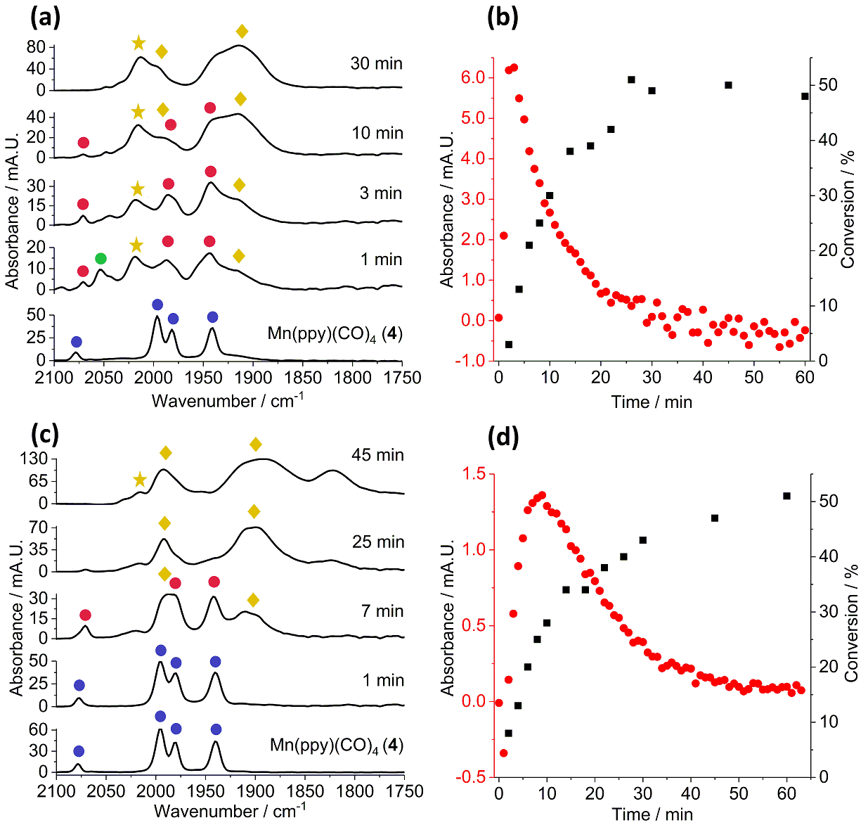
Figure 1 (a) IR spectral changes over time for the reaction of 1 + 2a → 3a catalyzed by BrMn(CO)₅ under conditions described in Scheme 3 {key: blue circle = 4; red circle = 6a'; green circle = BrMn(CO)₅; gold diamond / gold star = Mn carbonyl cluster species {[Mn] = Mn(CO)₃, Y = OH, alkynyl – see discussion}; (b) a kinetic plot {extracted from (a)} showing the formation and loss of 6a' (red circle) over time (in situ), in addition to % conversion of organic product 3a (black square) determined by ¹H NMR spectroscopic analysis (ex situ); (c) IR spectral changes over time for the reaction of 1 + 2a → 3a catalyzed by manganacycle 4; (d) as for (b) {kinetic data extracted from (c)}.
(~30 minutes); these Mn clusters are catalytically inactive.
The feasibility of manganacycle 4 as an intermediate in the reaction 1 + 2a → 3a was quantitatively assessed for its ability to act as a competent catalyst. The changes in the IR spectral region of the manganese carbonyls can be viewed in Figure 1(c), which is accompanied by the kinetic information extracted from the data (d). Analysis of the changes in the IR stretching bands shows the relatively slow consumption of 4 (no changes within 1 minute, in stark contrast to BrMn(CO)₅; kinetic details for this step are shown in the Supporting Information). Thus after 7 minutes the formation of the alkyne insertion complex 6a' and Mn carbonyl cluster species was observed, whose distribution appears different to the reaction mediated by BrMn(CO)₅. After ca. 10 minutes 4 is fully depleted, showing that this was the starting point for alkyne insertion, i.e. via loss of one CO ligand. Of particular note is the finding that the formation of 6a' is slower in the reaction catalyzed by 4 than that catalyzed by BrMn(CO)₅, providing strong support for alternative pathways for catalyst activation, which enters into a common catalytic cycle.

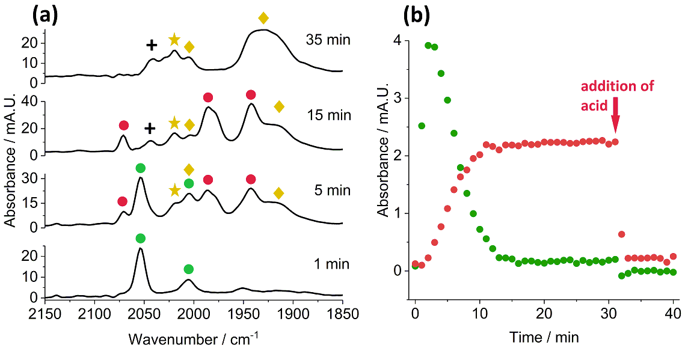
Figure 2 (a) IR spectral changes over time for the reaction of 1 + 2a → 3a catalyzed by BrMn(CO)₅ under conditions described in Scheme 3, run at 60 ⁰C (key: as for Fig. 1; + = unidentified manganese carbonyl species); (b) a kinetic plot {extracted from (a)} showing the formation and loss of 6a' (red circle) over time (in situ), to form organic product 3a (determined by ¹H NMR spectroscopic analysis (ex situ) – the initial growth of the bands for BrMn(CO)₅ are attributed to the dissolution of the solid into solution.

The reaction 1 + 2a → 3a catalyzed by BrMn(CO)₅, under the standard conditions at 60 ⁰C, allowed us to further gain more detail about the activation of the precatalyst species. Under these conditions no alkenylated product 3a was observed, demonstrating that protonation is unfeasible at this temperature. Analysis of the changes in the IR stretching bands indicates a slower consumption of the BrMn(CO)₅ precatalyst than the reaction run at 100 ⁰C. Again, formation of the alkyne insertion complex 6a' is observed after 1 minute, which after 12 minutes reaches a steady-state, i.e. with full consumption of the BrMn(CO)₅ precatalyst. Propionic acid (3 equiv. with respect to Mn; 30 mol%) was added at 32 minutes, resulting in complete loss of 6a', and concomitant formation of product 3a {5% yield, accounting for half of the original amount of BrMn(CO)₅ used; the remaining mass balance (loss) is accounted for through the formation of manganese carbonyl clusters, as observed in the IR spectra at 35 minutes}. Finally, in keeping with the reaction run at 100 ⁰C, we do not observe formation of manganacycle 4 on the timescale of the reaction.
We continued to investigate the reaction 1 + 2a → 3a catalyzed by BrMn(CO)₅ at 60 ⁰C, omitting various components to assess their impact on the distribution of manganese carbonyl species present within the mixtures. Withholding the base, Cy₂NH, resulted in some degradation of BrMn(CO)₅ (hold time = 25 minutes) to give Mn carbonyl clusters with no formation of either manganacycle 4 or alkyne insertion complex 6a' {Fig. 3(a)}. The addition of Cy₂NH triggers formation of 6a' with concomitant loss of BrMn(CO)₅ {Fig. 3(b)}. The kinetic curves for this reaction mirror those seen in Fig. 2(b).

Figure 3 (a) IR spectral changes over time for the reaction of 1 + 2a → 3a catalyzed by BrMn(CO)₅ under conditions described in Scheme 3, run at 60 ⁰C, withholding Cy₂NH for 25 minutes (key: as for Fig. 1); (b) a kinetic plot {extracted from (a)} showing the loss of BrMn(CO)₅ (green circle) over time (in situ), due to degradation – the initial growth of the bands for BrMn(CO)₅ (ca. 5 minutes) are attributed to the dissolution of the solid into solution {also seen in (d)}. The addition of Cy₂NH was made at 25 minutes; (c) as for (a), withholding only alkyne 2a for 10 hours; (d) a kinetic plot {extracted from (c)} showing the loss of BrMn(CO)₅ (green circle) over time (in situ), followed by addition of 2a at 10 hours; (e) as for (a), withholding only 2-phenylpyridine 1 (not added) – + = unidentified manganese carbonyl species; (f) comparative IR spectra (overlay) at 15 minutes reaction time for changes seen from Figs. 2(a), 3(a), 3(c) and 3(e).
In the absence of alkyne 2a, we see rapid loss of BrMn(CO)₅ with concomitant formation of manganacycle 4 {Fig. 3(c) and (d)}. Another manganese carbonyl species forms in this reaction, as indicated by the black triangles. The addition of alkyne 2a after 10 hours results in loss of 4 and formation of 6a', although the formation of the latter complex is slow, i.e. after a further 8 hours reaction time, only a small amount is formed (where the reaction is halted).
Withholding 2-phenylpyridine 1 from the reaction we see formation of Mn carbonyl clusters within 5 minutes. After 15 minutes, an unidentified species is once again observed (indicated by + symbol), also seen in Fig. 2(a).
It is informative to compare the key IR spectral changes, with the various components withheld from the reaction of 1 + 2a → 3a {Fig. 3(f)}. Withholding 1 demonstrates that the formation of the unidentified species (+ symbol) is independent of it. Withholding Cy₂NH indicates that manganacycle 4 or alkyne insertion complex 6a' are not formed. Catalyst degradation is the major dominating pathway, affording Mn carbonyl clusters that are dependent on the presence of alkyne 2a. The point is reinforced by a different manganese carbonyl species forming (black triangle) in the absence of 2a. The only conditions that give the same degraded Mn carbonyl clusters as the standard reaction conditions at 60 ⁰C, is the reaction without 1.
We further examined the interaction of BrMn(CO)₅ (1 equiv.) and Cy₂NH (2 equiv.) in nBu₂O at 60 ⁰C for 20 minutes. A major and minor manganese carbonyl species are formed (see Supporting Information). The former shares similar IR bands to the species observed in Fig. 3(c), indicated by black triangles. The minor species are attributed to hydroxylated Mn carbonyl clusters.
In an earlier study experiments employing deuterium-labelled substrates were run under similar reaction conditions (100 ⁰C, Et₂O) using 2-phenylpyridine 1 and propargyl benzoate, instead of phenyl acetylene 2a. This led to substantial deuterium scrambling amongst the alkenyl protons and the 2-phenyl group, highlight the complexity of the complete reaction network. Furthermore, addition of D₂O to that system resulted in deuterium scrambling. We recognized that as our reaction run with 2a at 60 ⁰C stops at the alkyne insertion complex 6a', that further useful data could be obtained for the catalyst activation step by running deuterium labelling experiments in this system. Using the standard reaction conditions at 60 ⁰C, two experiments were conducted (Scheme 4).

Scheme 4 Deuterium labelling studies. Each reaction is mediated by MnBr(CO)₅ (10 mol%), Cy₂NH (20 mol%), in nBu₂O at 60 °C for 30 minutes.
In the first experiment, 1 (2 eq.) was reacted with 2a-d (1 eq.) affording 6a' (characterized by in situ IR). Treatment with acetic acid (1 eq.) afforded deuterated 3a, with 78% deuterium incorporation at the C1' position, showing some loss of deuterium from 2a-d (a small amount if deuterium incorporation was also seen at C2', ca. 8%). The kinetic isotopic effect (KIE) for this reaction was found to be 1 (i.e. identical kinetic curves, see Supporting Information). In the second experiment, the reaction of 1-d₅ with 2a cleanly gave 6a', with a KIE of 1.75 (±0.11). Quenching of 6a' with acetic acid (1 eq.) gave product 3a, with 37% deuterium incorporation at the C1' position, supporting the formation of manganese alkynyl species activating the C-H bond in 1. The small magnitude of the KIE reflects the C-H bond activation step as not rate-determining, with CO loss during the catalyst activation controlling the reaction kinetics.
Viability of internal alkyne 2b as a substrate. We next turned our attention to understanding the reasons why internal alkyne 2b does not deliver alkenylated product 3b. From our results vide supra it appears that the terminal hydrogen in 2a is activated at the Mn(I) center. However, clearly 2b lacks this mode of activation. We examined the hypothetical reaction of 1 + 2b → 3b at 100 ⁰C, using in situ IR spectroscopic analysis (Fig. 4). The IR spectral changes reveal a fast reaction to give both manganacycle 4 (blue circle) and alkyne insertion complex 6b' (red circle) within 1 minute. Complexes 4 and 6b' are both formed and consumed at a similar rate. The formation of 4 stands in stark contrast to the reaction employing terminal alkyne 2a. We also see a fraction of BrMn(CO)₅ remains after 1 minute, but that another new species is present (indicated by #), whose depletion is complete within 5 minutes. At this time point we observe formation of two new species (indicated by *), in addition to a major new product (indicated by an open circle), which is the only species remaining after 5 hours, and assigned as the reductive elimination product 7b (purified and characterized fully, including X-ray diffraction analysis of a single crystal). This result confirms that any protonation pathway is inaccessible for substrate 2b. This is consistent with previous predictions made by Chen and Wang that the lack of a terminal hydrogen in 2b explains the absence of alkene product 3b. In a separate stoichiometric reaction of 4 (1 equiv.) with 2b (1 equiv.) in n-Bu₂O at 100 ⁰C for 1.5 hours led to the formation of 7b (~60%, by in situ ¹H NMR reaction monitoring, non-stirred). The outcome confirms the clean conversion of 4 → 7b, and that no paramagnetic manganese species were formed.
Effect of Cy₂NH/BrMn(CO)₅ ratio. It was anticipated that the ratio of Cy₂NH to BrMn(CO)₅ in the catalytic reaction could be critical to productive catalysis. From Chen and Wang’s original study, a ratio of 2:1 Cy₂NH/BrMn(CO)₅ was employed. However, no alterations to this ratio were made, changes which may have, in part, a significant effect in the catalytic process. A total of eight separate reactions (1 + 2a → 3a at 100 ⁰C, under the standing conditions given in Scheme 3) were run with varying ratios of Cy₂NH/BrMn(CO)₅, from 0.5:1, 1:1 through to 8:1. The observed rates (k_{obs}) for each reaction was extracted from the kinetic data obtained by ex situ ¹H NMR – a plot of k_{obs} versus Cy₂NH/BrMn(CO)₅ is given in Fig. 5.
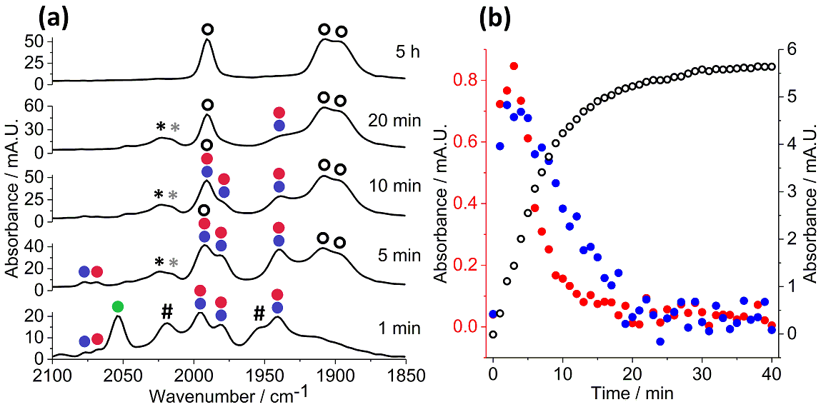
Figure 4 (a) IR spectral changes over time for the reaction of 1 + 2b → 3b catalyzed by BrMn(CO)₅ under conditions described in Scheme 3, run at 100 ⁰C (key: as for Fig. 1); (b) a kinetic plot {extracted from (a)} showing the loss of both the manganacycle 4 (blue circle), alkyne insertion complex 6b' (red circle) and new product 7b – # = unidentified Mn(CO)₃ complex. The two species indicated by * (in black and grey) are likely isomers of the reductive elimination product 7b.
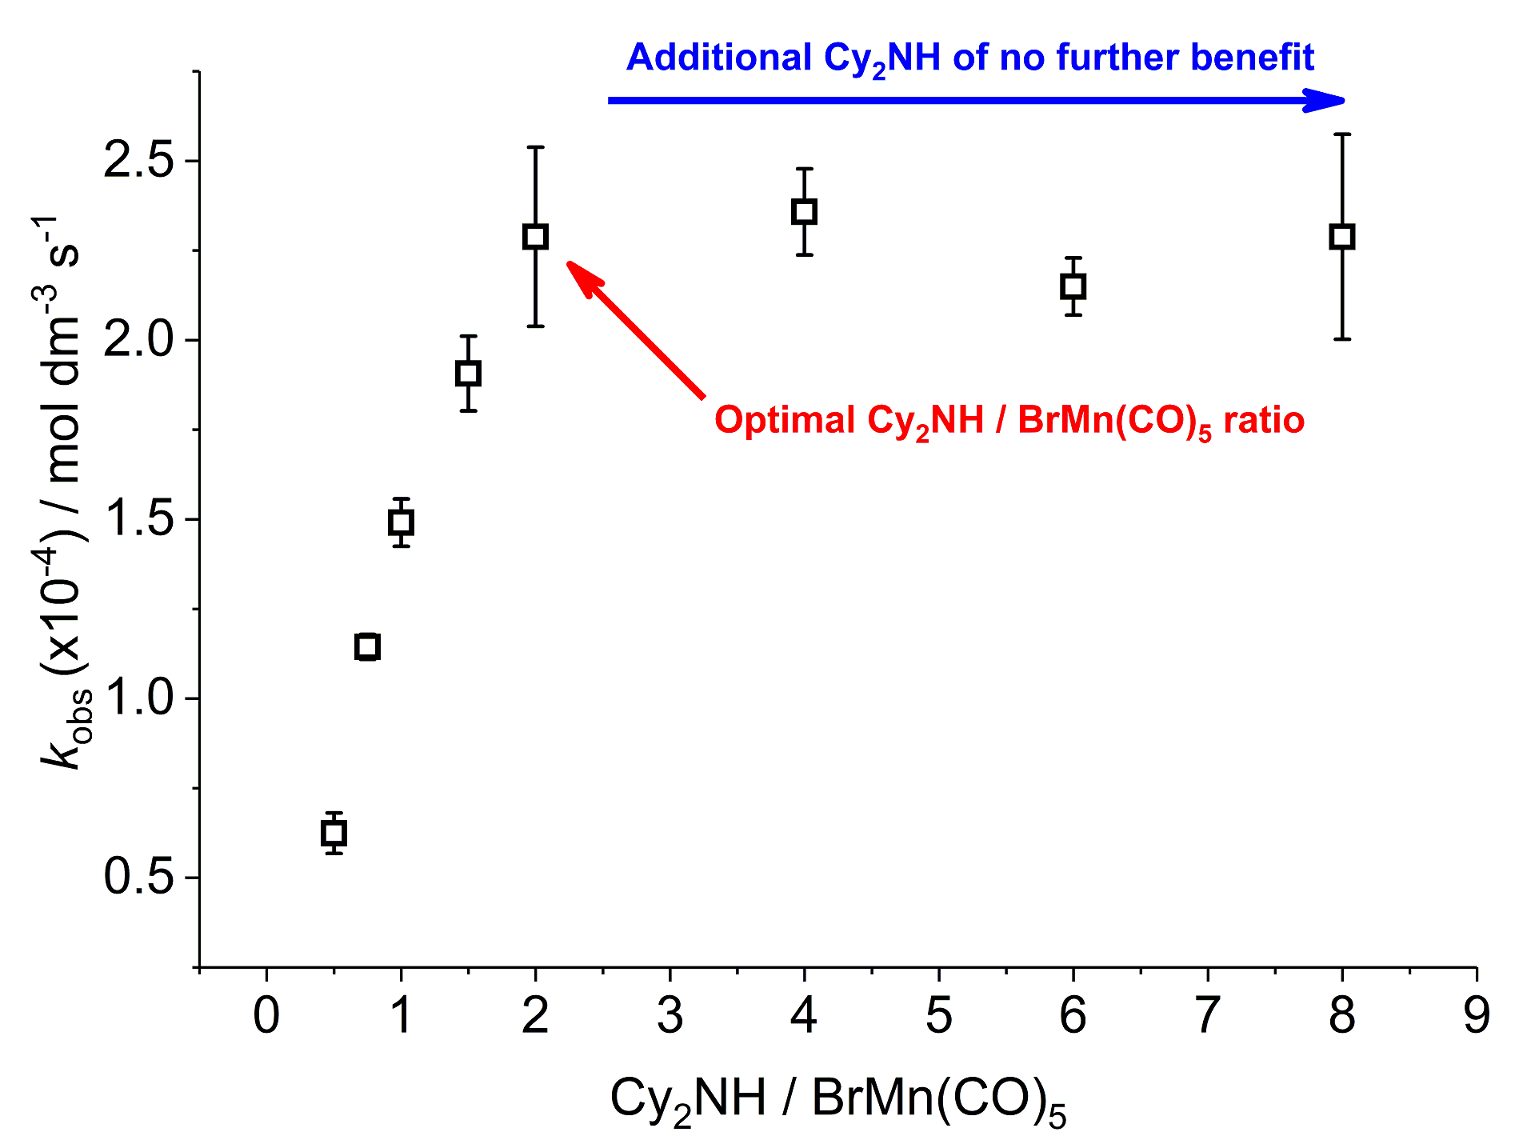
Figure 5 Plot of the dependence of Cy₂NH/BrMn(CO)₅ against k_{obs} extracted from kinetic data for the reaction 1 + 2a → 3a.
Alteration of the Cy₂NH/BrMn(CO)₅ ratio from 0.5:1 to 2:1 led to a positive response in the rate of product 3a formation – note that the response is non-linear. Curiously, at a ratio of Cy₂NH/BrMn(CO)₅ of >2:1, no further enhancement in rate was observed, i.e. the optimal ratio is 2:1 Cy₂NH/BrMn(CO)₅. Further comments about this trend and outcome are given later in the Discussion section.
Protonation pathways. Having identified and characterized the alkyne insertion complex 6a' derived from both manganacycle 4 and BrMn(CO)₅, we recognized that the species responsible for protonation, i.e. delivery of the product 3a, could be deduced, amongst other products. According to the original mechanistic proposal made by Chen and Wang, the alkyne 2a is responsible for protonation of 6a'. Thus, a reaction involving one equivalent each of 4 and 2a ought to give a maximum of 50% product conversion (this assumes that alkyne insertion is the only pathway forward, which is supported by our reported time-resolved IR spectroscopic studies). Unexpectedly, reaction of 4 + 2a gave only a small amount of the organic product 3a (7%) {Fig. 6(a), see figure for reaction conditions}, whilst consuming the majority of 4 (10% remaining). The major product was the reductive elimination product 7a (76%). Compound 8a was formed as a minor product (5%), resulting from double alkenylation. We note this is the first recording of the reductive elimination pathway becoming active employing a terminal alkyne with manganacycle derived from 1. Increasing the amount of 2a to two equivalents resulted in full conversion of 4, increased amounts of 8a (25%; 64% 7a), in addition to a slight increase in 3a (12%). Addition of four equivalents of 2a led to 8a becoming the major product (51%), at the expense of 7a (32%), with a small increase in 3a also recorded (17%).
We further examined the role of other ‘proton’ sources in the reaction of 2a (1 equiv.) with 4 {Fig. 6(b)}, all added at t=0. Addition of ten equivalents of water to the reaction mixture enabled for more efficient protonation to give 3a (42%); products 7a and 8a were still formed in 44% and 9% conversion, respectively. A similar distribution of products 3a and 7a was seen adding 2-phenylpyridine 1 as the proton source, formed with higher conversion. In this case, product 8a was not formed under these reaction conditions, indicating that 1 competes with product 3a for Mn-coordination resulting in diminished double alkenylation. Lastly, one equivalent of pyridine (lacking a suitable acidic proton) was added to the reaction producing 7a as the major product (68%) and 3a as the minor product (22%). The result confirms that pyridine assists in product 3a labalization, thwarting formation of 8a, in-keeping with the outcome resulting from addition of 1 to the reaction, under otherwise identical conditions.

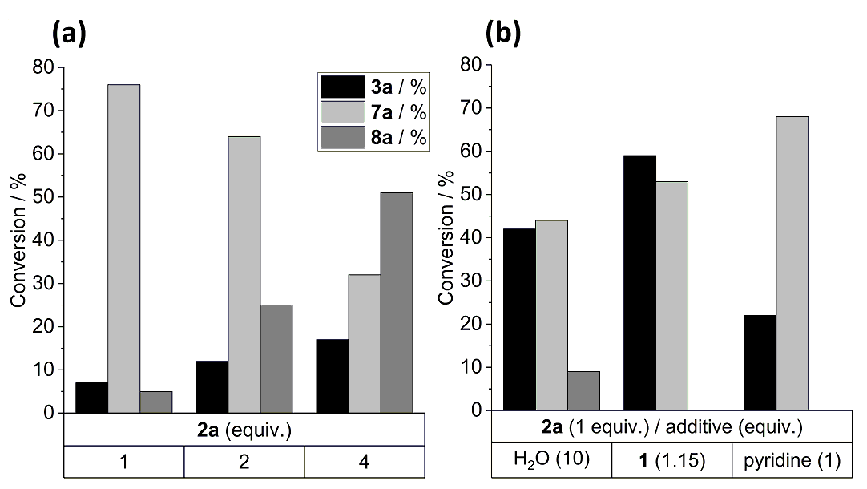
Figure 6 Examination of the protonation pathway for the reaction of 4 with 2a and various additives at 100 ⁰C, 0.5 h, under Ar atmosphere: (a) as a function of varying the amount of 2a; (b) by variation of different additives, 2-phenylpyridine (1), H₂O and pyridine.
Replacing the substrate(s)/additive by their deuterated analogues (e.g. 2a-d, 1-d₅ and D₂O), allowed for the monitoring of the deuterium content into product 3a, following the protonation step. Employing 2a-d (4 eq.) in the reaction 4 + 2a → 3a + 7a + 8a, gave deuterium incorporation into both alkene positions for 3a (68% at C1' and 60% at C2') and 8a (67% at C1' and 54% at C2'), displaying the ability of 2a to perform the protonation step. The loss of deuterium at the C1' position could arise from reversibility/instability of a manganese alkynyl species. No deuteration could be observed on the 2-phenylpyridine backbone. Regioselective deuterium incorporation at the C2' position (83%) was achieved through the addition of D₂O (1o eq.), with no deuteration occurring at either the C1' position or 2-phenylpyridine backbone. Following the addition of 1-d₅ (1 eq.) to the reaction, a mixture of deuterated analogues of 3a were observed. The reaction was found to give lower conversion to 3a (29%), as compared with the addition of the protio-analogue 1 (59%). The most abundant analogue (48% of isolated 3a) showed no deuterium incorporation, while mono-deuterated 3a is present in 18% abundance. Incorporation of four and five deuterium’s into the product was further seen (18% and 12% abundance respectively).
Theoretical (DFT) studies.
Further insight into the key steps involved in Mn-catalyzed reactions was obtained using Density Functional Theory (DFT); see E.S.I. for details of the methodology employed.
We modelled the reaction profile starting from the reaction of manganacycle 4 with phenylacetylene 2a (Scheme 5). It is important to state that 4 is a useful reference state for our calculations as alkyne coordination and insertion, reductive elimination versus protonation (by either 1, 2a or water) steps could be compared. Loss of a CO ligand and coordination of alkyne 2a leads to formation of 8a, from which a feasible transition state structure could be located (TS_{8a-6a}) connecting to the 7-membered manganacycle 6a. We previously observed this precise process using time-resolved infra-red spectroscopy.13 The energy of 6a indicates that it is stable enough to be characterized either directly or indirectly (i.e. as 6a'). Crucially, 6a acts as the ‘anvil point’ to either direct reductive elimination to give 7a' or to protonation giving the final product complex vide infra. The transition state connecting 6a to 7a was identified as (TS_{6a-7a'}), which requires loss of the η²-coordinated arene, revealing a 16-electron species, capable of a viable reductive elimination. We have described previously the isomerization of 7a' to 7a (thermodynamically more stable) and the factors affecting the balance between protonation and reductive elimination from the anvil point complex 6a.12 The results illustrated in Figure 6 reinforce the argument that unless 6a is intercepted by an appropriate proton source, reductive elimination to give 7a will occur.
Experimentally we have determined that 6a can be protonated by either 1, 2a and/or water. Three potential pathways that result in H-transfer to 6a and the generation of the product 3a have been located. In the first instance, a second molecule of alkyne can bind to 6a to give 9aa, where a change of binding mode from η²-C≡C to a C-H sigma complex gives 10aa, which can then undergo a σ-CAM process through TS_{10aa-12aa} to give 12aa, i.e. complex containing product 3a {Scheme 5(a)}.
An alternative pathway was also examined in which a second equivalent of 1 binds to 6a to give 9ab, a change in coordination mode the metallated 2-phenylpyridine would give sigma complex 10ab {Scheme 5(b)}. Thus, H-transfer through TS_{10ab-11ab}, followed by a shift in binding mode would then ultimately give 13ab in which the product is N-bound to the Mn. Finally, H-transfer can occur from the aqua manganese(I) complex 9ac {Scheme 5(c)}, which is lies at +26 kJ mol⁻¹. Protonation by cleavage of the O-H bond involves a high-lying transition state TS_{10ab-12ab}, then forming 12ac (i.e. complex containing coordinated 3a).
The calculations support a number of important mechanistic features, for example, the binding of PhC≡CH, 2-phenylpyridine and water to the formally unsaturated complex 6a is thermodynamically unfavorable in all cases, however tetracarbonyl 6a' lies at -51 kJ mol⁻¹, implying that the binding of CO will readily occur, supporting its observation in the ReactIR studies. The energies of transition states TS_{10aa-12aa} and TS_{10ab-11aa} are similar, (+80 kJ mol⁻¹ and +84 kJ mol⁻¹ respectively) indicating that the energetic span for proton transfer from either PhC≡CH or 2-phenylpyridine to the alkenyl ligand in 6a will be competitive. The transition state for proton transfer from water (TS_{10ab-12ab} +112 kJ mol⁻¹) is far higher and the resulting complex with bound 3a (12ac) is higher in energy than 6a. This would indicate that under conditions when both PhC≡CH and 2-phenylpyridine are present, this pathway will be disfavored. However, when this is not the case (e.g. when 1/2a are consumed) then this pathway will become relevant, providing a potential explanation for the formation of hydroxy-containing manganese carbonyl clusters at longer reaction times.
Further experimental evidence for multiple protonation pathways is provided from a determination of order with respect to 1 and 2a (under the standard reactions conditions at 100 ⁰C – see Supporting Information for details). For 2-phenylpyridine 1 an order of 0.87 (±0.06) was determined, which is keeping with 1 acting as substrate and as a proton source for the protonation step. For phenylacetylene 2a an unusual order of 0.32 (±0.03) was determined, indicating it being involved in multiple steps. Note: we cannot rule out that an aggregated Mn cluster containing terminal alkyne 2a is acting as a reservoir for the reaction.
Discussion.
Based on the experimental and computational evidence presented in our study, coupled with the initial mechanistic data gathered previously, a mechanism for the catalytic C-H bond alkenylation of 2-phenylpyridine 1 by BrMn(CO)₅, with both terminal (2a) and internal alkynes (2b), can be stitched together to provide a unified reaction mechanism (Scheme 6). The ensuing discussion is based around the four main questions raised vide supra.
Activation of the generic precatalyst, BrMn(CO)₅: The question of how BrMn(CO)₅ becomes activated under the catalytic conditions was answered by the reactions conducted at both 60 and 100 ⁰C. This revealed that terminal alkyne 2a reacts first with BrMn(CO)₅ in the presence of the base, Cy₂NH. Importantly, 2a effectively outcompetes 2-phenylpyridine 1 in this step, which allows us to propose Pathway A (initially requiring 2a) over Pathway B (initially requiring 1) as the preferred one for precatalyst activation.
The first step in the mechanism involves initial loss of CO from BrMn(CO)₅ I to give solvated tetracarbonyl Mn^{I} species II. Entering Pathway A, displacement of solvent with 2a gives η²-alkyne Mn^{I} complex III, possessing a highly activated C-H bond that can be deprotonated by the mild base, Cy₂NH. The increased acidity of the C-H bond on p-coordination of the alkyne to the metal shares a remarkable structural similarity with Cu^{I} species that are important in both Pd-catalyzed Sonogashira alkynylation chemistry and azide-alkyne “click” reactions. Therefore, base-deprotonation of IV leads to loss of Cy₂NH•HBr, forming Mn^{I}-acetylide V (note: it was possible to synthesize a manganese(I)(p-tolylacetylide) pentacarbonyl complex (14) by independent synthesis). In the presence and absence of 1 we found that Mn^{I} carbonyl clusters were formed with a similar distribution. Solvent displacement by 1 then reveals VI. A series of steps then take VI through to the key intermediate Mn^{I} complex VII (5). The alternative Pathway B requires that 1 displaces a solvent molecule II→VIII, which upon the action of Cy₂NH leads to arene deprotonation and bromide loss via IX to give manganacycle X (4) – this was the mode of action proposed by Chen and Wang.

Scheme 5 Computational studies using Density Functional Theory (DFT) methods. Energies are zero point energy-corrected electronic energies (top) and Gibbs energies at 298.15 K (bottom) in kJ mol⁻¹. [Mn] = fac-Mn(CO)₃
Experiments involving internal alkyne 2b showed that Pathway B is viable (through the observation of 4 during the catalytic reaction by IR spectroscopic analysis) when Pathway A is inaccessible (i.e. 2b not possessing an acidic proton). We note that withholding alkyne 2a, i.e. forcing the catalyst activation to occur through Pathway B, which enabled characterization of manganacycle 4, that after 2a was added alkyne insertion was remarkably slow.
The results of the isotopic labelling experiments involving 1-d₅ and 2a-d (Scheme 4) show that activation of the C-H bond in 1 is conducted by an alkynyl manganese species. Thus, C-D bond cleavage in 2a-d (reaction with 1) is evidenced by loss of deuterium in the product 3a-d (67% net transfer of deuterium). The reaction of 1-d₅ and 2a showed that deprotonation by the alkynyl manganese species occurred leading to protons being gained in the product 3a-d (37% net transfer of deuterium). The magnitude of the KIE from each of the two isotopic labelling experiments indicates that the C-H/C-D bond cleavage (in 1) by the alkynyl manganese species appears to be rate-determining. In addition, the KIE of 1.75 for the reaction of 1-d₅ with 2a leads us to conclude that CO loss is integral in the deprotonation pathway, i.e. deprotonation of VI to give VII (5) (Scheme 6). The discrepancies in observed deuterium incorporation likely arises from exchange of alkyne substrate with VII (5); with 2a/2a-d at least being present in a 9-fold excess over the Mn catalyst (assuming the single consumption of 2a/2a-d in the catalyst activation step – Pathway A).
Origin of the proton in the protonation (H-transfer) of XI (6): The experimental and theoretical calculations indicate that 1, 2a and water are feasible sources of proton for the protonation of XI (6) (Fig. 6 and Scheme 5). Stoichiometric reactions show that increasing the amount of 2a lead to increasing product 3a formation, coupled with the formation of double alkenylation product 8a. This is consistent with 2a providing a source of proton, albeit not being the sole supply, i.e. 7a is not observed under typical catalytic conditions.

Scheme 6 Substrate-controlled Catalyst Activation, Insertion and Protonation (SCAIP) Mechanism. Note: the proposed manganese clusters are representative of the high order species present.
The addition of 1 to these stoichiometric reactions lead to a significant increase in product 3a formation, while hindering the pathways that form 7a and 8a.
Through the addition of pyridine (as a substitute for the ligating properties of 1) we could deduce the dual role of 1, where its major role is as a proton source, but also its ability to libertate product 3a from the final manganese species XIII (12aa). Finally, addition of water assists in the formation of product 3a. All three pathways inferred by experiment are supported by the results of the DFT calculations (Scheme 5).
Catalyst deactivation: To the best of our knowledge there are no reports concerning catalyst deactivation in Mn^{I}-catalyzed C-H bond functionalization processes. At the onset of our studies we had in mind that catalyst loadings were high (typically 10 mol%) reported transformations, with catalyst turnover numbers ranging from 5 to 9.³⁻⁹ Our studies employing in situ IR spectroscopic analysis of reactions conducted at 60 and 100 ⁰C showed formation of Mn^{I} carbonyl clusters within the first few minutes of substrate turnover. The formation of the Mn^{I} carbonyl clusters impacts greatly on substrate turnover, which explains the product 3a conversions (ca. 50%). Finally, independently prepared hydroxylated Mn^{I} carbonyl clusters were found to be inactive catalyst species (reaction of 1 + 2a → 3a), demonstrating that they are not a reservoir of active 'Y-Mn^{I}(CO)₃', where Y = OH or CCPh.
On the poor reactivity of internal alkyne 2b: The only examples of 1,2-diphenylacetylene 2b being employed in Mn^{I}-catalyzed C-H bond functionalization chemistry involve the use of acid additives^{6b} or rely of C-N reductive elimination processes.^{6a} We have demonstrated that manganacycle 4 and 7-membered alkyne insertion complex 6b can be detected (by IR). As there are no accessible protons available (including from 1 and water) for the protonation step, we see liberation of reductive elimination product 7b. This outcome is in-keeping with the previous reported findings that diphenylacetylene 2b enable the isolation and characterization of 7-membered manganacycles (Fig. 7).
Figure 7 Previously reported stable 7-membered manganacycles 6c-6e, all forming through insertion of diphenylacetylene 2b into a Mn-C bond of the corresponding manganacycle (relating to 4).
Conclusion
Our mechanistic study has provided insight into the four key questions concerning catalytic C-H bond functionalization reactions mediated by manganese(I) carbonyl species. Our results explain why alkyne substrate dependencies, i.e. internal versus terminal alkynes, are observed in this chemistry and establish that different catalyst activation pathways for BrMn(CO)₅. For terminal alkynes the generation of Mn^{I}-acetylide species is highly likely, whose formation is reminiscent of Cu^{I}-acetylide species proposed to be important in traditional Sonogashira cross-coupling processes mediated by Pd/Cu. This study unequivocally establishes that terminal alkyne, 2-phenylpyridine and water can facilitate hydrogen-transfer in the protonation step leading to the liberation of protonated alkene products in Mn^{I}-catalyzed C-H bond functionalization reactions. Finally, catalyst deactivation is currently an issue facing the development of Mn^{I} carbonyl catalysis involving the activation of C-H bonds – we have determined that formation of Mn carbonyl clusters provides a dead-end for catalysis. The development of new Mn^{I} catalysts able to thwart formation of such species will likely enable higher turnover numbers to be achieved, which is arguably critical for the implementation of this promising C-H bond activation methodology in mainstream chemical synthesis.

Experimental
General Experimental and Instrumental Details. Reagents were purchased from Acros Organics, Alfa Aesar, Fluorochem, or Sigma-Aldrich and used as purchased unless otherwise stated. Dicyclohexylamine was degassed with N₂ under sonication and stored in a solvent ampule under N₂. Dry THF and MeCN were obtained from a Pure Solv MD-7 solvent system and stored under nitrogen. THF was also degassed by bubbling nitrogen through the solvent under sonication. Petroleum ether refers to the fraction of petroleum that is collected at 40−60 °C. Reactions requiring anhydrous conditions were carried out using Schlenk techniques (high vacuum, liquid nitrogen trap on a standard in-house built dual line). Room temperature upper and lower limits are stated as 13−25 °C, but typically 21 °C was recorded.
Compound 4 and Mn hydroxy cluster compounds¹⁵ ([{Mn(µ₃–OH)(CO)₃}₄], and [Mn₇(µ₃–OH)₈(CO)₁₈]) were prepared by literature methods.
Think-layer chromatography (TLC) was carried out using Merck 5554 aluminum-backed silica plates (silica gel 60 F254), and spots were visualized using UV light (at 254 nm). Where necessary, plates were stained and heated with one of potassium permanganate, anisaldehyde or vanillin as appropriate. Retention factors (Rf) are reported in parentheses along with the solvent system used. Flash column chromatography was performed according to the method reported by Still et al. using Fluorochem silica gel 60 (particle size 40−63 µm) and a solvent system as stated in the text.
NMR spectra were obtained in the solvent indicated using a JEOL ECX400 or JEOL ECS400 spectrometer (400 and 101 MHz for ¹H and ¹³C respectively) or a Bruker 500 (500 and 125 MHz for ¹H and ¹³C respectively). Chemical shifts are reported in parts per million and were referenced to the residual non-deuterated solvent of the deuterated solvent used (CHCl₃ TMH = 7.26 and TMC = 77.16 (CDCl₃), CDHCl₂ TMH = 5.31 and TMC = 54.0 (CD₂Cl₂), ¹H and ¹³C respectively). Spectra was typically run at a temperature of 298 K (for CDCl₃) or 295 K (for CD₂Cl₂). All ¹³C NMR spectra were obtained with ¹H decoupling. NMR spectra were processed using MestReNova software (version 11.0.3-18688, 2017). The spectra given below were typically saved as .emf files in MestReNova and inserted into a Microsoft Word document. For the ¹H NMR spectra, the resolution varies from 0.15 to 0.5 Hz; the coupling constants have been quoted to ±0.5 Hz in all cases for consistency. ¹H NMR chemical shifts are reported to two decimal places and ¹³C NMR chemical shifts are reported to one decimal place.
Infrared spectra were obtained using a Unicam Research Series FTIR (KBr IR) or a Bruker APLHA-Platinum FTIR Spectrometer with a platinum−diamond ATR sampling module. Where indicated, reactions were monitored in situ using a Mettler Toledo ReactIR ic₁₀ with a K6 conduit SiComp (silicon) probe and MCT detector.
MS spectra were measured using a Bruker Daltronics micrOTOF MS, Agilent series 1200LC with electrospray ionization (ESI and APCI) or on a Thermo LCQ using electrospray ionization, with <5 ppm error recorded for all HRMS samples. LIFDI mass spectrometry was carried out using a Waters GCT Premier MS Agilent 7890A GC (usually for analysis of organometallic compounds when ESI or APCI are not satisfactory ionization methods). Mass spectral data are quoted as the m/z ratio along with the relative peak height in brackets (base peak = 100). Mass to charge ratios (m/z) are reported in Daltons. High-resolution mass spectra are reported with <5 ppm error.
Melting points were recorded using a Stuart digital SMP3 machine.
All DFT calculations were performed using the TURBOMOLE V6.4 package using the resolution of identity (RI) approximation. Initial optimizations were performed at the (RI-)BP86/SV(P) level, followed by frequency calculations at the same level. Transition states were located by initially performing a constrained minimization (by freezing internal coordinates that change most during the reaction) of a structure close to the anticipated transition state. This was followed by a frequency calculation to identify the transition vector to follow during a subsequent transition state optimisation. A final frequency calculation was then performed on the optimized transition-state structure. All minima were confirmed as such by the absence of imaginary frequencies and all transition states were identified by the presence of only one imaginary frequency. Dynamic Reaction Coordinate analysis confirmed that transition states were connected to the appropriate minima. Finally, TS Single-point calculations on the (RI)BP86/SV(P)-optimized geometries were performed using the hybrid PBE0 functional and the flexible def2-TZVPP basis set. The (RI)PBE0/def2-TZVPP SCF energies were corrected for their zero-point energies, thermal energies (ΔE), and entropies (obtained from the (RI-)BP86/SV(P)-level frequency calculations at 298.15 K, ΔG 298.15). Solvent correction for CH₂Cl₂ was applied with the COSMO dielectric continuum model and dispersion effects modelled with Grimme’s D3 method. Calculated XYZ coordinates, single-point energies, and vibrational spectra are reported in the Supporting Information file.
General Procedure for Reaction Monitoring using In Situ IR Spectroscopic Analysis. General procedure A: A 100 mL three necked round bottomed flask equipped with stirrer bar was attached to the ReactIR silicon tipped ATR-IR probe. A background spectrum was collected and n-Bu₂O (10 mL) added, before septa were attached to the side joints. Thereafter an internal thermocouple was attached through a septum and the solvent was deoxygenated with an argon balloon. After the temperature had reached a steady level a solvent background spectrum was recorded to be used as a reference.
The sample measurements thereafter started and 2-phenylpyridine (1, 1.19 mL, 8.32 mmol, 2 eq.) was added through a septum. After the corresponding IR peaks had stabilized, phenylacetylene (2a, 0.45 mL, 4.16 mmol, 1 eq.) was added, followed by Cy₂NH (0.17 mL, 0.83 mmol, 20 mol%). MnBr(CO)₅ (114 mg, 0.42 mmol, 10 mol%) was added as the final reagent by rapid removal of the septum. IR spectra was recorded every 1 min and specific peaks in the metal carbonyl region (~2150-1800 cm⁻¹; peak resolution = ±4 cm⁻¹) were peak picked and monitored on individual experiment basis. The data was exported into a Microsoft Word document where the relevant processing was performed. Graph plots were generated, and curve fitting performed, using OriginPro 2017 software (SR2, b9.4.2.380).
When ex situ ¹NMR monitoring was necessary, aliquots (~50 µL, by microsyringe) of the reaction mixture were taken at appropriate time intervals. Aliquots were filtered through a Pasteur pipet (with cotton wool and Celite filter pad) into an NMR tube, after which a ¹H NMR spectrum was recorded of the sample to provide the product conversion, which could be cross-correlated with the changes recorded by IR spectroscopic analysis.
General Procedure for Stoichiometric Reactions. General procedure B: To a microwave vial equipped with a stirrer bar was added Mn(ppy)(CO)₄ (4, 8 mg, 0.025 mmol, 1 eq.). Phenylacetylene (2a, 3 µL, 0.025 mmol, 1 eq.) was added as a stock solution in n-Bu₂O (0.6 mL, 0.042 mol dm⁻³). The solution was deoxygenated by argon balloon before heating at 100 °C for 30 min. After cooling the solvent was removed in vacuo and ¹H NMR spectrum was recorded of the crude material.
Characterization of Organic Products. (E)-2-(2-styrylphenyl)pyridine 3a. Adapted from literature procedure³. To a microwave vial equipped with a stirrer bar was added MnBr(CO)₅ (14 mg, 0.05 mmol, 10 mol%), Cy₂NH (20 µL, 18 mg, 0.10 mmol, 20 mol%), 2-phenylpyridine (0.14 mL, 0.16 g, 1.00 mmol, 2 eq.) and phenylacetylene (54 µL, 0.05 g, 0.50 mmol, 1 eq.). nBu₂O (1.2 mL) was then added and the solution was deoxygenated with argon balloon before heating to 100 °C for 6 hours. After cooling the crude material was purified by flash column chromatography (petrol/Et₂O, 8:2, v/v) to afford a sticky oil (0.10 g, 79%).
R_{f} 0.12 (petrol/Et₂O, 8:2, v/v); ¹H NMR (500 MHz, CDCl₃, δ): 8.76 (ddd, J = 5.0, 2.0, 1.0 Hz, 1H), 7.79−7.72 (m, 2H), 7.57 (dd, J = 7.5, 1.5 Hz, 1H), 7.50−7.35 (m, 5H), 7.35-7.20 (m, 5H), 7.07 (d, J = 16.0 Hz, 1H); ¹³C NMR (125 MHz, CDCl₃, δ): 159.0, 149.7, 139.7, 137.7, 136.1, 135.8, 130.4, 130.2, 128.8, 128.7, 127.8, 127.7, 127.7, 126.7, 126.4, 125.2, 122.0; ESI-MS m/z (ion, %): 258 ([M+H]⁺, 100); ESI-HRMS m/z: 258.1277 [M+H]⁺ (calculated for C₁₉H₁₆N 258.1277); IR (neat, ATR, cm⁻¹): 3056, 3024, 1583, 1494, 1459, 1423, 1150, 1022, 960, 795, 749, 728, 690, 644, 616, 517.
Reductive elimination product 7a. Adapted from general procedure B. To a microwave vial equipped with a stirrer bar was added Mn(ppy)(CO)₄ (4, 32 mg, 0.1 mmol, 1 eq.) and phenylacetylene (11 µl, 10 mg, 0.1 mmol, 1 eq.) was added as a stock solution in nBu₂O (3 ml, 0.042 mol dm⁻¹). The solution was deoxygenated with argon balloon before heating to 100 °C for 30 minutes. After cooling the solvent was removed under reduced pressure and the product crystallized from CH₂Cl₂/pentane to afford the title compound as a brown solid (22 mg, 56%).
Mp 180−182 °C; ¹H NMR (500 MHz, CD₂Cl₂, δ): 8.01 (d, J = 8.5 Hz, 1H), 7.72 (dd, J = 7.5, 7.5 Hz, 1H), 7.61 (d, J = 8.0 Hz, 1H), 7.59−7.44 (m, 6H), 6.88 (s, 1H), 6.57 (s, 1H), 5.70 (s, 1H), 4.16 (d, J = 4.5 Hz, 1H), 3.23 (d, J = 5.5 Hz, 1H); ¹³C NMR (125 MHz, CD₂Cl₂, δ): 167.9, 142.6, 135.5, 133.8, 133.7, 130.3, 129.7, 129.5, 129.4, 127.9, 126.0, 123.4, 118.3, 91.5, 78.8, 72.8, 50.4; ESI-MS m/z (ion, %): 256 ([M+H]⁺, 100); ESI-HRMS m/z: 256.1121 [M+H]⁺ (calculated for C₁₉H₁₄N 256.1121); IR (CH₂Cl₂ solution, cm⁻¹): 1983, 1896, 1627, 1561, 1499, 1276, 1257.
Reductive elimination product 7b. Adapted from general procedure B. To a microwave vial equipped with a stirrer bar was added Mn(ppy)(CO)₄ (4, 32 mg, 0.1 mmol, 1 eq.) and diphenylacetylene (17 mg, 0.1 mmol, 1 eq.). Bu₂O (3 ml) was then added and the solution was deoxygenated with argon balloon before heating to 100 °C for 30 minutes. After cooling the solvent was removed under reduced pressure and the product crystallized from CH₂Cl₂/pentane to afford the title compound as a brown solid (41 mg, 86%).
Mp 202−204 °C ; ¹H NMR (500 MHz, CD₂Cl₂, δ): 8.01 (d, J = 8.5 Hz, 1H), 7.72 (dd, J = 7.5, 7.5 Hz, 1H), 7.61 (d, J = 8.0 Hz, 1H), 7.59−7.44 (m, 6H), 6.88 (s, 1H), 6.57 (s, 1H), 5.70 (s, 1H), 4.16 (d, J = 4.5 Hz, 1H), 3.23 (d, J = 5.5 Hz, 1H); ¹³C NMR (125 MHz, CD₂Cl₂, δ): 167.9, 142.6, 135.5, 133.8, 133.7, 130.3, 129.7, 129.5, 129.4, 127.9, 126.0, 123.4, 118.3, 91.5, 78.8, 72.8, 50.4; ESI-MS m/z (ion, %): 332 ([M+H]⁺, 100); ESI-HRMS m/z: 332.1428 [M+H]⁺ (calculated for C₂₅H₁₈N 332.1434); IR (CH₂Cl₂ solution, cm⁻¹): 1982, 1894, 1614, 1561, 1504, 1426, 1274.
2-(2,6-di(E)-2-(2-styrylphenyl))pyridine 8a. Adapted from general procedure B. To a microwave vial equipped with a stirrer bar was added Mn(ppy)(CO)₄ (4, 32 mg, 0.1 mmol, 1 eq.) and phenylacetylene (44 µl, 0.4 mmol, 4 eq.). Bu₂O (2.4 ml) was then added and the solution was deoxygenated with argon balloon before heating to 100 °C for 30 minutes. After cooling the crude material was purified by flash column chromatography (petrol/Et₂O, 8:2, v/v) to afford a yellow solid (8 mg, 22%).
R_{f} 0.20 (petrol/Et₂O, 8:2, v/v); ¹H NMR (500 MHz, CD₂Cl₂, δ): 8.79 (ddd, J = 5.0, 2.0, 1.0 Hz, 1H), 7.81 (ddd, J = 7.5, 7.5, 2.0 Hz, 1H), 7.73 (d, J = 8.0 Hz, 2H), 7.47 (dd, J = 8.0 Hz, 1H), 7.37 (ddd, J = 7.5, 5.0, 1.0 Hz, 1H), 7.33 (d, J = 7.5 Hz, 1H), 7.31−7.24 (m, 8H), 7.24−7.17 (m, 2H), 7.01 (d, J = 16.0 Hz, 2H), 6.76 (d, J = 16.0 Hz); ¹³C NMR (125 MHz, CD₂Cl₂, δ): 158.6, 150.2, 139.6, 137.9, 137.0, 136.6, 130.5, 129.1, 129.0, 128.2, 127.5, 127.0, 126.9, 125.2, 122.8; ESI-MS m/z (ion, %): 360 ([M+H]⁺, 100), 382 ([M+Na]⁺, 4); ESI-HRMS m/z: 360.1746 [M+H]⁺ (calculated for C₂₇H₂₂N 360.1747); IR (solid-state, ATR, cm⁻¹): 3056, 3025, 2956, 2015, 1928, 1584, 1561, 1494, 1473, 1449, 1419, 1274, 1228, 1178, 1147, 1072, 1022, 958, 787, 748, 732, 689, 619.
2-(Pentadeuteriophenyl)pyridine 1-d₅. Adapted from literature procedure³. Synthesis of phenylboronic ester-d₅: To a Schlenk tube under N₂ was added bromobenzene-d₅ (3.2 mL, 30 mmol, 1 eq.) and dry deoxygenated THF (120 mL). n-BuLi (2.5 M, 14.4 mL, 36 mmol, 1.2 eq.) was added dropwise at −78 ° and the solution stirred for 1 hour. B(OMe)₃ (8.7 mL, 78 mmol, 2.6 eq.) was added and the resulting mixture stirred for a further 1 hour, after warming to room temperature. The solution was acidified using HCl (10% in H₂O), extracted with Et₂O and the organic layer was dried over MgSO₄, filtered and concentrated in vacuo to give an off-white solid, used without further purification.
To a Schlenk tube under N₂ containing a stirred solution of phenylboronic ester-d₅ (3.9 g, 25 mmol, 1.3 eq.), Pd(PPh₃)₄ (699 mg, 0.6 mmol, 3.2 mol%) and Na₂CO₃ (15 g, 186 mmol, 5.6 eq.) in deoxygenated toluene (72 mL), water (72 mL) and EtOH (14 mL) was added 2-bromopyridine (1.8 mL, 19 mmol, 1 eq.). The reaction mixture was refluxed for 20 hours before cooling to room temperature. Water was added and extracted with EtOAc. The organic layer was dried over MgSO₄, filtered and concentrated in vacuo. The crude material was purified by flash column chromatography (petrol/EtOAc, 9:1, v/v) to yield a pale yellow liquid (2.84 g, 92%).
R_{f} 0.21 (petrol/EtOAc, 9:1, v/v); ¹H NMR (400 MHz, CDCl₃, δ): 8.70 (ddd, J = 5.0, 1.5, 1.5 Hz, 1H), 7.79−7.69 (m, 2H), 7.23 (ddd, J = 7.0, 5.0, 2.0 Hz, 1H); ¹³C NMR (101 MHz, CDCl₃, δ): 157.6, 149.8, 139.3, 136.9, 128.5 (m, ²H coupling), 126.6 (m, ²H coupling), 122.2, 120.7; ESI-MS m/z (ion, %): 161 ([M+H]⁺, 100); ESI-HRMS m/z: 161.1119 [M+H]⁺ (calculated for C₁₁H₅D₅N 161.1122); IR (neat, ATR, cm⁻¹): 3052, 3012, 1595, 1569, 1470, 1433, 1382, 1332, 1300, 1246, 1153, 1098, 1055, 1015, 988, 908, 832, 820, 799, 750, 731, 642, 606, 552.
1-Deuterio(phenyl)acetylene 2a-d. Adapted from literature procedure.¹⁸ To a Schlenk tube under N₂ was added phenylacetylene (2.75 mL, 25 mmol, 1 eq.), K₂CO₃ (5.18 g, 37.5 mmol, 1.5 eq.) and dry deoxygenated MeCN (60 mL). The solution was stirred at room temperature for 30 minutes, before D₂O (11.30 mL, 625 mmol, 25 eq.) was added and stirred for a further 1 hours. The reaction mixture was diluted with CH₂Cl₂ (60 mL) and the organic layer was collected and dried over MgSO₄, filtered followed by concentration in vacuo. The crude material was purified by distillation to yield a colorless liquid (1.14 g, 44%).
¹H NMR (400 MHz, CDCl₃, δ): 7.53−7.48 (m, 2H), 7.38−7.29 (m, 3H), 3.08 (s, 96% D incorporation); ¹³C NMR (101 MHz, CDCl₃, δ): 132.3, 128.9, 128.4, 122.2, 83.3 (m, ²H coupling), 77.03 (m, ²H coupling); EI-GC-MS m/z (ion): 103 ([C₈H₅D]⁺); EI-HRMS m/z: 103.0529 [C₈H₅D]⁺ (calculated for C₈H₅D 103.0532); IR (neat, ATR, cm⁻¹): 3080, 3058, 2583, 1487, 1443, 1070, 1025, 917, 754, 689, 530, 483.
Manganese(I)(p-tolylacetylide) pentacarbonyl 14. Adapted from literature procedure.³ To a Schlenk tube under N₂ was added 1-ethynyl-4-methylbenzene (0.57 mL, 4.5 mmol, 1 eq.) and THF (30 mL). n-BuLi (1.80 mL, 2.5 M, 4.5 mmol, 1 eq.) was added dropwise to the solution at –78 °C and stirred for 30 min. A solution of BrMn(CO)₅ (1.24 g, 4.5 mmol, 1 eq.) in THF (60 mL) was added slowly via cannula and stirred at –78 °C for a further 1 h. The reaction mixture was warmed to room temperature, poured into water (45 mL) and extracted with CH₂Cl₂ (3 × 60 mL). The combined organic layers were dried over MgSO₄, filtered and concentrated in vacuo. The crude material was purified by flash column chromatography (hexane/EtOAc, 99:1, v/v) to afford a yellow solid. The solid was dissolved in hexane and stirred over activated carbon for 10 minutes. Filtration through CeliteTM and concentration in vacuo yielded a white crystalline solid (0.45 g, 32%).
¹H NMR (500 MHz, CD₂Cl₂, δ): 7.24–7.20 (m, 2H), 7.05 (d, J = 8.9 Hz, 1H), 2.31 (s, 3H); ¹³C NMR (126 MHz, CD₂Cl₂, δ): 208.4, 207.6, 136.6, 131.6, 129.3, 124.7, 117.0, 89.2, 21.6; LIFDI-MS m/z (ion, %): 310 [M]⁺; IR (CH₂Cl₂ solution, cm⁻¹): 3009, 2970, 2136, 2110, 2040, 2010, 1739, 1366, 1229, 1217.
ASSOCIATED CONTENT
Full experimental details, compound characterization data, Cartesian coordinates of all computed chemical structures (from DFT studies), including additional information as indicated in the main text within this manuscript, are included in the Supporting Information file. Links to raw experimental data are also given for NMR spectra and in situ IR spectroscopic data. This material is available free of charge via the Internet at http://pubs.acs.org.
AUTHOR INFORMATION
Corresponding Authors
* Dr. J. M. Lynam (jason.lynam@york.ac.uk) and Prof. I. J. S. Fairlamb (ian.fairlamb@york.ac.uk).
Funding Sources
Syngenta and EPSRC iCASE Award (EP/H011455) and EPSRC “ENERGY’ Grant (EP/K031589/1).
ACKNOWLEDGMENT
We are grateful to Syngenta and the Engineering and Physical Sciences Research Council (EPSRC) (iCASE studentship to LAH and for the computational equipment used in this study, ref. EP/H011455/ and EPSRC “ENERGY’ grant, ref. EP/K031589/1) for funding. We thank Dr. Adrian C. Whitwood for the X-ray structure of compound 7b and Professor Paul H. Walton for insightful comments on this work.

REFERENCES

() For selected reviews concerning earth abundant catalysis in general, see: (a) Su, B.; Cao, Z. -C.; Shi Z.-J. Exploration of Earth-Abundant Transition Metals (Fe, Co, and Ni) as Catalysts in Unreactive Chemical Bond Activations. Acc. Chem. Res. 2015, 48, 886-896; (b) Bedford, R. B. How Low Does Iron Go? Chasing the Active Species in Fe-Catalyzed Cross-Coupling Reactions. Acc. Chem. Res. 2015, 48, 1485-1493; (c) Wang, D.; Astruc, D. The Recent Development of Efficient Earth-Abundant Transition-Metal Nanocatalysts, Chem. Soc. Rev. 2017, 46, 816-854; (d) Albrecht, M.; Bedford, R. B.; Plietker, B. Catalytic and Organometallic Chemistry of Earth-Abundant Metals. Organometallics 2014, 33, 5619-5621; (e) Webster, R. L. β-Diketiminate Complexes of the First Row Transition Metals: Applications in Catalysis. Dalton Trans. 2017, 46, 4483-4498; (f) Kitanosono, T.; Masuda, K.; Xu, P.; Kobayashi, S. Catalytic Organic Reactions in Water toward Sustainable Society. Chem. Rev. 2018, 118, 679-746.
() Bruce, M. I.; Goodall, B. L.; Iqbal, M. Z.; Stone, F. G. A.; Doedens, R. J.; Little, R. G. ortho-Metallation of Benzylideneaniline: Structure of C₆H₅N:CH·C₆H₄Mn(CO)₄. J. Chem Soc. D. 1971, 1595-1596.
() Zhou, B.; Chen, H.; Wang, C. Mn-Catalyzed Aromatic C–H Alkenylation with Terminal Alkynes. J. Am. Chem. Soc. 2013, 135, 1264-1267.
() (a) Wang, C. Manganese-Mediated C–C Bond Formation via C–H Activation: From Stoichiometry to Catalysis. Synlett 2013, 24, 1606-1613; (b) Liu, W.; Ackermann, L. Manganese-Catalyzed C–H Activation. ACS Catal. 2016, 6, 3743-3752; (c) Hu, Y.; Zhou, B.; Wang, C. Inert C–H Bond Transformations Enabled by Organometallic Manganese Catalysis. Acc. Chem. Res. 2018, 51, 816-827; (d) Recent Advances in Manganese-Catalysed C–H Activation: Scope and Mechanism. Cano, R.; Mackey, K.; McGlacken, G. P. Catal. Sci. Technol. 2018, 8, 1251-1266.
() (a) Zhou, B.; Ma, P.; Chen, H.; Wang, C. Amine-Accelerated Manganese-Catalyzed Aromatic C–H Conjugate Addition to α,β-Unsaturated Carbonyls. Chem. Commun. 2014, 50, 14558-14561; (b) Liu, W.; Zell, D.; John, M.; Ackermann, L. Manganese‐Catalyzed Synthesis of cis‐β‐Amino Acid Esters through Organometallic C-H Activation of Ketimines. Angew. Chem. Int. Ed. 2015, 54, 4092-4096; (c) Liu, W.; Richter, S. C.; Zhang, Y.; Ackermann, L. Manganese(I)‐Catalyzed Substitutive C−H Allylation. Angew. Chem. Int. Ed. 2016, 55, 7747-7750; (d) Hu, Y.; Wang, C. Manganese-Catalyzed Bicyclic Annulations of Imines and α,β-Unsaturated Esters via C−H Activation. Sci. China Chem. 2016, 59, 1301-1305; (e) Lu, Q.; Klauck, F. J. R.; Glorius, F. Manganese-Catalyzed Allylation via Sequential C–H and C–C/C–Het Bond Activation. Chem. Sci. 2017, 8, 3379-3383; (f) Zell, D.; Dhawa, U.; Muller, V.; Bursch, M.; Grimme, S.; Ackermann, L. C–F/C–H Functionalization by Manganese(I) Catalysis: Expedient (Per)Fluoro-Allylations and Alkenylations. ACS Catal. 2017, 7, 4209-4213; (g) Ni, J.; Zhao, H.; Zhang, A. Manganese(I)-Catalyzed C–H 3,3-Difluoroallylation of Pyridones and Indoles. Org. Lett. 2017, 19, 3159-3162; (h) Wang, C.; Wang, A.; Rueping, M. Manganese‐Catalyzed C−H Functionalizations: Hydroarylations and Alkenylations Involving an Unexpected Heteroaryl Shift. Angew. Chem. Int. Ed. 2017, 56, 9935-9938; (i) Cai, S.-H.; Ye, L.; Wang, D.-X. Wang, Y.-Q.; Lai, L.-J.; Zhu, C.; Feng, C.; Loh, T.-P. Manganese-Catalyzed Synthesis of Monofluoroalkenes via C–H Activation and C–F Cleavage. Chem. Commun. 2017, 53, 8731-8734; (j) Liu, S.-L.; Li, Y.; Guo, J.-R.; Yang, G.-C.; Li, Z.-H.; Gong, J.-F.; Song, M.-P. An Approach to 3-(Indol-2-yl)succinimide Derivatives by Manganese-Catalyzed C–H Activation. Org. Lett. 2017, 19, 4042-4045; (k) Chen, S.-Y.; Li, Q.; Wang, H. Manganese(I)-Catalyzed Direct C–H Allylation of Arenes with Allenes. J. Org. Chem. 2017, 82, 11173-11181; (l) Zhu, C.; Schwarz, J. L.; Cembellin, S.; Greßies, S.; Glorius, F. Highly Selective Manganese(I)/Lewis Acid Cocatalyzed Direct C−H Propargylation Using Bromoallenes. Angew. Chem. Int. Ed. 2018, 57, 437-441; (m) Hu, Y.; Zhou, B.; Chen, H.; Wang, C. Manganese‐Catalyzed Redox‐Neutral C−H Olefination of Ketones with Unactivated Alkenes. Angew. Chem. Int. Ed. 2018, 57, 12071-12075.
() (a) He, R.; Huang, Z.-T.; Zheng, Q.-Y.; Wang, C. Manganese‐Catalyzed Dehydrogenative [4+2] Annulation of N-H Imines and Alkynes by C-H/N-H Activation. Angew. Chem. 2014, 126, 5050-5053; (b) Shi, L.; Zhong, X.; She, H.; Lei, Z.; Li, F. Manganese Catalyzed C–H Functionalization of Indoles with Alkynes to Synthesize Bis/Trisubstituted Indolylalkenes and Carbazoles: the Acid is the Key to Control Selectivity. Chem. Commun. 2015, 51, 7136-7139; (c) Yang, X.; Jin, X.; Wang, C. Manganese‐Catalyzed ortho‐C−H Alkenylation of Aromatic N−H Imidates with Alkynes: Versatile Access to Mono‐Alkenylated Aromatic Nitriles. Adv. Synth. Catal. 2016, 358, 2436-2442; (d) Lu, Q.; Greßies, S.; Klauck, F. J. R.; Glorius, F. Manganese(I)‐Catalyzed Regioselective C−H Allenylation: Direct Access to 2‐Allenylindoles. Angew. Chem. Int. Ed. 2017, 56, 6660-6664; (e) Lu, Q.; Greßies, S.; Cembellin, S.; Klauck, F. J. R.; Daniliuc C. G.; Glorius, F. Redox‐Neutral Manganese(I)‐Catalyzed C−H Activation: Traceless Directing Group Enabled Regioselective Annulation. Angew. Chem. Int. Ed. 2017, 56, 12778-12782; (f) Wang, H.; Pesciaioli, F.; Oliveira J. C. A.; Warratz, S.; Ackermann, L. Synergistic Manganese(I) C−H Activation Catalysis in Continuous Flow: Chemoselective Hydroarylation. Angew. Chem. Int. Ed. 2017, 56, 15063-15067; (g) Lu, Q.; Cembellín, S.; Greßies, S.; Singha, S.; Daniliuc, C. G.; Glorius, F. Manganese(I)-Catalyzed C-H (2-indolyl)methylation: Expedient Access to Diheteroarylmethanes. Angew. Chem. Int. Ed. 2018, 57, 1399-1403.
() (a) Zhou, B.; Hu, Y.; Wang, C. Manganese‐Catalyzed Direct Nucleophilic C(sp²)-H Addition to Aldehydes and Nitriles. Angew. Chem. Int. Ed. 2015, 54, 13659-13663; (b) Sueki, S.; Wang, Z.; Kuninobu, Y. Manganese- and Borane-Mediated Synthesis of Isobenzofuranones from Aromatic Esters and Oxiranes via C–H Bond Activation. Org. Lett. 2016, 18, 304-307; (c) Liang, Y.-F.; Massignan, L.; Liu, W.; Ackermann, L. Catalyst‐Guided C=Het Hydroarylations by Manganese‐Catalyzed Additive‐Free C−H Activation. Chem. Eur. J. 2016, 22, 14856-14859.
() Liu, W.; Bang, J.; Zhang, Y.; Ackermann, L. Manganese(I)‐Catalyzed C–H Aminocarbonylation of Heteroarenes. Angew. Chem. Int. Ed. 2015, 54, 14137-14140.
() Liu, W.; Richter, S. C.; Mei, R.; Feldt, M.; Ackermann, L. Synergistic Heterobimetallic Manifold for Expedient Manganese(I)‐Catalyzed C-H Cyanation. Chem. Eur. J. 2016, 22, 17958-17961.
() Chapter 11, Fairlamb, I. J. S., pp. 129-139 in Green and Sustainable Medicinal Chemistry, RSC Publishing, 2016, Eds. Summerton, L.; Sneddon, H. F.; Jones, L. C.; Clark, J. H. Pd-catalysed Cross-couplings for the Pharmaceutical Sector and a Move to Cutting-edge C–H Bond Functionalization: Is Palladium Simply Too Precious?. ISBN: 978-1-78262-467-7.
() (a) Liu, W.; Groves, J. T. Manganese Catalyzed C–H Halogenation. Acc. Chem. Res. 2015, 48, 1727-1735; (b) Yang, J.; Gabriele, B.; Belvedere, S.; Huang, Y. Breslow, R. Catalytic Oxidations of Steroid Substrates by Artificial Cytochrome P-450 Enzymes. J. Org. Chem. 2002, 67, 5057-5067.
() Yahaya, N. P.; Appleby, K. M.; The, M.; Wagner, C.; Troschke, E.; Bray, J. T. W.; Duckett, S. B.; Hammarback, L. A.; Ward, J. S.; Milani, J.; Pridmore, N. E.; Whitwood, A. C.; Lynam, J. M.; Fairlamb, I. J. S. Manganese(I)‐Catalyzed C−H Activation: The Key Role of a 7‐Membered Manganacycle in H‐Transfer and Reductive Elimination. Angew. Chem. Int. Ed. 2016, 55, 12455-12459.
() Hammarback, L. A.; Clark, I. P.; Sazanovich, I. V.; Towrie, M.; Robinson, A.; Clarke, F.; Meyer, S.; Fairlamb, I. J. S.; Lynam, J. M. Mapping Out the Key Carbon–Carbon Cond-Forming Steps in Mn-Catalysed C–H Functionalization. Nat. Catal. 2018, 1, 830-840.
() (a) Ward, J. S.; Lynam, J. M.; Moir, J. W. B.; Sanin, D. E.; Mountford, A. P.; Fairlamb, I. J. S. A Therapeutically Viable Photo-Activated Manganese-Based CO-Releasing Molecule (photo-CO-RM). Dalton Trans. 2012, 41, 10514-10517; (b) Ward, J. S.; Bray, J. T. W.; Aucott, B. J.; Wagner, C.; Pridmore, N. E.; Whitwood, A. C.; Moir, J. W. B.; Lynam, J. M.; Fairlamb, I. J. S. Photoactivated Functionizable Tetracarbonyl(phenylpyridine)manganese(I) Complexes as CO‐Releasing Molecules: A Direct Suzuki–Miyaura Cross‐Coupling on a Thermally Stable CO‐RM. Eur. J. Inorg. Chem. 2016, 5044-5051.
() Hydroxylated Mn(I) carbonyl clusters are reported in the literatures, the data which correlates with the species indicated in the spectra Fig. 1(a). The other related species (indicated by gold diamonds) are proposed to derive from related alkynylated Mn(I) carbonyl clusters. It ought to be noted that a mixture of different Mn(I) carbonyl clusters are likely present under the reactions, which is in keeping with observations recorded within the literature: For ‘Mn(OH)(CO)₃’ type clusters, see: (a) Clerk, M. D.; Zaworotko, M. J. High-Nuclearity Manganese Carbonyl Complexes: Structures of [{Mn(µ³–OH)(CO)₃}₄] and [Mn₇(µ³–OH)₈(CO)₁₈]. J. Chem. Soc. Chem. Commun. 1991, 1607-1608. For ‘Mn(SR)(CO)₃’ type clusters, see: (b) Gläser, S.; Mede, R.; Görls, H.; Seupel, S.; Bohlender, C.; Wyrwa, R.; Schirmer, S.; Dochow, S.; Reddy, G. U.; Popp, J.; Westerhausen, M.; Schiller, A. Remote-Controlled Delivery of CO via Photoactive CO-Releasing Materials on a Fiber Optical Device. Dalton Trans. 2016, 45, 13222-13233. For ‘Ru(σ,μ²-alkynyl)(CO)₃’ type clusters, see: (c) Bock, S.; Mackenzie, C. F.; Skelton, B. W.; Byrne, L. T.; Koutsantonis, G. A.; Low, P. J. Clusters as Ligands: Synthesis, Structure and Coordination Chemistry of Ruthenium Clusters Derived From 4- and 5-Ethynyl-2,2′-bipyridine. J. Organomet. Chem. 2016, 812, 190-196.
() We further recognize that a product-derived acetoxy containing complex could be formed [κ²-OAcMn(CO)₃(3a)].
() Perutz, R. N.; Sabo-Etienne, S. The σ‐CAM Mechanism: σ Complexes as the Basis of σ‐Bond Metathesis at Late‐Transition‐Metal Centers. Angew. Chem. Int. Ed., 2007, 46, 2578-2592.
() Jin, L.; Tolentino, D. R; Melaimi, M.; Bertrand, G. Isolation of Bis(Copper) Key Intermediates in Cu-Catalyzed Azide-Alkyne “Click Reaction”. Sci. Adv. 2015, 1, e1500304.
() Chinchilla, R.; Nájera, C. The Sonogashira Reaction: A Booming Methodology in Synthetic Organic Chemistry. Chem. Rev. 2007, 107, 874–922.
()Bruce, M. I.; Goodall, B. L.; Matsuda, I. Cyclometallation reactions. XIII. Reactions of Phenyl-Substituted Heterocyclic Nitrogen-Donor Ligands. Aust. J. Chem. 1975, 28, 1259-1264.
() Still, W. C.; Kahn, M.; Mitra, A. Rapid Chromatographic Technique for Preparative Separations with Moderate Resolution. J. Org. Chem. 1978, 43, 2923-2925.
()(a) Császár, P.; Pulay, P. Geometry Optimization by Direct Inversion in the Iterative Subspace. J. Mol. Struct. 1984, 114, 31-34. (b) Ahlrichs, R.; Bär, M.; Häser, M.; Horn, H.; Kölmel, C. Electronic Structure Calculations on Workstation Computers: The Program System Turbomole. Chem. Phys. Lett. 1989, 162, 165-169. (c) Deglmann, P.; Furche, F.; Ahlrichs, R. An Efficient Implementation of Second Analytical Derivatives for Density Functional Methods. Chem. Phys. Lett. 2002, 362, 511-518. (d) Deglmann, P.; May, K.; Furche, F.; Ahlrichs, R. Nuclear Second Analytical Derivative Calculations Using Auxiliary Basis Set Expansions. Chem. Phys. Lett. 2004, 384, 103-107. (e) Eichkorn, K.; Treutler, O.; Öhm, H.; Häser, M.; Ahlrichs, R. Auxiliary Basis Sets to Approximate Coulomb Potentials. Chem. Phys. Lett. 1995, 240, 283-290. (f) Eichkorn, K.; Weigend, F.; Treutler, O.; Ahlrichs, R. Auxiliary Basis Sets for Main Row Atoms and Transition Metals and Their Use to Approximate Coulomb Potentials. Theor. Chem. Acc. 1997, 97, 119-124. (g) Treutler, O.; Ahlrichs, R. Efficient Molecular Numerical Integration Schemes. J. Chem. Phys. 1995, 102, 346-354. (h) von Arnim, M.; Ahlrichs, R. Geometry Optimization in Generalized Natural Internal Coordinates. J. Chem. Phys. 1999, 111, 9183-9190.
()Klamt, A.; Schuurmann, G. COSMO: A New Approach to Dielectric Screening in Solvents with Explicit Expressions for the Screening Energy and its Gradient. J. Chem. Soc., Perkin Trans. II 1993, 799-805.
()(a) Grimme, S.; Antony, J.; Ehrlich, S.; Krieg, H. A Consistent and Accurate Ab Initio Parametrization of Density Functional Dispersion Correction (DFT-D) for the 94 Elements H-Pu. J. Chem. Phys. 2010, 132, 154104-154119. (b) Grimme, S.; Ehrlich, S.; Goerigk, L. Effect of the Damping Function in Dispersion Corrected Density Functional Theory. J.Comp. Chem. 2011, 32, 1456-1465. SYNOPSIS TOC

