Supporting Information for:

Optimization of the high-throughput synthesis of multiblock copolymer nanoparticles in aqueous media via polymerization-induced self-assembly Amy A. Cockram†, Robert D. Bradley‡, Sylvie A. Lynch‡, Patricia C. D. Fleming‡, Neal S. J. Williams‡, Martin W. Murray‡, Simon N. Emmett‡, Steven P. Armes†

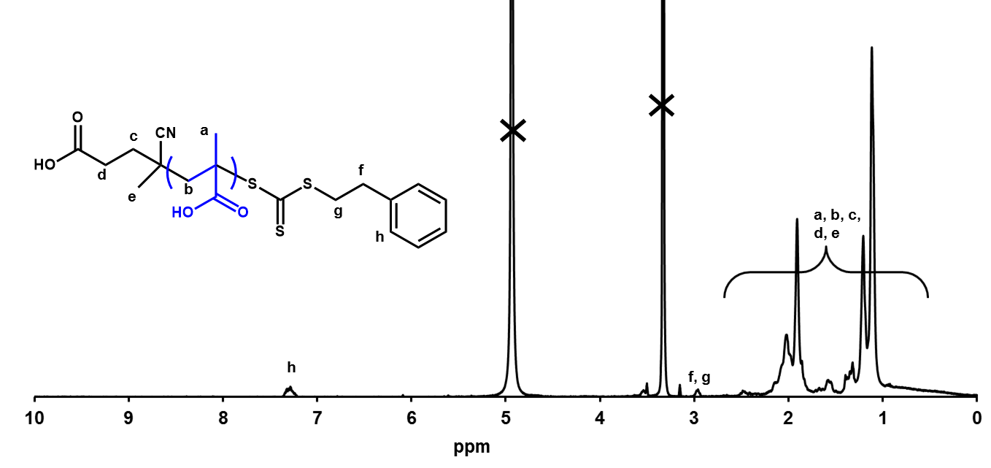
Figure S1. ¹H NMR spectra for purified PMAA₅₆ macro-CTA prepared via RAFT alcoholic solution polymerization. Integration of relevant peaks indicates a PMAA degree of polymerization (DP) of 56. The peaks marked with a cross are from the NMR solvent d₄-methanol (~3.3 ppm) and water (~3.5 ppm).

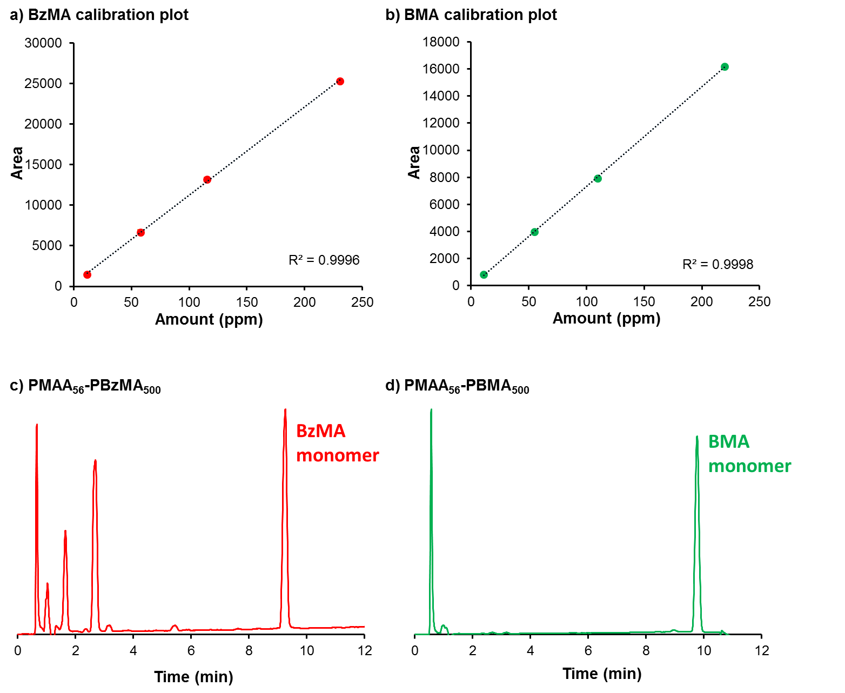
Figure S2. Monomer conversions for all high-throughput syntheses were determined by using HPLC to calculate the amount of residual monomer (ppm). Example calibration plots for (a) BzMA monomer and (b) BMA monomer and example chromatograms for (c) PMAA₅₆-PBzMA₅₀₀ and (d) PMAA₅₆-PBMA₅₀₀ are shown in this figure.
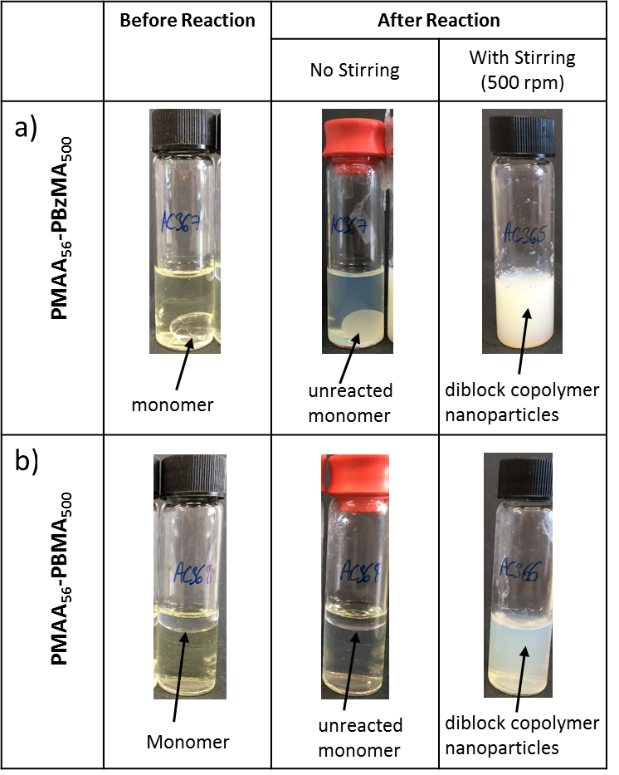

Figure S3. Digital photographs showing initial reaction mixtures and final diblock copolymer nanoparticle dispersions for the laboratory-scale synthesis of (a) PMAA₅₆-PBzMA₅₀₀ and (b) PMAA₅₆-PBMA₅₀₀. Reactions were either unstirred or stirred at 500 rpm with a magnetic flea. No significant polymerization was obtained for the unstirred reaction solution as judged by ¹H NMR spectroscopy.

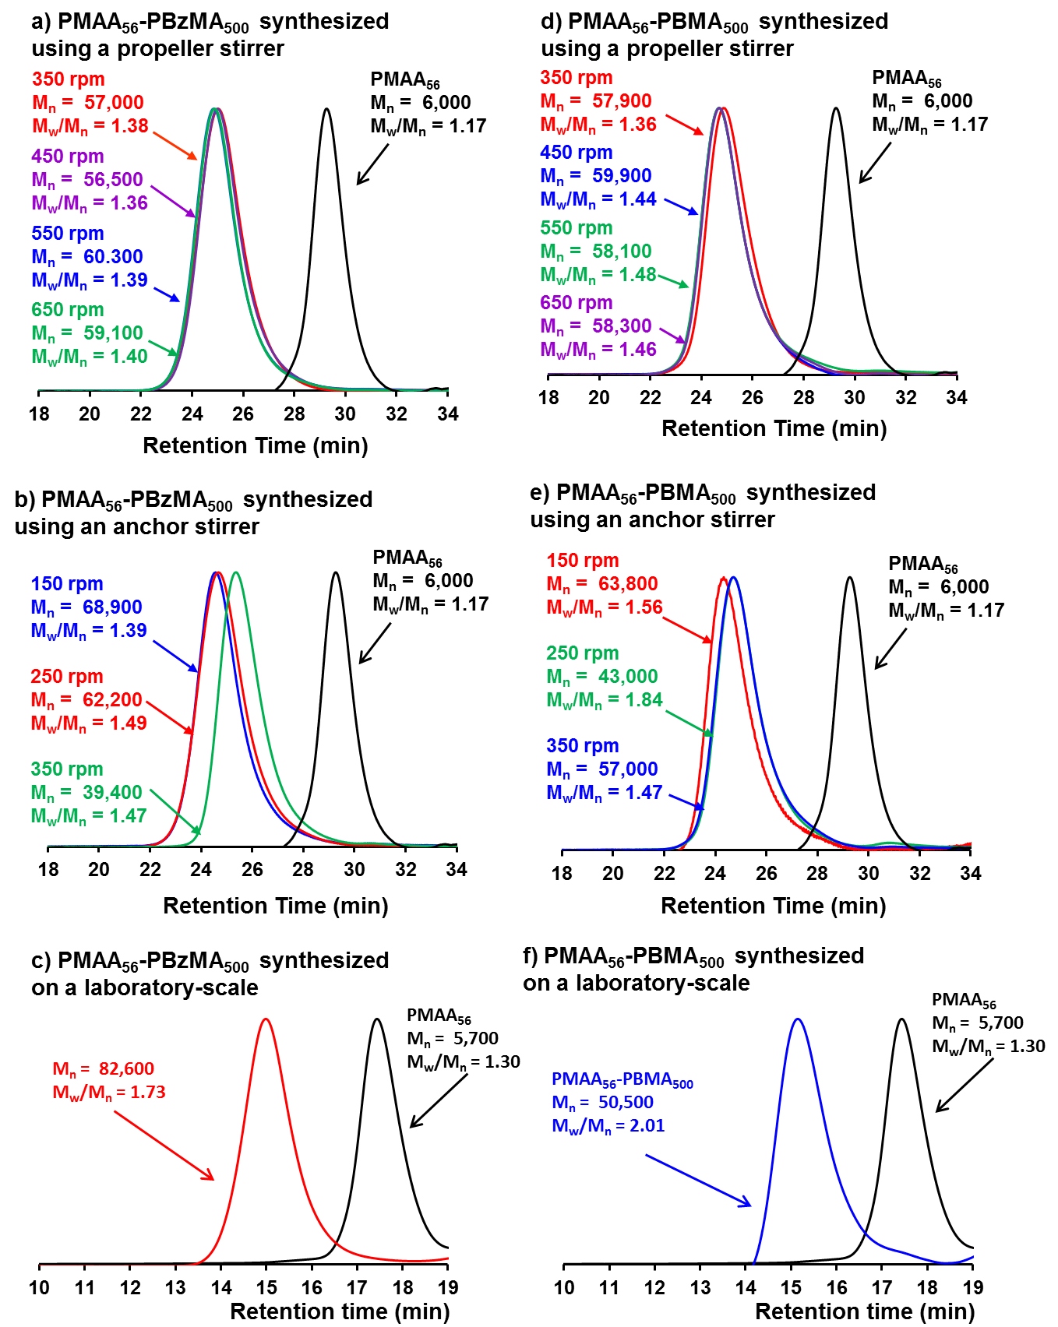

Figure S4. THF GPC chromatograms corresponding to the data reported in Table 2. This data demonstrates the effect of stirrer geometry and stirring rate (rpm) on the synthesis of PMAA₅₆-PBzMA₅₀₀ and PMAA₅₆-PBMA₅₀₀ diblock copolymer nanoparticles via high-throughput RAFT aqueous emulsion polymerization at 70 ºC. Chromatograms for the corresponding laboratory-scale polymers are included for comparison. All reactions were performed at 20 % w/w solids using a macro-CTA/initiator molar ratio of 5.0.

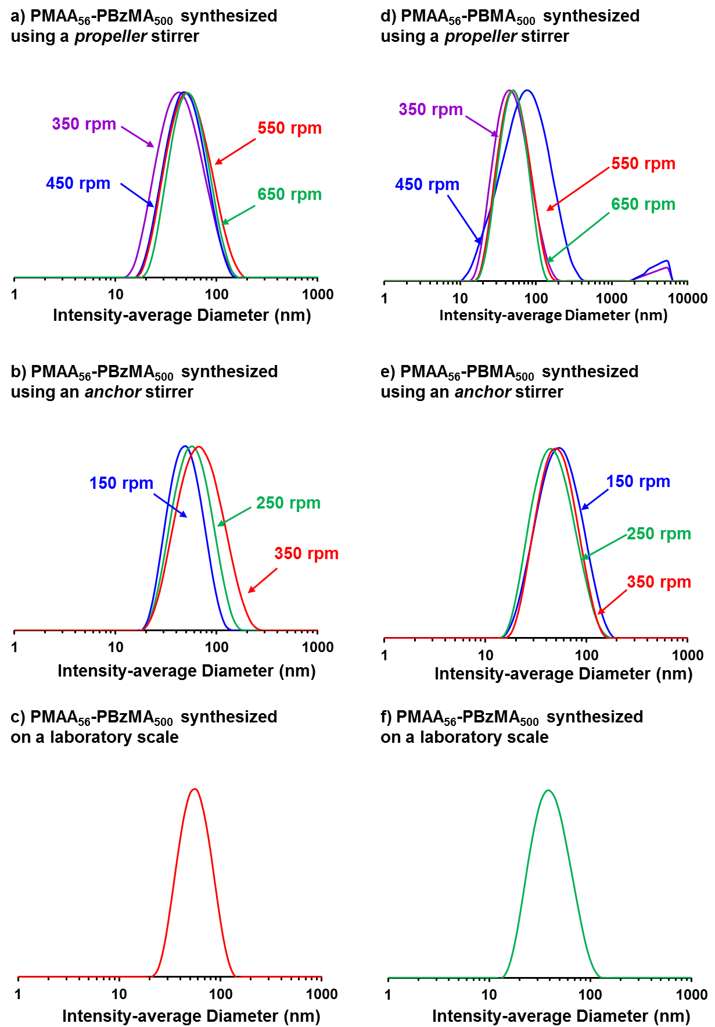
Figure S5. Intensity-average size distribution plots for dynamic light scattering data reported in Table 1 and Figure 2. This data demonstrates the effect of stirrer geometry and stirring rate (rpm) on the synthesis of PMAA₅₆-PBzMA₅₀₀ and PMAA₅₆-PBMA₅₀₀ diblock copolymer nanoparticles via high-throughput RAFT aqueous emulsion polymerization at 70 ºC. All reactions were performed at 20 % w/w solids using a macro-CTA/initiator molar ratio of 5.0. Intensity-average size distribution plots for the equivalent laboratory-scale syntheses (c) and (f) are also included for comparison.

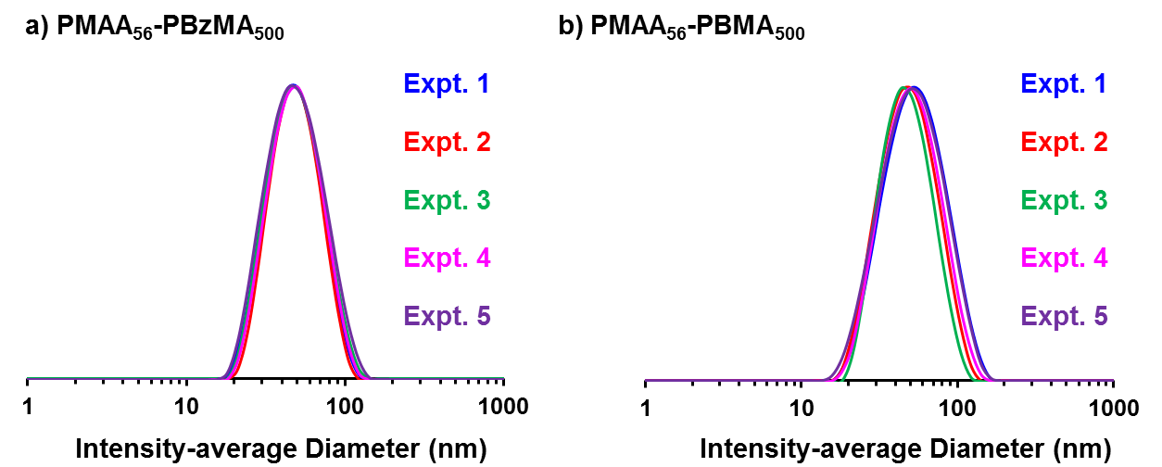

Figure S6. Intensity-average size distribution plots for dynamic light scattering data reported in Table 2. This data demonstrates the reproducibility of the PISA synthesis of diblock copolymer nanoparticles via high-throughput RAFT aqueous emulsion polymerization of either benzyl methacrylate (BzMA) or n-butyl methacrylate (BMA) at 70 °C using a PMAA₅₆ macro-CTA at pH 5.

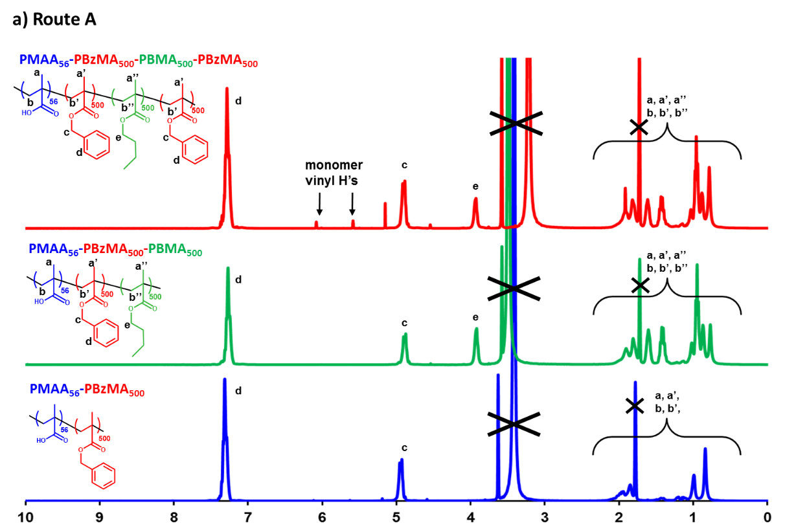
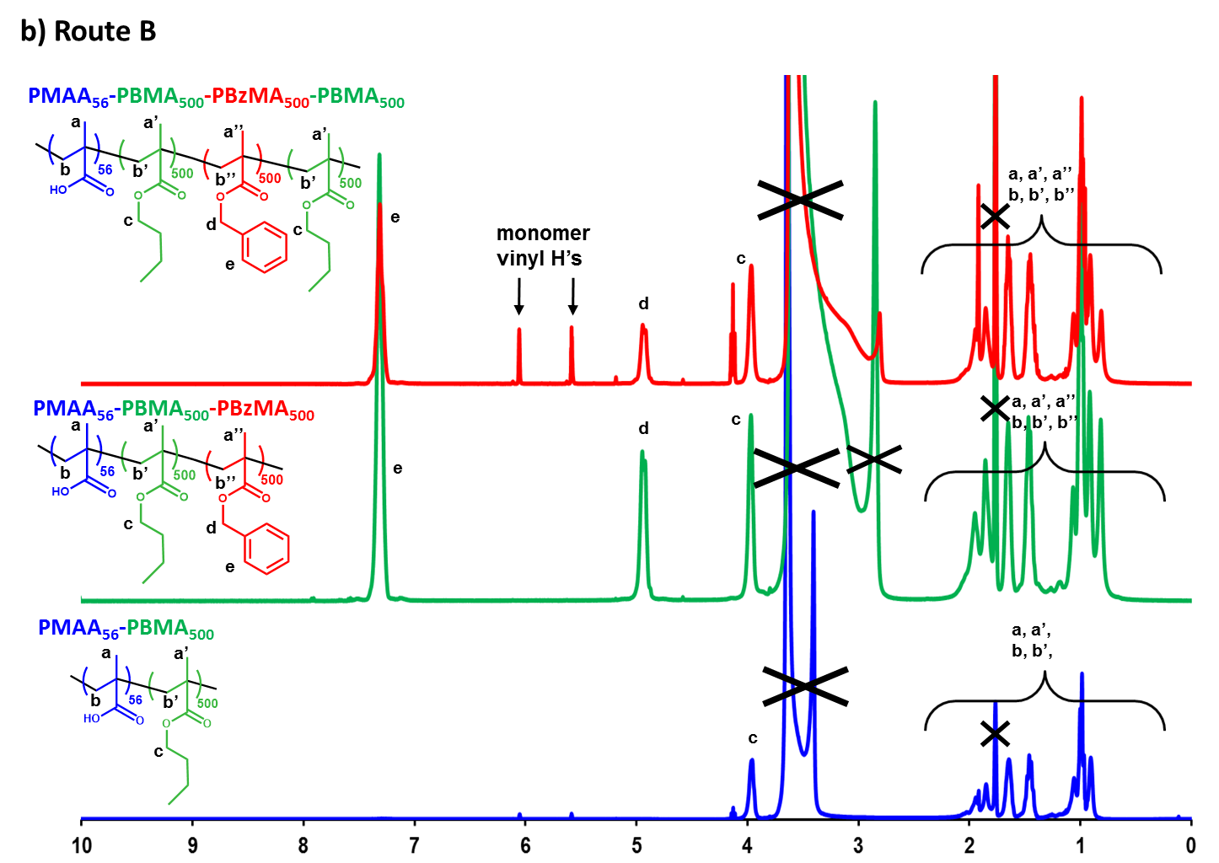
Figure S7. ¹H NMR spectra for diblock, triblock and tetrablock copolymers prepared via RAFT aqueous emulsion polymerization. These syntheses were performed on the high-throughput Chemspeed A100 robot synthesizer via either (a) Route A or (b) Route B as outlined in Scheme 2. The peaks labelled with a black cross correspond to solvent peaks from d₈-tetrahydrofuran (1.73 ppm and 3.58 ppm) and water (~3.5 ppm)
 | Target Composition | Overall Monomer Conversionª (%) |  | Average Particle diameter (nm)  by DLS | Average Particle PDI  by DLS | Average Particle diameter (nm)  by TEM | M_{n}^{b} | M_{w}/M_{n}^{b}
 |  | BzMA | BMA
High-Throughput Syntheses | PMAA₅₆-PBzMA₅₀₀ | 99 | - | 49 | 0.17 | 38 | 69,200 | 1.55
 | PMAA₅₆-PBzMA₅₀₀-PBMA₅₀₀ | > 99 | > 99 | 86 | 0.09 | 60 | 95,500 | 1.59
 | PMAA₅₆-PBzMA₅₀₀-PBMA₅₀₀-PBzMA₅₀₀ | 96 | > 99 | 106 | 0.10 | 64 | 130,400 | 1.64
 | PMAA₅₆-PBMA₅₀₀ | - | 94 | 47 | 0.21 | 40 | 69,000 | 1.62
 | PMAA₅₆-PBMA₅₀₀-PBzMA₅₀₀ | > 99 | > 99 | 82 | 0.16 | 49 | 103,900 | 1.85
 | PMAA₅₆-PBMA₅₀₀-PBzMA₅₀₀-PBMA₅₀₀ | 100 | 87 | 117 | 0.17 | 61 | 129,400 | 1.84
Laboratory-Scale Syntheses | PMAA₅₆-PBzMA₅₀₀ | > 99 | - | 64 | 0.16 | 40 | 79,900 | 2.11
 | PMAA₅₆-PBzMA₅₀₀-PBMA₅₀₀ | > 99 | > 99 | 80 | 0.13 | 57 | 130,800 | 2.16
 | PMAA₅₆-PBzMA₅₀₀-PBMA₅₀₀-PBzMA₅₀₀ | 96 | > 99 | 121 | 0.17 | 63 | 192,700 | 2.35
 | PMAA₅₆-PBMA₅₀₀ | - | > 99 | 62 | 0.15 | 48 | 87,800 | 2.00
 | PMAA₅₆-PBMA₅₀₀-PBzMA₅₀₀ | > 99 | > 99 | 90 | 0.17 | 52 | 205,700 | 2.30
 | PMAA₅₆-PBMA₅₀₀-PBzMA₅₀₀-PBMA₅₀₀ | >99 | > 99 | 109 | 0.16 | 67 | 280,200 | 2.25

ª Conversion determined by high-performance liquid chromatography (HPLC) for high-throughput syntheses and by ¹H NMR for laboratory-scale syntheses.
^{b} Molecular weight data determined by GPC using THF eluent containing 4 % v/v glacial acetic acid (calibrated using a series of near-monodisperse poly(methyl methacrylate) standards). These two data sets were analyzed using separate GPC instruments with differing column sets. Moreover, the copolymers obtained from the laboratory-scale syntheses were methylated using excess trimethylsilyldiazomethane, whereas those prepared using the high-throughput protocol were not subjected to this chemical derivatization. See Experimental for more details.
Table S1. Summary of diblock, triblock and tetrablock copolymers prepared via RAFT aqueous emulsion polymerization. These syntheses were performed either on the high-throughput Chemspeed A100 robot synthesizer or on a laboratory-scale. These multiblock copolymer syntheses were performed at 70 ºC using a PMAA₅₆ macro-CTA/initiator of 5.0, in aqueous solution at pH 5.

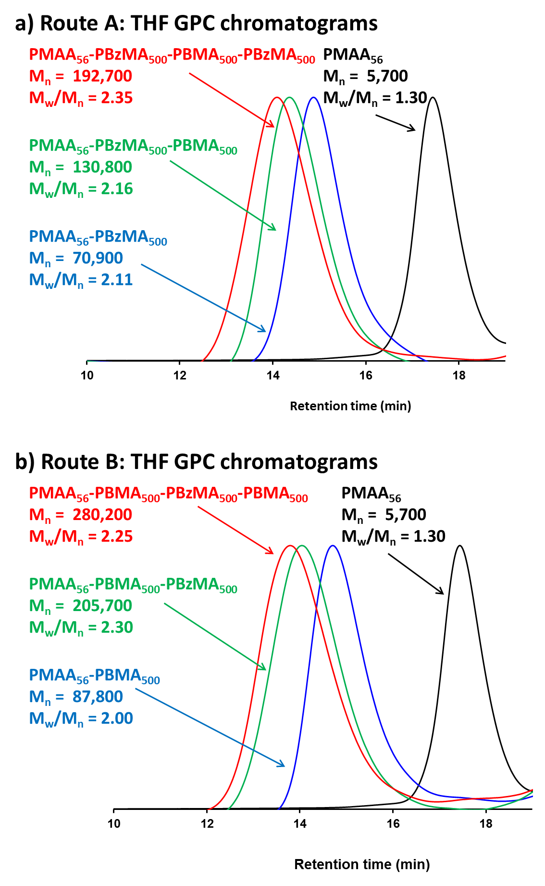

Figure S8. THF GPC chromatograms for diblock, triblock and tetrablock copolymers prepared via RAFT aqueous emulsion polymerization on a laboratory-scale. These block copolymers were prepared via either (a) Route A or (b) Route B as outlined in Scheme 2. The high-throughput and laboratory-scale polymers were analyzed using separate GPC instruments with differing column sets. Moreover, the copolymers obtained from the laboratory-scale syntheses were methylated using excess trimethylsilyldiazomethane, whereas those prepared using the high-throughput protocol were not subjected to this chemical derivatization. See Experimental for more details.

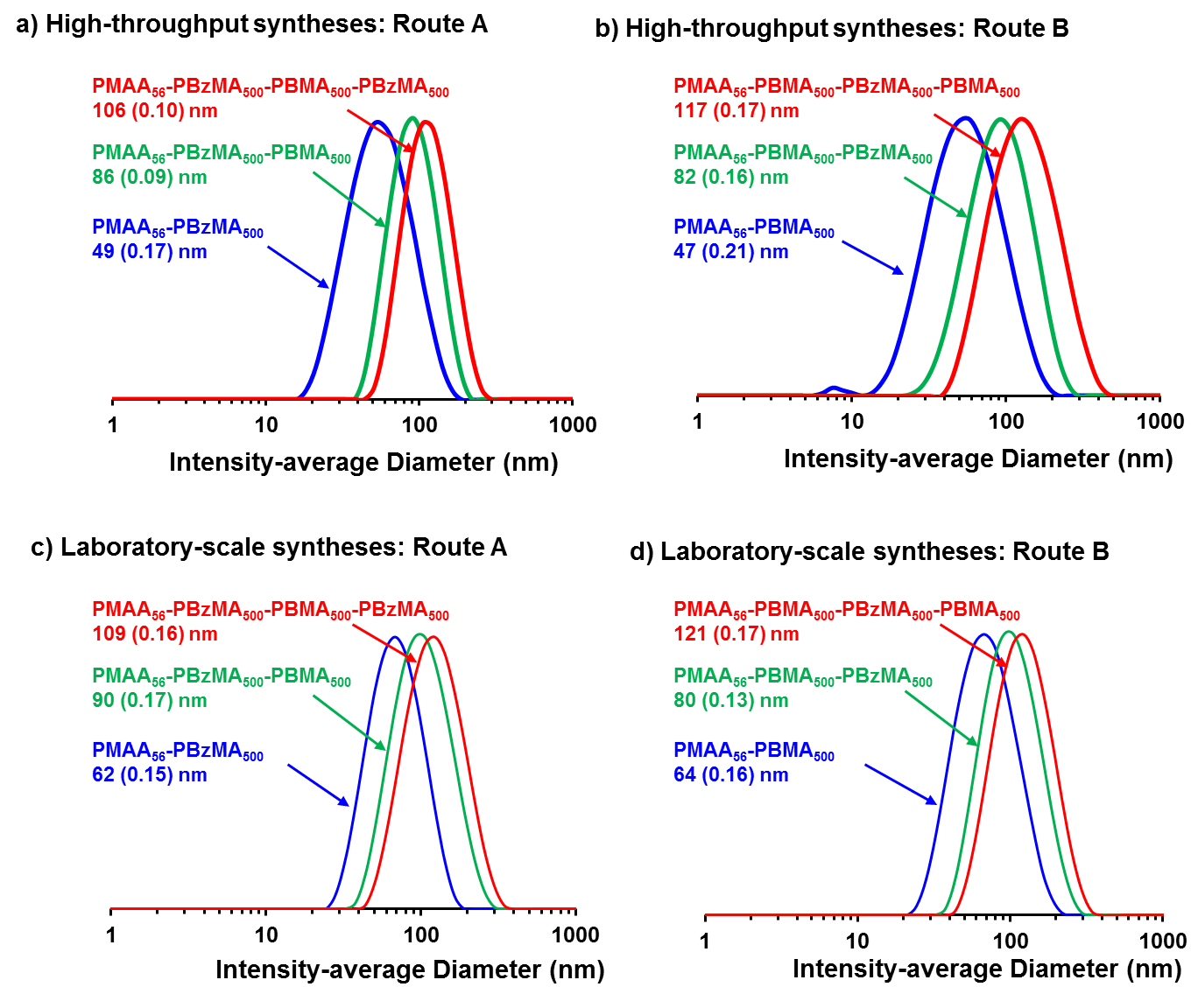
Figure S9. Intensity-average size distribution plots for dynamic light scattering data for diblock, triblock and tetrablock copolymers prepared via RAFT aqueous emulsion polymerization. These syntheses were performed either on the high-throughput Chemspeed A100 robot synthesizer or on a laboratory-scale. These block copolymers were prepared via either (a) Route A or (b) Route B as outlined in Scheme 2.

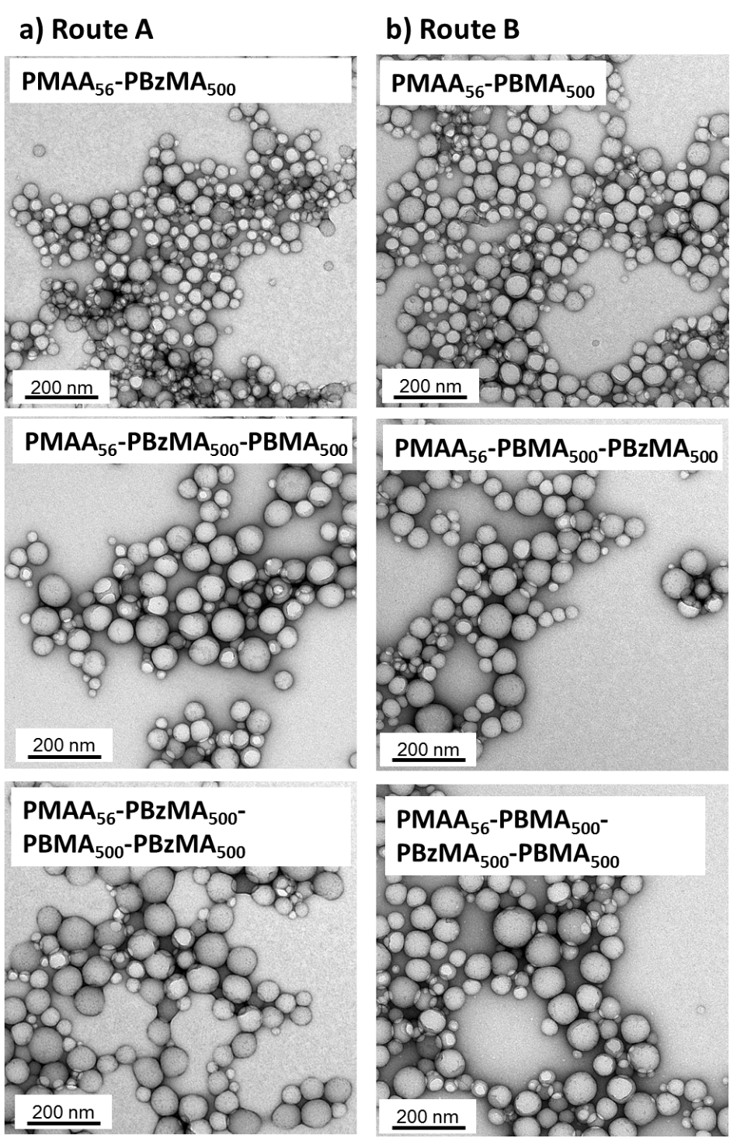

Figure S10. Representative TEM images obtained for the synthesis of diblock, triblock and tetrablock copolymers prepared on a laboratory-scale by RAFT aqueous emulsion polymerization. Spherical morphologies were obtained in all cases and an increase in mean nanoparticle diameter was observed by DLS and TEM with each subsequent block addition.

