Figure 1: Schematic Overview of the Development Process of the Conceptual Model
Development of draft conceptual model by working group based on disease area expertise, modeling knowledge, treatment guidelines
Finalized conceptual model
No
Has consensus/alignment been reached?
Yes
Revise the draft conceptual model based on expert panel inputs
Review draft model with expert panel
(via discussion guide, questionnaire and 1:1 semi structured interviews)
Convene an expert panel of 6 expert with a wide range of expertise
(epidemiologist, health economist, health services research & rheumatologist)
Systematic literature to inform and optimize the draft conceptual model
Scoping of the decision problem

Figure 2: RA Economic Model Influence Diagram for Structural Relationship

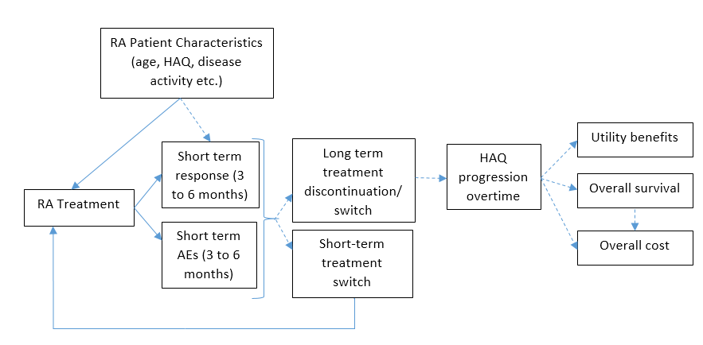

Figure 3: Proposed Conceptual Model to Evaluate Cost Effectiveness in RA
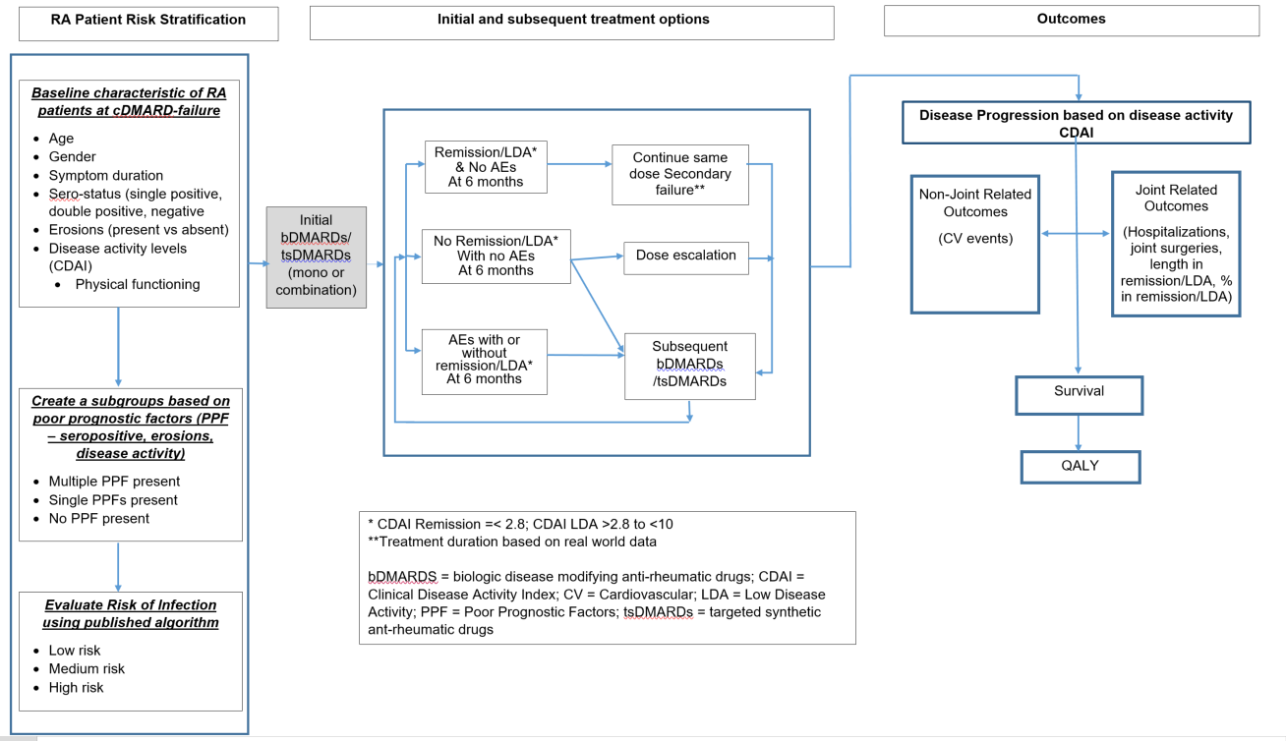

Figure 4: Revised Conceptual Model to Evaluate Cost Effectiveness in RA*
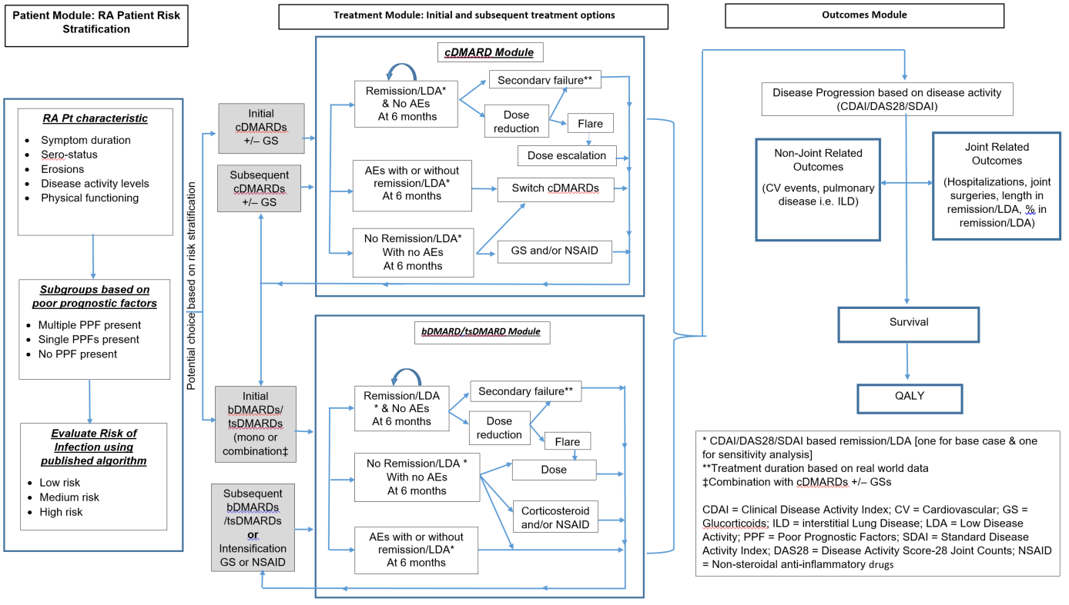
* difference between figure 3 & figure 4 include definition of primary failure; inclusion in treatment module a) cDMARD submodule b) primary and secondary failure c) inclusion of glucocorticoids as treatment escalation; inclusion in outcome module pulmonary disease

Table 1: Fixed Effects Regression Models for EQ5D
Models | R-Square | Root MSE | F- value
Patient global, Patient pain scale RADAI Joint Score | 0.70 | 0.09 | 14.2
RAPID3, RADAI Joint Score | 0.72 | 0.09 | 14.3
RAPID3 | 0.71 | 0.09 | 13.8
RAPID3, CDAI | 0.75 | 0.09 | 7.4
mHAQ | 0.68 | 0.10 | 15.4
mHAQ, RADAI Joint Score | 0.70 | 0.09 | 16.7
mHAQ, CDAI | 0.71 | 0.09 | 7.8
mHAQ, mHAQ square | 0.68 | 0.10 | 15.4
mHAQ, pain | 0.70 | 0.09 | 14.4
mdHAQ, RADAI Joint Score | 0.70 | 0.09 | 17.0
mdHAQ | 0.68 | 0.10 | 15.8
Models with baseline co-variates of age, duration, CRP and serostatus
Patient global, Patient pain scale RADAI Joint Score | 0.74 | 0.09 | 7.5
RAPID3, RADAI Joint Score | 0.73 | 0.09 | 15.1
RAPID3 | 0.71 | 0.09 | 14.0
RAPID3, CDAI | 0.75 | 0.09 | 7.4
mHAQ | 0.68 | 0.10 | 15.4
mHAQ, RADAI Joint Score | 0.69 | 0.09 | 16.7
mHAQ, CDAI | 0.71 | 0.09 | 7.8
mHAQ, mHAQ square | 0.68 | 0.10 | 15.4
mHAQ, pain | 0.70 | 0.09 | 14.5
mdHAQ, RADAI Joint Score | 0.70 | 0.09 | 14.6
mdHAQ | 0.68 | 0.10 | 15.7

Table 2: Summary of pros and cons of proposed changes, expert input and agreement
Changes proposed | Pros and Cons | Expert Inputs | Expert Agreement*
Model Structure | Pros: aligned with clinical practice & guidelines; allows to captures patient subgroups, treatment heterogeneity, non-joint outcomes;  Cons: increase in complexity; data availability | - Ideal, however data may not be available to populate model  - Include cDMARD-naïve and cDMARD inadequate responders  - Changes may not materially impact ICER  - The time involved in incorporating the changes might not be worth the extra accuracy | - of 5
Minimum of two disease activity measures for treatment response and disease progression | Pros: Aligns to treatment guidelines; less biased estimates (vs. single measure)  Con: Data availability; | - Data availability might be an issue | 4 of 5
Disease activity based mapping of utilities | Pros: Addresses the limitation of HAQ changes; Allows the model to be based entirely on disease activity; could lead to further improvements in mapping of utilities  Cons: Data availability | - HAQ would still be an unbiased estimator of disease progression  - Reasons for HAQ was its association to cost in RA  - Would not recommend RAPID3 by itself as it based entirely on patient report. Good to see that we are combining disease activity and RAPID3 | 3 of 5
Incorporation of subgroups | Pros: Allows for specific and targeted HTA evaluations  Cons: No general agreement that the prognostic factors are well established in RA; data availability | - Double sero-positives are at a higher risk of progressing (vs. single positive)  - Patients who have erosive disease at baseline are high risk of progression  - Additional subgroups could include elderly i.e. age >65 yrs (as they are increased risk of infections), CV and other RA extra-articular manifestations  - These are not just baseline factors | 5 of 5
Real world treatment patterns: | Pros: Allows for realistic estimates of cost and clinical benefits of standard of care  Cons: data availability; | - Generalizability of real world data vs. trials (where efficacy was gained)  - No controlled studies have examined switching therapy in patients who are well controlled  - GPs behavior cannot be clearly defined and consistent for dose reduction | 4 of 5
Incorporating extra-articular manifestations of RA: | Pros: Allows for improved estimation of benefit and cost of interventions  Cons: data availability; | - CV and lung disease should be considered  - Important if treatment would differentially impact extra-articular manifestations  - The strength of this evidence, particularly with respect to changes in markers and changes in hard outcomes is limited | 5 of 5
Mortality Associated with RA | Pros: allows for disease activity be the driver of benefits  Cons: potential for overestimation of survival; data availability | No comments | 5 of 5
*Agreement in principal that these need to be evaluated in future economic models; IR – inadequate response; ICER = Incremental cost effectiveness ratio

