Self-assembled ionic composites of negatively charged Zn(salen) complexes and triphenylmethane derived polycations as recyclable catalysts for the addition of carbon dioxide to epoxides

Svetlana A. Kuznetsova,[a] Yuri A. Rulev,[a] Vladimir A. Larionov,[a,b] Alexander F. Smol'yakov,[a] Yan V. Zubavichus,[c] Victor I. Maleev,[a] Han Li,[d] Michael North,*[d] Ashot S. Saghyan,[e] and Yuri N. Belokon*[a]

[a] Dr. S. A. Kuznetsova, Dr. Y. A. Rulev, Dr. V. A. Larionov, Dr. A. F. Smol'yakov, Dr. V. I. Maleev, Prof. Y. N. Belokon  
Nesmeyanov Institute of Organoelement Compounds  
Russian Academy of Sciences  
Vavilov Street 28, 119991 Moscow, Russian Federation  
E-mail: [yubel@ineos.ac.ru](mailto:yubel@ineos.ac.ru)

[b] Dr. V. A. Larionov  
Department of Inorganic Chemistry  
People’s Friendship University of Russia (RUDN University)  
Miklukho-Maklaya Street 6, 117198 Moscow, Russian Federation

[c] Dr. Y. V. Zubavichus

National Research Center

“Kurchatov Institute”

Akad. Kurchatova Sq. 1, 123098 Moscow, Russian Federation

[d] Mrs H. Li, Prof. M. North

Green Chemistry Centre of Excellence, Department of Chemistry

University of York

Heslington, YO10 5DD, UK

E-mail: [michael.north@york.ac.uk](mailto:michael.north@york.ac.uk)

#### [e] Prof. A.S. Saghyan Institute of Pharmacy of the Yerevan State University, 1 Alex Manoogian Str., 0025 Yerevan, Armenia, E-mail: saghyan@ysu.am

Supporting information for this article is given via a link at the end of the document.

**Abstract:** The design and synthesis of a novel type of self-assembled ionic composites composed of negatively charged Zn(salen) complexes and triphenylmethane derived polycations is reported. These composites were applied as easily recyclable catalysts for carbon dioxide addition to epoxides. The composites functioned as bifunctional catalysts which could be easily separated and recycled by precipitation from the reaction mixture upon addition of tetrachloromethane. The same batch of the catalyst could be employed for, at least, five runs with its catalytic properties improving as it was reused. A fully heterogeneous system was also prepared by cross-linking *leuco dye* with *para*-dibromoxylene and adding to it calculated amounts of Zn(salen) complex. The heterogeneous system was catalytically competent in the reaction between styrene oxide and carbon dioxide and its activity also increased on its reuse.

Introduction

Combustion of fossil fuels is likely to remain as a source of energy for the foreseeable future. This, along with the continued need for products such as cement whose manufacture produces large amounts of waste carbon dioxide, means that harmful carbon dioxide emissions will continue to increase. One way to turn this waste carbon dioxide into valuable chemicals is its reaction with epoxides **1** to form cyclic carbonates **2** (Scheme 1), a class of commodity chemicals finding applications as solvents, monomers for polymer synthesis, and as chemical starting materials.[1]



**Scheme 1.** Synthesis of cyclic carbonates.

There is a large volume of publications on the catalysis of this reaction using either metal complexes (salen complexes, in particular)[2,3] or organocatalysts, amongst which quaternary ammonium halides feature prominantly.[4,5] The most catalytically efficient systems usually consist of a combination of quaternary ammonium halides and Lewis acids (LA), which function cooperatively as illustrated in Scheme 2.[2,6] The key stage of the reaction is nucleophilic opening of the Lewis acid activated epoxide ring by the halide anion, generating an oxy-anion species. Subsequently, the negatively charged oxygen atom reacts with a carbon dioxide molecule to form a Lewis acid coordinated carbonate anion. Intramolecular nucleophilic substitution results in elimination of the halide anion, formation of the cyclic carbonate product and regenerates the Lewis acid and ammonium halide.[6,7] These binary catalyst systems can be highly efficient and in some cases are able to catalyse cyclic carbonate formation at ambient temperatures and low carbon dioxide pressure.[2] However, the recovery of the ammonium salts and Lewis acids from the reaction media requires energy intensive and time consuming procedures.[2-5] To further enhance the catalytic activity, the introduction of ammonium groups onto the salen ligand of a Lewis acid catalyst was proposed and the resulting monomolecular homogeneous catalysts were found to retain high activity.[8] This partially solved the problem of catalyst recovery, but also allowed immobilization of the salen complexes onto cross-linked polystyrene or silica to form heterogeneous catalysts for cyclic carbonate synthesis which could be easily separated from the product and reused.[9]



**Scheme 2.** Proposed mechanism of binary catalyst operation.

In recent times, immobilization of metal complexes within porous metal organic frameworks[2f,10,11] (MOFs) or covalent organic frameworks[10,12] (COFs) has been developed and the catalytic efficiencies of the resulting heterogeneous systems for carbon dioxide fixation demonstrated.[10-12] Covalent introduction of ammonium groups into the polymer body would make COF and MOF anchored salen complexes efficient heterogeneous catalysts for cyclic carbonate synthesis without the troublesome ammonium halide removal. This was achieved by condensing a chloromethyl substituted aluminium(salen) monomer and 2,4,6-tris(imidazolol-1-yl)-1,3,5-*s*-triazine to form a cationic porous COF.[13] This heterogeneous catalyst exhibited reasonable activity without the need for any co-catalysts and could be easily recycled.[13]

Unfortunately, the polymeric catalysts suffer from shortcomings, including problems of reagent diffusion, framework stability, high cost of the initial materials and number of steps needed to prepare the catalyst. Therefore, we decided to investigate a different approach to create a recyclable bifunctional catalyst for carbon dioxide and epoxide condensation. Thus it was envisaged that an organic polycation **3** could be combined with a zinc(salen) complex **4** substituted with two negatively charged sulphonate groups (Scheme 3). Polycation **3** is obtained from the inexpensive and commercially produced crystal violet *leuco dye* precursor by benzyl bromide alkylation. The combination of complexes **3** and **4** in different proportions could generate a set of self-assembled supramolecular ionic composites (**5**-**7**) with nucleophilic halide anions either present or completely absent within the structure. To simplify the initial studies, zinc was chosen as the central ion in the metal salen complex due to single oxidation state, non-paramagnetic nature and known tendency to form square-planar salen complexes.[14] It was expected that due to the electrostatic forces, the composites would form stable crystal structures insoluble in most organic solvents, but capable of reacting to external stimuli by increasing the distance between the ions and metal centers; “breathing,” in polar solvents and allowing substrates to reach the catalytic sites within the composite. Even if the final reaction mixture became so polar as to partially dissolve the composite, its recovery could be achieved by the addition of a nonpolar solvent. Herein we report the results of this study.



**Scheme 3.** Synthesis of ionic composites **5–7**.

Results and Discussion

Compounds **3** and **4** were prepared as described in the supporting information and characterized by NMR and IR spectra and elemental analysis. Mixing **3** and **4** in water at a molar ratio of 2 to 3 resulted in the precipitation of composite **5**, not containing any bromide ions (Scheme 3). The X-ray structure of composite **5** is shown in Figure 1. It is constructed of rather short layers of polyanions composed of several molecules of **4** interconnected by their sulphonate groups coordinated at the apical positions of the neighboring central metal ions. The countercations of **3** were positioned between the layers. The powder X-ray diffraction pattern of composite **5** is shown in Figure 2. The experimental (blue curve) and calculated based on the single-crystal X-ray structure (red curve) powder patterns are similar which confirms that the powder of composite **5** is homogeneous and that the single crystal structure is representative of the bulk material.

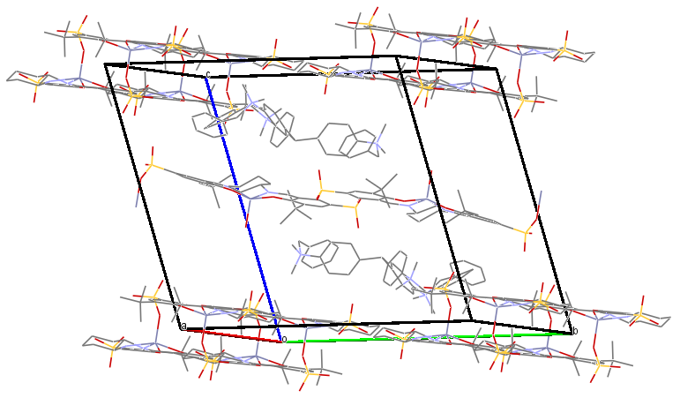

**Figure 1.** Packing view of the X-ray structure of composite **5**. Hydrogen atoms are omitted for clarity.

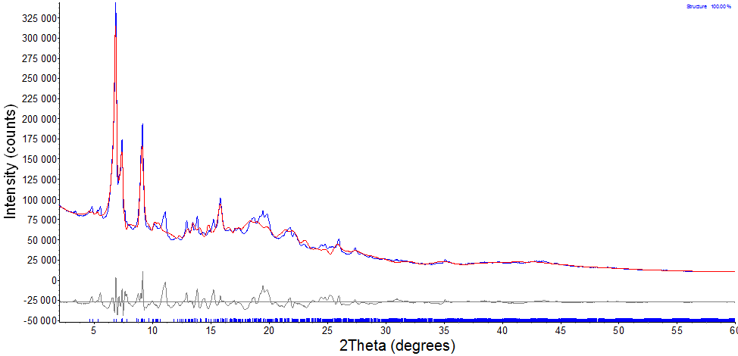

**Figure 2.** Experimental (blue) and calculated based on the single-crystal structure (red) powder X-ray diffraction patterns for composite **5** and their difference (grey). Blue ticks indicate calculated positions of the refined structure.

Composite **5** was also analysed by nitrogen porosimetry (data in Supporting Information, Section 11). It was found to contain mesopores and macropores with a BJH adsorption average pore radius of 10.4 nm, a BET surface area of 39.3 m2 g-1 and a BJH adsorption pore volume of 0.2 cm2 g-1. The porosimetry data is not directly relevant to the catalytic activity of the composite as the pore sizes are much larger than carbon dioxide and epoxides and there is extensive literature precedent for microporous, mesoporous and macroporous materials all showing catalytic activity for cyclic carbonate synthesis.[15] However, it provides an indication of how the solid state structure varies between species **5–9**.

Quaternary ammonium salt **3** was not an efficient catalyst for the addition of carbon dioxide to styrene oxide **1a** at 50 oC and 50 bar carbon dioxide pressure under solvent free conditions. Using 8 mol% of salt **3** and a reaction time of 24 hours, only traces of styrene carbonate **2a** were detected in the reaction mixture (Table 1, entry 1). Composite **5** (0.66 mol%) was then tested under the same conditions. The composite was not soluble in styrene oxide **1a**. After 24 hours the reaction was stopped, the temperature and pressure were brought to the ambient values and tetrachloromethane or diethyl ether was added to the reaction mixture to precipitate composite **5** (tetrachloromethanewas preferred to simplify the 1H NMR spectra). As there were no bromide ions present within composite **5**, the reaction was very slow and the yield of styrene carbonate **2a** was only 10% (Table 1, entry 2). The addition of tetrabutylammonium bromide (TBAB) to composite **5** resulted in an increase in the catalyst activity (Table 1, entries 2-5) as anticipated, until at a ratio of TBAB/**5** of 4:1, the yield reached 84% (Table 1, entry 5). TBAB is itself a known catalyst for cyclic carbonate synthesis,[16] so a control experiment was carried out and under the same reaction conditions use of TBAB (3 mol%) as the sole catalyst produced only 38% of carbonate **2a**.

|  |  |  |  |  |  |
| --- | --- | --- | --- | --- | --- |
|  | | | | | |
| **Table 1.** The addition of CO2 to neat styrene oxide **1a**, promoted by ionic composites **5–7**.[a] | | | | | |
| Entry | Catalyst (mol ratio of **4**:**3** = (m:n))(unless indicated otherwise) | TBAB/**5** (mol ratio) | Zn/Br (mol ratio) | Yield of **2a** (conv),[b] % | Selectivity,[b] % |
| 1[c] | **3** | - | - | traces | n.d. |
| 2 | **5** (3:2) | - | - | 10 (10) | >99 |
| 3 | **5** (3:2) | 2:1 | 1:0.7 | 51 (60) | >99 |
| 4 | **5** (3:2) | 3:1 | 1:1 | 65 (67) | >99 |
| 5[h] | **5** (3:2) | 4:1 | 1:1.3 | 84 (85) | >99 |
| 6[d] | **6** (1:1) | - | 1:1 | 29-33 (30-34) | >99 |
| 7 | **7** (1:2) | - | 1:4 | >98 (>99) | >99 |
| 8[e] | **7** (1:2) | - | 1:4 | traces | n.d. |
| 9[f] | **7** (1:2) | - | 1:4 | 33-40 (40-50) | >99 |
| 10[d] | **7** (1:2) | - | 1:4 | 98-99 (>99) | >99 |
| 11[e,g] | **7** (1:2) | - | 1:4 | traces | n.d. |
| 12[e,i] | **7’** (1:2) |  | 1:4 | 80-90 (>99) | >80 |
| [a] Reaction conditions: 2 mol% catalyst (relative to Zn) neat styrene oxide, 50 bar, 50 oC, 24 h, unless specified otherwise in a 7 mL autoclave. After the reaction, the catalyst was precipitated with CCl4 or Et2O and the filtrate evaporated. [b] Yields and conversions were determined by 1H NMR spectroscopy using *ortho*-xylene as a standard. [c] The loading of **3** was 3 mol%. [d] The catalyst was recovered (initially from a reaction carried out under the conditions of entry 7) and reused and the activity remained constant over five consecutive runs. [e] The experiment was conducted for 3 h, using freshly prepared composite. [f] The experiment was carried out for 3 h using the catalyst recovered from run 7. [g] The catalyst was prepared by adding 20 equiv. of styrene carbonate to a freshly prepared sample of the composite. [h] Fresh portions of the catalyst were used each time and for three repeated experiments the yields of **2a** were in the range of 80-86%. [i] A mixture of partly alkylated (with BnBr) leuco dye **3’**, salen ligand precursor of complex **4** alkylated with 2 eq of BnBr and ZnCl2 were combined to generate model catalyst **7’**. n.d. = not determined. | | | | | |

Mixing compounds **3** and **4** in a 1:1 ratio in water resulted in the formation of a precipitate which also contained a 1:1 ratio of the components and had a 1:1 ratio of Zn to bromide. This composite is designated as **6** (Scheme 3) and its powder X-ray diffraction pattern is shown in Figure 3. The powder patterns of composites **5** (Figure 2) and **6** (Figure 3) were different which confirmed their different structures. Porosimetry (data in Supporting Information, Section 11) showed that composite **6** was mesoporous with a BJH adsorption average pore radius of 3.4 nm, a BET surface area of 12.7 m2 g-1 and a BJH adsorption pore volume of 0.02 cm2 g-1. These values are all lower than the corresponding values for composite **5** and the pore volume is an order of magnitude lower. This is consistent with the majority of the pores which were present in composite **5** now being filled by bromide ions which have an ionic radius of just 0.196 nm.[17]

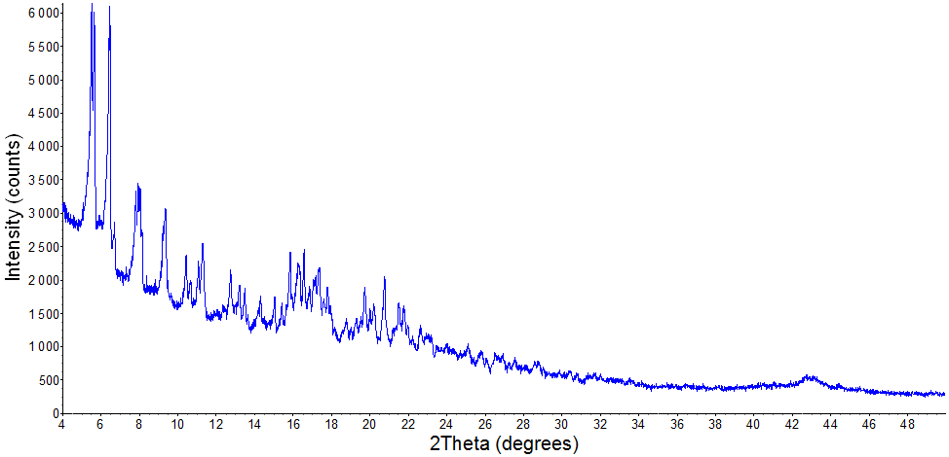

**Figure 3.** PXRD pattern of composite **6**.

The catalytic performance of composite **6** under the standard conditions was rather poor with the yield of styrene carbonate **2a** in the range of 29-33% (Table 1, entry 6). The catalyst could however, be easily precipitated by the addition of tetrachloromethane or diethyl ether and reused. Its activity remained constant over five runs (Table 1, entry 6). The 1H NMR spectra of composite **6** recovered from the reaction mixture did not significantly differ from that of freshly prepared composite **6** (Figure S4).

Composite **7** with a m:n ratio of 1:2 (Scheme 3), was prepared by adding an equivalent of salt **3** to a methanol solution of composite **6**, followed by evaporation of the solution. Porosimetry showed that composite **7** was again mesoporous with a BJH adsorption average pore radius of 4.0 nm, a BET surface area of 1.7 m2 g-1 and a BJH adsorption pore volume of 0.002 cm2 g-1. The order of magnitude reduction in the surface area and pore volumes compared to composite **6** are consistent with even more of the pores which were present in composite **5** now being filled by bromide ions.

The resulting solid material **7** contained a 1:4 ratio of zinc to bromide, so a better catalytic performance of the catalyst could be expected (Table 1, compare entries 3-5) and under the standard conditions a quantitative conversion of styrene oxide **1a** into styrene carbonate **2a** was observed (Table 1, entry 7). In view of this, the reaction time was reduced to three hours, but, unexpectedly, almost no styrene carbonate formation was detected employing freshly prepared composite **7** (Table 1, entry 8). Intriguingly, the catalyst recovered from entry 7 by tetrachloromethane precipitation and reused produced a 33-40% yield of styrene carbonate **2a** within a three hour reaction period (Table 1, entry 9). Evidently, some changes occurred with the catalyst during the reaction, improving its catalytic properties. The catalyst then remained active in, at least, five consecutive experiments without loss of its activity (Table 1, entry 10).

One rationale for the catalytic improvement could be the inclusion of the polar cyclic carbonate molecules within the composite structure, as indicated by the 1H NMR spectrum in DMSO-d6 of the recovered composite (Figure 4). However, the addition of 20 equivalents of styrene carbonate to freshly prepared composite **7** did not improve the performance of the catalyst (Table 1, entry 11). Clearly, some chemical transformation of composite **7** took place within the reaction, improving its performance. The filtered solutions obtained by diluting a reaction with diethyl ether or tetrachloromethane were analysed by rentgeno fluorescence and no zinc, bromine or sulphur atoms were detected, indicating that species containing these elements do not leach out of the composite during the reaction.

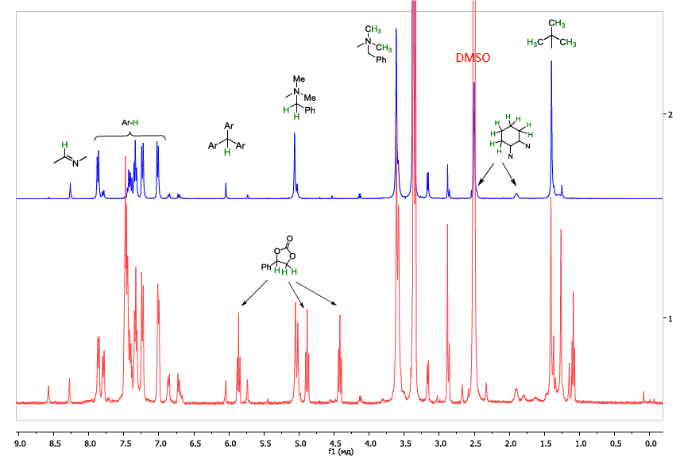

**Figure 4.** 1H NMR spectra in DMSO-d6 of the initial composite **7** (blue) and recovered composite **7** after 1st use in styrene carbonate synthesis (red). The peaks at 2.5 and 3.6 ppm correspond to DMSO and H2O respectively. In the red spectrum, the peaks at 4.4, 4.9 and 5.7 ppm correspond to styrene carbonate **2a**.

The 1H NMR spectra of the initial composite **7** and that of the catalyst recovered after a 24 hours reaction are presented in Figure 4. Evidently, both the zinc(salen) (**4**) and the polycation component (**3**) of composite **7** underwent concomitant structural changes. New resonances of **3** appeared at 5.75 and 3.59 ppm related to the central CH group and benzyl CH2 groups respectively. Resonances corresponding to uncharged MMe moieties also appeared at 2.8ppm. Simultaneously, a novel aldimine resonance for **4** appeared at 8.59 ppm and a new *tert*-butyl group resonance of the salen moiety appeared at 1.25 ppm. On the basis of these results it appears that, under the reaction conditions, benzyl groups were transferred from quaternary ammonium salt **3** to one or both of the sulfonate groups of zinc(salen) species **4** within composite **7**. There is literature precedent for quaternary ammonium salts undergoing a reverse Menschutkin reaction to form tertiary amines and alkyl halides during cyclic carbonate synthesis.[6] In the presence of traces of water in the reaction mixture, protonation of the phenolate groups may have occurred with the zinc ion acquiring oxygen (or/and bromide) ligands generating one or more new catalytically active species as shown in Scheme 4. The new formed phenolic groups within the zinc(salen) complex may be additionally stabilized by hydrogen bond formation with the newly formed unprotonated dimethylamino groups. Thus, the in situ formed species can be considered as Lewis acid activated Brønsted acids and would be expected to be highly efficient catalysts for cyclic carbonate synthesis.



**Scheme 4.** Proposed *in situ* conversion of initial composite **7** into a more catalytically active set of species. For simplicity only a subset of the species likely to be formed are shown as not all the sulphonate groups will be alkylated.

The catalyst recovered after use in cyclic carbonate synthesis was also analysed by porosimetry. This showed that the material was again mesoporous with a BJH adsorption average pore radius of 11.7 nm, a BET surface area of 1.3 m2 g‑1 and a BJH adsorption pore volume of 0.03 cm2 g-1. The increase in the pore radius and volume compared to fresh composite **7** are consistent with a change in the structure of the material and suggest that the recovered material has a less tightly packed structure. This is consistent with the absence of favourable ionic interactions between the salen and *leuco* dye components of the recovered material as shown in Scheme 4.

To support this hypothesis, the *leuco dye* was alkylated with only two equivalents of benzyl bromide (Scheme S2). The 1H NMR spectrum of the resulting product showed it to be a mixture of mono, bis and tris-alkylated molecules of the triamine. This mixture is designated as **3’**. The salen ligand precursor of complex **4** was also treated with benzyl bromide in the presence of sodium hydride in DMF and the resulting reaction mixture was purified on LH-20 Sephdex (Scheme S1). The 1H NMR spectrum of the yellow material so obtained (designated as **B’** and obtained in 40% yield) featured a set of, at least, three aldimine resonances, three CH2 resonances of benzyl groups (4.6-4.7 ppm) and a new set of aromatic resonances at 7.2-7.5 ppm. Integration of these signals suggested a structure with two benzyl groups attached to the original salen ligand. The yellow colour of **B’**, suggested that conjugation between phenols and aromatic imines was still present. The infrared spectrum **B’** showed adsorption bands at 3300 cm-1 corresponding to OH stretches. However, the adsorption band at 1038 cm-1 corresponding to the sulphonate group which was present in the salen ligand precursor of complex **4** almost disappeared from the spectrum of the alkylated product **B’**. A composite corresponding to that shown as being formed in Scheme 4 (and designated as **7’**) was then prepared by combining two equivalents of salt **3’** , one equivalent of ligand **B’** and one equivalent of anhydrous zinc chloride. When used as a catalyst under the conditions of Table 1 (entry 12), complete conversion of styrene oxide to the corresponding carbonate occurred within three hours, providing good support for the in situ formed catalyst having the structure shown in Scheme 4.

|  |  |  |  |  |
| --- | --- | --- | --- | --- |
|  | | | | |
| **Table 2**. Reaction of CO2 with various epoxides promoted by the ionic composite **7**.[a] | | | | |
| Entry | Substrate | Product | Yield (conv),[b]  % | Selectivity,[b] % |
| 1 | **1b** | **2b** | >98 (>99) | >99 |
| 2 | **1c** | **2c** | 40 (43) | >99 |
| 3[c] | **1c** | **2c** | >98 (>99) | >99 |
| 4 | **1d** | **2d** | >98 (>99) | >99 |
| [a] Reaction conditions: 2 mol% catalyst **7**, neat epoxide, 50 bar, 50 oC, 24 h, unless specified otherwise. At the end of the reaction, the catalyst was precipitated with CCl4 and the filtrate evaporated. [b] Yields and conversions were determined by 1H NMR spectroscopy using *ortho*-xylene as a standard. [c] The catalyst was recovered from entry 2 and reused. | | | | |

Bromide containing composite **7** could also be employed for the formation of other cyclic carbonates (Table 2, entries 1-4). *Para*-chlorostyrene oxide **1b** underwent reaction with very good yield (Table 2, entry 1). Hexene oxide **1c** reacted slowly and gave only a 40% yield of cyclic carbonate **2c** under the standard conditions. However, the in situ formed catalyst (Scheme 4) isolated at the end of this reaction was also much more active with this substrate and gave cyclic carbonate **2c** in quantitative yield. 3-Chloropropylene oxide **1d** was also a good substrate for the reaction (Table 2, entry 4).

To determine if the composite was active as a homogeneous or heterogeneous material, additional experiments were carried out. Composite **7** was insoluble in epoxide **1a** according to 1H NMR spectroscopy, but, as the reaction progressed, the forming cyclic carbonate **2a** could be a much better solvating media for the composite. Indeed it was observed that when the final reaction mixture of an experiment carried out under the conditions of Table 1, entry 7 was filtered at 50 oC, almost no sediment was left on the filter. However, when 1.5 equivalents of epoxide **1a** was added to the filtrate, the immediate formation of a precipitate was observed. The solid and liquid were separated and the liquid was shown to consist of **1a** and **2a** in a 1.8:1 ratio (see Supporting Information, Figure S2). Composite **7** was not detected in the filtrate by 1H NMR spectroscopy (see Supporting Information, Figure S2). Then, the filtrate was reacted with carbon dioxide under the standard reaction conditions. After 24 hours, the ratio of **1a**:**2a** had changed to 1:3 (see Supporting Information, Figure S3). This indicated that some minute amounts of catalyst were present in the filtered solution. This experiment whilst indicating the homogeneous nature of the catalyst, could not exclude some additional activity due to a heterogeneous part of composite **7**.

To clarify the catalyst state and construct a real heterogeneous catalytic system, a cross-linked ionic matrix **8** was synthesized from the *leuco dye* and *para*-dibromoxylene in methanol at room temperature (Scheme 5). The resulting insoluble material **8-Br** was obtained in 50% yield. All the bromine content of the matrix had an ionic nature and could be easily substituted by iodide ions in water to generate **8-I**. The material swelled in water and DMSO but did not swell in methanol or styrene oxide **1a**.

Matrices **8-Br** and **8-I** had very similar pore structures as determined by nitrogen porosimetry. The BJH adsorption average pore radii of 2.3 and 2.7 nm respectively, suggested that both materials were mesoporous, though pore radius distribution plots (data in Supporting Information, section 11) indicated a very wide spread of pore radius from <1 nm to >100 nm, showing the presence of micro-, meso- and macro-pores. The BET surface areas were 4.2 and 3.3 m2 g-1 and the BJH adsorption pore volumes were 0.006 and 0.005 cm2 g-1 respectively. These data are similar to those of composite **7** and the very low pore volumes again suggest that any pores present within the polymeric matrix are largely filled by the halide ions.

The addition of zinc(salen) complex **4** in water to **8-Br**(**I**) followed by washing with water resulted in formation of a heterogeneous catalytic material **9-Br**(**I**) with a ratio of Zn:Br(I) of 4:1. This material (with bromide counterions **9-Br**) was found to be a borderline microporous/mesoporous solid with a BJH adsorption average pore radius of 1.3 nm, a BET surface area of 2.6 m2 g-1 and a BJH adsorption pore volume of 0.003 cm2 g-1. These values are all reduced compared to those of polymer **8-Br** consistent with inclusion of at least some of the salen units within the **8-Br** pores.



**Scheme 5.** Synthesis of ionic matrix **8-Br**.

|  |  |  |  |
| --- | --- | --- | --- |
|  | | | |
| **Table 3**. The addition of CO2 to neat styrene oxide **1a**, promoted by the heterogeneous ionic composite **9**.[a] | | | |
| Entry | Catalyst | Conversion,[b] % | Selectivity,[b] % |
| 1 | **9-Br** | 43 | >99 |
| 2[c] | **9-Br** | 53 | >99 |
| 3[d] | **9-Br** | 60 | >99 |
| 4 | **9-I** | 39 | >99 |
| 5[c] | **9-I** | 95 | >99 |
| 6[d] | **9-I** | >99 | >99 |
| [a] Reaction conditions: 2 mol% catalyst (based on zinc content), neat **1a**, 50 bar, 50 oC, 24 hours, 7 ml autoclave. After the reaction, the heterogeneous catalyst was filtered and washed with 10-12 mL of tetrachloromethane. [b] Conversion was determined by 1H NMR spectroscopy. [c] The 2nd run with the recovered catalyst. [d] The 3rd run with the recovered catalyst. | | | |
|  | | | |

The activity of **9-Br** in the reaction between epoxide **1a** and carbon dioxide was low. Only 43% of cyclic carbonate **2a** was formed under the standard conditions (Table 3, entry 1). The activity of the recovered catalyst improved only slightly during the second and third uses of the catalyst (Table 3, entries 2 and 3) suggesting that it undergoes little or no conversion to a more active species under the reaction conditions. The iodide containing catalyst **9-**I had even lower catalytic activity than **9-Br** (Table 3, entry 4). However, the efficiency of recovered **9-**I increased markedly during its second and third uses (Table 3, entries 5 and 6) in the same way as that of composite **7** containing a bromide ion (Table 1, entries 8-10). The increased efficiency of **9-I** recovered from the reaction can be explained in the same way as the increasing activity of the at least partly homogeneous catalyst system **7** (Scheme 4). The observed activity of the purely heterogeneous systems (**9-Br** and **9-I**) does indicate that even in the case of the ionic composites derived from **3** and **4**, at least some impact of catalysis by heterogeneous components can be expected, especially in the early stages of the reaction where the reaction mixture is at its most non-polar.

Conclusions

Novel types of easily recyclable catalysts for carbon dioxide addition to epoxides have been developed based on electrostatically connected triply positively charged derivatives **3** of the commercially available *leuco dye* of crystal violet and a doubly negatively charged Zn(salen) complex **4** with two sulphate groups introduced into the molecule. The system functioned as a bifunctional catalyst which could be easily separated and recycled by the addition of tetrachloromethane to the reaction mixture. The same batch of the catalyst could be employed for, at least, five runs with its catalytic properties improving as it was reused. A fully heterogeneous system **9** was prepared by cross-linking *leuco dye* with *para*-dibromoxylene and adding to it calculated amounts of Zn(salen) complex **4**. The heterogeneous system was catalytically competent in the reaction between styrene oxide and carbon dioxide and its activity also increased on its reuse. The approach elaborated in this work can be easily developed further and applied to other types of M(salen) promoted reactions.

Experimental Section

Experimental details are given in the supporting information. CCDC-1838968 contains the supplementary crystallographic data for this paper. These data can be obtained free of charge from The Cambridge Crystallographic Data Centre via [http://www.ccdc.cam.ac.uk/data request/cif.CCDC](http://www.ccdc.cam.ac.uk/data%20request/cif.CCDC).

Acknowledgements

The authors gratefully acknowledge the financial support from a RFBR research grant № 18-53-05004 Arm-a. The RUDN University Program 5-100 is also thanked for support. The authors are also grateful to Alexander S. Goloveshkin for powder X-ray diffraction analysis. The contribution of center for molecule composition studies of INEOS RAS is gratefully acknowledged.

**Keywords:** cyclic carbonate • epoxide • carbon dioxide • ionic composite • heterogeneous catalyst

[1] For reviews, see: a) E. A. Quadrelli, G. Centi, J.-L. Duplan, S. Perathoner, *ChemSusChem* **2011**, *4*, 1194–1215; b) M. Peters, B. Köhler, W. Kuckshinrichs, W. Leitner, P. Markewitz, T. E. Müller, *ChemSusChem* **2011**, *4*, 1216–1240; c) I. Omae, *Coord. Chem. Rev.* **2012**, *256*, 1384–1405; d) B. Hu, C. Guild, S. L. Suib*, J. CO2 Utilization* **2013**, *1*, 18–27; e) M. Aresta, A. Dibenedetto, A. Angelini, *J. CO2 Utilization* **2013**, *3–4*, 65–73; f) A. A. Olajire, *J. CO2 Utilization* **2013**, *3–4*, 74–92; g) M. Aresta, A. Dibenedetto, A. Angelini, *Chem. Rev.* **2014**, *114*, 1709–1742; h) A. Otto, T. Grube, S. Schiebahn, D. Stolten, *Energy Environ. Sci.* **2015**, *8*, 3283–3297; i) A. J. Martín, G. O. Larrazábal, J. Pérez-Ramírez, *Green Chem.* **2015**, *17*, 5114–5130; j) Q. Liu, L. Wu, R. Jackstell, M. Beller, *Nat. Commun.* **2015**, *6*, 5933; k) M. Poliakoff, W. Leitner, E. S. Streng, *Faraday Discuss.* **2015**, *183*, 9–17; l) B. Yu, L.-N. He, *ChemSusChem* **2015**, *8*, 52–62.

[2] For reviews, see: a) A. Decortes, A. M. Castilla, A. W. Kleij, Angew. Chem. Int. Ed. **2010**, *49*, 9822−9837; b) X.-B. Lu, D. J. Darensbourg, *Chem. Soc. Rev.* **2012**, *41*, 1462–1484; c) C. Martín, G. Fiorani, A. W. Kleij, *ACS Catal.* **2015**, *5*, 1353−1370; d) V. D’Elia, J. D. A. Pelletier, J.-M. Basset, *ChemCatChem* **2015**, *7*, 1906–1917; e) J. W. Comerford, I. D. V. Ingram, M. North, X. Wu, *Green Chem.* **2015**, *17*, 1966–1987; f) A. C., Kathalikkattil, R. Babu, J. Tharun, R. Roshan, D.-W. Park, *Catal. Surv. Asia* **2015**, *19*, 223–235; g) H. Büttner, L. Longwitz, J. Steinbauer, C. Wulf, T. Werner, *Topics in Current Chem.* **2017**, *3*, 375; h) R. R. Shaikh, S. Pornpraprom, V. D’Elia, *ACS Catal*. **2018**, *8*, 419−450.

[3] For recent examples, see: a) C. J. Whiteoak, N. Kielland, V. Laserna, E. C. Escudero-Adán, E. Martin, A. W. Kleij, *J. Am. Chem. Soc.* **2013**, *135*, 1228–1231; b) J. Martinez, J. A. Castro-Osma, A. Earlam, C. Alonso-Moeno, A. Otero, A. Lara-Sanchez, M. North, A. Rodriguez-Dieguez, *Chem. Eur. J.* **2015**, *21*, 9850–9862; c) Y. A. Rulev, V. A. Larionov, A. V. Lokutova, M. A. Moskalenko, O. L. Lependina, V. I. Maleev, M. North, Y. N. Belokon, *ChemSusChem* **2016**, *9*, 216–222; d) J. A. Castro‐Osma, M. North, X. Wu, *Chem. Eur. J.* **2016**, *22*, 2100–2107; e) F. Chen, N. Liu, B. Dai, *ACS Sustainable Chem. Eng.* **2017**, *5*, 9065−9075; f) Z. Zhao, J. Qin, C. Zhang, Y. Wang, D. Yuan, Y. Yao, *Inorg. Chem.* **2017**, *56*, 4568–4575.

[4] For reviews, see: a) L. H. Yang, H. M. Wang, *ChemSusChem* **2014**, *7*, 962–998; b) Q. He, J. W. O'Brien, K. A. Kitselman, L. E. Tompkins, G. C. T. Curtis, F. M. Kerton, *Catal. Sci. Technol.* **2014**, *4*, 1513­–1528; c) G. Fiorani, W. S. Guo, A. W. Kleij, *Green Chem.* **2015**, *17*, 1375–1389; d) M. Cokoja, M. E. Wilhelm, M. H. Anthofer, W. A. Herrmann, F. E. Kühn, *ChemSusChem* **2015**, *8*, 2436–2454; e) D. H. Lan, N. Fan, Y. Wang, X. Gao, P. Zhang, L. Chen, C.-T. Au, S.-F. Yin, *Chinese J. Catal.* **2016**, *37*, 826–845; f) H. Zhou, X.B. Lu, *Sci. China Chem.* **2017**, *60*, 904–911; g) M. Alves, B. Grignard, R. Mereau, C. Jerome, T. Tassaing, C. Detrembleur, *Catal.Sci. Technol.* **2017**, *7*, 2651–2684.

[5] For recent examples, see: a) S. Gennen, M. Alves, R. Mereau, T. Tassaing, B. Gilbert,C. Detrembleur, C. Jerome, B. Grignard, *ChemSusChem* **2015**, *8*, 1845–1849; b) Y. Toda, Y. Komiyama, A. Kikuchi, H. Suga, *ACS Catal.* **2016**, *6*, 6906–6910; c) Y. A. Rulev, Z. T. Gugkaeva, A. V. Lokutova, V. I Maleev, A. S. Peregudov, X. Wu, M. North, Y. N. Belokon, *ChemSusChem* **2017**, *10*, 1152–1159; d) S. Sopeña, E. Martin, E. C. Escudero-Adán, A. W. Kleij, *ACS Catalysis* **2017**, *7*, 3532–3539; e) S. Arayachukiat, C. Kongtes, A. Barthel, S. V. C. Vummaleti, A. Poater, S. Wannakao, L. Cavallo, V. D’Elia, *ACS Sustainable Chem. Eng.* **2017**, *5*, 6392–6397; f) J. S. Cañellas, M. A. Pericàs, A. W. Kleij, *Green Chem.* **2017**, *19*, 5488–5493; g) J. Steinbauer, L. Longwitz, M. Frank, J. Epping, U. Kragl, T. Werner, *Green Chem.* **2017**, *19*, 4435–4445; h) Y. Kumatabara, M. Okada, S. Shirakawa, *ACS Sustainable Chem. Eng.* **2017**, *5*, 7295–7301; i) Z. Guo, Q. Jiang, Y. Shi, J. Li, X. Yang, W. Hou, Y. Zhou, J. Wang, *ACS Catal.* **2017**, *7*, 6770–6780; j) J. A. Castro-Osma, J. Martínez, F. de la Cruz-Martínez, M. P. Caballero, J. Fernández-Baeza, J. Rodríguez-López, A. Otero, A. Lara-Sánchez, J. Tejeda, *Catal. Sci. Technol.* **2018**, *8*, 1981–1987.

[6] M. North, R. Pasquale, *Angew. Chem. Int. Ed.* **2009**, *48*, 2946–2948.

[7] For reviews, see: a) M. North, R. Pasquale, C. Young, *Green Chem.* **2010**, *12*, 1514–1539; b) M. North, Arkivoc, **2012**, part (i), 610–628.

[8] a) C. Martín, C. J. Whiteoak, E. Martin, M. Martínez Belmonte, E. C. Escudero-Adán, A. W. Kleij, *Catal. Sci. Technol.* **2014**, *4*, 1615-1621; b) W.-M. Ren, Y. Liu, X.-B. Lu, *J. Org. Chem.* **2014**, *79*, 9771–9777; c) Y. Ren, J. Chen, C. Qi, H. Jiang, *ChemCatChem* **2015**, *7*, 1535–1538; d) Y. A. Rulev, Z. T. Gugkaeva, V. I. Maleev, M. North, Y. N. Belokon, *Beilstein J. Org. Chem.* **2015**, *11*, 1614–1623; e) F. de la Cruz-Martínez, J. Martínez, M. A. Gaona, J. Fernández-Baeza, L. F. Sánchez-Barba, A. M. Rodríguez, J. A. Castro-Osma, Antonio Otero, A. Lara-Sánchez, *ACS Sustainable Chem. Eng.* **2018**, *6*, 5322–5332.

[9] a) J. Meléndez, M. North, P. Villuendas, *Chem. Commun.* **2009**, 2577–2579; b) M. North, P. Villuendas, C. Young, *Chem. Eur. J.* **2009**, *15*, 11454–11457; c) X. Chen, J. Sun, J. Wang, W. Cheng, *Tetrahedron Lett.* **2012**, *53*, 2684–2688; d) M. Q. Zhu, M. A. Carreon, *J. Appl. Polym. Sci.* **2014**, *131*, 39738–39751.

[10] For reviews, see: a) S. M. J. Rogge, A. Bavykina, J. Hajek, H. Garcia, A. I. Olivos-Suarez, A. Sepúlveda-Escribano, A. Vimont, G. Clet, P. Bazin, F. Kapteijn, M. Daturi, E. V. Ramos-Fernandez, F. X. Llabrés i Xamena, V. Van Speybroeck, J. Gascon, *Chem. Soc. Rev.* **2017**, *46*, 3134–3184; b) J. Liang, Y.-B. Huang, R. Cao, *Coord. Chem. Rev.* **2017**, doi: 10.1016/j.ccr.2017.11.013; c) V. B. Saptal, B. M. Bhanage, *Curr. Opinion in Green and Sustainable Chem.* **2017**, *3*, 1–10.

[11] For recent examples, see: a) Z. Zhou, C. He, J.-H. Xiu, L. Yang, C.-Y. Duan, *J. Am. Chem. Soc.* **2015**, *137*, 15066−15069; b) A. C. Kathalikkattil, R. Roshan, J. Tharun, R. Babu, G.-S. Jeong, D.-W. Kim, S. J. Cho, D.-W. Park, *Chem. Commun.* **2016**, *52*, 280−283; c) L. Liu, S.-M. Wang, Z.-B. Han, M. Ding, D.-Q. Yuan, H.-L. Jiang, *Inorg. Chem.* **2016**, *55*, 3558–3565; d) Z. Xue, J. Jiang, M.-G. Ma, M.-F. Li, T.-C. Mu, *ACS Sustainable Chem. Eng.* **2017**, *5*, 2623–2631; e) J. Liang, R.-P. Chen, X.-Y. Wang, T.-T. Liu, X.-S. Wang, Y.-B. Huang, R. Cao, *Chem. Sci.* **2017**, *8*, 1570–1575; f) B.-B. Lu, J. Yang, Y.-Y. Liu, J.-F. Ma, *Inorg. Chem.* **2017**, *56*, 11710–11720; g) M. Gupta, D. De, K. Tomar, P. K. Bharadwaj, *Inorg. Chem*. **2017**, *56*, 14605–14611; h) R. Babu, J. F. Kurisingal, J.‐S. Chang, D.‐W. Park, *ChemSusChem* **2018**, *11*, 924–932; i) J. Liang, Y.-Q. Xie, X.-S. Wang, Q. Wang, T.-T. Liu, Y.-B. Huang, R. Cao, *Chem. Commun.* **2018**, *54*, 342–345; j) H.-F. Zhou, B. Liu, L. Hou, W.-Y. Zhang, Y.-Y. Wang, *Chem. Commun.* **2018**, *54*, 456–459; k) C.-S. Cao, Ying Shi, H. Xu, B. Zhao, *Dalton Trans.* **2018**, *47*, 4545–4553; l) J. Liang, Y.-Q. Xie, Q. Wu, X.-Y. Wang, T.-T. Liu, H.-F. Li, Y.-B. Huang, R. Cao, *Inorg. Chem.* **2018**, *57*, 2584–2593; m) D. Zhao, X.-H. Liu, J.-H. Guo, H.-J. Xu, Y. Zhao, Y. Lu, W.-Y. Sun, *Inorg. Chem.* **2018**, *57*, 2695–2704.

[12] For recent examples, see: a) P. Kaur, J. T. Hupp, S.-B. T. Nguyen, *ACS Catal.* **2011**, *1*, 819–835; b) V. Saptal, D. B. Shinde, R. Banerjee, B. M. Bhanage, *Catal. Sci. Technol.* **2016**, *6*, 6152–6158; c) M. H. Kim, T. Song, U. R. Seo, J. E. Park, K. Cho, S. M. Lee, H. J. Kim, Y.-J. Ko, Y. K. Chung, S. U. Son, *J. Mater. Chem. A*, **2017**, *5*, 23612–23619; d) Y. Xie, Q. Sun, Y. Fu, L. Song, J. Liang, X. Xu, H. Wang, J. Li, S. Tu, X. Lu, J. Li, *J. Mater. Chem. A* **2017**, *5*, 25594–25600; e) R. Luo, Y. Chen, Q. He, X. Lin, Q. Xu, X. He, W. Zhang, X. Zhou, H. Ji, *ChemSusChem* **2017**, *10*, 1526–1533; f) Y. Zhi, P. Shao, X. Feng, H. Xia, Y. Zhang, Z. Shi, Y. Mua, X. Liu, *J. Mater. Chem. A* **2018**, *6*, 374–382.

[13] T.-T. Liu, J. Liang, Y.-B. Huang, R. Cao, *Chem Comm.* **2016**, *52*, 13288–13291.

[14] a) Y.-M. Shen, W.-L. Duan, M. Shi, *J. Org. Chem.* **2003**, *68*, 1559−1562; b) A. Decortes, M. Martínez Belmonte, J. Benet-Buchholz, A. W. Kleij, *Chem. Commun.* **2010**, *46*, 4580−4582; c) A. Decortes, A. W. Kleij, *ChemCatChem* **2011**, *3*, 831−834; d) M. Taherimehr, A. Decortes, S. M. Al-Amsyar, W. Lueangchaichaweng, C. J. Whiteoak, E. C. Escudero-Adán, A. W. Kleij, P. P. Pescarmona, *Catal. Sci. Technol.* **2012**, *2*, 2231−2237; e) N. Kielland, E. C. Escudero-Adán, M. Martínez Belmonte, A. W. Kleij, *Dalton Trans.* **2013**, *42*, 1427−1436; f) F. Castro-Gomez, G. Salassa, A.W. Kleij, C. Bo, *Chem. Eur. J.* **2013**, *19*, 6289−6298.

[15] For representative examples see: a) B.-B. Lu, W. Jiang, J. Yang, Y.-Y. Liu, J.-F. Ma, *ACS Appl. Mater. Interfaces* **2017**, *9*, 39441–39449; b) C. M. Miralda, E. E. Macias, M. Zhu, P. Ratnasamy, M. A. Carreon, *ACS Catal.* **2012**, *2*, 180–183; c) Z. Xue, J. Jiang, M.-G. Ma, M.-F. Li, T. Mu, *ACS Sustainable Chem. Eng.* **2017**, *5*, 2623–2631; d) C.-Y. Gao, H.-R. Tian, J. Ai, L.-J. Li, S. Dang, Y.-Q. Lan, Z.-M. Sun, *Chem. Commun.* **2016**, *52*, 11147–11150; e) A. Chakraborty, A. Achari, M. Eswaramoorthy, T. K. Maji, *Chem. Commun.* **2016**, *52*, 11378–11381; f) X.-Y. Li, Y.-Z. Li, Y. Yang, L. Hou, Y.-Y. Wang, Z. Zhu, *Chem. Commun.* **2017**, *53*, 12970–12973; g) M. H. Beyzavi, R. C. Klet, S. Tussupbayev, J. Borycz, N. A. Vermeulen, C. J. Cramer, J. F. Stoddart, J. T. Hupp, O. K. Farha, *J. Am. Chem. Soc.* **2014**, *136*, 15861–15864; h) O. V. Zalomaeva, A. M. Chibiryaev, K. A. Kovalenko, O. A. Kholdeeva, B. S. Balzhinimaev, V. P. Fedin, *J. Catal.* **2013**, *298*, 179–185; i) A. Zanona, S. Chaemchuena, B. Mousavia, F. Verpoort, *J. CO2 Utilization* **2017**, *20*, 282–291; j) Y. Du, F. Cai, D.-L. Kong, L.-N. He, *Green Chem.* **2005**, *7*, 518–523; k) J. Wang, Y. Zhang, *Green Chem.* **2016**, *18*, 5248–5253;

[16] C. A. Montoya, A. B. Paninho, P. M. Felix, M. E. Zakrzewska, J. Vital, V. Najdanovic-Visak, A. V. M. Nunes, *J. Supercritical Fluids* **2015**, *100*, 155–159.

[17] R. D. Shannon *Acta Crystallographica* **1976**, *A32*, 751–767.

**Entry for the Table of Contents** (Please choose one layout)

|  |  |  |  |  |
| --- | --- | --- | --- | --- |
| FULL PAPER | | | | |
| The design and synthesis of novel type of self-assembled ionic composites of negatively charged Zn(salen) complexes and triphenylmethane derived polycations are reported. These composites were applied as easily recyclable catalysts for carbon dioxide addition to epoxides. |  |  |  | Svetlana A. Kuznetsova, Yuri A. Rulev, Vladimir A. Larionov, Alexander F. Smol'yakov, Yan V. Zubavichus, Victor I. Maleev, Han Li, Michael North,* Ashot S. Saghyan, and Yuri N. Belokon*  Page No. – Page No.  Self-assembled ionic composites of negatively charged Zn(salen) complexes and triphenylmethane derived polycations as recyclable catalysts for the addition of carbon dioxide to epoxides |
|  |  |