Running head: Microplastics in the environment
Corresponding author: Alistair Boxall
alistair.boxall@york.ac.uk

Microplastics in the aquatic environment: Evidence for or against adverse impacts and major knowledge gaps
Emily E. Burns†, Alistair A.B. Boxall*†
†Environment Department, University of York, Heslington, YO10 5NG, UK

ABSTRACT

There is increasing scientific and public concern over the presence of microplastics (MPs) in the natural environment. Here, we present the results of a systematic review of the literature to assess the weight of evidence for MPs causing environmental harm. We conclude that MPs do occur in surface water and sediments. Fragments and fibers predominate with beads making up only a small proportion of the detected MP types. Concentrations detected are orders of magnitude lower than those reported to affect molecular level endpoints, feeding, reproduction, growth, tissue inflammation and mortality in organisms. The evidence for MPs acting as a vector for hydrophobic organic compounds (HOC) to accumulate in organisms is also weak. The available data therefore suggest that these materials are not causing harm to the environment. There is however a mismatch between the particle types, size ranges, and concentrations of MPs used in laboratory tests and those measured in the environment. Select environmental compartments have also received limited attention. There is an urgent need for studies that address this mismatch by performing better quality and more holistic monitoring studies alongside more environmentally realistic effects studies. Only then will we be able to fully characterize risks of MPs to the environment in order to support the introduction of regulatory controls that can make a real positive difference to environmental quality.
Keywords: microplastics, species sensitivity distribution, risk, persistent organic pollutants (POPs)
Graphical abstract:
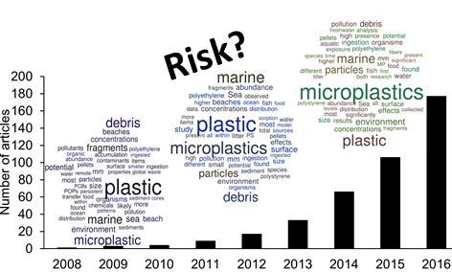

Caption: Number of scientific studies identified over the past eight years with the word 'microplastic' in the title, abstract or keywords (extracted from the Scopus and Web of Science data bases). Word clouds containing the 50 most frequently occurring words in abstracts from 2008-2011, 2012-2014 and 2015-2016 are overlaid.

INTRODUCTION
Over the past decade there has been increasing scientific, public and regulatory interest in the occurrence and impacts of microplastics (MPs) in the environment. MPs have been defined as plastic particles <5 mm in size (Hidalgo-Ruz et al. 2013) and arise from a number of sources including cosmetics, abrasion of larger items through use (such as tire fragments), and the fragmentation of larger items of plastic (Sundt et al. 2014). In 2010, <10 peer-reviewed articles contained the word ‘microplastic’ while this number had risen to around 306 in 2017. Alongside this, there have been significant policy and regulatory developments around the use and emissions of MPs. For example in the US the Microbead Free Water Act of 2015 or in the Environmental Protection (Microbeads) (England) Regulations 2017, where a ban on the use of microbeads in all wash-off cosmetic products has recently been announced.
These regulatory interests are being driven by the increasing evidence that MPs occur in the environment (Lusher 2015a), are taken up into organisms (Eerkes-Medrano et al. 2015) and the perception amongst many that the materials are adversely affecting marine life and that they may pose a risk to human health (Cole et al. 2011; Wright et al. 2013; Ivar do Sul et al. 2014; Van Cauwenberghe et al. 2015; Eerkes-Medrano et al. 2015; Galloway 2015; Koelmans et al. 2015; Lassen et al. 2015; Lusher 2015a; Oberbeckmann et al. 2015; Duis and Coors 2016; Auta et al. 2017; Anbumani and Kakkar 2018). However, various researchers have raised concerns over the quality of some of the studies (Song et al. 2014; Phuong et al. 2016; Connors et al. 2017; Lusher et al. 2017) and little effort has been made to put the findings from different studies into the environmental occurrence and effects of MPs into a risk context (Koelmans et al. 2017).
Therefore, in this paper, we present the results from a systematic review of the published literature to attempt to answer the question ‘Do existing data on the occurrence and effects of microplastics in the environment indicate that these materials are causing harm?’. In answering this question, we explore the evidence-base for a number of assertions made by the broader community around MPs in the environment, including: ‘Wastewater treatment processes are unable to remove microplastics’; ‘MPs occur in waters and sediment’; ‘MPs are taken up by organisms’; ‘MPs can act as vectors of persistent organic pollutants into organisms and through food chains’; and ‘MPs are adversely affecting organisms in the environment’. We also identify major knowledge gaps that need to be addressed in order to establish the extent of MP environmental impacts. It is our hope that the results of the analysis will help to focus future research efforts around the impacts of MPs in the environment.

METHODS
A systematic literature review was conducted in 2017 using publications identified by the search engines Scopus and Web of Science. The search term ‘microplastic’ and ‘environment’ were used and 320 peer-reviewed research articles identified. Further targeted searching was conducted when cited literature yielded relevant peer-reviewed articles and applicable reports published by government agencies that were missed by the search engine.
To allow comparison of data from different sources, ecotoxicity studies reporting concentrations in mass/L were converted to particles/L according to the method of Connors et al. (2017). Aquatic measured environmental concentrations (MECs) (freshwater and marine) were converted from particles/m³ to particles/L by dividing by a factor of 1000. MECs that were reported in particles/m² were not converted to particles/L and subsequently not included in assessments. A species sensitivity distribution was created using the US Environmental Protection Agency’s CADDIS Species Sensitivity Distribution Generator (US Environmental Protection Agency, 2014), also used in a recent study to build SSDs for engineered nanoparticles (Garner et al. 2015). Ecotoxicity and occurrence data for marine and freshwater species/environments were included. Ecotoxicity endpoints included were limited to mortality, growth and reproduction (Connors et al. 2017) and both no-observed effect concentrations (NOECs) and lowest-observed effect concentrations (LOECs) were included. Ecotoxicity data included were limited to 10–5000 µm particle size exposures because this reflects the smallest size fraction identified in environmental samples with commonly used spectrometric methods (Löder and Gerdts 2015; Song et al. 2015) and the upper MP size limit. Ecotoxicity data used to build the SSD are listed in the Supplementary Material.
SOURCES AND OCCURRENCE OF MICROPLASTICS IN THE ENVIRONMENT
In this paper, we use the definition of plastic described by GESAMP (2015) which defines a plastic as a synthetic water insoluble polymer, generally of petrochemical origin, can be moulded upon heating and manipulated into various shapes designed to be maintained during use (GESAMP 2015; Lassen et al. 2015). This includes both thermoplastics, such as polyethylene and polypropylene, and thermosets (i.e. cannot be re-moulded after successive heating) for example, polyurethane foams and epoxy resins (GESAMP, 2015). Microplastic is any solid plastic particle ≤ 5 mm in size (Eerkes-Medrano et al. 2015). Agreement on the higher end of the MP range (5 mm) is consistent in the literature, however various authors have proposed differing lower limits (Hidalgo-Ruz et al. 2013; GESAMP 2015; Lassen et al. 2015). This generally coincides with particle sampling size limitations (Barrows et al. 2017) or analytical limits of detection (Löder and Gerdts 2015; Shim et al. 2017). For example, GESAMP 2015 set the lower limit of the MP size range to 1 nm, while Lassen et al. (2015) limited the lower end of the range to 1 µm. Standardisation of the MP size range would be useful, as would agreed sub-classifications of particle size. For example, as particles become smaller, especially in the nanometre size range, they are expected to behave differently than the larger counterparts, which can influence environmental transport or fate (Besseling et al. 2017) and potentially increase the likelihood of adverse effects on exposed organisms (Jeong et al. 2016).
MPs present in the environment are classified as either primary or secondary, depending on their source. Primary MPs are used intentionally in the ≤ 5 mm size range and include cosmetic beads that are used in scrubs and shampoos, particles used for sandblasting and pre-production resin pellets (GESAMP 2015; Duis and Coors 2016). Secondary MPs are fragments of larger plastic materials degraded through either use (e.g. release of fibers from washing clothing or textiles), waste management or via fragmentation of larger plastic in the natural environment (e.g. plastic bags or bottles) (Lassen et al. 2015).
Little is known about the emission rates of these MPs sources to the environment and a detailed analysis of the current knowledge in this area is beyond the scope of this review. Briefly, the focus thus far has been on primary MPs (Lebreton et al. 2017). This is likely because usage/sales volume multiplied by MP content enables a rough emission estimation for down the drain MPs which are expected to enter the environment through wastewater treatment plants (WWTPs) (Sundt et al. 2014). Less is known about the formation rate of secondary MPs as this is influenced collectively by several factors such as polymer type and environmental exposure conditions (Song et al. 2017). Fragmentation can be aided by biotic activity, for example microbial degradation or animal activity (Sundt et al. 2014), while photodegradation will also fragment plastic particles at variable rates depending on the surrounding environment (e.g. temperature, water depth) and mechanical weathering is also possible (Cooper and Corcoran 2010). How these factors operate together is poorly understood, making exposure assessments of secondary MPs difficult (Ter Halle et al. 2017). In contrast, MPs in cosmetic products have received more attention (Gouin et al. 2015). Sundt et al. (2014) attempted a detailed assessment of all primary MP emissions for Norway and concluded that tire dust was expected to be the largest contributor to MP concentrations in the Baltic Sea, while consumer products were expected to have the smallest contribution. A similar conclusion was drawn for emission estimations of primary MPs in Denmark, 0.9% of the total MP emission to the aquatic environment was expected to be primary MPs (0.1% cosmetic products), while tire dust was expected to contribute 60% of the total MP emission to the aquatic environment (Lassen et al. 2015). Eunomia (2016) also came to a similar conclusion, where land based microplastic emissions to the marine environment were dominated by tire dust. In addition, Eunomia (2016) also reported the relative contribution of inland, coastal, and at sea activities on total plastic entering the marine environment as 0.5, 9 and 1.75 million tonnes, respectively (Eunomia 2016). As these emission estimates develop for both primary and secondary MPs to marine, freshwater and terrestrial systems, they can be paired with models (Besseling et al. 2017; Horton et al. 2017) that can estimate how particle size and source (e.g. wastewater effluent) impact MP environmental fate and occurrence.
Microplastic environmental occurrence
We identified 109 studies reporting MECs of microplastics in the environment. These studies have focused on sampling freshwater, marine water, and sediment. Data availability for terrestrial soils is virtually non-existent (Lwanga et al. 2017), despite agricultural MP sources or spreading of WWTP biosolids for agriculture, as well as land-based waste disposal being potential sources of MPs in agricultural soils (Wagner et al. 2014). In this section, we summarise the analytical methods used and the results obtained in terms of MP concentrations and characteristics.
Methods of microplastic sampling and analysis. The majority of monitoring studies (42%) employed solely visual identification methods (i.e. naked eye or dissecting microscopes), with 43% of those studies published in 2016/17 (Figure 1). Visual identification only permits identification down to 500 μm (Löder and Gerdts 2015). While visual confirmation techniques are inexpensive in terms of time and cost, misidentification of natural particles such as coal ash or coal fly (Eriksen et al. 2013), quartz or calcium carbonate (Ballent et al. 2016), or steric acid and castor oil (Ziajahromi et al. 2017b) is possible. Several authors have therefore concluded that the visual identification error rate for identifying natural particles as microplastics is unacceptably high, ranging from 33% to 70%. (Hidalgo-Ruz et al. 2013; Dekiff et al. 2014; Lenz et al. 2015; Lusher et al. 2015b; Ballent et al. 2016; Clunies-Ross et al. 2016; Fischer et al. 2016; Horton et al. 2017; Imhof et al. 2017; Kanhai et al. 2017). Studies not using appropriate analytical confirmation techniques are likely overestimating environmental concentrations of relevant size fractions (Lusher et al. 2017). This is especially true for fibers where visual analysis alone cannot differentiate between cotton or other natural fibrous materials and those of synthetic origin (Fischer et al. 2016). It is also evident from Fig. 1 that the total MP particle count ranges substantially among studies, 17 to over 100 000 pieces (Fig. 1), which is likely the result of both sampling location, effort, and method.
Advanced analytical confirmation methods (some form of Raman scattering or (µ)-Fourier transform infrared spectroscopy (FTIR)), which allow particles to be characterized in terms of their chemical make-up and hence to distinguish between natural particles and within polymer types, were used in 58% of the studies. The use of various Raman and FTIR spectroscopy techniques can also lower the particle size detection limit down to 1 and 10 µm, respectively (Löder and Gerdts 2015; Song et al. 2015; Duis and Coors 2016), however confidence in detection is decreased at <131 µm (Frère et al. 2017). In 64% of the studies involving confirmation methods, confirmation was performed on < 50% of particles sampled. A further 13% used a chemical identification technique to identify > 50% of particles sampled. While 23% confirmed 100% of suspected MPs (Figure 1). Confirmation of > 50% of suspect MPs was not limited to studies with low total particle (e.g. < 500) counts despite the additional cost and effort for sample analysis. Similarly to the studies using visual techniques, MECs from any study where < 50% of suspect MPs have been confirmed, should be treated with caution.
Problems can also be encountered for MP detections when using appropriate analytical confirmation methods due to difficulties pertaining to particle brittleness (breaking apart in the sample preparation stage), biofouling of particles (interfering with the signal), or the particle size is too small to be adequately analysed (Leslie et al. 2017; Shim et al. 2017).
Occurrence in surface water. Surface water monitoring for MPs has been performed in all continents (Figure 2). The majority of studies that have monitored MPs in the water column have focused on oceans and seas (n=58), with only a handful focusing on freshwater (n=10) (Figure 2). The studies report results in different units of items/m² and items/m³ which are incompatible and a conversion between the two is not straightforward (Isobe et al. 2015). Reporting in items/m² diminishes the usefulness of occurrence data, as all ecotoxicity tests are reported in terms of mass or particles/volume (Duis and Coors 2016). Despite this, recent occurrence studies report only items/m² (Ruiz-Orejon et al. 2016; Sutton et al. 2016; Imhof et al. 2017; Nel et al. 2017), highlighting the fact there is still a need for standardization of reporting. The sampling methods employed will also affect results (Lusher et al. 2014). A study comparing several commonly used sampling methodologies found concentrations differed by orders of magnitude depending on the method used (Song et al. 2014). This is due to the depth at which sampling was focused or particle size sampling limitations imposed by net mesh sizes. In contrast, methods that collect whole water samples (such as grab sampling) will not discriminate based on particle size (Barrows et al. 2017). Again, standardization is needed to produce repeatable and comparable monitoring results (Hidalgo-Ruz et al. 2013).
There is reasonable global coverage from the 16 years of occurrence data we have reviewed (Figure 2). Highest concentrations have been reported near heavily urbanised and industrialised coastal areas and in rivers, with the highest MECs being reported in the canals of Amsterdam (100000 items/m³ (100 items/L); Leslie et al. 2017), and off the South Korean coast (16727 items/m³ (16.7 items/L); Song et al. 2015). This observation is supported by a recent extensive modelling exercise which identified rivers passing through heavily industrialised areas in Asia as one of largest freshwater contributors to oceanic MP loads (Lebreton et al. 2017).
Occurrence in sediment. Fifty monitoring studies quantified MPs in marine/coastal sediments with only ten studies investigating occurrence in freshwater sediments (Figure 3). Like the water column monitoring studies, these investigations report occurrence in different units, i.e. items/kg, items/m² and items/m³ (Figure 3). While it can be possible to convert between units, the methodological details to achieve this are not always reported (Van Cauwenberghe et al. 2015). The majority of reported sediment monitoring studies were performed in Europe and similarly to the aqueous occurrence studies, a greater focus has been on beach/nearshore sediment (Figure 3). Freshwater sediment samples came mainly from lakes (66%). Highest concentrations were reported in the Taiwan Strait (42560 items/m³; Kunz et al. (2016)).
Microplastic type and chemical characterisation. Sample morphological composition was reported for sediment and the water column (marine and freshwater) in terms of sample concentration or percentage in 83% of the occurrence studies reviewed (Figure 4A and 4B). The overall average sample composition in the water column was 52% fibers followed by 29% fragments with other particle morphologies including beads/spherules, films, foams and others making up only a small proportion of the overall MPs detected. A similar trend was observed in sediment with 45% fibers followed by 29% fragments (Fig. 4B). In terms of polymer type, trends were also similar in the water column and sediment with the the greatest proportion of particles was comprised of polyethylene followed by polyethylene terephthalate and polyacrylamide in water (Fig. 4C) and polypropylene in sediment (Fig. 4B). Distributions of percentage compositions for different particle types seen in the sediment and water column monitoring data are summarised in Figure 4E and 4F.
MPs do occur in surface waters and sediments around the world. It is however difficult to define the precise degree of exposure in different regions and environmental matrices due to variability/challenges in sampling techniques (Song et al. 2014), differences in the MP detection methods used (Löder and Gerdts 2015), ways in which MPs in samples have been categorised (Helm 2017), differences in sampling design (Underwood et al. 2017), reporting units, and surveyed particle sizes (Phuong et al. 2016; Barrows et al. 2017). Standardization is imperative in the future to allow comparison of results across studies and comparison of monitoring data with data from effects studies.
Where MP characterisation has been done, the majority of MPs detected in monitoring studies are believed to be of secondary origin (i.e. fragments of larger plastic items that have degraded or fibers unintentionally released from clothing), which indicates that sources of secondary microplastics will be important to understand if policy or mitigation measures to reduce MPs in the environment are to be effective. A great deal of regulatory focus has been placed on primary microplastics which, in terms of occurrence, appear to be less significant based on the results presented here. Therefore, reducing or banning (e.g. cosmetic microbeads) may only have a limited impact on reducing environmental MP loads, a conclusion also drawn by Gouin et al. (2015). Tracing the source of secondary microplastics is more complex than primary microplastics, which may be why they have evaded focus so far. Therefore, reporting sample composition is important to help identify which particles are of highest priority for ecotoxicity testing and evaluation of their sources and pathways. The majority of data plotted in Figure 4 pertains to the marine environment (water column and sediment), however, the environmental distribution of MPs (polymer type and morphology) will vary based MP and environmental characteristics. Therefore, as more data becomes available for other compartments, such as freshwater and the sea surface layer, these data should be presented separately to better characterize MP distribution and exposure in various environmental compartments.
Are wastewater treatment plants significant sources of microplastics?
Wastewater treatment plants (WWTPs) are believed to be a significant contributor of MPs to the environment and it has have been suggested that they remove little or none of the MPs that are emitted to the wastewater system due to their small size (Browne et al. 2011; McCormick et al. 2014). Detecting MPs and estimating WWTP removal does present many challenges, for example biofouling is highly likely and many cellulosic fibers (e.g. toilet paper) are present, resulting in the possibility of a high percentage of misidentifications (e.g. Ziajahromi et al. 2017b). Ideally, therefore, when performing monitoring of MPs in WWTPs, all suspected MPs should be subject to analytical confirmation (Tagg et al. 2015; Dyachenko et al. 2017). Furthermore, robust sampling approaches are needed to capture daily variations in flow and WWTP residence times because significant differences have been found in samples taken throughout the day (Leslie et al. 2017).
A number of studies have been performed that have quantified the removal of MPs in different wastewater treatment processes (Table 1). Primary treatment alone can remove an average of 65% of the total MP influent load and secondary while tertiary treatment options can remove an average of 94% of the total influent load (Table 1). A study of Danish WWTPs predicted environmental emission rates of 0.3% of the incoming MP mass (Volertsen and Hansen 2017). The majority of MPs that have been detected in effluent are plastic fibers and fragments, with only a small proportion comprising microbeads, even though microbeads are the focus for regulatory concern. The observed removal of MPs is explained by the fact that even though they can move through the exclusion meshes, they are likely to float due to their density and be subsequently removed in the grease layer (Murphy et al. 2016) by skimmers (Carr et al. 2016) in the primary treatment process. If the microplastic is not floating it is likely fouled and will either sink to the bottom of a settling tank or associate with flocculants and subsequently be removed (Carr et al. 2016; Gouin et al. 2015). In either case, it is unlikely that a large fraction of the MP load will remain in the aqueous phase of the treatment process and subsequently be released with effluents to the environment. Volertsen and Hansen (2017) estimated the WWTP effluent is expected to contribute only 3% of the total MP load reaching the environment. In addition, a recent fate modelling exercise predicted effluent receiving rivers will efficiently retain many MPs prior to reaching the ocean, including the most dominant of the microplastic size fractions found in WWTP effluent (Besseling et al. 2017), suggesting freshwater sediments are the most relevant compartment when considering exposure to MPs released through WWTP effluent discharge to rivers.
The available data indicate that a significant proportion of MPs will be removed in WWTPs and of those emitted in effluent, only a small proportion will be microbeads. Results thus far (i.e. removals) indicate a far greater fraction of MPs entering wastewater will be directed to sewage sludge instead of effluent. This suggests that the impacts of spreading sewage sludge for agricultural applications may be a more pertinent exposure pathway to explore for MPs released to wastewater systems (Nizzetto et al. 2016).

Are microplastics ingested by organisms?
Several field studies have documented the ingestion of MPs in many species from multiple trophic levels and geographic areas (Table 2). We direct the interested reader towards the paper by Lusher (2015a) for an extensive review of animal ingestion of MPs in the field. MPs have been detected in fish, invertebrates and avian species (Table 2). Consistent with water and sediment MP occurrence data, the greatest proportion of MPs detected in tissues is made up of fibers and fragments, with only a small proportion being beads. A recent study of 400 fish from the North Sea employing strict quality control criteria, yielded only 2 MP particles found in a single fish (Hermsen et al. 2017). Additionally, fish and plankton sampled over the past 30 years in the North Sea showed no significant increases of internal MP concentration over time. Approximately 20% of the fish sampled contained MPs, and 93% of these MPs were fibers (Beer et al. 2017). Fiber abundance could be higher for two reasons: internal organism concentrations reflect aquatic and sediment MECs sample composition; or fibers are not egested as efficiently as harder particles (Murray and Cowie 2011). Fish tend to have the lowest internal concentration, this may be due to reduced exposure (e.g. feeding strategy) (Wagner et al. 2014), however field studies have demonstrated that higher internal MP concentrations were correlated with higher surrounding MP concentrations and not related to feeding mode, length or weight for both deep water invertebrates and fish species (Courtene-Jones et al. 2017; Pazos et al. 2017; Steer et al. 2017). This connection was possible to establish as the authors also quantified MPs in the surrounding water. This is not common practice, but greatly aids in the interpretation of results. Therefore, field uptake studies can be improved by reporting MP concentrations both internally and externally.
In the laboratory, many studies have demonstrated the uptake of MPs into organisms. Scherer et al. (2017) found MPs co-exposed with algae significantly reduced MP ingestion by D. magna, which is similar to a previous conclusion drawn by Ayukai (1987) where A. clausi demonstrated preferential feeding when exposed to algae and MP spheres. Weber et al. (2018) found the MP body burden of G. pulex depended on dose and age, while experiments conducted by Marín-Magán and Cañavate (1995) linked preferential ingestion to life stage in P. japonicus. When quantifying MP ingestion rates, it is important to consider test conditions as the presence of food or the type of food could impact results, in addition to the feeding mode and life stage of the test species (Connors et al. 2017).
The ingestion of MPs needs to be considered concomitantly with egestion rates to provide meaningful interpretation of the presence of MPs in organisms. Laboratory MP exposure studies on fish and invertebrate species are numerous, however few examine the question of whether MP ingestion affects egestion rates particularly at concentrations similar to those found in the environment (Au et al. 2015; Chua et al. 2014; Scherer et al. 2017). There is evidence of efficient gut clearance in goldfish of both bead shaped MPs and fibers (Grigorakis et al. 2017). Furthermore, Mazurais et al. (2015) observed complete egestion of bead shaped MPs (10–45 µm) from D. labrax larvae after a 48 h depuration period. Significant MP egestion has also been demonstrated in invertebrates, despite concern egestion could be impeded by their smaller size. Irregular particles (11–700 µm) were egested within 36 h by A. compressa (Chua et al. 2014); complete egestion of fibers in 4 h by G. fossarum (Blarer and Burkhardt-Holm, 2016); efficient gut clearance of beads and fragments (10–106 µm) by D. magna within 24 h, however fragments were slower to egest than beads (Frydkjaer et al. 2017); and complete egestion of a mixture of beads, fibers and fragments ingested by I. emarginata (Hammer et al. 2014). Au et al. (2015) reported slower egestion of fibers than MP particles (which was equivalent to food egestion) in H. azteca, however complete egestion did occur in both exposures. Finally, field observations of Atlantic cod identified that the vast majority of stomachs found with MPs, were also full of organic content (Bråte et al. 2016). The authors proposed that MP gut clearance was therefore similar to food. These findings suggest MP egestion will be significant in both fish and invertebrates and may be influenced by species and MP morphology, this information is important from as risk assessment point of view and should be reported with all MP exposure studies.
While many studies suggest MP egestion is significant, there are also a few observations of particles translocating from the digestive tract. For example, D. magna exposed to 1 µm spheres exhibited translocation across the gut epithelial barrier (Rosenkranz et al. 2009). Crabs exposed 0.5 µm spheres also demonstrated translocation to the haemolymph, gills and ovary (Farrell and Nelson 2013). MP tissue translocation from the gut to the circulatory system has also been demonstrated in mussels exposed to < 10 µm particles (Browne et al. 2008), however repetition of this experiment in pacific oyster did not result in translocation (Sussarellu et al. 2016). Von Moos et al. (2012) provided evidence of MP (< 80 µm) uptake into the digestive gland of blue mussels, causing an inflammatory response at the cellular level. Lu et al. (2016) exposed zebra fish to 20 and 5 µm as well as 70 nm MP particles and found 5 µm and 70 nm particles in the gills, liver, and gut, while 20 µm particles were found only in the gills and gut. The mechanisms for translocation from the gut to circulatory system and then to the liver are not well understood. The translocation of particles 5 µm to 150 µm is thought to be due to persorption, a phenomenon which occurs in vertebrate species where particles passively and infrequently pass from the gut to the circulatory system after ingestion (Volkheimer 1977). Interestingly, particles greater than the 150 µm size limit (which is the persorption threshold associated with humans) have been found in the fish liver (up to 600 µm) (Avio et al. 2015). It may be possible, albeit unlikely, that the persorption threshold in fish is higher, allowing >150 µm particles to infrequently pass into the circulatory system (Jovanović 2017; Jovanović et al. 2018), or another currently unknown mechanism could be occurring. Collard et al. (2017) reported translocation of mainly 323 µm MPs in anchovies and suggested two possible translocation theories 1) the agglomeration of smaller pieces that were taken up or 2) passage through the intestinal barrier, however the authors state methodological limitations prevent the precise localisation of MPs. There is also the possibility that studies demonstrating translocation of particles >150 µm could be subject to contamination, as follow-up research to define a possible mechanism for this translocation has yet to be undertaken (Avio et al. 2015; Jovanović et al. 2018). What is known is that translocation can occur and seems to be size dependent, but not consistently observed after every exposure. Particles smaller than 5 µm can enter the circulatory system more easily (e.g. nanoplastics), but smaller particles can also be removed more easily than larger particles (Jovanović 2017). It should be highlighted that methodological limitations and small study sizes prevent the precise localisation of MPs making robust conclusions difficult to draw, furthermore these studies, while useful, do not provide advancement towards understanding the mechanisms behind translocation. Thus, investigation of the mechanism behind the translocation of various particle sizes from the gut to the circulatory system and liver and the frequency of these events is an important knowledge gap that needs to be addressed. With a better understanding of the relationship between translocation mechanisms, frequency, and particle size, evaluation of the risks MP translocation may pose will become possible.
Similarly to WWTP samples, analytical confirmation of the presence of the MPs presents significant challenges in the tissues of organisms (Vandermeersch et al. 2015; Hermsen et al. 2017) and caution should be exercised when interpreting results from studies only using visual identification methods (Rochman et al. 2015; Bellas et al. 2016; Davidson and Dudas 2016; Zhao et al. 2016; Silva-Cavalcanti et al. 2017). Close attention should also be paid to sample extraction and digestion methods, because some are inefficient, potentially degrade, or colour plastics in a sample, such as methods using nitric acid (Dehaut et al. 2016).

Trophic transfer of microplastics
The trophic transfer of MPs has been suggested as an important biomagnification pathway for predators owing to their similarity to prey and small size, resulting in availability to lower trophic organisms (Andrady 2011). This could both impede feeding and permit MPs to be passed to predators, which, after prolonged periods of feeding, may result in biomagnification (Wright et al. 2013). Trophic transfer of MPs has been demonstrated in the laboratory (Farrell and Nelson 2013; Setälä et al. 2014; Tosetto et al. 2017); however, the circumstances of these conclusions are important to consider. Firstly, in these studies invertebrates have been limited to a diet of only MPs which could influence uptake (Scherer et al. 2017), secondly, invertebrates are then fed to predators prior to a depuration period and thirdly, MP occurrence in predators is quantified prior to depuration, despite the high MP egestion rates reported in the literature for species in both trophic levels. It is important to note that these artificial conditions are poorly representative of environmental conditions and thus should be interpreted with caution. The trophic transfer of MPs has yet to be shown in the field, while a recent study reported that both fish mass and trophic level were not related to microplastic ingestion leading authors to conclude that observed MP presence is ephemeral, suggesting low biomagnification potential due to significant gut clearance (Güven et al. 2017). This is in agreement with laboratory studies demonstrating low MP gut retention times in fish (Mazurais et al. 2015; Grigorakis et al. 2017) and invertebrates (Ugolini et al. 2013; Hämer et al. 2014; Blarer and Burkhardt-Holm 2016) providing further evidence that accumulation will be minimal; however, available data do demonstrate that MPs can be taken up by organisms in the environment.

DO MICROPLASTICS AFFECT MARINE AND FRESHWATER ORGANISMS?
Effect studies with MPs have explored a range of endpoints including survival, growth, reproduction, moulting and biochemical endpoints. In this section we review the types of tests that have been employed and the results obtained.

Study conditions
A variety of experimental designs have been used to evaluate the impacts of MPs on freshwater and marine organisms. The most common test material is polystyrene (PS) despite polyethylene (PE) being reported as the most common polymer in environmental samples (Figures 4A,B and 5). The majority of studies (95%) have worked with smaller particle sizes than those that can be confidently detected in the environment (e.g. <131 µm) (Figure 5). The majority of studies focus on spherical particles, with only a handful testing fibers (Au et al. 2015) or fragments (Imhof and Laforsch 2016), despite the prevalence of fragments and fibers in environmental samples, an issue also identified by a recent review on the subject (Phuong et al. 2016). The majority of test species used in the studies are from the primary consumer group (e.g. invertebrates) which is expected for ethical reasons (Figure 5), with the majority of studies investigating effects of MP exposure on marine organisms, suggesting a data gap for ecotoxicity pertaining to freshwater and terrestrial species.

Distribution of Ecotoxicity Endpoints
In Figure 6, NOECs (black points) and LOECs (red points) in terms of particles/L from each of the ecotoxicity studies reviewed are presented. The endpoints have been separated according to the particle size ranges studied, as this is thought to impact the likelihood of ingestion and therefore the effect (Jeong et al. 2016). Immediately it is clear that the particle sizes tested are much smaller than those that have been documented with confidence as occurring in the natural environment. Micro- and nanoparticles are able to be studied in laboratory-based effects studies because they can be labelled to ease analytical detection, for example, with a fluorescent label (Kaposi et al. 2014). In most of the studies, spherical particles that were either pre-cleaned or obtained straight from the manufacturer were used, while only five studies tested the effects of exposure to fibers (Hämer et al. 2014; Au et al. 2015) and weathered fragments (Rochman et al. 2013a; Imhof and Laforsch 2016; Ogonowski et al. 2016).
The ecotoxicity endpoint distributions (Figure 6) give a broad overview of our current understanding of the potential effects of MPs. They include non-standard and standard endpoints from both acute and chronic tests, regardless of whether or not the test followed established guidelines such as those recommended by the OECD. The majority of tests have resulted in a NOEC; however, in many cases this refers to the highest exposure concentration tested (Browne et al. 2008; Blarer and Burkhardt-Holm 2016; Watts et al. 2016; Chen et al. 2017). This would indicate that the true NOEC could actually be greater. Fragments are thought to have a higher potential to cause internal abrasion due to jagged or sharp edges; however, there is limited experimental data to confirm this. A single study thus far has reported a fragment effect concentration for 50% of the studied population (EC50) of 8.6 x 10⁷ particles/L for Daphnia magna (Ogonowski et al. 2016). The tested particle size was approximately ~1 mm, which is a relevant size in terms of reported MP MECs, however the EC50 is orders of magnitude greater than maximal MECs (e.g. 16.7–100 particles/L). A lethal dose for 50% of the tested population (LD50) has also been reported for fibers, 71430 fibers/L for the amphipod Hyalella azteca (Au et al. 2015) and 13000 fibers/L for the zooplankton Ceriodaphnia dubia (Ziajahromi et al. 2017a), which again is an order of magnitude greater than the highest reported MECs.
Endpoints presented in Figure 6 only pertain to reviewed studies where either particles/L was reported or a conversion from mass/L using particle size and density according to the methodology of Connors et al. (2017) was possible. In several cases, studies reported the exposure as mass or % diet and without the necessary particle characteristics to enable a particle/L conversion (i.e. Cedervall et al. 2012; Hämer et al. 2014; Imhof and Laforsch 2016; Lwanga et al. 2017; Tosetto et al. 2016). Several studies tested multiple particle sizes, however based the exposure on mass/L, therefore smaller MP sizes had particle/L counts orders of magnitude greater than the larger particles sizes tested (Jeong et al. 2016; Lu et al. 2016; Chen et al. 2017; Jeong et al. 2017). In these cases, it is not possible to evaluate whether smaller particles sizes are more harmful than larger particle sizes. Reporting in particles/L is preferable, as it is directly comparable to environmental occurrence data and a better option to encompass the diversity of microplastic particle sizes.
Effects from molecular or biomarker endpoints can be difficult to scale up to effects in the environment, however we report these endpoints in the interest of canvasing the breadth of reported effects to date. Unfortunately, not all studies could be included, for example Rochman et al. (2013a). Important biomarker responses related potentially to lack of nutrition were reported, however a conversion to particles/L was not possible as the authors did not report the size distribution of MPs used in the study. In addition, the study also, similarly to others (Paul-Pont et al. 2016), lacked a negative control. For example, part of the diet was replaced by plastic, therefore effects seen in treatment fish could be due to reduced diet, not the addition of the plastic (Duis and Coors 2016). A more realistic approach would be the addition of plastic to food without replacement (Imhof and Laforsch 2016) or including a negative control (Karami et al. 2016; Watts et al. 2016). A similar issue is observed in invertebrate studies where effects are attributed to MP intake without consideration of effects experienced from a lack of, or an inappropriate food source (Huntley et al. 1987; Scherer et al. 2017).
The usefulness of the ecotoxicity testing strategies employed in many of the studies, in terms of environmental relevance, has been questioned (Phuong et al. 2016). Study design limitations include: the lack of environmental relevance pertaining to the size, shape and concentration of tested MPs; lack of detailed test particle characterisation such as the size distribution, density, and assessment of chemicals potentially already sorbed prior to exposure (Connors et al. 2017); variability in reporting units (e.g. mass/L or particles/L, % diet); the use of non-standard endpoints or biomarkers (Karami 2017); and lack of appropriate controls (e.g. negative controls) (Duis and Coors 2016). In conclusion, data from laboratory-based studies indicate that some MPs have the potential to adversely affect organisms when exposed at very high concentrations, e.g. EC50 of 8.6 x 10⁷ particles/L (Ogonowski et al. 2016). However, there is a mismatch between the size, morphology, and concentration of MPs investigated in the effects studies and those monitored in the environment. Furthermore, environmental microplastics exist as a mixture and this should be reflected in ecotoxicity studies, for example testing fibers, fragments, and beads simultaneously in the appropriate proportions would be useful (Hämer et al. 2014; Ziajahromi et al. 2017a), in addition to investigating lesser studied particle types, such as films, fibers, and fragments as evidence suggest these morphologies could be more harmful than beads (Gray and Weinstein 2017; Hodson et al. 2017; Ziajahromi et al. 2017a). As a result, there are significant data gaps pertaining to MP ecotoxicity (Phuong et al. 2016; Connors et al. 2017; Karami 2017), and standardised testing which can generate EC50 data would be useful for regulatory risk assessment. Study designs should incorporate adequate controls and follow, when appropriate, OECD test guidelines. Most importantly, there is an urgent need for both monitoring and effect studies to report in concentrations that are comparable. In the field of particle toxicology, units of particle number per volume, surface area per volume, and mass per volume have been used. In performing these studies, it may be appropriate to use a number of standardized units. The key is that authors fully characterize the test particles used in ecotoxicity studies and report this data to enable conversions between the various units which allow comparison to exposure data.
Do microplastics act as vectors of persistent organic pollutants directly and through food chains?
It has been claimed that, due to their physicochemical properties, MPs adsorb significant loads of hydrophobic organic contaminants (HOCs) and that when these MPs are ingested, they can act as a vector for the transport of HOCs into the organism (Cole et al. 2011; Wright et al. 2013). This is sometimes referred to as the ‘Trojan horse effect’. We therefore examined literature that has discussed the potential for MPs to act as vectors of HOCs to a) identify the most influential papers cited as evidence of this phenomenon and b) determine whether the influential studies do indeed provide evidence of the Trojan horse effect.
Plastic is efficient at sorbing HOCs, mainly due to its hydrophobicity, and this been demonstrated in both the laboratory (Bakir et al. 2012; Bakir et al. 2014a) and in the field (Mato et al. 2001; Rios et al. 2010). The amount and particular HOCs adsorbed will be dependent on the polymer type, and available surface area (Rochman et al. 2013b). The amount of time HOCs take to reach an equilibrium between the plastic and the surrounding environment has be shown to take months to years (Endo et al. 2013; Rochman et al. 2013b; Koelmans et al. 2016), while desorption half-lives for some compounds range from 14 days to hundreds of years (Endo et al. 2013). This, in conjunction with recent modelling evidence (Gouin et al. 2011; Bakir et al. 2016; Koelmans et al. 2016; Lee et al. 2017) has led many to conclude that MPs in the environment are expected to act as sinks for HOCs and not sources to organisms post ingestion (Herzke et al. 2016; Kwon et al. 2017). Conversely, it has been suggested that internal gut conditions will facilitate HOC desorption (Teuten et al. 2007; Bakir et al. 2014b) and many studies published in 2017 suggest this contaminant exposure pathway is highly relevant, indicating the debate is still ongoing.
It is difficult to test the Trojan horse effect and studies that have attempted it have almost exclusively been limited to laboratory experiments. Modelling studies have also been employed to determine whether the effect is possible based on theory. An analysis of the different studies that have explored the effects of ingested MPs on HOC uptake is provided in Table 3. Correlations of HOCs in wild species with environmental MPs (Ryan et al. 1988; Tanaka et al. 2013) provide little proof that plastics are responsible for observed contamination of organisms. Laboratory studies that have employed environmentally unrealistic test gradients using either clean exposure media (sand or water), clean animals, or unrealistically high HOC concentrations also only provide limited proof of the effect (Ziccardi et al. 2016). It is not surprising that a transfer under these laboratory conditions can be shown (Browne et al. 2008; Chua et al. 2014; Wardrop et al. 2016), however these results need to be put into an environmental context. For example, several authors have observed less transfer from plastics than other more abundant and naturally occurring particles (e.g. sediment), suggesting that the transfer of contaminants from plastic is not significant (Browne et al. 2008; Beckingham and Ghosh 2017). Furthermore, studies with the polycyclic aromatic hydrocarbon, phenanthrene, indicate that greater sorption occurs to plankton than to plastic, suggesting that normal food sources may be a more important uptake pathway for certain HOCs than plastic (Frydkjaer et al. 2017). Another important component to consider is the desorption half-life from plastic. Several laboratory studies reported complete egestion of MPs (in unrealistically high exposures) in 24–48 hours (Grigorakis et al. 2017). This, in addition to the low internal concentrations of MPs in wild animals (Table 2), would suggest that plastic does not accumulate in the gut long enough to facilitate desorption, even if gut surfactants did slightly enhance the thermodynamic favourability of HOC desorption.
To demonstrate the inconclusive categorisation for studies seemingly providing evidence of the Trojan horse hypothesis, we use a study where Oryzias latipes were exposed to MPs associated with a concentration of HOCs measured in the marine environment (Rochman et al. 2013a). Fish were kept in clean water, refreshed regularly, with contaminated plastics sprinkled into the water with food (Rochman et al. 2013a). This study design is not actually testing the Trojan horse hypothesis, as it is impossible to differentiate whether MPs were ingested and HOCs subsequently desorbed internally or whether the unrealistic gradient between the clean water and MPs sorbed with HOCs caused the HOCs to leach directly into water and subsequently associate with the fish (i.e. bioconcentration instead of bioaccumulation).
A mass balance calculation was undertaken to determine the theoretical maximum concentration that the HOC associated MP exposed fish could have based on the reported concentrations on the pellets, Figure 7. HOC contamination of the control fish is evident (Figure 7) and may be result of the use of cod oil in the diet (Rochman et al. 2013a). To demonstrate the transfer of HOCs from plastic, the reported concentrations (black dots) would need to fall somewhere along the blue bars, this only occurs for fluoranthrene, pyrene, PCB 123 and PCB 187, none of which were reported as significantly different between control and treatment fish. There could be many reasons why the experimental results do not match the mass balance calculations. What we can say is the added contaminant contribution from pellets in most cases is substantially less than what the control fish were exposed to. When pellet HOC concentrations were much greater than those found in the control fish concentrations (pyrene, phenanthrene, fluoranthrene), a corresponding concentration spike in MP treatment fish was not observed, suggesting the MPs retained these compounds. Therefore this study and those using similar experimental designs are inconclusive and cannot be used in support of the Trojan horse hypothesis. A better design for example, would be to use marine fish and keep them in tanks of relevant sea water then subsequently introduce the pre-sorbed MPs; as well as controls without MPs in sea water and clean HOC free water. In conclusion, the available evidence either does not support that MPs can act as a vector of HOCs into organisms or is inconclusive. We were not able to find a study where uptake of HOCs could truly be attributed to transport into the organisms by MPs.
DO MICROPLASTICS POSE A RISK TO THE ENVIRONMENT?
A major component missing thus far from MP environmental research is putting the effects and occurrence studies into the context of risk. In a word analysis of abstracts from all reviewed literature ‘risk’ was determined to be the 188th ranked word while ‘concentration’ and ‘effect’ ranked 10th and 11th respectively. Risk assessment provides a starting point for particular MP shapes, sizes or polymers, are most likely to be harmful in the real world and also to identify geographical regions at greatest risk. This information would help to focus future research efforts to MPs of greatest concern and help inform which, if any mitigation strategies should be introduced and where they should be introduced. Therefore, in the next sections, we bring together the results of the monitoring and the effects studies to determine whether, based on the current evidence base, there is a likelihood for negative impacts in the natural environment.

Comparison of MECs with effects endpoints
To put the data from the effects studies into context, we initially compare the MEC distributions with effect concentration distributions (Figure 8). This comparison is limited to effects endpoints pertaining to growth, mortality and reproduction as these are the standard endpoints used in the regulatory risk assessment of chemicals (Connors et al. 2017). The lowest LOECs/NOECs (obtained for particles in the > 1 μm size range) from the effect studies were over two orders of magnitude greater than the highest MEC (Figure 8). Based on these data there is therefore little evidence that concentrations of MPs seen thus far in the environment have a negative effect on organisms, particularly given that many of the monitoring studies are thought to have overestimated concentrations due to limitations in the methodologies that we have described earlier.

Species Sensitivity Distribution
The comparisons of MECs with the ecotoxicity endpoint distributions is useful for gauging the overall trends between MP particle size related effects and MECs, however there is also enough data available in the literature to take the first steps towards creating species sensitivity distributions (SSDs) for MPs and performing a probabilistic assessment of risks. A SSD is a cumulative probability function based on ecotoxicity tests from multiple species representing a range of taxa (Posthuma et al. 2002). When these endpoints are combined into a distribution (log-normal), predictions of percentage species affected can be made (Newman et al. 2000). Therefore, an estimate of community level risk can be estimated by extrapolating this statistical distribution from individual species toxicity (Garner et al. 2015). Different environments (e.g. freshwater, marine and terrestrial) contain specialised species that employ a variety of feeding strategies (e.g. filter feeders), or life history characteristics that can increase MP exposure. Equally they could be particularly sensitive to MP ingestion due to body size or the inability of egest MPs (Wright et al. 2013). The SSD captures this inter-species variability to a stressor (e.g. MPs) which can then be used to derived key risk assessment components such as predicted no-effect concentrations (PNEC) (European Chemicals Bureau 2003) or a 5% hazard concentration (HC₅). The HC₅ is a key regulatory parameter used to derive legally binding environmental quality standards (EQS) and translates to the concentration where 5% of species in an ecosystem would be harmed (Wheeler et al. 2002). SSDs can also be used to derive maximum acceptable concentrations from a limited set of laboratory data (Silva et al. 2014).
An SSD was built using the Species Sensitivity Distribution Generator (US Environmental Protection Agency 2014). There are several assumptions and criteria required to build a representative SSD (Posthuma et al. 2002), and the authors recognise there are several limitations with the distribution presented in Figure 9. The usefulness of an SSD depends on the data it is created from, therefore important caveats to consider for the SSD presented in Figure 9 are: both NOECs and LOECs were used so that a range of species (9) could be included covering key taxa (e.g. fish species, isopods, copepods echinoderms, and crustaceans) see Supplementary Material for references. Only mortality, reproduction and growth endpoints (Connors et al. 2017) from the largest particle size class (10 – 5000 µm) of ecotoxicity studies were considered as this size fraction is most relevant to particle sizes measured in the environment and consequently most representative. It should be noted however, that only a single ecotoxicity study where a particles/L value could be calculated used a >100 µm particle size exposure. If no significant effect was reported or the concentration below the LOEC was reported this was considered the NOEC, while LOECs were the lowest concentration that had a significant effect. Endpoints were included that may not have adhered to high quality tests that are desirable for SSDs (Wheeler et al. 2002). Marine and freshwater data was combined in the SSD presented to increase statistical power, because alone, not enough data is yet available to build an SSD for the freshwater or marine environment singly. Freshwater and marine specific SSDs are presented in the Supplementary Material. We present the first attempt to build an SSD for the risk assessment of MPs, which in itself cannot provide regulatory guidance; however, it provides a starting point for what the SSD will look like and should be updated as more relevant data become available.
The confidence intervals of the 95% MEC and 5% effect concentration do not overlap, the HC₅ is 6.4 x 10⁴ particles/L, 3 orders of magnitude greater than the 95% MEC, 8.5 particles/L, which based on current data, indicates risks are limited. Knowledge gaps do however need to be addressed to improve the quality and relevance of the SSDs and enable sound probabilistic risk assessment of MPs in the environment (Koelmans et al. 2017). This includes ecotoxicity testing of relevant particle size and shape fractions, standardised testing and improved reporting of methods and results, and a greater focus on freshwater and terrestrial compartments. We have provided a starting point to be refined as research progresses, but despite the caveats, does likely provide a general idea of what a refined SSD will look like. The MEC distribution could begin to overlap with the SSD when methods to measure smaller particle sizes in the environment emerge. This would be useful for putting the vast majority of current ecotoxicity studies in an environmental context and should be considered a research priority. On the other hand, ecotoxicity data from the 10 – 5000 µm size fraction was nearest the concentrations reported in the environment (Figure 8).
Overall, the comparison of MECs with effects endpoints does not support the claim of some that MPs are negatively impacting the health of organisms in the environment. Concentrations of MPs seen to cause effects on organisms are orders of magnitude higher than concentrations of MPs measured in the environment. There are several limitations to keep in mind with regards to this comparison. We know that approximately half of the reported MECs have fiber contents greater than 50% followed by fragments, neither of which are well represented in the effect studies which tend to focus on beads (Hämer et al. 2014). The effects studies have also focused on particle sizes much smaller than those typically monitored in the environment. To answer the question, ‘do MPs negatively impact organisms in the environment?’, the size range of MPs needs to be clearly defined, monitoring studies need to characterize the complete size range of MPs occur in the environment, and effects studies need to work with test materials (plastic types, sizes and shapes) that are consistent with in those found in the environment. Only then will we be able to come to any conclusion as to whether MPs negatively impact the environment or not.

CONCLUSIONS AND RECOMMENDATIONS
MPs do occur in the environment, but based on our analysis there is currently limited evidence to suggest they are causing significant adverse impacts or that they are increasing the uptake of hydrophobic organic compounds into organisms. This conclusion is in line with conclusions from others calling into question the claims around risks posed by microplastics (Koelmans et al. 2017; Burton 2017). However, based on the current evidence, it is impossible to conclude that MPs do or do not cause harm to the environment. This is due to the fact that monitoring efforts tend to focus on only a fraction of the MP size range that could occur in the environment and that effects studies tend to work with materials which are not the ones currently being monitored. Only limited data are available for freshwater environments with even less for terrestrial systems, even though exposures in these environments could be greater than in the marine environment. In order to answer the question, ‘do microplastics cause harm in the environment’ work therefore needs to focus on the following aspects:
- Exposure of the environment to MPs - Higher quality occurrence data is needed in a broader range of compartments (i.e. including freshwater and terrestrial systems). This monitoring needs to determine concentrations of the complete size range of MPs that occur in the environment. Concentrations need to be expressed in meaningful units that can be compared to effects study data. Accurate classification and chemical characterisation of particles is essential. Monitoring of sources, such as diffuse (e.g, tire ware, paints, coatings) and point sources (e.g. industrial emissions and WWTPs) is needed to establish what the major sources are of MPs in the environment. This will likely require the development of new sampling and analytical methodologies with lower concentration and size detection limits which are able to detect all MPs and their transformation products, such as nanoplastics, in the natural environment. The lessons learned from other fields, such as nanoparticles, and interdisciplinary working involving analytical chemists and physicists, could be valuable to help tackle these analytical challenges. The use of exposure modelling approaches, such as that used by Lambert et al. (2013) to characterize environmental exposure to latex and its degradation products, will also help to characterize real world exposures. Exposure modelling may be particularly useful in situations where detection of a material is not possible due to limitations in current analytical methodologies and can provide information at greater spatial and temporal resolution than monitoring studies and help to identify major sources of exposure. To inform this exposure modelling, better information is needed on the types of macro- and microplastics in use, the amounts used and the usage patterns, as well as information on the fate and behaviour of these materials from laboratory and semi-field simulation studies.
- Effects characterisation – Effects studies are needed on the types of MPs that actually occur in the environment and on their transformation products, such as nanoplastics. In particular, more work is needed on the effects of fragments and fibers of the size ranges currently being observed in the environment and on the effects of secondary microplastics. Studies need to characterize potential effects on not only marine organisms but also freshwater and terrestrial species. While studies should explore potential impacts on non-standard organisms that could, due to their traits, be vulnerable to MP exposures, they should focus on ecologically relevant endpoints (e.g. mortality, growth and reproduction) that are used in the assessment of risks of standard chemicals. For secondary microplastics, where the environment will likely be exposed to a complex mixture of particles of different sizes and shape (Lambert et al. 2014), the use of semi-field environmental degradation studies on macroplastics followed by effects testing on the resulting materials (e.g. Lambert et al. 2014) might help to determine whether these materials are causing harm or not.
- Assessment of MP risks - The discussion around MPs in the environment needs to be risk based as occurrence does not always equate to impact and just because an effect is seen in the laboratory, this does not mean that the effect will occur in the real environment. Better design of monitoring and effect studies so that they yield data that inform risk assessment will mean that it will be possible to establish the degree of risk in different regions of the world and to identify activities and practices contributing most to the risk. This will mean that policies can be informed by sound science and that they will then actually have impact on the health of the environment.
We have presented the first detailed risk assessment of microplastics in the environment, using both a probabilistic method (SSD) and an ecotoxicity endpoint distribution to include non-standard endpoints to demonstrate that current ecotoxicity is a) not comparable with MECs in terms of particle size, however initial assessment provides little evidence of MPs causing harm in the real environment. We have also demonstrated that significant evidence for MPs acting as a vector for HOCs into organisms has yet to be proven and that recent laboratory and modelling evidence suggests the impact of this exposure pathway is minimal. There is currently limited evidence to suggest that adverse environmental impacts are caused by MPs, however there are major knowledge gaps that urgently need to be addressed to confirm or disprove this.
Supplemental data—are available on the Wiley Online Library at DOI: 10.1002/etc.xxxx

ACKNOWLEDGEMENT

This work was funded by the Personal Care Products Council. The authors would like to thank S. Dyer, K. Connors and I. Davies for their comments which greatly improved the manuscript.
Data availability—Data, associated metadata, and calculation tools are available by contacting the corresponding author (alistair.boxall@york.ac.uk).
REFERENCES
Alomar C, Deudero S. Evidence of microplastic ingestion in the shark Galeus melastomus Rafinesque, 1810 in the continental shelf odd the western Mediterranean Sea. Environ. Pollut. 223:223–229
Amelineau F, Bonnet D, Heitz O, Mortreux V, Harding AMA, Karnovsky N, Walkusz W, Fort J, Gremillet D. 2016. Microplastic pollution in the Greenland Sea: Background levels and selective contamination of planktivorous diving seabirds. Environ. Pollut. 219:1131–1139.
Anbumani S, Kakkar P. 2018. Ecotoxicological effects of microplastics on biota: A review. Environ. Sci. Pollut. Res. 15:14373–14396.
Andrady AL. 2011. Microplastics in the marine environment. Mar. Pollut. Bull. 62:1596–1605.
Au SY, Bruce TF, Bridges WC, Klaine SJ. 2015. Responses of Hyalella azteca to acute and chronic microplastic exposures. Environ. Toxicol. Chem. 34:2564–2572.
Auta HS, Emenike CU, Fauziah SH. 2017. Distribution and importance of microplastics in the marine environment: A review of the sources, fate, effects, and potential solutions. Environ. Int. 102:165–176.
Avio CG, Gorbi S, Regoli F. 2015. Experimental development of a new protocol for extraction and characterization of microplastics in fish tissues: First observations in commercial species from Adriatic Sea. Mar. Environ. Res. 111:18–26.
Ayukai T. 1987. Discriminate feeding of the calanoid copepod Acartia clausi in mixtures of phytoplankton and inert particles. Mar. Biol. 94:579–587.
Bakir A, O’Connor IA, Rowland SJ, Hendriks AJ, Thompson RC. 2016. Relative importance of microplastics as a pathway for the transfer of hydrophobic organic chemicals to marine life. Environ. Pollut. 219:56–65.
Bakir A, Rowland SJ, Thompson RC. 2012. Competitive sorption of persistent organic pollutants onto microplastics in the marine environment. Mar. Pollut. Bull. 64:2782–2789.
Bakir A, Rowland SJ, Thompson RC. 2014a. Transport of persistent organic pollutants by microplastics in estuarine conditions. Estuar. Coast. Shelf Sci. 140:14–21.
Bakir A, Rowland SJ, Thompson RC. 2014b. Enhanced desorption of persistent organic pollutants from microplastics under simulated physiological conditions. Environ. Pollut. 185:16–23.
Ballent A, Corcoran PL, Madden O, Helm PA, Longstaffe FJ. 2016. Sources and sinks of microplastics in Canadian Lake Ontario nearshore, tributary and beach sediments. Mar. Pollut. Bull. 110:383–395.
Barrows APW, Neumann CA, Berger ML, Shaw SD. 2017. Grab vs. neuston tow net: a microplastic sampling performance comparison and possible advances in the field. Anal. Methods 9:1446–1453.
Beckingham B, Ghosh U. 2017. Differential bioavailability of polychlorinated biphenyls associated with environmental particles: Microplastic in comparison to wood, coal and biochar. Environ. Pollut. 220:150–158.
Beer S, Garm A, Huwer B, Dierking J, Nielsen TG. 2017. No increase in marine microplastic concentration over the last three decades – A case study from the Baltic Sea. Sci. Total Environ. 621:1272–1279.
Bellas J, Martínez-Armental J, Martínez-Cámara A, Besada V, Martínez-Gómez C. 2016. Ingestion of microplastics by demersal fish from the Spanish Atlantic and Mediterranean coasts. Mar. Pollut. Bull. 109:55–60.
Besseling E, Quik JTK, Sun M, Koelmans AA. 2017. Fate of nano- and microplastic in freshwater systems: A modeling study. Environ. Pollut. 220:540–548.
Besseling E, Wegner A, Foekema EM, Van Den Heuvel-Greve MJ, Koelmans AA. 2013. Effects of microplastic on fitness and PCB bioaccumulation by the lugworm Arenicola marina (L.). Environ. Sci. Technol. 47:593–600.
Blarer P, Burkhardt-Holm P. 2016. Microplastics affect assimilation efficiency in the freshwater amphipod Gammarus fossarum. Environ. Sci. Pollut. Res. 23:23522–23532.
Boerger CM, Lattin GL, Moore SL, Moore CJ. 2010. Plastic ingestion by planktivorous fishes in the North Pacific Central Gyre. Mar. Pollut. Bull. 60:2275–2278.
Bråte ILN, Eidsvoll DP, Steindal CC, Thomas KV. 2016. Plastic ingestion by Atlantic cod (Gadus morhua) from the Norwegian coast. Mar. Pollut. Bull. 112:105–110.
Browne MA, Crump P, Niven SJ, Teuten E, Tonkin A, Galloway T, Thompson R. 2011. Accumulation of microplastic on shorelines worldwide: sources and sinks. Environ. Sci. Technol. 45:9175–9179.
Browne MA, Dissanayake A, Galloway TS, Lowe DM, Thompson RC. 2008. Ingested Microscopic plastic translocates to the circulatory system of the mussel, Mytilus edulis (L.). Environ. Sci. Technol. 42:5026–5031.
Browne MA, Niven SJ, Galloway TS, Rowland SJ, Thompson RC. 2013. Microplastic moves pollutants and additives to worms, reducing functions linked to health and biodiversity. Curr. Biol. 23:2388–2392.
Burton GA. 2017. Stressor exposures determine risk: so why do fellow scientists continue to focus on superficial microplastic risk. Environ. Sci. Technol. 51:13515–13516.
Carr SA, Liu J, Tesoro AG. 2016. Transport and fate of microplastic particles in wastewater treatment plants. Water Res. 91:174–182.
Cedervall T, Hansson LA, Lard M, Frohm B, Linse S. 2012. Food chain transport of nanoparticles affects behaviour and fat metabolism in fish. PLoS One 7:1–6.
Chen Q, Gundlach M, Yang S, Jiang J, Velki M, Yin D, Hollert H. 2017. Quantitative investigation of the mechanisms of microplastics and nanoplastics toward zebrafish larvae locomotor activity. Sci. Total Environ. 584–585:1022–1031.
Chua EM, Shimeta J, Nugegoda D, Morrison PD, Clarke BO. 2014. Assimilation of polybrominated diphenyl ethers from microplastics by the marine amphipod, Allorchestes compressa. Environ. Sci. Technol. 48:8127–8134.
Clunies-Ross PJ, Smith GPS, Gordon KC, Gaw S. 2016. Synthetic shorelines in New Zealand? Quantification and characterisation of microplastic pollution on Canterbury’s coastlines. New Zeal. J. Mar. Freshw. Res. 50:317–325.
Cole M, Lindeque P, Halsband C, Galloway TS. 2011. Microplastics as contaminants in the marine environment: A review. Mar. Pollut. Bull. 62:2588–2597.
Collard F, Gilbert B, Compere P, Eppe G, Das K, Jauniaux T, Parmentier E. 2017. Microplastics in livers of European anchovies (Engraulis encrasicolus, L.). Environ. Pollut. 229:1000–1005.
Collignon A, Hecq JH, Galgani F, Collard F, Goffart A. 2014. Annual variation in neustonic micro- and meso-plastic particles and zooplankton in the Bay of Calvi (Mediterranean-Corsica). Mar. Pollut. Bull. 79:293–298.
Connors KA, Dyer SD, Belanger SE. 2017. Advancing the quality of environmental microplastic research. Environ. Toxicol. Chem. 36:1697–1703.
Cooper DA, Corcoran PL. 2010. Effects of mechanical and chemical processes on the degradation of plastic beach debris on the island of Kauai, Hawaii. Mar. Pollut. Bull. 60:650–654.
Courtene-Jones W, Quinn B, Gary SF, Mogg AOM, Narayanaswamy BE. 2017. Microplastic pollution identified in deep-sea water and ingested by benthic invertebrates in the Rockall Trough, North Atlantic Ocean. 231:271–280.
Davidson K, Dudas SE. 2016. Microplastic Ingestion by Wild and Cultured Manila Clams (Venerupis philippinarum) from Baynes Sound, British Columbia. Arch. Environ. Contam. Toxicol. 71:147–156.
Davison P, Asch RG. 2011. Plastic ingestion by mesopelagic fishes in the North Pacific Subtropical Gyre. Mar. Ecol. Prog. Ser. 432:173–180.
De Witte B, Devriese L, Bekaert K, Hoffman S, Vandermeersch G, Cooreman K, Robbens J. 2014. Quality assessment of the blue mussel (Mytilus edulis): Comparison between commercial and wild types. Mar. Pollut. Bull. 85:146–155.
Dehaut A, Cassone AL, Frère L, Hermabessiere L, Himber C, Rinnert E, Rivière G, Lambert C, Soudant P, Huvet A, et al. 2016. Microplastics in seafood: Benchmark protocol for their extraction and characterization. Environ. Pollut. 215:223–233.
Dekiff JH, Remy D, Klasmeier J, Fries E. 2014. Occurrence and spatial distribution of microplastics in sediments from Norderney. Environ. Pollut. 186:248–256.
Duis K, Coors A. 2016. Microplastics in the aquatic and terrestrial environment: sources (with a specific focus on personal care products), fate and effects. Environ. Sci. Eur. 28:1–25.
Dyachenko A, Mitchell J, Arsem N. 2017. Extraction and identification of microplastic particles from secondary wastewater treatment plant (WWTP) effluent. Anal. Methods 9:1412–1418.
Eerkes-Medrano D, Thompson RC, Aldridge DC. 2015. Microplastics in freshwater systems: A review of the emerging threats, identification of knowledge gaps and prioritisation of research needs. Water Res. 75:63–82.
Endo S, Yuyama M, Takada H. 2013. Desorption kinetics of hydrophobic organic contaminants from marine plastic pellets. Mar. Pollut. Bull. 74:125–131.
Eriksen M, Mason S, Wilson S, Box C, Zellers A, Edwards W, Farley H, Amato S. 2013. Microplastic pollution in the surface waters of the Laurentian Great Lakes. Mar. Pollut. Bull. 77:177–182.
Eunomia. 2016. Plastics in the Marine Environment. Bristol, United Kingdom. [cited 2018/03/13]. Available from: http://www.eunomia.co.uk/reports-tools/plastics-in-the-marine-environment/
European Chemicals Bureau. 2003. Technical Guidance Document on Risk Assessment, Part 2, Chapter 3. EUR 20418 EN/2.
Farrell P, Nelson K. 2013. Trophic level transfer of microplastic: Mytilus edulis (L.) to Carcinus maenas (L.). Environ. Pollut. 177:1–3.
Fischer EK, Paglialonga L, Czech E, Tamminga M. 2016. Microplastic pollution in lakes and lake shoreline sediments - A case study on Lake Bolsena and Lake Chiusi (central Italy). Environ. Pollut. 213:648–657.
Frère L, Paul-Pont I, Rinnert E, Petton S, Jaffré J, Bihannic I, Soudant P, Lambert C, Huvet A. 2017. Influence of environmental and anthropogenic factors on the composition, concentration and spatial distribution of microplastics: A case study of the Bay of Brest (Brittany, France). Environ. Pollut. 225:211–222.
Frydkjaer CK, Iversen N, Roslev P. 2017. Ingestion and egestion of microplastics by the cladoceran Daphnia magna: effects of regular and irregular shaped plastic and sorbed phenanthrene. Bull. Environ. Contam. Toxicol. 99:655–661.
Galloway TS. 2015. Micro- and nano-plastics and human health. In Bergmann M, Gutow L, Klages M, eds, Marine Anthrogenic Litter, Cham: Springer International Publishing, pp 343–366
Garner KL, Suh S, Lenihan HS, Keller AA. 2015. Species sensitivity distributions for engineered nanomaterials. Environ. Sci. Technol. 49:5753–5759.
GESAMP. 2015. Sources, fate and effects of microplastics in the marine environment: A global assessment. Kershaw PJ, Editor. (IMO/FAO/UNESCO-IOC/UNIDO/WMO/IAEA/UN/UNEP/UNDP Joint Group of Experts on the Scientific Aspects of Marine Environmental Protection).
Gouin T, Avalos J, Brunning I, Brzuska K, Graaf J De, Kaumanns J, Koning T, Meyberg M, Rettinger K, Schlatter H, et al. 2015. Use of Micro-Plastic Beads in Cosmetic Products in Europe and Their Estimated Emissions to the North Sea Environment. SOFW J. 141:40–46.
Gouin T, Roche N, Lohmann R, Hodges G. 2011. A Thermodynamic Approach for Assessing the Environmental Exposure of Chemicals Absorbed to Microplastic. Environ. Sci. Technol. 45:1466–1472.
Gray A, Weinstein J. 2017. Size- and shape-dependent effects of microplastic particles on adult daggerblade grass shrimp (Palaemonetes pugio). Environ. Toxicol. Chem. 36:3074–3080.
Grigorakis S, Mason SA, Drouillard KG. 2017. Determination of the gut retention of plastic microbeads and microfibers in goldfish (Carassius auratus). Chemosphere 169:233–238.
Güven O, Gökdağ K, Jovanović B, Kıdeyş AE. 2017. Microplastic litter composition of the Turkish territorial waters of the Mediterranean Sea, and its occurrence in the gastrointestinal tract of fish. Environ. Pollut. 223:286–294.
Hämer J, Gutow L, Köhler A, Saborowski R. 2014. Fate of microplastics in the marine isopod Idotea emarginata. Environ. Sci. Technol. 48:13451–13458.
Helm PA. 2017. Improving microplastics source apportionment: a role for microplastic morphology and taxonomy? Anal. Methods 9:1328–1331.
Hermsen E, Pompe R, Besseling E, Koelmans AA. 2017. Detection of low numbers of microplastics in North Sea fish using strict quality assurance criteria. Mar. Pollut. Bull. 122:253–258.
Herzke D, Anker-Nilssen T, Nøst TH, Götsch A, Christensen-Dalsgaard S, Langset M, Fangel K, Koelmans AA. 2016. Negligible impact of ingested microplastics on tissue concentrations of persistent organic pollutants in northern fulmars off coastal Norway. Environ. Sci. Technol. 50:1924–1933.
Hidalgo-Ruz V, Gutow L, Thompson RC, Thiel M. 2013. Microplastics in the marine environment: A review of the methods used for identification and quantification. Environ. Sci. Technol. 46:3060–75.
Hodson ME, Duffus-Hodson CA, Clark A, Prendergast-Miller MT, Thorpe KL. 2017. Plastic bag derived-microplastics as a vector for metal exposure in terrestrial invertebrates. Environ. Sci. Technol. 51:4714–4721.
Horton AA, Walton A, Spurgeon DJ, Lahive E, Svendsen C. 2017. Microplastics in freshwater and terrestrial environments: Evaluating the current understanding to identify the knowledge gaps and future research priorities. Sci. Total Environ. 586:127–141.
Huntley ME, Ciminiello P, Lopez MDG. 1987. Importance of food quality in determining development and survival of Calanus pacificus (Copepoda: Calanoida). Mar. Biol. 95:103–113.
Imhof HK, Laforsch C. 2016. Hazardous or not – Are adult and juvenile individuals of Potamopyrgus antipodarum affected by non-buoyant microplastic particles? Environ. Pollut. 218:383–391.
Imhof HK, Sigl R, Brauer E, Feyl S, Giesemann P, Klink S, Leupolz K, Löder MGJ, Löschel LA, Missun J, et al. 2017. Spatial and temporal variation of macro-, meso- and microplastic abundance on a remote coral island of the Maldives, Indian Ocean. Mar. Pollut. Bull. 116:340–347.
Isobe A, Uchida K, Tokai T, Iwasaki S. 2015. East Asian seas: A hot spot of pelagic microplastics. Mar. Pollut. Bull. 101:618–623.
Ivar do Sul JA, Costa MF, Fillmann G. 2014. Microplastics in the pelagic environment around oceanic islands of the Western Tropical Atlantic Ocean. Water Air Soil Pollut. 225:2004
Jabeen K, Su L, Li J, Yang D, Tong C, Mu J, Shi H. 2017. Microplastics and mesoplastics in fish from coastal and fresh waters of China. Environ. Pollut. 221:141–149
Jeong C-B, Kang H-M, Lee M-C, Kim D-H, Han J, Hwang D-S, Souissi S, Lee S-J, Shin K-H, Park HG, et al. 2017. Adverse effects of microplastics and oxidative stress-induced MAPK/Nrf2 pathway-mediated defence mechanisms in the marine copepod Paracyclopina nana. Sci. Rep. 7:41323.
Jeong C-B, Won E-J, Kang H-M, Lee M-C, Hwang D-S, Hwang U-K, Zhou B, Souissi S, Lee S-J, Lee J-S. 2016. Microplastic size-dependent toxicity, oxidative stress induction, and p‑JNK and p‑p38 activation in the monogonont rotifer (Brachionus koreanus). Environ. Toxicol. Chem. 50:8849–8857.
Jovanović, B. 2017. Ingestion of microplastics by fish and its potential consequences from a physical perspective. Integr. Environ. Assess. Manag. 13:510–151.
Jovanović B, Gökdağ K, Güven O, Emre Y, Whitley EM, Kideys AE. 2018. Virgin microplastics are not causing imminent harm to fish after dietary exposure. Mar. Pollut. Bull. 130:123-131.
Kanhai LDK, Officer R, Lyashevska O, Thompson RC, O’Connor I. 2017. Microplastic abundance, distribution and composition along a latitudinal gradient in the Atlantic Ocean. Mar. Pollut. Bull. 115:307–314.
Kaposi KL, Mos B, Kelaher BP, Dworjanyn SA. 2014. Ingestion of microplastic has limited impact on a marine larva. Environ. Sci. Technol. 48:1638–1645.
Karami A. 2017. Gaps in aquatic toxicological studies of microplastics. Chemosphere 184:841–848.
Karami A, Romano N, Galloway T, Hamzah H. 2016. Virgin microplastics cause toxicity and modulate the impacts of phenanthrene on biomarker responses in African catfish (Clarias gariepinus). Environ. Res. 151:58–70.
Koelmans AA, Bakir A, Burton GA, Janssen CR. 2016. Microplastic as a vector for chemicals in the aquatic environment: Critical review and model-supported reinterpretation of empirical studies. Environ. Sci. Technol. 50:3315–3326.
Koelmans AA, Besseling E, Foekema E, Kooi M, Mintenig S, Ossendorp BC, Redondo-Hasselerharm PE, Verschoor A, van Wezel AP, Scheffer M. 2017. Risks of plastic debris: Unravelling fact, opinion, perception, and belief. Environ. Sci. Technol. 51:11513–11519.
Koelmans AA, Besseling E, Foekema EM. 2014. Leaching of plastic additives to marine organisms. Environ. Pollut. 187:49–54.
Koelmans AA, Besseling E, Shim WJ. 2015 Nanoplastics in the Aquatic Environment. Critical Review. In Bergmann M, Gutow L, Klages M, eds, Marine Anthrogenic Litter, Cham: Springer International Publishing, pp 325–340.
Kunz A, Walther BA, Löwemark L, Lee YC. 2016. Distribution and quantity of microplastic on sandy beaches along the northern coast of Taiwan. Mar. Pollut. Bull. 111:126–135.
Kwon J-H, Chang S, Hong SH, Shim WJ. 2017. Microplastics as a vector of hydrophobic contaminants: Importance of hydrophobic additives. Integr. Environ. Assess. Manag. 13:494–499.
Lambert S, Johnson C, Keller VDJ, Sinclair CJ, Williams RJ, Boxall ABA. 2013. Do natural rubber latex condoms pose a risk to aquatic systems? Environ. Sci. Process. Impacts 15 (12): 2312-2320.
Lassen C, Hansen SF, Magnusson K, Noren F, Hartmann NIB, Jensen PR, Nielsen TG, Brinch A. 2015. Microplastics: Occurrence, effects and sources of releases to the environment in Denmark. Environmental project No. 1793. Copenhagen.
Lebreton LCM, van der Zwet J, Damsteeg JW, Slat B, Andrady A, Reisser J. 2017. River plastic emissions to the world’s oceans. Nat. Commun. 8:15611.
Lee H, Chang S, Kim SK, Kwon JH. 2017. Fugacity analysis of polycyclic aromatic hydrocarbons between microplastics and seawater. Ocean Sci. J. 52:43–55.
Lenz R, Enders K, Stedmon CA, MacKenzie DMA, Nielsen TG. 2015. A critical assessment of visual identification of marine microplastic using Raman spectroscopy for analysis improvement. Mar. Pollut. Bull. 100:82–91.
Leslie HA, Brandsma SH, van Velzen MJM, Vethaak AD. 2017. Microplastics en route: Field measurements in the Dutch river delta and Amsterdam canals, wastewater treatment plants, North Sea sediments and biota. Environ. Int. 101:133–142.
Li J, Qu X, Su L, Zhang W, Yang D, Kolandhasamy P, Li D, Shi H. 2016. Microplastics in mussels along the coastal waters of China. Environ. Pollut. 214:177–184.
Löder MGJ, Gerdts G. 2015. Methodology used for the detection and identification of microplastics—A critical appraisal. In Bergmann M, Gutow L, Klages M, eds, Marine Anthropogenic Litter. Cham: Springer International Publishing. p. 201–227.
Lu Y, Zhang Y, Deng Y, Jiang W, Zhao Y, Geng J, Ding L, Ren H. 2016. Uptake and accumulation of polystyrene microplastics in zebrafish (Danio rerio) and toxic effects in liver. Environ. Sci. Technol. 50:4054–4060.
Lusher A. 2015a. Microplastics in the marine environment: Distribution, interactions and effects. In: Bermann M, Gutow L, Klages M, eds, Marine Anthropogenic Litter. Cham: Springer International Publishing. p. 245–307.
Lusher AL, Burke A, O’Connor I, Officer R. 2014. Microplastic pollution in the Northeast Atlantic Ocean: Validated and opportunistic sampling. Mar. Pollut. Bull. 88:325–333.
Lusher AL, Tirelli V, O’Connor I, Officer R, Halsband C, Galloway TS. 2015b. Microplastics in Arctic polar waters: the first reported values of particles in surface and sub-surface samples. Sci. Rep. 5:14947.
Lusher AL, Welden NA, Sobral P, Cole M. 2017. Sampling, isolating and identifying microplastics ingested by fish and invertebrates. Anal. Methods 9:1346–1360.
Lwanga EH, Gertsen H, Gooren H, Peters P, Salánki T, van der Ploeg M, Besseling E, Koelmans AA, Geissen V. 2017. Incorporation of microplastics from litter into burrows of Lumbricus terrestris. Environ. Pollut. 220:523–531.
Magnusson K, Norén F. 2014. Screening of microplastic particles in and down-stream a wastewater treatment plant. IVL Swedish Environmental Research Institute, C 55:22. doi:naturvardsverket-2226.
Marín-Magán V, Cañavate JP. 1995. Fluorometric determination of selectivity between live and inert food by Penaeus japonicus larvae. Aquaculture 134:307–311.
Mato Y, Isobe T, Takada H, Kanehiro H, Ohtake C, Tsuguchika K. 2001. Plastic resin pellets as a transport medium for toxic chemicals in the marine environment. Environ. Sci. Technol. 35:318–324.
Mazurais D, Ernande B, Quazuguel P, Severe A, Huelvan C, Madec L, Mouchel O, Soudant P, Robbens J, Huvet A, et al. 2015. Evaluation of the impact of polyethylene microbeads ingestion in European sea bass (Dicentrarchus labrax) larvae. Mar. Environ. Res. 112:78–85.
McCormick A, Hoellein TJ, Mason SA, Schluep J, Kelly JJ. 2014. Microplastic is an abundant and distinct microbial habitat in an urban river. Environ. Sci. Technol. 48:11863–11871.
McGoran AR, Clark PF, Morritt D. 2017. Presence of microplastic in the digestive tracts of European flounder, Platichthys flesus, and European smelt, Osmerus eperlanus, from the River Thames. Environ. Pollut. 220:744–751.
Michielssen MR, Michielssen ER, Ni J, Duhaime MB. 2016. Fate of microplastics and other small anthropogenic litter (SAL) in wastewater treatment plants depends on unit processes employed. Environ. Sci. Water Res. Technol. 2:1064–1073.
Murphy F, Ewins C, Carbonnier F, Quinn B. 2016. Wastewater Treatment Works (WwTW) as a Source of Microplastics in the Aquatic Environment. Environ. Sci. Technol. 50:5800–5808.
Murray F, Cowie PR. 2011. Plastic contamination in the decapod crustacean Nephrops norvegicus (Linnaeus, 1758). Mar. Pollut. Bull. 62:1207–1217.
Nadal MA, Alomar C, Deudero S. 2016. High levels of microplastic ingestion by the semipelagic fish bogue Boops boops (L.) around the Balearic Islands. Environ. Pollut. 214:517–523.
Nel HA, Hean JW, Noundou XS, Froneman PW. 2017. Do microplastic loads reflect the population demographics along the southern African coastline? Mar. Pollut. Bull. 115:115–119.
Neves D, Sobral P, Ferreira JL, Pereira T. 2015. Ingestion of microplastics by commercial fish off the Portuguese coast. Mar. Pollut. Bull. 101:119–126.
Newman MC, Ownby DR, Mézin LCA, Powell DC, Christensen TRL, Lerberg SB, Anderson B-A. 2000. Applying species-sensitivity distributions in ecological risk assessment: Assumptions of distribution type and sufficient numbers of species. Environ. Toxicol. Chem. 19:508–515.
Nizzetto L, Futter M, Langaas S. 2016. Are agricultural soils dumps for microplastics of urban origin? Environ. Sci. Technol. 50:10777–10779.
Oberbeckmann S, Löder MGJ, Labrenz M. 2015. Marine microplastic-associated biofilms – A review. Environ. Chem. 12:551–562.
Ogonowski M, Schür C, Jarsén Å, Gorokhova E. 2016. The effects of natural and anthropogenic microparticles on individual fitness in Daphnia magna. PLoS One 11:1–20.
Ory NC, Sobral P, Ferreira JL, Thiel M. 2017. Amberstripe scad Decapterus muroadsi (Carangidae) fish ingest blue microplastics resembling their copepod prey along the coast of Rapa Nui (Easter Island) in the South Pacific subtropical gyre. Sci. Total Environ. 586:430–437.
Paul-Pont I, Lacroix C, González Fernández C, Hégaret H, Lambert C, Le Goïc N, Frère L, Cassone AL, Sussarellu R, Fabioux C, Guyomarch J, Albentosa M, Huvet A, Soudant P. 2016. Exposure of marine mussels Mytilus spp. to polystyrene microplastics: Toxicity and influence on fluoranthene bioaccumulation. Environ. Pollut. 216:724–737.
Pazos RS, Maiztegui T, Colautti DC, Paracampo AH, Gómez N. 2017. Microplastics in gut contents of coastal freshwater fish from Río de la Plata estuary. Mar. Pollut. Bull. 122:85-90.
Phuong NN, Zalouk-Vergnoux A, Poirier L, Kamari A, Châtel A, Mouneyrac C, Lagarde F. 2016. Is there any consistency between the microplastics found in the field and those used in laboratory experiments? Environ. Pollut. 211:111–123.
Posthuma L, Suter II GW, Traas TP. 2002. Species Sensitivity Distributions in Ecotoxicology. Boca Raton, FL: Lewis Publishers.
Remy F, Collard F, Gilbert B, Compère P, Eppe G, Lepoint G. 2015. When microplastic is not plastic: The ingestion of artificial cellulose fibers by macrofauna living in seagrass macrophytodetritus. Environ. Sci. Technol. 49:11158–11166.
Rios LM, Jones PR, Moore C, Narayan UV. 2010. Quantitation of persistent organic pollutants adsorbed on plastic debris from the Northern Pacific Gyre’s “Eastern garbage patch.” J. Environ. Monit. 12:2226.
Rochman CM, Hoh E, Kurobe T, Teh SJ. 2013a. Ingested plastic transfers hazardous chemicals to fish and induces hepatic stress. Sci. Rep. 3:1–7.
Rochman CM, Hoh E, Hentschel BT, Kaye S. 2013b. Long-term field measurement of sorption of organic contaminants to five types of plastic pellets: Implications for plastic marine debris. Environ. Sci. Technol. 47:1646–1654.
Rochman CM, Tahir A, Williams SL, Baxa DV, Lam R, Miller JT, Teh F-C, Werorilangi S, Teh SJ. 2015. Anthropogenic debris in seafood: Plastic debris and fibers from textiles in fish and bivalves sold for human consumption. Sci. Rep. 5:14340.
Rosenkranz P, Chaudhry Q, Stone V, Fernandes TF. 2009. A comparison of nanoparticle and fine particle uptake by Daphia magna. Environ. Toxicol. Chem. 28:2142–2149
Ruiz-Orejon LF, Sarda R, Ramis-Pujol J. 2016. Floating plastic debris in the Central and Western Mediterranean Sea. Mar. Environ. Res. 120:136–144.
Rummel, CD, Löder MGJ, Fricke NF, Lang T, Griebeler E-M, Janke M, Gerdts G. 2016. Plastic ingestion by pelagic and demersal fish from the North Sea and Baltic Sea. Mar. Pollut. Bul. 102:134–141.
Ryan PG, Connell AD, Gardner BD. 1988. Plastic ingestion and PCBs in seabirds: Is there a relationship? Mar. Pollut. Bull. 19:174–176.
Scherer C, Brennholt N, Reifferscheid G, Wagner M. Feeding type and development drive the ingestion of microplastics by freshwater invertebrates. Sci. Reps. 7:17006.
Setälä O, Fleming-Lehtinen V, Lehtiniemi M. 2014. Ingestion and transfer of microplastics in the planktonic food web. Environ. Pollut. 185:77–83.
Shim WJ, Hong SH, Eo SE. 2017. Identification methods in microplastic analysis: A review. Anal. Methods 9:1384–1391.
Silva-Cavalcanti JS, Silva JDB, França EJ, Araújo MCB, Gusmão F. 2017. Microplastics ingestion by a common tropical freshwater fishing resource. Environ. Pollut. 221:218–226.
Silva PV, Silva ARR, Mendo S, Loureiro S. 2014. Toxicity of tributyltin (TBT) to terrestrial organisms and its species sensitivity distribution. Sci. Total Environ. 466–467:1037–1046.
Sleight VA, Bakir A, Thompson RC, Henry TB. 2017. Assessment of microplastic-sorbed contaminant bioavailability through analysis of biomarker gene expression in larval zebrafish. Mar. Pollut. Bull. 116:291–297.
Song YK, Hong SH, Jang M, Han GM, Jung SW, Shim WJ. 2017. Combined effects of UV exposure duration and mechanical abrasion on microplastic fragmentation by polymer type. Environ. Sci. Technol. 51:4368–4376.
Song YK, Hong SH, Jang M, Han GM, Shim WJ. 2015. occurrence and distribution of microplastics in the sea surface microlayer in Jinhae Bay, South Korea. Arch. Environ. Contam. Toxicol. 69:279–287.
Song YK, Hong SH, Jang M, Kang JH, Kwon OY, Han GM, Shim WJ. 2014. Large accumulation of micro-sized synthetic polymer particles in the sea surface microlayer. Environ. Sci. Technol. 48:9014–9021.
Steer M, Cole M, Thompson RC, Lindeque PK. 2017. Microplastic ingestion in fish larvae in the western English Channel. Environ. Pollut. 226:250–259.
Sundt P, Schulze P-E, Syversen F. 2014. Sources of microplastic pollution to the marine environment. Report no: M-321,2015, Project no: 1032.
Sussarellu R, Suquet M, Thomas Y, Lambert C, Fabioux C, Pernet MEJ, Le Goïc N, Quillien,V, Mingant C, Epelboin Y, Corporeau C, Guyomarch J, Robbens J, Paul-Pont I, Soudant P, Huvet A. 2016. Oyster reproduction is affected by exposure to polystyrene microplastics. Proc Natl Acad Sci USA. 113:2430-5
Sutton R, Mason SA, Stanek SK, Willis-Norton E, Wren IF, Box C. 2016. Microplastic contamination in the San Francisco Bay, California, USA. Mar. Pollut. Bull. 109:230–235.
Tagg AS, Sapp M, Harrison JP, Ojeda JJ. 2015. Identification and quantification of microplastics in wastewater using focal plane array-based reflectance micro-FT-IR imaging. Anal. Chem. 87:6032–6040.
Talvitie J, Heinonen M, Pääkkönen JP, Vahtera E, Mikola A, Setälä O, Vahala R. 2015. Do wastewater treatment plants act as a potential point source of microplastics? Preliminary study in the coastal Gulf of Finland, Baltic Sea. Water Sci. Technol. 72:1495–1504.
Tanaka K, Takada H. 2016. Microplastic fragments and microbeads in digestive tracts of planktivorous fish from urban coastal waters. Sci. Rep. 6:34351.
Tanaka K, Takada H, Yamashita R, Mizukawa K, Fukuwaka M, Watanuki Y. 2013. Accumulation of plastic-derived chemicals in tissues of seabirds ingesting marine plastics. Mar. Pollut. Bull. 69:219–222.
Ter Halle A, Ladirat L, Gendre X, Goudouneche D, Pusineri C, Routaboul C, Tenailleau C, Duployer B, Perez E. 2017. Understanding the fragmentation pattern of marine plastic debris. Environ. Sci. Technol. Lett. 50:5668–5675.
Teuten EL, Rowland SJ, Galloway TS, Thompson RC. 2007. Potential for plastics to transport hydrophobic contaminants. Environ. Sci. Technol. 41:7759–7764.
Teuten EL, Saquing JM, Knappe DRU, Barlaz MA, Jonsson S, Bjorn A, Rowland SJ, Thompson RC, Galloway TS, Yamashita R, Ochi D, Watanuki Y, Moore C, Viet PH, Tana TS, Prudente M, Boonyatumanond R, Zakaria MP, Akkhavong K, Ogata Y, Hirai H, Iwasa S, Mizukawa K, Hagino Y, Imamura A, Saha M, Takada H. 2009. Transport and release of chemicals from plastics to the environment and to wildlife. Philos. Trans. R. Soc. B Biol. Sci. 364:2027–2045.
Tosetto L, Brown C, Williamson JE. 2016. Microplastics on beaches: ingestion and behavioural consequences for beachhoppers. Mar. Biol. 163:1–13.
Tosetto L, Williamson JE, Brown C. 2017. Trophic transfer of microplastics does not affect fish personality. Anim. Behav. 123:159–167.
Ugolini A, Ungherese G, Ciofini M, Lapucci A, Camaiti M. 2013. Microplastic debris in sandhoppers. Estuar. Coast. Shelf Sci. 129:19–22.
Underwood AJ, Chapman MG, Browne MA. 2017. Some problems and practicalities in design and interpretation of samples of microplastic waste. Anal. Methods 9:1332–1345.
US Environmental Protection Agency. 2014. CADDIS Volume 4: Data Analysis. Species Sensitivity Distribution Generator. [cited 2018/03/13] Available from: https://www.epa.gov/caddis-vol4/caddis-volume-4-data-analysis-download-software
Van Cauwenberghe L, Devriese L, Galgani F, Robbens J, Janssen CR. 2015. Microplastics in sediments: A review of techniques, occurrence and effects. Mar. Environ. Res. 111:5–17.
Van Cauwenberghe L, Janssen CR. 2014. Microplastics in bivalves cultured for human consumption. Environ. Pollut. 193:65–70.
Vandermeersch G, Van Cauwenberghe L, Janssen CR, Marques A, Granby K, Fait G, Kotterman MJJ, Diogène J, Bekaert K, Robbens J, et al. 2015. A critical view on microplastic quantification in aquatic organisms. Environ. Res. 143:46–55.
Volertsen J, Hansen A. 2017. Microplastic in Danish wastewater: Sources, occurrences and fate. Environmental Project No. 1906.
Volkheimer G. 1977. Persorption of particles: Physiology and pharmacology. Adv. Pharmacol. Chemother. 14:164–187.
Von Moos N, Burkhardt-Holm P, Koehler A. 2012. Uptake and effects of microplastics on cells and tissue of the blue mussel Mytilus edulis L. after an experimental exposure. Environ. Sci. Technol. 46:327–335.
Wagner M, Scherer C, Alvarez-Muñoz D, Brennholt N, Bourrain X, Buchinger S, Fries E, Grosbois C, Klasmeier J, Marti T, et al. 2014. Microplastics in freshwater ecosystems: What we know and what we need to know. Environ. Sci. Eur. 26:1–9.
Wardrop P, Shimeta J, Nugegoda D, Morrison PD, Miranda A, Tang M, Clarke BO. 2016. Chemical pollutants sorbed to ingested microbeads from personal care products accumulate in fish. Environ. Sci. Technol. 50:4037–4044.
Watts AJR, Urbina MA, Goodhead R, Moger J, Lewis C, Galloway TS. 2016. effect of microplastic on the gills of the shore crab Carcinus maenas. Environ. Sci. Technol. 50:5364–5369.
Weber A, Scherer C, Brennholt N, Reifferscheid G, Wagner M. 2018. PET microplastics do not negatively affect the survival, development, metabolism and feeding activity of the freshwater invertebrate Gammarus pulex. Environ. Pollut. 234:181–189.
Wesch C, Barthel AK, Braun U, Klein R, Paulus M. 2016. No microplastics in benthic eelpout (Zoarces viviparus): An urgent need for spectroscopic analyses in microplastic detection. Environ. Res. 148:36–38.
Wheeler JR, Grist EPM, Leung KMY, Morritt D, Crane M. 2002. Species sensitivity distributions: Data and model choice. Mar. Pollut. Bull. 45:192–202.
Wright SL, Thompson RC, Galloway TS. 2013. The physical impacts of micro plastics on marine organisms: A review. Environ. Pollut. 178:483–492.
Zhao S, Zhu L, Li D. 2016. Microscopic anthropogenic litter in terrestrial birds from Shanghai, China: Not only plastics but also natural fibers. Sci. Total Environ. 550:1110–1115.
Ziajahromi S, Kumar A, Neale PA, Leusch FDL. 2017a. Impact of microplastic beads and fibers on waterflea (Ceriodaphnia dubia) survival, growth, and reproduction: Implications of single and mixture exposures. Environ. Sci. Tech. 51:13397-13406.
Ziajahromi S, Neale PA, Rintoul L, Leusch FDL. 2017b. Wastewater treatment plants as a pathway for microplastics: Development of a new approach to sample wastewater-based microplastics. Water Res. 112:93–99.
Ziccardi LM, Edgington A, Hentz K, Kulacki KJ, Kane Driscoll S. 2016. Microplastics as vectors for bioaccumulation of hydrophobic organic chemicals in the marine environment: A state-of-the-science review. Environ. Toxicol. Chem. 35:1667–1676.

TABLES AND FIGURES
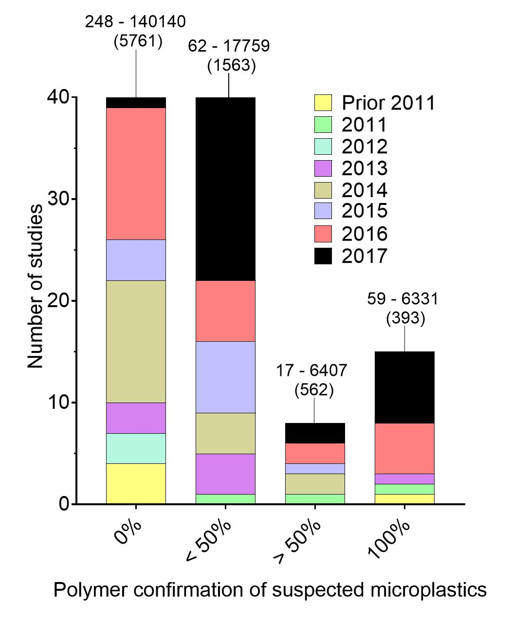
Figure 1. Percentage of suspected microplastics sampled subject to polymer identification using analytical techniques such as Raman and FTIR spectroscopy. 0% indicates only visual analysis techniques were used to identify microplastics. The total particle count for studies in each category are also provided as the range (i.e. the study identifying the fewest and greatest number of microplastic particles) and average. Additionally, 63%, 60%, 38% and 53% of studies did not report a total number of particles found in the 0%, <50%, >50%, and 100% polymer identification categories, respectively.

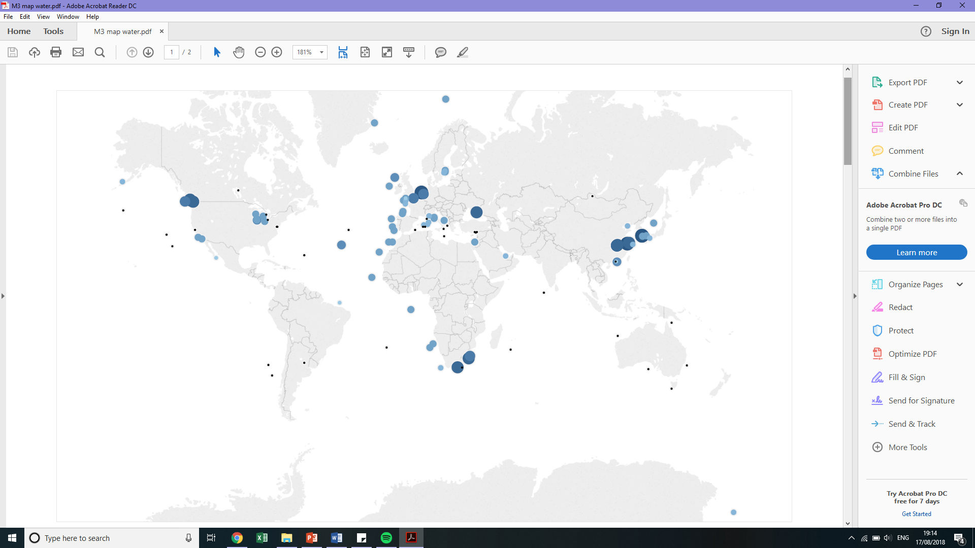
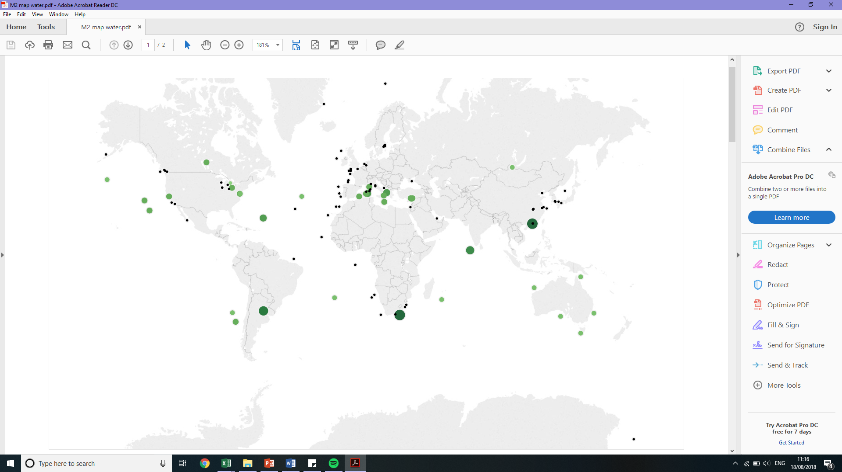
Measurement in items/m²
0.1 – 1
1 – 10
10 – 100
100 – 1000
1000 – 10000
>10000
0.01 – 0.1
Measurement in items/m³
0.001 – 0.01
0.01 – 0.1
0.1 – 1
1 – 10
10 – 100
>100

Figure 2. Global distribution of marine and freshwater aquatic MECs from reviewed literature, see Supplementary Material for references. Reported units were not converted and therefore relevant MECs are reported in two separate maps: items/m³ (top) and items/m² (bottom).

Measurement in items/kg or items/m³
>10 000
1000 – 10 000
100 – 1000
10 – 100

Measurement in items/kg or items/m²
>1000
100 – 1000
10 - 100
<10

Measurement in items/m³ or items/m²
1000 – 10 000
100 – 1000
10 – 100
1 – 10
>1
>10 000

Figure 3. Global distribution of marine and freshwater sediment MECs from reviewed literature, see Supplementary Material for references. Reported units were not converted and therefore relevant MECs are reported in three separate maps, items/m² (top), items/m³ (middle), and items/kg (bottom).

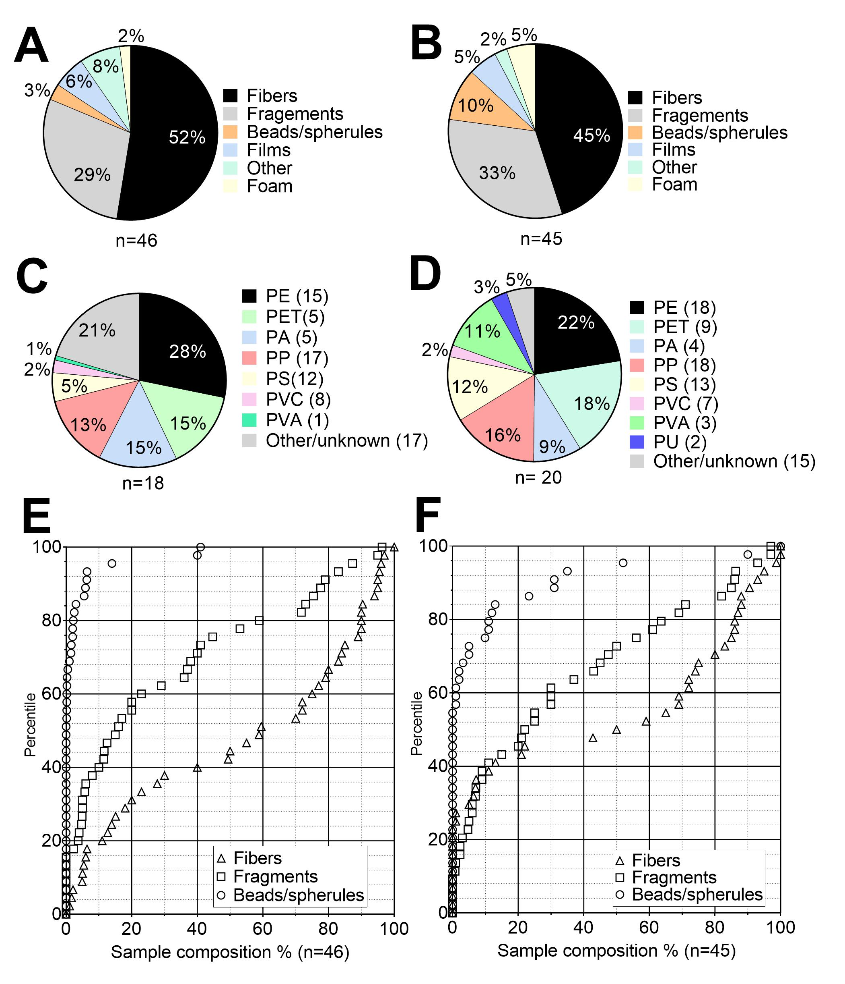
Figure 4. MEC sample summary characteristics. Average polymer composition per study in the water column (A) and sediment (B) and overall shape/morphology averages in the water column (C) and sediment (D). The sample percentages reported in reviewed studies of fibres, fragments and beads were ranked and plotted to give three distributions reflecting sample shape morphology trends in the water column (E) and sediment (F). Studies were only included which intended to quantify all MP shape morphologies. Both freshwater and marine studies were included. Polyethylene (PE), polyethylene terephthalate (PET), polyamide (PA), polypropylene (PP), polystyrene (PS), polyvinyl chloride (PVC), and polyvinyl alcohol (PVA), and polyurethane (PU).

Table 1. Summary of WWTP removals and effluent composition for specific treatment types reported in the literature. Full table references are reported in the Supplementary Material.
Treatment type | Reported Removal | Effluent composition |  |  | Reference
 |  | Fibre | Fragment | Bead/spherule
Primary | 50, 78 % | Mainly fibres |  |  | 1-2
Secondary | 98, 99, 96% | 36 – 48 % | 46 – 67% | 0 – 9% | 1, 3-4
Tertiary | 98, 97, 90, 99.9% | 8.8 % | 91% | Not reported | 2,4-6
Membrane Bioreactor | 72, 99 % | 61 – 84% | 11 – 33% | 0% | 4,7
¹Murphy et al., 2016
² Talvitie et al. 2015
³Magnusson and Noren, 2014
⁴Michielssen et al., 2016
⁵Ziajahromi et al., 2017
⁶Carr et al., 2016
⁷Leslie et al., 2017

Table 2. Average and internal concentration range as well as microplastic sample composition reported in reviewed studies from the literature. Full references are reported in the Supplementary Material.
Trophic group | Trophic group | Sample composition  Mean (range) |  | Reference
Fish | 0 – 19 (1.4) items/fish | 38 %(0–100)  27% (0–94)  2%(0–24) | Fibre  Fragment  Bead | 1–17
Invertebrate | 0.47 – 11.2 (2.8) items/organism  0.36 – 11 (3.05) particles/g | 91% (65– 100)  13% (0–13)  5.3% | Fibre  Fragment  Bead | 15–24
Bird | 14.2 items/bird | 74% (55–100)  7.7% (0–7.7)  0% | Fibre  Fragment  Bead | 25,26
¹Bellas et al., 2016  ²Silva-Cavalcanti et al., 2017  ³Rochman et al., 2015  ⁴Nadal et al., 2016  ⁵Neves et al., 2015  ⁶McGoran et al., 2017  ⁷Tanaka et al., 2016  ⁸Wesch et al., 2016  ⁹Güven et al., 2017 | ¹⁰Boerger et al., 2010  ¹¹Davison and Asch 2011  ¹²Ory et al., 2017  ¹³Collignon et al., 2014  ¹⁴Alomar et al., 2017  ¹⁵Jabeen et al, 2017  ¹⁶Rummel et al. 2016  ¹⁷Pazos et al. 2017  ¹⁸Li et al., 2016 | ¹⁹Davidson and Dudas, 2016  ²⁰Remy et al., 2015  ²¹De Witte et al., 2014  ²²Leslie et al., 2017  ²³VanCauwenberghe and Janssen 2014  ²⁴Courtene-Jones et al. 2017  ²⁵Zhao et al. 2016  ²⁶Amelineau et al. 2016

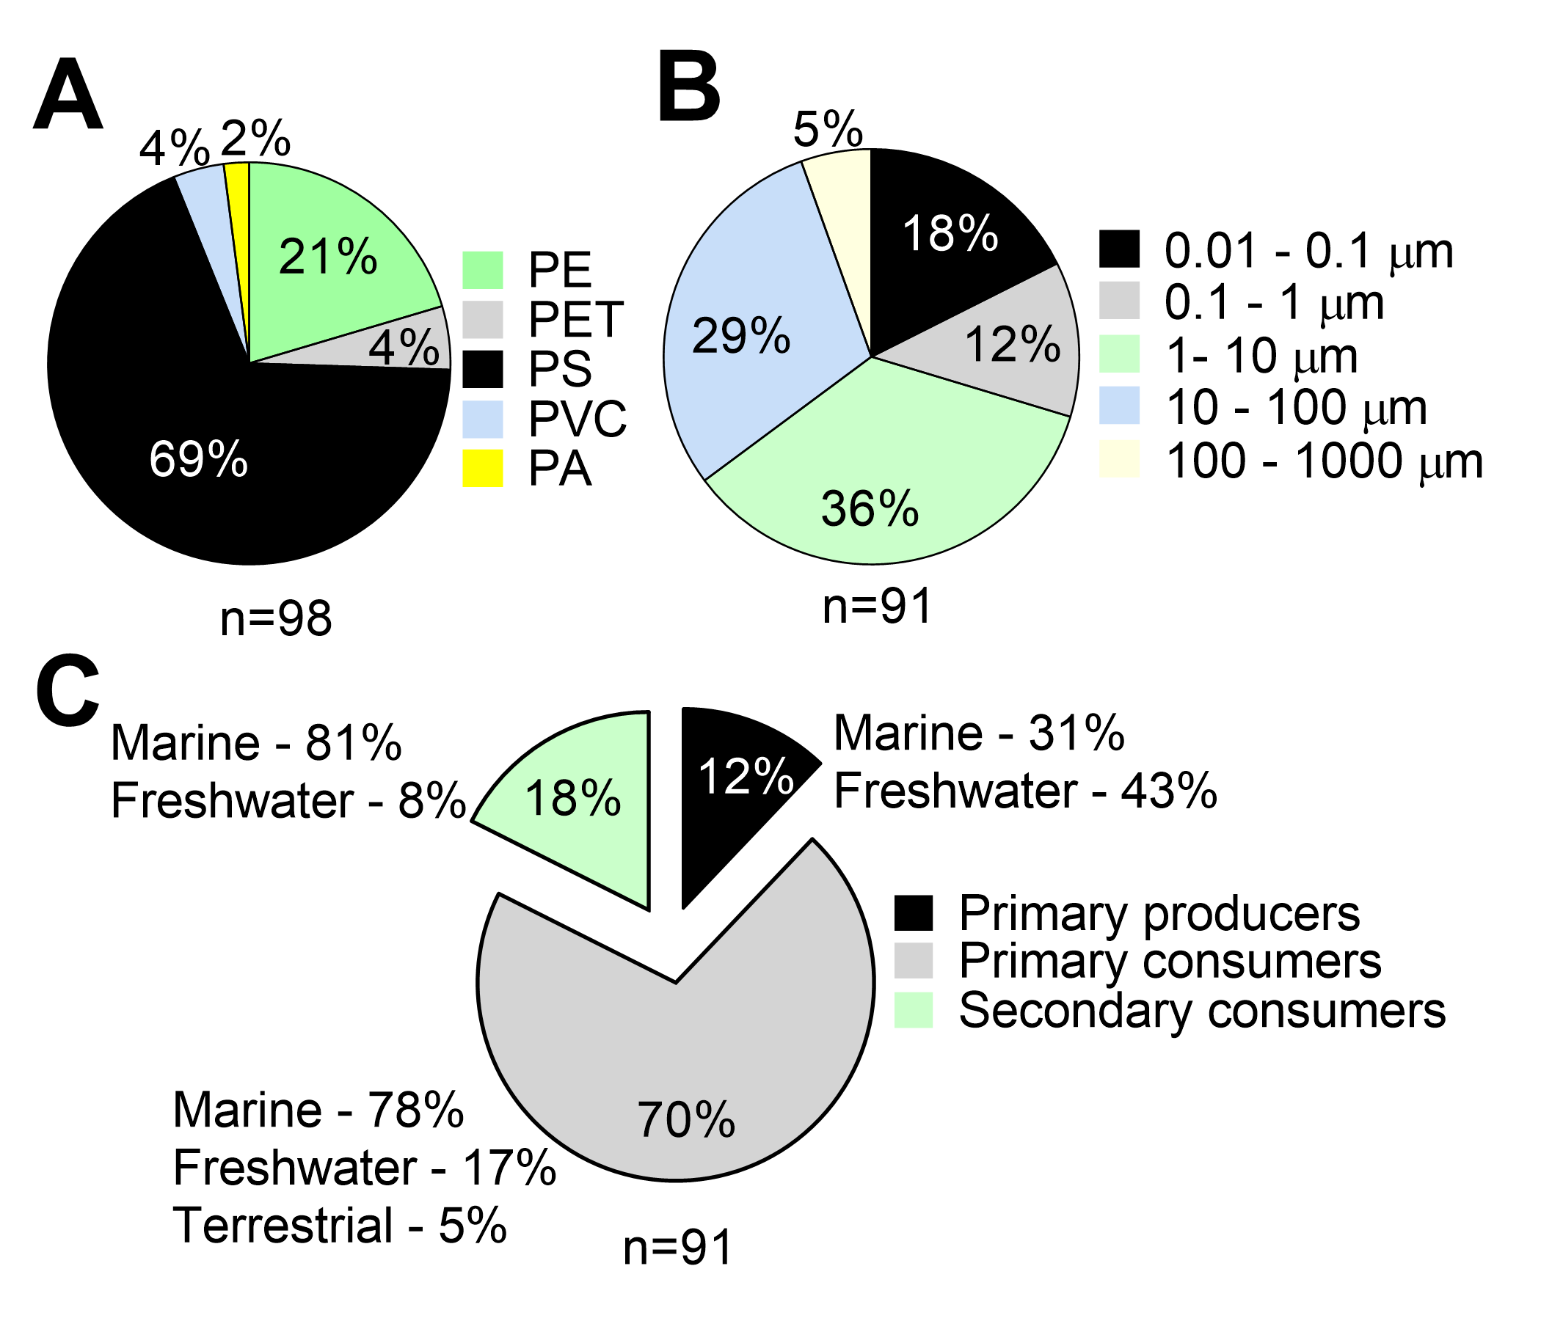
Figure 5. Summary of the test characteristics (particle types, sizes and test species) used in the identified effects studies for MPs. Pie charts are presented for exposure particle size and polymer as well as test species trophic level. Test species are initially reported by trophic level, followed by the percentage of those studies that used either marine, freshwater or terrestrial species.

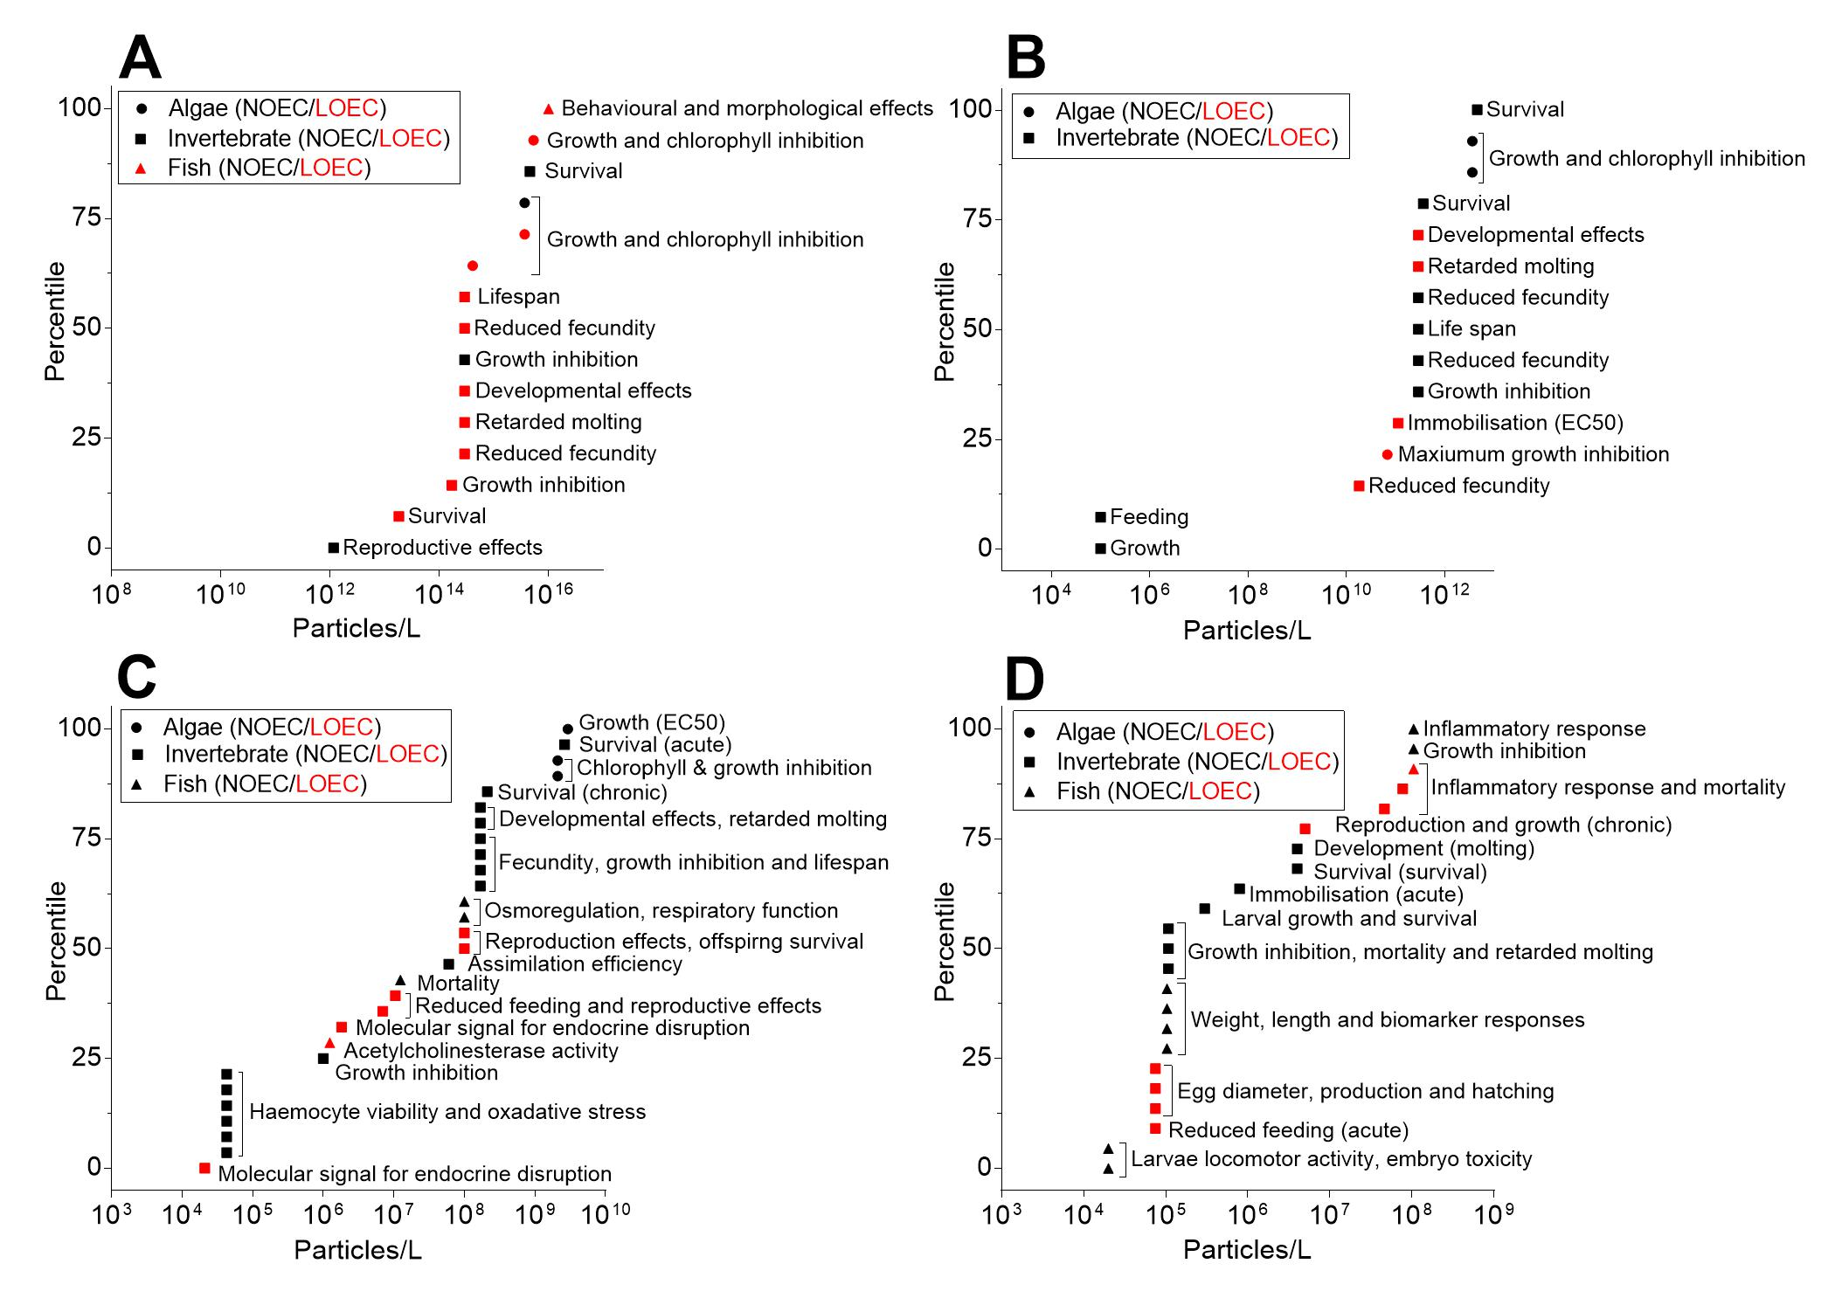
Figure 6. Microplastic cumulative ecotoxicity endpoint distributions for tests using particle sizes of 0.01-0.1 µm (A), 0.1-1 µm (B), 1-10 µm (C), and >10 µm (D). Red and black symbols represent LOECs and NOECs respectively. A cumulative distribution can be interpreted as where along the X-axis a NOEC/LOEC is likely to fall. For example in plot A, the 25th percentile of LOECs/NOECs is approximately 10¹⁴ particles/L, while the 75th is approximately 10¹⁵ particles/L. Endpoints include a range of acute, sub-lethal and standard and non-standard endpoints identified by our review, see Supplementary Material for references.

Table 3. Evaluation of evidence for ingestion and subsequent desorption of contaminants from microplastics as a significant exposure pathway. Studies conducted prior to 2016 are most commonly cited as evidence/support for the phenomenon.
Study type | Evidence category |  |  |  |  | Reasoning | Reference
 | Demonstrated | Inconclusive |  | Not supported
Field |  |  |  |  |  | Correlation between PCBs and mass of ingested plastic, correlation ≠ causation. | (Ryan et al., 1988)
Field |  |  |  |  |  | High degree of PCB and other contaminant absorption to polyethylene in seawater. | (Mato et al., 2001)
Model/lab |  |  |  |  |  | Presence of plastic will increase sediment organisms exposure, observed enhanced desorption rates in synthetic gut surfactant. Model limited: no biofouling or transport from organics for comparison. | (Teuten et al., 2007)
Lab |  |  |  |  |  | Chicks fed resin pellets, total PCB load not significant, but lower chlorinated congeners significantly different. Small sample size and large variability among replicates. | (Teuten et al., 2009)
Model |  |  |  |  |  | ‘MP as a vector for PBT substances may be relatively small compared to other exposure pathways.’ | (Gouin et al., 2011)
Field |  |  |  |  |  | PBDEs composition found in seabirds similar to plastic in stomach, prey samples taken 7 years later, > 1000 km away didn’t contain similar PBDEs. | (Tanaka et al., 2013)
Lab |  |  |  |  |  | Transfer from plastic demonstrated to worms, determined impact of plastic on PCB transfer small. | (Besseling et al., 2013)
Lab |  |  |  |  |  | Transfer demonstrated (high plastic, contaminant concentration), but 250% less than transferred from sediment (lower concentration than plastic). | (Browne et al., 2013)
Lab |  |  |  |  |  | Experimental design cannot differentiate between desorption in water and subsequent uptake or via internal gut releases (Trojan horse). Unrealistic contaminant gradient between pellets and exposure water. | (Rochman et al., 2013a)
Lab |  |  |  |  |  | Significance at 10x environmentally relevant concentrations. At environmentally relevant concentrations, uptake into amphipods was less than sediment. | (Chua et al., 2014)
Model |  |  |  |  |  | MP could be a substantial exposure pathway to worms, however conditions required unlikely in environment. Pathway for fish appears negligible. | (Koelmans et al., 2014)
Study type | Evidence category |  |  |  |  | Reasoning | Reference
 | Demonstrated |  | Inconclusive |  | Not supported
Field/model |  |  |  |  |  | POP concentration in seabirds not correlated with plastic ingestion. Modelling suggests more likely to act as passive sampler. | (Herzke et al., 2016)
Lab |  |  |  |  |  | Demonstrated uptake in worms, however plastic 76% less than sediment. Concluded transfer dominated by natural particles. | (Beckingham and Ghosh, 2017)
Model |  |  |  |  |  | Modelled existing empirical data, flux of HOCs bioaccumulated from natural prey > flux from plastic. | (Koelmans et al., 2016)
Model |  |  |  |  |  | Plastic is not a quantitatively important pathway for transfer of adsorbed chemicals. | (Bakir et al., 2016)
Model |  |  |  |  |  | Role of plastic as a vector to transfer to organisms minimal (PAHs, fugacity). | (Lee et al., 2017)
Lab |  |  |  |  |  | No elevated from sedimented MPs to larval fish in unrealistically high exposures. | (Sleight et al., 2016)
Lab |  |  |  |  |  | Ingestion of MPs is unlikely to increase worm exposure to zinc. | (Hodson et al., 2017)
HOC: Hydrophobic organic contaminant, POP: Persistent organic pollutant, MP: microplastic, PBT: persistent, bioaccumulative, toxic, PBDE: polybrominated diphenyl ethers, PCB: polychlorinated biphenyls, km: kilometres.

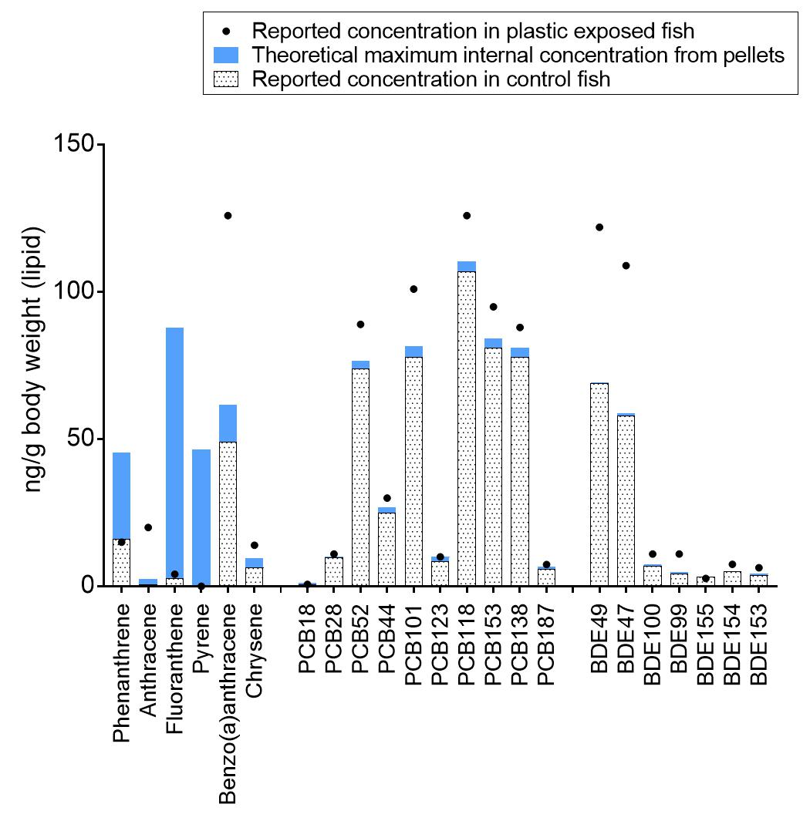
Figure 7. Calculated theoretical maximum lipid concentrations (ng/g) in marine plastic exposed fish (blue bars) based on a mass balance analysis of reported initial marine pellet concentrations from Rochman (2013a). Reported control fish (dotted bar) and marine plastic exposure fish (black dots) lipid concentrations are also plotted. Fish were assumed to be 300 mg and the lipid content ranged from 2.1-6.2% (C. Rochman – personal communication).

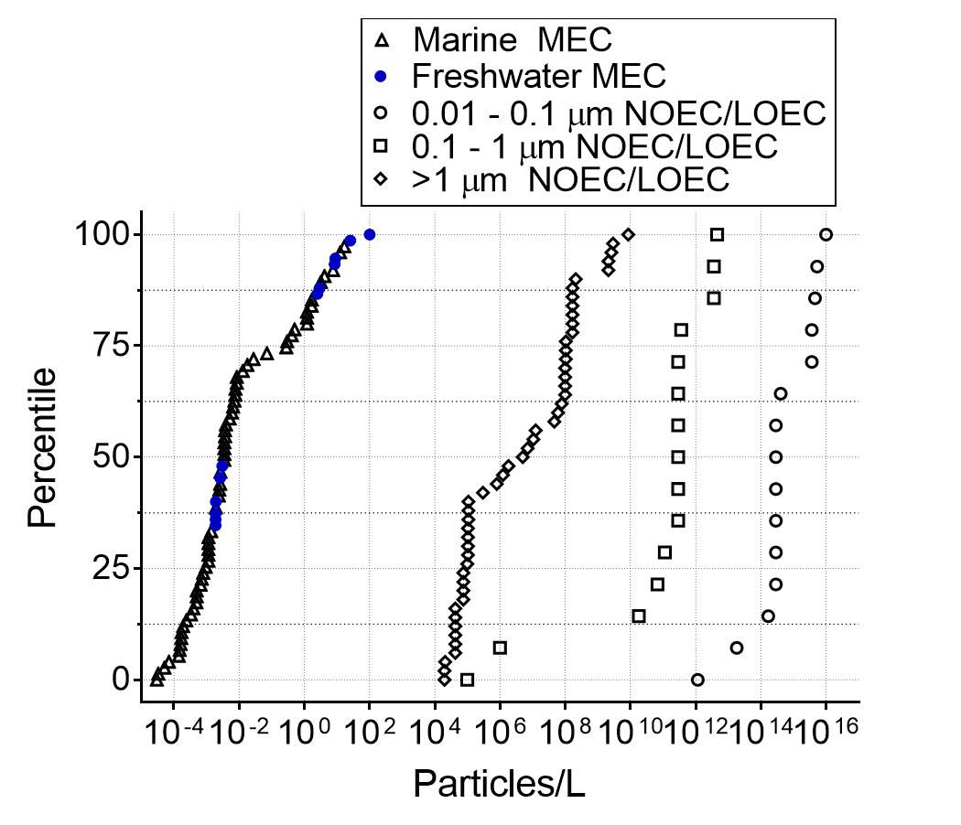
Figure 8. Cumulative species endpoint distribution plotted with the MEC distribution (marine and freshwater). Three separate endpoint distributions are plotted which contain both NOECs and LOECs from acute and chronic tests from fish, invertebrates and algae. Only endpoints related to growth, mortality and reproduction are plotted. Ecotoxicity endpoints are divided into three distributions based on test particle size: 0.01-0.1 µm, 0.1-1 µm and >1 µm.

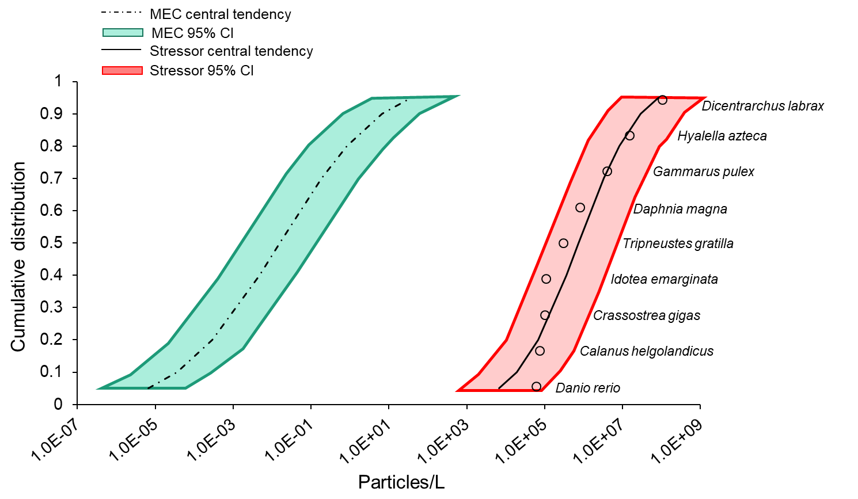
Figure 9. Species sensitivity distribution plotted with the 95% confidence interval (CI) (red) based on NOECs and LOEC from studies of particles in the size range of 10–5000 µm (most relevant to environmental size distributions). The measured environmental concentration (MEC) cumulative distribution is also plotted (marine and freshwater MECs) with the 95% CI (green).

