Explaining North-South disparities in mortality rates among 25-44 year olds in England: a longitudinal population study

Evangelos Kontopantelis, PhD Professor¹ ²; Iain Buchan, MD Professor¹; Roger T. Webb, PhD Professor³ ⁴ ⁵; Darren M. Ashcroft, PhD Professor⁴ ⁶; Mamas A. Mamas, MD Professor⁷; Tim Doran, MD Professor⁸

¹ Division of Informatics, Imaging & Data Sciences; Faculty of Biology, Medicine and Health; University of Manchester; Manchester; UK.
² National Institute for Health Research; School for Primary Care Research; University of Manchester; Manchester; UK.
³ Division of Psychology & Mental Health; Faculty of Biology, Medicine and Health; University of Manchester; Manchester; UK.
⁴ NIHR Greater Manchester Patient Safety Translational Research Centre, University of Manchester, Manchester, UK
⁵ Division of Psychology & Mental Health, University of Manchester and Manchester Academic Health Sciences Centre (MAHSC), Manchester, UK
⁶ Division of Pharmacy & Optometry; Faculty of Biology, Medicine and Health; University of Manchester; Manchester; UK.
⁷ Keele Cardiovascular Research Group; Centre for Prognosis Research; Institute of Primary Care and Health Sciences; Keele University; UK
⁸ Department of Health Sciences; Seebohm Rowntree Building; University of York; York; UK.

Correspondence to:
Prof Evangelos Kontopantelis
Faculty of Biology, Medicine and Health
Williamson Building, 5th floor
University of Manchester
M13 9PL
Telephone: +44(0)161 2757646
e-mail: e.kontopantelis@manchester.ac.uk

Abstract

Background: There has been a marked recent increase in excess mortality for adults aged 25-44 in the North compared to the South of England. We examined the underlying causes of the excess mortality and the relative contribution of socioeconomic deprivation.

Methods: Mortality data for adults aged 25-44 were aggregated and compared between England’s five northernmost versus five southernmost Government Office Regions, between 1981 and 2016. Poisson regression models, adjusted for age and sex, were used to quantify excess mortality in the North by underlying cause of death (accidents, alcohol-related, cardiovascular disease and diabetes, drug poisoning, suicide, cancer, other causes). The role of measured deprivation in explaining the excess, and regional variability in the excess were also explored.

Findings: A mortality divide appeared in the mid-1990s and rapidly increased thereafter for deaths attributed to accidents, alcohol and drug poisoning. Mortality rates for these conditions increased nationwide, but more quickly in the North. National mortality rates for cardiovascular deaths declined over the study period, but a long-standing gap between North and South persisted. Between 2014 and 2016, estimated excess numbers of death in the North for those aged 25-44 were 1881 for females and 3530 for males. Measured deprivation explained up to two-thirds of the excess mortality in the North. By 2016, in addition to the persistent North-South gap, mortality rates London were at least 13% lower than in all other regions of the North or South of England.

Interpretation: Sharp rises in deaths from accidents, alcohol and drug poisoning appear to have created new health divisions between England’s regions, possibly from exacerbated existing social and health inequalities which have been experienced by multiple generations. These divisions may indicate increasing psychological distress, despair and risk-taking among young and middle-aged adults, particularly outside London.

Funding: MRC and Wellcome Trust

Keywords:
England; inequalities; socioeconomic; North-South divide; all-cause mortality; cause-specific mortality; index of multiple deprivation (IMD); suicide; alcohol; cardiovascular; accidents; drugs; cancer.

Introduction
Historic economic, political and cultural patterns in England have created enduring inequalities in health outcomes between different social groups and communities. The most striking of these patterns are described as the “North-South divide”; a persistent disparity in wealth and health between the populations living in the North and South of the country. Worse health outcomes in the North reflect higher average levels of deprivation,¹ but deprived neighbourhoods in the North also have worse health outcomes than similarly deprived neighbourhoods in the South,² and people with the same socioeconomic status tend to have poorer health in the North than in the South.³ The plausible causes of these regional disparities in England are complex, and are likely to include environmental, occupational, migratory, epigenetic and lifestyle factors, in addition to long-term structural imbalances concentrating resources and investment in the South, particularly in and around London.⁴

In England, the North-South divide in health is most evident in patterns of mortality. Whilst national mortality rates have fallen over time, and the leading causes of death have transitioned from infectious diseases and occupational injuries to long-term conditions, the risk of premature death (aged under 75) has remained consistently higher in the North.⁵ Since the 1960s, premature mortality rates have been at least 10 percent higher in the North than the South,⁶ and the relative gap has persisted, despite high-profile inquiries,⁷ and national programmes intended to address health inequalities.⁸ Such national variability is not uncommon. In the US, it has been shown that those states with the lowest healthy life expectancies are almost exclusively concentrated in the South.⁹ In Spain, disability free life expectancy at birth and at 65 years is considerably lower in Southern Spain, with the difference at least partially attributed to education, unemployment and smoking.¹⁰ A North-South mortality divide also exists in France, with most départements in the South having some of the highest life expectancies for both males and females, and départements in the North consistently having the lowest.¹¹ Italy has one of the highest life expectancies in the world, but a more modest North-South gap also exists there, with both males and females in the North living longer on average.¹²

Recently, in England, there has been a marked trend of increasing northern excess mortality for those aged 25-44, until recently concealed in the mortality rates for the wider English population. This pattern first emerged in the mid-90s and the excess mortality rate reached 40% by 2015.⁵ Deaths in this age group are most commonly attributable to cardiovascular disease, accidents and also suicide, poisoning, and the sequelae of drug and alcohol misuse. However, it is not known how much each of these causes contributes to the recent rapid rise in mortality of young adults living in the North of England compared with the South. We identify and explore the reasons behind the recent increases in northern excess mortality, and examine how much of the excess mortality in the North is explained by deprivation.

Methods
Information on data sources and methodological/population details are provided in the supplement. Deaths and population data were aggregated into the ten Government Office Regions which were then categorised as either North (North East, North West, Yorkshire & the Humber, East Midlands and West Midlands) or South (East of England, South Central, South West, South East and London).^{5,6}

Cause-specific mortality rates were calculated from death registrations and mid-year population estimates and examined by age group, sex and area dichotomy over time. For each of the groups by cause of death (accidents, alcohol-related, female breast cancer, other cancers, cardiovascular disease & diabetes, drug poisoning, suicide, and all other causes) we used a Poisson regression model to calculate excess mortality rates in the North in each calendar year, for each sex, adjusted for the age distribution of the population in the two respective areas.

The estimated Incidence Rate Ratios (IRRs), which can be interpreted as the percentage of population-adjusted excess mortality in the North compared to the South, were depicted as sex-specific contour plots, by sex, to visualise changes in excess mortality according to age groups as a time-dependent variable. Using the IRR estimates from these models and the population structure, we also estimated the number of adjusted excess deaths ($D_{N}*(1-1/IRR)$, where $D_{N}$ the number of deaths in the North) in the North by underlying cause, cross-sectionally for the last three years of the study period (2014 to 2016). Standardised Mortality Rates (SMRs) per 100,000 people, by age and sex and with the total respective population of the study period as the reference (from 1981 or 1993 depending on the underlying cause), were calculated for each calendar year and by area and plotted over time.

To evaluate the role of measured deprivation in excess mortality in the North, we fitted Poisson regression models with the unit of analysis being a low geography level (average of 1500 people). The outcome was all-cause mortality in 2016 and the two covariates of interest were area and deprivation, while all models were adjusted for the age-sex population structure. The first model only included area (North vs South), a second one included area and overall deprivation (as measured by the 2015 Index of Multiple Deprivation – IMD), and a third included the 10 English regions and the overall deprivation. A fourth model included area and the IMD domains for employment, housing, crime and environment. The fifth and final model included the 10 English regions and these four IMD domains. Stata v15 was used throughout. Person-level consent and study registration was not required as public administrative data was used for this population-level study. Scripts for all analyses are available as a supplementary file. The corresponding author had sole access to all the data and the final responsibility to submit for publication, while the sponsor had no role in any aspect of the study.

Results

Number of deaths, 2014 to 2016
To highlight contemporary patterns we focused on deaths between 2014 and 2016. In addition, we also present time trends for the whole study period. From 2014 to 2016, there were 22530 deaths in males and 13179 in females aged 25 to 44. Deaths were substantially higher for males in all four age subgroups (25 to 29, 30 to 34, 25 to 39 and 40 to 44), with accidents, suicides and drug poisonings the most common causes of deaths in all age groups, and with the contribution of cardiovascular disease increasing with age. The pattern was similar for females, with a smaller contribution from suicides and accidents. Deaths were higher in the North, despite the larger population in the South (Figure 1). A greater proportion of all deaths were not included in one of the seven main groups of interest for females compared with males, and consequently were included in the “other” category. The relative contributions of each group of underlying causes are presented in Supplement Figure S1 (all figures and tables with an “S” prefix refer to the supplementary file).

Excess mortality in the North
Changes in excess mortality in the North from 1981 (1993 for drug poisonings) to 2016 are presented in contour plots for each group of underlying causes (Figures S2-S10), for all ages. At the start of the study period, there was little difference in all-cause mortality rates for ages 25-44 between North and South (Figure S2). In some years during the early to mid-1990s, there was no difference in male mortality. From the mid-1990s, excess mortality in the North increased for both sexes, exceeding 50% by the end of the study period in the 35-39 age group (IRR=1·52; 95%CI: 1·46, 1·58). Accidental (Figure S3), alcohol-related (Figure S4) and drug poisoning (Figure S7) deaths were associated with the highest excess mortality in the North over the whole study period, and for all causes excess mortality in the North increased over time. Variation between sexes was relatively small, although there was higher excess mortality from drug poisoning for females and higher excess suicide risk for males.

Between 2014 and 2016 the overall number of excess deaths in the North among females was 153, 318, 650 and 760 for the 25-29, 30-34, 35-39 and 40-44 age-groups respectively. For males, the respective figures were 382, 615, 1031 and 1502. The numbers of excess deaths by cause are given in Figure 2 and Tables S5-S6. For females, the major contributing causes, excluding ‘other’ causes, were alcohol-related, drug poisoning, cardiovascular disease, and cancer. For males, the patterns were similar, but with some key differences. First, suicide was also a major contributor for all age groups combined. Second, the contribution of cancer was considerably smaller. Third, accidents contributed more towards male deaths and this underlying cause was the largest specific contributor to excess deaths for the 25-29 age group. The contribution of each underlying cause in percentage terms is presented in Figure S11 and Tables S7-S8. A large proportion of excess deaths in the North across all age groups, 28% (526/1881) for females and 21% (752/3530) for males, was attributed to causes in the miscellaneous ‘other’ category. Incidence rate ratios by age group and underlying cause are reported in Tables S9-S10.

Standardised mortality rates
Age-standardised mortality rates over time indicate a marked and widening North-South gap among both males and females (Figure 3). From 2010, mortality rates increased nationwide for both sexes, but much more sharply in the North, resulting in a substantial gap by 2016. Underlying cause-specific SMR plots are provided in the supplement (Figures S12 to S19), with large gaps emerging in recent years for accidental (Figure S12), alcohol-related (Figure S13) and drug poisoning (Figure S16) deaths for both sexes. Rates for alcohol-related and drug poisoning deaths have increased in the North since the mid-1990s, whilst remaining relatively stable in the South. For accidents, a gap for males emerged in the late 1990s as mortality rates declined in the South.

For cardiovascular causes, mortality rates decreased sharply over time nationwide, but a gap between North and South was maintained throughout the study period (Figure S14). Cancer death rates (excluding breast cancer) have decreased nationwide over time, but the trends have plateaued since 2005 for females and 2010 for males, with small levels of northern excess mortality, especially for females (Figure S17). Breast cancer mortality rates fell over time but plateaued after 2010 with no evident mortality excess (Figure S18). Suicide rates have decreased since at least 1998 in both sexes, and throughout most of the study period there was little difference between North and South. A gap emerged for males between 2010 and 2012 as rates climbed in the North (Figure S15). The pattern for other causes of death declined over time in the South, for both males and females, but remained largely stable in the North, with widening gaps between North and South emerging around 2005 for females and around 2000 for males.

Spatial analysis demonstrated clustering of high mortality rates in the post-industrial cities of the North, particularly in the North East and North West (Figure 4). This is strongly associated with socio-economic deprivation, which is clustered in urban areas. Additional spatial maps, by sex and region, are provided in the supplement (Figures S20-S57).

Deprivation and regional patterns of mortality
Poisson regression analyses at small area level, adjusted for age-sex distribution, enabled evaluation of the role of measured deprivation in excess mortality in the North during 2016. The first model, which did not include deprivation, quantified the association between area and excess mortality in the North at 15% (IRR=1·15; 95%CI: 1·14, 1·15). In the second model, which included overall 2015 IMD, the association between area and mortality lowered to an excess of 7% (IRR=1·07; 95%CI: 1·06, 1·07). In the third model, where we fitted all 10 English regions as categories instead of a North-South dichotomy, all regions reported higher IRRs compared to London, especially the North East (IRR=1·22; 95%CI: 1·20, 1·24) and the North West (IRR=1·20; 95%CI: 1·19, 1·22) . In the fourth model, which used four subdomains of the IMD as covariates rather than the overall IMD, the association between area and mortality weakened further to an excess in the North of 5% (IRR=1·05; 95%CI: 1·04, 1·05) . In the fifth model we observed a similar regional pattern to the third model. Regional estimates from the third and fifth models are presented in Figure 5. Pseudo-R² reflected approximately 53% of explained variation for all models.

Discussion
Against a background of long-standing excess mortality in the North of England for the whole population, there has been a rapid and marked divergence between northern and southern mortality for adults aged 25-44 since the mid-1990s. Between 2014 and 2016, this resulted in average annual excess deaths in the North of 627 among females and 1177 among males. The major contributors to this disparity were accidents, drug-poisoning, alcohol and cardiovascular disease. Important contributions were also made by suicide among males, especially at ages 30-34, and by cancer among females. Overall excess mortality in the North was only partially explained by deprivation measured at small area level. Regional analysis showed that much of the North-South divide is attributable to substantially lower mortality in the capital. Although mortality rates in most northern regions were higher than in southern regions, rates in all regions – including those in the South – were at least 13% higher than rates in London.

Strengths and limitations
The study used large datasets covering the whole of England, 1981-2016. Nevertheless, the study had some limitations. First, the North-South dichotomy is one of convenience, although it reflects administrative boundaries delineating areas of political responsibility, as well as established social, economic and cultural divisions. Second, the categorisation of underlying causes of death enabled us to attribute most of the deaths to salient cohesive groups of causes, but many were also necessarily placed in the ‘other’ category. Third, a small number of deaths attributed to diabetes, and even fewer to obesity, were included in cardiovascular deaths. Our aim was to generate an inclusive category, since these underlying causes are often linked. Fourth, the IMD includes indicators that are very closely linked to mortality (for example, road traffic accidents), albeit predating the 2016 data that we used. Fifth, we assumed a uniform population distribution within each age group, which might not be the case for London (see supplement). Sixth, there is a delay in registration for one in five premature deaths, and some of our estimates may not accurately reflect time. Seventh, the role of internal and external migration is not taken into account and our findings will be at least partially explained by the migration of healthy individuals, attracted by better job opportunities to the South and, especially, London.¹³ Eighth, it could be argued that London is unique and an alternative North-South comparison could exclude London, to quantify the extent to which the North-South differences are driven by the population of London. However, we could not obtain detailed mortality data at the regional level, only aggregated into North and South, and this aspect should be explored in future work, as well as the role of cohort effects.

Key findings

The numbers of excess deaths in the North differed between males and females aged 25-44, with the North-South difference being almost double for males between 2014 and 2016. This is likely due to a combination of factors. Primarily, mortality rates for males are generally higher, therefore comparable relative differences across sexes would yield higher absolute numbers of excess northern male deaths. In addition, we observed a greater difference in the mortality risk between northern and southern males, compared to northern and southern females. This sex difference in the North-South mortality gap is plausibly related to greater susceptibility of males to socioeconomic pressures.¹⁴

The relative contribution of different causes of death towards excess mortality in the North has changed substantially over time. Cardiovascular deaths have been consistently higher in the North, and because cardiovascular disease remains a major contributor to total deaths, particularly in older males, it explains much of the mortality gap between North and South (22% or 333/1502 for males aged 40-44). However, cardiovascular disease mortality has fallen by over 50% over past four decades, and its contribution to regional variations in mortality is weakening.

Of the broad causes we examined, three – accidents, alcohol-related and drug-poisoning – demonstrated a relative increase in the North from the mid-1990s, coinciding with a widening gap in all-cause mortality. For fatal accidents and drug-poisonings there has been further separation since 2010, with mortality rates increasing nationwide, but much more quickly in the North. If these recent trends are not arrested, the national gains made from falling cardiovascular deaths will be overridden and excess mortality in the North may exceed 50%.

Interpretation of key findings
Accidents, alcohol and drug misuse, and suicide are all strongly associated with socioeconomic status. For example, in international studies, the most deprived males are twice as likely to die by suicide as the most affluent males, while for females the equivalent increase in risk is 50%.¹⁵ In England, suicide risk has also been associated with unemployment,¹⁶ and substantial increases in suicide have been observed during periods of recession, especially among males.¹⁴ However, physical health, mental health and deprivation, strong independent risk predictors of suicide,¹⁷ confound the relationship between unemployment and suicide.¹⁸ For accidents, there is a consistent association between socioeconomic deprivation and trauma incidence, especially penetrating (serious) trauma, and accident and emergency attendance.¹⁹ For road traffic fatalities, excessive speed, intoxication, failure to wear seat-belts, and unlicensed/uninsured driving are most prevalent in the most deprived areas in England, while pedestrian casualty rates are also associated with deprivation.²⁰ Geographical analysis of fatal traffic accidents found that nine of the ten highest-risk counties are in the North of England, with nine of the ten lowest-risk counties in the South.²¹ In particular, there is a North-South divide in fatality risk on single carriageways, where most road traffic casualties occur, with the exception of the South East (highest risk) and West Midlands (lowest risk).²² Northern infrastructure may be relevant in this context, with transport infrastructure investment heavily skewed towards the South, especially London. Work-related fatal accidents are also higher in the North of England, mainly due to variations in the regional industries and occupations and their associated risks. Fatal domestic accidents, such as fires, are strongly associated with risk factors closely linked to socioeconomic deprivation, including smoking and alcohol abuse.²³

The role of alcohol is important in this context, contributing to a large proportion of accidental injury seen in UK hospitals, not only through traffic and cycling accidents but also accidental falls.²⁴ Alcohol use also underpins the steep and sustained increase in liver cirrhosis deaths in Britain from the 1990s,²⁵ when the North-South divide in mortality for those aged 25-44 started to emerge.⁵ Socioeconomic inequalities, in terms of alcohol-related mortality, are greatest amongst people aged 25-44, with five-fold and four-fold relative risks in the most deprived areas for men and women, respectively.²⁶ Men aged 25-39 in the unskilled manual class are 10-20 times more likely to die from alcohol-related causes, compared to those in the professional class,²⁷ with personal income being the best predictor of alcohol-related death for men.²⁸ In addition, people living in urban areas experience higher alcohol-related mortality relative to those living in rural areas, with the association being much stronger for men.²⁶

For almost all types of cancer, mortality rates are higher in more deprived areas and have worse survival rates.^{29,30} Particularly striking deprivation gradients are observed for cancers of the oropharynx, and lung, which are primarily attributed to smoking.³¹ Similarly for cancer of the cervix, which is caused by human papillomavirus, and is largely determined by sexual behaviour risk factors, including age at first intercourse, number of sexual partners, failure to use a condom during intercourse with multiple partners and screening programme non-engagement.³² Alcohol abuse again plays a role, with steep socio-economic gradients observed for stomach and liver cancers. After alcohol, heroin and crack cocaine are the most harmful drugs at population level in the UK and deaths from drug overdoses are also strongly associated with deprivation,³³ with evidence of strong cohort effects emerging.³⁴

More research is needed to determine what triggered the observed divergence in mortality between North and South for young and middle-aged adults since the mid-1990s, but socioeconomic factors are likely to be central. In the US, for example, mortality rates have been rising for white non-Hispanics without a college degree and falling for those without a degree. The increases have been attributed to drug overdoses, suicides and alcohol-related liver mortality, and it has been suggested that disadvantages may be accumulated from one birth cohort to the next, and triggered by progressively worsening labour market opportunities for White British people with low levels of education.³⁵ Mechanisation, which has affected a large number of mid-level jobs in rich countries, may be partly to blame. Although it has also led to an increase in demand for high-skilled jobs, their number is smaller to the number of mid-level jobs lost, while individuals from a deprived background are at a disadvantage when competing for the former.³⁶

However, our findings of a persistent divide even after controlling for area-level deprivation suggest there must be additional explanatory factors related to geography, for example net migration (internal and external) of healthier individuals to the South of England.³⁷ Furthermore, the trends observed for ‘other’ and for cardiovascular diseases, also strongly associated with socioeconomic factors, suggest that divergence between North and South is not inevitable. For cardiovascular disease, worsening temporal trends in some risk factors (for example, physical activity, obesity and diabetes) have been offset by decreases in others (for example, smoking cessation and more optimal blood pressure and cholesterol control).³⁸ National cardiovascular initiatives have included targeted elements resulting in both overall reductions in mortality and some reductions in inequalities, particularly in younger age groups,³⁹ although the North-South divide in cardiovascular mortality remains. For example, the National Service Framework in coronary heart disease promoted assessment and treatment of cardiovascular risk in patients deemed to be at higher risk, the redesign of heart attack centres, and the roll out of primary percutaneous coronary interventions. Similar coordinated initiatives, both tackling underlying causes and improving health service responses, will be required to reverse the marked recent trends in mortality attributable to accidents, alcohol and drug poisoning.

Conclusions
The North-South divide in mortality for people aged 25-44 first emerged during the mid-1990s and continued into 2016. This mortality divide grew quickly over that period for accidents, alcohol and drug poisoning, whilst a long-standing gap for cardiovascular deaths remained and a gap for suicide in men emerged more recently. The sharp rises in mortality for accidents, alcohol and drug poisoning are profoundly concerning. Regional analysis confirms that most of the North is faring worse than most of the South, but further demonstrates that all regions, North and South, have substantially higher mortality rates than London. The reasons for this are complex and reach back centuries, with extreme concentration of power, wealth and opportunity in the capital having a malign effect on the rest of the country.⁴ England’s centralist tradition has blighted successive generations, and without major structural change will continue to damage public health.

Research in context

Evidence before this study
- In England, profound regional differences exist in standards of living, both within and between regions. A stark contrast exists between the North and the South of the country: termed the “North-South divide”.
- Cultural, economic and social differences between the North and South of England date back to the 11th Century and the Normal Conquest’s “Harrying of the North”.
- This divide was widely acknowledged by the 18th century, and played a prominent role in political theory, in the context of rapid industrialisation and working conditions of the poor.
- The North’s economy boomed in the Industrial Revolution then declined dramatically in the post-industrialisation era, with a major public health impact.
- From 1965 to 2008 the chances of dying early (under 75 years) were a fifth higher in the North of England than in the South, while England’s overall mortality fell by around 50% in males and 40% in females.
- From the mid-1990s, the North of England experienced a profound rise in premature mortality in adults aged 25-44, relative to the South. This was preceded by at least three decades of narrowing inequalities in mortality between the regions.

Added value of this study
- Excess mortality in the North for ages 25-44 was primarily attributed to alcohol, cardiovascular and drug-related deaths, with suicides, cancer and accidents also playing important roles.
- Measured deprivation explained up to two-thirds of excess mortality in the North, with the remaining one-third likely attributable to unmeasured aspects of deprivation or cultural differences.
- Most northern regions have higher mortality rates than most southern regions for young and middle-aged adults, but mortality rates in all regions, both North and South, are at least 13% higher than in London.

Implications of all the available evidence
- Socio-economic inequalities are at the heart of the “North-South divide” in mortality for those aged 25-44.
- Major structural change is needed to counter England’s centralist tradition, which is driving important public health inequalities for people aged 25-44, especially males.

Contributors
EK designed the study, extracted the data, and performed the analyses. EK and TD jointly drafted the manuscript. EK, TD and IB conceived the study. IB, RW, DA and MM critically revised the manuscript.
EK is the guarantor of this work and, as such, had full access to all the data in the study and takes responsibility for the integrity of the data and the accuracy of the data analysis.

Acknowledgments
MRC Health eResearch Centre grant MR/K006665/1 supported the time of EK. TD was supported by the Wellcome Trust (grant number 205427/Z/16/Z). The views expressed are those of the authors and not necessarily those of the MRC or the Wellcome Trust, which did not influence any aspect of the study. We would like to thank the Office of National Statistics for the wealth of information they have collected and systematically organised, which made this study possible.

Declaration of interest
All authors have completed the Unified Competing Interest form at www.icmje.org/coi_disclosure.pdf (available on request from the corresponding author) and declare no competing interests.

Copyright
The Corresponding Author has the right to grant on behalf of all authors and does grant on behalf of all authors, a worldwide licence to the Publishers and its licensees in perpetuity, in all forms, formats and media (whether known now or created in the future), to i) publish, reproduce, distribute, display and store the Contribution, ii) translate the Contribution into other languages, create adaptations, reprints, include within collections and create summaries, extracts and/or, abstracts of the Contribution, iii) create any other derivative work(s) based on the Contribution, iv) to exploit all subsidiary rights in the Contribution, v) the inclusion of electronic links from the Contribution to third party material where-ever it may be located; and, vi) licence any third party to do any or all of the above.

Transparency declaration
EK affirms that this manuscript is an honest, accurate, and transparent account of the study being reported; that no important aspects of the study have been omitted; and that any discrepancies from the study as planned have been explained.

Data sharing
Death data were obtained from the ONS at a cost and now freely available on the ONS website. The authors are happy to share the final datasets in an organised format, pending approval from the ONS.

References
1. Kontopantelis E, Mamas M, van Marwijk H, Ryan AM, Doran T. Geographical epidemiology of health and overall deprivation in England, its changes and persistence from 2004 to 2015. Journal of Epidemiology & Community Health, 2017.
2. Whitehead M, McInroy N, Bambra C. Due North: report of the inquiry on health equity for the North. Liverpool: University of Liverpool and the Centre for Economic Strategies 2014.
3. Doran T, Drever F, Whitehead M. Is there a north-south divide in social class inequalities in health in Great Britain? Cross sectional study using data from the 2001 census. Brit Med J 2004; 328(7447): 1043-5.
4. Commission SM. State of the nation 2017: Social mobility in Great Britain. London, UK: UK Government 2017.
5. Buchan IE, Kontopantelis E, Sperrin M, Chandola T, Doran T. North-South disparities in English mortality 1965-2015: longitudinal population study. J Epidemiol Commun H 2017; 71(9): 928-36.
6. Hacking JM, Muller S, Buchan IE. Trends in mortality from 1965 to 2008 across the English north-south divide: comparative observational study. Brit Med J 2011; 342.
7. Marmot M, Bell R. Fair society, healthy lives. Public Health 2012; 126: S4-S10.
8. Mackenbach JP. Can we reduce health inequalities? An analysis of the English strategy (1997-2010). J Epidemiol Commun H 2011; 65(7): 568-75.
9. Control CfD, Prevention. State-specific healthy life expectancy at age 65 years--United States, 2007-2009. MMWR Morbidity and mortality weekly report 2013; 62(28): 561.
10. Gutierrez-Fisac JL, Gispert R, Sola J. Factors explaining the geographical differences in Disability Free Life Expectancy in Spain. J Epidemiol Community Health 2000; 54(6): 451-5.
11. Barbieri M. Mortality in France by Departement. Population 2013; 68(3): 433-79.
12. How Does Italy's North-South Divide Impact Life Expectancy? 2018. https://theculturetrip.com/europe/italy/articles/how-does-italys-north-south-divide-impact-life-expectancy/ (accessed 10/08/2018.
13. Connolly S, O'Reilly D, Rosato M. Increasing inequalities in health: is it an artefact caused by the selective movement of people? Soc Sci Med 2007; 64(10): 2008-15.
14. Barr B, Taylor-Robinson D, Scott-Samuel A, McKee M, Stuckler D. Suicides associated with the 2008-10 economic recession in England: time trend analysis. BMJ 2012; 345: e5142.
15. Li Z, Page A, Martin G, Taylor R. Attributable risk of psychiatric and socio-economic factors for suicide from individual-level, population-based studies: a systematic review. Soc Sci Med 2011; 72(4): 608-16.
16. Lewis G, Sloggett A. Suicide, deprivation, and unemployment: record linkage study. BMJ 1998; 317(7168): 1283-6.
17. Webb RT, Kontopantelis E, Doran T, Qin P, Creed F, Kapur N. Suicide risk in primary care patients with major physical diseases: a case-control study. Arch Gen Psychiatry 2012; 69(3): 256-64.
18. Blakely TA, Collings SC, Atkinson J. Unemployment and suicide. Evidence for a causal association? J Epidemiol Community Health 2003; 57(8): 594-600.
19. Scantlebury R, Rowlands G, Durbaba S, Schofield P, Sidhu K, Ashworth M. Socioeconomic deprivation and accident and emergency attendances: cross-sectional analysis of general practices in England. Brit J Gen Pract 2015; 65(639): E649-E54.
20. Clarke DD, Ward P, Truman W, Bartle C. A poor way to die: social deprivation and road traffic fatalities. Behavioural Research in Road Safety 2008 Eighteenth Seminar; 2010; 2010. p. 81.
21. Jones AP, Haynes R, Kennedy V, Harvey IM, Jewell T, Lea D. Geographical variations in mortality and morbidity from road traffic accidents in England and Wales. Health Place 2008; 14(3): 519-35.
22. Road Safety Foundation. Cutting the cost of dangerous roads: British EURORAP results: Road Safety Foundation,, 2017.
23. Holborn PG, Nolan PF, Golt J. An analysis of fatal unintentional dwelling fires investigated by London Fire Brigade between 1996 and 2000. Fire Safety J 2003; 38(1): 1-42.
24. Skog OJ. Alcohol consumption and mortality rates from traffic accidents, accidental falls, and other accidents in 14 European countries. Addiction 2001; 96: S49-S58.
25. Leon DA, McCambridge J. Liver cirrhosis mortality rates in Britain from 1950 to 2002: an analysis of routine data. Lancet 2006; 367(9504): 52-6.
26. Erskine S, Maheswaran R, Pearson T, Gleeson D. Socioeconomic deprivation, urban-rural location and alcohol-related mortality in England and Wales. BMC Public Health 2010; 10: 99.
27. Harrison L, Gardiner E. Do the rich really die young? Alcohol-related mortality and social class in Great Britain, 1988-94. Addiction 1999; 94(12): 1871-80.
28. Makela P. Alcohol-related mortality as a function of socio-economic status. Addiction 1999; 94(6): 867-86.
29. Coleman MP, Rachet B, Woods LM, et al. Trends and socioeconomic inequalities in cancer survival in England and Wales up to 2001. Br J Cancer 2004; 90(7): 1367-73.
30. Cancer Research UK. Deprivation gradient for cancer mortality. http://www.cancerresearchuk.org/health-professional/cancer-statistics/mortality/deprivation-gradient2018).
31. Wardle J, Jarvis MJ, Steggles N, et al. Socioeconomic disparities in cancer-risk behaviors in adolescence: baseline results from the Health and Behaviour in Teenagers Study (HABITS). Prev Med 2003; 36(6): 721-30.
32. Bosch FX, Lorincz A, Munoz N, Meijer CJLM, Shah KV. The causal relation between human papillomavirus and cervical cancer. J Clin Pathol 2002; 55(4): 244-65.
33. Nutt DJ, King LA, Phillips LD, Independent Scientific Committee on D. Drug harms in the UK: a multicriteria decision analysis. Lancet 2010; 376(9752): 1558-65.
34. Parkinson J, Minton J, Lewsey J, Bouttell J, McCartney G. Drug-related deaths in Scotland 1979-2013: evidence of a vulnerable cohort of young men living in deprived areas. BMC Public Health 2018; 18(1): 357.
35. Case A, Deaton A. Mortality and Morbidity in the 21st Century. Brookings Pap Eco Ac 2017: 397-476.
36. OECD. OECD Employment Outlook 2018; 2018.
37. Rechel B, Mladovsky P, Ingleby D, Mackenbach JP, McKee M. Migration and health in an increasingly diverse Europe. Lancet 2013; 381(9873): 1235-45.
38. Davies AR, Smeeth L, Grundy EM. Contribution of changes in incidence and mortality to trends in the prevalence of coronary heart disease in the UK: 1996 2005. Eur Heart J 2007; 28(17): 2142-7.
39. Asaria P, Fortunato L, Fecht D, et al. Trends and inequalities in cardiovascular disease mortality across 7932 English electoral wards, 1982-2006: Bayesian spatial analysis. Int J Epidemiol 2012; 41(6): 1737-49; discussion 50-2.

Figure 1: Numbers of deaths attributed to specific underlying causes between 2014 and 2016, for females (top) and males (bottom)*†
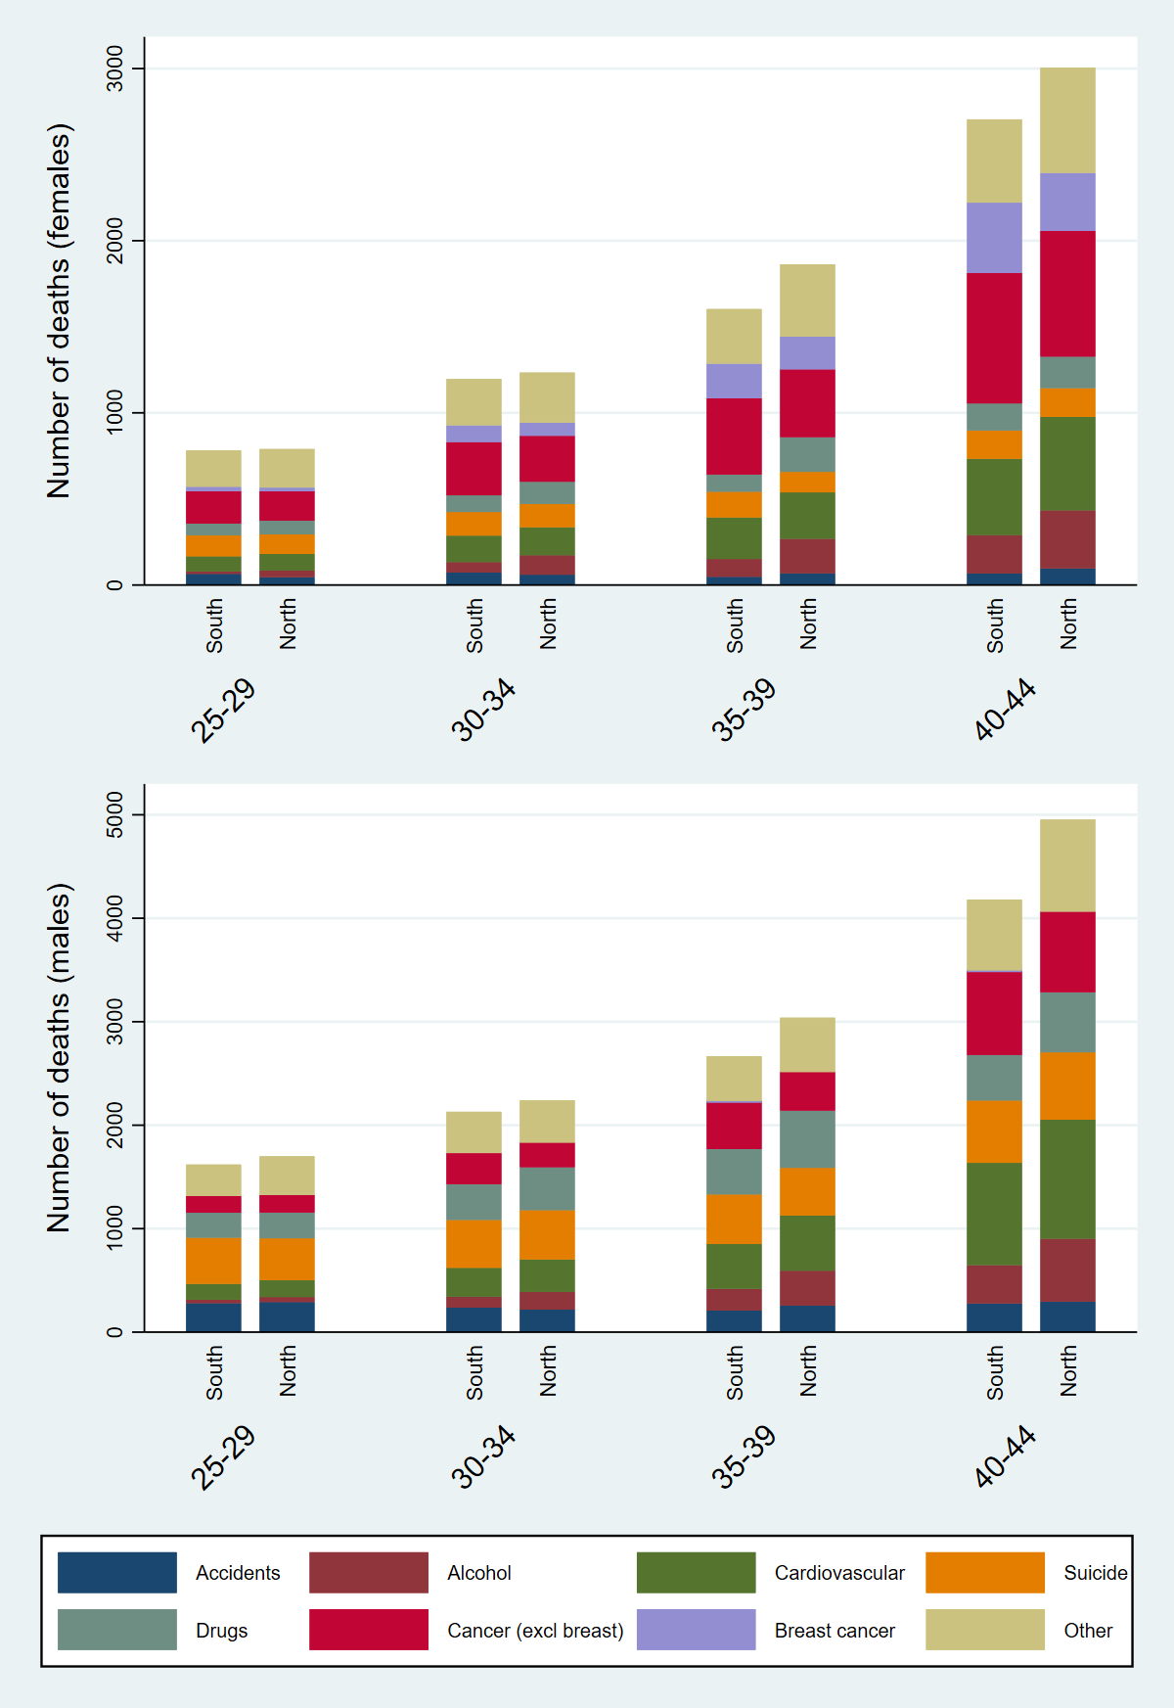
*Cardiovascular includes diabetes and obesity, with the overwhelming majority of deaths attributed to cardiovascular
†Population was larger in the South for all age subgroups, with an annual average of 4,081,133 females and 4,070,223 males, compared to 3,229,532 females and 3,211,064 males in the North
Figure 2: Numbers of excess deaths in the North attributed to specific underlying causes between 2014 and 2016, for females (top) and males (bottom)*†
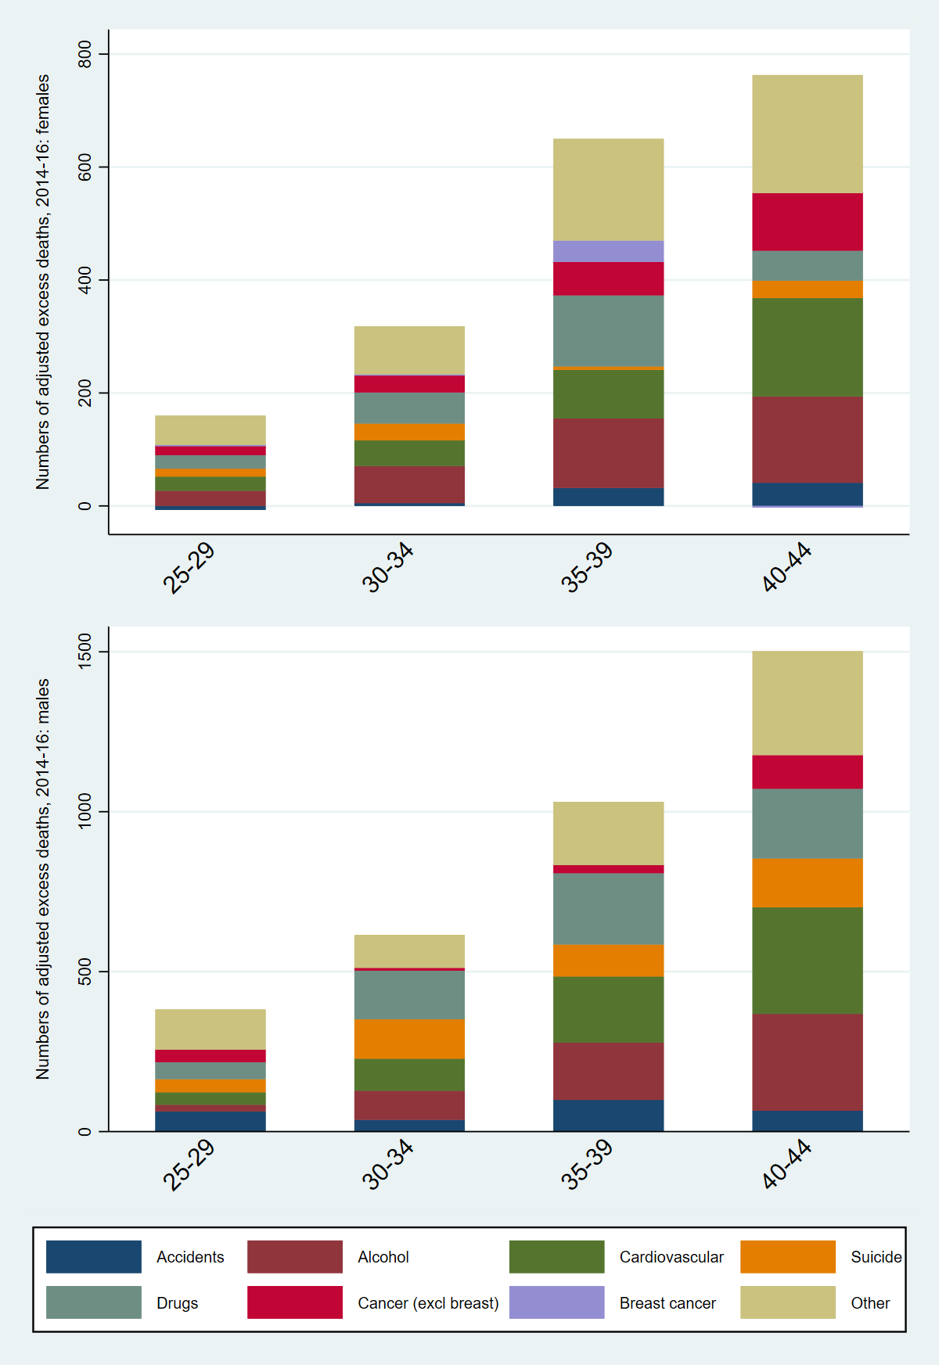
*Cardiovascular includes diabetes and obesity, with the overwhelming majority of deaths attributed to cardiovascular
† There are two very small negative estimates for the female groups (see supplement Table S6)
Figure 3: Directly age-standardised all-cause mortality rates for those aged 25 to 44 in the North and the South of England from 1981 to 2016, females (top) and males (bottom)
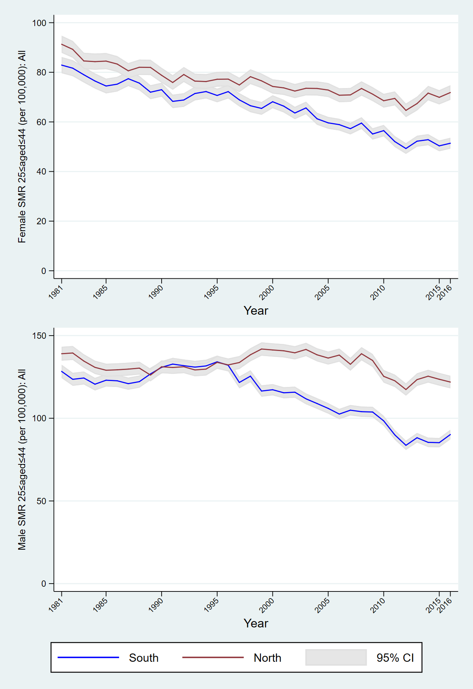
Figure 4: Directly age-standardised all-cause mortality rates for people aged 25 to 44 in 2016 at small area geographical level for the whole of England*
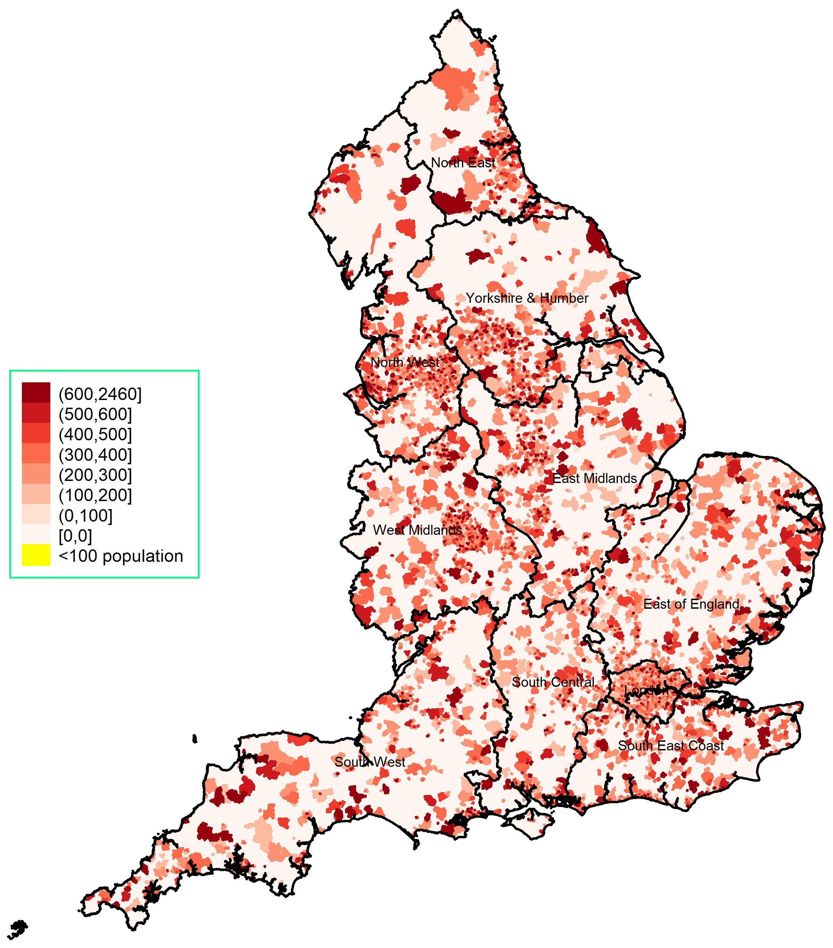
* areas with fewer than 100 residents aged 25-44 are supressed

Figure 5: Regional age-sex adjusted percentages of excess mortality from low geographical level Poisson regressions for 2016, compared to London; adjusting for overall IMD (top) and selected IMD subscales (bottom)*
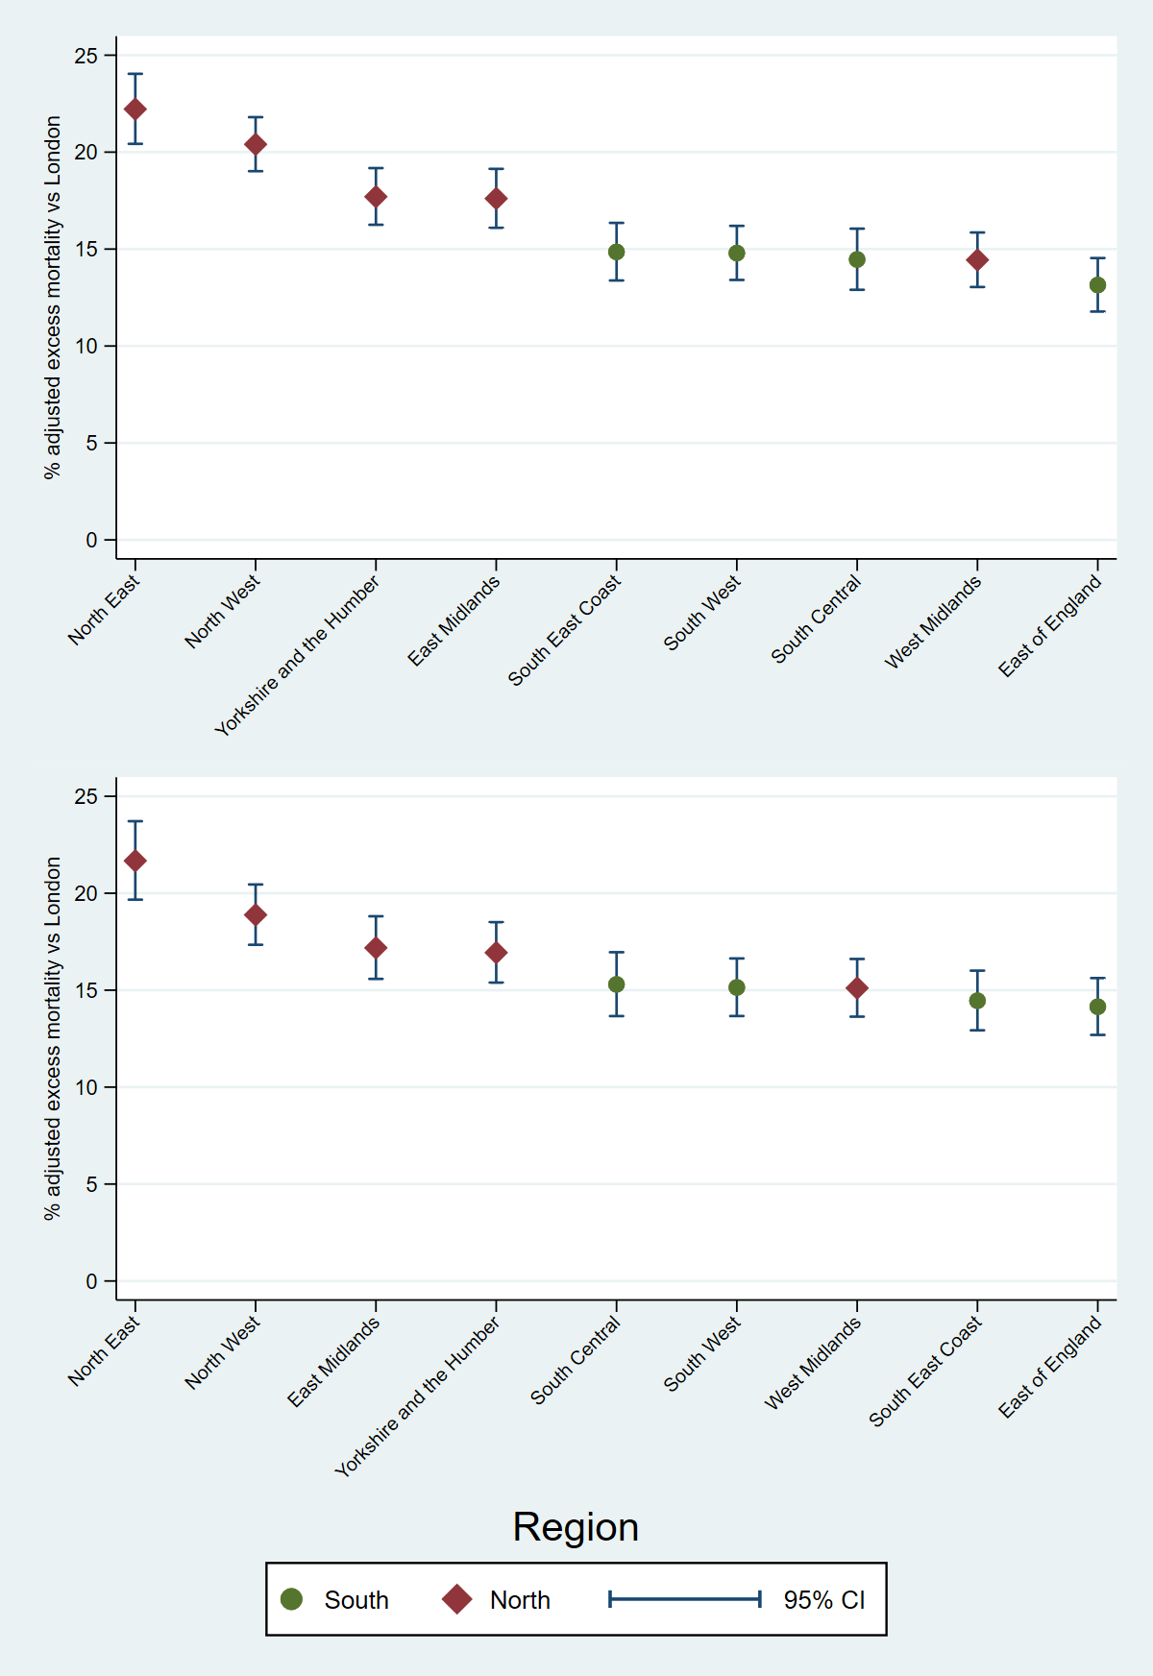
* 2015 IMD was used; domains in the bottom model were: employment, housing, crime, and environment (driven by collinearity concerns, except health which was removed due to overlap with the outcome)

