**BSG2018**

***Nutrition***

**BSG2018 – (Number)**

**PROSPECTIVE STUDY OF A LOW FODMAP DIET IN PATIENTS WITH COELIAC DISEASE AND IBS SYMPTOMS**

Nick Trott1, Matthew Kurien2, David S. Sanders1

1Department of Gastroenterology Royal Hallamshire Hospital, 2Academic Unit of Gastroenterology, Department of Infection, Immunity & Cardiovascular Disease, University of Sheffield, Sheffield, United Kingdom

**Introduction: P**atients with coeliac disease (CD) symptoms usually respond to a gluten free diet (GFD). However up to a quarter of adults with CD have persistent gastrointestinal (GI) symptoms despite strict adherence to a GFD and complete intestinal healing. Overlap between CD and irritable bowel syndrome (IBS) may explain this symptomology.Over the last decade there has been a renewed interest in dietary treatments in IBS particularly the low FODMAP diet (LFD) which temporally restricts fermentable carbohydrates. The aim of this prospective study was to investigate the efficacy of the LFD in patients with CD and IBS.

**Methods:** We conducted a prospective study of the LFD as an intervention in patients with treated-CD and persisting IBS symptoms. All CD patients met the ROME IV criteria, had negative coeliac serology and normal duodenal biopsy. All patients were reviewed by a specialist GI dietitian with experience in delivering the LFD. Symptom response was assessed using the validated Gastrointestinal Symptom Rating Scale (GSRS) from base-line to follow up.

**Results:** 24 patients with a mean age of 44 years (SD = 15.2) met the inclusion criteria. 8 patients chose not to pursue treatment and 2 were unable to complete the minimum treatment period. 14 patients (2 males) completed four weeks of a LFD. There were no differences in baseline demographics between patients who chose to participate in the study and those who did not, or who were unable to complete the study protocol (gender p = 0.7). Global symptom relief of gut symptoms was reported by 8/14 patients (57% p = 0.007 Figure 1). A sub-group analysis demonstrated a significant reduction in both abdominal pain (p = 0.001. Figure 2) and distension (p = 0.02. Figure 3) respectively. There were no significant differences to anthropometric and biochemical features at follow up compared with baseline.

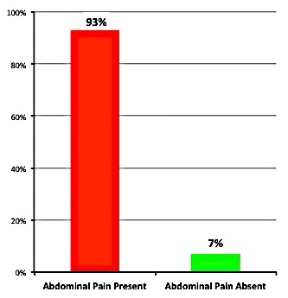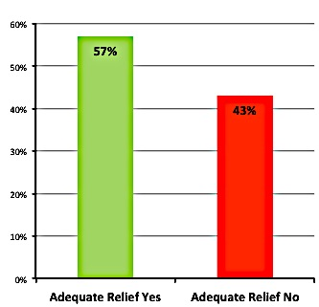**Conclusion:** This is the first study to demonstrate that a LFD is an effective dietary treatment for patients with biopsy confirmed treated-CD and on going GI symptomology. Such patients should be seen by a specialist dietitian to improve adherence, ensure nutritional adequacy and appropriate reintroduction of FODMAP containing foods.

Baseline

Follow up

**Figure 2**

Abdominal Pain Present

Baseline

No Relief

**Figure 1**

Adequate Relief at Follow Up

**Figure 3**

Abdominal Distension Present



Relief

Follow up

**Disclosure of Interest**: None Declared

**Keywords**: Coeliac Disease, IBS, Low FODMAP Diet