Figure 1: Governing Slum Redevelopment Projects in Trivandrum
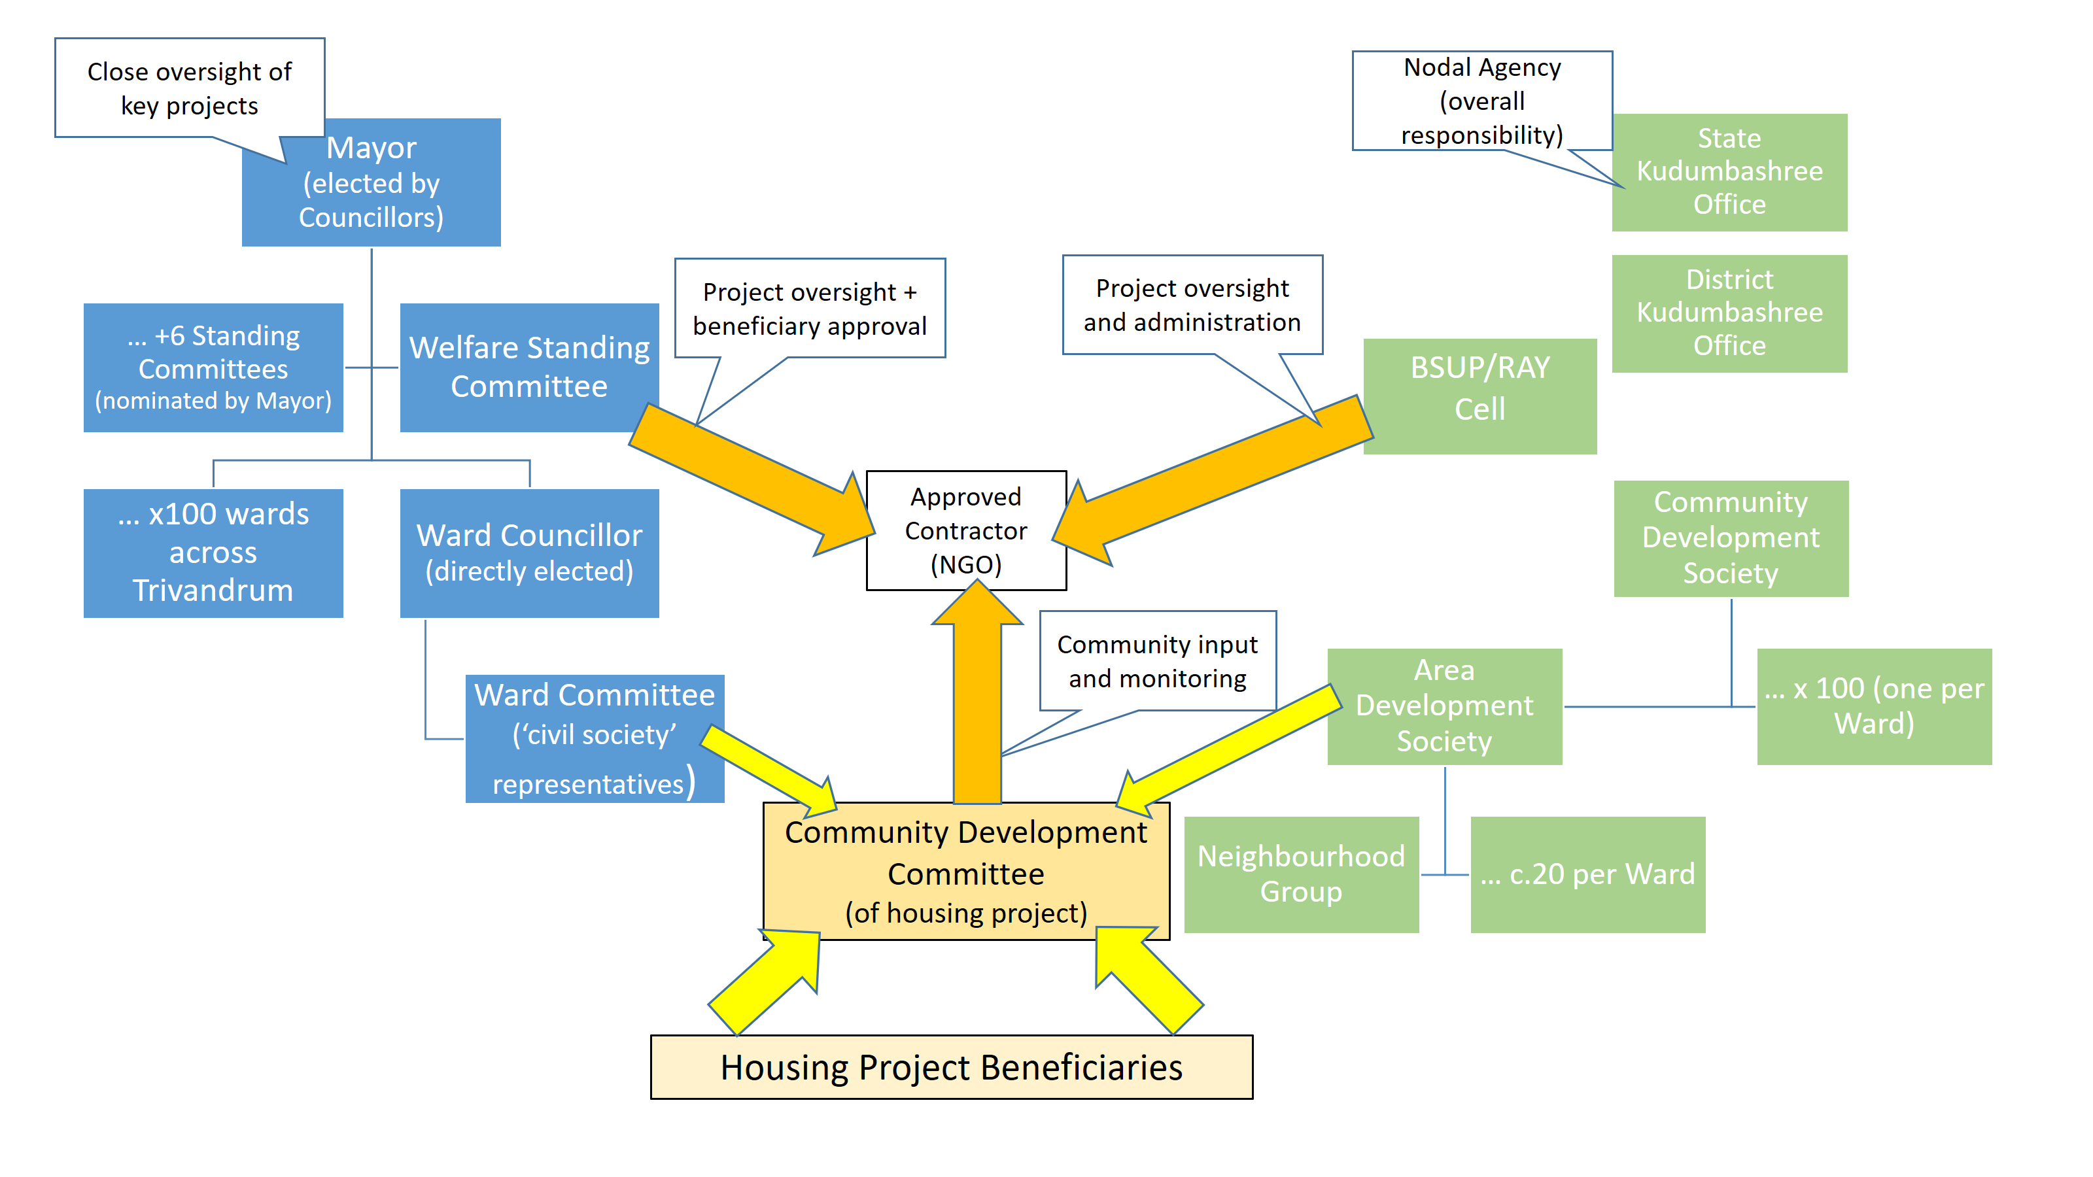
Key:
Blue boxes are elements of Trivandrum’s elected government
Green boxes are elements of Kudumbashree
Orange arrows show intended sources of project oversight (from Kudumbashree, local government and the community)
Gold arrows show intended membership of each housing project’s Community Development Committee

