CBMNet: The ‘Crossing Biological Membranes’ Network in Industrial Biotechnology and Bioenergy
Dr Jen Vanderhoven, The University of Sheffield, Sheffield. S10 2TN.
Professor Jeff Green, The University of Sheffield, Sheffield. S10 2TN.
Professor Gavin H. Thomas, Department of Biology, Wentworth Way, The University of York, York, YO10 5DD
Email: jeff.green@sheffield.ac.uk or gavin.thomas@york.ac.uk

ABSTRACT
The ~1300 academic and industry members of the BBSRC Network in Industrial Biotechnology and Bioenergy (NIBB) Crossing Biological Membranes (CBMNet), are motivated to explore how knowledge of the roles of biological membranes can be exploited to enhance the productivity of cell factories. Improving existing, and developing new, cell factories requires a deep understanding of the mechanisms by which substances are transported into, within, and out of the cells. Embedding consideration of membrane function into the design of cell factories is crucial for the future of almost all cell-based IBBE applications. CBMNet provides a forum for: knowledge exchange between academics and companies; developing new interactions in the context of responsible innovation; forming, and then supporting, new multi-disciplinary teams to develop innovative membrane-based solutions to overcome Industrial Biotechnology and Bioenergy (IBBE) bottlenecks; and funding consortia to carry out feasibility studies with the target of generating competitive bids for further research funding. More broadly, CBMNet is working with other NIBB to raise the profile of IBBE amongst policymakers and develop a national strategy for IBBE in the UK.

ABBREVIATIONS LIST
BBSRC – Biotechnology and Biological Sciences Research Council
CBMNet – Crossing Biological Membranes Network
EPSRC – Engineering and Physical Sciences Research Council
IBBE – Industrial Biotechnology and Bioenergy
NGOs – Non-Governmental Organisations
NIBB – Networks in IBBE

HISTORY OF CBMNet
In 2013, BBSRC, with support from EPSRC, committed £18 million to fund 13 Networks in Industrial Biotechnology and Bioenergy (NIBB). The NIBB promote collaborations between academia, industry, policymakers and NGOs to support IBBE activity in the UK. Each network has a particular focus and CBMNet emerged from the realisation that optimizing the productivity of existing and new cell factories is highly dependent on the function of biological membranes. Professors Jeffrey Green (University of Sheffield) and Gavin Thomas (University of York), secured funding for CBMNet to embed consideration of solute and protein transport as an integral component of the design of bacterial, yeast, and mammalian whole-cell biocatalysts capable of degrading a feedstock (enzyme secretion) and converting the released substrates (solute uptake) into useful products (product export).

CBMNet ACTIVITIES
CBMNet is working with its ~1300 members and other stakeholders to:
  - Improve community interactions (academic and business) through communication and co-ordinated events
  - Promote cross-disciplinary (bioscience, chemistry, engineering, social sciences) research with an IBBE focus applying genomic, systems biology and synthetic biology approaches
  - Facilitate links between business and academic researchers, extending knowledge exchange and translation of research in the IBBE
  - Provide proof of concept funding and deploy community expertise to construct high quality grant proposals
  - Raise the profile of the UK as leader in IBBE
  - Provide evidence-based and expert input for policymakers
  - Support professional development of CBMNet members, particular early career researchers

CBMNet RESEARCH
CBMNet addresses a core IBBE challenge, i.e. to develop innovative technologies to overcome yield restrictions caused by inefficient transport systems and inhibition of membrane function and to embed fully-integrated efficient transport systems into the design of cell factories. The network focuses on a pool of academic expertise that has not yet been widely utilized in the IBBE sector but impacts on almost all cell-factory-based IBBE processes. CBMNet has five core aims:
- Exploit biological transport processes to remove toxic products from the site of synthesis (usually the cytoplasm) before cellular damage occurs.
- Exploit genetic resources and molecular genetics to enhance the repertoire of transport options (both uptake and secretion systems) available for synthetic biology and IBBE applications.
- Study the interactions between toxic products and cell membranes to enable re-engineering for improved resistance and cross-membrane transport.
- Develop synergistic biological and process engineering strategies to enhance product yields.
- Understand barriers to translating work between academic and industrial settings and explore ways to mitigate these in the context of responsible innovation.

These aims are encapsulated in seven themes (Figure 1).
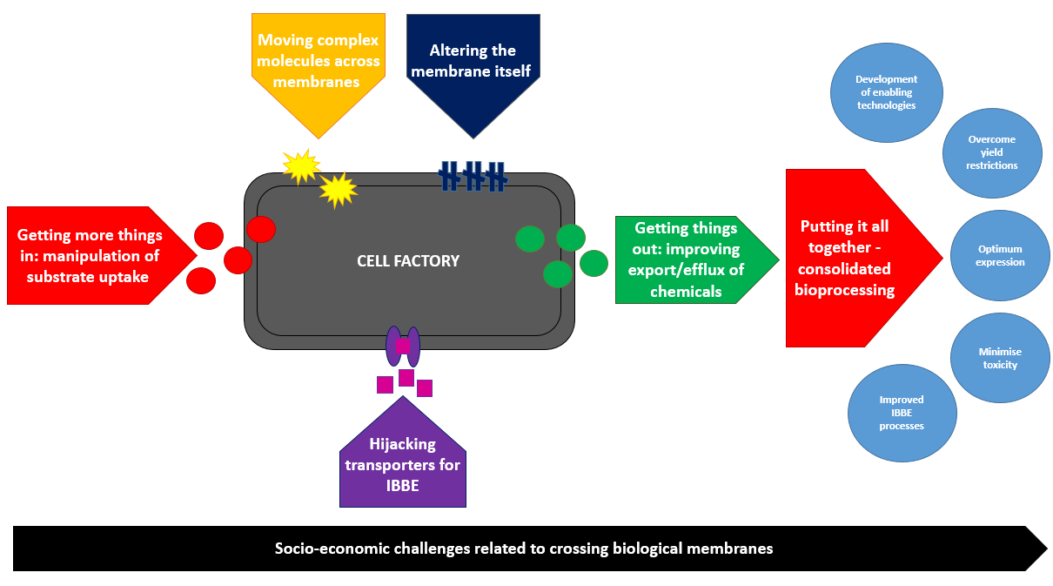
Figure 1. CBMNet themes

Getting more things in: manipulation of substrate uptake
The first step in any cell factory-based process is the uptake of molecules (substrates) across the cell membrane. For example, in the production of amino acids for food products, engineered forms of transporters have been used to optimise the uptake of the hydantoin feedstock. The aim is to use molecular genetics to expand the repertoire of substrate transport options and help optimise feedstock utilization and expand the capability of cell factories to use underexploited feedstocks.

Getting things out: improving export/ efflux of chemicals
Many of the most desirable bio-products are toxic and it is rarely possible to generate more than millimolar concentrations of product before its accumulation kills the biocatalyst. Effective and efficient transport of the product from the cytoplasm before cell damage occurs could transform many proof-of-concept bio-production systems into commercially viable processes. CBMNet seeks new applications for natural or re-engineered efflux or export systems, e.g. using the widely studied AcrB, TolC and EmrAB transporters to efflux free fatty acids from Escherichia coli for biodiesel synthesis.

Hijacking transporters for IBBE
Fundamental knowledge of the structure-function relationships of transporters can be exploited for biotechnology, because such systems often have relaxed substrate specificity and thus will operate with modified substrates. For example, the E. coli efflux pump AcrB has been used to excrete toxic short-chain alcohols, thereby improving tolerance.

Moving complex molecules across membranes
Secreting and post-translationally modifying complex molecules such as proteins within cell factories – including yeast and Chinese hamster ovary (CHO) cells – can involve passage across several biological membranes, which can be significant bottlenecks for high productivity. By leveraging molecular methods and engineering expertise, CBMNet members are seeking to increase the yield of recombinant proteins. The recent demonstration that recombinant proteins can be secreted from E. coli through the MscL mechanosensitive channel is a powerful demonstration of how fundamental understanding of membrane function might impact on IBBE.

Altering the membrane
The structure and function of biological membranes are defined by their protein and lipid composition and engineering lipids for heightened resistance to toxic products and enhancing protein function/stability is understudied in the context of IBBE. Incorporating heterologous lipid modifying enzymes into E. coli chassis has been shown to be a fruitful approach in enhancing tolerance to a wide range of toxic products,.

Putting it all together: consolidated bioprocessing
Consideration and combination of the CBMNet themes outlined above and in Figure 1 could have a transformative effect on many cell factory-based processes. For example, second generation biofuel processes require the rapid and efficient breakdown and utilisation of the components of lignocelluloses. An efficient cell factory would secrete or surface-locate the enzymatic functions required for hemicellulose degradation; take up simultaneously a range of hexose and pentose sugars, and use the uronic acids and hydroxycinnamic acid components of the hemicelluloses; efficiently efflux the end product and use other efflux systems to confer resistance to inhibitors. Combining all these features requires integration of multiple transporter, catabolism and regulatory-based functions within the cell by applying synthetic biology methods and metabolic modelling and is still a grand challenge of industrial biotechnology.

Socioeconomic challenges
To ensure that CBMNet’s work has lasting effects on the IBBE sector and beyond we are working to advance the field of responsible innovation and address the socioeconomic challenges related to IBBE.

NETWORK ACHIEVEMENTS
CBMNet membership stands at just under 1300 (as of April 2018), with roughly 75% academia and 25% industry members. The network is made up of 322 HEI’s and 214 companies, with 19% from Europe (non-UK), 13% international (non-UK and non-European) and 40% of Early Career Researchers.

CBMNet has funded over 65 academics to work on collaborative projects with more than 20 IBBE companies, in projects worth in excess of £800,000. CBMNet-funded projects and initiatives have led to 38 additional projects, supported by £17.6M in external grants for our members (of which over £1M comes from industry cash and in kind contributions). For example, the £3.5 million research project (DeTox, http://projectdetox.co.uk/) to improve the sustainable production of chemicals and biofuels by microbes was awarded by the Industrial Biotechnology Catalyst fund to a consortium of scientists led by CBMNet.
From the outset CBMNet forged international alliances, which is reflected in our 13% international membership, including partners from as far afield as New Zealand, Korea and Chile. An International Workshop Award enabled us to send our members to Nelson, New Zealand in August 2017 to the Cawthron Institute, for a five-day workshop to explore the bottlenecks in producing polysaccharides, other bioactives and functional food ingredients from marine biomass. Furthermore, an International Partnering Award has funded a UK-Taiwan exchange to investigate the structure and function of bacterial transporters for IBBE. Recently, we recently welcomed Canadian and European Colleagues to the UK to establish International Partnerships in IBBE in improved glycoform-based biopharmaceutical production in plants.

Our commitment to working internationally has been recognised in the recently awarded CBMNet led CoBioTech ERA £2.4M project ‘MEmbrane Modulation for BiopRocess enhANcEment’ (MEMBRANE) developed through CBMNet and led by CBMNet Management Board member Dr. Alan Goddard, with CBMNet Co-Director Professor Gavin Thomas, as Co-investigator. MEMBRANE will deliver bespoke robust industrially-viable cell factory strains, engineered to overcome current bioprocess and production bottlenecks, accelerating the commercialisation of two industrial bioprocesses.

One of the hallmarks of CBMNet is the commitment to promoting IBBE to early career scientists. To date the Network has sponsored 20 undergraduates through the CBMNet Vacation Scholarships programme and sponsored 24 Early Career Researcher grants, allowing members to attend major conferences and training events within their research areas.

CASE STUDY: VIRAL ANTIGEN PRODUCTION FOR VACCINE­‐MEDIATED DISEASE PREVENTION BY RATIONAL GLYCO-ENGINEERING­‐MEDIATED PROTEIN SECRETION IN A CELL FACTORY – PROFESSOR CARL SMYTHE, UNIVERSITY OF SHEFFIELD AND EXCIVION LIMITED
Excivion was formed in response to the need to develop affordable solutions to the present and looming health crises of a changing world. It produces novel vaccines that can be used to prevent emerging pandemic infectious diseases. Flaviviruses are a family of viruses spread by mosquitoes, and which cause a range of disorders, such as dengue fever and Zika microcephaly (part of the Zika congenital syndrome). Global travel, urbanisation, and expanding mosquito habitats have conspired to make flavivirus infections an even greater threat to humanity than was previously recognised, with over a billion people at risk worldwide. Latterly it has become apparent that development of novel flavivirus vaccines may be complicated by a risk of inadvertent disease enhancement. Conserved structural elements among different flaviviruses and flavivirus vaccines are responsible for serial boosting of antibodies that may paradoxically enhance dengue infection. The recently licensed vaccine product against dengue (Dengvaxia™), the only dengue vaccine so far, was recently withdrawn for the immunisation of persons naïve to dengue (principally children), over concerns that it was setting them up for enhanced disease, causing its manufacturer to write-off €100 million of annual revenue. These events were anticipated in the design and development of the novel vaccine prototypes used in this project. Excivion received funding from CBMNet, with Professor Carl Smythe and Professor David James from The University of Sheffield to implement a molecular ‘cloaking’ strategy whereby the offending structure of the vaccine protein is effectively obscured - preventing it from being recognised or ‘remembered’ by the immune system. The data from the project provided the collaborating company with sufficient confidence to successfully apply for a new round of Innovate UK funding (valued at £2 million) to develop a novel vaccine for the prevention of the spread of Zika virus and the developmental disorders it is known to cause.
COMPETING INTERESTS
The Authors declare that there are no competing interests associated with the manuscript.

FUNDING INFORMATION
CBMNet is funded from the BBSRC, Grant number BB/L013703/1

Shimamura T1, Weyand S, Beckstein O, Rutherford NG, Hadden JM, Sharples D, Sansom MS, Iwata S, Henderson PJ, Cameron AD. Molecular Basis of Alternating Access Membrane Transport by the Sodium-Hydantoin Transporter, Mhp1. Science (New York, NY). 2010;328(5977):470-473
Lennen RM, Politz MG, Kruziki MA, Pfleger BF. Identification of Transport Proteins Involved in Free Fatty Acid Efflux in Escherichia coli. Journal of Bacteriology. 2013;195 (1):135-144. doi:10.1128/JB.01477-12
Michael A. Fisher, Sergey Boyarskiy, Masaki R. Yamada, Niwen Kong, Stefan Bauer, and Danielle Tullman-Ercek. Enhancing Tolerance to Short-Chain Alcohols by Engineering the Escherichia coli AcrB Efflux Pump to Secrete the Non-native Substrate n-Butanol.ACS Synthetic Biology 2014 3 (1), 30-40
Rosa Morra, Francesco Del Carratore, Howbeer Muhamadali, Luminita Gabriela Horga, Samantha Halliwell, Royston Goodacre, Rainer Breitling, Neil Dixon. Translation Stress Positively Regulates MscL-Dependent Excretion of Cytoplasmic Proteins. 2018 mBio vol. 9 no. 1 e02118-17
Zaigao Tan, Jong Moon Yoon, David R. Nielsen, Jacqueline V. Shanks, Laura R. Jarboe, “Membrane engineering via trans unsaturated fatty acids production improves Escherichia coli robustness and production of biorenewables,” Metabolic Engineering, Vol. 35, May 2016, Pages 105-113
Zaigao Tan, Pouyan Khakbaz, Yingxi Chen, Jeremy Lombardo, Jong Moon Yoon, Jacqueline V Shanks, Jeffery B Klauda, Laura R Jarboe 2017, Metabolic engineering, 44, 1-12

